WATERSHED-BASED PLAN
Trout Brook Watershed
within the Town of Avon
October 22, 2019

Prepared By:
Town of Avon Department of Public Works
Geosyntec Consultants

Prepared For:

Contents
Executive Summary iii
Introduction 1
Purpose & Need 1
Watershed-Based Plan Outline 1
Project Partners and Stakeholder Input 2
Data Sources 2
Summary of Past and Ongoing Work 3
Element A: Identify Causes of Impairment & Pollution Sources 4
General Watershed Information 4
MassDEP Water Quality Assessment Report 6
Additional Water Quality Data 8
Water Quality Impairments 9
Water Quality Goals 10
Land Use Information 11
Pollutant Loading 17
Element B: Determine Pollutant Load Reductions Needed to Achieve Water Quality Goals 19
Estimated Pollutant Loads 19
Water Quality Goals 19
Element C: Describe management measures that will be implemented to achieve water quality goals 22
Ongoing Management Measures 22
Future Management Measures 22
Element D: Identify Technical and Financial Assistance Needed to Implement Plan 24
Current and Ongoing Management Measures 24
Future Management Measures 24
Element E: Public Information and Education 26
Elements F & G: Implementation Schedule and Measurable Milestones 28
Elements H & I: Progress Evaluation Criteria and Monitoring 29
Indirect Indicators of Load Reduction 29
Project-Specific Indicators 31
TMDL Criteria 31
Direct Measurements 31
Adaptive Management 31
References 32
Appendices 34
Appendix A – BMP Conceptual Design Details 34
Appendix B – Pollutant Load Export Rates (PLERs) 36

Executive Summary
Introduction: The purpose of a Massachusetts Watershed-Based Plan (WBP) is to organize information about Massachusetts' watersheds, and present it in a format that will enhance the development and implementation of projects that will restore water quality and beneficial uses in the Commonwealth. The Massachusetts WBP follows USEPA's recommended format for “nine-element” watershed plans. This WBP was developed by Geosyntec Consultants (Geosyntec) under the direction of the Avon Department of Public Works with funding, input, and collaboration from the Massachusetts Department of Environmental Protection (MassDEP).
Avon is located at the headwaters of the Taunton River which flows approximately 36 miles to its outlet in the Narragansett Bay. Trout Brook is part of the upper Taunton River watershed and is the primary receptor of stormwater runoff from the Town of Avon. This WBP was prepared for the watershed of Trout Brook within the Town of Avon.
Impairments and Pollution Sources: Trout Brook is a category 5 water body on the Massachusetts List of Integrated Waters due to fecal coliform, dissolved oxygen, total suspended solids, and turbidity. Due to these impairments and others, a TMDL for pathogens has been issued for the Taunton River watershed (including Trout Brook). There are many potential pollutant sources that are causing these impairments; however, urban stormwater runoff has been identified as one potential source of the dissolved oxygen and fecal coliform impairments.
Goals, Management Measures, and Funding: The primary goal of this WBP is to reduce total phosphorus loading to Trout Brook to address water quality impairments, eventually leading to delisting of the stream from the 303(d) list. It is expected that these pollutant load reductions will result in improvements to listed impairments throughout the study area. An interim goal is proposed to reduce phosphorus loading by 10 lb/yr in the next ten years. After the first ten years, focus will be shifted to the long-term goal of delisting the segment of Trout Brook within the Town of Avon.
It is expected that goals will be accomplished primarily through installation of structural BMPs to capture runoff and reduce loading as well as implementation of non-structural BMPs (e.g., street sweeping, catch basin cleaning), and watershed education and outreach. Structural BMPs will first be implemented at Avon Town Hall per a Fiscal Year 2019 Section 319 grant. Additional planning and implementation is expected to be performed in subsequent years, focusing on the watershed to Trout Brook.
It is expected that funding for management measures will be obtained from a variety of sources including Section 319 Grant Funding, Town capital funds, volunteer efforts, and other sources.
Public Education and Outreach: Goals of public education and outreach are to provide information about proposed stormwater improvements and their anticipated benefits and to promote watershed stewardship. The Town of Avon aims to engage watershed residents, businesses, and watershed organizations through informational signage, an educational poster, posting information on the Town website, tours of installed BMPs, and installation of pet waste disposal stations. It is expected that these programs will be evaluated by website activity, number of locations used to display the educational poster, attendance at BMP tours, and the number of pet waste bags distributed.
Implementation Schedule and Evaluation Criteria: Project activities will be implemented based on the information outlined in the following elements for monitoring, implementation of structural BMPs, public education and outreach activities, and periodic updates to the WBP. It is expected that a water quality monitoring program will enable direct evaluation of improvements over time. Other indirect evaluation metrics are also recommended, included quantification of potential pollutant load reductions from non-structural BMPs (e.g., street sweeping). The interim goal of this WBP is to reduce land use-based phosphorus loading by 10 lb/yr by 2029. The long-term goal of this WBP is to de-list the Trout Brook within the Town of Avon from the 303(d) list. The WBP will be re-evaluated and adjusted, as needed, once every six years.

Introduction
What is a Watershed-Based Plan?

Purpose & Need
The purpose of a Massachusetts Watershed-Based Plan (WBP) is to organize information about Massachusetts' watersheds, and present it in a format that will enhance the development and implementation of projects that will restore water quality and beneficial uses in the Commonwealth. The Massachusetts WBP follows USEPA's recommended format for “nine-element” watershed plans, as described below.
All states are required to develop WBPs, but not all states have taken the same approach. Most states develop watershed-based plans only for selected watersheds. MassDEP's approach has been to develop a tool to support statewide development of WBPs, so that good projects in all areas of the state may be eligible for federal watershed implementation grant funds under Section 319 of the Clean Water Act.
USEPA guidelines promote the use of Section 319 funding for developing and implementing WBPs. WBPs are required for all projects implemented with Section 319 funds, and are recommended for all watershed projects, whether they are designed to protect unimpaired waters, restore impaired waters, or both.

Watershed-Based Plan Outline
This WBP for the Trout Brook watershed within the Town of Avon includes nine elements (a through i) in accordance with USEPA Guidelines:
- An identification of the causes and sources or groups of similar sources that will need to be controlled to achieve the load reductions estimated in this watershed-based plan (and to achieve any other watershed goals identified in the watershed-based plan), as discussed in item (b) immediately below.
- An estimate of the load reductions expected for the management measures described under paragraph (c) below (recognizing the natural variability and the difficulty in precisely predicting the performance of management measures over time).
- A description of the nonpoint source (NPS) management measures needed to achieve the load reductions estimated under paragraph (b) above (as well as to achieve other watershed goals identified in this watershed-based plan), and an identification (using a map or a description) of the critical areas in which those measures will be needed to implement this plan.
- An estimate of the amounts of technical and financial assistance needed, associated costs, and/or the sources and authorities that will be relied upon, to implement this plan. As sources of funding, States should consider the use of their Section 319 programs, State Revolving Funds, USDA's Environmental Quality Incentives Program and Conservation Reserve Program, and other relevant Federal, State, local and private funds that may be available to assist in implementing this plan.
- An information/education component that will be used to enhance public understanding of the project and encourage their early and continued participation in selecting, designing, and implementing the NPS management measures that will be implemented.
- A schedule for implementing the NPS management measures identified in this plan that is reasonably expeditious.
- A description of interim, measurable milestones for determining whether NPS management measures or other control actions are being implemented.
- A set of criteria to determine if loading reductions are being achieved over time and substantial progress is being made towards attaining water quality standards and, if not, the criteria for determining whether this watershed-based plan needs to be revised or, if a NPS Total Maximum Daily Load (TMDL) has been established, whether the TMDL needs to be revised.
- A monitoring component to evaluate the effectiveness of the implementation efforts over time, measured against the criteria established under item (h) immediately above.

Project Partners and Stakeholder Input
This WBP was developed by Geosyntec Consultants (Geosyntec) under the direction of the Town of Avon with funding, input, and collaboration from the Massachusetts Department of Environmental Protection (MassDEP). This WBP was developed using funds from the Section 319 program to assist grantees in developing technically robust WBPs using MassDEP’s Watershed-Based Planning Tool. Avon was a recipient of Section 319 funding in Fiscal Year 2019 to implement BMPs in the Trout Brook watershed.
Core project stakeholders included:
- William A. Fitzgerald Jr., Director – Town of Avon Department of Public Works
- Brian Martin, Assistant Director – Town of Avon Department of Public Works
- Matt Reardon - MassDEP
- Jane Peirce – MassDEP
This WBP was developed as part of an iterative process. The Geosyntec project team collected and reviewed existing data from the Town of Avon. This information was then used to develop a preliminary WBP for review by core project stakeholders. A stakeholder conference call was then held to solicit input and gain consensus on elements included in the plan (e.g., water quality goals, public outreach activities, etc.). The WBP was finalized once stakeholder consensus was obtained for all elements.

Data Sources
This WBP was developed using the framework and data sources provided by MassDEP’s Watershed-Based Plan Tool and supplemented by information provided in the Avon Town Hall Green Infrastructure Demonstration Project Section 319 Nonpoint Source Pollution Grant Program application (Town of Avon, 2018). Additional data sources were reviewed and are summarized in subsequent sections of this WBP, if relevant, as listed by Table 1.

Table 1: Supplemental Data Sources
Title / Description | Source | Date
Identification and Assessment of Causes of Impairment: Trout Brook (MA62-07_2008(5)) | Town of Avon | 2018
Stormwater Asset Management: Water Infrastructure Planning and Technical Assistance Grant | Town of Avon | 2016

Summary of Past and Ongoing Work

Identification and Assessment of Causes of Impairment: Trout Brook (Town of Avon, 2018)
The Town of Avon was awarded a grant in 2018 through the Southeast New England Program (SNEP) for Coastal Watershed Restoration Grants Program by the USEPA and the New England Interstate Water Pollution Control Commission (NEIWPCC) for the Identification and Assessment of Causes of Impairment: Trout Brook application. This project resulted in a final report that summarizes the work completed with funding by the grant, provides conclusions on water quality in the Trout Brook watershed, identifies BMPs to improve water quality, and lists recommendations for next steps towards addressing the causes of impairments in Trout Brook.

Stormwater Asset Management – Water Infrastructure Planning and Technical Assistance Grant (Town of Avon, 2016)
In 2016, the Town of Avon was awarded a grant through the Water Infrastructure Planning and Technical Assistance Program, administered by MassDEP, to implement a stormwater operations and asset management system. The project efforts included inventorying stormwater assets, developing procedures for illicit discharge detection and elimination, and field investigation to assess the condition of the stormwater system and to collect data to support asset management. Data collected was used to develop a GIS database of Avon’s stormwater infrastructure. The project also included a public education and outreach component that included preparing and displaying a poster that informed residents about Avon’s approach to stormwater planning.

Element A: Identify Causes of Impairment & Pollution Sources
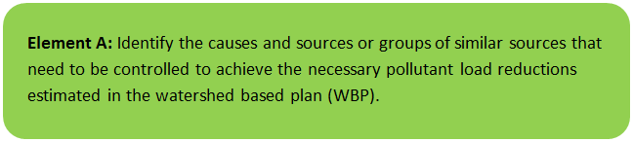

General Watershed Information
Avon is located at the headwaters of the Taunton River which flows approximately 36 miles to its outlet in Narragansett Bay. Trout Brook is a part of the upper Taunton River watershed and is the primary receptor of stormwater runoff from the Town of Avon. The Town of Avon also derives the entirety of the Town’s drinking water resources from the Trout Brook aquifer. This WBP was prepared for Trout Brook within the Town of Avon.
Table A-1 presents the general watershed information for the applicable MS4 subwatershed and Figure A-1 includes a map of the watershed boundary. The MS4 module of the watershed-based planning tool was used to enable computations of Trout Brook watershed statistics within the Town of Avon (identified as AVON_03; herein referred to as “the watershed”).
Table A-1: General Watershed Information
MS4 Subwatershed # | Waterbody Names (Assessment Unit ID) | Watershed Area (ac) | Major Basin
AVON_03 | Trout Brook (MA62-07) | 907 (ac) | TAUNTON

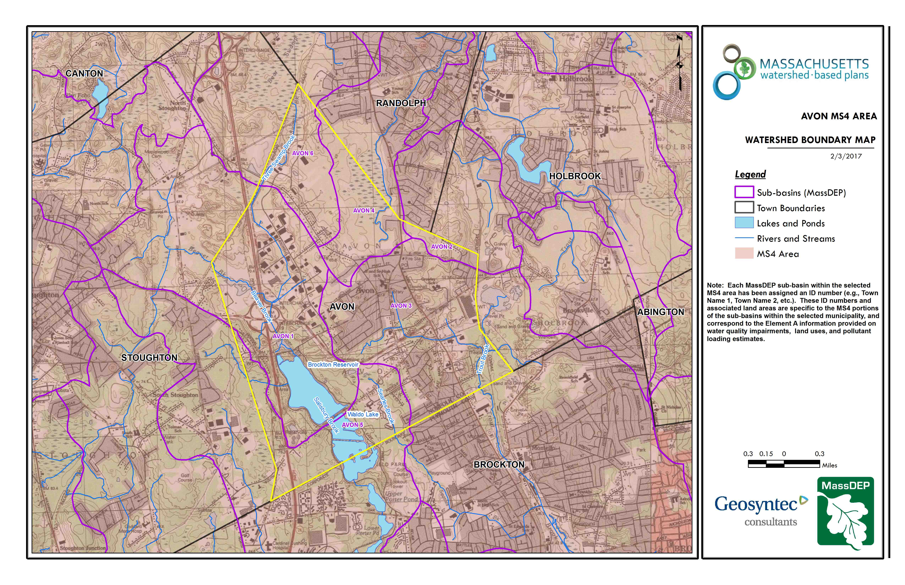Figure A-1: Watershed Boundary Map
Trout Brook
Avon Town Boundary
Approximate Watershed Boundary (Avon_03)
(MassGIS, 2007; MassGIS, 1999; MassGIS, 2001; USGS, 2016)

MassDEP Water Quality Assessment Report
The following reports are available:
- Final Pathogen TMDL for the Taunton River Watershed June 2011
- Taunton River Watershed 2001 Water Quality Assessment Report
Select excerpts from these documents relating to the water quality in the Trout Brook watershed are included below (note: relevant information is included directly from these documents for informational purposes and has not been modified, and the majority of sampling data cited in the box below is located downstream of the watershed (Avon_03)).
Taunton River Watershed 2001 Water Quality Assessment Report (MA62-07 - Trout Brook)
USE ASSESSMENT - AQUATIC LIFE
Habitat and Flow
ESS conducted instream habitat evaluations at four sites along Trout Brook in June/July 2002. The stations (upstream to downstream) were located at Studley Avenue, off of North Montello Street, Brockton (Station TB4); near East Ashland Street, Brockton (Station TB2); near Court Street, Brockton (Station TB3); and near Crescent Street (Route 27), Brockton (Station TB1). The habitat assessment scores were generally low ranging from 86 to 114/200. Channel flow status was the only habitat variable that consistently scored in the suboptimal range at all four sites evaluated. Instream habitat in this brook was limited as a direct result of development, poor instream cover, significant channel alteration, some sediment deposition, moderately unstable banks and little to no riparian zones (ESS 2003).
Toxicity - Effluent
One modified acute and chronic whole effluent toxicity test was conducted on the Avon Custom Mixing, Inc. treated sanitary effluent (Outfall #001) using both Ceriodaphnia dubia and Pimephales promelas. No acute or chronic toxicity to either test organism was detected in the August 2004 test. No other whole effluent toxicity testing reports have been submitted to MassDEP.
Chemistry – water
Between June and November 2002, the following four stations were sampled by ESS along this segment of Trout Brook as part of their NPS study (ESS 2003).
TB4 – Studley Avenue, off of North Montello Street, Brockton (n=3 sampling events).
TB2 – East Ashland Street, Brockton (n=5 sampling events).
TB3 – Court Street, Brockton (n=3 sampling events).
TB1 – Crescent Street (Route 27), Brockton (n=5 sampling events).
Results of these surveys are summarized below.
Dissolved Oxygen and % Saturation
The concentration of dissolved oxygen at the four stations monitored (day surveys only) ranged from 2.6 to 7.9 mg/L with eight of the fourteen measurements <5.0 mg/L. Percent saturation ranged from 30.8 to 85.9 and 11 of the 14 measurements were less than 60% saturation.
Temperature
The highest temperature measured in Trout Brook was 28.8°C (Station TB4) on the 1 August 2002.
pH
The pH in Trout Brook ranged from 6.0 to 7.8 SU at the four stations monitored. Only three of the 16 measurements were less than 6.5 SU.
Specific Conductance
Specific conductance ranged from 134.4 to 481.0 μmhos/cm (n=16).
TSS
The TSS concentrations ranged from 2.0 to 27 mg/L at the four stations sampled in Trout Brook. It should be noted that the highest concentrations (23 to 27 mg/L) were measured in the lower reach of the brook near Court Street and Crescent Street (Stations TB3 and TB1).
TKN
The concentration of TKN ranged from 0.3 to 2.6 mg/L (n=16).
Total Phosphorus
Total phosphorus concentrations ranged from 0.04 to 0.20 mg/L, however, it should be noted that the highest concentrations were consistently measured in the lower reach of the brook near Court Street and Crescent Street (stations TB3 and TB1). Only one of the 16 measurements was <0.05 mg/L.
Use Assessment: The Aquatic Life Use is not assessed for Trout Brook as a result of the lack of instream biological data (response type indicators of in-stream water quality conditions). This use in this urbanized subwatershed is identified with an Alert Status because of habitat degradation, low dissolved oxygen/saturation and elevated total phosphorus concentrations.
USE ASSESSMENT - PRIMARY AND SECONDARY CONTACT RECREATION AND AESTHETICS
Fecal coliform and E.coli samples were collected at four sampling stations in Trout Brook between June and November 2002 during both dry and wet weather events. From upstream to downstream these stations are summarized as follows (ESS 2003):
TB4 – Studley Avenue, off of North Montello Street, Brockton
TB2 – East Ashland Street, Brockton
TB3 – Court Street, Brockton
TB1 – Crescent Street (Route 27), Brockton
Samples were also collected from three tributaries to Trout Brook (Stations SEB1 and SEB2 on Searles Brook, Station MAB1 on Malfardar Brook, and Stations CB1 and CB2 on Cary Brook).
2003 Bacteria Data
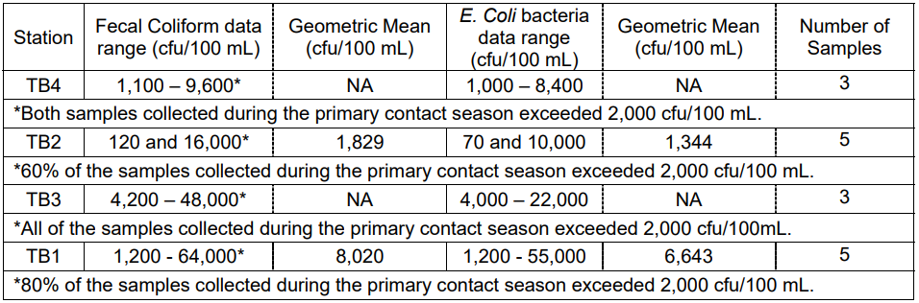
NB: Elevated bacteria counts in Trout Brook are representative of both dry and wet weather sampling conditions. Elevated bacteria counts were also documented in the three tributaries (ESS 2003).
No objectionable oils, odors, or other objectionable conditions were identified by ESS at the two most upstream sampling locations in Trout Brook (Station TB4) near Studley Avenue, off of North Montello Street, and near East Ashland Street, Brockton (Station TB2). Further downstream, however, near Court Street, Brockton (Station TB3), sewage and chemical odors were noted and the water column was described as opaque. No objectionable conditions (odors, oils, other deposits) were noted by ESS at the most downstream sampling location in Trout Brook near Crescent Street (Route 27), Brockton (Station TB1) (ESS 2003).
Use Assessment: The Primary and Secondary Contact Recreational uses are assessed as impaired because of elevated bacteria counts. The Aesthetics Use is assessed as support upstream from East Ashland Street (upper 2.1 mile reach) but is assessed as impaired downstream from East Ashland Street (lower 1.3 mile reach) because of objectionable conditions reported by ESS.
NPDES WASTEWATER DISCHARGE SUMMARY
Avon Custom Mixing Services, Inc., a manufacturer of elastometric compounds (rubber products), is authorized to discharge from its facility, Division of Chase and Sons, to Trout Brook. Although the NPDES permit #MA0026883 was issued November 2001, the company appealed the permit. Their permit appeal was denied in August 2002. Under the conditions of their permit, the facility is authorized to discharge 0.0015 MGD of treated sanitary effluent from its wastewater treatment facility and 0.15 MGD of combined non-contact cooling water and stormwater discharge from Outfall 002. Whole effluent toxicity limits are C-NOEC>21% and LC50>100% with a monitoring frequency of four times a year using both Ceriodaphnia dubia and Pimephales promelas. According to MassDEP Northeast Regional Office, the facility has occasional violations of their fecal coliform bacteria and ammonia limits (Ahsan 2005).
The former Hybripac Inc. in Avon was issued an emergency exclusion for their groundwater remediation project in 1997, which is no longer in effect (Pellerin 1997).
Warm Water Fishery
Report Recommendations:
Review and implement appropriate recommendations from the ESS Nonpoint Source Pollution Assessment Report and Management Plan (ESS 2003).
Conduct monitoring (biological, habitat and water quality) to evaluate impacts to Trout Brook from potential sources of pollution and to better assess the status of the Aquatic Life Use.
Continue to conduct bacteria sampling to evaluate effectiveness of nonpoint source pollution control activities and other actions (i.e., illicit connection identification/remediation) and to assess the status of the Primary and Secondary Contact Recreational uses.

Additional Water Quality Data
MassDEP Southeast Regional Office sampled water quality (E. coli) on four occasions during the 2006 sampling season between 5/10/2006 and 8/15/2006 at Connelly Road crossing, Avon. The geometric mean of the E. coli samples was 1,189 MPN/100 mL.
Water quality data was collected from Trout Brook as part of the Identification and Assessment of Causes of Impairment: Trout Brook study. Samples collected were analyzed in the field using field instrumentation and test kits for temperature, conductivity, salinity, dissolved oxygen, pH, and chlorine. In addition, the samples were analyzed by a laboratory for ammonia, surfactants, total nitrogen, total phosphorus, total sodium, fecal coliform, E. coli, total suspended solids, and BOD5. Samples were collected in the Trout Brook watershed during dry weather conditions from one outfall (other outfalls were not actively discharging at the time of sampling) on August 24, 2018. Due to the outfall being submerged, the next upstream structure (a drain manhole located at the intersection of Cross Street and Brentwood Avenue) in Avon was opened and the flow entering the manhole was sampled. While this outfall does receive contributions from the MS4, based on stormwater mapping and field investigation, this outfall also functions more as a culverted stream draining the upstream wetlands system, and therefore it was not surprising that the outfall was flowing during dry weather. Results indicated elevated concentrations of chlorine, total phosphorus, and total nitrogen (as compared to action levels identified in the study’s final report). The same location was also sampled during wet weather conditions on September 19, 2017. Two additional outfalls were also sampled on this day (one located north of Rock Street and another located in between Rock Street and Gill Street). Results of the analysis included elevated concentrations of E. coli, total nitrogen, total phosphorus, surfactants, and ammonia (as compared to action levels identified in the study’s final report).

Water Quality Impairments
Trout Brook is listed under category 5 of the Massachusetts List of Integrated Waters due to fecal coliform, dissolved oxygen, total suspended solids, and turbidity. In addition, a TMDL has been established for the Taunton River watershed (including Trout Brook) for pathogens. The sources of the impairments listed in Table A-3 are mostly unknown; however, urban stormwater runoff has been identified as a source of the dissolved oxygen impairment and is suspected as a source of the fecal coliform impacts detected at the Town of Avon’s Porter Public Water Supply Well.
Known water quality impairments, as documented in the MassDEP 2012 Massachusetts Integrated List of Waters, are listed below in Table A-3 for the Trout Brook watershed area. Impairment categories from the Integrated List are included in Table A-2.
Table A-2: 2012 MA Integrated List of Waters Categories
Integrated List Category | Description
1 | Unimpaired and not threatened for all designated uses.
2 | Unimpaired for some uses and not assessed for others.
3 | Insufficient information to make assessments for any uses.
4 | Impaired or threatened for one or more uses, but not requiring calculation of a Total Maximum Daily Load (TMDL), including:  4a: TMDL is completed  4b: Impairment controlled by alternative pollution control requirements  4c: Impairment not caused by a pollutant - TMDL not required
5 | Impaired or threatened for one or more uses and requiring preparation of a TMDL.

Table A-3: Water Quality Impairments
Assessment  Unit ID | Waterbody | Integrated  List  Category | Designated Use | Impairment Cause | Impairment Source
MA62-07 | Trout Brook | 5 | Aesthetic | Total Suspended Solids (TSS) | Source Unknown
MA62-07 | Trout Brook | 5 | Aesthetic | Turbidity | Source Unknown
MA62-07 | Trout Brook | 5 | Fish, other Aquatic Life and Wildlife | Oxygen, Dissolved | Unspecified Urban Stormwater
MA62-07 | Trout Brook | 5 | Primary Contact Recreation | Fecal Coliform | Source Unknown
MA62-07 | Trout Brook | 5 | Secondary Contact Recreation | Fecal Coliform | Source Unknown

Water Quality Goals
Water quality goals may be established for a variety of purposes, including the following:
a.) For water bodies with known impairments, a Total Maximum Daily Load (TMDL) is established by MassDEP and the United States Environmental Protection Agency (USEPA) as the maximum amount of the target pollutant that the waterbody can receive and still safely meet water quality standards. If the waterbody has a TMDL for total phosphorus (TP) or total nitrogen (TN), or total suspended solids (TSS), that information is provided below and included as a water quality goal.

b.) For water bodies without a TMDL for total phosphorus (TP), a default water quality goal for TP is based on target concentrations established in the Quality Criteria for Water (USEPA, 1986) (also known as the “Gold Book”). The Gold Book states that TP should not exceed 50 ug/L in any stream at the point where it enters any lake or reservoir, nor 25 ug/L within a lake or reservoir. For the purposes of developing WBPs, MassDEP has adopted 50 ug/L as the TP target for all streams at their downstream discharge point, regardless of which type of water body the stream discharges to.

c.) Massachusetts Surface Water Quality Standards (314 CMR 4.00, 2013) prescribe the minimum water quality criteria required to sustain a waterbody’s designated uses. Table A-4 lists the Class for each Assessment Unit ID within the watershed. The water quality goal(s) for bacteria are based on the Massachusetts Surface Water Quality Standards.
Table A-4: Surface Water Quality Classification by Assessment Unit ID
Assessment  Unit ID | Waterbody | Class
MA62-07 | Trout Brook | B

d.) Other water quality goals set by the community (e.g., protection of high-quality waters, in-lake phosphorus concentration goal to reduce recurrence of cyanobacteria blooms, etc.).
Refer to Table A-5 for a list of water quality goals. There are multiple impairments for Trout Brook; however, water quality goals are focused on reducing phosphorus and pathogen loading because there is an existing TMDL for pathogens for the Taunton River watershed and urban stormwater has been identified as a source of the dissolved oxygen impairment, which is commonly associated with phosphorus. Excess nutrients, including phosphorus and nitrogen, can cause eutrophication which depletes dissolved oxygen. Effective management of nutrients can limit eutrophication and allow dissolved oxygen to naturally replenish (USEPA, 2015).
It is expected that efforts to reduce loads of these pollutants will also result in improvements to other listed impairments for Trout Brook (e.g., turbidity and total suspended solids). Element C of this WBP includes proposed BMPs to address these impairments, including BMPs that provide increases in infiltration. Infiltration is a commonly used method to reduce phosphorus and bacteria loads in stormwater runoff and it can also capture particulates that contribute to turbidity and total suspended solids. Infiltration can be very effective at removing pollutants in stormwater runoff (USEPA, 1999).
Table A-5: Water Quality Goals
Pollutant | Goal | Source
Total Phosphorus (TP) | Total phosphorus should not exceed:  --50 ug/L in any stream | Quality Criteria for Water (USEPA, 1986)
Bacteria | Class B Standards  • Public Bathing Beaches: For E. coli, geometric mean of 5 most recent samples shall not exceed 126 colonies/ 100 ml and no single sample during the bathing season shall exceed 235 colonies/100 ml. For enterococci, geometric mean of 5 most recent samples shall not exceed 33 colonies/100 ml and no single sample during bathing season shall exceed 61 colonies/100 ml;  • Other Waters and Non-bathing Season at Bathing Beaches: For E. coli, geometric mean of samples from most recent 6 months shall not exceed 126 colonies/100 ml (typically based on min. 5 samples) and no single sample shall exceed 235 colonies/100 ml. For enterococci, geometric mean of samples from most recent 6 months shall not exceed 33 colonies/100 ml, and no single sample shall exceed 61 colonies/100 ml. | Final Pathogen TMDL for the Taunton River Watershed June 2011  Massachusetts Surface Water Quality Standards (314 CMR 4.00, 2013)
Dissolved Oxygen (DO) | Dissolved oxygen saturation should not be less than 5 mg/L in warm water fisheries or less than 6 mg/L in cold water fisheries. | Massachusetts Surface Water Quality Standards (314 CMR 4.00, 2013)

Land Use Information
Land use information and impervious cover is presented by the below tables and figures. Land use source data is from 2005 and was obtained from MassGIS (2009b).

Watershed Land Uses
As summarized by Table A-6, land use in the Trout Brook watershed (within Avon) is mostly residential (approximately 46 percent); approximately 36 percent of the watershed is forested; approximately 13 percent of the watershed is commercial or industrial; approximately 3 percent of the watershed is open land or water; approximately 1 percent is agricultural; and approximately 1 percent is devoted to highways.
Table A-6: Watershed Land Uses
Land Use | Area (acres) | % of Watershed
Medium Density Residential | 406.15 | 44.8
Forest | 325.11 | 35.8
Industrial | 61.86 | 6.8
Commercial | 59.42 | 6.6
Open Land | 26.2 | 2.9
Agriculture | 9.01 | 1
Highway | 8.07 | 0.9
Low Density Residential | 7.43 | 0.8
High Density Residential | 2.92 | 0.3
Water | 0.85 | 0.1

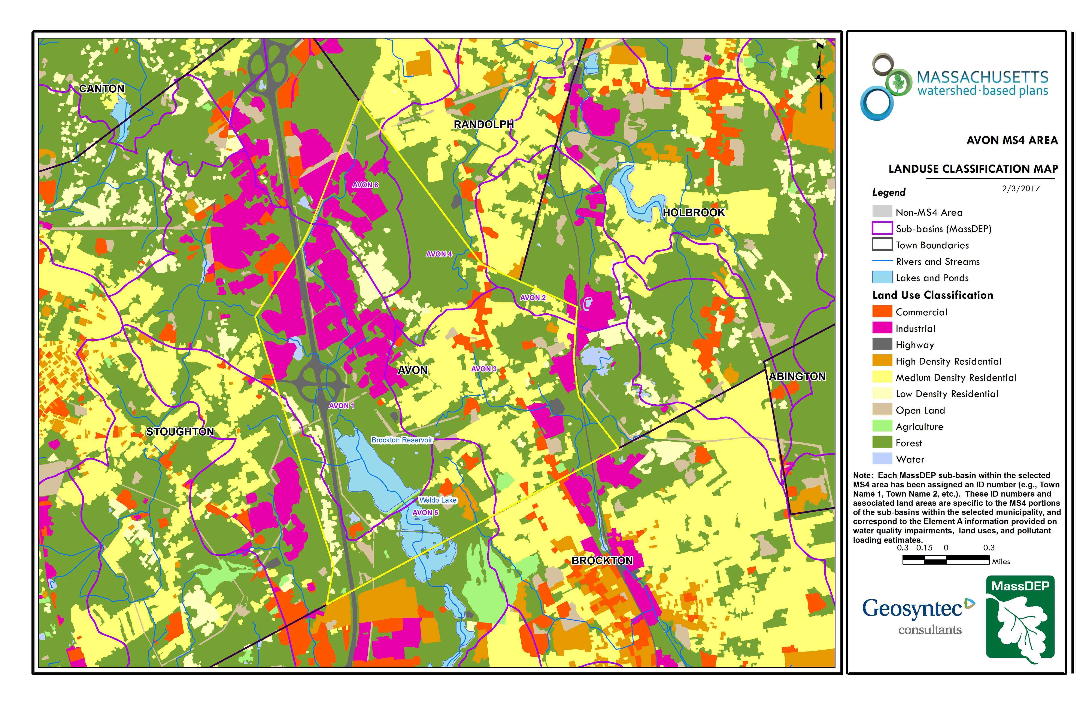
Figure A-2: Watershed Land Use Map
Avon Town Boundary
Approximate Watershed Boundary (Avon_03)
(MassGIS, 2007; MassGIS, 2009b; MassGIS, 1999; MassGIS, 2001; USGS, 2016)

Watershed Impervious Cover
There is a strong link between impervious land cover and stream water quality. Impervious cover includes land surfaces that prevent the infiltration of water into the ground, such as paved roads and parking lots, roofs, basketball courts, etc. Impervious area within the watershed of Trout Brook within the Town of Avon is distributed throughout the watershed, as illustrated in Figure A-8 below.
Impervious areas that are directly connected (DCIA) to receiving waters (via storm sewers, gutters, or other impervious drainage pathways) produce higher runoff volumes and transport stormwater pollutants with greater efficiency than disconnected impervious cover areas which are surrounded by vegetated, pervious land. Runoff volumes from disconnected impervious cover areas are reduced as stormwater infiltrates when it flows across adjacent pervious surfaces.
An estimate of DCIA for the watershed area was calculated based on the Sutherland equations. USEPA provides guidance (USEPA, 2010) on the use of the Sutherland equations to predict relative levels of connection and disconnection based on the type of stormwater infrastructure within the total impervious area (TIA) of a watershed. Within the watershed, the total area of each land use was summed and used to calculate the percent TIA (Table A-7).

Table A-7: TIA and DCIA Values for the Watershed
 | Estimated TIA (%) | Estimated DCIA (%)
Trout Brook Watershed | 25.9 | 17.4

The relationship between TIA and water quality can generally be categorized as listed by Table A-8 (Schueler et al. 2009). The TIA value for the watershed is 25.9%; therefore, Trout Brook can be expected to show fair to poor water quality.

Table A-8: Relationship between Total Impervious Area (TIA) and Water Quality (Schueler et al. 2009)
% Watershed  Impervious Cover | Stream Water Quality
0-10% | Typically high quality, and typified by stable channels, excellent habitat structure, good to excellent water quality, and diverse communities of both fish and aquatic insects.
11-25% | These streams show clear signs of degradation. Elevated storm flows begin to alter stream geometry, with evident erosion and channel widening. Streams banks become unstable, and physical stream habitat is degraded. Stream water quality shifts into the fair/good category during both storms and dry weather periods. Stream biodiversity declines to fair levels, with most sensitive fish and aquatic insects disappearing from the stream.
26-60% | These streams typically no longer support a diverse stream community. The stream channel becomes highly unstable, and many stream reaches experience severe widening, downcutting, and streambank erosion. Pool and riffle structure needed to sustain fish is diminished or eliminated and the substrate can no longer provide habitat for aquatic insects, or spawning areas for fish. Biological quality is typically poor, dominated by pollution tolerant insects and fish. Water quality is consistently rated as fair to poor, and water recreation is often no longer possible due to the presence of high bacteria levels.
>60% | These streams are typical of “urban drainage”, with most ecological functions greatly impaired or absent, and the stream channel primarily functioning as a conveyance for stormwater flows.

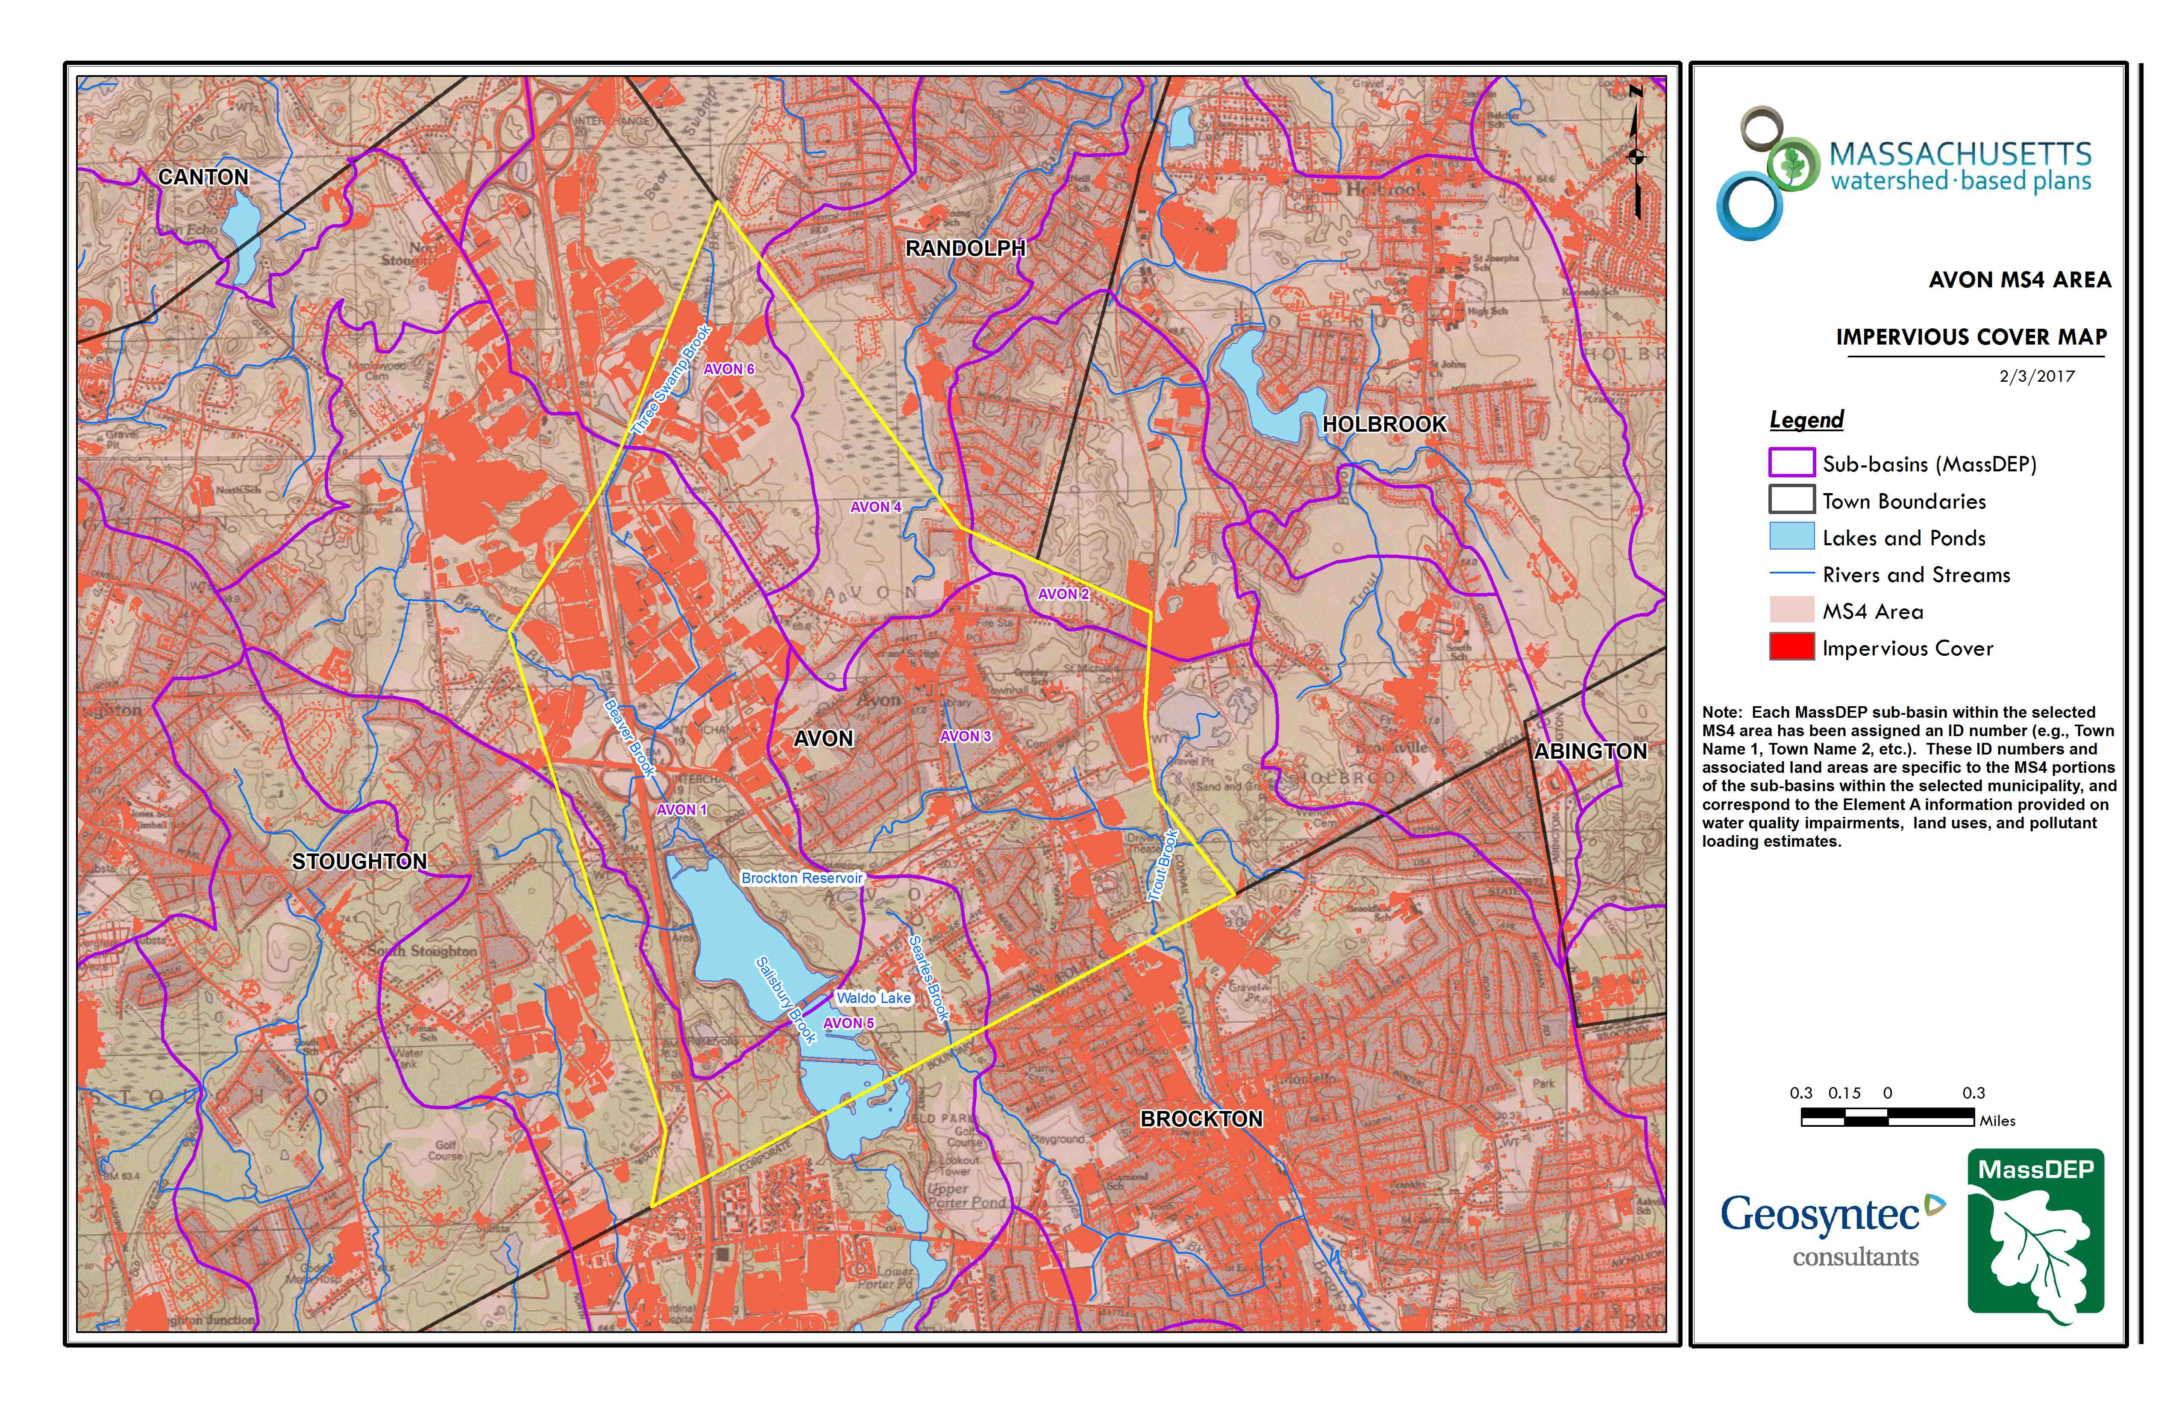
Figure A-3: Watershed Impervious Surface Map
Avon Town Boundary
Approximate Watershed Boundary (Avon_03)
(MassGIS, 2007; MassGIS 2009a; MassGIS, 1999; MassGIS, 2001; USGS, 2016)

Pollutant Loading
The land use data (MassGIS, 2009b) was intersected with impervious cover data (MassGIS, 2009a) and United States Department of Agriculture (USDA) Natural Resources Conservation Service (NRCS) soils data (USDA NRCS and MassGIS, 2012) to create a combined land use/land cover grid. The grid was used to sum the total area of each unique land use/land cover type.
The amount of DCIA was estimated using the Sutherland equations as described above and any reduction in impervious area due to disconnection (i.e., the area difference between TIA and DCIA) was assigned to the pervious D soil category for that land use to simulate that some infiltration will likely occur after runoff from disconnected impervious surfaces passes over pervious surfaces.
Pollutant loading for key nonpoint source pollutants in the watershed area was estimated by multiplying each land use/cover type area by its pollutant load export rate (PLER). The PLERs are an estimate of the annual total pollutant load exported via stormwater from a given unit area of a particular land cover type. The PLER values for TN, TP and TSS were obtained from USEPA (Voorhees, 2016b) (see documentation provided in Appendix B) as follows:
L_{n} = A_{n} * P_{n}
Where L_{n} = Loading of land use/cover type n (lb/yr); A_{n} = area of land use/cover type n (acres); P_{n} = pollutant load export rate of land use/cover type n (lb/acre/yr)

The estimated land use-based phosphorus to receiving waters within the watershed area is 420 pounds per year, as presented by Table A-9. The largest contributor of the land use-based phosphorus load originates from areas designated as residential (43% of the total phosphorus load) and commercial/industrial (37% of the total phosphorus load), indicating significant opportunity for phosphorus load reductions through BMP installation. Phosphorus generated from forested areas is a result of natural process such as decomposition of leaf litter and other organic material and generally represent a “best case scenario” with regards to phosphorus loading, meaning that those portions of the watershed are unlikely to provide opportunities for nutrient load reductions through best management practices. Forested areas contribute to 13% of the total phosphorus load to Trout Brook within the Town of Avon.
Table A-9: Estimated Pollutant Loading for Key Nonpoint Source Pollutants
Land Use Type | Pollutant Loading¹
 | Total  Phosphorus (TP)  (lbs/yr) | Total  Nitrogen (TN)  (lbs/yr) | Total  Suspended Solids (TSS)  (tons/yr)
Medium Density Residential | 176 | 1,529 | 21.08
Industrial | 80 | 682 | 8.54
Commercial | 74 | 638 | 7.98
Forest | 55 | 309 | 11.27
Open Land | 12 | 120 | 2.63
Agriculture | 10 | 69 | 1.74
Highway | 8 | 63 | 4.12
High Density Residential | 3 | 22 | 0.33
Low Density Residential | 3 | 25 | 0.35
TOTAL | 420 | 3,456 | 58.04
¹These estimates do not consider loads from point sources or septic systems.

Element B: Determine Pollutant Load Reductions Needed to Achieve Water Quality Goals
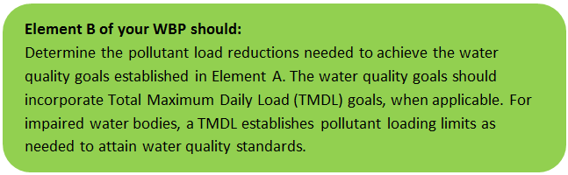

Estimated Pollutant Loads
Estimated pollutant loads for total phosphorus (TP) (420 lbs/yr), total nitrogen (TN) (3,456 lb/yr), and total suspended solids (TSS) (58 tons/yr) were previously presented in Element A of this WBP.

Water Quality Goals
There are many methodologies that can be used to set pollutant load reduction goals for a WBP. Goals can be based on water quality criteria, surface water standards, existing monitoring data, existing TMDL criteria, or other data. As discussed by Element A, water quality goals for this WBP are focused on addressing the Taunton River watershed TMDL and the assorted water quality impairments by focusing on reducing bacteria and nutrient loading to Trout Brook. A description of criteria for each water quality goal is described by Table B-1.
The following adaptive sequence is recommended to establish and track water quality goals.
- Establish a long-term bacteria reduction goal of 89 percent based on the Massachusetts Surface Water Quality Standards (MSWQS) (see Table B-1).
- Establish an interim goal to reduce land use-based phosphorus by 10 lbs/yr over the next 10 years (by 2029) within the watershed.
- Consider establishing realistic long-term phosphorus reduction goals by developing watershed load reduction targets specific to the Town of Avon. Element B of the Watershed Based Planning Tool provides guidance on how to calculate required phosphorus load reductions based on annual watershed discharge. For example, the tool calculates that phosphorus loading to the impaired segment of Trout Brook (from all surrounding Towns) is approximately 2,232 lbs/year and that a reduction of approximately 1,109 lbs/yr is required to consistently meet water quality goals of 50 µg/L for streams. The town of Avon’s estimated load for total phosphorus (TP) (420 lbs/yr) represents approximately 19% of the total load (2,232 lbs/yr) calculated for the Trout Brook watershed. Therefore, the town of Avon’s proportional required load reduction would be 211 lbs/yr out of the total 1,109 lbs/yr load reduction goal for the entire watershed. Future iterations of this plan will re-evaluate whether this long-term goal is appropriate after monitoring and additional BMP feasibility assessments are completed.
- Implement a water quality monitoring program in accordance with recommendations from Elements H&I. Use monitoring results to perform trend analysis to identify if proposed Element C management measures are resulting in improvements.
- Establish long-term goals to meet all applicable water quality standards, leading to the delisting of the segment of Trout Brook within the Town of Avon from the 303(d) list.

Table B-1: Pollutant Load Reductions Needed
Pollutant | Existing Estimated Total Load | Water Quality Goal | Planned Load Reduction
Total Phosphorus¹ | 420 lbs/yr | Total phosphorus should not exceed:  --50 ug/L in any stream  --25 ug/L within any pond, lake, or reservoir | 10 lbs/yr (interim goal)
Total Nitrogen | 3,456 lbs/yr | - | -
Total Suspended Solids | 58 ton/yr | - | -
Bacteria² | MSWQS for bacteria are concentration standards (e.g., colonies of fecal coliform bacteria per 100 ml), which are difficult to predict based on estimated annual loading. E. Coli samples collected by the MassDEP Southeast Regional Office on four occasions during the 2006 sampling season between 5/10/2006 and 8/15/2006 at Connelly Road had a geometric mean of 1189 colonies/100 mL. | Class B Standards  • Public Bathing Beaches: For E. coli, geometric mean of 5 most recent samples shall not exceed 126 colonies/ 100 ml and no single sample during the bathing season shall exceed 235 colonies/100 ml. For enterococci, geometric mean of 5 most recent samples shall not exceed 33 colonies/100 ml and no single sample during bathing season shall exceed 61 colonies/100 ml;  • Other Waters and Non-bathing Season at Bathing Beaches: For E. coli, geometric mean of samples from most recent 6 months shall not exceed 126 colonies/100 ml (typically based on min. 5 samples) and no single sample shall exceed 235 colonies/100 ml. For enterococci, geometric mean of samples from most recent 6 months shall not exceed 33 colonies/100 ml, and no single sample shall exceed 61 colonies/100 ml. | 89% - Concentration Based (TMDL)
Dissolved Oxygen³ | N/A – Concentration Based | Dissolved oxygen saturation should not be less than 5 mg/L in warm water fisheries or less than 6 mg/L in cold water fisheries. | Concentration Based
Notes:
- A default target TP concentrations is provided which is based on guidance provided by the USEPA in Quality Criteria for Water (1986), also known as the “Gold Book”.
- For all waterbodies, including impaired waters that have a pathogen TMDL, the water quality goal for bacteria is based on the Massachusetts Surface Water Quality Standards (314 CMR 4.00, 2013) that apply to the Water Class of the selected water body.
- Dissolved oxygen criteria are based on the Massachusetts Surface Water Quality Standards (314 CMR 4.00, 2013)

Element C: Describe management measures that will be implemented to achieve water quality goals
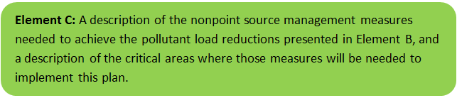

Ongoing Management Measures
The Town was awarded funding through the Fiscal Year 2019 Section 319 Nonpoint Source Pollution Grant Program to install the proposed structural BMPs listed in Table C-1 within the Trout Brook watershed. The planning-level cost estimates and pollutant load reduction estimates were based off information obtained from the Avon Town Hall Green Infrastructure Demonstration Project Section 319 Nonpoint Source Pollution Grant Program application (Town of Avon, 2018). It is anticipated that these BMPs will result in a combined annual load reduction of 0.9 lbs of phosphorus, 247 lbs of total suspended solids, 10.5 lbs of nitrogen, 6,012 billion fecal coliform colonies, 0.4 lbs of copper, 0.2 lbs of lead, and 1.2 lbs of zinc. Details of BMP designs to be installed at the Avon Town Hall parking lot are included in Appendix A.

Table C-1: Summary of Proposed BMP Pollutant Removal Estimates (Town of Avon, 2018)
Pollutant | Gravel Wetland | Tree Box Filters | Rain Garden | Total BMP Removal
Total Phosphorus (lb/yr) | 0.9 | 0.0 | 0.0 | 0.9
TSS (lb/yr) | 226.1 | 13.6 | 6.8 | 246.5
Total Nitrogen (lb/yr) | 9.9 | 0.0 | 0.5 | 10.4
Fecal Coliform (billion colonies/yr) | 6,011.7 | 0.0 | 0.0 | 6,011.7
Copper (lb/yr) | 0.4 | 0.0 | 0.0 | 0.4
Lead (lb/yr) | 0.2 | 0.0 | 0.0 | 0.2
Zinc (lb/yr) | 1.2 | 0.0 | 0.1 | 1.3

Future Management Measures
Once the proposed BMPs have been installed, Avon may consider additional investigation with the following recommended general sequence to identify and implement future structural BMPs.

Structural BMPs
- Identify Potential Implementation Locations: Perform a desktop analysis using aerial imagery and GIS data to develop a preliminary list of potentially feasible implementation locations based on soil type (i.e., hydrologic soil groups A and B); available public open space (e.g., lawn area in front of a police station); potential redevelopment sites where additional public-private partnerships may be leveraged; and other factors such as proximity to receiving waters, known problem areas, or publicly owned right of ways or easements. Additional analysis can also be performed to fine-tune locations to maximize pollutant removals such as performing loading analysis on specifically delineated subwatersheds draining to single outfalls and selecting those subwatersheds with the highest loading rates per acre.
- Visit Potential Implementation Locations: Perform field reconnaissance, preferably during a period of active runoff-producing rainfall, to evaluate potential implementation locations, gauge feasibility, and identify potential BMP ideas. During field reconnaissance, assess identified locations for space constraints, potential accessibility issues, presence of mature vegetation that may cause conflicts (e.g., roots), potential utility conflicts, site-specific drainage patterns, and other factors that may cause issues during design, construction, or long-term maintenance.
- Develop BMP Concepts: Once potential BMP locations are conceptualized, use the BMP-selector tool on the watershed-based planning tool to help develop concepts. Concepts can vary widely. One method is to develop 1-page fact sheets for each concept that includes a site description, including definition of the problem, a description of the proposed BMPs, annotated site photographs with conceptual BMP design details, and a discussion of potential conflicts such as property ownership, O&M requirements, and permitting constraints. The fact sheet can also include information obtained from the BMP-selector tool including cost estimates, load reduction estimates, and sizing information (i.e., BMP footprint, drainage area, etc.).
- Rank BMP Concepts: Once BMP concepts are developed, perform a priority ranking based on site-specific factors to identify the implementation order. Ranking can include many factors including cost, expected pollutant load reductions, implementation complexity, potential outreach opportunities and visibility to public, accessibility, expected operation and maintenance effort, and others.
Prioritized BMP concepts should focus on reducing total phosphorus and bacteria loading to Trout Brook, as summarized by the water quality goals (Element B).

Non-Structural BMPs
Planned BMPs can also be non-structural and can include practices such as street sweeping and catch basin cleaning to reduce TSS, TN, and TP loading; as well as Illicit Discharge Detection and Elimination (IDDE) to reduce bacteria concentrations. It is recommended that these municipal programs be evaluated and potentially optimized. First, it is recommended that potential removals from ongoing activities be calculated in accordance with Element HI. Next, it is recommended that ongoing activities be evaluated to see if potential improvements can be implemented to achieve higher pollutant load reductions such as increased frequency or improved technology. For example, by implementing microbial source tracking protocols to track and eliminate bacteria sources at key outfalls to Trout Brook.

Element D: Identify Technical and Financial Assistance Needed to Implement Plan
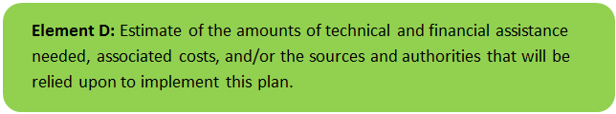

Current and Ongoing Management Measures
The funding needed to implement the proposed management measures presented in this watershed plan is based on estimates from the Avon Town Hall Green Infrastructure Demonstration Project Section 319 Nonpoint Source Pollution Grant Program application (Town of Avon, 2018). The total costs including construction of the structural BMPs, operation and maintenance manual, and information/education measures is estimated at approximately $129,345, as detailed by Table D-1. Additionally, annual operation and maintenance costs were estimated, based on best professional judgment, to be two percent of the BMP construction cost (i.e., approximately $1,400/year.
Table D-1: Summary of Proposed BMP Costs
Task/Objective | Cost
Town Employee Labor | $11,095
Design and Permitting | $32,105
Operation and Maintenance Manual | $4,205
Construction | $70,010
Project Management and Reporting | 2,580
Education and Outreach | $9,350
Total | $129,345

Future Management Measures
Funding for future BMP installations to further reduce loads within the watershed may be provided by a variety of sources, such as the Section 319 Nonpoint Source Pollution Grant Program, town capital funds, or other grant programs such as hazard mitigation funding. The Town of Avon has previously been successful with and will continue to pursue securing grant funding through the USEPA and NEIWPCC Southeast New England Program for Coastal Watershed Restoration Grants and the MassDEP Water Infrastructure Planning and Technical Assistance Grant Program. Guidance is available to provide additional information on potential funding sources for nonpoint source pollution reduction efforts.

Element E: Public Information and Education
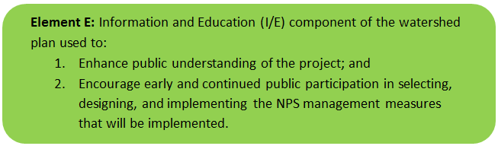

Step 1: Goals and Objectives
The goals and objectives for the watershed information and education program.
- Provide information about proposed stormwater improvements and their anticipated water quality benefits.
- Provide information to promote watershed stewardship through outreach products listed in Step 3 below.
Step 2: Target Audience
Target audiences that need to be reached to meet the goals and objectives identified above.
- All watershed residents (particularly pet owners).
- Businesses within the watershed.
- Watershed organizations and other user groups.
Step 3: Outreach Products and Distribution
The outreach product(s) and distribution form(s) that will be used for each.
- Develop and post informational signs at proposed the BMP location.
- Post information on the project on the Town website and distribute the information in the Town quarterly newsletter that includes information on BMPs that can be implemented on private property.
- Develop an educational poster to be displayed at Town Hall and other public locations (e.g., schools, library, etc.).
- Host three tours of the installed BMPs, following construction.
- Install pet waste disposal stations and distribute pet waste bags and educational flyers on the proper disposal of pet waste.
Step 4: Evaluate Information/Education Program
Information and education efforts and how they will be evaluated.
- Track and record website activity and the number of newsletters and flyers distributed.
- Track number of locations used to display the educational poster.
- Record attendance levels at the BMP tours.
- Track number of pet waste bags distributed from pet waste disposal stations.
Additional outreach products will be determined when future management measures and activities are planned for implementation in the watershed. This section of the WBP will be updated when the plan is re-evaluated in 2022 in accordance with Element F&G.

Elements F & G: Implementation Schedule and Measurable Milestones
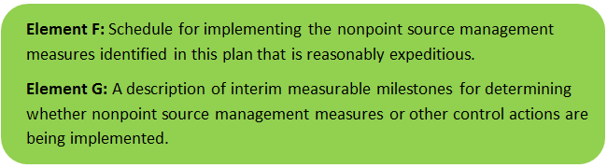

Table FG-1 provides a preliminary schedule for implementation of recommendations provided by this WBP. It is expected that the WBP will be re-evaluated and updated at least once every six years, or as needed, based on ongoing monitoring results and other ongoing efforts. Effort towards these milestones is expected to be dependent on available funding and community interest.
Table FG-1: Implementation Schedule and Interim Measurable Milestones
Category | Action | Year(s)
Monitoring / Vegetation | Perform annual water quality sampling per Element H&I monitoring guidance | Annual
Structural BMPs | Complete installation of BMPs at Town Hall | 2020
 | Obtain funding and implement 2-3 additional BMPs within the Trout Brook watershed | 2027
 | Obtain funding and implement 2-3 additional BMPs within the Trout Brook watershed | 2032
 | Obtain funding and implement 2-3 additional BMPs within the Trout Brook watershed | 2037
Nonstructural BMPs | Document potential pollutant removals from ongoing non-structural BMP practices (i.e., street sweeping, catch basin cleaning) | 2021
 | Evaluate ongoing non-structural BMP practices and determine if modifications can be made to optimize pollutant removals (e.g., increase frequency). | 2022
 | Routinely implement optimized non-structural BMP practices | Annual
Public Education and Outreach  (See Element E) | Distribute project information on the Town website and quarterly newsletter | 2020
 | Develop and post informational signs at proposed BMP locations and conduct BMP tours | 2020
 | Develop a poster on stormwater management and display in public locations | 2020
Adaptive Management  and Plan Updates | Establish working group comprised of stakeholders and other interested parties to implement recommendations and track progress. Meet at least twice per year. | 2021
 | Re-evaluate Watershed Based Plan at least once every six (6) years and adjust, as needed, based on ongoing efforts (e.g., based on monitoring results, 319 funding, etc.). – Next update, December 2025 | 2022
 | Reach interim goal to reduce land-based phosphorus by 10 pounds | 2029
 | Establish additional long-term reduction goal(s) from baseline monitoring results, if needed | 2029
 | Reach long-term goal to de-list the segment of Trout Brook within Avon from the 303(d) list

Elements H & I: Progress Evaluation Criteria and Monitoring
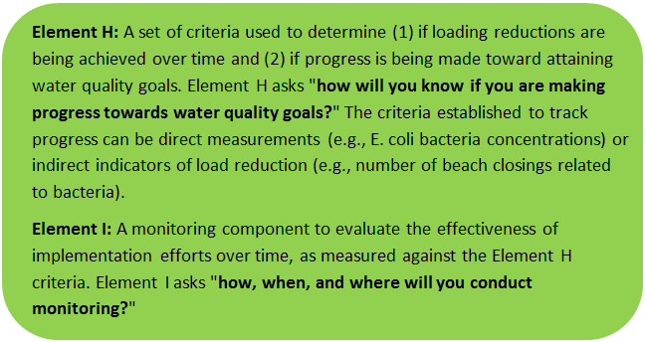 | 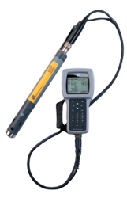

The water quality target concentration(s) is presented under Element A of this plan. To achieve this target concentration, the annual loading must be reduced to the amount described in Element B. Element C of this plan describes the various management measures that will be implemented to achieve this targeted load reduction. The evaluation criteria and monitoring program described will be used to measure the effectiveness of the proposed management measures (described in Element C) in improving the water quality of Trout Brook.

Indirect Indicators of Load Reduction

Non-Structural BMPs
Potential load reductions from non-structural BMPs (i.e., street sweeping and catch basin cleaning) can be estimated from indirect indicators, such as the number of miles of streets swept or the number of catch basins cleaned. Appendix F of the 2016 Massachusetts Small MS4 General Permit provides specific guidance for calculating phosphorus removal from these practices. As indicated by Element C, it is recommended that potential phosphorus removal from these ongoing actives be estimated. Next, it is recommended that ongoing activities be evaluated to see if potential improvements can be implemented to achieve higher pollutant load reductions such as increased frequency or improved technology.
Phosphorus load reductions can be estimated in accordance with Appendix F of the 2016 Massachusetts Small MS4 General Permit as summarized by Figure HI-1 and HI-2. Additionally, since there is a bacteria TMDL applicable to the study area, it is recommended that IDDE efforts required by the NPDES Small MS4 Permit be tracked.
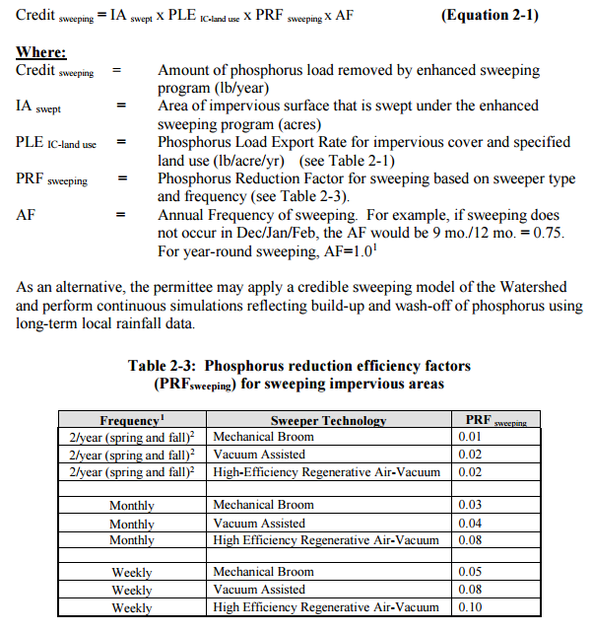
Figure HI-1. Street Sweeping Calculation Methodology
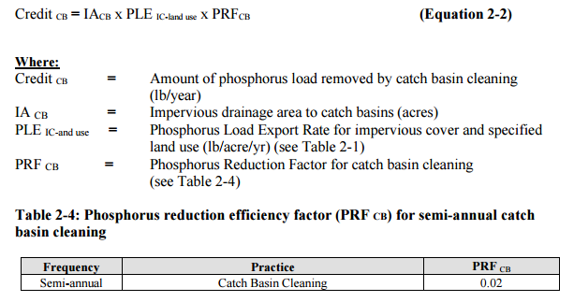
Figure HI-2. Catch Basin Cleaning Calculation Methodology

Project-Specific Indicators

Number of BMPs Installed and Pollutant Reduction Estimates:
Anticipated pollutant load reductions from existing, ongoing (i.e., under construction), and future BMPs will be tracked as BMPs are installed. For example, once ongoing BMPs are installed, the anticipated phosphorus load reduction is estimated to be 0.9 pounds per year.

TMDL Criteria
TMDL requirements encourage ongoing monitoring to assess progress towards the TMDL’s water quality goals, particularly in areas with minimal available water quality data and in areas where BMPs have been installed. The TMDL indicates monitoring data should be used to add/remove/modify BMPs as needed to improve water quality.

Direct Measurements
Direct measurements are generally expected to be performed as described below. Prior to implementing a direct measurement program, an abbreviated QAPP and/or Standard Operating Procedures (SOPs) will be established to flesh out details of the program and establish best practices for sample collection and analysis. Water quality monitoring may be performed through a volunteer training program to save on costs in accordance with established practices for MassDEP’s environmental monitoring for volunteers.

River Sampling
Establish regular sampling to meet TMDL recommendations including analysis of phosphorus, fecal coliform, dissolved oxygen, turbidity, and total suspended solids in Trout Brook. Additional parameters such as temperature, conductivity, pH, and flow rate could provide additional data for consideration. Monitoring locations will be selected based on accessibility and representativeness and shall be appropriate to quantify water quality improvements in the watershed.

Outfall Screening
Implement an outfall screening program to compare water quality screening criteria before and after implementation of BMPs. Parameters for screening would include fecal coliform, E. coli, biochemical oxygen demand, TSS, salinity, dissolved oxygen, pH, chlorine, and nutrients. Monitoring of water quality from the Town’s water supply wells may also provide useful data for comparison.

Adaptive Management
As discussed by Element B, the baseline monitoring program will be used to establish a long-term (i.e., 10 year) phosphorus load reduction goal (or other parameter(s) depending on results). Long-term goals will be re-evaluated at least once every three years and adaptively adjusted based on additional monitoring results and other indirect indicators. If monitoring results and indirect indicators do not show improvement to the total phosphorus concentrations and other indicators (e.g., dissolved oxygen) measured within the watershed, the management measures and loading reduction analysis (Elements A through D) will be revisited and modified accordingly.

References
314 CMR 4.00 (2013). "Division of Water Pollution Control, Massachusetts Surface Water Quality Standards"
Cohen, A. J.; Randall, A.D. (1998). "Mean annual runoff, precipitation, and evapotranspiration in the glaciated northeastern United States, 1951-80." Prepared for United States Geological Survey, Reston VA.
Geosyntec Consultants, Inc. (2014). "Least Cost Mix of BMPs Analysis, Evaluation of Stormwater Standards Contract No. EP-C-08-002, Task Order 2010-12." Prepared for Jesse W. Pritts, Task Order Manager, U.S. Environmental Protection Agency
Geosyntec Consultants, Inc. (2015). "Appendix B: Pollutant Load Modeling Report, Water Integration for the Squamscott-Exeter (WISE) River Watershed."
King, D. and Hagan, P. (2011). "Costs of Stormwater Management Practices in Maryland Counties." University of Maryland Center for Environmental Science Chesapeake Biological Laboratory. October 11, 2011.
Leisenring, M., Clary, J., and Hobson, P. (2014). "International Stormwater Best Management Practices (BMP) Database Pollutant Category Statistical Summary Report: Solids, Bacteria, Nutrients and Metals." Geosyntec Consultants, Inc. and Wright Water Engineers, Inc. December 2014.
MassDEP (2005). "Taunton River Watershed 2001 Water Quality Assessment Report "
MassDEP, USEPA, ENSR International (2011). “Final Pathogen TMDL for the Taunton River Watershed”
MassDEP (2012). "Massachusetts Year 2012 Integrated List of Waters Final Listing of Massachusetts' Waters Pursuant to Sections 305(b), 314 and 303(d) of the Clean Water Act"
MassDEP (2016a). "Massachusetts Clean Water Toolkit"
MassDEP (2016b). "Massachusetts Stormwater Handbook, Vol. 2, Ch. 2, Stormwater Best Management Practices"
MassGIS (1999). "Networked Hydro Centerlines" Shapefile
MassGIS (2001). "USGS Topographic Quadrangle Images" Image
MassGIS (2007). "Drainage Sub-basins" Shapefile
MassGIS (2009a). "Impervious Surface" Image
MassGIS (2009b). "Land Use (2005)" Shapefile
MassGIS (2013). "MassDEP 2012 Integrated List of Waters (305(b)/303(d))" Shapefile
Schueler, T.R., Fraley-McNeal, L, and K. Cappiella (2009). "Is impervious cover still important? Review of recent research" Journal of Hydrologic Engineering 14 (4): 309-315.
Town of Avon (2018). “Avon Town Hall Green Infrastructure Demonstration Project.”
Town of Avon (2016). “Stormwater Asset Management – Water Infrastructure Planning and Technical Assistance Grant.”
United States Bureau of Labor Statistics (2016). "Consumer Price Index"
United States Geological Survey (2016). "National Hydrography Dataset, High Resolution Shapefile"
University of Massachusetts, Amherst (2004). "Stormwater Technologies Clearinghouse"
USDA NRCS and MassGIS (2012). "NRCS SSURGO-Certified Soils" Shapefile
USEPA (1986). "Quality Criteria for Water (Gold Book)" EPA 440/5-86-001. Office of Water, Regulations and Standards. Washington, D.C.
USEPA (1999). “Preliminary Data Summary of Urban Storm Water Best Management Practices.”
USEPA (2010). "EPA's Methodology to Calculate Baseline Estimates of Impervious Area (IA) and Directly Connected Impervious Area (DCIA) for Massachusetts Communities."
USEPA. (2015). “Preventing Eutrophication: Scientific Support for Dual Nutrient Criteria.”
Voorhees, Mark, USEPA. (2015). "FW: Description of additional modelling work for Opti-Tool Project" Message to Chad Yaindl, Geosyntec Consultants. 23 April 2015. E-mail.
Voorhees, Mark, USEPA. (2016a). "FW: EPA Region 1 SW BMP performance equations" Message to Chad Yaindl, Geosyntec Consultants. 25 January 2016. E-mail.
Voorhees, Mark, USEPA. (2016b). "FW: Description of additional modelling work for Opti-Tool Project" Message to Chad Yaindl, Geosyntec Consultants. 23 April 2015. E-mail.

Appendices

Appendix A – BMP Conceptual Design Details
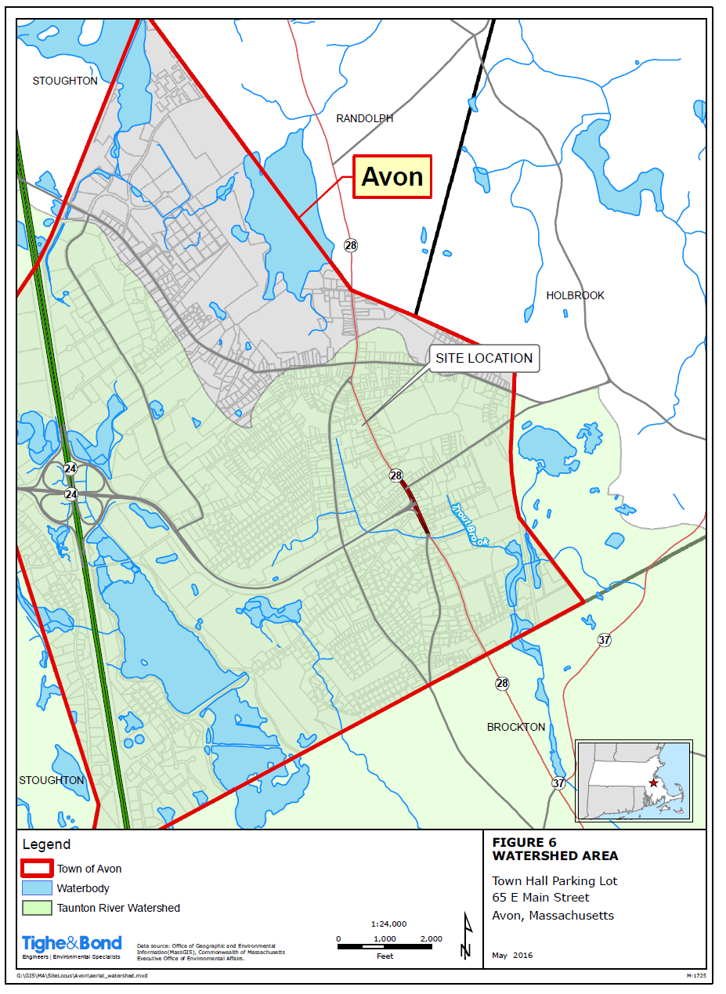
Site Locus (Town of Avon, 2018)

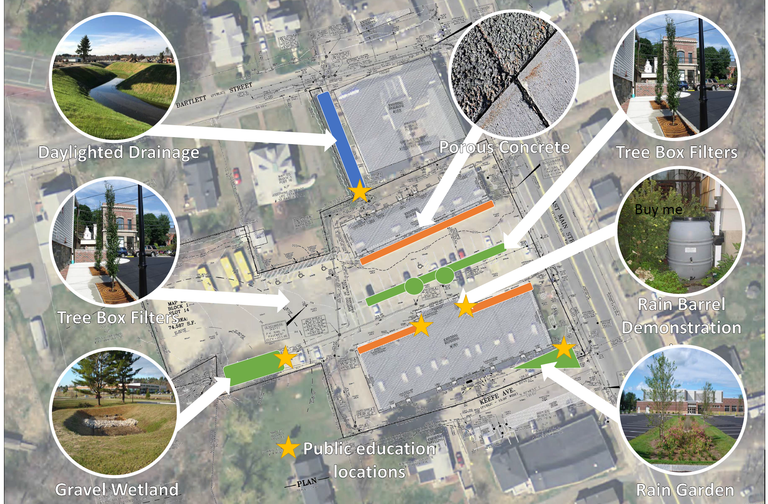
Conceptual BMP Design (Town of Avon, 2018)

Appendix B – Pollutant Load Export Rates (PLERs)

Land Use & Cover¹ | PLERs (lb/acre/year)
 | (TP) | (TSS) | (TN)
AGRICULTURE, HSG A | 0.45 | 7.14 | 2.59
AGRICULTURE, HSG B | 0.45 | 29.4 | 2.59
AGRICULTURE, HSG C | 0.45 | 59.8 | 2.59
AGRICULTURE, HSG D | 0.45 | 91.0 | 2.59
AGRICULTURE, IMPERVIOUS | 1.52 | 650 | 11.3
COMMERCIAL, HSG A | 0.03 | 7.14 | 0.27
COMMERCIAL, HSG B | 0.12 | 29.4 | 1.16
COMMERCIAL, HSG C | 0.21 | 59.8 | 2.41
COMMERCIAL, HSG D | 0.37 | 91.0 | 3.66
COMMERCIAL, IMPERVIOUS | 1.78 | 377 | 15.1
FOREST, HSG A | 0.12 | 7.14 | 0.54
FOREST, HSG B | 0.12 | 29.4 | 0.54
FOREST, HSG C | 0.12 | 59.8 | 0.54
FOREST, HSG D | 0.12 | 91.0 | 0.54
FOREST, HSG IMPERVIOUS | 1.52 | 650 | 11.3
HIGH DENSITY RESIDENTIAL, HSG A | 0.03 | 7.14 | 0.27
HIGH DENSITY RESIDENTIAL, HSG B | 0.12 | 29.4 | 1.16
HIGH DENSITY RESIDENTIAL, HSG C | 0.21 | 59.8 | 2.41
HIGH DENSITY RESIDENTIAL, HSG D | 0.37 | 91.0 | 3.66
HIGH DENSITY RESIDENTIAL, IMPERVIOUS | 2.32 | 439 | 14.1
HIGHWAY, HSG A | 0.03 | 7.14 | 0.27
HIGHWAY, HSG B | 0.12 | 29.4 | 1.16
HIGHWAY, HSG C | 0.21 | 59.8 | 2.41
HIGHWAY, HSG D | 0.37 | 91.0 | 3.66
HIGHWAY, IMPERVIOUS | 1.34 | 1,480 | 10.2
INDUSTRIAL, HSG A | 0.03 | 7.14 | 0.27
INDUSTRIAL, HSG B | 0.12 | 29.4 | 1.16
INDUSTRIAL, HSG C | 0.21 | 59.8 | 2.41
INDUSTRIAL, HSG D | 0.37 | 91.0 | 3.66
INDUSTRIAL, IMPERVIOUS | 1.78 | 377 | 15.1
LOW DENSITY RESIDENTIAL, HSG A | 0.03 | 7.14 | 0.27
LOW DENSITY RESIDENTIAL, HSG B | 0.12 | 29.4 | 1.16
LOW DENSITY RESIDENTIAL, HSG C | 0.21 | 59.8 | 2.41
LOW DENSITY RESIDENTIAL, HSG D | 0.37 | 91.0 | 3.66
LOW DENSITY RESIDENTIAL, IMPERVIOUS | 1.52 | 439 | 14.1
MEDIUM DENSITY RESIDENTIAL, HSG A | 0.03 | 7.14 | 0.27
MEDIUM DENSITY RESIDENTIAL, HSG B | 0.12 | 29.4 | 1.16
MEDIUM DENSITY RESIDENTIAL, HSG C | 0.21 | 59.8 | 2.41
MEDIUM DENSITY RESIDENTIAL, HSG D | 0.37 | 91.0 | 3.66
MEDIUM DENSITY RESIDENTIAL, IMPERVIOUS | 1.96 | 439 | 14.1
OPEN LAND, HSG A | 0.12 | 7.14 | 0.27
OPEN LAND, HSG B | 0.12 | 29.4 | 1.16
OPEN LAND, HSG C | 0.12 | 59.8 | 2.41
OPEN LAND, HSG D | 0.12 | 91.0 | 3.66
OPEN LAND, IMPERVIOUS | 1.52 | 650 | 11.3
¹HSG = Hydrologic Soil Group

MS4 subwatersheds are defined by the WBP-tool by intersecting MassGIS drainage sub-basins with regulated MS4 areas.
Guidance on funding sources to address nonpoint source pollution: http://prj.geosyntec.com/prjMADEPWBP_Files/Guide/Element%20D%20-%20Funds%20and%20Resources%20Guide.pdf
Note that goals and milestones of this WBP are intended to be adaptable and flexible. Goals and milestones are not intended to be tied to Municipal Separate Storm Sewer (MS4) permit requirements. Stakeholders will perform tasks contingent on available resources and funding.
Additional guidance is provided at: https://www.epa.gov/sites/production/files/2015-06/documents/stream.pdf and https://www.mass.gov/guides/water-quality-monitoring-for-volunteers#2

