WATERSHED-BASED PLAN
Lake Mansfield
Great Barrington, MA

December 5, 2018

Prepared By:
Great Barrington Planning Department
Lake Mansfield Alliance
Lake Mansfield Improvement Task Force
Geosyntec Consultants, Inc.

Prepared For:

Contents
Executive Summary 1
Introduction 3
What is a Watershed-Based Plan? 3
Purpose & Need 3
Watershed-Based Plan Outline 3
Project Partners and Stakeholder Input 4
Data Sources 4
Summary of Past and Ongoing Work 5
Element A: Identify Causes of Impairment & Pollution Sources 8
General Watershed Information 8
MassDEP Water Quality Assessment Report and TMDL Review 10
Additional Water Quality Data 10
Water Quality Impairments 12
Water Quality Goals 13
Land Use Information 14
Pollutant Loading 19
Element B: Determine Pollutant Load Reductions Needed to Achieve Water Quality Goals 21
Estimated Pollutant Loads 21
Water Quality Goals 21
Recommended Load Reduction 22
Element C: Describe management measures that will be implemented to achieve water quality goals 24
Field Watershed Investigation 24
Element D: Identify Technical and Financial Assistance Needed to Implement Plan 26
Element E: Public Information and Education 28
Elements F & G: Implementation Schedule and Measurable Milestones 30
Elements H & I: Progress Evaluation Criteria and Monitoring 31
Indirect Indicators of Load Reduction 31
Project-Specific Indicators 31
Direct Measurements 32
Adaptive Management 34
References 35

Appendix A – Pollutant Load Export Rates (PLERs)
Appendix B – BMP Opportunity Sites

Executive Summary
Introduction: The purpose of a Massachusetts Watershed-Based Plan (WBP) is to organize information about Massachusetts' watersheds, and present it in a format that will enhance the development and implementation of projects that will restore water quality and beneficial uses in the Commonwealth. The Massachusetts WBP follows USEPA's recommended format for “nine-element” watershed plans. This WBP was developed by Geosyntec Consultants (Geosyntec) under the direction of the Great Barrington Planning Department with funding, input, and collaboration with the Massachusetts Department of Environmental Protection (MassDEP).
Lake Mansfield (a.k.a. Mansfield Pond) is a 28-acre Great Pond located in the Town of Great Barrington, MA. The approximate 164-acre drainage area of Lake Mansfield is part of the greater Housatonic watershed and is entirely located within the Town of Great Barrington. The lake is located within walking distance of downtown and used as a scenic and recreation resource by the community. It includes a swimming beach, boat launch, adjacent conservation area, and hiking trails.
Impairments and Pollution Sources: Lake Mansfield is an impaired waterbody listed under Category 4C on the Massachusetts 303(d) List of Integrated Waters for non-native (invasive) aquatic macrophytes. Invasive plants have in the past grown to dominate the lake and choke off opportunities for summer recreation, including swimming, boating, and fishing. This growth occurred throughout the 1980s and 1990s and increased again in the 2000s. A 2012 weed assessment commissioned by the Town’s Conservation Commission indicated that these invasives are still present in 17 of 22 sampling stations across the lake. Water quality monitoring data from 1990 indicates that the lake experienced elevated phosphorus concentrations indicative of eutrophic conditions in the early 1990s. Additional monitoring performed in 2004 suggests that phosphorous release from bottom sediments is also a concern. More recent monitoring was performed in 2016 which suggests a decline in phosphorus levels; however, it is unclear if sampling results were reliable.
Past studies and photographic records demonstrate that nonpoint source pollution, delivering sediment and nutrients to the lake, is the primary pollutant of the lake. Sediment is filling in sensitive areas along the shorelines and encouraging the growth of invasives and nuisance plants. Sediment loading and the addition of nutrients through nonpoint source pollution are accelerating the eutrophication of the lake, also leading to nuisance plants and algae. The sedimentation of the lake is making the already shallow lake even shallower along the edges, thereby increasing water temperature and encouraging weed growth. The decreasing lake depth is also displacing water into a larger surface area, leading to increased erosion of the eastern buffer zone along the roadway.
The major sources of the nonpoint pollution of the lake are stormwater runoff from Knob Hill and the boat launch area at the southern end of the lake, from the parking area and beach at the northern end of the lake, and runoff from Lake Mansfield Road that borders the easterly side of the lake. Until the completion of a previous 319 project in 2013, runoff from upper Castle Hill Avenue was also a major nonpoint source. Evaluation and water quality studies since its completion have shown that project to be very effective at reducing sedimentation of the lake, removing 30 tons of runoff sediment annually.
Goals, Management Measures, and Funding: The primary goal of this WBP is to reduce runoff in order to improve water quality and ultimately remove the lake from the 303(d) list. This will be accomplished primarily through the installation of structural BMPs to capture runoff and the implementation of non-structural BMPs, including watershed education. These BMPs will reduce the sedimentation and nutrient loading that are the primary factors for non-native aquatic macrophyte growth in the lake.
For over a decade, the Town of Great Barrington has undertaken a methodical approach to improving the health and water quality of Lake Mansfield, in order to preserve this unique scenic and recreation resource within walking distance of downtown. Past efforts have included biological controls (weevils) and bottom barriers to mitigate weeds and directly address the listed impairment as well as implementation of structural BMPs to reduce sedimentation and delivery of other nonpoint source pollutants to the lake. Additional BMPs are proposed as part of this WBP that address remaining major source areas of nonpoint source pollution in the watershed.
It is expected that funding for management measures will be obtained from a variety of sources including Section 319 Grant Funding, Town Capital Funds, Volunteer efforts, and other sources.
Public Education and Outreach: Outreach and education will build on recent efforts to educate the watershed and general public about nonpoint source pollution and invasive weeds, with the goal of ensuring continued improvements in water quality and environmental stewardship. Recent efforts include but are not limited to: annual lake cleanup day, annual newsletter, kiosks with information signage, catch basin stenciling to discourage dumping, and dog waste stations. Future efforts will include implementation of informational signage on completed structural BMPs and periodic website updates, including posting this completed WBP.
Implementation Schedule and Evaluation Criteria: Project activities will be implemented categorically based on monitoring, implementation of structural BMPs, public education and outreach activities, and periodic updates to the WBP. It is expected that an annual water quality sampling and aquatic vegetation monitoring program will be established to enable direct evaluation of improvements over time. Results from the water quality sampling program will also be used to establish concrete long-term load reduction goals. It is expected that up to nine BMPs outlined by this plan will be designed and constructed by the year 2024 contingent upon funding availability. The overall goal of this WBP is to de-list the watershed from the 303(d) list by 2029. The WBP will be re-evaluated and adjusted, as needed, once every three years.

Introduction

What is a Watershed-Based Plan?

Purpose & Need
The purpose of a Massachusetts Watershed-Based Plan (WBP) is to organize information about Massachusetts' watersheds, and present it in a format that will enhance the development and implementation of projects that will restore water quality and beneficial uses in the Commonwealth. The Massachusetts WBP follows USEPA's recommended format for “nine-element” watershed plans, as described below.
All states are required to develop WBPs, but not all states have taken the same approach. Most states develop watershed-based plans only for selected watersheds. MassDEP's approach has been to develop a tool to support statewide development of WBPs, so that good projects in all areas of the state may be eligible for federal watershed implementation grant funds under Section 319 of the Clean Water Act.
USEPA guidelines promote the use of Section 319 funding for developing and implementing WBPs. WBPs are required for all projects implemented with Section 319 funds, and are recommended for all watershed projects, whether they are designed to protect unimpaired waters, restore impaired waters, or both.

Watershed-Based Plan Outline
This WBP for the Lake Mansfield (a.k.a. Mansfield Pond) Watershed includes nine elements (a through i) in accordance with USEPA Guidelines:
- An identification of the causes and sources or groups of similar sources that will need to be controlled to achieve the load reductions estimated in this watershed-based plan (and to achieve any other watershed goals identified in the watershed-based plan), as discussed in item (b) immediately below.
- An estimate of the load reductions expected for the management measures described under paragraph (c) below (recognizing the natural variability and the difficulty in precisely predicting the performance of management measures over time).
- A description of the nonpoint source (NPS) management measures needed to achieve the load reductions estimated under paragraph (b) above (as well as to achieve other watershed goals identified in this watershed-based plan), and an identification (using a map or a description) of the critical areas in which those measures will be needed to implement this plan.
- An estimate of the amounts of technical and financial assistance needed, associated costs, and/or the sources and authorities that will be relied upon, to implement this plan. As sources of funding, States should consider the use of their Section 319 programs, State Revolving Funds, USDA's Environmental Quality Incentives Program and Conservation Reserve Program, and other relevant Federal, State, local and private funds that may be available to assist in implementing this plan.
- An information/education component that will be used to enhance public understanding of the project and encourage their early and continued participation in selecting, designing, and implementing the NPS management measures that will be implemented.
- A schedule for implementing the NPS management measures identified in this plan that is reasonably expeditious.
- A description of interim, measurable milestones for determining whether NPS management measures or other control actions are being implemented.
- A set of criteria to determine if loading reductions are being achieved over time and substantial progress is being made towards attaining water quality standards and, if not, the criteria for determining whether this watershed-based plan needs to be revised or, if a NPS Total Maximum Daily Load (TMDL) has been established, whether the TMDL needs to be revised.
- A monitoring component to evaluate the effectiveness of the implementation efforts over time, measured against the criteria established under item (h) immediately above.

Project Partners and Stakeholder Input
This WBP was developed by Geosyntec Consultants (Geosyntec) under the direction of the Great Barrington Planning Department with funding, input, and collaboration with the Massachusetts Department of Environmental Protection (MassDEP). This WBP was developed using funds from the Section 319 program to assist grantees in developing technically robust WBPs using MassDEP’s Watershed-Based Planning Tool. Great Barrington was a recipient of Section 319 funding in Fiscal Year 2018.
Core project stakeholders included:
- Chris Rembold, Town Planner – Great Barrington Planning Department, Lake Mansfield Improvement Task Force
- Christine Ward – Lake Mansfield Alliance, Lake Mansfield Improvement Task Force
- Jane Peirce – MassDEP
This WBP was developed as part of an iterative process. The Geosyntec project team initially collected and reviewed existing data from the Town of Great Barrington, then performed a field investigation to visit the Lake Mansfield watershed and identify potential opportunities for improvements. This information was used to develop a preliminary WBP for review by core project stakeholders. A core stakeholder conference call was then held to solicit input and gain consensus on elements included in the plan (e.g., water quality goals, public outreach activities, etc.). The preliminary WBP was then reviewed by members of the Lake Mansfield Improvement Task Force and finalized based on their input.

Data Sources
This WBP was developed using the framework and data sources provided by MassDEP’s Watershed-Based Plan Tool and supplemented by data from additional studies and a field watershed investigation. Supplemental data sources were reviewed and are included in subsequent sections of this WBP, if relevant. Supplemental data sources are listed in Table 1.
Table 1: Supplemental Data Sources
Title / Description | Source | Date
A Diagnostic Feasibility Study for the Management of Mansfield Lake, Great Barrington, Massachusetts | Baystate Environmental Consultants, Inc. | 4/1990
Lake Mansfield Aquatic Vegetation Survey and Milfoil Weevil Assessment | Geosyntec Consultants, Inc. | 7/2005
Project Final Report, Castle Hill Avenue Storm Drainage Improvements 11-05/319 | Town of Great Barrington | 2011-2014
Knob Hill Stormwater Planning, Lake Mansfield, Great Barrington, Massachusetts, Final Report | Town of Great Barrington | 3/2012
Lake Mansfield 2012 Aquatic Vegetation Survey | Geosyntec Consultants, Inc. | 9/13/2012
Draft - Lake Mansfield Road Study, Town of Great Barrington, MA | Tighe & Bond | 9/5/2013
Planning for the Future: Lake Mansfield Road  (PowerPoint Presentation) | Lake Mansfield Improvement Task Force | 9/29/2014
MET Lake Mansfield Water Quality Monitoring Project, Final Report | Berkshire Environmental Research Center, Bard College at Simon's Rock | 6/8/2016
Town of Great Barrington, Lake Mansfield Recreation Area Improvements | Kyle Zick Landscape Architecture, Inc. (KZLA) | 6/17/2016
Knob Hill Stormwater Improvements, RFR# BRP-RFR-2017-06-319 | Town of Great Barrington | 3/31/2017
Lake Mansfield Cartop Access Facility (Permitted Plan) | Commonwealth of Massachusetts Department of Fish & Game Office of Fishing & Boating Access | 4/10/2018
Knob Hill Road Drainage Improvements, Knob Hill, Great Barrington, MA (Plans for Bid Package) | Foresight Land Services | 8/8/2018
Town of Great Barrington, MA, Lake Mansfield Road Area Improvements (Preliminary Design Set) | Woodard and Curran | 8/2018

Summary of Past and Ongoing Work
For over a decade, the Town of Great Barrington has undertaken a methodical, step-by-step approach to improving the health and water quality of Lake Mansfield, in order to preserve this unique scenic and recreation resource within walking distance of downtown. A summary of past projects is listed below.
Project Final Report, Castle Hill Avenue Storm Drainage Improvements 11-05/319 (Town of Great Barrington, 2011-2014)
The “Castle Hill Avenue Storm Drainage Improvements” Section 319 NPS Project 11-05/319 addressed one of the major sources of nonpoint source runoff, which was the storm drainage along Castle Hill Avenue, which caused the large sediment delta at the southwest edge of the lake. The project involved installation of a new stormwater system including 12 deep sump catch basins and one hydrodynamic stormwater treatment unit along Castle Hill Avenue. The system was installed August 16, 2013 and was estimated to treat a 17.35-acre area. Calculations were provided, which estimated a TSS removal from stormwater runoff prior to entering the lake of 4,700 pounds per year. An operation and maintenance plan for the system was also included. See Appendix B (Site 8) for more details.
Knob Hill Stormwater Planning, Lake Mansfield, Great Barrington, Massachusetts, Final Report (Town of Great Barrington, 2012)
This report was the result of a $10,700 Section 604(b) Water Quality Management Planning grant and included preliminary designs and cost estimates for stormwater best management practices (BMPs) to manage runoff originating from Knob Hill Road and the boat launch at the southern end of Lake Mansfield. Knob Hill Road is a paved street leading from the boat launch area up to the crest of a small hill. The road rises at grades of 10—12.5 percent for approximately 600 feet. Stormwater runoff flowed unchecked down Knob Hill Road and then either entered the lake via the boat launch or Lake Mansfield Road.
BMPs have recently been constructed at the boat launch; the design for the Knob Hill Road BMPs is now finalized and currently out to bid. See Appendix B (Sites 6 and 7) for more details.
Draft - Lake Mansfield Road Study, Town of Great Barrington, MA (Tighe & Bond, 2013)
This study evaluated several improvement alternatives along Lake Mansfield Road. A hydrologic and hydraulic analysis, traffic impact analysis of three improvement alternatives, and an evaluation of constructions costs for three alternatives was included as part of the study. The three alternatives included: (1) rehabilitating the road, installing a formal drainage system, and stabilizing the road embankment to maintain 2 way traffic; (2) re-classifying the road to one way traffic in order to reduce its level of use, in addition to rehabilitating it with drainage and bank stabilization; and (3) reclassifying the road as a park access road which is closed to through traffic, and performing more limited rehabilitation. There are now preliminary design drawings for Lake Mansfield Road improvements dated August 2018. See Appendix B (Site 3) for more details.
Geosyntec calculated total suspended solids (TSS) pollutant loading along the Lake Mansfield Road based on an array of potential options to understand potential reductions as summarized by Table 2. Results indicate that existing TSS loading for the existing 2,500-foot-long, 20-foot-wide road is approximately 746 pounds per year. Excluding implementation of any BMP practices (which would be expected to provide further reductions), it is estimated that reducing the road width to 12 feet will reduce existing TSS loading by approximately 271 pounds per year. If the road is eliminated altogether and replaced with forested area, a reduction of 677 pounds per year would be expected. Depending on selected BMPs and road width, it is expected that road rehabilitation could result in up to 600 pounds per year of TSS reduction.

Table 2: TSS Load Reduction Estimates for Various Road Reconfiguration Options
Variable | Existing Conditions, 20' Wide Road | Option 1,  18' Wide Road | Option 2,  12' Wide Road | Option 3,  No Road
Total Study Area (ac) | 1.15 | 1.15 | 1.15 | 1.15
Road Length (ft) | 2500 | 2500 | 2500 | 0
Road Width (ft) | 20 | 18 | 12 | 0
Road Area (ac) | 1.15 | 1.03 | 0.69 | 0.00
Forested Area (ac) | 0.00 | 0.11 | 0.46 | 1.15
Impervious (%) | 100% | 90% | 60% | 0%
Forest (%) | 0% | 10% | 40% | 100%
TSS Load (lb/acre/yr) | 746 | 678 | 475 | 69
TSS Load Difference (lb/acre/yr) | - | 68 | 271 | 677
1. Assumes 2,500 ft study area with 20 ft width (1.15 acres)
2. Assumes TSS Pollutant Load Export Rate of 650 lb/ac/yr for impervious area and 59 lb/ac/yr for forested area (see Appendix A)
Town of Great Barrington, Lake Mansfield Recreation Area Improvements (KZLA, 2016)
This report was an improvement plan for Lake Mansfield, the adjacent conservation forest, the recreation area (park and beach), Lake Mansfield Road, Knob Hill Road, and the Boat Launch. The intent of the Lake Mansfield Recreation Area Improvements project was to develop a comprehensive plan for implementation of improvements; illustrate the improvement options; identify all environmental and permitting requirements related to each improvement; recommend a phasing/sequencing plan and schedule for improvements including permitting; and develop estimated costs for design, permitting and construction. Appendix B (Site 1) includes more details on the conceptual design for the Recreation Area Parking with some added recommendations for stormwater BMPs.
Knob Hill Stormwater Improvements, RFR# BRP-RFR-2017-06-319 (Town of Great Barrington, 2017)
This report was a response to RFR BRP 2017-06-319 for the Knob Hill Road Stormwater Improvements. The project proposed to address stormwater runoff from Knob Hill Road—an identified nonpoint source pollution problem area. The proposed improvements include installation of deep sump catch basins with oil hoods and a hydrodynamic separator. The design for the Knob Hill Road BMPs is now finalized and currently out to bid. See Appendix B (Site 7) for more details.

Element A: Identify Causes of Impairment & Pollution Sources

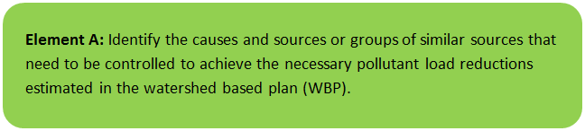

General Watershed Information
Lake Mansfield (a.k.a. Mansfield Pond) is a 28-acre Great Pond located in the Town of Great Barrington, MA. The lake has no notable tributaries. Inflows are primarily from direct precipitation, non-point sources (e.g., diffuse runoff from surrounding forest, road, lawn, etc.), the Castle Hill Avenue storm sewer system (one outfall), and groundwater seepage. There is no impounding structure regulating the water level of the lake. Water primarily exits the lake through a 12-inch outlet pipe underneath Lake Mansfield Road at the northern portion of the pond. The outlet pipe discharges westerly to an approximately 2,500 ft long unnamed stream, which flows into to the Housatonic River.
The approximate 164-acre drainage area of Lake Mansfield is part of the greater Housatonic watershed and is entirely located within the Town of Great Barrington. The lake is within walking distance of downtown and used as a scenic and recreation resource by the community. It includes a swimming beach, boat launch, adjacent conservation area and hiking trails. Up until 2010, the lake was also used as a water supply for the Great Barrington Fire Department. Table A-1 presents the general watershed information of Lake Mansfield, and Figure A-1 includes the watershed boundary.
Table A-1: General Watershed Information
Watershed Name (Assessment Unit ID): | Mansfield Pond (MA21065)
Major Basin: | HOUSATONIC
Watershed Area (within MA): | 164 (ac)
Water Body Size: | 28 (ac)

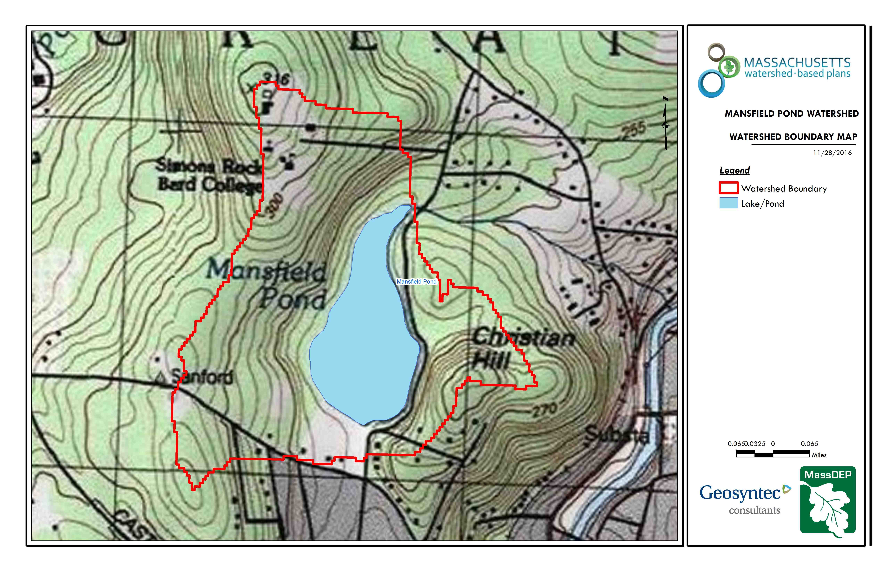
Figure A-1: Watershed Boundary Map
Outlet Pipe
Lake Mansfield Road
Boat Launch
Castle Hill Stormwater System Outfall
Recreation Area (Beach)
(Source: MassGIS, 1999; MassGIS, 2001; USGS, 2016)

MassDEP Water Quality Assessment Report and TMDL Review
The following water quality assessment was reviewed for this study:
- Housatonic River Watershed 2002 Water Quality Assessment Report

Housatonic River Watershed 2002 Water Quality Assessment Report (MA21065 - Mansfield Pond)
NOTE: RELEVANT INFORMATION IS INCLUDED DIRECTLY FROM 2002 REPORT FOR INFORMATIONAL PURPOSES AND HAS NOT BEEN MODIFIED.
The non-native aquatic macrophytes Myriophyllum spicatum and Potamogeton crispus were documented in Mansfield Pond during the 1997 DWM synoptic survey (Kennedy and Weinstein 2000). There was a project to reduce the Myriophyllum spicatum infestation using biological control (weevils) with a DEM 2000 lake and pond grant, however no post implementation data are available on the effectiveness.
An in situ profile was taken by DWM at the deep hole of the lake on 26 August 2003. Dissolved oxygen concentrations ranged from 0.8 to 7.9 mg/L; percent saturations ranged from 10 to 98% (Appendix D, Table D4). Severe oxygen depletion (<5 mg/L and 50% saturation) was only measured at depths greater than 4m, which does not constitute a significant portion of the lake area. Grab samples were collected in August and analyzed for total phosphorus, apparent color, and chlorophyll a. Total phosphorus concentrations suggest that phosphorus may be released from the sediments with concentrations in the bottom water measured at 0.08 mg/L. The chlorophyll a concentration was low (4.0 mg/m3).
The Aquatic Life Use is assessed as impaired because of the presence of the non-native aquatic macrophytes. Phosphorus release from sediments is also of concern.
The Town of Great Barrington maintains a public bathing beach on Mansfield Pond. The beach area was tested weekly during the bathing season for E. coli bacteria in 2001, 2003, and 2004 (n=36) (MA DPH 2002, 2004, 2005a). The beach was never formally posted. Currently, there is uncertainty associated with the accurate reporting of freshwater beach closure information to the Massachusetts DPH, which is required as part of the Beaches Bill. Therefore, no Primary Contact Recreational Use assessments (either support or impairment) decisions are being made using Beaches Bill data for this waterbody.
No other recent data are available, so the other uses are not assessed.

Additional Water Quality Data
The following relevant references were reviewed as they relate to water quality:
A Diagnostic Feasibility Study for the Management of Mansfield Lake, Great Barrington, Massachusetts (Baystate Environmental, 1990)
Routine sampling and data collection were conducted during the period of March 1988—February 1989, with groundwater sampling continuing until May 1989. Lake Mansfield was described as eutrophic during summer months, due to inputs from the watershed and long residence time of water in the lake.
Fifteen parameters were routinely assessed at five different sampling locations. Total Phosphorus (TP) was considered the most important limiting nutrient for primary production in the lake. The main sources of TP to the lake were listed as storm drainage runoff from road surfaces (mainly from Castle Hill Avenue); internal recycling from the sediments and rooted aquatic plants; baseline tributary flow; and other sources. Values of monitored TP are presented in Table A-2.
Table A-2: Baystate Phosphorus Sampling Results, 1990
Sampling Station | Mean (µg/L) | Maximum (µg/L) | Minimum (µg/L)
ML-1 | 159 | 280 | 50
ML-2s | 75 | 120 | 50
ML-2m | 86 | 100 | 50
ML-2b | 78 | 150 | 30
ML-3 | 69 | 170 | 40
ML-1 is located along the shore on the southwestern corner of the pond near the outfall from the Castle Hill Avenue storm sewer system. ML-2 is in the middle of the southern portion of the Pond (i.e., deepest location of pond. Sample results were taken from the surface (“s”), middle (“m”), and bottom (“b”) of the pond at this location. ML-3 is located at the northern portion of the pond at the outlet. TP in the surface waters (ML-2s) had an annual mean of 75 µg/L. ML-1 at the southwest portion of the lake was considerably greater at 159 µg/L. The annual mean of TP leaving the system was 69 µg/L. Results significantly exceeded the eutrophic benchmark for ponds (25 µg/L) (USEPA 1986) and are indicative of poor water quality.
To supplement the surface water sampling, groundwater sampling was also conducted, which involved either littoral interstitial porewater (LIP) samples collected in the littoral zone of the lake or sampling of driven point wells located just adjacent to the lake. Samples were taken at nine different locations around the lake in June 1988 and six of the locations were resampled in August 1988. Total dissolved phosphorus values ranged from 20—80 µg/L with a mean of 51 µg/L and an outlier of 330 µg/L. Orthophosphorus values were slightly lower, averaging 35 µg/L with a range of 10—80 µg/L and an outlier of 140 µg/L.
In addition, stormwater quality was monitored during three different storm events (7/21/88, 11/1/88, and 5/11/89) at the inlet ML-1 at the southwest edge of the lake, which receives significant stormwater runoff from several catch basins along Castle Hill Avenue. In general, the data indicated poor water quality entering the lake at this location, including high levels of TP and Total Suspended Solids (TSS) (consistent with the development of a large sediment delta below the outfall of ML-1 over the course of the study.
Recommended management options fell into two categories – those primarily aimed at reducing weed levels in the lake, and those pertaining to improving water quality entering the lake from the watershed.
Lake Mansfield Aquatic Vegetation Survey and Milfoil Weevil Assessment (Geosyntec, 2005)
Milfoil weevils were originally stocked in Lake Mansfield in 1995/1996 as part of a state-funded pilot project, which introduced 12,000 weevils at the lakes western shore. An additional 18,000 weevils were stocked in 1998 and 8,000 weevils were stocked in 2000. In 2001, it was documented that several native plants had become re-established as the dominant plant species within the lake, with milfoil growth reduced to very low densities over most of the lake.
Geosyntec Consultants conducted a macrophyte survey of Lake Mansfield on July 22, 2005. Aquatic vegetation was sampled from a boat at 23 sampling locations. Most of the lake was observed to have very dense growth of rooted aquatic plants. Of the 23 stations, 21 were in the highest plan growth density category (75-100% density). Of the 23 stations, 18 were also found to have low to moderate plant biomass, with plants growing primarily at the lake bottom or in less than half of the water column. Five stations had both very dense plant growth and high plant biomass. The Eurasian milfoil growth in the lake showed in increase since monitoring that was conducted in 2001. Seventeen species of aquatic plants were documents in Lake Mansfield and Eurasian milfoil was found at 22 of the 23 sampling stations, but it was only observed to be the dominant plant species at one of the stations located near the center of the lake. Many of the milfoil plants were observed to be in poor health, with significant evidence of insect herbivory by milfoil weevils.
From an ecological and recreational perspective, the lake appeared to be in better overall condition than it was prior to the initial weevil stocking ten years prior.
Lake Mansfield 2012 Aquatic Vegetation Survey (Geosyntec, 2012)
Geosyntec Consultants conducted an aquatic vegetation survey of Lake Mansfield on July 11, 2012. Aquatic vegetation was sampled from a boat at 23 sampling locations. Plant growth throughout the lake was dominated by an assemblage of species. Eurasian milfoil and curlyleaf pondweed were observed to be growing in small quantities. Overall biomass appeared to have increased since Geosyntec’s 2005 survey. Of the 23 stations, 20 had either dense or very dense plant growth. Of the 23 stations, 16 had very high biomass, with plant growth extending through either most of or the entire water column.
MET Lake Mansfield Water Quality Monitoring Project, Final Report (Berkshire Environmental Research Center, Bard College at Simon's Rock, 2016)
Seven sample sites within the lake and two stations on the Castle Hill stormwater drainage system were monitored monthly and during storm events over a 17-month period. Three of the sampling locations were in the same general location as the three sampling locations of the Baystate (1990) report. TSS levels appeared to have dropped significantly since the Baystate Environmental (1990) report (from an average of 14 ppm to an average of 3 ppm). There were issues with reliability of the TP sampling results, but the samples that were reliable indicated a drop in TP concentrations since 1990 (i.e., 0.03—0.28 ppm in 1998—1989 and ND—0.2 in 2015—2016). It was recommended that the Castle Hill Stormwater system be monitored more closely due to observations of restricted flow out of the system and two positive results of VOCs and results of high levels of Cl.
Bacteria Sampling at Lake Mansfield Beach
Bacteria monitoring for the Lake Mansfield Beach is performed during the bathing season on a weekly basis. According to the Lake Mansfield Task Force, there have been no known beach closures.

Water Quality Impairments
Lake Mansfield is an impaired water body listed under category 4c on the Massachusetts List of Integrated Waters due to invasive non-native plants. Biological control efforts and bottom barriers have mitigated this issue, but nonpoint source runoff from several areas in the watershed pollutes the lake with sediment, leading to shallower and warmer waters, and thereby making it easier for invasive plants to grow. In addition to physical problems associated with sediment deposition, sediment particles readily transport pollutants such as metals, nutrients, and pathogens.
Known water quality impairments, as documented in the Massachusetts Department of Environmental Protection (MassDEP) 2012 Massachusetts Integrated List of Waters, are listed below. Impairment categories from the Integrated List are as follows:
Table A-3: 2012 MA Integrated List of Waters Categories
Integrated List Category | Description
1 | Unimpaired and not threatened for all designated uses.
2 | Unimpaired for some uses and not assessed for others.
3 | Insufficient information to make assessments for any uses.
4 | Impaired or threatened for one or more uses, but not requiring calculation of a Total Maximum Daily Load (TMDL), including:  4a: TMDL is completed  4b: Impairment controlled by alternative pollution control requirements  4c: Impairment not caused by a pollutant - TMDL not required
5 | Impaired or threatened for one or more uses and requiring preparation of a TMDL.

Table A-4: Water Quality Impairments
Assessment  Unit ID | Waterbody | Integrated  List Category | Designated Use | Impairment Cause | Impairment Source
MA21065 | Mansfield Pond | 4C | Fish, other Aquatic Life and Wildlife | Eurasian Water Milfoil, Myriophyllum spicatum | Introduction of Non-native Organisms (Accidental or Intentional)
MA21065 | Mansfield Pond | 4C | Fish, other Aquatic Life and Wildlife | Non-Native Aquatic Plants | Introduction of Non-native Organisms (Accidental or Intentional)

Water Quality Goals
Water quality goals may be established for a variety of purposes, including the following:
a.) For water bodies with known impairments, a Total Maximum Daily Load (TMDL) is established by MassDEP and the United States Environmental Protection Agency (USEPA) as the maximum amount of the target pollutant that the waterbody can receive and still safely meet water quality standards. If the waterbody has a TMDL for total phosphorus (TP) or total nitrogen (TN), or total suspended solids (TSS), that information is provided below and included as a water quality goal.
b.) For water bodies without a TMDL for total phosphorus (TP), a default water quality goal for TP is based on target concentrations established in the Quality Criteria for Water (USEPA, 1986) (also known as the “Gold Book”). The Gold Book states that TP should not exceed 50 µg/L in any stream at the point where it enters any lake or reservoir, nor 25 µg/L within a lake or reservoir. For the purposes of developing WBPs, MassDEP has adopted 50 µg/L as the TP target for all streams at their downstream discharge point, regardless of which type of water body the stream discharges to.
c.) Massachusetts Surface Water Quality Standards (314 CMR 4.00, 2013) prescribe the minimum water quality criteria required to sustain a waterbody’s designated uses. Lake Mansfield is a Class 'B' waterbody. The water quality goal for fecal coliform bacteria is based on the Massachusetts Surface Water Quality Standards.
Table A-5: Surface Water Quality Classification by Assessment Unit ID
Assessment  Unit ID | Waterbody | Class
MA21065 | Mansfield Pond | B

d.) Other water quality goals set by the community (e.g., protection of high quality waters, in-lake phosphorus concentration goal to reduce recurrence of cyanobacteria blooms, etc.).
Table A-6: Water Quality Goals
Pollutant | Goal | Source
Total Phosphorus (TP) | Total phosphorus should not exceed:  --50 µg/L in any stream  --25 µg/L within any lake or reservoir | Quality Criteria for Water (USEPA, 1986)
Bacteria | Class B Standards  Public Bathing Beaches: For E. coli, geometric mean of 5 most recent samples shall not exceed 126 colonies/ 100 ml and no single sample during the bathing season shall exceed 235 colonies/100 ml. For enterococci, geometric mean of 5 most recent samples shall not exceed 33 colonies/100 ml and no single sample during bathing season shall exceed 61 colonies/100 ml;  Other Waters and Non-bathing Season at Bathing Beaches: For E. coli, geometric mean of samples from most recent 6 months shall not exceed 126 colonies/100 ml (typically based on min. 5 samples) and no single sample shall exceed 235 colonies/100 ml. For enterococci, geometric mean of samples from most recent 6 months shall not exceed 33 colonies/100 ml, and no single sample shall exceed 61 colonies/100 ml. | Massachusetts Surface Water Quality Standards (314 CMR 4.00, 2013)
Non-Native Aquatic Macrophytes | An aquatic vegetation survey of Lake Mansfield was performed on July 11, 2012 where increased biomass was observed from a previous 2005 assessment. This goal is therefore to consistently reduce the assessed biomass of non-native aquatic macrophytes, eventually leading to de-listing of the impairment from the 303(d) list. | Geosyntec (2012)
Note: There may be more than one water quality goal for bacteria due to different Massachusetts Surface Water Quality Standards Classes for different Assessment Units within the watershed.

Land Use Information
Land use information and impervious cover is presented by the below tables and figures. Land use source data is from 2005 and was obtained from MassGIS (2009b).
Watershed Land Uses
Land use in the Lake Mansfield watershed is mostly forested (approximately 62 percent); approximately 14 percent of the watershed is residential; approximately 3 percent is commercial; approximately 4 percent is open land; and open water makes up approximately 18 percent of the watershed. Most development in the watershed is located in the southern portion.
Table A-7: Watershed Land Uses
Land Use | Area (acres) | % of Watershed
Agriculture | 0 | 0
Commercial | 4.07 | 2.5
Forest | 101.43 | 61.9
High Density Residential | 0 | 0
Highway | 0 | 0
Industrial | 0 | 0
Low Density Residential | 15.86 | 9.7
Medium Density Residential | 7.58 | 4.6
Open Land | 5.65 | 3.5
Water | 29.17 | 17.8

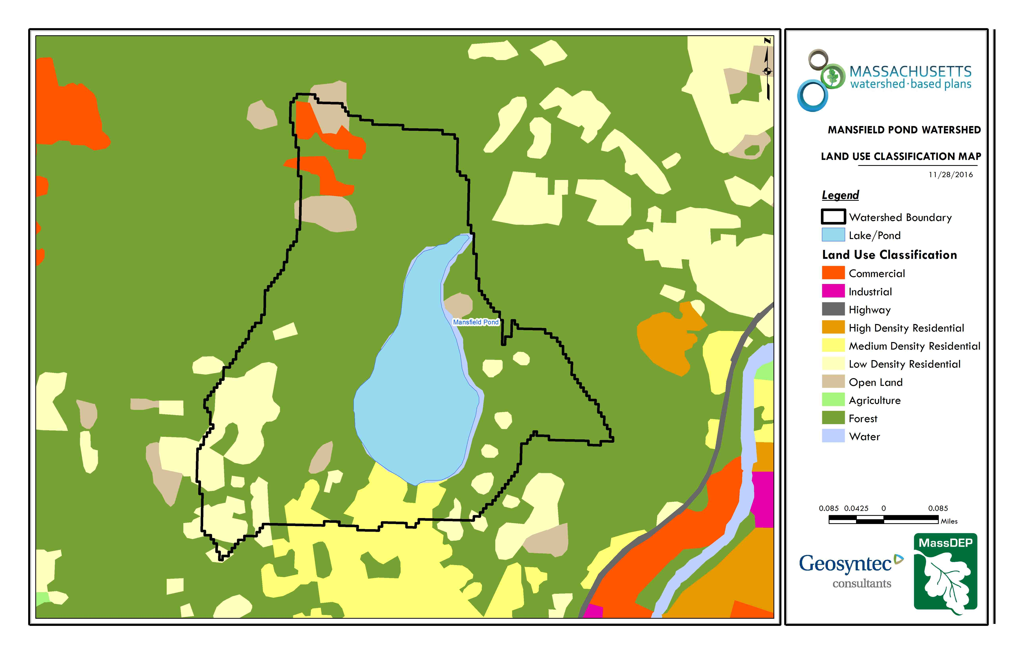
Figure A-2: Watershed Land Use Map
(Source: MassGIS, 2009b; MassGIS, 1999; MassGIS, 2001; USGS, 2016)
Watershed Impervious Cover
A majority of the watershed’s total impervious area (TIA) is located in the southern portion of the watershed. Impervious area includes land surfaces that prevent the infiltration of water into the ground, such as paved roads and parking lots, roofs, basketball courts, etc. There is a strong link between impervious land cover and stream water quality. Impervious areas that are directly connected (DCIA) to receiving waters (via storm sewers, gutters, etc.) produce higher runoff volumes and transport stormwater pollutants with greater efficiency than disconnected impervious cover areas which are surrounded by vegetated, pervious land. Runoff volumes from disconnected impervious cover areas are reduced as stormwater infiltrates when it flows across adjacent pervious surfaces.
DCIA for the watershed was calculated based on the Sutherland equations. USEPA provides guidance (USEPA, 2010) on the use of the Sutherland equations to predict relative levels of connection and disconnection based on the type of stormwater infrastructure within the TIA of a watershed. Any reduction in impervious area due to disconnection (i.e., the area difference between TIA and DCIA) was assigned to the pervious D soil category for that land use to simulate that some infiltration will likely occur after runoff from disconnected impervious surfaces passes over pervious surfaces. The estimated TIA and DCIA in the watershed is summarized below.
Estimated TIA in the watershed: 8.4%
Estimated DCIA in the watershed: 5.5 %

The relationship between TIA and water quality can generally be categorized as listed by Table A-8 (Schueler et al. 2009). The TIA in the watershed is approximately 8.4%; therefore, surrounding streams (i.e., the outlet) can be expected to show good to excellent water quality.
Table A-8: Relationship between Total Impervious Area (TIA) and water quality (Schueler et al. 2009)
% Watershed  Impervious Cover | Stream Water Quality
0-10% | Typically, high quality, and typified by stable channels, excellent habitat structure, good to excellent water quality, and diverse communities of both fish and aquatic insects.
11-25% | These streams show clear signs of degradation. Elevated storm flows begin to alter stream geometry, with evident erosion and channel widening. Streams banks become unstable, and physical stream habitat is degraded. Stream water quality shifts into the fair/good category during both storms and dry weather periods. Stream biodiversity declines to fair levels, with most sensitive fish and aquatic insects disappearing from the stream.
26-60% | These streams typically no longer support a diverse stream community. The stream channel becomes highly unstable, and many stream reaches experience severe widening, downcutting, and streambank erosion. Pool and riffle structure needed to sustain fish is diminished or eliminated and the substrate can no longer provide habitat for aquatic insects, or spawning areas for fish. Biological quality is typically poor, dominated by pollution tolerant insects and fish. Water quality is consistently rated as fair to poor, and water recreation is often no longer possible due to the presence of high bacteria levels.
>60% | These streams are typical of “urban drainage”, with most ecological functions greatly impaired or absent, and the stream channel primarily functioning as a conveyance for stormwater flows.

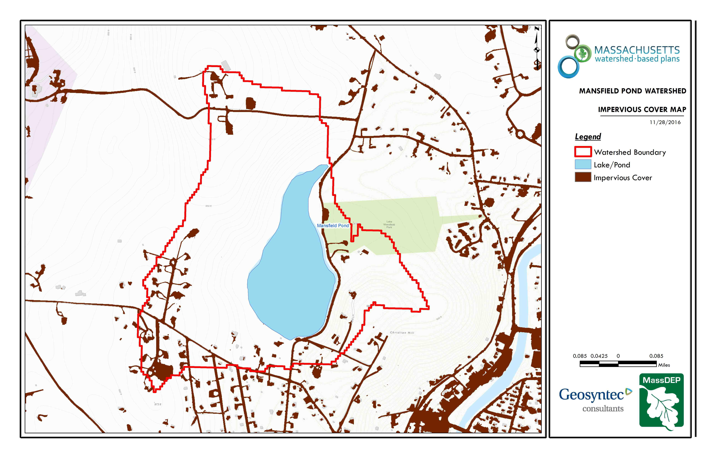
Figure A-3: Watershed Impervious Surface Map
(Source: MassGIS, 2009b; MassGIS, 1999; MassGIS, 2001; USGS, 2016)

Pollutant Loading
The land use data (MassGIS, 2009b) was intersected with impervious cover data (MassGIS, 2009a) and United States Department of Agriculture (USDA) Natural Resources Conservation Service (NRCS) soils data (USDA NRCS and MassGIS, 2012) to create a combined land use/land cover grid. The grid was used to sum the total area of each unique land use/land cover type.
Pollutant loading for key nonpoint source pollutants in the watershed was estimated by multiplying each land use/cover type area by its pollutant load export rate (PLER). The PLERs are an estimate of the annual total pollutant load exported via stormwater from a given unit area of a land cover type. The PLER values for TN, TP and TSS were obtained from USEPA (Voorhees, 2016b) (see documentation provided in Appendix A) as follows:
L_{n} = A_{n} * P_{n}
Where L_{n} = Loading of land use/cover type n (lb/yr); A_{n} = area of land use/cover type n (acres); P_{n} = pollutant load export rate of land use/cover type n (lb/acre/yr)
The estimated land-use based phosphorus to the pond is 28 pounds per year, as presented by Table A-9. Most of the land-use based phosphorus load is estimated to be from forested areas (60%). Most phosphorus generated from forested areas is a result of natural process such as decomposition of leaf litter and other organic material and generally represent a “best case scenario” with regards to phosphorus loading, meaning that more than half of the watershed is unlikely to provide opportunities for nutrient load reductions through best management practices.
It should be noted that it is possible that pollutant loading estimates provided by Table A-9 under-represent actual conditions for the following reasons.
- There are multiple dirt and gravel roads in the Castle Hill Neighborhood that likely contribute significantly more pollutant loading (TSS, TN, TP) to the lake than estimated from the standard PLER from residential areas (Appendix A).
- Pollutant load estimates are solely based on land use based runoff and do not consider other sources of such as internal loading from bottom sediments, septic systems, and aerial deposition; all of which can be a significant source of pollutant load to a pond. For example, lake sediments contain phosphorus that is bound to the sediment particles. During periods of anoxia (oxygen concentration ≤ 1 mg/L), phosphorus can be released into the water from lake sediments in soluble form, making it biologically available to fuel increased algal productivity. It is often the case that internal loading impacts the water quality of shallow lakes and ponds such as Lake Mansfield more than deeper systems as suggested by the previously summarized by the 2002 Water Quality Assessment Report (Element A, Section 2).

Table A-9: Estimated Pollutant Loading for Key Nonpoint Source Pollutants
Land Use Type | Pollutant Loading¹
 | Total Phosphorus (TP) (lbs/yr) | Total Nitrogen (TN) (lbs/yr) | Total Suspended Solids (TSS) (tons/yr)
Agriculture | 0 | 0 | 0.00
Commercial | 2 | 21 | 0.26
Forest | 17 | 91 | 2.82
High Density Residential | 0 | 0 | 0.00
Highway | 0 | 0 | 0.00
Industrial | 0 | 0 | 0.00
Low Density Residential | 6 | 55 | 0.79
Medium Density Residential | 2 | 16 | 0.22
Open Land | 1 | 10 | 0.19
TOTAL | 28 | 194 | 4.28
- These estimates do not consider loads from point sources or septic systems.

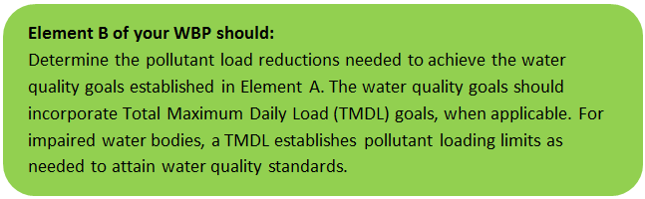Element B: Determine Pollutant Load Reductions Needed to Achieve Water Quality Goals

Estimated Pollutant Loads
Table B-1 lists estimated pollutant loads for the following primary nonpoint source (NPS) pollutants: total phosphorus (TP), total nitrogen (TN), total suspended solids (TSS). These estimated loads are based on the pollutant loading analysis presented in Section 7 of Element A.

Water Quality Goals
Water quality goals for primary NPS pollutants are listed in Table B-1 based on the following:
- For all water bodies, including impaired waters that have a pathogen TMDL, the water quality goal for bacteria is based on the Massachusetts Surface Water Quality Standards (314 CMR 4.00, 2013) that apply to the Water Class of the selected water body.
- If the water body does not have a TMDL for TP, a default target TP concentrations is provided which is based on guidance provided by the USEPA in Quality Criteria for Water (1986), also known as the “Gold Book”. Because there are no similar default water quality goals for TN and TSS, goals for these pollutants are provided in Table B-1 only if a TMDL exists or alternate goal(s) have been optionally established by the WBP author.
- According to the USEPA Gold Book, total phosphorus should not exceed 50 µg/L in any stream at the point where it enters any lake or reservoir. The water quality loading goal was estimated by multiplying this target maximum phosphorus concentration (50 µg/L) by the estimated annual watershed discharge for the selected water body. To estimate the annual watershed discharge, the mean flow was used, which was estimated based on United States Geological Survey (USGS) “Runoff Depth” estimates for Massachusetts (Cohen and Randall, 1998). Cohen and Randall (1998) provide statewide estimates of annual Precipitation (P), Evapotranspiration (ET), and Runoff (R) depths for the northeastern U.S. According to their method, Runoff Depth (R) is defined as all water reaching a discharge point (including surface and groundwater), and is calculated by:
P – ET = R
- A mean Runoff Depth R was determined for the watershed by calculating the average value of R within the watershed boundary. This method includes the following assumptions/limitations:
  - For lakes and ponds, the estimate of annual TP loading is averaged across the entire watershed. However, a given lake or reservoir may have multiple tributary streams, and each stream may drain land with vastly different characteristics. For example, one tributary may drain a highly developed residential area, while a second tributary may drain primarily forested and undeveloped land. In this case, one tributary may exhibit much higher phosphorus concentrations than the average of all streams in the selected watershed.
  - The estimated existing loading value only accounts for phosphorus due to stormwater runoff. Other sources of phosphorus may be relevant, particularly phosphorus from on-site wastewater treatment (septic systems) within close proximity to receiving waters. Phosphorus does not typically travel far within an aquifer, but in watersheds that are primarily unsewered, septic systems and other similar groundwater-related sources may contribute a significant load of phosphorus that is not captured in this analysis. As such, it is important to consider the estimated TP loading as "the expected TP loading from stormwater sources."
Table B-1: Pollutant Load Reductions Needed
Pollutant | Existing Estimated Total Load | Water Quality Goal | Required Load Reduction
Total Phosphorus | 28 lbs/yr | (*See below recommendation) | (*See below recommendation)
Total Nitrogen | 194 lbs/yr | - | -
Total Suspended Solids | 4 ton/yr | (*See below recommendation) | (*See below recommendation)
Bacteria | MSWQS for bacteria are concentration standards (e.g., colonies of fecal coliform bacteria per 100 ml), which are difficult to predict based on estimated annual loading. | Class B. Class B Standards  Public Bathing Beaches: For E. coli, geometric mean of 5 most recent samples shall not exceed 126 colonies/ 100 ml and no single sample during the bathing season shall exceed 235 colonies/100 ml. For enterococci, geometric mean of 5 most recent samples shall not exceed 33 colonies/100 ml and no single sample during bathing season shall exceed 61 colonies/100 ml;  Other Waters and Non-bathing Season at Bathing Beaches: For E. coli, geometric mean of samples from most recent 6 months shall not exceed 126 colonies/100 ml (typically based on min. 5 samples) and no single sample shall exceed 235 colonies/100 ml. For enterococci, geometric mean of samples from most recent 6 months shall not exceed 33 colonies/100 ml, and no single sample shall exceed 61 colonies/100 ml. | -

Recommended Load Reduction
Lake Mansfield is impaired for non-native aquatic macrophytes. A water quality goal was established under Element A to consistently reduce the assessed biomass of non-native aquatic macrophytes, eventually leading to de-listing of the impairment from the 303(d) list. Past studies have suggested that nonpoint source runoff from several areas in the watershed pollute the lake with sediment, leading to shallower and warmer waters, and thereby making it easier for plants to grow. Sediment particles readily transport other pollutants such as metals, nutrients, and pathogens. As evidenced by past water quality monitoring data, phosphorus levels in the lake have been historically elevated.
Management measures will primarily focus on reducing sediment loading to the lake, which is expected to decrease non-native aquatic macrophyte biomass and decrease phosphorus concentrations and other pollutants. As previously discussed in Element A, Section 7, it is likely that predicted loads under represent actual conditions given gravel and dirt roads in the watershed and the potential for internal loading from bottom sediments. For example, a previously installed management measure at Castle Hill (See Element C, Site 8) is expected to reduce sediment loading to the lake by approximately 30 tons per year as compared to the 4 tons of total loading to the watershed per year estimated by Table B-1. Since water quality monitoring has not been recently performed and pollutant load estimates likely under represent actual conditions, the following adaptive sequence is proposed to establish and track quantitative load reduction goals:
- Establish an interim goal to reduce land-use based sediment loading by 500 pounds over the next 3 years (by 2022).
- Establish a baseline water quality and vegetation monitoring program in accordance with Element I. Use results from monitoring program to calculate annual sediment and phosphorus budgets and obtain a better understanding of other water quality parameters such as dissolved oxygen. Annual budgets will provide more fine-tuned predictions of loading including other potential sources such as internal phosphorus loading from sediments.
- Establish realistic long-term load reduction goals with the goal of de-listing Lake Mansfield from the 303(d) list for non-native aquatic macrophytes and approaching or exceeding oligotrophic conditions within the next 10 years (by 2029).

Element C: Describe management measures that will be implemented to achieve water quality goals

Field Watershed Investigation
Geosyntec performed a field investigation in the Lake Mansfield watershed on September 4, 2018 to identify additional potential structural BMPs that may be implemented to reduce pollutant loads to Lake Mansfield with an emphasis on reductions in sediment loading towards overall reductions in non-native aquatic macrophyte biomass. All developed portions of the watershed were visited with a focus on known problem areas. These known problem areas are listed below (See Figure A-1 for location callouts).
- Castle Hill / Knob Hill Neighborhoods
- Boat Launch
- Lake Mansfield Beach and Parking Area
- Lake Mansfield Road and Buffer Area
As previous summarized in Section 1, there are multiple BMPs that have already been implemented or are planned to be implemented in the watershed. The recommended implementation sites discussed in this section are not intended to be an all-inclusive listing of potential stormwater improvements in the watershed. Rather, these recommendations are representative examples of potential opportunistic stormwater improvements and retrofits. Appendix B presents details of BMP designs that are currently in-progress as well as new BMP opportunity locations identified by the field visit. Each BMP opportunity location includes:
- A site summary that describes current conditions and stormwater drainage patterns;
- A description of proposed improvements, including potential operations and maintenance and permitting requirements;
- Estimated costs that represent installed contractor construction costs (i.e., capital costs); and
- Estimated TP, TN, and TSS pollutant load reduction for the proposed BMP.
Proposed BMPs should be designed to treat the water quality volume to the maximum extent practicable. The water quality volume is defined in the Massachusetts Stormwater Handbook as the volume equal to 0.5 inches of runoff times the total impervious area that drains to the BMP. However, each proposed BMP should be designed to achieve the most treatment that is practical given the size and logistical constraints of the site.
Refer to Figure C-1 for a location map of proposed BMPs and to Table D-1 for a summary of BMP characteristics and estimated costs.
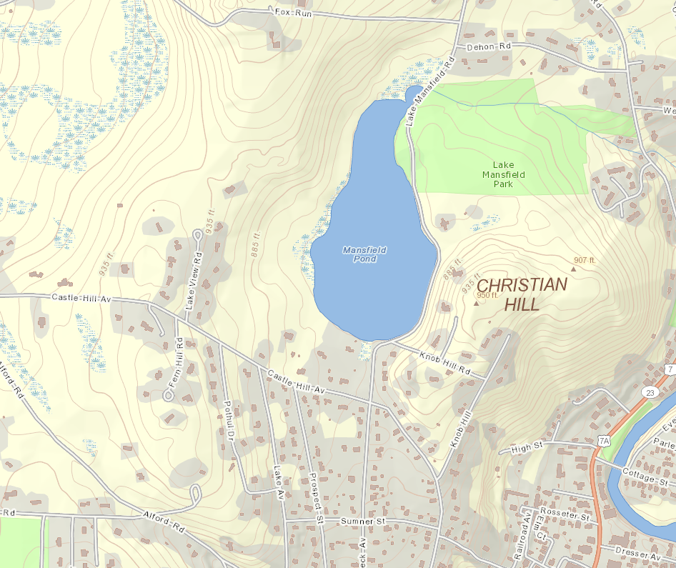
Site 1; Site 2
(Proposed)
Site 3; Site 4
(Proposed)
Site 5
(Proposed)
Site 6; Site 7
(In Progress)
Site 8
(Completed)
Site 9
(Proposed)
Site 10
(Proposed)
Site 11
(Proposed)
Figure C-1. BMP Opportunity Sites (See Appendix B for site descriptions)
(Map source: MassGIS OLIVER viewer, standard basemap)

Element D: Identify Technical and Financial Assistance Needed to Implement Plan

Table D-1 presents the anticipated funding needed to implement the management measures at Lake Mansfield presented in this WBP. The table includes planning level costs for structural BMPs, operation and maintenance activities, information/education measures, and monitoring/evaluation activities. The table also includes summary statistics of proposed BMPs including potential pollutant load reductions.
Results from the table indicate that total sediment load reductions of over 1,000 pounds per year can be expected through implementation, excluding existing sites. It is expected that actual reductions will be significantly greater as pollutant load reductions were unable to be calculated for many of the BMP Sites (e.g., Site 1) from existing information. Actual load reductions can be calculated when designs are finalized and alternatives are selected. It is expected that implementation of these BMPs will play a significant role in decreasing sediment loading to Lake Mansfield.
It is expected that the following funding sources will be used to implement these BMPs:
- Section 319 Grant Funding
- Town Capital Funds
- Town Community Preservation Act Funds
- Town Wetland Funds (i.e., filing fees to enforce Massachusetts Wetlands Protection Act)
- Massachusetts Environmental Trust Funds
- Hazard Mitigation Grant Funding
- Volunteer time for public outreach and monitoring

Table D-1: Summary of Proposed BMPs and Funding Needed to Implement the Watershed Plan.
Site | BMP Identification / Location | BMP Description | Drainage Area (ac) | Imp. Area (%) | Est. Load Reduction (lb/yr) |  |  | Cost Estimates ($) |  |  |  | Site Specific Notes
 |  |  |  |  | TN | TP | TSS | Capital¹ | O&M Materials² | Technical Assistance³ | Total
Structural BMPs (from Element C)
1 | Lake Mansfield Recreation Parking near Beach | Proposed parking improvement concept by KZLA (2016) with added recommendation: turf pavers, bioswales, bioretention cells | 1.60 | 19% | 3.6 | 0.5 | 274 | $550,000 | N/A | $50,000 | $600,000 | - Estimated pollutant load reduction only considers bioretention cells and bioswales.  - Capital cost and technical assistance cost were referenced from the KZLA (2016) report. Potential O&M costs are unknown.
2 | Emergency Vehicle Parking near Beach | Proposed 50-ft water quality swale; 200-sq. ft. bioretention cell; grass paver parking | 0.30 | 100% | 2.6 | 0.3 | 125 | $11,000 | $250 | $4,400 | $15,650 | It is recommended that this site be implemented if Site 1 is not implemented.
3 | Lake Mansfield Road Improvements | Proposed conceptual design alternatives by Woodard and Curran (2018): increase vegetated lake buffer; install drainage swales, install riprap filtration channels (rock sandwich) | N/A | N/A | N/A | N/A | 600 | $1,010,000 | N/A | $250,000 | $1,260,000 | - Depending on selected BMPs and road width, it is expected that road rehabilitation could result in up to 600 pounds per year of TSS reduction.  - Capital cost and technical assistance cost were referenced from KZLA (2016) report. Potential O&M costs are unknown.
4 | East View Pool Club | Proposed pave 200 ft section of driveway and install water quality swales | 0.76 | 12% | 0.0 | 0.0 | 39 | $38,000 | $250 | $15,200 | $53,450
5 | Mansfield Road, private property | Proposed revegetation and stabilization and parking restriction | 0.40 | 28% | 0.2 | 0.0 | 25 | $6,000 | $250 | $2,400 | $8,650
6 | Lake Mansfield Boat Launch | Existing, installed 2018: Paved boat launch, restored vegetated buffer, grassed depression  Proposed: turn grassed depression into a bioretention cell | 0.37 | 100% | 3.2 | 0.4 | 154 | $10,000 | $250 | $4,000 | $14,250
7 | Knob Hill Road | Construction Pending: proposed hydrodynamic separator (Town of Great Barrington, 2017) | 0.80 | 25% | 3.3 | 0.5 | 108 | $297,000 | N/A | $189,800 | $486,800 | - Estimated pollutant load reduction calculated using treatment percentages from “Knob Hill Stormwater Improvements” (Great Barrington, 2017).  - Estimated cost includes design, construction and permitting from “Knob Hill Stormwater Improvements” (Great Barrington, 2017). O&M costs unknown.
8 | Castle Hill Drainage System | Existing, installed 2013: new drainage system installed with catch basins and hydrodynamic separator | 17.40 | 22% | 0.0 | 0.0 | 60,000 | N/A | N/A | N/A | N/A | -Estimated TSS load reduction based on information from Town of Great Barrington (30 ton/yr).
9 | Pothul Drive⁵ | Proposed: water quality swales | 7.62 | 5% | 0.0 | 0.2 | 247 | $9,000 | $250 | $3,600 | $12,850
10 | Castle Hill Avenue and Lakeview Road⁵ | Proposed: road paving and bank slope stabilization | 2.90 | 17% | see note 5 | see note 5 | see note 5 | $4,000 | $250 | $1,600 | $5,850
11 | Castle Hill Avenue and Fern Hill Road⁵ | Proposed: rock swale maintenance and check dams | 3.40 | 2% | see note 5 | see note 5 | see note 5 | $4,000 | $250 | $1,600 | $5,850
Sub-Total: |  |  |  |  | 12.9 | 2.0 | 61,572 | $1,939,000 | $1,750 | $522,600 | $2,463,350
Information / Education (Element E)
- | Project Updates | Post project updates to website, including completed WBP | - | - | - | - | - | - | - | - | $0
- | Signage | Create information signage for up to 3 BMPs | - | - | - | - | - | $3,000 | - | - | $0
Sub-Total: |  |  |  |  | - | - | - | $3,000 | $0 | $0 | $3,000
Monitoring and Evaluation (Element H & I )
- | Sampling QAPP / SOPs | Write sampling QAPP and vegetation sampling / management plan | - | - | - | - | - | - | - | 6,000 | $0 | QAPP TBA – estimated cost will vary widely depending on level of detail.
- | Annual Water Quality Sampling | TBA | - | - | - | - | - | - | - | $10,000 |  | Extent of sampling program TBA – annual ballpark cost placeholder.
- | Annual Aquatic Vegetation Monitoring and Control | TBA | - | - | - | - | - | - | - | $5,000 | $0 | Extent of monitoring program TBA – annual ballpark cost placeholder.
Sub-Total: |  |  |  |  | $0 | $0 | $0 | $0 | $0 | $21,000 | $21,000
TOTALS: |  |  |  |  |  |  |  | $1,942,000 | $1,750 | $543,600 | $2,487,350
General Notes
1. Planning level capital costs for BMPs obtained from WBP Element C and/or professional judgement from past projects.
2. Technical assistance (i.e. engineering) estimated based on capital costs - design (30%), survey (2%), permitting (3%), Construction Quality Assurance (5%) unless otherwise noted
3. Annual operation and maintenance estimated as 2% of capital costs unless otherwise noted. Actual costs may vary widely based on who performs maintenance
4. Estimates of pollutant reduction unknown for Site 3; however could be significant once designs finalized
5. Site 9, 10, 11 are within the existing Castle Hill Drainage System. TSS load reductions achieved by Site 9, 10, 11 would reduce the load to the downstream Hydrodynamic separator.

Element E: Public Information and Education
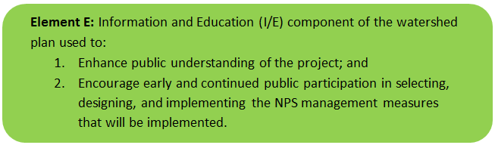

Step 1: Goals and Objectives
The goals and objectives for the watershed information and education program.
- Provide information about proposed stormwater improvements and their anticipated water quality benefits.
- Provide information to promote watershed stewardship.
Step 2: Target Audience
Target audiences that need to be reached to meet the goals and objectives identified above.
- All watershed residents.
- Businesses within the watershed.
- Recreational users of Lake Mansfield (i.e., beach-goers, etc.).
- Watershed organizations and other user groups (Lake Mansfield Alliance, Great Barrington Land Conservancy, Lake Mansfield Improvement Task Force, etc.)
Step 3: Outreach Products and Distribution
The following outreach products have been completed:
1. The Lake Mansfield Newsletter is published annually and distributed via the Great Barrington Land Conservancy website. It is also mailed to the Great Barrington Lakes Committee members and posted for free at the beach kiosk and other public areas. The newsletter promotes watershed stewardship and highlights volunteer opportunities.
2. The Great Barrington Land Conservancy partnered with the Housatonic Valley Association to affix labels to catch basins that discourage dumping to Lake Mansfield.
3. There are currently three kiosks (Recreation (beach) Area, Boat Launch and at trail heads) that contain informational signage
4. Bear proof trash bins; dog waste bags and bins; and baby changing stations are all available at the Recreation Area.
5. Perform Annual Lake Mansfield Cleanup. This has been a successful event with approximately 30 volunteers participating for the last eight to ten years.
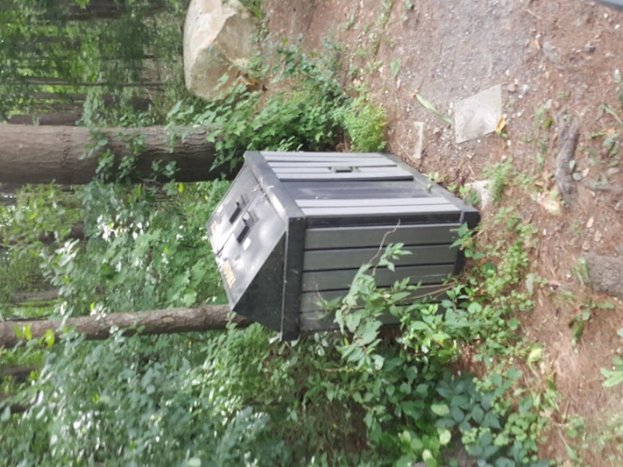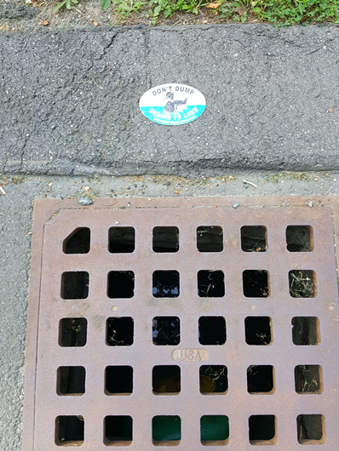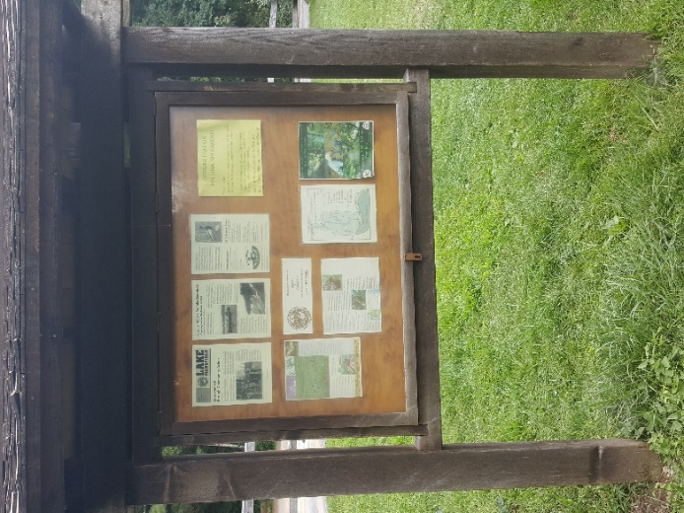

Figure E-1: Existing Examples of Public Education and Outreach in the Lake Mansfield Watershed
The following outreach products are anticipated:
1. Post the completed Lake Mansfield Watershed Based Plan the Great Barrington and other websites. Periodically update website(s) as the WBP is implemented (e.g., BMP construction, monitoring results, etc.).
2. Create additional informational signage to highlight BMPs that are installed throughout the watershed on public land.
3. Ongoing implementation of previously completed outreach efforts listed above.

Elements F & G: Implementation Schedule and Measurable Milestones

Table FG-1 provides a preliminary schedule for implementation of recommendations provided by this WBP. It is expected that the WBP will be re-evaluated and updated in 2021, or as needed, based on ongoing monitoring results and other ongoing efforts.
Table FG-1: Implementation Schedule and Interim Measurable Milestones
Category | Action | Year(s)
Monitoring / Vegetation | Write Quality Assurance Project Plan (QAPP) for sampling and establish water quality monitoring program | 2019
 | Perform annual water quality sampling per Element H&I monitoring guidance. | Annual
 | Perform annual aquatic vegetation monitoring and control | Annual
 | Establish long-term 10-year sediment or phosphorus reduction goal(s) (or other) from baseline monitoring results (See Element B, Section 3) | 2020
Structural BMPs | Obtain funding and implement 2-3 recommended sites from Appendix B | 2020
 | Obtain funding and implement 2-3 recommended sites from Appendix B | 2022
 | Obtain funding and implement 2-3 recommended sites from Appendix B | 2024
Public Education and Outreach  (See Element E) | Periodically post project updates to website, including completed WBP and “snapshot” progress report | Annual
 | Continue ongoing implementation of previously completed outreach efforts (See Element D) | Annual
 | Create information signage for up to 3 completed BMPs | 2022
Adaptive Management  and Plan Updates | Establish working group comprised of stakeholders and other interested parties to implement recommendations and track progress. Meet at least twice per year. | 2019
 | Re-evaluate Watershed Based Plan at least once every three (3) years and adjust, as needed, based on ongoing efforts (e.g., based on monitoring results, 319 funding, etc.). – Next update, December 2021 | 2021
 | Reach long-term goal to de-list watershed from 303(d) list for non-native aquatic macrophytes | 2029

Elements H & I: Progress Evaluation Criteria and Monitoring
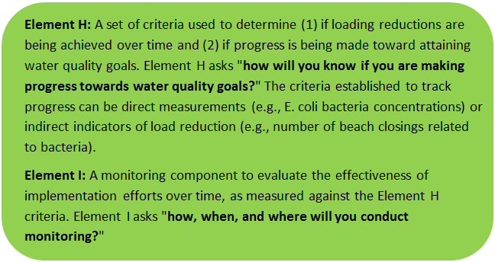 | 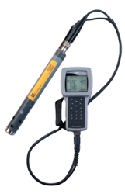

The water quality target concentration(s) is presented under Element A of this plan. To achieve this target concentration, the annual loading must be reduced to the amount described in Element B. Element C of this plan describes the various management measures that will be implemented to achieve this targeted load reduction. The evaluation criteria and monitoring program described below will be used to measure the effectiveness of existing management measures (described in Introduction) and proposed management measures (described in Element C) in improving the water quality of Lake Mansfield.

Indirect Indicators of Load Reduction
Vegetation Monitoring: As previously discussed, aquatic vegetation is monitored and managed on an as-needed basis. Annual assessments will be performed using stations and methods consistent with past assessments (i.e., Geosyntec 2005, Geosyntec 2012). Results from annual monitoring will be used as a metric for measuring changes in biomass and as a metric for understanding water quality trends in response to implementation of measures recommended as part of this WBP. It is also recommended that annual vegetation assessments include recommendations as feasible for control measures such as previously implemented biological controls (i.e. weevils).
Vegetation monitoring may be performed through a volunteer training program or in accordance with established practices for MassDEP’s environmental monitoring for volunteers.

Project-Specific Indicators
Number of BMPs Installed: Element C of this WBP recommends the installation of BMPs at 11 new locations. The anticipated pollutant load reduction has been documented for each proposed BMP, where applicable. The number of BMPs that were installed will be tracked and quantified as part of this monitoring program. For example, if all recommended BMPs are installed, the anticipated sediment load reduction is estimated to be more than 1,000 pounds per year.
As discussed in Element D, it is expected that actual reductions will be significantly greater than 1,000 pounds. Pollutant load reductions were unable to be calculated for many of the BMP Sites (e.g., Site 1) from existing information. Actual load reductions can be calculated when designs are finalized, and alternatives are selected. It is expected that implementation of these BMPs will play a significant role in decreasing sediment loading to Lake Mansfield. It is recommended that anticipated pollutant removals of BMPs that are implemented be tracked and documented as designs are finalized.

Direct Measurements
Direct field measurements are expected to be performed as described below. It is expected that volunteers will be perform a majority of monitoring. Prior to implementing a direct measurement program, an abbreviated QAPP and/or Standard Operating Procedures (SOPs) will be established to flesh out details of the program and establish best practices for sample collection and analysis.
Beach Bacteria Sampling: Sampling at beaches will continue as summarized by Element A, Section 3. Bacteria counts will be tracked as they relate to water quality standards summarized by Element B, Section 2. Data will be used to track the percentage of the sampling season that the beaches are closed (i.e., number of days closed / number of days open) and evaluate changes over time. At the time of writing this WBP, there have been no beach closures resulting from bacteria sampling.
BMP, TSS, and Flow Monitoring: As feasible, the effectiveness of structural BMPs will be evaluated by routine inspection during and after storm events to measure amounts of sediment collected (i.e. hydrodynamic separators, catch basins, etc.). As feasible, TSS and discharge will also be periodically measured at the watershed’s major outfall to the lake in the Castle Hill neighborhood during notable storm events with a goal to capture up to four events per year. TSS and discharge measurements can later be converted to estimates of annual loading to the lake. Results from this monitoring effort will aid in better characterizing base loading to the lake.
In-Lake Phosphorus and Water Quality Monitoring: Based on a literature review summarized in Element A of this plan, Lake Mansfield does not have a monitoring plan. The most recent known water quality samples collected systematically throughout the lake and its receiving waters were collected by Baystate Environmental (1990) and Berkshire Environmental Research Center (2016). In-lake phosphorus measurements will provide the most direct means of evaluating the effects of the measures in the plan which have been proposed specifically to reduce phosphorus loading. It is recommended that sampling be performed at the locations depicted by Figure HI-1. Monitoring stations have been selected to be consistent with past monitoring performed by Baystate Environmental. Additional stations could also be included at locations of interest, such as near the boat launch.
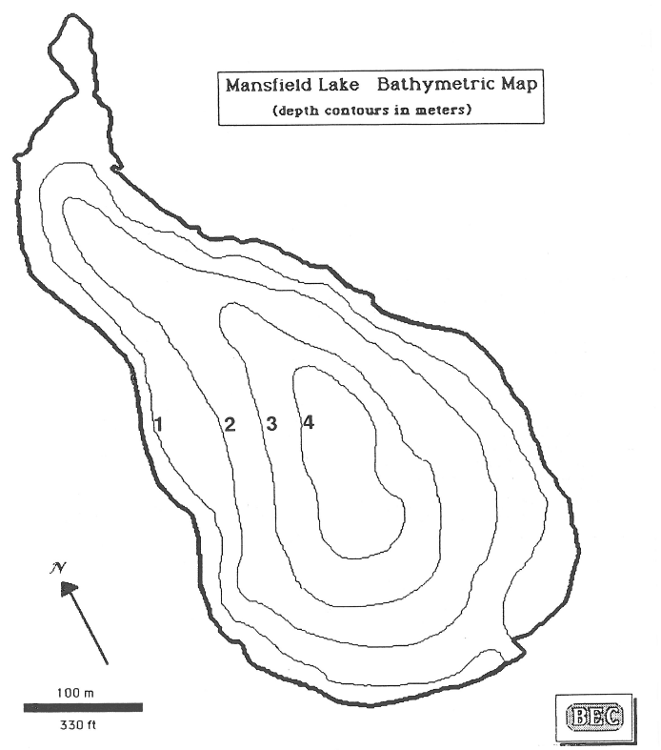
ML -3
(surface)
ML -2
(surface, middle, bottom)
ML -1
(surface)
Figure HI-1. Proposed Water Quality Monitoring Locations
(Figure Source: Baystate Environmental, 1990)

Regular monitoring of phosphorus levels at the proposed monitoring locations is recommended to provide data on phosphorus concentration trends in response to implementation of the measures described in Element C. Depending on available funding and volunteer resources, the following options for monitoring are recommended:
Option 1: Perform baseline phosphorus sampling three times per year, during spring (late April/early May), mid-summer (early to mid-July) and late summer (early- to mid-September). Collect surface samples at ML-1 and ML-3. At ML-2, also collect samples from the middle of the water column, and near the bottom (approximately 0.5m from bottom) using a Kemmerer sampler or similar type of depth sampling equipment.
Option 2: In addition to the phosphorus monitoring described above, conduct the following during each of the three recommended sampling events:
- Collect chlorophyll-a samples (surface grab sample) at each location. Chlorophyll-a provides an indirect measure of algal productivity;
- Use a Secchi disk to measure water clarity at each location.
- Use an in-situ multi-parameter water quality probe (e.g., YSI or comparable brand, which can be rented on a daily basis) to collect the following information at 5 ft intervals at each sampling location:
- Temperature
- Dissolved oxygen
- Specific conductance
- pH
Option 3: As a one-time effort to characterize seasonal internal phosphorus loading, the following could be conducted at ML-2:
- Conduct phosphorus water column sampling and in-situ monitoring as described above, once every two weeks from ice-off until fall turnover (typically in mid-October, when the pond surface temperature becomes equal to the bottom temperature). The information gathered from this sampling program can be used to quantify the mass of phosphorus released seasonally from the pond’s sediments, which occurs during summer thermal stratification when the hypolimnion becomes nearly depleted of oxygen.
Water quality monitoring may be performed through a volunteer training program or in accordance with established practices for MassDEP’s environmental monitoring for volunteers.

Adaptive Management
As discussed by Section 3 of Element B, the baseline monitoring program (recommended Options 1 and 2) will be used to establish a long-term i.e., 10 year) phosphorus load reduction goal (or other parameter(s) depending on results). Long-term goals will be re-evaluated at least once every three years and adaptively adjusted based on additional monitoring results and other indirect indicators. If monitoring results and indirect indicators do not show improvement to the total phosphorus concentrations measured within Lake Mansfield, the management measures and loading reduction analysis (Elements A through D) will be revisited and modified accordingly.
Further, the Lake Mansfield Improvement Task Force will implement recommendations from this WBP and track overall progress. The working group will continue to prepare an annual “snapshot” progress report for dissemination to the public. The progress report will re-iterate goals of this WBP, will summarize indirect indicators, project-specific indicators, and direct measurements as they relate to established water quality goals; and will provide an indication of ongoing outreach efforts and overall next steps.

References
314 CMR 4.00 (2013). "Division of Water Pollution Control, Massachusetts Surface Water Quality Standards"
Baystate Environmental (1990). “A Diagnostic Feasibility Study for the Management of Mansfield Lake, Great Barrington, Massachusetts”. April 1990.
Berkshire Environmental Research Center, Bard College at Simon’s Rock. “MET Lake Mansfield Water Quality Monitoring Project, Final Report”. June 8, 2016.
Cohen, A. J.; Randall, A.D. (1998). "Mean annual runoff, precipitation, and evapotranspiration in the glaciated northeastern United States, 1951-80." Prepared for United States Geological Survey, Reston VA.
Commonwealth of Massachusetts Department of Fish & Game Office of Fishing & Boating Access (2018). Lake Mansfield Cartop Access Facility (Permitted Plan). April 10, 2018.
Foresight Land Services (2018). Knob Hill Road Drainage Improvements, Knob Hill, Great Barrington, MA. August 8, 2018.
Geosyntec Consultants, Inc. (2005). “Lake Mansfield Aquatic Vegetation Survey and Milfoil Weevil Assessment”. July 2005.
Geosyntec Consultants, Inc. (2012). “Lake Mansfield 2012 Aquatic Vegetation Survey”. September, 13, 2012.
Geosyntec Consultants, Inc. (2014). "Least Cost Mix of BMPs Analysis, Evaluation of Stormwater Standards Contract No. EP-C-08-002, Task Order 2010-12." Prepared for Jesse W. Pritts, Task Order Manager, U.S. Environmental Protection Agency
Geosyntec Consultants, Inc. (2015). "Appendix B: Pollutant Load Modeling Report, Water Integration for the Squamscott-Exeter (WISE) River Watershed."
King, D. and Hagan, P. (2011). "Costs of Stormwater Management Practices in Maryland Counties." University of Maryland Center for Environmental Science Chesapeake Biological Laboratory. October 11, 2011.
Kyle Zick Landscape Architects (KZLA). (2016). “Town of Great Barrington, Lake Mansfield Recreation Area Improvements”. June 17, 2016.
Leisenring, M., Clary, J., and Hobson, P. (2014). "International Stormwater Best Management Practices (BMP) Database Pollutant Category Statistical Summary Report: Solids, Bacteria, Nutrients and Metals." Geosyntec Consultants, Inc. and Wright Water Engineers, Inc. December 2014.
MassDEP (2002). "Housatonic River Watershed 2002 Water Quality Assessment Report"
MassDEP (2012). "Massachusetts Year 2012 Integrated List of Waters Final Listing of Massachusetts' Waters Pursuant to Sections 305(b), 314 and 303(d) of the Clean Water Act"
MassDEP (2016a). "Massachusetts Clean Water Toolkit"
MassDEP (2016b). "Massachusetts Stormwater Handbook, Vol. 2, Ch. 2, Stormwater Best Management Practices"
MassGIS (1999). "Networked Hydro Centerlines" Shapefile
MassGIS (2001). "USGS Topographic Quadrangle Images" Image
MassGIS (2007). "Drainage Sub-basins" Shapefile
MassGIS (2009a). "Impervious Surface" Image
MassGIS (2009b). "Land Use (2005)" Shapefile
MassGIS (2013). "MassDEP 2012 Integrated List of Waters (305(b)/303(d))" Shapefile
Schueler, T.R., Fraley-McNeal, L, and K. Cappiella (2009). "Is impervious cover still important? Review of recent research" Journal of Hydrologic Engineering 14 (4): 309-315.
Tighe and Bond (2013). “Draft - Lake Mansfield Road Study, Town of Great Barrington, MA”. September 5, 2013.
Town of Great Barrington (2011-2014). “Project Final Report, Castle Hill Avenue Storm Drainage Improvements 11-05/319”.
Town of Great Barrington (2012). “Knob Hill Stormwater Planning, Lake Mansfield, Great Barrington, Massachusetts, Final Report”.
Town of Great Barrington (2017). “Knob Hill Road Stormwater Improvements, Lake Mansfield, Town of Great Barrington, MA, Nonpoint Source Pollution Mitigation”. Response to RFR BRP 2017-06-319 Section 319 Nonpoint Source Pollution Grant Program. June 2, 2017.
United States Bureau of Labor Statistics (2016). "Consumer Price Index"
United States Geological Survey (2016). "National Hydrography Dataset, High Resolution Shapefile"
University of Massachusetts, Amherst (2004). "Stormwater Technologies Clearinghouse"
USDA NRCS and MassGIS (2012). "NRCS SSURGO-Certified Soils" Shapefile
USEPA (1986). "Quality Criteria for Water (Gold Book)" EPA 440/5-86-001. Office of Water, Regulations and Standards. Washington, D.C.
USEPA. (2010). "EPA's Methodology to Calculate Baseline Estimates of Impervious Area (IA) and Directly Connected Impervious Area (DCIA) for Massachusetts Communities."
Voorhees, Mark, USEPA. (2015). "FW: Description of additional modelling work for Opti-Tool Project" Message to Chad Yaindl, Geosyntec Consultants. 23 April 2015. E-mail.
Voorhees, Mark, USEPA. (2016a). "FW: EPA Region 1 SW BMP performance equations" Message to Chad Yaindl, Geosyntec Consultants. 25 January 2016. E-mail.
Voorhees, Mark, USEPA. (2016b). "FW: Description of additional modelling work for Opti-Tool Project" Message to Chad Yaindl, Geosyntec Consultants. 23 April 2015. E-mail.
Woodard and Curran. (2018). “Town of Great Barrington, MA, Lake Mansfield Road Area Improvements”. August, 2018.

Appendices

Appendix A – Pollutant Load Export Rates (PLERs)
Land Use & Cover¹ | PLERs (lb/acre/year)
 | (TP) | (TSS) | (TN)
AGRICULTURE, HSG A | 0.45 | 7.14 | 2.59
AGRICULTURE, HSG B | 0.45 | 29.4 | 2.59
AGRICULTURE, HSG C | 0.45 | 59.8 | 2.59
AGRICULTURE, HSG D | 0.45 | 91.0 | 2.59
AGRICULTURE, IMPERVIOUS | 1.52 | 650 | 11.3
COMMERCIAL, HSG A | 0.03 | 7.14 | 0.27
COMMERCIAL, HSG B | 0.12 | 29.4 | 1.16
COMMERCIAL, HSG C | 0.21 | 59.8 | 2.41
COMMERCIAL, HSG D | 0.37 | 91.0 | 3.66
COMMERCIAL, IMPERVIOUS | 1.78 | 377 | 15.1
FOREST, HSG A | 0.12 | 7.14 | 0.54
FOREST, HSG B | 0.12 | 29.4 | 0.54
FOREST, HSG C | 0.12 | 59.8 | 0.54
FOREST, HSG D | 0.12 | 91.0 | 0.54
FOREST, HSG IMPERVIOUS | 1.52 | 650 | 11.3
HIGH DENSITY RESIDENTIAL, HSG A | 0.03 | 7.14 | 0.27
HIGH DENSITY RESIDENTIAL, HSG B | 0.12 | 29.4 | 1.16
HIGH DENSITY RESIDENTIAL, HSG C | 0.21 | 59.8 | 2.41
HIGH DENSITY RESIDENTIAL, HSG D | 0.37 | 91.0 | 3.66
HIGH DENSITY RESIDENTIAL, IMPERVIOUS | 2.32 | 439 | 14.1
HIGHWAY, HSG A | 0.03 | 7.14 | 0.27
HIGHWAY, HSG B | 0.12 | 29.4 | 1.16
HIGHWAY, HSG C | 0.21 | 59.8 | 2.41
HIGHWAY, HSG D | 0.37 | 91.0 | 3.66
HIGHWAY, IMPERVIOUS | 1.34 | 1,480 | 10.2
INDUSTRIAL, HSG A | 0.03 | 7.14 | 0.27
INDUSTRIAL, HSG B | 0.12 | 29.4 | 1.16
INDUSTRIAL, HSG C | 0.21 | 59.8 | 2.41
INDUSTRIAL, HSG D | 0.37 | 91.0 | 3.66
INDUSTRIAL, IMPERVIOUS | 1.78 | 377 | 15.1
LOW DENSITY RESIDENTIAL, HSG A | 0.03 | 7.14 | 0.27
LOW DENSITY RESIDENTIAL, HSG B | 0.12 | 29.4 | 1.16
LOW DENSITY RESIDENTIAL, HSG C | 0.21 | 59.8 | 2.41
LOW DENSITY RESIDENTIAL, HSG D | 0.37 | 91.0 | 3.66
LOW DENSITY RESIDENTIAL, IMPERVIOUS | 1.52 | 439 | 14.1
MEDIUM DENSITY RESIDENTIAL, HSG A | 0.03 | 7.14 | 0.27
MEDIUM DENSITY RESIDENTIAL, HSG B | 0.12 | 29.4 | 1.16
MEDIUM DENSITY RESIDENTIAL, HSG C | 0.21 | 59.8 | 2.41
MEDIUM DENSITY RESIDENTIAL, HSG D | 0.37 | 91.0 | 3.66
MEDIUM DENSITY RESIDENTIAL, IMPERVIOUS | 1.96 | 439 | 14.1
OPEN LAND, HSG A | 0.12 | 7.14 | 0.27
OPEN LAND, HSG B | 0.12 | 29.4 | 1.16
OPEN LAND, HSG C | 0.12 | 59.8 | 2.41
OPEN LAND, HSG D | 0.12 | 91.0 | 3.66
OPEN LAND, IMPERVIOUS | 1.52 | 650 | 11.3
1HSG = Hydrologic Soil Group

Appendix B – BMP Opportunity Sites

Site 1: Recreation Area Parking
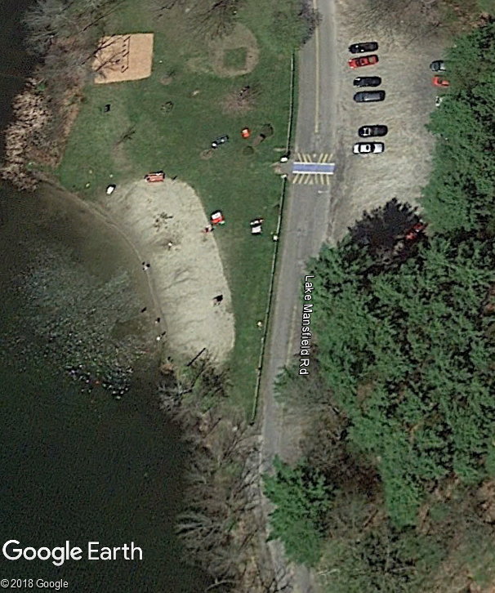
Emergency Vehicle Parking Space
Beach
Parking Area
Photo 1-1
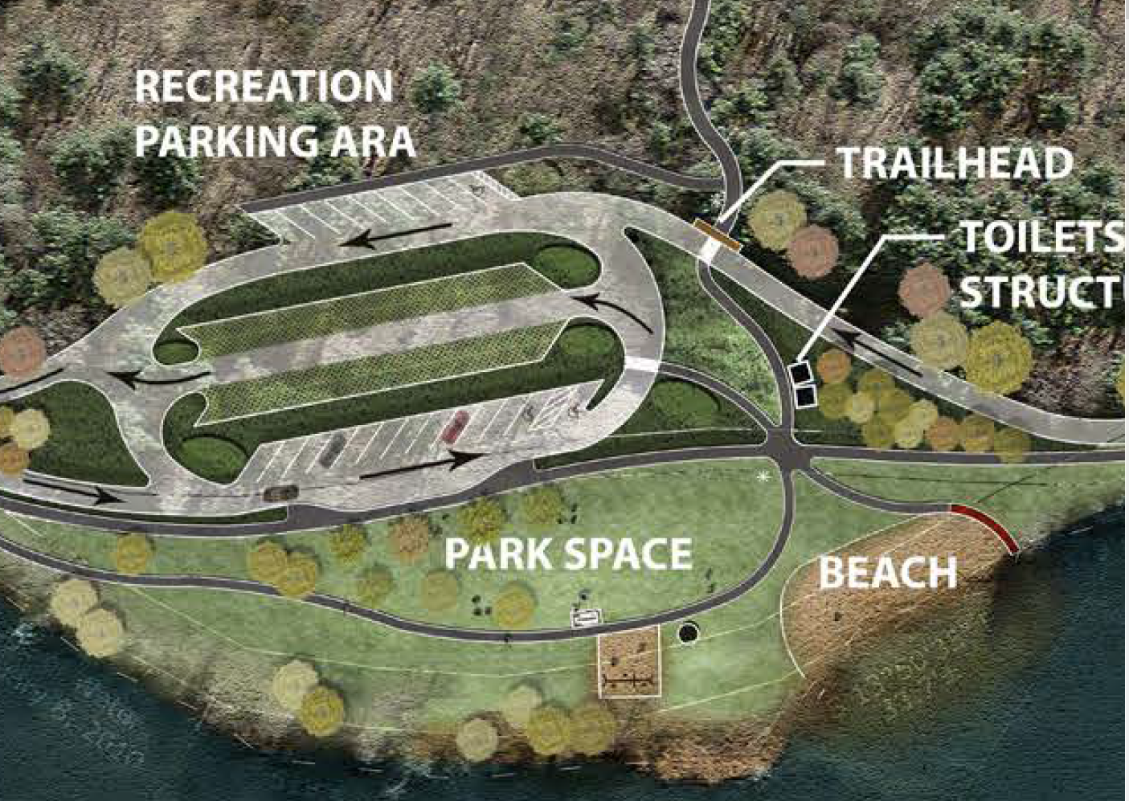
Bioswales
Turf pavers
Bioretention Cells
Photo 1-2
BMP Type: Bioswales, Bioretention Cells, Turf pavers
BMP Location: Lake Mansfield Recreation Area Parking
Site Summary: Stormwater runoff from the unpaved parking lot generally flows southwest across Lake Mansfield Road and across the southern portion of the beach/recreation area. The parking area runoff is currently a significant nonpoint source of sediment to the lake and a source of erosion on the beach and the shoreline south of the beach (current emergency vehicle parking area). Photo 1-1 depicts the current general direction of stormwater runoff from the parking area.
Proposed Improvement: As part of the “Town of Great Barrington Lake Mansfield Recreation Area Improvements” (KZLA, 2016), a conceptual level design was presented for proposed updates to the recreation parking area. Photo 1-2 depicts the concept illustration from the report with some added callouts. The recommended parking plan moves the parking north of its existing location with a total of 50 paved parking spaces. The proposed stormwater management system includes turf pavers for the “overflow” parking spaces, two bioswales and six “small detention basins”. As an update to KZLA’s report, it is recommended that the proposed “small detention basins” be replaced with bioretention cells to allow for greater pollutant removal efficiency.
Expected O&M: Remove accumulated sediment from bioswales, turf pavers, and bioretention cells annually and maintain/replace plants as needed every two years. Re-mulch annually. Remove accumulated sediment/debris, as needed.
Wetland Permitting: It is likely that Wetlands Protection Act (WPA) and Other permitting will be required as part of this work as directed by KZLA.
Parcel Ownership: Town of Great Barrington
Sizing Characteristics
BMP Drainage Area (acres) | 1.60
BMP Size (storm depth; inches) | 0.5
Impervious Area (%) | 19
Estimated Pollutant Load Reduction¹
TP (lbs./yr.) | 0.51
TN (lbs./yr.) | 3.58
TSS (lbs./yr.) | 273.6
Estimated Cost
Planning-level Capital Cost² | $550,000
1. The estimated pollutant load reduction only considers bioretention cells and bioswales for this planning-level estimate.
2. Planning level capital cost obtained from KZLA (2016) report.

Site 2: Emergency Vehicle Parking*
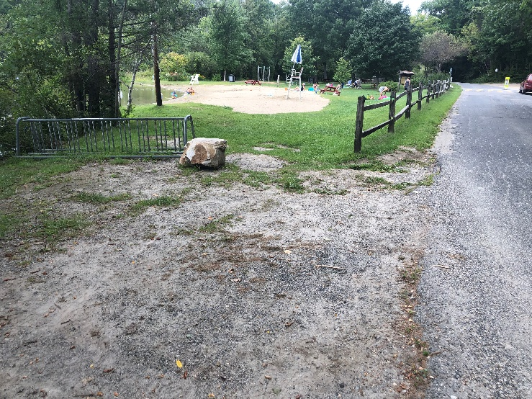
Overflow
Riprap Pad
Extend Fence
Runoff
Bioswale
Grass Paver Parking Pad
Photo 2-1
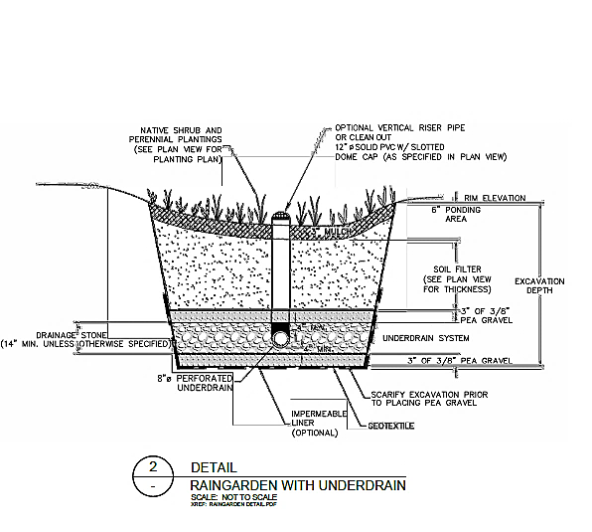
Photo 2-2
BMP Type: Swale, Rain Garden, and Grass Pavers
BMP Location: Rec. Area Emergency Vehicle Parking
*This site is likely not needed if Site 1 is implemented
Site Summary: As summarized above (Site 1), runoff from the Lake Mansfield Recreation Area parking lot flows across the Emergency Vehicle Parking Area and into Lake Mansfield (Photo 1-1). It appears that unstabilized sand/dirt from the Parking Area is eroding and potentially contributing to increased sediment inputs into Lake Mansfield (Photo 1-1). A bike rack and large stone bollard are also at this location.
Proposed Improvement: Install an approx. 50-ft water quality swale (or asphalt Cape Cod berm) along the downstream edge of Lake Mansfield Road across from the Recreation Area parking lot to direct runoff into an approximately 200-square foot rain garden (Example cross-section included in Photo 2-2). Extend the fence around the edge of the rain garden to keep pedestrians from approaching the rain garden; however, provide a gate to allow emergency personnel access. Relocate the rock bollard and bike rack to discourage pedestrians from using this area. Install a mesh grass paver structure to serve as vegetated parking area for emergency vehicles.
Expected O&M: Remove accumulated sediment from water quality swale and rain garden annually and maintain/replace plants as needed every two years. Re-mulch annually. Remove accumulated sediment/debris, as needed.
Wetland Permitting: As a project with minor buffer zone disturbances, Wetlands Protection Act (WPA) permitting is expected to require submittal of a Notice of Intent.
Parcel Ownership: Town of Great Barrington
Sizing Characteristics
BMP Drainage Area (acres)¹ | 0.30
BMP Size (storm depth; inches) | 0.5
Impervious Area (%) | 100
Estimated Pollutant Load Reduction
TP (lbs./yr.) | 0.34
TN (lbs./yr.) | 2.61
TSS (lbs./yr.) | 124.7
Estimated Cost
Planning-level Capital Cost | $11,000
1. This drainage area only considers the impervious parking lot given size constraints; excess flow will be configured to overflow from the bioretention cell to the lake via a stabilized outlet.
Site 3: Lake Mansfield Road Area Improvements
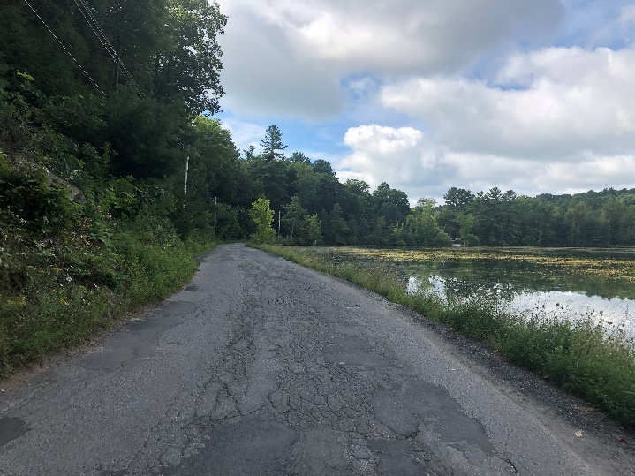
Ponding
Asphalt deterioration
Vegetated Bank Destruction
Photo 3-1

BMP Type: Bank, Road, and Drainage Revitalization
BMP Location: Lake Mansfield Road
Site Summary: Lake Mansfield Road is a heavily used vehicle and pedestrian road that is suffering from severe asphalt deterioration, lack of a formal drainage system, and continued destruction of the vegetated buffer around the Lake’s edge (Photo 3-1).
Proposed Improvement: Several Improvements are being considered for rehabilitation of Lake Mansfield Road:
- Increase vegetated lake buffer by reducing width of asphalt road by 4-5 feet (Photo 3-2), leaving road width to be between 14 and 18 feet;
- Install formal drainage swales at upstream edge of road to reduce ponding issues and asphalt destruction; and
- Install riprap filtration channels (Rock Sandwich) underneath the road at all existing functioning and failed culvert points to improve water filtration prior to discharging into the Lake.
A preliminary design set (not for construction) dated August 2018 was prepared by Woodard and Curran. More detailed information can be found in “Town of Great Barrington Lake Mansfield Recreation Area Improvements” (KZLA, 2016). The cost estimate for construction, design and permitting presented in the KZLA report is approximately $1,260,000. Potential BMP sizing characteristics are unknown.
Depending on selected BMPs and road width, it is expected that road rehabilitation could result in up to 600 pounds per year of TSS reduction as summarized in the Introduction section of this WBP.
Note that property ownership varies along the road. Coordination of easements with owners may be necessary.

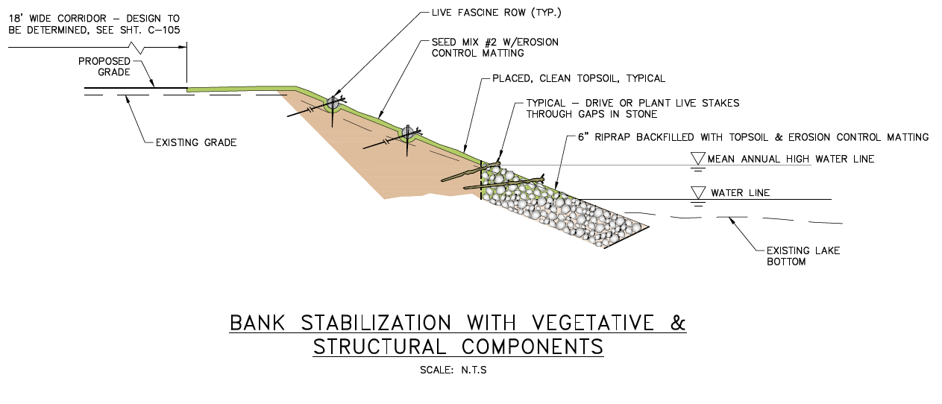
Photo 3-2
Site 4: East View Pool Club
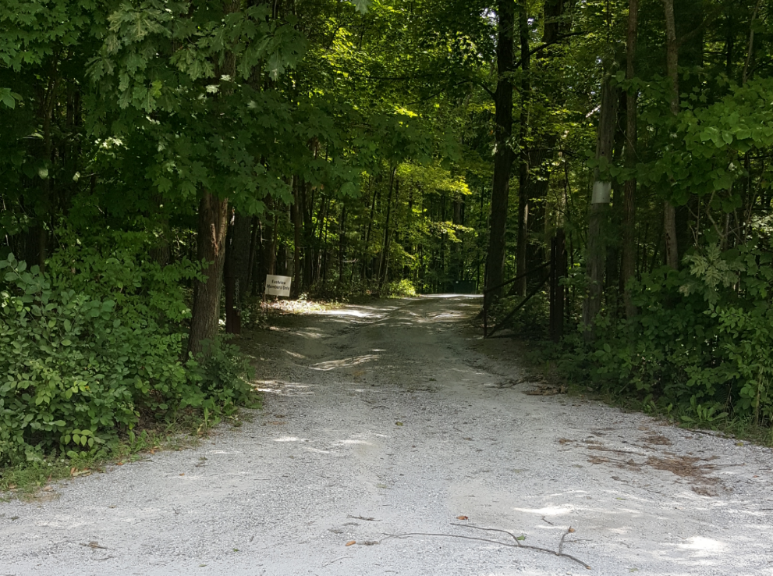
Erosion
Flow Direction
Photo 4-1
Photo 4-2
Proposed Crown Paved Driveway
Water Quality Swale
Water Quality Swale
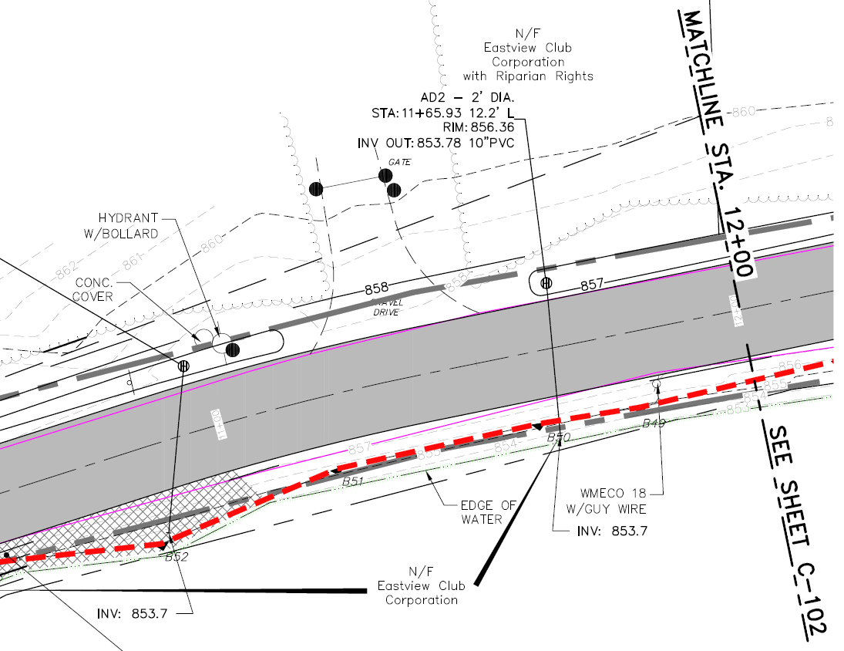
Proposed Catch Basins
Photo 4-3

Proposed Swales

Water Quality Swale
Water Quality Swale
Crowned Paved Driveway
BMP Type: Driveway Stabilization and Water Quality Swales
BMP Location: 32 Lake Mansfield Road
Site Summary: Deep gully erosion was visible on the East View Pool Club driveway. Runoff from the unstabilized gravel/dirt driveway flows across Lake Mansfield Road into Lake Mansfield and is a significant nonpoint source of sediment into Lake Mansfield (Photo 4-1).
Proposed Improvement: Install water quality swales on both sides of the driveway. Pave an approximately 200-ft section of driveway (up to the high point) and crown the driveway centerline to convey runoff into the ditches and ultimately into the catch basins along Lake Mansfield Road that are proposed in the August 2018 Lake Mansfield Road Area Improvement Preliminary Design Set (Photo 4-2 & Photo 4-3). Pipes are proposed from the catch basins, which discharge into Lake Mansfield.
Expected O&M: Remove accumulated sediment from rock ditches annually. Remove accumulated leaf or other debris, as needed.
Wetland Permitting: As a project with minor buffer zone disturbances, WPA permitting is expected to require submittal of an NOI.
Parcel Ownership: Private – coordination of easements with owner may be necessary.
Sizing Characteristics
BMP Drainage Area (acres) | .76
BMP Size (storm depth; inches) | 0.5
Impervious Area (%) | 12
Estimated Pollutant Load Reduction
TP (lbs./yr.) | 0.03
TN (lbs./yr.) | 0.0
TSS (lbs./yr.)¹ | 38.7
Estimated Cost
Planning-level Capital Cost | $38,000
1. The TSS pollutant load reduction will likely be greater, since this estimate doesn’t consider the stabilization of the driveway.

Site 5: Fishing Access
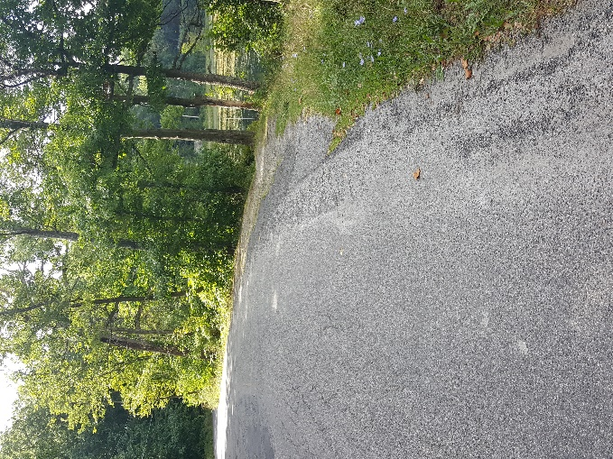
Photo 5-1
Vehicle parking at Shoulder
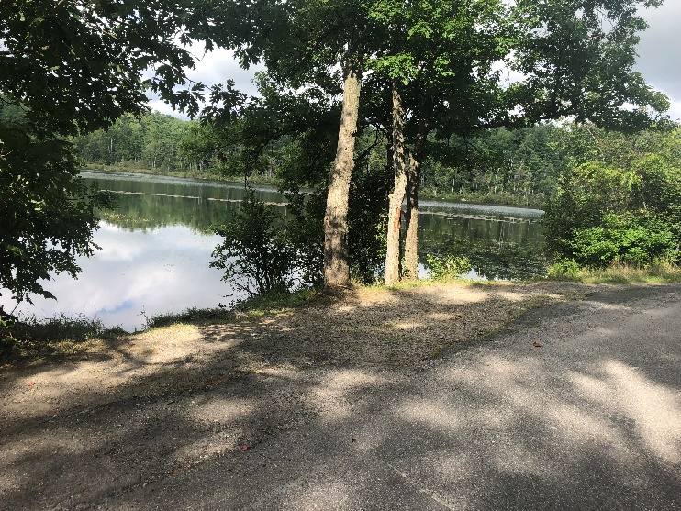
Photo 5-2
Large Rock or Bollards
No Parking Signage
Revegetation and Stabilization
BMP Type: Vegetative Stabilization and Parking Restriction
BMP Location: 30 Lake Mansfield Road
Site Summary: The homeowner at 30 Lake Mansfield Road owns the lake access across the road from their driveway where people often park their car and fish along the bank. Vehicle parking on this narrow buffer zone has created bank erosion issues and increased sediment inputs into Lake Manfield (Photo 5-1).
Proposed Improvement: The homeowner has indicated that this location should remain open to fishermen but supports restricting parking to limit erosion (the public can park at the beach and walk to this location). Install several large rock or pole bollards along the edge of the existing pavement to block off areas for vehicle parking. Install ‘no-parking’ signage near the bollards. Re-vegetate the bank area between the edge of the road and the Lake’s edge. Install a small path for fisherman’s access (Photo 5-2).
Expected O&M: Re-vegetate annually if bare soils are observed after the initial seeding/planting of the area.
Parcel Ownership: Private - coordination of easements with owner may be necessary.
Sizing Characteristics
BMP Drainage Area (acres) | 0.4
BMP Size (storm depth; inches) | --
Impervious Area (%) | 28
Estimated Pollutant Load Reduction
TP (lbs./yr.) | 0.0
TN (lbs./yr.) | 0.19
TSS (lbs./yr.) | 25.3
Estimated Cost
Planning-level Capital Cost | $6,000

Site 6: Boat Launch
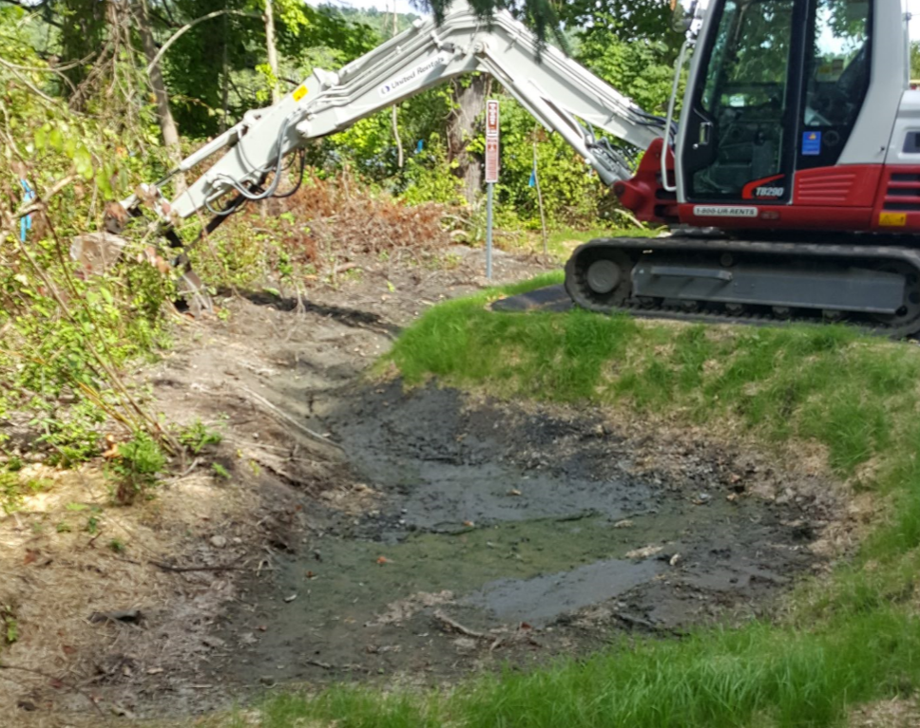
Photo 6-1
Runoff
Bioretention Cell
Runoff
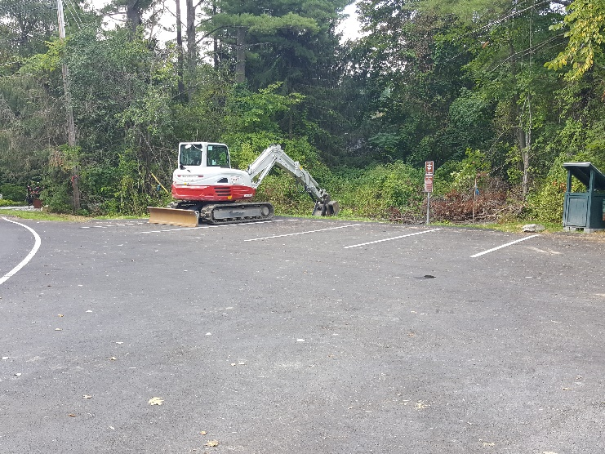
Photo 6-2
Recently paved boat launch parking area
Bioretention Cell
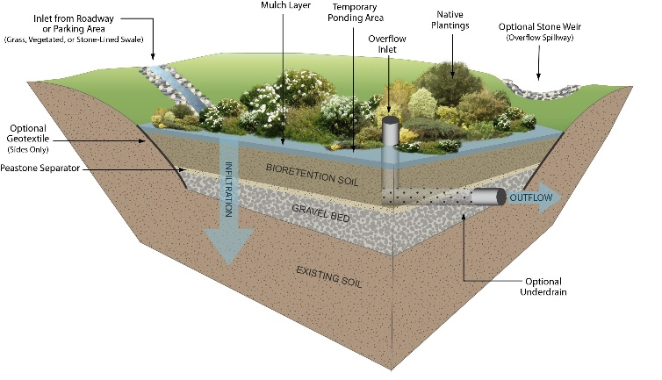
Photo 6-3
BMP Type: Bioretention Cell
BMP Location: Lake Mansfield Boat Launch
Summary: Runoff from Knob Hill Road has historically caused erosion and sedimentation issues at the Lake Mansfield Boat Launch. Stormwater BMP improvements are nearing completion at the boat launch. The improvements include concrete paving of the boat launch and parking spaces, added curbing, restoring vegetated buffer, and an approximately 660-sf grassed depression that collects runoff from the boat launch area (Photo 6-1 & Photo 6-2). The current depression does not have a gravel bed layer, bioretention soil media layer or native plantings.
Proposed Improvement: Make the existing vegetated depression a bioretention cell by installing a 6-inch gravel bed layer and a 2.5-4 feet thick bioretention cell soil media layer to increase biological treatment of the stormwater infiltrating through the bioretention cell. Also install 2-3 inches of mulch and include a minimum of 6-inch ponding depth. In addition, native species should be planted within the ponding area of the bioretention cell to improve bioretention resiliency, stormwater treatment, biodiversity and aesthetics (Photo 6-3). With some added informational signage, this BMP could also have significant public education and outreach value.
Expected O&M: Remove accumulated sediment from the bioretention cell and vegetate annually. Replant grass and native plantings as needed to maintain adequate vegetative cover. Remove accumulated debris prior to mowing.
Wetland Permitting: Not expected, proposed improvements are maintenance related tasks to improve functionality.
Parcel Ownership: Town of Great Barrington
Sizing Characteristics
BMP Drainage Area (acres) | 0.37
BMP Size (storm depth; inches) | 0.5
Impervious Area (%) | 100
Estimated Pollutant Load Reduction
TP (lbs./yr.) | 0.42
TN (lbs./yr.) | 3.22
TSS (lbs./yr.) | 153.7
Estimated Cost
Planning-level Capital Cost | $10,000

Site 7: Knob Hill Road
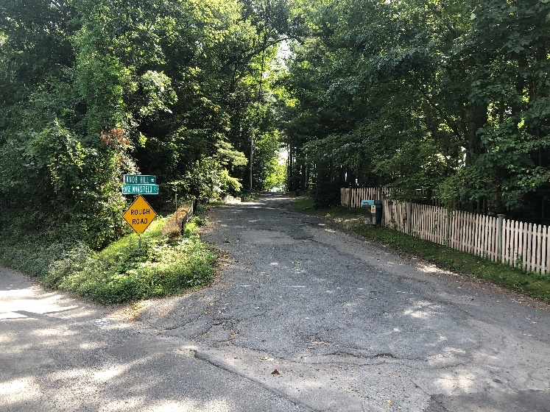
Intersection of Knob Hill Road and Lake Mansfield Road
Runoff
Photo 7-1
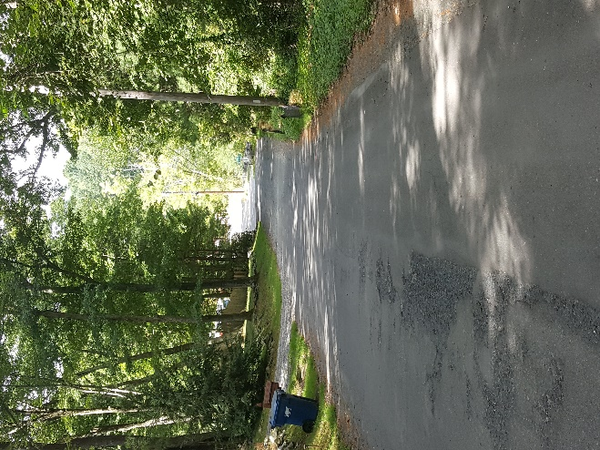
Photo 7-2
High point of Knob Hill Road
BMP Type: Hydrodynamic Separator
BMP Location: Knob Hill Road
Site Summary: Knob Hill Road is a steep residential road with several unpaved driveways. The steep grade of the residential road and lack of proper drainage system has resulted in destructive stormwater flows that cause erosion as well as sediment inputs into Lake Mansfield. Knob Hill Road has been identified as a consistent source of nonpoint stormwater pollution (Town of Great Barrington, 2017) (Photo 7-1 & Photo 7-2).
Proposed Improvement: The details of the proposed improvement, which is currently out to bid is included in the plan set entitled “Knob Hill Road Drainage Improvements” (Foresight Land Services, 2018). The design includes paving the road up to the high point with 4.5” bituminous concrete; installing a curb system; and installing a series of catch basins along both sides of the road, which will be piped to manholes and stormwater pipes underneath the centerline of the road. The proposed stormwater sewer system will eventually discharge to a hydrodynamic separator proposed at the intersection of Knob Hill Road and Lake Mansfield Road. The hydrodynamic separator is proposed to discharge through a pipe to a stone pad outlet structure and a grass reinforced swale along Lake Mansfield Road. The swale will eventually discharge to the existing wetland along Lake Mansfield Road. See Site 3 for additional information on proposed improvements to Lake Mansfield Road.
Expected O&M: Remove accumulated sediment from hydrodynamic separator, stone pad outlet structure, and grass reinforced swale annually and maintain vegetative cover as needed. Remove accumulated debris as needed.
Parcel Ownership: Town of Great Barrington
Sizing Characteristics
BMP Drainage Area (acres) | 0.8
BMP Size (storm depth; inches) | --
Impervious Area (%) | 25%
Estimated Pollutant Load Reduction¹
TP (lbs./yr.) | 0.5
TN (lbs./yr.) | 3.25
TSS (lbs./yr.) | 108.3
Estimated Cost²
Planning-level Capital Cost | $297,000
1. The estimated pollutant load reduction was calculated using the treatment percentages presented in “Knob Hill Stormwater Improvements” (Town of Great Barrington, 2017).
2. The estimated cost is detailed in “Knob Hill Stormwater Improvements” (Town of Great Barrington, 2017).

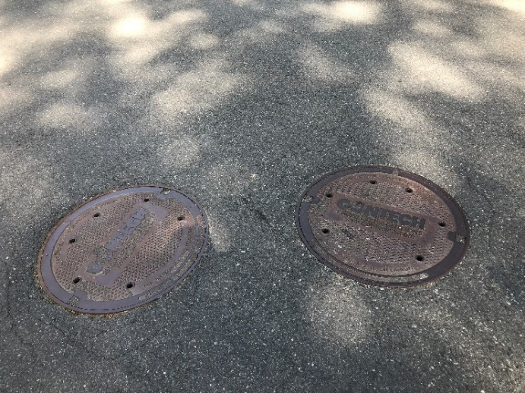
Photo 8-1
Hydrodynamic Separators
Hydrodynamic Separators
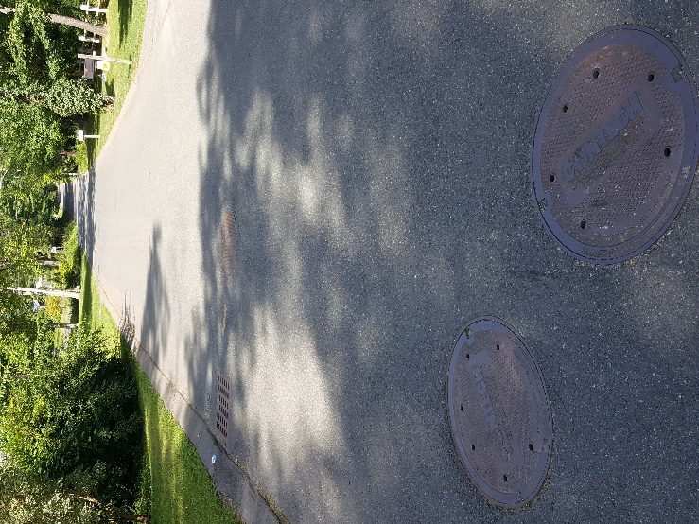
Photo 8-2
Catch basins
Site 8: Castle Hill Drainage System (Existing)
BMP Type: Hydrodynamic Separator and Catch Basins
BMP Location: Castle Hill Avenue
Site Summary: A new drainage system was installed on Castle Hill Avenue in August 2013, which addressed one of the major sources of nonpoint source runoff to the lake (Photo 8-1 and 8-2). The project involved installation of a new stormwater system including 12 deep sump catch basins and one hydrodynamic stormwater treatment unit along Castle Hill Avenue. The system was estimated to treat a 17.4 acre area. Sediment collected in the catch basins and hydrodynamic separator were measured and it was estimated that the system is removing approximately 30 ton/year of TSS. The project was funded by the Town of Great Barrington as well as through a 319 grant (Project No. 11-05/319). Record Drawings were prepared by Tighe and Band.
O&M: There is an operation and maintenance plan available for the system. The success of the hydrodynamic separators is proportional to the operation and maintenance schedule for clean-out and inspection of the catch basins. The system is maintained annually, and the catch basins and separators are vacuumed out. Approximately 30 tons of sediment was vacuumed out of this Castle Hill Avenue system after year 1, and we estimate that is about what is captured in the system annually.
Parcel Ownership: Town of Great Barrington
Sizing Characteristics
BMP Drainage Area (acres) | 17.4
BMP Size (storm depth; inches) | -
Impervious Area (%) | 22
Estimated Pollutant Load Reduction
TP (lbs./yr.) | -
TN (lbs./yr.) | -
TSS (lbs/yr.)¹ | 60,000
Estimated Cost
Planning-level Capital Cost | N/A (already completed)
1. Estimated based on information from Town of Great Barrington (30 ton/yr).

Site 9: Pothul Drive
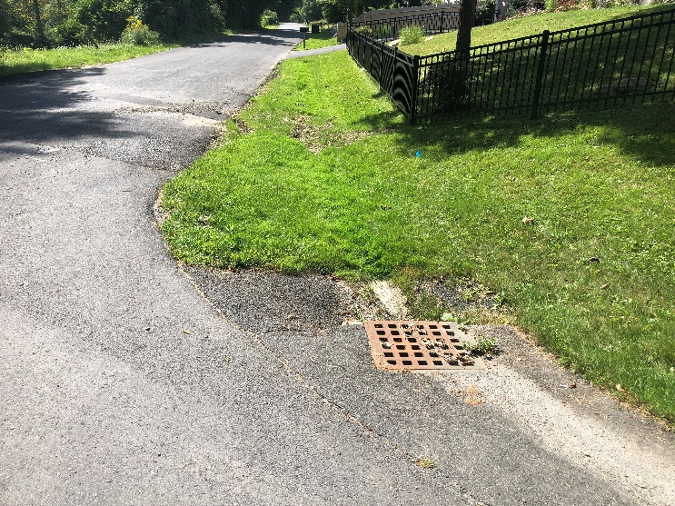
Photo 9-1
Existing Catch Basin
Runoff
Water Quality Swale 1
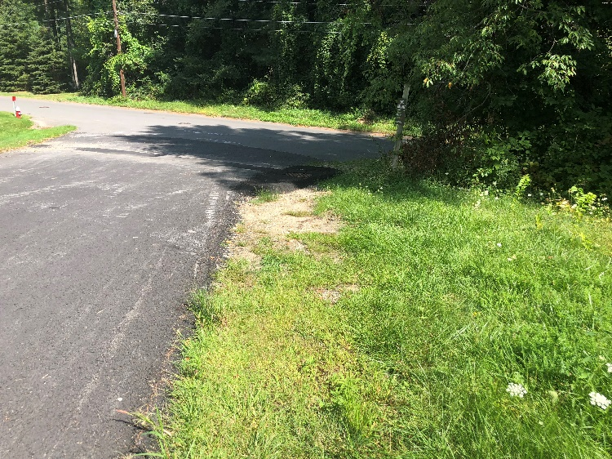
Photo 9-2
Existing Catch Basin
Runoff
Water Quality Swale 2
BMP Type: Water Quality Swales
BMP Location: Intersection of Pothul Drive and Castle Hill Avenue
Site Summary: Runoff from Pothul Drive and Castle Hill Avenue drains into two existing catch basins at either side of Pothul Drive where it intersects with Castle Hill Avenue. These catch basins are part of the Castle Hill drainage system, which was implemented in 2013 (Site 8). Unstabilized soil was observed up-gradient of the catch basins.
Proposed Improvement: Install two grass-lined water quality swales upstream of the catch basins to treat the stormwater prior to discharging into the catch basins. Water quality swale 1 (Photo 9-1) will be approximately 80 feet long. Water quality swale 2 (Photo 9-2) will be approximately 40 feet long. Depending on further analysis, a rock-lined swale may be more appropriate, which may help to capture more sediment and reduce erosion.
Expected O&M: Remove accumulated sediment and debris maintain/replace grasses as needed annually.
Parcel Ownership: Town of Great Barrington (Right-of-Way)
Sizing Characteristics
BMP Drainage Area (acres) | 7.12
BMP Size (storm depth; inches) | 0.5
Impervious Area (%) | 16
Estimated Pollutant Load Reduction
TP (lbs./yr.) | 0.31
TN (lbs./yr.) | -
TSS (lbs./yr.) | 438
Estimated Cost
Planning-level Capital Cost | $9,000
1. Site 9 is within the existing Castle Hill Drainage System (Site 8). TSS load reductions achieved by Site 9 would reduce the load to the downstream hydrodynamic separator.
Site 10: Castle Hill Avenue and Lakeview Road
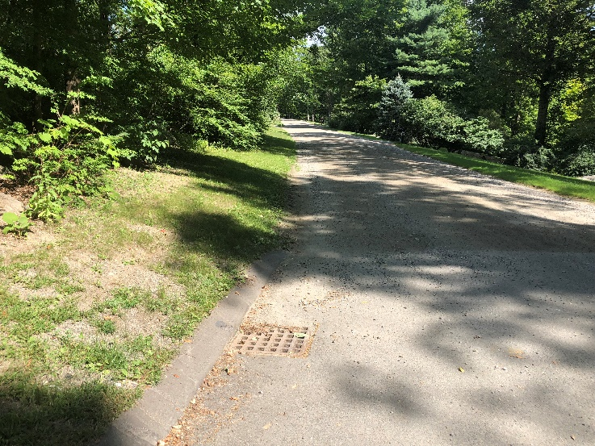
Photo 10-1
Vegetate Bare Area
Runoff
Pave Bare Section
Catch Basin
BMP Type: Road Paving and Bank Slope Stabilization
BMP Location: Intersection of Lakeview Road and Castle Hill Avenue
Site Summary: Stormwater runoff flows along a portion of Lake View Road, which is unpaved and enters the catch basin, which is at the intersection with Castle Hill Avenue. This catch basin is part of the Castle Hill drainage system, which was implemented in 2013 (Site 8). Evidence of gravel and sediment tracking into and around the catch basin from the dirt road was observed during the 9/4/18 field visit. An unstabilized area located within a road easement also exists adjacent and upgradient of the catch basin.
Proposed Improvement: Pave an approx. 30-ft section of Lakeview road upgradient of the catch basin to reduce sediment inflow from vehicle tracking to the existing catch basin. Vegetate the partially bare slope upgradient of the existing catch basin (Photo 8-1).
Expected O&M: Re-vegetate areas of bare soil as needed. Remove or sweep accumulated sediment/debris away from catch basins.
Parcel Ownership: Town of Great Barrington
Sizing Characteristics
BMP Drainage Area (acres) | 2.9
BMP Size (storm depth; inches) | --
Impervious Area (%) | 17
Estimated Pollutant Load Reduction
TP (lbs./yr.) | see note1
TN (lbs./yr.) | see note 1
TSS (lbs./yr.) | see note 1
Estimated Cost
Planning-level Capital Cost | $4,000
1. Site 10 is within the existing Castle Hill Drainage System (Site 8). Any TP, TN or TSS load reductions achieved by Site 10 would reduce the load to the downstream hydrodynamic separator.
Site 11: Castle Hill Avenue and Fern Hill Road
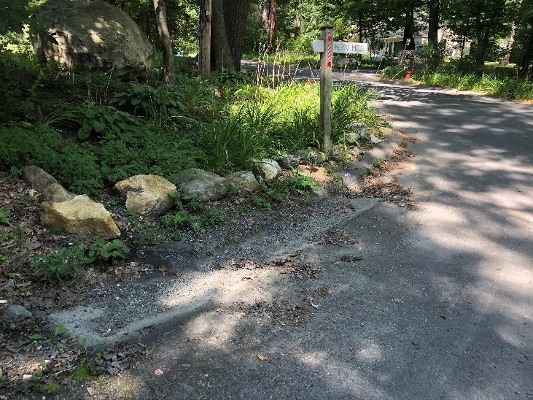
Photo 11-1
Existing Catch Basin
Existing Rock Swale
Runoff
Check Dams
Check Dams
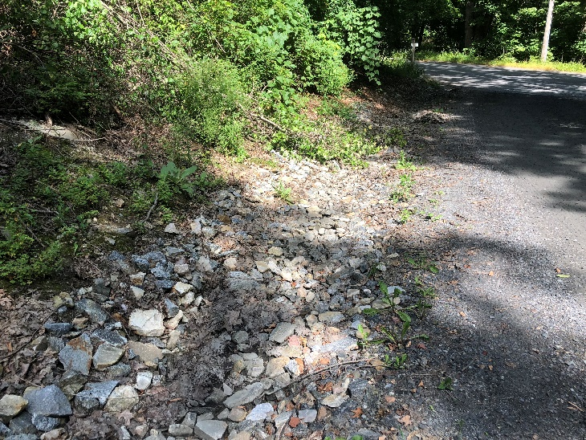
Photo 11-2
Catch Basin
Leaf and Sediment Buildup
Rock Swale
BMP Type: Rock Swale Maintenance and Check Dams
BMP Location: Intersection of Castle Hill Avenue and Fern Hill Rd
Site Summary: Residential Road runoff from Fern Hill Road is conveyed towards a catch basin on Castle Hill Avenue via an existing approx. 70-ft rock-lined drainage swale. The drainage swale appeared to be clogged with leaf debris and sediment (Photo 11-2).
Proposed Improvement: Maintain the Fern Hill Road rock-lined swale by removing accumulated debris. Install 2 – 3 rock check dams near the terminal end of the swale to reduce the velocity of the runoff and to also add convenient maintenance points for debris and sediment removal (Photo 11-1).
Expected O&M: Remove accumulated sediment semi-annually. Remove accumulated yard waste or leaf debris as needed.
Parcel Ownership: Town Owned (Right-Of-Way)
Sizing Characteristics
BMP Drainage Area (acres) | 3.4
BMP Size (storm depth; inches) | --
Impervious Area (%) | 2
Estimated Pollutant Load Reduction
TP (lbs./yr.) | see note 1
TN (lbs./yr.) | see note 1
TSS (lbs./yr.) | see note 1
Estimated Cost
Planning-level Capital Cost | $4,000
1. Site 11 is within the existing Castle Hill Drainage System (Site 8). Any TP, TN or TSS load reductions achieved by Site 10 would reduce the load to the downstream hydrodynamic separator.

