WATERSHED-BASED PLAN
Sevenmile River Watershed within
the Towns of Spencer, Leicester, Paxton, Rutland, Oakham, East Brookfield and Charlton
February 2020

Prepared By:
Geosyntec Consultants, Inc.
Town of Spencer, Massachusetts

Prepared For:
This project has been financed with Federal Funds from the Environmental Protection Agency (EPA) to the Massachusetts Department of Environmental Protection (the Department) under an s. 319 competitive grant. The contents do not necessarily reflect the views and policies of EPA or of the Department, nor does the mention of trade names or commercial products constitute endorsement or recommendation for use
Contents
Executive Summary 1
Introduction 3
Purpose & Need 3
Watershed-Based Plan Outline 3
Project Partners and Stakeholder Input 4
Data Sources 4
Summary of Past and Ongoing Work 5
Element A: Identify Causes of Impairment & Pollution Sources 6
General Watershed Information 6
MassDEP Water Quality Assessment Report and TMDL Review 8
Additional Water Quality Data 24
Water Quality Impairments 32
Water Quality Goals 34
Land Use Information 37
Pollutant Loading 43
Element B: Determine Pollutant Load Reductions Needed to Achieve Water Quality Goals 45
Estimated Pollutant Loads 45
Water Quality Goals 45
Recommended Load Reduction 47
Element C: Describe management measures that will be implemented to achieve water quality goals 49
Existing and Ongoing Management Measures 49
Future Management Measures 51
Element D: Identify Technical and Financial Assistance Needed to Implement Plan 53
Current and Ongoing Management Measures 53
Future Management Measures 54
Element E: Public Information and Education 55
Elements F & G: Implementation Schedule and Measurable Milestones 56
Elements H & I: Progress Evaluation Criteria and Monitoring 58
Indirect Indicators of Load Reduction 58
Project-Specific Indicators 60
TMDL Criteria 60
Direct Measurements 60
Adaptive Management 61
References 62
Appendices 65
Appendix A – BMP Design Details
Appendix B – Pollutant Load Export Rates (PLERs)

Executive Summary
Introduction: The purpose of a Massachusetts Watershed-Based Plan (WBP) is to organize information about Massachusetts' watersheds, and present it in a format that will enhance the development and implementation of projects that will restore water quality and beneficial uses in the Commonwealth. The Massachusetts WBP follows USEPA's recommended format for “nine-element” watershed plans. This WBP was developed by Geosyntec Consultants (Geosyntec) under the direction of the Town of Spencer’s Department of Utilities and Facilities with funding, input, and collaboration from the Massachusetts Department of Environmental Protection (MassDEP).
This WBP was prepared for the approximately 40-square mile Sevenmile River watershed, which is a tributary to the Quaboag Pond and Chicopee River . Major streams in the watershed include the Sevenmile River (MA36-11 and MA36-12), Caruth Brook, Cranberry River (MA36-20), Shaw Brook, Turkey Brook, and Turkey Hill Brook. The headwater of Sevenmile River is Browning Pond (MA36025). Other major lakes and ponds in the watershed include Cranberry Meadow Pond (MA36040), Eames Pond (MA36056), Lake Whittemore (MA36165), Moose Hill Reservoir (MA36179), Shaw Pond (MA36138), Sugden Reservoir (MA36150), Thompsons Pond (MA36155), and Turkey Hill Pond (MA36157).
Impairments and Pollution Sources: The Sevenmile River (MA36-11 and MA36-12) flows from Browning Pond (MA36025) in Oakham and is a tributary to the East Brookfield River (MA36-13), which flows into Quaboag Pond (MA36130) in East Brookfield.
The Sevenmile River is a category 5 water body on the 2016 Massachusetts List of Integrated Waters for impairments related to elevated levels of Escherichia coli (E. coli) bacteria due to unknown sources. Because of this impairment, a TMDL for the Sevenmile River is required but has not yet been developed. The headwaters of Sevenmile River, Browning Pond (MA36025), is also a category 5 water body on the 2016 Massachusetts List of Integrated Waters for impairments primarily related to nutrient and biological indicators from unknown sources.
Quaboag Pond (MA36130) is a category 5 water body on the 2016 Massachusetts List of Integrated Waters for impairments primarily related to elevated levels of Total Phosphorus (TP) due to municipal point source discharges, non-point sources, and internal nutrient recycling. Quaboag Pond has a completed TMDL for TP with a target reduction of 30% of TP loading to the pond.
Goals, Management Measures, and Funding: The primary goal of this WBP is to reduce E. coli and TP loading to the Sevenmile River, eventually leading to delisting of impaired waterbodies in the study area from the 2016 Massachusetts List of Integrated Waters (303(d) list). It is expected that these pollutant load reductions will result in improvements to listed impairments throughout the study area.
It is expected that goals will be accomplished primarily through installation of structural BMPs to capture runoff and reduce loading as well as implementation of non-structural BMPs (e.g., street sweeping, catch basin cleaning), and watershed education and outreach. Eight structural BMPs at three different sites (Powder Mill Park, Spencer Water Treatment Plant, and Spencer Department of Public Works) were previously constructed by the Town of Spencer under the Federal Fiscal Year 2017 Section 319 grant (Project Number 17-09/319). Additional structural BMPs will be implemented in the Town of Spencer at Spencer Road, Meadow Road, and Meadowbrook Lane per the Federal Fiscal Year 2020 Section 319 grant (Project Number 20-03/319). Additional planning and implementation is also expected to be performed in subsequent years, focusing on each water body in the study area.
It is expected that funding for management measures will be obtained from a variety of sources including Section 319 Grant Funding, Town capital funds, volunteer efforts, and other sources.
Public Education and Outreach: Goals of public education and outreach are to provide information about proposed stormwater improvements and their anticipated benefits and to promote watershed stewardship. The Town of Spencer aims to engage watershed residents, businesses, and watershed organizations through newsletters, informational signage, online resources, and project presentations at Central Massachusetts Regional Stormwater Coalition (Coalition) meetings. It is expected that these programs will be evaluated by website activity, number of newsletters and flyers distributed, attendance at Coalition meetings, other tools applicable to the type of outreach performed.
Implementation Schedule and Evaluation Criteria: Project activities will be implemented based on the information outlined in the following elements for monitoring, implementation of structural BMPs, public education and outreach activities, and periodic updates to the WBP. It is expected that a water quality monitoring program will enable direct evaluation of improvements over time. Other indirect evaluation metrics are also recommended, included quantification of potential pollutant load reductions from non-structural BMPs (e.g., street sweeping). The long-term goal of this WBP is to de-list the all waterbodies within the study area from the 303(d) list by 2035. The WBP will be re-evaluated and adjusted, as needed, once every three years.

Introduction
What is a Watershed-Based Plan?

Purpose & Need
The purpose of a Massachusetts Watershed-Based Plan (WBP) is to organize information about Massachusetts' watersheds, and present it in a format that will enhance the development and implementation of projects that will restore water quality and beneficial uses in the Commonwealth. The Massachusetts WBP follows USEPA's recommended format for “nine-element” watershed plans, as described below.
All states are required to develop WBPs, but not all states have taken the same approach. Most states develop watershed-based plans only for selected watersheds. MassDEP's approach has been to develop a tool to support statewide development of WBPs, so that good projects in all areas of the state may be eligible for federal watershed implementation grant funds under Section 319 of the Clean Water Act.
USEPA guidelines promote the use of Section 319 funding for developing and implementing WBPs. WBPs are required for all projects implemented with Section 319 funds, and are recommended for all watershed projects, whether they are designed to protect unimpaired waters, restore impaired waters, or both.

Watershed-Based Plan Outline
This WBP for the Sevenmile River watershed includes nine elements (a through i) in accordance with USEPA Guidelines:
- An identification of the causes and sources or groups of similar sources that will need to be controlled to achieve the load reductions estimated in this watershed-based plan (and to achieve any other watershed goals identified in the watershed-based plan), as discussed in item (b) immediately below.
- An estimate of the load reductions expected for the management measures described under paragraph (c) below (recognizing the natural variability and the difficulty in precisely predicting the performance of management measures over time).
- A description of the nonpoint source (NPS) management measures needed to achieve the load reductions estimated under paragraph (b) above (as well as to achieve other watershed goals identified in this watershed-based plan), and an identification (using a map or a description) of the critical areas in which those measures will be needed to implement this plan.
- An estimate of the amounts of technical and financial assistance needed, associated costs, and/or the sources and authorities that will be relied upon, to implement this plan. As sources of funding, States should consider the use of their Section 319 programs, State Revolving Funds, USDA's Environmental Quality Incentives Program and Conservation Reserve Program, and other relevant Federal, State, local and private funds that may be available to assist in implementing this plan.
- An information/education component that will be used to enhance public understanding of the project and encourage their early and continued participation in selecting, designing, and implementing the NPS management measures that will be implemented.
- A schedule for implementing the NPS management measures identified in this plan that is reasonably expeditious.
- A description of interim, measurable milestones for determining whether NPS management measures or other control actions are being implemented.
- A set of criteria to determine if loading reductions are being achieved over time and substantial progress is being made towards attaining water quality standards and, if not, the criteria for determining whether this watershed-based plan needs to be revised or, if a NPS Total Maximum Daily Load (TMDL) has been established, whether the TMDL needs to be revised.
- A monitoring component to evaluate the effectiveness of the implementation efforts over time, measured against the criteria established under item (h) immediately above.

Project Partners and Stakeholder Input
This WBP was developed by Geosyntec Consultants (Geosyntec) under the direction of the Town of Spencer with funding, input, and collaboration from the Massachusetts Department of Environmental Protection (MassDEP). This WBP was developed using funds from the Section 319 program to assist grantees in developing technically robust WBPs using MassDEP’s Watershed-Based Planning Tool. Spencer was a recipient of Section 319 funding in Federal Fiscal Year 2017 and Federal Fiscal Year 2020 to implement stormwater best management practices (BMPs) in the Sevenmile River watershed.
Core project stakeholders included:
- Bill Krukowski – Town of Spencer, Utilities and Facilities Superintendent
- Matt Reardon - MassDEP
This WBP was developed as part of an iterative process. The Geosyntec project team collected and reviewed existing data from the Town of Spencer. This information was then used to develop a preliminary WBP for review by core project stakeholders. A stakeholder conference call was then held to solicit input and gain consensus on elements included in the plan (e.g., water quality goals, public outreach activities, etc.). The WBP was finalized once stakeholder consensus was obtained for all elements.

Data Sources
This WBP was developed using the framework and data sources provided by MassDEP’s Watershed-Based Plan Tool and supplemented by information provided in the 2016 and 2019 Section 319 Nonpoint Source Pollution Grant Program applications for “Town of Spencer Stormwater BMPs: Sevenmile River Watershed Project” (Town of Spencer, 2016; Town of Spencer, 2019a). Additional data sources were reviewed and are summarized in subsequent sections of this WBP, if relevant, as listed by Table 1.

Table 1: Supplemental Data Sources
Title / Description | Source | Date
Project Number 17-09/319 Final Report | Town of Spencer | 2019
Chicopee River Watershed SMART Monitoring Program 2005 - 2010 | MassDEP | 2017
Chicopee River Watershed SMART Monitoring Program 2011 - 2013 | MassDEP | 2017
Technical Memorandum CN 323.2 Chicopee River Watershed 2008 Macroinvertabrate Bioassessment | MassDEP | 2014
Technical Memorandum CN 323.1 Chicopee River Watershed 2008 DWM Water Quality Monitoring Data | MassDEP | 2013
Total Maximum Daily Loads of Total Phosphorus for Quaboag & Quacumquasit Ponds | MassDEP | 2006

Summary of Past and Ongoing Work
The Town of Spencer was awarded funding through the Federal Fiscal Year 2017 and Federal Fiscal Year 2020 Section 319 Nonpoint Source Pollution Grant Program to install the proposed structural BMPs listed in Table 2 within the Sevenmile River watershed (Town of Spencer, 2016; Town of Spencer, 2019a). Currently, the Town of Spencer has completed construction of eight individual BMPs at three different sites. The remaining BMPs proposed under the 2017 and 2020 grants are in various phases of completion, as indicated in Table 2.
Table 2: Summary of Past and Ongoing Work in Sevenmile River Watershed
Location | Proposed and/or Completed BMPs | Project Number | Current  Project  Status
Powder Mill Park | - Sediment Forebay  - Rain Garden | 17-09/319 | CONSTRUCTED
Spencer Water Treatment Plant | - Sediment Forebay  - Rain Garden | 17-09/319 | CONSTRUCTED
Spencer Department of Public Works Building | - Grass Sediment Forebay  - Grass Swale  - Rain Garden | 17-09/319 | CONSTRUCTED
84 North Spencer Road | - Infiltration practice such as rain garden, bioswale, or infiltration basin with appropriate pre-treatment | 20-03/319 | IN DESIGN
Hillsville/Meadow Road | - Infiltration practice such as rain garden, bioswale, or infiltration basin with appropriate pre-treatment | 20-03/319 | DESIGN COMPLETED
Pleasant Street/Meadowbrook Lane | - Underground Infiltration Chamber | 20-03/319 | DESIGN COMPLETED & IN CONTRACTING
30 Meadow Road | - Sediment Forebay  - Rain Garden | 20-03/319 | DESIGN COMPLETED & IN CONTRACTING

Element A: Identify Causes of Impairment & Pollution Sources

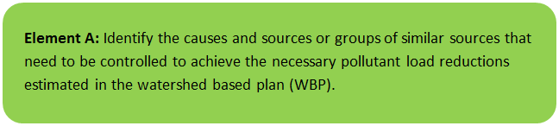

General Watershed Information
This WBP was prepared for the Sevenmile River watershed, which is primarily located in the Town of Spencer, Massachusetts and was delineated to a point approximately 1 mile upstream of the Sevenmile River’s confluence with the East Brookfield River (MA36-13). The East Brookfield River flows into Quabong Pond (MA36130). Other towns in the Sevenmile River watershed include Charlton, Leicester, Oakham, Paxton, and Rutland, Massachusetts. The headwater of Sevenmile River is Browning Pond (MA36025). Other lakes/ponds in the watershed include Cranberry Meadow Pond (MA36040), Eames Pond (MA36056), Lake Whittemore (MA36165), Moose Hill Reservoir (MA36179), Shaw Pond (MA36138), Sugden Reservoir (MA36150), Thompsons Pond (MA36155), and Turkey Hill Pond (MA36157). The Sevenmile River has a drainage area of approximately 25,500 acres (approximately 40 square miles) and is within the Chicopee River Basin.
Table A-1 presents the general watershed information for the Sevenmile River watershed and Figure A-1 includes a map of the watershed boundary.
Table A-1: General Watershed Information
Watershed Name (Assessment Unit ID): | Caruth Brook; Cranberry River (MA36-20); Sevenmile River (MA36-11); Sevenmile River (MA36-12); Shaw Brook (MA32-52); Turkey Brook; Turkey Hill Brook (MA36-49)
Major Basin: | Chicopee River
Watershed Area (within MA): | 25,489 acres

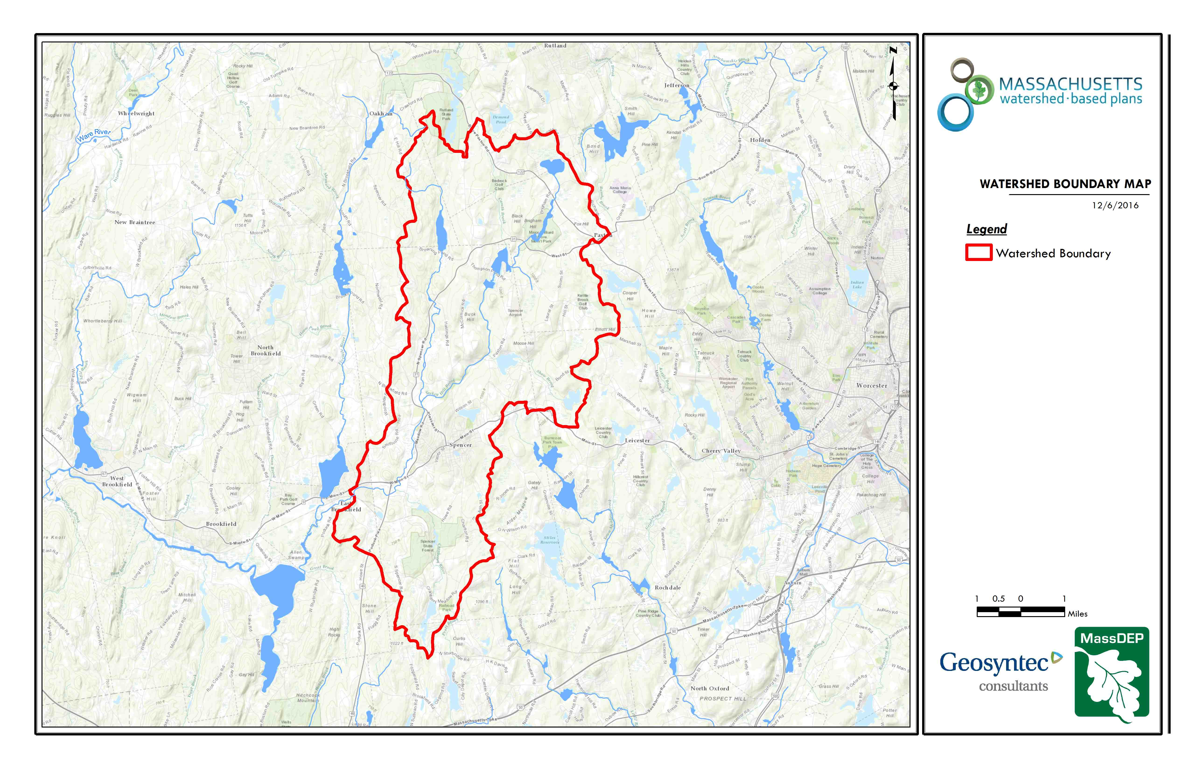
Figure A-1: Sevenmile River Watershed Boundary Map
(MassGIS, 2007; MassGIS, 1999; MassGIS, 2001; USGS, 2016)

MassDEP Water Quality Assessment Report and TMDL Review
The following reports are available:

- Chicopee River Watershed 2003 Water Quality Assessment Report
- Total Maximum Daily Loads of Total Phosphorus for Quaboag & Quacumquasit Ponds
- Chicopee River Watershed 2008 DWM Water Quality Monitoring Data
- Chicopee River Watershed 2008 Macroinvertebrate Bioassessment
- Chicopee River Watershed SMART Monitoring Program 2005 – 2010
- Chicopee River Watershed SMART Monitoring Program 2011 – 2013
- Diagnostic Evaluation Management Alternatives and Recommendations: 21 Commonwealth Lakes and Ponds
Select excerpts and summaries from these documents relating to the water quality in the Sevenmile River (MA36-11 and MA36-12), Cranberry River (MA36-20) and Quaboag Pond (MA36130) are included below. Quaboag Pond is located downstream and outside of the Sevenmile River watershed. A summary of the TMDL is included because actions taken in the Sevenmile River watershed contribute to achieving TMDL goals in Quaboag Pond. Relevant information is included directly from the “Chicopee River Watershed 2003 Water Quality Assessment Report,” “Total Maximum Daily Loads of Total Phosphorus for Quaboag & Quacumquasit Ponds,” and “Chicopee River Watershed 2008 DWM Water Quality Monitoring Data” documents for informational purposes and have not been modified. Relevant Information from the “Chicopee River Watershed 2008 Macroinvertebrate Bioassessment,” “Chicopee River Watershed SMART Monitoring 2005 – 2010,” and “Chicopee River Watershed SMART Monitoring Program 2011 – 2013” are summarized from a document received on December 23, 2019 via email communication with Matthew Reardon, MassDEP (Reardon, 2019).
Chicopee River Watershed 2003 Water Quality Assessment Report (MA36-20 - Cranberry River)
Aquatic Life Use
Biology
MA DFG stocks the Cranberry River and Howe Pond with trout (MA DFG 2007). MA DFG conducted fish population sampling in Cranberry River near Howe Road, Spencer State Park, Spencer (Site 1147), on 2 August 2005 using a backpack electro-shocker (Richards 2006). Thirty yellow bullhead, twelve pumpkinseed, nine bluegill, eight white sucker, six chain pickerel, two brown trout, two largemouth bass, one black crappie, one tadpole madtom, and one fallfish were collected (72 fish total).
The Cranberry River is considered to be a Coldwater Fishery Resource under criteria developed by the MA DFG. At one station in 1983 multiple age classes of reproducing brook trout were collected (Richards 2006). Although the 2005 survey did not result in the collection of brook trout it is unclear as to the exact location of the 1983 sampling station. The fish assemblage documented as result of the 2005 survey consists of mostly macrohabitat generalist species. It is possible that the species composition is habitat related since the 2005 sampling station is just downstream from Howe Pond in and upstream from a forested wetland. Additional monitoring of the Cranberry River in an attempt to document the continued presence and extent of brook trout within this watershed is warranted.
Toxicity
Ambient
The Spencer Wastewater Treatment Plant (WWTP) staff collected water from the Cranberry River at the South Spencer Road Crossing for use as dilution water in the facility’s whole effluent toxicity tests. Between May 2003 and May 2007 survival of C. dubia exposed (approximately 7 days) to the Cranberry River water ranged from 70 to 100% (n=17). Survival was <75% in only one test. Hardness ranged from 18.0 mg/L to 44.0 mg/L (n=17).
Effluent
Whole effluent toxicity tests have been conducted on the Spencer Wastewater Treatment Plant (WWTP) treated effluent. Between May 2000 and May 2007, twenty-two valid chronic tests were conducted using C. dubia. The chronic whole effluent toxicity tests using C. dubia were all >100% effluent (n=27). Results of the LC50 were all 100% effluent (n=24) (Appendix D).
Water Chemistry
DWM conducted water quality monitoring at one station (CRN01-South Spencer Road, Spencer) along this segment of the Cranberry River between May and October 2003 (Appendix B). In-situ parameters were measured on eight occasions, including three pre-dawn occasions. Grab samples were also collected and analyzed for TSS, turbidity, ammonia-nitrogen, and total phosphorus (Appendix B). On two occasions dissolved oxygen did not meet the criterion and pH was generally below the criterion, but by less than 0.5 SU. There are large wetland areas upstream from the sampling station. A beaver dam was noted in May near this station and by November it was breached with the installation of a culvert. Beaver activity is common upstream from the sampling station. There is also a large impoundment upstream from the sampling station. Given these factors it is likely that low dissolved oxygen and pH values are due to natural conditions. Nutrients at this station were also low.
The Aquatic Life Use is assessed as support given the good survival of test organisms and good water quality conditions. However, this use is identified with an “Alert Status” due to occasional low dissolved oxygen concentrations and the absence of brook trout and other fluvial species. The low dissolved oxygen conditions are likely to be naturally-occurring.
Primary and Secondary Contact Recreation and Aesthetics Uses
Howe Pond Beach in Spencer State Forest is present on this segment. Currently there is uncertainty associated with the accurate reporting of freshwater beach closure information to the Massachusetts DPH, which is required as part of the Beaches Bill. Therefore, this information is not used to assess the contact recreational uses. The pond is currently marked with “No Swimming” signs.
DWM conducted fecal coliform and E. coli bacteria monitoring at one station (CRN01-South Spencer Road, Spencer) along this segment of the Cranberry River between April and October 2003 (Appendix B). Bacteria counts during both wet and dry weather at this site were low with the exception of October 15th, which had a bacteria count of 480 cfu/100mL and represents a wet weather sampling event. The geometric mean of E. coli counts was 53.3 cfu/100 mL.
Parameter DWM 2003 (n=6)
Fecal coliform (cfu/100mL) 2 - 500
Geometric mean 72.4
E. coli (cfu/100mL) 2 - 480
Geometric mean 53.3
DWM field crews did not find any objectionable deposits with the exception of trash on one occasion and sand from the road on two occasions. No water odors or scums were noted by DWM field crews. Slight shoreline erosion was noted at this site.
The Primary and Secondary Contact Recreational Uses are assessed as support as the geometric mean of E. coli counts meets the criterion. Primary Contact Recreation Use is identified with an “Alert Status” given the one wet weather sample that exceeded 235 cfu/100mL. Given the lack of objectionable conditions at this location the Aesthetics Use is assessed as support.
Report Recommendations:
Conduct water quality monitoring to evaluate designated uses. Water quality monitoring below the Spencer WWTP could test for total phosphorus and copper to document in stream conditions before any future Spencer WWTP upgrades.

Chicopee River Watershed 2003 Water Quality Assessment Report (MA36-11 - Sevenmile River)
Aquatic Life Use
Habitat and Flow
The USGS maintained a gage near Spencer, MA, on the Sevenmile River (Gage 01175670) 40 feet upstream from the bridge on Cooney Road and 1.5 miles north of Spencer. In August 2005 the UGSS gage was relocated to the downstream side of the Cooney Road bridge. The drainage area for this gage is 8.81 mi2 and the period of record is October 1960 to present. The average discharge is 14.9 cfs (1961-2005) (USGS 2007). The maximum discharge occurred on 18 March 1968 (412 cfs) while the minimum discharge occurred on 6, 7, 9, and 18 September 2001 (0.03 cfs) (Socolow et al. 2004). According to the USGS records are good except for estimated daily discharges, which are poor (Socolow et al. 2004). The Sevenmile River has been subject to occasional regulation by upstream ponds since 1971 (Socolow et al. 2004). Flow fluctuations in the Sevenmile River due to the Bond Construction Company’s withdrawal have been reported (Conners, 2007).
Biology
MA DFG stocks the Sevenmile River with trout (MA DFG 2007). MA DFG conducted fish population sampling in the Sevenmile River at numerous locations in Spencer.
MA DFG conducted fish population sampling near the Route 31-North Spencer Road crossing and Hasting Road in Spencer (Site 1151) on 29 July 2005 using a backpack electro-shocker (Richards 2006). Twenty-two common shiner, seven pumpkinseed, five tessellated darter, three yellow bullhead, two white sucker, two largemouth bass, two chain pickerel, one fallfish and one bluegill were collected (45 fish total). Although the majority of fish collected at this site are fluvial dependent/fluvial specialist species, a number of macrohabitat generalist species were also represented.
MA DFG conducted fish population sampling upstream from the Cooney Road crossing in Spencer (Site 789) on 18 July 2002 using a backpack electro-shocker (Richards 2006). Seventy-two common shiner, thirty longnose dace, thirty-six eastern blacknose dace, nineteen fallfish, thirteen yellow bullhead, eleven tessellated darter, five white sucker, three chain pickerel, and one brook trout were collected (197 fish total). The fish community was dominated by fluvial dependent/fluvial specialist species.
MA DFG conducted fish population sampling downstream from the Cooney Road crossing in Spencer (Site 791) on 18 July 2002 using a backpack electro-shocker (Richards 2006). Thirty-two fallfish, twenty-eight common shiner, twenty-three tessellated darter, nineteen longnose dace, eighteen yellow bullhead, seven eastern blacknose dace, four white sucker, three chain pickerel, two bluegill, two brown bullhead, one hybrid redfin/chain pickerel, and one golden shiner were collected (140 fish total). The majority of fish collected at this site are fluvial dependent/fluvial specialist species.
MA DFG conducted fish population sampling south of the Cooney Road crossing in Spencer (Site 1150) on 28 July 2005 using a backpack electro-shocker (Richards 2006). Fifty-six fallfish, eight yellow bullhead, four longnose dace, two yellow perch, two common shiner, two white sucker, and one brown trout were collected (75 fish total). The majority of fish collected at this site are fluvial dependent/fluvial specialist species.
The Sevenmile River is considered to be a Coldwater Fishery Resource (CFR) under criteria developed by the MA DFG. One brook trout was collected in 2002 and appeared to be a wild fish. It is unclear why the Sevenmile River is considered a CRF as historic MA DFG data seems to suggest otherwise. The four trout listed within their historic dataset were all greater than >140 millimeters. It seems possible that these were stocked fish. Although the MA DFG fish surveys did not firmly establish the presence of a reproducing salmonid population, fluvial specialist/dependent species dominated the fish samples at all four locations. The fish assemblages varied somewhat between stations and time, however the consistent fluvial specialist/dependent species suggest a stable flow regime. In addition, a number of the species present are considered only moderately tolerant to pollution. It should be noted that water temperatures as high as 24.3 C have been recently documented by MassDEP (MassDEP 2006a).
Water Chemistry
DWM conducted water quality monitoring at two stations (SMG – Cooney Road at the USGS flow gaging station and SM01- upstream from the Route 9 bridge, Spencer) along this segment of the Sevenmile River between May and October 2003 (Appendix B). Station SMG is also the MassDEP, Central Regional Office, Strategic Monitoring and Assessment for River Basin Teams station. CERO crews conduct water quality monitoring at this location yearly from 1998 to present. CERO data collected between 2001 and 2003 are summarized in this report. Between both crews in-situ parameters were measured on ten occasions at Station SMG in 2003 with three measurements during pre-dawn hours. In-situ parameters were measured on eight occasions at Station SM01 in 2003 with three measurements during pre-dawn hours. Grab samples were also collected and analyzed for TSS, turbidity and nutrients at both sites (Appendix B).
All water quality parameters at Station SMG met state criteria with the exception of a few low pH measurements in the winter during the CERO sampling. Generally nutrient concentrations at this station were low. The total phosphorus concentration was greater than 0.050 mg/L on only one occasion (MassDEP 2006a). For a summary of water quality data collected at Station SMG by both crews see table below.
[See table on page 51 of Water Quality Assessment Report]
Low dissolved oxygen concentrations, which does not meet standards criteria, were documented on five of the eight sampling events at Station SM01, although on three occasions the DO measurements were taken during predawn, worst-case conditions (Appendix B). Site SM01 is downstream from the Great Meadow wetland area and the Sevenmile River is relatively low gradient along this stretch of the river, which may contribute to naturally low dissolved oxygen. There are also large areas of agriculture upstream from the Great Meadows wetland area. pH is also slightly below the criterion at Station SM01. TDS and conductivity are also higher at SM01 than Station SMG (Appendix B). Nutrients at this station were low (Appendix B).
The Aquatic Life use is assessed as support given the presence of fluvial specialists/dependent fish species and generally good water quality conditions. However, the segment is identified with an “Alert Status” due to the low dissolved oxygen and low pH found at SM01. There is uncertainty over whether low DO is due to natural conditions. Historic measurements in the 1980s met the criterion and were higher than found during 2003 sampling (Kimball 2007).
Primary and Secondary Contact Recreation and Aesthetics Uses
DWM conducted fecal coliform and E. coli bacteria monitoring at two stations (SMG – Cooney Road at the USGS flow gaging station and SM01- upstream from the Route 9 bridge, Spencer) along this segment of the Sevenmile River between May and October 2003 (Appendix B). DWM and CERO crews collected four bacteria samples in 2003. All of these samples had low bacteria counts and represent both wet and dry weather conditions (Appendix B, MassDEP 2006a). Six bacteria samples were collected by DWM at Station SM01 and, with the exception of the October 15th sample, all samples had low bacteria counts. The October 15th sample result was 1000 cfu/100 ml E. coli and represents wet weather conditions. The geometric mean of all bacteria samples collected by DWM crews at Station SM01 is 51.7 cfu/100mL. Not enough data was collected at station SMG to compute a geometric mean.
[See table on page 52 of Water Quality Assessment Report]
CERO crews noted that sunken granite blocks from a partially dismantled dam were present at Station SMG. Neither DWM field crews nor CERO crews noted any objectionable deposits at Station SMG. No water odors were noted but white foam was commonly observed at this site. The river at Station SMG appears to be a depositional area for sand/gravel, possibly from extraction activities upstream. A large gravel bar has formed on the western bank and has blocked flow through the western culvert except on extreme high flows.
DWM field crews did not find any objectionable deposits at Station SM01 with the exception of minimal trash on one occasion. No scums were noted at Station SM01 and no water odor was noted with the exception of one occasion when a musty smell was noted. Slight bank erosion and undercut banks were noted at this station.
The Primary and Secondary Contact Recreation Uses are assessed as support based on low bacteria counts. One wet weather sample on October 15th had a high bacteria count, so the Primary Contact Recreation Use is identified with an “Alert” status”. The Aesthetics Use is assessed as support given the general lack of objectionable conditions noted by both DWM and CERO field crews.
Report Recommendations:
Continue water quality monitoring to evaluate designated uses.
Conduct bacteria sampling during wet weather events to determine whether bacterial source tracking is warranted with special attention paid to Station SM01.
Conduct macroinvertebrate sampling to fully assess the Aquatic Life Use.

Chicopee River Watershed 2003 Water Quality Assessment Report (MA36-12 - Sevenmile River)
Aquatic Life Use
Habitat and Flow
DWM field crews noted sand deposits coming from Route 49 at one water quality monitoring station (SM02, Route 49 Bridge, Spencer). Slight erosion was noted at this site in addition to sand deposits. On April 16th 2003 the sand deposits were characterized as “forming large delta from Route 49” and it was noted that the road lacks a catch basin (Appendix B).
Biology
MA DFG stocks the Sevenmile River with trout (MA DFG 2007).
Water Chemistry
DWM conducted water quality monitoring at one station (SM02, Route 49 Bridge, Spencer) along this segment of the Sevenmile River between May and October 2003 (Appendix B). In-situ parameters were measured on eight occasions, including three pre-dawn occasions. Grab samples were also collected and analyzed for TSS, turbidity, ammonia-nitrogen, and total phosphorus (Appendix B). Generally pH was slightly less than the criterion. On one occasion (during worst-case conditions) dissolved oxygen did not meet the criterion. Ammonia-nitrogen and total phosphorus concentrations at Station SM02 were generally low.
The Aquatic Life Use is assessed as support for this segment given generally good water quality conditions.
Primary and Secondary Contact Recreation and Aesthetics Uses
DWM conducted fecal coliform and E. coli bacteria monitoring at one station (SM02, Route 49 Bridge, Spencer) along this segment of the Sevenmile River between April and October 2003 (Appendix B). Bacteria counts during both wet and dry weather at this site were low with the exception of October 15th, which had a bacteria count of 440 cfu/100mL and represents a wet weather sampling event. The geometric mean of E. coli counts was 42.0 cfu/100 mL.
Parameter DWM 2003 (n=6)
Fecal coliform (cfu/100mL) < 2-1100
Geometric mean 89.3
E. coli (cfu/100mL) <2 - 440
Geometric mean 42.0
DWM field crews did not find any objectionable deposits with the exception of two occasions where sand deposits coming from Route 49 were observed. Slight erosion was noted at this site in addition to sand deposits. No water odors or scums were noted except on one occasion when a chlorine smell was noted and an oil sheen was found. Water clarity was generally recorded as slightly turbid.
The Primary and Secondary Contact Recreation Uses are assessed as support based on low bacteria counts. Elevated bacteria counts found during wet weather sampling by DWM are a cause of concern. Elevated bacteria counts at the Route 49 bridge found by ESS in 2002 during both dry and wet weather are also a cause of concern (ESS 2005). Given these facts this segment is given “Alert Status” for Primary Contact Recreation Use. Given the general lack of objectionable conditions at this location the Aesthetics Use is assessed as support.
Report Recommendations:
The recommendations of the Quaboag and Quacumquasit Ponds TMDL (MassDEP 2006b) affecting this tributary should be implemented.
Best management practices should be instituted to stop sand deposition in the Sevenmile River where it crosses under Route 49 in Spencer. A habitat walk should be conducted to determine the extent of sand deposition and quality of habitat along this reach.
Macroinvertebrate sampling should be conducted to determine water quality and assess Aquatic Life Use in this segment.
Effluent from the Spencer WWTP generally has greater copper concentrations than its permitted value and may have adverse affects on aquatic life in the upper part of this segment. Recently a copper removal optimization engineering report required by an Administrative Order from the EPA was written for the town of Spencer. The engineering report outlines steps to reduce copper in town drinking water and treatment techniques available at the Spencer WWTP to reduce copper concentrations in the plants effluent. Copper testing in the upper Sevenmile River to document conditions before any future Spencer WWTP upgrades may be conducted.

Total Maximum Daily Loads of Phosphorus for Quaboag & Quacumquasit Ponds (Sevenmile River)
This report develops total phosphorus TMDLs for Quaboag Pond and for Quacumquasit Pond in the Chicopee Basin Watershed. The lakes are listed on the "Massachusetts Year 2002 Integrated List of Waters" for metal and exotic species and Quaboag Pond has a history of algal blooms that is an indicator of nutrient enriched system, better known as the process of eutrophication. Quaboag Pond was added to the 2004 Integrated list because of excessive nutrients and noxious aquatic plants (following a large noxious cyanobacteria bluegreen bloom in July 2004). In freshwater systems the primary nutrient known to accelerate eutrophication is phosphorus. This report will satisfy the requirement of a TMDL for Quaboag Pond and will serve as a protective TMDL for Quacumquasit Pond. In order to prevent further degradation in water quality and to ensure that each lake meets state water quality standards, the TMDL establishes a phosphorus limit for each lake and outlines actions to achieve that goal. Because of uncertainties in the analysis, this will be considered a Phased TMDL and additional monitoring will be required to determine what additional implementation may be required in the future.

Even when a water body is not listed for nutrients, because of the inter-relationship of the cause and effects of the pollutants and response variables, it is a prudent policy to be conservative when determining loading allocations and planning management strategies. In-lake data used for this analysis were collected by DEP and combined with a group of five empirical lake phosphorus models for Quacumquasit Pond and a simple mass balance model for Quaboag Pond to estimate the reductions in phosphorus loading needed to meet Water Quality Standards. Because Quaboag Pond is a shallow, warmwater fishery and naturally more eutrophic due to the large watershed, the target phosphorus concentration was set higher than in Quacumquasit Pond. The latter pond is a deep coldwater trout lake with a small watershed and requires a lower phosphorus concentration target to maintain clear conditions and to maintain dissolved oxygen in the deep hypolimnetic zone of the lake for the trout fishery.

The following table lists the two lakes, their total phosphorus concentrations and annual phosphorus loads, as well as the selected target phosphorus concentration and loads necessary to achieve surface water quality standards. The target and loads for Quaboag Pond focus on summer conditions due to the quick flow of water through the pond, while the target for Quacumqausit Pond is based on spring concentrations and annual loads that are more appropriate for a lake with a long water residence time.

Total Phosphorus Targets. WBID | Lake Name | Current Load  Year 2003  kg/yr | Surface TP (ppb) | Target Load  (kg/yr) | Target TP (ppb)
MA36130 | Quaboag Pond | 3710 | 43 (June-Sept.) | 2588 | 30 (June-Sept.)
MA36131 | Quacumquasit Pond | 199 | 15 (Spring) | 146 | 12 (Spring)

The implementation of the TMDL is comprised of 4 parts: 1) Optimization/Upgrades to the Spencer Wastewater Treatment Plant, to meet 0.2 mg/l (0.79 lb/day) summer limit, 2) Control of nonpoint source pollution targeting Phase II stormwater controls by Town of Spencer and MassHighway for State Route 9, Route 31 and Route 49, by requiring roadway sweeping and catchbasin inspection/cleaning twice a year or other approved BMPs, 3) Modification to increase Quacumquasit flood control gate height by adding 18 inches to height, and 4) Modification to Quaboag Pond macrophyte management plan to target specific recreational zones such as boat channels and swimming areas.

Because of the limited data available on discrete sources of nutrients within a given watershed, a locally organized watershed survey is recommended to identify and target reductions in nonpoint sources of nutrients and sediments. A portion of the phosphorus load can be regulated under existing NPDES permits, however, the majority of the load originates from non-point sources. In most cases, authority to regulate nonpoint source pollution and thus successful implementation of this TMDL is limited to local government entities and will require cooperative support from local volunteers, lake and watershed associations, and local officials in municipal government. Those activities can take the form of expanded education, obtaining and/or providing funding, and possibly local enforcement. Funding support to aid in implementation of this TMDL is available on a competitive basis under various state programs including the Section 319 Grant Program. The Town of Brookfield, working with the Quaboag and Quacumquasit Lake Association have just received a 319 grant of $162,500 which will be increased by matching funds from the Town to implement the nonpoint source controls recommended by this TMDL including parts 2-4, above.

Table 1. Quaboag Pond MA36130 TMDL May-October Load Allocation. Source | Current TP Loading (kg/yr) | Current TP Loading (kg/day) | Target TP Load Allocation (kg/yr) | Target TP Load Allocation (kg/day)
Load Allocation
Forest | 1378 | 3.77 | 938 | 2.57
Wetland | 64 | 0.18 | 63 | 0.17
Agriculture | 590 | 1.62 | 402 | 1.10
Open Land | 163 | 0.44 | 111 | 0.30
Residential (Low den.) | 375 | 1.03 | 255 | 0.70
Septic System | 48 | 0.13 | 33 | 0.09
Internal recycling | 603 | 1.65 | 411 | 1.13

Waste Load Allocation
Spencer WWTP NPDES(MA0100919)* | 131 | 0.36 | 131 | 0.36
Urban & road stormwater. | 358 | 0.99 | 244 | 0.67
Total Inputs | 3710 | 10.16 | 2588 | 7.09

Chicopee River Watershed 2008 DWM Water Quality Monitoring Data (MA36-11 - Sevenmile River)

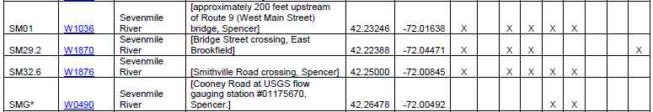

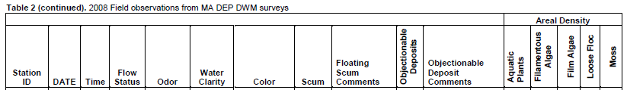

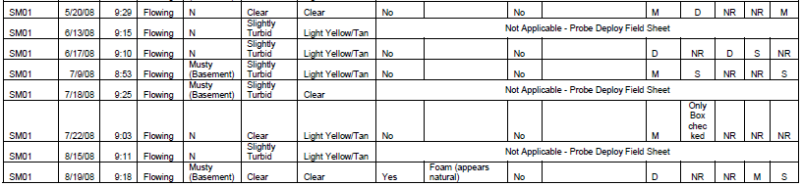

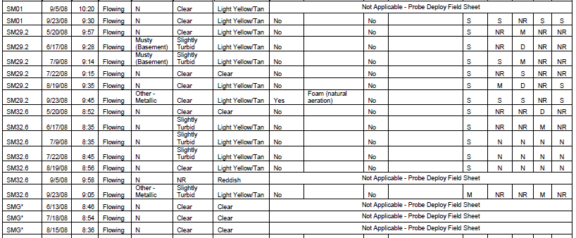

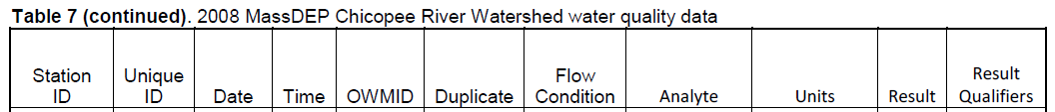

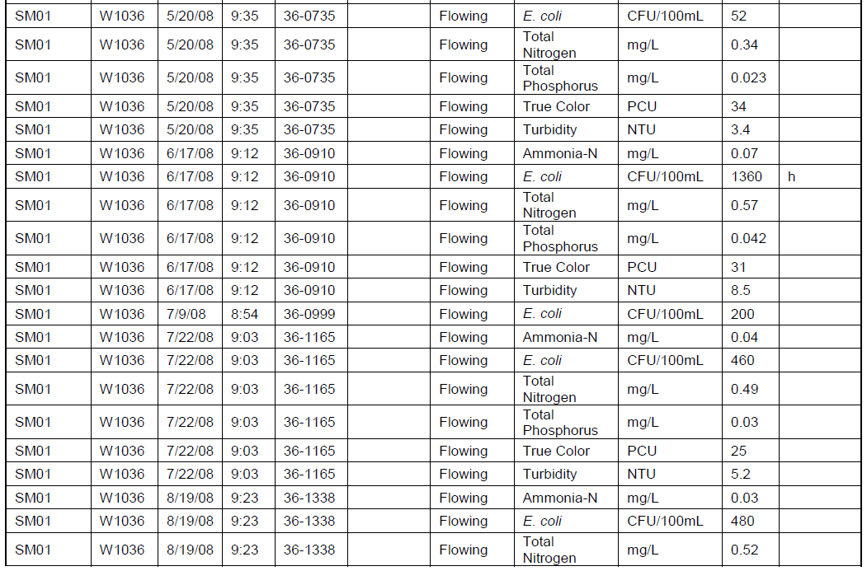

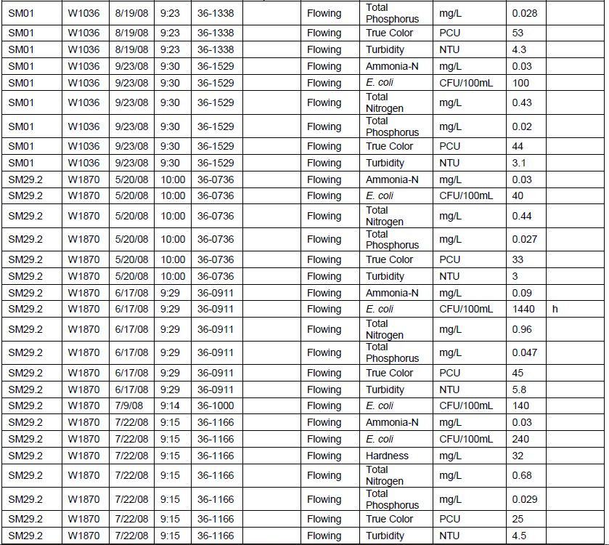
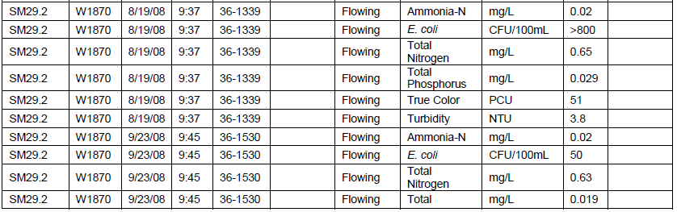

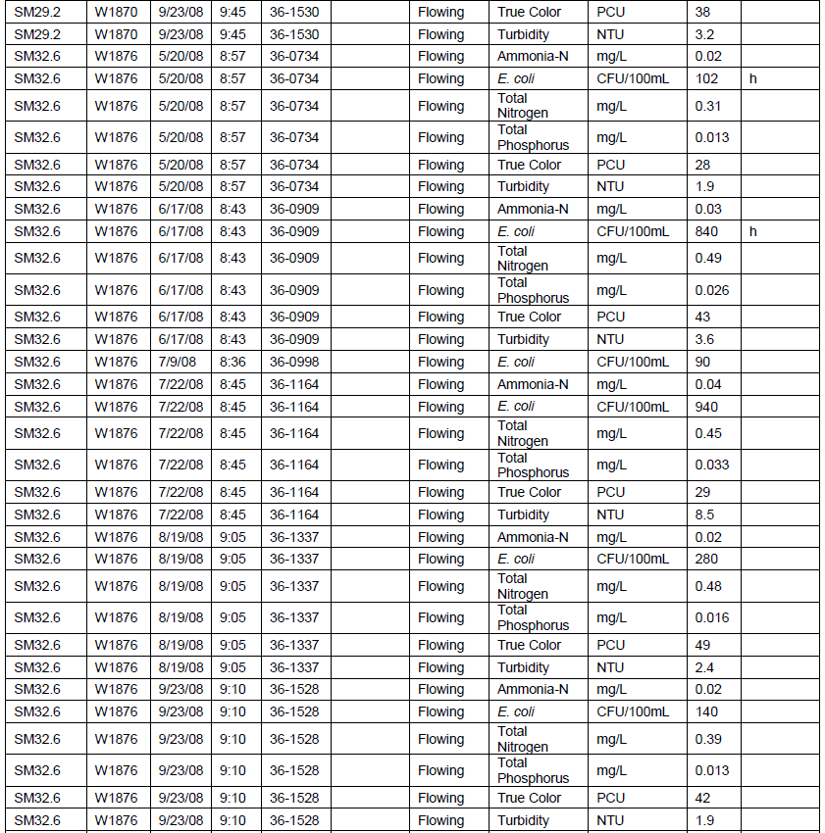

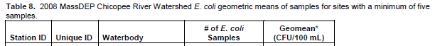

Chicopee River Watershed 2008 Benthic Macroinvertebrate Assessment (MA36-11 – Sevenmile River)
The segment MA36-11 at station B0643 (SEVENMILE RIVER, approximately 100 meters downstream from Cooney Road, Spencer was sampled on 9/9/2008 the RBPIII status was determined to be “slightly impacted” when compared to the reference (UniqueID: B0654). This station had a habitat score of 181 considered to be “Comparable” when compared to the reference (MassDEP Undated 1, Reardon 2014).

Project | Year | UNIQUE ID | Field ID | Ref PC | Richness | HBI | EPT Index | EPT/ CHIR | SC/ FC | FC/ Total | % Dom Taxon | Total Habitat Score
Chicopee 2008 | 2008 | B0643 | SMG00 | B0654 | 24 | 4.27 | 12 | 4.12 | 0.23 | 0.54 | 30.30% | 181
Comparison to Reference Station Unique ID B0654 (below)
% Richness | % HBI | % EPT Index | % EPT CHIR | % SC/ FC | Dominant Taxon Score | % Total Habitat Score
65% | 85% | 67% | 119% | 35% | 2 | 98%
-SC/FC- scraper to filterer ratio; FC/Total – ratio filter collector to total; EPT/ CHIR – ratio EPT to Chironomidae (for complete definition of metrics and more information see Reardon 2014)

Fish Community Data and DELTS
Sevenmile River MA36-11 is listed as a Coldwater Fisheries Resource (CFR) by MassWildlife.

Chicopee River Watershed SMART Monitoring Program 2005 – 2010 (MA36-11 – Sevenmile River)

DO, pH, Temperature
SMART [Strategic Monitoring and Assessment for River basin Teams] monitoring was conducted in Central Massachusetts from 1998 to 2013. One SMART monitoring station was located on this segment (Station W090, Cooney Road at USGS flow gauging station #01175670, Spencer]. Attended probe data from 2005 to 2010 is summarized in the table below. For more information and SMART monitoring data see: https://www.mass.gov/guides/smart-monitoring-technical-memoranda

MassDEP SMART 2005-2010. Station W090, Cooney Road at USGS flow gauging station #01175670, Spencer]. In Situ Multiprobe Data
Date | OWMID | Time | Depth | Temp | pH | Cond@ 25C | TDS | DO | DO SATURATION
 |  | (24hr) | (m) | (C) | (SU) | (us/cm) | (mg/l) | (mg/l) | (%)
2/16/2005 | SM-6147 | 8:59 | 0.6 | 0.2 | 6.2 | 81 | 52 | 14.1 | 97
4/20/2005 | SM-6189 | 9:08 | 0.2 | 12.9 | 6.4 | 82 | 53 | 10.1 | 96
6/15/2005 | SM-1359 | 9:10 | 0.1 | 20.1 | 6.1 | 88 | 57 | 7.7 | 85
8/23/2005 | SM-1441 | 8:58 | 0.2 | 16.9 | 7.0 | 109 | 71 | 9.4 | 97
10/19/2005 | SM-1511 | 9:09 | 0.4 | 11.2 | 6.0 | 78 | 51 | 9.9 | 90
1/18/2006 | SM-1581 | 8:47 | 0.4 | 0.5 | 6.0 | 77 | 50 | 13.3 | 92
3/15/2006 | SM-1651 | 8:56 | 0.2 | 2.9 | 6.2 | 71 | 46 | 13.2 | 97
5/16/2006 | SM-1721 | 8:50 | 0.5 | 10.9 | 6.1 | 76 | 50 | 10.4 i | 94 i
7/11/2006 | SM-1779 | 8:57 | 0.3 | 22.0 | 6.9 | 83 | 54 | 7.8 | 89
10/4/2006 | SM-1871 | 9:00 | 0.2 | 13.4 | 6.9 | 102 | 66 | 10.2 | 98
11/7/2006 | SM-1931 | 8:47 | 0.2 | 3.9 | 6.6 | 70 | 46 | 12.8 | 98
3/13/2007 | SM-2001 | 8:57 | 0.4 | 0.0 u | 6.2 u | 76 u | 49 u | 13.8 u | 95 u
4/17/2007 | SM-2071 | 9:16 | 0.5 | 4.2 | 5.9 | 65 | 42 | 12.0 | 92
6/12/2007 | SM-2141 | 8:44 | 0.3 | 19.9 | 6.6 | 76 | 50 | 8.4 | 92
8/28/2007 | SM-2211 | 8:43 | 0.2 | 18.2 | 7.0 | 126 | 82 | 8.8 | 94
10/16/2007 | SM-2281 | 9:12 | 0.2 | 8.1 | 6.6 | 126 | 82 | 10.6 | 90
1/23/2008 | SM-2351 | 8:37 | 0.2 | -0.1 | 6.4 | 81 | 53 | 14.4 | 99
3/25/2008 | SM-2421 | 9:01 | 0.2 | 2.6 | 6.4 | 79 | 51 | 13.6 | 100
5/20/2008 | SM-2491 | 9:37 | 0.4 | 12.1 | 6.6 | 84 | 55 | 10.5 | 98
6/16/2008 | SM-2537 | 8:52 | 0.3 | 17.7 | 6.7 | 92 | 60 | 8.8 | 92
7/22/2008 | SM-2597 | 8:44 | 0.2 | 21.4 | 6.8 | 94 | 61 | 7.9 | 90
8/18/2008 | SM-2643 | 8:33 | 0.3 | 18.5 | 6.8 | 83 | 54 | 8.5 | 91
9/23/2008 | SM-2703 | 8:42 | 0.2 | 11.9 | 6.5 | 89 | 58 | 10.2 i | 94 i
11/18/2008 | SM-2773 | 8:57 | 0.3 | 3.9 | 6.7 | 87 | 56 | 12.6 | 96
2/23/2009 | SM-2843 | 8:57 | 0.3 | -0.3 | 6.2 | 95 | 62 | 14.7 | 100
4/28/2009 | SM-2915 | 8:27 | 0.3 | 16.8 | 6.4 | 90 | 58 | 8.9 | 92
6/23/2009 | SM-2987 | 8:38 | 0.4 | 17.3 | 6.4 | 90 | 58 | 8.6 | 90
8/25/2009 | SM-3059 | 8:30 | ## i | 21.7 | 6.8 | 83 | 54 | 7.8 | 89
10/27/2009 | SM-3131 | 8:34 | 0.3 | 7.6 | 6.7 | 87 u | 56 u | 11.0 | 92
2/9/2010 | SM-3203 | ** | ** | ** | ** | ** | ** | ** | **
7/20/2010 | SM-3275 | 8:26 | 0.2 | 22.0 | 7.0 | 111 | 72 | 8.2 | 94
10/5/2010 | SM-3347 | 9:00 | 0.4 | 12.8 | 6.8 | 100 u | 65 u | 9.6 | 91
11/16/2010 | SM-3419 | 8:22 | 0.3 | 7.2 | 6.4 | 108 | 70 | 11.5 | 96

Multiprobe data qualifiers:
** = Missing data.
-- = No data.
## = Censored data (data that have been discarded for some reason).
c = Greater than calibration standard used for pre-calibration, or outside the acceptable range about the calibration standard.
i = Inaccurate readings from multiprobe likely.
m = Method not followed; one or more protocols contained in the DWM Multi-probe SOP not followed.
r = Data not representative of actual field conditions.
s = Field sheet recorded data were used to accept data, not data electronically recorded in the Multi-probe surveyor unit, due to operator error or equipment failure.
u = Unstable readings.

Nutrients (Primary Producer Screening, Physico-chemical Screening)
SMART [Strategic Monitoring and Assessment for River basin Teams] monitoring was conducted in Central Massachusetts from 1998 to 2013. One SMART monitoring station was located on this segment (Station W090, Cooney Road at USGS flow gauging station #01175670, Spencer]. Water quality data from 2005 to 2010 is summarized in the table below. For more information and SMART monitoring data see: https://www.mass.gov/guides/smart-monitoring-technical-memoranda

MassDEP SMART 2005-2010. Station W090, Cooney Road at USGS flow gauging station #01175670, Spencer]. Chemistry Data
Date | OWMID | Time | Alkalinity | Hardness | Chloride | Total Suspended Solids | Turbidity | Total Nitrogen | NH3-N | NO3-NO2-N | Total Phosphorus
 |  | (24hr) | (mg/l) | (mg/l) | (mg/l) | (mg/l) | (NTU) | (mg/l) | (mg/l) | (mg/l) | (mg/l)
2/16/2005 | SM-1147 | 8:45 | 5 | 14 | 10 | 1.0 | 1.1 | 0.39 | 0.03 | 0.22 | 0.012
4/20/2005 | SM-1189 | 9:00 | 12 | 16 | 13 | 1.2 | 1.3 | 0.30 | <0.02 | 0.06 | 0.015
6/15/2005 | SM-1358 | 9:05 | 11 | 17 | 13 | 2.9 | 4.4 | 0.54 | 0.03 | 0.08 | 0.026
8/23/2005 | SM-1440 | 8:45 | 12 | 25 | 14 | 5.0 | 2.1 | 0.43 | <0.02 | 0.18 | 0.023
10/19/2005 | SM-1510 | 8:55 | 4 | 13 | 12 | <1.0 | 0.9 | 0.25 | <0.02 | 0.03 | 0.011
1/18/2006 | SM-1580 | 8:30 | 4 | 13 | 12 | 1.1 | 0.7h | 0.27 | <0.02 | 0.17 | 0.007h
3/15/2006 | SM-1650 | 8:50 | 6m | 12m | 11m | 1.6m | 1.2m | 0.32m | <0.02m | 0.15m | 0.012m
5/16/2006 | SM-1720 | 8:35 | 5 | 14 | 12 | 2.3 | ##h | 0.23 | <0.02 | 0.02 | 0.012
7/11/2006 | SM-1778 | 8:45 | 9 | 15 | 11 | 10 | 2.5h | 0.50 | 0.03 | 0.11 | 0.034
10/4/2006 | SM-1870 | 8:35 | 10 | 22 | 13 | <1.0 | 1.3h | 0.36 | <0.02 | 0.16 | 0.013
11/7/2006 | SM-1930 | 8:35 | 7 | 15 | 13 | 1.0 | 1.0h | 0.28 | <0.02 | 0.08 | 0.010
3/13/2007 | SM-2000 | 8:45 | 7 | 14 | 11 | 2.1 | 1.8h | 0.49 | 0.07 | 0.26 | 0.016
4/17/2007 | SM-2070 | 9:05 | 2 | 10 | 11 | 3.8 | 1.7h | 0.31 | <0.02 | 0.14 | 0.014
6/12/2007 | SM-2140 | 8:30 | 9 | 15 | 11 | 5.3 | 2.9h | 0.53 | 0.07 | 0.13 | 0.031
8/28/2007 | SM-2210 | 8:25 | 9 | 30 | 14 | <1.0h | 1.0h | 0.29 | <0.02 | 0.15 | 0.008
10/16/2007 | SM-2280 | 9:15 | 11 | 31 | 13 | <1.0 | 0.7h | 0.28 | <0.02 | 0.15 | 0.005
1/23/2008 | SM-2350 | 8:30 | 6 | 16 | 16 | <1.0 | 0.5h | 0.33 | <0.02 | 0.18 | 0.005
3/25/2008 | SM-2420 | 8:45 | 4 | 13 | 13 | <1.0d | 0.6h | 0.24 | <0.02 | 0.10 | 0.005
5/20/2008 | SM-2490 | 9:20 | 4 | 15 | 15 | <1.0 | 1.1h | 0.26 | <0.02 | <0.02 | 0.012
6/16/2008 | SM-2536 | 8:35 | 7 | 20 | 13 | 2.4 | 2.1h | 0.40 | 0.02 | 0.08 | 0.020
7/22/2008 | SM-2596 | 8:35 | ** | 22 | 11 | ** | ** | 0.67 | 0.04 | 0.09 | 0.077
8/18/2008 | SM-2642 | 8:20 | ** | 19 | 9 | 2.3h | 2.6 | 0.38 | 0.02 | 0.07 | 0.015
9/23/2008 | SM-2702 | 8:30 | 7 | 18 | 12 | <1.0 | 1.3h | 0.27 | <0.02 | 0.07 | 0.010
11/18/2008 | SM-2772 | 8:35 | 6 | 15 | 14 | <1.0 | 1.0h | 0.24 | <0.02 | <0.02 | 0.012
2/23/2009 | SM-2842 | 8:40 | 5 | 16 | 15 | <1.0 | 0.7 | 0.32 | 0.02 | 0.18 | 0.006
4/28/2009 | SM-2914 | 8:15 | 8 | 18 | 15 | 4.6d | 1.7 | 0.32 | 0.02 | 0.07 | 0.017
6/23/2009 | SM-2986 | 8:27 | 6 | 17 | 15 | 4.2 | 2.4b | 0.35 | 0.05 | 0.07 | 0.021
8/25/2009 | SM-3058 | 8:20 | 7 | 17 | 13 | 3.0 | 2.5 | 0.39 | <0.02 | 0.03 | 0.023
10/27/2009 | SM-3130 | 8:25 | 7 | 18 | 14 | 4.9 | 1.6 | 0.26 | <0.02 | 0.04 | 0.012
2/9/2010 | SM-3202 | ** | ** | ** | ** | ** | ** | ** | ** | ** | **
7/20/2010 | SM-3274 | 8:15 | 8 | 26 | 15 | 1.1 | 2.6h | 0.41 | <0.02 | 0.16 | 0.016
10/5/2010 | SM-3346 | 8:50 | 7 | 21 | 15 | 1.5d | 1.4h,j | 0.32 | <0.02 | <0.02 | 0.013
11/16/2010 | SM-3418 | 8:10 | 4 | 21 | 14 | <1.0 | 0.9h | 0.24 | <0.02 | 0.05 | 0.007

Laboratory sample data qualifiers:
** = Missing data.
-- = No data.
## = Censored data (data that have been discarded for some reason).
[ ] = A result reported inside brackets has been censored, but is shown for informational purposes.
b = Blank contamination in lab reagent blanks and/or field blank samples.
d = Precision of field duplicates (as Relative Percent Difference, RPD) did not meet project data quality objectives identified for program or in QAPP.
e = Not theoretically possible. Specifically, used for bacteria data where colonies per unit volume for E. coli bacteria are greater than fecal coliform bacteria.
h = Holding time violation (usually indicating possible bias low).
j = ‘Estimated’ value; used for lab-related issues where certain lab QC criteria are not met and re-testing is not possible (as identified by the WES lab only). Also used to report sample data where the sample concentration is less than the reporting detection limit (RDL) and greater than the method detection limit (MDL) (RDL > x > MDL). Also used to note where values have been reported at levels less than the MDL.
m = Method SOP not followed, only partially implemented or not implemented at all, due to complications with sample matrix (e.g. sediment in sample, floc formation), lab error (e.g. cross-contamination between samples), additional steps taken by the lab to deal with matrix complications, lost/unanalyzed samples, and missing data.

Chicopee River Watershed SMART Monitoring Program 2011 – 2013 (MA36-11 – Sevenmile River)

DO, pH, Temperature
SMART [Strategic Monitoring and Assessment for River basin Teams] monitoring was conducted in Central Massachusetts from 1998 to 2013. One SMART monitoring station was located on this segment (Station W090, Cooney Road at USGS flow gauging station #01175670, Spencer]. Attended probe data from 2011 to 2013 is summarized in the table below. For more information and SMART monitoring data see: https://www.mass.gov/guides/smart-monitoring-technical-memoranda

MassDEP SMART 2011-2013. Station W090, Cooney Road at USGS flow gauging station #01175670, Spencer]. In Situ Multiprobe Data
Date | OWMID | Time | Depth | Temp | pH | Cond@ 25C | TDS | DO | DO SATURATION
 |  | (24hr) | (m) | (C) | (SU) | (us/cm) | (mg/l) | (mg/l) | (%)
3/22/2011 | SM-3491 | 8:23 | 0.3 | 2.9 | 6.0 | 73 | 47 | 13.2 | 98
4/26/2011 | SM-3563 | 8:19 | 0.3 | 11.5 | 6.5 | 82 | 53 | 10.6 | 98
6/21/2011 | SM-3635 | 8:21 | 0.3 | 18.1 | 6.2 | 90 | 58 | 8.4 | 89
8/30/2011 | SM-3707 | 9:02 | 0.6 | 18.7 | 6.1 | 68 | 44 | 7.8 | 85
10/25/2011 | SM-3779 | 8:15 | 0.4 | 9.5 | 6.6 | 77 | 50 | 11.1 | 97
1/24/2012 | SM-3851 | 8:18 | 0.4 | 0.5 | 6.4 | 90 | 58 | ##i,u | ##i,u
3/27/2012 | SM-3923 | 8:16 | ##i | 4.0 | 6.4 | 83 | 54 | 12.9 | 99
5/23/2012 | SM-3995 | 8:17 | ##i | 18.3 | 6.7 | 77 | 50 | 8.5 | 90
7/24/2012 | SM-4067 | 8:37 | ##i | 21.0 | 7.0 | 118 | 77 | 8.0i | 90i
9/25/2012 | SM-4139 | 8:31 | ##i | 10.9 | 6.7 | 92 | 60 | 10.2 | 92
11/13/2012 | SM-4211 | 8:10 | 9.4 | 9.4 | 6.5 | 84 | 55 | 11.0 | 96
2/26/2013 | SM-4283 | 8:14 | 0.0i | 0.9 | 6.5 | 94 | 61 | 14.6 | 103
4/23/2013 | SM-4355 | 8:20 | ##i | 9.5 | 6.7 | 86i | 56i | 11.8 | 104
Multiprobe data qualifiers:
** = Missing data.
-- = No data.
## = Censored data (data that have been discarded for some reason).
c = Greater than calibration standard used for pre-calibration, or outside the acceptable range about the calibration standard.
i = Inaccurate readings from multiprobe likely.
m = Method not followed; one or more protocols contained in the DWM Multi-probe SOP not followed.
r = Data not representative of actual field conditions.
s = Field sheet recorded data were used to accept data, not data electronically recorded in the Multi-probe surveyor unit, due to operator error or equipment failure.
u = Unstable readings.

Nutrients (Primary Producer Screening, Physico-chemical Screening)
SMART [Strategic Monitoring and Assessment for River basin Teams] monitoring was conducted in Central Massachusetts from 1998 to 2013. One SMART monitoring station was located on this segment (Station W090, Cooney Road at USGS flow gauging station #01175670, Spencer]. Water quality data from 2011 to 2013 is summarized in the table below. For more information and SMART monitoring data see: https://www.mass.gov/guides/smart-monitoring-technical-memoranda

MassDEP SMART 2011-2013. Station W090, Cooney Road at USGS flow gauging station #01175670, Spencer]. Chemistry Data
Date | OWMID | Time | Alkalinity | Hardness | Chloride | Total Suspended Solids | Turbidity | Total Nitrogen | NH3-N | NO3-NO2-N | Total Phosphorus
 |  | (24hr) | (mg/l) | (mg/l) | (mg/l) | (mg/l) | (NTU) | (mg/l) | (mg/l) | (mg/l) | (mg/l)
3/22/2011 | SM-3490 | 8:10 | 4 | 13 | 11 | <1.0 | 0.6h | 0.27 | 0.02 | 0.13 | 0.006
4/26/2011 | SM-3562 | 8:04 | 5 | 15 | 13 | 1.0 | 0.6h | 0.24a | <0.02 | 0.06 | 0.007
6/21/2011 | SM-3634 | 8:10 | ** | 19 | 13 | 2.5 | ** | 0.49 | 0.03 | 0.12 | 0.023
8/30/2011 | SM-3706 | 8:55 | 5 | 12 | 12 | 2.3 | 1.2h | 0.32 | <0.02 | <0.02 | 0.015
10/25/2011 | SM-3778 | 8:10 | 6 | 15 | 12 | 1.1 | 1.3h | 0.32 | <0.02 | 0.06 | 0.010
1/24/2012 | SM-3850 | 8:03 | 6 | 16 | 16 | 4.1 | 2.6 | 0.40 | 0.03 | 0.18 | 0.015
3/27/2012 | SM-3922 | 8:10 | 8 | 17 | 11 | 1.9 | 1.9b | 0.33 | <0.02 | 0.10 | 0.014
5/23/2012 | SM-3994 | 8:05 | 8d | 16 | 10 | 3.9 | 2.6 | 0.31 | 0.04 | 0.04 | 0.020
7/24/2012 | SM-4066 | 8:25 | 14 | 29 | 15 | 10h | 3.6b | 0.66 | <0.02 | 0.32 | 0.032
9/25/2012 | SM-4138 | 8:10 | 11 | 22 | 13 | <1.0 | 1.6 | 0.30 | <0.02 | 0.06 | 0.010
11/13/2012 | SM-4210 | 8:00 | 8 | 18 | 12 | 3.1 | 1.1b | 0.25 | <0.02 | 0.04 | 0.009d
2/26/2013 | SM-4282 | 8:05 | 6 | 16 | 15 | 1.4 | 0.8 | 0.38 | <0.02 | 0.18 | 0.007
4/23/2013 | SM-4354 | 8:08 | 7 | 15 | 14 | 1.8 | 0.9 | 0.28 | <0.02 | 0.06 | 0.011
Laboratory sample data qualifiers:
** = Missing data.
-- = No data.
## = Censored data (data that have been discarded for some reason).
[ ] = A result reported inside brackets has been censored, but is shown for informational purposes.
b = Blank contamination in lab reagent blanks and/or field blank samples.
d = Precision of field duplicates (as Relative Percent Difference, RPD) did not meet project data quality objectives identified for program or in QAPP.
e = Not theoretically possible. Specifically, used for bacteria data where colonies per unit volume for E. coli bacteria are greater than fecal coliform bacteria.
h = Holding time violation (usually indicating possible bias low).
j = ‘Estimated’ value; used for lab-related issues where certain lab QC criteria are not met and re-testing is not possible (as identified by the WES lab only). Also used to report sample data where the sample concentration is less than the reporting detection limit (RDL) and greater than the method detection limit (MDL) (RDL > x > MDL). Also used to note where values have been reported at levels less than the MDL.
m = Method SOP not followed, only partially implemented or not implemented at all, due to complications with sample matrix (e.g. sediment in sample, floc formation), lab error (e.g. cross-contamination between samples), additional steps taken by the lab to deal with matrix complications, lost/unanalyzed samples, and missing data.

Additional Water Quality Data
Unpublished data from two data sources are summarized from a document received via email communication received on December 23, 2019 from Matthew Reardon, MassDEP (Reardon, 2019). The two data sources are listed below:
- Open File Analysis of DWM WPP Water Quality Data Collected Between 2010 and 2014 Using CALM Guidance (MassDEP, Undated 1)
- Open files of Unpublished, Validated Water Quality Monitoring Data, Field Sheet Data, and GIS Datalayers in Development (MassDEP, Undated 2)

Open File Analysis of DWM WPP Water Quality Data Collected Between 2010 and 2014 Using Calm Guidance

2008 Multiprobe Data of MassDEP Site W0490 [Cooney Road at USGS flow gauging station #01175670, Spencer]
Dissolved oxygen/temperature probes were deployed at station W0490 [Cooney Road at USGS flow gauging station #01175670, Spencer] on three occasions for a total of 9 days over the period beginning 6/13/2008 and ending 8/18/2008 The minimum dissolved oxygen at this station was 6.02 mg/L and the deployment mean dissolved oxygen ranged from 7.06 mg/L to 7.59 mg/L. The maximum daily DO shift for the deployment was in July where the maximum daily DO shift was 1.75 mg/L. The warmwater dissolved oxygen criterion was met at this station. Temperature ranged from 17.5 degrees Celsius to 25.1 degrees Celsius. The temperature exceeded 20 degrees Celsius for 72 of the 216 hours the probe was deployed. The temperature did not exceed 28.3 degrees Celsius (the warmwater criterion).

DO probe data [Station W090, Cooney Road at USGS flow gauging station #01175670, Spencer]
Unique ID | Waterbody | Class | Qualifier | Start Date | Days | OWMID Minimum DO | Daily Mean Minimum DO | Maximum Daily DO Shift | OWMID Mean DO | OWMID Maximum Saturation | Violates Criteria
W0490 | SEVENMILE RIVER | B | WWF, HQW | 06/13/08 | 3 | 6.99 | 7.27 | 1.03 | 7.59 | 90.9 | None
W0490 | SEVENMILE RIVER | B | WWF, HQW | 07/18/08 | 3 | 6.02 | 6.46 | 1.75 | 7.06 | 92.0 | None
W0490 | SEVENMILE RIVER | B | WWF, HQW | 08/15/08 | 3 | 7.05 | 7.09 | 0.86 | 7.43 | 89.7 | None

DO probe deployment graph - [Station W090, Cooney Road at USGS flow gauging station #01175670, Spencer]
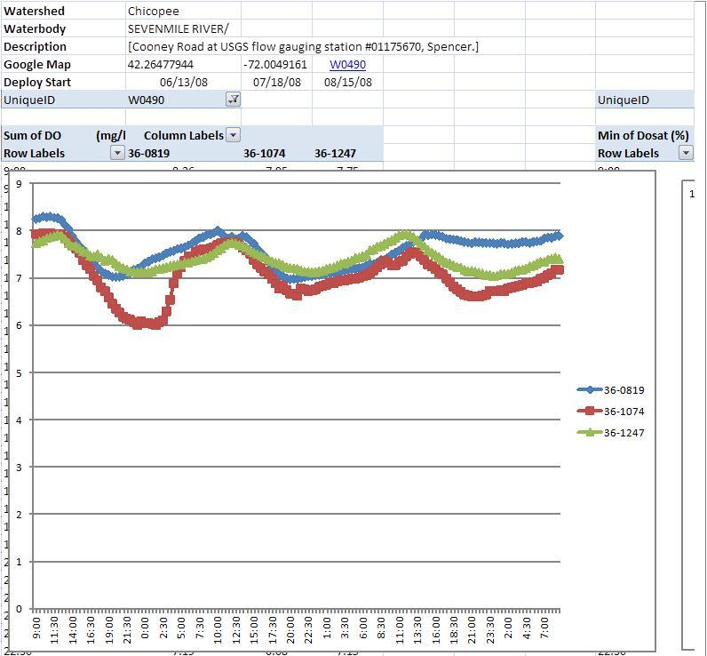

2008 Multiprobe Data of MassDEP Site W1876 [Smithville Road crossing, Spencer]
Dissolved oxygen/temperature probes were deployed at station W1876 [Smithville Road crossing, Spencer] on one occasion for a total of 5 days over the period beginning 9/05/2008 and endin 9/10/2008. The minimum dissolved oxygen at this station was 5.43 mg/L and the deployment mean dissolved oxygen was 7.28 mg/L. The maximum daily DO shift for the deployment was 2.26 mg/L. The warmwater dissolved oxygen criterion was met at this station. Temperature ranged from 18.3 degrees Celsius to 22.8 degrees Celsius. The temperature exceeded 20 degrees Celsius for 89.9 of the 118.5 hours the probe was deployed. The temperature did not exceed 28.3 degrees Celsius (the warmwater criterion).
DO probe data - MassDEP Site W1876 [Smithville Road crossing, Spencer]
Unique ID | Waterbody | Class | Qualifier | Start Date | Days | OWMID Minimum DO | Daily Mean Minimum DO | Maximum Daily DO Shift | OWMID Mean DO | OWMID Maximum Saturation | Violates Criteria
W1876 | SEVENMILE RIVER | B | WWF, HQW | 09/05/08 | 5 | 5.43 | 7.13 | 2.26 | 7.28 | 91.6 | None

DO probe deployment graph - W1876 [Smithville Road crossing, Spencer]
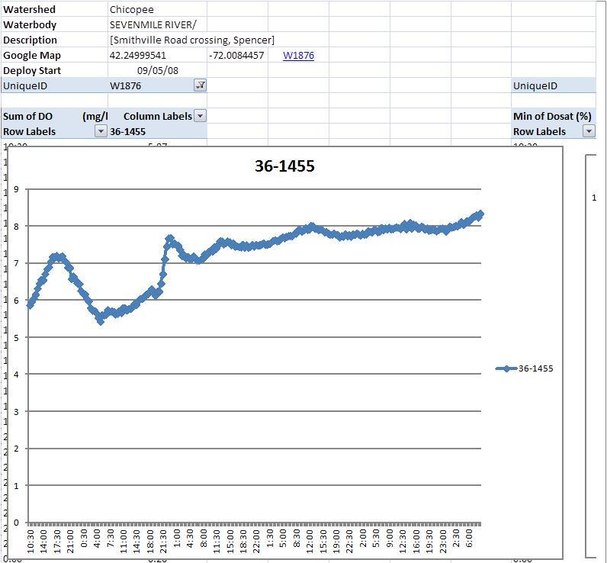

2008 Multiprobe Data of MassDEP Site W1036 [approximately 200 feet upstream of Route 9 (West Main Street) bridge, Spencer]
Dissolved oxygen/temperature probes were deployed at station W1036 [approximately 200 feet upstream of Route 9 (West Main Street) bridge, Spencer] on four occasions for a total of 14 days over the period beginning 6/13/2008 and ending 9/10/2008 The minimum dissolved oxygen at this station was 3.72 mg/L and the deployment mean dissolved oxygen ranged from 4.77 mg/L to 6.72 mg/L. The maximum daily DO shift for the deployment was in July where the maximum daily DO shift was 5.73 mg/L. The warmwater dissolved oxygen criterion was met at this station. Temperature ranged from 17.7 degrees Celsius to 26.2 degrees Celsius. The temperature exceeded 20 degrees Celsius for 238.7 of the 334.5 hours the probe was deployed. The temperature did not exceed 28.3 degrees Celsius (the warmwater criterion)
DO probe data - W1036 [approximately 200 feet upstream of Route 9 (West Main Street) bridge, Spencer]
Unique ID | Waterbody | Class | Qualifier | Start Date | Days | OWMID Minimum DO | Daily Mean Minimum DO | Maximum Daily DO Shift | OWMID Mean DO | OWMID Maximum Saturation | Violates Criteria
W1036 | Sevenmile Riverr | B | WWF, HQW | 06/13/08 | 3 | 5.10 | 5.36 | 1.83 | 6.10 | 88.7 | WWEL
W1036 | Sevenmile Riverr | B | WWF, HQW | 07/18/08 | 3 | 3.72 | 4.40 | 5.73 | 6.72 | 132.3 | WW/ENR
W1036 | Sevenmile Riverr | B | WWF, HQW | 08/15/08 | 3 | 4.46 | 5.10 | 1.19 | 5.66 | 77.5
W1036 | Sevenmile Riverr | B | WWF, HQW | 09/05/08 | 5 | 3.82 | 4.22 | 2.95 | 4.77 | 78.3 | WW
WWEL- Warmwater early life stage; WW – Warmerwater; ENR – indicator of enrichment
DO probe deployment graph - W1036 [approximately 200 feet upstream of Route 9 (West Main Street) bridge, Spencer]
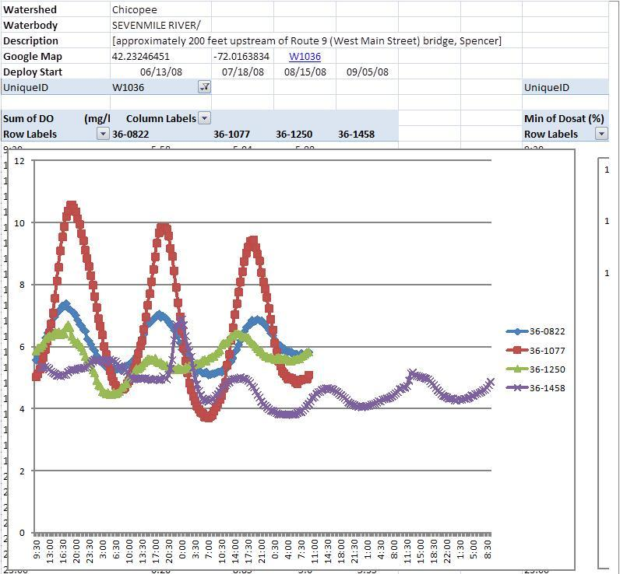

Bacteria Data
MassDEP Watershed Planning Program Bacteria Data (2005-2011)
UniqueID | Year | Date First Sample | Date Last Sample | Sample Count | Geometric Mean (CFU or MPN/100ml) | Bacteria Type
W0490 | 2007 | 08/28/07 | 08/28/07 | 1 | 32 | E. coli
W0490 | 2008 | 06/16/08 | 09/23/08 | 4 | 100 | E. coli
W1876 | 2008 | 05/20/08 | 09/23/08 | 6 | 256 | E. coli
W1036 | 2008 | 05/20/08 | 09/23/08 | 6 | 260 | E. coli
W0490 | 2009 | 04/28/09 | 08/25/09 | 3 | 46 | E. coli
W0490 | 2010 | 07/20/10 | 10/05/10 | 2 | 56 | E. coli
W0490 | 2011 | 04/26/11 | 08/30/11 | 3 | 33 | E. coli

Aesthetics Observations
The Aesthetics Use was assessed for segment MA36-11 consisting of the following site(s) (data year): W0490 (2005, 2006, 2007, 2008, 2009, 2010, 2011); W1036 (2008); W1876 (2008).There were generally no noted objectionable conditions (odors, deposits, growths, or turbidity) recorded by DWM-WPP field sampling crews during the surveys.

Open files of Unpublished, Validated Water Quality Monitoring Data, Field Sheet Data, and GIS Datalayers in Development (MassDEP, Undated 2)

2008 Attended Data of MassDEP Site W0490 [Cooney Road at USGS flow gauging station #01175670, Spencer]
Attended probes measurements were conducted at station W0490 [Cooney Road at USGS flow gauging station #01175670, Spencer] during the sampling season. Six discrete temperature readings, 0 of which failed warmwater criteria, were measured. 6 discrete pH were measured, and all met criterion. Dissolved oxygen readings were obtained on six occasions with 0 recordings < 5 mg/L.

Attended Data – [Station W0490 Cooney Road at USGS flow gauging station #01175670, Spencer]
Unique ID | OWMID | Date | Time | Sample Depth (meters) | Depth Qualifiers* | Temperature (deg. C) | Temperature Qualifiers* | pH (SU) | pH Qualifiers* | Specific Conductivity (uS/cm) | Specific Conductivity Qualifiers* | Total Dissolved Solids (mg/l) | Total Dissolved Solids Qualifiers* | Dissolved Oxygen (mg/l) | Dissolved Oxygen Qualifiers* | Saturation (%) | Saturation Qualifiers*
W0490 | 36-0820 | 6/13/08 | 8:55 | 0.2 |  | 17.4 |  | 6.8 |  | 95 |  | 61 |  | 8.2 | i | 86 | i
W0490 | 36-0821 | 6/16/08 | 9:09 | 0.3 |  | 18 |  | 6.8 |  | 89 |  | 57 |  | 8.1 |  | 87
W0490 | 36-1075 | 7/18/08 | 8:59 | 0.1 |  | 20.2 |  | 7 |  | 103 |  | 66 |  | 8.1 |  | 91
W0490 | 36-1076 | 7/21/08 | 9:06 | 0.2 |  | 22.2 |  | 6.7 |  | 106 |  | 68 |  | 7.4 |  | 87
W0490 | 36-1248 | 8/15/08 | 8:44 | 0.1 |  | 18.7 |  | 6.7 |  | 80 |  | 52 |  | 7.9 |  | 86
W0490 | 36-1249 | 8/18/08 | 9:02 | 0.2 |  | 18.9 |  | 6.7 |  | 81 |  | 52 |  | 7.6 |  | 83
Multiprobe data qualifiers:
** = Missing data.
-- = No data.
## = Censored data (data that have been discarded for some reason).
c = Greater than calibration standard used for pre-calibration, or outside the acceptable range about the calibration standard.
i = Inaccurate readings from multiprobe likely.
m = Method not followed; one or more protocols contained in the DWM Multi-probe SOP not followed.
r = Data not representative of actual field conditions.
s = Field sheet recorded data were used to accept data, not data electronically recorded in the Multi-probe surveyor unit, due to operator error or equipment failure.
u = Unstable readings.

2008 Attended Data of MassDEP Site W1876 [Smithville Road crossing, Spencer]
Attended probes measurements were conducted at station W1876 [Smithville Road crossing, Spencer] during the 2008 sampling season. 7 discrete temperature readings, 0 of which failed warmwater criteria, were measured. 7 discrete pH were measured with 3 which did not met criterion and 0 were considered 'severe' violations of the criterion. Dissolved oxygen readings were obtained on 7 occasions with 0 recordings < 5mg/L.
Attended Data Summary
Unique ID | Waterbody | Count Temp | Count Temp CWF GT20 | Count Temp CWF GT22 Severe | Count Temp WWF GT28.3 | Count Temp WWF GT30.3 Severe. | Count.PH | Count pH LT6.5 GT8.3 | Count pH LT6.0 GT8.8 Severe | Count DO | Count DO CWF LT5.0 | Count DO WWF LT4.0 | DOSAT max
W1876 | SEVENMILE RIVER | 7 | 2 | 0 | 0 | 0 | 7 | 3 | 0 | 7 | 0 | 0 | 97

Attended Data - W1876 [Smithville Road crossing, Spencer]
Unique ID | OWMID | Date | Time | Sample Depth (meters) | Depth Qualifiers* | Temperature (deg. C) | Temperature Qualifiers* | pH (SU) | pH Qualifiers* | Specifiic Conductivity (uS/cm) | Specific Conductivity Qualifiers* | Total Dissolved Solids (mg/l) | Total Dissolved Solids Qualifiers* | Dissolved Oxygen (mg/l) | Dissolved Oxygen Qualifiers* | Saturation (%) | Saturation Qualifiers*
W1876 | 36-0803 | 5/20/08 | 9:10 | 0.6 |  | 11.1 |  | 6.5 |  | 115 |  | 75 |  | 10.7 |  | 97
W1876 | 36-0961 | 6/17/08 | 8:49 | 0.4 |  | 16.8 |  | 6.6 |  | 133 |  | 87 |  | 8.4 |  | 87
W1876 | 36-1216 | 7/22/08 | 8:43 | 0.7 |  | 21.7 |  | 6.4 |  | 129 |  | 83 |  | 6 |  | 70
W1876 | 36-1389 | 8/19/08 | 9:10 | 0.5 |  | 20.7 |  | 6.7 |  | 126 |  | 82 |  | 7.7 |  | 86
W1876 | 36-1456 | 9/5/08 | 10:03 | ## | i | 18.8 |  | 6.4 |  | 121 |  | 77 |  | 5.7 |  | 61
W1876 | 36-1457 | 9/10/08 | 9:26 | -- |  | 18.3 |  | 6.5 |  | 106 |  | 68 |  | 8.3 |  | 89
W1876 | 36-1511 | 9/23/08 | 9:15 | 0.7 |  | 13 |  | 6.4 |  | 112 |  | 72 |  | 9 |  | 85
Multiprobe data qualifiers:
** = Missing data.
-- = No data.
## = Censored data (data that have been discarded for some reason).
c = Greater than calibration standard used for pre-calibration, or outside the acceptable range about the calibration standard.
i = Inaccurate readings from multiprobe likely.
m = Method not followed; one or more protocols contained in the DWM Multi-probe SOP not followed.
r = Data not representative of actual field conditions.
s = Field sheet recorded data were used to accept data, not data electronically recorded in the Multi-probe surveyor unit, due to operator error or equipment failure.
u = Unstable readings.

Water quality sampling was conducted at station W1876 [Smithville Road crossing, Spencer] on 5 occasions during the 2008 sampling season. The average total phosphorus was 0.02 mg/L while the maximum total phosphorus was 0.033 mg/L. No observations of dense or very dense filamentous algae were noted. The maximum daily DO shift was 2.3 and the maximum DO saturation was 92 %.
Nutrient Data Summary - W1876 [Smithville Road crossing, Spencer]
Unique ID | Waterbody | Count | NH3 Violations | Year | WQ Sample Count | TP Average | TP Max | Fieldsheet  Count | Filamentous Dense or Very Dense | Max Daily DO Shift | Max Saturation
W1876 | SEVENMILE RIVER | 5 | 0 | 2008 | 5 | 0.02 | 0.033 | 6 | 0 | 2.3 | 92

2008 Attended Data of MassDEP Site W1036 [approximately 200 feet upstream of Route 9 (West Main Street) bridge, Spencer]
Attended probes measurements were conducted at station W1036 [approximately 200 feet upstream of Route 9 (West Main Street) bridge, Spencer] during the sampling season. 9 discrete temperature readings, 0 of which failed warmwater criteria, were measured. 9 discrete pH were measured with 5 which did not met criterion and 0 were considered 'severe' violations of the criterion. Dissolved oxygen readings were obtained on 9 occasions with 0 recordings < 5mg/L.
Attended Data Summary
Unique ID | Waterbody | Count Temp | Count Temp CWF GT20 | Count Temp CWF GT22 Severe | Count Temp WWF GT28.3 | Count Temp WWF GT30.3 Severe. | Count.PH | Count pH LT6.5 GT8.3 | Count pH LT6.0 GT8.8 Severe | Count DO | Count DO CWF LT5.0 | Count DO WWF LT4.0 | DOSAT max
W1036 | SEVENMILE RIVER | 9 | 3 | 1 | 0 | 0 | 9 | 5 | 0 | 9 | 0 | 0 | 88

Attended Data - W1036 [approximately 200 feet upstream of Route 9 (West Main Street) bridge, Spencer]
Unique ID | OWMID | Date | Time | Sample Depth (meters) | Depth Qualifiers* | Temperature (deg. C) | Temperature Qualifiers* | pH (SU) | pH Qualifiers* | Specifiic Conductivity (uS/cm) | Specific Conductivity Qualifiers* | Total Dissolved Solids (mg/l) | Total Dissolved Solids Qualifiers* | Dissolved Oxygen (mg/l) | Dissolved Oxygen Qualifiers* | Saturation (%) | Saturation Qualifiers*
W1036 | 36-0786 | 5/20/08 | 9:40 | 0.2 |  | 11.2 |  | 6.5 |  | 125 |  | 81 |  | 9.6 |  | 88
W1036 | 36-0823 | 6/13/08 | 9:24 | 0.3 |  | 18.2 |  | 6.4 |  | 155 |  | 99 |  | 5.6 | i | 59 | i
W1036 | 36-0824 | 6/16/08 | 9:36 | 0.4 |  | 17.7 |  | 6.4 |  | 145 |  | 93 |  | 5.9 |  | 63
W1036 | 36-1078 | 7/18/08 | 9:27 | 0.3 |  | 22 |  | 6.5 |  | 171 |  | 109 |  | 5 |  | 57
W1036 | 36-1079 | 7/21/08 | 9:39 | 0.2 |  | 22.5 |  | 6.3 |  | 136 |  | 87 |  | 5.1 |  | 60
W1036 | 36-1251 | 8/15/08 | 9:18 | 0.1 |  | 19.4 |  | 6.5 |  | 141 |  | 90 |  | 5.9 |  | 65
W1036 | 36-1252 | 8/18/08 | 9:31 | 0.2 |  | 19.7 |  | 6.5 |  | 132 |  | 85 |  | 5.8 |  | 64
W1036 | 36-1459 | 9/5/08 | 10:37 | ## | i | 20.3 |  | 6.4 |  | 173 |  | 111 |  | 5 |  | 56
W1036 | 36-1460 | 9/10/08 | 9:50 | -- |  | 18 |  | 6.2 |  | 109 |  | 70 |  | 5.1 |  | 55
Multiprobe data qualifiers:
** = Missing data.
-- = No data.
## = Censored data (data that have been discarded for some reason).
c = Greater than calibration standard used for pre-calibration, or outside the acceptable range about the calibration standard.
i = Inaccurate readings from multiprobe likely.
m = Method not followed; one or more protocols contained in the DWM Multi-probe SOP not followed.
r = Data not representative of actual field conditions.
s = Field sheet recorded data were used to accept data, not data electronically recorded in the Multi-probe surveyor unit, due to operator error or equipment failure.
u = Unstable readings.

Water quality sampling was on conducted at one station W1036 [approximately 200 feet upstream of Route 9 (West Main Street) bridge, Spencer] on 5 occasions during the 2008 sampling season. The average total phosphorus was 0.029 mg/L while the maximum total phosphorus was 0.042 mg/L. 1 observations of dense or very dense filamentous algae were noted. The maximum daily DO shift was 5.7 and the maximum DO saturation was 132%.
Nutrient Data Summary - W1036 [approximately 200 feet upstream of Route 9 (West Main Street) bridge, Spencer]
Unique ID | Waterbody | Count | NH3 Violations | Year | WQ Sample Count | TP Average | TP Max | Fieldsheet  Count | Filamentous Dense or Very Dense | Max Daily DO Shift | Max Saturation
W1036 | SEVENMILE RIVER | 5 | 0 | 2008 | 5 | 0.029 | 0.042 | 6 | 1 | 5.7 | 132

Water Quality Impairments
Known water quality impairments, as documented in the Massachusetts Department of Environmental Protection (MassDEP) 2016 Massachusetts Integrated List of Waters, are listed below in Table A-3 for waterbodies in the delineated Sevenmile River watershed area (only Integrated List Category 4 or Integrated List Category 5 waterbodies are included). Impairment categories from the Integrated List are included in Table A-2.
Sevenmile River is listed under category 5 of the Massachusetts List of Integrated Waters due to impairments relating to E. coli. Sevenmile River is a tributary to the East Brookfield River (MA36-13), which flows to Quaboag Pond (MA36130). Quaboag Pond is listed under category 5 due to impairments related to TP and has a TMDL for TP.
Table A-2: 2016 MA Integrated List of Waters Categories
Integrated List Category | Description
1 | Unimpaired and not threatened for all designated uses.
2 | Unimpaired for some uses and not assessed for others.
3 | Insufficient information to make assessments for any uses.
4 | Impaired or threatened for one or more uses, but not requiring calculation of a Total Maximum Daily Load (TMDL), including:  4a: TMDL is completed  4b: Impairment controlled by alternative pollution control requirements  4c: Impairment not caused by a pollutant - TMDL not required
5 | Impaired or threatened for one or more uses and requiring preparation of a TMDL.

Table A-3: Water Quality Impairments
Assessment  Unit ID | Waterbody | Integrated  List  Category | Designated Use | Impairment Cause | Impairment Source
MA36-11 | Sevenmile River | 5 | Primary Contact Recreation | Escherichia Coli | Source Unknown
MA36-12 | Sevenmile River | 5 | Primary Contact Recreation | Escherichia Coli | Source Unknown
MA36025 | Browning Pond | 5 | Fish, other Aquatic Life and Wildlife | Non-Native Aquatic Plants | Introduction of Non-native Organisms (Accidental or Intentional)
MA36025 | Browning Pond | 5 | Fish Consumption | Mercury in Fish Tissue | Atmospheric Deposition - Toxics
MA36025 | Browning Pond | 5 | Fish, other Aquatic Life and Wildlife, | Nutrient/Eutrophication Biological Indicators | Source Unknown
MA36056 | Eames Pond | 5 | Fish, other Aquatic Life and Wildlife | Dissolved Oxygen | Source Unknown
MA36165 | Lake Whittemore | 5 | Aesthetic; Primary Contact Recreation; and Secondary Contact Recreation | Turbidity | Source Unknown
MA36150 | Sugden Reservoir | 4a | Aesthetic; Primary Contact Recreation; and Secondary Contact Recreation | Nutrient/Eutrophication Biological Indicators | Source Unknown
MA36157 | Turkey Hill Pond | 4c | Fish, other Aquatic Life and Wildlife | Non-Native Aquatic Plants | Introduction of Non-native Organisms (Accidental or Intentional)
MA36130 | Quaboag Pond¹ | 5 | Aesthetic; Fish, other Aquatic Life and Wildlife; Primary Contact Recreation; Secondary Contact Recreation | Eurasian Water Milfoil, Myriophyllum spicatum | Introduction on Non-native Organisms (Accidental or Intentional)
MA36130 | Quaboag Pond¹ | 5 | Aesthetic; Fish, other Aquatic Life and Wildlife; Primary Contact Recreation; Secondary Contact Recreation | Excess Algal Growth | Internal Nutrient Recycling, Municipal Point Source Discharges, Non-Point Sources
MA36130 | Quaboag Pond¹ | 5 | Fish Consumption | Mercury in Fish Tissue | Source Unknown
MA36130 | Quaboag Pond¹ | 5 | Aesthetic; Fish, other Aquatic Life and Wildlife; Primary Contact Recreation; Secondary Contact Recreation | Non-Native Aquatic Plants | Introduction on Non-native Organisms (Accidental or Intentional)
MA36130 | Quaboag Pond¹ | 5 | Fish, other Aquatic Life and Wildlife | Total Phosphorus | Internal Nutrient Recycling, Municipal Point Source Discharges, Non-Point Sources
¹Quaboag Pond is located downstream of the Sevenmile River Watershed.

Water Quality Goals
Water quality goals may be established for a variety of purposes, including the following:
a.) For water bodies with known impairments, a Total Maximum Daily Load (TMDL) is established by MassDEP and the United States Environmental Protection Agency (USEPA) as the maximum amount of the target pollutant that the waterbody can receive and still safely meet water quality standards. If the waterbody has a TMDL for total phosphorus (TP) or total nitrogen (TN), or total suspended solids (TSS), that information is provided below and included as a water quality goal.

b.) For water bodies without a TMDL for total phosphorus (TP), a default water quality goal for TP is based on target concentrations established in the Quality Criteria for Water (USEPA, 1986) (also known as the “Gold Book”). The Gold Book states that TP should not exceed 50 ug/L in any stream at the point where it enters any lake or reservoir, nor 25 ug/L within a lake or reservoir. For the purposes of developing WBPs, MassDEP has adopted 50 ug/L as the TP target for all streams at their downstream discharge point, regardless of which type of water body the stream discharges to.

c.) Massachusetts Surface Water Quality Standards (314 CMR 4.00, 2013) prescribe the minimum water quality criteria required to sustain a waterbody’s designated uses. Table A-4 lists the Class for selected Assessment Unit ID within the Sevenmile River watershed. The water quality goal(s) for bacteria are based on the Massachusetts Surface Water Quality Standards.
Table A-4: Surface Water Quality Classification by Assessment Unit ID
Assessment  Unit ID | Waterbody | Class
MA36-11 | Sevenmile River | B\WWF
MA36-12 | Sevenmile River | B\WWF
MA36-20 | Cranberry River | B
MA36025 | Browning Pond | B
MA36056 | Eames Pond | B
MA36165 | Lake Whittemore | B
MA36150 | Sugden Reservoir | B
MA36157 | Turkey Hill Pond | B
MA36160 | Quaboag Pond¹ | B
¹Quaboag Pond is located downstream of the Sevenmile River Watershed.

d.) Other water quality goals set by the community (e.g., protection of high quality waters, in-lake phosphorus concentration goal to reduce recurrence of cyanobacteria blooms, etc.).
Refer to Table A-5 for a list of water quality goals. Element C of this WBP includes proposed BMPs to address these impairments, including BMPs that provide increases in infiltration. Infiltration is a commonly used method to reduce phosphorus and bacteria loads in stormwater runoff and it can also help with peak runoff rate attenuation, reduced thermal impacts to receiving waters, and enhanced base flow to receiving waters (USEPA, 2014).
Table A-5: Water Quality Goals
Pollutant | Goal | Source
Total Phosphorus (TP) | Total phosphorus should not exceed:  --50 ug/L in any stream  --25 ug/L within any lake or reservoir | Quality Criteria for Water (USEPA, 1986)
Additional TMDL Criteria | Total phosphorus loading should be reduced by 30% | Total Maximum Daily Loads of Total Phosphorus for Quaboag & Quacumquasit Ponds
Escherichia Coli  (E. coli) | Class B Standards  • Public Bathing Beaches: For E. coli, geometric mean of 5 most recent samples shall not exceed 126 colonies/ 100 ml and no single sample during the bathing season shall exceed 235 colonies/100 ml. For enterococci, geometric mean of 5 most recent samples shall not exceed 33 colonies/100 ml and no single sample during bathing season shall exceed 61 colonies/100 ml;  • Other Waters and Non-bathing Season at Bathing Beaches: For E. coli, geometric mean of samples from most recent 6 months shall not exceed 126 colonies/100 ml (typically based on min. 5 samples) and no single sample shall exceed 235 colonies/100 ml. For enterococci, geometric mean of samples from most recent 6 months shall not exceed 33 colonies/100 ml, and no single sample shall exceed 61 colonies/100 ml. | Massachusetts Surface Water Quality Standards (314 CMR 4.00, 2013)
Note: There may be more than one water quality goal for bacteria due to different Massachusetts Surface Water Quality Standards Classes for different Assessment Units within the watershed.

Land Use Information
Land use information and impervious cover is presented by the below tables and figures. Land use source data is from 2005 and was obtained from MassGIS (2009b).

Watershed Land Uses
As summarized by Table A-6, land use in the Sevenmile River watershed is mostly forested (approximately 70.8 percent); approximately 12.1 percent of the watershed is residential; approximately 9.3 percent is agricultural; approximately 5.6 percent of the watershed is open land or water; approximately 1.7 percent of the watershed is commercial or industrial; and approximately 0.5 percent is devoted to highways.
The Sevenmile River watershed is a part of the Quaboag Pond watershed. A summary of the watershed land uses in the Sevenmile River watershed compared to the overall Quaboag Pond watershed is provided in Table A-7. The percentage of land use is comparable for the agriculture, residential, and commercial or industrial land uses.

Table A-6: Watershed Land Uses in Sevenmile River Watershed
Land Use | Area (acres) | % of Watershed
Forest | 18047.71 | 70.8
Agriculture | 2373.76 | 9.3
Low Density Residential | 2330.05 | 9.1
Water | 781.94 | 3.1
Open Land | 655.36 | 2.6
High Density Residential | 585.11 | 2.3
Commercial | 210.76 | 0.8
Industrial | 213.89 | 0.8
Medium Density Residential | 165.13 | 0.6
Highway | 125.30 | 0.5
TOTAL | 25,489.01 | 100.0

Table A-7: Watershed Land Uses in Sevenmile River and Quaboag Pond Watersheds
Land Use | Sevenmile River Watershed |  | Quaboag Pond Watershed¹
 | Area (acres) | % of Watershed | Area (acres) | % of Watershed
Forest | 18048 | 70.8 | 31689 | 63.4
Residential (Low, Medium, and High) | 3080 | 12.1 | 5298 | 10.6
Agriculture | 2374 | 9.3 | 5879 | 11.8
Open Land, Water and Wetlands | 1437 | 5.6 | 6281 | 12.6
Commercial and Industrial | 425 | 1.7 | 808 | 1.6
Highways | 125.3 | 0.5 | - | -
TOTAL | 25,489 | 100.0 | 49,955 | 100.0
¹Quaboag Pond watershed land use information from Table 4 of Total Maximum Daily Load of Total Phosphorus for Quaboag and Quacumquasit Ponds

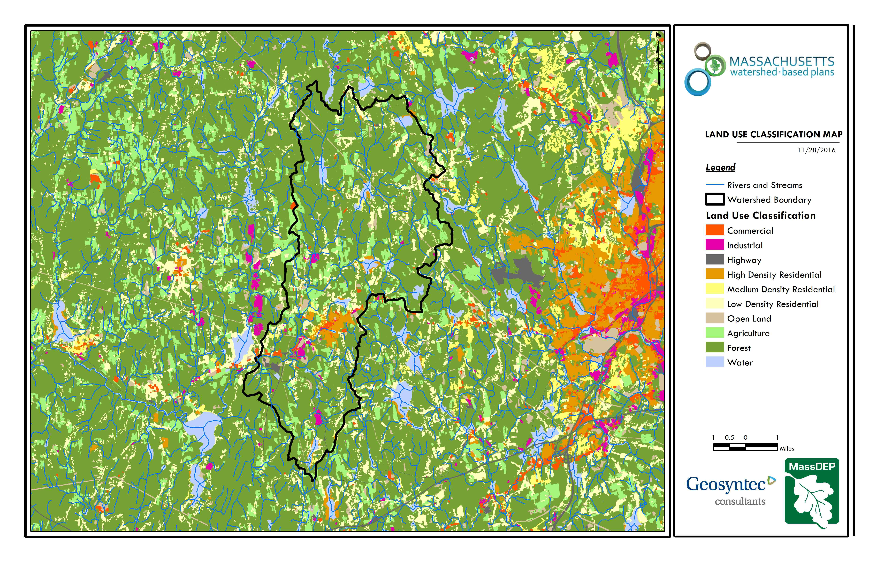
Figure A-2: Sevenmile River Watershed Land Use Map
(MassGIS, 2007; MassGIS, 2009b; MassGIS, 1999; MassGIS, 2001; USGS, 2016)

Watershed Impervious Cover
There is a strong link between impervious land cover and stream water quality. Impervious cover includes land surfaces that prevent the infiltration of water into the ground, such as paved roads and parking lots, roofs, basketball courts, etc. Impervious area within the watershed of the Sevenmile River is concentrated in the central portion of the watershed as illustrated in Figure A-8 below.
Impervious areas that are directly connected (DCIA) to receiving waters (via storm sewers, gutters, or other impervious drainage pathways) produce higher runoff volumes and transport stormwater pollutants with greater efficiency than disconnected impervious cover areas which are surrounded by vegetated, pervious land. Runoff volumes from disconnected impervious cover areas are reduced as stormwater infiltrates when it flows across adjacent pervious surfaces.
An estimate of DCIA for the watershed was calculated based on the Sutherland equations. USEPA provides guidance (USEPA, 2010) on the use of the Sutherland equations to predict relative levels of connection and disconnection based on the type of stormwater infrastructure within the total impervious area (TIA) of a watershed. Within each subwatershed, the total area of each land use was summed and used to calculate the percent TIA (Table A-8).
Table A-8: TIA and DCIA values for the Watershed
Watershed | Estimated TIA (%) | Estimated DCIA (%)
Sevenmile River | 5.8 | 4.1

The relationship between TIA and water quality can generally be categorized as listed by Table A-9 (Schueler et al. 2009). The TIA value for the watershed range is 5.8%; therefore, the river and surrounding tributaries can be expected to show good to excellent water quality.

Table A-9: Relationship between Total Impervious Area (TIA) and water quality (Schueler et al. 2009)

% Watershed  Impervious Cover | Stream Water Quality
0-10% | Typically high quality, and typified by stable channels, excellent habitat structure, good to excellent water quality, and diverse communities of both fish and aquatic insects.
11-25% | These streams show clear signs of degradation. Elevated storm flows begin to alter stream geometry, with evident erosion and channel widening. Streams banks become unstable, and physical stream habitat is degraded. Stream water quality shifts into the fair/good category during both storms and dry weather periods. Stream biodiversity declines to fair levels, with most sensitive fish and aquatic insects disappearing from the stream.
26-60% | These streams typically no longer support a diverse stream community. The stream channel becomes highly unstable, and many stream reaches experience severe widening, downcutting, and streambank erosion. Pool and riffle structure needed to sustain fish is diminished or eliminated and the substrate can no longer provide habitat for aquatic insects, or spawning areas for fish. Biological quality is typically poor, dominated by pollution tolerant insects and fish. Water quality is consistently rated as fair to poor, and water recreation is often no longer possible due to the presence of high bacteria levels.
>60% | These streams are typical of “urban drainage”, with most ecological functions greatly impaired or absent, and the stream channel primarily functioning as a conveyance for stormwater flows.

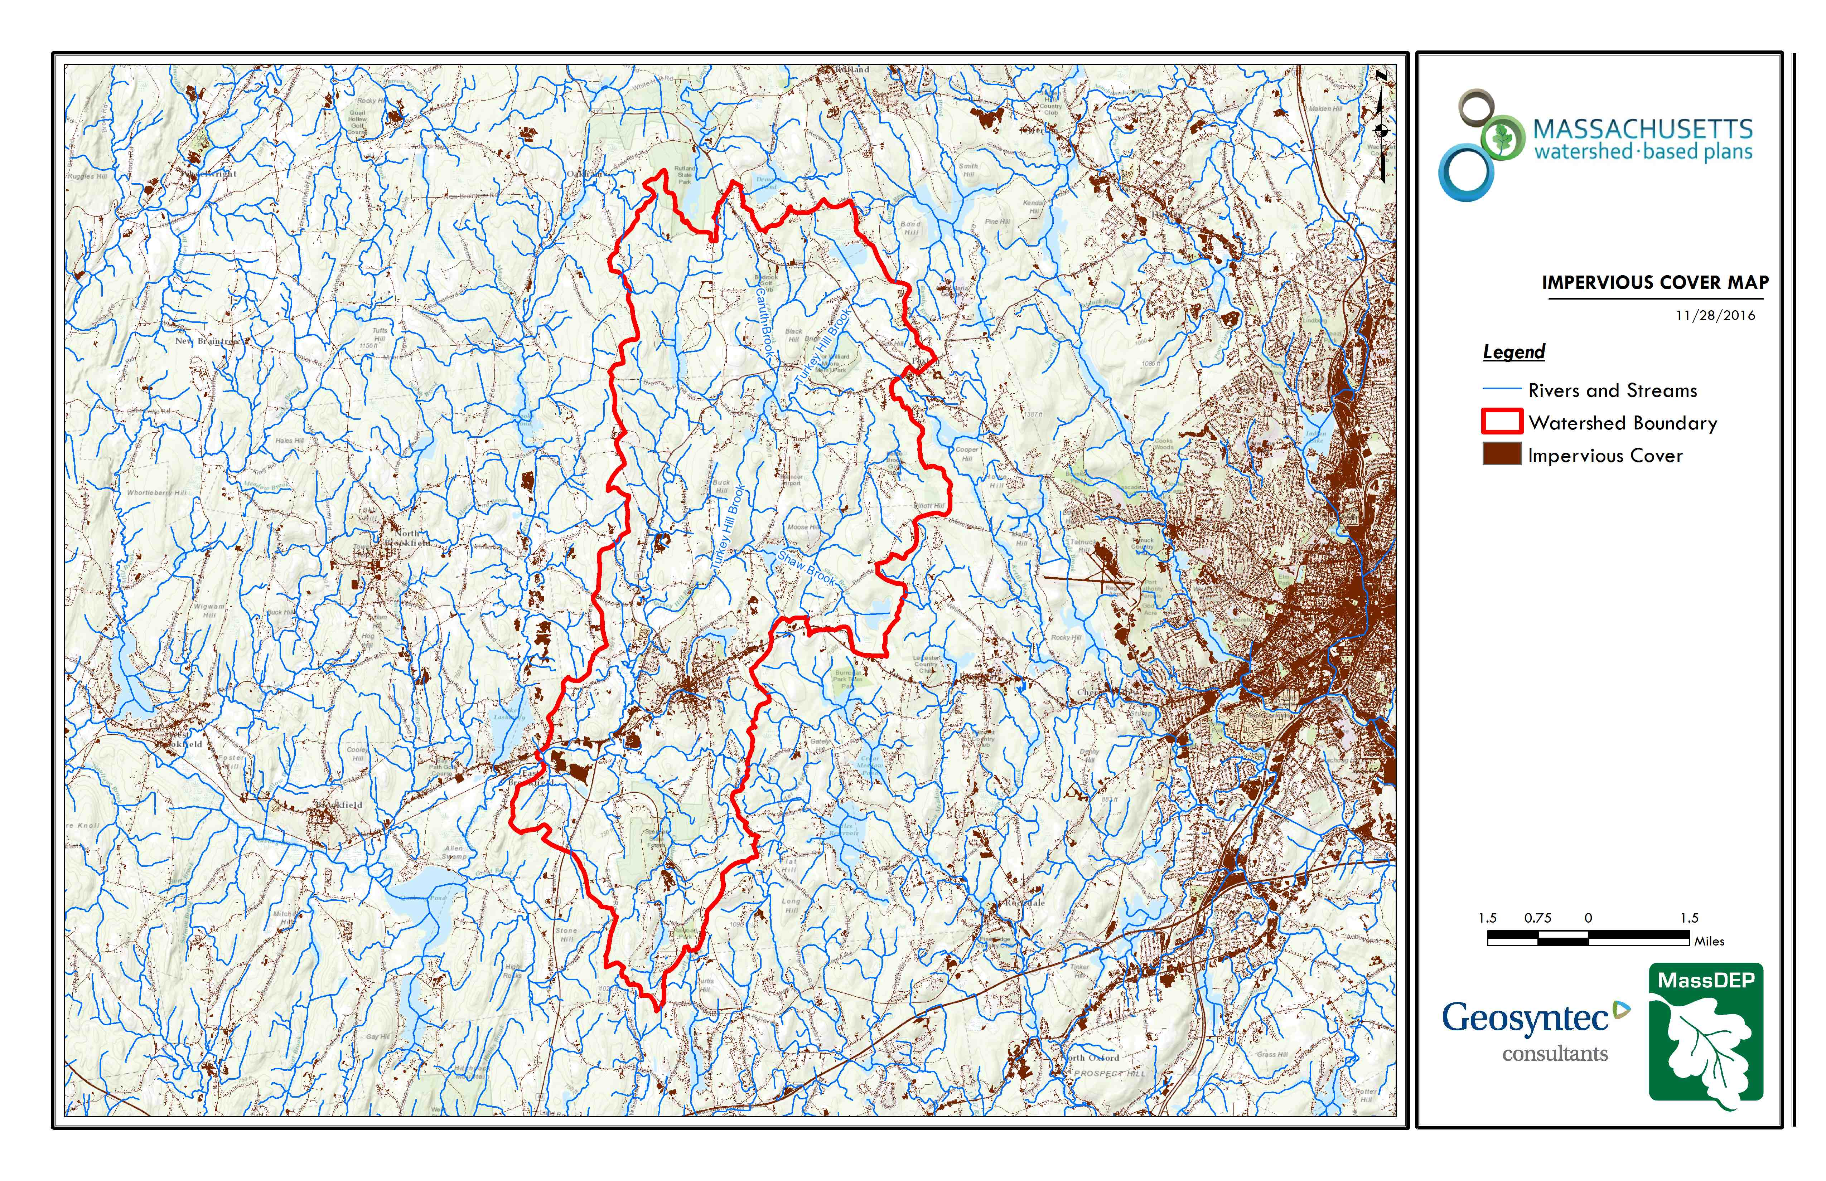
Figure A-3: Sevenmile River Watershed Impervious Surface Map
(MassGIS, 2007; MassGIS, 2009b; MassGIS, 1999; MassGIS, 2001; USGS, 2016)

Pollutant Loading
The land use data (MassGIS, 2009b) was intersected with impervious cover data (MassGIS, 2009a) and United States Department of Agriculture (USDA) Natural Resources Conservation Service (NRCS) soils data (USDA NRCS and MassGIS, 2012) to create a combined land use/land cover grid. The grid was used to sum the total area of each unique land use/land cover type.
The amount of DCIA was estimated using the Sutherland equations as described above and any reduction in impervious area due to disconnection (i.e., the area difference between TIA and DCIA) was assigned to the pervious D soil category for that land use to simulate that some infiltration will likely occur after runoff from disconnected impervious surfaces passes over pervious surfaces.
Pollutant loading for key nonpoint source pollutants in the watershed was estimated by multiplying each land use/cover type area by its pollutant load export rate (PLER). The PLERs are an estimate of the annual total pollutant load exported via stormwater from a given unit area of a particular land cover type. The PLER values for TN, TP and TSS were obtained from USEPA (Voorhees, 2016b) (see documentation provided in Appendix B) as follows:
$$L_{n}=A_{n}* P_{n}$$
Where: $L_{n}$ = Loading of land use/cover type n (lb/yr)
$A_{n}$ = area of land use/cover type n (acres)
$P_{n}$ = pollutant load export rate of land use/cover type n (lb/acre/yr)
The estimated land use-based phosphorus to receiving waters within the watershed area is 5,555 pounds per year, as presented by Table A-10. The largest contributor of the land use-based TP and TN load originates from areas designated as forested (44% of the total phosphorus load and 33% of the total nitrogen load). Nutrients generated from forested areas is a result of natural processes such as decomposition of leaf litter and other organic material and generally represent a “best case scenario” with regards to phosphorus loading, meaning that those portions of the watershed are unlikely to provide opportunities for nutrient load reductions through best management practices. The second-largest contributors of the land-used based TP and TN load in the watershed are residential areas (22% of the TP load and 30% of the TN load), indicating significant opportunity for TP and TN load reductions through stormwater BMP installation. Commercial and industrial areas contribute approximately 8% of the TP load and 10% of the TN load, presenting another area of opportunity for TP and TN load reduction through stormwater BMPs (e.g., at municipal-owned facilities).
A comparison of the percentage of land-used based TP loading in the Sevenmile River watershed to the overall Quaboag Pond watershed is provided in Table A-11. The percentage of TP loading from different land use types are comparable amongst the subwatershed (Sevenmile River) and overall watershed (Quaboag Pond).
Table A-10: Estimated Pollutant Loading for Key Nonpoint Source Pollutants in Sevenmile River Watershed

Land Use Type | Pollutant Loading¹
 | Total  Phosphorus (TP)  (lbs/yr) | Total  Nitrogen (TN)  (lbs/yr) | Total  Suspended Solids (TSS)  (tons/yr)
Forest | 2,434 | 12,291 | 583.84
Agriculture | 1,139 | 6,793 | 89.08
Low Density Residential | 706 | 7,248 | 97.34
High Density Residential | 450 | 3,179 | 46.37
Open Land | 220 | 2,239 | 46.78
Commercial | 214 | 1,852 | 23.16
Industrial | 203 | 1,761 | 22.03
Highway | 131 | 1,017 | 69.16
Medium Density Residential | 58 | 526 | 7.12
TOTAL | 5,555 | 36,905 | 984.88
¹These estimates do not consider loads from point sources or septic systems.

Table A-11: Estimated Total Phosphorus Loading for Key Nonpoint Source Pollutants in Sevenmile River and Quaboag Pond Watersheds.

 | Total Phosphorus (TP) Loading ¹
Land Use | Sevenmile River Watershed |  | Quaboag Pond Watershed²
 | lbs/yr | % of Loading | Lbs/yr | % of Loading
Forest | 2,434 | 44 | 3,667 | 47
Residential (Low, Medium, and High) | 1,139 | 21 | 1,571 | 20
Agriculture | 1,214 | 22 | 1,628 | 21
Open Land and Wetlands | 220 | 4 | 603 | 8
Commercial and Industrial | 417 | 8 | 326 | 4
Highways | 131 | 2 | - | -
TOTAL | 5,555 | 100 | 7,795 | 100
¹These estimates do not consider loads from point sources, septic systems, or internal recycling.
²Quaboag Pond pollutant loading information from Table 4 of Total Maximum Daily Load of Total Phosphorus for Quaboag and Quacumquasit Ponds.

Element B: Determine Pollutant Load Reductions Needed to Achieve Water Quality Goals

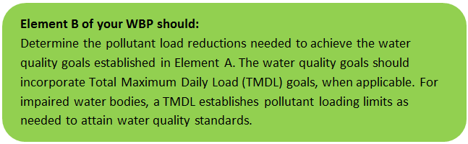

Estimated Pollutant Loads
Estimated pollutant loads for total phosphorus (TP) (5,555 lbs/yr), total nitrogen (TN) (36,905 lb/yr), and total suspended solids (TSS) (985 tons/yr) were previously presented in Table A-9 of this WBP. Bacteria cannot be presented as a load, however, the measured geomean concentration of E. coli in the Sevenmile River ranged from 32 - 256 cfu/100ml (see Section 2, MassDEP Water Quality Assessment Report and TMDL Review).

Water Quality Goals
There are many methodologies that can be used to set pollutant load reduction goals for a WBP. Goals can be based on water quality criteria, surface water standards, existing monitoring data, existing TMDL criteria, or other data. As discussed by Element A, water quality goals for this WBP are focused on improving water quality within the Sevenmile River watershed by focusing on reducing E. Coli and TP loading to Sevenmile River. TP water quality goals from this WBP are based on criteria from the Total Maximum Daily Loads of Total Phosphorus for Quaboag & Quacumquasit Ponds (MassDEP, 2006). The TMDL established an overall 30 percent load reduction goal of approximately 2,471 lb/year (1,122 kg/year) for Quaboag Pond and provided waste load allocations (WLA) for TP based on specific land use areas (See Table B-1). The TMDL required most sources of TP to be reduced by approximately 32%, with the exception of Wetlands (2%) and the Spencer WWTP (0% reduction). Because the overall Quaboag Pond watershed has a similar distribution of land use and pollutant load sources to the Sevenmile River watershed (see Tables A-7 and A-11), a target TP loading reduction of 32% was applied to the Sevenmile River watershed as a water quality goal (see Table B-2). E. coli water quality goals of this WBP are based on MSWQS concentration standards and are difficult to predict based on estimated annual loading, but water quality goals are described in Table B-2.

Table B-1: Total Phosphorus Goals for Quaboag Pond Watershed [Table adapted from "Total Maximum Daily Loads of Total Phosphorus for Quaboag & Quacumquasit Ponds" (MassDEP, 2006)]

Source | Load Allocation Summary for Quaboag Pond Watershed*
 | Current TP Loading  (lbs/yr) | Target TP Load Allocation  (lbs/yr) | % Reduction Required
Forest | 3032 | 2061 | 32
Wetland | 141 | 139 | 2
Agriculture | 1298 | 884 | 32
Open Land | 359 | 244 | 32
Residential | 825 | 561 | 32
Septic System | 106 | 73 | 31
Internal Recycling | 1327 | 904 | 32
Spencer WWTP | 288 | 288 | 0
Urban & Road Stormwater | 788 | 537 | 32
TOTAL | 8162 | 5691 | 30
*Load allocation summarized based on Table 1 of Total Maximum Daily Loads of Total Phosphorus for Quaboag & Quacumquasit Ponds. Loads have been converted from their original format of kg/yr to lb/yr.

Table B-2: Pollutant Load Reductions Needed

Pollutant | Existing Estimated Total Load | Water Quality Goal | Required Load Reduction
Total Phosphorus | 5555 lbs/yr | 3777 lbs/yr | 1778 lbs/yr
Bacteria | MSWQS for bacteria are concentration standards (e.g., colonies of fecal coliform bacteria per 100 ml), which are difficult to predict based on estimated annual loading. E. coli samples collected between May—October 2003 from the Sevenmile River had a geometric means ranging from 42 to 52 colonies/100 ml (MassDEP 2003). E. coli samples collected from May—November 2008 revealed a geometric mean ranging from 206 to 256 colonies/ 100 ml (MassDEP, 2008). Other E. coli data obtained between 2007 – 2011 along Sevenmile River indicated a geometric mean of E. Coli ranging from 32 to 56 colonies/ 100 ml (MassDEP, Undated 1), | Class B. Class B Standards  • Public Bathing Beaches: For E. coli, geometric mean of 5 most recent samples shall not exceed 126 colonies/ 100 ml and no single sample during the bathing season shall exceed 235 colonies/100 ml. For enterococci, geometric mean of 5 most recent samples shall not exceed 33 colonies/100 ml and no single sample during bathing season shall exceed 61 colonies/100 ml;  • Other Waters and Non-bathing Season at Bathing Beaches: For E. coli, geometric mean of samples from most recent 6 months shall not exceed 126 colonies/100 ml (typically based on min. 5 samples) and no single sample shall exceed 235 colonies/100 ml. For enterococci, geometric mean of samples from most recent 6 months shall not exceed 33 colonies/100 ml, and no single sample shall exceed 61 colonies/100 ml. | 50% - Concentration Based

Recommended Load Reduction
Past water quality monitoring data summarized by Element A, Section 2 (MassDEP Water Quality Assessment Report and TMDL Review) indicates that the geometric mean of E. coli samples collected in the Sevenmile River (ranging from 32 to 256 colonies/100 ml) sometimes exceed the benchmark for streams (geometric mean of samples greater than 126 colonies/100 ml and no single sample greater than 235 colonies/100 ml) (Massachusetts Surface Water Quality Standards 2013).
Phosphorus monitoring data included in Element A, Section 2 (MassDEP Water Quality Assessment Report and TMDL Review) indicates that TP concentrations ranged from 6 to 77 µg/L, with only one of the measurements above 50 µg/L, the benchmark for streams (USEPA 1986). However, because the Sevenmile River is a tributary to the Quaboag Pond, reducing TP to the Sevenmile River is still a water quality goal. A long-term reduction of 32% of external TP loading is proposed to improve the water quality within the Sevenmile River watershed, consistent with what is required in the Quaboag Pond TMDL.
The proposed projects described in this plan are expected to reduce both E. coli and TP loads to the Sevenmile River, however, additional load reductions will be required to meet the water quality benchmark.
The following adaptive sequence is recommended to sequentially track and meet these load reduction goals:
- Given current water quality conditions, establish a short-term goal to reduce land use-based phosphorus by 5% (278 pounds) over the next 5 years (by 2025). Considering known pollutant loads for existing and proposed BMPs (please refer to the Introduction or Element C for more details on existing and proposed BMPs), it is anticipated that land use-based phosphorus loading will be reduced by approximately 1% (62 pounds) at completion of the BMPs proposed by the Town of Spencer (by 2022) (Town of Spencer 2019a, Town of Spencer 2019b).
- Given current water quality conditions, establish a short-term goal to reduce the geometric mean concentration of E. coli by 50% over the next 10 years (by 2030). Considering known pollutant loads for existing and proposed BMPs (please refer to the Introduction or Element C for more details on existing and proposed BMPs), it is anticipated that the projects implemented in the last 4 years will reduce land use-based fecal coliform loading by 60,814 billion colonies/year (Town of Spencer, 2019b).
- Establish a baseline water quality monitoring program in accordance with Element I. Results from the monitoring program should advise if Element C management measures have been effective at addressing listed water quality impairments or water quality goals for other indicator parameters established by Element A of this WBP (e.g., nitrogen, dissolved oxygen, chlorophyll-a). Results can further be used to periodically inform or adjust load reduction goals.
- Periodically evaluate the long-term reduction goal to reduce land-use based TP by 32% and E. coli by 50% over the next 15 years (by 2035). Based on monitoring data, revise existing or establish additional long-term reduction goal(s), if needed, to lead to delisting of all assessment units within the study watershed from the 303(d) list.

Element C: Describe management measures that will be implemented to achieve water quality goals

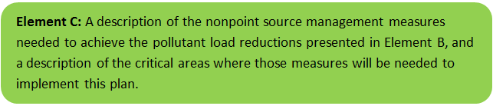

Existing and Ongoing Management Measures
The Town was awarded funding through the Federal Fiscal Year 2017 and Federal Fiscal Year 2020 Section 319 Nonpoint Source Pollution Grant Program to install the proposed structural BMPs listed in Table C-1 within the Sevenmile River watershed (Town of Spencer, 2016; Town of Spencer, 2019a).
Currently, the Town of Spencer has completed construction of rain gardens at three different locations within the Sevenmile River watershed. Resulting from the implementation of these BMPs, a combined TN reduction of 135 lbs/yr, TP reduction of 26 lbs/yr, TSS reduction of 36,818 lbs/yr, E. coli reduction of 60,814 billion colonies, and Zinc reduction of 45 lbs/yr was estimated (Town of Spencer, 2019b). There are additional infiltration BMPs (e.g., rain garden, subsurface infiltration chamber) proposed at four different locations, which are in various phases of completion. Once these BMPs are constructed, it is expected that they will achieve an additional load reduction of 36 lbs/yr of TP, 18,438 lbs/yr of TSS, and 8 lbs/yr of Zinc. Table C-1 includes detail on the estimated pollutant load reduction of the various BMP locations as well as the current stage of completion. Current design information of the proposed BMPs at 84 North Spencer Road, Hillsville/Meadow Road, Pleasant Street/Meadowbrook Lane, and 30 Meadow Road are included in Appendix A.
The Town of Spencer has also been awarded funding through the Municipal Vulnerability Preparedness (MVP) program to design and construct: (1) a green infrastructure parking lot (three rain gardens, one infiltration basin) and (2) a green infrastructure project on Valley Street. Spencer is also internally funding two additional rain gardens along Meadow Road. Design for these projects are in the beginning stages and are therefore not included in Table C-1 below.
Table C-1: Existing and Proposed Management Measures and Estimated Pollutant Load Reductions
Location | Proposed and/or Completed BMPs | Estimated Pollutant Load Reduction¹ |  |  |  |  | Current  Project  Status | Section 319 Grant Funding (Year Awarded)
 |  | Fecal Coliform (billion colonies/yr)² | Total Phosphorus (lb/yr) | Total Nitrogen (lb/yr)² | TSS  (lb/yr) | Zinc  (lb/yr)
Powder Mill Park | - Sediment Forebay  - Rain Garden | 4,381 | 2 | 10 | 2,737 | 3 | CONSTRUCTED | 2017
Spencer Water Treatment Plant | - Sediment Forebay  - Rain Garden | 3,292 | 2 | 8 | 2,731 | 3 | CONSTRUCTED | 2017
Spencer Department of Public Works Building | - Grass Sediment Forebay  - Grass Swale  - Rain Garden | 53,141 | 22 | 117 | 31,350 | 39 | CONSTRUCTED | 2017
84 North Spencer Road | - Infiltration practice such as rain garden, bioswale, or infiltration basin with appropriate pre-treatment | - | 4 | - | 1,988 | 1 | IN DESIGN | 2020
Hillsville/Meadow Road | - Infiltration practice such as rain garden, bioswale, or infiltration basin with appropriate pre-treatment | - | 19 | - | 9,804 | 4 | DESIGN COMPLETED | 2020
Pleasant Street/Meadowbrook Lane | - Underground Infiltration Chamber | - | 10 | - | 5,273 | 2 | DESIGN COMPLETED & IN CONTRACTING | 2020
30 Meadow Road | - Sediment Forebay  - Rain Garden | - | 3 | - | 1,373 | 1 | DESIGN COMPLETED & IN CONTRACTING | 2020

NOTES:
1. The pollutant load reduction estimates were based off information obtained from the Federal Fiscal Year 2020 “Stormwater BMPs: Sevenmile River Watershed” Section 319 Nonpoint Source Pollution Grant Program application (Town of Spencer, 2019a) and the Project Number 17-09/319 Final Report associated with the Federal Fiscal Year 2017 awarded funding (Town of Spencer, 2019b).
2. Fecal coliform and Total Nitrogen pollutant load reduction estimates not available for 84 North Spencer Road, Hillsville/Meadow Road, Pleasant Street/Meadowbrook Lane, and 30 Meadow Road.

Future Management Measures
Once the proposed BMPs have been installed, the Town of Spencer may consider additional BMP implementation to meet water quality goals.
As discussed by Element B, it is recommended that future planning initially focus on water quality goals related to E. coli and TP in the Sevenmile River Watershed. It is recommended that management measures be recommended for future BMPs that emphasize reducing E. coli and TP loading to meet target water quality goals, as feasible. The following general sequence is recommended to identify and implement structural BMPs.

Structural BMPs
- Identify Potential Implementation Locations: Perform a desktop analysis using aerial imagery and GIS data to develop a preliminary list of potentially feasible implementation locations based on soil type (i.e., hydrologic soil groups A and B); available public open space (e.g., lawn area in front of a police station); potential redevelopment sites where additional public-private partnerships may be leveraged; and other factors such as proximity to receiving waters, known problem areas, or publicly owned right of ways or easements. Additional analysis can also be performed to fine-tune locations to maximize pollutant removals such as performing loading analysis on specifically delineated subwatersheds draining to single outfalls and selecting those subwatersheds with the highest loading rates per acre.
- Visit Potential Implementation Locations: Perform field reconnaissance, preferably during a period of active runoff-producing rainfall, to evaluate potential implementation locations, gauge feasibility, and identify potential BMP ideas. During field reconnaissance, assess identified locations for space constraints, potential accessibility issues, presence of mature vegetation that may cause conflicts (e.g., roots), potential utility conflicts, site-specific drainage patterns, and other factors that may cause issues during design, construction, or long-term maintenance.
- Develop BMP Concepts: Once potential BMP locations are conceptualized, use the BMP-selector tool on the watershed-based planning tool to help develop concepts. Concepts can vary widely. One method is to develop 1-page fact sheets for each concept that includes a site description, including definition of the problem, a description of the proposed BMPs, annotated site photographs with conceptual BMP design details, and a discussion of potential conflicts such as property ownership, O&M requirements, and permitting constraints. The fact sheet can also include information obtained from the BMP-selector tool including cost estimates, load reduction estimates, and sizing information (i.e., BMP footprint, drainage area, etc.).
- Rank BMP Concepts: Once BMP concepts are developed, perform a priority ranking based on site-specific factors to identify the implementation order. Ranking can include many factors including cost, expected pollutant load reductions, implementation complexity, potential outreach opportunities and visibility to public, accessibility, expected operation and maintenance effort, and others.
Prioritized BMP concepts should focus on reducing E. coli and TP loading to the Sevenmile River as summarized by Element B.

Non-Structural BMPs
Planned BMPs can also be non-structural (e.g., street sweeping, catch basin cleaning, Illicit Discharge Detection and Elimination (IDDE) to reduce bacteria concentrations). It is recommended that these municipal programs be evaluated and potentially optimized. First, it is recommended that potential removals from ongoing activities be calculated in accordance with Element H & I. Next, it is recommended that ongoing activities be evaluated to see if potential improvements can be implemented to achieve higher pollutant load reductions such as increased frequency or improved technology (e.g., by implementing microbial source tracking protocols to track and eliminate bacteria sources at key outfalls to the Sevenmile River).

Element D: Identify Technical and Financial Assistance Needed to Implement Plan

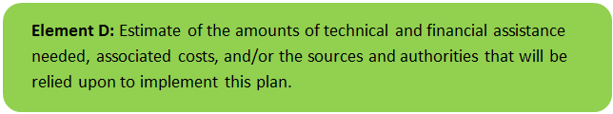

Current and Ongoing Management Measures
The funding needed to implement the proposed management measures presented in this watershed plan are based on information obtained from the Federal Fiscal Year 2020 “Stormwater BMPs: Sevenmile River Watershed” Section 319 Nonpoint Source Pollution Grant Program application (Town of Spencer, 2019a) and the Project Number 17-09/319 Final Report associated with the Federal Fiscal Year 2017 awarded funding (Town of Spencer, 2019b). Table D-1 details the total project spending for the implementation of the Federal Fiscal Year 2017 grant, including the design and construction of eight structural BMPs, purchase of BMP construction materials, development of operation and maintenance manuals, education/outreach and reporting for a total cost of $197,709 (Town of Spencer, 2019b). Table D-2 details the approximately $148,500 of estimated funding needed to implement the remaining portions of the watershed plan described above, including ongoing pollutant load reduction estimates, design and permitting of BMPs, construction of BMPs, development of operation and maintenance plans, reporting, and public education/outreach measures (Town of Spencer, 2019a). Annual operation and maintenance costs are estimated to be approximately $600 per site based on email communication with Town of Spencer Utilities and Facilities Superintendent Bill Krukowski (Krukowski, 2020). This amounts to $4200 annually for the seven proposed site locations.
Table D-1: Summary of Project Spending to Implement the Watershed Plan through June 30, 2019.
Expense Item | s.319 Amount | Non-Federal Match and Source | Total Amount
Salary and Wages
Town of Spencer | $0 | $32,237 | $32,237
Sub-contractual Services
Design, Engineering, Oversight, and Reporting | $39,269 | $54,995 | $92,264
Construction | $43,210 | $0 | $43,210
Materials and Supplies
BMP materials | $23,913 | $3,978 | $27,891
Copying, postage, misc. office | $110 | $0 | $110
Totals | $106,500 | $91,209 | $197,709

Table D-2: Summary of Funding Needed to Implement the Remaining Portions of Watershed Plan.
Expense Item | s.319 Amount | Non-Federal Match and Source | Total Amount
Pollutant Load Reduction Estimate | $0 | $500 | $500
Design & Permitting | $29,000 | $3,300 | $32,300
Construction Phase Services (including Surveying, Wetlands Specialist, Landscape Architect, General Contractor and purchase of BMP materials) | $43,600 | $56,500 | $100,100
Development of O&M Plan | $2,600 | $0 | $2,600
Reporting | $9,200 | $0 | $9,200
Outreach and Education | $3,800 | $0 | $3,800
Totals | $88,200 | $60,300 | $148,500

Future Management Measures
Funding for future BMP installations to further reduce loads within the watershed may be provided by a variety of sources, such as the Section 319 Nonpoint Source Pollution Grant Program, town capital funds, or other grant programs such as the Municipal Vulnerability Preparedness program. The Town of Spencer has previously been successful with and will continue to pursue securing grant funding through various sources. Guidance is available to provide additional information on potential funding sources for nonpoint source pollution reduction efforts.

Element E: Public Information and Education

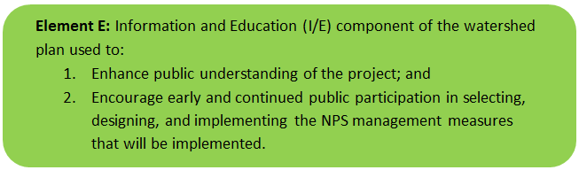

Step 1: Goals and Objectives
The goals and objectives for the watershed information and education program.
- Provide information about proposed stormwater improvements and their anticipated water quality benefits.
- Provide information to promote watershed stewardship.
Step 2: Target Audience
Target audiences that need to be reached to meet the goals and objectives identified above.
- All watershed residents (particularly pet owners).
- Businesses within the watershed.
- Watershed organizations and other user groups, including the 30 member communities in the Central Massachusetts Regional Stormwater Coalition (Coalition).
Step 3: Outreach Products and Distribution
The outreach product(s) and distribution form(s) that will be used for each.
- Develop a newsletter to be mailed to residents and Coalition members.
- Post literature (e.g., pamphlet, flyer, poster) on the project at the Spencer Town Hall; with electronic copies made available to Coalition members, including information on nonpoint source pollution reduction and operation and maintenance history.
- Develop mid-project and end of project PowerPoint presentations to be presented at two meetings of the Coalition.
- All materials will be available electronically via the Town of Spencer and Coalition websites.
Step 4: Evaluate Information/Education Program
Information and education efforts and how they will be evaluated.
- Track and record website activity and the number of newsletters and flyers distributed.
- Record attendance levels at the mid-project and end of Project PowerPoint presentation meetings to the Coalition.

Elements F & G: Implementation Schedule and Measurable Milestones

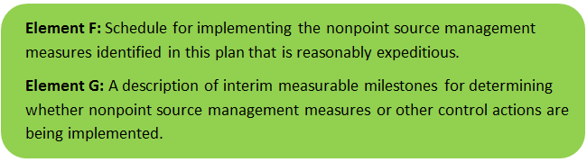

Table FG-1 provides a preliminary schedule for implementation of the recommendations provided by this WBP that have not yet been completed. It is expected that the WBP will be re-evaluated and updated at least once every three years, or as needed, based on ongoing monitoring results and other ongoing efforts. Effort towards these milestones is expected to be dependent on available funding and community interest. New projects for further implementation of the watershed-based plan will be identified through future data analysis and stakeholder engagement and will be included in updates to the implementation schedule.
Table FG-1: Implementation Schedule and Interim Measurable Milestones for Remaining Portions of Watershed Plan.
Category | Action | Year(s)
Task 1: Project Evaluation | Estimate quantity of pollutant load removal to be achieved as required and applicable. Provide estimate based on initial proposed BMPs; provide update if any changes during design and construction.  DELIVERABLES: An analysis of BMP implementation pollutant load reductions by utilizing the Simple Method, or the most current equivalent tool accepted by EPA and MassDEP at time of project completion. The Simple Method will be used to evaluate the pre- and post-BMP implementation pollutant loads within project specific sub-watersheds to estimate total NPS reduction benefit to Sevenmile River. | February 2020 (initial)  December 2021  (final)
Task 2: Design and Permitting of Stormwater Management BMPs | Design and permitting of two stormwater Management BMPs to reduce the amount of pollutants from stormwater runoff before such stormwater enters drainage pathways leading to the Sevenmile River. The following types of stormwater BMP treatment trains will be considered for final design and implementation of stormwater management improvements: BMPs such as bioretention rain gardens, vegetated swales, and infiltration practices, all typically with pretreatment practices such as deep sump catch basins and/or first flush capture treatment tanks. Two new study areas which have land available for siting of BMPs have been identified as first priority; however, if any of these study areas should prove to be too challenging during final design stage for site specific engineering reasons, or due to public review concerns, then other study areas were identified previously under the 2016 grant application as candidates for implementation of BMP treatment trains.  DELIVERABLES: Construction Plans and specifications as necessary to implement the proposed BMPs. | October 2020
Task 3: Construction Phase Services | Two BMPs already designed under the 2016 319 Grant will be constructed, including an infiltrating rain garden at 30 Meadow Road and Cultec Recharger® chambers at Meadowbrook Lane. Two new BMPs which will be designed under Task 2 of this project will also be constructed. Cost for construction materials for the two new BMPs is included here. Materials for the two BMPs already designed have already been purchased and are not included as part of this grant application.  DELIVERABLES: (1) Four (4) constructed Stormwater BMPs; (2) Documentation of sampling stations to be included with selected BMP location(s), for future Town use to evaluate pollutant removal performance; and (3) Construction administration documents, | September 2021
Task 4: Development of an Operation and Maintenance (O&M) Plan | An Operation and Maintenance (O & M) Plan will be developed and implemented to ensure long-term continued effectiveness of the BMPs.  DELIVERABLE: Operation and Maintenance Plan | Ongoing as BMP construction completed
Task 5: Preparation of Reports | Quarterly progress reports, a Draft Final Report, and a Final Report will be prepared and submitted, as required.  DELIVERABLES: Quarterly Progress Reports; Draft Final Report; Final Report | Quarterly
Task 6: Outreach and Education for Stormwater Management BMPs | In addition to the stormwater remediation projects, the Town will produce educational materials addressing nonpoint source pollution in the Sevenmile River watershed. Providing outreach and education on the value of the River, and on protecting ground and surface water resources will be an important component to this grant. These efforts will include a description of the goals of the project, description of the nature and purpose of the constructed stormwater BMPs, and information on how local residents can help to improve the water quality of the Sevenmile River.  DELIVERABLES: (1) Newsletter to be mailed to residents and to the 30 member communities of the Central Massachusetts Regional Stormwater Coalition; (2) Literature to be posted and/or available at Town Hall (e.g., pamphlet, flyer, poster); with electronic copies made available to Coalition members; (3) PowerPoint Presentations of the project (mid-project and at completion); and (4) PDF copies of all materials to be available electronically via Town and Coalition websites | Annually  (September – October 2020; August – September 2021)

Elements H & I: Progress Evaluation Criteria and Monitoring

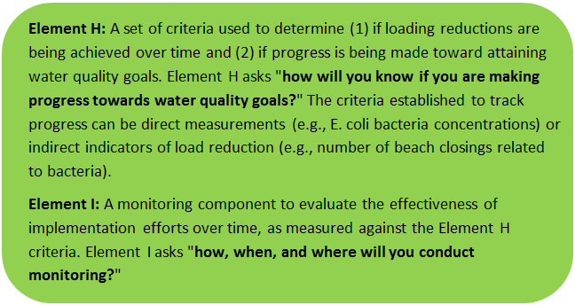 | 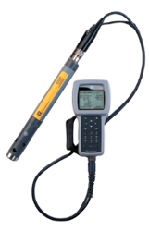

The water quality target concentration(s) and water quality goals are presented under Element A of this plan. To achieve these target concentrations and water quality goals, the annual loading must be reduced to the amount described in Element B. Element C of this plan describes the various management measures that will be implemented to achieve this targeted load reduction. The evaluation criteria and monitoring program described will be used to measure the effectiveness of the proposed management measures (described in Element C) in improving the water quality of Sevenmile River.

Indirect Indicators of Load Reduction

Non-Structural BMPs
Potential load reductions from non-structural BMPs (i.e., street sweeping and catch basin cleaning) can be estimated from indirect indicators, such as the number of miles of streets swept or the number of catch basins cleaned. Appendix F of the 2016 Massachusetts Small MS4 General Permit provides specific guidance for calculating phosphorus removal from these practices. As indicated by Element C, it is recommended that potential phosphorus removal from these ongoing actives be estimated. Next, it is recommended that ongoing activities be evaluated to see if potential improvements can be implemented to achieve higher pollutant load reductions such as increased frequency or improved technology.
Phosphorus load reductions can be estimated in accordance with Appendix F of the 2016 Massachusetts Small MS4 General Permit as summarized by Figure HI-1 and HI-2. Additionally, because there is a bacteria reduction water quality goal applicable to the study area, it is recommended that IDDE efforts required by the NPDES Small MS4 Permit be tracked.
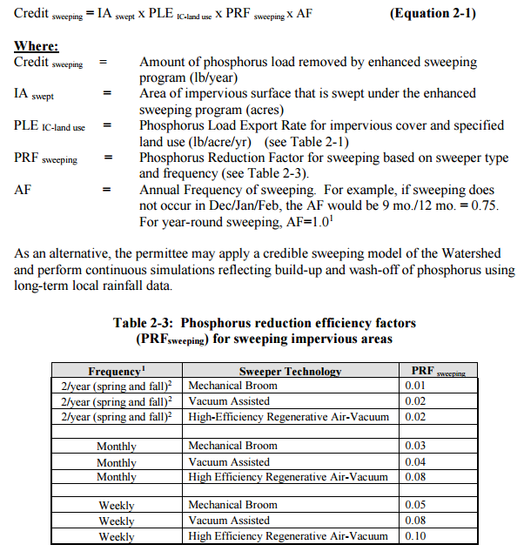
Figure HI-1. Street Sweeping Calculation Methodology
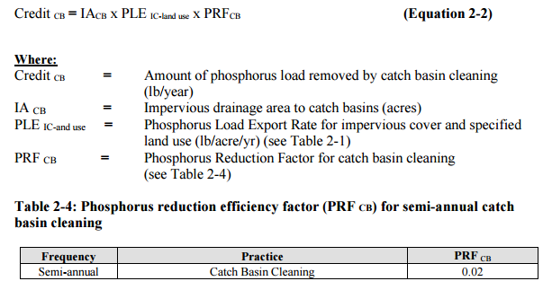
Figure HI-2. Catch Basin Cleaning Calculation Methodology

Project-Specific Indicators

Number of BMPs Installed and Pollutant Reduction Estimates:
Anticipated pollutant load reductions from existing, ongoing (i.e., under construction), and future BMPs will be tracked as BMPs are installed. For example, the existing BMPs are currently estimated to provide a TP reduction of 26 lbs/yr. Once the BMPs currently in design and construction phases are installed, the anticipated phosphorus load reduction is estimated to increase by 36 lbs/yr pounds per year, for a total of 62 lbs/yr.

TMDL Criteria
TMDL requirements encourage ongoing monitoring to assess progress towards the TMDL’s water quality goals, particularly in areas with minimal available water quality data and in areas where BMPs have been installed. The TMDL indicates monitoring data should be used to add/remove/modify BMPs as needed to improve water quality.

Direct Measurements
Direct measurements are generally expected to be performed as described below. Prior to implementing a direct measurement program, an abbreviated QAPP and/or Standard Operating Procedures (SOPs) will be established to flesh out details of the program and establish best practices for sample collection and analysis. Water quality monitoring may be performed through a volunteer training program to save on costs in accordance with established practices for MassDEP’s environmental monitoring for volunteers.

River Sampling
Establish regular sampling to understand the water quality in the Sevenmile River watershed, including determining sources for pollution and tracking achievements towards water quality goals, including analysis of E. coli, phosphorus, nitrogen, turbidity, and total suspended solids in the Sevenmile River. Additional parameters such as chlorophyll-a, dissolved oxygen, temperature, conductivity, pH, and flow rate could provide additional data for consideration. Monitoring locations will be selected based on accessibility and representativeness and shall be appropriate to quantify water quality improvements in the watershed.
It is recommended to prioritize water quality sampling at the Sevenmile River locations that were a part of the 2005 – 2010 and 2011 - 2013 Chicopee River SMART Monitoring Programs (e.g., Sevenmile River at Cooney Road [upstream of the project area] and the Sevenmile River Route 9 [downstream of the project area]).

In-Lake Phosphorus and Water Quality Monitoring
Sampling programs specific for the ponds (e.g., Browning Pond) within the watershed could be established to more closely track the progress of water quality improvements towards water quality goals. Monitoring locations should at minimum include the outlet of the pond, tributaries, and the deepest “in-lake” location. It is recommended that sampling programs include analysis of E. coli, secchi disk transparency, phosphorus, chlorophyll-a, turbidity, temperature/oxygen profiles, and aquatic vegetation. These parameters will also enable tracking relative to Carlson’s state trophic index to evaluate improvements over time.

Outfall Screening
Implement an outfall screening program to compare water quality screening criteria before and after implementation of BMPs. Parameters for screening would include fecal coliform, E. coli, biochemical oxygen demand, TSS, salinity, dissolved oxygen, pH, chlorine, and nutrients. Monitoring of water quality from the Town’s water supply wells may also provide useful data for comparison.

Adaptive Management
As discussed by Element B, the baseline monitoring program will be used to establish a long-term (i.e., 15 year) E. coli and phosphorus load reduction goal (or other parameter(s) depending on results). Long-term goals will be re-evaluated at least once every three years and adaptively adjusted based on additional monitoring results and other indirect indicators. If monitoring results and indirect indicators do not show improvement to the E. coli and total phosphorus concentrations and other indicators (e.g., chlorophyll-a) measured within the watershed, the management measures and loading reduction analysis (Elements A through D) will be revisited and modified accordingly.

References
314 CMR 4.00 (2013). "Division of Water Pollution Control, Massachusetts Surface Water Quality Standards"
Cohen, A. J.; Randall, A.D. (1998). "Mean annual runoff, precipitation, and evapotranspiration in the glaciated northeastern United States, 1951-80." Prepared for United States Geological Survey, Reston VA.
Geosyntec Consultants, Inc. (2014). "Least Cost Mix of BMPs Analysis, Evaluation of Stormwater Standards Contract No. EP-C-08-002, Task Order 2010-12." Prepared for Jesse W. Pritts, Task Order Manager, U.S. Environmental Protection Agency
Geosyntec Consultants, Inc. (2015). "Appendix B: Pollutant Load Modeling Report, Water Integration for the Squamscott-Exeter (WISE) River Watershed."
King, D. and Hagan, P. (2011). "Costs of Stormwater Management Practices in Maryland Counties." University of Maryland Center for Environmental Science Chesapeake Biological Laboratory. October 11, 2011.
Krukowski, Bill. (2020). “O&M Costs – Constructed BMPs.” Message to Alessandra Braswell, Geosyntec Consultants. 21 January 2020. E-mail.
Leisenring, M., Clary, J., and Hobson, P. (2014). "International Stormwater Best Management Practices (BMP) Database Pollutant Category Statistical Summary Report: Solids, Bacteria, Nutrients and Metals." Geosyntec Consultants, Inc. and Wright Water Engineers, Inc. December 2014.
MassDEP (1989). “Diagnostic Evaluation Management Alternatives and Recommendations: 21 Commonwealth Lakes and Ponds”
MassDEP (2006). “Total Maximum Daily Loads of Total Phosphorus for Quaboag & Quacumquasit Ponds”
MassDEP (2008). "Chicopee River Watershed 2003 Water Quality Assessment Report"
MassDEP (2012). "Massachusetts Year 2012 Integrated List of Waters Final Listing of Massachusetts' Waters Pursuant to Sections 305(b), 314 and 303(d) of the Clean Water Act"
MassDEP (2013). “Chicopee River Watershed 2008 DWM Water Quality Monitoring Data”
MassDEP (2014). “Chicopee River Watershed 2008 Macroinvertebrate Bioassessment”
MassDEP (2016a). “Chicopee River Watershed SMART Monitoring Program 2005 – 2010”
MassDEP (2016b). “Chicopee River Watershed SMART Monitoring Program 2011 – 2013”
MassDEP (2016c). "Massachusetts Clean Water Toolkit"
MassDEP (2016d). "Massachusetts Stormwater Handbook, Vol. 2, Ch. 2, Stormwater Best Management Practices"
MassDEP. Undated 1. "Open file analysis of DWM WPP water quality data collected between 2000 and 2014 using CALM guidance." Division of Watershed Management, Massachusetts Department of Environmental Protection, Worcester, Massachusetts.
MassDEP. Undated 2. "Open files of unpublished, validated water quality monitoring data, field sheet data, and GIS datalayers in development." Division of Watershed Management, Massachusetts Department of Environmental Protection, Worcester, Massachusetts
MassGIS (1999). "Networked Hydro Centerlines" Shapefile
MassGIS (2001). "USGS Topographic Quadrangle Images" Image
MassGIS (2007). "Drainage Sub-basins" Shapefile
MassGIS (2009a). "Impervious Surface" Image
MassGIS (2009b). "Land Use (2005)" Shapefile
MassGIS (2013). "MassDEP 2012 Integrated List of Waters (305(b)/303(d))" Shapefile
Reardon, M. (2014). Chicopee River Watershed 2008 Benthic Macroinvertebrate Bioassessment. Massachusetts Department of Environmental Protection, Division of Watershed Management, Worcester, MA.
Reardon, M. (2019). “Sevenmile River MA36-11 Summary of Water Quality Data.” Message to Alessandra Braswell, Geosyntec Consultants. 23 December 2019. E-mail.
Schueler, T.R., Fraley-McNeal, L, and K. Cappiella (2009). "Is impervious cover still important? Review of recent research" Journal of Hydrologic Engineering 14 (4): 309-315.
United States Bureau of Labor Statistics (2016). "Consumer Price Index"
United States Geological Survey (2016). "National Hydrography Dataset, High Resolution Shapefile"
University of Massachusetts, Amherst (2004). "Stormwater Technologies Clearinghouse"
USDA NRCS and MassGIS (2012). "NRCS SSURGO-Certified Soils" Shapefile
USEPA (1986). "Quality Criteria for Water (Gold Book)" EPA 440/5-86-001. Office of Water, Regulations and Standards. Washington, D.C.
USEPA. (2010). "EPA's Methodology to Calculate Baseline Estimates of Impervious Area (IA) and Directly Connected Impervious Area (DCIA) for Massachusetts Communities."
Town of Spencer (2016). “Town of Spencer Stormwater BMPs: Sevenmile River Watershed Project” Section 319 Nonpoint Source Pollution Grant Program Application.
Town of Spencer (2019a). “Town of Spencer Stormwater BMPs: Sevenmile River Watershed Project” Section 319 Nonpoint Source Pollution Grant Program Application.
Town of Spencer (2019b). Project Number 17-09/319 Final Report.
Voorhees, Mark, USEPA. (2015). "FW: Description of additional modelling work for Opti-Tool Project" Message to Chad Yaindl, Geosyntec Consultants. 23 April 2015. E-mail.
Voorhees, Mark, USEPA. (2016a). "FW: EPA Region 1 SW BMP performance equations" Message to Chad Yaindl, Geosyntec Consultants. 25 January 2016. E-mail.
Voorhees, Mark, USEPA. (2016b). "FW: Description of additional modelling work for Opti-Tool Project" Message to Chad Yaindl, Geosyntec Consultants. 23 April 2015. E-mail.

Appendices

Appendix A – BMP Design Details

Appendix B – Pollutant Load Export Rates (PLERs)

Land Use & Cover¹ | PLERs (lb/acre/year)
 | (TP) | (TSS) | (TN)
AGRICULTURE, HSG A | 0.45 | 7.14 | 2.59
AGRICULTURE, HSG B | 0.45 | 29.4 | 2.59
AGRICULTURE, HSG C | 0.45 | 59.8 | 2.59
AGRICULTURE, HSG D | 0.45 | 91.0 | 2.59
AGRICULTURE, IMPERVIOUS | 1.52 | 650 | 11.3
COMMERCIAL, HSG A | 0.03 | 7.14 | 0.27
COMMERCIAL, HSG B | 0.12 | 29.4 | 1.16
COMMERCIAL, HSG C | 0.21 | 59.8 | 2.41
COMMERCIAL, HSG D | 0.37 | 91.0 | 3.66
COMMERCIAL, IMPERVIOUS | 1.78 | 377 | 15.1
FOREST, HSG A | 0.12 | 7.14 | 0.54
FOREST, HSG B | 0.12 | 29.4 | 0.54
FOREST, HSG C | 0.12 | 59.8 | 0.54
FOREST, HSG D | 0.12 | 91.0 | 0.54
FOREST, HSG IMPERVIOUS | 1.52 | 650 | 11.3
HIGH DENSITY RESIDENTIAL, HSG A | 0.03 | 7.14 | 0.27
HIGH DENSITY RESIDENTIAL, HSG B | 0.12 | 29.4 | 1.16
HIGH DENSITY RESIDENTIAL, HSG C | 0.21 | 59.8 | 2.41
HIGH DENSITY RESIDENTIAL, HSG D | 0.37 | 91.0 | 3.66
HIGH DENSITY RESIDENTIAL, IMPERVIOUS | 2.32 | 439 | 14.1
HIGHWAY, HSG A | 0.03 | 7.14 | 0.27
HIGHWAY, HSG B | 0.12 | 29.4 | 1.16
HIGHWAY, HSG C | 0.21 | 59.8 | 2.41
HIGHWAY, HSG D | 0.37 | 91.0 | 3.66
HIGHWAY, IMPERVIOUS | 1.34 | 1,480 | 10.2
INDUSTRIAL, HSG A | 0.03 | 7.14 | 0.27
INDUSTRIAL, HSG B | 0.12 | 29.4 | 1.16
INDUSTRIAL, HSG C | 0.21 | 59.8 | 2.41
INDUSTRIAL, HSG D | 0.37 | 91.0 | 3.66
INDUSTRIAL, IMPERVIOUS | 1.78 | 377 | 15.1
LOW DENSITY RESIDENTIAL, HSG A | 0.03 | 7.14 | 0.27
LOW DENSITY RESIDENTIAL, HSG B | 0.12 | 29.4 | 1.16
LOW DENSITY RESIDENTIAL, HSG C | 0.21 | 59.8 | 2.41
LOW DENSITY RESIDENTIAL, HSG D | 0.37 | 91.0 | 3.66
LOW DENSITY RESIDENTIAL, IMPERVIOUS | 1.52 | 439 | 14.1
MEDIUM DENSITY RESIDENTIAL, HSG A | 0.03 | 7.14 | 0.27
MEDIUM DENSITY RESIDENTIAL, HSG B | 0.12 | 29.4 | 1.16
MEDIUM DENSITY RESIDENTIAL, HSG C | 0.21 | 59.8 | 2.41
MEDIUM DENSITY RESIDENTIAL, HSG D | 0.37 | 91.0 | 3.66
MEDIUM DENSITY RESIDENTIAL, IMPERVIOUS | 1.96 | 439 | 14.1
OPEN LAND, HSG A | 0.12 | 7.14 | 0.27
OPEN LAND, HSG B | 0.12 | 29.4 | 1.16
OPEN LAND, HSG C | 0.12 | 59.8 | 2.41
OPEN LAND, HSG D | 0.12 | 91.0 | 3.66
OPEN LAND, IMPERVIOUS | 1.52 | 650 | 11.3
¹HSG = Hydrologic Soil Group

Watersheds are defined by the WBP-tool by utilizing MassGIS drainage sub-basins.
Guidance on funding sources to address nonpoint source pollution: http://prj.geosyntec.com/prjMADEPWBP_Files/Guide/Element%20D%20-%20Funds%20and%20Resources%20Guide.pdf
Additional guidance is provided at: https://www.epa.gov/sites/production/files/2015-06/documents/stream.pdf and https://www.mass.gov/guides/water-quality-monitoring-for-volunteers#2
Additional guidance is provided at: https://www.epa.gov/sites/production/files/2015-06/documents/lakevolman.pdf

