


WATERSHED-BASED PLAN | 
Manchaug Pond

March 2021

Prepared By:
Manchaug Pond Foundation
&
Comprehensive Environmental Inc.

Prepared For:


Contents
Element A: Identify Causes of Impairment & Pollution Sources 5
1. General Watershed Information 5
2. MassDEP Water Quality Assessment Report and TMDL Review 6
3. Manchaug Pond-Specific Literature Review 8
4. Water Quality Impairments 10
5. Water Quality Goals 11
6. Land Use Information 12
7. Pollutant Loading 16
Element B: Determine Pollutant Load Reductions Needed to Achieve Water Quality Goals 18
1. Estimated Pollutant Loads 18
2. Water Quality Goals 18
Element C: Describe management measures that will be implemented to achieve water quality goals 20
Element D: Identify Technical and Financial Assistance Needed to Implement Plan 51
Element E: Public Information and Education 52
Step 1: Goals and Objectives 52
Step 2: Target Audience 53
Step 3: Outreach Products and Distribution 53
Step 4: Evaluate Information/Education Program 55
Elements F & G: Implementation Schedule and Measurable Milestones 56
Elements H & I: Progress Evaluation Criteria and Monitoring 59
Indirect Indicators of Load Reduction 59
Project-Specific Indicators 59
Direct Measurements 60
Adaptive Management 60
Recommendations 60
References 62


Watershed-Based Plan Introduction
What is a Watershed-Based Plan?

Purpose & Need
The purpose of a Massachusetts Watershed-Based Plan (WBP) is to organize information about Massachusetts watersheds, and present it in a format that will enhance the development and implementation of projects that will restore water quality and beneficial uses in the Commonwealth. The Massachusetts WBP follows USEPA's recommended format for “nine-element” watershed plans, as described below.
All states are required to develop WBPs, but not all states have taken the same approach. Most states develop watershed-based plans only for selected watersheds. MassDEP's approach has been to develop a tool to support statewide development of WBPs, so that good projects in all areas of the state may be eligible for federal watershed implementation grant funds under Section 319 of the Clean Water Act.
Background
USEPA guidelines promote the use of Section 319 funding for developing and implementing WBPs. WBPs are required for all projects implemented with Section 319 funds, and are recommended for all watershed projects, whether they are designed to protect unimpaired waters, restore impaired waters, or both.
The USEPA Guidelines list the following nine elements required to be included in WBPs:
- An identification of the causes and sources or groups of similar sources that will need to be controlled to achieve the load reductions estimated in this watershed-based plan (and to achieve any other watershed goals identified in the watershed-based plan), as discussed in item (b) immediately below.
- An estimate of the load reductions expected for the management measures described under paragraph (c) below (recognizing the natural variability and the difficulty in precisely predicting the performance of management measures over time).
- A description of the NPS management measures needed to achieve the load reductions estimated under paragraph (b) above (as well as to achieve other watershed goals identified in this watershed-based plan), and an identification (using a map or a description) of the critical areas in which those measures will be needed to implement this plan.
- An estimate of the amounts of technical and financial assistance needed, associated costs, and/or the sources and authorities that will be relied upon, to implement this plan. As sources of funding, States should consider the use of their Section 319 programs, State Revolving Funds, USDA's Environmental Quality Incentives Program and Conservation Reserve Program, and other relevant Federal, State, local and private funds that may be available to assist in implementing this plan.
- An information/education component that will be used to enhance public understanding of the project and encourage their early and continued participation in selecting, designing, and implementing the NPS management measures that will be implemented.
- A schedule for implementing the NPS management measures identified in this plan that is reasonably expeditious.
- A description of interim, measurable milestones for determining whether NPS management measures or other control actions are being implemented.
- A set of criteria to determine if loading reductions are being achieved over time and substantial progress is being made towards attaining water quality standards and, if not, the criteria for determining whether this watershed-based plan needs to be revised or, if a NPS Total Maximum Daily Load (TMDL) has been established, whether the TMDL needs to be revised.
- A monitoring component to evaluate the effectiveness of the implementation efforts over time, measured against the criteria established under item (h) immediately above.

Element A: Identify Causes of Impairment & Pollution Sources

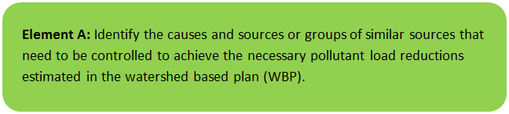 | 

General Watershed Information
Manchaug Pond is a 380-acre Great Pond located in Sutton and Douglas, MA and serves as the headwaters to the Mumford and Blackstone River systems. See Figure A-1 for Watershed Boundary Map. The pond averages approximately 13 feet deep with a maximum depth of around 30 feet. It encompasses a 4,288-acre watershed within the Towns of Sutton, Douglas and Oxford. The pond is fed by Stump Pond and several tributaries located along the north and west sides. The Whiten Reservoir has been known to flow into Manchaug Pond at the southwestern end during periods of unusually high water. Manchaug Pond feeds Stevens Pond and this outlet is the high point of the Mumford River Watershed, which is a major tributary to the Blackstone River. Its 5 ½ mile shoreline includes: several family run campgrounds; a YMCA children’s camp; a public access boat ramp with parking (~38 spaces) that is maintained by the Town of Sutton in coordination with the MA Office of Fishing and Boating Access; the Waters Farm Living History Museum; and hundreds of shoreline homes and watershed residents. Land use within the watershed consists mainly of summer turned year-round homes with steep slopes and many agricultural related land uses. Manchaug Pond’s fisheries offers a dozen species including large and smallmouth bass, bluegills and pumpkinseed, as well as pickerel and perch. Wetland habitats and coves bring spring peepers, bullfrogs and green and tree frogs with sightings of snapping and painted turtles, leopard frogs, crayfish and mussels, dragonflies, heron, cormorants, and various migrating wood ducks and buffleheads. A tributary serves as a coldwater fishery for brook trout. Vernal pools in the western hillside, coupled with the bordering oak-hickory forest, bring species of special concern to the watershed: spotted and eastern box turtles, and marbled and four-toed salamanders. Common are the visits of ospreys and bald eagles who fish this resource.
Table A-1: General Watershed Information

Watershed Name (Assessment Unit ID): | Manchaug Pond (MA51091)
Major Basin: | BLACKSTONE
Watershed Area (within MA): | 4,288 (ac)
Water Body Size: | 365 (ac)

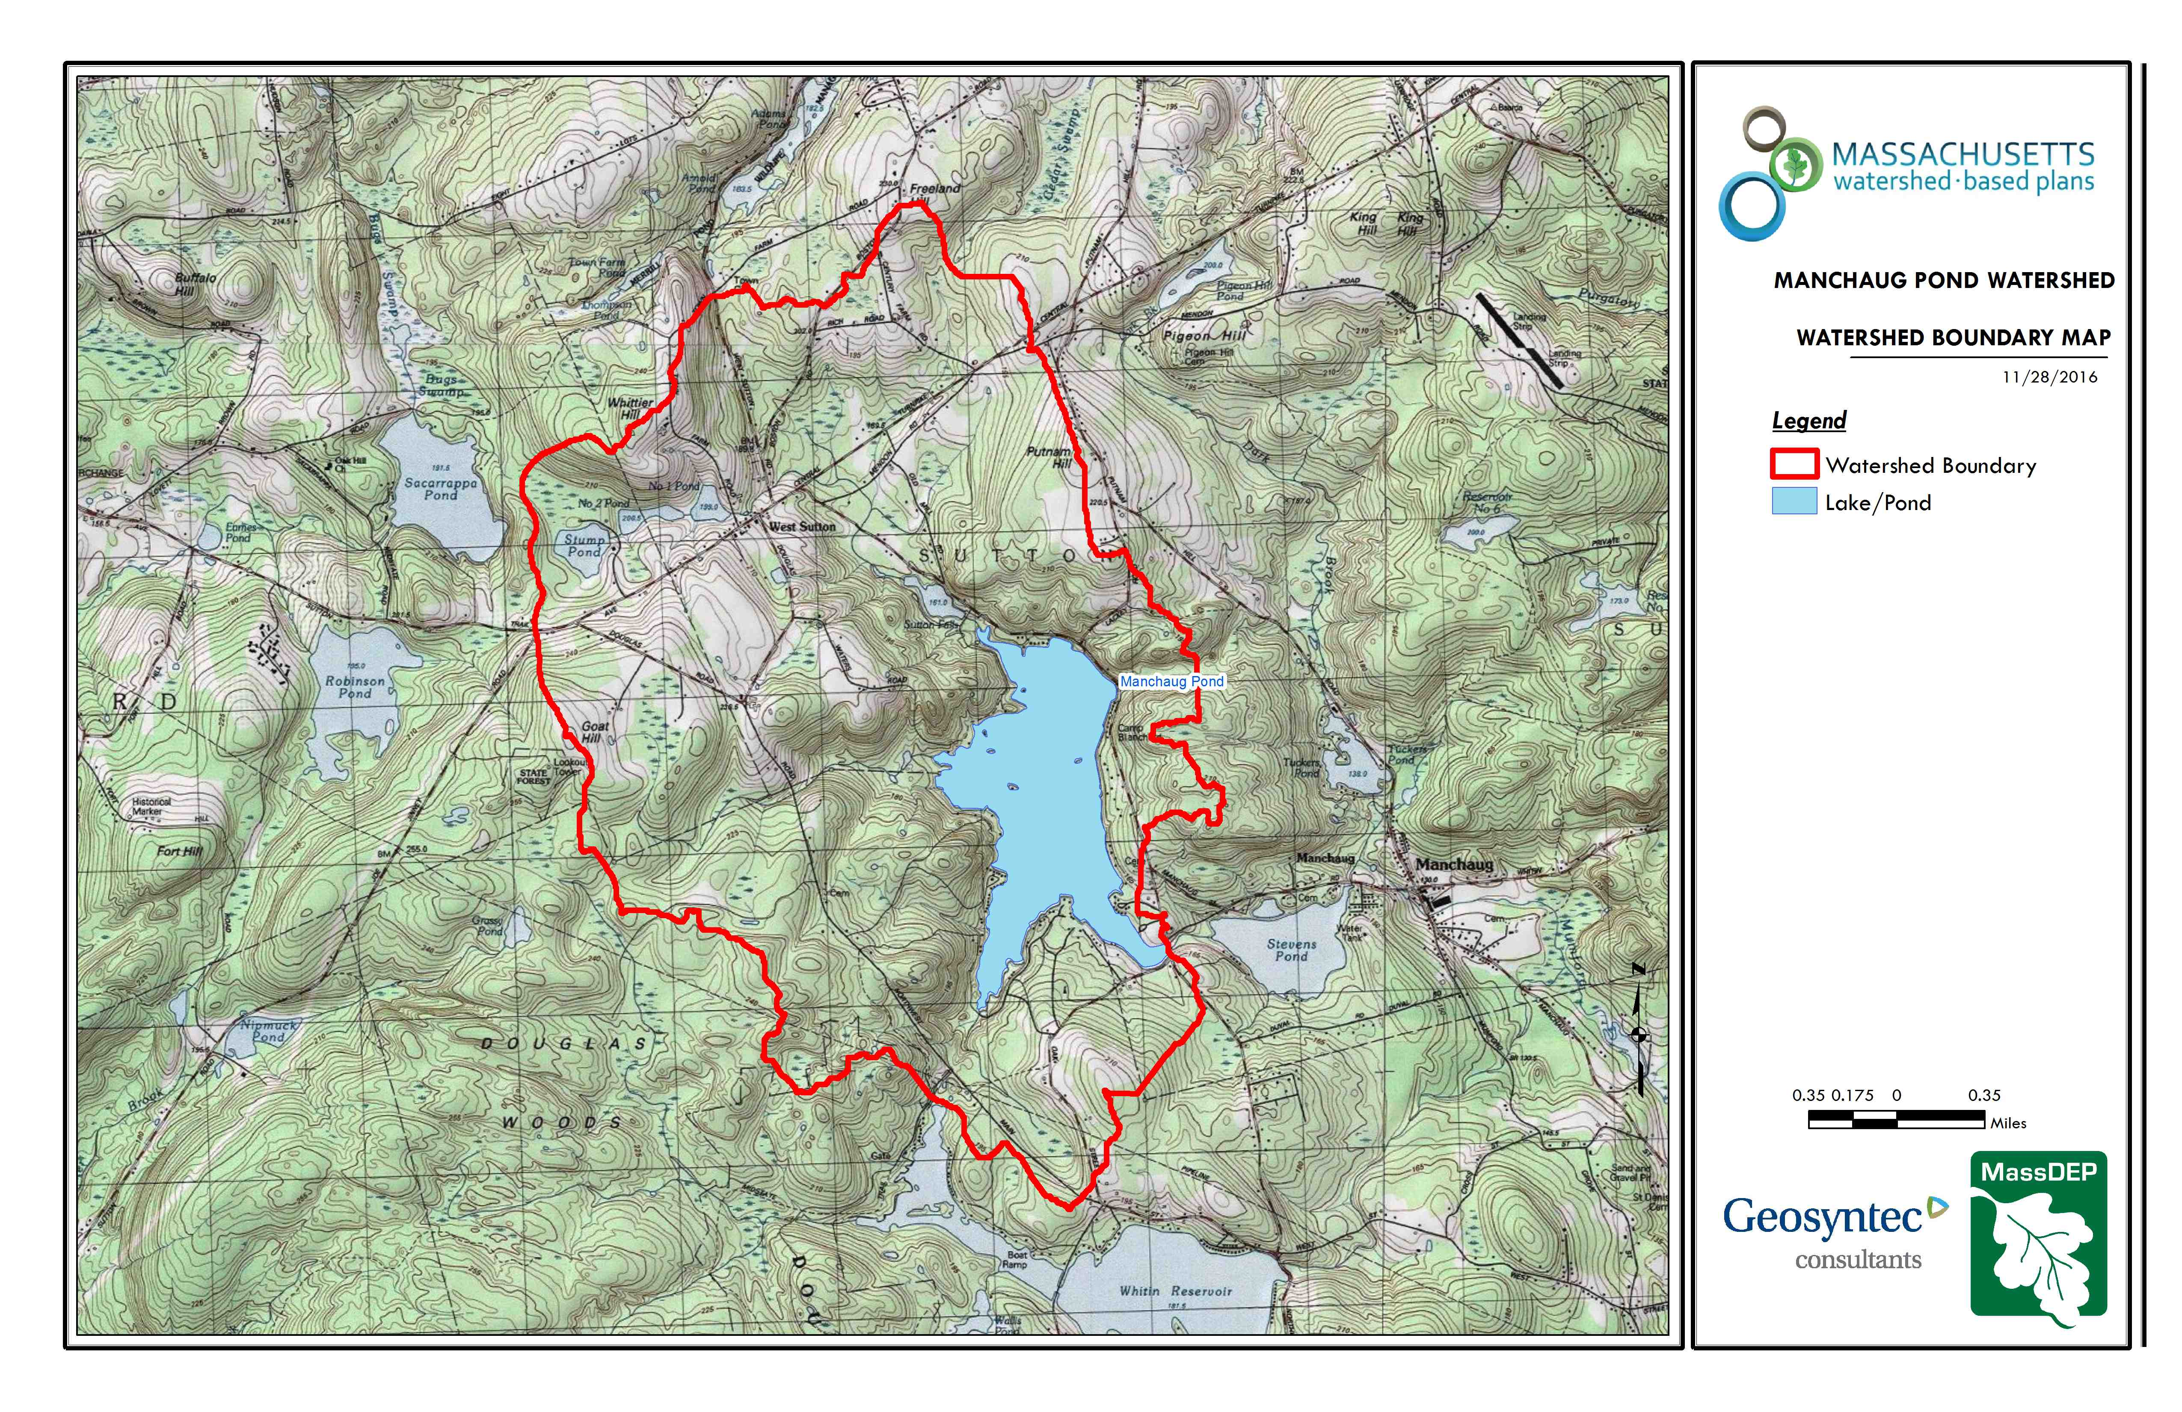
Figure A-1: Watershed Boundary Map (MassGIS, 1999; MassGIS, 2001; USGS, 2016)
Ctrl + Click on the map to view a full sized image in your web browser.

MassDEP Water Quality Assessment Report
The following reports are available:
- Blackstone River Watershed 2003-2007 Water Quality Assessment Report
- Northeast Regional Mercury Total Maximum Daily Load Final Addendum for Massachusetts

Sections relevant to Manchaug Pond summarized below.

Blackstone River Watershed 2003-2007 Water Quality Assessment Report (MA51091 - Manchaug Pond)
Habitat and Flow
The Manchaug Reservoir Corporation (former owner of the Manchaug Pond Dam) operated the dam to provide dilution flows at the downstream Guilford of Maine manufacturing facility. Although the Guilford of Maine facility for which a minimum flow was required has closed, there are ongoing issues with dam operations which are of concern. In the fall of 2008 (as well as many years prior), the flashboards were removed from the Manchaug Pond spillway, resulting in the alteration of vast areas of protected resources by lowering the water level approximately six feet (MassDEP 2009). Furthermore, the flashboards were not replaced in the spring, thus failing to restore the illegally altered wetlands. On April 21, 2009 MassDEP ordered the dam owner to install the flashboards and maintain the Manchaug Pond water levels according to historic practices.
Biology
A non-native species (Potamogeton crispus) was observed in Manchaug Pond during the 1994 Blackstone River Watershed synoptic lake surveys (MassDEP 1994). A second non-native species (Cabomba caroliniana) was observed in Manchaug Pond during the 1998 synoptic surveys (MassDEP 1998). A potential non-native macrophyte species (Myriophyllum sp., possibly M. heterophyllum) was also observed.
Water Chemistry
An in-situ profile was taken by DWM at the deep hole of Manchaug Pond on 10 September 2003. Dissolved oxygen concentrations ranged from 8.3 to <0.2 mg/L (Haque and Mattson 2007). Low dissolved oxygen levels were measured in the bottom water at depths of 6.0 m or greater which represents approximately 25% of the lake area. The depth integrated chlorophyll a concentration was 7.5 mg/m³ while the Secchi disk depth was 3.2 m. The average surface phosphorus data was recorded at 0.011 mg/l .
The Aquatic Life Use is assessed as impaired for Manchaug Pond because of the infestation with C. caroliniana and P. crispus, non-native aquatic macrophytes as well as oxygen depletion which affects approximately 25% of the lake area. The potential infestation with M. heterophyllum is also noted as a concern, as well as flow fluctuations associated with dam operations at the Manchaug Pond outlet.
Fish Consumption Use
Fish (largemouth bass, Micropterus salmoides, white perch, Morone americana, yellow perch, Perca flavescens, bluegill, Lepomis macrochirus, brown bullhead Ameiurus nebulosus) were collected by DWM biologists from Manchaug Pond in June 2008 and were analyzed for mercury (Maietta 2007). Mercury concentrations in the largemouth bass sample are of concern (Maietta et al. 2009). MA DPH has not yet evaluated the data.
The Fish Consumption Use is not assessed since MA DPH has not yet reviewed the data. This use is identified with an Alert Status however because of the concentrations of mercury in the largemouth bass sample (M. salmoides) which are of concern. All applicable statewide fish consumption advisories issued by MA DPH due to mercury contamination apply to this waterbody.
Primary and Secondary Contact Recreational and Aesthetics Uses
On 10 September 2003, MassDEP DWM staff recorded field observations regarding aesthetics in Manchaug Pond. Observations included the presence of dense algae with many large clumps of suspended algae. The water had a light green tint and was described as highly turbid (Haque and Mattson 2007, MassDEP 2003).
In May 2006, Blackstone River Watershed Association volunteers, under guidance from Mass Riverways, conducted a Stream Team survey at Manchaug Pond (BRWA 2006). They noted the presence of trash, foaming brown appearance of water, lots of weeds, and petroleum sheens from recreational boating.
There are four beaches along the shoreline of Manchaug Pond (including Lake Manchaug Camping in Douglas and Camp Blanchard and King’s Family Campground in Sutton) along with Sutton Falls Camping Area in Sutton (near the inlet at Aldrich Mill Pond). Per the MPF, the Sutton Board of Health requires weekly testing for E. coli and fecal coliform with results sent weekly to MassDEP. The Douglas Board of Health requires weekly E. coli sampling with results sent to the MA Department of Public Health at the end of the season. Currently there are no Primary Contact Recreational Use assessment (either support or impairment) decisions being made using Beaches Bill data for this waterbody.
The Primary and Secondary Contact Recreation and Aesthetics uses are not assessed for Manchaug Pond but an Alert Status is identified for these uses due to the adverse conditions noted by DWM and BRWA volunteers i.e., large clumps of suspended algae, highly turbid water column, weeds, trash, and petroleum sheens.
Report Recommendations:
Continue to monitor for the presence of invasive non-native aquatic vegetation and determine the extent of the infestation. Prevent spreading of invasive aquatic plants. Once the extent of the problem is determined and control practices are exercised, vigilant monitoring needs to be practiced to guard against infestations in unaffected areas, including downstream from the site, and to ensure that managed areas stay in check. A key portion of the prevention program should be posting of boat access points with signs to educate and alert lake-users to the problem and their responsibility to prevent spreading these species. The watershed/canoe/kayak groups should consider seeking volunteers to provide outreach on preventing the spread of exotic invasive plants at popular access points during the busiest weekends of the summer. The Final GEIR for Eutrophication and Aquatic Plant Management in Massachusetts (Mattson et al. 2004) should also be consulted prior to the development of any lake management plan to control non-native aquatic plant species. Plant control options can be selected from several techniques (e.g., bottom barriers, drawdown, herbicides, etc.) each of which has advantages and disadvantages that need to be addressed for the specific site. However, methods that result in fragmentation (such as cutting or raking) should not be used for many species because of the propensity for these invasive species to reproduce and spread vegetatively (from cuttings). Conduct an aquatic macrophyte survey in late July/August to confirm species of Myriophyllum.

Manchaug Pond-Specific Literature Review
The following relevant Manchaug Pond-specific references were reviewed when preparing this Watershed Based Plan in addition to the individual water quality and vegetation data tables cited in the References section of this report.
- Wastewater Management Plan, Nonpoint Source Pollution. Nonpoint Sources: By Type, Location, and Quantity. Central Massachusetts Regional Planning Commission. March 1977. The Center for Environment and Man, Inc., 1977. This phosphorus focused report estimates the current (as of 1977), pristine and future supply of phosphorus from various watershed sources. Data includes a hydraulic retention time of 209 days with an estimated annual cycle of 66% phosphorus remaining in sediment while 34% leaving the pond with outflow. Phosphorus sources assessed included erosion-related, atmospheric, septic systems, livestock, motor vehicles and point sources. Results indicated that in pristine condition Manchaug Pond would have a total phosphorus load of 211 kg/yr (low oligotrophic); current (1977) conditions include a total phosphorus load of 710 kg/yr (mid-mesotrophic); and a Year 2000 projected load of 1,031 kg/yr (low eutrophic).
- Manchaug Watershed Quality Improvement/Reclamation Study. Town of Sutton Conservation Commission, January 1980. IEP, 1980. Completed in 1980, this report details a watershed investigation in the Upper Manchaug Watershed for the purpose of determining nutrient sources and to provide recommendations to reduce water quality impacts. Water quality and aquatic vegetation data is discussed along with the completion of a nutrient budget that included Stump Pond, Number 2 Pond, Hotel Pond and Sutton Falls. It was concluded that these ponds provide nutrient retention or a filtering function through physical settling, biological uptake and chemical transformation. The estimated annual total phosphorus load to Manchaug Pond is 660 lbs/year. Total phosphorus concentrations in water samples collected at the inlet of Manchaug Pond between 1975 and 1979 ranged from 10 ppb to 40 ppb. These concentrations are consistent with those found in water samples collected from the upper watershed ponds and tributaries during the same time period. The report stated that agricultural runoff is a major source of nutrients within the upper watershed however, the potential for an even greater nutrient loading exists from other land uses such as intensive subdivision development. Recommendations included in-lake management and land use planning and management.
- Manchaug Pond Watershed Survey – Final Report. Comprehensive Environmental Inc, 2005. This report identifies potential pollutant sources and details prioritized Best Management Practices (BMPs) potential locations identified during a watershed survey completed in 2005. Sources included horse farms, campsites/outhouses/septic systems, unpaved roads, steep slopes, agricultural land uses, and recreation trails. Structural and non-structural BMPs were recommended including considerations for ease of installation and cost. Conceptual designs were included and utilized to obtain future grant funds.
- Project Final Report; Manchaug Pond NPS Implementation Project. Project #05-12/319. Prepared for the Massachusetts Department of Environmental Protection and the U.S. Environmental Protection Agency. 2007-2011. Manchaug Pond Association, 2011. Final report summarizing completed structural and non-structural BMPs implemented within the Manchaug Pond Watershed.
- Aquatic Vegetation Assessment at Manchaug Pond, Sutton/Douglas, MA. Prepared for the Manchaug Pond Foundation Board of Directors. Aquatic Control Technology, 2014. This report includes the results of the vegetation survey and recommended aquatic vegetation management plan for Manchaug Pond and Aldrich Mill Pond. Its purpose was to serve as a guide to the MPFs decision on how to proceed with control and management of the pond’s aquatic plants.
- Project Final Report; Manchaug Pond Water Quality Improvements – Phase 2, Project #13-05/319. Prepared for the Massachusetts Department of Environmental Protection and the U.S. Environmental Protection Agency. 2013-2016. Manchaug Pond Foundation, 2016. Final report summarizing completed structural and non-structural BMPs implemented within the Manchaug Pond Watershed.
- Aquatic Vegetation Survey Report, Manchaug Pond. Prepared for Manchaug Pond Foundation. Solitude, 2017. This report includes the results of the 2017 vegetation survey of Manchaug Pond to help determine the current extent of aquatic vegetation with special regard to exotic, invasive species.

TMDL Review
MassDEP (unpublished) previously conducted a loading analysis of Lake Manchaug using the NPS Lake model (Mattson and Isaac, 1999). An estimated total annual TP load to the pond of 413 kg/yr (910.5 lbs/yr) and using Reckhow (1979) estimated lake TP equal to 13.8 ppb. The approximately 101 houses on septic system around 100 meters of the pond were estimated to have an annual TP load of 50.5 kg/yr (111.3 lbs/yr). MassDEP (unpublished) previously identified an estimated target TP concentration of 11 ppb. This estimated target is expected to maintain the pond in its current mesotrophic state and also allow for primary and secondary contact recreation in summer. The pond has organic enrichment/low DO problems and therefore needs a restorative TMDL. Watershed phosphorus reduction is needed to meet the identified target.

Previous analysis indicates an estimated target TP Load allocation of 329 kg/yr (725.3 lbs/yr) and an average of 33% reduction from modeled TP loading may be needed. The agriculture, open land, residential (low and high density) were estimated to need an average 30% reduction in TP loads while a 50% reduction in loads from commercial/industrial land uses was identified in one scenario. Additionally septic systems were estimated to need a 31% load reduction.

Water Quality Impairments
Known water quality impairments, as documented in the Massachusetts Department of Environmental Protection (MassDEP) 2016 Massachusetts Integrated List of Waters, are listed below. Impairment categories from the Integrated List are as follows:
Table A-2: 2016 MA Integrated List of Waters Categories
Integrated List Category | Description
1 | Unimpaired and not threatened for all designated uses.
2 | Unimpaired for some uses and not assessed for others.
3 | Insufficient information to make assessments for any uses.
4 | Impaired or threatened for one or more uses, but not requiring calculation of a Total Maximum Daily Load (TMDL), including:  4a: TMDL is completed  4b: Impairment controlled by alternative pollution control requirements  4c: Impairment not caused by a pollutant - TMDL not required
5 | Impaired or threatened for one or more uses and requiring preparation of a TMDL.

Table A-3: Water Quality Impairments
Assessment  Unit ID | Waterbody | Integrated  List  Category | Impairment
MA51091 | Manchaug Pond | 5 | Non-Native Aquatic Plants
MA51091 | Manchaug Pond | 5 | Dissolved Oxygen
MA51091 | Manchaug Pond | 5 | Mercury in Fish Tissue

Integrated List History
This pond was originally listed in the 1996 Integrated List for Organic Enrichment/Low DO, Noxious Aquatic Plants and Exotic species. A 1998 DWM Synoptic Survey of the Pond described “slight to moderate turbidity, slight dissolved organics, moderate algal bloom, development moderate to heavy around most of lake, non-native plants (Cabomba caroliniana, Myriophyllum heterophyllum sp), <5% of entire surface covered by submergent and emergent plants, ≤25% loss of open water habitat over entire pond”. The pond was also assessed as mesotrophic. With the 2010 Integrated List the original impairments were mapped for Oxygen, Dissolved and (Non-Native Aquatic Plants*). The Mercury in Fish Tissue impairment was added in the 2012 Integrated List.

Water Quality Goals
Water quality goals may be established for a variety of purposes, including the following:
a.) For water bodies with known impairments, a Total Maximum Daily Load (TMDL) is established by MassDEP and the United States Environmental Protection Agency (USEPA) as the maximum amount of the target pollutant that the waterbody can receive and still safely meet water quality standards. If the waterbody has a TMDL for total phosphorus (TP) or total nitrogen (TN), or total suspended solids (TSS), that information is provided below and included as a water quality goal.
b.) For water bodies without a TMDL for total phosphorus (TP), a default water quality goal for TP is based on target concentrations established in the Quality Criteria for Water (USEPA, 1986) (also known as the “Gold Book”). The Gold Book states that TP should not exceed 50 ug/L in any stream at the point where it enters any lake or reservoir, nor 25 ug/L within a lake or reservoir. For the purposes of developing WBPs, MassDEP has adopted 50 ug/L as the TP target for all streams at their downstream discharge point, regardless of which type of water body the stream discharges to.
c.) Massachusetts Surface Water Quality Standards (314 CMR 4.00, 2013) prescribe the minimum water quality criteria required to sustain a waterbody’s designated uses. Manchaug Pond is a Class 'B' waterbody. The water quality goal for fecal coliform bacteria is based on the Massachusetts Surface Water Quality Standards.

Table A-4: Surface Water Quality Classification by Assessment Unit ID
Assessment  Unit ID | Waterbody | Class
MA51091 | Manchaug Pond | B

d.) Other water quality goals set by the community (e.g., protection of high-quality waters, in-lake phosphorus concentration goal to reduce recurrence of cyanobacteria blooms, etc.).

Table A-5: Water Quality Goals
Pollutant | Goal | Source
Total Phosphorus (TP) | Total phosphorus should not exceed:  --50 ug/L in any stream  --25 ug/L within any lake or reservoir | Quality Criteria for Water (USEPA, 1986)
Bacteria | Class B Standards  • Public Bathing Beaches: For E. coli, geometric mean of 5 most recent samples shall not exceed 126 colonies/ 100 ml and no single sample during the bathing season shall exceed 235 colonies/100 ml. For enterococci, geometric mean of 5 most recent samples shall not exceed 33 colonies/100 ml and no single sample during bathing season shall exceed 61 colonies/100 ml;  • Other Waters and Non-bathing Season at Bathing Beaches: For E. coli, geometric mean of samples from most recent 6 months shall not exceed 126 colonies/100 ml (typically based on min. 5 samples) and no single sample shall exceed 235 colonies/100 ml. For enterococci, geometric mean of samples from most recent 6 months shall not exceed 33 colonies/100 ml, and no single sample shall exceed 61 colonies/100 ml. | Massachusetts Surface Water Quality Standards (314 CMR 4.00, 2013)
Note: There may be more than one water quality goal for bacteria due to different Massachusetts Surface Water Quality Standards Classes for different Assessment Units within the watershed.

The water quality goal for Manchaug Pond is to consistently meet or exceed USEPA and Massachusetts Water Quality Standards for total phosphorus and bacteria concentrations. To achieve this goal, the Manchaug Pond Foundation recognizes these standards need to be met in ponds and tributaries throughout the watershed. Watershed management and sampling efforts will focus on subcatchments with the highest pollutant concentrations and isolate areas to help identify nonpoint pollution sources. The Manchaug Pond Foundation will work with the municipalities and community members within the Manchaug Pond watershed to develop and implement appropriate stormwater best management practices (BMPs) that will target the removal of nutrients and bacteria as sources are identified. Refer to Table A-5 for a list of water quality goals.

Land Use Information
A. Watershed Land Uses
Land use information is presented based on the general watershed land use as well as the amount of impervious cover.
Table A-6: Watershed Land Uses
Land Use | Area (acres) | % of Watershed
Forest | 2603.78 | 60.6
Agriculture | 583.86 | 13.6
Water | 434.76 | 10.1
Low Density Residential | 431.42 | 10
Open Land | 133.49 | 3.1
High Density Residential | 46.69 | 1.1
Commercial | 27.2 | 0.6
Medium Density Residential | 22.59 | 0.5
Industrial | 6.49 | 0.2
Highway | 3.21 | 0.1

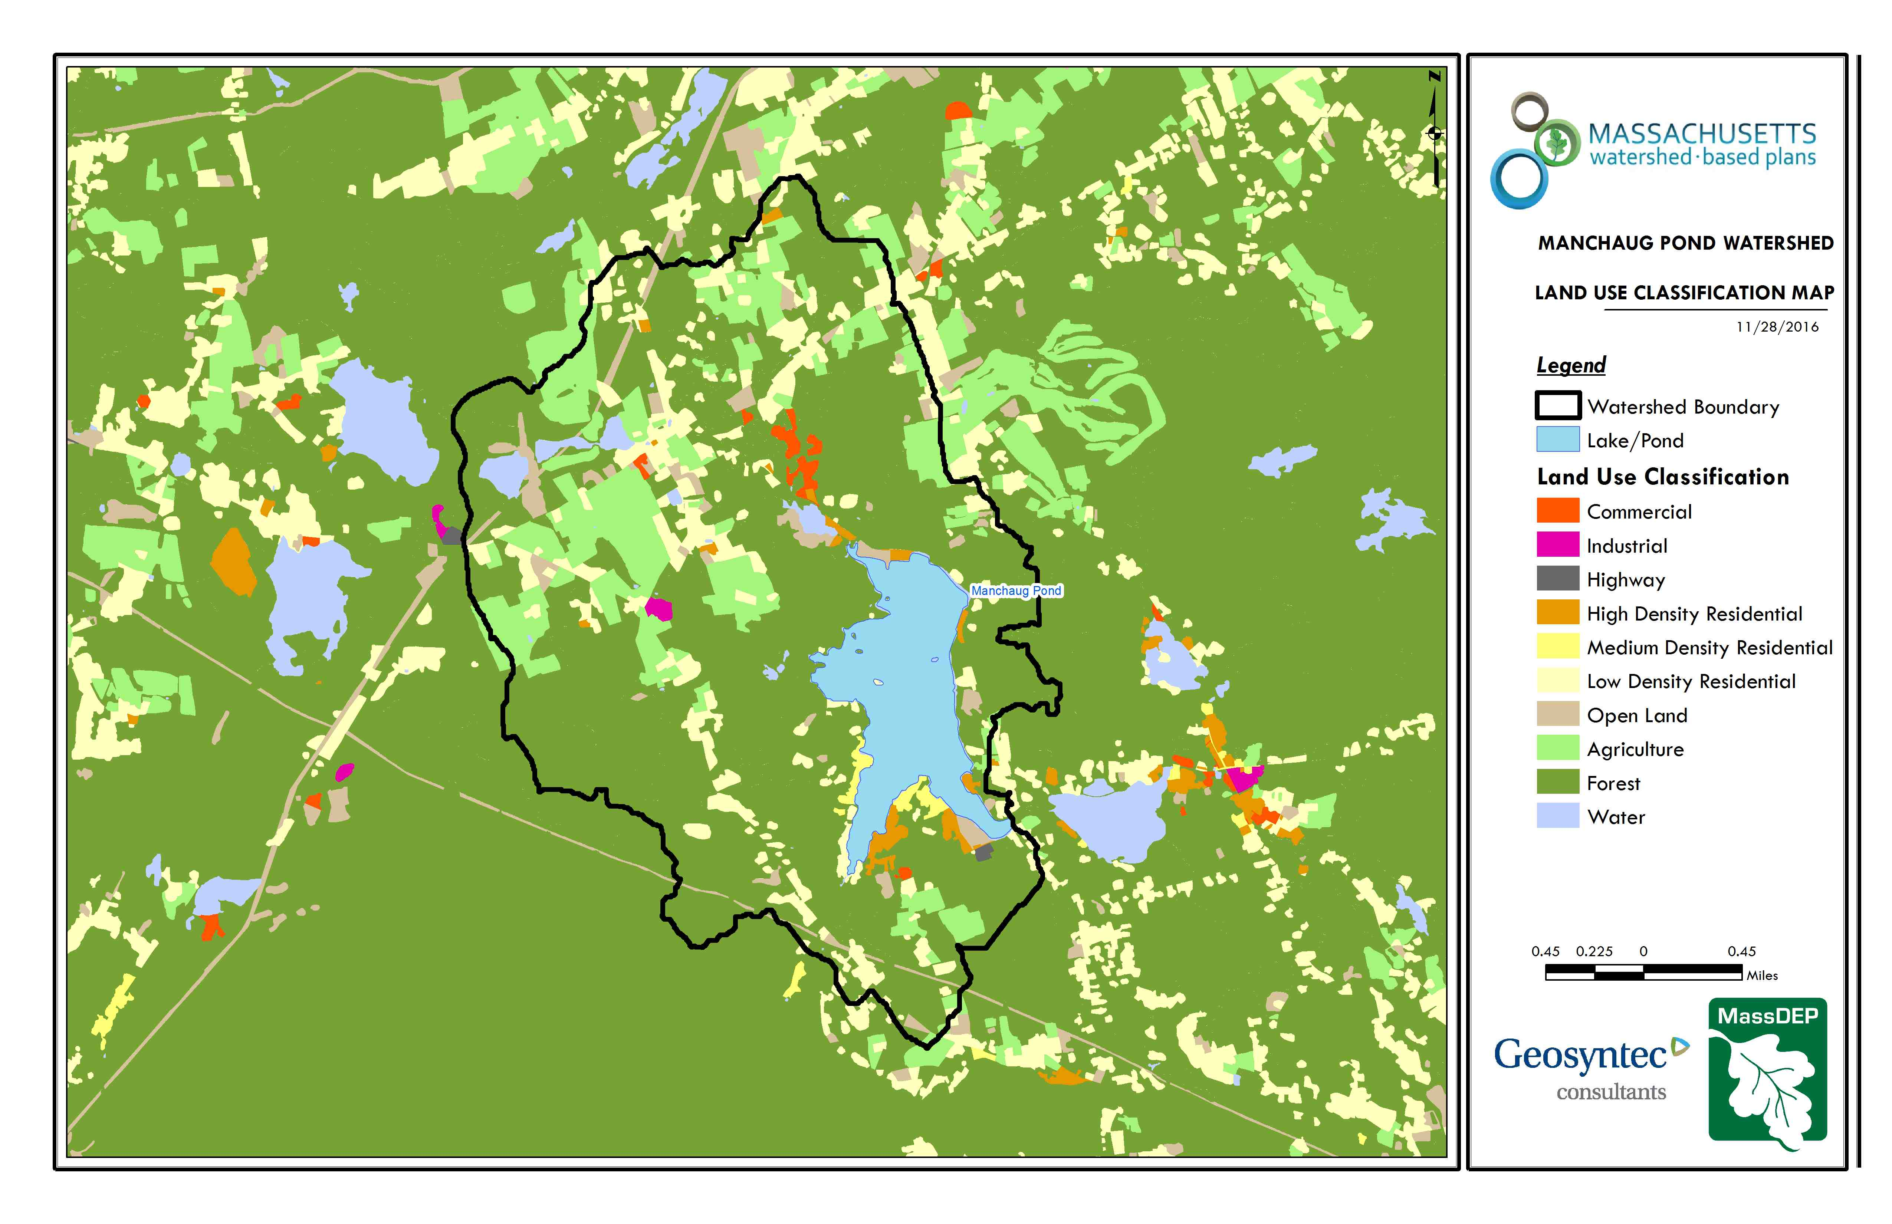
Figure A-2: Watershed Land Use Map (MassGIS, 2009b; MassGIS, 1999; MassGIS, 2001; USGS, 2016)
Ctrl + Click on the map to view a full-sized image in your web browser.

B. Watershed Impervious Cover
There is a strong link between impervious land cover and stream water quality. Impervious cover includes land surfaces that prevent the infiltration of water into the ground, such as paved roads and parking lots, roofs, basketball courts, etc.
Impervious areas that are directly connected (DCIA) to receiving waters (via storm sewers, gutters, or other impervious drainage pathways) produce higher runoff volumes and transport stormwater pollutants with greater efficiency than disconnected impervious cover areas which are surrounded by vegetated, pervious land. Runoff volumes from disconnected impervious cover areas are reduced as stormwater infiltrates when it flows across adjacent pervious surfaces.
An estimate of DCIA for the watershed was calculated based on the Sutherland equations. USEPA provides guidance (USEPA, 2010) on the use of the Sutherland equations to predict relative levels of connection and disconnection based on the type of stormwater infrastructure within the total impervious area (TIA) of a watershed. Within each subwatershed, the total area of each land use were summed and used to calculate the percent TIA.

Estimated TIA in the watershed: 5.2 %
Estimated DCIA in the watershed: 3.5 %

The relationship between TIA and water quality can generally be categorized as follows (Schueler et al. 2009):

Table A-7: Relationship between Total Impervious Area (TIA) and water quality (Schueler et al. 2009)
% Watershed  Impervious Cover | Stream Water Quality
0-10% | Typically high quality, and typified by stable channels, excellent habitat structure, good to excellent water quality, and diverse communities of both fish and aquatic insects.
11-25% | These streams show clear signs of degradation. Elevated storm flows begin to alter stream geometry, with evident erosion and channel widening. Streams banks become unstable, and physical stream habitat is degraded. Stream water quality shifts into the fair/good category during both storms and dry weather periods. Stream biodiversity declines to fair levels, with most sensitive fish and aquatic insects disappearing from the stream.
26-60% | These streams typically no longer support a diverse stream community. The stream channel becomes highly unstable, and many stream reaches experience severe widening, downcutting, and streambank erosion. Pool and riffle structure needed to sustain fish is diminished or eliminated and the substrate can no longer provide habitat for aquatic insects, or spawning areas for fish. Biological quality is typically poor, dominated by pollution tolerant insects and fish. Water quality is consistently rated as fair to poor, and water recreation is often no longer possible due to the presence of high bacteria levels.
>60% | These streams are typical of “urban drainage”, with most ecological functions greatly impaired or absent, and the stream channel primarily functioning as a conveyance for stormwater flows.

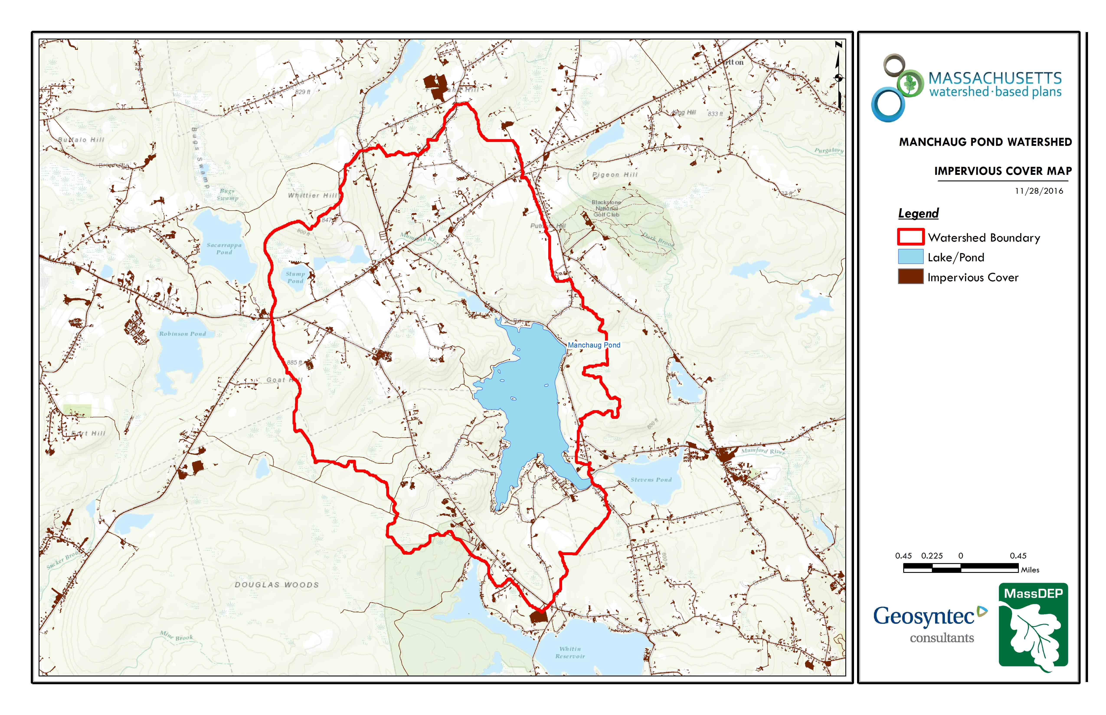
Figure A-3: Watershed Impervious Surface Map (MassGIS, 2009b; MassGIS, 1999; MassGIS, 2001; USGS, 2016)
Ctrl + Click on the map to view a full sized image in your web browser.
Land Use Interpretation
The watershed is largely forested (~ 61% of watershed). Agriculture, water, and low density residential land uses comprise 13.6%, 10.1 %and 10.0% of the watershed area respectively. The Town of Sutton is a right-to-farm community with both agricultural land uses and residential hobby farm activities within the watershed. The right-to-farm bylaw was passed to encourage the pursuit of agriculture, promote agriculture-based economic opportunity, protect farmland within the town by allowing agricultural uses and related activities to function with minimal conflict with abutters and agencies. It is estimated that there is over 3,500 acres of land in forestry and agriculture in Sutton in addition to the small hobby and backyard farms that exist throughout the Manchaug Pond watershed area in both Sutton and Douglas. The Manchaug Pond watershed has a relatively low TIA and DCIA. Although Table A-7 indicates high-quality water based on the TIA relationship, significant agricultural uses within the watershed may render this metric optimistic in some areas.

Pollutant Loading
The land use data (MassGIS, 2009b) was intersected with impervious cover data (MassGIS, 2009a) and United States Department of Agriculture (USDA) Natural Resources Conservation Service (NRCS) soils data (USDA NRCS and MassGIS, 2012) to create a combined land use/land cover grid. The grid was used to sum the total area of each unique land use/land cover type.
The amount of DCIA was estimated using the Sutherland equations as described above and any reduction in impervious area due to disconnection (i.e., the area difference between TIA and DCIA) was assigned to the pervious D soil category for that land use to simulate that some infiltration will likely occur after runoff from disconnected impervious surfaces passes over pervious surfaces.
Pollutant loading for key nonpoint source pollutants in the watershed was estimated by multiplying each land use/cover type area by its pollutant load export rate (PLER). The PLERs are an estimate of the annual total pollutant load exported via stormwater from a given unit area of a particular land cover type. The PLER values for TN, TP and TSS were obtained from USEPA (Voorhees, 2016b) (see documentation provided in Appendix A) as follows:
L_{n}= A_{n}* P_{n}
Where L_{n} = Loading of land use/cover type n (lb/yr); A_{n} = area of land use/cover type n (acres); P_{n} = pollutant load export rate of land use/cover type n (lb/acre/yr)

Table A-8: Estimated Pollutant Loading for Key Nonpoint Source Pollutants
Land Use Type | Pollutant Loading¹
Land Use Type | Total  Phosphorus (TP)  (lbs/yr) | Total  Nitrogen (TN)  (lbs/yr) | Total  Suspended Solids (TSS)  (tons/yr)
Forest | 365 | 1,880 | 74.92
Agriculture | 286 | 1,719 | 23.31
Low Density Residential | 124 | 1,259 | 16.94
Open Land | 50 | 495 | 10.69
High Density Residential | 23 | 172 | 2.47
Commercial | 11 | 97 | 1.22
Medium Density Residential | 8 | 70 | 0.97
Industrial | 7 | 57 | 0.72
Highway | 2 | 14 | 0.6
TOTAL | 876 | 5,764 | 131.83
¹These estimates do not consider loads from point sources or septic systems. The approximately 101 houses on septic system around 100 meter of the pond were estimated to have annual TP load of 111.3 lbs/yr.

Element B: Determine Pollutant Load Reductions Needed to Achieve Water Quality Goals

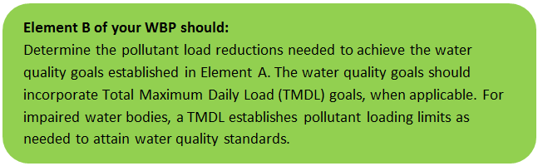 | 

Estimated Pollutant Loads
Table B-1 lists estimated pollutant loads for the following primary nonpoint source (NPS) pollutants: total phosphorus (TP), total nitrogen (TN), total suspended solids (TSS). These estimated loads are based on the pollutant loading analysis presented in Element A.

Water Quality Goals
There are many methodologies that can be used to set pollutant load reduction goals for a WBP. Goals can be based on water quality criteria, surface water standards, existing monitoring data, existing TMDL criteria, or other data. As discussed by Section A, water quality goals for this WBP are focused on protecting existing good water quality and reducing pollutant loads to help improve water quality.

The following adaptive sequence is recommended to establish and track water quality goals:
- Establish an interim goal to reduce phosphorus loading to Manchaug Pond by 5 pounds, nitrogen loading by 21 pounds and sediment loading by 4,435 pounds over the next 3 years (by the end of 2023) to protect and improve existing water quality.
- Establish a baseline water quality monitoring program in accordance with Element I. Results from the monitoring program should advise if Element C management measures are effective at improving water quality over time.
- Establish long-term goals to further reduce phosphorus and/or nitrogen loading based on monitoring results.
- Ultimate goal is to improve existing water quality in the watershed while delisting Manchaug Pond from the 303(d) list for dissolved oxygen.

Table B-1: Pollutant Load Reductions Needed
Pollutant | Existing Estimated Total Load | Water Quality Goal | Required Load Reduction*
Total Phosphorus | 876 lbs/yr | 871 lbs/yr | 5 lbs/yr
Total Nitrogen | 5764 lbs/yr | 5,743 lbs/yr | 21 lbs/yr
Total Suspended Solids | 132 ton/yr | 259,565 | 4,435 lbs/yr
Bacteria | MSWQS for bacteria are concentration standards (e.g., colonies of fecal coliform bacteria per 100 ml), which are difficult to predict based on estimated annual loading. | Class B. Class B Standards  • Public Bathing Beaches: For E. coli, geometric mean of 5 most recent samples shall not exceed 126 colonies/ 100 ml and no single sample during the bathing season shall exceed 235 colonies/100 ml. For enterococci, geometric mean of 5 most recent samples shall not exceed 33 colonies/100 ml and no single sample during bathing season shall exceed 61 colonies/100 ml;  • Other Waters and Non-bathing Season at Bathing Beaches: For E. coli, geometric mean of samples from most recent 6 months shall not exceed 126 colonies/100 ml (typically based on min. 5 samples) and no single sample shall exceed 235 colonies/100 ml. For enterococci, geometric mean of samples from most recent 6 months shall not exceed 33 colonies/100 ml, and no single sample shall exceed 61 colonies/100 ml.
* Note these are interim goals, see page 18 above.

TMDL Pollutant Load Criteria
No TMDL pollutant load criteria data available for Manchaug Pond.
Previous loading analysis and monitoring indicate the water quality improvements for Manchaug Pond include reductions in Total Phosphorus concentrations are needed to maintain its current mesotrophic state. An average of 33% reduction from modeled TP loading may be needed, while agriculture, open land, residential (low and high density) were estimated to need an average 30% reduction in TP loads while a 50% reduction in loads from commercial/industrial land uses was identified in one scenario. Additionally septic systems were estimated to need a 31% load reduction. A restorative TMDL is needed for Manchaug Pond, which establishes nutrient and bacteria concentrations, to better analyze pollutant loading sources in the watershed and to develop current reduction criteria intended to meet goals for improving water quality and address organic enrichment.

Element C: Describe management measures that will be implemented to achieve water quality goals

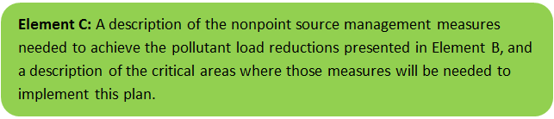 | 

Comprehensive Environmental Inc. (CEI) conducted a watershed survey in 2005 and again in 2020 of the Manchaug Pond Watershed in Sutton and Douglas. Members of the MPF accompanied CEI staff at times and provided valuable site history and first-person accounts of select issues and areas of interest within the watershed. Based on the results of this survey, the following pages present potential Best Management Practices (BMPs) and restoration practices that relate to stormwater management nonpoint source control within the watershed.
The recommended implementation sites discussed in this section are not intended to be an all-inclusive listing of potential stormwater improvements in the watershed. Rather, these recommendations are representative examples of potential stormwater improvements and retrofits that could be implemented at numerous sites throughout the watershed. All developed portions of the watershed were visited, but emphasis was generally placed on those areas with direct conveyance to Manchaug Pond.

Table C-1: Summary of Proposed Stormwater BMPs
BMP Location | Drainage Area (ac) | Impervious Area (%) | Estimated Load Reduction (lb/yr)
BMP Location | Drainage Area (ac) | Impervious Area (%) | TN | TP | TSS
Lackey Road Sediment Trap | 8.0 | 10 | 7.7 | 1.8 | 2,000
Central Turnpike Leaching Catch Basin | 1.3 | 30 | 3.2 | 0.7 | 1,250
Ledgestone Road Raingarden and Vegetated Swale | 3.5 | 15 | 1.5 | 0.4 | 325
Waters Farm Road Hobby Farm Vegetated Buffer | 1.0 | 5 | 0.6 | 0.2 | 85
Parker Road Culvert and Vegetated Swale | 0.6 | 10 | 0.5 | 0.1 | 95
Boat Ramp Structural BMPS to include porous pavement, infiltration structures | 1.0 | 80 | 8.2 | 1.7 | 680
Totals | 15.4 | NA | 21.7 | 4.9 | 4,435
Additional Management Measures – See Elements C and E for additional details.
* See BMP description and management measures for additional information.

Primary BMP Recommendations
The BMP improvement sites described on the following pages were identified during CEI’s watershed survey (See Appendix B for survey results). The design goal for the proposed BMPs would be to size the BMP to treat and infiltrate the water quality volume to the maximum extent practicable. The water quality volume is defined in the Massachusetts Stormwater Handbook as the volume equal to 0.5 inches of runoff times the total impervious area within the drainage area of the BMP. However, each proposed BMP should be designed to achieve the most treatment that is practical given the size and logistical constraints of the site.
Each BMP description includes:
- A site summary that describes current conditions and stormwater drainage patterns;
- A description and conceptual design of proposed improvements;
- Estimated costs that represent installed BMPs including engineering, permitting and construction (note: select costs assume in-kind service and materials via the Town of Sutton and MPF where feasible; if all outside contractors are used, costs will likely increase significantly);
- Summary of expected operations and maintenance requirements; and
- Estimated pollutant load reduction for the proposed BMP.
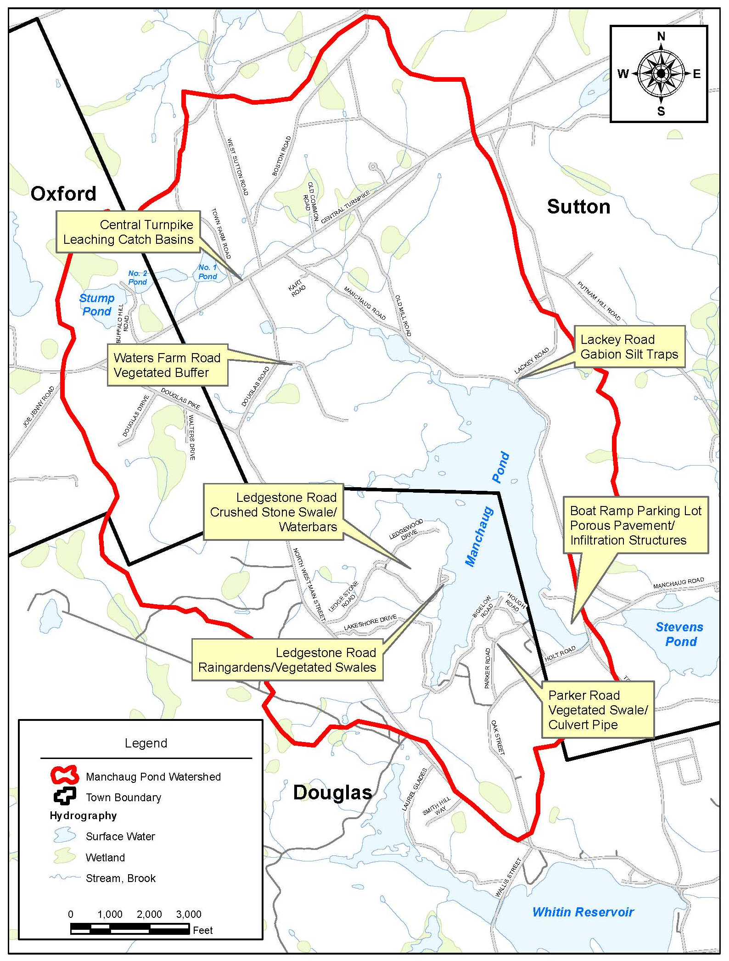
Figure C-1: Primary BMP Recommended Locations
The following Primary BMPs have been submitted for FY2021 s319 Nonpoint Source Pollution grant funds.

Lackey Road Sediment Trap
Site Summary
Lackey Road is located on the northeast side of Manchaug Pond where it intersects with Manchaug Road. The approach to the lake is very steep and generates a significant amount of runoff which results in erosion and channelizing on the road shoulders. Sediment from the slope is carried into the pond through a stream channel, drainage swale and two culverts beneath Manchaug Road. Lackey Road is heavily sanded during winter storm events to maintain safe conditions for vehicular traffic, which also contributes a significant amount of sediment.
Proposed Improvements
The proposed BMPs at this location include crushed stone to stabilize shoulders of Lackey Road with check dams to reduce the flow velocity and sediment traps on each side of the road to collect and filter runoff to remove sand and sediment before discharging to Manchaug Pond. The sediment traps will be constructed with wire gabion baskets filled with crushed stone.
Expected O&M:
Sediment and debris collected by each trap will be removed each spring/fall during the routine drainage system maintenance schedule. Repairs to displaced crushed stone will be completed to prevent scouring along the road shoulder and sediment forebay.
Wetland Permitting
All work will be within a publicly owned right-of-way and constructed by the Sutton Highway Department. A Notice of Intent (NOI) will be filed with the Sutton Conservation Commission for work located within jurisdictional resource areas/buffer zones.

Sizing Characteristics
Drainage Area (acres) | 8.0
Impervious Area (%) | 10
Estimated Load Reduction (lb/yr)
TN (lbs/yr) | 7.7
TP (lbs/yr) | 1.8
TSS (lbs/yr) | 2000
Estimated Cost
Total (includes 20% contingency) | $16,100

Central Turnpike Leaching Catch Basins
Site Summary
Three existing catch basins along Central Turnpike in the Town of Sutton do not include deep sumps for sediment removal or provide infiltration. The proposed catch basins will include deep sumps to collect sediment and perforations with a stone bed to provide stormwater infiltration and treatment.
Proposed Improvements
Three leaching catch basins are proposed to replace the existing structures. The proposed catch basins will include deep sumps to collect sediment and perforations with a stone bed to provide stormwater infiltration and treatment.
Expected O&M:
Sediment and debris collected by each leaching catch basin will be removed each spring/fall during the routine drainage system maintenance schedule by the Sutton Highway Department.
Wetland Permitting
All work will be within a publicly owned right-of-way and constructed by the Sutton Highway Department. A Notice of Intent (NOI) will be filed with the Sutton Conservation Commission for work located within jurisdictional resource areas/buffer zones.

Sizing Characteristics
Drainage Area (acres) | 1.3
Impervious Area (%) | 30
Estimated Load Reduction (lb/yr)
TN (lbs/yr) | 3.2
TP (lbs/yr) | 0.7
TSS (lbs/yr) | 1,250
Estimated Cost
Total (includes 20% contingency) | $38,400

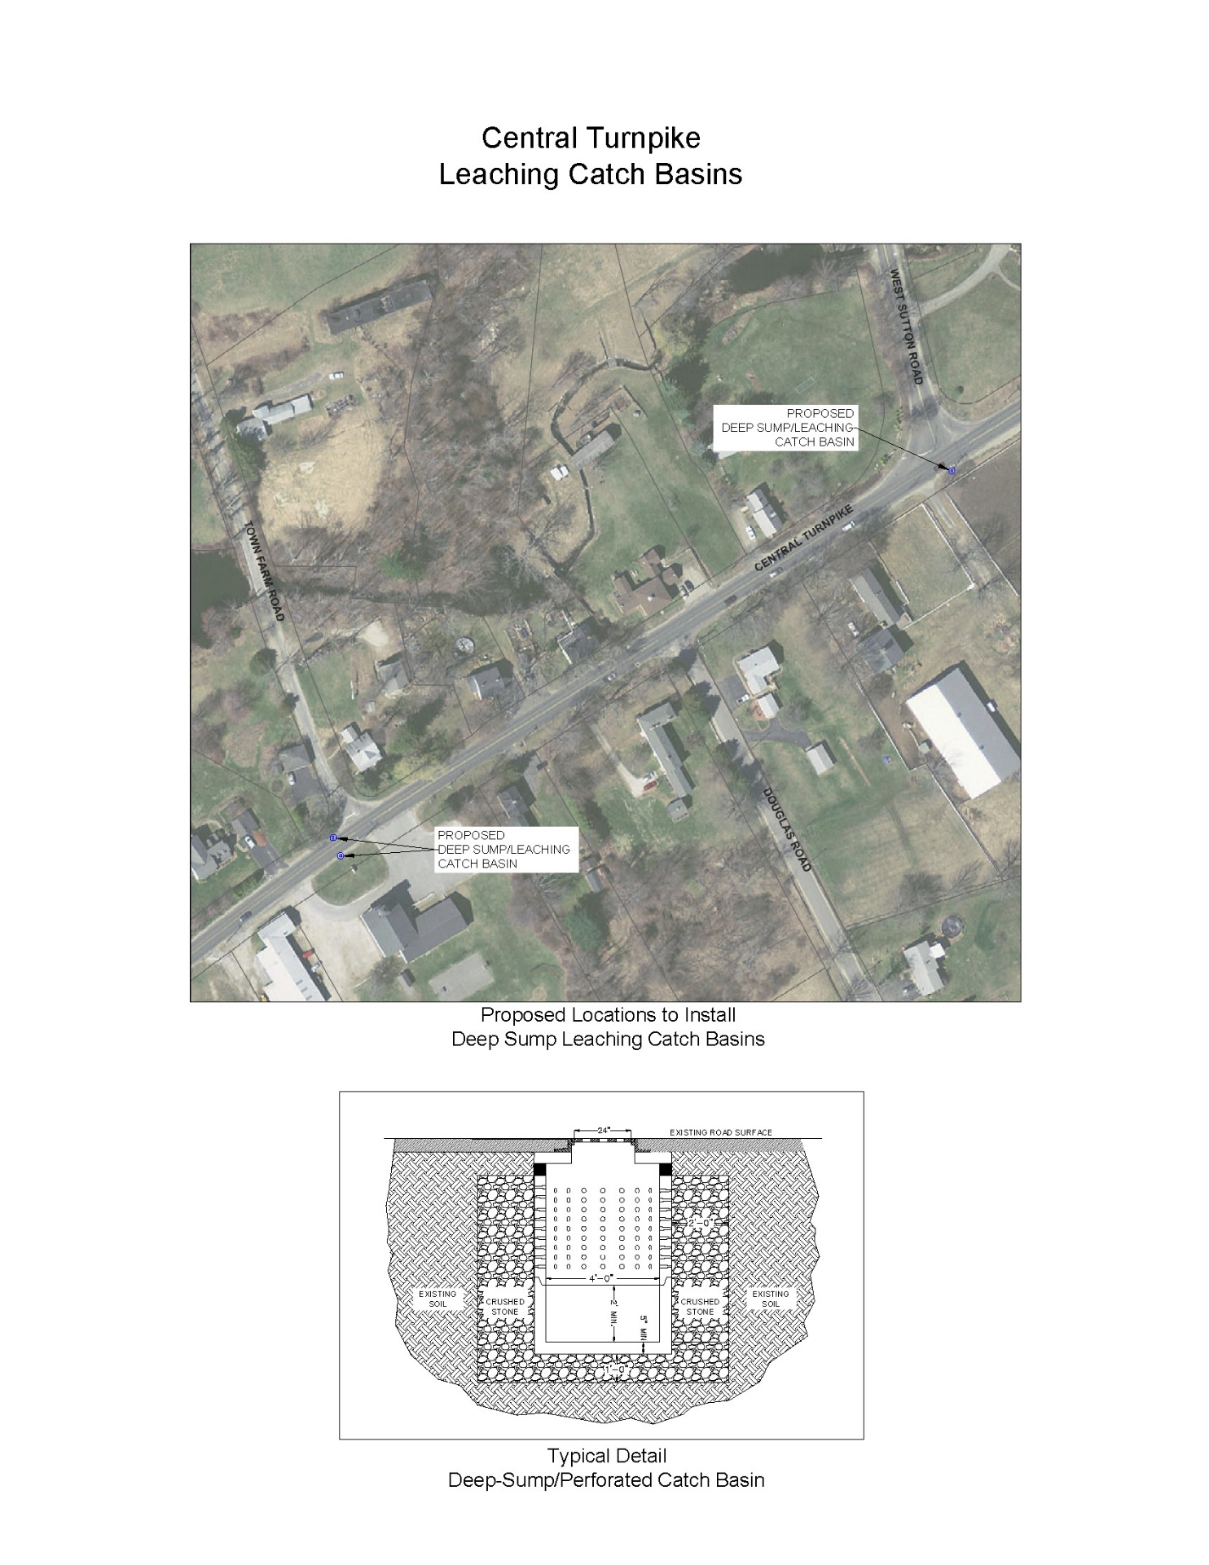
Ledgestone Road Raingardens and Vegetated Swale
Site Summary
Ledgestone Road is located on the west side of Manchaug Pond within the Town of Douglas. The land use in the area of this BMP location is primarily medium density residential with lakefront homes. The existing drainage system does not provide any form of treatment and consists of shallow catch basins to collect stormwater and convey it through pipes which discharge directly into Manchaug Pond. The pollutant sources in the drainage area include sediment from Ledgestone Road and nutrients from adjacent residential properties.
Proposed Improvements
The proposed drainage improvements selected at this location include two raingardens and a vegetated swale, which will provide sediment removal, promote infiltration and provide nutrient treatment to stormwater runoff before discharging to Manchaug Pond. This location will also provide a good demonstration site which the Manchaug Pond Foundation (MPF) could promote to residents within the watershed and local community.
Expected O&M:
Sediment and debris collected by the raingardens and vegetated swales will be removed each spring/fall during the routine drainage system maintenance schedule. Spring cleanup of the raingardens will include removal and replacement of any dead plants and spreading mulch to maintain the garden’s infiltration capacity. The MPF will be responsible for the required annual maintenance.
Wetland Permitting
All work will be completed within private property with permission. Construction of the BMP will be performed by a licensed contractor with the assistance of MPF to plant the proposed BMPs with approved native species. A Notice of Intent (NOI) will be filed with the Douglas Conservation Commission for work located within jurisdictional resource areas/buffer zones.

Sizing Characteristics
Drainage Area (acres) | 3.5
Impervious Area (%) | 15
Estimated Load Reduction (lb/yr)
TN (lbs/yr) | 1.5
TP (lbs/yr) | 0.4
TSS (lbs/yr) | 325
Estimated Cost
Total (includes 20% contingency) | $22,800

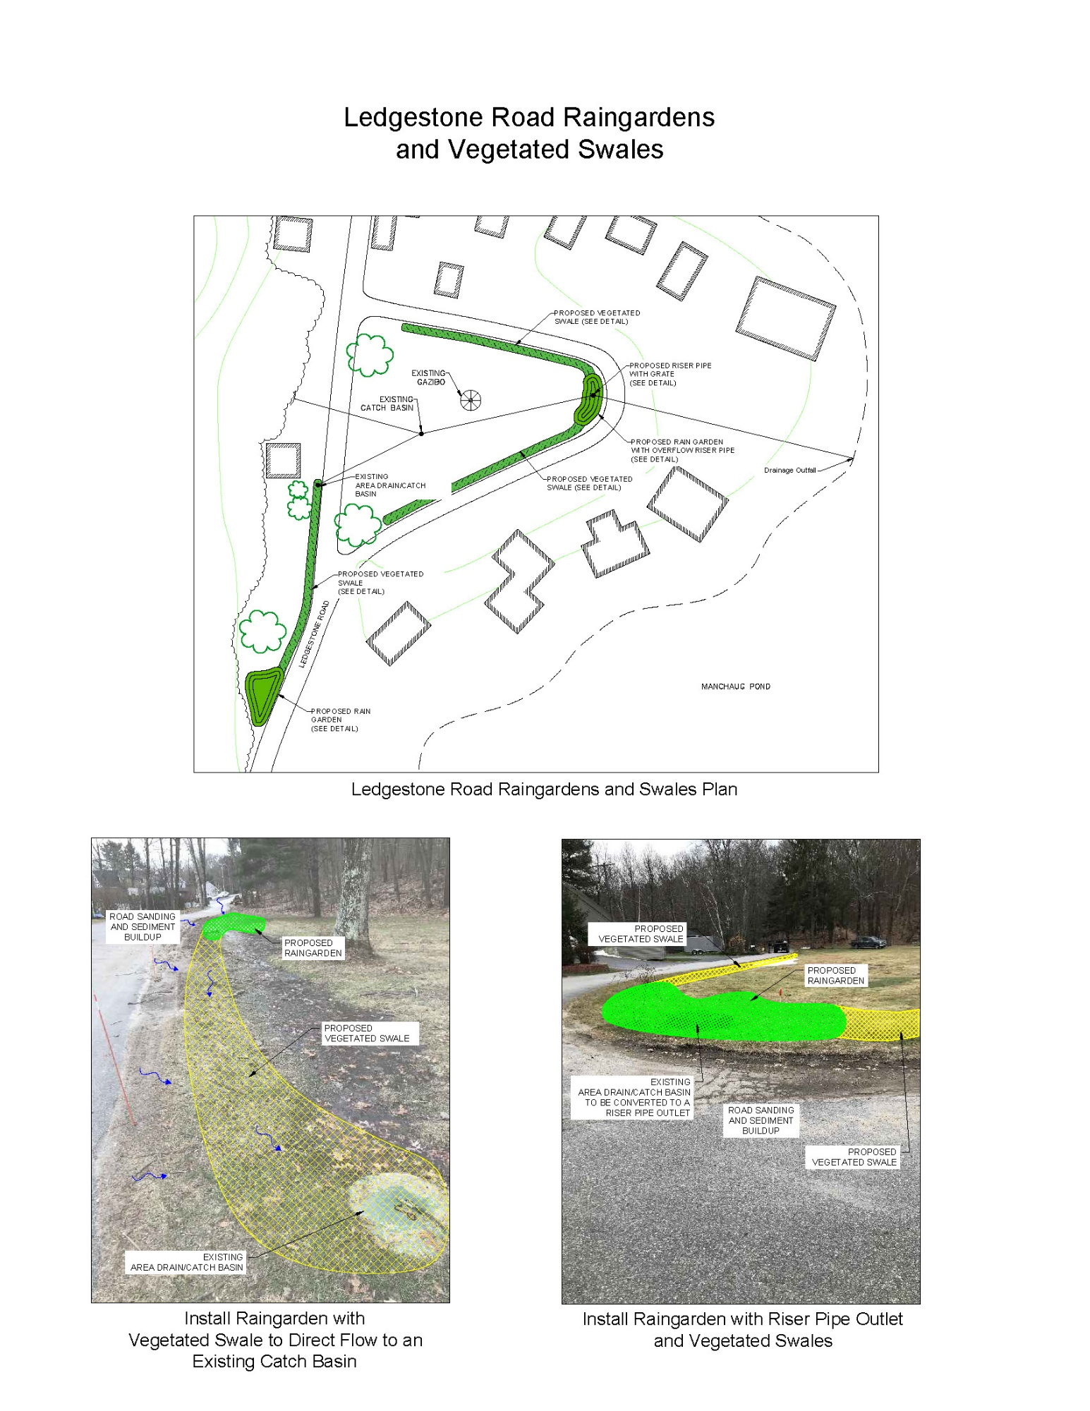
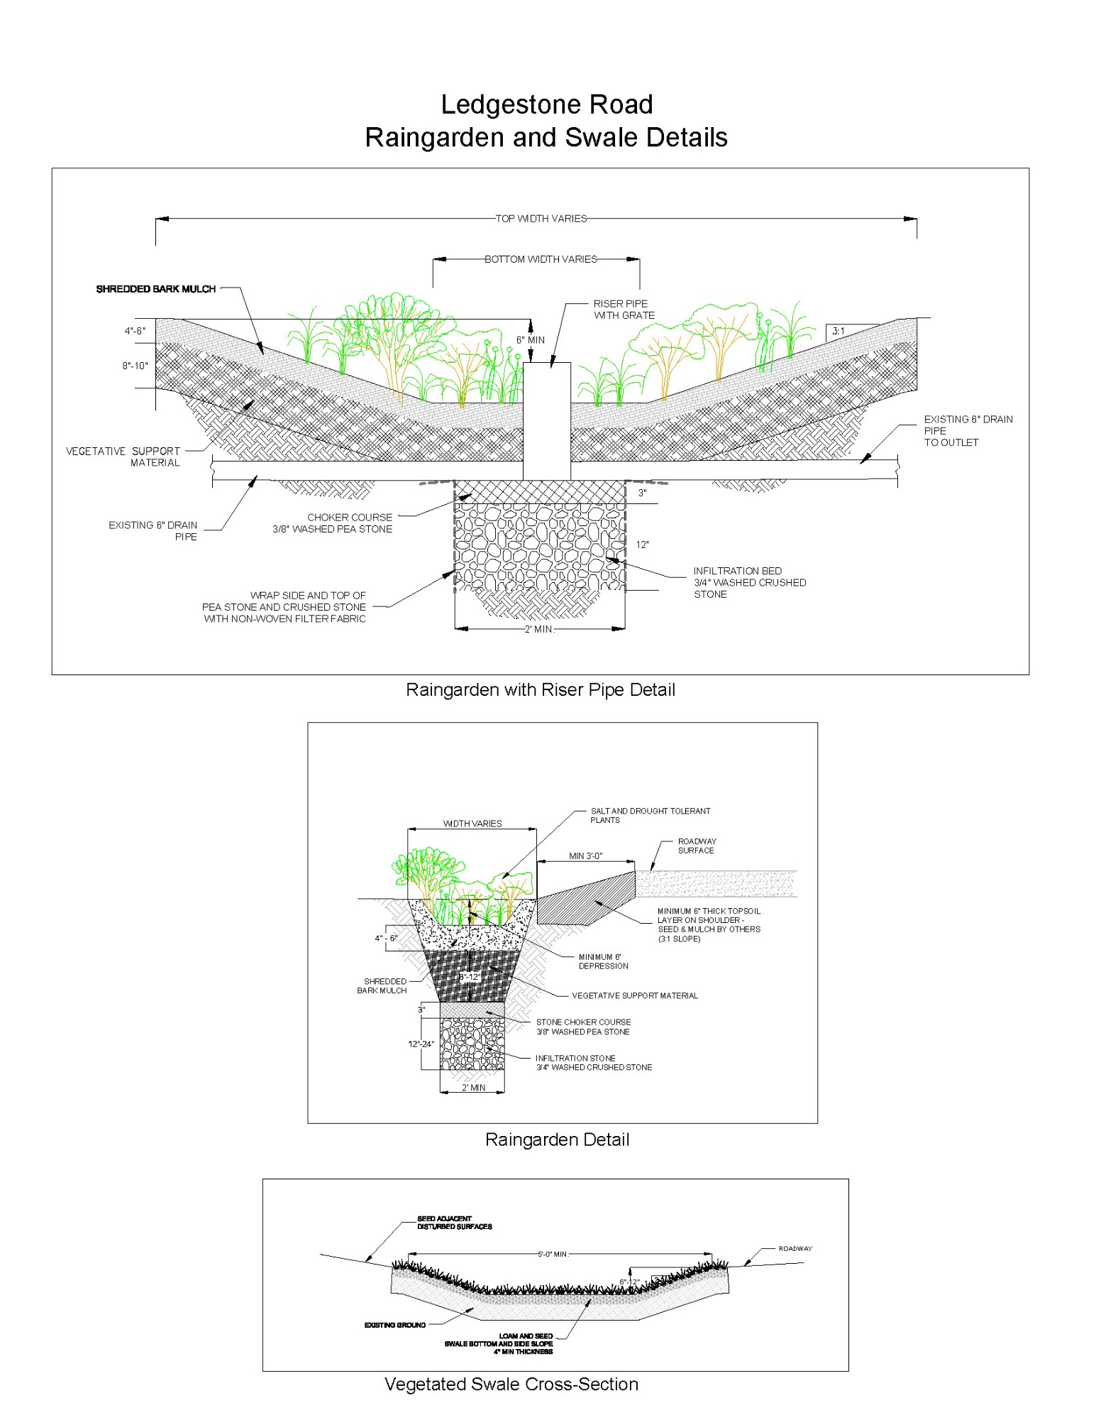
Waters Farm Road Hobby Farm Vegetated Buffer
Site Summary
Waters Farm Road is located within the Town of Sutton. A hobby farm on the north end of the road includes a pasture which is used to keep livestock. At the base of the pasture is a small pond that is tributary to Manchaug Pond. There is little to no vegetated buffer around the pond due to grazing activities and no fencing to prevent the livestock from accessing the pond and tributary. Algae blooms often occur in the pond during summer months which cover the entire surface.
Proposed Improvements
The proposed stormwater BMPs for this location includes a vegetated buffer area and shallow berm around the perimeter of the pond to collect and filter runoff from the pasture. Fencing along the buffer will provide a barrier to prevent livestock from grazing in the buffer area and gaining access to the pond and tributary.
Expected O&M:
Maintenance for the vegetated buffer will include trimming plants as needed and replacement of any non-viable plants in the spring/fall. Routine inspection of fencing is required to identify sections in need of repair. Replace fencing as needed to prevent livestock from accessing the pond and tributary. The MPF and hobby farm owner will be responsible for the required annual maintenance.
Wetland Permitting
All work will be completed within private property with permission. Construction of the BMP will be performed by a licensed contractor with the assistance of MPF to plant the proposed BMPs with approved native species. A Notice of Intent (NOI) will be filed with the Sutton Conservation Commission for work located within jurisdictional resource areas/buffer zones.

Sizing Characteristics
Drainage Area (acres) | 1.0
Impervious Area (%) | 5
Estimated Load Reduction (lb/yr)
TN (lbs/yr) | 0.6
TP (lbs/yr) | 0.2
TSS (lbs/yr) | 85
Estimated Cost
Total (includes 20% contingency) | $17,600

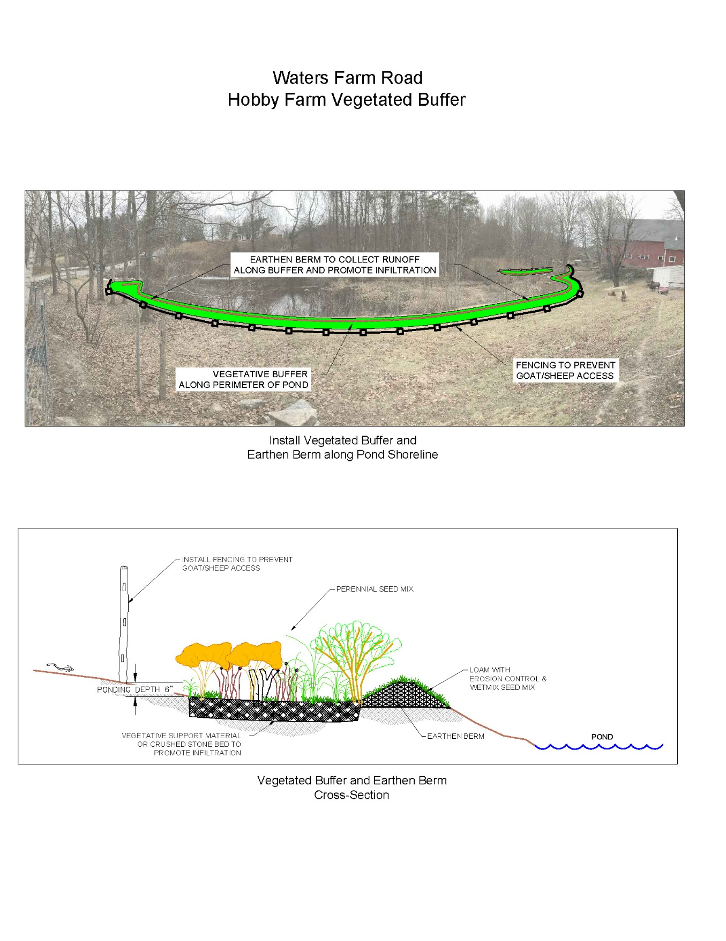

Parker Road Culvert and Vegetated Swale
Site Summary
Parker Road is located on the south end of Manchaug Pond within the Town of Douglas. The drainage area for the BMPs collects runoff from Parker Road and adjacent wooded area. This section of Parker Road does not include existing drainage features to properly collect or convey runoff. The road has a gravel surface that is currently being eroded/channelized due to surface runoff coming from an adjacent wooded area. The sediment from the road is carried to a downstream wetland area that is located between the road and pond. Sediment transport from this section of the road significantly impacts the wetland.
Proposed Improvements
An existing drainage culvert will be repaired or replaced and a vegetated swale with check dams will be constructed along the eastern side of Parker Road to convey runoff before directing it into an existing plunge pool on the west side of the road. The plunge pool is a drainage BMP which was installed during a previous 319 grant project to collect and filter runoff prior to discharging to the downstream wetland area.
Expected O&M:
Sediment and debris collected by the vegetated swale and existing plunge pool will be removed each spring/fall during the routine drainage system maintenance schedule. Repairs to the vegetated swale will be completed to prevent scouring along the road shoulder. Sediment build up in the drainage culverts will be removed to properly convey stormwater flow.
Wetland Permitting
All work will be completed within private property with permission. Construction of the BMP will be performed by a licensed contractor and MPF will be responsible for the required annual maintenance. A Notice of Intent (NOI) will be filed with the Douglas Conservation Commission for work located within jurisdictional resource areas/buffer zones.

Sizing Characteristics
Drainage Area (acres) | 0.6
Impervious Area (%) | 10
Estimated Load Reduction (lb/yr)
TN (lbs/yr) | 0.5
TP (lbs/yr) | 0.1
TSS (lbs/yr) | 95
Estimated Cost
Total (includes 20% contingency) | $10,800

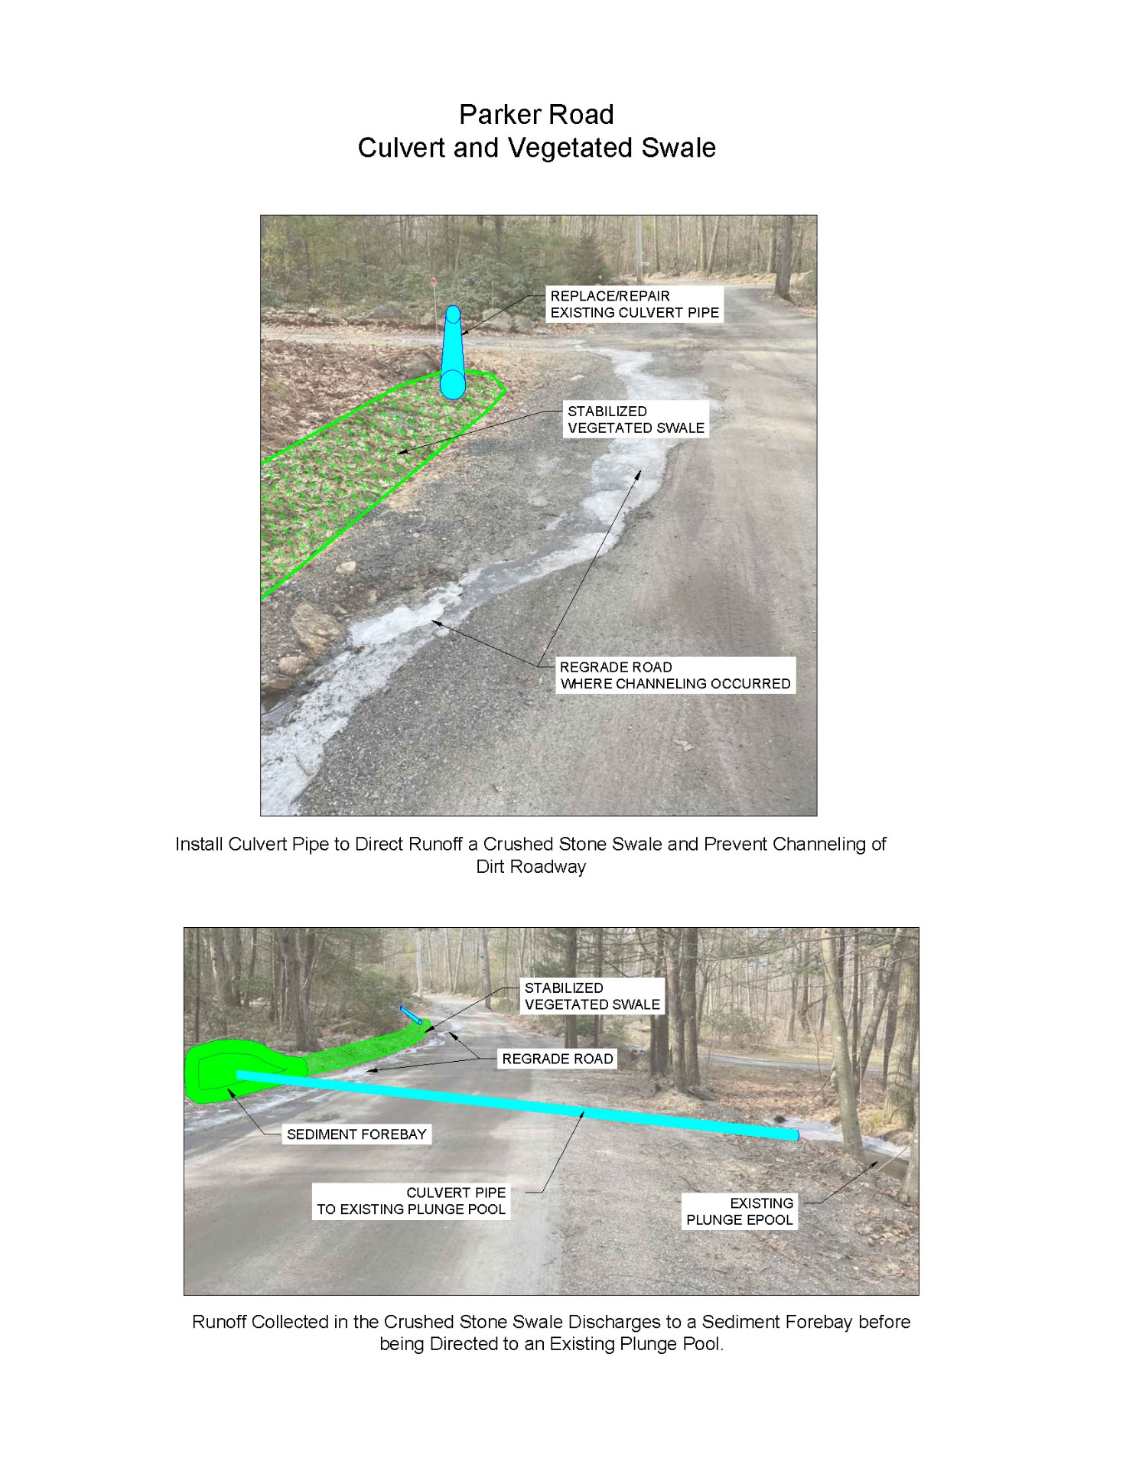
Boat Ramp Structural BMPs
Site Summary
The Manchaug Pond Boat Ramp is located in the southeast corner of the pond within the Town of Sutton. This drainage area for the boat ramp collects runoff from a parking lot that is used for recreational access to Manchaug Pond. The boat ramp accommodates access for motorized boats, canoes and other watercraft. The parking lot creates a source for sediment and pollutants such as grease and oil from parked vehicles.
This public boat ramp is maintained by the Town of Sutton and is managed in tandem with the MA Office of Fishing and Boating Access (OFBA). Note that several small BMPs were installed in coordination with OFBA at this location as a result of the 2005 s319 grant and remain in working order (pavement replacement geogrid and rain garden). The Town is now prepared to rehab this entire area including resurfacing, therefore a more thorough BMP implementation project is proposed. Previously installed BMPs will remain and have been incorporated into the conceptual design. The Town of Sutton will also contribute a cash match to this effort
Proposed Improvements
Proposed drainage improvements for this boat ramp include installation of porous pavement and four infiltration structures with underlying stone beds to promote infiltration and provide treatment to stormwater runoff from the paved surface. The existing parking lot is sloped toward the pond. On the northern side of the parking lot, stormwater runoff is collected along curbed parking spaces and directed into a raingarden which was built during a previous 319 grant project. The middle section of the parking lot sheet flows toward the pond, where a portion of the runoff flows across a grassed area with underlying geo-grid to help promote infiltration. The geo-grid was also installed during the previous grant project.
The proposed porous asphalt and infiltration structures will provide additional infiltration and treatment by collecting runoff from areas of the parking lot that do not currently flow to either of the previously installed BMPs and provide additional storage to collect larger volumes of stormwater runoff.
Expected O&M:
Sediment and debris collected by the infiltration structures will be removed each spring/fall during the routine drainage system maintenance schedule. Porous asphalt will be cleaned each spring to maintain voids in the pavement and promote infiltration.
Wetland Permitting
The Town of Sutton Highway Department will construct these BMPs with in-house construction staff and equipment. A Notice of Intent (NOI) will be filed with the Sutton Conservation Commission for work located within jurisdictional resource areas/buffer zones.

Sizing Characteristics
Drainage Area (acres) | 1.0
Impervious Area (%) | 80
Estimated Load Reduction (lb/yr)
TN (lbs/yr) | 8.2
TP (lbs/yr) | 1.7
TSS (lbs/yr) | 680
Estimated Cost
Total (includes 20% contingency) | $227,400

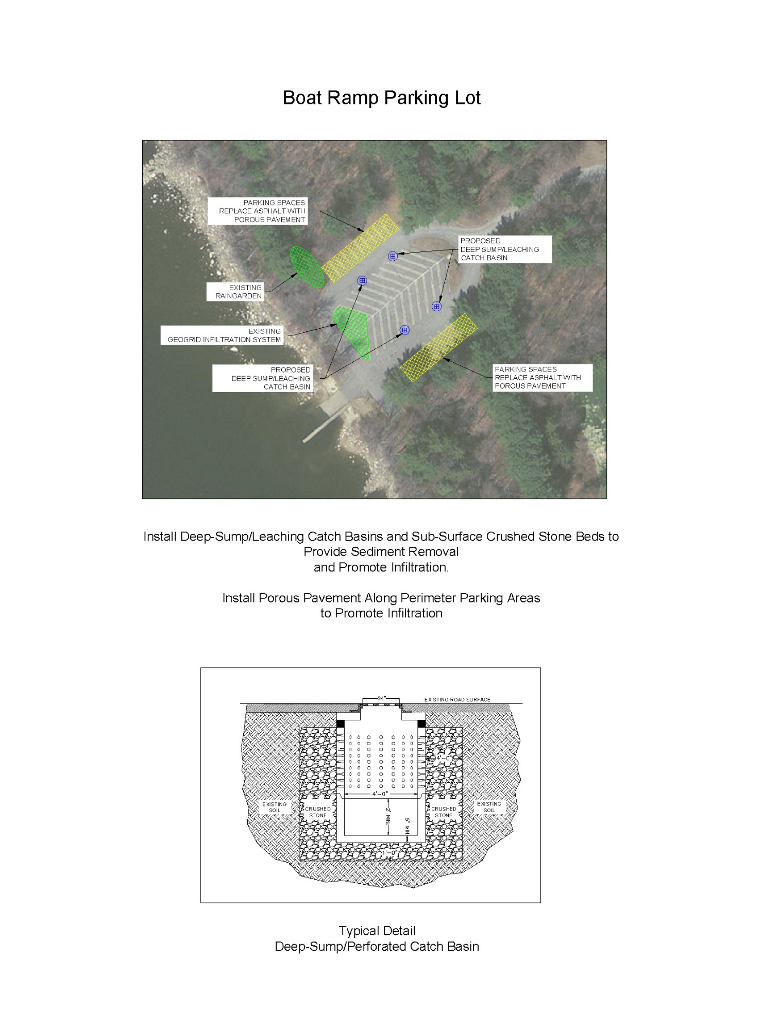
Ledgestone Road Steep Slope, Rubber Water Bars and Crushed Stone Swales
Demonstration BMP Design
Site Summary
A significant portion of the Manchaug Pond Watershed consists of steep slopes and unpaved driveways. As a result, residential driveways are often a source of sediment and erosion leading to the closest tributary or directly to the pond. A water bar BMP demonstration project will be constructed at one residential property on Ledgestone Drive with a steep sloped driveway. The MPF will work with the resident to construct this demonstration project, documenting the process (before, during and after) through photographs/video, online construction updates and the development of a post-construction fact sheet that will be made available to watershed residents via the MPF website, newsletter and hard copies for the MPF display.
Proposed Improvements
This basic design will include specifications that can be utilized on most steep slope, unpaved residential driveways and will be included in the fact sheet along with lessons learned, sizing, material sources, costs and operation and maintenance requirements. The intent of this task is to alleviate a significant source of erosion from the demonstration site and to also to provide a readily available solution for other watershed residents with unpaved steep slope driveways experiencing sedimentation and erosion.
The proposed drainage improvements selected at this location include several water bars along the driveway to redirect runoff into the adjacent wooded area or two crushed stone swales to help convey runoff and allow it to filter through the vegetation and infiltrate before reaching the pond.
Expected O&M:
Sediment and debris collected by the water bars and crushed stone swales will be removed each spring/fall. Repairs to the water bars and crushed stone swales will be completed to prevent displacement or scouring. The MPF will be responsible for the required annual maintenance.
Wetland Permitting
All work will be completed within private property and construction of the BMP will be performed by MPF volunteers with private property owner permission. A Notice of Intent (NOI) will be filed with the Douglas Conservation Commission for work located within jurisdictional resource areas/buffer zones.
Sizing Characteristics
Drainage Area (acres) | 3.5
Impervious Area (%) | 5
Estimated Load Reduction (lb/yr)
TN (lbs/yr) | 1.5
TP (lbs/yr) | 0.4
TSS (lbs/yr) | 325
Estimated Cost
Total (includes 20% contingency) | $3,000
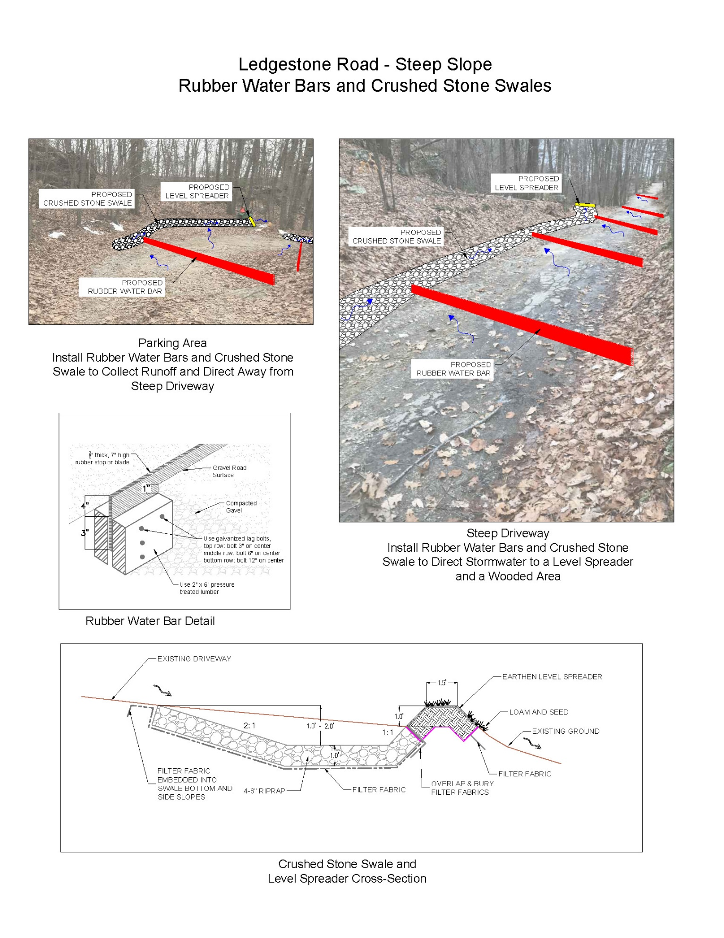
Additional Management Measures
Water Quality Monitoring
Water quality samples have historically been recorded within Manchaug Pond however very little sampling of tributaries (streams and brooks) within the watershed has been completed. The objective of the Manchaug Pond Water Quality Monitoring Program is to collect water samples at multiple tributary and drainage system locations, in addition to current in-lake locations (Deep-hole A), to determine the extent of pollutants entering Manchaug Pond and to help identify nonpoint sources throughout the watershed.
The Manchaug Pond watershed is best described as a rural area that primarily includes forested land with low density residential spread throughout. Higher density residential development has occurred along the shoreline with three campgrounds (Old Holbrook Place, Lake Manchaug Camping and Kings Family Campground) and a YMCA facility (Camp Blanchard) located on Manchaug Pond. A fourth campground (Sutton Falls Camping Area) is located on Aldrich Mill Pond. Old Holbrook Place, Kings Family Campground, Sutton Falls Camping Area and the YMCA are located in the Town of Sutton and are required to perform weekly water testing for E.coli and coliform. Lake Manchaug Camping is located in the Town of Douglas and is required to perform water testing for E.coli. The test results are submitted to State agencies and the Board of Health from each Town either weekly or at the end of the summer season. Agricultural land uses in the watershed include a dairy farm on Douglas Road, horse stables on Waters Road and Central Turnpike and several hobby farms spread throughout the watershed. With the exception of forested land, all of these developed land uses create potential nonpoint sources of pollutants that could impact water quality.
The sampling approach for tributaries and drainage system locations should include collection of dry weather samples in early summer, followed by wet weather rounds during the mid-summer and then a final round of dry weather samples in the fall. This sampling approach is intended to develop water quality data before and during storm events in order to better identify upstream pollutant source contributions within the Manchaug Pond watershed. Dry weather samples will help identify potential sources of pollutants to the pond while wet weather samples will provide a more accurate assessment of nonpoint pollutant contribution within each tributary and will better isolate drainage areas to help identify sources. Pollutant concentrations of the dry and wet weather samples should be compared with other samples collected on the same date. Pollutant concentrations should also be compared to Deep-hole A samples to determine the correlation between concentrations in stormwater runoff and in-lake observations.
When elevated pollutant concentrations are found in an initial downstream sample, the drainage area for the tributary or drainage outfall needs to be evaluated to determine logical secondary sampling locations. As watershed monitoring efforts progress upstream, the time spent to collect water samples and investigate potential pollutant sources can become time consuming, especially if the source is intermittent. The field crew will need to evaluate the contributing watershed area to determine the best approach to isolate potential source areas. The objective of secondary sampling locations is to divide the contributing drainage area into smaller, isolated subcatchments. Working in an upstream direction, secondary samples are commonly collected at points where two tributaries converge or where a tributary discharges to a waterbody (pond, lake) or wetland area. Other possible secondary sample locations include change of land use or topography along a tributary. A road crossing can also be a convenient location for secondary sampling and allows easy access.
Pollutant concentrations in water quality samples collected at secondary locations may be consistent with associated downstream samples and clearly indicate additional upstream investigation is needed. Conversely, water quality samples collected at secondary locations may result in pollutant concentrations that are reduced or absent, which could indicate the pollutant source is somewhere between the two sampling locations and the investigation should be focused in the drainage area contributing to that section of the tributary. Since nonpoint pollutant sources may be intermittent, multiple monitoring rounds may be required during dry and wet weather conditions to confirm water quality and to accurately identify the source.
Dry weather monitoring events are defined as no precipitation occurring within 72 hours prior to a sampling event and wet weather monitoring events are defined as a storm event greater than 0.5 inch of precipitation in a 24-hour period, with first flush occurring ten minutes after flow is observed. Water quality samples should be collected within the first ten minutes (first flush) during wet weather monitoring.
Collecting a water sample at the inlet of a pond or wetland will isolate the upstream drainage area from the waterbody and help determine whether the water quality in the tributary is consistent with samples collected downstream or within the waterbody. If pollutant concentrations in the tributary sample are elevated, investigation should continue upstream. When pollutant concentrations in the tributary are less or absent, the investigation should focus on the waterbody and its contributing drainage area. The type of land use, property management practices surrounding a waterbody and wildlife (e.g. beavers, waterfowl) within the pond are potential nonpoint pollutant sources that could degrade water quality.
Identifying secondary sampling locations where land use or topography change occurs is an alternative method for isolating subcatchment areas within the watershed. Locations where land use changes are observed (e.g. from forested to residential or open space to agricultural) provides a logical water sampling point to correlate land management practices to pollutant concentrations in stormwater runoff that flows into a tributary. Wet weather sampling is a good method for determining how types of land use can affect water quality within a watershed. Samples collected during a storm event will reveal how land management practices, such as fertilizer application or accumulation of pollutants that are exposed to rain, can contribute to water quality impacts of Manchaug Pond.
Topographic characteristics can also provide a good sampling point. Areas with steep slopes may contribute more concentrated flows since the landscape does not provide an opportunity for runoff to collect and infiltrate before flowing to a tributary or waterbody. Slopes along the east and west shorelines of Manchaug Pond are very steep and create several small tributaries that discharge directly into the pond without flowing through wetlands or low lying areas. As a result, stormwater runoff receives very little natural treatment or attenuation to remove pollutants and reduce peak runoff. The natural terrain in these areas restricts opportunities to construct stormwater treatment devices and highlights the importance of a comprehensive water quality monitoring program that identifies tributaries with poor water quality and isolate areas which require investigation to identify and address nonpoint pollution sources.
A successful water quality monitoring program requires detailed protocols and proper training to maintain quality control. A Quality Assurance Project Plan (QAPP) should be developed by the MPF in accordance with EPA (U.S. Environmental Protection Agency) guidance to establish protocols for water quality-related monitoring, water sample processing and analytical methodology. Water monitoring team members can be trained to follow procedures in the QAPP for water sample collection and to maintain consistent documentation of field observations.
Primary Watershed Monitoring Locations
The primary sampling locations within the Manchaug Pond watershed are at downstream points of tributaries and at the inlet or outlet of large ponds. These locations were selected to assess the water quality from large drainage areas within the watershed and identify where additional upstream monitoring efforts are recommended. The primary monitoring locations are identified on Figure C-2
Northern Subcatchments
The northern end of the watershed includes a chain of ponds (Stump Pond, No. 2 Pond and No.1 Pond), wetland areas and several larger tributaries. The subcatchment area for the ponds include forested and agricultural (hay fields) land uses with a tributary flowing northeast before crossing Central Turnpike where it flows into a large wetland area. Four additional tributaries are located to the north of Central Turnpike which collect runoff primarily from forested land, hay fields and low density residential. Hobby farms and horse stables are also located in this subcatchment area where tributaries flow near or through the properties before crossing Central Turnpike.
Tributaries from the northern end of the watershed converge in a large wetland area before crossing Manchaug Road and flow into Sutton Pond. Initial monitoring for the northern watershed should be located where the tributary crosses Manchaug Road. Water quality samples and field monitoring should be conducted on the upstream side of the road. Road crossings are good locations for secondary sampling in this area of the watershed since each crossing will isolate large subcatchment areas. Secondary sampling, upstream of Manchaug Road, should be performed at the Mendon Road and Old Mill Road crossings. Working in an upstream direction, monitoring locations would be performed at Central Turnpike, West Sutton Road, Boston Road, Rich Road and Century Farm Road.
Northwest Subcatchments
Additional watershed areas to the northwest of Sutton Pond include forested, low density residential and agricultural land. Two small tributaries located in this area of the watershed provide good secondary monitoring to help isolate smaller subcatchments and where land use changes occur. Each of these tributaries cross roads and are accessible for upstream monitoring.
The first of the two tributaries crosses Waters Road where a hobby farm is currently located. A small pond collects runoff from a pasture area and a small tributary that is upstream of the farm. The subcatchment for the upstream tributary includes forested, low-density residential and agricultural land uses. Collecting water quality samples at the outlet of the pond would be a good location to perform initial upstream monitoring. If water quality sample results indicate poor water quality, additional upstream monitoring is recommended. Additional monitoring should be located immediately upstream of the hobby farm property to isolate this property and assess upstream water quality of the tributary flowing into the pond.
The second northwest tributary crosses Douglas Road where a pond is located. Monitoring should be performed at the outlet of the pond (upstream side of the road). If water quality sample results indicate poor water quality, additional upstream monitoring is recommended. A small tributary enters the north end of the pond which collects runoff from a subcatchment area between Douglas Road, Central Turnpike and Manchaug Road. The subcatchment area includes low-density residential, hay fields and agricultural land uses. Monitoring the tributary can be performed where it crosses Douglas Road (north of the pond).
Steep Slopes
Water quality monitoring for areas with steep slopes should begin at locations where tributaries discharge to Manchaug Pond or a drainage culvert. Initial monitoring at these locations will isolate large drainage areas to Manchaug Pond.
On the east side of the pond, where tributaries cross Manchaug Road through culvert pipes, samples should be collected on the upstream side of the pipes. Along the western shoreline, tributary discharge points to the pond are a bit harder to access and will require walking through wooded areas to collect samples and perform in-field monitoring. Permission should be obtained from land-owners to cross through land to access monitoring locations.
A tributary which discharges to Manchaug Pond near the intersection of Lackey Road and Manchaug Road collects runoff from a subcatchment area that is currently primarily forested. If primary water quality sample results indicate poor water quality, additional upstream sampling will require access in wooded areas and permission from landowners.
Three tributaries discharge to Manchaug Pond along the western shoreline. Collectively, the watershed for these tributaries is between Douglas Road (north) and Lakeshore Drive (south). The land use in this subcatchment area is primarily forested with agriculture in the upper reaches and a mix of low-density and medium-density residential lower in the watershed. The primary sampling locations are along the shore where tributaries discharge to the pond. Road crossings would provide good upstream monitoring locations for these tributaries if required. Land use changes and convergence with smaller tributaries should also be considered when identifying upstream monitoring locations.
Southern Subcatchment
The drainage area in the south end of the watershed is collected by two tributaries which converge upstream of Lakeshore Drive before discharging to Manchaug Pond. The land use in the subcatchments includes forested, low-density and medium-density residential. One of the tributaries crosses North West Main Street, which could be an accessible location for upstream monitoring. Additional upstream sampling, along either tributary, will require access in wooded areas and permission from landowners.
Water Quality Monitoring Program Development & Recommendations
Recommendations include considering the implementation of additional water quality sampling locations per the above guidance. Additionally, based on 2020 observations by the MPF, it is recommended that the addition of harmful algal blooms and/or cyanobacteria monitoring be added to the current water quality monitoring plan. It is also highly recommended that a Quality Assurance Project Plan (QAPP) be developed for sample collection, monitoring and assessment activities. A QAPP outlines the procedures a monitoring project will use to ensure that the samples participants collect and analyze the data they store and manage to meet project goals.
In 2008, the Massachusetts Inland Volunteer Monitoring General Quality Assurance Project Plan (QAPP) For Water Quality Monitoring, Wetland Biological Assessments And Invasive Species Monitoring (General QAPP) was developed to assist volunteer organizations in collecting high-quality, defensible data in which to base future watershed decisions. This General QAPP was developed for organizations that monitor watershed resources, coordinates such efforts with state priority projects, and gathers valuable information to support the protection and restoration of important aquatic habitats and natural resources. The General QAPP contains baseline requirements to be met for various levels of data collection projects, as well as common objectives, parameters, methods and approaches for river, lake, and wetland chemical and biological monitoring. Historically, Massachusetts citizen groups active in wetlands and water bodies have conducted monitoring programs including: ground and surface water quality monitoring, wetland biological assessments, and monitoring for invasive species to support the protection and restoration of critical natural resources.
This General QAPP addresses monitoring activities related to the following four issues:
- Water Quality: The Commonwealth’s watersheds suffer from a number of impairments to water quality, with over 90% of the impaired waterbodies in Massachusetts containing elevated levels of bacteria or nutrients. Data collected from this effort are intended to assist MassDEP in evaluating waterbodies that have not yet been assessed, documenting water quality trends necessary for the designation of strategies to remediate the impairment, and evaluating water quality in areas where these strategies are already being implemented.
- Biological & Habitat Assessment: Biological assessments (e.g. macroinvertebrate, aquatic plant survey, fish sampling) are a direct measure of the health of the aquatic community. They are used to evaluate aquatic life use-support status and to supplement other water quality monitoring and management programs. Biological assessments are considered response indicators: measures of integrated or cumulative reactions to exposure and stress, such as elevated temperature or chemical levels, depressed oxygen levels, or altered habitat. Habitat assessments are considered stressor indicators, in that they can reveal activities or alterations that affect the aquatic environment, such as: increased sediment, unnaturally changing flow regimes, changes in river channel morphology, and reduced shading.
- Wetland Health Assessment: Wetland biological assessments are a critical component of the evaluation of development impacts on important aquatic habitats. Evaluation of these impacts requires not only the collection of water quality data, but also an assessment of the biological response of these systems to anthropogenic factors. These assessments will aid the Commonwealth in establishing baseline conditions, measuring the scale of the impacts to these systems, and assessing the response of wetlands to restoration efforts.
- Invasive Species: Invasive, introduced species may pose a significant threat to the Commonwealth’s freshwaters.
Volunteer monitoring activities typically include one or more of the following objectives:
- Provide quality-controlled data that support the assessment and restoration of watersheds and critical habitats through the implementation of Commonwealth programs such as Clean Water Act Section 319 projects.
- Leverage the Commonwealth’s funds to increase the collection of quality data. A common goal of data collection is to produce data of known and documented quality, in support of state monitoring programs, state water body health assessments (305(b)), Total Maximum Daily Load (TMDL) programs, municipal infrastructure improvements, Clean Water Act Section 319 projects, Massachusetts Wetlands Restoration Program projects, to collect baseline information for waters that are currently not assessed, and to advise local-level decision makers and educate the public on the condition of local waters and habitats.
- Watershed/Wetlands health assessment. This objective is to assess the ecological health (which may include water quality, habitat, plants, benthic macroinvertebrates, etc.), relative to the attainment of designated uses as described in the Massachusetts Surface Water Quality Standards. Information objectives may include: addressing specific baseline data needs, monitoring for changes in watershed/wetlands health and evaluating the need for restoration or mitigation efforts.
- Pollution source identification and impact assessment. Impacts may be positive (e.g. best management practice or BMP) or negative (e.g. pollution source). This objective is met in two stages: a) source tracking: as necessary to locate suspected pollution sources, and b) monitoring known/potential sources with temporal or spatial bracketing of a particular impact on a schedule chosen to capture discharges and, for comparison purposes, periods when or locations where no discharge occurs, as appropriate.
- Invasive species assessments. This objective is to monitor existing invasive species and provide early detection of newly arrived species by gathering quantitative information on introduced species in a variety of habitats. By collecting data on the location of invasive species, state agencies may be better able to determine the extent of an invasion and possible methods for spread prevention and/or eradication.
- Public education and outreach. This objective is to train and engage volunteers in monitoring to develop better understanding of the importance of water resources and to encourage their fellow citizens to take an active role in the preservation and restoration of their local water bodies and watersheds.
- Local infrastructure improvements. This objective is to evaluate the performance of stormwater infrastructure such as settling basins, retention basins, conveyances, outfall pipes, etc.
It is recommended that a QAPP be developed for ongoing water quality sampling and aquatic vegetation surveys.

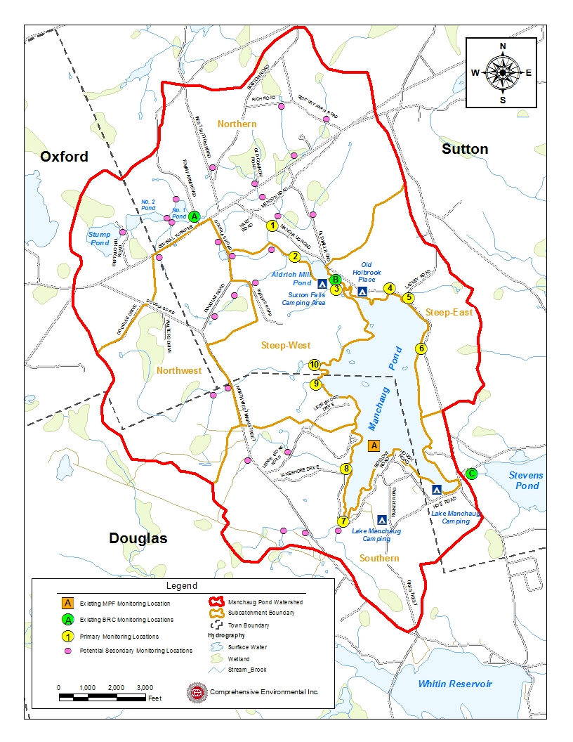

Figure C-2: Recommended Sampling & Monitoring Locations
Water Level Management and Winter Drawdown
Manchaug Pond Dam
The Manchaug Pond Dam was originally constructed in 1836 by downstream textile mill owners with a primary purpose to impound the pond, creating a reservoir to provide the mills with a continuous flow through the year. In 1960, extensive improvements were made which included widening and raising the dam crest, constructing the downstream earthen embankment, replacing the overflow spillway, expanding the low-level outlet, and accommodating Torrey Road.
The Town of Sutton owns the dam while the MPF holds the deed to the flow-rights of Douglas and Sutton. Today, the Manchaug Pond Dam stretches 330-feet long, 28-feet high, and 36-feet wide with Torrey Road at its crest and sits in the town of Sutton, MA. The upstream side of the dam is a stepped-face stone-masonry wall made up of large stone blocks with joints mortared with concrete.
While the waters of Manchaug Pond Reservoir are no longer needed in the manufacturing processes of downstream textile mills, today the importance of the 380-acre reservoir and its dam are no less important and are found to be farther reaching:
- provides required minimum, continual flow in the Mumford River supporting aquatic species;
- supplies storage capacity to attenuate flooding concerns on-lake and downstream;
- provides and enhances fisheries and wetlands;
- ensures connectivity with in-flowing coldwater fishery streams;
- allows year-round recreational opportunities benefiting tourism;
- provides higher quality of life in this corner of the Blackstone Valley and Commonwealth.
The downstream slope is a grass/vegetation covered earth slope constructed in the 1960’s when extensive improvements were made to the dam. Primarily a reinforced concrete box culvert, it extends from the upstream side through the center of the day to the downstream side measuring approximately 10-ft. wide by 9.35-ft. high. The low-level outlet is comprised of a hand-operated gate which opens to a 2-ft. by 2-ft. stone conduit through the dam structure enlarging to a 2-ft. by 3-ft. high reinforced-concrete outlet on the downstream side of the earthen embankment, added during the 1960 construction.
With the upstream face of the dam exposed, inspection and maintenance can be performed as needed which would include re-pointing and facing of the concrete. Visual inspections of the dam are made with daily water surface elevations and precipitation levels recorded and necessary adjustments made to the low-level gate and flashboards/stoplogs in compliance with the Conservation Commission and Mass DEP orders.
Annual and as-needed maintenance includes:
- cutting of the grass-covered earthen embankment twice a year;
- re-pointing with concrete of the upstream stepped-face’s stone-masonry wall; and
- in compliance with Massachusetts Office of Dam Safety regulations, a Phase I Inspection/Evaluation is conducted every other year by an outside engineering firm.
Specific improvements include:
- replacement of the low-level gate mechanism with steel construction and the renovation of the operator’s platform in 2006;
- repairs to the spillway box culvert in 2005, 2008, 2009, and 2013;
- new flashboards/stoplogs installed in 2015;
- new flashboards installed in 2016
The care and operation of the dam is executed in accordance with the Order of Conditions issued to the town by the Sutton Conservation Commission citing the MassDEP Unilateral Administrative Order and actual historic rule curve levels.
Annual Winter Drawdown
Since 1990, the Manchaug Pond Foundation and its prior organization, the Manchaug Pond Association, has worked with the dam owner to employ lake-level drawdown as the best option for controlling aquatic invasive species. In 2018, both the Sutton and Douglas Conservation Commissions issued Order of Conditions (DEP file numbers 303-0866 and 143-0956) which mandates drawdown and other physical/mechanical means of management as the first-line of defense in the control of invasives.
Drawdown allows for the desiccation, freezing, and physical disruption of plants, roots, and seed beds around the shoreline. In addition to reducing the growth of non-native invasive weeds such as Fanwort and Variable Milfoil, MPF notes successful control of Asian Clam at the state public access boat ramp. A look at Manchaug Pond’s bathymetry shows how lake-level drawdown can be an effective method for aiding in the management of aquatic vegetation in the shallow shoreline areas of lakes and ponds. This is further discussed later in this document.
The annual drawdown of the water level begins around Columbus Day or the first week of October and reaches its lowest point in January/February. This is a gradual drawdown with timing to allow for amphibians, reptiles and other aquatic organisms to move to deeper water before ice formation and substrate freezing and to provide fall recreational opportunities. Lake refill must be achieved by April 1st to provide a stable pool elevation and habitat for spring spawning and connectivity with the watershed in-flowing cold-water fishery stream. The lower winter water level provides storage capacity for runoff from unusually high precipitation and snow-melt events.
Water level goals include:
- April 1st:Refilling of the lake from the winter drawdown occurs in February and March to bring the water level to full or just above as required by Massachusetts Department of Environmental Protection (MassDEP) and the MA Department of Fish and Wildlife (MassWildlife) for healthy fisheries during spawning months.
- Spring/Summer: Maintain water level at full as much as possible for connectivity to the coldwater fishery stream and healthy fisheries in coves, wetlands and along the shore as required by MassWildlife. This is dependent on rainfall, evaporation and downstream conditions.
- Early October: Winter drawdown begins.
- Mid-Late January: Reach greatest low of drawdown.
- Late January-Early February: End winter drawdown
Aquatic Plant Management
With over 3,000 lakes and ponds in Massachusetts, many have experienced an increase in nuisance and invasive aquatic vegetation through the years. With an approach based on prevention, early detection and rapid response, as recommended by most Massachusetts state agencies, the MPF has been actively tracking aquatic plant species type, location and density for over decade in Manchaug Pond.
Concern regarding nuisance aquatic plants within the Manchaug Pond Watershed can be traced back to early watershed reports such as the 1980 Manchaug Watershed Quality Improvement/Reclamation Study completed for the Town of Sutton Conservation Commission. Although focused on the upper reaches of the Manchaug Watershed more likely to directly impact Manchaug Pond, this 1980 report indicated that ‘though Manchaug Pond is of relatively high water quality, a proliferation of rooted aquatic plant and algae growth within the ponds of the upper watershed and even downstream as far as Sutton Falls, has sparked alarming concern by many over the potential threat to Manchaug Pond itself’.
Later aquatic vegetation surveys within Manchaug Pond conducted in 2009 and 2010 focused on general vegetation in the littoral zone via a point intercept method to document the species distribution, percent cover, and biomass of aquatic macrophyte species at random data point locations. Updated in 2014, it was estimated that approximately 75-acres or 20% of Manchaug Pond contains the invasive fanwort (Cabomba caroliniana) and variable milfoil (Myriophyllum heterophyllum). It was stated that both plants have the potential to infest the entire littoral zone, outcompeting desirable, indigenous species, degrading water quality and limiting recreational opportunities.
In addition to the above professional surveys, trained MPF watershed volunteers undertake annual aquatic vegetation surveys, with most recent monitoring occurring in 2018 and 2019. Additionally, on average over two dozen volunteers participate in the MPF’s annual weed removal effort targeting emergent invasive species in the more accessible areas of the Manchaug Pond shoreline. The MPF actively initiates public education and outreach related to nuisance aquatic weeds, encouraging residents and visitors to inspect and remove plants from all water vessels entering and existing Manchaug Pond.
A number of aquatic vegetation control techniques beyond prevention are available, however no in-depth study of the various options and impacts has been conducted to date for Manchaug Pond. Control techniques may include but are not limited to:
- Winter Drawdown - Lowering of the water level to dry and freeze susceptible vegetation, with limited potential to control algal growth.
- Harvesting - Multiple methods of mechanical plant cutting, with or without removal, and algal collection. May include hydroraking/mechanical harvesting, suction harvesting, hand harvesting, rotovation etc.
- Biological Control/Biomanipulation - Altering biological communities to control algae or macrophytes through biological interactions.
- Benthic Barriers - Placement of materials on the bottom of a lake to cover and impede the growth of macrophytes.
- Herbicides and Algaecides - Introduction of biocidal chemicals to directly kill vascular plants and/or algae.
- Dyes and Covers - Addition of coloring agents or sheet material to inhibit light penetration and reduce vascular plant and algae growths.
- Dredging - Removal of sediment and associated plants to inhibit growth.
The evaluation of vegetation control techniques should start with the initial identification of target species and the development of a metric and rubric that identifies the different levels of success and/or criteria for future efforts. Additionally, the evaluation of techniques should outline each approach with the following considerations:

- Short and long-term effectiveness
- Human health impacts
- Non-target impacts
- Water quality impacts
- Recreational use impacts
- Ecological impacts
- Planning requirements
- Implementation logistics
- Monitoring requirements (before, during and after implementation)
- Mitigation (if needed)
- Regulatory requirements
- Short and long-term costs (direct and indirect)

Addressing the above considerations combined with a well-developed set of criteria to evaluate the program are essential to a successful control project.
For example, the effectiveness of drawdown as an aquatic plant control technique often depends on the susceptibility of the target species to drawdown and secondary impacts to other species. Some species decrease as a result of drawdown while others will increase. An increase may be the result of a more conducive environment and/or lack of competition, to name a few. Based on propagation and overwintering strategies, perennial species may be controlled more easily with drawdown techniques. Conversely, annual species which rely on seed reproduction may not be as easily controlled and possibly result in an increase in density. Drawdown success factors may depend on:
- Weather, including persistence of snow that may impact the level of drying and freezing;
- High groundwater levels that may increase seepage, preventing drying and freezing;
- Presence of existing seed beds that may rapidly re-establish, particularly if a competing species has been reduced or eliminated;
- Sediment composition and slope which can help determine desiccation rates;
- Drawdown depth and extent of exposed area; and
- Overall plant density and diversity
Another example of vegetation control includes herbicide application. With careful evaluation and planning
required, herbicide use must consider a number of complex issues related to public health and ecological impacts. Not generally an issue with drawdown, chemical use must consider exposure potential based on the individual product or formulation, dilution factors, toxicity and application rate. Strict regulatory factors in Massachusetts based on risk of adverse impacts to human health or the environment when used in accordance with its label restrictions must also be considered. Herbicide treatment is often considered an effective short-term management procedure but often requires multiple applications or regular maintenance treatments.
Overall, many elements factor into the decision to actively engage in nuisance aquatic weed control efforts and many more on the preferred technique for any given waterbody.
The following include recommendations for consideration of future nuisance aquatic weed control in Manchaug Pond:
- Continue existing education and outreach efforts by the MPF to promote prevention and early detection of nuisance aquatic weeds;
- Develop education program for watershed residents on perennial vs. annual aquatic plants and the ecological benefits of native aquatic plant species;
- Develop inspection and education program with the boat ramp managing entity modeled on the MA Division of Conservation and Recreation Boat Ramp Monitor Program. Consider recruiting and training volunteers to inspect incoming and existing water vessels at the boat ramp during high traffic times;
- Continue the recruitment and training of volunteers to complete an annual nuisance aquatic weed survey;
- Continue annual volunteer effort to remove invasive weeds in easily accessible areas by hand;
- Consider an in-depth review of historical nuisance aquatic weed data and current conditions to develop more formal management plan options based on the above outlined factors and develop agreed upon goals to establish success criteria.

Future Management Measures
As discussed earlier in this section it is recommended that future planning and implementation of management measures in the watershed primarily focus on load reductions to Manchaug Pond and tributaries through a combination of structural and non-structural BMPs.

Structural BMPs
The following general sequence is recommended to identify and implement structure BMPs based on an initial source evaluation survey (Appendix B) throughout the watershed.
- Identify Potential Implementation Locations: Combined with the initial source evaluation survey (Appendix B) and water quality data (if available), perform a desktop analysis using aerial imagery and GIS data to develop a preliminary list of potentially feasible implementation locations based on soil type (i.e. hydrologic soil groups A and B); available public open space (e.g., lawn area in front of a police station); and other factors such as proximity to receiving waters, known problem areas, or publicly owned right of ways or easements. Additional analysis can also be performed to fine-tune locations to maximize pollutant removals such as performing loading analysis on specifically delineated subwatersheds draining to single outfalls and selecting those subwatersheds with the highest loading rates per acre.
- Visit Potential Implementation Locations: Perform field reconnaissance, preferably during a period of active runoff-producing rainfall, to evaluate potential implementation locations, gauge feasibility, and identify potential BMP ideas. During field reconnaissance, assess identified locations for space constraints, potential accessibility issues, presence of mature vegetation that may cause conflicts (e.g., roots), potential utility conflicts, site-specific drainage patterns, and other factors that may cause issues during design, construction, or long-term maintenance.
- Develop BMP Concepts: Once potential BMP locations are conceptualized, use the BMP-selector tool of the watershed based planning tool to help develop concepts or work with stormwater consulting engineer to develop site specific conceptual designs.
- Rank BMP Concepts: Once BMP concepts are developed, perform a priority ranking based on site-specific factors to identify the implementation order. Ranking can include many factors including cost, expected pollutant load reductions, implementation complexity, potential outreach opportunities and visibility to public, accessibility, expected operation and maintenance effort, and others.

Non-Structural BMPs
Planned BMPs can also be non-structural and can include practices such as street sweeping and catch basin cleaning to reduce TSS, TN, and TP loading; as well as Illicit Discharge Detection and Elimination (IDDE) to reduce bacteria concentrations. The 2016 Massachusetts Small MS4 General Permit includes requirements for implementation of street sweeping, catch basin cleaning, and IDDE programs. It is recommended that these municipal programs be evaluated and potentially optimized. First, it is recommended that potential removals from ongoing activities be calculated in accordance with Element H. Next, it is recommended that ongoing activities be evaluated to see if potential improvements can be implemented to achieve higher pollutant load reductions such as increased frequency or improved technology.
In addition to municipal participation, the MPF can utilize existing education and outreach infrastructure to develop new programs based on water quality data and volunteer input.

Element D: Identify Technical and Financial Assistance Needed to Implement Plan

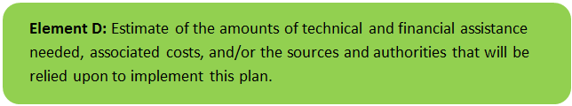 | 

Table D-1 presents the funding needed to implement the management measures presented in this watershed plan. The table includes costs for structural and non-structural BMPs, operation and maintenance activities, information/education measures, and monitoring/evaluation activities. It is anticipated that these BMPs will result in a combined load reduction of approximately 4,435 pounds of TSS, 4.9 pounds of Total Phosphorus and 21.7 pounds of Total Nitrogen.

Note that costing of additional recommendations and management measures including those related to public education and outreach, water quality monitoring, nuisance aquatic vegetation and water level management are not included in Table D-1 as the level of effort and schedule can vary with many elements fully or partially implementable by the MPF and their volunteers.

Table D-1: Summary of Funding Needed to Implement the Watershed Plan
BMP Description & Management Measure* | Drainage Area (ac) | Impervious Area (%) | Estimated Load Reduction (lb/yr) |  |  | Cost Estimates ($)**
BMP Description & Management Measure* | Drainage Area (ac) | Impervious Area (%) | TN | TP | TSS | Implementation | Annual O&M | Total
Lackey Road Sediment Trap | 8.0 | 10 | 7.7 | 1.8 | 2,000 | $13,400 | $500 | $13,900
Central Turnpike Leaching Catch Basin | 1.3 | 30 | 3.2 | 0.7 | 1,250 | $32,000 | $500 | $32,500
Ledgestone Road Raingarden and Vegetated Swale | 3.5 | 15 | 1.5 | 0.4 | 325 | $19,000 | $500 | $19,500
Waters Farm Road Hobby Farm Vegetated Buffer | 1.0 | 5 | 0.6 | 0.2 | 85 | $14,700 | $250 | $14,950
Parker Road Culvert and Vegetated Swale | 0.6 | 10 | 0.5 | 0.1 | 95 | $7,500 | $500 | $8,000
Boat Ramp Structural BMPS to include porous pavement, infiltration structures | 1.0 | 80 | 8.2 | 1.7 | 680 | $157,900 | $2,500 | $160,400
Totals | 15.4 | NA | 21.7 | 4.9 | 4,435 | $244,500 | $4,750 | $249,250
Additional Management Measures – See Elements C and E for additional details. Costs will vary depending on implementation strategy.
* See Watershed Based Plan for further BMP description and Management Measures.
** Cost estimates based on previous projects with in-kind services and material often provided by various stakeholders (town, MPF) for select BMPs.

Element E: Public Information and Education

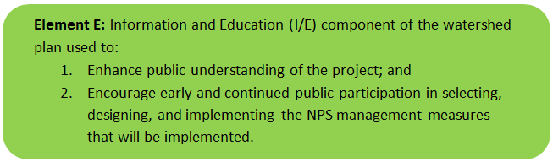 | 

Step 1: Goals and Objectives
The goals and objectives for the watershed information and education program.
The MPF aims to serve in a leadership role as stewards of the lake and watershed and as advocates and educators for its proper use and preservation as part of the Blackstone River system. A variety of issues and concerns are addressed through MPF initiatives, ranging from operation of the dam, safe boating and public access and watershed protection. Ongoing education and outreach efforts are outlined below.
Ongoing Efforts
- Website page that is updated regularly with >600 subscribers
- Active Facebook, YouTube, Twitter and Instagram social media
- Distribution of educational material and use of kiosk at various events including the Spring Social and Annual Meeting in August
- Spring and Fall clean up
- Dam race
- Bi-yearly newsletters
- Updated kiosk materials
- Annual Vessel Safety Check at boat ramp
- Distribution of aquatic hitchhikers/invasive species
Previous efforts have included successful completion of education and outreach tasks under s.319 Nonpoint Source Grants.
Current public education and outreach goals and objectives include:
- Watershed Stewardship – Provide information to promote watershed stewardship.
- Stormwater Improvements – Provide information about specific stormwater improvements that are being implemented and their water quality benefits.
- Agricultural Activities – Establish ongoing education and outreach program for both agricultural and backyard farming activities focused on non-point source reduction.
- Seasonal Camps – Establish camper education program for seasonal camps within the watershed.
- Nuisance Aquatic Weeds – Increase nuisance aquatic vegetation education efforts.
- Homeowner Good Housekeeping – Establish ongoing residential education program to focus homeowner maintenance issues including septic system maintenance, buffer zone uses, fertilizer/pesticide use and storage, waterfowl feeding, buffers, lawn and yard maintenance, pet waste and overall nonpoint source reduction.

Step 2: Target Audience
Target audiences that need to be reached to meet the goals and objectives identified above.
- All watershed residents including youth and seasonal residents.
- Visitors and recreational users of Manchaug Pond.
- Agricultural industry and staff within the watershed.
- Backyard/hobby farmers.

Step 3: Outreach Products and Distribution
The outreach product(s) and distribution form(s) that will be used for each.
- Update Manchaug Pond Foundation website (www.manchaugpond.org) periodically to include general watershed activity information and homeowner good housekeeping topics to include:

  - septic system maintenance
  - vegetated buffers
  - pet waste
  - fertilizer/pesticide use and storage
  - land/garden maintenance
  - nuisance aquatic weeds
  - raingarden/rain barrel use

- Continue local event attendance as opportunities are presented, utilizing Manchaug Pond educational kiosk developed as part of a previous s.313 Nonpoint Source Pollution Grant.
- Continue sponsoring and producing local programming for watershed residents and the general public with a focus on watershed outreach and education. These have included the MPF annual meeting and workshop, spring social, Waters Farm agricultural events etc. where the MPF education kiosk is utilized.
- Installation of a permanent education kiosk at the MPF owned Overlook property. The Overlook includes a 40-stall working stable and is open to visitors and horse enthusiasts. It presents an ideal opportunity to install a small informative kiosk with agriculture/horse related educational material geared towards watershed protection – with Manchaug Pond in the background. The site itself is a working stable and presents an example of horsekeeping management with water quality in mind which will be featured in some of the kiosk materials.
- Hobby Farming with Water Quality in Mind Technical Outreach Visits – includes direct outreach to backyard/hobby farmers and horse owners to provide site specific recommendations on stormwater management, nutrient and manure management and water quality protection. This effort includes visiting hobby/backyard farmers to provide individualized recommendations on site layout; land, nutrient, and animal management; and nonpoint source reduction. A list of recommendations and annotated designs (if applicable) will be provided and discussed with each participant based on the guidance document Hobby Farming with Water Quality in Mind: A Guide to Successful Backyard Farming While Protecting Our Water Resources, October 2017 (funded under s319 project #15-05/319 – Small Farm BMP Guidance) and located here: www.hobbyfarmbmps.org.
- Hobby Farm Newsletter/Fact Sheet. The MPF will put together a series of electronic newsletters to feature nonpoint source topics relevant to agricultural related watershed activities based on the guidance document Hobby Farming with Water Quality in Mind: A Guide to Successful Backyard Farming While Protecting Our Water Resources. This 150+ page publication was structured so that each section also consisted of stand-alone Fact Sheets specifically designed to be used in short-topic/newsletter format for easy distribution and a quick read. Each newsletter will consist of one of the 43 available fact sheets. Newsletters will be released via electronic format with a small budget for hard copy printing for any of the in-person events the MPF participates in as well as the MPF mobile display. With a substantial membership and online following as well as a robust website, these newsletters will be distributed via email through existing website subscribers and MPF membership, online at www.manchaugpond.org and all MPF existing social media outlets including Facebook, Instagram and Twitter.
List of possible topics and available fact sheets include:

- Understanding your soil
- The important of annual soil testing
- Essential plant nutrients
- Understanding fertilizer and soil amendment types
- Fertilizer: what’s in the bag
- Keeping nutrients in your soil: alternative planning methods
- Plant material composting
- Nutrient and soil amendment application
- Animal space needs
- Grazing and grass management
- Mud management
- Manure management
- Animal manure composting
- Controlling animal access to waterways: fencing
- Controlling animal access to waterways: crossings
- Controlling animal access to waterways: alternative water sources
- Vegetated buffers
- Vegetated filter strips
- Vegetated swales
- Infiltrations trenches and dry wells
- Rain gardens
- Rain barrels and cisterns
- Tree planting for water quality
- Integrated pest management
- Pesticide use and water quality
- Reading a pesticide label
- Pesticide storage and disposal
- Equipment safety and maintenance basics
- Reading hazardous material labels and safety data sheets
- Hazardous material use, storage and disposal
- Solid waste management
- Neighbor relations: communication
- Neighbor relations: fly, mosquito and rodent control
- Food safety
- Emergency management planning
- Backyard Gardening & Hobby Farm Water Quality Webinar Series. This effort will develop a series of webinars based on the backyard gardening and hobby farming newsletters (see above). The MPF will pre-record a series of 12 or more short webinars that coincide with the newsletters based on the . The MPF will record these short segment webinars with minor assistance from a media editor and make links available on their website and provide links on all existing social media accounts with videos residing on You Tube. Videos will also be made available to the Towns of Sutton and Douglas for community access via town websites.

Step 4: Evaluate Information/Education Program
Information and education efforts and how they will be evaluated.
Each educational and outreach activity will include a follow-up evaluation or participant survey. Online and social media material can be tracked and evaluated through webpage and video views.

Elements F & G: Implementation Schedule and Measurable Milestones

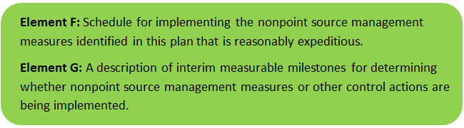 | 

Table FG-1 provides a preliminary schedule for implementation of recommendations provided by this monitoring plan. It is expected that the WBP will be re-evaluated and updated in 2022 as needed based on ongoing monitoring results and other ongoing efforts.
Table FG-1: Implementation Schedule and Interim Measurable Milestones
Category | Action | Year
Monitoring | Perform annual water quality sampling and monitoring. | Annual/Ongoing
Monitoring | Develop MassDEP approved Quality Assurance Project Plan (QAPP). | 2021-2022
Monitoring | Perform annual aquatic vegetation monitoring. | Annual
Vegetation Control | Assess lake-level drawdown and available aquatic vegetation control techniques; develop metrics for success. | 2021
Structural BMPs | Implement Structural BMPs detailed in Table FG-2 below. | 2021-2022
Structural BMPs | Assess potential to implement additional recommended structural BMPs. | 2021-2022
Public Education & Outreach | Update Manchaug Pond Foundation website. | Annual/Ongoing
Public Education & Outreach | Local event attendance with mobile education & Outreach display. | Annual/Ongoing
Public Education & Outreach | Continue sponsoring and producing local programming. | Annual/Ongoing
Public Education & Outreach | Installation of a permanent education kiosk at the MPF owned Overlook property. | 2021
Public Education & Outreach | Hobby Farming with Water Quality in Mind Technical Outreach Visits. | 2022
Public Education & Outreach | Hobby Farm Newsletter/Fact Sheet. | 2021-2022
Public Education & Outreach | Backyard Gardening & Hobby Farm Water Quality Webinar Series | 2021-2022
Adaptive Management & Plan Updates | Re-evaluate Watershed Based Plan and adjust as needed based on ongoing efforts (e.g. based on monitoring results, 319 grant funding, etc.). | Bi-annual  (next update – 2022)

Table FG-2: Implementation Schedule for Structural BMPs
A. Structural & Non-Structural BMPs
LEACHING CATCH BASIN  Boat Ramp Parking Lot | Design Plans | Submit Permit | Complete Permitting | Begin Construction | Complete Construction
LEACHING CATCH BASIN  Boat Ramp Parking Lot | 5/1/2021 | 7/1/2021 | 8/1/2021 | 12/1/2021 | 10/1/2022
LEACHING CATCH BASIN  Boat Ramp Parking Lot | Design Plans | Complete Permitting | Submit Permit | Begin Construction | Complete Construction
LEACHING CATCH BASIN  Boat Ramp Parking Lot | 5/1/2021 | 7/1/2021 | 8/1/2021 | 12/1/2021 | 10/1/2022
LEACHING CATCH BASIN  Boat Ramp Parking Lot | Design Plans | Submit Permit | Complete Permitting | Begin Construction | Complete Construction
LEACHING CATCH BASIN  Boat Ramp Parking Lot | 5/1/2021 | 7/1/2021 | 8/1/2021 | 12/1/2021 | 10/1/2022
LEACHING CATCH BASIN  Boat Ramp Parking Lot | Design Plans | Complete Permitting | Submit Permit | Begin Construction | Complete Construction
LEACHING CATCH BASIN  Boat Ramp Parking Lot | 5/1/2021 | 7/1/2021 | 8/1/2021 | 12/1/2021 | 10/1/2022
POROUS PAVEMENT  Boat Ramp Parking Lot | Design Plans | Submit Permit | Complete Permitting | Begin Construction | Complete Construction
POROUS PAVEMENT  Boat Ramp Parking Lot | 5/1/2021 | 7/1/2021 | 8/1/2021 | 12/1/2021 | 10/1/2022
GRASSED CHANNEL/ WATER QUALITY SWALE  Parker Road | Design Plans | Complete Permitting | Submit Permit | Begin Construction | Complete Construction
GRASSED CHANNEL/ WATER QUALITY SWALE  Parker Road | 5/1/2021 | 7/1/2021 | 8/1/2021 | 4/1/2022 | 10/1/2022
BIORETENTION AND RAIN GARDENS  Hough Road | Design Plans | Submit Permit | Complete Permitting | Begin Construction | Complete Construction
BIORETENTION AND RAIN GARDENS  Hough Road | 5/1/2021 | 7/1/2021 | 8/1/2021 | 4/1/2022 | 10/1/2022
BIORETENTION AND RAIN GARDENS  Ledgestone Road | Design Plans | Submit Permit | Complete Permitting | Begin Construction | Complete Construction
BIORETENTION AND RAIN GARDENS  Ledgestone Road | 5/1/2021 | 7/1/2021 | 8/1/2021 | 5/1/2022 | 10/1/2022
GRASSED CHANNEL/ WATER QUALITY SWALE  Ledgestone Road | Design Plans | Submit Permit | Complete Permitting | Begin Construction | Complete Construction
GRASSED CHANNEL/ WATER QUALITY SWALE  Ledgestone Road | 5/1/2021 | 7/1/2021 | 8/1/2021 | 5/1/2022 | 10/1/2022
VEGETATED FILTER STRIP (= 50 FT WIDE)  Waters Road | Design Plans | Submit Permit | Complete Permitting | Begin Construction | Complete Construction
VEGETATED FILTER STRIP (= 50 FT WIDE)  Waters Road | 5/1/2021 | 7/1/2021 | 8/1/2021 | 10/1/2022 | 12/1/2022
LEACHING CATCH BASIN  Central Turnpike | Design Plans | Submit Permit | Complete Permitting | Begin Construction | Complete Construction
LEACHING CATCH BASIN  Central Turnpike | 5/1/2021 | 7/1/2021 | 8/1/2021 | 6/1/2022 | 10/1/2022
LEACHING CATCH BASIN  Central Turnpike | Design Plans | Submit Permit | Complete Construction | Begin Construction | Complete Construction
LEACHING CATCH BASIN  Central Turnpike | 5/1/2021 | 7/1/2021 | 8/1/2021 | 6/1/2022 | 10/1/2022
LEACHING CATCH BASIN  Central Turnpike | Design Plans | Submit Permit | Complete Construction | Begin Construction | Complete Construction
LEACHING CATCH BASIN  Central Turnpike | 5/1/2021 | 7/1/2021 | 8/1/2021 | 6/1/2022 | 10/1/2022
Rubber Water Bars  Driveway off Ledgestone Road | Design Plans | Submit Permit | Complete Permitting | Begin Construction | Complete Construction
Rubber Water Bars  Driveway off Ledgestone Road | 5/1/2021 | 7/1/2021 | 8/1/2021 | 8/1/2022 | 10/1/2022
Sediment Trap/Forebay  Lackey Road | Design Plans | Submit Permit | Complete Permitting | Begin Construction | Complete Construction
Sediment Trap/Forebay  Lackey Road | 5/1/2021 | 7/1/2021 | 8/1/2021 | 8/1/2022 | 10/1/2022

B. Public Education & Outreach
Backyard Gardening & Hobby Farm Water Quality Newsletters | Development of Monthly Agricultural Newsletters
Backyard Gardening & Hobby Farm Water Quality Newsletters | 12/31/2022
Backyard Gardening & Hobby Farm Water Quality Webinar | Development of Short Topic Hobby Farm Webinars
Backyard Gardening & Hobby Farm Water Quality Webinar | 12/31/2022
Hobby Farming Technical Outreach | Coordinate Visits | Visit Participant Sites | Followup Site Visit | Complete Final Evaluation of Program
Hobby Farming Technical Outreach | 6/1/2021 | 8/31/2021 | 10/31/2021 | 12/31/2021
Overlook at Manchaug Pond Educational Kiosk | Kiosk Installation and Material Development
Overlook at Manchaug Pond Educational Kiosk | 12/31/2021

C. Monitoring
Continue Nuisance Aquatic Weed Survey | Data Collection & Recording
Continue Nuisance Aquatic Weed Survey | 12/31/2021
Continue Seasonal In-Pond Water Quality Monitoring | Data Collection & Recording
Continue Seasonal In-Pond Water Quality Monitoring | 12/31/2021
Evaluation of Existing Monitoring Program | Summary of Program Elements
Evaluation of Existing Monitoring Program | 6/30/2020

Elements H & I: Progress Evaluation Criteria and Monitoring

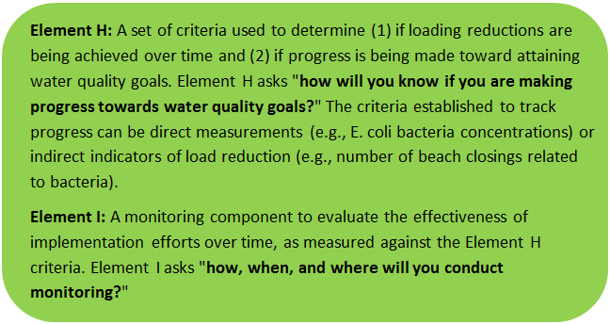 | 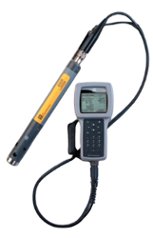

The water quality target concentration(s) is presented under Element A of this plan. To achieve this target concentration, the annual loading must be reduced to the amount described in Element B. Element C of this plan describes the various management measures that will be implemented to achieve this targeted load reduction. The evaluation criteria and monitoring program described below will be used to measure the effectiveness of the proposed management measures (described in Element C) in improving the water quality of Manchaug Pond.

Indirect Indicators of Load Reduction
Indirect indicators will be measured by in-lake and watershed water quality sampling results and aquatic plant surveys to document seasonal and yearly changes. Water sample collection and monitoring efforts will continue to help evaluate trends in water quality data and help identify sources of non-point pollution within the watershed.

Project-Specific Indicators
Number of BMPs installed: Element C of this WBP recommends the installation of BMPs at multiple locations throughout the watershed. The anticipated pollutant load reduction has been documented for each proposed BMP where applicable. The number of BMPs that were installed will be tracked and quantified as part of this monitoring program. If all recommended BMPs are installed, a reduction in annual loading of 0.34 lbs. phosphorus, 2.87 lbs. nitrogen and 3155 lbs. total suspended solids is expected.
Public Education & Outreach degree of change: Project-specific performance indicators of public education and outreach efforts include changes in behaviors tracked through surveys and follow-up visits.

Direct Measurements
MPF will continue to implement watershed management strategies in an effort to improve water quality in Manchaug Pond and contributing tributaries. Water quality monitoring results will be used as an indicator of how effective the strategies are at improving water quality and will be updated and modified based on water quality data and environmental changes that occur in the watershed.

Adaptive Management
If after 3 years of management measure implementation, interim targets are not met and the direct measurements and indirect indicators do not show improvement in the total phosphorus concentrations measured within Manchaug Pond, the management measures and loading reduction analysis (Elements A through D) will be revisited and modified accordingly.

Recommendations
To achieve the long-term goal of protecting the water quality of Manchaug Pond and reducing impairments associated with nutrient loading, a variety of watershed management best management practices (BMPs) are recommended. These recommendations include a combination of structural and non-structural BMPs, public education and outreach, and continued monitoring.
Structural BMPs
Structural stormwater management BMPs recommended in Element C of this report are typically capital intensive and are recommended to be implemented over time based on available resources. As previously discussed, typical funding mechanisms include state and federal grants such as the Section 319 Nonpoint Source Pollution Grant Program administered by MassDEP. Grants often require matching contributions in the form of cash or in-kind labor. For example, the Section 319 grant program requires a 40% non-Federal match. One potential avenue to fund the recommended BMPs in this report is to partner with the Town of Sutton and/or the Town of Douglas.
Public Education and Outreach
Public education and outreach efforts discussed in Element E include:
- MPF Website Update – Continued update of MPF website periodically with new nonpoint source pollution topics.
- Hobby Farming Technical Outreach – In-person consultation with hobby/backyard farmers within the watershed to include recommendations and follow-up visit;
- Backyard Gardening & Hobby Farm Water Quality Newsletter Series – Development of Newsletter series focused on agriculture and water quality;
- Backyard Gardening & Hobby Farm Water Quality Webinar Series – Development of Webinar series (in tandem with above newsletter) focused on agriculture and water quality;
- The Overlook at Manchaug Pond Educational Kiosk – installation of small kiosk at this MPF managed property that houses a working 40-stall horse barn; and
- MPF Sponsored Events & Educational Outreach Opportunities – various education and outreach activities sponsored and/or attended by the MPF where volunteers are present to answer questions, discuss watershed issues and utilize the MPF mobile educational display.
Water Quality Monitoring
Continue annual water quality monitoring while considering adding new locations as funding and volunteer resources permit. Additionally, continue aquatic vegetation annual survey and season monitoring. Consider developing MassDEP approved QAPP for all monitoring, sampling and survey activities.

References
314 CMR 4.00 (2013). "Division of Water Pollution Control, Massachusetts Surface Water Quality Standards"
Aquatic Control Technology, 2014. Aquatic Vegetation Assessment at Manchaug Pond, Sutton/Douglas, MA. Prepared for the Manchaug Pond Foundation Board of Directors.
Blackstone River Coalition, 2018. Water Quality Data, Qualitative Table. 2006-2018.
Briggs, Mark, 2008 (Chairman, Sutton Conservation Commission). Rule Curve Analysis, 1999-2008.
The Center for Environment and Man, Inc., 1977. Wastewater Management Plan, Nonpoint Source Pollution. Nonpoint Sources: By Type, Location, and Quantity. Central Massachusetts Regional Planning Commission. March 1977.
Cohen, A. J.; Randall, A.D. (1998). "Mean annual runoff, precipitation, and evapotranspiration in the glaciated northeastern United States, 1951-80." Prepared for United States Geological Survey, Reston VA.
Comprehensive Environmental Inc., 2017. Hobby Farming with Water Quality in Mind: A Guide to Successful Backyard Farming with While Protecting Our Water Resources. Prepared for the Massachusetts Department of Environmental Protection and the U.S. Environmental Protection Agency.
Comprehensive Environmental Inc, 2005. Manchaug Pond Watershed Survey – Final Report.
IEP, 1980. Manchaug Watershed Quality Improvement/Reclamation Study. Town of Sutton Conservation Commission, January 1980.
Leisenring, M., Clary, J., and Hobson, P. (2014). "International Stormwater Best Management Practices (BMP) Database Pollutant Category Statistical Summary Report: Solids, Bacteria, Nutrients and Metals." Geosyntec Consultants, Inc. and Wright Water Engineers, Inc. December 2014.
Lycott Environmental. Various Aquatic Plant Surveys dated 1990, 2003, 2009 and 2010.
Manchaug Pond Association, 2011. Project Final Report; Manchaug Pond NPS Implementation Project. Project #05-12/319. Prepared for the Massachusetts Department of Environmental Protection and the U.S. Environmental Protection Agency. 2007-2011.
Manchaug Pond Foundation. Water Quality Data, 2014-2018.
Manchaug Pond Foundation, 2018. Manchaug Pond 2018 Aquatic Plant Survey, Grid Survey of Submerged Aquatics. Blackstone River Coalition Data.
Manchaug Pond Foundation, 2016. Project Final Report; Manchaug Pond Water Quality Improvements – Phase 2, Project #13-05/319. Prepared for the Massachusetts Department of Environmental Protection and the U.S. Environmental Protection Agency. 2013-2016.
Manchaug Pond Foundation Website: www.manchaugpond.org
Massachusetts Department of Environmental Protection – Division of Watershed Management. Blackstone River Watershed 2003-2007 Water Quality Assessment Report.
Massachusetts Department of Environmental Protection (2010). Draft Total Maximum Daily Loads of Phosphorus for Selected Lower Blackstone Basin Lakes. Worcester, MA.
Massachusetts Department of Environmental Protection (2012). "Massachusetts Year 2012 Integrated List of Waters Final Listing of Massachusetts' Waters Pursuant to Sections 305(b), 314 and 303(d) of the Clean Water Act"
Massachusetts Department of Environmental Protection (2016a). "Massachusetts Clean Water Toolkit"
Massachusetts Department of Environmental Protection (2016b). "Massachusetts Stormwater Handbook, Vol. 2, Ch. 2, Stormwater Best Management Practices"
Massachusetts Department of Environmental Protection, 2019. Massachusetts Nonpoint Source Management Program Plan 2020-2024. September 30, 2019.
Massachusetts Water Watch Partnership, 2008. Massachusetts Inland Volunteer Monitoring General Quality Assurance Project Plan (QAPP), Version 1.0, For Water Quality Monitoring, Wetland Biological Assessments, and Invasive Species Monitoring.
MassGIS (1999). "Networked Hydro Centerlines" Shapefile
MassGIS (2001). "USGS Topographic Quadrangle Images" Image
MassGIS (2007). "Drainage Sub-basins" Shapefile
MassGIS (2009a). "Impervious Surface" Image
MassGIS (2009b). "Land Use (2005)" Shapefile
MassGIS (2013). "MassDEP 2012 Integrated List of Waters (305(b)/303(d))" Shapefile
Mattson, M.D. and R.A. Isaac. 1999. Calibration of Phosphorus Export coefficients for Total Maximum Daily Loads of Massachusetts Lakes. Lake and Reservoir Man. 15(3):209-219.
Reckhow, K.H. 1979. Uncertainty Analysis Applied to Vollenweider’s Phosphorus Loading Criteria. J. Water Poll. Control Fed. 51(8):2123-2128.
Schueler, T.R., Fraley-McNeal, L, and K. Cappiella (2009). "Is impervious cover still important? Review of recent research" Journal of Hydrologic Engineering 14 (4): 309-315.
Solitude, 2017. Aquatic Vegetation Survey Report, Manchaug Pond. Prepared for Manchaug Pond Foundation.
UMass Water Resources Research Center, 2004. Eutrophication and Aquatic Plant Management in Massachusetts, Final Generic Environmental Impact Report. Prepared for the Commonwealth of Massachusetts Department of Environmental Protection, Department of Conservation and Recreation, and Executive Office of Environmental Affairs.
United States Bureau of Labor Statistics (2016). "Consumer Price Index"
United States Geological Survey (2016). "National Hydrography Dataset, High Resolution Shapefile"
University of Massachusetts, Amherst (2004). "Stormwater Technologies Clearinghouse"
USDA NRCS and MassGIS (2012). "NRCS SSURGO-Certified Soils" Shapefile
USEPA (1986). "Quality Criteria for Water (Gold Book)" EPA 440/5-86-001. Office of Water, Regulations and Standards. Washington, D.C.
USEPA. (2010). "EPA's Methodology to Calculate Baseline Estimates of Impervious Area (IA) and Directly Connected Impervious Area (DCIA) for Massachusetts Communities."
Voorhees, Mark, USEPA. (2016). "FW: Description of additional modelling work for Opti-Tool Project" Message to Chad Yaindl, Geosyntec Consultants. 23 April 2015. E-mail

Water Quality Assessment Reports
"Blackstone River Watershed 2003-2007 Water Quality Assessment Report

TMDL
No TMDL Found

Appendix A – Pollutant Load Export Rates (PLERs)
Land Use & Cover¹ | PLERs (lb/acre/year)
Land Use & Cover¹ | (TP) | (TSS) | (TN)
AGRICULTURE, HSG A | 0.45 | 7.14 | 2.59
AGRICULTURE, HSG B | 0.45 | 29.4 | 2.59
AGRICULTURE, HSG C | 0.45 | 59.8 | 2.59
AGRICULTURE, HSG D | 0.45 | 91.0 | 2.59
AGRICULTURE, IMPERVIOUS | 1.52 | 650 | 11.3
COMMERCIAL, HSG A | 0.03 | 7.14 | 0.27
COMMERCIAL, HSG B | 0.12 | 29.4 | 1.16
COMMERCIAL, HSG C | 0.21 | 59.8 | 2.41
COMMERCIAL, HSG D | 0.37 | 91.0 | 3.66
COMMERCIAL, IMPERVIOUS | 1.78 | 377 | 15.1
FOREST, HSG A | 0.12 | 7.14 | 0.54
FOREST, HSG B | 0.12 | 29.4 | 0.54
FOREST, HSG C | 0.12 | 59.8 | 0.54
FOREST, HSG D | 0.12 | 91.0 | 0.54
FOREST, HSG IMPERVIOUS | 1.52 | 650 | 11.3
HIGH DENSITY RESIDENTIAL, HSG A | 0.03 | 7.14 | 0.27
HIGH DENSITY RESIDENTIAL, HSG B | 0.12 | 29.4 | 1.16
HIGH DENSITY RESIDENTIAL, HSG C | 0.21 | 59.8 | 2.41
HIGH DENSITY RESIDENTIAL, HSG D | 0.37 | 91.0 | 3.66
HIGH DENSITY RESIDENTIAL, IMPERVIOUS | 2.32 | 439 | 14.1
HIGHWAY, HSG A | 0.03 | 7.14 | 0.27
HIGHWAY, HSG B | 0.12 | 29.4 | 1.16
HIGHWAY, HSG C | 0.21 | 59.8 | 2.41
HIGHWAY, HSG D | 0.37 | 91.0 | 3.66
HIGHWAY, IMPERVIOUS | 1.34 | 1,480 | 10.2
INDUSTRIAL, HSG A | 0.03 | 7.14 | 0.27
INDUSTRIAL, HSG B | 0.12 | 29.4 | 1.16
INDUSTRIAL, HSG C | 0.21 | 59.8 | 2.41
INDUSTRIAL, HSG D | 0.37 | 91.0 | 3.66
INDUSTRIAL, IMPERVIOUS | 1.78 | 377 | 15.1
LOW DENSITY RESIDENTIAL, HSG A | 0.03 | 7.14 | 0.27
LOW DENSITY RESIDENTIAL, HSG B | 0.12 | 29.4 | 1.16
LOW DENSITY RESIDENTIAL, HSG C | 0.21 | 59.8 | 2.41
LOW DENSITY RESIDENTIAL, HSG D | 0.37 | 91.0 | 3.66
LOW DENSITY RESIDENTIAL, IMPERVIOUS | 1.52 | 439 | 14.1
MEDIUM DENSITY RESIDENTIAL, HSG A | 0.03 | 7.14 | 0.27
MEDIUM DENSITY RESIDENTIAL, HSG B | 0.12 | 29.4 | 1.16
MEDIUM DENSITY RESIDENTIAL, HSG C | 0.21 | 59.8 | 2.41
MEDIUM DENSITY RESIDENTIAL, HSG D | 0.37 | 91.0 | 3.66
MEDIUM DENSITY RESIDENTIAL, IMPERVIOUS | 1.96 | 439 | 14.1
OPEN LAND, HSG A | 0.12 | 7.14 | 0.27
OPEN LAND, HSG B | 0.12 | 29.4 | 1.16
OPEN LAND, HSG C | 0.12 | 59.8 | 2.41
OPEN LAND, HSG D | 0.12 | 91.0 | 3.66
OPEN LAND, IMPERVIOUS | 1.52 | 650 | 11.3
¹HSG = Hydrologic Soil Group

Appendix B –Manchaug Pond Watershed Source Evaluation Survey

Manchaug Pond Watershed Evaluation - Source/Site List
Site # | Location | Potential Pollution Issue | Recommended BMP/Management Measure
1 | Horse Barn on Central Turnpike Road. | Bacteria Source from Livestock which could migrate to Tributaries | Property owner will be invited to participate in the Hobby Farming Technical Outreach Program as part of the proposed stormwater BMPs being proposed in the 2020 319 Grant application.
2 | Horse Barn Near Intersection of Mendon Road and Old Mill Road. | Bacteria Source from Livestock which could migrate to Tributaries | Property owner will be invited to participate in the Hobby Farming Technical Outreach Program as part of the proposed stormwater BMPs being proposed in the 2020 319 Grant application.
3 | Campground located on Manchaug Road near north end of Manchaug Pond | Bacteria source causing algae blooms in Aldrich Mill Pond. | There are two campgrounds (Holbrook and Sutton Falls) located at the north end of the pond. Both campgrounds are understood to be in compliance with the septic regulations however a significant portion of each is not connected to the septic system.  Sources of bacteria and nutrients may be entering the pond from upstream locations in the watershed. Additional water quality monitoring and watershed investigation is needed to isolate tributaries with high pollutant concentrations and identify potential sources.
4 | Horse Barn on Lackey Road. | Bacteria Source from Livestock which could migrate to Tributaries | Property owner(s) will be invited to participate in the Hobby Farming Technical Outreach Program as part of the proposed stormwater BMPs being proposed in the 2020 319 Grant application.
5 | Lackey Road  Steep Slope Drainage Channels | Steep Channels (5-10% Slope) Erosion and Source of Sediment Migration | Installation of sediment traps and channel stabilization BMPs were completed at the intersection of Lackey Road and Manchaug Road.  Stormwater BMPs are proposed in the 2020 grant application to stabilize drainage ditches along Lackey Road and install additional sediment traps
6 | Low Lying Flood Area along Manchaug Road | Sediment Migration from Sheet Flow and Bank Erosion | Installation of large diameter infiltration catch basin and crushed stone infiltration bed was completed
7 | Drainage System along Northeast Corner of Manchaug Pond along Manchaug Road | Source of Sediment Migration from Manchaug Road | Installation of sediment traps and channel stabilization BMPs were completed
8 | Camp & Outhouse on Manchaug Road (Before road starts to climb) | Bacteria Source from Outhouse or Camp Septic Management Practices | Camp has been removed and a new home built.
Site # | Location | Potential Pollution Issue | Recommended BMP/Management Measure
9 | Long/Moderately Steep Drainage Channels on Manchaug Road. | Drainage Channels (2-3% Slope) Erosion and Source of Sediment and Petroleum Migration | Installation of sediment traps and channel stabilization BMPs were completed
10 | Camp on Manchaug Road (Before road starts to climb) | Bacteria Source from Outhouse or Camp Septic Management Practices | Implement Septic Management Practices through Public Education & Outreach
11 | Irma Jones Cul-de-Sac | Beach Erosion and Source of Sediment Migration | Installation of raingarden, infiltration catch basin and stabilization of beach area were completed
12 | Boat Ramp on Torrey Road. | Source of Sediment & Petroleum Migration | Installation of sediment trap, bio-retention area and infiltration catch basins were completed  Additional stormwater BMPs are proposed in the 2020 grant application, including deep sump/perforated catch basins, sub-surface crushed stone infiltration bed and porous pavement.
13 | Campground located on Oak Street near southeast end of Manchaug Pond | Bacteria Source from Camp Ground Septic Management Practices | New owner upgraded the septic system approximately 3 years ago.
14 | Plow Pull-Off Locations along Oak Street near Sutton/Douglas Border | Source of Sediment Migration from Winter Sanding and Snow Storage | Installation of two deep sump catch basins were completed.
15 | Parker Road and other Gravel Roads located off Oak Street | Gravel Road Erosion and Source of Sediment Migration | Installation of sediment traps and road shoulder stabilization were completed.  Additional stormwater BMPs are proposed in the 2020 grant application to address channeling and sediment transport downstream of the previously completed BMP locations.
16 | Steep Gravel Roads located off Northwest Main Street | Gravel Road Erosion and Source of Sediment Migration | This property is currently for sale. Once the property is sold, MPF will contact the new owner to obtain approval to install BMPs which stabilize steep slopes and direct stormwater runoff to wooded areas.
17 | Steep Paved Roads located off Northwest Main Street | Source of Heavy Winter Sanding & Sediment Migration | BMPs proposed in the 2020 grant application to stabilize steep slopes and direct stormwater runoff to vegetated/wooded area
18 | Steep Gravel Road located at the end of Waters Road. | Gravel Road Erosion and Source of Sediment Migration | Manchaug Pond Foundation now owns and manages this property. Several upgrades have been made to the property and stormwater BMPs put in place.
19 | Horse Farm/Preservation and Wilderness Trails located on Waters Road | Bacteria Source from Livestock and Camping Outhouses located along trails | Property owner will be invited to participate in the Hobby Farming Technical Outreach Program as part of the proposed stormwater BMPs being proposed in the 2020 319 Grant application.
Site # | Location | Potential Pollution Issue | Recommended BMP/Management Measure
20 | Horse Farm located on Waters Road | Bacteria Source from Livestock which could migrate to tributaries | Manchaug Pond Foundation now owns and manages this property. Several upgrades have been made to the property and stormwater BMPs put in place.
21 | Horse Farm Located on Douglas Road near the Douglas/Sutton Town line | Bacteria Source from Livestock which could migrate to tributaries | Property owner will be invited to participate in the Hobby Farming Technical Outreach Program as part of the proposed stormwater BMPs being proposed in the 2020 319 Grant application.
22 | Farm Located at Douglas Road Fork (Very Large Agricultural Area) | Bacteria and Sediment Source from Livestock and other Agricultural Practices which could migrate to tributaries | Installation of sediment/animal waste traps and bioretention cells were completed at Whittier Farm.  Installation of a vegetated buffer was completed between an agricultural field and shoreline of No. 2 Pond.  MPF will continue to work with the property owner to identify future stormwater BMPs opportunities.
23 | Horse Barn Near the Intersection of Central Turnpike & Douglas Road. | Bacteria Source from Livestock which could migrate to tributaries | Property owner will be invited to participate in the Hobby Farming Technical Outreach Program as part of the proposed stormwater BMPs being proposed in the 2020 319 Grant application.
24 | Farm Located on Town Farm Road. (Very Large Agricultural Area) | Bacteria and Sediment Source from Livestock and other Agricultural Practices which could migrate to tributaries | Property owner will be invited to participate in the Hobby Farming Technical Outreach Program as part of the proposed stormwater BMPs being proposed in the 2020 319 Grant application.
25 | Horse Barn located near the intersection of Boston Road and Rich Road. | Bacteria Source from Livestock which could migrate to tributaries | Property owner will be invited to participate in the Hobby Farming Technical Outreach Program as part of the proposed stormwater BMPs being proposed in the 2020 319 Grant application.
26 | Horse Barn located near the intersection of Boston Road and Century Farm Road. | Bacteria Source from Livestock which could migrate to tributaries | Property owner will be invited to participate in the Hobby Farming Technical Outreach Program as part of the proposed stormwater BMPs being proposed in the 2020 319 Grant application.
27 | Horse Barn located on Century Farm Road. | Bacteria Source from Livestock which could migrate to tributaries | Property owner will be invited to participate in the Hobby Farming Technical Outreach Program as part of the proposed stormwater BMPs being proposed in the 2020 319 Grant application.
28 | Steep Driveway and drainage channels on Manchaug Road | Source of Heavy Winter Sanding & Sediment Migration | Installation of sediment trap, raingarden and road shoulder stabilization were completed.
29 | Drainage channels on Old Mill Road. | Source of Heavy Winter Sanding & Sediment Migration | Installation of two deep sump/infiltration catch basins and vegetated swale were completed.
Site # | Location | Potential Pollution Issue | Recommended BMP/Management Measure
30 | Drainage channels on corner of Manchaug Road and Holt Road. | Source of Heavy Winter Sanding & Sediment Migration | Installation of vegetated swale with check dams was completed.
31 | Steep Paved Roads and cul-de-sac located at end of Ledgestone Road | Source of Heavy Winter Sanding, Sediment Migration and Standing Water | Stormwater BMPs are proposed in the 2020 grant application to address sediment transport into existing closed drainage system which directly discharges to Manchaug Pond.
32 | Small Farm with Livestock and Pond with no Vegetated Buffer | Bacteria Source from Livestock which could migrate to Tributaries | Stormwater BMPs are proposed in the 2020 grant application to address and provide runoff filtration, remove nutrients and promote infiltration.
33 | Leaching Catch Basins  Central Turnpike | Source of Sediment & Petroleum Migration | Stormwater BMPs are proposed in the 2020 grant application to address provide runoff filtration, remove nutrients and promote infiltration.
34 | Hough Road | Source of sediment from dirt road washing into drainage swale which discharges to Manchaug Pond | MPF will work with the private community to develop to better manage sediment accumulation from gravel roads and identify locations where future BMPs can be installed.
35 | 2 Lakefront Camps at the end of Waters Road | Bacteria Source from Outhouse or Camp Septic Management Practices | Contact Owners to confirm compliance with Septic Management Practices through Public Education & Outreach
Note: Site # refers to the location on the following map and is not a priority ranking.
Red Site # refers to elements that have been included in 2020 s.319 Nonpoint Source Grant Application.

Interim goal has been established as a starting point and is intended to be representative of realistic potential load reductions that can be achieved through ongoing BMP implementation to continue improving water quality. Interim goal is not based on water quality data or calculations of potential concentration-based improvements.
Massachusetts Water Watch Partnership, 2008. Massachusetts Inland Volunteer Monitoring General Quality Assurance Project Plan (QAPP), Version 1.0, For Water Quality Monitoring, Wetland Biological Assessments, and Invasive Species Monitoring. www.mass.gov/guides/water-quality-monitoring-for-volunteers
Manchaug Pond Foundation website www.manchaugpond.org
Manchaug Pond Foundation website www.manchaugpond.org
UMass Water Resources Research Center, 2004. Eutrophication and Aquatic Plant Management in Massachusetts, Final Generic Environmental Impact Report. Prepared for the Commonwealth of Massachusetts Department of Environmental Protection, Department of Conservation and Recreation, and Executive Office of Environmental Affairs.
UMass Water Resources Research Center, 2004. Eutrophication and Aquatic Plant Management in Massachusetts, Final Generic Environmental Impact Report. Prepared for the Commonwealth of Massachusetts Department of Environmental Protection, Department of Conservation and Recreation, and Executive Office of Environmental Affairs.

