

WATERSHED-BASED PLAN | 
CANTON
Pequit Brook and Beaver Meadow Brook Watersheds within the Town of Canton
March 4, 2019

Prepared By:
Town of Canton Department of Public Works
Neponset River Watershed Association
Geosyntec Consultants

Prepared For:

Contents
Executive Summary iii
Introduction 1
Purpose & Need 1
Watershed-Based Plan Outline 1
Project Partners and Stakeholder Input 2
Data Sources 2
Summary of Past and Ongoing Work 3
Element A: Identify Causes of Impairment & Pollution Sources 4
General MS4 Watershed Information 4
MassDEP Water Quality Assessment Report and TMDL Review 6
Additional Water Quality Data 9
Water Quality Impairments 10
Water Quality Goals 14
Land Use Information 16
Pollutant Loading 24
Element B: Determine Pollutant Load Reductions Needed to Achieve Water Quality Goals 28
Water Quality Goals 28
Element C: Describe management measures that will be implemented to achieve water quality goals 30
Current and Ongoing Management Measures 30
Future Management Measures 30
Element D: Identify Technical and Financial Assistance Needed to Implement Plan 33
Element E: Public Information and Education 34
Elements F & G: Implementation Schedule and Measurable Milestones 36
Elements H & I: Progress Evaluation Criteria and Monitoring 38
Indirect Indicators of Load Reduction 38
Project-Specific Indicators 40
TMDL Criteria 40
Direct Measurements 40
Adaptive Management 40
References 41
Appendices 43
Appendix A – Additional Water Quality Information 43
Appendix B – Proposed BMPs (Town of Canton, 2017) 58
Appendix C – Pollutant Load Export Rates (PLERs) 62

Executive Summary
Introduction: The purpose of a Massachusetts Watershed-Based Plan (WBP) is to organize information about Massachusetts' watersheds, and present it in a format that will enhance the development and implementation of projects that will restore water quality and beneficial uses in the Commonwealth. The Massachusetts WBP follows USEPA's recommended format for “nine-element” watershed plans. This WBP was developed by Geosyntec Consultants (Geosyntec) under the direction of the Canton Department of Public Works with funding, input, and collaboration with the Massachusetts Department of Environmental Protection (MassDEP).
The Neponset River Watershed includes approximately 130 square miles of land southwest of Boston. It drains to the Neponset River which stretches for approximately 30 miles from its headwaters in Foxborough to its outlet near Dorchester and Quincy. This WBP focuses specifically on Pequit Brook and Beaver Meadow Brook and their associated tributaries and waterbodies that ultimately drain to the Neponset River within the Town of Canton.
Impairments and Pollution Sources: The Neponset River is a category 5 water body on the Massachusetts List of Integrated Waters due to a variety of impairments from multiple sources, including impairments related to fecal coliform and nutrients (phosphorus). Because of these impairments, a TMDL for bacteria was issued for the Neponset River watershed that includes part of the Town of Canton watershed. Pequit Brook and Beaver Meadow Brook are also listed on the Massachusetts List of Integrated Waters for impairments relating to dissolved oxygen. The sources of the impairments for Pequit Brook and Beaver Meadow Brook are unknown; however, stormwater has been identified as a priority concern by past MassDEP WBPs for the Neponset River watershed and the Neponset River TMDL, as well as by other organizations, such as Executive Office of Energy & Environmental Affairs.
Monitoring data collected by the Citizens Water Monitoring Network, managed by the Neponset River Watershed Association, regularly tracks concentrations of dissolved oxygen, phosphorus, and E. coli in Pequit Brook and Beaver Meadow Brook. Results of this water quality monitoring suggest that the streams often face low levels of dissolved oxygen, high levels of phosphorus, and regularly fail to meet water quality standards for swimming and fishing, following wet weather events.
Goals, Management Measures, and Funding: Water quality goals for this WBP are focused on addressing the Neponset River Watershed Bacteria TMDL, listed dissolved oxygen impairments, and observed elevated concentrations of phosphorus from ambient monitoring data. It is expected that these reductions will result in improvements to listed impairments throughout the study area. This WBP includes an adaptive sequence to establish and track specific water quality goals. First, an interim goal has been established to reduce phosphorus loading by 10 pounds in the next five years. From there, focus will be shifted to the long-term goal of delisting all assessment units within the study area based on adaptively adjusting goals based on ongoing monitoring results.
It is expected that goals will be accomplished primarily through installation of structural BMPs to capture runoff and reduce loading, as well as implementation of non-structural BMPs (e.g., street sweeping, catch basin cleaning), and watershed education and outreach. Structural BMPs will first be implemented at Devoll Field and Luce School per a Fiscal Year 2018 Section 319 grant. From there, additional planning and implementation is expected to be performed, focusing on each water body in the study area.
It is expected that funding for management measures will be obtained from a variety of sources including Section 319 Grant Funding, Town Capital Funds, Volunteer efforts, and other sources.
Public Education and Outreach: Goals of public education and outreach are to provide information about proposed stormwater improvements and their anticipated benefits and to promote watershed stewardship. The Town of Canton and Neponset River Watershed Association aim to engage watershed residents and businesses through interpretive signage, educational mailing, online resources, school visit programs, and a variety of other means. It is expected that these programs will be evaluated by tracking coverage from local media, number of mailers distributed, activity on online resources, and other tools applicable to the type of outreach performed.
Implementation Schedule and Evaluation Criteria: Project activities will be implemented based on information outlined in the following elements for monitoring, implementation of structural BMPs, and public education and outreach activities. It is expected that water quality monitoring will enable direct evaluation of improvements over time. Other indirect evaluation metrics are also recommended, included quantification of potential pollutant load reductions from non-structural BMPs (e.g., street sweeping). The interim goal of this WBP is to reduce land use-based phosphorus loading by 10 pounds by 2024. The long-term goal of this WBP is to de-list the all waterbodies within the study area from the 303(d) list. The WBP will be re-evaluated and adjusted, as needed, once every three years.

Introduction


What is a Watershed-Based Plan?

Purpose & Need
The purpose of a Massachusetts Watershed-Based Plan (WBP) is to organize information about Massachusetts' watersheds, and present it in a format that will enhance the development and implementation of projects that will restore water quality and beneficial uses in the Commonwealth. The Massachusetts WBP follows USEPA's recommended format for “nine-element” watershed plans, as described below.
All states are required to develop WBPs, but not all states have taken the same approach. Most states develop watershed-based plans only for selected watersheds. MassDEP's approach has been to develop a tool to support statewide development of WBPs, so that good projects in all areas of the state may be eligible for federal watershed implementation grant funds under Section 319 of the Clean Water Act.
USEPA guidelines promote the use of Section 319 funding for developing and implementing WBPs. WBPs are required for all projects implemented with Section 319 funds, and are recommended for all watershed projects, whether they are designed to protect unimpaired waters, restore impaired waters, or both.

Watershed-Based Plan Outline
This WBP for Canton’s municipal separate storm sewer system (MS4) watershed includes nine elements (a through i) in accordance with USEPA Guidelines:
- An identification of the causes and sources or groups of similar sources that will need to be controlled to achieve the load reductions estimated in this watershed-based plan (and to achieve any other watershed goals identified in the watershed-based plan), as discussed in item (b) immediately below.
- An estimate of the load reductions expected for the management measures described under paragraph (c) below (recognizing the natural variability and the difficulty in precisely predicting the performance of management measures over time).
- A description of the nonpoint source (NPS) management measures needed to achieve the load reductions estimated under paragraph (b) above (as well as to achieve other watershed goals identified in this watershed-based plan), and an identification (using a map or a description) of the critical areas in which those measures will be needed to implement this plan.
- An estimate of the amounts of technical and financial assistance needed, associated costs, and/or the sources and authorities that will be relied upon, to implement this plan. As sources of funding, States should consider the use of their Section 319 programs, State Revolving Funds, USDA's Environmental Quality Incentives Program and Conservation Reserve Program, and other relevant Federal, State, local and private funds that may be available to assist in implementing this plan.
- An information/education component that will be used to enhance public understanding of the project and encourage their early and continued participation in selecting, designing, and implementing the NPS management measures that will be implemented.
- A schedule for implementing the NPS management measures identified in this plan that is reasonably expeditious.
- A description of interim, measurable milestones for determining whether NPS management measures or other control actions are being implemented.
- A set of criteria to determine if loading reductions are being achieved over time and substantial progress is being made towards attaining water quality standards and, if not, the criteria for determining whether this watershed-based plan needs to be revised or, if a NPS Total Maximum Daily Load (TMDL) has been established, whether the TMDL needs to be revised.
- A monitoring component to evaluate the effectiveness of the implementation efforts over time, measured against the criteria established under item (h) immediately above.

Project Partners and Stakeholder Input
This WBP was developed by Geosyntec Consultants (Geosyntec) under the direction of the Canton Department of Public Works with funding, input, and collaboration with the Massachusetts Department of Environmental Protection (MassDEP). This WBP was developed using funds from the Section 319 program to assist grantees in developing technically robust WBPs using MassDEP’s Watershed-Based Planning Tool. Canton was a recipient of Section 319 funding in Fiscal Year 2018.
Core project stakeholders included:
- Michael Trotta, Superintendent – Canton Department of Public Works
- Barbara Reardon – Canton Town Engineer
- Town of Canton Board of Selectmen
- Neponset River Watershed Association
- Jane Peirce – MassDEP
This WBP was developed as part of an iterative process. The Geosyntec project team collected and reviewed existing data from the Town of Canton. This information was then used to develop a preliminary WBP for review by core project stakeholders. A stakeholder conference call was then held to solicit input and gain consensus on elements included in the plan (e.g., water quality goals, public outreach activities, etc.). The WBP was finalized once stakeholder consensus was obtained for all elements.

Data Sources
This WBP was developed using the framework and data sources provided by MassDEP’s Watershed-Based Planning Tool and supplemented by data from additional studies. Supplemental data sources were reviewed and are summarized in subsequent sections of this WBP, if relevant, as listed by Table 1.
Table 1: Supplemental Data Sources
Title / Description | Source | Date
Neponset River Watershed Association Citizen Water Monitoring Network | https://www.neponset.org/your-watershed/cwmn-data/ | 1994-present
Final Report – FY2016 Sustainable Water Management Initiative Grant | Town of Canton | 2016

Summary of Past and Ongoing Work

Mitigation and Minimization Alternatives to Improve Streamflow in the Neponset River Watershed
In 2016, the Town of Canton was awarded funding through the Sustainable Water Management Initiative Grant to perform a study to evaluate water management alternatives for improving streamflow in the Neponset River watershed. The study focused on estimates of water volumes available for mitigation, listing costs associated with mitigation measures, evaluating effectiveness of mitigation measures for improving streamflow, and comparison of costs and overall basin impacts. The study also identified and prioritized 128 sites for stormwater retrofits.

Neponset River Watershed Association Citizen Water Monitoring Network
The Citizen Water Monitoring Network (CWMN), led by the Neponset River Watershed Association and partially funded by the Town of Canton, has been collecting water quality data throughout the Neponset River Watershed since 1994. Refer to the website or Element A.3 for more details.

Town of Canton Stormwater Requirements for Site Plans
The Town of Canton is working to establish water quality bylaws with town-wide water quality criteria for new subdivisions. The effort is aimed at integrating stormwater criteria into the requirements for site plans that are reviewed.

Town of Canton Stormwater Infrastructure Maintenance
The Town of Canton has mapped stormwater infrastructure, such as outfalls, since 2003 and has also tracked stormwater maintenance (catch basin cleaning, street sweeping, outfall maintenance, etc.) since 2008. Town efforts have also included outfall sampling, most recently in 2010.

Element A: Identify Causes of Impairment & Pollution Sources

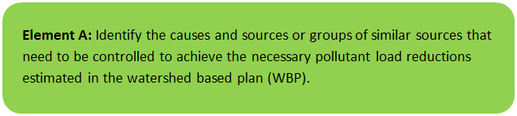 | 

General MS4 Watershed Information
The Neponset River Watershed includes approximately 130 square miles of land southwest of Boston. It drains to the Neponset River which stretches for approximately 30 miles from its headwaters in Foxborough to its outlet near Dorchester and Quincy. The Town of Canton is located at the heart of the Neponset River Watershed and includes major tributaries to the Neponset River, such as Pequid Brook (a.k.a. Pequit Brook) and Beaver Meadow Brook (which both converge at the East Branch of the Neponset River).
This WBP focuses specifically on Pequit Brook and Beaver Meadow Brook and their associated tributaries and waterbodies that ultimately drain to the Neponset River within the Town of Canton. Since these waterbodies are all located within Canton’s regulated Municipal Separate Storm Sewer System (MS4), the Watershed-Based Planning Tool’s MS4 module was used to develop this plan to enable computation of statistics for these waterbodies specific to the Town of Canton.
Table A-1 presents the general watershed information within the applicable MS4 subwatersheds and Figure A-1 includes a map of subwatershed boundaries.
Table A-1: General Subwatershed Information
MS4 Subwatershed # | Waterbody Names (Assessment Unit ID) | Subwatershed Area (ac) | Major Basin
CANTON_01 | Glen Echo Pond (MA73022); Pequit Brook (MA73-22); York Brook | 2336.6 (ac) | BOSTON HARBOR
CANTON_05 | Pequit Brook (MA73-22); Reservoir Pond (MA73048) | 1064.3 (ac) | BOSTON HARBOR
CANTON_08 | Beaver Meadow Brook (MA73-20); Bolivar Pond (MA73005); East Branch (MA73-05); East Branch Neponset River; Forge Pond (MA73020); Massapoag Brook (MA73-21); Pequit Brook (MA73-22) | 909.6 (ac) | BOSTON HARBOR
CANTON_11 | Beaver Meadow Brook (MA73-20) | 706.8 (ac) | BOSTON HARBOR

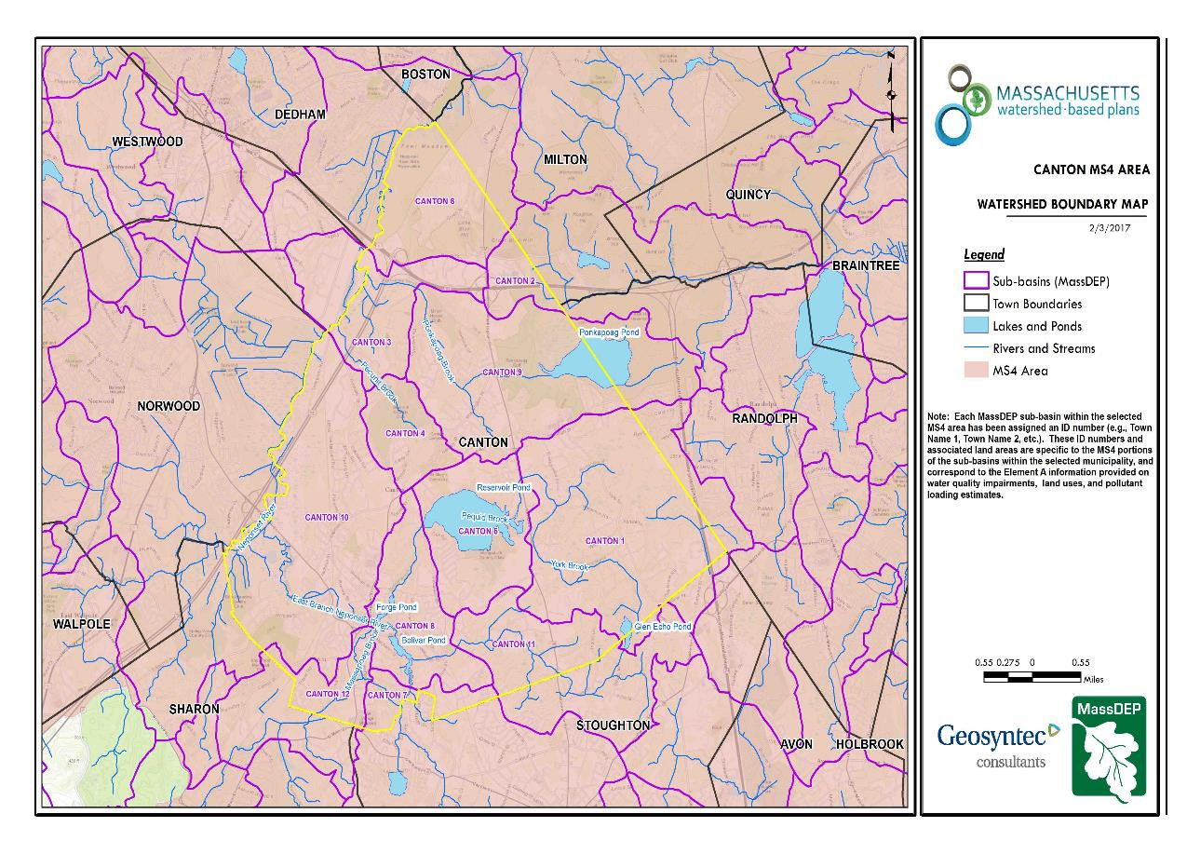
Figure A-1: MS4 Subwatershed Boundary Map
Canton_08
Approximate Watershed Boundary
Beaver Meadow Brook
Pequit Brook
Canton_05
Canton_11
Canton_01
(MassGIS, 2007; MassGIS, 1999; MassGIS, 2001; USGS, 2016)

MassDEP Water Quality Assessment Report and TMDL Review
The following reports are available:
- Neponset River Watershed 2004 Water Quality Assessment Report
- Northeast Regional Mercury Total Maximum Daily Load Final Addendum for Massachusetts
- Total Maximum Daily Loads of Bacteria for Neponset River Basin
Select excerpts from these documents relating to the water quality in the Canton subwatershed are included below (note: relevant information is included directly from these documents for informational purposes and has not been modified). Additional information on the TMDL for Bacteria in the Neponset River Basin is included in Appendix A.
Neponset River Watershed 2004 Water Quality Assessment Report (MA73022 - Glen Echo Pond )
Aquatic Life
A non-native species (Myriophyllum heterophyllum) has been observed in Glen Echo Pond.

Fish Consumption
This waterbody does not have a site-specific fish consumption advisory. All applicable statewide fish consumption advisories issued by MA DPH due to mercury contamination apply to this waterbody (See Special Note 2).

Primary Contact
Insufficient data were available to assess the Primary Contact Use.

Secondary Contact
Insufficient data were available to assess the Secondary Contact Use.

Aesthetics
Insufficient data were available to assess the Aesthetic Use.

Report Recommendations:
NA

Neponset River Watershed 2004 Water Quality Assessment Report (MA73-20 - Beaver Meadow Brook )
Aquatic Life
Insufficient data were available to assess the Aquatic Life Use.

Fish Consumption
This waterbody does not have a site-specific fish consumption advisory. All applicable statewide fish consumption advisories issued by MA DPH due to mercury contamination apply to this waterbody (See Special Note 2).

Primary Contact
NepRWA collected E. coli samples at one site in 2007 and 2008. The annual geometric means of the samples collected at the site during the primary contact season were 49 CFU/100ml and 48 CFU/100ml. These results do not violate the geometric mean criterion (126 CFU/100ml) for E. coli.

Secondary Contact
NepRWA collected E. coli samples at one site in 2007 and 2008. The annual geometric means of the samples collected at the site were 49 CFU/100ml and 48 CFU/100ml. These results do not violate the geometric mean criterion (630 CFU/100ml) for E. coli.

Aesthetics
Insufficient data were available to assess the Aesthetic Use.

Report Recommendations:
NA

Neponset River Watershed 2004 Water Quality Assessment Report (MA73-05 - East Branch Neponset River )
Aquatic Life
Insufficient data were available to assess the Aquatic Life Use.

Fish Consumption
This waterbody does not have a site-specific fish consumption advisory. All applicable statewide fish consumption advisories issued by MA DPH due to mercury contamination apply to this waterbody (See Special Note 2).

Primary Contact
NepRWA collected E. coli samples at one site in 2008. The annual geometric mean of the samples collected at the site during the primary contact season was 179 CFU/100ml. This result violates the geometric mean criterion (126 CFU/100ml) for E. coli.

Secondary Contact
NepRWA collected E. coli samples at one site in 2007 and 2008. The annual geometric means of the samples collected at the site were 179 CFU/100ml and 183 CFU/100ml. These results do not violate the geometric mean criterion (630 CFU/100ml) for E. coli.

Aesthetics
Insufficient data were available to assess the Aesthetic Use.

Report Recommendations:
NA

Neponset River Watershed 2004 Water Quality Assessment Report (MA73-22 - Pequit Brook )
Aquatic Life
NepRWA measured dissolved oxygen at two sites in 2007 and 2008 (n=20) and found eight violations of the dissolved oxygen criterion (5.0 mg/L). The violations ranged from 3.3 mg/L to 4.9 mg/L.

Fish Consumption
This waterbody does not have a site-specific fish consumption advisory. All applicable statewide fish consumption advisories issued by MA DPH due to mercury contamination apply to this waterbody (See Special Note 2).

Primary Contact
NepRWA collected E. coli samples at one site in 2007 and 2008. The annual geometric means of the samples collected at each site during the primary contact season ranged from 33 CFU/100ml to 123 CFU/100ml. These results do not violate the geometric mean criterion (126 CFU/100ml) for E. coli. An Alert Status is identified for this use due to spikes in E. coli concentrations.

Secondary Contact
NepRWA collected E. coli samples at two sites in 2007 and 2008. The annual geometric means of the samples collected at each site ranged from 33 CFU/100ml to 175 CFU/100ml. These results do not violate the geometric mean criterion (630 CFU/100ml) for E. coli.

Aesthetics
Insufficient data were available to assess the Aesthetic Use.

Report Recommendations:
NA

Neponset River Watershed 2004 Water Quality Assessment Report (MA73-21 - Massapoag Brook )
Aquatic Life
Non-native species (Cabomba caroliniana, Marsilea quadrifolia) have been observed in Manns Pond which is part of this segment.

Fish Consumption
This waterbody does not have a site-specific fish consumption advisory. All applicable statewide fish consumption advisories issued by MA DPH due to mercury contamination apply to this waterbody (See Special Note 2).

Primary Contact
NepRWA collected E. coli samples at two sites in 2007 and 2008. The annual geometric means of the samples collected at each site during the primary contact season ranged from 10 CFU/100ml to 65 CFU/100ml. These results do not violate the geometric mean criterion (126 CFU/100ml) for E. coli.

Secondary Contact
NepRWA collected E. coli samples at two sites in 2007 and 2008. The annual geometric means of the samples collected at each site ranged from 10 CFU/100ml to 65 CFU/100ml. These results do not violate the geometric mean criterion (630 CFU/100ml) for E. coli.

Aesthetics
Insufficient data were available to assess the Aesthetic Use.

Report Recommendations:
NA

Neponset River Watershed 2004 Water Quality Assessment Report (MA73048 - Reservoir Pond )
Aquatic Life
Non-native species (Myriophyllum heterophyllum, Cabomba caroliniana) have been observed in Reservoir Pond.

Fish Consumption
This waterbody does not have a site-specific fish consumption advisory. All applicable statewide fish consumption advisories issued by MA DPH due to mercury contamination apply to this waterbody (See Special Note 2).

Primary Contact
Insufficient data were available to assess the Primary Contact Use.

Secondary Contact
Insufficient data were available to assess the Secondary Contact Use.

Aesthetics
Insufficient data were available to assess the Aesthetic Use.

Report Recommendations:
NA

Additional Water Quality Data
The Neponset River Watershed Association’s Citizen Water Monitoring Network (CWMN) has been collecting water quality data throughout the Neponset River Watershed since 1994. Sampling sites are visited on a monthly basis and are assessed for:
- Depth of the water body
- Rate of water flow
- Clarity, color, and odor of the water
- Temperature of the air & water
- Current and prior weather
- Dissolved oxygen levels
- Analytical tests for pH, bacteria (e. coli), total phosphorus, total nitrogen, ammonia, chlorophyll-a, and other parameters
The CWMN includes four sites relative to the study area presented by this WBP (See Figure A-2). Results suggest that Pequit Brook and Beaver Meadow Brook suffer from high levels of phosphorus regularly exceeding 50 µg/L. Results also suggest that Pequit Brook (upstream of Reservoir Pond) often experiences levels of dissolved oxygen less than 5 mg/L, not sustainable for supporting fish. In addition, Pequit Brook and Beaver Meadow Brook regularly fail to meet water quality standards for swimming and fishing following wet weather events. In 2018, the geometric mean concentrations for E.coli were 324 CFU/100mL (PQB036) and 266 CFU/100mL (PQB040) in Pequit Brook and 498 CFU/100mL in Beaver Meadow Brook.

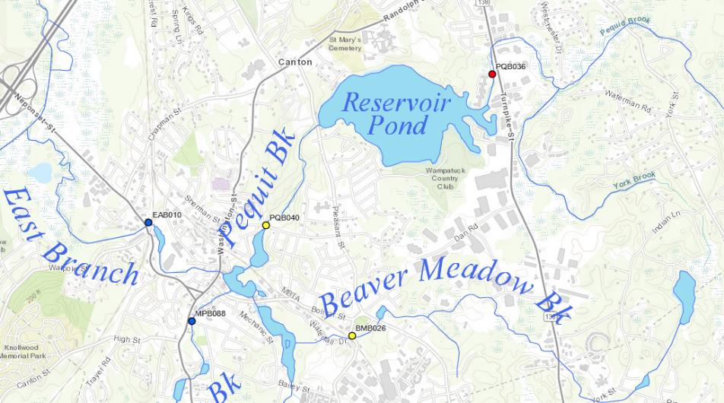
Beaver Meadow Brook
(BMB026)
Pequit Brook
(PQB036)
East Branch
(EAB010)
Pequit Brook
(PQB040)
Figure A-2. CWMN Water Quality Monitoring Locations within the focus area of this WBP.
(Source: https://www.neponset.org/your-watershed/cwmn-data/)

Water Quality Impairments
The Neponset River is listed under category 5 of the Massachusetts List of Integrated Waters due to over 30 impairments including sedimentation/siltation, dissolved oxygen, fecal coliform, total phosphorus, turbidity, excess algal growth, and DDT, among others. A TMDL has been established for the Neponset River watershed for bacteria. In addition, Pequit Brook and Beaver Meadow Brook are both listed under category 5 of the Massachusetts List of Integrated Waters due to dissolved oxygen. Additional tributaries and waterbodies within the study area of this Watershed-Based Plan as delineated by MS4 boundaries are also listed on the Massachusetts List of Integrated Waters for a range of impairments including non-aquatic native plants, turbidity, total phosphorus, and others.
Refer to Table A-2 for applicable integrated waters categories and to Tables A-3 for a summary of impairments and sources within the study area. The sources of the impairments listed in Table A-3 for Pequit Brook and Beaver Meadow Brook are unknown; however, stormwater has been identified as a priority concern by past MassDEP WBPs for the Neponset River watershed, by the Executive Office of Energy & Environmental Affairs’ (EEA) Boston Harbor Watershed Assessment and Action Plan, and by the Neponset River TMDL (Town of Canton, 2017).
Table A-2: 2012 MA Integrated List of Waters Categories
Integrated List Category | Description
1 | Unimpaired and not threatened for all designated uses.
2 | Unimpaired for some uses and not assessed for others.
3 | Insufficient information to make assessments for any uses.
4 | Impaired or threatened for one or more uses, but not requiring calculation of a Total Maximum Daily Load (TMDL), including:  4a: TMDL is completed  4b: Impairment controlled by alternative pollution control requirements  4c: Impairment not caused by a pollutant - TMDL not required
5 | Impaired or threatened for one or more uses and requiring preparation of a TMDL.

Tables A-3: Water Quality Impairments
MS4 Subwatershed #: CANTON_01
Assessment  Unit ID | Waterbody | Integrated  List  Category | Designated Use | Impairment Cause | Impairment Source
MA73022 | Glen Echo Pond | 4C | Fish, other Aquatic Life and Wildlife | Non-Native Aquatic Plants | Introduction of Non-native Organisms (Accidental or Intentional)
MA73-22 | Pequit Brook | 5 | Fish, other Aquatic Life and Wildlife | Oxygen, Dissolved | Source Unknown

MS4 Subwatershed #: CANTON_05
Assessment  Unit ID | Waterbody | Integrated  List  Category | Designated Use | Impairment Cause | Impairment Source
MA73-22 | Pequit Brook | 5 | Fish, other Aquatic Life and Wildlife | Oxygen, Dissolved | Source Unknown
MA73048 | Reservoir Pond | 4A | Fish Consumption | Mercury in Fish Tissue | Atmospheric Deposition - Toxics
MA73048 | Reservoir Pond | 4A | Fish, other Aquatic Life and Wildlife | Non-Native Aquatic Plants | Introduction of Non-native Organisms (Accidental or Intentional)

MS4 Subwatershed #: CANTON_08
Assessment  Unit ID | Waterbody | Integrated  List  Category | Designated Use | Impairment Cause | Impairment Source
MA73005 | Bolivar Pond | 5 | Primary Contact Recreation | Turbidity | Source Unknown
MA73005 | Bolivar Pond | 5 | Fish, other Aquatic Life and Wildlife | Non-Native Aquatic Plants | Introduction of Non-native Organisms (Accidental or Intentional)
MA73020 | Forge Pond | 5 | Primary Contact Recreation | Turbidity | Source Unknown
MA73-05 | East Branch | 5 | Fish Consumption | DDT | Source Unknown
MA73-05 | East Branch | 5 | Fish, other Aquatic Life and Wildlife | Aquatic Macroinvertebrate Bioassessments | Contaminated Sediments
MA73-05 | East Branch | 5 | Fish, other Aquatic Life and Wildlife | Aquatic Macroinvertebrate Bioassessments | Impacts from Hydrostructure Flow Regulation/modification
MA73-05 | East Branch | 5 | Fish, other Aquatic Life and Wildlife | Aquatic Macroinvertebrate Bioassessments | Industrial Point Source Discharge
MA73-05 | East Branch | 5 | Fish, other Aquatic Life and Wildlife | Aquatic Macroinvertebrate Bioassessments | Source Unknown
MA73-05 | East Branch | 5 | Fish, other Aquatic Life and Wildlife | Low flow alterations | Contaminated Sediments
MA73-05 | East Branch | 5 | Fish, other Aquatic Life and Wildlife | Low flow alterations | Impacts from Hydrostructure Flow Regulation/modification
MA73-05 | East Branch | 5 | Fish, other Aquatic Life and Wildlife | Low flow alterations | Industrial Point Source Discharge
MA73-05 | East Branch | 5 | Fish, other Aquatic Life and Wildlife | Low flow alterations | Source Unknown
MA73-05 | East Branch | 5 | Fish, other Aquatic Life and Wildlife | Other | Contaminated Sediments
MA73-05 | East Branch | 5 | Fish, other Aquatic Life and Wildlife | Other | Impacts from Hydrostructure Flow Regulation/modification
MA73-05 | East Branch | 5 | Fish, other Aquatic Life and Wildlife | Other | Industrial Point Source Discharge
MA73-05 | East Branch | 5 | Fish, other Aquatic Life and Wildlife | Other | Source Unknown
MA73-05 | East Branch | 5 | Fish, other Aquatic Life and Wildlife | Oxygen, Dissolved | Contaminated Sediments
MA73-22 | Pequit Brook | 5 | Fish, other Aquatic Life and Wildlife | Oxygen, Dissolved | Source Unknown
MA73-21 | Massapoag Brook | 5 | Primary Contact Recreation | Turbidity | Source Unknown
MA73-21 | Massapoag Brook | 5 | Aesthetic | Turbidity | Source Unknown
MA73-21 | Massapoag Brook | 5 | Fish, other Aquatic Life and Wildlife | Aquatic Macroinvertebrate Bioassessments | Source Unknown
MA73-21 | Massapoag Brook | 5 | Fish, other Aquatic Life and Wildlife | Non-Native Aquatic Plants | Introduction of Non-native Organisms (Accidental or Intentional)
MA73-21 | Massapoag Brook | 5 | Fish, other Aquatic Life and Wildlife | Phosphorus (Total) | Source Unknown
MA73-05 | East Branch | 5 | Fish, other Aquatic Life and Wildlife | Oxygen, Dissolved | Impacts from Hydrostructure Flow Regulation/modification
MA73-05 | East Branch | 5 | Fish, other Aquatic Life and Wildlife | Oxygen, Dissolved | Industrial Point Source Discharge
MA73-05 | East Branch | 5 | Fish, other Aquatic Life and Wildlife | Oxygen, Dissolved | Source Unknown
MA73-05 | East Branch | 5 | Fish, other Aquatic Life and Wildlife | PCB in Fish Tissue | Source Unknown
MA73-05 | East Branch | 5 | Fish, other Aquatic Life and Wildlife | Temperature, water | Impacts from Hydrostructure Flow Regulation/modification
MA73-05 | East Branch | 5 | Primary Contact Recreation | Escherichia coli | Source Unknown
MA73-05 | East Branch | 5 | Primary Contact Recreation | Fecal Coliform | Unspecified Urban Stormwater
MA73-20 | Beaver Meadow Brook | 5 | Fish, other Aquatic Life and Wildlife | Oxygen, Dissolved | Source Unknown
MA73-21 | Massapoag Brook | 5 | Secondary Contact Recreation | Turbidity | Source Unknown

MS4 Subwatershed #: CANTON_11
Assessment  Unit ID | Waterbody | Integrated  List  Category | Designated Use | Impairment Cause | Impairment Source
MA73-20 | Beaver Meadow Brook | 5 | Fish, other Aquatic Life and Wildlife | Oxygen, Dissolved | Source Unknown

Water Quality Goals
Water quality goals may be established for a variety of purposes, including the following:
a.) For waterbodies with known impairments, a Total Maximum Daily Load (TMDL) is established by MassDEP and the United States Environmental Protection Agency (USEPA) as the maximum amount of the target pollutant that the waterbody can receive and still safely meet water quality standards. If the waterbody has a TMDL for total phosphorus (TP) or total nitrogen (TN), or total suspended solids (TSS), that information is provided below and included as a water quality goal.
b.) For waterbodies without a TMDL for total phosphorus (TP), a default water quality goal for TP is based on target concentrations established in the Quality Criteria for Water (USEPA, 1986) (also known as the “Gold Book”). The Gold Book states that TP should not exceed 50 ug/L in any stream at the point where it enters any pond, lake, or reservoir, nor 25 ug/L within a pond, lake, or reservoir. For the purposes of developing WBPs, MassDEP has adopted 50 ug/L as the TP target for all streams at their downstream discharge point, regardless of which type of water body the stream discharges to.
c.) Massachusetts Surface Water Quality Standards (314 CMR 4.00, 2013) prescribe the minimum water quality criteria required to sustain a waterbody’s designated uses. Table A-4 lists the Class for each Assessment Unit ID within the Canton subwatersheds. The water quality goal(s) for bacteria are based on the Massachusetts Surface Water Quality Standards.
Tables A-4: Surface Water Quality Classification by Assessment Unit ID
MS4 Subwatershed #: CANTON_01
Assessment  Unit ID | Waterbody | Class
MA73022 | Glen Echo Pond | B
MA73-22 | Pequit Brook | B

MS4 Subwatershed #: CANTON_05
Assessment  Unit ID | Waterbody | Class
MA73048 | Reservoir Pond | B
MA73-22 | Pequit Brook | B

MS4 Subwatershed #: CANTON_08
Assessment  Unit ID | Waterbody | Class
MA73005 | Bolivar Pond | B
MA73020 | Forge Pond | B
MA73-05 | East Branch | B
MA73-20 | Beaver Meadow Brook | B
MA73-21 | Massapoag Brook | B
MA73-22 | Pequit Brook | B

MS4 Subwatershed #: CANTON_11
Assessment  Unit ID | Waterbody | Class
MA73-20 | Beaver Meadow Brook | B

d.) Other water quality goals set by the community (e.g., protection of high quality waters, in-lake phosphorus concentration goal to reduce recurrence of cyanobacteria blooms, etc.).
Refer to Table A-5 for a list of water quality goals. There are multiple impairments for tributaries and waterbodies within the Town of Canton subwatersheds; however, because there is an impairment in the Neponset River for nutrients and a pathogens TMDL for the greater Neponset River watershed, water quality goals are focused on reducing these common nonpoint source pollutants. Dissolved Oxygen (DO) has also been added as a parameter because the Town of Canton is currently working to install management measures in Pequit Brook and Beaver Meadow Brook, both of which are impaired for DO. See Element C for a description of ongoing management measures.
Note that it is outside the scope of this WBP to establish water quality goals for all impairments within all waterbodies in the town subswatershed study area. However, it is expected that efforts to reduce phosphorus and bacteria loading will also result in improvements to other listed impairments for waterbodies within the Town of Canton subwatersheds. For example, excess nutrients, including phosphorus and nitrogen, can cause eutrophication which depletes dissolved oxygen. Effective management of nutrients can limit eutrophication and allow dissolved oxygen to naturally replenish (USEPA, 2015).
Table A-5: Water Quality Goals
Pollutant | Waterbody Name  (Assessment Unit ID(s)) | Goal | Source
Total Phosphorus (TP) |  | Total phosphorus should not exceed:  --50 ug/L in any stream  --25 ug/L within any pond, lake, or reservoir | Quality Criteria for Water (USEPA, 1986)
Bacteria | All Assessment Units within the Subwatershed | Class B Standards  • Public Bathing Beaches: For E. coli, geometric mean of 5 most recent samples shall not exceed 126 colonies/ 100 ml and no single sample during the bathing season shall exceed 235 colonies/100 ml. For enterococci, geometric mean of 5 most recent samples shall not exceed 33 colonies/100 ml and no single sample during bathing season shall exceed 61 colonies/100 ml;  • Other Waters and Non-bathing Season at Bathing Beaches: For E. coli, geometric mean of samples from most recent 6 months shall not exceed 126 colonies/100 ml (typically based on min. 5 samples) and no single sample shall exceed 235 colonies/100 ml. For enterococci, geometric mean of samples from most recent 6 months shall not exceed 33 colonies/100 ml, and no single sample shall exceed 61 colonies/100 ml. | Massachusetts Surface Water Quality Standards (314 CMR 4.00, 2013)
Dissolved Oxygen (DO) | All Assessment Units within the Subwatershed | Dissolved oxygen saturation should not be less than 5 mg/L in warm water fisheries or less than 6 mg/L in cold water fisheries. | Massachusetts Surface Water Quality Standards (314 CMR 4.00, 2013)
Note: There may be more than one water quality goal for bacteria due to different Massachusetts Surface Water Quality Standards Classes for different Assessment Units within the watershed.

Land Use Information
Land use information and impervious cover is presented by the below tables and figures. Land use source data is from 2005 and was obtained from MassGIS (2009b).
Watershed Land Uses
As summarized by Table A-6, land use in the Canton subwatersheds are mostly forested (approximately 54 percent); approximately 23 percent of the watershed is residential; approximately 12 percent of the watershed is commercial or industrial; approximately 9 percent of the watershed is residential; approximately 2 percent is agricultural; and less than 0.5% percent is devoted to highways.
Table A-6: Subwatershed Land Uses
Total Combined Canton Watersheds
Land Use | Area (acres) | % of Watershed
Agriculture | 89.37 | 2%
Commercial | 118.1 | 2%
Forest | 2719.68 | 54%
High Density Residential | 91.82 | 2%
Highway | 19.44 | 0%
Industrial | 478.95 | 10%
Low Density Residential | 488.7 | 10%
Medium Density Residential | 569.53 | 11%
Open Land | 133.54 | 3%
Water | 308.06 | 6%
TOTAL | 5017.19 | 100%

MS4 Subwatershed #: CANTON_01
Land Use | Area (acres) | % of Watershed
Agriculture | 6.53 | 0.3
Commercial | 19.88 | 0.9
Forest | 1614.54 | 69.1
High Density Residential | 17.2 | 0.7
Highway | 12.8 | 0.5
Industrial | 154 | 6.6
Low Density Residential | 408.37 | 17.5
Medium Density Residential | 41.08 | 1.8
Open Land | 48.56 | 2.1
Water | 13.59 | 0.6

MS4 Subwatershed #: CANTON_05
Land Use | Area (acres) | % of Watershed
Agriculture | 70.77 | 6.6
Commercial | 53.51 | 5
Forest | 302.89 | 28.5
High Density Residential | 1.71 | 0.2
Highway | 0 | 0
Industrial | 147.07 | 13.8
Low Density Residential | 34.32 | 3.2
Medium Density Residential | 170.03 | 16
Open Land | 23.53 | 2.2
Water | 260.43 | 24.5

MS4 Subwatershed #: CANTON_08
Land Use | Area (acres) | % of Watershed
Agriculture | 10.29 | 1.1
Commercial | 44.63 | 4.9
Forest | 361.9 | 39.8
High Density Residential | 60.04 | 6.6
Highway | 6.64 | 0.7
Industrial | 39.59 | 4.4
Low Density Residential | 23.86 | 2.6
Medium Density Residential | 294.17 | 32.3
Open Land | 34.71 | 3.8
Water | 33.74 | 3.7

MS4 Subwatershed #: CANTON_11
Land Use | Area (acres) | % of Watershed
Agriculture | 1.78 | 0.3
Commercial | 0.08 | 0
Forest | 440.35 | 62.3
High Density Residential | 12.87 | 1.8
Highway | 0 | 0
Industrial | 138.29 | 19.6
Low Density Residential | 22.15 | 3.1
Medium Density Residential | 64.25 | 9.1
Open Land | 26.74 | 3.8
Water | 0.3 | 0

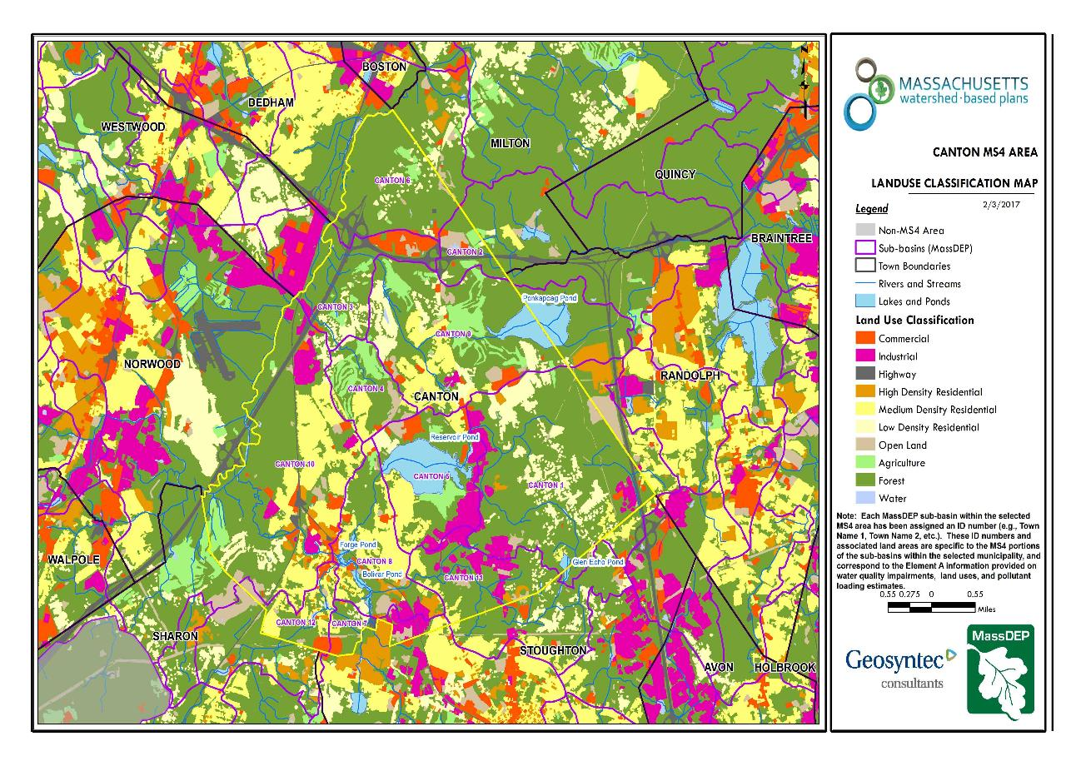
Figure A-3: MS4 Subwatershed Land Use Map
Pequit Brook
Beaver Meadow Brook
Approximate Watershed Boundary
Canton_08
Canton_05
Canton_01
Canton_11
(MassGIS, 2007; MassGIS, 2009b; MassGIS, 1999; MassGIS, 2001; USGS, 2016)

Watershed Impervious Cover
There is a strong link between impervious land cover and stream water quality. Impervious cover includes land surfaces that prevent the infiltration of water into the ground, such as paved roads and parking lots, roofs, basketball courts, etc. Impervious area within the Town of Canton subwatershed is concentrated in the central portion of the watershed, between Pequit Brook and Beaver Meadow Brook near Reservoir Pond, as illustrated in Figure A-4 below.
Impervious areas that are directly connected (DCIA) to receiving waters (via storm sewers, gutters, or other impervious drainage pathways) produce higher runoff volumes and transport stormwater pollutants with greater efficiency than disconnected impervious cover areas which are surrounded by vegetated, pervious land. Runoff volumes from disconnected impervious cover areas are reduced as stormwater infiltrates when it flows across adjacent pervious surfaces.
An estimate of DCIA for the area was calculated based on the Sutherland equations. USEPA provides guidance (USEPA, 2010) on the use of the Sutherland equations to predict relative levels of connection and disconnection based on the type of stormwater infrastructure within the total impervious area (TIA) of a watershed. Within each subwatershed, the total area of each land use were summed and used to calculate the percent TIA (Table A-7).
Table A-7: TIA and DCIA values for the subwatersheds
MS4 Subwatershed # | Estimated TIA (%) | Estimated DCIA (%)
CANTON_01 | 12.6 | 8.9
CANTON_05 | 20.2 | 15.5
CANTON_08 | 21.1 | 14.1
CANTON_11 | 20.4 | 16.2

The relationship between TIA and water quality can generally be categorized as listed by Table A-8 (Schueler et al. 2009). The TIA values for the subwatershed range from 12.5% to 21.1%; therefore, tributaries and waterbodies can be expected to show fair to good water quality.
Table A-8: Relationship between Total Impervious Area (TIA) and water quality (Schueler et al. 2009)
% Watershed  Impervious Cover | Stream Water Quality
0-10% | Typically high quality, and typified by stable channels, excellent habitat structure, good to excellent water quality, and diverse communities of both fish and aquatic insects.
11-25% | These streams show clear signs of degradation. Elevated storm flows begin to alter stream geometry, with evident erosion and channel widening. Streams banks become unstable, and physical stream habitat is degraded. Stream water quality shifts into the fair/good category during both storms and dry weather periods. Stream biodiversity declines to fair levels, with most sensitive fish and aquatic insects disappearing from the stream.
26-60% | These streams typically no longer support a diverse stream community. The stream channel becomes highly unstable, and many stream reaches experience severe widening, downcutting, and streambank erosion. Pool and riffle structure needed to sustain fish is diminished or eliminated and the substrate can no longer provide habitat for aquatic insects, or spawning areas for fish. Biological quality is typically poor, dominated by pollution tolerant insects and fish. Water quality is consistently rated as fair to poor, and water recreation is often no longer possible due to the presence of high bacteria levels.
>60% | These streams are typical of “urban drainage”, with most ecological functions greatly impaired or absent, and the stream channel primarily functioning as a conveyance for stormwater flows.

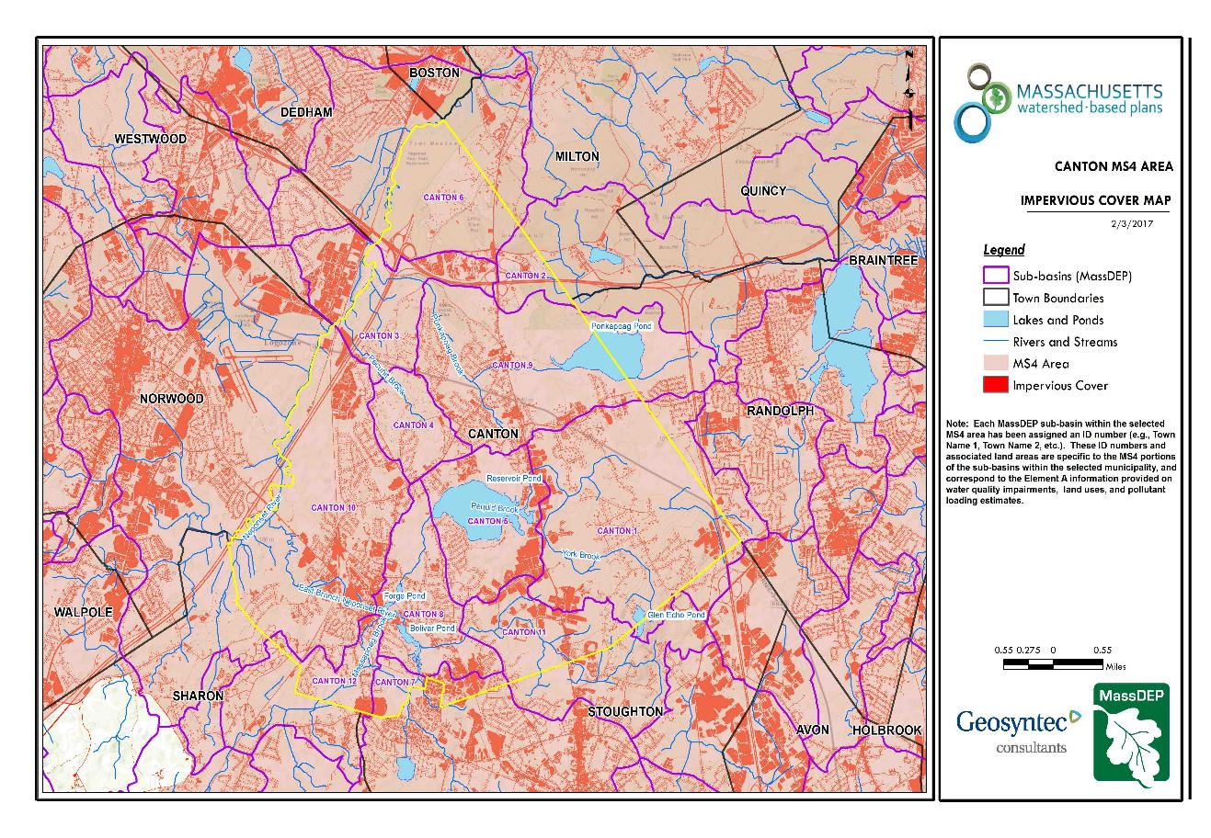
Pequit Brook
Canton_08
Approximate Watershed Boundary
Beaver Meadow Brook
Canton_05
Canton_01
Canton_11
Figure A-4: MS4 Subwatershed Impervious Surface Map
(MassGIS, 2007; MassGIS 2009a; MassGIS, 1999; MassGIS, 2001; USGS, 2016)

Pollutant Loading
The land use data (MassGIS, 2009b) was intersected with impervious cover data (MassGIS, 2009a) and United States Department of Agriculture (USDA) Natural Resources Conservation Service (NRCS) soils data (USDA NRCS and MassGIS, 2012) to create a combined land use/land cover grid. The grid was used to sum the total area of each unique land use/land cover type.
The amount of DCIA was estimated using the Sutherland equations as described above and any reduction in impervious area due to disconnection (i.e., the area difference between TIA and DCIA) was assigned to the pervious D soil category for that land use to simulate that some infiltration will likely occur after runoff from disconnected impervious surfaces passes over pervious surfaces.
Pollutant loading for key nonpoint source pollutants in the study area was estimated by multiplying each land use/cover type area by its pollutant load export rate (PLER). The PLERs are an estimate of the annual total pollutant load exported via stormwater from a given unit area of a particular land cover type. The PLER values for TN, TP and TSS were obtained from USEPA (Voorhees, 2016b) (see documentation provided in Appendix A) as follows:
L_{n} = A_{n} * P_{n}
Where L_{n} = Loading of land use/cover type n (lb/yr); A_{n} = area of land use/cover type n (acres); P_{n} = pollutant load export rate of land use/cover type n (lb/acre/yr)

The estimated land use-based phosphorus to receiving waters within the study area is 1,726 pounds per year, as presented by Table A-9. The largest contributors of land use-based phosphorus load originates from areas designated as industrial (35% of the total phosphorus load) and forested (22% of the total phosphorus load). Phosphorus generated from forested areas is a result of natural process such as decomposition of leaf litter and other organic material and generally represent a “best case scenario” with regards to phosphorus loading, meaning that those portions of the watershed are unlikely to provide opportunities for nutrient load reductions through best management practices.
Table A-9: Estimated Pollutant Loading for Key Nonpoint Source Pollutants
Total Combined Canton Subwatershed
Land Use Type | Pollutant Loading¹
Land Use Type | Total  Phosphorus (TP)  (lbs/yr) | Total  Nitrogen (TN)  (lbs/yr) | Total  Suspended Solids (TSS)  (tons/yr)
Agriculture | 47 | 284 | 4.18
Commercial | 136 | 1,160 | 14.52
Forest | 385 | 1,988 | 94.02
High Density Residential | 94 | 620 | 9.28
Highway | 15 | 126 | 7.46
Industrial | 608 | 5,203 | 65.08
Low Density Residential | 165 | 1,624 | 22.33
Medium Density Residential | 236 | 2,025 | 28.17
Open Land | 40 | 427 | 8.47
TOTAL | 1,726 | 13,457 | 253.51
¹These estimates do not consider loads from point sources or septic systems.

MS4 Subwatershed #: CANTON_01
Land Use Type | Pollutant Loading¹
Land Use Type | Total  Phosphorus (TP)  (lbs/yr) | Total  Nitrogen (TN)  (lbs/yr) | Total  Suspended Solids (TSS)  (tons/yr)
Agriculture | 6 | 38 | 0.93
Commercial | 25 | 213 | 2.66
Forest | 225 | 1,158 | 60.12
High Density Residential | 18 | 121 | 1.81
Highway | 12 | 97 | 6.14
Industrial | 201 | 1,720 | 21.51
Low Density Residential | 140 | 1,385 | 18.93
Medium Density Residential | 17 | 152 | 2.06
Open Land | 14 | 178 | 3.27
TOTAL | 657 | 5,060 | 117.42
¹These estimates do not consider loads from point sources or septic systems.

MS4 Subwatershed #: CANTON_05
Land Use Type | Pollutant Loading¹
Land Use Type | Total  Phosphorus (TP)  (lbs/yr) | Total  Nitrogen (TN)  (lbs/yr) | Total  Suspended Solids (TSS)  (tons/yr)
Agriculture | 35 | 208 | 2.79
Commercial | 55 | 469 | 5.88
Forest | 44 | 227 | 8.23
High Density Residential | 1 | 7 | 0.10
Highway | 0 | 0 | 0.00
Industrial | 192 | 1,647 | 20.60
Low Density Residential | 10 | 95 | 1.40
Medium Density Residential | 68 | 587 | 8.16
Open Land | 6 | 31 | 0.79
TOTAL | 410 | 3,271 | 47.95
¹These estimates do not consider loads from point sources or septic systems.

MS4 Subwatershed #: CANTON_08
Land Use Type | Pollutant Loading¹
Land Use Type | Total  Phosphorus (TP)  (lbs/yr) | Total  Nitrogen (TN)  (lbs/yr) | Total  Suspended Solids (TSS)  (tons/yr)
Agriculture | 5 | 32 | 0.38
Commercial | 56 | 477 | 5.97
Forest | 52 | 270 | 11.85
High Density Residential | 57 | 377 | 5.62
Highway | 3 | 29 | 1.32
Industrial | 52 | 442 | 5.53
Low Density Residential | 8 | 77 | 1.06
Medium Density Residential | 132 | 1,129 | 15.70
Open Land | 9 | 130 | 2.24
TOTAL | 374 | 2,964 | 49.66
¹These estimates do not consider loads from point sources or septic systems.

MS4 Subwatershed #: CANTON_11
Land Use Type | Pollutant Loading¹
Land Use Type | Total  Phosphorus (TP)  (lbs/yr) | Total  Nitrogen (TN)  (lbs/yr) | Total  Suspended Solids (TSS)  (tons/yr)
Agriculture | 1 | 6 | 0.08
Commercial | 0 | 1 | 0.01
Forest | 64 | 333 | 13.82
High Density Residential | 18 | 115 | 1.75
Highway | 0 | 0 | 0.00
Industrial | 163 | 1,394 | 17.44
Low Density Residential | 7 | 67 | 0.94
Medium Density Residential | 19 | 157 | 2.25
Open Land | 11 | 88 | 2.17
TOTAL | 283 | 2,161 | 38.45
¹These estimates do not consider loads from point sources or septic systems.

Element B: Determine Pollutant Load Reductions Needed to Achieve Water Quality Goals

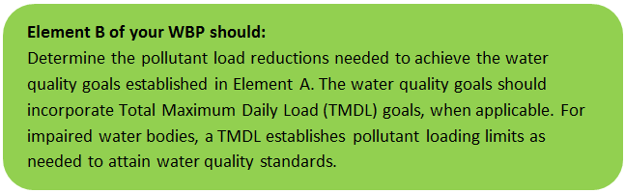 | 

Water Quality Goals
There are many methodologies that can be used to set pollutant load reduction goals for a WBP. Goals can be based on water quality criteria, surface water standards, existing monitoring data, existing TMDL criteria, or other data. As discussed by Section A.4, water quality goals for this WBP are focused on addressing the Neponset River Watershed Bacteria TMDL, listed dissolved oxygen impairments, and observed elevated concentrations of phosphorus from ambient monitoring data. A description of criteria for each water quality is described by Table B-1.
The following adaptive sequence is recommended to establish and track water quality goals.
- Establish an interim goal to reduce land use-based phosphorus by 10 pounds over the next 5 years (by 2024) within the study area subwatersheds.
- Consider establishing realistic long-term phosphorus reduction goals by developing water-body specific watershed-based plans or incorporating estimates into a future iteration of this watershed-based plan. Element B of the Watershed Based Planning Tool provides guidance on how to calculate required phosphorus load reductions based on annual watershed discharge. For example, the tool calculates that phosphorus loading from the headwaters of Pequit Brook (just upstream of Reservoir Pond) is approximately 885 lbs/year and that a reduction of approximately 14 lbs/yr is required to consistently meet water quality goals of 50 µg/L for streams.
- Continue to maintain and expand, as feasible, the Citizen Water Monitoring Network in accordance with recommendations from Elements H&I. Use monitoring results to perform trend analysis to identify if proposed Element C management measures are resulting in improvements and to identify site candidates to be sampled as indicator sites.
- Establish long-term goals to meet all applicable water quality standards, leading to the delisting of all assessment units within the study area subwatersheds from the 303(d) list.

Table B-1: Pollutant Load Reductions Needed
Pollutant | Existing Estimated Total Load | Water Quality Goal | Planned Load Reduction
Total Phosphorus¹ | 1,726 lbs/yr (From Section A.6) | Total phosphorus should not exceed:  --50 ug/L in any stream  --25 ug/L within any pond, lake, or reservoir | 10 lbs/yr initially
Bacteria² | N/A – Concentration Based | Class B. Class B Standards  • Public Bathing Beaches: For E. coli, geometric mean of 5 most recent samples shall not exceed 126 colonies/ 100 ml and no single sample during the bathing season shall exceed 235 colonies/100 ml. For enterococci, geometric mean of 5 most recent samples shall not exceed 33 colonies/100 ml and no single sample during bathing season shall exceed 61 colonies/100 ml;  • Other Waters and Non-bathing Season at Bathing Beaches: For E. coli, geometric mean of samples from most recent 6 months shall not exceed 126 colonies/100 ml (typically based on min. 5 samples) and no single sample shall exceed 235 colonies/100 ml. For enterococci, geometric mean of samples from most recent 6 months shall not exceed 33 colonies/100 ml, and no single sample shall exceed 61 colonies/100 ml. | N/A – Concentration Based
Dissolved Oxygen³ | N/A – Concentration Based | Dissolved oxygen saturation should not be less than 5 mg/L in warm water fisheries or less than 6 mg/L in cold water fisheries. | N/A – Concentration Based
Notes:
- A default target TP concentrations is provided which is based on guidance provided by the USEPA in Quality Criteria for Water (1986), also known as the “Gold Book”. An initial goal of 50 µg/L for all waterbodies within the watershed will be established. If this goal is achieved, a goal of 25 µg/L for ponds within the watershed will be considered per EPA Gold Book Criteria.
- For all waterbodies, including impaired waters that have a pathogen TMDL, the water quality goal for bacteria is based on the Massachusetts Surface Water Quality Standards (314 CMR 4.00, 2013) that apply to the Water Class of the selected water body. See Appendix A for additional information from the Neponset River Watershed Bacteria TMDL.
- Dissolved oxygen criteria are based on the Massachusetts Surface Water Quality Standards (314 CMR 4.00, 2013)

Element C: Describe management measures that will be implemented to achieve water quality goals

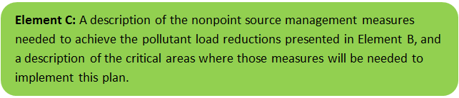 | 

Current and Ongoing Management Measures
The Town of Canton was awarded funding through the Fiscal Year 2018 Section 319 Nonpoint Source Pollution Grant Program to install the proposed structural BMPs listed in Table C-1. The Devoll Field BMP is located in the Beaver Meadow Brook watershed and the Luce School BMPs are located in the Pequit Brook watershed. BMPs were planned during the application process and are in the process of detailed design and construction. It is anticipated that these BMPs will result in a combined annual load reduction of 921.05 pounds of total suspended solids, 8.93 pounds of total nitrogen, 113,070 billion colonies of bacteria, and 2.28 pounds of total phosphorus (Reardon, 2019). The Town of Canton also has plans related to street sweeping and catch basin cleaning to implement as part of the current management measures. Annual public education and outreach is also completed by the Neponset Stormwater Partnership. Details of BMP design are included in Appendix B.
Table C-1: Summary of Proposed BMPs
BMP Description | Location
One rain garden and a constructed swale | Devoll Field
Two rain gardens | Luce School Bus Loop
Catch basin with a beehive grate that directs flow to a raingarden | Luce School Playground
Four demonstration rain gardens | Luce School Front
One bioretention cell | Luce School Side

Future Management Measures
In 2016, the Town of Canton prepared a final report on Mitigation and Minimization Alternatives to Improve Streamflow in the Neponset River Watershed, which identified and ranked 128 sites with opportunity for retrofits (Figure C-1). Future management measures will first focus on implementing BMPs from the report in the Town of Canton subwatersheds. Once the options identified in the report have been exhausted, Canton may consider additional investigation with the following recommended general sequence to identify and implement future structural BMPs.
- Identify Potential Implementation Locations: Perform a desktop analysis using aerial imagery and GIS data to develop a preliminary list of potentially feasible implementation locations based on soil type (i.e., hydrologic soil groups A and B); available public open space (e.g., lawn area in front of a police station); potential redevelopment sites where additional public-private partnerships may be leveraged; and other factors such as proximity to receiving waters, known problem areas, or publicly owned right of ways or easements. Additional analysis can also be performed to fine-tune locations to maximize pollutant removals such as performing loading analysis on specifically delineated subwatersheds draining to single outfalls and selecting those subwatersheds with the highest loading rates per acre.
- Visit Potential Implementation Locations: Perform field reconnaissance, preferably during a period of active runoff-producing rainfall, to evaluate potential implementation locations, gauge feasibility, and identify potential BMP ideas. During field reconnaissance, assess identified locations for space constraints, potential accessibility issues, presence of mature vegetation that may cause conflicts (e.g., roots), potential utility conflicts, site-specific drainage patterns, and other factors that may cause issues during design, construction, or long-term maintenance.
- Develop BMP Concepts: Once potential BMP locations are conceptualized, use the BMP-selector tool of the watershed-based planning tool to help develop concepts. Concepts can vary widely. One method is to develop 1-page fact sheets for each concept that includes a site description, including definition of the problem, a description of the proposed BMPs, annotated site photographs with conceptual BMP design details, and a discussion of potential conflicts such as property ownership, O&M requirements, and permitting constraints. The fact sheet can also include information obtained from the BMP-selector tool including cost estimates, load reduction estimates, and sizing information (i.e., BMP footprint, drainage area, etc.).
- Rank BMP Concepts: Once BMP concepts are developed, perform a priority ranking based on site-specific factors to identify the implementation order. Ranking can include many factors including cost, expected pollutant load reductions, implementation complexity, potential outreach opportunities and visibility to public, accessibility, expected operation and maintenance effort, and others.
Prioritized BMP concepts should focus on reducing total phosphorus and bacteria loading as summarized by the water quality goals (Element B, Section 4).
Note that planned BMPs can also be non-structural (e.g., street sweeping, catch basin cleaning, illicit discharge detection and elimination). Section 2.3.7 of the 2016 Massachusetts Small MS4 General Permit includes requirements for implementation of enhanced street sweeping and catch basin cleaning programs. It is recommended that these municipal programs be evaluated and potentially optimized. First, it is recommended that potential pollutant load removals from ongoing activities be calculated in accordance with Element HI. Next, it is recommended that ongoing activities be evaluated to see if potential improvements can be implemented to achieve higher pollutant load reductions such as increased frequency or improved technology.
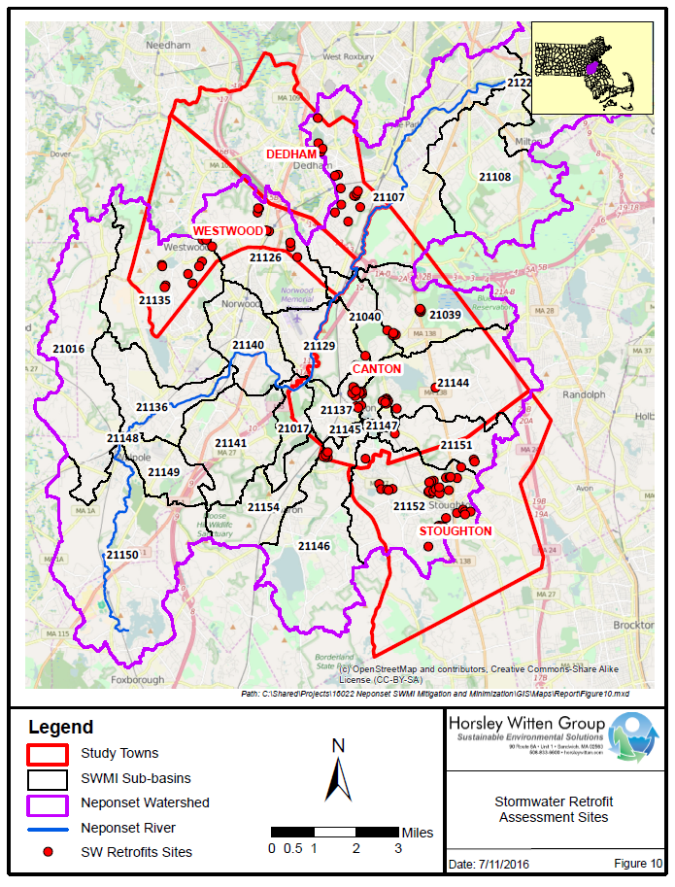
Figure C-1: Stormwater BMP Retrofit Opportunities (Town of Canton, 2017)

Element D: Identify Technical and Financial Assistance Needed to Implement Plan

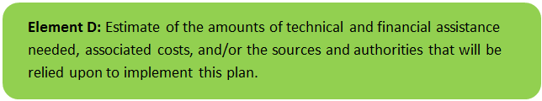 | 

Current and Ongoing Management Measures
The funding needed to implement the proposed management measures presented in this watershed plan is based on estimates provided by the Town of Canton. The total construction cost for the structural BMPs is estimated at approximately $130,280, as detailed by Table D-1, with a project total capital cost (including engineering design, survey, public outreach, and Town DPW construction participation, etc.) of $241,992.

Table D-1: Summary of Proposed BMP Costs
Task/Objective | Cost
Devoll Field BMPs | $50,220
Luce School BMPs | $80,060
Total | $130,280

Future Management Measures
Funding for future BMP installations to further reduce loads within the watershed may be provided by a variety of sources, such as the Section 319 Nonpoint Source Pollution Grant Program, town capital funds, or other grant programs such as hazard mitigation funding. The Town of Canton has previously been successful with and will continue to pursue securing grant funding through the MassDEP Sustainable Water Management Initiative (SWMI). Guidance is available to provide additional information on potential funding sources for nonpoint source pollution reduction efforts.

Element E: Public Information and Education

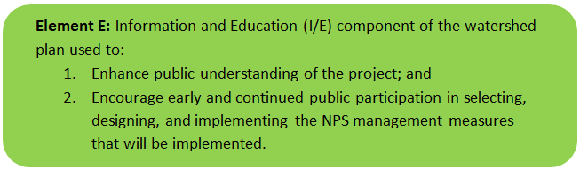 | 

Step 1: Goals and Objectives
The goals and objectives for the watershed information and education program.
- Provide information about proposed stormwater improvements and their anticipated water quality benefits.
- Provide information to promote watershed stewardship.
Step 2: Target Audience
Target audiences that need to be reached to meet the goals and objectives identified above.
- All watershed residents.
- Businesses within the watershed.
- Watershed organizations and other user groups.
Step 3: Outreach Products and Distribution
The outreach product(s) and distribution form(s) that will be used for each.
- Distribute a press release on proposed BMPs to local media.
- Develop and distribute a town-wide educational mailing.
- Develop and post interpretive signage with the structural BMPs.
- Post a project summary online and email links to the summary to residents and local officials.
- Regular stormwater related outreach messaging from the Neponset Stormwater Partnership, including but not limited to fertilizer outreach, stormwater hotline, educational website, dog waste outreach, fall leaf litter outreach, septic system outreach, green infrastructure technical assistance, etc.
- Semi-annual visits by Neponset River Watershed Association to Luce School to educate children.
Step 4: Evaluate Information/Education Program
Information and education efforts and how they will be evaluated.
- Track coverage from local media.
- Track number of educational mailers distributed.
- Track webpage activity on the online project summary.
- Luce School Elementary School Outreach: Staff from the Neponset River Watershed Association visit the Luce school 5 grade classes for two days each year. During the visit, students are taught about the water cycle, ground water conservation, and stormwater runoff. Once proposed Element C BMPs are completed from the FY 2018 s.319 grant, an outdoor component will be added to the regular curricula so that the students can visit the BMPs and experience hands-on learning. The Canton Town Engineer may also join for the visit to explain the design elements and how the installations work. In addition to the classroom visit, interpretive signage will be placed at the school entrance that explain how the structures work, why stormwater management is important, and suggestions of ways students can reduce their stormwater impacts.

Elements F & G: Implementation Schedule and Measurable Milestones

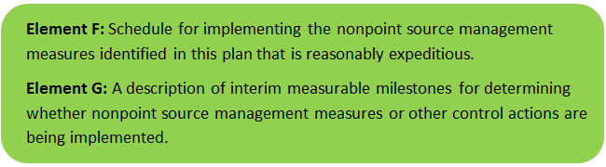 | 

Table FG-1 provides a preliminary schedule for implementation of recommendations provided by this WBP. It is expected that the WBP will be re-evaluated and updated in 2022, or as needed, based on ongoing monitoring results and other ongoing efforts.
Table FG-1: Implementation Schedule and Interim Measurable Milestones
Category | Action | Year(s)
Goal Adjustments | Consider establishing realistic water-body specific long-term phosphorus reduction goals be developing water-body specific WBPs or incorporating estimates in a future iteration of this WBP | 2024
Monitoring / Vegetation | Consider expanding or adjusting Citizen Water Monitoring Network to additional or alternative waterbodies / sampling locations as resources allow – see Element H&I for suggestions. | Annual
Monitoring / Vegetation | Continue to perform volunteer water quality sampling and analysis | Annual
Structural BMPs | Complete installation of BMPs at Luce School and Devoll Field | 2020
Structural BMPs | Obtain funding and implement 2-3 additional BMPs within the subwatershed | 2022
Structural BMPs | Obtain funding and implement 2-3 additional BMPs within the subwatershed | 2024
Structural BMPs | Obtain funding and implement 2-3 additional BMPs within the subwatershed | 2026
Nonstructural BMPs | Document potential pollutant removals from ongoing non-structural BMP practices (i.e., street sweeping, catch basin cleaning, IDDE) | 2020
Nonstructural BMPs | Evaluate ongoing non-structural BMP practices and determine if modifications can be made to optimize pollutant removals (e.g., increase frequency). | 2021
Nonstructural BMPs | Routinely implement optimized non-structural BMP practices and track progress | Annual
Public Education and Outreach  (See Element E) | Periodically post project updates to website and social media profiles, including completed WBP and updates of progress | Annual
Public Education and Outreach  (See Element E) | Distribute a press release on proposed BMPs | 2020
Public Education and Outreach  (See Element E) | Post interpretive signage with the proposed BMPs | 2020
Public Education and Outreach  (See Element E) | Distribute a town-wide educational mailing on proposed BMPs | 2020
Public Education and Outreach  (See Element E) | Post project summary online and email link to residents and local officials | 2020
Public Education and Outreach  (See Element E) | Distribution of various educational materials on multiple topics by Neponset Stormwater Partnership | Annual
Adaptive Management  and Plan Updates | Establish working group comprised of stakeholders and other interested parties to implement recommendations and track progress. | 2020
Adaptive Management  and Plan Updates | Re-evaluate Watershed-Based Plan at least once every three (3) years and adjust, as needed, based on ongoing efforts (e.g., based on monitoring results, 319 funding, etc.). | 2022
Adaptive Management  and Plan Updates | Reach interim goal to reduce land-based phosphorus by 10 pounds | 2024
Adaptive Management  and Plan Updates | Reach long-term goal to de-list all subwatershed waterbodies from the 303(d) list

Elements H & I: Progress Evaluation Criteria and Monitoring

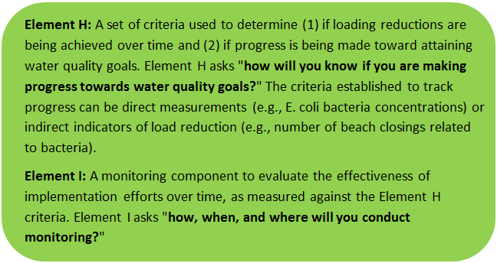 | 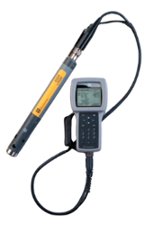

The water quality target concentration(s) is presented under Element A of this plan. To achieve this target concentration, the annual loading must be reduced to the amount described in Element B. Element C of this plan describes the various management measures that will be implemented to achieve this targeted load reduction. The evaluation criteria and monitoring program described below will be used to measure the effectiveness of the proposed management measures (described in Element C) in improving the water quality of the Neponset River.

Indirect Indicators of Load Reduction

Non-structural BMPs
Potential load reductions from non-structural BMPs (e.g., street sweeping, catch basin cleaning, IDDE) can be estimated from indirect indicators, such as the number of miles of streets swept or the number of catch basins cleaned. Appendix F of the 2016 Massachusetts Small MS4 General Permit provides specific guidance for calculating phosphorus removal from these practices. As indicated by Element C, it is recommended that potential phosphorus removal from these ongoing actives be estimated. Next, it is recommended that ongoing activities be evaluated to see if potential improvements can be implemented to achieve higher pollutant load reductions such as increased frequency or improved technology.
Phosphorus load reductions can be estimated in accordance with Appendix F of the 2016 Massachusetts Small MS4 General Permit as summarized by Figure HI-1 and HI-2. Additionally, since there is a bacteria TMDL in the study area, it is recommended that IDDE efforts required by the NPDES Small MS4 Permit be tracked.

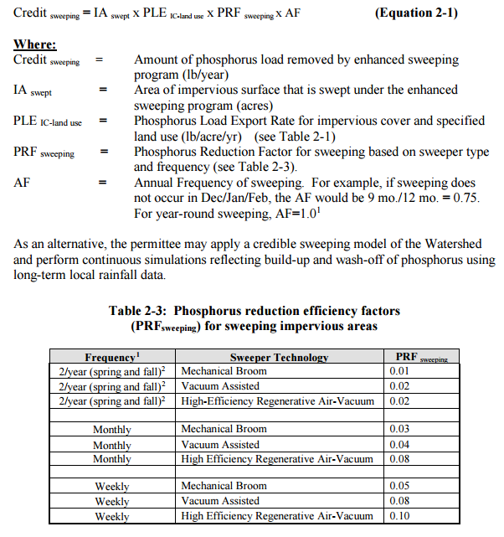
Figure HI-1. Street Sweeping Calculation Methodology
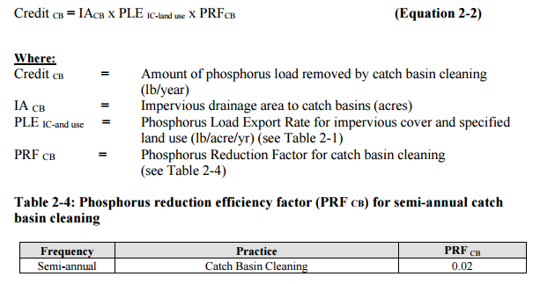
Figure HI-2. Catch Basin Cleaning Calculation Methodology

Project-Specific Indicators

Number of BMPs Installed and Pollutant Reduction Estimates
Anticipated pollutant load reductions from existing, ongoing (i.e., under construction), and future BMPs will be tracked as BMPs are installed. Once ongoing BMPs are installed, the anticipated phosphorus load reduction is estimated to be 2.9 pounds per year.

TMDL Criteria
TMDL requirements include the continuation of the Neponset River Watershed Association’s monitoring program during both wet and dry weather. In addition, the TMDL requires development of a detailed monitoring plan and sampling associated with illicit discharge detection.

Direct Measurements
Direct measurements are generally expected to be performed in accordance with existing monitoring activities by the Citizen Water Monitoring Network (CWMN) of the Neponset River Watershed Association, as summarized below, along with additional recommendations to supplement sampling. The CWMN includes a collection of core sampling sites, which are sampled regularly, and indicator sites, which are alternated based on anticipated needs. These indicator sites can be used to investigate areas of interest, such as in-lake locations, with minimal additional cost and effort.

River Sampling
Continue regular sampling in accordance with the CWMN.

In-Lake Phosphorus and Water Quality Monitoring
Consider developing sampling programs specific for the contributing ponds (Reservoir Pond, Forge Pond, and Bolivar Pond) within the watershed to enable tracking of improvements over time. Since tributaries are already covered by the CWMN river sampling, monitoring locations should, at minimum, include the deepest “in-lake” location. It is recommended that sampling be performed at minimum three times per year, once in the spring (late April/early May, once in mid-summer (early to mid-July), and once in late-summer (early- to mid- September). Sampling parameters can include nutrients (nitrogen and phosphorus), dissolved oxygen, temperature, chlorophyll-a, and turbidity. These parameters will enable tracking relative to Carlson’s Trophic State Index to evaluate improvements over time.

Adaptive Management
As discussed by Section 3 of Element F&G, this WBP, including interim and long-term goals, will be re-evaluated at least once every three years and adaptively adjusted based on additional monitoring results and other indirect indicators. If monitoring results and indirect indicators do not show improvement to the total phosphorus concentrations and other indicators (e.g., dissolved oxygen) measured within the town subwatershed, the management measures and loading reduction analysis (Elements A through D) will be revisited and modified accordingly.

References
314 CMR 4.00 (2013). "Division of Water Pollution Control, Massachusetts Surface Water Quality Standards"
Cohen, A. J.; Randall, A.D. (1998). "Mean annual runoff, precipitation, and evapotranspiration in the glaciated northeastern United States, 1951-80." Prepared for United States Geological Survey, Reston VA.
Geosyntec Consultants, Inc. (2014). "Least Cost Mix of BMPs Analysis, Evaluation of Stormwater Standards Contract No. EP-C-08-002, Task Order 2010-12." Prepared for Jesse W. Pritts, Task Order Manager, U.S. Environmental Protection Agency
Geosyntec Consultants, Inc. (2015). "Appendix B: Pollutant Load Modeling Report, Water Integration for the Squamscott-Exeter (WISE) River Watershed."
King, D. and Hagan, P. (2011). "Costs of Stormwater Management Practices in Maryland Counties." University of Maryland Center for Environmental Science Chesapeake Biological Laboratory. October 11, 2011.
Leisenring, M., Clary, J., and Hobson, P. (2014). "International Stormwater Best Management Practices (BMP) Database Pollutant Category Statistical Summary Report: Solids, Bacteria, Nutrients and Metals." Geosyntec Consultants, Inc. and Wright Water Engineers, Inc. December 2014.
MassDEP (1998). "Total Maximum Daily Loads of Bacteria for Neponset River Basin "
MassDEP (2010). "Neponset River Watershed 2004 Water Quality Assessment Report"
MassDEP (2012). "Massachusetts Year 2012 Integrated List of Waters Final Listing of Massachusetts' Waters Pursuant to Sections 305(b), 314 and 303(d) of the Clean Water Act"
MassDEP (2016a). "Massachusetts Clean Water Toolkit"
MassDEP (2016b). "Massachusetts Stormwater Handbook, Vol. 2, Ch. 2, Stormwater Best Management Practices"
MassGIS (1999). "Networked Hydro Centerlines" Shapefile
MassGIS (2001). "USGS Topographic Quadrangle Images" Image
MassGIS (2007). "Drainage Sub-basins" Shapefile
MassGIS (2009a). "Impervious Surface" Image
MassGIS (2009b). "Land Use (2005)" Shapefile
MassGIS (2013). "MassDEP 2012 Integrated List of Waters (305(b)/303(d))" Shapefile
Reardon, Barbara, Town of Canton. (2019). “Re: Watershed Based Plan Project Update” Message to Hayley O’Grady, Geosyntec Consultants. 1 February 2019. E-mail.
Schueler, T.R., Fraley-McNeal, L, and K. Cappiella (2009). "Is impervious cover still important? Review of recent research" Journal of Hydrologic Engineering 14 (4): 309-315.
Town of Canton, Department of Public Works (2017). “Pequit and Beaver Meadow Brook BMP Retrofit Project.”
United States Bureau of Labor Statistics (2016). "Consumer Price Index"
United States Geological Survey (2016). "National Hydrography Dataset, High Resolution Shapefile"
University of Massachusetts, Amherst (2004). "Stormwater Technologies Clearinghouse"
USDA NRCS and MassGIS (2012). "NRCS SSURGO-Certified Soils" Shapefile
USEPA (1986). "Quality Criteria for Water (Gold Book)" EPA 440/5-86-001. Office of Water, Regulations and Standards. Washington, D.C.
USEPA. (2010). "EPA's Methodology to Calculate Baseline Estimates of Impervious Area (IA) and Directly Connected Impervious Area (DCIA) for Massachusetts Communities."
USEPA. (2015). “Preventing Eutrophication: Scientific Support for Dual Nutrient Criteria.”
Voorhees, Mark, USEPA. (2015). "FW: Description of additional modelling work for Opti-Tool Project" Message to Chad Yaindl, Geosyntec Consultants. 23 April 2015. E-mail.
Voorhees, Mark, USEPA. (2016a). "FW: EPA Region 1 SW BMP performance equations" Message to Chad Yaindl, Geosyntec Consultants. 25 January 2016. E-mail.
Voorhees, Mark, USEPA. (2016b). "FW: Description of additional modelling work for Opti-Tool Project" Message to Chad Yaindl, Geosyntec Consultants. 23 April 2015. E-mail.

Appendices

Appendix A – Additional Water Quality Information
Total Maximum Daily Loads of Bacteria for Neponset River Basin
(MA73-20 - Beaver Meadow Brook and MA73-22 - Pequit Brook)
Problem Assessment
Extensive water quality data are available for the Neponset River and tributaries. In 1994 the Massachusetts Department of Environmental Protection (MADEP), in cooperation with several other state agencies and citizen monitoring groups, initiated a comprehensive assessment of the Neponset River Basin. The results of this work identified that numerous waterbody segments, including lakes and ponds, in the Neponset River Basin were not attaining the State’s water quality standards. The most pervasive water quality problem identified was, and remains, due to excessive levels of fecal coliform indicator bacteria.
Since the 1994 study, the Neponset River Watershed Association (NepRWA), a non-profit organization, has collected annual water quality data at numerous locations throughout the basin. Beginning in 1996, all of NepRWA’s monitoring activities have been conducted according to EPA approved Quality Assurance Project Plans (QAPP) developed by NepRWA. Establishing a QAPP represents a significant accomplishment by NepRWA that has resulted in the collection of credible data used to identify waterbody segments that do not attain water quality standards, and identify specific pollutant sources requiring control measures. The following figures (originally Figures 4 and 5 of the “Total Maximum Daily Loads of Bacteria for Neponset River Basin” report, 2002) provide the locations of
MADEP (1994) and the NepRWA (1997 through 1999) sampling stations, respectively.
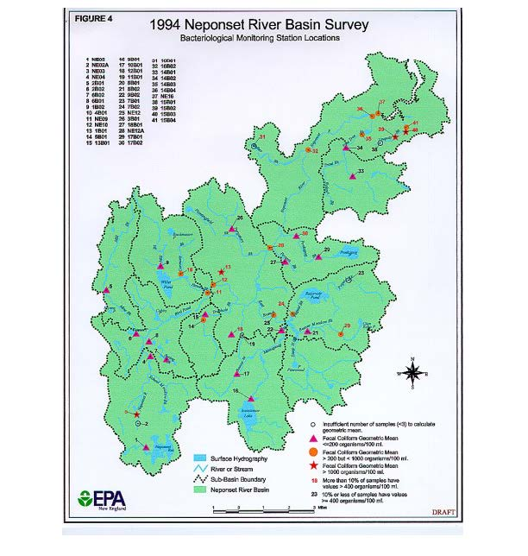
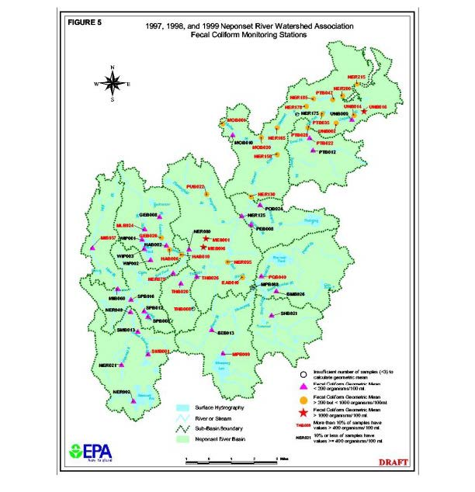
Fecal Contamination of the Neponset River Basin
The NepRWA annual water quality monitoring program and the 1994 MADEP monitoring efforts provide an extensive bacterial monitoring coverage through out the basin. Between 1997 and 1999, NepRWA established and monitored 57 surface water stations, and MADEP monitored 41 stations for bacteria in 1994. The locations of the MADEP and NepRWA (1997-1999) bacteria monitoring stations are provided in the figures above (originally Figures 4 and 5 of “Total Maximum Daily Loads of Bacteria for Neponset River Basin” report, 2002), respectively, illustrating the extensive coverage of the monitoring programs. Individual data may be found in The Neponset River Watershed, 1994 Resource Assessment Report, dated October 1995 and the NepRWA annual monitoring reports. The figures illustrate the extent of non-attainment of the fecal coliform standards in the Neponset River and tributaries. Monitoring stations are depicted where the geometric means exceed 200 organisms per 100 ml and/or where more than 10 % of the samples have values exceeding 400 organisms per 100ml. For the NepRWA stations (1997 –1999), Figure 5 indicates the highest geometric mean of the three years. As indicated, the entire length of the Neponset River, starting near Route 1 in Foxborough downstream to the estuary, and several tributaries do not meet the fecal coliform standards. Also, numerous tributaries were found to be in non-attainment. Exceedences of the fecal coliform criteria were observed at 60% of the NepRWA stations for one or more years, and at 51% of the 1994 MADEP stations. The high percentage of NepRWA stations exceeding fecal coliform criteria is not surprising, considering that, to aid in source identification efforts, NepRWA targeted its monitoring activities in areas with known or suspected problems.
The following tables (originally Tables 4 through 7 of the “Total Maximum Daily Loads of Bacteria for Neponset River Basin” report, 2002) present the calculated geometric means and percent of samples exceeding 400 organisms per 100 ml for each location in 1994, 1997, 1998, and 1999.

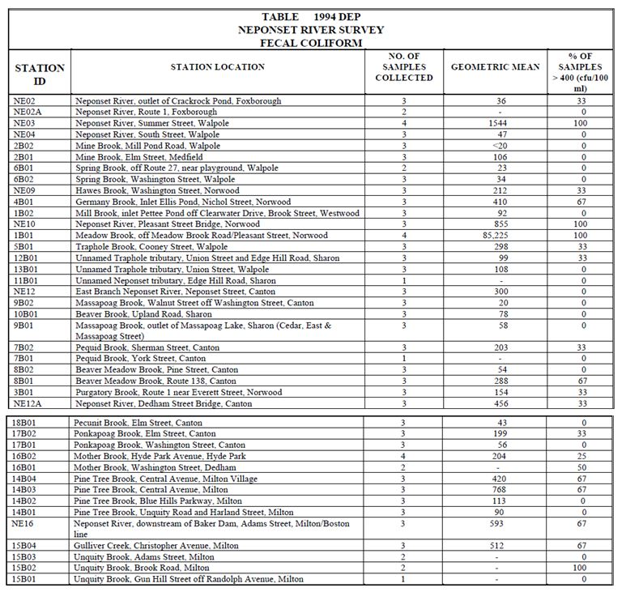
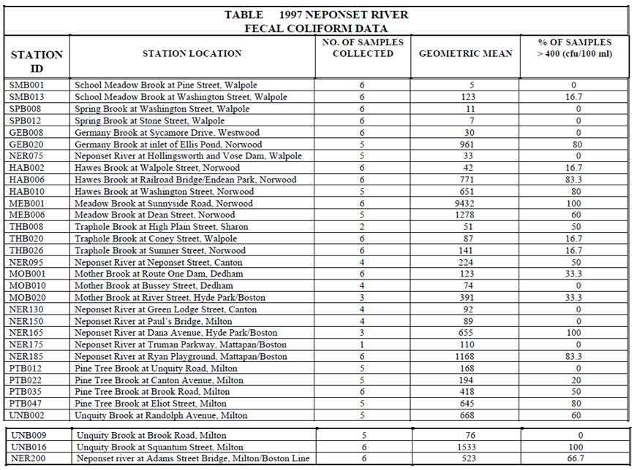
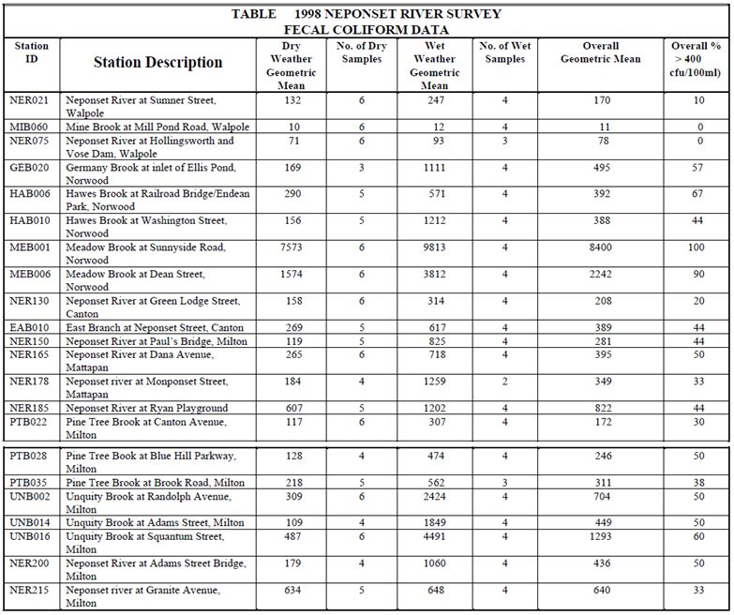
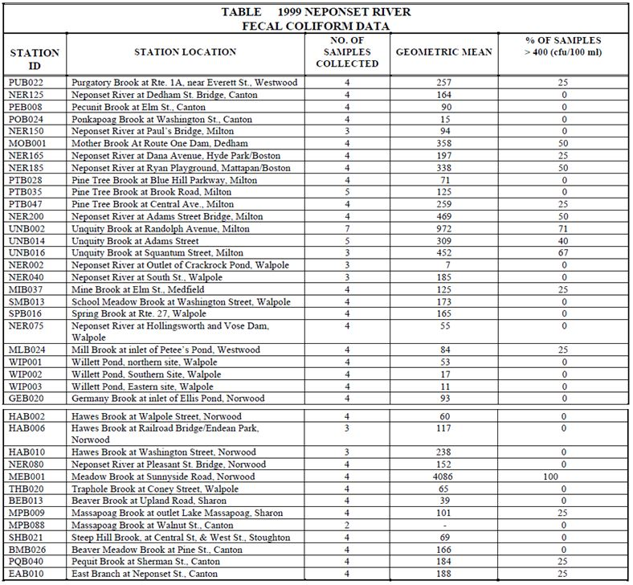
Consistent with the Water Quality Standards for fecal coliform, data are summarized and presented in terms of a geometric mean, which is often used as a measure of central tendency for bacteria data. Review of these data reveal that many of the same segments continuously exceed standards indicating the presence of relatively consistent bacteria sources. These data clearly illustrate the impacts of urbanization on ambient bacteria levels since the more developed areas of the watershed typically have the higher bacteria levels. By contrast, low fecal coliform levels are observed in the less developed subwatersheds (i.e., Mine Brook). These data are useful for estimating the natural background contribution for both dry and wet weather conditions.
The majority of the existing data represent dry weather conditions. These data are valuable for identifying dry weather sources of bacteria such as leaking sewers and illicit sewer connections, but are limited for assessing the overall quality of surface waters because there are also impacts associated with wet weather sources. NepRWA was successful in monitoring four wet weather events during the 1998 sampling season. These data are extremely useful to begin documenting the magnitude of wet weather impacts, and give a more complete assessment of the waterbodies during all weather and flow conditions. To illustrate the relative magnitudes of dry and wet weather bacteria levels, the 1998 data table (originally Table 6 of the “Total Maximum Daily Loads of Bacteria for Neponset River Basin” report, 2002) provides separate geometric means for dry and wet weather conditions. As expected, the wet weather geometric means are typically significantly greater than the dry weather geometric means reflecting the inputs of wet weather sources such as storm water runoff and the flushing of materials from piped drainage systems.
Also, the 1997 data are particularly informative because they are representative of drought-like conditions when river flows and the pollutant assimilative capacity were very low. Comparison of the 1997 and 1998 dry weather geometric means reveals that, for most stations, the 1997 dry weather geometric means are notably higher than the 1998 dry weather geometric means.
Stream Base Flow and In-Stream Fecal Coliform Levels
The Neponset River Basin fecal coliform data illustrate the relationship between stream base flow quantity and in-stream bacteria concentrations. As stream base flow (flow in stream channel during dry weather conditions) declines bacteria concentrations typically increase. This relationship is due primarily to the fact that stream base flow is composed mostly of ground water flow entering the stream channel.
The very low concentrations of bacteria in ground water due to the natural filtering action of the soil matrix through which ground water flows effectively dilutes bacterial wastes from other sources that may be entering the stream during dry weather conditions. Individual bacteria data collected from the Meadow Brook system in Norwood clearly illustrate this relationship.
Small urbanized watershed systems like Meadow Brook are particularly vulnerable to declining base flows following extended dry weather conditions. In the case of Meadow Brook the highly impervious cover of the watershed and the presence of an antiquated sewer system which carries sanitary sewage and ground water infiltration out of the basin to the MWRA's Deer Island Wastewater Treatment Facility contribute to reduced base flow. The high percentage of impervious cover in the watershed significantly reduces the opportunity for rainwater to percolate into the ground and recharge ground water which in turn recharges stream base flow. Instead much of the rainfall is converted to storm water runoff which quickly passes out of the system.
The importance of maintaining and restoring stream base flow through protecting and enhancing ground water recharge to protect and improve water quality as well as effectively manage municipal storm water will be discussed in the TMDL implementation section of this document.
Identification of Fecal Coliform Bacteria Sources
Largely through the efforts of the NepRWA, the stream teams (citizen monitoring groups active in several subwatersheds of the Neponset River watershed), and MADEP field staff, numerous point and nonpoint sources of fecal contamination have been identified. The following table (originally Table 8 of “Total Maximum Daily Loads of Bacteria for Neponset River Basin” report, 2002) summarizes the river segments impaired due to measured fecal coliform contamination and identifies suspected and known sources. Dry weather sources include leaking sewer pipes, storm water drainage systems (illicit connections of sanitary sewers to storm drains), and failing septic systems. Wet weather sources include storm water runoff and sanitary sewer overflows.
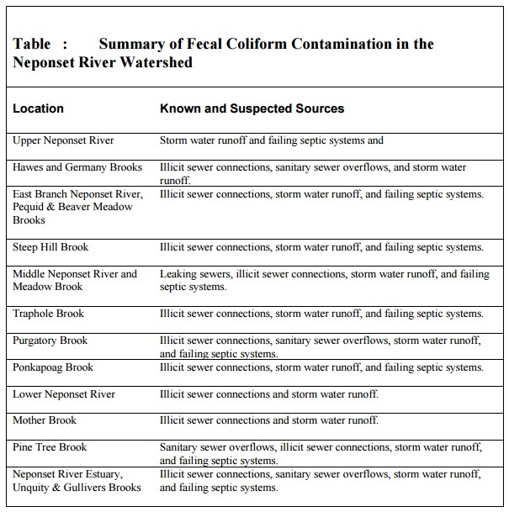
The NepRWA has effectively used its monitoring program to identify bacteria sources and initiate the implementation of necessary controls. For example, the elevated fecal coliform levels in Meadow Brook have been traced to leaking sewers with under-drains that transport sewage to the storm drainage system and to Meadow Brook. Norwood has corrected portions of the faulty sewer system and obtained additional funding to continue repair work.
There are no permitted point source discharges of fecal coliform within the Neponset River Basin. However, a number of nonpoint and non-permitted point pollutant sources do exist. Nonpermitted point sources include piped storm water drainages systems and sanitary sewer overflows. Possible nonpoint sources include, diffuse storm water runoff, leaking sewers, and failing or inadequate septic systems depending on the nature of the discharge to surface waters (discrete or diffuse).
It is difficult to provide accurate quantitative estimates of fecal coliform contributions from the various sources in the Neponset River Basin because many of the sources are diffuse and intermittent, and extremely difficult to monitor or accurately model. Therefore, a general level of quantification according to source category is provided. This approach is suitable for the TMDL analysis because it indicates the magnitude of the sources and illustrates the need for controlling them. Additionally, many of the sources (failing septic systems, leaking sewer pipes, sanitary sewer overflows, and illicit sanitary sewer connections) are prohibited because they indicate a potential health risk and, therefore, must be eliminated. However, estimating the magnitude of overall bacteria loading (the sum of all contributing sources) is achieved for wet and dry conditions using the extensive ambient data available that define baseline conditions.
Leaking sewer pipes, illicit sewer connections, sanitary sewer overflows (SSOs), and failing septic systems represent a direct threat to public health since they result in discharges of partially treated or untreated human wastes to the surrounding environment. Quantifying these sources is extremely speculative without direct monitoring of the source because the magnitude is directly proportional to the volume of the source and its proximity to the surface water. Typical values of fecal coliform in untreated domestic wastewater range from 104 to 106 MPN/100ml.
Illicit sewer connections into storm drains result in direct discharges of sewage via the storm drainage system outfalls. The existence of illicit sewer connections to storm drains is well documented in many urban drainage systems, particularly older systems that may have once been combined. In collecting information to support its Municipal Storm Water NPDES Permit application, the Boston Water and Sewer Commission (BWSC) identified and eliminated fifty seven illicit connections within the Neponset Basin during 1994 and 1995 (MADEP, 1995).
Since 1997 BWSC has corrected nine illicit connections eliminating an estimated 12,550 gallons per day of sanitary sewage from the storm drainage system and there are two additional illicit connections that have been assigned to a contract for repair (BWSC, 2000). It is probable that numerous other illicit sewer connections exist in storm drainage systems serving the older developed portions of the basin. Monitoring of storm drain outfalls during dry weather is needed to document the presence or absence of sewage in the drainage systems. NepRWA has been active in monitoring storm drain outfalls that has led to the identification of several illicit connections. All communities in the Neponset Basin are subject to the Storm water Phase II Final Rule that will require the development and implementation of an illicit discharge detection and elimination plan.
Storm water runoff is another significant contributor of fecal coliform pollution. During rain events, fecal matter from domestic animals and wildlife are readily transported to surface waters via the storm water drainage systems and/or overland flow. The natural filtering capacity provided by vegetative cover and soils is dramatically reduced as urbanization occurs because of the increase in impervious areas (i.e., streets, parking lots, etc.) in the watershed.
Extensive storm water data have been collected and compiled both locally and nationally in an attempt to characterize the quality of storm water. Bacteria are easily the most variable of storm water pollutants, with concentrations often varying by factors of 10 to 100 during a single storm. The following table (originally Table 9 and 10 of “Total Maximum Daily Loads of Bacteria for Neponset River Basin” report, 2002) summarizes wet weather sampling results of five storm drain outfalls in the Neponset River Basin and provides observed ranges of fecal coliform in storm water from different land uses during two storms monitored in the Wachusett Reservoir.
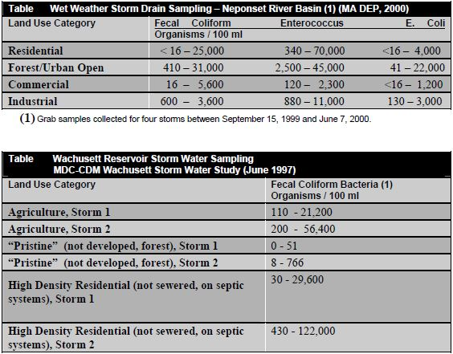
Considering this variability, storm water bacteria concentrations are difficult to accurately predict. Caution must be exercised when using values from single wet weather grab samples to estimate the magnitude of bacteria loading because it is often unknown whether the sample is representative of the “true” mean. To gain an understanding of the magnitude of bacterial loading from storm water and avoid overestimating or underestimating bacteria loading, event mean concentrations (EMC) are often used. Typical storm water event mean densities for various indicator bacteria are provided in the following tables (originally Table 11 and 12 of “Total Maximum Daily Loads of Bacteria for Neponset River Basin” report, 2002). These EMCs illustrate that storm water bacteria concentrations from certain land uses (i.e., residential) are typically at levels sufficient to cause water quality problems.
NepRWA has begun to quantify the magnitude and extent of fecal contamination in the Neponset Basin during wet weather conditions. With the exception of two sampling stations, Mine Brook (MIB060) and the Neponset River at Hollingsworth and Vose (NER075), excessive levels of fecal coliform were observed at all stations highlighting the need for improved storm water management. The extent of urbanized land cover in the Neponset Basin in conjunction with the fecal coliform EMCs in the following tables (originally Tables 11 and 12 respectively of “Total Maximum Daily Loads of Bacteria for Neponset River Basin” report, 2002), supports the assertions that storm water runoff is a significant cause contributing to the non-attainment of designated uses, and that reductions of wet weather bacteria sources are warranted. However, since wet weather data in the Neponset Basin remains limited, a progressive implementation of the TMDL is proposed to address wet weather bacteria sources. This approach requires estimating the pollutant reductions necessary to meet water quality standards using the best available information and allows controls to be implemented while additional data are collected.
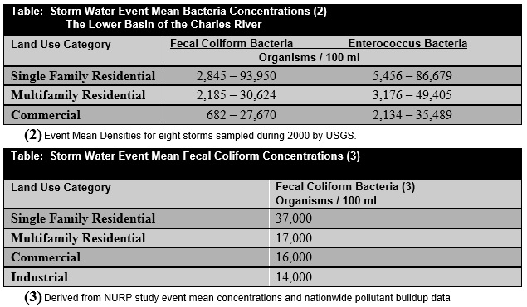
Septic systems designed, installed and maintained in accordance with 310 CMR 15.000: Title 5, are not significant sources of fecal coliform bacteria. Studies demonstrate that wastewater located four feet below properly functioning septic systems contain on average less than one fecal coliform bacteria organism per 100 ml (Ayres Associates, 1993). Failed or non-conforming septic systems, however, can be a major contributor of fecal coliform to the Neponset River and tributaries. Wastes from failing septic systems enter surface waters either as direct overland flow or via groundwater. Wet weather events typically increase the rate of transport of pollutant loadings from failing septic systems to surface waters because of the wash-off effect from runoff and the increased rate of groundwater recharge.
TMDL Information
Pathogen (MA73-27, MA73-22, MA73-02, MA73-01, MA73-05, MA73-20)
Total Maximum Daily Load Development
Section 303 (d) of the Federal Clean Water Act (CWA) requires states to place water bodies that do not meet the water quality standards on a list of impaired waterbodies. The CWA requires each state to establish Total Maximum Daily Loads (TMDLs) for listed waters and the pollutant contributing to the impairment(s). TMDLs determine the amount of a pollutant that a waterbody can safely assimilate without violating the water quality standards. Both point and nonpoint pollution sources are accounted for in a TMDL analysis. Point sources of pollution (those discharges from discrete pipes or conveyances) receive a wasteload allocation (WLA) specifying the amount of pollutant each point source can release to the waterbody. Nonpoint sources of pollution (all sources of pollution other than point) receive a load allocation (LA) specifying the amount of a pollutant that can be released to the waterbody by this source. In accordance with the CWA, a TMDL must account for seasonal variations and a margin of safety, which accounts for any lack of knowledge concerning the relationship between effluent limitations and water quality. Thus:
TMDL = WLAs + LAs + Margin of Safety
Where:
WLA = Waste Load Allocation which is the portion of the receiving water’s loading capacity that is allocated to each existing and future point source of pollution.

LA = Load Allocation which is the portion of the receiving water’s loading capacity that is allocated to each existing and future nonpoint source of pollution.
FECAL COLIFORM TMDL
Loading Capacity. The pollutant loading that a waterbody can safely assimilate is expressed as either mass-per-time, toxicity or some other appropriate measure (40 C.F.R. § 130.2(i)). Typically, TMDLs are expressed as total maximum daily loads. However, MADEP believes it is appropriate to express bacteria TMDLs in terms of concentration because the fecal coliform standard is also expressed in terms of the concentration of organisms per 100 ml. Since source concentrations may not be directly added, the previous equation does not apply. To ensure attainment with Massachusetts’ water quality standards for bacteria, all sources (at their point of discharge to the receiving water) must be equal to or less than the standard. Expressing the TMDL in terms of daily loads is difficult to interpret given the very high numbers of bacteria and the magnitude of the allowable load is dependent on flow conditions and, therefore, will vary as flow rates change. For example, a very high number of bacteria are allowable if the volume of water that transports the bacteria is high too. Conversely, a relatively low number of bacteria may exceed water quality standard if flow rates are low. For all the above reasons the TMDL is simply set equal to the standard and may be expressed as follows:
TMDL = Fecal Coliform Standard = WLA(p1) = LA(n1) = WLA(p2) = etc.
Where:
WLA(p1) = allowable concentration for point source category (1)
LA(n1) = allowable concentration for nonpoint source category (1)
WLA(p2) = allowable concentration for point source category (2) etc.
For Class B surface waters the fecal coliform TMDL includes two components: (1) the geometric mean of a representative set of fecal coliform samples shall not exceed 200 organisms per 100 ml; and (2) no more than 10 % of the samples shall exceed 400 organisms per 100 ml. For Class SB surface Waters the fecal coliform TMDL is more restrictive to protect the shellfish use goal and also includes two components: (1) the geometric mean of a representative set of fecal coliform samples shall not exceed 88 organisms per 100 ml; and (2) no more than 10 % of the samples shall exceed 260 organisms per 100 ml.
The goal to attain water quality standards at the point of discharge is environmentally protective, and offers a practical means to identify and evaluate the effectiveness of control measures. In addition, this approach establishes clear objectives that can be easily understood by the public and individuals responsible for monitoring activities. Also, the goal of attaining standards at the point of discharge minimizes human health risks associated with exposure to pathogens because it does not consider losses due to die-off and settling that are known to occur.
Wasteload Allocations (WLAs) and Load Allocations (LAs). Although, there are no permitted discharges of fecal coliform into the Neponset River and its tributaries, direct storm water discharges from numerous storm drainage systems occur. Piped discharges are, by definition, point sources regardless of whether they are currently subject to the requirements of NPDES permits. Therefore, a WLA set equal to the fecal coliform standard will be assigned to the portion of the storm water that discharges to surface waters via storm drains.
WLAs and LAs are identified for all known source categories including both dry and wet weather sources for Class B and SB segments within the Neponset River Basin. Establishing WLAs and LAs that only address dry weather bacteria sources would not ensure attainment of standards because of the significant contribution of wet weather bacteria sources to fecal coliform criteria exceedences. Illicit sewer connections and deteriorating sewers leaking to storm drainage systems represent the primary dry weather point sources of bacteria, while failing septic systems and possibly leaking sewer lines represent the nonpoint sources. Wet weather point sources include discharges from storm water drainage systems, sanitary sewer overflows (SSOs) and, until recently, combined sewer overflows (CSOs). Wet weather nonpoint sources primarily include diffuse storm water runoff.
The following table (originally Table 13 of “Total Maximum Daily Loads of Bacteria for Neponset River Basin” report, 2002) presents the fecal coliform bacteria WLAs and LAs for the various source categories. Source categories representing discharges of untreated sanitary sewage to receiving waters are prohibited, and therefore, assigned WLAs and LAs equal to zero. There are two sets of WLAs and LAs, one for Class B waters and the other for Class SB waters. The WLA and LA for storm water discharging to the lower fresh water portion of the Neponset River (Boston, Milton and Quincy) is set equal to the fecal coliform standard for SB waters in order to ensure that standards for restricted shellfish harvesting are met in the estuary.
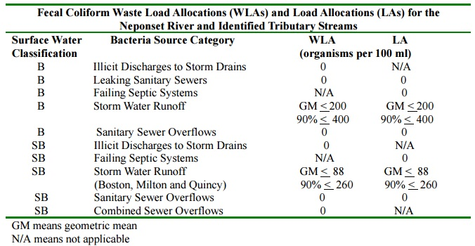
The TMDL should provide a discussion of the magnitudes of the pollutant reductions needed to attain the goals of the TMDL. Since accurate estimates of existing sources are generally unavailable, it is difficult to estimate the pollutant reductions for specific sources. For the illicit sources, the goal is complete elimination (100% reduction). However, overall wet weather bacteria load reductions can be estimated using typical storm water bacteria concentrations, and the magnitude of the wet weather data observed in the Neponset Basin. This information indicates that two to three orders of magnitude (99 to 99.9%) reductions in storm water fecal coliform loadings will be necessary, especially in the developed areas draining to small tributaries.
In addition, overall reductions needed to attain water quality standards can be estimated using the extensive ambient fecal coliform data that are available from the Neponset Basin. Using ambient data is beneficial because it provides more realistic estimates of existing conditions and the magnitude of cumulative loading to the surface waters. Reductions are calculated using data from both wet weather conditions and combined wet and dry conditions and are presented in the following table (originally Table 14 of “Total Maximum Daily Loads of Bacteria for Neponset River Basin” report, 2002). Data from 1998 are used since it includes the greatest number of observations at a given location and includes the most wet weather observations. Examining wet weather data separately provides estimates of the magnitude of reductions from all sources during wet weather conditions. As indicated before, bacteria reductions of one to two orders of magnitude are needed to attain water quality standards. For example, when viewing the data in the table below at station MEB001 it would take a 98.9% reduction in fecal coliform during wet weather conditions to meet water quality standards. The 90% observation listed in the table means that 90% of the samples collected at that station fall below the value of 35,000 organisms per 100 ml. That value would have to be reduced to 400 organisms per 100 ml to meet water quality standards criteria (or stated another way a reduction of 98.9 % would be necessary).
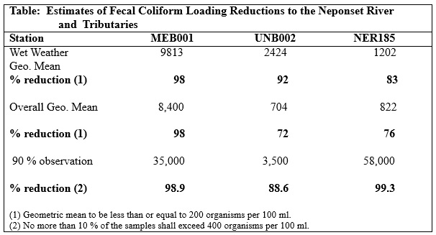
Margin of Safety: For this analysis, margin of safety is implied. First, the TMDL does not account for mixing in the receiving waters and assumes that zero dilution is available. Realistically, influent water will mix with the receiving water and become diluted provided that the influent water concentration does not exceed the TMDL concentration. Second, the goal of attaining standards at the point of discharge does not account for losses due to die-off and settling that are known to occur.
Seasonal Variability: TMDLs must also account for seasonal variability. This TMDL has set WLAs and LAs for all known and suspected source categories equal to the fecal coliform criteria independent of seasonal conditions. This will ensure the attainment of water quality standards regardless of seasonal and climatic conditions. Any controls that are necessary will be in place throughout the year, and, therefore, will be protective of water quality year round.
Total Maximum Daily Loads of Bacteria for Neponset River Basin

Appendix B – Proposed BMPs (Town of Canton, 2017)
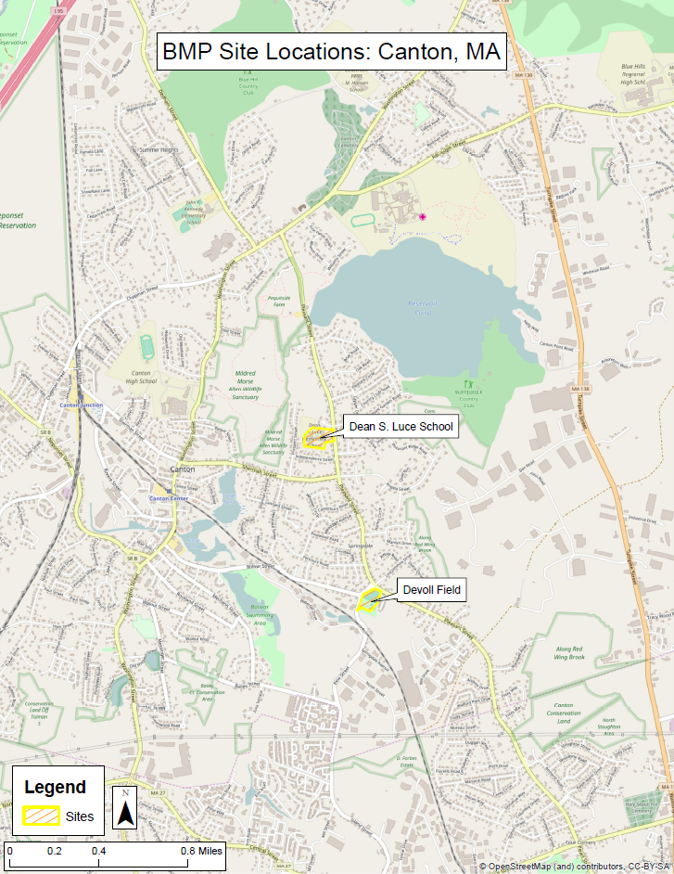
Site location Map for Proposed BMPs

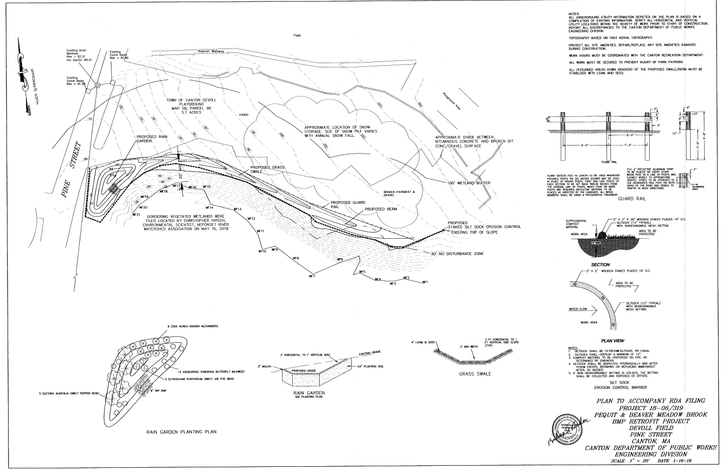Engineering Plans for Proposed Devoll Field BMPs
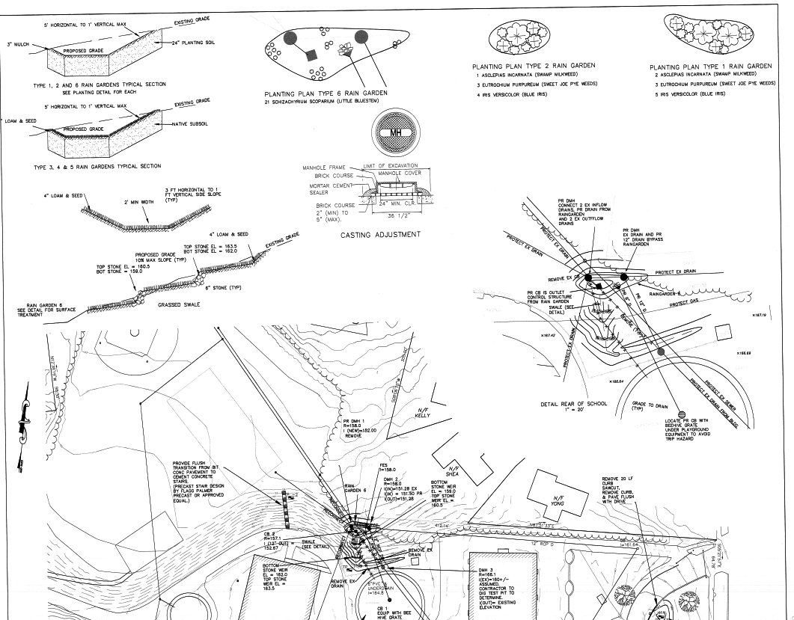
Engineering Plans for Proposed Luce School BMPs (Part I)
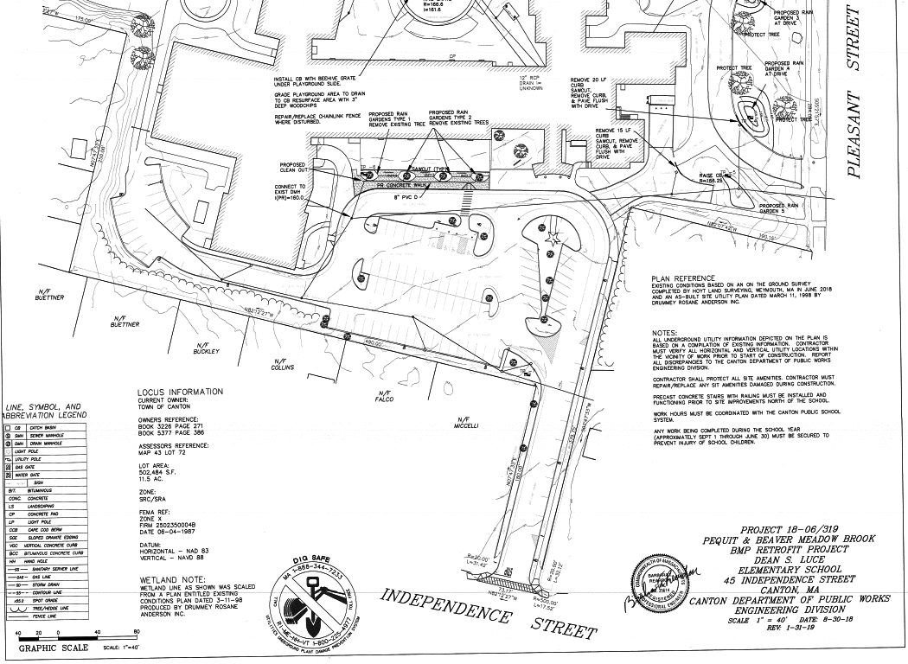
Engineering Plans for Proposed Luce School BMPs (Part II)

Appendix C – Pollutant Load Export Rates (PLERs)
Land Use & Cover¹ | PLERs (lb/acre/year)
Land Use & Cover¹ | (TP) | (TSS) | (TN)
AGRICULTURE, HSG A | 0.45 | 7.14 | 2.59
AGRICULTURE, HSG B | 0.45 | 29.4 | 2.59
AGRICULTURE, HSG C | 0.45 | 59.8 | 2.59
AGRICULTURE, HSG D | 0.45 | 91.0 | 2.59
AGRICULTURE, IMPERVIOUS | 1.52 | 650 | 11.3
COMMERCIAL, HSG A | 0.03 | 7.14 | 0.27
COMMERCIAL, HSG B | 0.12 | 29.4 | 1.16
COMMERCIAL, HSG C | 0.21 | 59.8 | 2.41
COMMERCIAL, HSG D | 0.37 | 91.0 | 3.66
COMMERCIAL, IMPERVIOUS | 1.78 | 377 | 15.1
FOREST, HSG A | 0.12 | 7.14 | 0.54
FOREST, HSG B | 0.12 | 29.4 | 0.54
FOREST, HSG C | 0.12 | 59.8 | 0.54
FOREST, HSG D | 0.12 | 91.0 | 0.54
FOREST, HSG IMPERVIOUS | 1.52 | 650 | 11.3
HIGH DENSITY RESIDENTIAL, HSG A | 0.03 | 7.14 | 0.27
HIGH DENSITY RESIDENTIAL, HSG B | 0.12 | 29.4 | 1.16
HIGH DENSITY RESIDENTIAL, HSG C | 0.21 | 59.8 | 2.41
HIGH DENSITY RESIDENTIAL, HSG D | 0.37 | 91.0 | 3.66
HIGH DENSITY RESIDENTIAL, IMPERVIOUS | 2.32 | 439 | 14.1
HIGHWAY, HSG A | 0.03 | 7.14 | 0.27
HIGHWAY, HSG B | 0.12 | 29.4 | 1.16
HIGHWAY, HSG C | 0.21 | 59.8 | 2.41
HIGHWAY, HSG D | 0.37 | 91.0 | 3.66
HIGHWAY, IMPERVIOUS | 1.34 | 1,480 | 10.2
INDUSTRIAL, HSG A | 0.03 | 7.14 | 0.27
INDUSTRIAL, HSG B | 0.12 | 29.4 | 1.16
INDUSTRIAL, HSG C | 0.21 | 59.8 | 2.41
INDUSTRIAL, HSG D | 0.37 | 91.0 | 3.66
INDUSTRIAL, IMPERVIOUS | 1.78 | 377 | 15.1
LOW DENSITY RESIDENTIAL, HSG A | 0.03 | 7.14 | 0.27
LOW DENSITY RESIDENTIAL, HSG B | 0.12 | 29.4 | 1.16
LOW DENSITY RESIDENTIAL, HSG C | 0.21 | 59.8 | 2.41
LOW DENSITY RESIDENTIAL, HSG D | 0.37 | 91.0 | 3.66
LOW DENSITY RESIDENTIAL, IMPERVIOUS | 1.52 | 439 | 14.1
MEDIUM DENSITY RESIDENTIAL, HSG A | 0.03 | 7.14 | 0.27
MEDIUM DENSITY RESIDENTIAL, HSG B | 0.12 | 29.4 | 1.16
MEDIUM DENSITY RESIDENTIAL, HSG C | 0.21 | 59.8 | 2.41
MEDIUM DENSITY RESIDENTIAL, HSG D | 0.37 | 91.0 | 3.66
MEDIUM DENSITY RESIDENTIAL, IMPERVIOUS | 1.96 | 439 | 14.1
OPEN LAND, HSG A | 0.12 | 7.14 | 0.27
OPEN LAND, HSG B | 0.12 | 29.4 | 1.16
OPEN LAND, HSG C | 0.12 | 59.8 | 2.41
OPEN LAND, HSG D | 0.12 | 91.0 | 3.66
OPEN LAND, IMPERVIOUS | 1.52 | 650 | 11.3
¹HSG = Hydrologic Soil Group

MS4 subwatersheds are defined by the WBP-tool by intersecting MassGIS drainage sub-basins with regulated MS4 areas.
An initial goal of 50 µg/L for all waterbodies within the watershed will be established. If this goal is achieved, a goal of 25 µg/L for ponds within the watershed will be considered per EPA Gold Book Criteria.
Guidance on funding sources to address nonpoint source pollution: http://prj.geosyntec.com/prjMADEPWBP_Files/Guide/Element%20D%20-%20Funds%20and%20Resources%20Guide.pdf
A full explanation of the CWMN, including sampling frequencies, parameters, and locations is provided at this link: https://www.neponset.org/your-watershed/cwmn-data/.
Additional guidance is provided at: https://www.epa.gov/sites/production/files/2015-06/documents/lakevolman.pdf

