


WATERSHED-BASED PLAN | 
Lake Cochituate

June 29, 2018

Prepared By:
Town of Natick Conservation Commission
Town of Wayland Surface Water Quality Committee
City of Framingham Conservation Commission
Massachusetts Department of Conservation and Recreation
Geosyntec Consultants

Prepared For:


Contents
Introduction 4
What is a Watershed-Based Plan? 4
1. Purpose & Need 4
2. Watershed-Based Plan Outline 4
3. Project Partners and Stakeholder Input 5
4. Data Sources 5
Element A: Identify Causes of Impairment & Pollution Sources 7
1. General Watershed Information 7
2. MassDEP Water Quality Assessment Report Review 10
3. Additional Water Quality Data 12
4. Water Quality Impairments 18
5. Water Quality Goals 19
6. Land Use Information 21
7. Pollutant Loading and Trophic Response 25
Element B: Determine Pollutant Load Reductions Needed to Achieve Water Quality Goals 33
1. Estimated Pollutant Loads 33
2. Water Quality Goals 33
3. Recommended Load Reduction 35
Element C: Describe management measures that will be implemented to achieve water quality goals 36
1. Field Watershed Investigation 36
2. BMP Recommendations 36
3. BMP Prioritization 37
Element D: Identify Technical and Financial Assistance Needed to Implement Plan 41
Element E: Public Information and Education 42
Elements F & G: Implementation Schedule and Measurable Milestones 46
Elements H & I: Progress Evaluation Criteria and Monitoring 47
References 51
Appendices 54
Appendix A – Pollutant Load Export Rates (PLERs) 54
Appendix B – Lake Cochituate Volume Estimates 63
Appendix C.1 – Primary BMP Recommendations 65
Appendix C.2 – Secondary BMP Recommendations 98

Introduction


What is a Watershed-Based Plan?

Purpose & Need
The purpose of a Massachusetts Watershed-Based Plan (WBP) is to organize information about Massachusetts' watersheds, and present it in a format that will enhance the development and implementation of projects that will restore water quality and beneficial uses in the Commonwealth. The Massachusetts WBP follows USEPA's recommended format for “nine-element” watershed plans, as described below.
All states are required to develop WBPs, but not all states have taken the same approach. Most states develop watershed-based plans only for selected watersheds. MassDEP's approach has been to develop a tool to support statewide development of WBPs, so that good projects in all areas of the state may be eligible for federal watershed implementation grant funds under Section 319 of the Clean Water Act.
USEPA guidelines promote the use of Section 319 funding for developing and implementing WBPs. WBPs are required for all projects implemented with Section 319 funds, and are recommended for all watershed projects, whether they are designed to protect unimpaired waters, restore impaired waters, or both.

Watershed-Based Plan Outline
This WBP for the Lake Cochituate Watershed includes nine elements (a through i) in accordance with USEPA Guidelines:
- An identification of the causes and sources or groups of similar sources that will need to be controlled to achieve the load reductions estimated in this watershed-based plan (and to achieve any other watershed goals identified in the watershed-based plan), as discussed in item (b) immediately below.

- An estimate of the load reductions expected for the management measures described under paragraph (c) below (recognizing the natural variability and the difficulty in precisely predicting the performance of management measures over time).

- A description of the nonpoint source (NPS) management measures needed to achieve the load reductions estimated under paragraph (b) above (as well as to achieve other watershed goals identified in this watershed-based plan), and an identification (using a map or a description) of the critical areas in which those measures will be needed to implement this plan.

- An estimate of the amounts of technical and financial assistance needed, associated costs, and/or the sources and authorities that will be relied upon, to implement this plan. As sources of funding, States should consider the use of their Section 319 programs, State Revolving Funds, USDA's Environmental Quality Incentives Program and Conservation Reserve Program, and other relevant Federal, State, local and private funds that may be available to assist in implementing this plan.

- An information/education component that will be used to enhance public understanding of the project and encourage their early and continued participation in selecting, designing, and implementing the NPS management measures that will be implemented.

- A schedule for implementing the NPS management measures identified in this plan that is reasonably expeditious.

- A description of interim, measurable milestones for determining whether NPS management measures or other control actions are being implemented.

- A set of criteria to determine if loading reductions are being achieved over time and substantial progress is being made towards attaining water quality standards and, if not, the criteria for determining whether this watershed-based plan needs to be revised or, if a NPS Total Maximum Daily Load (TMDL) has been established, whether the TMDL needs to be revised.

- A monitoring component to evaluate the effectiveness of the implementation efforts over time, measured against the criteria established under item (h) immediately above.

Project Partners and Stakeholder Input
This WBP was developed by Geosyntec Consultants (Geosyntec) under the direction of Massachusetts Department of Conservation and Recreation (MADCR) with funding, input, and collaboration from the towns of Natick and Wayland, and the city of Framingham. Core project stakeholders included:
- Vanessa Curran – MADCR
- Anne Carroll – MADCR
- Victoria Parsons – Town of Natick Conservation Commission
- Jeremy Marsette – Town of Natick Department of Public Works
- Mike Lowery – Town of Wayland Surface Water Quality Committee
- Jack Carr - Town of Wayland Surface Water Quality Committee
- Paul Brinkman – Town of Wayland Department of Public Works
- Robert McArthur – City of Framingham Conservation Commission
This WBP was developed as part of an iterative process. The Geosyntec project team initially collected and reviewed existing data from core project stakeholders and developed a preliminary WBP. A stakeholder meeting was then held to solicit input from core project stakeholders and gain consensus on elements included in the plan (e.g., water quality goals, public outreach activities, etc.). The WBP was updated based on this meeting, then a second round of stakeholder edits was solicited via email. Input was also solicited by stakeholders to members of the public such as Friends of Cochituate State Park. The WBP was finalized following a final presentation to stakeholders.

Data Sources
This WBP was developed using the framework and data sources provided by Massachusetts Department of Environmental Protection’s (MassDEP) Watershed-Based Plan Tool and supplemented by data from stakeholders, past studies, site visits, and additional analysis. Supplemental data sources were reviewed and included in subsequent sections of this WBP if relevant. Supplemental data sources are listed in Table 1.

Table 1: Supplemental Data Sources
Title / Description | Source | Date
Stormwater bylaws for Natick, Wayland, and Framingham | Natick, Wayland, Framingham | Varies
Bacteria monitoring data for Lake Cochituate Beaches (Camp Arrowhead, Saxonville Beach, DCR Beach, Wayland Town Beach) | Massachusetts Department of Conservation and Recreation | 2018
List of nearshore properties within 200 feet of Lake Cochituate on septic systems in Natick, Wayland, and Framingham. | Natick, Wayland, Framingham | 2018
Outfall investigations, site visits, and Best Management Practices (BMP) recommendations for the Town of Natick | Geosyntec | 2017
Microwatershed (i.e., catchment) delineations and pollutant load prioritization of all developed areas in the Lake Cochituate Watershed (Natick, Wayland, and Framingham) | Geosyntec | 2017
Year-End Report for the 2015 Aquatic Plant Management of the Lake Cochituate System | Aquatic Control Technology | 2016
Sediment Cleanup on Lake Cochituate | U.S. Army (article) | 2010
NOI for Control of Nuisance Aquatic Vegetation with Herbicides | ESS Group | 2006
NOI for Physical and Biological Control of Nuisance Aquatic Vegetation | ESS Group | 2006
Lake Cochituate/Fiske Pond Macrophyte Assessment | Geosyntec | 2006
Lake Cochituate and Fiske Pond Plant Survey | ENSR | 2006
Lake Water Quality Survey 2005 | Massachusetts Department of Environmental Protection | 2013
Release Notification Form, Immediate Response Action Completion Statement and Downgradient Property Status Opinion | Weston & Sampson | 2004
Lake Cochituate Long Term Vegetation Management Plan | Aquatic Control Technology | 2004
Lake Cochituate Nonpoint Source Pollution Watershed Management Plan | Metropolitan Area Planning Council | 2004
Pond-Aquifer Interaction at South Pond of Lake Cochituate, Natick, Massachusetts | United States Geological Survey | 2001
Snake Brook Watershed Preliminary Dredging Feasibility and Nutrient Loading Evaluation | ENSR | 1998
Lake Cochituate Phase II Implementation and Restoration Project | Massachusetts Department of Environmental Protection | 1988
Lake Cochituate Restoration Project - Snake Brook Dredging | Jason M. Cortell and Associates | 1980
Nutrient Control Alternatives at Lake Cochituate: Results of Rapid Sand Filtration Pilot Test and High Gradient Magnetic Filtration Tests | Jason M. Cortell and Associates | 1980
Nutrient Budgets for Fisk Pond and South Pond and the Impact of Nutrient Controls on the Waterbodies | Jason M. Cortell and Associates | 1978
Condition and Estimated Effectiveness of the Pegan Brook Filter Beds | Jason M. Cortell and Associates | 1977

Element A: Identify Causes of Impairment & Pollution Sources
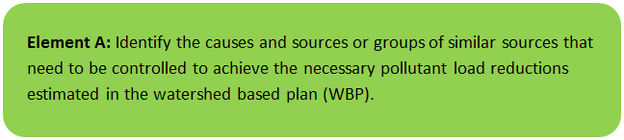 | 

General Watershed Information
The Lake Cochituate watershed is located within the city of Framingham and the towns of Natick, Wayland, Sherborn, and Ashland and lies in the Sudbury River Basin. Cochituate means “swift river” in the Algonquin language and refers to Cochituate Brook, which connects the lake to the Sudbury River. Lake Cochituate consists of four basins connected by shallow, narrow waterways. Fisk Pond also drains to Lake Cochituate. Water ﬂows generally northward through Fisk Pond and the four basins from South Basin to Carling, Middle, and North Basin before discharging into Cochituate Brook (MA82A-22). Small dams built in the nineteenth century at the outlet of the lake, to increase lake storage, raised the natural lake level by 13 feet (USGS, 2001).
The drainage area of Lake Cochituate at its outlet is approximately 11,300 acres. The contributing watershed area includes four major tributaries: Beaver Dam Brook, Course Brook, Pegan Brook, and Snake Brook. In addition, the lake receives flow from Fisk Pond and several shoreline (i.e., “proximal”) subwatershed areas that drain directly to the lake. Lake Cochituate is an intensively used recreational resource, with a major state park providing a public swimming beach, two boat access ramps, fishing, and picnicking, and several town facilities also offering swimming beaches (MAPC, 2004). See Figure A-1 for a map depicting the overall Lake Cochituate Watershed and its subwatersheds and Figure A-2 for a map depicting specific basins within the system. Also see Appendix A maps prepared by Geosyntec Consultants (2017b) that depict delineated microwatersheds (i.e., catchments within subwatersheds) and their outfalls within developed portions of the watershed.
Table A-1: General Watershed Information
Watershed Name: | Lake Cochituate
Major Basin: | CONCORD (SuAsCo)
Watershed Area: | Beaver Dam Brook – 4,796 (ac)  Course Brook – 2,379 (ac)  Fisk Pond – 219 (ac)  Pegan Brook – 312 (ac)  South Basin – 977 (ac)  Middle Basin¹ – 573 (ac) (includes Carling Basin)  Snake Brook – 1479 (ac)  North Basin – 563 (ac)  Total: 11,300 (ac)
Water Body Size (Assessment Unit ID): | MA82038 -Fisk Pond – 62 (ac)  MA82127 - Lake Cochituate (South Basin) – 240 (ac)  MA82126 - Lake Cochituate (Carling Basin) – 14 (ac)  MA82125 - Lake Cochituate (Middle Basin) – 135 (ac)  MA82020 - Lake Cochituate (North Basin) – 196 (ac)  Total: 647 (ac)

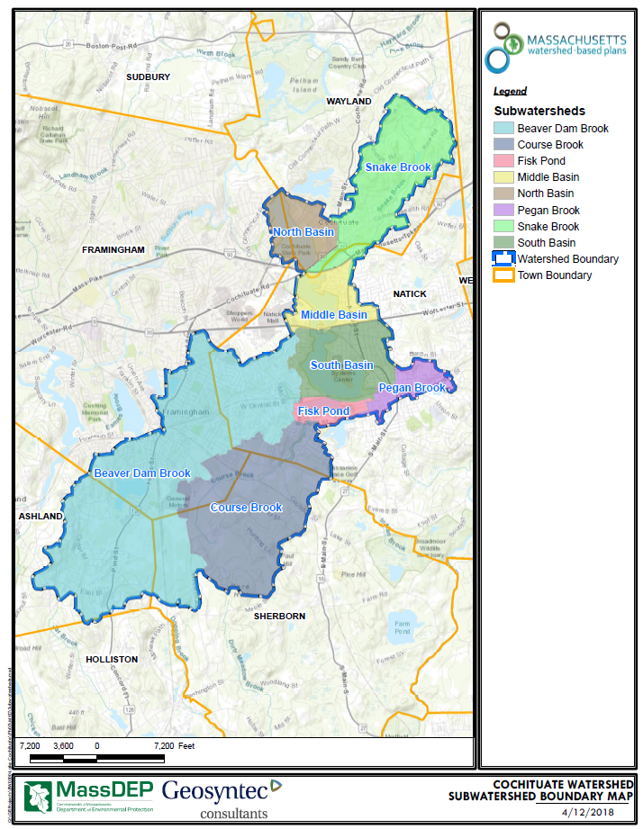
Figure A-1: Watershed and Subwatershed Boundary Map

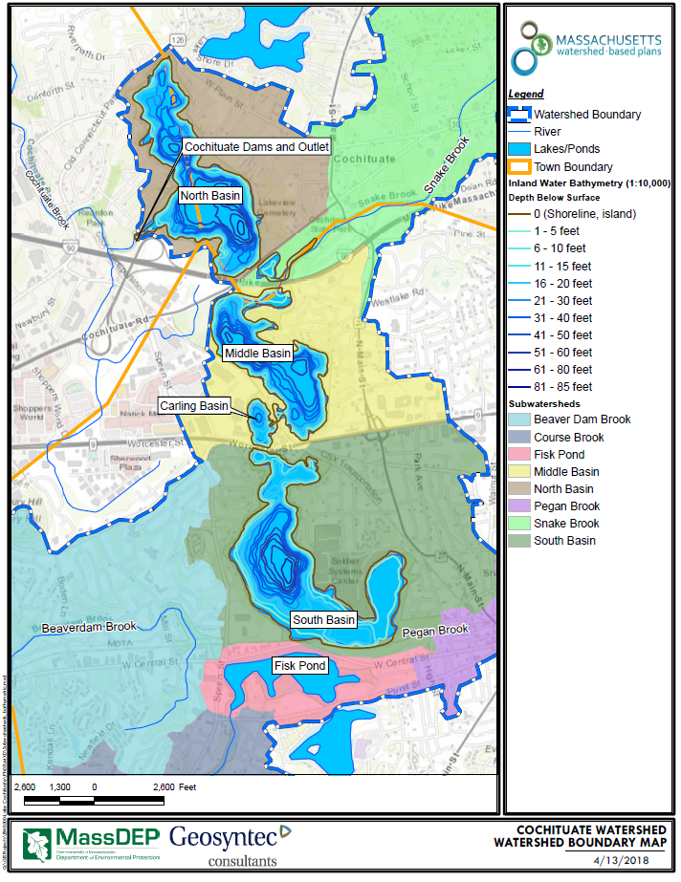
Figure A-2: Waterbody and Bathymetry Map

MassDEP Water Quality Assessment Report Review
The following water quality report related to Lake Cochituate and Fisk Pond was reviewed for this study:
- SuAsCo Watershed 2001 Water Quality Assessment Report, SUASCO WATERSHED LAKE ASSESSMENTS

SuAsCo Watershed 2001 Water Quality Assessment Report, SUASCO WATERSHED LAKE ASSESSMENTS
NOTE: RELEVANT INFORMATION IS INCLUDED DIRECTLY FROM 2001 REPORT FOR INFORMATIONAL PURPOSES AND HAS NOT BEEN MODIFIED.

MA82038 - Fisk Pond:
A non-native aquatic macrophyte species (M. heterophyllum) was identified by DWM during the 1996 synoptic survey. Since the pond is infested with a non-native aquatic macrophyte species the Aquatic Life Use is assessed as impaired. There is no formal bathing beach on Fisk Pond (Wade 2004). Fisk Pond is on the 2002 Integrated List of Waters in Category 4c because of exotic species (MA DEP 2003a)

MA82127 - Lake Cochituate (South Basin)
The Army Natick R&D Lab Superfund Site is located on the banks of the South Basin of Lake Cochituate. In 1996 DWM conducted a synoptic survey of Lake Cochituate. At the time of that survey a species of Myriophyllum was identified, but could not be confirmed as M. heterophyllum. Three non-native aquatic species (M. spicatum, M. heterophyllum, P. crispus) were identified in the South Basin of Lake Cochituate by MA DCR (Straub 2004).

Friesz and Church (2001) noted that storm sewers adjacent to the “South Pond” of Lake Cochituate drain directly into the lake. Approximately bi-weekly (February 1998 to July 1999) and continuous (18 September to 19 September 1998) water temperatures recorded in the South Basin as part of the Friesz and Church study ranged from 2.5°C in February 1999 to 27.7 °C in August 1998 (n=80). Conductivities recorded as part of the Friesz and Church study ranged from 224 to 424 μS/cm (n=30). The Aquatic Life Use is assessed as impaired because of the presence of the non-native aquatic macrophyte species. DWM conducted fish toxics monitoring in the South Basin of Lake Cochituate in 1995 (Maietta 2002, Appendix B, Table B1). MDPH issued a site-specific fish consumption advisory for all of Lake Cochituate due to elevated PCB concentrations in fish tissue. Potential sources are unknown at this time (PCBs are not a site contaminant of concern at the Superfund site). Because of the site -specific advisory the Fish Consumption Use is assessed as impaired.

The Natick Board of Health samples the semi-public beach at the handicapped day camp for E. coli bacteria (Wade 2004) and there were no reported closures. Too limited data are available so the recreational uses and aesthetic uses are currently not assessed. Lake Cochituate (South Basin) is on the 2002 Integrated List of Waters in Category 5 priority organics and organic enrichment/low DO (MA DEP 2003a).

MA82126 - Lake Cochituate (Carling Basin)
DWM conducted monitoring in Lake Cochituate in 2003 for nutrient criteria development. Three non-native aquatic macrophytes (M. spicatum, M. heterophyllum, P. crispus) were identified in both the Middle and South basins of Lake Cochituate by MA DCR (Straub 2004). It is presumed that these non-native macrophytes are also in this portion of Lake Cochituate, so the Aquatic Life Use is assessed as impaired. DWM conducted fish toxics monitoring in the South basin of Lake Cochituate in 1995. MDPH issued a site-specific fish consumption advisory for all of Lake Cochituate due to elevated levels of PCBs in fish tissue. Because of the site-specific advisory the Fish Consumption Use is assessed as impaired. Lake Cochituate (Carling Basin) is on the 2002 Integrated List of Waters in Category 5 because of priority organics (MA DEP 2003a).

MA82125 - Lake Cochituate (Middle Basin)
There is a concrete boat ramp, maintained by MA DCR, that allows recreational access to Lake Cochituate in Wayland (PAB 2003). In 1996 DWM conducted a synoptic survey of Lake Cochituate. Three non-native aquatic species (M. spicatum, M. heterophyllum, P. crispus) were identified in the Middle Basin of Lake Cochituate by MA DCR (Straub 2004). In 2003 DWM conducted monitoring in Lake Cochituate for nutrient criteria development. The Aquatic Life Use is assessed as impaired because of the presence
of the non-native aquatic macrophyte species. DWM conducted fish toxics monitoring in the South Basin of Lake Cochituate in 1995. MDPH issued a site-specific fish consumption advisory for all of Lake Cochituate due to elevated concentrations of PCBs in fish tissue.

The MA DCR Lake Cochituate Beach in Natick near Route 30 was closed to swimming in 2001 between 6/28 and 7/4, 8/23 and 8/25, and 8/30 and 9/1. In 2002 the beach in Natick was closed between 6/20 and 6/21, 6/26 to 6/30, and 8/14 to 8/16 due to elevated Enterococci counts. The beach was also closed between 8/13 and 8/14 due to suspected swimmer’s itch (MDPH 2002b). The Primary Contact Recreational Use is assessed as impaired because of the frequency and duration of beach postings due to elevated bacteria counts. Lake Cochituate (Middle Basin) is on the 2002 Integrated List of Waters in Category 5 because of priority organics and organic enrichment/low DO (MA DEP 2003a). There was a technical memorandum that examined nutrient controls at Lake Cochituate in 1980 and a Lake Cochituate Restoration Project (MA DEP 2005).

MA82020 - Lake Cochituate (North Basin)
There is a cartop boat access, maintained by MA DCR, that allows recreational access to this basin of Lake Cochituate in Wayland (PAB 2003). In 1996 DWM conducted a synoptic survey of Lake Cochituate. Eurasian milfoil (M. spicatum) was identified in Lake Cochituate in June 2003 by MA DCR. In 2003 DWM conducted monitoring in Lake Cochituate for nutrient criteria development. Due to the presence of the non-native aquatic macrophyte species, the Aquatic Life Use is assessed as impaired. In 1995 DWM conducted fish toxics monitoring in the South Basin of Lake Cochituate. MDPH issued a site-specific fish consumption advisory for all of Lake Cochituate due to elevated concentrations of PCBs. Because of the site-specific advisory the Fish Consumption Use is assessed as impaired.

The Framingham Board of Health conducted weekly bacteria sampling from mid-June to September of 2001 and 2002 in Lake Cochituate. The Wayland Board of Health also conducted weekly bacteria sampling at the Wayland Town Beach on Lake Cochituate between Memorial Day and Labor Day 2001 and 2002. The Wayland Town Beach was closed only once on 7 June 2002. The Wayland Board of Health believes that Canada geese and other waterfowl are the main source of bacteria (Calichman 2004). Because the beaches were open for the vast majority of the 2001 and 2002 bathing seasons the recreational uses are assessed as support.

A s. 319 grant was awarded in 2001 (01-01/319) to install BMPs to reduce sediment and nutrient loads entering the lake from Snake Brook. Lake Cochituate (North Basin) is on the 2002 Integrated List of Waters in Category 5 because of priority organics and organic enrichment/low DO (MA DEP 2003a). The MAPC (2004) Lake Cochituate Nonpoint Source Pollution Water Quality Management Plan provides recommendations to improve water quality degradation associated with stormwater runoff throughout the Lake Cochituate watershed.

Watershed Wide Lake Recommendations:
• Coordinate with MA DCR and/or other groups that conduct lake surveys to generate quality-assured lake data. Conduct more intensive lake surveys to better determine the lake trophic and use support status and identify causes and sources of impairment. As sources are identified within lake watersheds they should be eliminated or, at least, minimized through the application of appropriate point or nonpoint source control techniques.
• Work with MDPH and local municipalities to collect quality-assured data under the “Beaches Bill,” which requires water quality testing (bacteria sampling) at all formal bathing beaches. When available, review data and beach closure information to assess the status of the recreational uses.
• Review the MA DEP Drinking Water Program SWAP evaluations when they are completed to develop and implement recommendations for the protection of Class A lakes in the SuAsCo Watershed.
• Work with the MA DCR Weed Watchers Program to monitor ponds in the SuAsCo Watershed for the presence of exotic invasive species and to develop a removal plan if an infestation is found. Additional information may be obtained from the MA DEM website: http://www.mass.gov/dcr/waterSupply/lakepond/lakepond.htm
• Quick action is necessary to manage non-native aquatic or wetland plant species that are isolated in one or a few location(s) in order to alleviate the need for costly and potentially fruitless efforts to do so in the future. Two courses of action should be pursued concurrently. More extensive surveys need to be conducted, particularly downstream from recorded locations to determine the extent of the infestation. And, "spot" treatments [refer to the Generic Environmental Impact Report (GEIR) for Eutrophication and Aquatic Plant Management in Massachusetts (Mattson et al. 2004) for advantages and disadvantages of each] should be undertaken to control populations at these sites. These treatments may include careful hand-pulling of individual plants in small areas. In larger areas other techniques, such as selective herbicide application, may be necessary. In either case, the treatments should be undertaken prior to fruit formation and with a minimum of fragmentation of the individual plants. These actions will minimize the spreading of the populations. This GEIR (Mattson et al. 2004) should be consulted prior to the development of any lake management plan to control non-native aquatic or wetland plant species.
• Where non-native plant infestations are more extensive conduct additional monitoring to determine the extent of the problem. The Generic Environmental Impact Report for Eutrophication and Aquatic Plant Management in Massachusetts (Mattson et al 2004) should be consulted prior to the development of any lake management plan to control non-native aquatic plant species. Plant control options can be selected from several techniques (i.e., bottom barriers, drawdown, herbicides, etc.) each of which has advantages and disadvantages that need to be addressed for the specific site. However, methods that result in fragmentation (such as cutting or raking) should be discouraged because of the propensity for some invasive species to reproduce and spread vegetatively (from cuttings).
• Prevent spreading of non-native plants. Once the extent of the problem is determined and control practices are exercised vigilant monitoring needs to be practiced to guard against infestations in unaffected areas and to ensure that managed areas stay in check. A key portion of the prevention program should be posting of boat access points with signs to educate and alert lake-users to the transport mechanisms and their ability/responsibility to reduce the spread of these species.
• Implement recommendations identified in TMDLs and lake diagnostic/feasibility studies, including lake watershed surveys, to identify sources of impairment. The single draft TMDL report for total phosphorus, which is being developed for the eight lakes sampled by DWM in 2001 has been delayed (Mattson 2004).

Additional Water Quality Data
The following relevant references were reviewed as they relate to water quality:
Additional Data from SuAsCo 2001 Water Quality Assessment Report
In 2001, MassDEP’s Division of Watershed Management conducted water quality monitoring in an unnamed tributary (locally known as Cochituate Brook) to the Sudbury River. Samples were collected at two stations (CB01- Outlet Lake Cochituate, Framingham, and CB02- School Street/Route 126, Framingham). Total phosphorus concentrations measured by DWM ranged between 0.014 and 0.032 mg/L (MassDEP, 2005) (Table A-2).
The Aquatic Life Use for this unnamed tributary, locally known as Cochituate Brook, is assessed as impaired based on a moderately/severely impacted benthic community. Although the water quality data were indicative of generally good conditions, the benthic community was hyperdominated by filter feeders which is representative of impairment associated with increased organic loading, originating from Lake Cochituate (MassDEP, 2005).
These data were supplemented in 2010 by MassDEP at a similar location to CB-02 (i.e., approximately 600 feet upstream of School Street). Total measured phosphorus concentrations ranged between 0.018 and 0.030 mg/L (results appended to Table A-2). Results show that total phosphorus concentrations were similar to those collected in 2001 and are indicative that water quality conditions might not be degrading at this location over time.
Table A-2: Mass DEP Phosphorus Sampling Results, 2001
Location / Description | Date | Time | Analyte | Units | Result
CB-01 – Lake Cochituate Outlet | 7/10/2001 | 4:40 AM | Total Phosphorus | mg/L | 0.014
CB-01 – Lake Cochituate Outlet | 7/31/2001 | 5:25 AM | Total Phosphorus | mg/L | 0.015
CB-01 – Lake Cochituate Outlet | 9/11/2001 | 5:55 AM | Total Phosphorus | mg/L | 0.015
CB-02 – School Street / Route 126 | 7/10/2001 | 5:10 AM | Total Phosphorus | mg/L | 0.023
CB-02 – School Street / Route 126 | 7/31/2001 | 5:50 AM | Total Phosphorus | mg/L | 0.025
CB-02 – School Street / Route 126 | 9/11/2001 | n/a | Total Phosphorus | mg/L | 0.032
(Appended 2010 Data)
600 ft Upstream of School Street | 5/4/2010 | 11:32 AM | Total Phosphorus | mg/L | 0.024
600 ft Upstream of School Street | 6/8/2010 | 11:48 AM | Total Phosphorus | mg/L | 0.021
600 ft Upstream of School Street | 7/13/2010 | 11:40 AM | Total Phosphorus | mg/L | 0.030
600 ft Upstream of School Street | 8/9/2010 | 10:36 AM | Total Phosphorus | mg/L | 0.025
600 ft Upstream of School Street | 9/13/2010 | 10:45 AM | Total Phosphorus | mg/L | 0.018
Table Data Sources:
- https://www.mass.gov/lists/water-quality-assessment-reports-merrimack-through-weymouth-weir-watersheds
- https://www.mass.gov/files/documents/2016/08/nm/82wqar3_0.pdf
- https://www.mass.gov/files/documents/2016/08/ow/82wqarap.pdf
2004 Lake Cochituate Nonpoint Source Pollution Watershed Management Plan
The Metropolitan Area Planning Council (MAPC) prepared a nonpoint source pollution watershed management plan for Lake Cochituate (MAPC, 2004). Part of the plan included a review of past water quality data. Findings from the report are listed below:
- Stormwater runoff from developed areas and roadways is considered to be the major and primary source of pollution in the lake and its tributaries.
- Lake Cochituate is a highly impacted resource that suffers from eutrophication, due in part to high inflows of phosphorus into the lake from stormwater runoff due to high levels of impervious cover. Beaver Dam Brook is the largest single source of nutrient loads.
- Sources of phosphorus to the lake may include animal waste and lawn fertilizers. Excess phosphorus in Fisk Pond’s bottom sediments contributes to an overabundance of aquatic weeds and elevates phosphorus levels within the pond’s water column during spring and fall turnover of the lake’s epilimnion, according to a 1978 study by Jason Cortell and Camp Dresser McKee.
- A combination of steep slopes, development along parts of the lake’s shores, heavy recreational use, and highway crossings contribute to erosion in sections of the shoreline.
- The watershed of Lake Cochituate is one of the most heavily urbanized basins in the area west of Boston (MetroWest). The lake, along with its tributaries in the Sudbury River basin, suffer from the effects of urbanization and stormwater runoff.
- It has been noted by the USGS that withdrawals from the Natick wells cause an induced infiltration of lake water into the adjacent aquifer as a result of the wells’ cones of depression in the water table.
- Lake Cochituate has recently suffered an outbreak of the invasive aquatic Eurasian Milfoil. The outbreak first occurred in South Basin in 2002, and Milfoil is now found in all three basins. To date there does not appear to be any Eurasian Milfoil in North Basin. The MADCR is taking steps to control the outbreak though placement of barriers at the outlets between each pond, and a treatment plan has been proposed and is undergoing review.

1994 Nutrient Sampling performed by Massachusetts Department of Environmental Management
The 2004 MAPC study also included a summary of water quality sampling efforts that have been performed in the watershed. The most recent relevant sampling data was collected by Massachusetts Department of Environmental Management (MA DEM) staff on August 16 and 17, 1995 (Table A-3) as summarized by MAPC (2004). Results indicate that total phosphorus concentrations at all locations exceeded the eutrophic benchmark for ponds (0.025 mg/L) and receiving waters (0.05 mg/L) (USEPA, 1986).
Table A-3: DEM Nutrient Sampling Results, August 16 & 17, 1994
Station | Total Phosphorus (mg/L) | Ammonia Nitrogen (mg/L)
1 South Basin – deep hole | 0.032 | <0.05
 | 0.033 | <0.05
 | 0.045 | 0.05
2 Fisk Pond Outlet | 0.037 | <0.05
3 Pegan Brook | 0.040 | <0.05
4 Middle Basin – deep hole | 0.035 | <0.05
 | 0.046 | <0.05
 | 0.140 | 0.33
5. Snake Brook | 0.058 | <0.05
6 North Basin – deep hole | 0.040 | <0.05
 | 0.042 | 0.13
 | 0.771 | 1.67
7 North Outlet | 0.027 | <0.05
Sampling source: DEM, Office of Water Resources, 1995
2005 Water Quality Monitoring Data Collected by Massachusetts Department of Environmental Protection
The middle basin of Lake Cochituate was sampled by Mass DEP’s Division of Watershed Management in 2005 as part of a nutrient criteria data collection effort (MassDEP, 2013). The lake was sampled once in late summer while stratified. Results for the near-surface samples from Lake Cochituate indicated that total phosphorus concentrations were below the eutrophic benchmark for ponds (0.025 mg/L) and receiving waters (0.05 mg/L) (USEPA, 1986). However a sample collected near the bottom of the lake far exceeded this benchmark.
Table A-4: Mass DEP Phosphorus Sampling Results, 2005
Water Body | Date | Time | Sample Depth (meters) | Analyte | Units | Result
Lake Cochituate Middle Basin | 9/13/2005 | 13:40 | 0.5 | Total Phosphorus | mg/L | 0.01
Lake Cochituate Middle Basin | 9/13/2005 | 13:40 | 0.5 | Total Phosphorus | mg/L | 0.009
Lake Cochituate Middle Basin | 9/13/2005 | 13:50 | 14.2 | Total Phosphorus | mg/L | 1.9

2002 – 2017 Bacteria Sampling at Beaches
Bacteria monitoring data for Lake Cochituate Beaches was provided by MADCR (MADCR, 2018). Table A-5 summarizes samples at each location that exceeded Massachusetts water quality standards. Although water quality standards are not frequently exceeded, the monitoring data suggests that elevated bacteria concentrations happen periodically and are potentially caused by nonpoint sources of pollution (i.e., after significant precipitation). The below provides a summary of data by location:
- Camp Arrowhead: Four E. coli exceedances of 143 samples collected from 6/3/2002 to 8/7/2017
- Framingham Town Beach: Two E. coli exceedances of 136 samples collected from 6/21/2004 to 8/14/2017
- DCR State Beach: 12 enterococcus exceedances of 239 samples collected from 5/21/2002 to8/29/2017
- Wayland Town Beach: Ten E. coli exceedances of 757 samples collected from 5/23/2002 to 8/28/2017

Table A-5: Bacteria Sampling Exceedance Results (2002 – 2017)
Location | Sample Date | Sample Time | Indicator | Count (colonies/100 mL)
Camp Arrowhead | 7/1/2013 | 10:10 AM | E. coli | 324
Camp Arrowhead | 7/21/2008 | 9:13 AM | E. coli | 252
Camp Arrowhead | 6/4/2007 | 9:50 AM | E. coli | 390
Camp Arrowhead | 6/13/2005 | 10:10 AM | E. coli | 380
Framingham Town Beach | 8/8/2011 | 10:28 AM | E. coli | 400
Framingham Town Beach | 6/26/2006 | 11:35 AM | E. coli | 248
DCR State Beach | 8/19/2014 | 8:00 AM | Enterococci | 89
DCR State Beach | 8/30/2011 | 7:30 AM | Enterococci | 112
DCR State Beach | 8/10/2010 | 8:02 AM | Enterococci | 120
DCR State Beach | 8/7/2008 | 8:00 AM | Enterococci | 80
DCR State Beach | 8/5/2008 | 8:00 AM | Enterococci | 80
DCR State Beach | 7/29/2008 | 7:30 AM | Enterococci | 92
DCR State Beach | 8/28/2007 | 8:00 AM | Enterococci | 1600
DCR State Beach | 6/5/2007 | 8:55 AM | Enterococci | 66
DCR State Beach | 8/31/2004 | - | Enterococci | 124
DCR State Beach | 8/5/2004 | - | Enterococci | 160
DCR State Beach | 8/3/2004 | - | Enterococci | 100
DCR State Beach | 6/25/2002 | 8:30 AM | Enterococci | 170
Wayland Town Beach | 7/8/2013 | 11:00 AM | E. coli | 1420
Wayland Town Beach | 6/7/2002 | 2:00 PM | E. coli | 230
Wayland Town Beach | 6/7/2002 | 2:00 PM | E. coli | 300
Wayland Town Beach | 8/14/2003 | 12:00 AM | Enterococci | > 600
Wayland Town Beach | 8/12/2003 | 12:00 AM | Enterococci | > 600
Wayland Town Beach | 8/12/2003 | 12:00 AM | Enterococci | > 600
Wayland Town Beach | 8/5/2003 | 8:47 AM | Enterococci | 80
Wayland Town Beach | 7/29/2003 | 8:27 AM | Enterococci | 300
Wayland Town Beach | 7/29/2003 | 8:28 AM | Enterococci | 116
Wayland Town Beach | 7/17/2003 | 9:45 AM | Enterococci | > 600
Wayland Town Beach | 7/17/2003 | 9:45 AM | Enterococci | > 600
Wayland Town Beach | 7/1/2003 | 8:48 AM | Enterococci | 76
Wayland Town Beach | 6/26/2003 | 8:26 AM | Enterococci | 80
Wayland Town Beach | 6/26/2003 | 8:28 AM | Enterococci | 120
Wayland Town Beach | 6/17/2003 | 8:31 AM | Enterococci | > 600
Wayland Town Beach | 6/17/2003 | 8:30 AM | Enterococci | > 600

2010 Sediment Cleanup on Lake Cochituate
A significant dredging project was performed in the summer of 2010. The objective of the dredging (i.e., “sediment cleanup”) was to reduce the potential for human health risks associated with the sediment due to polychlorinated biphenyls (PCBs) in fish caught near the Natick Soldier Systems Center (NSSC) shoreline in Pegan Cove. The Army selected the plan after completion of a Feasibility Study, which evaluated several possible risk management and cleanup alternatives. The intent of the cleanup was to reduce the average PCB concentration in sediment to less than 1 part per million (ppm) across Pegan Cove. This cleanup goal was selected because it is protective of humans who catch and eat native fish from the NSSC shoreline, is similar to existing PCB sediment concentrations observed at the higher-elevation Fisk Pond, and is consistent with goals selected at other PCB sites in New England (US Army, 2010).
The selected cleanup plan involved the removal of PCB-contaminated sediment using a hydraulic dredging technique from three "hot spot" areas within Pegan Cove. This technique basically vacuums the desired depth of sediment from the lake bottom. Post-dredging sampling of each dredged area was conducted to verify that the cleanup goals were met (US Army, 2010).
Vegetation Management Reports
Several invasive aquatic vegetation species; Myriophyllum spicatum (Eurasian Milfoil, E. Milfoil), Myriophyllum heterophyllum (Variable Milfoil, V. Milfoil), and Trapa natans (Water Chestnut) were first observed in the Lake Cochituate system in the early 2000s. As a result, a long-term vegetation management plan for Lake Cochituate was developed for MA DCR in 2004 (Aquatic Control Technology, 2004).
Since this time, a variety of management efforts, including hand-pulling, suction harvesting, mechanical harvesting/hydro-raking, benthic matting, fragment barriers, water circulators and herbicides (both systemic and contact) have been implemented in Lake Cochituate via a coordinated effort between MA DCR and several municipal departments. Due to funding and coordination of multiple stakeholders, implementation of these control efforts followed a segmented approach (i.e., control efforts were implemented per waterbody and varied in frequency and scale) and as such, have rendered long-term results difficult to achieve. Given each waterbody impacts the next, both from upstream to downstream and downstream to upstream, based on natural flow and recreational uses, implementation of a system-wide approach was needed to achieve an overall reduction in invasive aquatic vegetation in Lake Cochituate (excerpt from Aquatic Control Technology, 2016).
According to the most recent management report (Aquatic Control Technology, 2016), the management activities implemented in Lake Cochituate effectively controlled the following invasive and nuisance aquatic plant species: M. spicatum, M. heterophyllum, T. natans, and Ceratophyllum demersum during the 2015 season. Overall, native aquatic plant species continued to persist throughout Lake Cochituate following treatments and in general, their frequency of occurrence increased or remained nearly unchanged after treatments.
The recommended management program includes:
- Pre-management surveys to identify target species’ distributions and appropriate management techniques early in the growing season (i.e., May/June).
- Implementation of management activities throughout the growing season (June – August), with timing and frequency determined by interim survey results.
- A post-management survey at the end of the growing season (i.e., September/early October) to evaluate the overall efficacy of the annual management program.

Water Quality Impairments
Known water quality impairments, as documented in MassDEP’s 2012 Massachusetts Integrated List of Waters, are listed below. Impairment categories from the Integrated List are as follows:
Table A-6: 2012 MA Integrated List of Waters Categories
Integrated List Category | Description
1 | Unimpaired and not threatened for all designated uses.
2 | Unimpaired for some uses and not assessed for others.
3 | Insufficient information to make assessments for any uses.
4 | Impaired or threatened for one or more uses, but not requiring calculation of a Total Maximum Daily Load (TMDL), including:  4a: TMDL is completed  4b: Impairment controlled by alternative pollution control requirements  4c: Impairment not caused by a pollutant - TMDL not required
5 | Impaired or threatened for one or more uses and requiring preparation of a TMDL.

Table A-7: Water Quality Impairments
Assessment  Unit ID | Waterbody | Integrated  List  Category | Designated Use | Impairment Cause | Impairment Source
MA82038 | Fisk Pond | 4C | Fish, other Aquatic Life and Wildlife | Non-Native Aquatic Plants | Introduction of Non-native Organisms (Accidental or Intentional)
MA82127 | Lake Cochituate  (South Basin) | 5 | Fish Consumption | PCB in Fish Tissue | Source Unknown
MA82127 | Lake Cochituate  (South Basin) | 5 | Fish, other Aquatic Life and Wildlife | Eurasian Water Milfoil, Myriophyllum spicatum | Introduction of Non-native Organisms (Accidental or Intentional)
MA82127 | Lake Cochituate  (South Basin) | 5 | Fish, other Aquatic Life and Wildlife | Non-Native Aquatic Plants | Introduction of Non-native Organisms (Accidental or Intentional)
MA82127 | Lake Cochituate  (South Basin) | 5 | Fish, other Aquatic Life and Wildlife | Oxygen, Dissolved | Source Unknown
MA82126 | Lake Cochituate  (Carling Basin) | 5 | Fish Consumption | PCB in Fish Tissue | Source Unknown
MA82126 | Lake Cochituate  (Carling Basin) | 5 | Fish, other Aquatic Life and Wildlife | Eurasian Water Milfoil, Myriophyllum spicatum | Introduction of Non-native Organisms
MA82126 | Lake Cochituate  (Carling Basin) | 5 | Fish, other Aquatic Life and Wildlife | Non-Native Aquatic Plants | Introduction of Non-native Organisms
MA82125 | Lake Cochituate  (Middle Basin) | 5 | Fish Consumption | PCB in Fish Tissue | Source Unknown
MA82125 | Lake Cochituate  (Middle Basin) | 5 | Fish, other Aquatic Life and Wildlife | Eurasian Water Milfoil, Myriophyllum spicatum | Introduction of Non-native Organisms
MA82125 | Lake Cochituate  (Middle Basin) | 5 | Fish, other Aquatic Life and Wildlife | Non-Native Aquatic Plants | Introduction of Non-native Organisms
MA82125 | Lake Cochituate  (Middle Basin) | 5 | Fish, other Aquatic Life and Wildlife | Oxygen, Dissolved | Source Unknown
MA82125 | Lake Cochituate  (Middle Basin) | 5 | Primary Contact Recreation | Enterococcus | Source Unknown
MA82020 | Lake Cochituate  (North Basin) | 5 | Fish Consumption | PCB in Fish Tissue | Source Unknown
MA82020 | Lake Cochituate  (North Basin) | 5 | Fish, other Aquatic Life and Wildlife | Eurasian Water Milfoil, Myriophyllum spicatum | Introduction of Non-native Organisms
MA82020 | Lake Cochituate  (North Basin) | 5 | Fish, other Aquatic Life and Wildlife | Oxygen, Dissolved | Source Unknown

Water Quality Goals
Water quality goals may be established for a variety of purposes, including the following:
a.) For water bodies with known impairments, a Total Maximum Daily Load (TMDL) is established by MassDEP and the United States Environmental Protection Agency (USEPA) as the maximum amount of the target pollutant that the waterbody can receive and still safely meet water quality standards. If the waterbody has a TMDL for total phosphorus (TP), total nitrogen (TN), or total suspended solids (TSS), that information is provided below and included as a water quality goal.

b.) For water bodies without a TMDL for total phosphorus (TP), a default water quality goal for TP is based on target concentrations established in the Quality Criteria for Water (USEPA, 1986) (also known as the “Gold Book”). The Gold Book states that TP should not exceed 50 ug/L in any stream at the point where it enters any lake or reservoir, nor 25 ug/L within a lake or reservoir. For the purposes of developing WBPs, MassDEP has adopted 50 ug/L as the TP target for all streams at their downstream discharge point, regardless of which type of water body the stream discharges to.

c.) Massachusetts Surface Water Quality Standards (314 CMR 4.00, 2013) prescribe the minimum water quality criteria required to sustain a waterbody’s designated uses. Lake Cochituate is a Class 'B' waterbody. The water quality goal for bacteria is based on the Massachusetts Surface Water Quality Standards.

Table A-8: Surface Water Quality Classification by Assessment Unit ID
Assessment  Unit ID | Waterbody | Class
MA82038  MA82127  MA82126  MA82125  MA82020 | Fisk Pond  Lake Cochituate (South Basin)  Lake Cochituate (Carling Basin)  Lake Cochituate (Middle Basin)  Lake Cochituate (North Basin) | B

d.) Other water quality goals set by the community (e.g., protection of high quality waters, in-lake phosphorus concentration goal to reduce recurrence of cyanobacteria blooms, etc.).

Table A-9: Water Quality Goals
Pollutant | Goal | Source
Total Phosphorus (TP) | Total phosphorus should not exceed:  --50 ug/L in any stream  --25 ug/L within any lake or reservoir | Quality Criteria for Water (USEPA, 1986)
Bacteria | Class B Standards  • Public Bathing Beaches: For E. coli, geometric mean of 5 most recent samples shall not exceed 126 colonies/ 100 ml and no single sample during the bathing season shall exceed 235 colonies/100 ml. For enterococci, geometric mean of 5 most recent samples shall not exceed 33 colonies/100 ml and no single sample during bathing season shall exceed 61 colonies/100 ml;  • Other Waters and Non-bathing Season at Bathing Beaches: For E. coli, geometric mean of samples from most recent 6 months shall not exceed 126 colonies/100 ml (typically based on min. 5 samples) and no single sample shall exceed 235 colonies/100 ml. For enterococci, geometric mean of samples from most recent 6 months shall not exceed 33 colonies/100 ml, and no single sample shall exceed 61 colonies/100 ml. | Massachusetts Surface Water Quality Standards (314 CMR 4.00, 2013)
Note: There may be more than one water quality goal for bacteria due to different Massachusetts Surface Water Quality Standards Classes for different Assessment Units within the watershed.

Land Use Information
Land use information and impervious cover is presented by the below tables and figures. Land use source data is from 2005 and was obtained from MassGIS (2009b).
Watershed Land Uses
Land use in the Lake Cochituate watershed is typical of suburban areas with more development in the downstream portions of the watershed. Development is mostly concentrated in the Beaver Dam Brook subwatershed and in proximal areas to Lake Cochituate. The total watershed is approximately 50% developed (residential, commercial, industrial, etc.) and 50% undeveloped (open water, open land, forest, etc.).

Table A-10: Watershed Land Uses
Land Use | Subwatershed Area (acres) |  |  |  |  |  |  |  | Total Watershed (ac) | Total Watershed (%)
Land Use | Beaver Dam Brook | Course Brook | Pegan Brook | Fiske Pond | South Basin | Middle Basin | Snake Brook | North Basin | Total Watershed (ac) | Total Watershed (%)
Agriculture | 49 | 215 | 2 | 0 | 4 | 3 | 21 | 0 | 295 | 3%
Commercial | 450 | 46 | 53 | 19 | 109 | 137 | 48 | 6 | 868 | 8%
Forest | 1,757 | 1,536 | 41 | 59 | 163 | 138 | 930 | 135 | 4,759 | 42%
High Density Residential | 1,187 | 113 | 123 | 27 | 169 | 24 | 103 | 47 | 1,792 | 16%
Highway | 65 | 8 | 9 | 1 | 12 | 11 | 13 | 4 | 124 | 1%
Industrial | 259 | 57 | 7 | 0 | 25 | 12 | 0 | 0 | 361 | 3%
Low Density Residential | 103 | 190 | 29 | 8 | 22 | 5 | 151 | 0 | 507 | 4%
Medium Density Residential | 680 | 105 | 47 | 7 | 206 | 67 | 165 | 138 | 1,416 | 13%
Open Land | 137 | 99 | 0 | 27 | 16 | 15 | 20 | 31 | 344 | 3%
Water | 109 | 11 | 0 | 72 | 252 | 160 | 27 | 201 | 832 | 7%
TOTAL | 4,796 | 2,379 | 312 | 219 | 977 | 573 | 1,479 | 563 | 11,297 | 100%

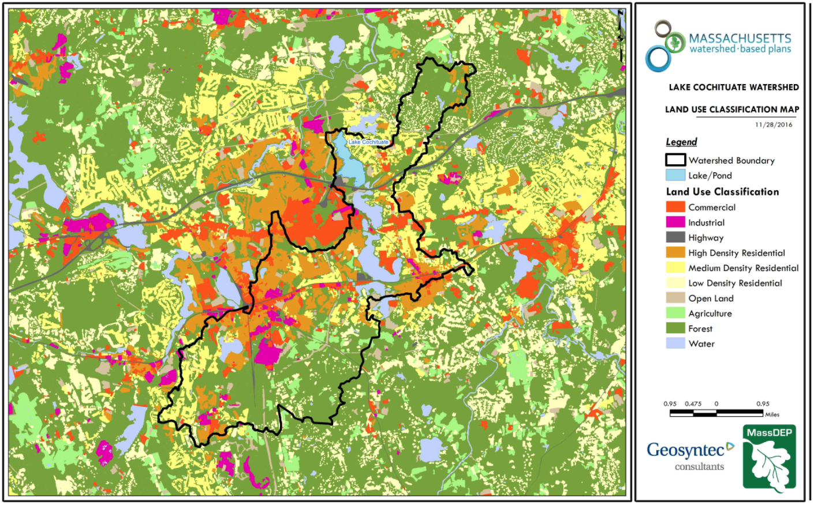
Figure A-3: Watershed Land Use Map (MassGIS, 2009b; MassGIS, 1999; MassGIS, 2001; USGS, 2016)

Watershed Impervious Cover
Impervious cover includes land surfaces that prevent the infiltration of water into the ground, such as paved roads and parking lots, roofs, basketball courts, etc. Impervious area varies throughout the watershed and ranges from 11% in the Course Brook subwatershed to 47% in the Pegan Brook subwatershed. Beaver Dam Brook represents more than half of the total impervious area (TIA) in the watershed at 1,394 acres.
Table A-11: Total Impervious Area (TIA) by Subwatershed
Subwatershed | Total Area (acres) | Impervious Area (acres) | % Impervious
Beaver Dam Brook | 4,796 | 1,394 | 29%
Course Brook | 2,379 | 257 | 11%
Pegan Brook | 312 | 145 | 47%
Fiske Pond | 219 | 42 | 19%
South Basin | 977 | 218 | 22%
Middle Basin | 573 | 153 | 27%
Snake Brook | 1,479 | 202 | 14%
North Basin | 563 | 66 | 12%
TOTAL | 11,297 | 2,477 | 22%

There is a strong link between impervious land cover and stream water quality. The relationship between TIA and water quality can generally be categorized as listed by Table A-9 (Schueler et al. 2009). The TIA in the Lake Cochituate watershed is 22%; therefore, streams can be expected to show clear signs of degradation as summarized below. According to MAPC (2004), urbanization and increased impervious surfaces within the Lake Cochituate watershed are having negative impacts on the watershed’s resources. These impacts include the degradation of water quality, impairment of recreational uses, a decreased ability to sustain aquatic life, and altered flow dynamics that result in increased peak runoff and suspended sediments and decreased groundwater recharge.
Table A-12: Relationship between Total Impervious Area (TIA) and water quality (Schueler et al. 2009)
% Watershed  Impervious Cover | Stream Water Quality
0-10% | Typically high quality, and typified by stable channels, excellent habitat structure, good to excellent water quality, and diverse communities of both fish and aquatic insects.
11-25% | These streams show clear signs of degradation. Elevated storm flows begin to alter stream geometry, with evident erosion and channel widening. Streams banks become unstable, and physical stream habitat is degraded. Stream water quality shifts into the fair/good category during both storms and dry weather periods. Stream biodiversity declines to fair levels, with most sensitive fish and aquatic insects disappearing from the stream.
26-60% | These streams typically no longer support a diverse stream community. The stream channel becomes highly unstable, and many stream reaches experience severe widening, downcutting, and streambank erosion. Pool and riffle structure needed to sustain fish is diminished or eliminated and the substrate can no longer provide habitat for aquatic insects, or spawning areas for fish. Biological quality is typically poor, dominated by pollution tolerant insects and fish. Water quality is consistently rated as fair to poor, and water recreation is often no longer possible due to the presence of high bacteria levels.
>60% | These streams are typical of “urban drainage”, with most ecological functions greatly impaired or absent, and the stream channel primarily functioning as a conveyance for stormwater flows.

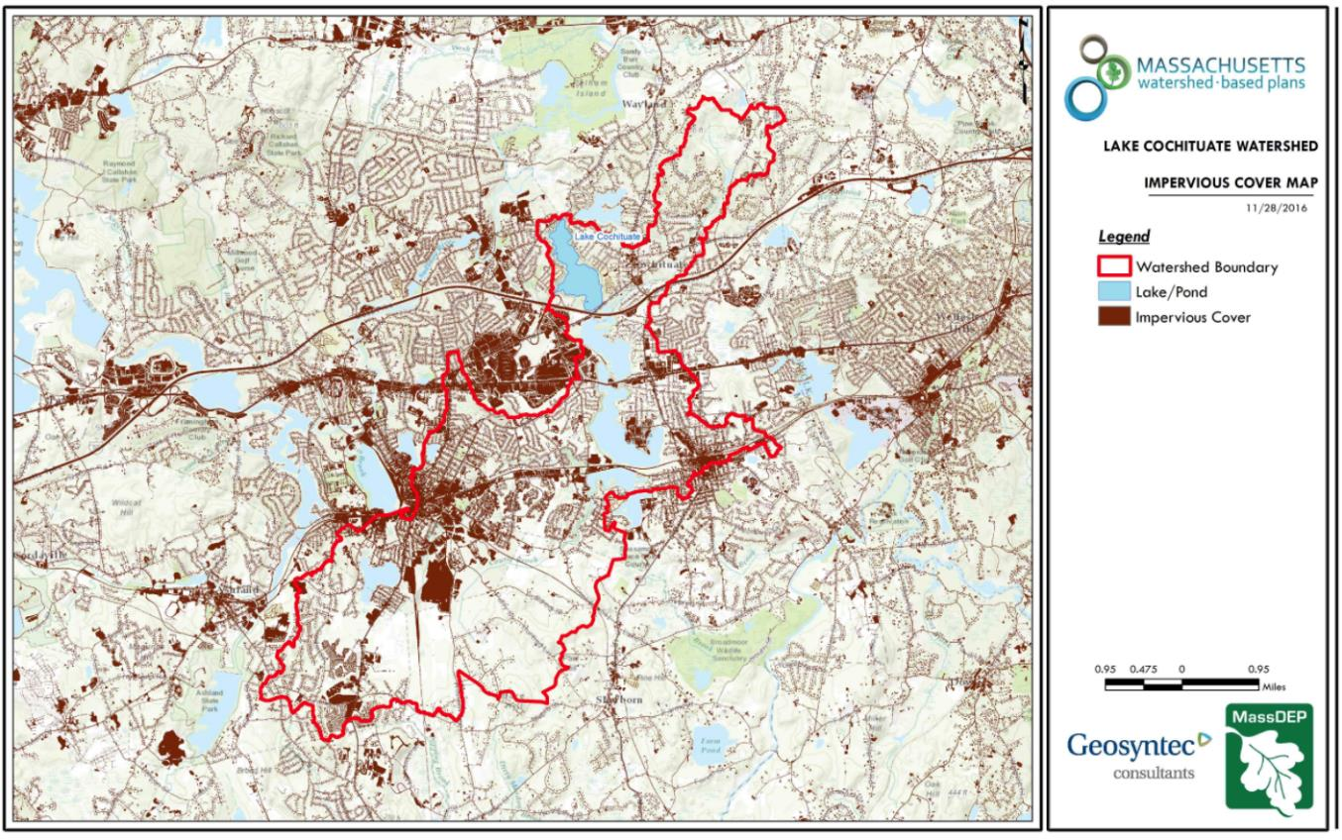
Figure A-4: Watershed Impervious Surface Map (MassGIS, 2009b; MassGIS, 1999; MassGIS, 2001; USGS, 2016)

Pollutant Loading and Trophic Response
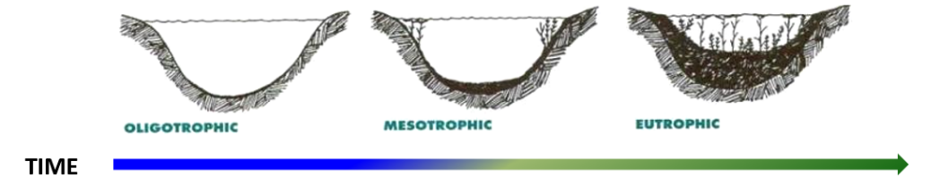
Eutrophication is the gradual process of nutrient enrichment in aquatic ecosystems such as lakes and ponds that results in increased biological productivity. Eutrophication occurs naturally as ponds become more biologically productive over geological time, but this process is often accelerated by human activities in the watershed. Nutrients that contribute to eutrophication can come from many natural and anthropogenic sources, such as fertilizers applied to residential lawns and agricultural fields; septic systems; deposition of nitrogen from the atmosphere; erosion of soil containing nutrients; and sewage treatment plant discharges. Land development not only increases the sources of nutrients, but also decreases opportunities for natural attenuation (e.g., uptake by vegetation) of such nutrients before they can reach a water body.
Eutrophication is the natural process by which nutrients, organic matter and sediments gradually accumulate within a water body, resulting in decreased depth and increased biological productivity. This process can be greatly accelerated by human activities in the watershed.
Nutrients such as phosphorus and nitrogen can stimulate abundant growth of algae and rooted plants in water bodies. Over time, this enhanced plant growth leads to reduced dissolved oxygen in the water, as plant material decomposes and consumes oxygen. Phosphorus is typically the “limiting nutrient” for freshwater lakes, which means that plant productivity is most often controlled by the supply of this nutrient. As such, increases in phosphorus load in a lake watershed are closely correlated with increases in plant productivity and accelerated eutrophication.
To understand the magnitude of the role that phosphorus plays in the productivity of Lake Cochituate, Geosyntec calculated an annual phosphorus budget by considering various phosphorus sources within the watershed, including nonpoint source pollution from stormwater runoff (i.e., land-use based), septic system discharge, and aerial deposition, as discussed in the below sections.
Land-Use Based Phosphorus Loading
The land use data (MassGIS, 2009b) was intersected with impervious cover data (MassGIS, 2009a) and United States Department of Agriculture (USDA) Natural Resources Conservation Service (NRCS) soils data (USDA NRCS and MassGIS, 2012) to create a combined land use/land cover grid. The grid was used to sum the total area of each unique land use/land cover type.
The amount of directly connected impervious area (DCIA) was estimated using the Sutherland equations (USEPA, 2010) and any reduction in impervious area due to disconnection (i.e., the area difference between TIA and DCIA) was assigned to the pervious D soil category for that land use to simulate that some infiltration will likely occur after runoff from disconnected impervious surfaces passes over pervious surfaces.
Pollutant loading for key nonpoint source pollutants in the watershed was estimated by multiplying each land use/cover type area by its pollutant load export rate (PLER). The PLERs are an estimate of the annual total pollutant load exported via stormwater from a given unit area of a particular land cover type. The PLER values for TN, TP and TSS were obtained from USEPA (Voorhees, 2016b) (see documentation provided in Appendix B) as follows:
L_{n} = A_{n} * P_{n}
Where L_{n} = Loading of land use/cover type n (lb/yr); A_{n} = area of land use/cover type n (acres); P_{n} = pollutant load export rate of land use/cover type n (lb/acre/yr)

The estimated land-use based phosphorus load to Lake Cochituate is 5,907 pounds per year (Table A-10). A comparative review of pollutant loading by subwatershed indicates that, on a per acre basis, pollutant loading from the Beaver Dam Brook subwatershed is disproportionately higher than other subwatersheds. The Beaver Dam Brook Watershed comprises approximately 42% of the entire watershed but contributes 54% of the estimated land-use based phosphorus load to Lake Cochituate (Table A-11). It should also be noted that 765 pounds (13%) of the watershed’s total phosphorus load (5,907 pounds) is estimated to come from forested areas. Most phosphorus generated from forested areas is a result of natural processes such as decomposition of leaf litter and other organic material. Such areas generally represent a “best case scenario” with regard to phosphorus loading, meaning that 13% of the watershed is unlikely to provide opportunities for nutrient load reductions through best management practices.

To further characterize pollutant loading in the Lake Cochituate watershed, microwatersheds (i.e., catchments) were delineated throughout developed portions of the watershed that discharge to definable stormwater outfalls. Land use base pollutant loading was then estimated for each microwatershed and a priority ranking of microwatersheds based on loading was performed. This information was used for subsequent BMP investigations as discussed in Element C of this report. Refer to Figure A-5 for a map of prioritized microwatersheds and to Geosyntec (2017b) for tabulated results for each microwatershed.

Table A-13: Estimated Land Use Based Pollutant Loading for Key Nonpoint Source Pollutants
Land Use Type | Pollutant Loading¹
Land Use Type | Total | Total | Total
Land Use Type | Phosphorus (TP) | Nitrogen (TN) | Suspended Solids (TSS)
Land Use Type | (lbs/yr) | (lbs/yr) | (tons/yr)
Agriculture | 147 | 891 | 11
Commercial | 1,179 | 10,068 | 126
Forest | 765 | 4,187 | 177
High Density Residential | 1,847 | 11,794 | 179
Highway | 134 | 1,034 | 71
Industrial | 552 | 4,692 | 59
Low Density Residential | 234 | 2,249 | 33
Medium Density Residential | 936 | 7,235 | 107
Open Land | 114 | 1,165 | 24
TOTAL | 5,907 | 43,315 | 787
¹These estimates do not consider loads from point sources or septic systems.

Table A-14: Estimated Land Use Based Pollutant Loading for Key Nonpoint Source Pollutants (by Subwatershed)
Subwatershed | Pollutant Loading¹
Subwatershed | Total | Total | Total
Subwatershed | Phosphorus (TP) | Nitrogen (TN) | Suspended Solids (TSS)
Subwatershed | (lbs/yr) | (lbs/yr) | (tons/yr)
Beaver Dam Brook | 3178 | 23125 | 408
Course Brook | 788 | 5532 | 120
Pegan Brook | 86 | 619 | 11
Fiske Pond | 311 | 2524 | 42
South Basin | 175 | 1307 | 23
Middle Basin | 315 | 2311 | 38
Snake Brook | 545 | 4002 | 84
North Basin | 508 | 3897 | 62
TOTAL | 5907 | 43315 | 787
¹These estimates do not consider loads from point sources or septic systems.

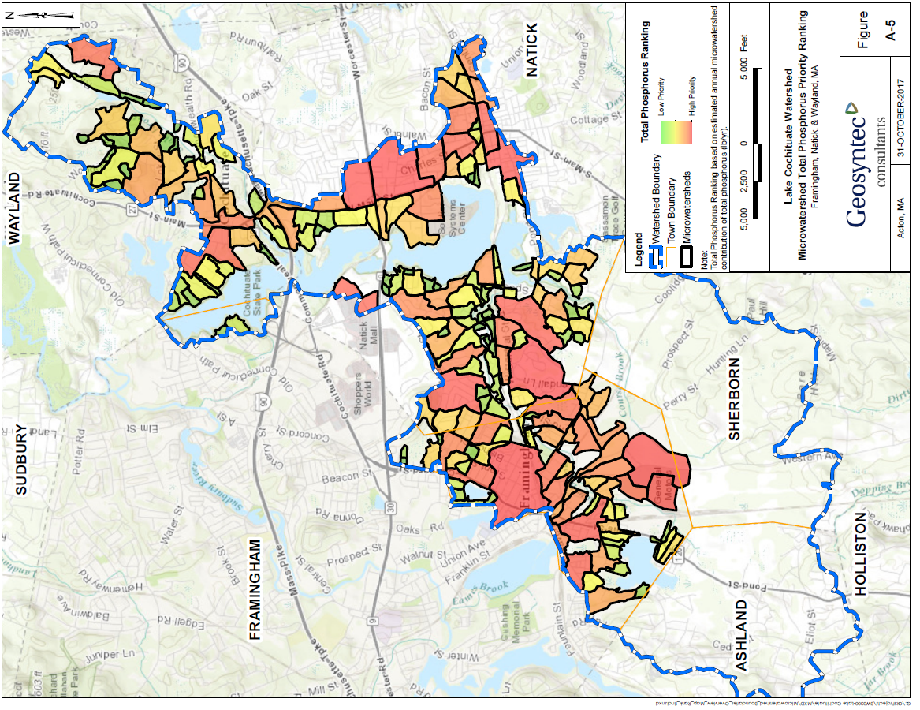
Figure A-5: Lake Cochituate Microwatershed Priority Phosphorus Ranking

Phosphorus from Septic Systems
Septic systems allow treated wastewater effluent, which is rich in phosphorus and other nutrient content, to leach into the groundwater and potentially migrate to the lake. Because phosphorus tends to become bound to soil particles, the distance it can travel may be relatively short. For this reason, it is customary to only include septic systems in the near shore area (within 200 feet of shoreline) when calculating an annual septic system phosphorus load.
Natick, Wayland, and Framingham provided data associated with septic systems within 200 feet of the lake. The data included 69 homes in Natick, 26 homes in Wayland, and ten homes in Framingham in the near shore areas that are served by septic systems. Based on the provided data, Geosyntec calculated an annual phosphorus load from septic systems of 45 pounds per year using the following formula:
$$S=\sum_{i=0}^{h}{{B_{i}∙n_{i}∙Q}_{c}∙}m_{i}∙P_{w}∙θ$$
Where:
S is the total P load from septic systems (lbs.);
$h$ is the total number of homes considered in the inventory;
$B_{i}$ is the number of bedrooms served by the system (assumed 4);
$n_{i}$ is the average number of persons per bedroom (0.85, determined from past experience in similar areas);
Q_{c} is the per-capita daily water use (69.3 gal/person/day, USEPA, 2002);
$m_{i}$ is the number of months that the home is occupied (assumed year-round occupation);
$P_{w}$is the concentration of phosphorus in wastewater (10 mg/L, US EPA, 2002);
$θ$ is the fraction of phosphorus removal attributed to the septic system and leach field (0.94).
Phosphorus from Aerial Deposition
Atmospheric deposition of phosphorus is an estimate of the load of phosphorus delivered through wet or “dryfall” precipitation depositing phosphorus-containing particles directly on the surface of Lake Cochituate. Deposition rates were determined from published literature (Reckhow, 1980). The annual atmospheric deposition load was calculated assuming a deposition rate of 0.24 lb. P/ac/yr, for a total atmospheric load of 155 lb. P/yr.
Total External Phosphorus Load
The total external phosphorus load into Lake Cochituate was calculated to be 6107 pounds per year (2770 kg/yr) as summarized by Table A-15. Therefore, phosphorus loading to Lake Cochituate is dominated by land use sources (i.e., surface runoff).
Table A-15 Summary of Calculated External Phosphorus Loading to Lake Cochituate
Parameter | Value | Units
Land Use (i.e., surface runoff) | 5907 | lb/yr
Septic Systems | 45 | lb/yr
Aerial Deposition | 155 | lb/yr
TOTAL | 6107 | lb/yr
Trophic Response to Phosphorus Loading
In-lake phosphorus response models are commonly used to predict in-lake phosphorus concentrations as a function of annual phosphorus loading, mean lake depth, and hydraulic residence time. The models are useful for understanding the relationships between current phosphorus loading and in-lake concentration, as well as for estimating in-lake concentrations under hypothetical scenarios, such as future buildout. One of the most commonly used in-lake response models is the Vollenweider model, which predicts an average annual in-lake phosphorus concentration. Phosphorus concentrations predicted by the Vollenweider model assume that the lake is uniformly mixed, such as at spring turnover. The Vollenweider model is based on a five-year study of approximately 200 waterbodies in Europe, North America, Japan and Australia (Vollenweider and Schweiz, 1975).
The Vollenweider Equation is provided below, with calculations for Lake Cochituate based on the phosphorus loading estimate discussed above, including phosphorus from land use (i.e., surface runoff), septic systems, and aerial deposition. The equation parameters and the values specific to Lake Cochituate are presented in Table A-16. The Vollenweider Equation is:
$$p_{v}=\frac{L_{p}}{\left(q_{s}\left(1+\sqrt{τ_{w}}\right)\right)}$$
where:
$p_{v}$ = mean in-lake phosphorus concentration estimated by Vollenweider equation;
$L_{p}$ = annual phosphorus load/lake area;
$τ_{w}$ = hydraulic residence time;
$q_{s}$ = hydraulic overflow rate=mean depth /hydraulic residence time = $z$/$τ_{w}$;
$z$ = mean depth
Table A-16 Vollenweider Model Parameters and Assumptions
Parameter |  | Value | Units | Source/Assumption
W | Total P Loading Rate | 6,107 | lb/yr | Calculated Pollutant Load Value
A_{s} | Lake Area | 647 | ac | Element A, Section 1
V | Volume | 1,451 | MG | Bathymetry data (MassGIS, 2017), Appendix C
z | Average Lake Depth | 6.9 | ft | Calculated Value (V/A_{s})
Q | Annual Discharge | 7,077 | MG/yr | USGS Station 01098500, based on mean annual discharge of 30 cfs from 1978 through 2017
L_{p} | Areal Loading Rate | 9.4 | lb/ac/yr | Calculated Value (W/A_{s})
q_{s} | Hydraulic Overflow Rate | 33.6 | ft/yr | Calculated Value (Q/A_{s})
τ_{w} | Hydraulic Residence Time | 4.9 | yr | Calculated Value (V/Q)
p_{v} | Predicted In-Lake Phosphorus Concentration | 32.2 | µg/L | See above equation (Note: direct computation of values in this table will not yield this result as internal conversion into metric units is required. Specific metric conversions are as follows: L_{p} = 1058.02 mg/m²/yr, q_{s} = 10.232 m/yr. Thus, 1058.02/(10.232*(1+sqrt(4.9)) = 32.2 µg/L.
Based on the estimated annual external phosphorus load of 6,107 pounds per year, the Vollenweider equation predicts an in-lake phosphorus concentration of 32.2 µg/L when Lake Cochituate is in a fully mixed state. This predicted concentration is above the previously discussed USEPA Gold Book Standard of 25 µg/L, which is also the threshold (lower limit) concentration for classification as a eutrophic pond. Results generally agree with 1994 MA DEM sampling data presented by Table A-2 where in-lake sampling concentrations ranged from 32 to 771 µg/L and suggest that that the Vollenweider equation provides a reasonable initial estimate of in-lake phosphorus dynamics.
The relationship between residence time (e.g., flushing rate), external phosphorus load, and in-lake phosphorus concentration presented by the Vollenweider model has implications for future lake management. Based on the modeled annual phosphorus load estimate of 6,107 pounds per year, the Vollenweider equation predicts that an annual load reduction of 190 pounds per year would be required to decrease the in-lake phosphorus concentration by 1 µg/L.
Refer to Table A-17 for a summary of hypothetical reduction scenarios and Figure A-6 for a visual depiction. For example, to reduce in-lake phosphorus concentration to the approximate 25 µg/L eutrophic benchmark, an estimated 1,344 pound reduction (22%) in annual phosphorus loading would be required. A 5% reduction in annual phosphorus loading (305 pounds per year) would be expected to reduce in-lake phosphorus concentration to 30.5 µg/L. A pollutant load reduction target is proposed as part of Element B of the WBP.
Table A-17 Summary of Hypothetical Load Reduction Scenarios
Scenario | Required Reduction | Resulting Load | Resulting In-Lake Concentration
Existing Conditions | - | 6107 | 32.2
1 µg/L Reduction | 190 | 5917 | 31.1
5% Reduction | 305 | 5802 | 30.5
10% Reduction | 611 | 5497 | 28.9
15% Reduction | 916 | 5191 | 27.3
20% Reduction | 1221 | 4886 | 25.7
22% Reduction | 1344 | 4764 | 25.1

Figure A-6: Lake Cochituate Vollenweider Relationship Between Phosphorus Loading and In-Lake Concentration
Assumptions and Limitations:
- The Vollenweider equation assumes uniform mixing (i.e., spring and fall turnover) and does not account for internal phosphorus loading (i.e., seasonal release from bottom sediments). The Element I (Monitoring) section of this report provides recommendations on future monitoring efforts to provide calibration and validation of the model. Once calibrated, the model can be used to provide more precise estimates of in-lake phosphorus concentrations and estimates of the lake’s response to future decreases (e.g., implementation of nutrient control BMPs) or increases (e.g., due to land development) in the watershed’s phosphorus load.
- The Vollenweider equation was applied to all inter-connected components of Lake Cochituate (North Basin, Middle Basin, Carling Basin, South Basin). Fisk Pond was excluded given a lack of bathymetry data. It is likely that actual in-lake phosphorus concentrations will vary throughout each basin. Future work may consider computing in-lake phosphorus concentrations for each basin to fine-tune management strategies.

Element B: Determine Pollutant Load Reductions Needed to Achieve Water Quality Goals

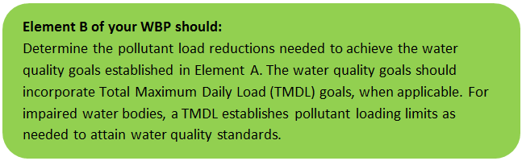 | 

Estimated Pollutant Loads
Table B-1 lists estimated existing pollutant loads for the following primary nonpoint source (NPS) pollutants: total phosphorus (TP), total nitrogen (TN), total suspended solids (TSS). These estimated loads are based on the pollutant loading analysis presented in Section 4 of Element A.

Water Quality Goals
Water quality goals for primary NPS pollutants are listed in Table B-1 based on the following:
- For all water bodies, including impaired waters that have a pathogen TMDL, the water quality goal for bacteria is based on the Massachusetts Surface Water Quality Standards (314 CMR 4.00, 2013) that apply to the Water Class of the selected water body.
- If the water body does not have a TMDL for TP, a default target TP concentrations is provided which is based on guidance provided by the USEPA in Quality Criteria for Water (1986), also known as the “Gold Book”. Because there are no similar default water quality goals for TN and TSS, goals for these pollutants are provided in Table B-1 only if a TMDL exists or alternate goal(s) have been optionally established by the WBP author.
- According to the USEPA Gold Book, total phosphorus should not exceed 50 ug/L in any stream at the point where it enters any lake or reservoir. The water quality loading goal was estimated by multiplying this target maximum phosphorus concentration (50 ug/L) by the estimated annual watershed discharge for the selected water body. To estimate the annual watershed discharge, the mean flow was used, which was estimated based on United States Geological Survey (USGS) “Runoff Depth” estimates for Massachusetts (Cohen and Randall, 1998). Cohen and Randall (1998) provide statewide estimates of annual Precipitation (P), Evapotranspiration (ET), and Runoff (R) depths for the northeastern U.S. According to their method, Runoff Depth (R) is defined as all water reaching a discharge point (including surface and groundwater), and is calculated by:
P – ET = R
A mean Runoff Depth R was determined for the watershed by calculating the average value of R within the watershed boundary. This method includes the following assumptions/limitations:

  - For lakes and ponds, the estimate of annual TP loading is averaged across the entire watershed. However, a given lake or reservoir may have multiple tributary streams, and each stream may drain land with vastly different characteristics. For example, one tributary may drain a highly developed residential area, while a second tributary may drain primarily forested and undeveloped land. In this case, one tributary may exhibit much higher phosphorus concentrations than the average of all streams in the selected watershed.

  - Phosphorus loading is based on the factors listed in Element A, Section 7 including land use, septic systems, and aerial deposition. Internal phosphorus loading was not considered as part of this estimate.

Table B-1: Pollutant Load Reductions Needed
Pollutant | Existing Estimated Total Load | Water Quality Goal | Required Load Reduction
Total Phosphorus | 6,107 lbs/yr | 4,764 lbs/yr (see below) | 1,344 lbs/yr
Total Nitrogen | 43,315 lbs/yr | - | -
Total Suspended Solids | 787 ton/yr | - | -
Bacteria | MSWQS for bacteria are concentration standards (e.g., colonies of bacteria per 100 ml), which are difficult to predict based on estimated annual loading. | Class B. Class B Standards  • Public Bathing Beaches: For E. coli, geometric mean of 5 most recent samples shall not exceed 126 colonies/ 100 ml and no single sample during the bathing season shall exceed 235 colonies/100 ml. For enterococci, geometric mean of 5 most recent samples shall not exceed 33 colonies/100 ml and no single sample during bathing season shall exceed 61 colonies/100 ml;  • Other Waters and Non-bathing Season at Bathing Beaches: For E. coli, geometric mean of samples from most recent 6 months shall not exceed 126 colonies/100 ml (typically based on min. 5 samples) and no single sample shall exceed 235 colonies/100 ml. For enterococci, geometric mean of samples from most recent 6 months shall not exceed 33 colonies/100 ml, and no single sample shall exceed 61 colonies/100 ml.

Recommended Load Reduction
Based on results from the trophic status modeling (See Element A, Section 7), the existing phosphorus load to Lake Cochituate is estimated at 6,107 pounds per year with 97% coming from land use (i.e., surface runoff) contributions. The model estimates that the resulting in-lake phosphorus concentration is 32.2 µg/L, which is typically indicative of eutrophic conditions. To improve water quality, a long-term reduction of annual phosphorus loading of 1,344 pounds by 2035 is proposed to approach oligotrophic conditions (approximate 22% overall reduction).
In addition, the following adaptive sequence is recommended to improve and track load reduction goals:
- Establish a baseline monitoring program in accordance with Element I and use results to calibrate the trophic response model (Element A, Section 7).
- Based on the calibrated trophic response model and monitoring data, re-evaluate long-term reduction goal and establish a realistic 3-year interim load reduction goal.
- Re-evaluate long-term and interim goals at least once every 3 years and adaptively adjust based on future refinements to the model and/or additional monitoring results.

Element C: Describe management measures that will be implemented to achieve water quality goals

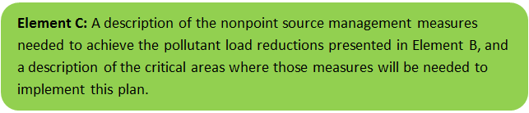 | 

Field Watershed Investigation
Geosyntec performed field investigations in the Lake Cochituate Watershed (“Watershed”) in Natick on June 15-16, 2017 (Geosyntec Consultants, 2017a) and in Wayland on April 11, 2018 to identify potential best management practices (BMPs) and restoration practices that can be implemented to reduce pollutant load to Lake Cochituate. Based on the results of these field investigations, the following pages present primary and secondary potential BMPs and restoration practices that relate to stormwater management and phosphorus load reduction for the watershed.
The recommended implementation sites discussed in this section are not intended to be an all-inclusive listing of potential stormwater improvements in the watershed. Rather, these recommendations are representative examples of potential stormwater improvements and retrofits that could be implemented at numerous sites throughout the watershed. All developed portions of the watershed were visited, but emphasis was generally placed on those areas with direct conveyance to Lake Cochituate (e.g., Wayland Town Beach parking lot drains into stormwater outfalls that discharge directly into the Lake).

BMP Recommendations
Site specific primary BMP Recommendations are provided by Appendix D.1 of this WBP for Natick and Wayland based on Geosyntec’s field investigations. Each BMP recommendation includes:
- A site summary that describes current conditions and stormwater drainage patterns;
- A description of proposed improvements;
- Estimated costs that represent installed contractor construction costs (i.e., capital costs); and
- Estimated Total Phosphorus (TP), Total Nitrogen (TN), and Total Suspended Solids (TSS) pollutant load reduction for the proposed BMP.

The design goal for the proposed BMPs would be to size the BMP to treat and infiltrate the water quality volume to the maximum extent practicable. The water quality volume is defined in the Massachusetts Stormwater Handbook as the volume equal to 0.5 inches of runoff times the total impervious area that drains to the BMP. However, each proposed BMP should be designed to achieve the most treatment that is practical given the size and logistical constraints of the site. Secondary (alternative) BMP improvement sites are listed in Appendix D.2. Each secondary BMP recommendation includes a location and photo of the site and a listing of the potential improvement (e.g., hydrodynamic separator).

BMP Prioritization
Primary BMP recommendations were scored and prioritized based on the following factors as described in detail in Table C-1 below:
- Estimated phosphorus load reduction (lb/yr);
- Estimated capital costs;
- Expected level of operation and maintenance effort;
- Estimated microwatershed phosphorus loading (lb/yr);
- Educational outreach opportunity; and
- Implementation complexity.

BMP scoring ranges from Low (40) to High (100). BMPs were prioritized based on their score. The top third were assigned a priority ranking of “high”, the middle third were assigned a priority ranking of “medium”, and the bottom third were assigned a priority ranking of “low”. Refer to Figures C-1 and C-2 for locations of proposed primary and secondary BMP locations and their priority ranking. Also refer to Table C-2 for scoring and subsequent ranking of each BMP.

Table C-1: BMP Ranking Criteria
BMP Score |  | Low |  | Medium |  | High
 |  | Range | Score | Range | Score | Range | Score
Est. BMP Load Reduction (lb/yr)¹ | TP | 0 - 0.2 | 15 | 0.2 - 2.0 | 20 | 2.0 + | 25
Cost Estimates ($)¹ | Capital | $35,000 + | 10 | $15,000 - $35,000 | 15 | <$15,000 | 20
Cost Estimates ($)¹ | Annual O&M | $1,000+ | 5 | $500-$1,000 | 10 | <$500 | 15
Est. Watershed TP Loading (lb/yr)² |  | <15 lbs/yr | 10 | 15 - 50 lbs/yr | 15 | 50+ lbs/yr | 20
Educational Outreach Opportunity |  | Low potential visibility | 0 | Moderate potential visibility | 5 | High potential visibility | 10
Implementation Complexity ³ |  | Challenging | 0 | Moderate | 5 | Minimal | 10
Totals |  |  | 40 |  | 70 | Highest possible score: | 100
1. From MassDEP WBP-Tool, Element C.
2. From Geosyntec Consultants (2017b).
3. Implementation complexity is a qualitative indicator based on expected site conditions and was scored using professional judgement based on the following criteria: property ownership, access, potential for underground utility conflicts, potential for tree removal, potential for traffic impacts, and potential for wetland permitting.

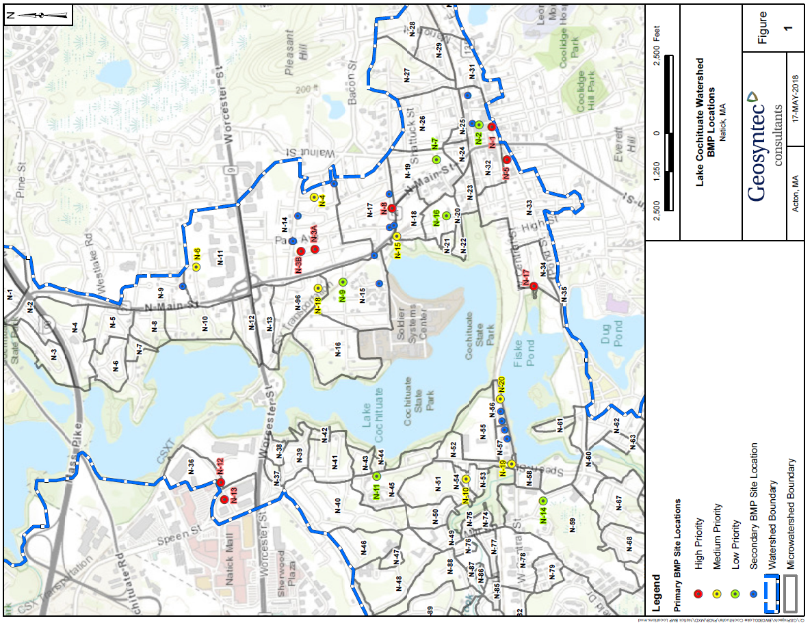
Figure C-1 Prioritized BMP Locations (Natick)
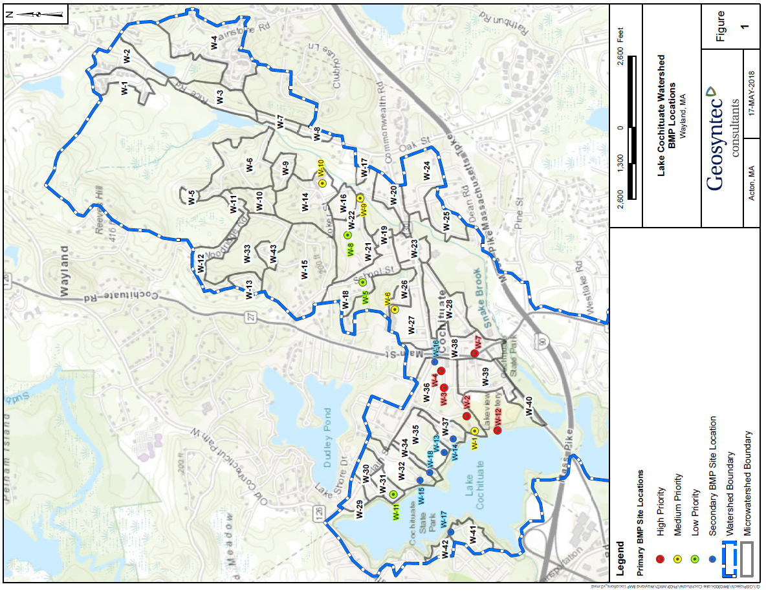
Figure C-2 Prioritized BMP Locations (Wayland)

Table C-2: BMP Scoring and Prioritization Summary
1. BMP ranking and scoring was performed based on site specific information contained in Appendix D.1.

Element D: Identify Technical and Financial Assistance Needed to Implement Plan

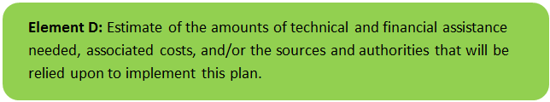 | 

Table D-1 presents the anticipated funding needed to implement the management measures in Natick and Wayland as presented in this WBP. The table includes planning level costs for structural BMPs, operation and maintenance activities, and engineering technical assistance. The table also includes anticipated performance of BMPs where applicable and other characteristics (e.g., drainage area).

Table D-1: Summary of Funding Needed to Implement the Watershed Plan


Element E: Public Information and Education
Element E: An information/education (I/E) component of the watershed plan used to:
- Enhance public understanding of the project; and
- Encourage early and continued public participation in selecting, designing, and implementing the NPS management measures that will be implemented.

Step 1: Goals and Objectives
The goals and objectives for the watershed information and education program.
- Provide information about proposed stormwater improvements and their anticipated water quality benefits.
- Provide information to promote watershed stewardship.
Step 2: Target Audience
Target audiences that need to be reached to meet the goals and objectives identified above.
- All watershed residents.
- Businesses within the watershed.
- Recreational users of Lake Cochituate (boaters, beach-goers, etc.).
- Watershed organizations and other user groups (Lake Cochituate Watershed Council, Keep Natick Beautiful, Friends of Cochituate State Park, SuAsCo Watershed Community Council, Organization for the Assabet River, Community Rowing, etc.)

Step 3: Outreach Products and Distribution
The following outreach products are anticipated:
1. Post the completed Lake Cochituate Watershed Based Plan to Natick, Wayland, Framingham, and other websites. Periodically update website(s) as the WBP is implemented (e.g., BMP construction, monitoring results, etc.).
2. Develop brochure promoting watershed stewardship and post to website(s) (as described in more detail below).
3. Implement a green infrastructure workshop program (as described in more detail below).
4. Work with the community to implement a storm drain stenciling program to discourage dumping into Lake Cochituate and its receiving waters. For example, “Don’t dump, drains directly to Lake Cochituate”, “Beaver Brook”, etc.). The storm drain stenciling program can be implemented as part of a boy scout or girl scout project or other community based organization. The storm drain stenciling program will be initiated in the immediate vicinity of Lake Cochituate, then will be expanded to surrounding areas (e.g., receiving waters).
5. Create informational signage to highlight BMPs that are installed throughout the watershed on public land.
6. Circulate microwatershed information to watershed residents and businesses. A Google Earth compatible file of microwatersheds and their anticipated phosphorus loading and priority ranking prepared by Geosyntec Consultants (2017b) is available publicly on the MassDEP WBP-tool when a user selects Lake Cochituate. The file can be loaded into Google Earth and a user can review the expected pollutant loading to Lake Cochituate that results from their microwatershed.

Step 4: Evaluate Information/Education Program
The effectiveness of the program is anticipated to be evaluated in the following ways:

Outreach Product | Target Audience | Implementation Champion(s) | Evaluation
Post completed WBP to stakeholder websites | All organizations and people from Step 2. | All stakeholders – Natick, Wayland, Framingham, MA DCR | Track number of web page views
Develop brochure promoting watershed stewardship | All organizations and people from Step 2 with a focus on near-abutters and recreational users | All stakeholders to collaboratively develop brochure and distribute | Number of physical brochures distributed to target audience
Implement green infrastructure workshop program | Watershed residents and businesses | All stakeholders to participate – Natick to coordinate and initiate the workshop program. | Track attendance to workshop
Implement storm drain stenciling program | All organizations and people from Step 2. | All stakeholders - Wayland to coordinate with local scouts or other community organization to initiate program. | Number of stenciled features
Implement informational signage | All organizations and people from Step 2. | All stakeholders corresponding to locations where BMPs installed (e.g., Murphy Field, Natick) | Number of BMPs with signage
Circulate microwatershed information | Watershed residents and businesses | All stakeholders – Natick, Wayland, Framingham, MA DCR | N/A

Brochures and Public Education Workshops
Public information and education efforts can be used to enhance public understanding of lake and watershed management issues, such as control/prevention of non-native species and phosphorus loading reduction projects. Public information and education about lake management efforts can be provided via town and/or lake association websites, social media, print brochures, local newspaper articles, and other media.
Brochure: An educational print or web-based brochure could be developed on homeowner practices that reduce loading of phosphorus and other pollutants to the ponds. Example text is provided on the following page.

Public Education Workshops: There are many organizations that provide green infrastructure workshops focused towards educating property owners in the watershed on how to implement green infrastructure on their properties such as raingardens, rain barrels, infiltration trenches, vegetated buffers, low- or no-phosphorus fertilizers, etc. Specific topics typically addressed include:
- Stormwater and Green Infrastructure concepts
- Case study of benefits and costs
- Practices (including step-by step instruction on how to design and build a residential raingarden)
- Recommended native plantings
- Tools for estimating cost and pollutant load reductions
- Construction Do’s and Don’ts
Other Resources: Homeowners within the watershed are encouraged to review the following educational resources:
  - Massachusetts Nonpoint Source Pollution Management Manual: http://projects.geosyntec.com/NPSManual/
  - Innovative Land Planning Techniques – A Handbook for Sustainable Development: http://des.nh.gov/organization/divisions/water/wmb/repp/innovative_land_use.htm
  - The Vermont Raingarden Manual: http://nsgl.gso.uri.edu/lcsg/lcsgh09001.pdf
  - A Shoreland Homeowner’s Guide to Stormwater Management
http://des.nh.gov/organization/commissioner/pip/publications/wd/documents/nhdes-wd-10-8.pdf

Example homeowner pollution prevention brochure text. Other content could include lake/watershed maps, information on aquatic plants and invasive species, and ongoing monitoring efforts.
How YOU Can Help Protect Lake Cochituate!

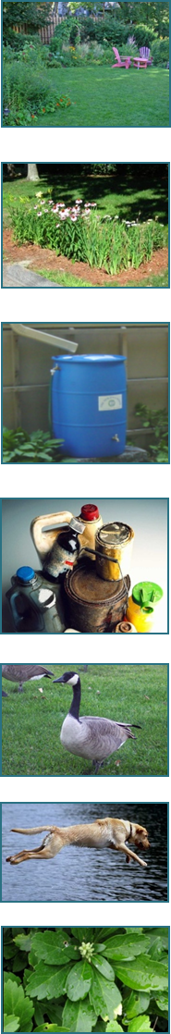
“Just say No” to fertilizer. Lawn fertilizer is transported to Lake Cochituate by stormwater runoff, fueling algae blooms that reduce water clarity and can lead to beach closures. Use natural alternatives to lawn and garden chemicals and establish low-maintenance, native vegetation on your property.

Build a raingarden to manage stormwater runoff from your property. Raingardens protect water quality while beautifying your home and neighborhood! For more information, see: http://nsgl.gso.uri.edu/lcsg/lcsgh09001.pdf

Rain barrels are a great way to re-use rainwater from roofs for gardening and landscaping. A rain barrel will save most homeowners about 1,300 gallons of water during the peak summer months. Diverting this water from storm drains also decreases the impact of runoff to streams. Rain barrels can be purchased at many home and garden centers.

Keep litter, leaves, and debris out of street gutters and storm drains. Dispose of used oil, antifreeze, paints, and other household chemicals properly. Do not dump these products in storm drains. These outlets drain directly to Lake Cochituate, contributing streams and wetlands.

Don't feed waterfowl! Bread and snack food are harmful to waterfowl. Feeding discourages winter migration and encourages large bird flocks that degrade lake shorelines with droppings and can contribute to beach closures.

Pick up after your pet! Use biodegradable doggie bags to collect pet waste. Don't dispose of pet waste in storm drains.

Control soil erosion on your property by planting ground cover and stabilizing erosion-prone areas.

Elements F & G: Implementation Schedule and Measurable Milestones
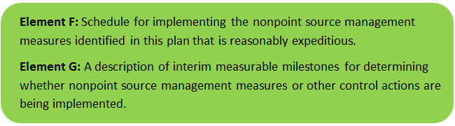 | 
Table FG-1 provides a preliminary schedule for implementation of recommendations provided by this WBP. It is expected that the WBP will be re-evaluated and updated in 2020, or as needed, based on ongoing monitoring results and other ongoing efforts.
Table FG-1: Implementation Schedule and Interim Measurable Milestones
Category | Action | Year(s)
Monitoring / Vegetation | Write Quality Assurance Project Plan (QAPP) for sampling and establish water quality monitoring program | 2019
Monitoring / Vegetation | Perform annual water quality sampling per Element H&I monitoring guidance. | Annual
Monitoring / Vegetation | Establish interim 3-year phosphorus reduction goal based on baseline monitoring results (See Element B, Section 2) | 2020
Monitoring / Vegetation | Perform aquatic vegetation monitoring and control (per existing program) | Annual
Structural BMPs | Evaluate and obtain funding sources (e.g., s.319 DEP Grant Funding) | 2018-2019
Structural BMPs | Implement 1 to 3 recommended structural BMPs in Natick | 2019
Structural BMPs | Perform BMP investigations in Framingham | 2019
Structural BMPs | Implement 1 to 3 recommended structural BMPs in Wayland | 2020
Structural BMPs | Implement 1 to 3 recommended structural BMPs in Framingham | 2021
Structural BMPs | Assess potential implementation of additional recommended structural BMPs | 2021
Structural BMPs | Track implemented BMPs and their potential pollutant removals, including BMPs above and beyond Element C of this WBP (e.g., required subdivision BMPs, etc.) (See Element H & I) | Ongoing
Non-Structural BMPs | Perform non-structural BMP assessment for Wayland, Framingham, and Natick (street sweeping, catch basin cleaning, etc.) and document potential pollutant removals | 2019
Non-Structural BMPs | Implement non-structural BMP practices consistently throughout watershed | 2020
Public Education and Outreach  (See Element E) | Post completed WBP to websites and perform periodic updates | 2018 / Bi-Annual
Public Education and Outreach  (See Element E) | Develop Public Education Brochure and distribute to target audience | 2018
Public Education and Outreach  (See Element E) | Implement green infrastructure workshop program | 2019
Public Education and Outreach  (See Element E) | Implement storm drain stenciling program | 2019
Public Education and Outreach  (See Element E) | Implement information signage on installed BMPs | 2020
Adaptive Management  and Plan Updates | Establish working group comprised of stakeholders and other interested parties to implement recommendations and track progress. Meet at least twice per year. | 2019
Adaptive Management  and Plan Updates | Prepare annual “snapshot” progress report and disseminate to the public (See Element I) | Annual
Adaptive Management  and Plan Updates | Re-evaluate Watershed Based Plan at least once every three (3) years and adjust, as needed, based on ongoing efforts (e.g., based on monitoring results, 319 funding, etc.). – Next update, June 2021 | 2021
Adaptive Management  and Plan Updates | Reach Interim Phosphorous Load Reduction Goal | 2023
Adaptive Management  and Plan Updates | Reach Long-Term Phosphorus Load Reduction Goal (See Element A, Section 3) | 2035

Elements H & I: Progress Evaluation Criteria and Monitoring
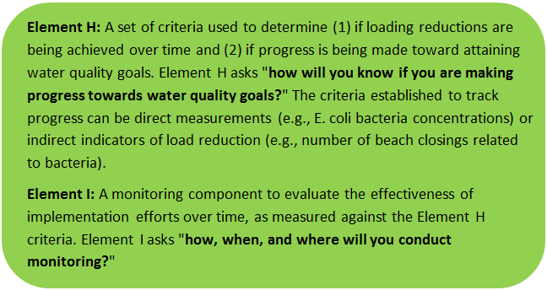 | 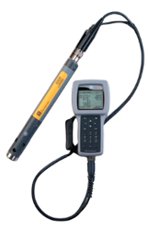

The water quality target concentration(s) is presented under Element A of this plan. To achieve this target concentration, the annual loading must be reduced to the amount described in Element B. Element C of this plan describes the various management measures that will be implemented to help achieve this targeted load reduction. The evaluation criteria and monitoring program described below will be used to measure the effectiveness of the proposed management measures (described in Element C) in improving the water quality of Lake Cochituate.

Indirect Indicators of Load Reduction
Algae and Vegetation Monitoring: As previously discussed, nuisance algae and vegetation is managed on an as-needed basis and is monitored annually to track progress. Annual monitoring will be continued and used as a metric for understanding water quality trends in response to implementation of measures recommended as part of this WBP.

Project-Specific Indicators
Number of BMPs Installed: Element C of this WBP recommends the installation of BMPs at 33 different locations. The anticipated pollutant load reduction has been documented for each proposed BMP, where applicable. The number of BMPs that were installed will be tracked and quantified as part of this monitoring program. For example, if all recommended BMPs are installed, the anticipated phosphorus load reduction is estimated to be 24 pounds per year. This results in a reduction of less than 1% of total phosphorus load to the watershed.
It is also recommended that pollutant removals of any other BMPs that are implemented (above and beyond the Element C recommendations) be tracked and documented. This can include pre-existing BMPs and BMPs that are implemented in the future (e.g., required BMPs installed at new subdivisions). Element C of the WBP tool can be used to input BMP information and estimate pollutant removals based on basic input information (i.e., BMP type, drainage area, design storm size, and land use) (http://prj.geosyntec.com/MassDEPWBP)
Number of Non-structural BMPs Installed: Table FG-1 of this WBP recommends that an assessment of non-structural BMPs be performed to document potential additional pollutant removals. Ongoing and additional non-structural BMP practices that are initiated as part of this assessment can be included as indirect indicators of load reduction (for example, street sweeping and catch basin cleaning).
Direct Measurements
Beach Bacteria Sampling: Continue sampling at beaches as summarized by Element A, Section 3. Track bacteria counts as they relate to water quality standards summarized by Element B, Section 2. Track the percentage of the sampling season that the beaches are closed (i.e., number of days closed / number of days open) and evaluate changes over time.
In-Lake Phosphorus Monitoring: Based on a literature review summarized in Element A of this plan, Lake Cochituate does not have a monitoring plan. The most recent known water quality samples collected systematically throughout the lake and its receiving waters were collected by MA DEM in 1994 (other than bacteria monitoring at beaches). In-lake phosphorus measurements will provide the most direct means of evaluating the effects of the measures in the plan which have been proposed specifically to reduce phosphorus loading. It is recommended that sampling be performed at the locations summarized by Table HI-1 and depicted on Figure HI-1.
Table HI-1: Proposed Water Quality Monitoring Stations
Station No.¹ | Station | Sample Location | Sample Depth² | Latitude | Longitude
1 | South Basin Deep Hole | In-Lake | Profile | -71.369115 | 42.289228
2 | Fiske Pond Outlet | Inlet | Surface | -71.366575 | 42.283054
3 | Pegan Brook Inlet to South Basin | Inlet | Profile | -71.357939 | 42.285008
4 | Middle Basin Deep Hole | In-Lake | Profile | -71.367834 | 42.304771
5 | Snake Brook Inlet to North Basin | Inlet | Surface | -71.372782 | 42.312691
6 | North Basin Deep Hole | In-Lake | Profile | -71.373829 | 42.315317
7 | North Basin Outlet | Inlet | Profile | -71.384307 | 42.314757
Notes:
1. Additional optional locations could include: Fiske Pond Deep Hole, Beaver Dam Brook Inlet to Fiske Pond, Course Brook Inlet to Fiske Pond
2. Profile sampling entails collecting samples from the surface (epilimnion), near the middle of the water column (metalimnion), and near the bottom (hypolimnion).
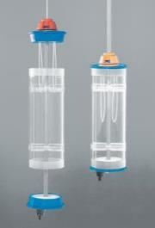
As discussed in Element A, the in-lake phosphorus concentrations predicted by the Vollenweider equation assume that the pond is uniformly mixed. As such, the results of the epilimnetic (i.e., surface) phosphorus monitoring during the summer (when the lake is stratified) are likely to understate the phosphorus levels that would be measured if the lake was uniformly mixed. However, regular monitoring of phosphorus levels from a profile (samples from the epilimnion, metalimnion and hypolimnion) at the proposed monitoring locations is recommended to provide data on phosphorus concentration trends in response to implementation of the measures described in Element C. Depending on available funding and volunteer resources, the following options for monitoring are recommended:
Kemmerer depth sampler
Option 1: Perform baseline phosphorus sampling three times per year, during spring (late April/early May), mid-summer (early to mid-July) and late summer (early- to mid-September). At each of the in-lake locations (i.e., deep hole), collect samples from the surface, middle of the water column, and near the bottom (approximately 1 ft from bottom) using a Kemmerer sampler or similar type of depth sampling equipment. Also collect surface grab samples from the inlet locations, just upstream of the confluence with the lake.
Option 2: In addition to the phosphorus monitoring described above, conduct the following during each of the three recommended sampling events:
- Collect additional grab samples at Option 1 locations for Ammonia, Nitrate, Total Kjeldahl Nitrogen, and Orthophosphate.
- Use a Secchi disk to measure water clarity at each location.
- Collect depth integrated chlorophyll-a and phytoplankton samples at each in-lake location within the euphotic zone. The euphotic zone can be approximated as three times the Secchi disk transparency depth.
- Use an in-situ multi-parameter water quality probe (e.g., YSI or comparable brand, which can be rented on a daily basis) to collect the following information at 5 ft intervals at each sampling location:
- Temperature
- Dissolved oxygen
- Specific conductance
- pH
Option 3: As a one-time effort to characterize seasonal internal phosphorus loading, the following could be conducted at the in-lake locations:
- Conduct phosphorus water column sampling and in-situ monitoring as described above, once every two weeks from ice-off until fall turnover (typically in mid-October, when the pond surface temperature becomes equal to the bottom temperature). The information gathered from this sampling program can be used to quantify the mass of phosphorus released seasonally from the pond’s sediments, which occurs during summer thermal stratification when the hypolimnion becomes nearly depleted of oxygen.
Model Calibration and Future Use: Results from monitoring data can be used to calibrate and validate the trophic response model and adjust inputs accordingly (e.g., land-use based component from various sub-watersheds). Inputs to the model can also be adjusted to predict changes in in-lake phosphorus concentrations based on recommended management actions (e.g., BMP installation, etc.) as described in Element A, Section 7 of this WBP.
Adaptive Management
As discussed by Section 3 of Element B, the baseline monitoring program (recommended Options 1 and 2) will be used to calibrate the trophic response model (Element A, Section 7), establish a 3-year interim phosphorus load reduction goal, and to re-evaluate the long-term reduction goal. The interim and long-term goals will be re-evaluated at least once every three years and adaptively adjusted based on future refinements to the model, additional monitoring results, and other indirect indicators. If monitoring results and indirect indicators do not show improvement to the total phosphorus concentrations measured within Lake Cochituate, the management measures and loading reduction analysis (Elements A through D) will be revisited and modified accordingly.
Further, a working group (i.e., stormwater advisory committee) comprised of stakeholders and other interested parties (e.g., watershed organizations) will be established to implement recommendations from this WBP and track overall progress. The working group will prepare an annual “snapshot” progress report for dissemination to the public. The progress report will re-iterate goals of this WBP, will summarize indirect indicators, project-specific indicators, and direct measurements as they relate to established water quality goals; and will provide an indication of ongoing outreach efforts and overall next steps.
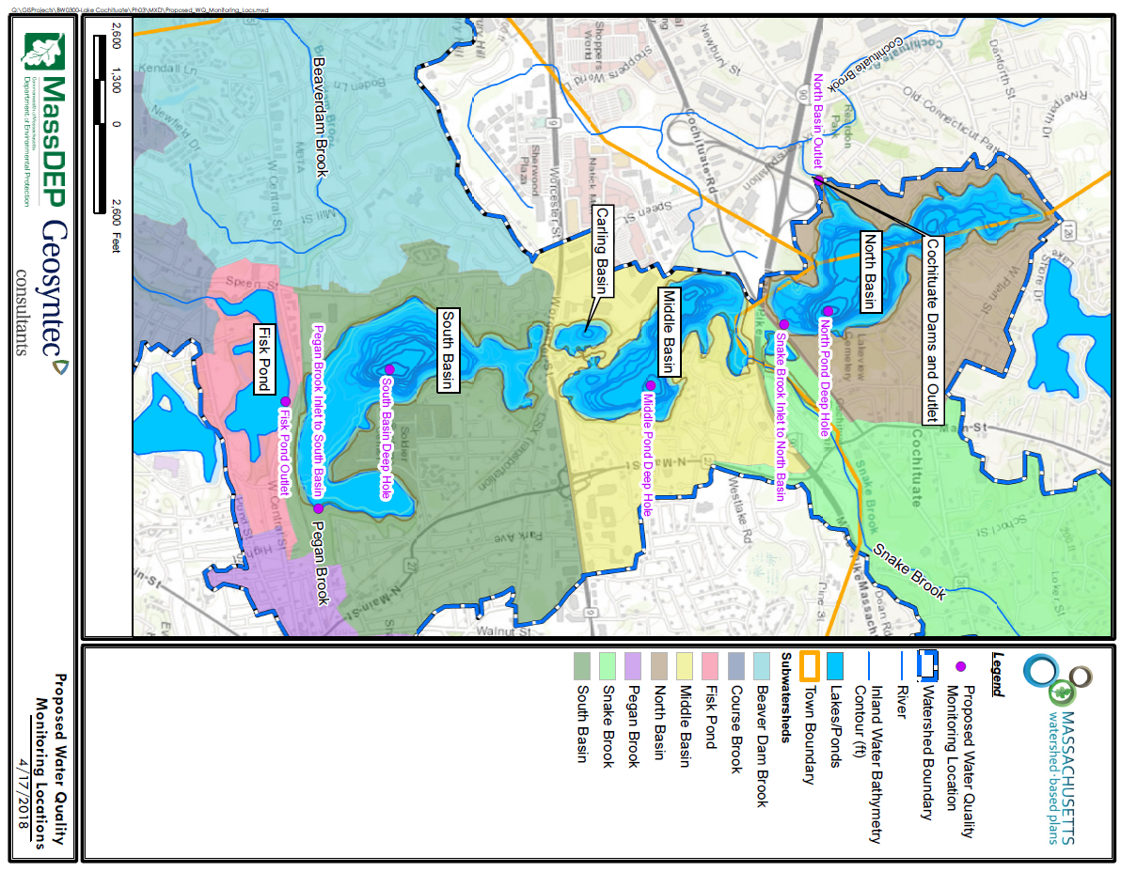
Figure HI-1. Proposed Water Quality Monitoring Locations

References
Aquatic Control Technology (2016). “Year-End Report for the 2015 Aquatic Plant Management of the Lake Cochituate System”. Prepared for MA DCR, January 2016.
Aquatic Control Technology (2004). “Lake Cochituate Long Term Vegetation Management Plan”. Prepared for MA DCR, May 2004.
314 CMR 4.00 (2013). "Division of Water Pollution Control, Massachusetts Surface Water Quality Standards"
Cohen, A. J.; Randall, A.D. (1998). "Mean annual runoff, precipitation, and evapotranspiration in the glaciated northeastern United States, 1951-80." Prepared for United States Geological Survey, Reston VA.
Geosyntec Consultants, Inc. (2014). "Least Cost Mix of BMPs Analysis, Evaluation of Stormwater Standards Contract No. EP-C-08-002, Task Order 2010-12." Prepared for Jesse W. Pritts, Task Order Manager, U.S. Environmental Protection Agency
Geosyntec Consultants, Inc. (2015). "Appendix B: Pollutant Load Modeling Report, Water Integration for the Squamscott-Exeter (WISE) River Watershed."
Geosyntec Consultants, Inc. (2017a). "Lake Cochituate (Natick) Watershed Planning Project – Retrofit Proposal Memorandum"
Geosyntec Consultants, Inc. (2017b). "Lake Cochituate Microwatershed Characterizations and Priority Ranking"
Gillion and Patmont (1983). “Lake Phosphorus Loading from Septic Systems by Seasonally Perched Groundwater.”
King, D. and Hagan, P. (2011). "Costs of Stormwater Management Practices in Maryland Counties." University of Maryland Center for Environmental Science Chesapeake Biological Laboratory. October 11, 2011.
Leisenring, M., Clary, J., and Hobson, P. (2014). "International Stormwater Best Management Practices (BMP) Database Pollutant Category Statistical Summary Report: Solids, Bacteria, Nutrients and Metals." Geosyntec Consultants, Inc. and Wright Water Engineers, Inc. December 2014.
Massachusetts Department of Conservation and Recreation (2018). "Bacteria monitoring data for Lake Cochituate Beaches”. Personnel communication, Vanessa Curran, DCR, April 4, 2018.
Metropolitan Area Planning Council (2004) “Lake Cochituate Nonpoint Source Pollution Watershed Management Plan”
MassDEP (2013). “Lake Water Quality Survey 2005, DWM water quality monitoring data”. Published July 2013, DWM Control Number CN 224.5.
MassDEP (2012). "Massachusetts Year 2012 Integrated List of Waters Final Listing of Massachusetts' Waters Pursuant to Sections 305(b), 314 and 303(d) of the Clean Water Act"
MassDEP (2016a). "Massachusetts Clean Water Toolkit"
MassDEP (2016b). "Massachusetts Stormwater Handbook, Vol. 2, Ch. 2, Stormwater Best Management Practices"
MassGIS (1999). "Networked Hydro Centerlines" Shapefile
MassGIS (2001). "USGS Topographic Quadrangle Images" Image
MassGIS (2007). "Drainage Sub-basins" Shapefile
MassGIS (2009a). "Impervious Surface" Image
MassGIS (2009b). "Land Use (2005)" Shapefile
MassGIS (2013). "MassDEP 2012 Integrated List of Waters (305(b)/303(d))" Shapefile
MassGIS (2017). "Inland Water Bathymetry (1:10,000)" Shapefile
Reckhow, K.H., Beulac, M.N., and Simpson, J.T. (1980). “Modeling phosphorus loading and lake response under uncertainty: a manual and compilation of export coefficients,” U.S. EPA Repot No. EPA-440/5-80-011, Office of Water Regulations, Criteria and Standards Division, U.S. Environmental Protection Agency, Washington DC.
Michigan DNR (2000). “Manual of Fisheries and Survey Methods”. Chapter 12 – three methods for computing the volume of a lake.
Schueler, T.R., Fraley-McNeal, L, and K. Cappiella (2009). "Is impervious cover still important? Review of recent research" Journal of Hydrologic Engineering 14 (4): 309-315.
United States Army (2010). Sediment Cleanup on Lake Cochituate, USAG Natick Environmental Office, June 24, 2010.
United States Bureau of Labor Statistics (2016). "Consumer Price Index"
United States Geological Survey (2016). "National Hydrography Dataset, High Resolution Shapefile"
University of Massachusetts, Amherst (2004). "Stormwater Technologies Clearinghouse"
USDA NRCS and MassGIS (2012). "NRCS SSURGO-Certified Soils" Shapefile
USEPA (2002). “Onsite Wastewater Treatment Systems Manual”. Report No. EPA/625/R-00/008, Office of Research and Development, U.S. Environmental Protection Agency, Washington D.C.
USEPA (1986). "Quality Criteria for Water (Gold Book)" EPA 440/5-86-001. Office of Water, Regulations and Standards. Washington, D.C.
USEPA. (2010). "EPA's Methodology to Calculate Baseline Estimates of Impervious Area (IA) and Directly Connected Impervious Area (DCIA) for Massachusetts Communities."
United States Geological Survey (2001). “Pond-Aquifer Interaction at South Pond of Lake Cochituate, Natick, Massachusetts”
Voorhees, Mark, USEPA. (2015). "FW: Description of additional modelling work for Opti-Tool Project" Message to Chad Yaindl, Geosyntec Consultants. 23 April 2015. E-mail.
Voorhees, Mark, USEPA. (2016a). "FW: EPA Region 1 SW BMP performance equations" Message to Chad Yaindl, Geosyntec Consultants. 25 January 2016. E-mail.
Voorhees, Mark, USEPA. (2016b). "FW: Description of additional modelling work for Opti-Tool Project" Message to Chad Yaindl, Geosyntec Consultants. 23 April 2015. E-mail.
Vollenweider, R.A., Schweiz, Z, (1975). “Input-Output models with special reference to the phosphorus loading concept in limnology”. Hydrologie 37:53. DOI: 10.1007/BF025178.

Appendices

Appendix A – Lake Cochituate Microwatersheds
Refer to Geosyntec Consultants (2017b) for explanation of maps (clickable hyperlink).
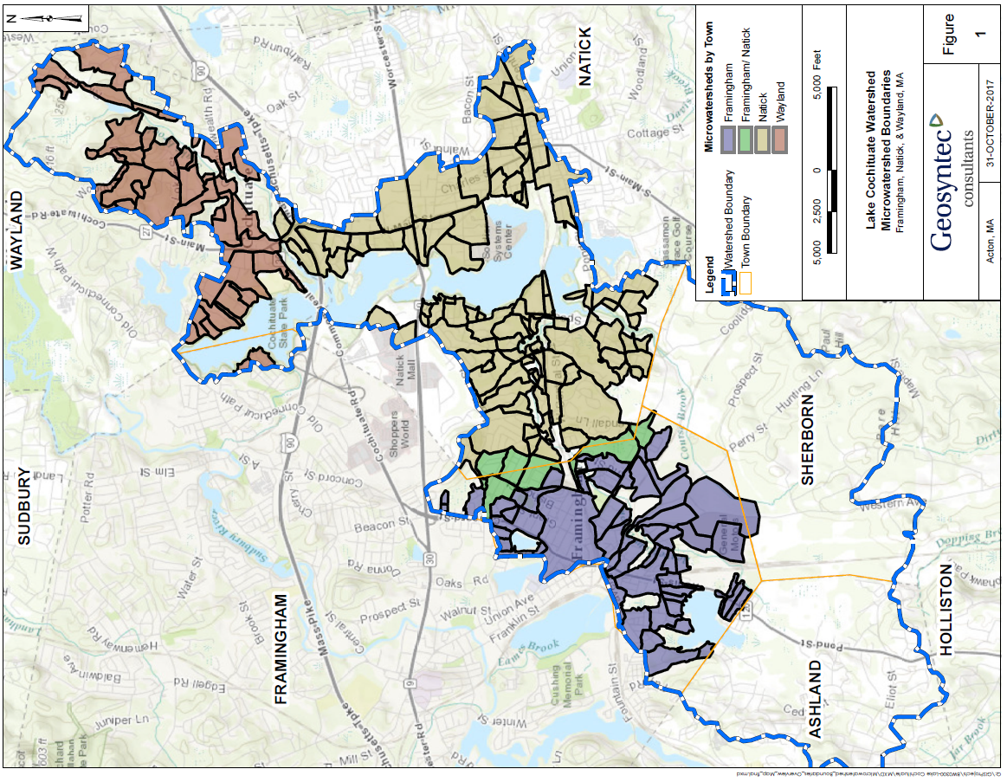
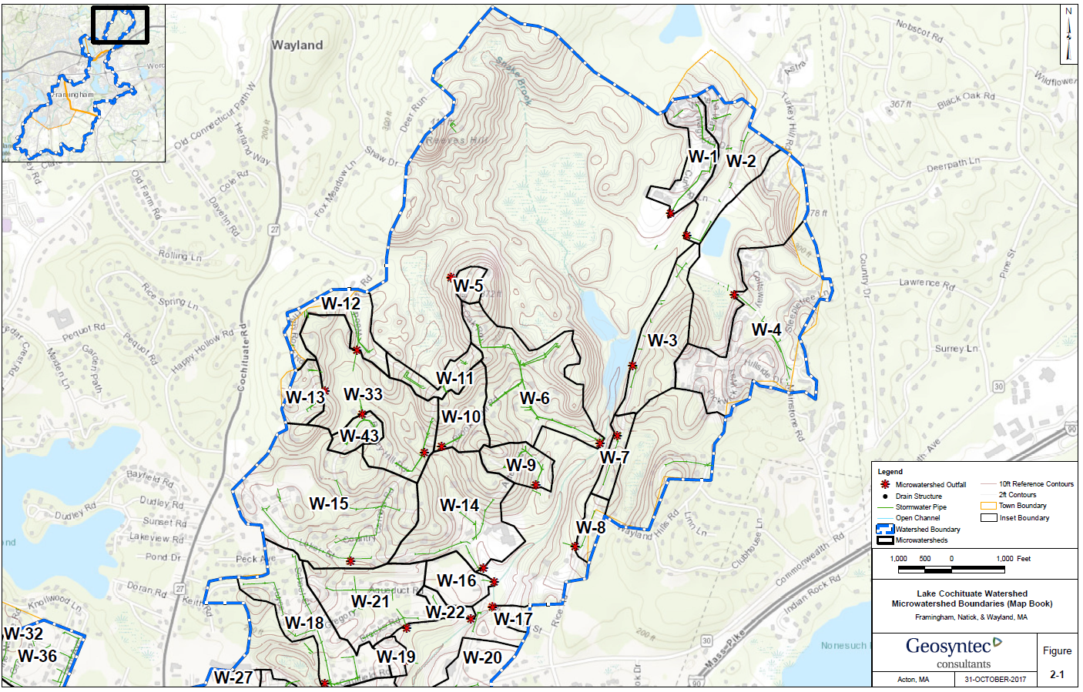

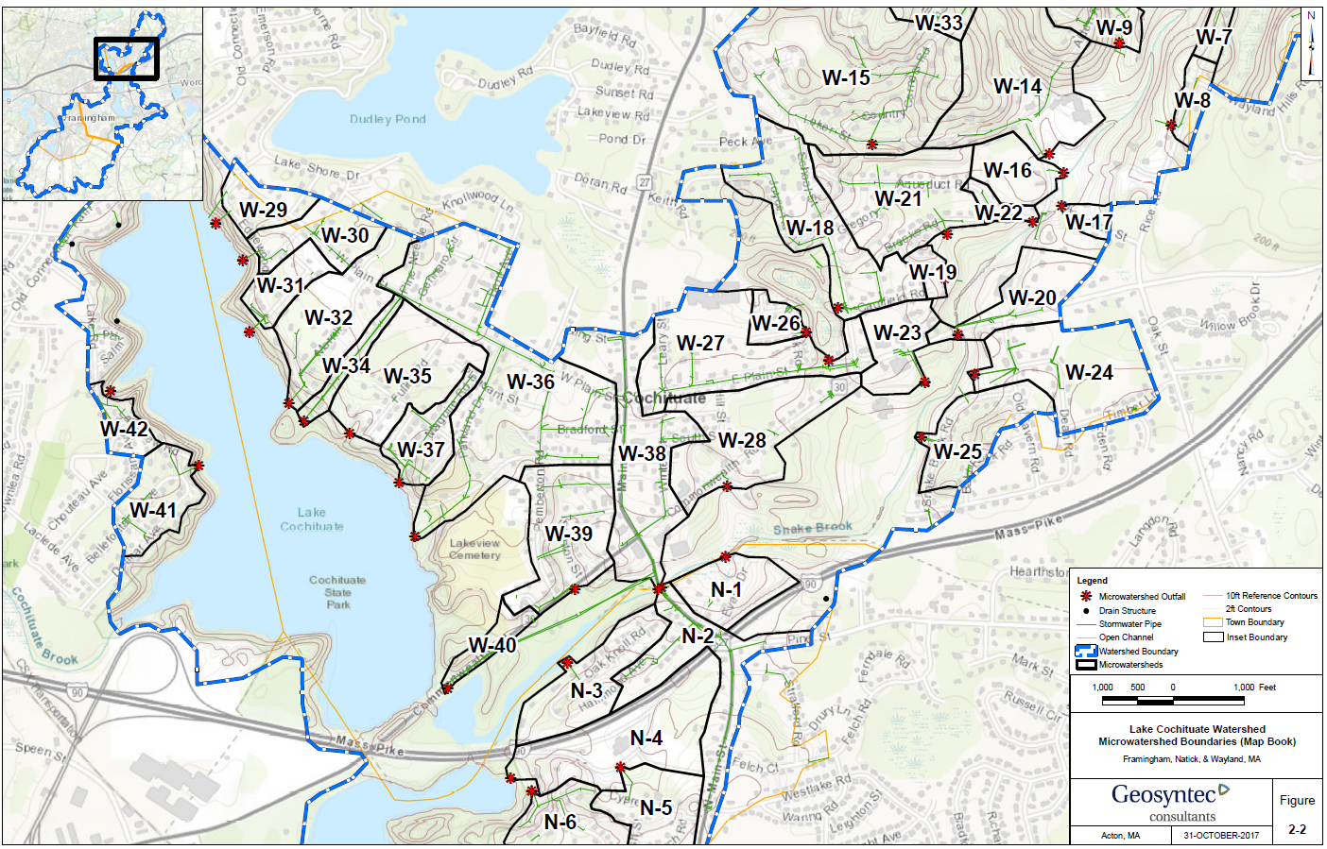
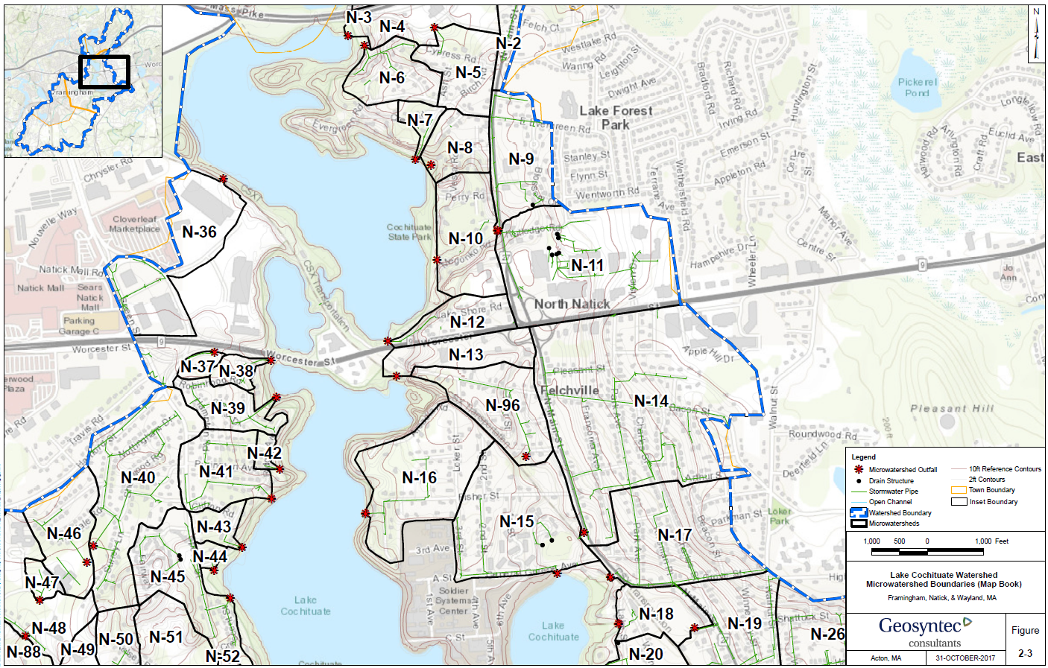
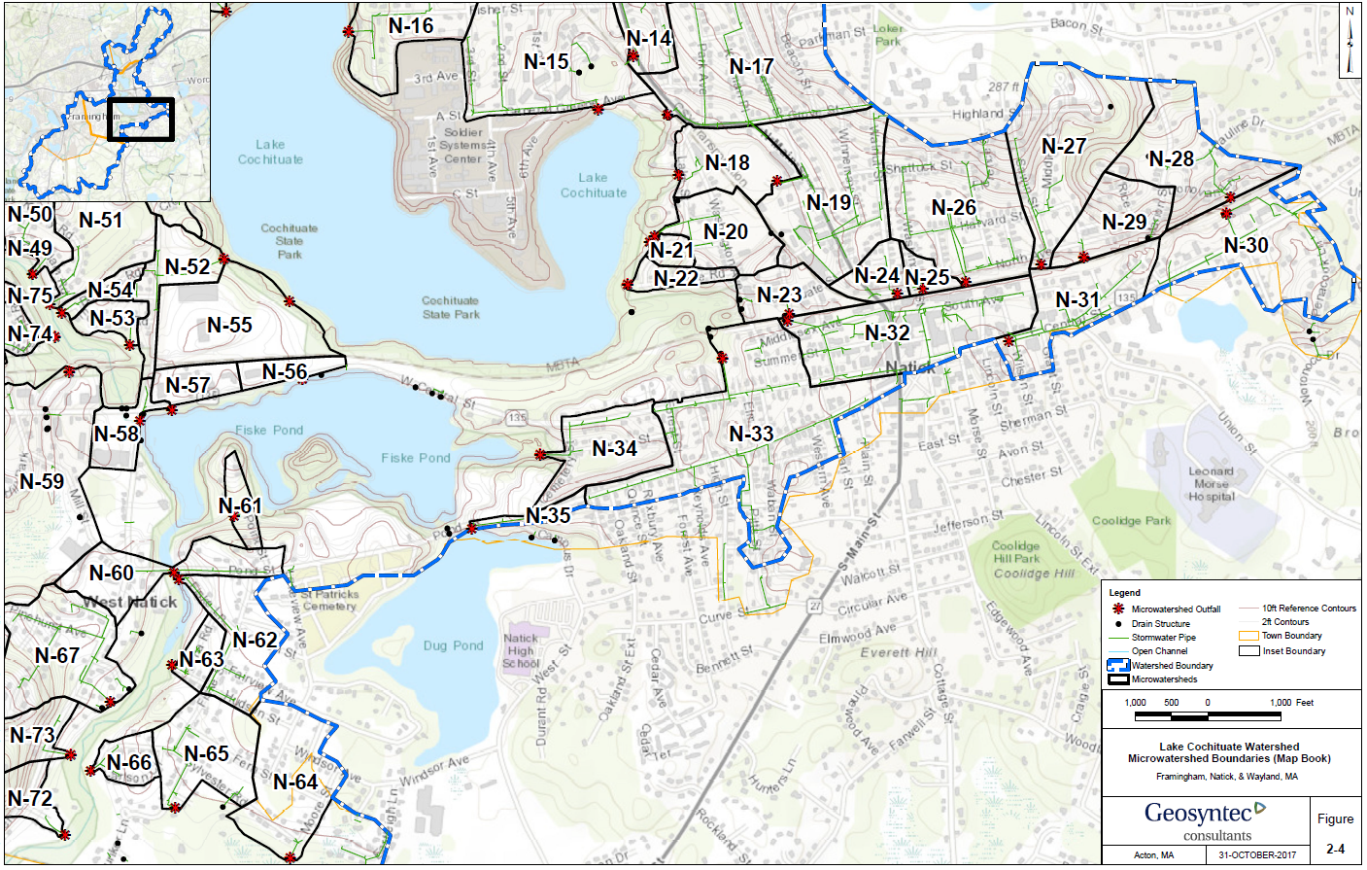
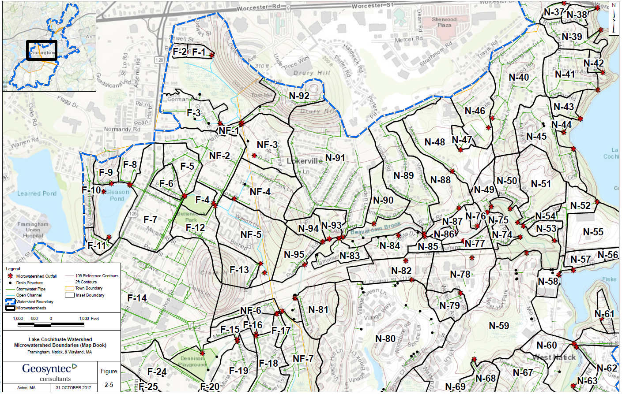
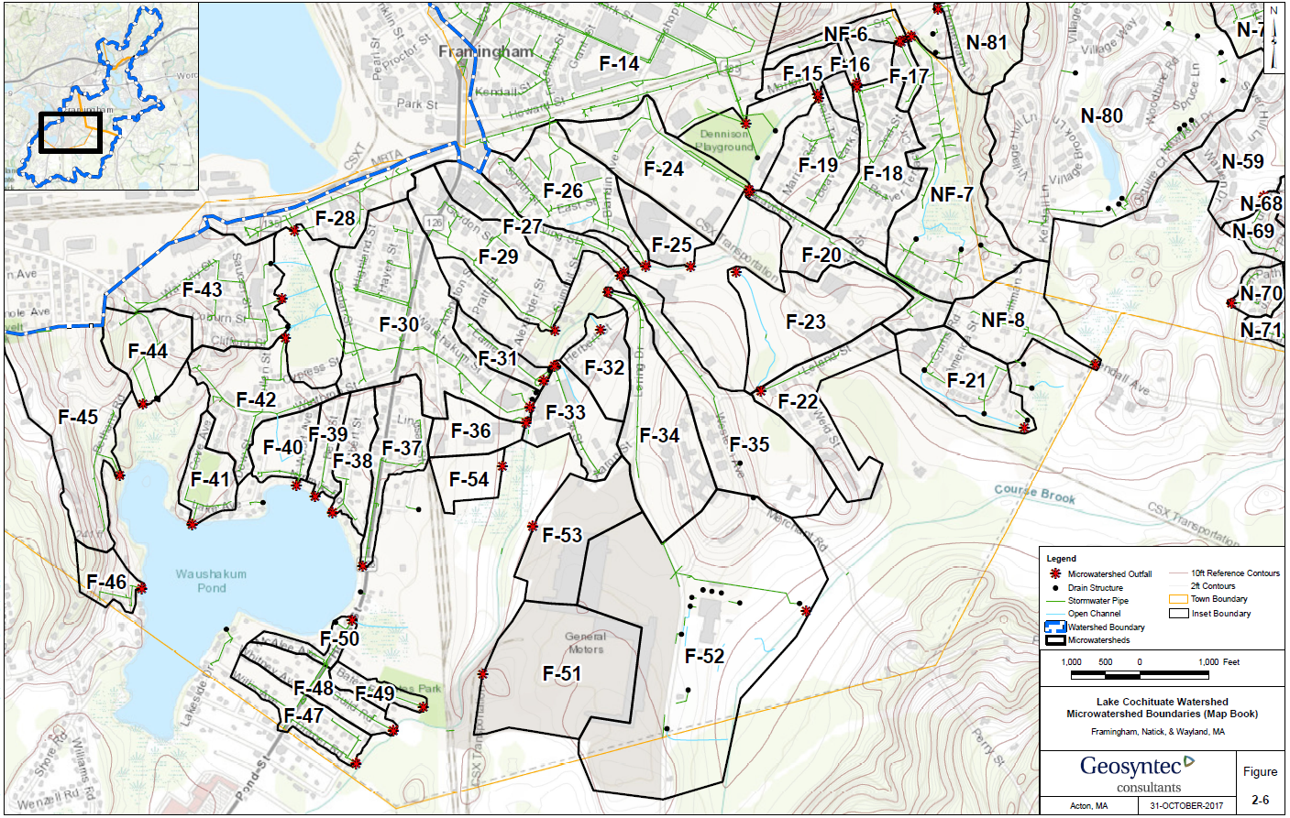

Appendix B – Pollutant Load Export Rates (PLERs)

Land Use & Cover¹ | PLERs (lb/acre/year)
Land Use & Cover¹ | (TP) | (TSS) | (TN)
AGRICULTURE, HSG A | 0.45 | 7.14 | 2.59
AGRICULTURE, HSG B | 0.45 | 29.4 | 2.59
AGRICULTURE, HSG C | 0.45 | 59.8 | 2.59
AGRICULTURE, HSG D | 0.45 | 91.0 | 2.59
AGRICULTURE, IMPERVIOUS | 1.52 | 650 | 11.3
COMMERCIAL, HSG A | 0.03 | 7.14 | 0.27
COMMERCIAL, HSG B | 0.12 | 29.4 | 1.16
COMMERCIAL, HSG C | 0.21 | 59.8 | 2.41
COMMERCIAL, HSG D | 0.37 | 91.0 | 3.66
COMMERCIAL, IMPERVIOUS | 1.78 | 377 | 15.1
FOREST, HSG A | 0.12 | 7.14 | 0.54
FOREST, HSG B | 0.12 | 29.4 | 0.54
FOREST, HSG C | 0.12 | 59.8 | 0.54
FOREST, HSG D | 0.12 | 91.0 | 0.54
FOREST, HSG IMPERVIOUS | 1.52 | 650 | 11.3
HIGH DENSITY RESIDENTIAL, HSG A | 0.03 | 7.14 | 0.27
HIGH DENSITY RESIDENTIAL, HSG B | 0.12 | 29.4 | 1.16
HIGH DENSITY RESIDENTIAL, HSG C | 0.21 | 59.8 | 2.41
HIGH DENSITY RESIDENTIAL, HSG D | 0.37 | 91.0 | 3.66
HIGH DENSITY RESIDENTIAL, IMPERVIOUS | 2.32 | 439 | 14.1
HIGHWAY, HSG A | 0.03 | 7.14 | 0.27
HIGHWAY, HSG B | 0.12 | 29.4 | 1.16
HIGHWAY, HSG C | 0.21 | 59.8 | 2.41
HIGHWAY, HSG D | 0.37 | 91.0 | 3.66
HIGHWAY, IMPERVIOUS | 1.34 | 1,480 | 10.2
INDUSTRIAL, HSG A | 0.03 | 7.14 | 0.27
INDUSTRIAL, HSG B | 0.12 | 29.4 | 1.16
INDUSTRIAL, HSG C | 0.21 | 59.8 | 2.41
INDUSTRIAL, HSG D | 0.37 | 91.0 | 3.66
INDUSTRIAL, IMPERVIOUS | 1.78 | 377 | 15.1
LOW DENSITY RESIDENTIAL, HSG A | 0.03 | 7.14 | 0.27
LOW DENSITY RESIDENTIAL, HSG B | 0.12 | 29.4 | 1.16
LOW DENSITY RESIDENTIAL, HSG C | 0.21 | 59.8 | 2.41
LOW DENSITY RESIDENTIAL, HSG D | 0.37 | 91.0 | 3.66
LOW DENSITY RESIDENTIAL, IMPERVIOUS | 1.52 | 439 | 14.1
MEDIUM DENSITY RESIDENTIAL, HSG A | 0.03 | 7.14 | 0.27
MEDIUM DENSITY RESIDENTIAL, HSG B | 0.12 | 29.4 | 1.16
MEDIUM DENSITY RESIDENTIAL, HSG C | 0.21 | 59.8 | 2.41
MEDIUM DENSITY RESIDENTIAL, HSG D | 0.37 | 91.0 | 3.66
MEDIUM DENSITY RESIDENTIAL, IMPERVIOUS | 1.96 | 439 | 14.1
OPEN LAND, HSG A | 0.12 | 7.14 | 0.27
OPEN LAND, HSG B | 0.12 | 29.4 | 1.16
OPEN LAND, HSG C | 0.12 | 59.8 | 2.41
OPEN LAND, HSG D | 0.12 | 91.0 | 3.66
OPEN LAND, IMPERVIOUS | 1.52 | 650 | 11.3
¹HSG = Hydrologic Soil Group

Appendix C – Lake Cochituate Volume Estimates
Bathymetry data were obtained from MassGIS (2017) and used to estimate the volume of Lake Cochituate. The area was tabulated for each 5-ft depth contour, then the volume was estimated based on the commonly used equation to compute the frustrum of a circular cone (Michigan DNR, 2000).
$$V=\frac{1}{3}H\left(A_{1}+A_{2}+\sqrt{A_{1}+A_{2}}\right)$$
Where: V = volume of water
H = difference in depth between two successive depth contours
A₁ = Area of lake within the outer depth contour
A₂ = Area of lake within the inner depth contour

Waterbody | Contour Depth (ft) | Area (acres) | Incremental Volume (ac-ft)
North Basin | 0 | 196.0 | -
North Basin | 5 | 38.6 | 535.9
North Basin | 10 | 19.3 | 142.0
North Basin | 15 | 13.4 | 81.3
North Basin | 20 | 17.5 | 77.0
North Basin | 25 | 21.1 | 96.5
North Basin | 30 | 19.3 | 101.0
North Basin | 35 | 14.3 | 83.8
North Basin | 40 | 13.2 | 68.8
North Basin | 45 | 16.2 | 73.3
North Basin | 50 | 27.7 | 108.4
North Basin | 55 | 10.2 | 91.2
North Basin | 60 | 4.4 | 35.6
North Basin | 65 | 1.3 | 13.3
Sub-Total |  |  | 1,508.2
Middle Basin | 0 | 135.0 | -
Middle Basin | 5 | 35.0 | 398.0
Middle Basin | 10 | 9.3 | 104.1
Middle Basin | 15 | 9.1 | 46.2
Middle Basin | 20 | 10.6 | 49.3
Middle Basin | 25 | 13.1 | 59.1
Middle Basin | 30 | 11.2 | 60.8
Middle Basin | 35 | 9.9 | 52.8
Middle Basin | 40 | 11.7 | 53.9
Middle Basin | 45 | 18.9 | 75.7
Middle Basin | 50 | 14.6 | 83.6
Middle Basin | 55 | 1.1 | 32.9
Sub-Total |  |  | 1,016.4
Carling Basin | 0 | 14.0 | -
Carling Basin | 5 | 5.4 | 46.8
Carling Basin | 10 | 2.7 | 19.7
Carling Basin | 15 | 3.4 | 15.0
Carling Basin | 20 | 2.3 | 14.0
Carling Basin | 25 | 2.3 | 11.3
Carling Basin | 30 | 0.7 | 7.2
Sub-Total |  |  | 114.0
South Basin | 0 | 240.0 | -
South Basin | 5 | 133.1 | 919.7
South Basin | 10 | 42.8 | 419.1
South Basin | 15 | 1.3 | 85.8
South Basin | 20 | 11.0 | 26.7
South Basin | 25 | 10.1 | 52.8
South Basin | 30 | 9.6 | 49.3
South Basin | 35 | 8.1 | 44.3
South Basin | 40 | 11.2 | 48.1
South Basin | 45 | 6.8 | 44.6
South Basin | 50 | 5.4 | 30.6
South Basin | 55 | 7.3 | 31.8
South Basin | 60 | 7.5 | 37.0
South Basin | 65 | 3.0 | 25.4
Sub-Total (ac-ft) |  |  | 1,815.2
Grand Total (ac-ft) |  |  | 4,453.7
Grand Total (MG) |  |  | 1,451.0

Appendix D.1 – Primary BMP Recommendations
Site Natick 1: Natick Fire Department

Catch Basin 1
Runoff
Location of Tree Filter 1
Photo 1-1
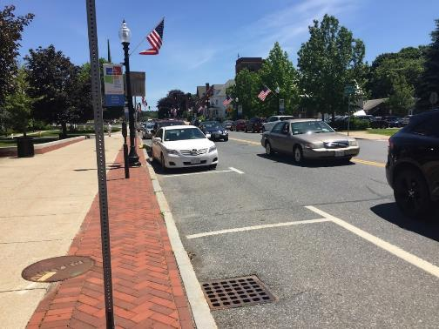
Catch Basin 2
Photo 1-2
Location of Tree Filter 2
Micro-watershed No.: N-32
BMP Type: Tree Filters
BMP Location: Curb Locations along East Central Street
Priority Rank: High

Site Summary:
Runoff from the Natick Fire Department vehicle entrance drive drains to the north edge of East Central Street into two existing catch basins.
Proposed Improvement:
Install two tree filters on the northern edges of East Central Street outside of the Fire Department within the curb at the locations adjacent to catch basins 1 outside the fire department and catch basin 2 outside the library.
Expected O&M:
Remove accumulated sediment from Tree Filters and maintain/replace plants as needed every two years.
Parcel Ownership: Town Owned (Right-of-way)

Sizing Characteristics
BMP Drainage Area (acres) | 0.44
BMP Size (storm depth; inches) | 0.5
Impervious Area (%) | 100
Estimated Pollutant Load Reduction
TP (lbs./yr.) | 0.46
TN (lbs./yr.) | 4.1
TSS (lbs./yr.) | 157.2
Estimated Cost
Planning-level Capital Cost | $25,000

Site Natick 2: Morris Library
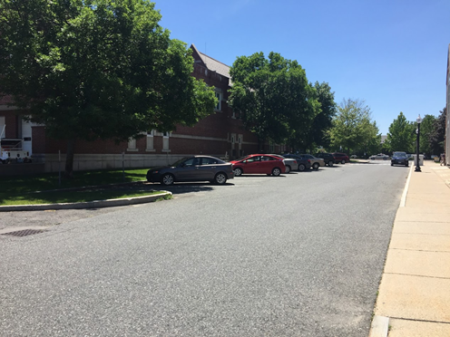
Photo 2-1
Runoff
Permeable Pavers
Micro-watershed No.: N-32
BMP Type: Permeable Pavers
BMP Location: 10 Clarendon Street
Priority Rank: Low
Site Summary:
Runoff from the Natick Police Department Parking Lot and Clarendon Street drains to an existing catch basin on Clarendon Street.
Proposed Improvement:
Install approx. 5000–square feet of permeable pavers to infiltrate runoff.
Expected O&M:
Remove accumulated sediment from permeable pavers by means of street sweeper or vacuum as needed twice a year.
Parcel Ownership: Town Owned Parcel

Sizing Characteristics
BMP Drainage Area (acres) | 0.44
BMP Size (storm depth; inches) | 0.5
Impervious Area (%) | 100
Estimated Pollutant Load Reduction
TP (lbs./yr.) | 0.46
TN (lbs./yr.) | 4.1
TSS (lbs./yr.) | 157.2
Estimated Cost
Planning-level Capital Cost | $66,400

Site Natick 3A: Murphy Field
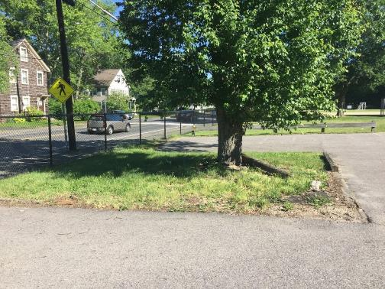
Photo 3A-1
Runoff
Berm
Raingarden
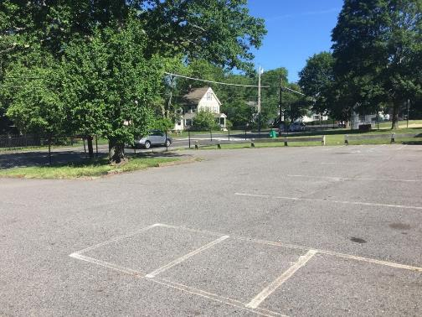
Photo 3A-2
Runoff Catchment Area
Runoff
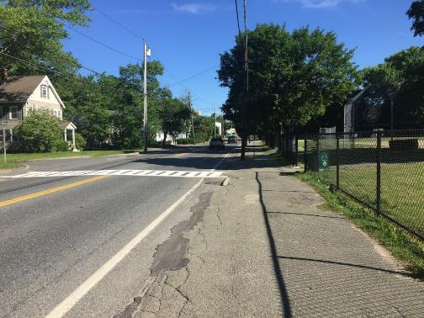
Photo 3A-3
Murphy Field Entrance
Catch Basin
Micro-watershed No.: N-14
BMP Type: Raingarden
BMP Location: 157 North Main Street
Priority Rank: High
Site Summary:
Murphy field is a recreational park that consists of a large grassed athletic field, playground area, and both an asphalt and gravel public parking lot. Runoff from the athletic field and asphalt parking lot drains west to an existing catch basin located on North Main Street outside the parking lot entrance. A mature tree and grassed area is located near the northwest corner of the parking lot. The sidewalk and catch basins outside Murphy Field along North Main Street appeared to have been repaired multiple times and potentially require additional rehabilitation.
Proposed Improvement:
Install a 30-foot long berm at the northwestern edge of the Murphy Field parking lot to convey runoff from the northern section of the parking lot towards the grassed area. Install an approx. 400-square foot Raingarden within the grassed area to treat the section of parking lot runoff.
Expected O&M: Remove accumulated sediment from raingarden annually and maintain/replace plants as needed every two years. Re-mulch annually. Remove accumulated sediment/debris, as needed.
Parcel Ownership: Town owned (Recreational Park)

Sizing Characteristics
BMP Drainage Area (acres) | 2.4
BMP Size (storm depth; inches) | 0.5
Impervious Area (%) | 22
Estimated Pollutant Load Reduction
TP (lbs./yr.) | 0.73
TN (lbs./yr.) | 5.9
TSS (lbs./yr.) | 271.6
Estimated Cost
Planning-level Capital Cost | $44,700

Site Natick 3B: Murphy Field
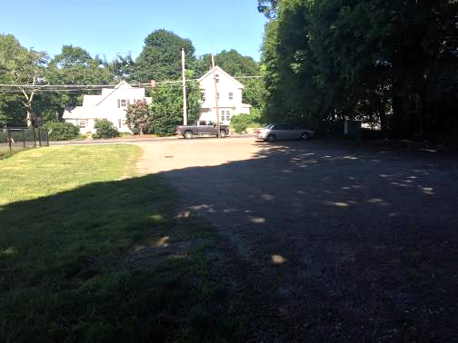
Photo 3B-1
Area to be Paved
Runoff
Bioretention Cell
Catch Basin
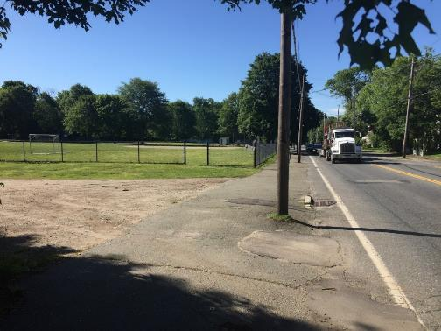
Photo 3B-2
Curb Cut
Catch Basin
Area to be Paved
Bioretention Cell
Micro-watershed No.: N-14
BMP Type: Bioretention
BMP Location: 157 North Main Street
Priority Rank: High
Site Summary:
Murphy field is a recreational park that consists of a large grassed athletic field, playground area, and both an asphalt and gravel public parking lot. Runoff from the northern portion of the athletic field and the gravel parking lot drains to a clogged catch basin located in the center of the existing gravel parking lot. The catch basin has likely become clogged due to the dirt and gravel surface of the parking lot. The sidewalk and catch basins outside Murphy Field along North Main Street appeared to have been repaired multiple times and potentially require additional rehabilitation.
Proposed Improvement:
Pave the gravel parking lot with asphalt and convey the runoff south towards the available grassed area adjacent to the gravel parking lot. Install an approx. 800–square foot bioretention cell in the grassed area to treat the parking lot runoff. Install curb cut at catch basin to redirect runoff from North Main Street adjacent to the gravel parking lot to convey a portion of road runoff to the bioretention cell.
Expected O&M:
Remove accumulated sediment from bioretention cell annually and maintain/replace plants as needed every two years. Re-mulch annually. Remove accumulated sediment/debris, as needed.
Parcel Ownership: Town owned (Recreational Park)
Sizing Characteristics
BMP Drainage Area (acres) | 1.9
BMP Size (storm depth; inches) | 0.5
Impervious Area (%) | 30%
Estimated Pollutant Load Reduction
TP (lbs./yr.) | 0.74
TN (lbs./yr.) | 5.9
TSS (lbs./yr.) | 274
Estimated Cost
Planning-level Capital Cost | $35,400

Site Natick 4: Fairbanks Place
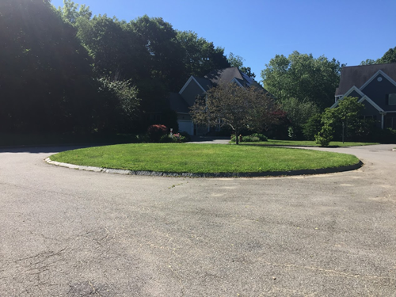
Photo 4-1
Curb Cut
Bioretention Cell

Micro-watershed No.: N-14
BMP Type: Bioretention
BMP Location: Cul-De-Sac at Fairbanks Place
Priority Rank: Medium
Site Summary:
Fairbanks Place is a residential cul-de-sac style road. Runoff from three homes and upper Fairbanks Place drain north around cul-de-sac and flows towards two catch basins on the east and west sides of Fairbanks Place.
Proposed Improvement:
Install a curb cut within the cul-de-sac to allow for stormwater to flow inside the grassed circle. Install an approx. 700-square foot bioretention cell in the circular grassed area to infiltrate the residential runoff.
Expected O&M:
Remove accumulated sediment from bioretention cell annually and maintain/replace plants as needed every two years. Re-mulch annually. Remove accumulated sediment/debris, as needed.
Parcel Ownership: Town owned (Right-Of-Way)

Sizing Characteristics
BMP Drainage Area (acres) | 0.5
BMP Size (storm depth; inches) | 0.5
Impervious Area (%) | 30
Estimated Pollutant Load Reduction
TP (lbs./yr.) | 0.18
TN (lbs./yr.) | 1.4
TSS (lbs./yr.) | 66.3
Estimated Cost
Planning-level Capital Cost | $9,300

Site Natick 5: Town Parking Lot Location 1

Runoff
Runoff
Infiltration Trench
Photo 5-1
Micro-watershed No.: N-33
BMP Type: Infiltration Trench
BMP Location: 29 Pond Street
Priority Rank: High
Site Summary:
Runoff from the town parking lot flows to catch basins on the northern and southern edges of the parking lot.
Proposed Improvement:
Pave the parking lot to convey runoff to the centerline of the lot. Install an approx. 5000–square foot infiltration trench in the center of the parking lot.
Expected O&M:
Remove accumulated sediment from trench surface as needed annually. Replant grass as needed to maintain adequate vegetative cover. Remove accumulated debris prior to mowing.
Parcel Ownership: Town Owned (Public Parking Lot)

Sizing Characteristics
BMP Drainage Area (acres) | 1.0
BMP Size (storm depth; inches) | 0.5
Impervious Area (%) | 100
Estimated Pollutant Load Reduction
TP (lbs./yr.) | 1.03
TN (lbs./yr.) | 9.3
TSS (lbs./yr.) | 357.3
Estimated Cost
Planning-level Capital Cost | $18,600

Site Natick 6: Rutledge Road
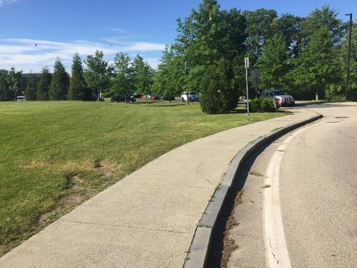
Photo 6-1
Bioretention Cell
Curb Cut
Catch Basin
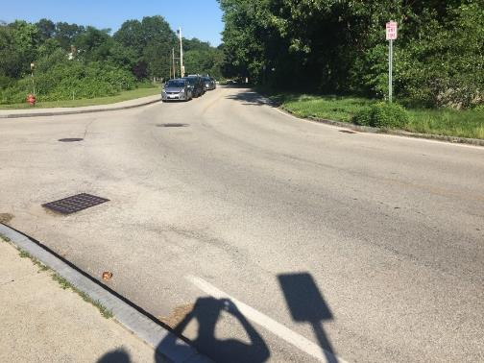
Curb Cut
Catch Basin
Speed Bump
Photo 6-2
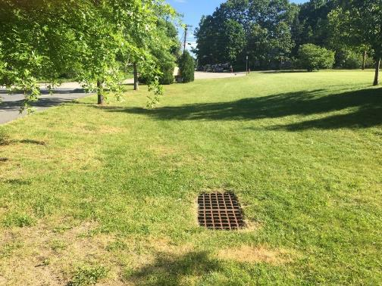
Rutledge Rd
Bioretention Cell
Photo 6-3
Micro-watershed No.: N-11
BMP Type: Bioretention
BMP Location: Rutledge Road
Priority Rank: Medium
Site Summary:
The entrance of Wilson Middle School is located along Rutledge Road. A catch basin at the east side of the Wilson Middle School entrance collects road runoff draining southwest from both Rutledge Road and Rutledge Lane which discharges untreated to an outfall draining into Lake Cochituate. The area is comprised of a large athletic field, school grounds, and residential roads.
Proposed Improvement:
Install speed bump across Rutledge Road adjacent to the entrance of the Middle school to direct runoff from Rutledge Lane and both sides of Rutledge Road, as well as provide effective traffic calming. Install curb cut through sidewalk to convey runoff from speed bump to grassed area at the western side of the athletic field. Install a approx. 2000-square foot bioretention cell within grassed area to treat road runoff.
Expected O&M:
Remove accumulated sediment from bioretention cell annually and maintain/replace plants as needed every two years. Mow grassed swale regularly. Replant grass as needed to maintain adequate vegetative cover. Remove accumulated debris prior to mowing.
Parcel Ownership: Town owned (Public School Property)

Sizing Characteristics
BMP Drainage Area (acres) | 1.9
BMP Size (storm depth; inches) | 0.5
Impervious Area (%) | 28%
Estimated Pollutant Load Reduction
TP (lbs./yr.) | 0.70
TN (lbs./yr.) | 5.6
TSS (lbs./yr.) | 259.2
Estimated Cost
Planning-level Capital Cost | $35,400

Site Natick 7: Willow Street
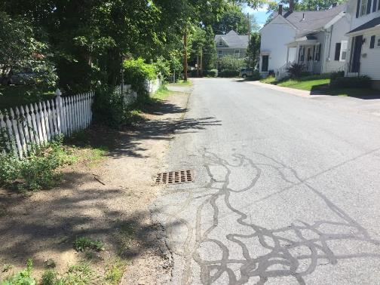
Catch Basin
Water Quality Swale
Runoff
Photo 7-1
Micro-watershed No.: N-19
BMP Type: Water Quality Swale
BMP Location: Intersection of Winnemay and Willow Street
Priority Rank: Low
Site Summary:
Untreated runoff flows west from upper Willow Street to a catch basin on the northern edge of Willow Street adjacent to Winnemay Street. The area is comprised of narrow residential streets.
Proposed Improvement:
Redirect runoff draining to the existing catch basin on the northern edge of Willow Street of the road to allow runoff to be conveyed to the existing easement. Install an approx. 650-square foot water quality swale in the easement on Willow Street.
Expected O&M:
Remove accumulated sediment from swale and maintain/replace plants as needed every two years. Replant grass as needed to maintain adequate vegetative cover. Remove accumulated debris, as needed.
Parcel Ownership: Town Owned (Right-Of-Way)

Sizing Characteristics
BMP Drainage Area (acres) | 0.4
BMP Size (storm depth; inches) | 0.5
Impervious Area (%) | 35
Estimated Pollutant Load Reduction
TP (lbs./yr.) | 0.03
TN (lbs./yr.) | -
TSS (lbs./yr.) | 44.7
Estimated Cost
Planning-level Capital Cost | $5,800

Site Natick 8: Grove Street and North Main Street
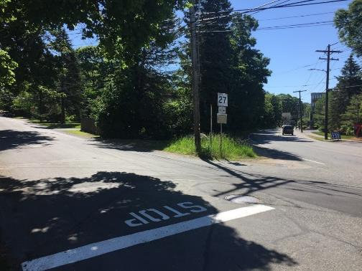
Runoff
Curb Cut
Catch Basin
Raingarden
Area to be Paved
Photo 8-1
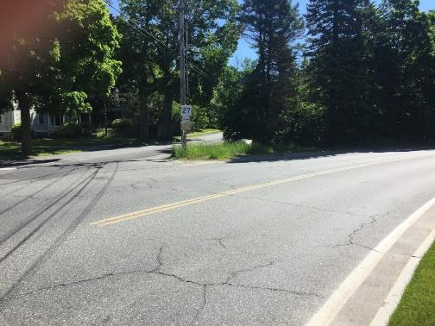
Runoff
Raingarden
Photo 8-2
Micro-watershed No.: N-17
BMP Type: Raingarden
BMP Location: Intersection of Grove Street and North Main Street
Priority Rank: High
Site Summary:
Untreated residential runoff flows west from Grove Street and North Main Street towards an existing catch basin at the intersection of Grove Street and North Main Street. An undeveloped grassed corner lot located within a road easement exists upgradient of the catch basin where lower Grove Street and North Main Street drain towards.
Proposed Improvement:
Install a curb cut along the lower southern shoulder of Grove Street. Grade the northern shoulder of North Main Street to convey runoff to drain into the undeveloped corner lot before it enters the existing catch basin. Install an approx. 700–square foot raingarden in the corner lot to capture and treat the combined residential runoff and road runoff.
Expected O&M:
Remove accumulated sediment from raingarden annually and maintain/replace plants as needed every two years. Re-mulch annually. Remove accumulated sediment/debris, as needed.
Parcel Ownership: Town owned (Right-of-Way)

Sizing Characteristics
BMP Drainage Area (acres) | 0.4
BMP Size (storm depth; inches) | 0.52
Impervious Area (%) | 90
Estimated Pollutant Load Reduction
TP (lbs./yr.) | 0.52
TN (lbs./yr.) | 4.0
TSS (lbs./yr.) | 188.4
Estimated Cost
Planning-level Capital Cost | $9,300

Site Natick 9: Fisher Street
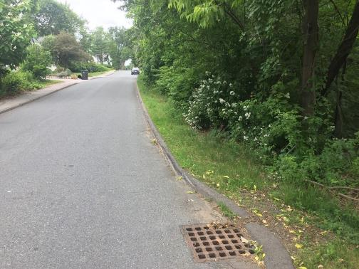
Bioretention Cell
Runoff
Curb Cut
Catch Basin
Photo 9-1
Micro-watershed No.: N-15
BMP Type: Bioretention
BMP Location: 11 Fisher Street
Priority Rank: Low
Site Summary:
Untreated residential runoff flows east on Fisher Street towards an existing catch basin. An undeveloped grassed area located within a road easement exists downgradient of the catch basin.
Proposed Improvement:
Install a curb cut along the upper shoulder of Fisher Street to allow runoff to be conveyed onto the grassed area along Fisher Street. Install an approx. 800–square foot bioretention cell at the curb cut in the corner lot to capture and treat the combined residential runoff and road runoff.
Expected O&M:
Remove accumulated sediment from bioretention cell annually and maintain/replace plants as needed every two years. Re-mulch annually. Remove accumulated sediment/debris, as needed.
Parcel Ownership: Town Owned (Utility Easement)

Sizing Characteristics
BMP Drainage Area (acres) | 2.3
BMP Size (storm depth; inches) | 0.25
Impervious Area (%) | 29
Estimated Pollutant Load Reduction
TP (lbs./yr.) | 0.62
TN (lbs./yr.) | 5.5
TSS (lbs./yr.) | 251.2
Estimated Cost
Planning-level Capital Cost | $26,700

Site Natick 10: Lodge Road
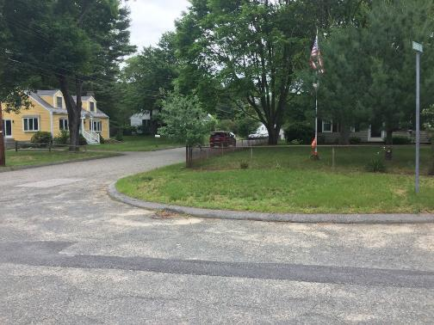
Raingarden
Runoff
Catch Basin
Curb Cut
Photo 10-1
Micro-watershed No.: N-54
BMP Type: Raingarden
BMP Location: Intersection of Lodge and Belmore Road
Priority Rank: Medium
Site Summary:
Road runoff from Lodge drains to a catch basin at the intersection of Lodge Road and Belmore Road.
Proposed Improvement:
Redirect the runoff draining to the catch basin on the southeast corner of the lot. Install a curb cut at the location of the catch basin to convey runoff over the sidewalk and onto the grassed area. Install an approx. 500–square foot raingarden.
Expected O&M:
Remove accumulated sediment from raingarden annually and maintain/replace plants as needed every two years. Re-mulch annually. Remove accumulated sediment/debris, as needed.
Parcel Ownership: Town Owned (Right-Of-Way)

Sizing Characteristics
BMP Drainage Area (acres) | 0.4
BMP Size (storm depth; inches) | 0.5
Impervious Area (%) | 90
Estimated Pollutant Load Reduction
TP (lbs./yr.) | 0.41
TN (lbs./yr.) | 3.2
TSS (lbs./yr.) | 150.7
Estimated Cost
Planning-level Capital Cost | $7,400

Site Natick 11: Fairway Circle
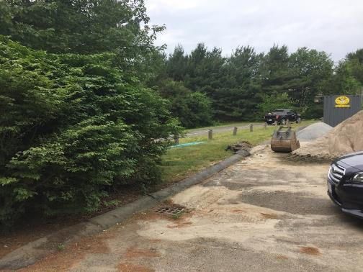
Runoff
Water Quality Swale
Catch Basin
Curb Cut
Photo 11-1
Micro-watershed No.: N-45
BMP Type: Water Quality Swale
BMP Location: 204 Speen Street
Priority Rank: Low
Road runoff from the parking lot south of Ziti’s Italian Trattoria is drained by one catch basin at the southeast corner of the lot.
Proposed Improvement:
Redirect the runoff draining to the catch basin on the southeast corner of the lot. Install a curb cut at the location of the catch basin to convey runoff over the sidewalk and onto the grassed area. Install an approx. 1200–square foot water quality swale.
Expected O&M:
Remove accumulated sediment from water quality swale annually and maintain/replace plants as needed every two years. Re-mulch annually. Remove accumulated sediment/debris, as needed.
Parcel Ownership: Town Owned (Utility Easement)

Sizing Characteristics
BMP Drainage Area (acres) | 0.25
BMP Size (storm depth; inches) | 0.5
Impervious Area (%) | 100
Estimated Pollutant Load Reduction
TP (lbs./yr.) | 0.05
TN (lbs./yr.) | -
TSS (lbs./yr.) | 71.1
Estimated Cost
Planning-level Capital Cost | $3,600

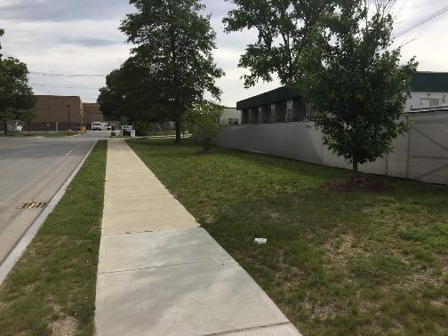
Water Quality Swale
Catch Basin
Curb Cut
Photo 12-1
Site Natick 12: Superior Drive – East
Micro-watershed No.: N-36
BMP Type: Water Quality Swale
BMP Location: 30 Prime Parkway
Priority Rank: High
Site Summary:
Parking lot runoff drains southeast towards an existing catch basin located adjacent to a grassed easement southwest of the FedEx Facility. The area is generally comprised of commercial buildings.
Proposed Improvement:
Redirect the runoff draining to existing catch basin on the southern edge of Superior Drive. Install a curb cut at the location of the existing basin and through the sidewalk to convey water onto the grassed area. Install an approx. 3000-square foot water quality swale along the grassed area parallel to the street.
Expected O&M:
Remove accumulated sediment from swale and maintain/replace plants as needed every two years. Replant grass as needed to maintain adequate vegetative cover. Remove accumulated debris, as needed.
Parcel Ownership: Town Owned (Right-Of-Way)

Sizing Characteristics
BMP Drainage Area (acres) | 0.4
BMP Size (storm depth; inches) | 0.5
Impervious Area (%) | 90
Estimated Pollutant Load Reduction
TP (lbs./yr.) | 0.38
TN (lbs./yr.) | 3.4
TSS (lbs./yr.) | 129.7
Estimated Cost
Planning-level Capital Cost | $7,400

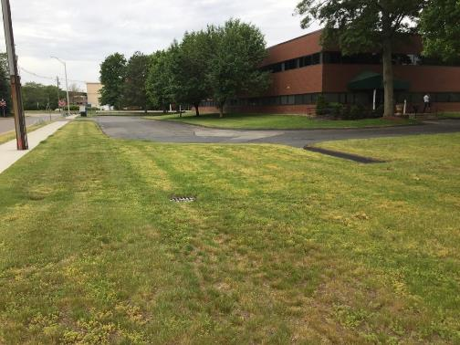
Curb Cut
Bioretention Cell
Curb Cut
Photo 13-1
Site Natick 13: Superior Drive - West
Micro-watershed No.: N-36
BMP Type: Bioretention
BMP Location: 15 Superior Drive
Priority Rank: High
Site Summary:
Road runoff from Superior Drive drains to catch basins on the northern and southern sides of Superior Drive. The area is comprised of commercial property.
Proposed Improvement:
Redirect the runoff draining to the catch basin on the southeast corner of the lot. Install a curb cut at the location of the catch basin in the road as well as the parking lot to convey runoff onto the grassed area. Install an approx. 4000–square foot bioretention cell.
Expected O&M:
Remove accumulated sediment from bioretention cell annually and maintain/replace plants as needed every two years. Re-mulch annually. Remove accumulated sediment/debris, as needed.
Parcel Ownership: Town Owned (Right-Of-Way)

Sizing Characteristics
BMP Drainage Area (acres) | 0.5
BMP Size (storm depth; inches) | 0.5
Impervious Area (%) | 100
Estimated Pollutant Load Reduction
TP (lbs./yr.) | 0.67
TN (lbs./yr.) | 5.6
TSS (lbs./yr.) | 186.8
Estimated Cost
Planning-level Capital Cost | $16,500

Site Natick 14: Mill Street
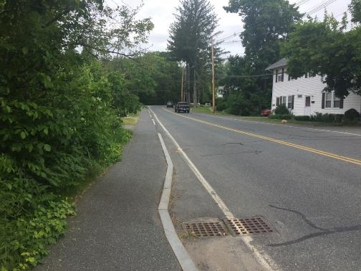
Location of Hydrodynamic Separator
Runoff
Runoff
Photo 14-1
Micro-watershed No.: N-59
BMP Type: Hydrodynamic Separator
BMP Location: 40 Mill Street
Priority Rank: Low
Site Summary:
Road runoff from the northern and southern ends of Mill Road drains to a catch basin that discharges directly to an outfall.
Proposed Improvement:
Install a hydrodynamic separator in place of the catch basin on Mill Street.
Expected O&M:
Remove accumulated sediment from hydrodynamic separator as needed every two years.
Parcel Ownership: Town Owned (Right-Of-Way)

Sizing Characteristics
BMP Drainage Area (acres) | 0.8
BMP Size (storm depth; inches) | -
Impervious Area (%) | 100
Estimated Pollutant Load Reduction
TP (lbs./yr.) | -
TN (lbs./yr.) | -
TSS (lbs./yr.) | 87.8
Estimated Cost
Planning-level Capital Cost | $9,200

Site Natick 15: Lake Street
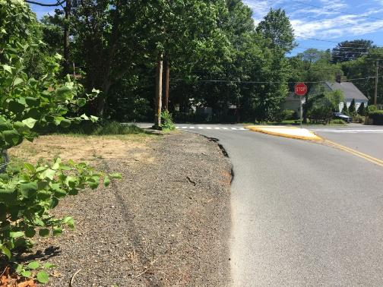
Photo 15-1
Runoff
Erosion and scour
Bioretention Cell
Micro-watershed No.: N-18
BMP Type: Bioretention
BMP Location: 1 Lake Street
Priority Rank: Medium
Site Summary:
Untreated runoff flows south from North Main Street onto Lake Street. Soil scour and erosion was observed where the pavement on Lake Street met the entrance of the road easement.
Proposed Improvement:
Grade the entrance of the utility easement to allow runoff to drain into the entrance. Install an approx. 1000–square foot bioretention cell at the west corner of Lake Street and North Main Street.
Expected O&M:
Remove accumulated sediment from bioretention cell and maintain/replace plants as needed every two years. Re-mulch annually. Remove accumulated sediment/debris, as needed.
Parcel Ownership: Town Owned (Utility Easement)

Sizing Characteristics
BMP Drainage Area (acres) | 1.1
BMP Size (storm depth; inches) | 0.5
Impervious Area (%) | 29
Estimated Pollutant Load Reduction
TP (lbs./yr.) | 0.42
TN (lbs./yr.) | 3.3
TSS (lbs./yr.) | 154.3
Estimated Cost
Planning-level Capital Cost | $20,500

Site Natick 16: Navy Field Park
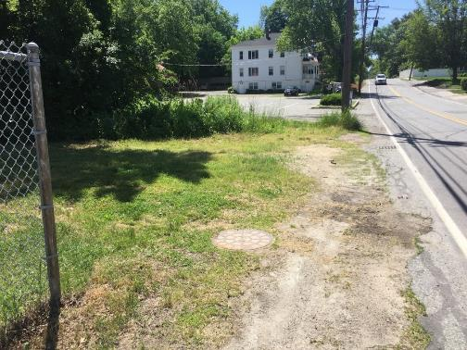
Photo 16-1
Catch Basin
Bioretention Cell
Runoff
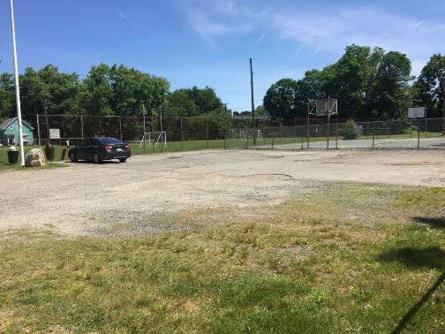
Photo 16-2
Bioretention Cell
Runoff
Area to be Paved
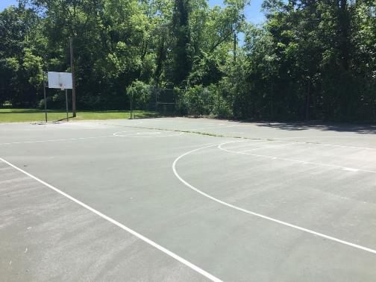
Photo 16-3
Prop. Permeable Surface
Micro-watershed No.: N-20
BMP Type: Bioretention and Permeable Surface
BMP Location: 1 Lake Street
Priority Rank: Low
Site Summary:
Navy Field is a recreational park with a large athletic field, paved parking lot, and a basketball court. The parking lot and basketball court runoff drain to the existing catch basins on Washington Avenue. The parking lot at Navy Field was in poor condition.
Proposed Improvement:
Pave the parking lot to direct runoff southwest towards the edge of the park. Install an approx. 1000–square foot bioretention cell to accept the parking lot runoff. Redirect runoff draining to the catch basin on Washington Avenue and grade the area to allow a portion of road runoff to be conveyed to the bioretention cell. Consider resurfacing with permeable surface the existing basketball court to infiltrate runoff.
Expected O&M:
Remove accumulated sediment from bioretention cell annually and maintain/replace plants as needed every two years. Re-mulch annually. Remove accumulated sediment/debris, as needed.
Parcel Ownership: Town Owned (Recreational Park)

Sizing Characteristics
BMP Drainage Area (acres) | 2.1
BMP Size (storm depth; inches) | 0.5
Impervious Area (%) | 33
Estimated Pollutant Load Reduction
TP (lbs./yr.) | 0.88
TN (lbs./yr.) | 7.0
TSS (lbs./yr.) | 327.2
Estimated Cost
Planning-level Capital Cost | $39,100

Site Natick 17: Cemetery Road
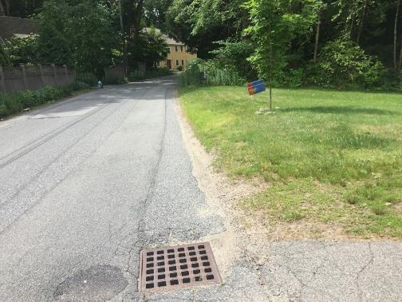
Bioretention Cell
Catch Basin
Runoff
Photo 17-1
Micro-watershed No.: N-34
BMP Type: Bioretention
BMP Location: Intersection of Tucker and Cemetery Street
Priority Rank: High
Site Summary:
Runoff from upper Cemetery Road drains north to a catch basin on the west side of Cemetery Road.
Proposed Improvement:
Redirect runoff draining to the catch basin on Cemetery Road. Grade the area to allow water to convey onto the grassed area. Install an approx. 600–square foot bioretention cell.
Expected O&M:
Remove accumulated sediment from bioretention cell and maintain/replace plants as needed every two years. Re-mulch annually. Remove accumulated sediment/debris, as needed.
Parcel Ownership: Town Owned (Right-Of-Way)

Sizing Characteristics
BMP Drainage Area (acres) | 0.65
BMP Size (storm depth; inches) | 0.5
Impervious Area (%) | 69
Estimated Pollutant Load Reduction
TP (lbs./yr.) | 5.2
TN (lbs./yr.) | 4.0
TSS (lbs./yr.) | 192.0
Estimated Cost
Planning-level Capital Cost | $12,100

Site Natick 18: Jackson Court
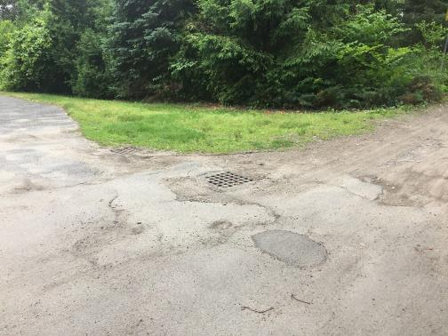
Raingarden
Clogged Catch Basin
Catch Basin
Runoff
Photo 18-1
Micro-watershed No.: N-96
BMP Type: Raingarden
BMP Location: Intersection of Tyler Street and Jackson Court
Priority Rank: Medium
Site Summary:
Runoff from Jackson Court and Tyler Street drain to two catch basins at the intersection of the two roads. Tyler street is a dirt road and the catch basin appeared to be clogged with sediment.
Proposed Improvement:
Install an approx. 400-square foot raingarden at the location of the existing catch basin.
Expected O&M:
Remove accumulated sediment from raingarden annually and maintain/replace plants as needed every two years. Re-mulch annually. Remove accumulated sediment/debris, as needed.
Parcel Ownership: Town Owned (Utility Easement)

Sizing Characteristics
BMP Drainage Area (acres) | 0.3
BMP Size (storm depth; inches) | 0.5
Impervious Area (%) | 85
Estimated Pollutant Load Reduction
TP (lbs./yr.) | 0.07
TN (lbs./yr.) | 0.6
TSS (lbs./yr.) | 25.8
Estimated Cost
Planning-level Capital Cost | $5,600

Site Natick 19: Speen Street
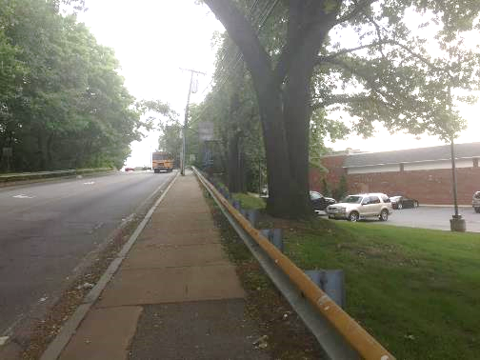
Runoff
Swale
Catch Basin
Curb Cut
Photo 19-1
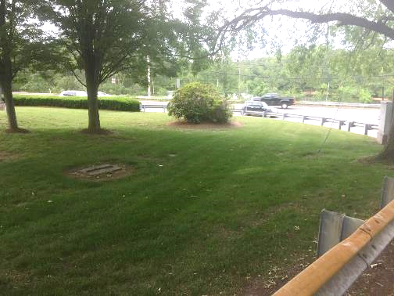
Bioretention Cell
Swale / Runoff from
Curb Cut
Photo 19-2
Micro-watershed No.: N-57
BMP Type: Swale and Bioretention Cell
BMP Location: 137 West Central Street (State Highway 135)
Priority Rank: Medium
Site Summary:
Road runoff from Speen Street flows south towards catch basins located at the intersection of Speen Street and State Highway 135 adjacent to the CVS on West Central Street. The catch basins drain to outfalls that discharge directly into Fiske Pond. The area is comprised predominantly of commercial buildings.
Proposed Improvement:
Redirect the runoff draining to the catch basin on the east side of Speen Street. Install a curb cut at the location of the catch basin to convey runoff over the sidewalk and onto the grassed area west of the CVS. Install a swale to convey the runoff to an approx. 900–square foot bioretention cell.
Expected O&M:
Remove accumulated sediment from bioretention cell annually and maintain/replace plants as needed every two years. Mow grassed swale regularly. Replant grass as needed to maintain adequate vegetative cover. Remove accumulated debris prior to mowing.
Parcel Ownership: Town Owned (Right-Of-Way)

Sizing Characteristics
BMP Drainage Area (acres) | 0.25
BMP Size (storm depth; inches) | 0.5
Impervious Area (%) | 100
Estimated Pollutant Load Reduction
TP (lbs./yr.) | 0.19
TN (lbs./yr.) | 1.57
TSS (lbs./yr.) | 350.3
Estimated Cost
Planning-level Capital Cost | $4,700
Site Natick 20: Veterans of Foreign Affairs (V.F.W.)
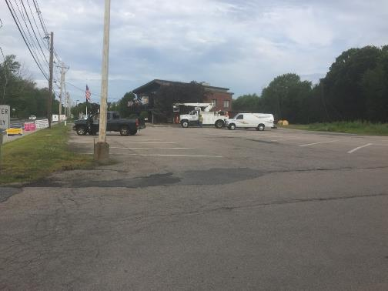
Runoff
Bioretention Cell
Photo 20-1
Micro-watershed No.: N-56
BMP Type: Bioretention
BMP Location: 113 West Central Street (State Highway 135)
Priority Rank: Medium
Site Summary:
Runoff drains south from the parking lot of the V.F.W. and flows to a narrow grassed median parallel to State Highway 135. Runoff also drains from the parking lot to two catch basins on State Highway 135. Both catch basins drain to outfalls that discharge directly into Fiske Pond.
Proposed Improvement:
Install an approx. 2500–square foot bioretention cell in the location of the grassed median to capture and treat the runoff draining towards the median from the parking lot.
Expected O&M:
Remove accumulated sediment from bioretention cell annually and maintain/replace plants as needed every two years. Mow grassed swale regularly.
Parcel Ownership: Town Owned (Right-Of-Way)

Sizing Characteristics
BMP Drainage Area (acres) | 0.88
BMP Size (storm depth; inches) | 0.5
Impervious Area (%) | 100
Estimated Pollutant Load Reduction
TP (lbs./yr.) | 0.91
TN (lbs./yr.) | 8.2
TSS (lbs./yr.) | 314.4
Estimated Cost
Planning-level Capital Cost | $16,400

Site W-1: Wayland Town Beach
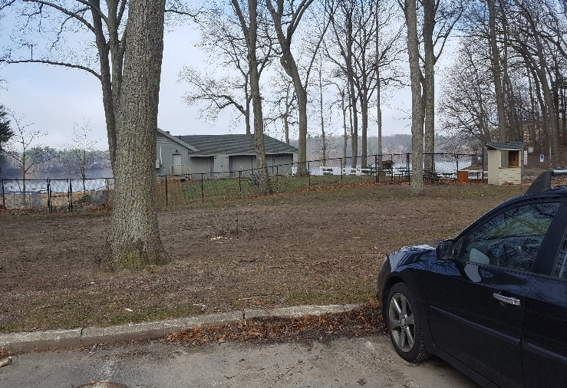
Ex. Spillway
Install Curb Cut
Bioretention Cell
Runoff
Photo 1-1
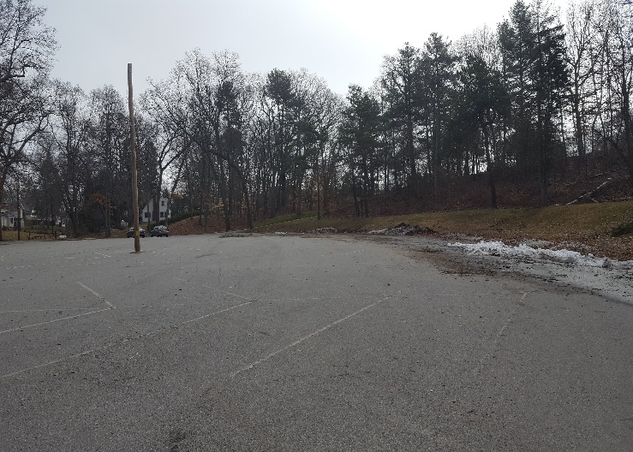
Runoff
Town Beach Entrance
Photo 1-2
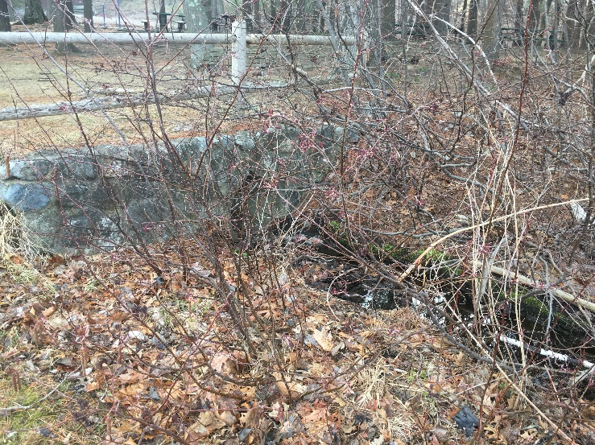
Photo 1-3
Parking Lot Outfall

Micro-watershed No.: W-36
BMP Type: Bioretention
BMP Location: Wayland Town Beach
Priority Rank: Medium
Site Summary:
Runoff from the parking lot at Wayland Town Beach flows towards three existing catch basins and a channel drain at the entrance of the Beach. The runoff appears to be treated by an existing underground hydrodynamic separator prior to discharging through a culvert pipe to Lake Cochituate. The existing channel drain appeared to be clogged and required cleaning. Wayland Town Beach would serve as an excellent location for education outreach.
Proposed Improvement:
Install one or more curb cuts along the parking lot edge to allow stormwater runoff to flow into grassed bioretention cells within the 8,000-square foot area between the existing parking lot and the entrance of Wayland Town Beach. Overflow would be directed to existing spillway (Photo 1-1) or to the existing underground drainage infrastructure.
Expected O&M:
Remove accumulated sediment from bioretention cell annually. Mow routinely to maintain ideal grass height.
Wetland Permitting:
As a project with minor buffer zone disturbances, WPA permitting is expected to require submittal of an ANOI.
Parcel Ownership: Town Owned Parcel

Sizing Characteristics
BMP Drainage Area (acres) | 3.0
BMP Size (storm depth; inches) | 0.5
Impervious Area (%) | 73
Estimated Pollutant Load Reduction
TP (lbs./yr.) | 2.5
TN (lbs./yr.) | 19.6
TSS (lbs./yr.) | 933
Estimated Cost
Planning-level Capital Cost | $96,000
Site Wayland 2: Wayland Town Beach Entrance
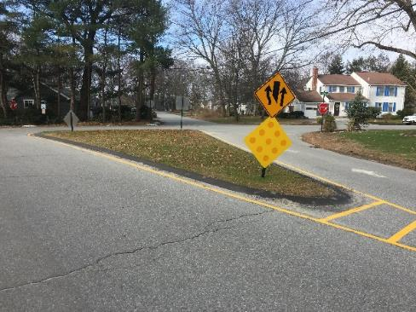
Catch Basin
Bioretention Cell
Photo 2-1
Runoff
Micro-watershed No.: W-36
BMP Type: Bioretention
BMP Location: 13 Grace Road
Curb Cut
Priority Rank: High
Site Summary:
Runoff from upper Parkland Drive drains to an existing catch basin adjacent to a grassed median at the intersection of Parkland Drive and Grace Road.
Proposed Improvement:
Install one or more curb cuts along the edge of the median to allow stormwater runoff to flow into a grassed bioretention cell within the 1,000-square foot area in the median. Existing catch basin can be used as overflow during larger storm events
Expected O&M:
Remove accumulated sediment from bioretention cell annually. Mow routinely to maintain ideal grass height.
Parcel Ownership: Town Owned Parcel

Sizing Characteristics
BMP Drainage Area (acres) | 1.50
BMP Size (storm depth; inches) | 0.5
Impervious Area (%) | 89
Estimated Pollutant Load Reduction
TP (lbs./yr.) | 1.53
TN (lbs./yr.) | 11.7
TSS (lbs./yr.) | 559.33
Estimated Cost
Planning-level Capital Cost | $28,000

Site Wayland 3: Cochituate Baseball Field A
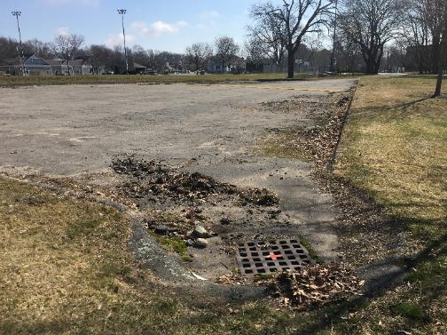
Proposed Bioretention Cell
Existing Catch Basin
Photo 3-1
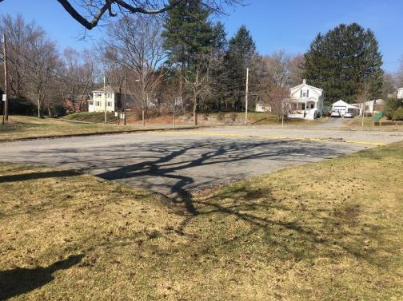
Runoff
Existing Catch Basin
Existing Curb Cut
Photo 3-2
Micro-watershed No.: W-36
BMP Type: Bioretention
BMP Location: Intersection of Pemberton Rd and Bradford St
Priority Rank: High
Site Summary:
Cochituate Baseball Field is a recreational park that consists of a large grassed athletic field, playground area, and paved parking lots. Runoff from the athletic field drains southwest to an existing catch basin located at the edge of the southern paved lot that appeared to require resurfacing. A speed bump or potential water berm was installed in the center of the damaged asphalt lot to direct water or slow traffic.
Proposed Improvement:
Install a 2,000-square foot grassed bioretention cell at the location of the existing catch basin southwestern edge of the lower Baseball field parking lot to capture runoff from the athletic field and the paved parking lot. Option to resurface the existing parking lot.
Expected O&M: Remove accumulated sediment from bioretention cell annually. Mow routinely to maintain ideal grass height.
Parcel Ownership: Town owned (Recreational Park)

Sizing Characteristics
BMP Drainage Area (acres) | 2.1
BMP Size (storm depth; inches) | 0.5
Impervious Area (%) | 19
Estimated Pollutant Load Reduction
TP (lbs./yr.) | 0.56
TN (lbs./yr.) | 4.7
TSS (lbs./yr.) | 213.2
Estimated Cost
Planning-level Capital Cost | $39,100

Site Wayland 4: Cochituate Baseball Field B
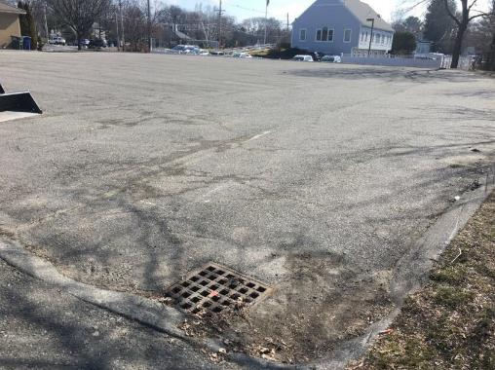
Runoff
Hydrodynamic Separator
Photo 4-1
Micro-watershed No.: W-36
BMP Type: Hydrodynamic Separator
BMP Location: West Plain Street
Priority Rank: High
Site Summary:
Cochituate Baseball Field is a recreational park that consists of a large grassed athletic field, playground area, and paved parking lots. Runoff from the northern parking lot drains southwest to an existing catch basin located on Bradford Street.
Proposed Improvement:
Install a hydrodynamic separator in place of the catch basin for treatment of stormwater.
Expected O&M:
Remove accumulated sediment from hydrodynamic separator as needed every two years. Remove accumulated sediment/debris, as needed.
Parcel Ownership: Town owned (Recreational Park)

Sizing Characteristics
BMP Drainage Area (acres) | 0.7
BMP Size (storm depth; inches) | 0.5
Impervious Area (%) | 100
Estimated Pollutant Load Reduction
TP (lbs./yr.) | -
TN (lbs./yr.) | -
TSS (lbs./yr.) | 76.80
Estimated Cost
Planning-level Capital Cost | $10,000

Site Wayland 5: Joyce Road
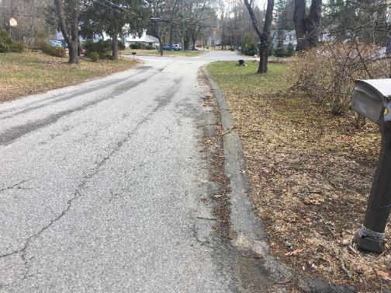
Runoff
Curb Cut
Water Quality Swale
Catch Basins
Photo 5-1

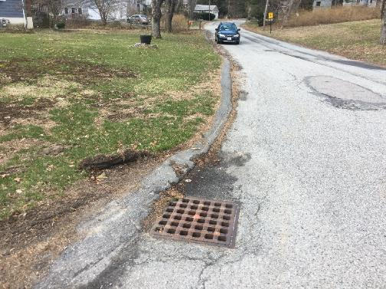
Photo 5-2
Catch Basin 2
Catch Basin 1
Runoff
Micro-watershed No.: W- 18
BMP Type: Water Quality Swale
BMP Location: Right of Way by 6 Joyce Road
Priority Rank: Low
Site Summary:
Joyce Road is a residential neighborhood near the town Middle School. Runoff from upper Joyce Road flows into two catch basins at the intersection of Joyce Road and School Street.
Proposed Improvement:
Install a curb cut at the edge of Joyce Road to allow for stormwater to flow into a 175-foot long water quality swale prior to discharging into the existing catch basins.
Expected O&M:
Remove accumulated sediment from swale and maintain/replace plants as needed every two years. Replant grass as needed to maintain adequate vegetative cover. Remove accumulated debris, as needed.
Parcel Ownership: Town owned (Right-Of-Way)

Sizing Characteristics
BMP Drainage Area (acres) | 0.5
BMP Size (storm depth; inches) | 0.5
Impervious Area (%) | 75
Estimated Pollutant Load Reduction
TP (lbs./yr.) | 0.1
TN (lbs./yr.) | -
TSS (lbs./yr.) | 128.1
Estimated Cost
Planning-level Capital Cost | $13,000

Site Wayland 6: Wayland Middle School
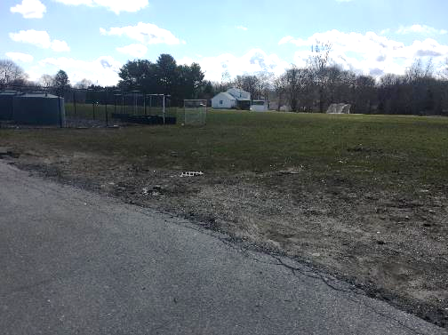
Raingarden
Runoff
Catch Basin
Photo 6-1
Micro-watershed No.: W-27
BMP Type: Raingarden
BMP Location: 201 Main Street
Priority Rank: Medium
Site Summary:
Runoff from the Middle School parking lot flows toward a catch basin adjacent to the soccer athletic fields south of the school. The dirt area around the catch basin appears to be used for parking vehicles.
Proposed Improvement:
Install an approx. 4,000–square foot raingarden at the edge of the parking lot to capture and treat the combined rooftop and parking lot runoff.
Expected O&M:
Remove accumulated sediment annually, mow, and maintain/replace plants as needed every two years.
Parcel Ownership: Town Owned Lot

Sizing Characteristics
BMP Drainage Area (acres) | 2.5
BMP Size (storm depth; inches) | 0.5
Impervious Area (%) | 100
Estimated Pollutant Load Reduction
TP (lbs./yr.) | 2.6
TN (lbs./yr.) | 23.3
TSS (lbs./yr.) | 893.1
Estimated Cost
Planning-level Capital Cost | $46,600

Site Wayland 7: Hannah Williams Playground
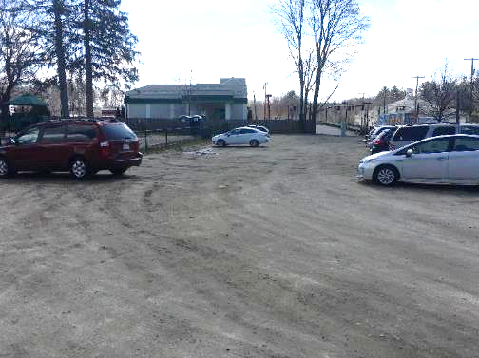
Photo 7-1
Pave to Direct Runoff
Bioretention Swale
Micro-watershed No.: W-38
BMP Type: Bioretention
BMP Location: 83 North Main Street
Priority Rank: High
Site Summary:
Hannah Williams Playground is a recreational park with a field and a playground. Runoff appears to pool in various low points within the dirt parking lot.
Proposed Improvement:
Pave parking area to direct stormwater to the west edge of the Hannah Williams Playground. Install an approx. 800–square foot bioretention swale at the edge of the parking lot to capture and treat the parking lot runoff.
Expected O&M:
Remove accumulated sediment from bioretention cell annually. Mow routinely to maintain ideal grass height.
Parcel Ownership: Town Owned Lot

Sizing Characteristics
BMP Drainage Area (acres) | 0.6
BMP Size (storm depth; inches) | 0.5
Impervious Area (%) | 29
Estimated Pollutant Load Reduction
TP (lbs./yr.) | 0.22
TN (lbs./yr.) | 1.8
TSS (lbs./yr.) | 84.2
Estimated Cost
Planning-level Capital Cost | $11,200

Site Wayland 8: Aquaduct Road
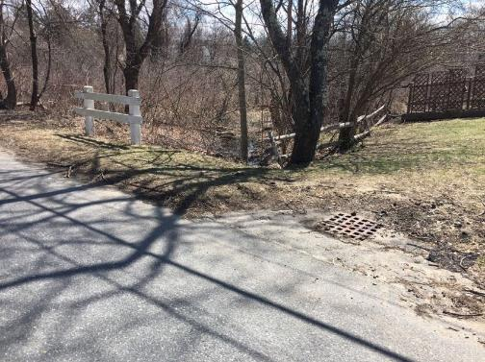
Snake Brook
Rip Rap Protection
Photo 8-1
Runoff
Catch Basin
Micro-watershed No.: W-21
BMP Type: Hydrodynamic Separator and Rip Rap Armor
BMP Location: 47 Aquaduct Road
Priority Rank: Low
Site Summary:
Road runoff from upper Aquaduct Road drains east to an existing catch basin. The road runoff appears to bypass the catch basin and flow directly into Snake Brook.
Proposed Improvement:
Install a hydrodynamic separator in place of the catch basin for treatment of stormwater. Install rip rap armor on the downstream side of the catch basin to reduce bank erosion along Snake Brook.
Expected O&M:
Remove accumulated sediment from hydrodynamic separator as needed every two years. Remove accumulated sediment/debris, as needed.
Wetland Permitting: As a replacement/ upgrade of existing stormwater infrastructure, no WPA permitting is anticipated.
Parcel Ownership: Town Owned (Right-Of-Way)

Sizing Characteristics
BMP Drainage Area (acres) | 1.1
BMP Size (storm depth; inches) | 0.5
Impervious Area (%) | 33
Estimated Pollutant Load Reduction
TP (lbs./yr.) | -
TN (lbs./yr.) | -
TSS (lbs./yr.) | 45.3
Estimated Cost
Planning-level Capital Cost | $12,700

Site Wayland 9: Thompson Road
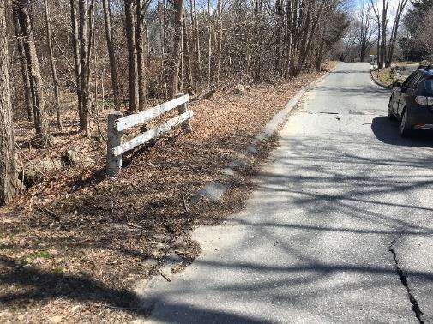
Raingarden
Riprap Armor
Runoff
Photo 9-1
Micro-watershed No.: W-22
BMP Type: Raingarden and Rip Rap Armor
BMP Location: 16 Thompson Road
Priority Rank: Medium
Site Summary:
Road runoff flows from the eastern end of Thompson Road and flows off the road directly into Snake Brook. Erosion and scouring was observed on the bank.
Proposed Improvement:
Install riprap armor in the location of the existing erosion scour. Design riprap armor to direct runoff into a 400—square foot raingarden prior to discharging into Snake Brook (raingarden would extend further than depicted in photo).
Expected O&M:
Remove accumulated sediment from hydrodynamic separator as needed every two years.
Wetland Permitting: As a project with minor buffer zone disturbances, WPA permitting is expected to require submittal of an abbreviated notice of intent (ANOI).
Parcel Ownership: Town Owned (Right-Of-Way)

Sizing Characteristics
BMP Drainage Area (acres) | 0.70
BMP Size (storm depth; inches) | 0.5
Impervious Area (%) | 100
Estimated Pollutant Load Reduction
TP (lbs./yr.) | 0.79
TN (lbs./yr.) | 6.1
TSS (lbs./yr.) | 290.9
Estimated Cost
Planning-level Capital Cost | $13,000

Site Wayland 10: The Loker School
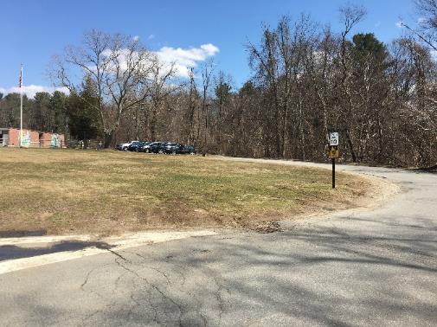
Runoff
Runoff
Catch Basin
Cape Cod Berm
Bioretention Cell
Photo 10-1
Micro-watershed No.: W- 14
BMP Type: Bioretention
BMP Location: 47 Loker Street
Priority Rank: Medium
Site Summary:
The Loker School is an elementary school adjacent to Snake Brook. Runoff from the school parking lot and along the cul-de-sac drains into an existing catch basin that discharges directly into Snake Brook.
Proposed Improvement:
Install a cape cod berm or grassed swale along the cul-de-sac to reduce runoff erosion and to convey runoff into the cul-de-sac. Install an approx. 5,000-square foot bioretention cell within the cul-de-sac.
Expected O&M:
Remove accumulated sediment from bioretention cell annually and maintain/replace plants as needed every two years. Re-mulch annually. Remove accumulated sediment/debris, as needed.
Wetland Permitting: As a project with minor buffer zone disturbances, WPA permitting is expected to require submittal of an ANOI.
Parcel Ownership: Town Owned Parcel

Sizing Characteristics
BMP Drainage Area (acres) | 3.0
BMP Size (storm depth; inches) | 0.5
Impervious Area (%) | 82
Estimated Pollutant Load Reduction
TP (lbs./yr.) | 2.5
TN (lbs./yr.) | 22.0
TSS (lbs./yr.) | 844.5
Estimated Cost
Planning-level Capital Cost | $55,900

Site Wayland 11: Edgewood Road
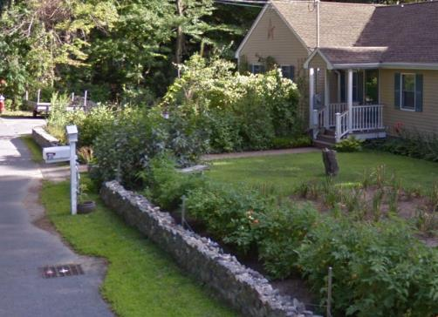
Location of Hydrodynamic Separator
Catch Basin
Photo 11-1
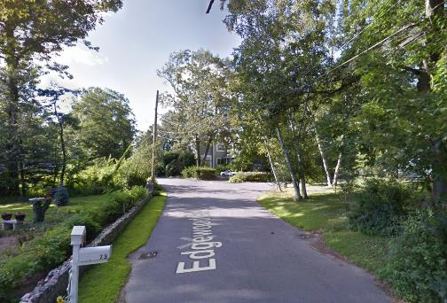
Catch Basin
Runoff
Photo 11-2
Micro-watershed No.: W-31
BMP Type: Hydrodynamic Separator
BMP Location: 67 Edgewood Drive
Priority Rank: Low
Site Summary:
Road runoff from Edgewood Drive flows to an existing catch basin on the Edgewood Drive. Runoff from existing catch basin discharges to an outfall to Lake Cochituate (North Basin).
Proposed Improvement:
Install a hydrodynamic separator in place of the catch basin on Edgewood Drive.
Expected O&M:
Remove accumulated sediment from hydrodynamic separator as needed every two years.
Wetland Permitting: As a replacement/ upgrade of existing stormwater infrastructure, no WPA permitting is anticipated.
Parcel Ownership: Town Owned (Right-Of-Way)

Sizing Characteristics
BMP Drainage Area (acres) | 1.7
BMP Size (storm depth; inches) | 0.5
Impervious Area (%) | 23
Estimated Pollutant Load Reduction
TP (lbs./yr.) | -
TN (lbs./yr.) | -
TSS (lbs./yr.) | 54.1
Estimated Cost
Planning-level Capital Cost | $20,100

Site Wayland 12: North Cochituate State Park
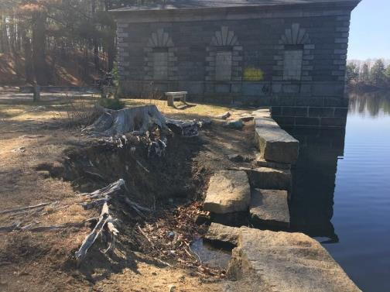
Bank Erosion
Collapsed Wall
Runoff
Photo 12-1
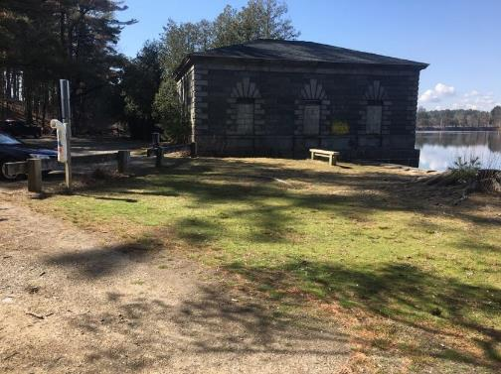
Erosion Area
Vegetated Buffer
Steep upgradient slope
Parking Area
Photo 12-2
Micro-watershed No.: 37
BMP Type: Vegetative Buffer
BMP Location: 88 Commonwealth Road
Priority Rank: High
Site Summary:
Runoff sheets over the unpaved parking area at North Cochituate State Park and from a steeply sloped upgradient forest area. Severe erosion and a collapsed segment of a retaining wall was observed along the bank and could result in pollutants directly entering the lake. It was unclear if the severe erosion was caused by runoff or other disturbance (e.g., storm damage from Spring 2018 Nor’easters).
Proposed Improvement:
Stabilize and repair existing bank and retaining wall and install a 50-linear foot vegetated buffer along the edge of the parking area, consisting of a double row of shrubs at approximately 3 foot spacing to slow runoff velocities, trap sediment, and reduce migration of sediment into the lake.
Expected O&M: Inspect plantings annually and replace as needed.
Wetland Permitting: As a project with buffer zone disturbances, WPA permitting is expected to require submittal of Notice of Intent. Retaining wall repair and bank restoration is also expected to require waterways permitting (Chapter 91) and potentially Section 404 permitting through the Army Corps of Engineers.
Parcel Ownership: Town Owned (Right-Of-Way)
Sizing Characteristics
BMP Drainage Area (acres) | 1.0
BMP Size (storm depth; inches) | -
Impervious Area (%) | 15
Estimated Pollutant Load Reduction
TP (lbs./yr.) | -
TN (lbs./yr.) | 0.26
TSS (lbs./yr.) | 55.10
Estimated Cost
Planning-level Capital Cost* | $23,000
*Note: Cost only included for vegetated buffer and not bank restoration or retaining wall repair.

Appendix D.2 – Secondary BMP Recommendations

Alternative Site Natick 22: Natick Police Department  Micro-watershed No.: N-32  BMP Type: Bioretention Cells (parking lot islands)  BMP Location: 10 Clarendon Street |  | 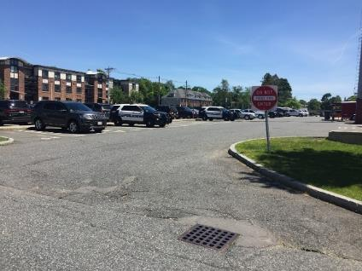
Alternative Site Natick 23: South Ave Parking Lot  Micro-watershed No.: N-32  BMP Type: Bioretention Cell  BMP Location: 73 South Avenue |  | 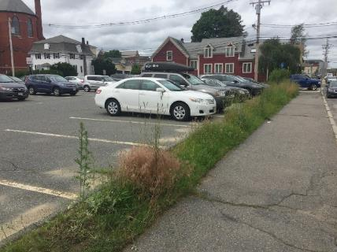
Alternative Site Natick 24: Bacon Street  Micro-watershed No.: N-14  BMP Type: Raingarden  BMP Location: North Main Street and Kansas Street |  | 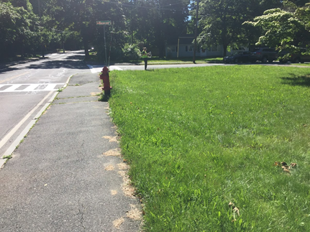
Alternative Site Natick 24: Bacon Street and Park Ave (A)  Micro-watershed No.: N-14  BMP Type: Bioretention Cell  BMP Location: Intersection of Park Avenue and Bacon Street |  | 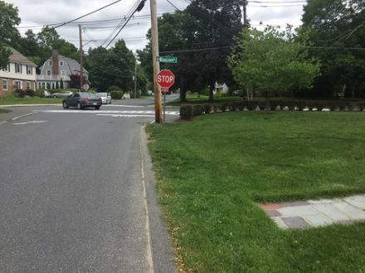
Alternative Site Natick 25: Park Avenue  Micro-watershed No.: N-17  BMP Type: Raingarden  BMP Location: Intersection of Park Street and Grove Street |  | 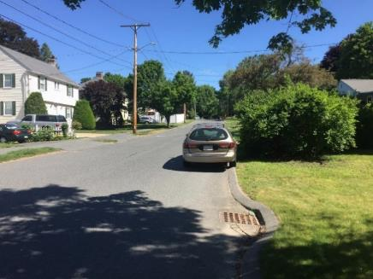
Alternative Site Natick 26: Park Avenue and Main Street  Micro-watershed No.: N-18  BMP Type: Bioretention Cell  BMP Location: Intersection of North Main Street and Park Avenue |  | 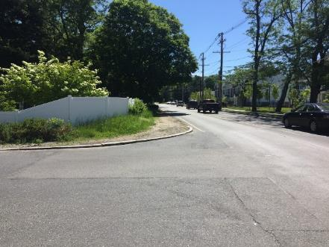
Alternative Site Natick 27: Bacon Street and Park Ave (B)  Micro-watershed No.: N-17  BMP Type: Water Quality Swale  BMP Location: Intersection of Park Avenue and Bacon Street |  | 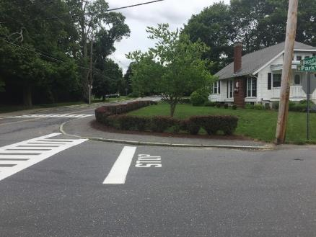
Alternative Site Natick 28: Charles Street  Micro-watershed No.: N-17  BMP Type: Raingarden  BMP Location: Intersection of Charles Street and Grove Street |  | 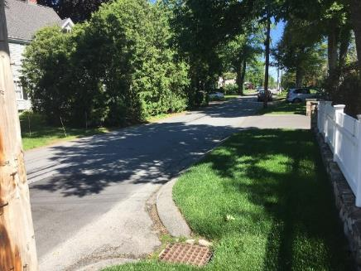

Alternative Site Natick 29: Lois Street  Micro-watershed No.: N-17  BMP Type: Water Quality Swale  BMP Location: Intersection of Lois Street and Arthur Street |  | 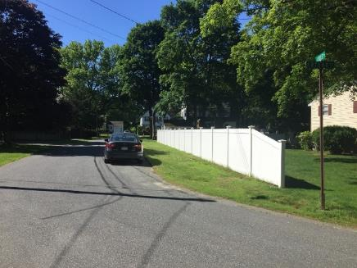
Alternative Site Natick 30: Heritage Lane  Micro-watershed No.: N-16  BMP Type: Bioretention Cell  BMP Location: Intersection of Kansas Street and Heritage Lane |  | 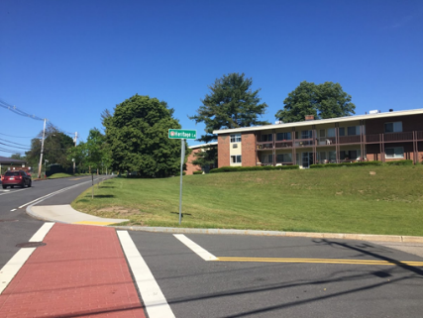
Alternative Site Natick 31: North Main Street  Micro-watershed No.: N-15  BMP Type: Water Quality Swale  BMP Location: North Main Street and Kansas Street |  | 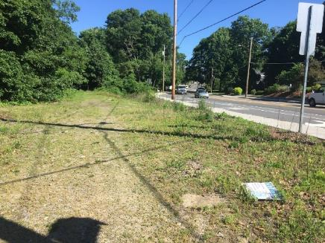
Alternative Site Natick 32: Blossom Circle  Micro-watershed No.: N-9  BMP Type: Extended Detention Basin  BMP Location: 6 Blossom Circle |  | 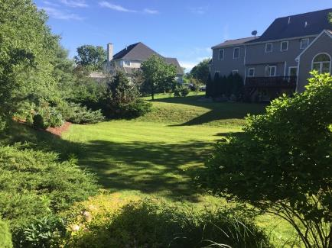

Alternative Site Natick 33: Natick Animal Clinic  Micro-watershed No.: N-57  BMP Type: Bioretention Cell  BMP Location: 121 West Central Street |  | 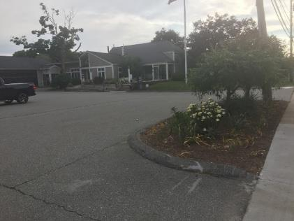
Alternative Site Natick 34: Pizza Shop  Micro-watershed No.: N-57  BMP Type: Hydrodynamic Separators  BMP Location: 127 West Central Street |  | 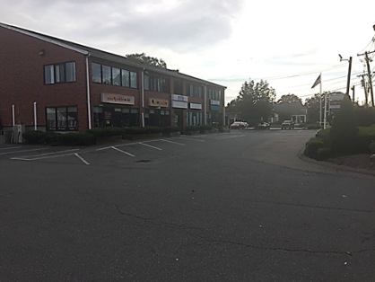
Alternative Site Natick 35: De Luca Landscaping  Micro-watershed No.: N-9  BMP Type: Bioretention Cell  BMP Location: 115 West Central Street |  | 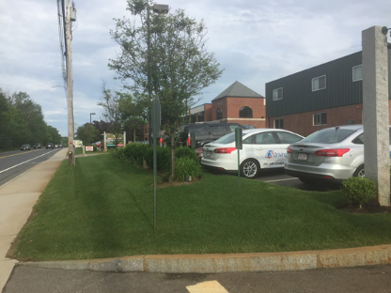
Alternative Site Natick 36: Lakeview Crossing  Micro-watershed No.: N-7  BMP Type: Bioretention Cell  BMP Location: 119 West Central Street |  | 
Alternative Site Wayland 13: Fuller Road  Micro-watershed No.: 35  BMP Type: Hydrodynamic Separator  BMP Location: 59 Fuller Road |  | 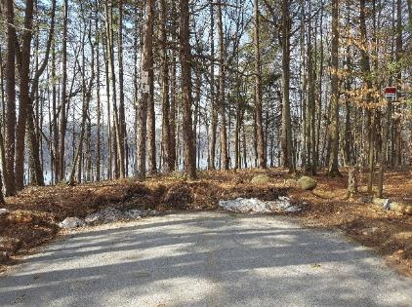
Alternative Site Wayland 14: Maguire Road  Micro-watershed No.: 37  BMP Type: Vegetative Barrier  BMP Location: North Main Street and Kansas Street |  | 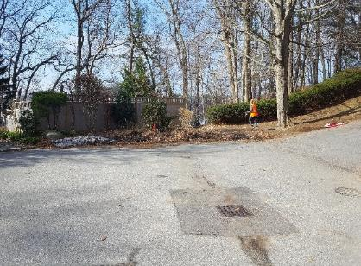
Alternative Site Wayland 15: Lake Road Terrace  Micro-watershed No.: 32  BMP Type: Hydrodynamic Separator  BMP Location: Intersection of Lake Road and Lake Road Terrace |  | 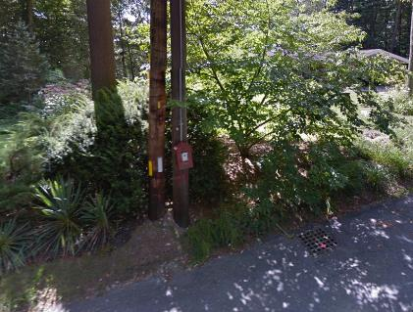
Alternative Site Wayland 16: Cochituate Baseball Field C  Micro-watershed No.: 36  BMP Type: Raingarden  BMP Location: West Plain Street |  | 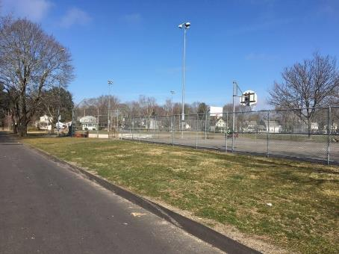
Alternative Site Wayland 17: Lakeview Road  Micro-watershed No.: 41  BMP Type: Hydrodynamic Separator  BMP Location: 24 Lakeview Road |  | 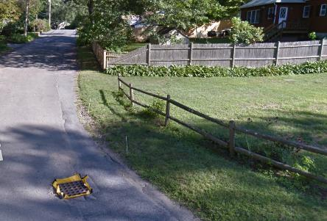
Alternative Site Wayland 18: Parkridge Road  Micro-watershed No.: 34  BMP Type: Hydrodynamic Separator  BMP Location: Intersection of Parkridge Road and Edgewood Road |  | 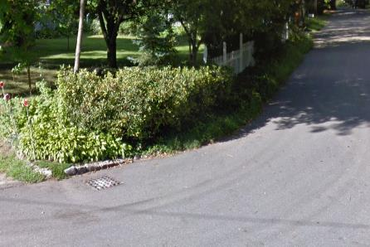

Waushakum Pond is also located within the Lake Cochituate Watershed and is listed as impaired but has intentionally been omitted from discussion as this Watershed Based Plan focuses specifically on Lake Cochituate. Information for Waushakum Pond is available on MassDEP’s WBP tool website (http://prj.geosyntec.com/MassDEPWBP).
No single E. coli sample during bathing season shall exceed 235 colonies/100 ml and no single enterococcus sample shall exceed 61 colonies/100 ml during the bathing season (Massachusetts Surface Water Quality Standards 314 CMR 4.00, 2013)
Geosyntec Consultants, Inc. (2017b). "Lake Cochituate Microwatershed Characterizations and Priority Ranking"
This factor represents a phosphorus removal percentage after soil absorption and is based on past experience developing phosphorus budgets for other similar systems and from prior literature reviews (e.g., Gillion and Patmont, 1983).
A comprehensive summary of potential funding programs can be found at: http://prj.geosyntec.com/prjMADEPWBP_Files/Guide/Element%20D%20-%20Funds%20and%20Resources%20Guide.pdf
Refer to the Chesapeake Bay Foundation for information on how to start a storm drain stenciling project: http://www.cbf.org/join-us/education-program/resources/storm-drain-stenciling.html
Example step-by-step instructions prepared by Charles River Watershed Association

