


WATERSHED-BASED PLAN | 
Pratt Pond

May 31, 2017

Prepared By:
Town of Upton, Department of Public Works
1 Main Street, Suite 13
Upton, MA

Prepared For:



Contents

Element A: Nonpoint Source Pollution Causes and Sources
Element B: Pollutant Load Reductions Needed / Water Quality Goals
Element C: Management Measures to Achieve Water Quality Goals
Element D: Technical and Financial Assistance Needed
Element E: Public Information and Education
Elements F & G: Implementation Schedule and Interim Measurable Milestones
Elements H & I: Progress Evaluation Criteria and Monitoring

References/Appendix

Element A: Identify Causes of Impairment & Pollution Sources

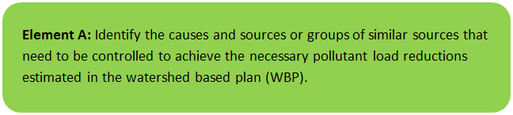 | 

1. General Watershed Information

Table A-1: General Watershed Information

Watershed Name (Assessment Unit ID): | Pratt Pond (MA51123)
Major Basin: | BLACKSTONE
Watershed Area (within MA): | 1335.6 (ac)
Water Body Size: | 39 (ac)

Pratt Pond is a 39-acre “Class B” pond in the Pratt Pond Watershed (MA51123) in Upton, Massachusetts. The pond is located within the Blackstone basin and is Category 4C listed for Non-Native Aquatic Plants, but not any specific pollutants of concern. The Upton State Forest is in the northern (upstream) portion of the watershed; therefore, most the pond’s watershed is forested (80%) with estimated impervious cover of just 4.5%. The Pond has a recreational swimming beach and public access boat ramp and is avidly used by local fishermen, recreational boaters, and swimmers.

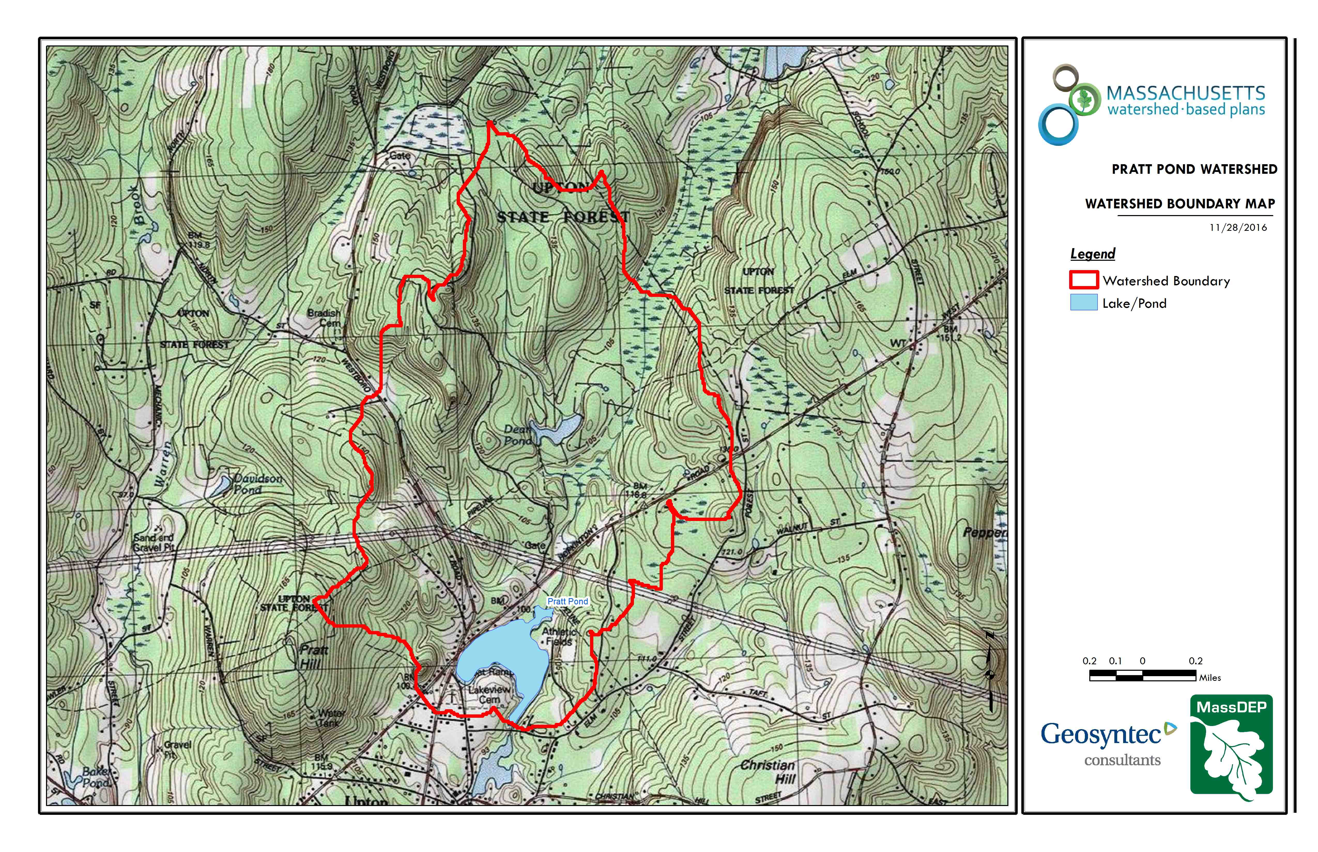
Figure A-1: Watershed Boundary Map (MassGIS, 1999; MassGIS, 2001; USGS, 2016)

2. MassDEP Water Quality Assessment Report and TMDL Review
The following reports are available:
- Blackstone River Watershed 2003-2007 Water Quality Assessment Report

Blackstone River Watershed 2003-2007 Water Quality Assessment Report (MA51123 - Pratt Pond)
Aquatic Life Use
Biology
In 2009, Pratt Pond was stocked with trout (MA DFG 2009).
One non-native aquatic macrophyte species, Cabomba caroliniana, was observed in Pratt Pond during the 1994 Blackstone River Watershed synoptic lake surveys (MassDEP 1994). Myriophyllum heterophyllum also infests the pond (MassDEP 2008b).
The Aquatic Life Use is assessed as impaired for Pratt Pond because of the infestation with C. caroliniana and M. heterophyllum, non-native aquatic macrophytes.
Primary and Secondary Contact Recreational and Aesthetics Uses
There is one beach along the shoreline of Pratt Pond (Pratt Pond Beach) in Upton. Currently there is uncertainty associated with the accurate reporting of freshwater beach closure information to the MA DPH which is required as part of the Beaches Bill. Therefore no Primary Contact Recreational Use assessment (either support or impairment) decisions are being made using Beaches Bill data for this waterbody.
Report Recommendations:
Continue to monitor for the presence of invasive non-native aquatic vegetation and determine the extent of the infestation. Prevent spreading of invasive aquatic plants. Once the extent of the problem is determined and control practices are exercised, vigilant monitoring needs to be practiced to guard against infestations in unaffected areas, including downstream from the site, and to ensure that managed areas stay in check. A key portion of the prevention program should be posting of boat access points with signs to educate and alert lake-users to the problem and their responsibility to prevent spreading these species. The watershed/canoe/kayak groups should consider seeking volunteers to provide outreach on preventing the spread of exotic invasive plants at popular access points during the busiest weekends of the summer. The Final GEIR for Eutrophication and Aquatic Plant Management in Massachusetts (Mattson et al. 2004) should also be consulted prior to the development of any lake management plan to control non-native aquatic plant species. Plant control options can be selected from several techniques (e.g., bottom barriers, drawdown, herbicides, etc.) each of which has advantages and disadvantages that need to be addressed for the specific site. However, methods that result in fragmentation (such as cutting or raking) should not be used for many species because of the propensity for these invasive species to reproduce and spread vegetatively (from cuttings).
Support improvement of freshwater Beaches Bill data quality and reporting.

3. Water Quality Impairments
Known water quality impairments, as documented in the Massachusetts Department of Environmental Protection (MassDEP) 2012 Massachusetts Integrated List of Waters, are listed below. Impairment categories from the Integrated List are as follows:
Table A-2: 2012 MA Integrated List of Waters Categories
Integrated List Category | Description
1 | Unimpaired and not threatened for all designated uses.
2 | Unimpaired for some uses and not assessed for others.
3 | Insufficient information to make assessments for any uses.
4 | Impaired or threatened for one or more uses, but not requiring calculation of a Total Maximum Daily Load (TMDL), including:  4a: TMDL is completed  4b: Impairment controlled by alternative pollution control requirements  4c: Impairment not caused by a pollutant - TMDL not required
5 | Impaired or threatened for one or more uses and requiring preparation of a TMDL.

Table A-3: Water Quality Impairments

Assessment  Unit ID | Waterbody | Integrated  List  Category | Designated Use | Impairment Cause | Impairment Source
MA51123 | Pratt Pond | 4C | Fish, other Aquatic Life and Wildlife | Non-Native Aquatic Plants | Introduction of Non-native Organisms (Accidental or Intentional)

4. Water Quality Goals
Water quality goals may be established for a variety of purposes, including the following:
a.) For water bodies with known impairments, a Total Maximum Daily Load (TMDL) is established by MassDEP and the United States Environmental Protection Agency (USEPA) as the maximum amount of the target pollutant that the waterbody can receive and still safely meet water quality standards. If the waterbody has a TMDL for total phosphorus (TP) or total nitrogen (TN), or total suspended solids (TSS), that information is provided below and included as a water quality goal.

b.) For water bodies without a TMDL for total phosphorus (TP), a default water quality goal for TP is based on target concentrations established in the Quality Criteria for Water (USEPA, 1986) (also known as the “Gold Book”). The Gold Book states that TP should not exceed 50 ug/L in any stream at the point where it enters any lake or reservoir, nor 25 ug/L within a lake or reservoir. For the purposes of developing WBPs, MassDEP has adopted 50 ug/L as the TP target for all streams at their downstream discharge point, regardless of which type of water body the stream discharges to.

c.) Massachusetts Surface Water Quality Standards (314 CMR 4.00, 2013) prescribe the minimum water quality criteria required to sustain a waterbody’s designated uses. Pratt Pond is a Class 'B' waterbody. The water quality goal for fecal coliform bacteria is based on the Massachusetts Surface Water Quality Standards.

Table A-4: Surface Water Quality Classification by Assessment Unit ID

Assessment  Unit ID | Waterbody | Class
MA51123 | Pratt Pond | B

d.) Other water quality goals set by the community (e.g., protection of high quality waters, in-lake phosphorus concentration goal to reduce recurrence of cyanobacteria blooms, etc.).

Table A-5: Water Quality Goals

Pollutant | Goal | Source
Total Phosphorus (TP) | Total phosphorus should not exceed:  --50 ug/L in any stream  --25 ug/L within any lake or reservoir | Quality Criteria for Water (USEPA, 1986)
Bacteria | Class B Standards  • Public Bathing Beaches: For E. coli, geometric mean of 5 most recent samples shall not exceed 126 colonies/ 100 ml and no single sample during the bathing season shall exceed 235 colonies/100 ml. For enterococci, geometric mean of 5 most recent samples shall not exceed 33 colonies/100 ml and no single sample during bathing season shall exceed 61 colonies/100 ml;  • Other Waters and Non-bathing Season at Bathing Beaches: For E. coli, geometric mean of samples from most recent 6 months shall not exceed 126 colonies/100 ml (typically based on min. 5 samples) and no single sample shall exceed 235 colonies/100 ml. For enterococci, geometric mean of samples from most recent 6 months shall not exceed 33 colonies/100 ml, and no single sample shall exceed 61 colonies/100 ml. | Massachusetts Surface Water Quality Standards (314 CMR 4.00, 2013)
Note: There may be more than one water quality goal for bacteria due to different Massachusetts Surface Water Quality Standards Classes for different Assessment Units within the watershed.

5. Land Use Information
A. Watershed Land Uses

Table A-6: Watershed Land Uses
Land Use | Area (acres) | % of Watershed
Agriculture | 5.81 | 0.4
Commercial | 0 | 0
Forest | 1060.09 | 79.4
High Density Residential | 0 | 0
Highway | 0 | 0
Industrial | 0 | 0
Low Density Residential | 132.3 | 9.9
Medium Density Residential | 0 | 0
Open Land | 95.29 | 7.1
Water | 42.12 | 3.2
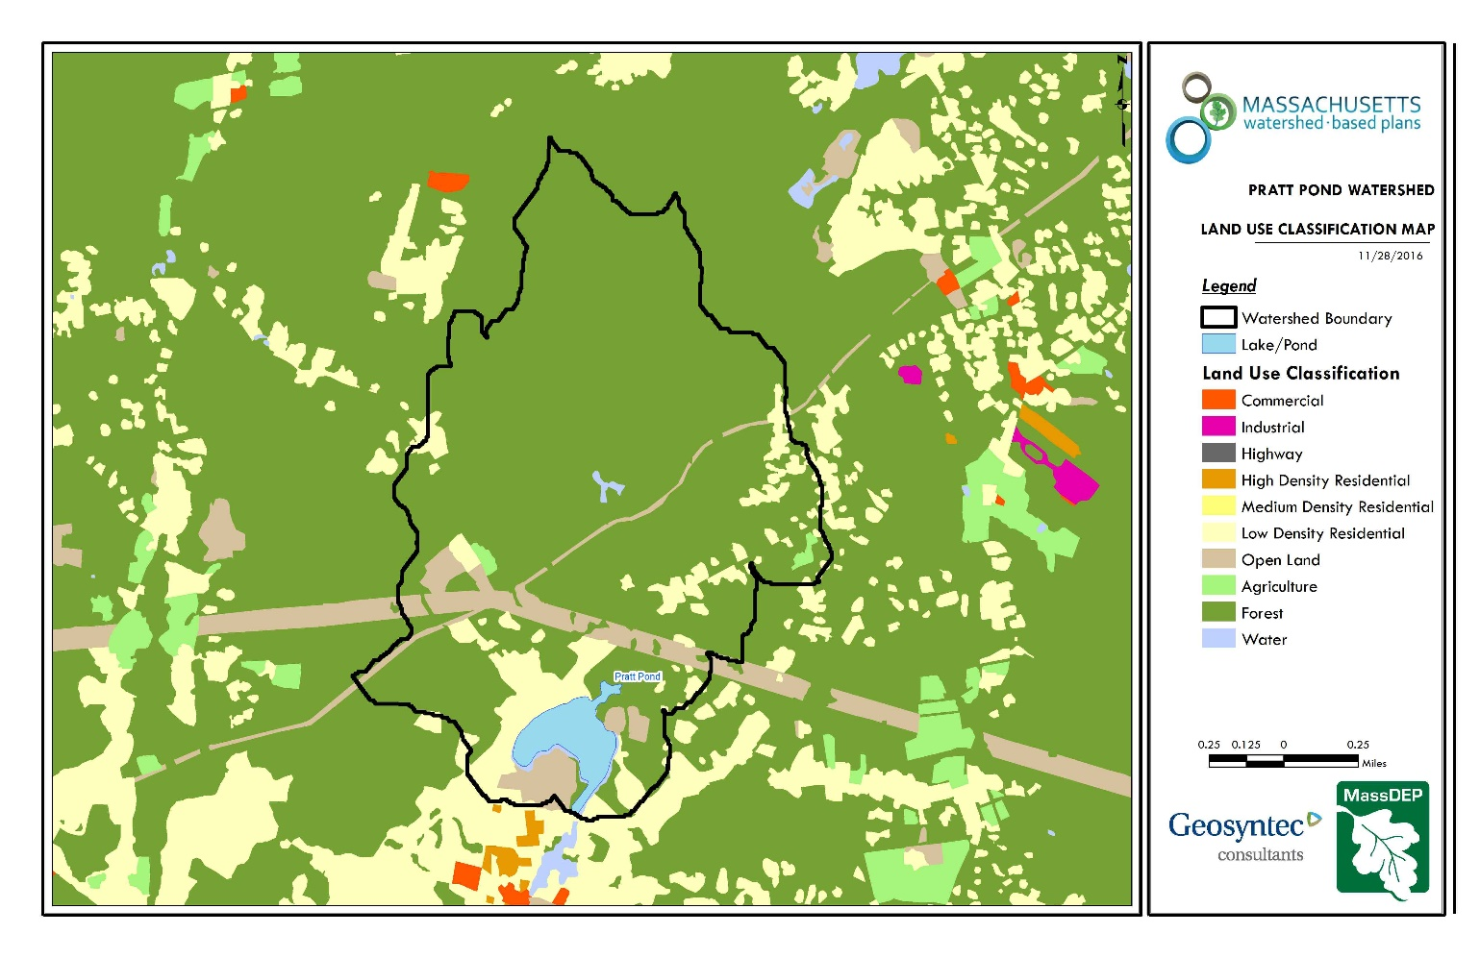
Figure A-2: Watershed Land Use Map (MassGIS, 2009b; MassGIS, 1999; MassGIS, 2001; USGS, 2016)

B. Watershed Impervious Cover

There is a strong link between impervious land cover and stream water quality. Impervious cover includes land surfaces that prevent the infiltration of water into the ground, such as paved roads and parking lots, roofs, basketball courts, etc.
Impervious areas that are directly connected (DCIA) to receiving waters (via storm sewers, gutters, or other impervious drainage pathways) produce higher runoff volumes and transport stormwater pollutants with greater efficiency than disconnected impervious cover areas which are surrounded by vegetated, pervious land. Runoff volumes from disconnected impervious cover areas are reduced as stormwater infiltrates when it flows across adjacent pervious surfaces.
An estimate of DCIA for the watershed was calculated based on the Sutherland equations. USEPA provides guidance (USEPA, 2010) on the use of the Sutherland equations to predict relative levels of connection and disconnection based on the type of stormwater infrastructure within the total impervious area (TIA) of a watershed. Within each subwatershed, the total area of each land use were summed and used to calculate the percent TIA.

Estimated TIA in the watershed: 4.5 %
Estimated DCIA in the watershed: 3 %

The relationship between TIA and water quality can generally be categorized as follows (Schueler et al. 2009):

Table A-7: Relationship between Total Impervious Area (TIA) and water quality (Schueler et al. 2009)

% Watershed  Impervious Cover | Stream Water Quality
0-10% | Typically high quality, and typified by stable channels, excellent habitat structure, good to excellent water quality, and diverse communities of both fish and aquatic insects.
11-25% | These streams show clear signs of degradation. Elevated storm flows begin to alter stream geometry, with evident erosion and channel widening. Streams banks become unstable, and physical stream habitat is degraded. Stream water quality shifts into the fair/good category during both storms and dry weather periods. Stream biodiversity declines to fair levels, with most sensitive fish and aquatic insects disappearing from the stream.
26-60% | These streams typically no longer support a diverse stream community. The stream channel becomes highly unstable, and many stream reaches experience severe widening, downcutting, and streambank erosion. Pool and riffle structure needed to sustain fish is diminished or eliminated and the substrate can no longer provide habitat for aquatic insects, or spawning areas for fish. Biological quality is typically poor, dominated by pollution tolerant insects and fish. Water quality is consistently rated as fair to poor, and water recreation is often no longer possible due to the presence of high bacteria levels.
>60% | These streams are typical of “urban drainage”, with most ecological functions greatly impaired or absent, and the stream channel primarily functioning as a conveyance for stormwater flows.

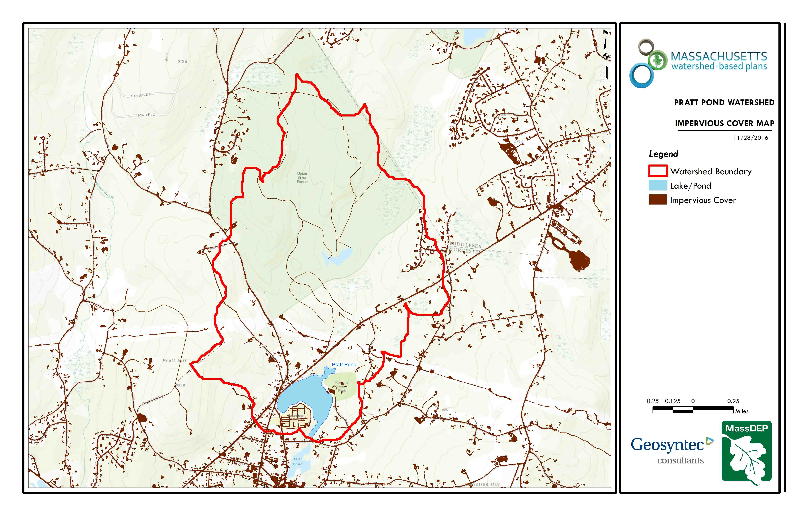
Figure A-3: Watershed Impervious Surface Map (MassGIS, 2009b; MassGIS, 1999; MassGIS, 2001; USGS, 2016)
Land use information:

The Upton State Forest is in the northern (upstream) portion of the watershed; therefore, most the pond’s watershed is forested (80%) with estimated impervious cover of just 4.5%. Areas of focus for this WBP are in the developed and heavily used areas – 1) in the vicinity of the recreation beach, and 2) in the vicinity of the boat ramp.

6. Pollutant Loading
The land use data (MassGIS, 2009b) was intersected with impervious cover data (MassGIS, 2009a) and United States Department of Agriculture (USDA) Natural Resources Conservation Service (NRCS) soils data (USDA NRCS and MassGIS, 2012) to create a combined land use/land cover grid. The grid was used to sum the total area of each unique land use/land cover type.
The amount of DCIA was estimated using the Sutherland equations as described above and any reduction in impervious area due to disconnection (i.e., the area difference between TIA and DCIA) was assigned to the pervious D soil category for that land use to simulate that some infiltration will likely occur after runoff from disconnected impervious surfaces passes over pervious surfaces.
Pollutant loading for key nonpoint source pollutants in the watershed was estimated by multiplying each land use/cover type area by its pollutant load export rate (PLER). The PLERs are an estimate of the annual total pollutant load exported via stormwater from a given unit area of a particular land cover type. The PLER values for TN, TP and TSS were obtained from USEPA (Voorhees, 2016b) (see documentation provided in Appendix A) as follows:
L_{n} = A_{n} * P_{n}
Where L_{n} = Loading of land use/cover type n (lb/yr); A_{n} = area of land use/cover type n (acres); P_{n} = pollutant load export rate of land use/cover type n (lb/acre/yr)

Table A-8: Estimated Pollutant Loading for Key Nonpoint Source Pollutants

Land Use Type | Pollutant Loading¹
Land Use Type | Total  Phosphorus (TP)  (lbs/yr) | Total  Nitrogen (TN)  (lbs/yr) | Total  Suspended Solids (TSS)  (tons/yr)
Agriculture | 3 | 20 | 0.32
Commercial | 0 | 0 | 0.00
Forest | 144 | 729 | 28.27
High Density Residential | 0 | 0 | 0.00
Highway | 0 | 0 | 0.00
Industrial | 0 | 0 | 0.00
Low Density Residential | 38 | 372 | 5.13
Medium Density Residential | 0 | 0 | 0.00
Open Land | 28 | 281 | 5.73
TOTAL | 213 | 1,401 | 39.46
¹These estimates do not consider loads from point sources or septic systems.

Pollutant loading information:

The Town currently does not monitor for Phosphorus; however, in-lake monitoring is recommended as part of Element I of this WBP.

Element B: Determine Pollutant Load Reductions Needed to Achieve Water Quality Goals

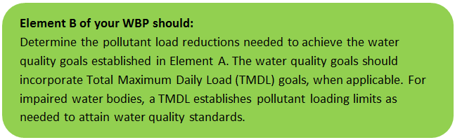 | 

- Estimated Pollutant Loads
Table 1 lists estimated pollutant loads for the following primary nonpoint source (NPS) pollutants: total phosphorus (TP), total nitrogen (TN), total suspended solids (TSS). These estimated loads are based on the pollutant loading analysis presented in Section 4 of Element A.

- Water Quality Goals
Water quality goals for primary NPS pollutants are listed in Table 1 based on the following:
- TMDL water quality goals (if a TMDL exists for the water body);
- For all water bodies, including impaired waters that have a pathogen TMDL, the water quality goal for bacteria is based on the Massachusetts Surface Water Quality Standards (314 CMR 4.00, 2013) that apply to the Water Class of the selected water body.
- If the water body does not have a TMDL for TP, a default target TP concentrations is provided which is based on guidance provided by the USEPA in Quality Criteria for Water (1986), also known as the “Gold Book”. Because there are no similar default water quality goals for TN and TSS, goals for these pollutants are provided in Table 1 only if a TMDL exists or alternate goal(s) have been optionally established by the WBP author.
- According to the USEPA Gold Book, total phosphorus should not exceed 50 ug/L in any stream at the point where it enters any lake or reservoir. The water quality loading goal was estimated by multiplying this target maximum phosphorus concentration (50 ug/L) by the estimated annual watershed discharge for the selected water body. To estimate the annual watershed discharge, the mean flow was used, which was estimated based on United States Geological Survey (USGS) “Runoff Depth” estimates for Massachusetts (Cohen and Randall, 1998). Cohen and Randall (1998) provide statewide estimates of annual Precipitation (P), Evapotranspiration (ET), and Runoff (R) depths for the northeastern U.S. According to their method, Runoff Depth (R) is defined as all water reaching a discharge point (including surface and groundwater), and is calculated by:
P – ET = R
A mean Runoff Depth R was determined for the watershed by calculating the average value of R within the watershed boundary. This method includes the following assumptions/limitations:

  - For lakes and ponds, the estimate of annual TP loading is averaged across the entire watershed. However, a given lake or reservoir may have multiple tributary streams, and each stream may drain land with vastly different characteristics. For example, one tributary may drain a highly developed residential area, while a second tributary may drain primarily forested and undeveloped land. In this case, one tributary may exhibit much higher phosphorus concentrations than the average of all streams in the selected watershed.

  - The estimated existing loading value only accounts for phosphorus due to stormwater runoff. Other sources of phosphorus may be relevant, particularly phosphorus from on-site wastewater treatment (septic systems) within close proximity to receiving waters. Phosphorus does not typically travel far within an aquifer, but in watersheds that are primarily unsewered, septic systems and other similar groundwater-related sources may contribute a significant load of phosphorus that is not captured in this analysis. As such, it is important to consider the estimated TP loading as "the expected TP loading from stormwater sources."

Table B-1: Pollutant Load Reductions Needed

Pollutant | Estimated Total Load | Water Quality Goal | Required Load Reduction
Total Phosphorus | 213 lbs/yr | 192 lbs/yr | 21 lbs/yr  (see “pollutant load reduction information” below)
Total Nitrogen | 1401 lbs/yr
Total Suspended Solids | 39 ton/yr
Bacteria | MSWQS for bacteria are concentration standards (e.g., colonies of fecal coliform bacteria per 100 ml), which are difficult to predict based on estimated annual loading. | Class B. Class B Standards  • Public Bathing Beaches: For E. coli, geometric mean of 5 most recent samples shall not exceed 126 colonies/ 100 ml and no single sample during the bathing season shall exceed 235 colonies/100 ml. For enterococci, geometric mean of 5 most recent samples shall not exceed 33 colonies/100 ml and no single sample during bathing season shall exceed 61 colonies/100 ml;  • Other Waters and Non-bathing Season at Bathing Beaches: For E. coli, geometric mean of samples from most recent 6 months shall not exceed 126 colonies/100 ml (typically based on min. 5 samples) and no single sample shall exceed 235 colonies/100 ml. For enterococci, geometric mean of samples from most recent 6 months shall not exceed 33 colonies/100 ml, and no single sample shall exceed 61 colonies/100 ml.

Pollutant load reduction information: At the time of writing this WBP, there are no known water chemistry data (e.g., phosphorus concentrations) for characterizing the trophic status of Pratt Pond. Given the iterative and adaptive nature of this plan, the monitoring portion of this WBP (Element I) recommends that monitoring be performed to close this data gap and establish a specific phosphorus related water quality goal with the next update of the WBP (expected in 2019). In the interim, the current external phosphorus load is estimated to be 213 pounds per year per WBP tool estimates. A long-term 10% reduction in external loading is proposed to be protective of the good water quality within Pratt Pond and provide assimilative capacity as land development continues in the watershed.
Element C: Describe management measures that will be implemented to achieve water quality goals

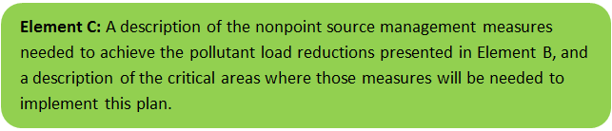 | 

FIELD WATERSHED INVESTIGATION
Geosyntec Consultants conducted a field investigation of the Pratt Pond Watershed (“Watershed”) on May 5, 2017 in Upton, Massachusetts. The field investigation was performed during a time of active precipitation to enable visualization of active flow patterns. Precipitation totals for the day were approximately 0.9” in the Watershed. The Upton State Forest comprises most of the northern (upstream) portion of the watershed. 80% of the Watershed is forested with estimated impervious cover of just 4.5%. Pratt Pond has a recreational swimming beach and public access boat ramp and is avidly used by local fishermen, recreational boaters, and swimmers. The pond is located within the Blackstone River Watershed and is Category 4C listed for Non-Native Aquatic Plants, but not for any specific pollutants of concern.
The primary purpose of the field investigation was to identify potential best management practices (BMPs) and restoration practices that can be implemented to protect the generally healthy watershed and high water quality of Pratt Pond. Given the mostly undeveloped nature of the watershed, BMP recommendations are focused on two areas of interest where significant runoff and potential pollutant loading was observed during the field investigation:
- Boat Ramp Vicinity: Two steeply sloping roads (School Street and North Main Street) intersect and discharge untreated runoff into the southwestern perimeter of the pond. Untreated runoff is primarily discharged through an 8-inch corrugated metal outfall and a 10-foot long asphalt chute. Based on existing grading, minimal runoff enters Pratt Pond through the boat ramp; however, an unpaved shoulder (approximately 100-foot long) adjacent to the boat ramp receives sheet flow and concentrated runoff. Rill and gully erosion was observed at regular intervals along the shoulder.
- Recreational Beach Vicinity: The Kiwanis recreational beach is located along the northeastern corner of Pratt Pond. The area is comprised of a large parking lot, a community center, and a sports complex with multiple athletic fields. The entire area drains to a single catch basin located in the southern corner of the parking lot which discharges untreated runoff through a 6-inch PVC outfall onto the southeastern side of the beach. The catch basin was at capacity during the field investigation and ponding in within the southern corner of the parking lot was observed. The 6-inch outfall discharges onto an embedded concrete block that provides minimal energy dissipation. Active erosion and scouring was observed during the field investigation.
Figure C-1 shows the location of each proposed BMP site. The hydrologic soil type of soils in the vicinity of each proposed BMP were evaluated and are all classified as Type A or B (See Figure C-2). Type A and Type B soils generally have low runoff potential and are excellent for installation of infiltrating BMPs.

Primary BMP Recommendations
The BMP improvement sites described on the following pages were identified during Geosyntec’s field investigation. The design goal for the proposed BMPs would be to size the BMP to treat and infiltrate the water quality volume to the maximum extent practicable. The water quality volume is typically defined in the Massachusetts Stormwater Handbook as the volume equal to 0.5 to 1 inches of runoff times the total impervious area within the drainage area of the BMP. However, each proposed BMP should be designed to achieve the most treatment that is practical given the size and logistical constraints of the site.

Each BMP site description includes:
- A site summary that describes current conditions and stormwater drainage patterns;
- A description of proposed improvements;
- Estimated costs that represent installed contractor construction costs (i.e. capital costs); and
- Estimated pollutant load reduction for the proposed BMP (if estimates are available).
Planning level cost estimates and pollutant load reduction estimates were based off information obtained in the following sources and were also adjusted to 2016 values using the Consumer Price Index (CPI) (United States Bureau of Labor Statistics, 2016):

- Geosyntec Consultants, Inc. (2014);
- Geosyntec Consultants, Inc. (2015);
- King and Hagen (2011);
- Leisenring, et al. (2014);
- King and Hagen (2011);
- MassDEP (2016a);
- MassDEP (2016b);
- University of Massachusetts, Amherst (2004);
- Voorhees (2015);
- Voorhees (2016a);
- Voorhees (2016b);

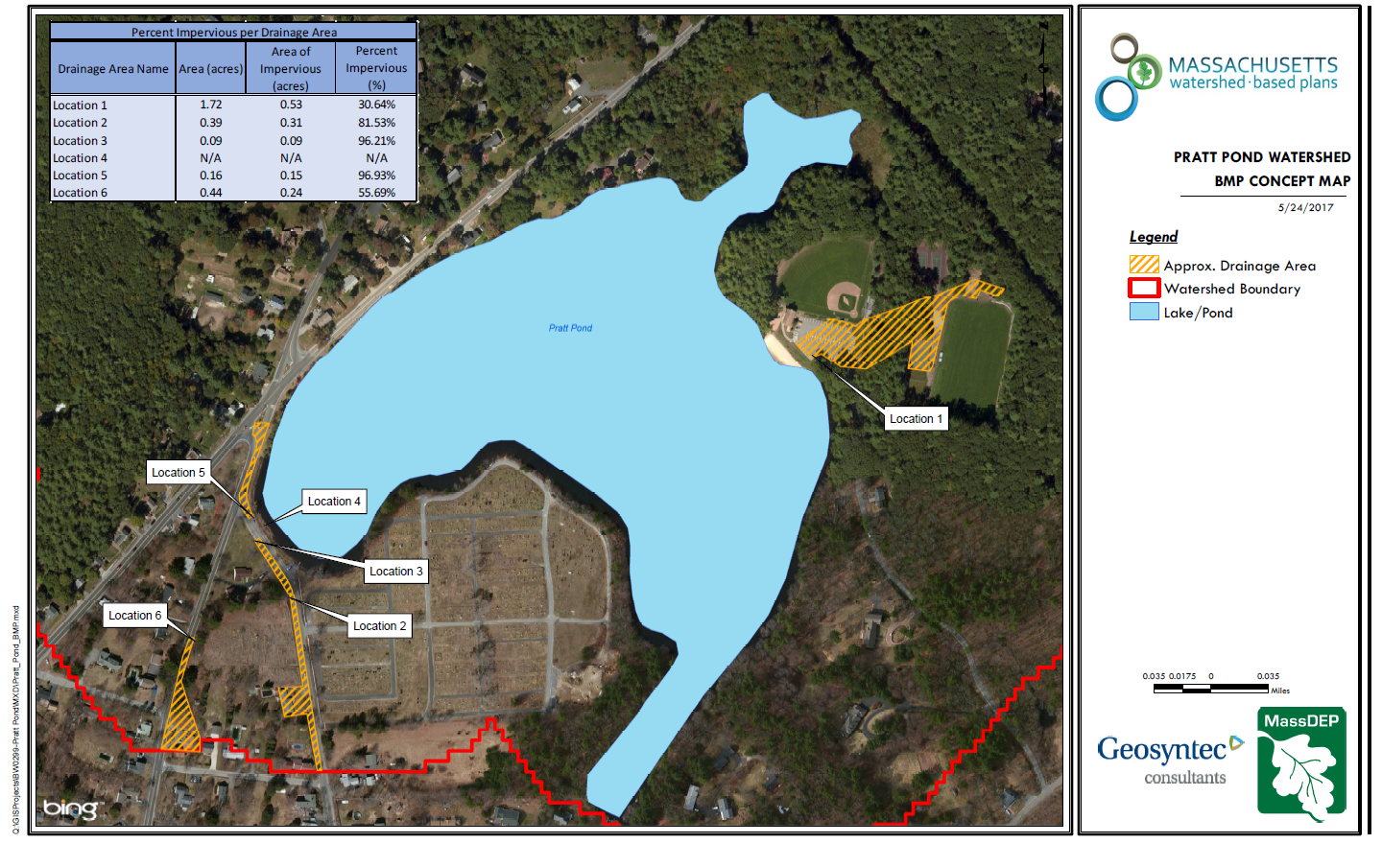
Figure C-1. Potential BMP Improvement Sites

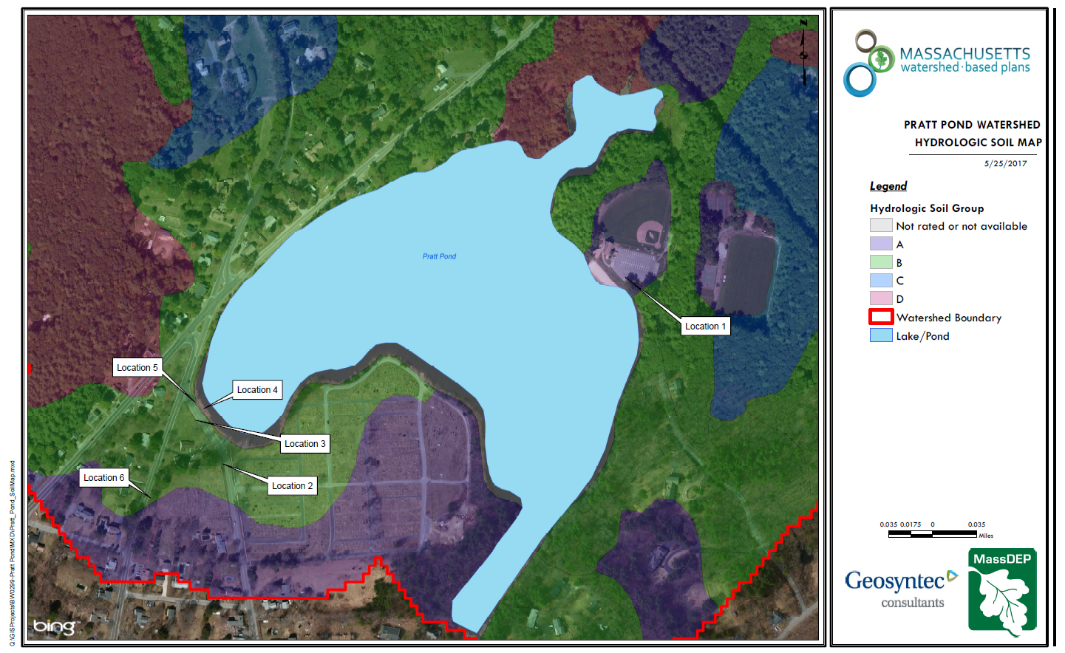
Figure C-2. Hydrologic Soil Classifications

Location 1: Kiwanis Beach Road
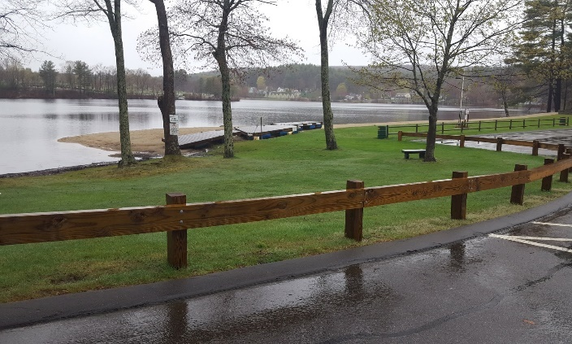
Bioretention Cell
WQ Swale
Catch Basin
Photo 1-1
Outfall
Curb Cut
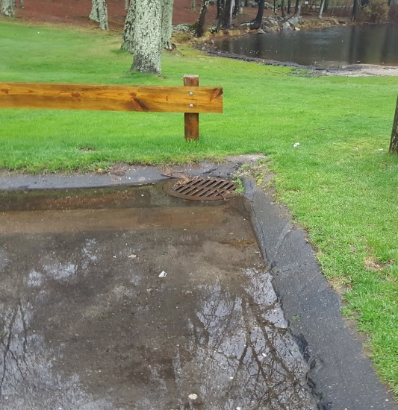
Outfall
Catch Basin / Ponding
Photo 1-2
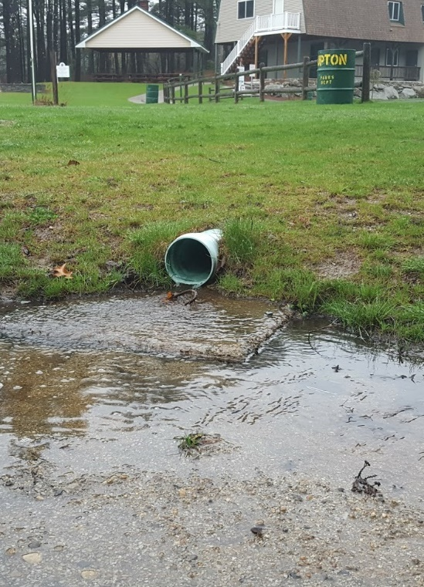
Outfall
(Erosion D/S)
Photo 1-3
Recreational Beach Parking Lot
Site Summary: Photos 1-1, 1-2, 1-3
The Kiwanis recreational beach is located along the northeastern corner of the Pratt Pond. The area is comprised of a large parking lot, a community center, and a sports complex with multiple athletic fields. The entire area drains via a steep asphalt walking path to a single catch basin located in the southern corner of the parking lot which discharges untreated runoff through a 6-inch PVC outfall onto the southeastern side of the beach. The catch basin was at capacity and ponding was observed during the site investigation. Active erosion and scouring was observed on the beach at the outfall.
Proposed Improvement: Photo 1-1, Image 1-4
Install 500-square foot bioretention cell within the grassed area adjacent to the parking lot. Runoff from the bioretention would be conveyed to the catch basin through a 75-linear foot grassed swale with stone outlet protection. Install level spreader and riprap outlet protection at outfall to dissipate energy and minimize future erosion.
Expected O&M: Remove accumulated sediment from bioretention cell and energy dissipation pad annually and maintain/replace plants as needed every two years. Mow grassed swale regularly. Replant grass as needed to maintain adequate vegetative cover. Remove accumulated debris prior to mowing.
Wetland Permitting: As a project with minor buffer zone disturbances, WPA permitting is expected to require submittal of an ANOI.
Sizing Characteristics
Drainage Area (acres) | 1.75
Impervious Area (%) | 31
Estimated Load Reduction (lb/yr)
TN (lbs/yr) | 4.6
TP (lbs/yr) | 0.55
TSS (lbs/yr) | 360.92
Estimated Costs ($)
Capital | $32,052

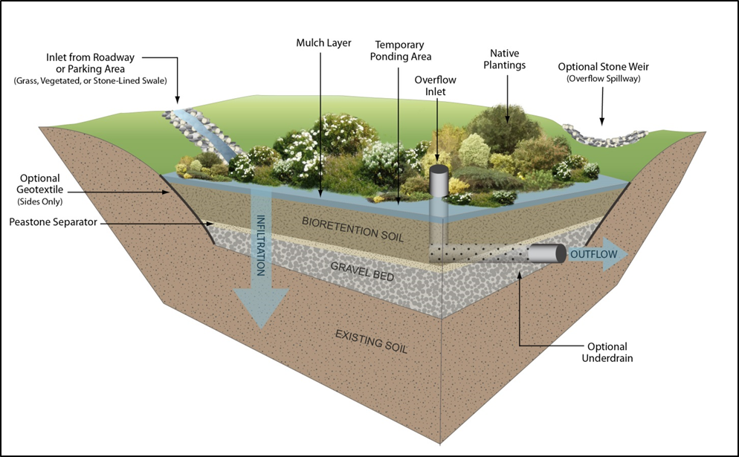
Image 1-4
Image 1-4 is a cross section schematic of a typical bioretention cell. Bioretention cells are shallow landscaped depressions that incorporate plantings and engineered soil with a high porosity and infiltration capacity. Bioretention cells control stormwater runoff volume by providing storage, reducing peak discharge, and removing pollutants through physical, chemical, and biological processes occurring in plants and soil (MA Stormwater Handbook).

Location 2: North Main Street (A)
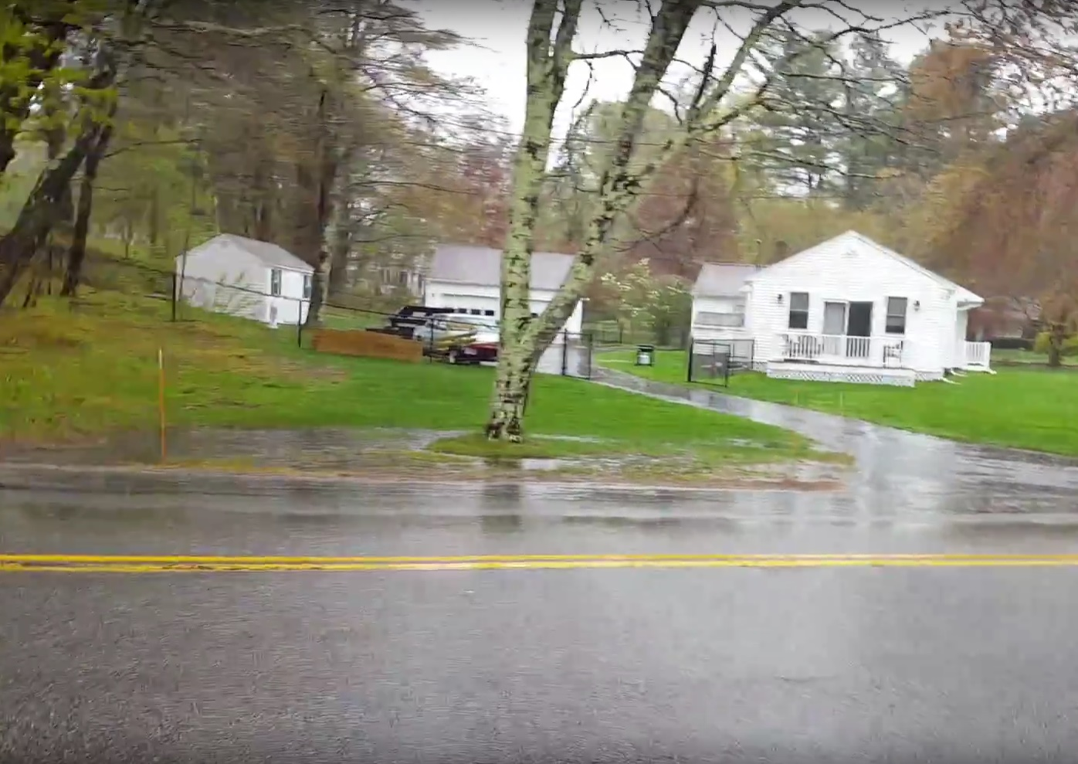
71 School St
Ponding
Photo 2-1
Western Side of Road, Across from Boat Ramp
Site Summary: Photo 2-1
A corner lot at 71 School Street receives runoff from North Main Street and School Street. Runoff travels down North Main Street and ponds at the end of 71 School Street’s driveway before continuing along the front of the property and entering a catch basin. The catch basin discharges to an 8-inch corrugated metal outfall across the street and into Pratt Pond.
Proposed Improvements: Photo 2-2
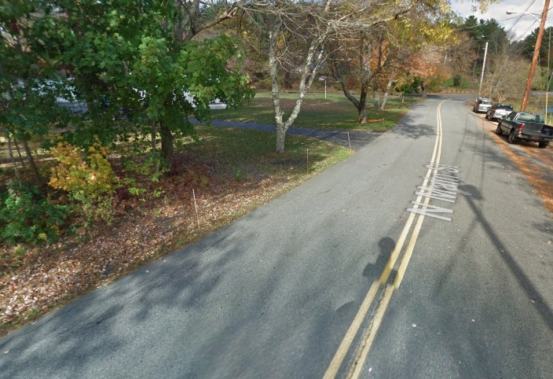
Install 40-linear foot gravel infiltration trench within the right of the way upstream of the driveway. Install sediment forebay (stone filled depression) at the upstream mouth of the trench to capture sediment and minimize maintenance frequency. Once at capacity, runoff would continue down the street to the downstream catch basin per existing conditions.
Photo 2-2
Infiltration Trench with Sediment Forebay
Catch Basin
Infiltration trench extent could be expanded depending on access agreement with homeowner to extend onto property.
Expected O&M: Infiltration trenches are susceptible to clogging and should be cleaned regularly. Coordinate snow plow to minimize snow dumping onto infiltration trench.
Infiltration trenches are shallow excavations filled with stone. The stone provides underground storage for stormwater runoff. The stored runoff gradually exfiltrates through the bottom and/or sides of the trench into the subsoil and eventually into the water table (Massachusetts Stormwater Handbook).
Sizing Characteristics
Drainage Area (acres) | 0.40
Impervious Area (%) | 82
Estimated Load Reduction (lb/yr)
TN (lbs/yr) | 4.24
TP (lbs/yr) | 0.34
TSS (lbs/yr) | 128.89
Estimated Costs ($)
Capital | $2,851

Location 3: North Main Street (B)
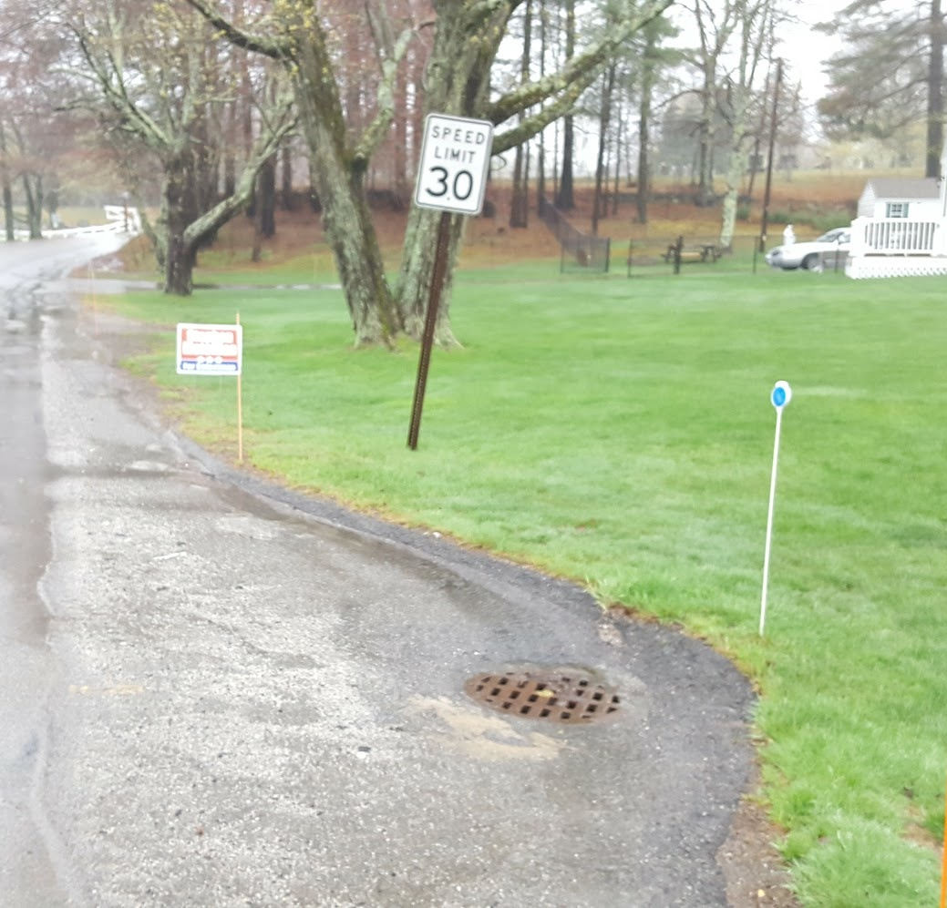
Bioretention Cell
Catch Basin
Photo 3-1
Performance of recommended improvement would increase when paired with the upstream infiltration trench (Site 2).

Downstream of Location 2
Site Summary: Photo 3-1
A corner lot at 71 School Street receives runoff from North Main Street and School Street. Runoff travels down North Main Street and ponds at the end of 71 School Street’s driveway before continuing along the front of the property and entering a catch basin. The catch basin discharges to an 8-inch corrugated metal outfall across the street and into Pratt Pond.
Proposed Improvements: Photo 3-1
Remove existing asphalt surrounding the catch basin and install 200-square foot bioretention cell within the public right of way. The existing catch basin would be used as an overflow during larger storm events.
Bioretention cell extent could be expanded depending on access agreement with homeowner to extend onto property.
Expected O&M: Remove accumulated sediment from bioretention cell annually and maintain/ replace plants as needed every two years
Wetland Permitting: As a project with minor buffer zone disturbances, WPA permitting is expected to require submittal of an ANOI.
Sizing Characteristics
Drainage Area (acres) | 0.10
Impervious Area (%) | 100
Estimated Load Reduction (lb/yr)
TN (lbs/yr) | 1.1
TP (lbs/yr) | 0.12
TSS (lbs/yr) | 43.90
Estimated Costs ($)
Capital | $4,022

Location 4: North Main Street (C)
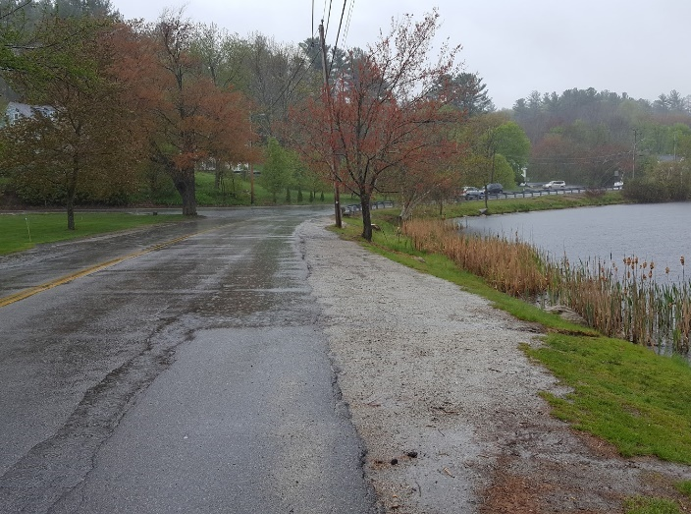
Photo 4-1
Vegetated Buffer
Asphalt Stabilization
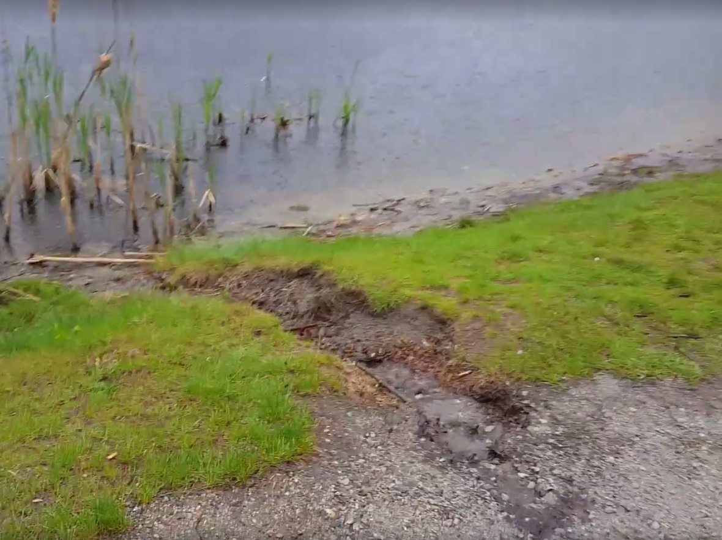
Photo 4-2
Gully Erosion
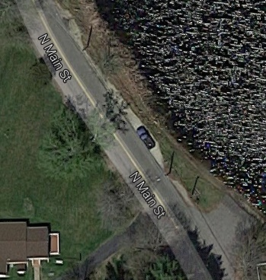
Asphalt Stabilization and Vegetated Buffer Area
Boat Ramp
Photo 4-3
Road Shoulder Adjacent to Pond
Site Summary: Photos 4-1, 4-2
The road shoulder along North Main Street adjacent to the Boat Ramp is unpaved and used as parking by boaters, fisherman, and other recreational users. The shoulder receives sheet flow from North Main Street and School Street. Rill and gully erosion was observed at regular intervals along the shoulder.
Proposed Improvements: Photo 4-2, 4-3
- Stabilize approximately 100-linear feet of the road shoulder with asphalt paving. Design paved shoulder so a vehicle with a small trailer can fit within the shoulder.
- Install reinforced turf mat and vegetative buffer between shoulder and Pratt Pond. Buffer would consist of double row of shrubs at 3 foot spacing on center to slow runoff velocities, trap sediment, and thereby minimize migration of sediment and other pollutants into the channel.
- Install strategically located stone check dams to dissipate concentrated flow and minimize erosive energy.
Expected O&M: Inspect plantings annually and replace as needed.
Wetland Permitting: As a project with minor buffer zone disturbances, WPA permitting is expected to require submittal of an ANOI.
Sizing Characteristics
Drainage Area (acres) | -
Impervious Area (%) | 100
Estimated Load Reduction (lb/yr)
TN (lbs/yr) | 0.99
TP (lbs/yr) | -
TSS (lbs/yr) | 138.27
Estimated Costs ($)
Capital | $16,148

Location 5: North Main Street (D)
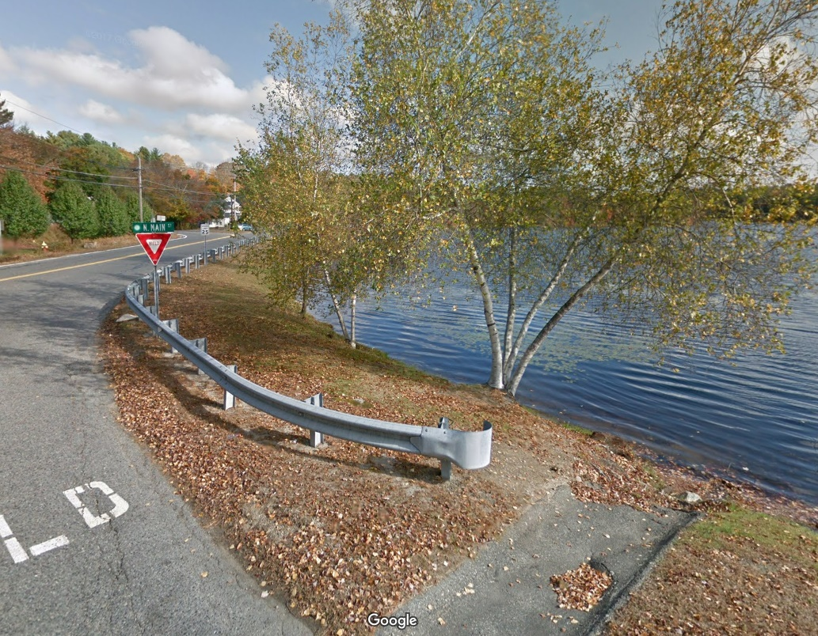
Water Quality Swale
Sediment Forebay
Riprap Energy Dissipation Pad
Photo 5-1
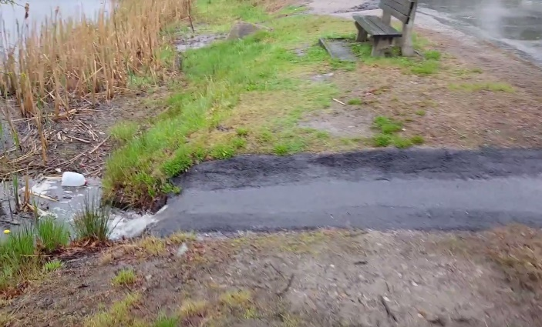
Discharge During Rain
Photo 5-2
See below for recommended Location 6 improvement, which would minimize runoff from the southern portion of School Street.

Intersection with School Street
Site Summary: Photos 5-1, 5-2
A 10-foot asphalt chute discharges untreated runoff from School Street directly into Pratt Pond at the intersection of School Street and North Main Street.
Proposed Improvements: Photo 5-1
- Remove asphalt chute and replace with riprap energy dissipation pad. Grade mouth of dissipation pad into a sediment forebay.
- Install 75-linear foot water quality swale behind guard rail that discharges into sediment forebay. Install stone check dams within water quality swale to minimize runoff velocities.
The water quality swale would capture runoff from the northern portion of School Street, while the sediment forebay would capture runoff from the southern portion of School Street.
Expected O&M: Remove accumulated sediment and debris from energy dissipation pad and swale as needed. Mow grassed swale regularly. Replant grass as needed to maintain adequate vegetative cover and minimize erosion.
Wetland Permitting: This project involves minor activity within the buffer zone to stabilize and existing outlet area and could be permitted through a Negative Determination under a WPA request for Determination of Applicability.
Sizing Characteristics
Drainage Area (acres) | 0.16
Impervious Area (%) | 100
Estimated Load Reduction (lb/yr)
TN (lbs/yr) | -
TP (lbs/yr) | 0.15
TSS (lbs/yr) | 133.66
Estimated Costs ($)
Capital | $8,337

Location 6: School Street
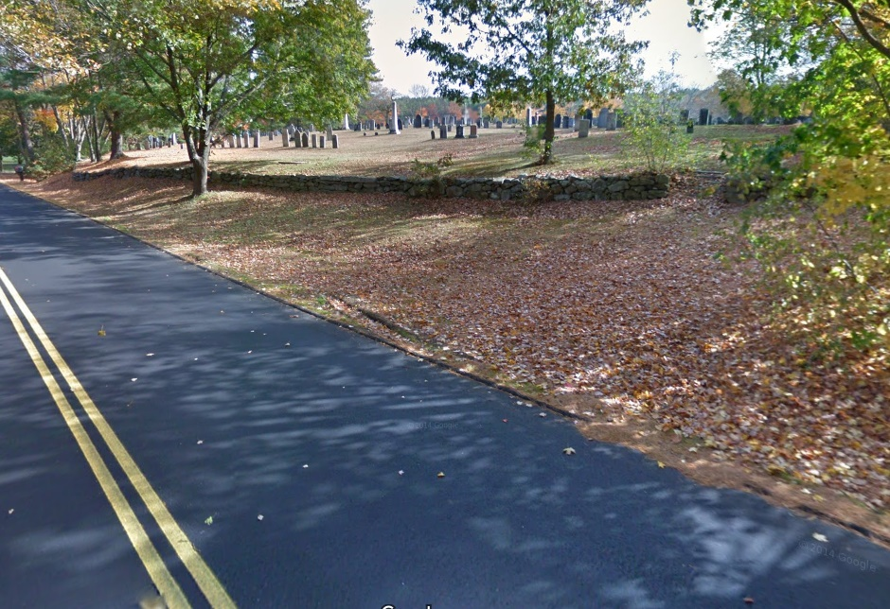
Bioretention Cell
Water Quality Swale
Photo 6-1
Adjacent to Town Cemetery
Site Summary: Photo 6-1
Untreated runoff sheets down School Street and into the aforementioned asphalt chute (See Site 5) which then enters Pratt Pond.
Proposed Improvements: Photo 6-1
Install 300-squate foot bioretention cell which overflows into a 100-linear foot water quality swale along shoulder of road. Install stone outlet protection at downstream end of water quality swale and stone check dams within the swale.
Expected O&M: Remove accumulated sediment from bioretention cell and swale annually and maintain/replace plants as needed every two years. Mow swale regularly.
Wetland Permitting: None expected.
Sizing Characteristics
Drainage Area (acres) | 0.44
Impervious Area (%) | 56
Estimated Load Reduction (lb/yr)
TN (lbs/yr) | 3.03
TP (lbs/yr) | 0.33
TSS (lbs/yr) | 113.86
Estimated Costs ($)
Capital | $21,640

Element D: Identify Technical and Financial Assistance Needed to Implement Plan

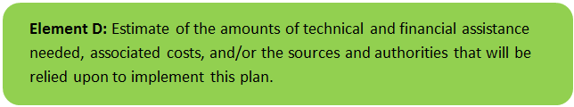 | 

Table D-1 presents the funding needed to implement the management measures presented in this watershed plan. The table includes costs for structural and non-structural BMPs, operation and maintenance materials, information/education measures, and monitoring/evaluation activities. The table also includes anticipated performance of BMPs where applicable and other characteristics (e.g., drainage area).

Table D-1: Summary of Funding Needed to Implement the Watershed Plan.

Element E: Public Information and Education

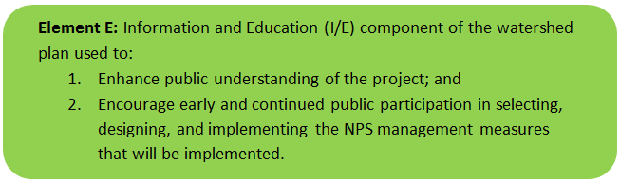 | 

Step 1: Goals and Objectives
The goals and objectives for the watershed information and education program.

- Provide information about specific stormwater improvements that are being implemented and their water quality benefits.
- Provide information to promote watershed stewardship.

Step 2: Target Audience
Target audiences that need to be reached to meet the goals and objectives identified above.

- All watershed residents
- Recreational users of Pratt Pond including boaters, fishermen, and beachgoers.

Step 3: Outreach Products and Distribution
The outreach product(s) and distribution form(s) that will be used for each.

The following outreach products are anticipated:
- Project updates will be posted on the Department of Public Works Town Website.
- A press release describing the overall project and anticipated benefits will be posted to the Town Crier (The Town's local newspaper).
- A brochure will be developed and posted to the website promoting watershed stewardship.

Step 4: Evaluate Information/Education Program
Information and education efforts and how they will be evaluated.

The effectiveness of the program will be evaluated by tracking the number of web page views (goal of 500 views).

Elements F & G: Implementation Schedule and Measurable Milestones

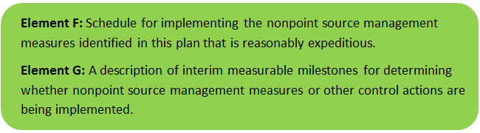 | 

Scheduling and milestone information:

The Town of Upton is submitting a grant application for RFR# BRP-RFR-2017-06-319. If the Town is awarded grant funding, the below schedule is based on a start date of January 1, 2018. The anticipated duration of the project is 19 months to accommodate post construction monitoring. The below schedule is extended to 24 months to account for potential contingency time (e.g., if construction takes longer than anticipated). Therefore, the expected completion date is 12/29/2019.

It is also expected that the WBP will be re-evaluated and updated in 2019 following completion of post-construction monitoring.

Table FG-1: Implementation Schedule and Interim Measurable Milestones
Month | ₂₀₁₈ |  |  |  |  |  |  |  |  |  |  |  | ₂₀₁₉
Month | ₁ | ₂ | ₃ | ₄ | ₅ | ₆ | ₇ | ₈ | ₉ | ₁₀ | ₁₁ | ₁₂ | ₁₃ | ₁₄ | ₁₅ | ₁₆ | ₁₇ | ₁₈ | ₁₉ | ₂₀ | ₂₁ | ₂₂ | ₂₃ | ₂₄
Task 1: Design and Permitting
Task 2: Construction and CQA
Task 3: O&M Manual & Maintenance
Task 4: Outreach Materials
Task 5: In-Lake Monitoring
Task 6: Communications |  |  |  | Q |  |  |  | Q |  |  |  | Q |  |  |  | Q |  |  |  | Q |  |  |  | Q
Q = Quarterly s.319 project reporting

Elements H & I: Progress Evaluation Criteria and Monitoring

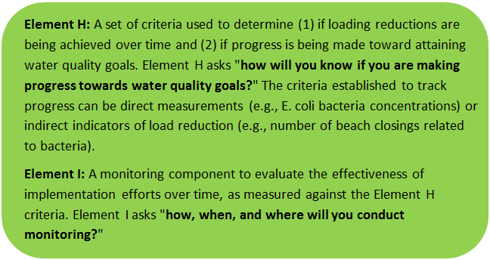 | 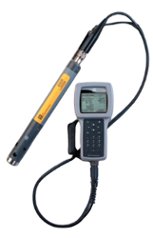

The water quality target concentration(s) is presented under Element A of this plan. To achieve this target concentration, the annual loading must be reduced to the amount described in Element B. Element C of this plan describes the various management measures that will be implemented to achieve this targeted load reduction. The evaluation criteria and monitoring program described below will be used to measure the effectiveness of the proposed management measures (described in Element C) in improving the water quality of Gulf Pond.

Indirect Indicators of Load Reduction
Indirect indicators are not proposed to be evaluated as part of this WBP given the existing good water quality within Pratt Pond.

Project-Specific Indicators
Number of BMPs installed:
Element C of this WBP recommends the installation of BMPs at six different locations. The anticipated pollutant load reduction has been documented for each proposed BMP where applicable. The number of BMPs that were installed will be tracked and quantified as part of this monitoring program. If all BMPs are installed, the anticipated phosphorus load reduction is estimated to be 1.5 pound per year.

TMDL Criteria
Not applicable to Pratt Pond.

Direct Measurements
In-Lake Phosphorus Monitoring: As discussed in Element B, there are no known water chemistry data for characterizing the trophic status of Pratt Pond; therefore, watershed-scale monitoring will be implemented to evaluate the collective effectiveness of management measures implemented within the watershed. In-lake phosphorus measurements will provide the most direct means of evaluating the effects of measures which have been implemented specifically to reduce phosphorus loading. Regular monitoring (i.e. 3 times per summer) of phosphorus levels from a profile (samples from the epilimnion, metalimnion and hypolimnion) at 3 monitoring locations (as shown on Figure HI-1) will be performed to provide data on phosphorus concentration trends in response to implementation of the measures described in Element C.

Baseline monitoring will commence prior to BMP implementation and will continue annually. Findings from the monitoring program will be evaluated during the next update of the WBP (expected in 2019) and modifications will be made as needed.

Adaptive Management
If after 3 years of management measure implementation, interim targets are not met and the direct measurements and indirect indicators do not show improvement in the total phosphorus concentrations measured within Pratt Pond, the management measures and loading reduction analysis (Elements A through D) will be revisited and modified accordingly.
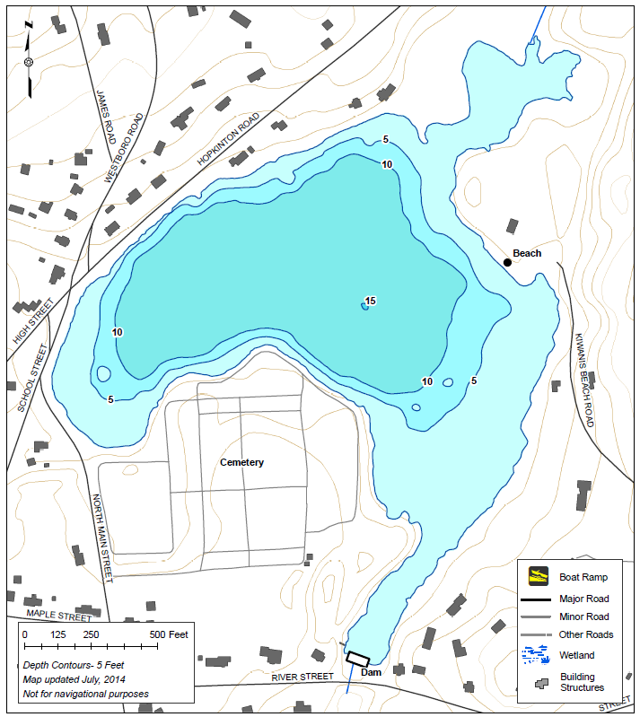
Figure HI-1. Proposed In-Lake Phosphorus Monitoring Locations
(Map Source: MA Division of Fisheries and Wildlife)
Location 2 - West
Location 3 - East
Location 1 - Tributary
BMP Implementation Area
BMP Implementation Area
References / Appendix

References
314 CMR 4.00 (2013). "Division of Water Pollution Control, Massachusetts Surface Water Quality Standards"
Cohen, A. J.; Randall, A.D. (1998). "Mean annual runoff, precipitation, and evapotranspiration in the glaciated northeastern United States, 1951-80." Prepared for United States Geological Survey, Reston VA.
Geosyntec Consultants, Inc. (2014). "Least Cost Mix of BMPs Analysis, Evaluation of Stormwater Standards Contract No. EP-C-08-002, Task Order 2010-12." Prepared for Jesse W. Pritts, Task Order Manager, U.S. Environmental Protection Agency
Geosyntec Consultants, Inc. (2015). "Appendix B: Pollutant Load Modeling Report, Water Integration for the Squamscott-Exeter (WISE) River Watershed."
King, D. and Hagan, P. (2011). "Costs of Stormwater Management Practices in Maryland Counties." University of Maryland Center for Environmental Science Chesapeake Biological Laboratory. October 11, 2011.
Leisenring, M., Clary, J., and Hobson, P. (2014). "International Stormwater Best Management Practices (BMP) Database Pollutant Category Statistical Summary Report: Solids, Bacteria, Nutrients and Metals." Geosyntec Consultants, Inc. and Wright Water Engineers, Inc. December 2014.
MassDEP (2012). "Massachusetts Year 2012 Integrated List of Waters Final Listing of Massachusetts' Waters Pursuant to Sections 305(b), 314 and 303(d) of the Clean Water Act"
MassDEP (2016a). "Massachusetts Clean Water Toolkit"
MassDEP (2016b). "Massachusetts Stormwater Handbook, Vol. 2, Ch. 2, Stormwater Best Management Practices"
MassGIS (1999). "Networked Hydro Centerlines" Shapefile
MassGIS (2001). "USGS Topographic Quadrangle Images" Image
MassGIS (2007). "Drainage Sub-basins" Shapefile
MassGIS (2009a). "Impervious Surface" Image
MassGIS (2009b). "Land Use (2005)" Shapefile
MassGIS (2013). "MassDEP 2012 Integrated List of Waters (305(b)/303(d))" Shapefile
Schueler, T.R., Fraley-McNeal, L, and K. Cappiella (2009). "Is impervious cover still important? Review of recent research" Journal of Hydrologic Engineering 14 (4): 309-315.
United States Bureau of Labor Statistics (2016). "Consumer Price Index"
United States Geological Survey (2016). "National Hydrography Dataset, High Resolution Shapefile"
University of Massachusetts, Amherst (2004). "Stormwater Technologies Clearinghouse"
USDA NRCS and MassGIS (2012). "NRCS SSURGO-Certified Soils" Shapefile
USEPA (1986). "Quality Criteria for Water (Gold Book)" EPA 440/5-86-001. Office of Water, Regulations and Standards. Washington, D.C.
USEPA. (2010). "EPA's Methodology to Calculate Baseline Estimates of Impervious Area (IA) and Directly Connected Impervious Area (DCIA) for Massachusetts Communities."
Voorhees, Mark, USEPA. (2015). "FW: Description of additional modelling work for Opti-Tool Project" Message to Chad Yaindl, Geosyntec Consultants. 23 April 2015. E-mail.
Voorhees, Mark, USEPA. (2016a). "FW: EPA Region 1 SW BMP performance equations" Message to Chad Yaindl, Geosyntec Consultants. 25 January 2016. E-mail.
Voorhees, Mark, USEPA. (2016b). "FW: Description of additional modelling work for Opti-Tool Project" Message to Chad Yaindl, Geosyntec Consultants. 23 April 2015. E-mail.

Water Quality Assessment Reports
"Blackstone River Watershed 2003-2007 Water Quality Assessment Report"

TMDL
No TMDL Found

Appendix A – Pollutant Load Export Rates (PLERs)

Land Use & Cover¹ | PLERs (lb/acre/year)
Land Use & Cover¹ | (TP) | (TSS) | (TN)
AGRICULTURE, HSG A | 0.45 | 7.14 | 2.59
AGRICULTURE, HSG B | 0.45 | 29.4 | 2.59
AGRICULTURE, HSG C | 0.45 | 59.8 | 2.59
AGRICULTURE, HSG D | 0.45 | 91.0 | 2.59
AGRICULTURE, IMPERVIOUS | 1.52 | 650 | 11.3
COMMERCIAL, HSG A | 0.03 | 7.14 | 0.27
COMMERCIAL, HSG B | 0.12 | 29.4 | 1.16
COMMERCIAL, HSG C | 0.21 | 59.8 | 2.41
COMMERCIAL, HSG D | 0.37 | 91.0 | 3.66
COMMERCIAL, IMPERVIOUS | 1.78 | 377 | 15.1
FOREST, HSG A | 0.12 | 7.14 | 0.54
FOREST, HSG B | 0.12 | 29.4 | 0.54
FOREST, HSG C | 0.12 | 59.8 | 0.54
FOREST, HSG D | 0.12 | 91.0 | 0.54
FOREST, HSG IMPERVIOUS | 1.52 | 650 | 11.3
HIGH DENSITY RESIDENTIAL, HSG A | 0.03 | 7.14 | 0.27
HIGH DENSITY RESIDENTIAL, HSG B | 0.12 | 29.4 | 1.16
HIGH DENSITY RESIDENTIAL, HSG C | 0.21 | 59.8 | 2.41
HIGH DENSITY RESIDENTIAL, HSG D | 0.37 | 91.0 | 3.66
HIGH DENSITY RESIDENTIAL, IMPERVIOUS | 2.32 | 439 | 14.1
HIGHWAY, HSG A | 0.03 | 7.14 | 0.27
HIGHWAY, HSG B | 0.12 | 29.4 | 1.16
HIGHWAY, HSG C | 0.21 | 59.8 | 2.41
HIGHWAY, HSG D | 0.37 | 91.0 | 3.66
HIGHWAY, IMPERVIOUS | 1.34 | 1,480 | 10.2
INDUSTRIAL, HSG A | 0.03 | 7.14 | 0.27
INDUSTRIAL, HSG B | 0.12 | 29.4 | 1.16
INDUSTRIAL, HSG C | 0.21 | 59.8 | 2.41
INDUSTRIAL, HSG D | 0.37 | 91.0 | 3.66
INDUSTRIAL, IMPERVIOUS | 1.78 | 377 | 15.1
LOW DENSITY RESIDENTIAL, HSG A | 0.03 | 7.14 | 0.27
LOW DENSITY RESIDENTIAL, HSG B | 0.12 | 29.4 | 1.16
LOW DENSITY RESIDENTIAL, HSG C | 0.21 | 59.8 | 2.41
LOW DENSITY RESIDENTIAL, HSG D | 0.37 | 91.0 | 3.66
LOW DENSITY RESIDENTIAL, IMPERVIOUS | 1.52 | 439 | 14.1
MEDIUM DENSITY RESIDENTIAL, HSG A | 0.03 | 7.14 | 0.27
MEDIUM DENSITY RESIDENTIAL, HSG B | 0.12 | 29.4 | 1.16
MEDIUM DENSITY RESIDENTIAL, HSG C | 0.21 | 59.8 | 2.41
MEDIUM DENSITY RESIDENTIAL, HSG D | 0.37 | 91.0 | 3.66
MEDIUM DENSITY RESIDENTIAL, IMPERVIOUS | 1.96 | 439 | 14.1
OPEN LAND, HSG A | 0.12 | 7.14 | 0.27
OPEN LAND, HSG B | 0.12 | 29.4 | 1.16
OPEN LAND, HSG C | 0.12 | 59.8 | 2.41
OPEN LAND, HSG D | 0.12 | 91.0 | 3.66
OPEN LAND, IMPERVIOUS | 1.52 | 650 | 11.3
¹HSG = Hydrologic Soil Group

