WATERSHED-BASED PLAN
Lake Attitash

May 15, 2017

Prepared By:
Robert Desmarais, PE
Director of Public Works
City of Amesbury
39 South Hunt Road
Amesbury, MA 01913

Prepared For:

Contents
Element A: Identify Causes of Impairment & Pollution Sources 4
1. General Watershed Information 4
2. MassDEP Water Quality Assessment Report and TMDL Review 5
3. Water Quality Impairments 6
4. Water Quality Goals 6
5. Land Use Information 9
6. Pollutant Loading 12
Element B: Determine Pollutant Load Reductions Needed to Achieve Water Quality Goals 14
Element C: Describe management measures that will be implemented to achieve water quality goals 18
Element D: Identify Technical and Financial Assistance Needed to Implement Plan 19
Element E: Public Information and Education 20
Step 1: Goals and Objectives 20
Step 2: Target Audience 20
Step 3: Outreach Products and Distribution 20
Step 4: Evaluate Information/Education Program 21
Elements F & G: Implementation Schedule and Measurable Milestones 22
Elements H & I: Progress Evaluation Criteria and Monitoring 23
References / Appendix 25
Appendix A – Pollutant Load Export Rates (PLERs) 27

Element A: Identify Causes of Impairment & Pollution Sources

1. General Watershed Information

Table A-1: General Watershed Information

Watershed Name (Assessment Unit ID): | Lake Attitash (MA84002)
Major Basin: | MERRIMACK
Watershed Area (within MA): | 1688.7 (ac)
Water Body Size: | 369 (ac)

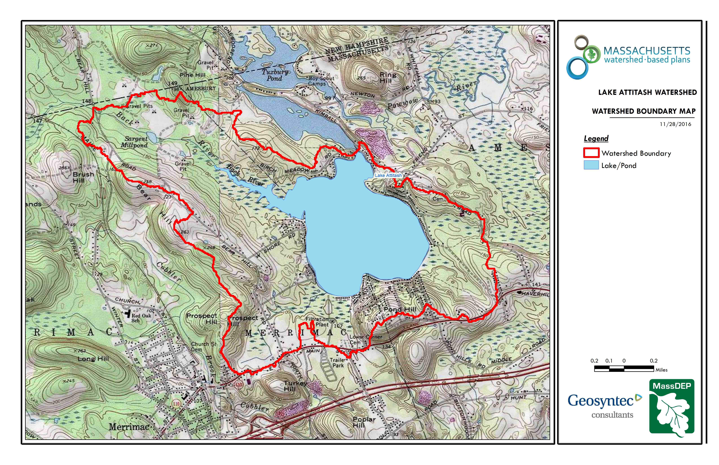
Figure A-1: Watershed Boundary Map (MassGIS, 1999; MassGIS, 2001; USGS, 2016)
Ctrl + Click on the map to view a full sized image in your web browser.

Lake Attitash is a secondary drinking water supply for Amesbury.

2. MassDEP Water Quality Assessment Report and TMDL Review
The following reports are available:
- WRS Lake Attitash Management Report
- Merrimack River Watershed 2004 Water Quality Assessment Report
- Northeast Regional Mercury Total Maximum Daily Load
- TOWN OF AMESBURY LAKE ATTITASH WATERSHED MANAGEMENT PLAN

Merrimack River Watershed 2004 Water Quality Assessment Report (MA84002 - Lake Attitash )
Insufficient data were available to assess the Aquatic Life Use.
MA DPH has issued a fish consumption advisory due to mercury contamination for Lake Attitash. Children younger than 12 years of age, pregnant women, women of childbearing age who may become pregnant, and nursing mothers should not eat any fish from this water body. The general public should not consume Largemouth Bass from this water body.
Cause(s) of Impairment: Mercury in Fish Tissue
Source(s) of Impairment: Atmospheric Deposition - Toxics, Source Unknown
Insufficient data were available to assess the Primary Contact Recreational Use.
Insufficient data were available to assess the Secondary Contact Recreational Use.
Insufficient data were available to assess the Aesthetics Use.
Report Recommendations:
Conduct monitoring to confirm the presence of non-native aquatic plants.

Literature review information:

Lake Attitash Management Report, WRS (2016): Developed nutrient budget for the lake indicating internal loading of phosphorus is leading to cyanobacteria blooms. Evaluation of treatment options indicates phosphorus inactivation by in lake aluminum treatment is the best option.

Town of Amesbury Lake Attitash Watershed Management Plan, CDM (1999): Initial watershed assessment recommending numerous BMP's around the lake. These have been completed.

3. Water Quality Impairments
Known water quality impairments, as documented in the Massachusetts Department of Environmental Protection (MassDEP) 2016 Massachusetts Integrated List of Waters, are listed below. Impairment categories from the Integrated List are as follows:
Table A-2: 2016 MA Integrated List of Waters Categories
Integrated List Category | Description
1 | Unimpaired and not threatened for all designated uses.
2 | Unimpaired for some uses and not assessed for others.
3 | Insufficient information to make assessments for any uses.
4 | Impaired or threatened for one or more uses, but not requiring calculation of a Total Maximum Daily Load (TMDL), including:  4a: TMDL is completed  4b: Impairment controlled by alternative pollution control requirements  4c: Impairment not caused by a pollutant - TMDL not required
5 | Impaired or threatened for one or more uses and requiring preparation of a TMDL.

Table A-3: Water Quality Impairments

Assessment  Unit ID | Waterbody | Integrated  List  Category | Designated Use | Impairment Cause | Impairment Source
MA84002 | Lake Attitash | 5 | Fish Consumption | Mercury in Fish Tissue | Atmospheric Deposition - Toxics
MA84002 | Lake Attitash | 5 | Fish Consumption | Mercury in Fish Tissue | Source Unknown
MA84002 | Lake Attitash | 5 | Primary Contact Recreation, Secondary Contact Recreation, Aesthetic | Harmful Algal Blooms | Source Unknown
MA84002 | Lake Attitash |  | Primary Contact Recreation, Secondary Contact Recreation, Aesthetic | Harmful Algal Blooms | Discharges from Municipal Separate Storm Sewer Systems (MS4)

4. Water Quality Goals
Water quality goals may be established for a variety of purposes, including the following:
a.) For water bodies with known impairments, a Total Maximum Daily Load (TMDL) is established by MassDEP and the United States Environmental Protection Agency (USEPA) as the maximum amount of the target pollutant that the waterbody can receive and still safely meet water quality standards. If the waterbody has a TMDL for total phosphorus (TP) or total nitrogen (TN), or total suspended solids (TSS), that information is provided below and included as a water quality goal.

b.) For water bodies without a TMDL for total phosphorus (TP), a default water quality goal for TP is based on target concentrations established in the Quality Criteria for Water (USEPA, 1986) (also known as the “Gold Book”). The Gold Book states that TP should not exceed 50 ug/L in any stream at the point where it enters any lake or reservoir, nor 25 ug/L within a lake or reservoir. For the purposes of developing WBPs, MassDEP has adopted 50 ug/L as the TP target for all streams at their downstream discharge point, regardless of which type of water body the stream discharges to.

c.) Massachusetts Surface Water Quality Standards (314 CMR 4.00, 2013) prescribe the minimum water quality criteria required to sustain a waterbody’s designated uses. Lake Attitash is a Class 'A' waterbody. The water quality goal for fecal coliform bacteria is based on the Massachusetts Surface Water Quality Standards.

Table A-4: Surface Water Quality Classification by Assessment Unit ID

Assessment  Unit ID | Waterbody | Class
MA84002 | Lake Attitash | A

d.) Other water quality goals set by the community (e.g., protection of high quality waters, in-lake phosphorus concentration goal to reduce recurrence of cyanobacteria blooms, etc.).

Table A-5: Water Quality Goals

Pollutant | Goal | Source
Total Phosphorus (TP) | Total phosphorus should not exceed:  --50 ug/L in any stream  --25 ug/L within any lake or reservoir | Quality Criteria for Water (USEPA, 1986)

Table A-5 shows he above goal as set by EPA, Table 9 below show the modeling scenarios. It is the intention of the treatment to reduce the internal load, thus bringing the Total Phosphorus to 15ug/l.
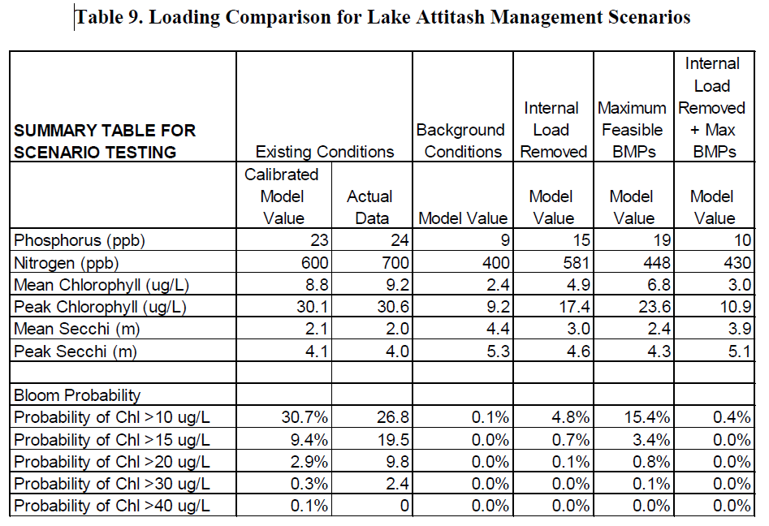
(excerpted from WRS 2016, pg 23)

5. Land Use Information
A. Watershed Land Uses

Table A-6: Watershed Land Uses

Land Use | Area (acres) | % of Watershed
Forest | 816.57 | 48.4
Water | 376.55 | 22.3
Medium Density Residential | 134.13 | 7.9
Agriculture | 130.52 | 7.7
Low Density Residential | 91.19 | 5.4
Open Land | 61.53 | 3.6
High Density Residential | 46.04 | 2.7
Industrial | 17.83 | 1.1
Commercial | 13.36 | 0.8
Highway | 0.98 | 0.1

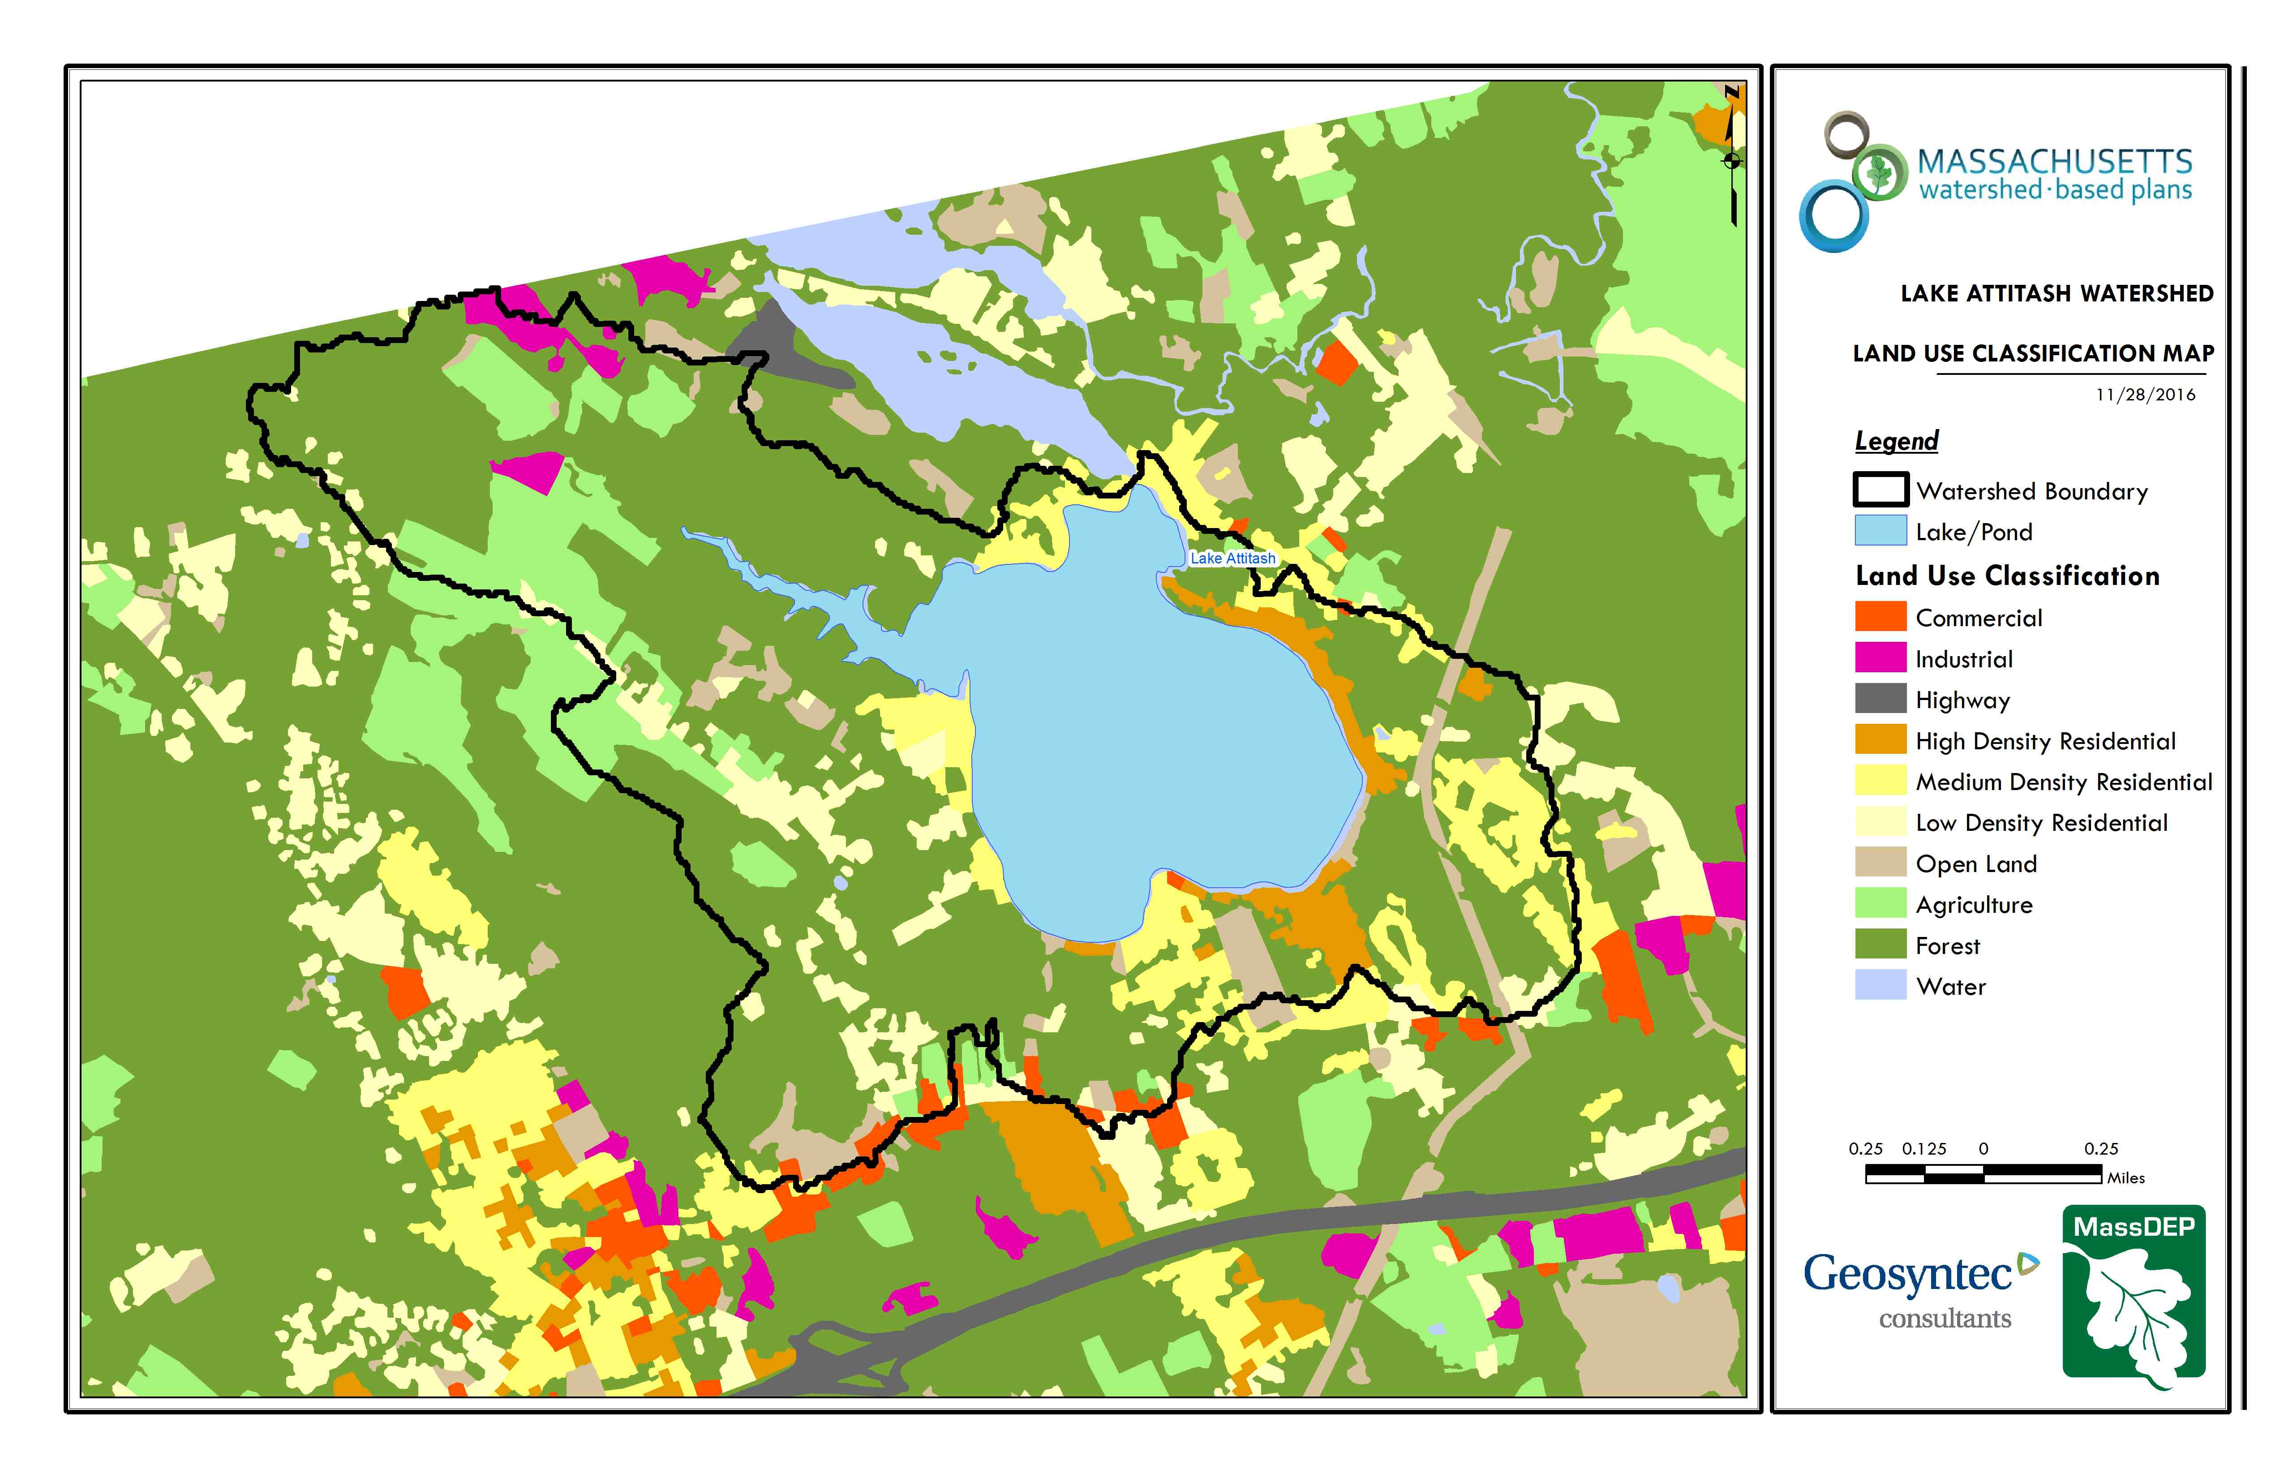
Figure A-2: Watershed Land Use Map (MassGIS, 2009b; MassGIS, 1999; MassGIS, 2001; USGS, 2016)
Ctrl + Click on the map to view a full sized image in your web browser.

B. Watershed Impervious Cover

There is a strong link between impervious land cover and stream water quality. Impervious cover includes land surfaces that prevent the infiltration of water into the ground, such as paved roads and parking lots, roofs, basketball courts, etc.
Impervious areas that are directly connected (DCIA) to receiving waters (via storm sewers, gutters, or other impervious drainage pathways) produce higher runoff volumes and transport stormwater pollutants with greater efficiency than disconnected impervious cover areas which are surrounded by vegetated, pervious land. Runoff volumes from disconnected impervious cover areas are reduced as stormwater infiltrates when it flows across adjacent pervious surfaces.

An estimate of DCIA for the watershed was calculated based on the Sutherland equations. USEPA provides guidance (USEPA, 2010) on the use of the Sutherland equations to predict relative levels of connection and disconnection based on the type of stormwater infrastructure within the total impervious area (TIA) of a watershed. Within each subwatershed, the total area of each land use were summed and used to calculate the percent TIA.

Estimated TIA in the watershed: 10.3 %
Estimated DCIA in the watershed: 6.9 %

The relationship between TIA and water quality can generally be categorized as follows (Schueler et al. 2009):

Table A-7: Relationship between Total Impervious Area (TIA) and water quality (Schueler et al. 2009)

% Watershed  Impervious Cover | Stream Water Quality
0-10% | Typically high quality, and typified by stable channels, excellent habitat structure, good to excellent water quality, and diverse communities of both fish and aquatic insects.
11-25% | These streams show clear signs of degradation. Elevated storm flows begin to alter stream geometry, with evident erosion and channel widening. Streams banks become unstable, and physical stream habitat is degraded. Stream water quality shifts into the fair/good category during both storms and dry weather periods. Stream biodiversity declines to fair levels, with most sensitive fish and aquatic insects disappearing from the stream.
26-60% | These streams typically no longer support a diverse stream community. The stream channel becomes highly unstable, and many stream reaches experience severe widening, downcutting, and streambank erosion. Pool and riffle structure needed to sustain fish is diminished or eliminated and the substrate can no longer provide habitat for aquatic insects, or spawning areas for fish. Biological quality is typically poor, dominated by pollution tolerant insects and fish. Water quality is consistently rated as fair to poor, and water recreation is often no longer possible due to the presence of high bacteria levels.
>60% | These streams are typical of “urban drainage”, with most ecological functions greatly impaired or absent, and the stream channel primarily functioning as a conveyance for stormwater flows.

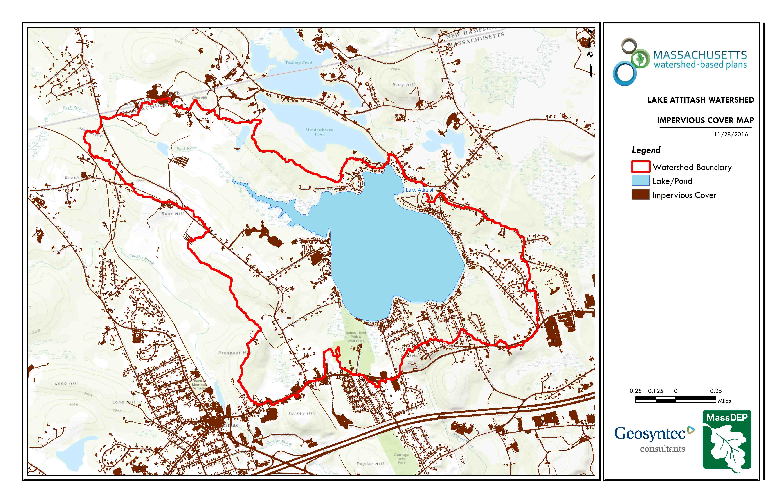
Figure A-3: Watershed Impervious Surface Map (MassGIS, 2009b; MassGIS, 1999; MassGIS, 2001; USGS, 2016)
Ctrl + Click on the map to view a full sized image in your web browser.

Land use information:

The above land use model illustrates the inherent problem with Lake Attitash. The Watershed has a low TIA and should have much higher water quality than it currently exhibits.

6. Pollutant Loading
The land use data (MassGIS, 2009b) was intersected with impervious cover data (MassGIS, 2009a) and United States Department of Agriculture (USDA) Natural Resources Conservation Service (NRCS) soils data (USDA NRCS and MassGIS, 2012) to create a combined land use/land cover grid. The grid was used to sum the total area of each unique land use/land cover type.
The amount of DCIA was estimated using the Sutherland equations as described above and any reduction in impervious area due to disconnection (i.e., the area difference between TIA and DCIA) was assigned to the pervious D soil category for that land use to simulate that some infiltration will likely occur after runoff from disconnected impervious surfaces passes over pervious surfaces.
Pollutant loading for key nonpoint source pollutants in the watershed was estimated by multiplying each land use/cover type area by its pollutant load export rate (PLER). The PLERs are an estimate of the annual total pollutant load exported via stormwater from a given unit area of a particular land cover type. The PLER values for TN, TP and TSS were obtained from USEPA (Voorhees, 2016b) (see documentation provided in Appendix A) as follows:
L_{n} = A_{n} * P_{n}
Where L_{n} = Loading of land use/cover type n (lb/yr); A_{n} = area of land use/cover type n (acres); P_{n} = pollutant load export rate of land use/cover type n (lb/acre/yr)

Table A-8: Estimated Pollutant Loading for Key Nonpoint Source Pollutants

Land Use Type | Pollutant Loading¹
 | Total  Phosphorus (TP)  (lbs/yr) | Total  Nitrogen (TN)  (lbs/yr) | Total  Suspended Solids (TSS)  (tons/yr)
Forest | 120 | 636 | 26.63
Agriculture | 62 | 368 | 5.21
Medium Density Residential | 58 | 486 | 6.91
High Density Residential | 38 | 253 | 3.77
Low Density Residential | 30 | 299 | 4.19
Open Land | 26 | 246 | 5.53
Commercial | 14 | 119 | 1.49
Industrial | 13 | 113 | 1.41
Highway | 0 | 0 | 0.01
TOTAL | 361 | 2,521 | 55.15
¹These estimates do not consider loads from point sources or septic systems.
Pollutant loading information:
Phosphorus loading causes Harmful Algal Blooms in Lake Attitash, threatening Amesbury’s drinking water. These Phosphorus levels in Lake Attitash are high enough to warrant a TMDL for Phosphorus.
1999 CDM report shows mean values for surface water phosphorus are 43 ug/l. 2016 WRS report using the LLRM model estimates a minimum internal phosphorus loading at 117 kg/year or 40% of the total loading.

WRS (2016) estimated watershed pollutant loads using 2010 land use data for Massachusetts and New Hampshire. In addition, pollutant loads for atmospheric deposition, internal loadings, waterfowl and septic systems were estimated and use for the calibration of an Lakes Loading Response Model (LLRM). Given sewering around the lake septic system loads were estimated to be negligible. The table below take from Development of a Management Plan for Lake Attitash, Amesbury and Merrimac, Massachusetts (WRS 2016, pg. 23). In order to calibrate the LLRM model the watershed loads estimated using export coefficients were cut in half (WRS 2016, pg.21).
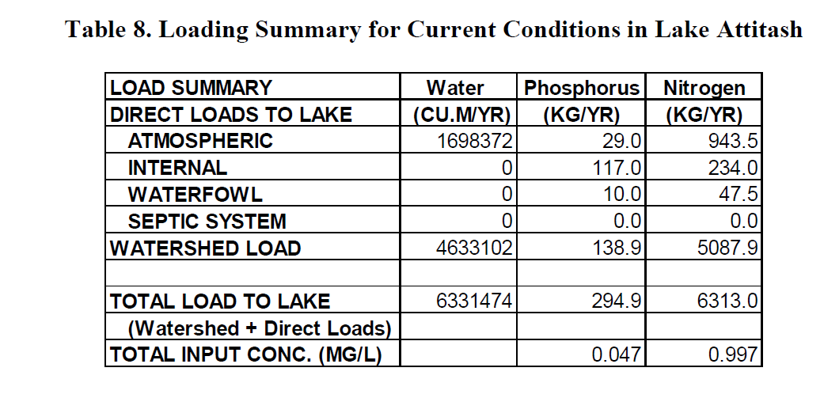
(Table 8 Loading Summary for Current Conditions in Lake Attitash excerpted from WRS (2016, pg. 21)

Element B: Determine Pollutant Load Reductions Needed to Achieve Water Quality Goals

- Estimated Pollutant Loads
Table 1 lists estimated pollutant loads for the following primary nonpoint source (NPS) pollutants: total phosphorus (TP), total nitrogen (TN), total suspended solids (TSS). These estimated loads are based on the pollutant loading analysis presented in Section 4 of Element A.

- Water Quality Goals
Water quality goals for primary NPS pollutants are listed in Table 1 based on the following:
- TMDL water quality goals (if a TMDL exists for the water body);
- For all water bodies, including impaired waters that have a pathogen TMDL, the water quality goal for bacteria is based on the Massachusetts Surface Water Quality Standards (314 CMR 4.00, 2013) that apply to the Water Class of the selected water body.
- If the water body does not have a TMDL for TP, a default target TP concentrations is provided which is based on guidance provided by the USEPA in Quality Criteria for Water (1986), also known as the “Gold Book”. Because there are no similar default water quality goals for TN and TSS, goals for these pollutants are provided in Table 1 only if a TMDL exists or alternate goal(s) have been optionally established by the WBP author.
- According to the USEPA Gold Book, total phosphorus should not exceed 50 ug/L in any stream at the point where it enters any lake or reservoir. The water quality loading goal was estimated by multiplying this target maximum phosphorus concentration (50 ug/L) by the estimated annual watershed discharge for the selected water body. To estimate the annual watershed discharge, the mean flow was used, which was estimated based on United States Geological Survey (USGS) “Runoff Depth” estimates for Massachusetts (Cohen and Randall, 1998). Cohen and Randall (1998) provide statewide estimates of annual Precipitation (P), Evapotranspiration (ET), and Runoff (R) depths for the northeastern U.S. According to their method, Runoff Depth (R) is defined as all water reaching a discharge point (including surface and groundwater), and is calculated by:
P – ET = R
A mean Runoff Depth R was determined for the watershed by calculating the average value of R within the watershed boundary. This method includes the following assumptions/limitations:

  - For lakes and ponds, the estimate of annual TP loading is averaged across the entire watershed. However, a given lake or reservoir may have multiple tributary streams, and each stream may drain land with vastly different characteristics. For example, one tributary may drain a highly developed residential area, while a second tributary may drain primarily forested and undeveloped land. In this case, one tributary may exhibit much higher phosphorus concentrations than the average of all streams in the selected watershed.

  - The estimated existing loading value only accounts for phosphorus due to stormwater runoff. Other sources of phosphorus may be relevant, particularly phosphorus from on-site wastewater treatment (septic systems) within close proximity to receiving waters. Phosphorus does not typically travel far within an aquifer, but in watersheds that are primarily unsewered, septic systems and other similar groundwater-related sources may contribute a significant load of phosphorus that is not captured in this analysis. As such, it is important to consider the estimated TP loading as "the expected TP loading from stormwater sources."

Table B-1: Pollutant Load Reductions Needed

Pollutant | Existing Estimated Total Load | Water Quality Goal | Required Load Reduction
Total Phosphorus | 650lbs/yr | 418 lbs/yr | 232 lbs/yr
Total Nitrogen | 2521 lbs/yr
Total Suspended Solids | 55 ton/yr
Bacteria | MSWQS for bacteria are concentration standards (e.g., colonies of fecal coliform bacteria per 100 ml), which are difficult to predict based on estimated annual loading. | Class A. Class A Standards  • Public Water Supply Intakes in Unfiltered Public Water Supplies: For samples from any 6 month period, either fecal coliform shall not exceed 20 organisms/100 ml in all samples, or total coliform shall not exceed 100 organisms/100 ml in 90% of samples. If both fecal and total coliform are measured, only fecal coliform criterion apply.  • Public Bathing Beaches: For E. coli, geometric mean of 5 most recent samples shall not exceed 126 colonies/100 ml and no single sample during the bathing season shall exceed 235 colonies/100 ml. For enterococci, geometric mean of 5 most recent samples shall not exceed 33 colonies/100 ml and no single sample during bathing season shall exceed 61 colonies/100 ml;  • Other Waters and Non-bathing Season at Bathing Beaches: For E. coli, geometric mean of samples from most recent 6 months shall not exceed 126 colonies/100 ml (typically based on min. 5 samples) and no single sample shall exceed 235 colonies/100 ml. For enterococci, geometric mean from most recent 6 months shall not exceed 33 colonies/100 ml, and no single sample shall exceed 61 colonies/100 ml.

TMDL Pollutant Load Criteria
No TMDL Pollutant Load Criteria Data Found

Pollutant load reduction information:
The work of the Lake Attitash Association, Amesbury, Merrimac, EPA and MADEP have conducted over the previous 20 years has been successful. However, the attached studies show a different picture and that while the watershed loading is largely under control based upon past and continuing watershed efforts, the pollutant load into the lake from the past 40+ years of development and activity has resulted in significant accumulation of phosphorus in the lake sediments (WRS, 2016). This accumulation results in harmful algal blooms. The goal is to reduce the internal loading of this accumulated sediment by 90%, to return the lake to "normal" biological activity thereby eliminating harmful algal blooms and safer drinking water for Amesbury.

Table B-1 shows loading of phosphorus based upon land use and indicated that Lake Attitash requires an additional 232 lbs/year reduction in order to meet its water quality goal. P load reduction from external sources would be desirable and the teams hopes to explore future options for watershed BMPs.

Element C: Describe management measures that will be implemented to achieve water quality goals

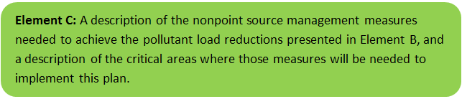

For a description of previous installed BMPs and management action see WRS (2016, pg 39)). Table C1 presents the proposed management measures as well as the estimated pollutant load reductions and costs. The planning level cost estimates and pollutant load reduction estimates were based off information obtained in the following sources and were also adjusted to 2016 values using the Consumer Price Index (CPI) (United States Bureau of Labor Statistics, 2016):

- Geosyntec Consultants, Inc. (2014);
- Geosyntec Consultants, Inc. (2015);
- King and Hagen (2011);
- Leisenring, et al. (2014);
- King and Hagen (2011);
- MassDEP (2016a);
- MassDEP (2016b);
- University of Massachusetts, Amherst (2004);
- Voorhees (2015);
- Voorhees (2016a);
- Voorhees (2016b);

Table C-1: Proposed Management Measures, Estimated Pollutant Load Reductions and Costs

Structural BMPs
No Structural BMP Data Found

Additional BMPs

BMP TYPE | Phosphorus Inactivation
BMP LOCATION | Lake Wide
DESCRIPTION | Single treatment of the surficial sediments with aluminum over the 194 acres area below a water depth of 3.5 m. The proposed treatment would reduce the average phosphorus in the upper water column to 16ug/l and reduce the internal loading of the lake to 90% of current level for 15-20 years.
ESTIMATED POLLUTANT LOAD REDUCTIONS | 20mg/l
ESTIMATED COST ($) | 542,000

Element D: Identify Technical and Financial Assistance Needed to Implement Plan

Table D-1 presents the funding needed to implement the management measures presented in this watershed plan. The table includes costs for structural and non-structural BMPs, operation and maintenance activities, information/education measures, and monitoring/evaluation activities.

Table D-1: Summary of Funding Needed to Implement the Watershed Plan.

Management  Measures | Location | Capital Costs | Operation &  Maintenance Costs | Relevant  Authorities | Technical  Assistance Needed | Funding Needed
Structural and Non-Structural BMPs (from Element C)
Phosphorus Inactivation | Lake Wide | $542,000 | $0 | Amesbury, Merrimac, Lake Attitash Association | Consultant | $605,100
Information/Education (see Element E)
Outreach | Watershed | $2,500 | $2,500/year | As above | Greenscapes | $7,500*
Monitoring and Evaluation (see Element H/I)
Lake Monitoring | Lake Wide | $5,000 | $2,000/year | LAA | Lab Work | $7,000*
Total Funding Needed: |  |  |  |  |  | $605,100
Funding Sources:
- City of Amesbury
- Town of Merrimac
- Lake Attitash Association

*These task/funds are not included in the grant.

Element E: Public Information and Education

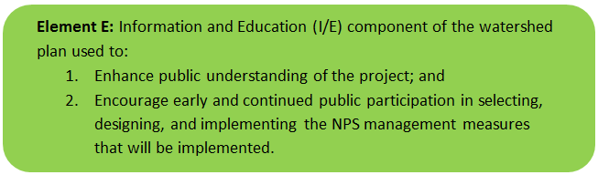

Step 1: Goals and Objectives
The goals and objectives for the watershed information and education program.

The Towns of Amesbury and Merrimac currently participate in education and monitoring activities, and the Lake Attitash Association is prepared to spearhead an enhanced effort to improve resident understanding of P dynamics in the lake and watershed and their role in protecting the lake. The LAA will be responsible for monitoring lake condition following treatment, with training and support from a qualified firm.

Step 2: Target Audience
Target audiences that need to be reached to meet the goals and objectives identified above.

Residents around Lake Attitash are primary target audience. Amesbury and Merrimac school children are a secondary audience.

Step 3: Outreach Products and Distribution
The outreach product(s) and distribution form(s) that will be used for each.

Greenscapes a subscription education service will be used for the schools and to develop literature for the Lake Attitash Association. The LAA will educate residents at their annual meeting and will distribute literature and offer landscaping advising sessions to residents around the lake to assist them with preventing nutrient loading. LAA and municipal websites will be updated with educational information regarding nutrient loading in Lake Atittash. Amesbury will send educational flyers in the water bills to all Attitash residents in Amesbury.

Step 4: Evaluate Information/Education Program
Information and education efforts and how they will be evaluated.

Records of brochures distributed, web page hits and consultations with residents will be kept and reported.

Other Information

Elements F & G: Implementation Schedule and Measurable Milestones

Table FG-1: Implementation Schedule and Interim Measurable Milestones

A. Structural & Non-Structural BMPs
Phosphorus Inactivation  Lake Wide | Permitting complete | Treatment applicaiton
 | 4/30/2018 | 5/31/2018

B. Public Education & Outreach
Brochure to Residents | Brochure complete | Brochure sent to Residents | Brochure uploaded on Websites
 | 3/1/2018 | 4/1/2018 | 4/1/2018
Landscape consulting | LAA Trained | Invitations to Lake Attitash Residents | Consultations complete
 | 4/1/2018 | 5/1/2018 | 10/1/2019
School Program | Greenscapes program in schools | Contract with Greenscapes | Greenscapes program in schools | Greenscapes program in schools
 | 5/1/2017 | 3/1/2018 | 5/1/2019 | 5/1/2020

C. Monitoring
Post Treatment Evaluation | Data collection
 | 10/1/2019
Project Evaluaton | Final QAPP | Evaluation Complete
 | 5/1/2018 | 10/1/2018

Elements H & I: Progress Evaluation Criteria and Monitoring

The water quality target concentration(s) is presented under Element A of this plan. To achieve this target concentration, the annual loading must be reduced to the amount described in Element B. Element C of this plan describes the various management measures that will be implemented to achieve this targeted load reduction. The evaluation criteria and monitoring program described below will be used to measure the effectiveness of the proposed management measures (described in Element C) in improving the water quality of Gulf Pond.

Indirect Indicators of Load Reduction
The improvement is rapid, so the results of treatment will be evident within days to weeks. The key criteria are P concentration in the water column (top and bottom), algae abundance and portion of algal biomass represented by cyanobacteria, and water clarity. Adequate pre-treatment data already exist to provide a valid comparison to post-treatment data, but additional data will be collected prior to treatment. Follow up monitoring should demonstrate P <16 µg/L, algal biomass <3000 µg/L with minimal cyanobacteria, and water clarity >3 m.

Project-Specific Indicators
As noted above, the improvement is rapid, so the results of treatment will be evident within days to weeks. The key criteria are P concentration in the water column (top and bottom), algae abundance and portion of algal biomass represented by cyanobacteria, and water clarity. Adequate pre-treatment data already exist to provide a valid comparison to post-treatment data, but additional data will be collected prior to treatment. Follow up monitoring should demonstrate P <16 µg/L, algal biomass <3000 µg/L with minimal cyanobacteria, and water clarity >3 m.

TMDL Criteria
N/A

Direct Measurements
Phosphorus, Algal biomass, algal composition and Secchi depth will be monitored prior to treatment and after treatment. This data can be compared to the large volumes of historical data collected to determine the success of the treatment. The sampling location will be the deep hole index point shown in the EPA 2014 study.

Adaptive Management
10. As noted above, the improvement is rapid, so the results of treatment will be evident within days to weeks. The key criteria are P concentration in the water column (top and bottom), algae abundance and portion of algal biomass represented by cyanobacteria, and water clarity. Adequate pre-treatment data already exist to provide a valid comparison to post-treatment data, but additional data will be collected prior to treatment. Follow up monitoring should demonstrate P <16 µg/L, algal biomass <3000 µg/L with minimal cyanobacteria, and water clarity >3 m.

As stated above the team will pursue future efforts to continue the phosphorus reduction.

References / Appendix

References
314 CMR 4.00 (2013). "Division of Water Pollution Control, Massachusetts Surface Water Quality Standards"
Cohen, A. J.; Randall, A.D. (1998). "Mean annual runoff, precipitation, and evapotranspiration in the glaciated northeastern United States, 1951-80." Prepared for United States Geological Survey, Reston VA.
Geosyntec Consultants, Inc. (2014). "Least Cost Mix of BMPs Analysis, Evaluation of Stormwater Standards Contract No. EP-C-08-002, Task Order 2010-12." Prepared for Jesse W. Pritts, Task Order Manager, U.S. Environmental Protection Agency
Geosyntec Consultants, Inc. (2015). "Appendix B: Pollutant Load Modeling Report, Water Integration for the Squamscott-Exeter (WISE) River Watershed."
King, D. and Hagan, P. (2011). "Costs of Stormwater Management Practices in Maryland Counties." University of Maryland Center for Environmental Science Chesapeake Biological Laboratory. October 11, 2011.
Leisenring, M., Clary, J., and Hobson, P. (2014). "International Stormwater Best Management Practices (BMP) Database Pollutant Category Statistical Summary Report: Solids, Bacteria, Nutrients and Metals." Geosyntec Consultants, Inc. and Wright Water Engineers, Inc. December 2014.
MassDEP (2012). "Massachusetts Year 2012 Integrated List of Waters Final Listing of Massachusetts' Waters Pursuant to Sections 305(b), 314 and 303(d) of the Clean Water Act"
MassDEP (2016a). "Massachusetts Clean Water Toolkit"
MassDEP (2016b). "Massachusetts Stormwater Handbook, Vol. 2, Ch. 2, Stormwater Best Management Practices"
MassGIS (1999). "Networked Hydro Centerlines" Shapefile
MassGIS (2001). "USGS Topographic Quadrangle Images" Image
MassGIS (2007). "Drainage Sub-basins" Shapefile
MassGIS (2009a). "Impervious Surface" Image
MassGIS (2009b). "Land Use (2005)" Shapefile
MassGIS (2013). "MassDEP 2012 Integrated List of Waters (305(b)/303(d))" Shapefile
Schueler, T.R., Fraley-McNeal, L, and K. Cappiella (2009). "Is impervious cover still important? Review of recent research" Journal of Hydrologic Engineering 14 (4): 309-315.
United States Bureau of Labor Statistics (2016). "Consumer Price Index"
United States Geological Survey (2016). "National Hydrography Dataset, High Resolution Shapefile"
University of Massachusetts, Amherst (2004). "Stormwater Technologies Clearinghouse"
USDA NRCS and MassGIS (2012). "NRCS SSURGO-Certified Soils" Shapefile
USEPA (1986). "Quality Criteria for Water (Gold Book)" EPA 440/5-86-001. Office of Water, Regulations and Standards. Washington, D.C.
USEPA. (2010). "EPA's Methodology to Calculate Baseline Estimates of Impervious Area (IA) and Directly Connected Impervious Area (DCIA) for Massachusetts Communities."
Voorhees, Mark, USEPA. (2015). "FW: Description of additional modelling work for Opti-Tool Project" Message to Chad Yaindl, Geosyntec Consultants. 23 April 2015. E-mail.
Voorhees, Mark, USEPA. (2016a). "FW: EPA Region 1 SW BMP performance equations" Message to Chad Yaindl, Geosyntec Consultants. 25 January 2016. E-mail.
Voorhees, Mark, USEPA. (2016b). "FW: Description of additional modelling work for Opti-Tool Project" Message to Chad Yaindl, Geosyntec Consultants. 23 April 2015. E-mail.

Water Quality Assessment Reports
"Merrimack River Watershed 2004 Water Quality Assessment Report"
WRS Lake Attitash Management Report
Merrimack River Watershed 2004 Water Quality Assessment Report
Northeast Regional Mercury Total Maximum Daily Load
Town of Amesbury Lake Attitash Watershed Management Plan

TMDL
No TMDL Found

Appendix A – Pollutant Load Export Rates (PLERs)

Land Use & Cover¹ | PLERs (lb/acre/year)
 | (TP) | (TSS) | (TN)
AGRICULTURE, HSG A | 0.45 | 7.14 | 2.59
AGRICULTURE, HSG B | 0.45 | 29.4 | 2.59
AGRICULTURE, HSG C | 0.45 | 59.8 | 2.59
AGRICULTURE, HSG D | 0.45 | 91.0 | 2.59
AGRICULTURE, IMPERVIOUS | 1.52 | 650 | 11.3
COMMERCIAL, HSG A | 0.03 | 7.14 | 0.27
COMMERCIAL, HSG B | 0.12 | 29.4 | 1.16
COMMERCIAL, HSG C | 0.21 | 59.8 | 2.41
COMMERCIAL, HSG D | 0.37 | 91.0 | 3.66
COMMERCIAL, IMPERVIOUS | 1.78 | 377 | 15.1
FOREST, HSG A | 0.12 | 7.14 | 0.54
FOREST, HSG B | 0.12 | 29.4 | 0.54
FOREST, HSG C | 0.12 | 59.8 | 0.54
FOREST, HSG D | 0.12 | 91.0 | 0.54
FOREST, HSG IMPERVIOUS | 1.52 | 650 | 11.3
HIGH DENSITY RESIDENTIAL, HSG A | 0.03 | 7.14 | 0.27
HIGH DENSITY RESIDENTIAL, HSG B | 0.12 | 29.4 | 1.16
HIGH DENSITY RESIDENTIAL, HSG C | 0.21 | 59.8 | 2.41
HIGH DENSITY RESIDENTIAL, HSG D | 0.37 | 91.0 | 3.66
HIGH DENSITY RESIDENTIAL, IMPERVIOUS | 2.32 | 439 | 14.1
HIGHWAY, HSG A | 0.03 | 7.14 | 0.27
HIGHWAY, HSG B | 0.12 | 29.4 | 1.16
HIGHWAY, HSG C | 0.21 | 59.8 | 2.41
HIGHWAY, HSG D | 0.37 | 91.0 | 3.66
HIGHWAY, IMPERVIOUS | 1.34 | 1,480 | 10.2
INDUSTRIAL, HSG A | 0.03 | 7.14 | 0.27
INDUSTRIAL, HSG B | 0.12 | 29.4 | 1.16
INDUSTRIAL, HSG C | 0.21 | 59.8 | 2.41
INDUSTRIAL, HSG D | 0.37 | 91.0 | 3.66
INDUSTRIAL, IMPERVIOUS | 1.78 | 377 | 15.1
LOW DENSITY RESIDENTIAL, HSG A | 0.03 | 7.14 | 0.27
LOW DENSITY RESIDENTIAL, HSG B | 0.12 | 29.4 | 1.16
LOW DENSITY RESIDENTIAL, HSG C | 0.21 | 59.8 | 2.41
LOW DENSITY RESIDENTIAL, HSG D | 0.37 | 91.0 | 3.66
LOW DENSITY RESIDENTIAL, IMPERVIOUS | 1.52 | 439 | 14.1
MEDIUM DENSITY RESIDENTIAL, HSG A | 0.03 | 7.14 | 0.27
MEDIUM DENSITY RESIDENTIAL, HSG B | 0.12 | 29.4 | 1.16
MEDIUM DENSITY RESIDENTIAL, HSG C | 0.21 | 59.8 | 2.41
MEDIUM DENSITY RESIDENTIAL, HSG D | 0.37 | 91.0 | 3.66
MEDIUM DENSITY RESIDENTIAL, IMPERVIOUS | 1.96 | 439 | 14.1
OPEN LAND, HSG A | 0.12 | 7.14 | 0.27
OPEN LAND, HSG B | 0.12 | 29.4 | 1.16
OPEN LAND, HSG C | 0.12 | 59.8 | 2.41
OPEN LAND, HSG D | 0.12 | 91.0 | 3.66
OPEN LAND, IMPERVIOUS | 1.52 | 650 | 11.3
¹HSG = Hydrologic Soil Group

