WATERSHED-BASED PLAN
Fort River Watershed within the Towns of Amherst, Belchertown, Hadley, Pelham, and Shutesbury
December, 2019

Prepared By:
Town of Amherst
University of Massachusetts-Amherst
Geosyntec Consultants, Inc.

Prepared For:
This project has been financed with Federal Funds from the Environmental Protection Agency (EPA) to the Massachusetts Department of Environmental Protection (the Department) under an s. 319 competitive grant. The contents do not necessarily reflect the views and policies of EPA or of the Department, nor does the mention of trade names or commercial products constitute endorsement or recommendation for use.
Contents
Executive Summary i
Introduction 1
Purpose & Need 1
Watershed-Based Plan Outline 1
Project Partners and Stakeholder Input 2
Data Sources 3
Summary of Past and Ongoing Work 3
Element A: Identify Causes of Impairment & Pollution Sources 5
General Watershed Information 5
MassDEP Water Quality Assessment Report and TMDL Review 7
Water Quality Impairments 12
Water Quality Goals 13
Land Use Information 16
Pollutant Loading 21
Element B: Determine Pollutant Load Reductions Needed to Achieve Water Quality Goals 23
Estimated Pollutant Loads 23
Water Quality Goals 23
Recommended Load Reduction 24
Element C: Describe management measures that will be implemented to achieve water quality goals 26
Current and Ongoing Management Measures 26
Future Management Measures 27
Element D: Identify Technical and Financial Assistance Needed to Implement Plan 29
Current and Ongoing Management Measures 29
Future Management Measures 30
Element E: Public Information and Education 31
Elements F & G: Implementation Schedule and Measurable Milestones 33
Elements H & I: Progress Evaluation Criteria and Monitoring 35
Indirect Indicators of Load Reduction 35
Project-Specific Indicators 37
TMDL Criteria 37
Direct Measurements 37
Adaptive Management 38
References 39

Executive Summary
Introduction: The purpose of a Massachusetts Watershed-Based Plan (WBP) is to organize information about Massachusetts' watersheds, and present it in a format that will enhance the development and implementation of projects that will restore water quality and beneficial uses in the Commonwealth. The Massachusetts WBP follows USEPA's recommended format for “nine-element” watershed plans. This WBP was developed by Geosyntec Consultants (Geosyntec) under the direction of the Town of Amherst and the University of Massachusetts-Amherst with funding, input, and collaboration from the Massachusetts Department of Environmental Protection (MassDEP).
The Fort River (MA34-27) is a tributary to the Connecticut River (segment MA34-04) and includes several tributaries, ponds and reservoirs located in the Towns of Amherst, Belchertown, Hadley, Pelham, and Shutesbury. This WBP was prepared for waterbodies located within the Fort River Watershed (MA34-27). These waterbodies include Fort River (MA34-27); Adams Brook; Amethyst Brook (MA34-35); Baker Brook; Buffam Brook; Dean Brook; Dunlop Brook; Gates Brook; Harris Brook; Harts Brook; Hearthstone Brook; Hop Brook; Nurse Brook; Plum Brook; Scarboro Brook; and Fearing Brook.
Impairments and Pollution Sources: The Fort River is listed on the Massachusetts List of Integrated Waters as a category 5 waterbody for impairments related to elevated levels of Escherichia coli (E. coli) bacteria. The Fort River discharges to the Connecticut River (segment MA34-04), which is a category 5 water body on the Massachusetts List of Integrated Waters because of priority organics and pathogens. Because of these impairments, TMDLs for the Connecticut River and Fort River are required but have not yet been developed. The required TMDLs that will impact the Fort River watershed are anticipated to include E. coli and pathogens.
The cause of E. coli impairment for the Fort River Watershed is unknown, but the impaired section is located within the Towns of Amherst and Hadley. The Town of Amherst has identified that wet weather E. coli levels measured in Fearing Brook near its confluence with Fort River were Too Numerous To Count (TNTC). The University of Massachusetts-Amherst has identified an equine farm in Belchertown that is bisected by an unnamed tributary to Hop Brook which ultimately discharges to the impaired segment of Fort River. The farm allows animals to directly access the unnamed tributary and manure was historically mismanaged. The Town of Amherst and the University have developed strategies to reduce pollutant loading from runoff that ultimately discharges to the Fort River and the Connecticut River.
Goals, Management Measures, and Funding: The primary goal of this WBP is to reduce total Escherichia coli (E. coli) loading to Fort River to address known E. coli and pathogen impairments in the Fort River and Connecticut River watersheds, eventually leading to delisting of impaired waterbodies in the study area from the 303(d) list. It is expected that these pollutant load reductions will result in improvements to listed impairments throughout the study area.
It is expected that goals will be accomplished primarily through installation of structural BMPs to capture runoff and reduce loading as well as implementation of non-structural BMPs (e.g., street sweeping, catch basin cleaning), and watershed education and outreach. Structural BMPs will first be implemented at the confluence of Fearing Brook in Amherst and at Moonlit Farm in Belchertown per Fiscal Year 2020 Section 319 grants (Project Numbers: 20-02, 20-07). Additional planning and implementation is expected to be performed in subsequent years, focusing on each water body in the study area.
It is expected that funding for management measures will be obtained from a variety of sources including Section 319 Grant Funding, Town capital funds, volunteer efforts, and other sources.
Public Education and Outreach: Goals of public education and outreach are to provide information about proposed stormwater improvements and their anticipated benefits and to promote watershed stewardship. The Town of Amherst aims to engage students and watershed residents through signage, use of the proposed project as a “living classroom”, tours and programming centered on the proposed project, and promotion of the proposed project and related events on the Town’s social media. The project is located on Town conservation land, which includes community gardens and a public walking trail. In addition to residents visiting the conservation area, the Town of Amherst plans to engage Fort River Elementary School, Amherst College, and the Hitchcock Center for the Environment for bringing students and tour groups to the proposed project site. It is expected that public outreach and education will be evaluated by tracking residents, tour groups, and classroom visits to the conservation area, and activity associated with the Town’s social media posting relevant to the project or watershed stewardship.
The University of Massachusetts aims to engage the equine industry and community horse owners by hosting an annual field day at the proposed project, including the generation of educational materials and subsequent follow up discussion with interested attendees. It is expected that this program will be evaluated by tracking field day attendance. The University of Massachusetts-Amherst plans to distribute fact sheets and newsletters to an email list serve of over 800 relevant parties and post news of the project on the “Crops, Dairy, Livestock and Equine” UMass Extension webpage. It is expected that this program will be evaluated by tracking the number of emails and the size of the list serve receiving the emails in addition to visitors to the UMass Extension webpage.
Implementation Schedule and Evaluation Criteria: Project activities will be implemented based on the information outlined in the following elements for monitoring, implementation of structural BMPs, public education and outreach activities, and periodic updates to the WBP. It is expected that a water quality monitoring program will enable direct evaluation of improvements over time. Other indirect evaluation metrics are also recommended, included quantification of potential pollutant load reductions from non-structural BMPs (e.g., street sweeping). The long-term goal of this WBP is to de-list the all waterbodies within the study area from the 303(d) list by 2035. The WBP will be re-evaluated and adjusted, as needed, once every three years.

Introduction
What is a Watershed-Based Plan?

Purpose & Need
The purpose of a Massachusetts Watershed-Based Plan (WBP) is to organize information about Massachusetts' watersheds, and present it in a format that will enhance the development and implementation of projects that will restore water quality and beneficial uses in the Commonwealth. The Massachusetts WBP follows USEPA's recommended format for “nine-element” watershed plans, as described below.
All states are required to develop WBPs, but not all states have taken the same approach. Most states develop watershed-based plans only for selected watersheds. MassDEP's approach has been to develop a tool to support statewide development of WBPs, so that good projects in all areas of the state may be eligible for federal watershed implementation grant funds under Section 319 of the Clean Water Act.
USEPA guidelines promote the use of Section 319 funding for developing and implementing WBPs. WBPs are required for all projects implemented with Section 319 funds, and are recommended for all watershed projects, whether they are designed to protect unimpaired waters, restore impaired waters, or both.

Watershed-Based Plan Outline
This WBP for Fort River Watershed includes nine elements (a through i) in accordance with USEPA Guidelines:
- An identification of the causes and sources or groups of similar sources that will need to be controlled to achieve the load reductions estimated in this watershed-based plan (and to achieve any other watershed goals identified in the watershed-based plan), as discussed in item (b) immediately below.
- An estimate of the load reductions expected for the management measures described under paragraph (c) below (recognizing the natural variability and the difficulty in precisely predicting the performance of management measures over time).
- A description of the nonpoint source (NPS) management measures needed to achieve the load reductions estimated under paragraph (b) above (as well as to achieve other watershed goals identified in this watershed-based plan), and an identification (using a map or a description) of the critical areas in which those measures will be needed to implement this plan.
- An estimate of the amounts of technical and financial assistance needed, associated costs, and/or the sources and authorities that will be relied upon, to implement this plan. As sources of funding, States should consider the use of their Section 319 programs, State Revolving Funds, USDA's Environmental Quality Incentives Program and Conservation Reserve Program, and other relevant Federal, State, local and private funds that may be available to assist in implementing this plan.
- An information/education component that will be used to enhance public understanding of the project and encourage their early and continued participation in selecting, designing, and implementing the NPS management measures that will be implemented.
- A schedule for implementing the NPS management measures identified in this plan that is reasonably expeditious.
- A description of interim, measurable milestones for determining whether NPS management measures or other control actions are being implemented.
- A set of criteria to determine if loading reductions are being achieved over time and substantial progress is being made towards attaining water quality standards and, if not, the criteria for determining whether this watershed-based plan needs to be revised or, if a NPS Total Maximum Daily Load (TMDL) has been established, whether the TMDL needs to be revised.
- A monitoring component to evaluate the effectiveness of the implementation efforts over time, measured against the criteria established under item (h) immediately above.

Project Partners and Stakeholder Input
This WBP was developed by Geosyntec Consultants (Geosyntec) under the direction of the Town of Amherst and the University of Massachusetts-Amherst with funding, input, and collaboration from the Massachusetts Department of Environmental Protection (MassDEP). This WBP was developed using funds from the Section 319 program to assist grantees in developing technically robust WBPs using MassDEP’s Watershed-Based Planning Tool. The Town of Amherst and the University of Massachusetts-Amherst were recipients of Section 319 funding in Fiscal Year 2020 to implement BMPs in the Fort River Watershed.
Core project stakeholders included:
- David Ziomek, Assistant Manager – Town of Amherst
- Elizabeth Willson – Town of Amherst
- Jim Brassord – Amherst College
- Cindy Delpapa – MA Division of Ecological Restoration (DER)
- Julie Johnson – Hitchcock Center for the Environment
- John Presnosil, Owner – Moonlit Farm
- Masoud Hashemi – UMass Extension (Crops, Dairy, Livestock, and Equine), University of Massachusetts Stockbridge School of Agriculture
- Timothy Randhir – Department of Environmental Conservation, University of Massachusetts-Amherst
- Cassandra Urrichio – UMass Extension (Crops, Dairy, Livestock, and Equine), University of Massachusetts Stockbridge School of Agriculture
- Matthew Reardon – MassDEP
This WBP was developed as part of an iterative process. The Geosyntec project team collected and reviewed existing data from the Town of Amherst and the University of Massachusetts-Amherst. This information was then used to develop a preliminary WBP for review by core project stakeholders. A stakeholder conference call was then held to solicit input and gain consensus on elements included in the plan (e.g., water quality goals, public outreach activities, etc.). The WBP was finalized once stakeholder consensus was obtained for all elements.

Data Sources
This WBP was developed using the framework and data sources provided by MassDEP’s Watershed-Based Plan Tool and supplemented by information provided in the “Fearing Brook Floodplain Creation Project” Section 319 Nonpoint Source Pollution Grant Program application (Town of Amherst, 2019) and the “Implementation, Remediation, and Education of Selected Best Management Practices to Minimize the Environmental Impact of Two Equine Operations” Section 319 Nonpoint Source Pollution Grant Program application (University of Massachusetts-Amherst, 2019).

Summary of Past and Ongoing Work
The Town of Amherst and the University of Massachusetts-Amherst have a history of successfully planning for watershed improvements. The stakeholders from the University of Massachusetts-Amherst (see Project Partners and Stakeholder Input) have implemented six s319 grants in the past 19 years (University of Massachusetts-Amherst, 2019), although none of the previous projects were located in the Fort River watershed. The Town of Amherst has been able to coordinate on multiple watershed studies within the Fort River watershed as summarized by the below project descriptions (Town of Amherst, 2019). The Town of Amherst has also had successful implementation of their Stormwater Management Program (SWMP), which impacts a large portion of the Fort River watershed. A summary of recent accomplishments of the SWMP is also included in the sections below.

Town of Amherst Year 1 Annual Report
This 2019 report included the results of the Town of Amherst’s first year of Stormwater Management Plan (SWMP) implementation. The Town of Amherst had multiple achievements including: 270 miles of street sweeping, 160 catch basins cleaned, 20-30 construction plans reviewed, 100-150 construction sites inspected, and organization of a town-wide cleanup day on May 4, 2019 that engaged watershed residents. The Town of Amherst continued to maintain its dedicated Stormwater Management webpage. Future plans for the next year of implementation were also outlined in the report, including public education efforts, catch basin stenciling, updating the wetlands bylaws, performing another annual town cleanup day, organizing a “Source to Sea” Cleanup for the Fort River, and working on additional new stormwater bylaws.
Preliminary Assessment of the Fearing Brook Corridor
This February 2018 report was the result of the Massachusetts Division of Ecological Restoration engaging the technical expertise of the firm Milone and MacBroom, Inc. (MMI). The project assessed the conditions of Fearing Brook, identified degraded or impaired reaches, identified factors within the channel and watershed causing degraded conditions and assessed the channel and watershed for potential restoration projects. The report noted that an exposed sewer pipe was located in the stream. The report identified seven projects on Fearing Brook, including a floodplain connectivity project that was ultimately selected and is further described in this plan.

Hydrologic Effects of Land Use in the Fearing Brook Watershed
This May 2017 report was the result of a Master’s Thesis by Anthony Damiano for University of Massachusetts. The report provided a geographic information system (GIS) analysis of the Fearing Brook watershed. The study highlighted critical areas in the watershed to address concerns in flow regime and water quality. The Amherst College campus was identified as a potential location for green infrastructure projects.

Monitoring, Assessing, and Restoring Urban Streams: Fearing Brook Restoration Project
This report was the result of a study led by Rebecca Szal in partial fulfillment of her Bachelor’s degree at the Hampshire College School of Natural Science in April 2016. The report was prepared to provide the Town of Amherst an analysis of the current condition of Fearing Brook and the stressors on Fearing Brook, including potential pollutant sources and hydrologic and hydraulic conditions. Analytical measurements in the study included substrate composition, discharge, temperature, dissolved oxygen, conductivity, salinity, turbidity, nitrates, nitrites, phosphates, pH and total dissolved solids. The biotic community was also assessed. Restoration concepts, including rain gardens, bank plantings, integrated wetlands, were discussed along with potential implementation locations.

Identifying Sources of Fecal Contamination in the Fearing Brook Watershed
This report was submitted to New England Environmental Inc. in February 2016 by Dr. Stephen Jones and Derek Rothenheber at the University of New Hampshire’s Jackson Estuarine Laboratory. The report’s goal was to identify the sources of fecal contamination in the Fearing Brook Watershed. The report found that the Fearing Brook watershed is consistently impacted by fecal pollution. Results found that human contamination was present at the downstream end of the study area and gull contamination was present throughout the watershed.

Fearing Brook Watershed Plan Study Report and Remedial Recommendations
This report was prepared for the Town of Amherst by New England Environmental Inc. in May of 2015. The report developed a surface water monitoring protocol for the Fearing Brook watershed to start developing a data record for locations along the brook over time. Nine sampling locations were established, and analytical data was collected, including: temperature, pH, DO, turbidity, EV potential, nutrient levels, metals, hydrocarbons, overall bacteria levels, and major species were responsible for the fecal contamination. Microbial source tracking found that the brook had fecal contamination from mammal (pets or rodents), human, and gull sources. Ruminant (cows, sheep) markers were not detected at any of the sample sites. The human markers were observed in the lower reaches of the watershed but not at the upstream end.

Element A: Identify Causes of Impairment & Pollution Sources
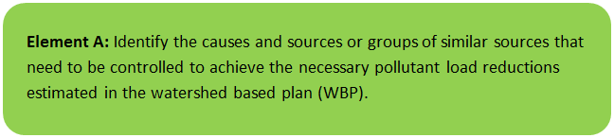

General Watershed Information
This WBP was prepared for waterbodies located within the Fort River Watershed located in the Towns of Amherst, Belchertown, Hadley, Pelham, and Shutesbury. These waterbodies include the Fort River (MA34-27); Adams Brook; Amethyst Brook (MA34-35); Baker Brook; Buffam Brook; Dean Brook; Dunlop Brook; Gates Brook; Harris Brook; Harts Brook; Hearthstone Brook; Hop Brook (MA34-61); Nurse Brook; Plum Brook; and Scarboro Brook. Acadia Lake and Lake Holland are also included in the watershed. The Fort River is the longest free-flowing tributary to the Connecticut River, and has a drainage area of approximately 36,000 acres (approximately 56 square miles).
Table A-1 presents the general watershed information for the applicable Fort River watershed and Figure A-1 includes a map of the watershed boundary.
Table A-1: General Subwatershed Information
Fort River Watershed Information
Watershed Name (Assessment Unit ID): | Adams Brook; Amethyst Brook (MA34-35); Baker Brook; Buffam Brook; Dean Brook; Dunlop Brook; Fort River (MA34-27); Gates Brook; Harris Brook; Harts Brook; Hearthstone Brook; Hop Brook (MA34-61); Nurse Brook; Plum Brook; Scarboro Brook; Fearing Brook
Major Basin: | Connecticut River
Watershed Area (within MA): | 35,730 acres

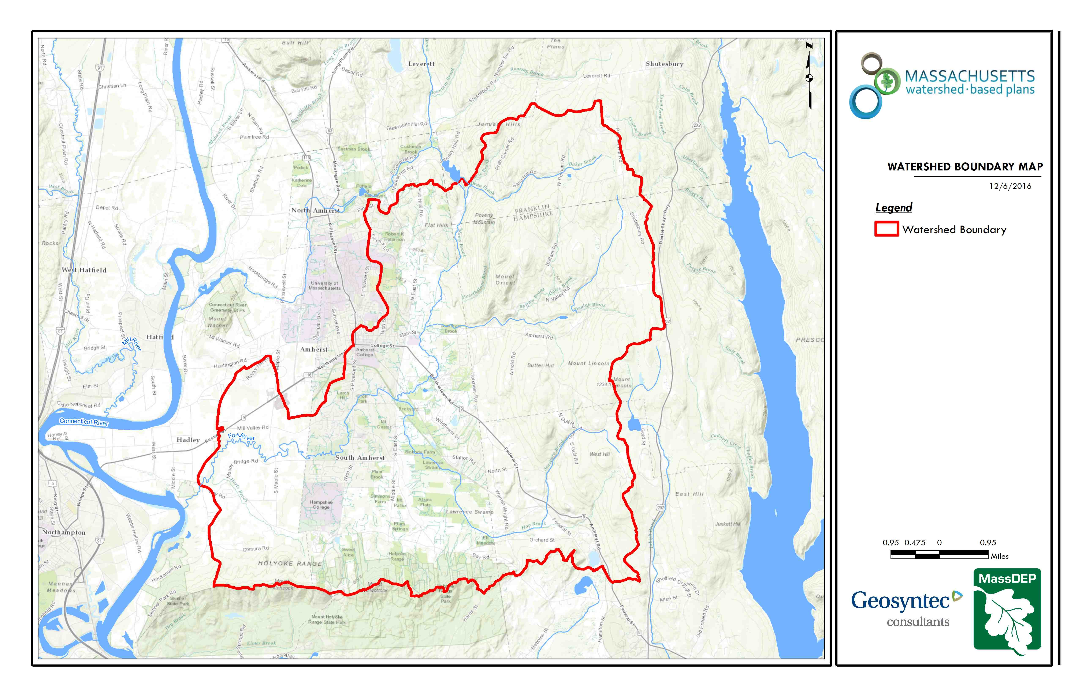
Hop Brook
Fearing Brook
Fort River
Figure A-1: Watershed Boundary Map
(MassGIS, 2007; MassGIS, 1999; MassGIS, 2001; USGS, 2016)

MassDEP Water Quality Assessment Report and TMDL Review
The following reports are available:
- Connecticut River Watershed 2003 Water Quality Assessment Report
- Connecticut River Watershed 2008 DWM Water Quality Monitoring Data (MassDEP 2013a)
- Connecticut River Watershed 2008 Benthic Macroinvertebrate Bioassessment (MassDEP 2013b)
Select excerpts from these documents relating to the water quality in the Fort River watershed is included below (note: relevant information is included directly from these documents for informational purposes and has not been modified).
Connecticut River Watershed 2003 Water Quality Assessment Report (MA34-27 - Fort River)
Aquatic Life Use
Biology
MA DFG collected fish community data at the Fort River at Site 948 upstream from South Maple Street in Hadley in 2003 (Richards 2006). Only four fish species, and five total fish were collected. However, sampling efficiency was rated at 50% and comments indicated that the current was very swift and that section should be sampled with a barge instead of backpack electroshocking equipment. Two rock bass, 1 longnose dace, 1 fallfish, and 1 chain pickerel were collected.
Toxicity – Effluent
Whole effluent toxicity tests were conducted on the Coal Storage and Handling Facility treated effluent. Between August 2000 and April 2005, 16 valid tests were conducted using both C. dubia and P. promelas. The LC50s were all >100% effluent (n=16).
Water Chemistry
DWM conducted water quality sampling at Route 47 in Hadley, Station 27B, on this segment of the Fort River between April and October 2003 (Appendix B and E). Most measurements were indicative of good water quality conditions. Total phosphorus concentrations were elevated and ranged from 0.029 to 0.160 mg/L (half of the measurements exceeded 0.05 mg/L). It should be noted that on 6 August, a wet weather sampling date, TSS was 46 mg/L and turbidity was 8.9 NTU.
The Fort River is assessed as support for the Aquatic Life Use based on the good water quality data. Total phosphorus concentrations were frequently elevated and are of concern, and result in an Alert Status for this use.
Primary and Secondary Contact Recreation and Aesthetics Uses
DWM collected E. coli samples from the Fort River at Route 47 in Hadley (Station 27B) between April and November 2003 (Appendix B). The geometric mean of these samples was 254 cfu/100ml.
DWM personnel made field observations at Station 27B during surveys conducted between April and October 2003. No objectionable deposits or water odors were recorded. White foam was recorded on one occasion and water clarity was recorded as highly turbid on three occasions (MassDEP 2003).
The Primary Contact Recreational Use is assessed as impaired because of elevated E. coli bacteria counts. The Secondary Contact Recreation and Aesthetics uses are assessed as support based upon bacteria counts that are acceptable for secondary contact and the general lack of objectionable conditions. These uses are identified with an Alert Status due to high TSS concentrations and high turbidity documented during wet weather sampling.
Report Recommendations:
Investigate the origin and pattern of highly turbid conditions noted on several occasions.
Consider this segment for bacteria source tracking work to investigate sources of elevated bacteria counts.

Connecticut River Watershed 2008 DWM Water Quality Monitoring Data (MA34-27 - Fort River)
Water Quality Monitoring Data
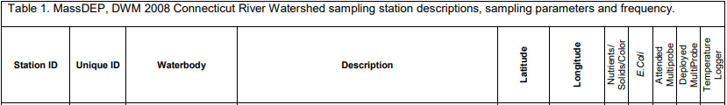

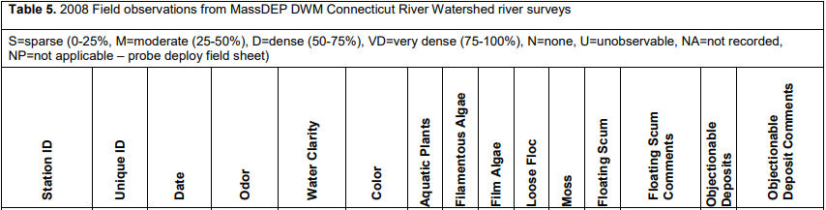
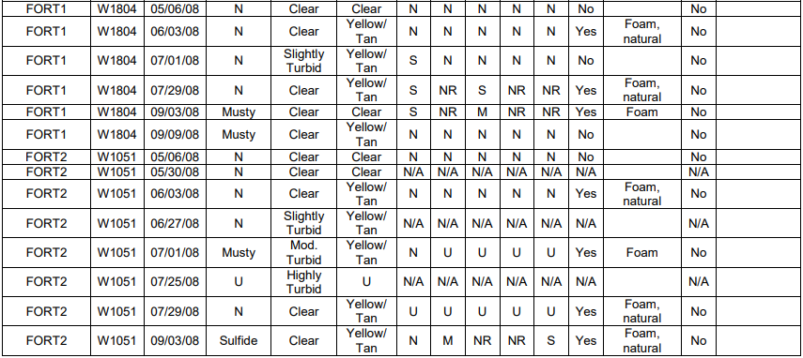

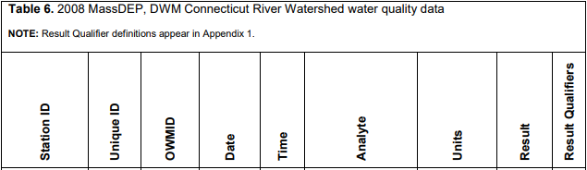
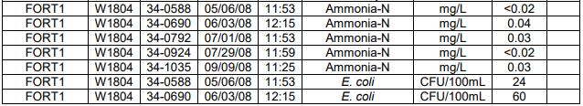
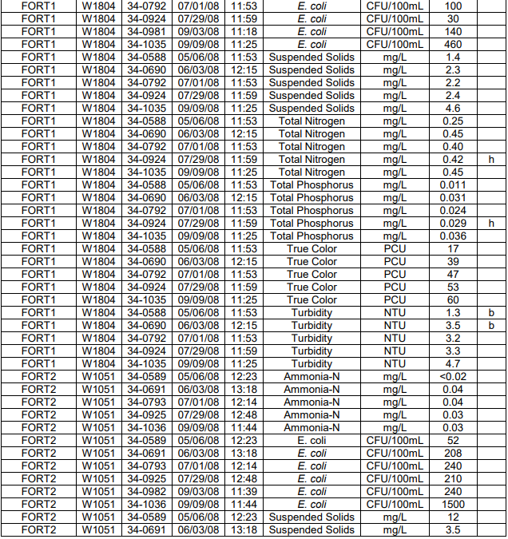
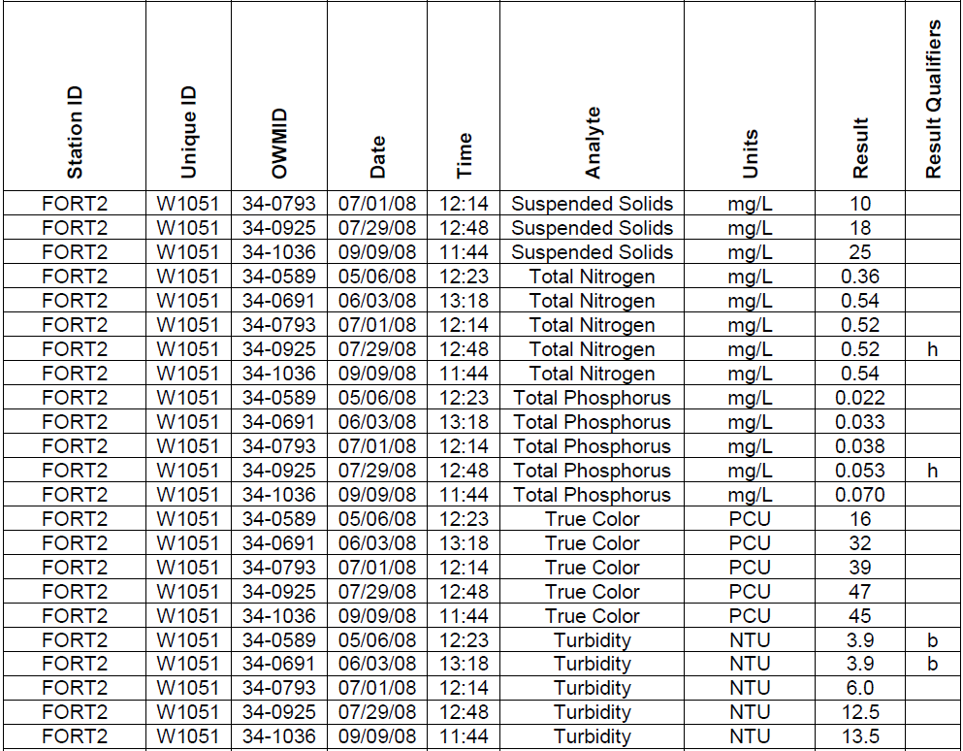
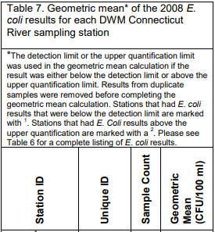
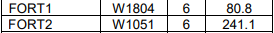

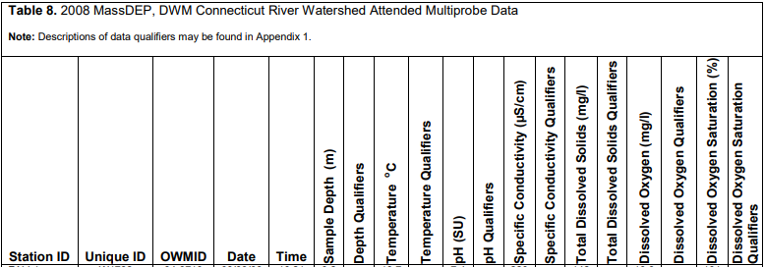
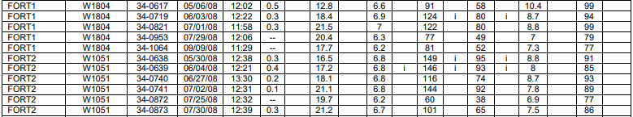
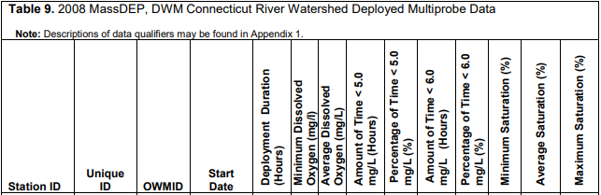

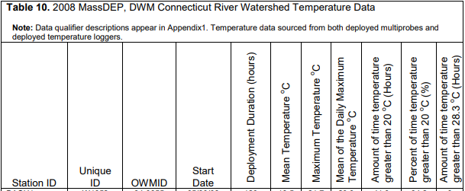

In addition to the Fort River sampling stations detailed above, sampling was conducted by MassDEP in 2008 in two other waterbodies in the Fort River watershed (Hop Brook and Amethyst Brook). Amethyst Brook (MA34-35) was sampled for macroinvertebrates at station B0514 (Upstream from swale off end of Allen Mill Road, Amherst, MA) on 7/21/2008. This station served as the reference site for the 2008 Connecticut biomonitoring survey (MassDEP 2013b). Amethyst Brook was sampled in 2008 by MassDEP at Station W1783 (hiking trail bridge crossing north/west off Allen Mill Road, Amherst). Hop Brook was sampled in 2008 by MassDEP at Station W1800 (Station Road, Amherst). Although results are not detailed here, they can be found in Connecticut River Watershed 2008 DWM Water Quality Monitoring Data (MassDEP 2013a).

Water Quality Impairments
Fort River is listed under category 5 of the Massachusetts List of Integrated Waters due to impairments relating to E. coli, which is summarized by Table A-3.
The source of the impairment listed in Table A-3 are unknown; however, the Town of Amherst and the University of Massachusetts-Amherst have identified two contributing sources which are targeted by the best management practices described in this plan. Additional investigation is required to develop watershed strategies to reduce pollutant loading from stormwater runoff that ultimately discharge to the Fort River and the Connecticut River.
Known water quality impairments, as documented in the MassDEP 2016 Massachusetts Integrated List of Waters, are listed below in Table A-3 for waterbodies in the delineated watershed area. Impairment categories from the Integrated List are included in Table A-2.

Table A-2: 2016 MA Integrated List of Waters Categories
Integrated List Category | Description
1 | Unimpaired and not threatened for all designated uses.
2 | Unimpaired for some uses and not assessed for others.
3 | Insufficient information to make assessments for any uses.
4 | Impaired or threatened for one or more uses, but not requiring calculation of a Total Maximum Daily Load (TMDL), including:  4a: TMDL is completed  4b: Impairment controlled by alternative pollution control requirements  4c: Impairment not caused by a pollutant - TMDL not required
5 | Impaired or threatened for one or more uses and requiring preparation of a TMDL.

Table A-3: Water Quality Impairments
Assessment  Unit ID | Waterbody | Integrated List  Category | Designated Use | Impairment Cause | Impairment Source
MA34-27 | Fort River | 5 | Primary Contact Recreation | Escherichia coli | Source Unknown

Water Quality Goals
Water quality goals may be established for a variety of purposes, including the following:
a.) For waterbodies with known impairments, a Total Maximum Daily Load (TMDL) is established by MassDEP and the United States Environmental Protection Agency (USEPA) as the maximum amount of the target pollutant that the waterbody can receive and still safely meet water quality standards. If the waterbody has a TMDL for total phosphorus (TP) or total nitrogen (TN), or total suspended solids (TSS), that information is provided below and included as a water quality goal.
b.) For waterbodies without a TMDL for total phosphorus (TP), a default water quality goal for TP is based on target concentrations established in the Quality Criteria for Water (USEPA, 1986) (also known as the “Gold Book”). The Gold Book states that TP should not exceed 50 ug/L in any stream at the point where it enters any lake or reservoir, nor 25 ug/L within a lake or reservoir. For the purposes of developing WBPs, MassDEP has adopted 50 ug/L as the TP target for all streams at their downstream discharge point, regardless of which type of water body the stream discharges to.
c.) Massachusetts Surface Water Quality Standards (314 CMR 4.00, 2013) prescribe the minimum water quality criteria required to sustain a waterbody’s designated uses. Table A-4 lists the Class for each Assessment Unit ID within the Amherst subwatersheds that contribute to the Fort River. The water quality goal(s) for bacteria are based on the Massachusetts Surface Water Quality Standards.

Table A-4: Surface Water Quality Classification by Assessment Unit ID
Assessment  Unit ID | Waterbody | Class
MA34-27 | Fort River | B

d.) Other water quality goals set by the community (e.g., protection of high-quality waters, in-lake phosphorus concentration goal to reduce recurrence of cyanobacteria blooms, etc.).
Refer to Table A-5 for a list of water quality goals. There are known impairments for Fort River; however, because there are no existing TMDLs for Fort River or its receiving waterbody, the Connecticut River, water quality goals are focused on reducing common nonpoint source pollutants as well as E. coli.
It is expected that efforts to reduce loads of these pollutants will also result in improvements to other nonpoint source pollutants for waterbodies within the Fort River watershed (e.g., nutrients, turbidity). Element C of this WBP includes proposed BMPs to address these pollutants, including BMPs that provided increases in infiltration. Infiltration is a commonly used method to reduce phosphorus and bacteria loads in stormwater runoff and it can also help with peak runoff rate attenuation, reduced thermal impacts to receiving waters, and enhanced base flow to receiving waters (USEPA, 2014).

Table A-5: Water Quality Goals
Pollutant | Waterbody Name  (Assessment Unit ID(s)) | Goal | Source
Total Phosphorus (TP) | Fort River (MA34-27) | Total phosphorus should not exceed:  --50 ug/L in any stream  --25 ug/L within any lake or reservoir | Quality Criteria for Water (USEPA, 1986)
Bacteria | Fort River (MA34-27) | Class B Standards  • Public Bathing Beaches: For E. coli, geometric mean of 5 most recent samples shall not exceed 126 colonies/ 100 ml and no single sample during the bathing season shall exceed 235 colonies/100 ml. For enterococci, geometric mean of 5 most recent samples shall not exceed 33 colonies/100 ml and no single sample during bathing season shall exceed 61 colonies/100 ml;  • Other Waters and Non-bathing Season at Bathing Beaches: For E. coli, geometric mean of samples from most recent 6 months shall not exceed 126 colonies/100 ml (typically based on min. 5 samples) and no single sample shall exceed 235 colonies/100 ml. For enterococci, geometric mean of samples from most recent 6 months shall not exceed 33 colonies/100 ml, and no single sample shall exceed 61 colonies/100 ml. | Massachusetts Surface Water Quality Standards (314 CMR 4.00, 2013)
Note: There may be more than one water quality goal for bacteria due to different Massachusetts Surface Water Quality Standards Classes for different Assessment Units within the watershed.

Land Use Information
Land use information and impervious cover is presented by the tables and figures below. Land use source data is from 2005 and was obtained from MassGIS (2009b).

Watershed Land Uses
As summarized by Table A-6, land use in the Fort River watershed is mostly forested (approximately 72.8 percent); approximately 12.5 percent is agricultural; approximately 9.9 percent of the watershed is residential; approximately 2.4 percent of the watershed is open land or water; approximately 1.8 percent of the watershed is commercial; approximately 0.4 percent of the watershed is industrial; and approximately 0.1 percent is devoted to highways.
Table A-6: Watershed Land Uses
Land Use | Area (acres) | % of Watershed
Forest | 26,024.17 | 72.8
Agriculture | 4,481.27 | 12.5
Low Density Residential | 2,276.53 | 6.4
Medium Density Residential | 774.98 | 2.2
Commercial | 658.3 | 1.8
Open Land | 640.39 | 1.8
High Density Residential | 455 | 1.3
Water | 211.71 | 0.6
Industrial | 157.16 | 0.4
Highway | 50.8 | 0.1
TOTAL: | 35,730.31 | 100

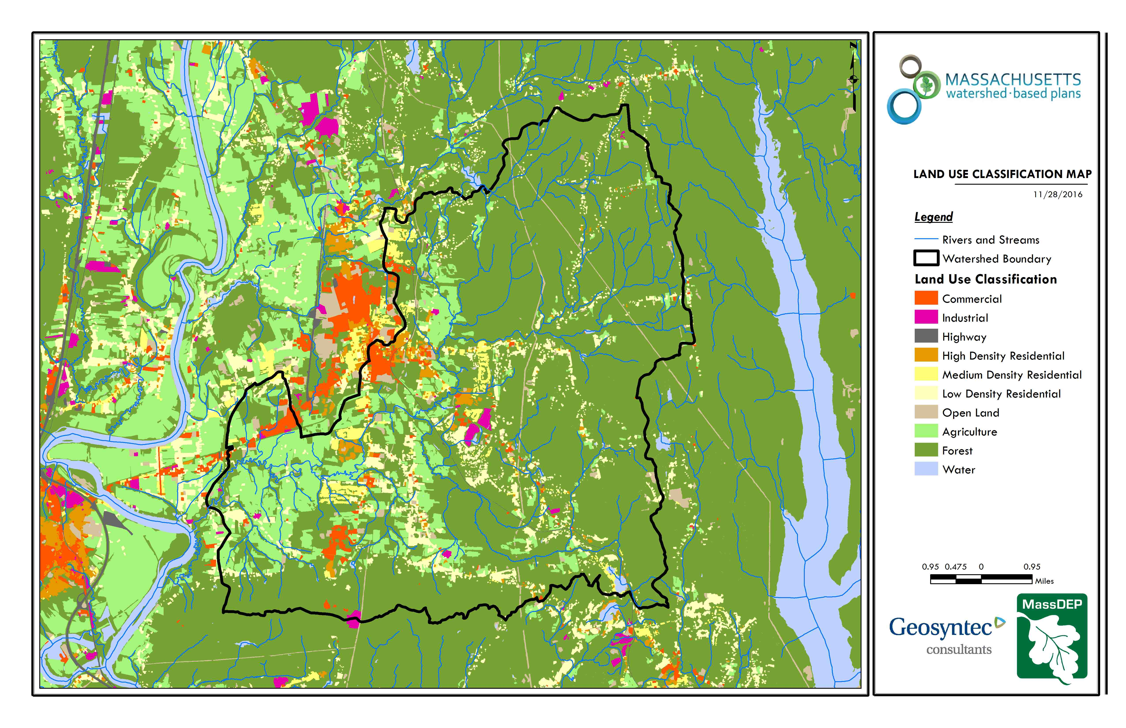
Fort River
Fearing Brook
Hop Brook
Figure A-2: Subwatershed Land Use Map
(MassGIS, 2007; MassGIS, 2009b; MassGIS, 1999; MassGIS, 2001; USGS, 2016)

Watershed Impervious Cover
There is a strong link between impervious land cover and stream water quality. Impervious cover includes land surfaces that prevent the infiltration of water into the ground, such as paved roads and parking lots, roofs, basketball courts, etc. Impervious area within the watershed of the Fort River is concentrated in western and central portion of the watershed as illustrated in Figure A-8 below.
Impervious areas that are directly connected (DCIA) to receiving waters (via storm sewers, gutters, or other impervious drainage pathways) produce higher runoff volumes and transport stormwater pollutants with greater efficiency than disconnected impervious cover areas which are surrounded by vegetated, pervious land. Runoff volumes from disconnected impervious cover areas are reduced as stormwater infiltrates when it flows across adjacent pervious surfaces.
An estimate of DCIA for the subwatershed area was calculated based on the Sutherland equations. USEPA provides guidance (USEPA, 2010) on the use of the Sutherland equations to predict relative levels of connection and disconnection based on the type of stormwater infrastructure within the total impervious area (TIA) of a watershed. Within the subwatershed, the total area of each land use was summed and used to calculate the percent TIA (Table A-7).
Table A-7: TIA and DCIA values for the Watershed
Watershed | Estimated TIA (%) | Estimated DCIA (%)
Fox River | 5.2 | 3.8

The relationship between TIA and water quality can generally be categorized as listed by Table A-8 (Schueler et al. 2009). The TIA value for the watershed range is 5.2%; therefore, the river and surrounding tributaries can be expected to show good to excellent water quality. This can be seen as the largely forested Amethyst Brook watershed had a reference station for benthic macroinvertebrates in 2008 while more downstream developed areas have more water quality stress.

Table A-8: Relationship between Total Impervious Area (TIA) and water quality (Schueler et al. 2009)
% Watershed  Impervious Cover | Stream Water Quality
0-10% | Typically high quality, and typified by stable channels, excellent habitat structure, good to excellent water quality, and diverse communities of both fish and aquatic insects.
11-25% | These streams show clear signs of degradation. Elevated storm flows begin to alter stream geometry, with evident erosion and channel widening. Streams banks become unstable, and physical stream habitat is degraded. Stream water quality shifts into the fair/good category during both storms and dry weather periods. Stream biodiversity declines to fair levels, with most sensitive fish and aquatic insects disappearing from the stream.
26-60% | These streams typically no longer support a diverse stream community. The stream channel becomes highly unstable, and many stream reaches experience severe widening, downcutting, and streambank erosion. Pool and riffle structure needed to sustain fish is diminished or eliminated and the substrate can no longer provide habitat for aquatic insects, or spawning areas for fish. Biological quality is typically poor, dominated by pollution tolerant insects and fish. Water quality is consistently rated as fair to poor, and water recreation is often no longer possible due to the presence of high bacteria levels.
>60% | These streams are typical of “urban drainage”, with most ecological functions greatly impaired or absent, and the stream channel primarily functioning as a conveyance for stormwater flows.

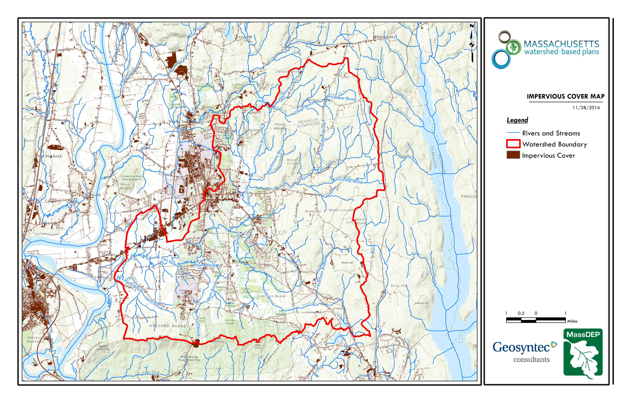
Hop Brook
Fearing Brook
Fort River
Figure A-3: Watershed Impervious Surface Map
(MassGIS, 2007; MassGIS 2009a; MassGIS, 1999; MassGIS, 2001; USGS, 2016)

Pollutant Loading
The land use data (MassGIS, 2009b) was intersected with impervious cover data (MassGIS, 2009a) and United States Department of Agriculture (USDA) Natural Resources Conservation Service (NRCS) soils data (USDA NRCS and MassGIS, 2012) to create a combined land use/land cover grid. The grid was used to sum the total area of each unique land use/land cover type.
The amount of DCIA was estimated using the Sutherland equations as described above and any reduction in impervious area due to disconnection (i.e., the area difference between TIA and DCIA) was assigned to the pervious D soil category for that land use to simulate that some infiltration will likely occur after runoff from disconnected impervious surfaces passes over pervious surfaces.
Pollutant loading for key nonpoint source pollutants in the subwatershed area was estimated by multiplying each land use/cover type area by its pollutant load export rate (PLER). The PLERs are an estimate of the annual total pollutant load exported via stormwater from a given unit area of a particular land cover type. The PLER values for TN, TP and TSS were obtained from USEPA (Voorhees, 2016b) (see documentation provided in Appendix C) as follows:
L_{n} = A_{n} * P_{n}
Where L_{n} = Loading of land use/cover type n (lb/yr); A_{n} = area of land use/cover type n (acres); P_{n} = pollutant load export rate of land use/cover type n (lb/acre/yr)

The estimated land use-based phosphorus to receiving waters within the watershed areas is 7,827 pounds per year, as presented by Table A-9. The largest contributor of the land use-based phosphorus and nitrogen load originates from areas designated as forested (45% of the total phosphorus load and 36% of the total nitrogen load). Phosphorus generated from forested areas is a result of natural process such as decomposition of leaf litter and other organic material and generally represent a “best case scenario” with regards to phosphorus loading, meaning that those portions of the watershed are unlikely to provide opportunities for nutrient load reductions through best management practices. The second largest contributors of the land use-based phosphorus and nitrogen load in the watershed are agricultural areas. Agricultural areas provide excellent opportunities for nutrient load reductions through agriculture best management practices.

Table A-9: Estimated Pollutant Loading for Key Nonpoint Source Pollutants within Fort River
Land Use Type | Pollutant Loading¹
 | Total  Phosphorus (TP)  (lbs/yr) | Total  Nitrogen (TN)  (lbs/yr) | Total  Suspended Solids (TSS)  (tons/yr)
Forest | 3,529 | 17,864 | 595.14
Agriculture | 2,168 | 12,976 | 143.41
Commercial | 614 | 5,333 | 66.71
Low Density Residential | 582 | 5,799 | 80.17
High Density Residential | 355 | 2,429 | 35.92
Medium Density Residential | 263 | 2,268 | 31.64
Open Land | 180 | 1,743 | 35.54
Industrial | 101 | 918 | 11.47
Highway | 36 | 287 | 17.38
TOTAL | 7,827 | 49,618 | 1,017.38
¹These estimates do not consider loads from point sources or septic systems.

Element B: Determine Pollutant Load Reductions Needed to Achieve Water Quality Goals
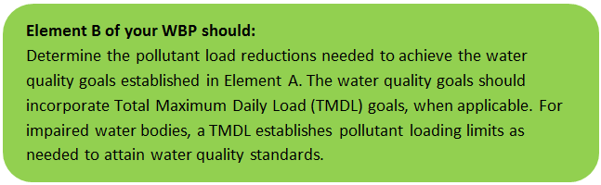

Estimated Pollutant Loads
Estimated pollutant loads for total phosphorus (TP) (7,827 lbs/yr), total nitrogen (TN) (49,618 lb/yr), and total suspended solids (TSS) (1,017 tons/yr) were previously presented in Table A-9 of this WBP. Bacteria cannot be presented as a load, however, the measured geomean concentration of E. coli was 254 cfu/100ml based on the Connecticut River Watershed 2003 Water Quality Assessment Report. Similar to the 2003 results, the 2008 water quality sampling results had a measured geomean concentration of E. coli of 241 cfu/100mL (Station W1051).

Water Quality Goals
There are many methodologies that can be used to set pollutant load reduction goals for a WBP. Goals can be based on water quality criteria, surface water standards, existing monitoring data, existing TMDL criteria, or other data. As discussed by the Water Quality Goals section of Element A, the water quality goals for this WBP are focused on addressing E. coli for Fort River. A description of criteria for phosphorus and bacteria is described by Table B-1.

Table B-1: Pollutant Load Reductions Needed
Pollutant | Existing Estimated Total Load | Water Quality Goal | Planned Load Reduction
Total Phosphorus | 7,827 lbs/yr | 6,653 lbs/yr | 1,174 lbs/yr
Total Nitrogen | 49,618 lbs/yr
Total Suspended Solids | 1,017 ton/yr
Bacteria | MSWQS for bacteria are concentration standards (e.g., colonies of fecal coliform bacteria per 100 ml), which are difficult to predict based on estimated annual loading. E. Coli samples collected between April—November 2003 from the Fort River at Route 47 in Hadley (Station 27B) had a geometric mean of 254 colonies/100 ml | Class B. Class B Standards  • Public Bathing Beaches: For E. coli, geometric mean of 5 most recent samples shall not exceed 126 colonies/ 100 ml and no single sample during the bathing season shall exceed 235 colonies/100 ml. For enterococci, geometric mean of 5 most recent samples shall not exceed 33 colonies/100 ml and no single sample during bathing season shall exceed 61 colonies/100 ml;  • Other Waters and Non-bathing Season at Bathing Beaches: For E. coli, geometric mean of samples from most recent 6 months shall not exceed 126 colonies/100 ml (typically based on min. 5 samples) and no single sample shall exceed 235 colonies/100 ml. For enterococci, geometric mean of samples from most recent 6 months shall not exceed 33 colonies/100 ml, and no single sample shall exceed 61 colonies/100 ml. | 50% – Concentration Based

Recommended Load Reduction
Past water quality monitoring data summarized by the MassDEP Water Quality Assessment Report and TMDL Review section of Element A indicates that the geometric mean of E. coli samples collected in the Fort River (254 cfu/100ml) exceeds the benchmark for streams (geometric mean of samples greater than 126 colonies/100 ml and no single sample greater than 235 colonies/100 ml) (Massachusetts Surface Water Quality Standards 2013). Town of Amherst sampling of a tributary to the Fort River, Fearing Brook, indicates the wet weather Fecal Coliform Units (FCUs) in Fearing Brook upstream of the confluence with Fort River was Too Numerous to Count (TNTC). In addition, the University of Massachusetts-Amherst identified a farm where animals could directly access a tributary to Fort River, which undoubtably contributes bacteria loading.
Phosphorus monitoring data included in the MassDEP Water Quality Assessment Report and TMDL Review section of Element A indicates that total phosphorus concentrations were elevated and ranged from 29 to 160 µg/L, with half of the measurements above 50 µg/L, the benchmark for streams (USEPA 1986). Fort River was given an “Alert Status” in the Connecticut River Watershed 2003 Water Quality Assessment Report for designated uses based on phosphorus. The methodology used in the WBP tool for calculating a water quality goal for TP produces a water quality goal of 9,728 lbs/yr, which is greater than the estimated TP load of 7,827 lb/yr. Given the iterative and adaptive nature of this plan, the monitoring portion of this WBP (Element I) recommends that monitoring be performed to close this data gap, which may help establish a specific phosphorus related water quality goal with the next update of the WBP (expected in 2021). In the interim, the current external phosphorus load is estimated to be 7,827 pounds per year per WBP tool estimates. A long-term 15% reduction in external loading is proposed to improve the water quality within the Fort River.
The proposed projects described in this plan are expected to reduce both E. coli and phosphorus loads to Fort River, however, additional load reductions will be required to meet the water quality benchmark.
The following adaptive sequence is recommended to sequentially track and meet these load reduction goals:
- Given current water quality conditions, establish an interim goal to reduce land use-based phosphorus by 15% (1,174 pounds) over the next 5 years (by 2024). Considering known pollutant loads for existing and proposed BMPs (please refer to the Introduction or Element C for more details on existing and proposed BMPs), it is anticipated that land use-based phosphorus loading will be reduced by approximately 12% (945 pounds) at completion of the BMPs proposed by the Town of Amherst and the University of Massachusetts-Amherst (by 2020).
- Given current water quality conditions, establish an interim goal to reduce the geometric mean concentration of E. coli by 50% over the next 10 years (by 2029). Considering known pollutant loads for existing and proposed BMPs (please refer to the Introduction or Element C for more details on existing and proposed BMPs), it is anticipated that land use-based E. coli loading will be reduced by 3.53x10¹² colonies/year from Moonlit Farm BMPs (University of Massachusetts-Amherst, 2019) in addition to the unquantified, but anticipated reductions through the Fearing Brook floodplain creation (Town of Amherst, 2019).
- Establish a baseline water quality monitoring program in accordance with Element I. Results from the monitoring program should advise if Element C management measures have been effective at addressing listed water quality impairments or water quality goals for other indicator parameters established by Table A-5 of this WBP (e.g., Total phosphorus and E. coli). Results can further be used to periodically inform or adjust load reduction goals.
- Establish a long-term reduction goal to reduce land use-based phosphorus and E. coli over the next 15 years. Based on monitoring data, establish additional long-term reduction goal(s), if needed, to lead to delisting of all assessment units within the study watershed from the 303(d) list.

Element C: Describe management measures that will be implemented to achieve water quality goals

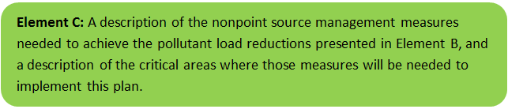
Current and Ongoing Management Measures
The Town was awarded funding through the Fiscal Year 2020 Section 319 Nonpoint Source Pollution Grant Program to install the proposed structural BMPs listed in Tables C-1 (Town of Amherst) and C-2 (University of Massachusetts-Amherst) within the Fort River Watershed. The planning level cost estimates and pollutant load reduction estimates were based off information obtained from the “Fearing Brook Floodplain Creation Project” Section 319 Nonpoint Source Pollution Grant Program application (Town of Amherst, 2019) and the “Implementation, Remediation, and Education of Selected Best Management Practices to Minimize the Environmental Impact of Two Equine Operations” Section 319 Nonpoint Source Pollution Grant Program application (University of Massachusetts-Amherst, 2019). It is anticipated that these BMPs will result in a combined load reduction of approximately 945 pounds of total phosphorus and at least 3.53x10¹² organisms/year of E. coli. Details of BMP design are included in Appendix A (Town of Amherst, 2019) and Appendix B (University of Massachusetts-Amherst, 2019).
Table C-1: Town of Amherst Proposed Management Measures, Estimated Pollutant Load Reductions and Costs
Town of Amherst BMPs
BMP Type | Floodplain Restoration
BMP Location | Fearing Brook
Estimated Pollutant Load Reduction | Biochemical Oxygen Demand (BOD) | 48.6% Removal
 | Nitrogen | 38.0% Removal
 | Phosphorus | 42.5% Removal
 | Total Suspend Solids (TSS) | 68.3% Removal
 | E. coli | Unquantified
Estimated Cost ($) | $464,834

The floodplain restoration project will include bank and channel stabilization of Fearing Brook to reduce erosion (TSS load); reconnecting Fearing Brook to its historic floodplain to allow for attenuated flows, reduced stormwater volume through infiltration, treatment of nutrients and E. coli, and TSS capture; and providing in-stream and floodplain habitat improvements to improve aquatic life and reduce thermal load.
Table C-2: University of Massachusetts-Amherst Proposed Management Measures, Estimated Pollutant Load Reductions and Costs
Moonlit Farm BMPs
BMP Type | Equine Farm Improvements
BMP Location | Moonlit Farm (Unnamed Tributary to Hop Brook)
Estimated Pollutant Load Reduction | Biochemcial Oxygen Demand (BOD) | Unquantified
 | Nitrogen | 2,847 lbs-N/year
 | Phosphorus | 899 lbs-P/year
 | Total Suspend Solids | Unquantified
 | E. coli | 3.53x10¹² organisms/year
Estimated Cost ($) | $239,033

The equine farm improvements at Moonlit Farm in Belchertown will include:

- A solar-powered, 3-pile static aerated composting system;
- Three sacrifice lots with at least 2,400 square feet;
- Gutters and downspout to reduce runoff into unnamed tributary to Hop Brook;
- Fencing to inhibit horses from directly accessing the unnamed tributary and wetlands; and
- Cleaning and repairing the forested area near the unnamed tributary where manure was historically dumped.

Future Management Measures
As discussed by the Recommended Load Reduction section in Element B, It is recommended that future planning initially focus on water quality goals related to E. coli and phosphorus in the Fort River Watershed. It is recommended that management measures be recommended for future BMPs that emphasize reducing E. coli and total phosphorus loading to meet target water quality goals, as feasible. The following general sequence is recommended to identify and implement structural BMPs. The sequence has significant overlap with the Town of Amherst’s SWMP and should be coordinated accordingly during implementation.
- Identify Potential Implementation Locations: Perform a desktop analysis using aerial imagery and GIS data to develop a preliminary list of potentially feasible implementation locations based on soil type (i.e., hydrologic soil groups A and B); available public open space (e.g., lawn area in front of a police station); potential redevelopment sites where additional public-private partnerships may be leveraged; and other factors such as proximity to receiving waters, known problem areas, or publicly owned right of ways or easements. Additional analysis can also be performed to fine-tune locations to maximize pollutant removals such as performing loading analysis on specifically delineated subwatersheds draining to single outfalls and selecting those subwatersheds with the highest loading rates per acre. Prior reports have also identified potential locations for restoration and green infrastructure projects on the Amherst College campus and other areas within the Fearing Brook watershed (Damiano, 2017 and MMI, 2019).
- Visit Potential Implementation Locations: Perform field reconnaissance, preferably during a period of active runoff-producing rainfall, to evaluate potential implementation locations, gauge feasibility, and identify potential BMP ideas. During field reconnaissance, assess identified locations for space constraints, potential accessibility issues, presence of mature vegetation that may cause conflicts (e.g., roots), potential utility conflicts, site-specific drainage patterns, and other factors that may cause issues during design, construction, or long-term maintenance.
- Develop BMP Concepts: Once potential BMP locations are conceptualized, use the BMP-selector tool on the watershed-based planning tool to help develop concepts. Concepts can vary widely. One method is to develop 1-page fact sheets for each concept that includes a site description, including definition of the problem, a description of the proposed BMPs, annotated site photographs with conceptual BMP design details, and a discussion of potential conflicts such as property ownership, O&M requirements, and permitting constraints. The fact sheet can also include information obtained from the BMP-selector tool including cost estimates, load reduction estimates, and sizing information (i.e., BMP footprint, drainage area, etc.).
- Rank BMP Concepts: Once BMP concepts are developed, perform a priority ranking based on site-specific factors to identify the implementation order. Ranking can include many factors including cost, expected pollutant load reductions, implementation complexity, potential outreach opportunities and visibility to public, accessibility, expected operation and maintenance effort, and others.
Prioritized BMP concepts should focus on reducing E. coli and total phosphorus loading to the Fort River as summarized by the Recommended Load Reduction section in Element B and Table B-1.
Note that planned BMPs can also be non-structural (e.g., street sweeping, catch basin cleaning). It is recommended that these municipal programs be evaluated and potentially optimized. First, it is recommended that potential pollutant load removals from ongoing activities be calculated in accordance with Element H and I. Next, it is recommended that ongoing activities be evaluated to see if potential improvements can be implemented to achieve higher pollutant load reductions such as increased frequency or improved technology.

Element D: Identify Technical and Financial Assistance Needed to Implement Plan
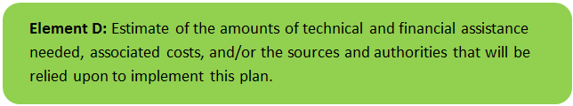

Current and Ongoing Management Measures
The funding needed to implement the proposed management measures presented in this watershed plan is based on estimates from the “Fearing Brook Floodplain Creation Project” Section 319 Nonpoint Source Pollution Grant Program application (Town of Amherst, 2019) and the “Implementation, Remediation, and Education of Selected Best Management Practices to Minimize the Environmental Impact of Two Equine Operations” Section 319 Nonpoint Source Pollution Grant Program application (University of Massachusetts-Amherst, 2019). The total costs for structural and non-structural BMPs, operation and maintenance activities, information/education measures, and monitoring/evaluation activities is estimated at approximately $703,867, as detailed by Tables D-1 (Town of Amherst) and D-2 (University of Massachusetts-Amherst). Additionally, annual operation and maintenance costs were estimated, based on best professional judgment, to be two percent of the BMP supplies cost (i.e., approximately $2,900/year); this estimate will be reevaluated when the projects are implemented and exact operation and maintenance activities, along with operation and maintenance agreements, are established.
Table D-1: Summary of Proposed BMPs Costs (Fearing Brook Floodplain Creation Project, Town of Amherst)
Expense Item | s.319 Amount | Non-Federal Match and Source | Total Amount
Salary - By Title and Hourly Range
Town Environmental Scientist ($40/hr) | $0 | $10,000 | $10,000
DER Program Manager ($65/hr) | $0 | $6,700 | $6,700
Subcontractual Service
Town Environmental Scientist ($40/hr) | $150,955 | $46,000 – in kind services, Town hauls & disposes of soil | $196,995
DER Program Manager ($65/hr) | $20,000 | 0 | $20,000
Materials and Supplies
Erosion control & construction fencing | $7,360 | $0 | $7,360
Boulders, steps, coir logs | $28,750 | $0 | $28,750
New topsoil | $30,475 | $0 | $30,475
Plantings, seed & mulch for restoration | $38,969 | $36,500 – Town cash | $75,469
Other
Preparation of preliminary 60% design | $0 | $49,085 | $49,085
Preparation Final design & bid package | $0 | $40,000 | $40,000
Totals | $276,549 | $188,285 | $464,834

Table D-2: Summary of Proposed BMPs Costs (Moonlit Farm BMPs, University of Massachusetts-Amherst)
Expense Item | s.319 Amount | Non-Federal Match and Source | Total Amount
Salary and Wages
University staff (salary and 38.5% fringe) | $0 | $43,190 | $43,190
Technical Extension staff (salary and 2.03 fringe) | $38,858 | $0 | $38,858
Students Assistance (part time and 1.73 fringe) | $3,882 | $0 | $3,882
Supplies
Publications (posters, signage, worksheets) | $250 | $0 | $250
BMP supplies and contracts | $68,200 | $0 | $68,200
Travel | $750 | $0 | $750
Indirect Costs
26% indirect | $20,807 | $0 | $20,807
59.5% vs 26% waived indirect on Fed share | $0 | $52,508 | $52,508
Totals | $143,335 | $95,698 | $239,033

Future Management Measures
Funding for future BMP installations to further reduce loads within the watershed may be provided by a variety of sources, such as the Section 319 Nonpoint Source Pollution Grant Program, town capital funds, or other grant programs such as hazard mitigation funding. Section 604b watershed planning grants are also available to support BMPs design work and water quality sampling and assessment. The Town of Amherst and the University of Massachusetts-Amherst have previously been successful with and will continue to pursue securing additional funding through various sources. Guidance is available to provide additional information on potential funding sources for nonpoint source pollution reduction efforts.

Element E: Public Information and Education
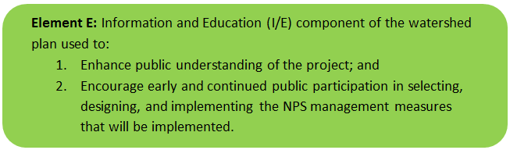

Step 1: Goals and Objectives
The goals and objectives for the watershed information and education program.
- Provide information about proposed stormwater improvements and their anticipated water quality benefits.
- Provide information to promote watershed stewardship.
Step 2: Target Audience
Target audiences that need to be reached to meet the goals and objectives identified above.
- All watershed residents.
- Businesses within the watershed.
- Farmers within the watershed (targeted through UMass Extension).
- Schools within the watershed, including Amherst College and Fort River Elementary School.
- Watershed organizations and other user groups, including Hitchcock Center for the Environment.
- Horse owners and related groups (such as riding clubs).
Step 3: Outreach Products and Distribution
The outreach product(s) and distribution form(s) that will be used for each.
- Develop and post informational signs at proposed BMP locations (Fearing Brook Floodplain Creation, and Moonlit Farm Improvements).
- Allow for the use of the Fearing Brook Floodplain as a “living classroom” for Amherst College and Fort River Elementary and develop programming centered on the proposed project.
- Encourage tours and community engagement of the Fearing Brook Floodplain Project through use of the Fort River Farm Conservation Area and the Hitchcock Center for the Environment.
- Promote the Fearing Brook Floodplain on the Town of Amherst’s social media pages.
- One annual field day at Moonlit Farm, which will include an educational workshop for equine farm owners and its users on the BMPs.
- A minimum of five new and/or revised factsheets related to the various aspects of manure management, composting, protecting wetlands, sacrifice lots, pasture management, mud management, and controlling runoff will be generated and posted online (“Crops, Dairy, Livestock and Equine” UMass Extension website) and emailed to an equine list serve (800 members and counting).
Step 4: Evaluate Information/Education Program
Information and education efforts and how they will be evaluated.
- Track the number of classes or number of students who utilize the Fearing Brook Floodplain as a “living classroom,” participate in tours or programming, or study the Fearing Brook for their studies.
- Track the number and size of tours of the Fearing Brook Floodplain Project through the Fort River Farm Conservation Area.
- Track the number of posts and associated activity (likes/shares) related to posts of the Fearing Brook Floodplain Project on the Town of Amherst’s social media pages.
- Track field day and workshop attendance at Moonlit Farm.
- Tracking the number of fact sheet emails and the size of the list serve receiving the emails in addition to visitors to the UMass Extension webpage.

Elements F & G: Implementation Schedule and Measurable Milestones
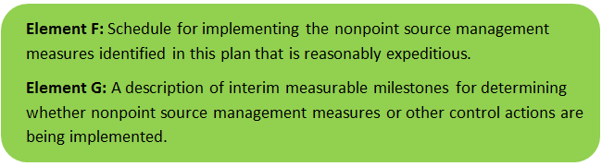

Table FG-1 provides a preliminary schedule for implementation of recommendations provided by this WBP. It is expected that the WBP will be re-evaluated and updated in 2022, or as needed, based on ongoing monitoring results and other ongoing efforts. New projects for further implementation of the watershed based plan will be identified through future data analysis and stakeholder engagement and will be included in updates to the implementation schedule.

Table FG-1: Implementation Schedule and Interim Measurable Milestones for Fearing Brook Floodplain Creation Project
Category | Action | Estimated Cost | Year(s)
Monitoring /Evaluation | Write Quality Assurance Project Plan (QAPP) for sampling and establish water quality monitoring program | TBD | 2020
 | Perform annual water quality sampling per Element H&I monitoring guidance | TBD | Annual
 | Upon completion of the Fearing Brook Floodplain Creation Project, the Town of Amherst will inspect the area following rain events to ascertain if the stream is fully and easily accessing the recreated floodplain. It will be assumed if the floodplain reconnection is experiencing frequent inundation during rain events/snow melt that the predicted pollutant removals are being achieved | $11,500 | Periodically (after rain events)
 | The implemented BMPs at Moonlit Farm will be evaluated through a) continuous oversight with recommendation from technical guidance committee b) photos and videos taken before and after each specific task implementation, and c) Quantities of N, P, pathogens will be estimated for each implemented BMPs, using NRCS guidance. | $20,000 | On-going
Structural BMPs | Document estimated pollutant removals from existing BMPs in the watershed |  | 2020
 | Complete installation of proposed BMPs associated with the Fearing Brook Floodplain Creation Project | $418,834 | 2020
 | Complete installation of proposed BMPs at Moonlit Farm | $189,033 | 2021--2022
 | Obtain funding and implement 2-3 additional BMPs within the Fort River watershed | $200,000 | 2024
 | Obtain funding and implement 2-3 additional BMPs within the Fort River watershed | $200,000 | 2026
Nonstructural BMPs | Document potential pollutant removals from ongoing non-structural BMP practices (i.e., street sweeping, catch basin cleaning) | TBD | 2020
 | Evaluate ongoing non-structural BMP practices and determine if modifications can be made to optimize pollutant removals (e.g., increase frequency). | TBD | 2021
 | Routinely implement optimized non-structural BMP practices | TBD | Annual
Public Education and Outreach  (See Element E) | Implement signage at the Fort River Conservation Area that will explain the Fearing Brook Floodplain Creation Project and its benefits | $11,500 | 2020
 | Tours of the Fearing Brook Floodplain Creation Project will be hosted by the Town of Amherst for Fort River Elementary and Amherst College staff so that the area can be used as a living classroom for their students. | $11,500 | On-going
 | The Town of Amherst and/or the Massachusetts Division of Ecological Restoration (DER) will organize walks at the Fort River Farm Conservation Area, which will focus on the river and restoration efforts | $11,500 | On-going
 | One annual field day will be held at Moonlit Farm to discuss the rational and demonstrate the implemented bmps. | $15,000 | Annual
 | A minimum of five new and/or revised factsheets related to the various aspects of manure management, composting, protecting wetlands, sacrifice lots, pasture management, mud management, and controlling runoff will be generated and posted online. Copies of and revised factsheets and the calendar developed for this task will be submitted in a suitable format for reproduction and web posting. | $15,000 | 2020--2021
Adaptive Management  and Plan Updates | Establish working group comprised of stakeholders and other interested parties to implement recommendations and track progress. Meet at least twice per year. | -- | 2020
 | Re-evaluate Watershed Based Plan at least once every three (3) years and adjust, as needed, based on ongoing efforts (e.g., based on monitoring results, 319 funding, etc.). – Next update, December 2022 | -- | 2022
 | Reach interim goal to reduce land-based phosphorus by 15% (1,174 lbs/yr) | -- | 2024
 | Reach interim goal to reduce the geometric mean concentration of E. coli by 50% | -- | 2029
 | Establish additional long-term reduction goal(s) from baseline monitoring results, if needed | -- | 2024
 | Reach long-term phosphorus and E. coli load reduction goals | -- | 2034

Elements H & I: Progress Evaluation Criteria and Monitoring
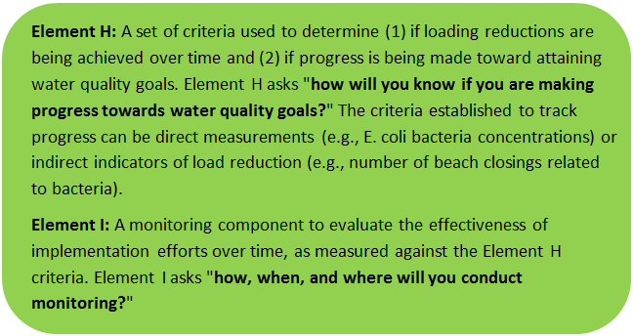 | 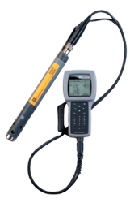

The water quality target concentration(s) is presented under Element A of this plan. To achieve this target concentration, the annual loading must be reduced to the amount described in Element B. Element C of this plan describes the various management measures that will be implemented to achieve this targeted load reduction. The evaluation criteria and monitoring program described will be used to measure the effectiveness of the proposed management measures (described in Element C) in improving the water quality of the Fort River.

Indirect Indicators of Load Reduction

Non-Structural BMPs
Potential load reductions from non-structural BMPs (i.e., street sweeping and catch basin cleaning) can be estimated from indirect indicators, such as the number of miles of streets swept or the number of catch basins cleaned. Appendix F of the 2016 Massachusetts Small MS4 General Permit provides specific guidance for calculating phosphorus removal from these practices. As indicated by Element C, it is recommended that potential phosphorus removal from these ongoing actives be estimated. Next, it is recommended that ongoing activities be evaluated to see if potential improvements can be implemented to achieve higher pollutant load reductions such as increased frequency or improved technology.
The Town of Amherst currently performs street sweeping and catch basin cleaning, in addition to other non-structural BMPs. The Town organized a town-wide clean-up day, which engaged watershed residents. The Town discontinued the use of sand for icy road conditions, which decreased total suspended solids in street catch basins. The Town of Amherst is developing multiple programs to address water quality, including erosion and sediment control standards for construction projects, and post-construction water quality requirements.
Phosphorus load reductions can be estimated in accordance with Appendix F of the 2016 Massachusetts Small MS4 General Permit as summarized by Figure HI-1 and HI-2.
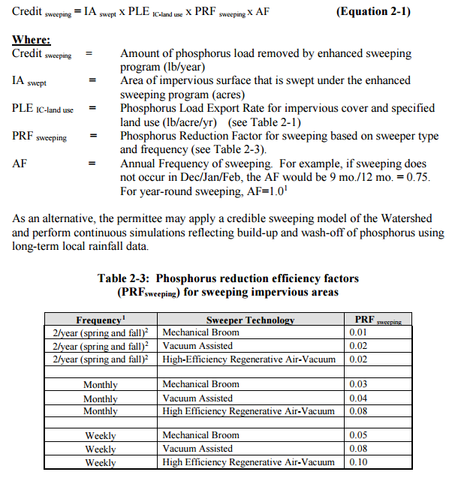
Figure HI-1. Street Sweeping Calculation Methodology
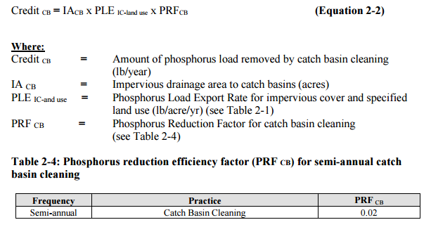
Figure HI-2. Catch Basin Cleaning Calculation Methodology

Project-Specific Indicators

Moonlit Farm
The implemented BMPs at Moonlit Farm will be evaluated through a) continuous oversight with recommendation from technical guidance committee b) photos and videos taken before and after each specific task implementation, and c) Quantities of N, P, pathogens will be estimated for each implemented BMPs, using NRCS guidance.

Fearing Brook Floodplain Creation Project
Upon completion of the Fearing Brook Floodplain Creation Project, the Town of Amherst will inspect the area following rain events to ascertain if the stream is fully and easily accessing the recreated floodplain. It will be assumed if the floodplain reconnection is experiencing frequent inundation during rain events/snow melt that the predicted pollutant removals are being achieved.

Town of Amherst Stormwater Management Plan (SWMP) Implementation:
On-going efforts by the Town of Amherst during implementation of their Stormwater Management Program (SWMP) will be tracked in annual reports that are posted on the Town’s dedicated Stormwater Management webpage. The Town of Amherst is currently developing additional stormwater ordinances for new developments which will require the use of green infrastructure. As part of the SWMP, the Town of Amherst will identify new or retrofit opportunities for green infrastructure and will install at least one BMP as a demonstration project to remove nitrogen.

TMDL Criteria
Fort River (MA34-27) will be included in the upcoming “Massachusetts Statewide TMDL for Pathogen-Impaired Inland Freshwater Rivers” which is currently being drafted.

Direct Measurements
Direct measurements are generally expected to be performed as described below. Prior to implementing a direct measurement program, an abbreviated QAPP and/or Standard Operating Procedures (SOPs) will be established to flesh out details of the program and establish best practices for sample collection and analysis. Water quality monitoring may be performed through a volunteer training program to save on costs in accordance with established practices for MassDEP’s environmental monitoring for volunteers.

River Sampling
Sampling will be conducted approximately once per month from May—October to understand the water quality in Fort River Watershed, including determining sources for pollution and tracking achievements toward water quality goals, including analysis of E. coli, phosphorus, nitrogen, and turbidity. Additional parameters such as chlorophyll-a, dissolved oxygen, temperature, conductivity, pH, and flow rate could provide additional data for consideration. If possible, obtain sampling of Fearing Brook and the unnamed tributary to Hop Brook (downstream of Moonlit Farm) to determine the impact of proposed BMPs within the watershed. Additional monitoring locations may be selected following installation of stormwater BMPs based on accessibility and representativeness and shall be appropriate to quantify water quality improvements in the watershed.

In-Lake Phosphorus and Water Quality Monitoring
Sampling programs specific for the contributing ponds (Arcadia Lake and Lake Holland) within the watershed could be established to more closely track the progress of water quality improvements towards water quality goals. Monitoring locations should at minimum include the outlet of the pond, tributaries, and the deepest “in-lake” location. It is recommended that sampling programs include analysis of E. coli, secchi disk transparency, phosphorus, chlorophyll-a, turbidity, temperature/oxygen profiles, and aquatic vegetation. These parameters will also enable tracking relative to Carlson’s state trophic index to evaluate improvements over time.

Adaptive Management
As discussed by Recommended Load Reduction section of Element B, the baseline monitoring program will be used to establish a long-term i.e., 15 year) E. coli and phosphorus load reduction goal (or other parameter(s) depending on results). Long-term goals will be re-evaluated at least once every three years and adaptively adjusted based on additional monitoring results and other indirect indicators. If monitoring results and indirect indicators do not show improvement to the E. coli and total phosphorus concentrations and other indicators (e.g., chlorophyll-a) measured within the watershed, the management measures and loading reduction analysis (Elements A through D) will be revisited and modified accordingly.

References
314 CMR 4.00 (2013). "Division of Water Pollution Control, Massachusetts Surface Water Quality Standards"
Cohen, A. J.; Randall, A.D. (1998). "Mean annual runoff, precipitation, and evapotranspiration in the glaciated northeastern United States, 1951-80." Prepared for United States Geological Survey, Reston VA.
Damiano, A. (2017). “Hydrologic Effects of Land Use in the Fearing Brook Watershed.” Master’s Thesis for the University of Massachusetts.
Geosyntec Consultants, Inc. (2014). "Least Cost Mix of BMPs Analysis, Evaluation of Stormwater Standards Contract No. EP-C-08-002, Task Order 2010-12." Prepared for Jesse W. Pritts, Task Order Manager, U.S. Environmental Protection Agency
Geosyntec Consultants, Inc. (2015). "Appendix B: Pollutant Load Modeling Report, Water Integration for the Squamscott-Exeter (WISE) River Watershed."
Jones, S.; Rothenheber, D. (2016). “Identifying Sources of Fecal Contamination in the Fearing Brook Watershed.” Jackson Estuarine Laboratory at the University of New Hampshire.
King, D. and Hagan, P. (2011). "Costs of Stormwater Management Practices in Maryland Counties." University of Maryland Center for Environmental Science Chesapeake Biological Laboratory. October 11, 2011.
Leisenring, M., Clary, J., and Hobson, P. (2014). "International Stormwater Best Management Practices (BMP) Database Pollutant Category Statistical Summary Report: Solids, Bacteria, Nutrients and Metals." Geosyntec Consultants, Inc. and Wright Water Engineers, Inc. December 2014.
MassDEP (2008). “Connecticut River Watershed, 2003 Water Quality Assessment Report”
MassDEP (2012). "Massachusetts Year 2012 Integrated List of Waters Final Listing of Massachusetts' Waters Pursuant to Sections 305(b), 314 and 303(d) of the Clean Water Act"
MassDEP (2013a). “Connecticut River Watershed 2008 DWM Water Quality Monitoring Data”
MassDEP (2013b). "Connecticut River Watershed 2008 Benthic Macroinvertebrate Bioassessment" CN: 322.2, Division of Watershed Management, Massachusetts Department of Environmental Protection, Worcester, MA.
MassDEP (2016a). "Massachusetts Clean Water Toolkit"
MassDEP (2016b). "Massachusetts Stormwater Handbook, Vol. 2, Ch. 2, Stormwater Best Management Practices"
MassGIS (1999). "Networked Hydro Centerlines" Shapefile
MassGIS (2001). "USGS Topographic Quadrangle Images" Image
MassGIS (2007). "Drainage Sub-basins" Shapefile
MassGIS (2009a). "Impervious Surface" Image
MassGIS (2009b). "Land Use (2005)" Shapefile
MassGIS (2013). "MassDEP 2012 Integrated List of Waters (305(b)/303(d))" Shapefile
Milone and MacBroom, Inc. (2018). “Preliminary Assessment of the Fearing Brook Corridor.” Prepared for Megan Sampson, Program Adminstrator, Division of Ecological Restoration, Massachusetts Department of Fish and Game.
New England Environmental, Inc. (2015). “Fearing Brook Watershed Plan Study Report and Remedial Recommendations.” Prepared for Town of Amherst, MA, Office of Conservation and Development.
Schueler, T.R., Fraley-McNeal, L, and K. Cappiella (2009). "Is impervious cover still important? Review of recent research" Journal of Hydrologic Engineering 14 (4): 309-315.
Szal, R. (2016). “Monitoring, Assessing, and Restoring Urban Streams: Fearing Brook Restoration Project.” Report for partial fulfillment of Bachelor’s degree at the Hampshire School of Natural Sciences.
Town of Amherst (2019). “Fearing Brook Floodplain Creation Project”
Town of Amherst (2019). “Stormwater Management Program (SWMP), Town of Amherst, MA”
Town of Amherst (2019). “Town of Amherst Year 1 Annual Report”
United States Bureau of Labor Statistics (2016). "Consumer Price Index"
United States Geological Survey (2016). "National Hydrography Dataset, High Resolution Shapefile"
University of Massachusetts, Amherst (2004). "Stormwater Technologies Clearinghouse"
University of Massachusetts, Amherst (2019). “Implementation, Remediation, and Education of Selected Best Management Practices to Minimize the Environmental Impact of Two Equine Operations”
USDA NRCS and MassGIS (2012). "NRCS SSURGO-Certified Soils" Shapefile
USEPA (1986). "Quality Criteria for Water (Gold Book)" EPA 440/5-86-001. Office of Water, Regulations and Standards. Washington, D.C.
USEPA. (2010). "EPA's Methodology to Calculate Baseline Estimates of Impervious Area (IA) and Directly Connected Impervious Area (DCIA) for Massachusetts Communities."
Voorhees, Mark, USEPA. (2015). "FW: Description of additional modelling work for Opti-Tool Project" Message to Chad Yaindl, Geosyntec Consultants. 23 April 2015. E-mail.
Voorhees, Mark, USEPA. (2016a). "FW: EPA Region 1 SW BMP performance equations" Message to Chad Yaindl, Geosyntec Consultants. 25 January 2016. E-mail.
Voorhees, Mark, USEPA. (2016b). "FW: Description of additional modelling work for Opti-Tool Project" Message to Chad Yaindl, Geosyntec Consultants. 23 April 2015. E-mail.

Appendices
Appendix A – Proposed BMP Design Details (Town of Amherst, 2019)

Appendix B – Proposed BMP Design Details (University of Massachusetts-Amherst, 2019)

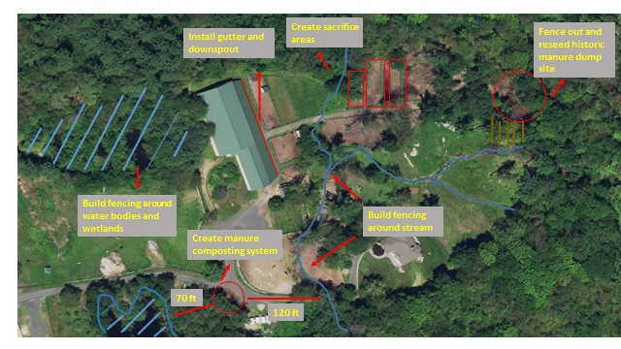

Appendix C – Pollutant Load Export Rates (PLERs)
Land Use & Cover¹ | PLERs (lb/acre/year)
 | (TP) | (TSS) | (TN)
AGRICULTURE, HSG A | 0.45 | 7.14 | 2.59
AGRICULTURE, HSG B | 0.45 | 29.4 | 2.59
AGRICULTURE, HSG C | 0.45 | 59.8 | 2.59
AGRICULTURE, HSG D | 0.45 | 91.0 | 2.59
AGRICULTURE, IMPERVIOUS | 1.52 | 650 | 11.3
COMMERCIAL, HSG A | 0.03 | 7.14 | 0.27
COMMERCIAL, HSG B | 0.12 | 29.4 | 1.16
COMMERCIAL, HSG C | 0.21 | 59.8 | 2.41
COMMERCIAL, HSG D | 0.37 | 91.0 | 3.66
COMMERCIAL, IMPERVIOUS | 1.78 | 377 | 15.1
FOREST, HSG A | 0.12 | 7.14 | 0.54
FOREST, HSG B | 0.12 | 29.4 | 0.54
FOREST, HSG C | 0.12 | 59.8 | 0.54
FOREST, HSG D | 0.12 | 91.0 | 0.54
FOREST, HSG IMPERVIOUS | 1.52 | 650 | 11.3
HIGH DENSITY RESIDENTIAL, HSG A | 0.03 | 7.14 | 0.27
HIGH DENSITY RESIDENTIAL, HSG B | 0.12 | 29.4 | 1.16
HIGH DENSITY RESIDENTIAL, HSG C | 0.21 | 59.8 | 2.41
HIGH DENSITY RESIDENTIAL, HSG D | 0.37 | 91.0 | 3.66
HIGH DENSITY RESIDENTIAL, IMPERVIOUS | 2.32 | 439 | 14.1
HIGHWAY, HSG A | 0.03 | 7.14 | 0.27
HIGHWAY, HSG B | 0.12 | 29.4 | 1.16
HIGHWAY, HSG C | 0.21 | 59.8 | 2.41
HIGHWAY, HSG D | 0.37 | 91.0 | 3.66
HIGHWAY, IMPERVIOUS | 1.34 | 1,480 | 10.2
INDUSTRIAL, HSG A | 0.03 | 7.14 | 0.27
INDUSTRIAL, HSG B | 0.12 | 29.4 | 1.16
INDUSTRIAL, HSG C | 0.21 | 59.8 | 2.41
INDUSTRIAL, HSG D | 0.37 | 91.0 | 3.66
INDUSTRIAL, IMPERVIOUS | 1.78 | 377 | 15.1
LOW DENSITY RESIDENTIAL, HSG A | 0.03 | 7.14 | 0.27
LOW DENSITY RESIDENTIAL, HSG B | 0.12 | 29.4 | 1.16
LOW DENSITY RESIDENTIAL, HSG C | 0.21 | 59.8 | 2.41
LOW DENSITY RESIDENTIAL, HSG D | 0.37 | 91.0 | 3.66
LOW DENSITY RESIDENTIAL, IMPERVIOUS | 1.52 | 439 | 14.1
MEDIUM DENSITY RESIDENTIAL, HSG A | 0.03 | 7.14 | 0.27
MEDIUM DENSITY RESIDENTIAL, HSG B | 0.12 | 29.4 | 1.16
MEDIUM DENSITY RESIDENTIAL, HSG C | 0.21 | 59.8 | 2.41
MEDIUM DENSITY RESIDENTIAL, HSG D | 0.37 | 91.0 | 3.66
MEDIUM DENSITY RESIDENTIAL, IMPERVIOUS | 1.96 | 439 | 14.1
OPEN LAND, HSG A | 0.12 | 7.14 | 0.27
OPEN LAND, HSG B | 0.12 | 29.4 | 1.16
OPEN LAND, HSG C | 0.12 | 59.8 | 2.41
OPEN LAND, HSG D | 0.12 | 91.0 | 3.66
OPEN LAND, IMPERVIOUS | 1.52 | 650 | 11.3
¹HSG = Hydrologic Soil Group

Watersheds are defined by the WBP-tool by utilizing MassGIS drainage sub-basins.
Guidance on funding sources to address nonpoint source pollution: http://prj.geosyntec.com/prjMADEPWBP_Files/Guide/Element%20D%20-%20Funds%20and%20Resources%20Guide.pdf
Additional guidance is provided at: https://www.epa.gov/sites/production/files/2015-06/documents/stream.pdf and https://www.mass.gov/guides/water-quality-monitoring-for-volunteers#2
Additional guidance is provided at: https://www.epa.gov/sites/production/files/2015-06/documents/lakevolman.pdf

