WATERSHED-BASED PLAN
MILLBURY
Blackstone River Watershed within the Town of Millbury
March 4, 2019

Prepared By:
Millbury Department of Planning & Development
Geosyntec Consultants, Inc.

Prepared For:

Contents
Executive Summary iii
Introduction 1
Purpose & Need 1
Watershed-Based Plan Outline 1
Project Partners and Stakeholder Input 2
Data Sources 2
Summary of Past and Ongoing Work 3
Element A: Identify Causes of Impairment & Pollution Sources 4
General Watershed Information 4
MassDEP Water Quality Assessment Report and TMDL Review 6
Additional Water Quality Data 10
Water Quality Impairments 15
Water Quality Goals 16
Land Use Information 21
Pollutant Loading 28
Element B: Determine Pollutant Load Reductions Needed to Achieve Water Quality Goals 32
Water Quality Goals 32
TMDL Pollutant Load Criteria 33
Recommended Load Reduction 40
Element C: Describe management measures that will be implemented to achieve water quality goals 42
Current and Ongoing Management Measures 42
Future Management Measures 42
Element D: Identify Technical and Financial Assistance Needed to Implement Plan 44
Current and Ongoing Management Measures 44
Future Management Measures 44
Element E: Public Information and Education 46
Elements F & G: Implementation Schedule and Measurable Milestones 48
Elements H & I: Progress Evaluation Criteria and Monitoring 50
Indirect Indicators of Load Reduction 50
Project-Specific Indicators 52
TMDL Criteria 52
Direct Measurements 52
Adaptive Management 52
References 54
Appendices 56
Appendix A – Additional Water Quality Information 56
Appendix B – Water Quality Impairments 68
Appendix C – Pollutant Load Export Rates (PLERs) 80

Executive Summary
Introduction: The purpose of a Massachusetts Watershed-Based Plan (WBP) is to organize information about Massachusetts' watersheds, and present it in a format that will enhance the development and implementation of projects that will restore water quality and beneficial uses in the Commonwealth. The Massachusetts WBP follows USEPA's recommended format for “nine-element” watershed plans. This WBP was developed by Geosyntec Consultants (Geosyntec) under the direction of the Millbury Department of Planning and Development with funding, input, and collaboration with the Massachusetts Department of Environmental Protection (MassDEP).
The Blackstone River flows approximately 48 miles from its headwaters in Worcester to the Narragansett Bay in Rhode Island and has an overall drainage area of approximately 540 square miles. The entirety of the Town of Millbury is located within the greater Blackstone River Watershed. This WBP focuses specifically on waterbodies and their associated watershed areas located within the Town of Millbury that drain to the Blackstone River. These waterbodies include Singletary Brook, Singletary Pond, Dorothy Pond, and others.
Impairments and Pollution Sources: The Blackstone River is a category 5 waterbody on the Massachusetts List of Integrated Waters due to a variety of impairments from multiple sources, including impairments related to sediment and nutrients (phosphorus). Multiple upstream ponds and tributaries of the Blackstone River in the Millbury study area are also listed on the Massachusetts List of Integrated Waters for various impairment categories. In total, there are more than twenty listed impairments across the eight waterbodies within the study area. Because of these impairments, a draft TMDL for pathogens was issued for the greater Blackstone watershed that includes the entirety of the river’s drainage area. A TMDL for phosphorus has also been established for three of the ponds (the Howe Reservoirs, Dorothy Pond, and Brierly Pond) within the Millbury watershed area to the Blackstone River (a.k.a., Upper Blackstone Ponds).
There are many potential pollutant sources that are causing these impairments. Primary causes are likely nonpoint source runoff throughout the study area and discharge from the Upper Blackstone Water Pollution Abatement District’s (UPBWPAD) wastewater treatment plant which discharges effluent to the river immediately upstream of Millbury. Current water quality monitoring data collected as part of UPBWAD’s monitoring program indicate that phosphorus concentrations in the Blackstone River are typically slightly higher than 100 µg/L, which exceeds the widely referenced USEPA criteria of 50 µg/L for streams. It should be noted that monitored phosphorus levels in the Blackstone River have significantly decreased since modifications were made to the treatment plant in 2012-2013.
Goals, Management Measures, and Funding: The primary goal of this WBP is to reduce total phosphorus and bacteria loading to address total phosphorus TMDL requirements in the Upper Blackstone Ponds and Draft (upcoming) TMDL requirements for pathogens in the greater Blackstone watershed, eventually leading to delisting of all impaired waterbodies in the study area from the 303(d) list. It is expected that reductions in these pollutants will result in improvements to listed impairments throughout the study area. To address this long-term goal, an interim goal is proposed to first reduce phosphorus loading to the Upper Blackstone Ponds to meet TMDL requirements and achieve delisting of these waterbodies. From there, focus will be shifted to the greater Blackstone River watershed within the study area.
It is expected that goals will be accomplished primarily through installation of structural BMPs to capture runoff and reduce loading as well as implementation of non-structural BMPs (e.g., street sweeping, catch basin cleaning), and watershed education and outreach. Structural BMPs will first be implemented in downtown Millbury per a Fiscal Year 2018 Section 319 grant. From there, additional planning and implementation is expected to be performed, starting at each pond with a total phosphorus TMDL, then expanding to surrounding portions of the study area.
It is expected that funding for management measures will be obtained from a variety of sources including Section 319 Grant Funding, Town Capital Funds, Volunteer efforts, and other sources.
Public Education and Outreach: Goals of public education and outreach are to provide information about proposed stormwater improvements and their anticipated benefits and to promote watershed stewardship. The Town of Millbury aims to engage watershed residents, businesses, and watershed organizations through informational signage, information sessions, online resources, pet waste stations, storm drain stenciling, and a variety of other means. It is expected that these programs will be evaluated by tracking attendance to informational sessions, number of web page views, number of pet waste stations installed, number of storm drains stenciled, and other tools applicable to the type of outreach performed.
Implementation Schedule and Evaluation Criteria: Project activities will be implemented based on the information outlined in the following elements for monitoring, implementation of structural BMPs, public education and outreach activities, and periodic updates to the WBP. It is expected that annual water quality sampling will be continued and expanded to other locations within the study area, including the Upper Blackstone Ponds, to enable direct evaluation of improvements over time. Other indirect evaluation metrics are also recommended, included quantification of potential pollutant load reductions from non-structural BMPs (e.g., street sweeping). The interim goal of this WBP is to reach phosphorus reduction goals for all ponds with established TMDLs by 2029. The long-term goal of this WBP is to de-list the all waterbodies within the study area from the 303(d) list by 2049. The WBP will be re-evaluated and adjusted, as needed, once every three years.

Introduction

What is a Watershed-Based Plan?

Purpose & Need
The purpose of a Massachusetts Watershed-Based Plan (WBP) is to organize information about Massachusetts' watersheds, and present it in a format that will enhance the development and implementation of projects that will restore water quality and beneficial uses in the Commonwealth. The Massachusetts WBP follows USEPA's recommended format for “nine-element” watershed plans, as described below.
All states are required to develop WBPs, but not all states have taken the same approach. Most states develop watershed-based plans only for selected watersheds. MassDEP's approach has been to develop a tool to support statewide development of WBPs, so that good projects in all areas of the state may be eligible for federal watershed implementation grant funds under Section 319 of the Clean Water Act.
USEPA guidelines promote the use of Section 319 funding for developing and implementing WBPs. WBPs are required for all projects implemented with Section 319 funds, and are recommended for all watershed projects, whether they are designed to protect unimpaired waters, restore impaired waters, or both.

Watershed-Based Plan Outline
This WBP for Millbury’s municipal separate storm sewer system (MS4) watershed includes nine elements (a through i) in accordance with USEPA Guidelines:
- An identification of the causes and sources or groups of similar sources that will need to be controlled to achieve the load reductions estimated in this watershed-based plan (and to achieve any other watershed goals identified in the watershed-based plan), as discussed in item (b) immediately below.
- An estimate of the load reductions expected for the management measures described under paragraph (c) below (recognizing the natural variability and the difficulty in precisely predicting the performance of management measures over time).
- A description of the nonpoint source (NPS) management measures needed to achieve the load reductions estimated under paragraph (b) above (as well as to achieve other watershed goals identified in this watershed-based plan), and an identification (using a map or a description) of the critical areas in which those measures will be needed to implement this plan.
- An estimate of the amounts of technical and financial assistance needed, associated costs, and/or the sources and authorities that will be relied upon, to implement this plan. As sources of funding, States should consider the use of their Section 319 programs, State Revolving Funds, USDA's Environmental Quality Incentives Program and Conservation Reserve Program, and other relevant Federal, State, local and private funds that may be available to assist in implementing this plan.
- An information/education component that will be used to enhance public understanding of the project and encourage their early and continued participation in selecting, designing, and implementing the NPS management measures that will be implemented.
- A schedule for implementing the NPS management measures identified in this plan that is reasonably expeditious.
- A description of interim, measurable milestones for determining whether NPS management measures or other control actions are being implemented.
- A set of criteria to determine if loading reductions are being achieved over time and substantial progress is being made towards attaining water quality standards and, if not, the criteria for determining whether this watershed-based plan needs to be revised or, if a NPS Total Maximum Daily Load (TMDL) has been established, whether the TMDL needs to be revised.
- A monitoring component to evaluate the effectiveness of the implementation efforts over time, measured against the criteria established under item (h) immediately above.

Project Partners and Stakeholder Input
This WBP was developed by Geosyntec Consultants (Geosyntec) under the direction of the Millbury Department of Planning and Development with funding, input, and collaboration with the Massachusetts Department of Environmental Protection (MassDEP). This WBP was developed using funds from the Section 319 program to assist grantees in developing technically robust WBPs using MassDEP’s Watershed-Based Planning Tool. Millbury was a recipient of Section 319 funding in Fiscal Year 2018.
Core project stakeholders included:
- Laurie Connors, Director – Millbury Department of Planning and Development
- Jane Peirce – MassDEP
This WBP was developed as part of an iterative process. The Geosyntec project team collected and reviewed existing data from the Town of Millbury. This information was then used to develop a preliminary WBP for review by core project stakeholders. A stakeholder conference call was then held to solicit input and gain consensus on elements included in the plan (e.g., water quality goals, public outreach activities, etc.). The WBP was finalized once stakeholder consensus was obtained for all elements.

Data Sources
This WBP was developed using the framework and data sources provided by MassDEP’s Watershed-Based Plan Tool and supplemented by data from additional studies. Supplemental data sources were reviewed and are summarized in subsequent sections of this WBP, if relevant, as listed by Table 1.
Table 1: Supplemental Data Sources
Title / Description | Source | Date
Blackstone River Water Quality Study: 2012 | Upper Blackstone Water Pollution Abatement District (UBWPAD) | 2012
Blackstone River Water Quality Study: 2013 | Upper Blackstone Water Pollution Abatement District (UBWPAD) | 2013
Millbury Downtown Improvement through Low Impact Development and Green Infrastructure: Summary Findings Report of Community-Led Workshops | Mass Audubon | June 15, 2016
2017 UBWPAD Blackstone River Monitoring Program Board Presentation | Upper Blackstone Water Pollution Abatement District (UBWPAD) | 2017
2018 UBWPAD Blackstone River Monitoring Program Board Presentation | Upper Blackstone Water Pollution Abatement District (UBWPAD) | 2018

Summary of Past and Ongoing Work
The Town of Millbury has a history of successfully planning for watershed improvements as summarized by the below project description.

Millbury Downtown Improvement through Low Impact Development and Green Infrastructure: Summary Findings Report of Community-Led Workshops
This report was the result of technical assistance from the Central Massachusetts Regional Planning Commission (CMRPC), Mass Audubon, Horsley Witten Group, and the Blackstone River Coalition and funding by the USEPA to the New England Interstate Water Pollution Control Commission on behalf of the Narragansett Bay Estuary Program. The project identified green infrastructure (GI) and low impact development (LID) measures that would improve stormwater treatment and increase attractiveness of selected areas in Millbury’s downtown. Identified opportunities for improvement focused on stormwater management, transportation, and beautification. This report provides the basis of the green infrastructure design that the Town of Millbury plans to implement with the help of Fiscal Year 2018 Section 319 grant funds. This project represents one phase of a larger plan to improve stormwater capacity and reduce non-point source pollution to the Blackstone River.

Element A: Identify Causes of Impairment & Pollution Sources
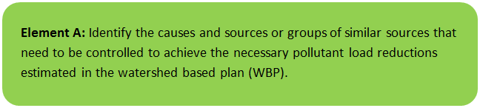

General Watershed Information
The Blackstone River flows approximately 48 miles from its headwaters in Worcester to the Narragansett Bay in Rhode Island and has an overall drainage area of approximately 540 square miles. The Blackstone River receives effluent from the Upper Blackstone Water Pollution Abatement District’s wastewater treatment facility that services the City of Worcester and surrounding communities (including Auburn, Cherry Valley Sewer District, Holden, Millbury, Rutland, and West Boylston).
The entirety of the Town of Millbury is located within the greater Blackstone River Watershed. This WBP focuses specifically on waterbodies and their associated watershed areas located within the Town of Millbury that drain to the Blackstone River. These waterbodies include Singletary Brook, Singletary Pond, Dorothy Pond, and others. The MS4 module of the watershed-based planning tool was used to enable computation of watershed statistics for applicable waterbodies within the Town of Millbury. Table A-1 presents the general watershed information within the applicable MS4 subwatersheds and Figure A-1 includes a map of subwatershed boundaries.
Table A-1: General Subwatershed Information
MS4 Subwatershed # | Waterbody Names (Assessment Unit ID) | Subwatershed Area (ac) | Major Basin
MILLBURY_01 | Blackstone River (MA51-03); Broad Meadow Brook; Dorothy Pond (MA51039); Hathaway Pond (MA51059); Howe Pond (MA51069); Howe Reservoirs (MA51070); Howe Reservoirs (MA51071); Riverlin Street Pond (MA51137); Singletary Brook; Slaughterhouse Pond (MA5 | 5435.6 (ac) | BLACKSTONE
MILLBURY_05 | Singletary Brook; Singletary Brook (MA51-31); Singletary Pond (MA51152) | 73.8 (ac) | BLACKSTONE
MILLBURY_06 | Blackstone River (MA51-03) | 211.1 (ac) | BLACKSTONE
MILLBURY_07 | Brierly Pond (MA51010); Singletary Brook; Singletary Brook (MA51-31); Singletary Pond (MA51152) | 818.2 (ac) | BLACKSTONE

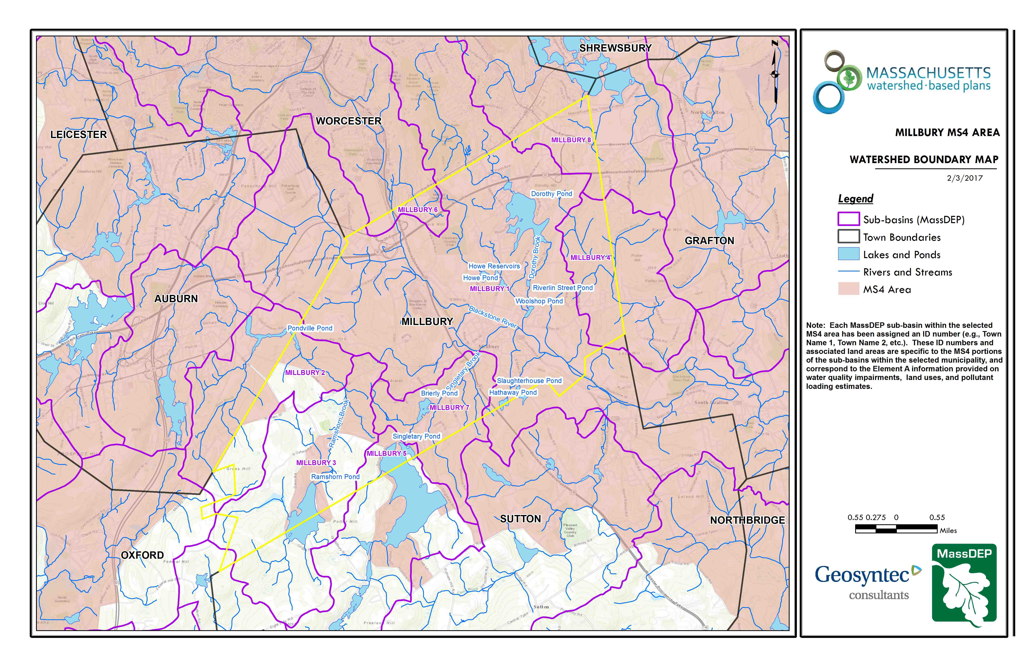Figure A-1: MS4 Subwatershed Boundary Map
Blackstone River
Millbury_05
Millbury_07
Millbury_06
Millbury_01
Approximate Watershed Boundary
(MassGIS, 2007; MassGIS, 1999; MassGIS, 2001; USGS, 2016)

MassDEP Water Quality Assessment Report and TMDL Review
The following reports are available:
- Blackstone River Watershed 2003-2007 Water Quality Assessment Report
- DIAGNOSTIC STUDY OF SINGLETARY LAKE FINAL REPORT JANUARY 1991
- Draft Pathogen TMDL for the Blackstone River Watershed
- SINGLETARY LAKE, LAKE MANAGEMENT PLAN
- STUDY OF AUBURN POND DAM, EDDY POND DAM, LEESVILLE POND DAM, PONDVILLE POND DAM JANUARY 2001
- Total Maximum Daily Loads of Phosphorus for Selected Northern Blackstone Lakes

Select excerpts from these documents relating to the water quality of the Blackstone River in Millbury are included below (note: relevant information is included directly from these documents for informational purposes and has not been modified). Additional summary information is included in Appendix A.

Blackstone River Watershed 2003-2007 Water Quality Assessment Report (MA51-03 - Blackstone River)
Aquatic Life Use
Habitat and Flow
There is a USGS flow gaging station located at West Main Street, Millbury; the period of record began on 7/1/2002. The Blackstone River experiences rapid flow fluctuations as a result of surface water runoff of precipitation and snow melt over large expanses of impervious surfaces in the urbanized headwaters. Flow fluctuations also occur daily as a result of wastewater treatment plant flows downstream of the UBWPAD discharge (USGS 2009a).

Station BS09C was accessed upstream of the former (southern) Millbury Street Bridge by SMART crews every two months from March 2000 to June 2002 (Appendix F, Beaudoin 2004b). Within the stream, undercut banks were prominent, as was a depositional gravel bar.

When the Millbury Street Bridge was demolished, and the lower end of Millbury Street closed, Station BS09C was relocated to the Blackstone River Road Bridge, approximately 135 yards upstream; access is via the Blackstone River Bikeway which is adjacent to the station. Both locations for Station BS09C are considered to represent similar conditions. SMART monitoring has been conducted at this location since October 2002 (to the present). As with the original location of this station, instream aquatic vegetation was absent. Dense periphytic growth (as filamentous algae) typically covers bottom substrates. During and after runoff events, flow fluctuates widely here, associated with the highly urbanized nature of the upstream watershed (USGS 2009a). Numerous observations of rapidly falling water levels were noted, as well as recurring deposits of sand on the bank approximately 5 feet higher than the typical water level (Appendix F, Beaudoin 2004b). The channel was scoured and bottom substrates embedded.

The City of Worcester operates a CSO treatment facility, the Quinsigamond Avenue Combined Sewer Overflow Storage and Treatment Facility (QCSOSTF), which discharges approximately 2 river miles upstream of Station BS09C on Mill Brook. During runoff conditions, the facility treats storm and sewage flows from the roughly 20% of the city that has combined storm/sewer conduits. Both of the Station BS09C locations are within the area impacted by the discharge, as evidenced by bacteria data (collected since July 2007), periphyton, color and odor observations (Beaudoin 2009a).

In 1985, the U.S. Army Corps of Engineers constructed a bank protection project on the Blackstone River near the former location of the McCracken Road Bridge (now a one-lane bridge that provides access from McCracken Road to the east side of the Blackstone River above the current McCracken Road Bridge; adjacent to the Blackstone River Bikeway). According to the USACOE (2009d):

“Large shoals had formed in the center of the Blackstone River and redirected the flow of the river. These redirected waters eroded a 300-foot-long section of the west riverbank, undermining the bridge's west abutment and threatening the bridge's stability. The Corps removed the shoals to restore the flow of the river to its original channel and constructed about 300 feet of stone slope protection along each riverbank. Although erosion had occurred only on the west riverbank, stone slope protection was also placed on the east riverbank to protect it from possible erosion when the original river channel was restored.”

DWM conducted benthic macroinvertebrate sampling in this reach of the Blackstone River in 2003, near an abandoned bridge that was formerly the river crossing of McCracken Road (since relocated a short distance downstream) in Millbury (BLK02). Habitat quality was limited mostly by some instream sedimentation and associated embeddedness, as well as the limited riparian vegetative zone width and instream cover. Instream aquatic vegetation was extremely abundant, covering virtually the entire river bottom and dominated by rooted submerged macrophytes, including Potamogeton crispus; a luxuriant algal community was also observed (Appendix C).

The Blackstone River Coalition is conducting a feasibility study to determine if the Consolidated Street Railway (Mass Electric) Dam, Millbury is a candidate for removal. The removal of this small dam (3 m height, 36 m length) would enhance aquatic habitat as well as improve the safety of recreational paddlers in this reach. Issues identified include: the lack of data on sediment quantity, quality and management; the lack of a target fish species and critical habitat; and the scarcity of project resources (staff, funds).

Biology
A fish kill in August 2002 resulted from the release of chlorinated water from the draining of a public swimming pool to the municipal storm drain system, entering the river at the base of Mill Brook (Hartley 2002). Over 1,000 fish were found, including 11 species: bluegill (Lepomis macrochirus), largemouth bass (Micropterus salmoides), white sucker (Catostomus commersonii), golden shiner (Notemigonus crysoleucas), yellow bullhead (Ameiurus natalis), blacknose dace (Rhinichthys atratulus), chain pickerel (Esox niger), yellow perch (Perca flavescens), pumpkinseed (Lepomis gibbosus), tesselated darter Etheostoma olmstedii) and black crappie (Pomoxis nigromaculatus) (Hartley 2009). Other fish kills have occurred in headwater streams that impact this segment i.e., Salisbury Pond.

In September 2003, MassDEP DWM biologists conducted benthic macroinvertebrate sampling in the Blackstone River in the reach near the historic McCracken Road Bridge, downstream from the UBWPAD discharge in Millbury, MA (BLK02). The RBP III analysis indicated that the benthic macroinvertebrate community was "moderately/severely-impacted" compared to the reference station conditions on the Mumford River below Manchaug Street, Douglas (Station BLK09-8A)(Appendix C, Fiorentino 2006). This analysis was similar to the one noted in the 1997 survey.

MA DFG conducted fish population sampling at six sampling locations along this segment of the Blackstone River in August and September 2001 and July 2007. From upstream to downstream, the sites were located off Blackstone River Road, west of Rte 146 (2384), north of Millbury Street; Worcester (323), east of Cemetery & railroad tracks near Saint Brigid Cemetery off West Street (2214), the Blackstone River Cemetery, Millbury (467), south of Rte. 122A, Millbury (441), and north and south of Depot Street, Sutton (466) (MassDFG 2008). The fish assemblage was dominated by white sucker (Catostomus commersonii), a fluvial specialist tolerant of organic enrichment, thermal and habitat stressors. With the exception of a single brook trout (Salvelinus fontinalis), the remaining fish observed were macrohabitat generalists. The MADFG noted fin rot and lesions on fish collected from 3 of the 4 stations sampled during 2001.

Toxicity
Ambient
Water from the Blackstone River was collected just downstream of the Millbury Street Bridge in Worcester for use as dilution water in the UBWPAD facility’s whole effluent toxicity tests. Between January 2000 and January 2008, survival of C. dubia exposed (approximately 7 days) to the Blackstone River water was > 90% with the exception of the July 2000 test event when survival was 0% (n=34). Survival of P. promelas exposed to the Blackstone River water (approximately 7 day exposures) ranged from 50 to 100% (n=31) and was < 75% in seven test events -- April 2000, 2002, 2004, 2005, and 2007, October 2006 and January 2008.

Water from the Blackstone River was collected at the Riverlin Street Bridge off Route 122A in Millbury for use as dilution water in the Millbury WWTP’s acute whole effluent toxicity tests. Between February 2001 and December 2004, survival of both C. dubia and P. promelas exposed (48 hours) to the Blackstone River water was 100% (n=15).

Effluent
Modified acute and chronic whole effluent toxicity tests have been conducted on the UBWPAD treated effluent. Between January 2000 and January 2008, 32 valid chronic tests were conducted using C. dubia and 21 valid tests using P. promelas. No acute whole effluent toxicity was detected by either test organism (i.e., LC50’s were all >100% effluent). The CNOEC results for C. dubia ranged from <12.5 to 100% effluent and did not meet the CNOEC limit of >90% effluent in 13 of the 32 valid test events (CNOECs all =50% effluent in April and October 2000, April, July, and October 2003, April and June 2005, January 2007; CNOECs = 25% effluent in January 2004 and October 2007; CNOECs = 12.5% effluent in January 2001 and June 2003; and CNOEC <12.5% effluent in October 2001). The CNOEC results for the P. promelas tests all met the CNOEC limit.

Acute whole effluent toxicity tests were conducted on the Millbury Wastewater Treatment Plant (WWTP) treated effluent between February 2001 and December 2004. A total of 15 tests were conducted using both C. dubia and P. promelas. Acute toxicity to C. dubia was detected in five of the 15 test events with LC50’s ranging from 18.9% to 78.4% effluent. Acute toxicity to P. promelas was detected in three test events with LC50s ranging from 70.7 to 94% effluent. All other test events did not indicate acute whole effluent toxicity (i.e., LC50s >100% effluent). The facility tied its discharge into the UBWPAD system in January 2005.

Water Chemistry
A dry weather study of water quality in the Blackstone Watershed was conducted from 2000-2003 (Wright et al 2004). Samples were collected at 24 sites on the Blackstone, Mumford, Quinsigamond and West Rivers on four dates under dry weather conditions. Insufficient data are currently available to complete the DWM external data validation process required for assessment decision.

The Greenwood Street Landfill, Worcester is located on the west side of the Blackstone River, north of the Upper Blackstone Water Pollution Abatement District (UBWPAD) facility and discharge. Some of the leachate from the landfill is conveyed to the UBWPAD facility for treatment; an additional volume flowed to a concrete-lined channel that discharged to the Blackstone River. An assessment of the leachate reaching the channel indicated elevated levels of suspended solids, PCBs, chloride, arsenic, lead and manganese (Monahan 2004d). The city was ordered to immediately cap the pipes conveying this leachate to the discharge channel, as these pollutants constituted a violation of state and federal clean water laws. Capping was completed between November 9-12, 2004, and the leachate has since been pumped to the UBWPAD facility for treatment (Belsito 2009).

CERO SMART staff conducted bimonthly in situ and water quality monitoring in the upper Blackstone River (BS09B and BS09C) on 26 occasions from March 2000 through October 2004 (Appendix F, Beaudoin 2004b). Mid-morning DO values ranged from 7.5 to 13.6 mg/L (08:30 to 10:02 am). The maximum water temperature was 23.6ºC while pH ranged from 6.5 to 7.3 SU. When compared to reference conditions at the West River station, conductivity values were consistently elevated; values at Station BS09C ranged from 239 to 1,250 uS/cm. Ammonia concentrations were low, ranging from <0.01 to 0.29 mg/L (as NH3-N)) and ammonia toxicity was not a concern. Total phosphorus concentrations ranged from 0.028 to 0.33 mg/L from March 2000 to Nov 2004; of these, approximately half (12 of 26) of the values were greater than 0.050 mg/L.

On 2 October 2003, the failure of two electrical grids and the lack of a backup generator at the Upper Blackstone wastewater treatment facility resulted in the release of approximately 9 million gallons of untreated and partially treated waste to the Blackstone River over a six-hour period (Boynton 2003, Monahan 2004b). MassDEP staff conducted water quality and bacteria monitoring to track the spill on October 3rd and 6th (Beaudoin 2003, Appendix B-1 Tamul 2005). Approximately 60 feet upstream of the UBWPAD effluent discharge (Station 1), mid-morning DO measurements ranged from 7.8 to 9.7 mg/L; the maximum temperature was 18.5°C; and conductivity values were high (444 to 620 µS/cm).

Downstream of the discharge (BLK02), water quality varied with the location and intensity of the spill plume i.e., as the plume flowed downstream, various factors caused the plume to elongate. The maximum temperature observed was immediately downstream of the discharge on both dates (17.6ºC), which was approximately 6ºC warmer than the river 60 feet upstream of the discharge. Conductivity also rose below the discharge, approximately 100 µS/cm above background. DO decreased by approximately 3 mg/L below the discharge on both dates.

DWM staff conducted monthly in situ and water quality monitoring at two locations in this segment of the Blackstone River between May and October 2003: on eight dates at the McCracken Road station, Millbury (BLK02); and on six occasions downstream of Singing Dam, Sutton (BS12). At McCracken Road, the maximum temperature was 22.7°C. Early to mid-morning DO measurements (between 03:14 and 10:16 am, n=9) ranged from 1.5 to 7.9 mg/L. It should be noted that all measurements between 24 July and 12 September were less than 5.0 mg/L, a seven-week period. Conductivity values were high, ranging from 492 to 782 µS/cm, and pH values varied little (6.8 to 7.0 SU. Ammonia concentrations ranged from 0.58 to 4.8 mg/L (NH3-N). Ammonia levels were below the criteria with the possible exception of one measurement (4.7 mg/L) on 27 August; however, no in situ measurements were taken at that time, so a comparison to criteria cannot be made. Total phosphorus concentrations were all elevated, ranging from 0.19 to 0.76 mg/L (n=4) (Appendix B Tamul 2005).

At Singing Dam, Sutton, the maximum temperature was 22.4°C. Early to mid-morning DO measurements (between 3:35 to 11:10, n=6) ranged from 7.3 to 9.5 mg/L. Conductivity values ranged from 480 to 737 µS/cm, and pH values ranged from 7.0 to 7.3 SU. Ammonia concentrations ranged from 0.35 to 4.2 mg/L, and none exceeded the criteria. Total phosphorus concentrations were elevated here as well, ranging from 0.18 to 1.1 mg/L (Appendix B Tamul 2005).

The Aquatic Life Use is assessed as impaired for this segment due to the moderately/severely impaired benthic and fish communities, habitat quality degradation (physical substrate habitat alteration -- sedimentation/erosion/embeddedness, and other flow regime alterations -- rapid flow fluctuations), and poor water quality conditions (low DO, evidence of enrichment, elevated total phosphorus). The presence of the non-native Potamogeton crispus in this segment is of concern, as well as episodic fish kill event(s), elevated conductivity (possibly related to road salting activities) and occasional ambient toxicity. Sources of these conditions include the municipal point source discharge, the complex of wet weather discharges (point source and combination of stormwater, SSO and/or CSOs), habitat modification (scouring, erosion, deposition) associated with rapid flow fluctuations resulting from impervious surface runoff, and infrastructure construction activities.

Fish Consumption
Fish were collected by DWM biologists from this segment of the Blackstone River in 1985 and were analyzed for metals (Maietta 2007). The Fish Consumption Use is not assessed for this segment since no site-specific fish consumption advisory was issued by MA DPH. All applicable statewide fish consumption advisories issued by MA DPH due to mercury contamination apply to this waterbody.

Primary and Secondary Contact Recreational and Aesthetics Uses
The Blackstone River is used by canoeists and kayakers for recreation. In 2000 and 2005, the John H. Chaffee Blackstone River Valley National Heritage Corridor organized canoe trips on the Blackstone River; the first spanned 4 days, and went from the Middle River, Worcester to Providence, RI. The Rhode Island Canoe and Kayak Association (RICKA) organizes canoe/kayak events throughout the Blackstone Valley each summer (RICKA 2009).

Station BS09C was accessed upstream of the former (southern) Millbury Street Bridge by SMART crews every two months from March 2000 to June 2002 (Appendix F, Beaudoin 2004b). Banks were populated with dense poison ivy, grape vines and shrubs, with overhanging canopy up- and downstream from the bridge footprint; however, instream aquatic vegetation was completely absent throughout this area. Undercut banks were prominent. The bottom is mainly cobble and gravel, typically covered in a dense growth of filamentous algae. Turbidity is common at this station; observations ranged from low to highly turbid (“coffee-colored”) on nearly every sampling date (Beaudoin 2004b). Oily sheens were noted on five events. The banks and stream bed were heavily littered with trash, including construction debris, chain link fencing, metals, cables, wood, silt fencing, hay bales, tires, buckets, floatables, fabric, and shopping carts. Colors and odors were also indicative of the urbanized nature of this headwater station. Observations of color included clear, green, coffee, brown, chocolate and gray; odors included none, septic, musty and raw sewage. As noted above, discharges from the Worcester CSO treatment facility infrequently impact this part of the Blackstone River.

When the Millbury Street Bridge was demolished, and the lower end of Millbury Street closed, Station BS09C was relocated to the Blackstone River Road Bridge, approximately 135 yards upstream (beginning in October 2002). Both locations are considered to represent similar conditions. As with the original location of this station, instream aquatic vegetation was consistently absent; dense periphytic growth (as filamentous algae) typically covered bottom substrates; elevated turbidity was consistently noted; and foam and oily sheens were observed frequently. Trash was always present at this location, although at a reduced density overall than the downstream location.

In 2003, MassDEP DWM collected six E. coli samples from the Blackstone River near the historic McCracken Road Bridge in Millbury (BLK02) during the primary contact season. The geometric mean of the six samples was 207 cfu/100 ml, with counts ranging from 90 to 890 cfu/100 ml. DWM also conducted bacteria monitoring downstream of Singing Dam at Blackstone Street, Sutton (BS12) in 2003. The geomean of six samples was 144 cfu/100 ml, with counts ranging from 45 to 560 cfu/100 ml.

MassDEP staff conducted water quality and bacteria monitoring to track the UBWPAD sewage spill described above on October 3rd and 6th (Beaudoin 2003). Bacteria samples collected on October 2nd before the spill began showed background levels in this segment ranged from 84 to 210 cfu/100 ml. On October 3rd, E. coli ranged from 1,000 cfu/100 ml above the UBWPAD spill to 300,000 cfu/100 ml at the Pleasant Street Bridge, Grafton, which indicated the approximate location of the spill. By October 6th, the highest value in this segment was down to 210 cfu/100 ml.

Record levels of rainfall in October 2005 (15.65 inches) caused the Blackstone River to rise to nearly 100 times its normal volume (Larrabee 2005; NWS 2009). As a result, bar racks at the Upper Blackstone facility became clogged, causing the release of more than 90 million gallons of raw sewage (over a 14-hour period) to the river. MassDEP conducted bacteria sampling on October 18th to evaluate the impact of the release on the river. E. coli collected in this segment ranged from 517.2 cfu/100 ml at the Pleasant Street Bridge, Grafton to >2419.6 cfu/100 ml (above the discharge, at Blackstone River Road)(Connors 2005).

DWM staff observed aesthetic conditions at seven locations in this segment in 2003. Observations documented recurring issues at some and/or all locations: odors (septic, effluent, chlorine, musty); dense patches of aquatic macrophytes; and moderate to dense periphyton.

The Primary and Secondary Contact Recreational and Aesthetic Uses are assessed as impaired due to aesthetically objectionable conditions throughout the segment (odors, elevated turbidity, foams and sheens, dense periphyton cover and objectionable deposits of debris/floatables/trash). The Primary Contact Recreational Use is also assessed as impaired based on elevated E. coli counts.

SMART monitoring since October 2002

Report Recommendations
Evidence of episodes of instream toxicity to P. promelas in the Blackstone River just downstream from the new Millbury Street Bridge in Worcester is of concern. Most of these episodes occurred during the April testing events. Additional instream toxicity testing should be conducted by environmental monitoring agencies (e.g., EPA) if possible. UBWPAD should continue to monitor survival of test organisms exposed to river water samples as part of their whole effluent toxicity tests. Continue to closely monitor the UBWPAD WET toxicity test results. If either the frequency and/or magnitude of the CNOEC permit limit violations increases, evaluate the need to require additional testing or implement a toxicity identification/toxicity reduction evaluation to better evaluate the cause(s) of the problem.

Conduct an investigation on the source(s) of elevated conductivity in this segment using chloride as an indicator.

United County Industries (MAG250014) - The new general permit for non-contact cooling water discharges is being finalized. When this new permit becomes available, United County Industries should submit their application for coverage.

The Lewcott Corporation (MAG250969): the new general permit for non-contact cooling water discharges is being finalized. When this new permit becomes available, there will be limits for TRC based on available dilution rather than monitoring only requirements. Since the source of water for this facility is municipal the effluent discharge may need to be dechlorinated prior to discharge in order to meet the TRC limits. Another option may be for the facility to install a closed loop cooling water system.

Additional Water Quality Data
The following relevant references were reviewed as they relate to water quality:

Millbury Water Quality Sampling of Little Dorothy Pond
Water quality sampling was performed by Northeast Geoscience on Little Dorothy Pond (a waterbody that is hydrologically connected to Dorothy Pond) to assess if the location was suitable for a proposed town beach. Sampling completed each year from 2002-2005 indicated elevated concentrations of heavy metals that could pose a risk to a proposed beach in Little Dorothy Pond. In addition, Northeast Geoscience collected sediment and surface water samples from the proposed beach location in 2006, the results of which indicated elevated concentrations of pesticides, SVOCs, and metals. It is believed that the proposed beach location was located hydraulically downgradient of a landfill.

Blackstone River Water Quality Study
The Upper Blackstone Water Pollution Abatement District (UBWPAD) has been performing monthly monitoring since 2010 to monitor and evaluate changes to the water quality of the Blackstone River and potential impacts of the wastewater treatment plant that discharges to the river. Monitoring is performed in partnership with CDM Smith, Normandeau Associates, and University of Massachusetts Amherst. The program tracks nutrients, chlorophyll-a, and periphyton to assess the overall quality of the river. MassDEP added continuous monitoring of dissolved oxygen to the program in 2017. Data from this program is used for development of watershed and water quality assessments for Massachusetts Integrated Lists of Waters, in collaboration with MassDEP. Phosphorus concentrations for historical samples (2000-2006) suggested high concentrations of phosphorus in the Blackstone River (as shown in Figures A-2 through A-6); however, recent updates to the operations of the UBWPAD have resulted in lower phosphorus concentrations.

2018 UBWPAD Blackstone River Monitoring Program Board Presentation (UBWPAD, 2018)
In 2017, phosphorus concentrations in the Blackstone River were at or slightly higher than the MassDEP 2016 Consolidated Assessment and Listing Methodology (CALM) screening threshold of 100 µg/L.
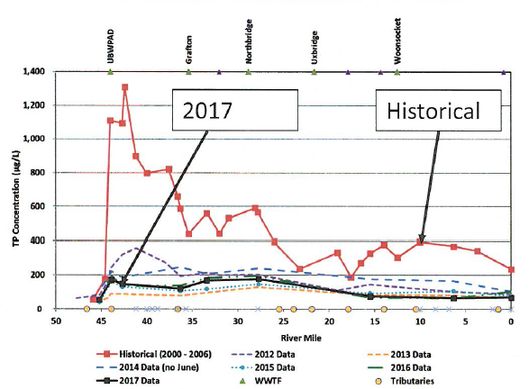
Figure A-2: Blackstone River Water Quality Study: 2017 Phosphorus Results (UBWPAD, 2018)

2017 UBWPAD Blackstone River Monitoring Program Board Presentation (UBWPAD, 2017)
In 2016, phosphorus concentrations in the Blackstone River appeared consistent with concentrations from 2012 and 2013 and nitrogen concentrations appeared generally lower than previous years.
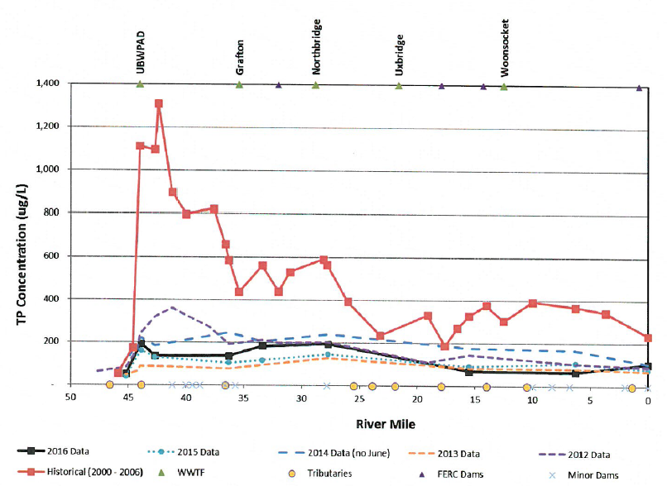
Figure A-3: Blackstone River Water Quality Study: 2016 Phosphorus Results (UBWPAD, 2017)
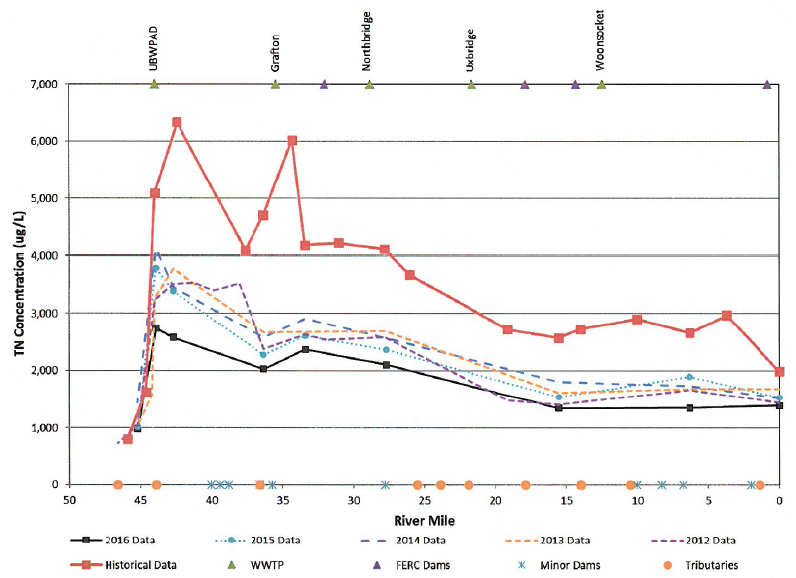
Figure A-4: Blackstone River Water Quality Study: 2016 Nitrogen Results (UBWPAD, 2017)

Blackstone River Water Quality Study: 2013 (UBWPAD, 2013)
In 2013, UBWPAD completed multiple changes to stabilize the wastewater treatment facility’s operations and to improve nutrient removal.
Monitoring results indicated nutrient reductions in the wastewater treatment plant effluent of 89% for phosphorus and 61% for nitrogen, when compared to results from 2006-2008. Phosphorus concentrations in the Blackstone River were found to be approximately 80% lower in 2013 than historical values at low flow conditions. Chlorophyll-a concentrations were generally lower in 2013 than 2012 and periphyton assessment was below “nuisance level”, consistent with results from 2012.
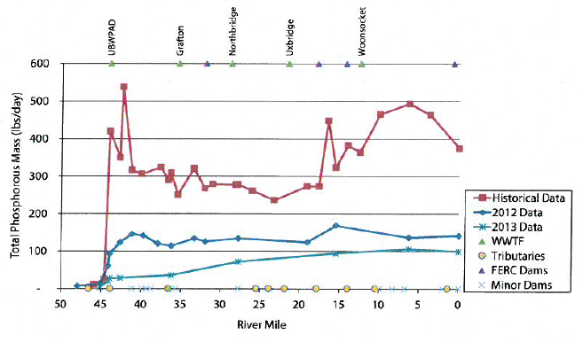
Figure A-5: Blackstone River Water Quality Study: 2013 Phosphorus Results (UBWPAD, 2013)

Blackstone River Water Quality Study: 2012 (UBWPAD, 2012)
Monitoring results indicated nutrient reductions in the wastewater treatment plant effluent of 78% for phosphorus and 61% for nitrogen, when compared to results from 2006-2008. Phosphorus and nitrogen concentrations in the Blackstone River were found to be approximately 66% lower and 38% lower, respectively, in 2012 than historical values at low flow conditions. Chlorophyll-a concentrations were lower than historical values in some reaches of the river and periphyton assessment was below “nuisance level”, although results indicated increased periphyton growth downstream of the treatment facility discharge.
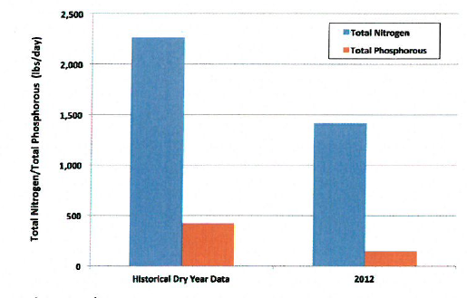
Figure A-6: Blackstone River Water Quality Study: 2012 Nutrient Results (UBWPAD, 2012)

Water Quality Impairments
The Blackstone River is an impaired waterbody listed under category 5 on the Massachusetts List of Integrated Waters due to a variety of impairments from multiple sources, including impairments related to sediment and nutrients (phosphorus). Tributaries of the Blackstone River in the Millbury study area are also listed on the Massachusetts List of Integrated Waters under the categories and impairments summarized by Table A-2. Known water quality impairments for the Blackstone River Watershed, as documented in the Massachusetts Department of Environmental Protection (MassDEP) 2012 Massachusetts Integrated List of Waters, are listed in detail in Appendix B. The appendix includes more than twenty types of impairments across the eight waterbodies, which are summarized by waterbody in Table A-2.
Because of these impairments, a draft Total Maximum Daily Load (TMDL) for pathogens was issued for the greater Blackstone watershed that includes the entirety of the river’s drainage area (MassDEP, 2006). A TMDL for phosphorus has also been established for three of the ponds (the Howe Reservoirs, Dorothy Pond, and Brierly Pond) within the Millbury watershed area to the Blackstone River (MassDEP, 2002).

Table A-2: 2012 MA Integrated List of Waters Categories for Waterbodies of Interest
Waterbody | Integrated List Category | Impairment Category Description | Impairment
Blackstone River | 5 | Impaired or threatened for one or more uses and requiring preparation of a TMDL. | MultipleNumerous (See Appendix B)
Dorothy Pond | 4A | Impaired or threatened for one or more uses, TMDL is completed. | Turbidity, non-native aquatic plants, Eurasian Water Milfoil, and Myriophyllum spicatum
Howe Reservoirs | 4C | Impaired or threatened for one or more uses, impairment not caused by pollutant, TMDL not required. | Low flow alterations, non-native aquatic plants, and aquatic plants (macrophytes)
Riverlin Street Pond | 4C | Impaired or threatened for one or more uses, impairment not caused by pollutant, TMDL not required. | Non-native aquatic plants
Woolshop Pond | 5 | Impaired or threatened for one or more uses and requiring preparation of a TMDL. | Aquatic plants (macrophytes), non-native aquatic plants, and turbidity
Brierly Pond | 4A | Impaired or threatened for one or more uses, TMDL is completed. | Aquatic plants (macrophytes), non-native aquatic plants
Singletary Brook | 5 | Impaired or threatened for one or more uses and requiring preparation of a TMDL. | Aquatic plants (macrophytes) and non-native aquatic plants
Singletary Pond | 4C | Impaired or threatened for one or more uses, impairment not caused by pollutant, TMDL not required. | Eurasian Water Milfoil, Myriophyllum spicatum, and non-native aquatic plants
Note: See Appendix B for information on designated uses and sources of impairments.

Water Quality Goals
Water quality goals may be established for a variety of purposes, including the following:
a.) For waterbodies with known impairments, a Total Maximum Daily Load (TMDL) is established by MassDEP and the United States Environmental Protection Agency (USEPA) as the maximum amount of the target pollutant that the waterbody can receive and still safely meet water quality standards. If the waterbody has a TMDL for total phosphorus (TP) or total nitrogen (TN), or total suspended solids (TSS), that information is provided below and included as a water quality goal.
b.) For waterbodies without a TMDL for total phosphorus (TP), a default water quality goal for TP is based on target concentrations established in the Quality Criteria for Water (USEPA, 1986) (also known as the “Gold Book”). The Gold Book states that TP should not exceed 50 ug/L in any stream at the point where it enters any lake or reservoir, nor 25 ug/L within a lake or reservoir. For the purposes of developing WBPs, MassDEP has adopted 50 ug/L as the TP target for all streams at their downstream discharge point, regardless of which type of waterbody the stream discharges to.
c.) Massachusetts Surface Water Quality Standards (314 CMR 4.00, 2013) prescribe the minimum water quality criteria required to sustain a waterbody’s designated uses. Table A-4 lists the Class for each Assessment Unit ID within the Millbury subwatersheds that contribute to the Blackstone River. The water quality goal(s) for bacteria are based on the Massachusetts Surface Water Quality Standards.
Tables A-4: Surface Water Quality Classification by Assessment Unit ID
MS4 Subwatershed #: MILLBURY_01
Assessment Unit ID | Waterbody | Class
MA51-03 | Blackstone River | B\WWF
MA51039 | Dorothy Pond | B
MA51059 | Hathaway Pond | B
MA51069 | Howe Pond | B
MA51070 | Howe Reservoirs | B
MA51071 | Howe Reservoirs | B
MA51137 | Riverlin Street Pond | B
MA51153 | Slaughterhouse Pond | B
MA51186 | Woolshop Pond | B

MS4 Subwatershed #: MILLBURY_05
Assessment  Unit ID | Waterbody | Class
MA51152 | Singletary Pond | B
MA51-31 | Singletary Brook | B

MS4 Subwatershed #: MILLBURY_06
Assessment Unit ID | Waterbody | Class
MA51-03 | Blackstone River | B\WWF

MS4 Subwatershed #: MILLBURY_07
Assessment Unit ID | Waterbody | Class
MA51010 | Brierly Pond | B
MA51152 | Singletary Pond | B
MA51-31 | Singletary Brook | B

d.) Other water quality goals set by the community (e.g., protection of high quality waters, in-lake phosphorus concentration goal to reduce recurrence of cyanobacteria blooms, etc.).
Refer to Table A-5 for a list of water quality goals. There are many impairments within the Blackstone River watershed within the Town of Millbury; however, because there is an existing TMDL for total phosphorus in upper Blackstone ponds and a draft TMDL for pathogens in the greater Blackstone watershed, water quality goals are focused on reducing these common nonpoint source pollutants. It is expected that reductions to these pollutants will result in improvements to other listed impairments.

Table A-5: Water Quality Goals
Pollutant | Waterbody Name  (Assessment Unit ID(s)) | Goal | Source
Total Phosphorus (TP) | All Assessment Units within the watershed | Total phosphorus should not exceed:  --50 ug/L in any stream  --25 ug/L within any lake or reservoir | Quality Criteria for Water (USEPA, 1986)
 | Dorothy Pond (MA51039), Howe Reservoir (MA51071), Brierly Pond (MA51010) | The following table (originally on page 4 of “Total Maximum Daily Loads of Phosphorus for Selected Northern Blackstone Lakes” report, 2002) lists the lakes that were evaluated, their predicted total phosphorus concentration and load using the landuse model and selected target concentration and loads necessary to achieve water quality standards. The results indicate that current phosphorus loads to these lakes need to be reduced on an average of 27% and range from a low of about 2% (Eddy Pond, Auburn, MA) to a high of 68% (Southwick Pond, Leicester, MA).  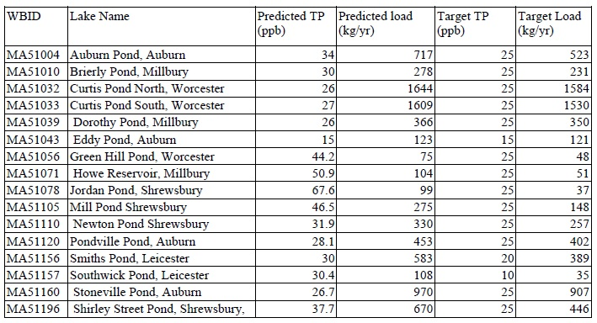 | Total Maximum Daily Loads of Phosphorus for Selected Northern Blackstone Lakes
Bacteria | All Assessment Units within the watershed | Class B Standards  • Public Bathing Beaches: For E. coli, geometric mean of 5 most recent samples shall not exceed 126 colonies/ 100 ml and no single sample during the bathing season shall exceed 235 colonies/100 ml. For enterococci, geometric mean of 5 most recent samples shall not exceed 33 colonies/100 ml and no single sample during bathing season shall exceed 61 colonies/100 ml;  • Other Waters and Non-bathing Season at Bathing Beaches: For E. coli, geometric mean of samples from most recent 6 months shall not exceed 126 colonies/100 ml (typically based on min. 5 samples) and no single sample shall exceed 235 colonies/100 ml. For enterococci, geometric mean of samples from most recent 6 months shall not exceed 33 colonies/100 ml, and no single sample shall exceed 61 colonies/100 ml. | Massachusetts Surface Water Quality Standards (314 CMR 4.00, 2013)
Note: There may be more than one water quality goal for bacteria due to different Massachusetts Surface Water Quality Standards Classes for different Assessment Units within the watershed.

Land Use Information
Land use information and impervious cover is presented by the below tables and figures. Land use source data is from 2005 and was obtained from MassGIS (2009b).

Watershed Land Uses
As summarized by Table A-6, land use in the Blackstone River watershed (within Millbury) is mostly forested (approximately 48 percent); approximately 26 percent of the watershed is residential; approximately 11 percent of the watershed is open land or water; approximately 8 percent of the watershed is commercial or industrial; approximately 4 percent is agricultural; and approximately 4 percent is devoted to highways. The tables following Table A-6 provide tabulated land uses by each subwatershed.

Tables A-6: Subwatershed Land Uses¹
Total Combined Millbury MS4 Watershed to the Blackstone River
Land Use | Area (acres) | % of Watershed
Agriculture | 237.26 | 4%
Commercial | 181.46 | 3%
Forest | 3132.08 | 48%
High Density Residential | 297.11 | 5%
Highway | 256.55 | 4%
Industrial | 357.44 | 5%
Low Density Residential | 468.78 | 7%
Medium Density Residential | 908.91 | 14%
Open Land | 418.6 | 6%
Water | 280.59 | 4%
TOTALS | 6538.78 | 100%
- Table summarizes land uses from MS4 Watersheds Millbury_01, 05, 06, 0 7.

MS4 Subwatershed #: MILLBURY_01
Land Use | Area (acres) | % of Watershed
Agriculture | 219.22 | 4
Commercial | 161.25 | 3
Forest | 2590.97 | 47.7
High Density Residential | 231.27 | 4.3
Highway | 230.1 | 4.2
Industrial | 279.42 | 5.1
Low Density Residential | 387.9 | 7.1
Medium Density Residential | 705.27 | 13
Open Land | 391.13 | 7.2
Water | 239.08 | 4.4

MS4 Subwatershed #: MILLBURY_05
Land Use | Area (acres) | % of Watershed
Agriculture | 0 | 0
Commercial | 0.01 | 0
Forest | 29.04 | 39.4
High Density Residential | 6.37 | 8.6
Highway | 0 | 0
Industrial | 0 | 0
Low Density Residential | 12.58 | 17
Medium Density Residential | 9.17 | 12.4
Open Land | 0.69 | 0.9
Water | 15.94 | 21.6

MS4 Subwatershed #: MILLBURY_06
Land Use | Area (acres) | % of Watershed
Agriculture | 3.11 | 1.5
Commercial | 8.97 | 4.2
Forest | 67.14 | 31.8
High Density Residential | 20.42 | 9.7
Highway | 26.45 | 12.5
Industrial | 61.89 | 29.3
Low Density Residential | 18.34 | 8.7
Medium Density Residential | 2.85 | 1.3
Open Land | 0.93 | 0.4
Water | 1.05 | 0.5

MS4 Subwatershed #: MILLBURY_07
Land Use | Area (acres) | % of Watershed
Agriculture | 14.93 | 1.8
Commercial | 11.23 | 1.4
Forest | 444.93 | 54.4
High Density Residential | 39.05 | 4.8
Highway | 0 | 0
Industrial | 16.13 | 2
Low Density Residential | 49.96 | 6.1
Medium Density Residential | 191.62 | 23.4
Open Land | 25.85 | 3.2
Water | 24.52 | 3

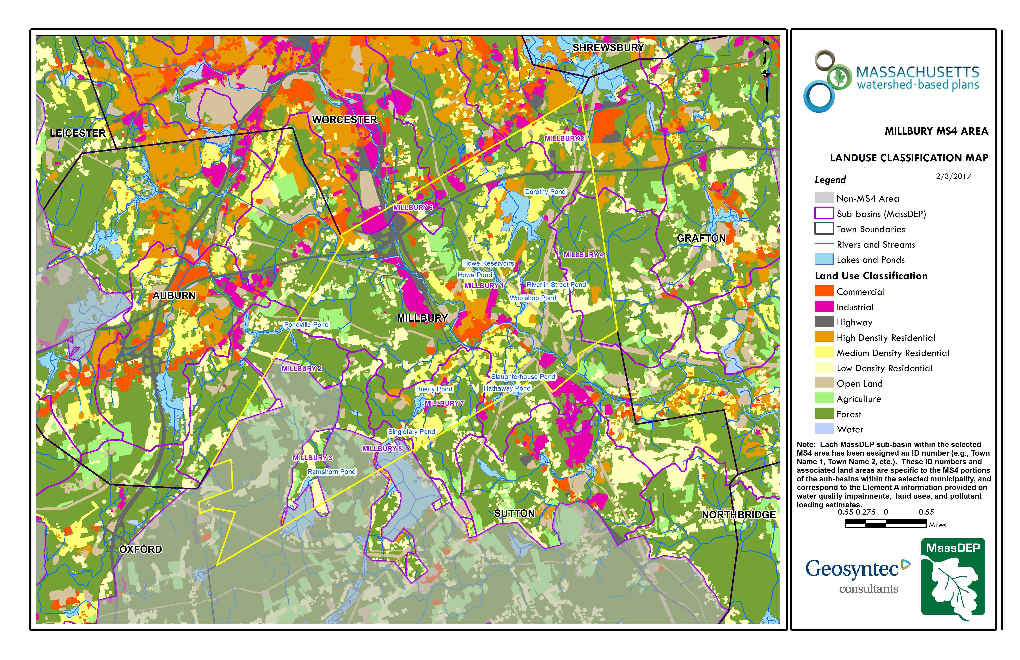Figure A-7: MS4 Subwatershed Land Use Map
Millbury_05
Millbury_07
Approximate Watershed Boundary
Millbury_06
Millbury_01
(MassGIS, 2007; MassGIS, 2009b; MassGIS, 1999; MassGIS, 2001; USGS, 2016)

Watershed Impervious Cover
There is a strong link between impervious land cover and stream water quality. Impervious cover includes land surfaces that prevent the infiltration of water into the ground, such as paved roads and parking lots, roofs, basketball courts, etc. Impervious area within the watershed of the Blackstone River within the Town of Millbury is concentrated in central portion of the watershed (Millbury_01), along the banks of the river, as illustrated in Figure A-8 below.
Impervious areas that are directly connected (DCIA) to receiving waters (via storm sewers, gutters, or other impervious drainage pathways) produce higher runoff volumes and transport stormwater pollutants with greater efficiency than disconnected impervious cover areas which are surrounded by vegetated, pervious land. Runoff volumes from disconnected impervious cover areas are reduced as stormwater infiltrates when it flows across adjacent pervious surfaces.
An estimate of DCIA for the areas were calculated based on the Sutherland equations. USEPA provides guidance (USEPA, 2010) on the use of the Sutherland equations to predict relative levels of connection and disconnection based on the type of stormwater infrastructure within the total impervious area (TIA) of a watershed. Within each subwatershed, the total area of each land use were summed and used to calculate the percent TIA (Table A-7).
Table A-7: TIA and DCIA values for each subwatershed
MS4 Subwatershed # | Estimated TIA (%) | Estimated DCIA (%)
MILLBURY_01 | 16.9 | 12.3
MILLBURY_05 | 10.9 | 6.1
MILLBURY_06 | 38 | 30.1
MILLBURY_07 | 15.5 | 10.1

The relationship between TIA and water quality can generally be categorized as listed by Table A-8 (Schueler et al. 2009). The TIA values for the subwatersheds range from 15.5-38%; therefore, the river and surrounding tributaries can be expected to show fair to poor water quality.
Table A-8: Relationship between Total Impervious Area (TIA) and water quality (Schueler et al. 2009)
% Watershed  Impervious Cover | Stream Water Quality
0-10% | Typically high quality, and typified by stable channels, excellent habitat structure, good to excellent water quality, and diverse communities of both fish and aquatic insects.
11-25% | These streams show clear signs of degradation. Elevated storm flows begin to alter stream geometry, with evident erosion and channel widening. Streams banks become unstable, and physical stream habitat is degraded. Stream water quality shifts into the fair/good category during both storms and dry weather periods. Stream biodiversity declines to fair levels, with most sensitive fish and aquatic insects disappearing from the stream.
26-60% | These streams typically no longer support a diverse stream community. The stream channel becomes highly unstable, and many stream reaches experience severe widening, downcutting, and streambank erosion. Pool and riffle structure needed to sustain fish is diminished or eliminated and the substrate can no longer provide habitat for aquatic insects, or spawning areas for fish. Biological quality is typically poor, dominated by pollution tolerant insects and fish. Water quality is consistently rated as fair to poor, and water recreation is often no longer possible due to the presence of high bacteria levels.
>60% | These streams are typical of “urban drainage”, with most ecological functions greatly impaired or absent, and the stream channel primarily functioning as a conveyance for stormwater flows.

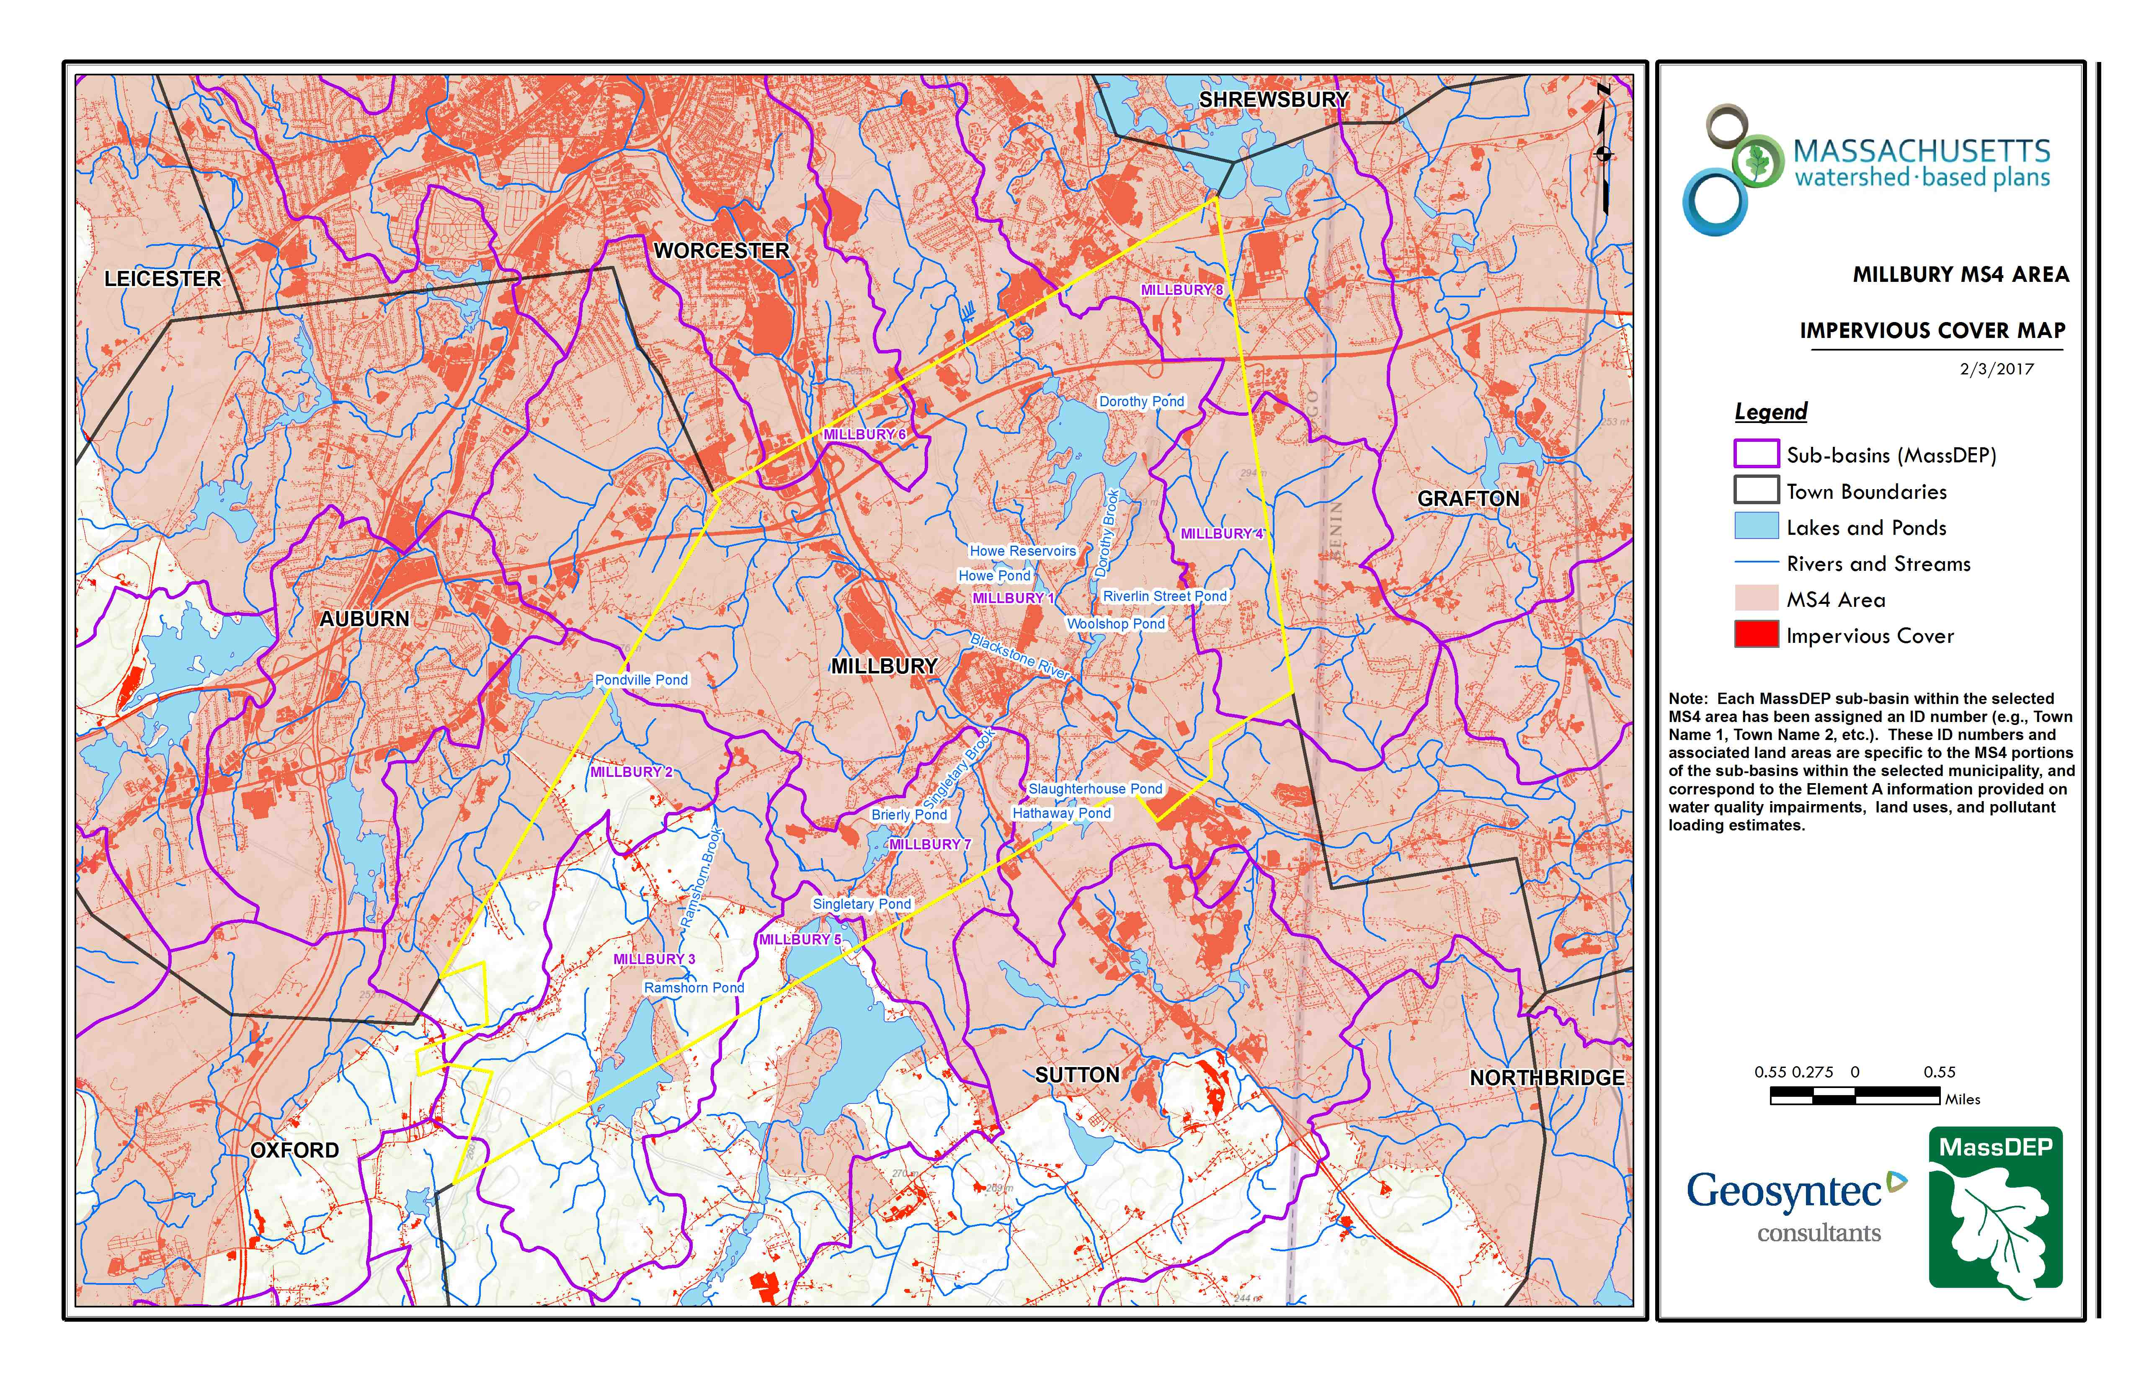Figure A-8: MS4 Subwatershed Impervious Surface Map
Approximate Watershed Boundary
Millbury_05
Millbury_07
Millbury_06
Millbury_01
(MassGIS, 2007; MassGIS 2009a; MassGIS, 1999; MassGIS, 2001; USGS, 2016)

Pollutant Loading
The land use data (MassGIS, 2009b) was intersected with impervious cover data (MassGIS, 2009a) and United States Department of Agriculture (USDA) Natural Resources Conservation Service (NRCS) soils data (USDA NRCS and MassGIS, 2012) to create a combined land use/land cover grid. The grid was used to sum the total area of each unique land use/land cover type.
The amount of DCIA was estimated using the Sutherland equations as described above and any reduction in impervious area due to disconnection (i.e., the area difference between TIA and DCIA) was assigned to the pervious D soil category for that land use to simulate that some infiltration will likely occur after runoff from disconnected impervious surfaces passes over pervious surfaces.
Pollutant loading for key nonpoint source pollutants in the areas was estimated by multiplying each land use/cover type area by its pollutant load export rate (PLER). The PLERs are an estimate of the annual total pollutant load exported via stormwater from a given unit area of a particular land cover type. The PLER values for TN, TP and TSS were obtained from USEPA (Voorhees, 2016b) (see documentation provided in Appendix C) as follows:
L_{n} = A_{n} * P_{n}
Where L_{n} = Loading of land use/cover type n (lb/yr); A_{n} = area of land use/cover type n (acres); P_{n} = pollutant load export rate of land use/cover type n (lb/acre/yr)

The estimated land-use based phosphorus to the river within the subwatershed areas is 2,223 pounds per year, as presented by Table A-9. Most of the land-use based phosphorus load is accounted for in the Millbury_01 MS4 subwatershed, the largest of the subwatersheds, with much originating from forested (20%) and industrial (20%) land uses. Phosphorus generated from forested areas is a result of natural process such as decomposition of leaf litter and other organic material and generally represent a “best case scenario” with regards to phosphorus loading, meaning that those portions of the watershed are unlikely to provide opportunities for nutrient load reductions through best management practices.
Tables A-9: Estimated Pollutant Loading for Key Nonpoint Source Pollutants
Total Combined Millbury MS4 Watershed to the Blackstone River
Land Use Type | Pollutant Loading¹
 | Total  Phosphorus (TP)  (lbs/yr) | Total  Nitrogen (TN)  (lbs/yr) | Total  Suspended Solids (TSS)  (tons/yr)
Agriculture | 119 | 726 | 10.19
Commercial | 206 | 1761 | 22.04
Forest | 450 | 2341 | 93.02
High Density Residential | 222 | 1461 | 21.94
Highway | 208 | 1,671 | 101.34
Industrial | 447 | 3834 | 47.97
Low Density Residential | 138 | 1390 | 18.88
Medium Density Residential | 323 | 2696 | 38.02
Open Land | 126 | 1196 | 25.01
TOTAL | 2238 | 17073 | 378.4
¹These estimates do not consider loads from point sources or septic systems.

MS4 Subwatershed #: MILLBURY_01
Land Use Type | Pollutant Loading¹
 | Total  Phosphorus (TP)  (lbs/yr) | Total  Nitrogen (TN)  (lbs/yr) | Total  Suspended Solids (TSS)  (tons/yr)
Agriculture | 111 | 676 | 9.57
Commercial | 182 | 1,555 | 19.46
Forest | 365 | 1,884 | 74.72
High Density Residential | 160 | 1,047 | 15.75
Highway | 186 | 1,492 | 91.04
Industrial | 363 | 3,107 | 38.87
Low Density Residential | 110 | 1,106 | 15.01
Medium Density Residential | 244 | 2,035 | 28.71
Open Land | 107 | 1,042 | 21.07
TOTAL | 1,827 | 13,943 | 314.20
¹These estimates do not consider loads from point sources or septic systems.

MS4 Subwatershed #: MILLBURY_05
Land Use Type | Pollutant Loading¹
 | Total  Phosphorus (TP)  (lbs/yr) | Total  Nitrogen (TN)  (lbs/yr) | Total  Suspended Solids (TSS)  (tons/yr)
Agriculture | 0 | 0 | 0.00
Commercial | 0 | 0 | 0.00
Forest | 5 | 25 | 0.69
High Density Residential | 4 | 28 | 0.41
Highway | 0 | 0 | 0.00
Industrial | 0 | 0 | 0.00
Low Density Residential | 3 | 28 | 0.38
Medium Density Residential | 3 | 27 | 0.38
Open Land | 1 | 6 | 0.17
TOTAL | 15 | 113 | 2.03
¹These estimates do not consider loads from point sources or septic systems.

MS4 Subwatershed #: MILLBURY_06
Land Use Type | Pollutant Loading¹
 | Total  Phosphorus (TP)  (lbs/yr) | Total  Nitrogen (TN)  (lbs/yr) | Total  Suspended Solids (TSS)  (tons/yr)
Agriculture | 1 | 8 | 0.09
Commercial | 13 | 109 | 1.36
Forest | 11 | 63 | 2.73
High Density Residential | 14 | 104 | 1.50
Highway | 22 | 179 | 10.30
Industrial | 66 | 570 | 7.14
Low Density Residential | 9 | 89 | 1.24
Medium Density Residential | 1 | 8 | 0.11
Open Land | 0 | 3 | 0.04
TOTAL | 138 | 1,132 | 24.50
¹These estimates do not consider loads from point sources or septic systems.

MS4 Subwatershed #: MILLBURY_07
Land Use Type | Pollutant Loading¹
 | Total  Phosphorus (TP)  (lbs/yr) | Total  Nitrogen (TN)  (lbs/yr) | Total  Suspended Solids (TSS)  (tons/yr)
Agriculture | 7 | 42 | 0.53
Commercial | 11 | 97 | 1.22
Forest | 69 | 369 | 14.88
High Density Residential | 44 | 282 | 4.28
Highway | 0 | 0 | 0.00
Industrial | 18 | 157 | 1.96
Low Density Residential | 16 | 167 | 2.25
Medium Density Residential | 75 | 626 | 8.82
Open Land | 18 | 145 | 3.73
TOTAL | 258 | 1,885 | 37.67
¹These estimates do not consider loads from point sources or septic systems.

Element B: Determine Pollutant Load Reductions Needed to Achieve Water Quality Goals

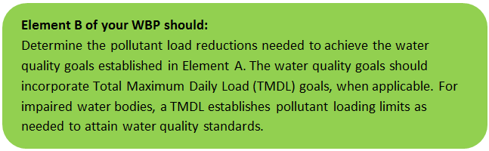

Water Quality Goals
There are many methodologies that can be used to set pollutant load reduction goals for a WBP. Goals can be based on water quality criteria, surface water standards, existing monitoring data, existing TMDL criteria, or other data. As discussed by Section A.5, water quality goals for this WBP are focused on addressing the phosphorus TMDL for upper Blackstone River Ponds in Millbury (i.e., Dorothy Pond, the Howe Reservoirs, and Brierly Pond) and the draft bacteria TMDL for the Blackstone River. A description of criteria for phosphorus and bacteria is described by Table B-1.
Table B-1: Pollutant Load Reductions Needed
Pollutant | Watershed Assessment  Unit ID | Existing Estimated Total Load | Water Quality Goal | Required Load Reduction
Total Phosphorus | Dorothy Pond (MA51039), Howe Reservoir (MA51071), Brierly Pond (MA51010) | 2,238 lb/yr (from Section A.6) | See TMDL information and recommendation below | See TMDL information and recommendation below
Bacteria | Blackstone River (MA51-03) | MSWQS for bacteria are concentration standards (e.g., colonies of fecal coliform bacteria per 100 ml), which are difficult to predict based on estimated annual loading. | Class B. Class B Standards  • Public Bathing Beaches: For E. coli, geometric mean of 5 most recent samples shall not exceed 126 colonies/ 100 ml and no single sample during the bathing season shall exceed 235 colonies/100 ml. For enterococci, geometric mean of 5 most recent samples shall not exceed 33 colonies/100 ml and no single sample during bathing season shall exceed 61 colonies/100 ml;  • Other Waters and Non-bathing Season at Bathing Beaches: For E. coli, geometric mean of samples from most recent 6 months shall not exceed 126 colonies/100 ml (typically based on min. 5 samples) and no single sample shall exceed 235 colonies/100 ml. For enterococci, geometric mean of samples from most recent 6 months shall not exceed 33 colonies/100 ml, and no single sample shall exceed 61 colonies/100 ml. | Draft Pathogen TMDL for the Blackstone River Watershed

TMDL Pollutant Load Criteria
Total Phosphorus
Loading Capacity
Modeling Assumptions, Key Input, Calibration and Validation:
There are no numeric models available to predict the growth of rooted aquatic macrophytes as a function of nutrient loading estimates, therefore the control of nuisance aquatic plants is based on best professional judgment. However, the goal of the TMDL is to prevent future eutrophication from occurring, thus the nutrient loading still needs to be controlled. To control eutrophication, the Carlson Trophic State Index (TSI) predicts a lake should have total phosphorus concentrations of about 40 ppb to meet the 4-foot transparency requirement for swimming beaches in Massachusetts and targets are set lower than this. Due to the lack of data on mean depth and other parameters, a simple water quality model was used to link watershed phosphorus loading to in-lake total phosphorus concentration targets. Based on the NPSLAKE model phosphorus loading output and predicted water runoff volumes, an estimated in-lake total phosphorus (TP) concentration was derived based on the Reckhow (1979) model:
TP=L/(11.6+1.2*q)*1000
where
TP= the predicted average total phosphorus concentration (mg/l) in the lake.
L= Phosphorus loading in g/m2/yr (the total loading in grams divided by lake area in meters).
q= The areal water loading in m/yr from total water runoff in m3/yr divided by lake area in m2.
Similarly, by setting the TP to the target total phosphorus concentration, a target load was estimated by solving the equation above. As noted in Mattson and Isaac (1999) the Reckhow (1979) model was developed on similar, north temperate lakes and most Massachusetts lakes will fall within the range of phosphorus loading and hydrology of the calibration data set. Additional assumptions, and details of calibration and validation are given in Reckhow (1979).
Wasteload Allocations, Load Allocations and Margin of Safety:
For most lakes, point source wasteload allocation is zero. The margin of safety is set by establishing a target that is below that expected to meet the 4-foot swimming standard (about 40 ppb). Thus, the TMDL is the same as the target load allocation to nonpoint sources as indicated in the right side of the following table (originally part of Table 4 of “Total Maximum Daily Loads of Phosphorus for Selected Northern Blackstone Lakes” report, 2002). Loading allocations are based on the NPSLAKE landuse modeled phosphorus budget. Note that if lakes have surface TP concentrations that are much larger than that predicted by the NPSLAKE model, internal sources of phosphorus, such as the sediments, may also be a contributing source of phosphorus to the surface waters and should be considered for further evaluation and control.
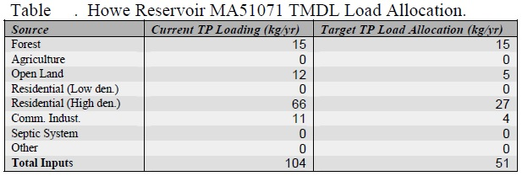

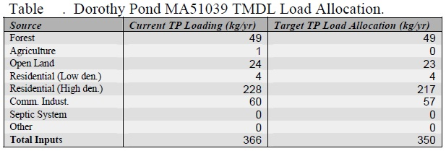

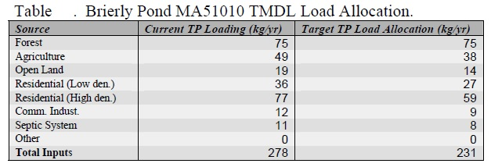
Phosphorus loading allocations for each landuse category are shown (are rounded to the nearest kg/yr) in the above table. No reduction in forest loading is targeted, because other than logging operations, which are relatively rare and already have BMPs in place, this source is unlikely to be reduced by additional BMPs. The remaining load reductions are allocated as a proportional phosphorus loading reduction.
The TMDL is the sum of the wasteload allocations (WLA) from point sources (e.g., sewage treatment plants) plus load allocations (LA) from nonpoint sources (e.g., landuse sources) plus a margin of safety (MOS). Thus, the TMDL can be written as:
TMDL = WLA + LA + MOS
Seasonality:
As the term implies, TMDLs are often expressed as maximum daily loads. However, as specified in 40 CFR 130.2(I), TMDLs may be expressed in other terms when appropriate. For this case, the TMDL is expressed in terms of allowable annual loadings of phosphorus. Although critical conditions occur during the summer season when weed growth is more likely to interfere with uses, water quality in many lakes is generally not sensitive to daily or short term loading but is more a function of loadings that occur over longer periods of time (e.g. annually).
Therefore, seasonal variation is taken into account with the estimation of annual loads. In addition, evaluating the effectiveness of nonpoint source controls can be more easily accomplished on an annual basis rather than a daily basis.
For most lakes, it is appropriate and justifiable to express a nutrient TMDL in terms of allowable annual loadings. The annual load should inherently account for seasonal variations by being protective of the most sensitive time of year. The most sensitive time of year in most lakes occurs during summer, when the frequency and occurrence of nuisance algal blooms and macrophyte growth are usually greatest. Therefore, because these phosphorus TMDLs were established to be protective of the most environmentally sensitive period (i.e., the summer season), it will also be protective of water quality during all other seasons. Additionally, the targeted reduction in annual phosphorus load to the ponds will result in the application of phosphorus controls that also address seasonal variation. For example, certain control practices such as stabilizing eroding drainage ways or maintaining septic systems will be in place throughout the year while others will be in effect during the times the sources are active (e.g., application of lawn fertilizer).
Reckhow, K.H. 1979. Uncertainty Analysis Applied to Vollenweider's Phosphorus Loading Criteria. J. Water Poll. Control Fed. 51(8):2123-2128
Mattson, M.D. and R.A. Isaac. 1999. Calibration of Phosphorus Export coefficients for Total Maximum Daily Loads of Massachusetts Lakes. Lake and Reservoir Man. 15(3):209-219.
Total Maximum Daily Loads of Phosphorus for Selected Northern Blackstone Lakes

Pathogen
Pathogen TMDL Development
Section 303 (d) of the Federal Clean Water Act (CWA) requires states to place water bodies that do not meet the water quality standards on a list of impaired waterbodies. The most recent impairment list, 2002 List, identifies eleven segments within the Blackstone River watershed for use impairment caused by excessive indicator bacteria concentrations.
The CWA requires each state to establish Total Maximum Daily Loads (TMDLs) for listed waters and the pollutant contributing to the impairment(s). TMDLs determine the amount of a pollutant that a waterbody can safely assimilate without violating the water quality standards. Both point and non-point pollution sources are accounted for in a TMDL analysis. Point sources of pollution (those discharges from discrete pipes or conveyances) subject to NPDES permits receive a waste load allocation (WLA) specifying the amount of pollutant each point source can release to the waterbody. Non-point sources of pollution (all sources of pollution other than point) receive a load allocation (LA) specifying the amount of a pollutant that can be released to the waterbody by this source. In accordance with the CWA, a TMDL must account for seasonal variations and a margin of safety, which accounts for any lack of knowledge concerning the relationship between effluent limitations and water quality. Thus:
TMDL = WLAs + LAs + Margin of Safety
Where:
WLA = Waste Load Allocation which is the portion of the receiving water’s loading capacity that is allocated to each existing and future point source of pollution.
LA = Load Allocation which is the portion of the receiving water’s loading capacity that is allocated to each existing and future non-point source of pollution.
This TMDL uses an alternative standards-based approach which is based on indicator bacteria concentrations, but considers the terms of the above equation. This approach is more in line with the way bacterial pollution is regulated (i.e., according to concentration standards) and achieves essentially the same result as if the equation were to be used.
Indicator Bacteria TMDL
Loading Capacity
The pollutant loading that a waterbody can safely assimilate is expressed as either mass-per-time, toxicity or some other appropriate measure (40 CFR § 130.2). Typically, TMDLs are expressed as total maximum daily loads. Expressing the TMDL in terms of daily loads is difficult to interpret given the very high numbers of indicator bacteria and the magnitude of the allowable load is dependent on flow conditions and, therefore, will vary as flow rates change. For example, a very high load of indicator bacteria are allowable if the volume of water that transports indicator bacteria is also high. Conversely, a relatively low load of indicator bacteria may exceed water quality standard if flow rates are low. Therefore, the MADEP believes it is appropriate to express indicator bacteria TMDLs in terms of a concentration because the water quality standard is also expressed in terms of the concentration of organisms per 100 mL. Since source concentrations may not be directly added due to varying flow conditions, the TMDL equation is modified and reflects a margin of safety in the case of this pathogen concentration based TMDL. To ensure attainment with Massachusetts’ WQS for indicator bacteria, all sources (at their point of discharge to the receiving water) must be equal to or less than the WQS for indicator organisms. For all the above reasons the TMDL is simply set equal to the concentration-based standard and may be expressed as follows:
TMDL = State Standard = WLA(p1) = LA(n1) = WLA(p2) = etc.
Where:
WLA(p1) = allowable concentration for point source category (1)
LA(n1) = allowable concentration for nonpoint source category (1)
WLA(p2) = allowable concentration for point source category (2) etc.
For Class A surface waters (1) the arithmetic mean of a representative set of fecal coliform samples shall not exceed 20 organisms per 100 mL; and (2) no more than 10% of the samples shall exceed 100 organisms per 100 mL.
For Class B surface waters (1) the geometric mean of a representative set of fecal coliform samples shall not exceed 200 organisms per 100 mL; and (2) no more than 10% of the samples shall exceed 400 organisms per 100 mL.
For freshwater bathing beaches (MADPH standard, not yet adopted by the MADEP) (1) the geometric mean of the most recent five enterococci levels within the same bathing season shall not exceed 33 colonies per 100 mL and (2) no single enterococci sample shall exceed 61 colonies per 100 mL. – OR – (1) the geometric mean of the most recent five E. coli levels within the same bathing season shall not exceed 126 colonies per 100 mL and (2) no single E. coli sample shall exceed 235 colonies per 100 mL.
Waste Load Allocations (WLAs) and Load Allocations (LAs).
There are eight municipal WWTPs, one CSO, and other NPDES-permitted wastewater discharges within the Blackstone River Drainage Basin. NPDES wastewater discharge WLAs are set at the WQS. In addition there are numerous storm water discharges from storm drainage systems throughout the watershed. All piped discharges are, by definition, point sources regardless of whether they are currently subject to the requirements of NPDES permits. Therefore, a WLA set equal to the WQS will be assigned to the portion of the storm water that discharges to surface waters via storm drains.
WLAs and LAs are identified for all known source categories including both dry and wet weather sources for Class A and Class B segments within the Blackstone River Basin. Establishing WLAs and LAs that only address dry weather indicator bacteria sources would not ensure attainment of standards because of the significant contribution of wet weather indicator bacteria sources to WQS exceedances. Illicit sewer connections and deteriorating sewers leaking to storm drainage systems represent the primary dry weather point sources of indicator bacteria, while failing septic systems and possibly leaking sewer lines represent the non-point sources. Wet weather point sources include discharges from storm water drainage systems (including MS4s), sanitary sewer overflows (SSOs) and combined sewer overflows (CSOs). Wet weather non-point sources primarily include diffuse storm water runoff.
The following table (originally Table 6-1 of “Draft Pathogen TMDL for the Blackstone River Watershed” report) presents the indicator bacteria WLAs and LAs for the various source categories. WLAs and LAs will change to reflect the revised indicator organisms (E. coli and enterococci) when the updated WQS have been finalized. Source categories representing discharges of untreated sanitary sewage to receiving waters are prohibited, and therefore, assigned WLAs and LAs equal to zero. There are three sets of WLAs and LAs: Class A waters, Class B waters and Freshwater Beaches.
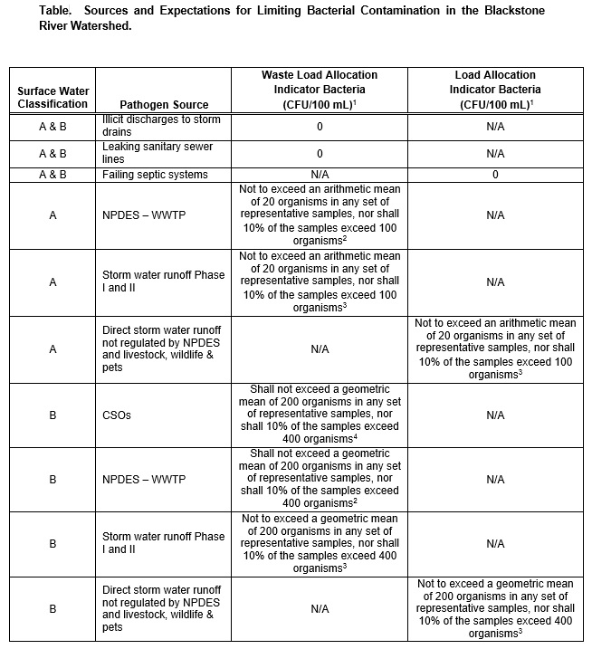
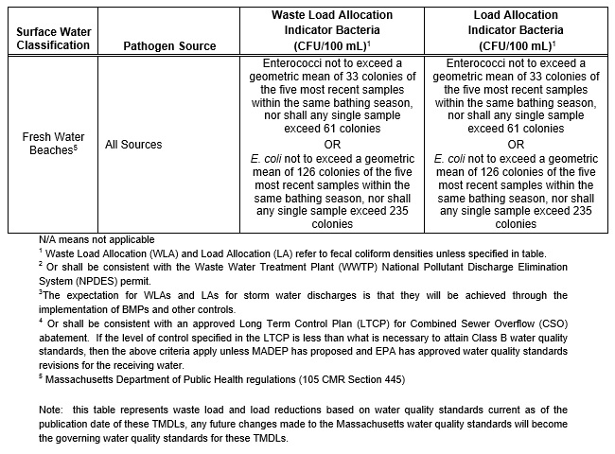
As a reference, typical storm water event mean densities for various indicator bacteria in a Massachusetts watershed and nationwide are provided in the following tables (originally Tables 5-2 and 5-3 of “Draft Pathogen TMDL for the Blackstone River Watershed”).
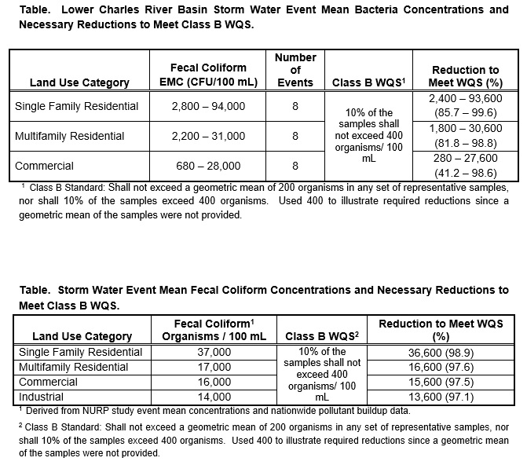
The TMDL should provide a discussion of the magnitudes of the pollutant reductions needed to attain the goals of the TMDL. Since accurate estimates of existing sources are generally unavailable, it is difficult to estimate the pollutant reductions for specific sources. For the illicit sources including failing septic systems, the goal is complete elimination (100% reduction). However, overall wet weather indicator bacteria load reductions can be estimated using typical storm water bacteria concentrations, as presented in the “Blackstone River Basin Watershed Water Quality Assessment Report” and additional data reports from the MADEP. These data indicate that up to two to three orders of magnitude (i.e., greater than 90%) reductions in storm water fecal coliform loadings generally will be necessary, especially in developed areas. This goal is expected to be accomplished through implementation of the best management practices (BMPs) associated with the Phase II control program in designated Urban Areas. The specific goal for controlling discharges from combined sewer overflows (CSOs) will be based on the site specific studies embodied in the Long Term Control Plan being developed by each community with combined sewers.
The expectation to attain WQS at the point of discharge is environmentally protective, and offers a practical means to identify and evaluate the effectiveness of control measures. In addition, this approach establishes clear objectives that can be easily understood by the public and individuals responsible for monitoring activities.
This TMDL applies to the eleven pathogen impaired segments of the Blackstone River watershed that are currently listed on the CWA § 303(d) list of impaired waters. MADEP recommends however, that the information contained in this TMDL guide management activities for all other waters throughout the watershed to help maintain and protect existing water quality. For these non-impaired waters, Massachusetts is proposing “pollution prevention TMDLs” consistent with CWA § 303(d)(3).
The analyses conducted for the pathogen impaired segments in this TMDL would apply to the non-impaired segments, since the sources and their characteristics are equivalent. The waste load and/or load allocation for each source and designated use would be the same as specified herein. Therefore, the pollution prevention TMDLs would have identical waste load and load allocations based on the sources present and the designated use of the water body segment (see the table “Sources and Expectations for Limiting Bacterial Contamination” above).
This Blackstone River watershed TMDL may, in appropriate circumstances, also apply to segments that are listed for pathogen impairment in subsequent Massachusetts CWA § 303(d) Integrated List of Waters. For such segments, this TMDL may apply if, after listing the waters for pathogen impairment and taking into account all relevant comments submitted on the CWA § 303(d) list, the Commonwealth determines with EPA approval of the CWA § 303(d) list that this TMDL should apply to future pathogen impaired segments.
Margin of Safety
This section addresses the incorporation of a Margin of Safety (MOS) in the TMDL analysis. The MOS accounts for any uncertainty or lack of knowledge concerning the relationship between pollutant loading and water quality. The MOS can either be implicit (i.e., incorporated into the TMDL analysis through conservative assumptions) or explicit (i.e., expressed in the TMDL as a portion of the loadings). This TMDL uses an implicit MOS, through inclusion of two conservative assumptions. First, the TMDL does not account for mixing in the receiving waters and assumes that zero dilution is available. Realistically, influent water will mix with the receiving water and become diluted below the water quality standard, provided that the receiving water concentration does not exceed the TMDL concentration. Second, the goal of attaining standards at the point of discharge does not account for losses due to die-off and settling of indicator bacteria that are known to occur.
Seasonal Variability
In addition to a Margin of Safety, TMDLs must also account for seasonal variability. Pathogen sources to Blackstone River waters arise from a mixture of continuous and wet-weather driven sources, and there may be no single critical condition that is protective for all other conditions. This TMDL has set WLAs and LAs for all known and suspected source categories equal to the Massachusetts WQS independent of seasonal and climatic conditions. This will ensure the attainment of water quality standards regardless of seasonal and climatic conditions. Controls that are necessary will be in place throughout the year, protecting water quality at all times. However, for discharges that do not affect intakes for water supplies and primary contact recreation is not taking place (i.e., during the winter months), seasonal disinfection is permitted for NPDES point source discharges.
Draft Pathogen TMDL for the Blackstone River Watershed

Recommended Load Reduction
Past water quality monitoring data summarized by Element A, Section 3 indicates that the Blackstone River experiences elevated levels of phosphorus exceeding the benchmark for streams (50 µg/L) (USEPA 1986). For example, data collected as part of the 2018 UBWPAD Blackstone River Monitoring Program indicates phosphorus concentrations throughout the river were slightly higher than 100 µg/L. Significant load reductions may be required to meet the water quality benchmark.
Total Phosphorus TMDLs have been established for three surface waterbodies within the Millbury subwatershed to the Blackstone River, including the Howe Reservoirs, Dorothy Pond, and Brierly Pond. Based on the load reduction goals outlined in the TMDL Criteria (See Section B.2), a minimum load reduction goal of 256 pounds per year (equivalent to 116 kg/yr) is proposed. This reduction would represent a decrease of 12 percent of the total phosphorus load to the river within the Millbury subwatershed.
To further improve water quality in the watershed, the following adaptive sequence is recommended to establish and track load reduction goals.
- Given current water quality conditions, establish an initial goal to reduce land-based phosphorus by 10 pounds over the next 3 years (by 2022).
- Establish an interim goal to reduce land-use based phosphorus by 11% (256 lb) over the next 10 years (by 2029) to meet TMDL requirements of the upstream waterbodies, ultimately leading to their delisting from the 303(d) list. Consider developing specific watershed-based plans for ponds with established TMDLs to provide a more targeted plan to achieving reductions.
- Continue and expand baseline monitoring programs in accordance with Elements H&I. Use results from monitoring programs to periodically inform load reduction goals and continue to gain a better understanding of other water quality parameters that contribute to listed impairments such as dissolved oxygen, turbidity, and non-native aquatic plants.
- Coordinate with surrounding communities that also discharge to the Blackstone River and establish realistic long-term reduction goals for total phosphorus and bacteria to meet water quality benchmarks and TMDLs within the next 30 years (by 2049).

Element C: Describe management measures that will be implemented to achieve water quality goals

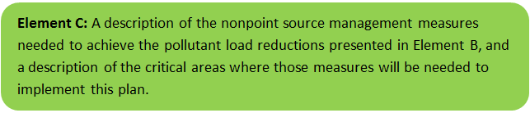

Current and Ongoing Management Measures
The Town of Millbury was awarded funding through the Fiscal Year 2018 Section 319 Nonpoint Source Pollution Grant Program to install the proposed structural BMPs listed in Table C-1. The planning level cost estimates and pollutant load reduction estimates were based off information obtained from the Armory Village Green Infrastructure Project Section 319 Nonpoint Source Pollution Grant Program application (Town of Millbury, 2017). BMPs were planned during the application process and are in the process of detailed design and construction. It is anticipated that these BMPs will result in a combined load reduction of 942 pounds of total suspended solids, 34 pounds of total nitrogen, 6 trillion colonies of bacteria, and 3.9 pounds of total phosphorus. Pollutant load estimates may be subject to change, pending completion of final designs.
Table C-1: Summary of Proposed BMPs
BMP Description | Location
3 bioretention cells (or rain gardens) | Upper Common, South Main Street
2 trees with flow-through planters | Lower Common, South Main Street
4 bioretention cells (or rain gardens) | Lower Common, South Main Street, Elm Street
8 tree box filters | Lower Common, Upper Common, Elm Street
Underground infiltration structure | Beneath the parking lot on South Main Street
Replacement of sections of existing impervious surface with concrete pavers and tree plantings | Throughout the project area

Future Management Measures
As discussed by Element B Section 4, It is recommended that future planning initially focus on water quality of the upper Blackstone ponds (the Howe Reservoirs, Dorothy Pond, and Brierly Pond) that have established TMDLs for total phosphorus before addressing the greater Blackstone River watershed within Millbury. It is recommended that management measures be recommended for each pond that emphasize reducing total phosphorus loading to meet target TMDL reductions, as feasible. The following general sequence is recommended to identify and implement structural BMPs.
- Identify Potential Implementation Locations: Perform a desktop analysis using aerial imagery and GIS data to develop a preliminary list of potentially feasible implementation locations based on soil type (i.e., hydrologic soil groups A and B); available public open space (e.g., lawn area in front of a police station); and other factors such as proximity to receiving waters, known problem areas, or publicly owned right of ways or easements. Additional analysis can also be performed to fine-tune locations to maximize pollutant removals such as performing loading analysis on specifically delineated subwatersheds draining to single outfalls and selecting those subwatersheds with the highest loading rates per acre.
- Visit Potential Implementation Locations: Perform field reconnaissance, preferably during a period of active runoff-producing rainfall, to evaluate potential implementation locations, gauge feasibility, and identify potential BMP ideas. During field reconnaissance, assess identified locations for space constraints, potential accessibility issues, presence of mature vegetation that may cause conflicts (e.g., roots), potential utility conflicts, site-specific drainage patterns, and other factors that may cause issues during design, construction, or long-term maintenance.
- Develop BMP Concepts: Once potential BMP locations are conceptualized, use the BMP-selector tool of the watershed-based planning tool to help develop concepts. Concepts can vary widely. One method is to develop 1-page fact sheets for each concept that includes a site description, including definition of the problem, a description of the proposed BMPs, annotated site photographs with conceptual BMP design details, and a discussion of potential conflicts such as property ownership, O&M requirements, and permitting constraints. The fact sheet can also include information obtained from the BMP-selector tool including cost estimates, load reduction estimates, and sizing information (i.e., BMP footprint, drainage area, etc.).
- Rank BMP Concepts: Once BMP concepts are developed, perform a priority ranking based on site-specific factors to identify the implementation order. Ranking can include many factors including cost, expected pollutant load reductions, implementation complexity, potential outreach opportunities and visibility to public, accessibility, expected operation and maintenance effort, and others.
Prioritized BMP concepts should focus on reducing total phosphorus loading to each pond as summarized by the TMDL criteria (Element B, Section 3). Once BMPs are planned and constructed for each pond, focus can then be shifted to planning and implementing management measures for the Blackstone River and its tributaries within the study area.
Note that planned BMPs can also be non-structural (e.g., street sweeping, catch basin cleaning). Section 2.3.7 of the 2016 Massachusetts Small MS4 General Permit includes requirements for implementation of enhanced street sweeping and catch basin cleaning programs. It is recommended that these municipal programs be evaluated and potentially optimized. First, it is recommended that potential pollutant load removals from ongoing activities be calculated in accordance with Element HI. Next, it is recommended that ongoing activities be evaluated to see if potential improvements can be implemented to achieve higher pollutant load reductions such as increased frequency or improved technology.

Element D: Identify Technical and Financial Assistance Needed to Implement Plan
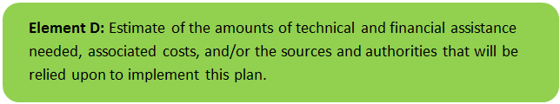

Current and Ongoing Management Measures
The funding needed to implement the proposed management measures presented in this watershed plan is based on estimates from the Armory Village Green Infrastructure Project Section 319 Nonpoint Source Pollution Grant Program application (Town of Millbury, 2017). The total costs for the project, including structural and non-structural BMPs, operation and maintenance activities, information/education measures, and monitoring/evaluation activities, among other costs, is estimated at approximately $1,483,490, as detailed by Table D-1. Costs of the project are summarized by major construction areas in Table D-1 and include materials and conceptual-level construction costs.
Table D-1: Summary of Proposed BMPs Costs
Construction Area | Cost
Roadway | $450,120
Lower Common | $353,811
Lower Bust Stop Corner | $80,550
Remaining Right Side of S. Main St. | $50,035
North Common Corner | $59,350
Upper Bus Stop Corner | $78,640
Additional Costs/Fees | $410,984
Total | $1,483,490

Future Management Measures
Additional funding from sources such as the Parkland Acquisitions and Renovations for Communities (PARC) grant from the Massachusetts Division of Conservation Services, the Complete Streets Implementation Grant, the Municipal ADA Improvement Grant, and National Grid’s Urban and Community Forestry Grant have been considered to implement projects. Funding for future BMP installations to further reduce loads within the watershed may be provided by any of these or other sources, such as the Section 319 Nonpoint Source Pollution Grant Program, town capital funds, or other grant programs such as hazard mitigation funding. Guidance is available to provide additional information on potential funding sources for nonpoint source pollution reduction efforts.

Element E: Public Information and Education
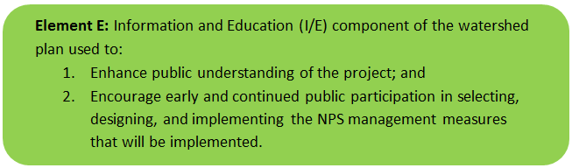

Step 1: Goals and Objectives
The goals and objectives for the watershed information and education program.
- Provide information about proposed stormwater improvements and their anticipated water quality benefits
- Provide information to promote watershed stewardship
Step 2: Target Audience
Target audiences that need to be reached to meet the goals and objectives identified above.
- All watershed residents
- Businesses within the watershed
- Watershed organizations and other user groups (UBWPAD, etc.)
Step 3: Outreach Products and Distribution
The outreach product(s) and distribution form(s) that will be used for each.
- Develop and host public input/information sessions for the Armory Village Green Infrastructure Project once final construction plans have been developed
- Publish press releases on the Armory Village Green Infrastructure Project in the Millbury-Sutton Chronicle during project design and construction phases
- Develop informational signage and a kiosk for the Armory Village Green Infrastructure Project
- Develop a webpage detailing the BMPs installed as part of the Armory Village Green Infrastructure Project. Periodically update website highlighting other anticipated improvements and updates
- Conduct a social media campaign to raise awareness about proposed improvements
- Install pet waste stations at all municipal parks, particularly those in the watersheds of Brierly Pond and Dorothy Pond
- Develop an informational kiosk in Town Hall and the Town Library to educate property owners on preventing non-point source pollutants. The information could focus on benefits of rain gardens, minimizing application of phosphorus-based fertilizers to lawns adjacent to waterbodies and wetlands, minimizing law waste deposits to waterbodies and wetlands, maintaining septic systems, and fencing livestock away from streams and wetlands
- Implement a storm drain stenciling program
Step 4: Evaluate Information/Education Program
Information and education efforts and how they will be evaluated.
- Track public information session attendance
- Track number of press releases published
- Track number of web page views (goal of 500 views per year).
- Track number of social media followers and social media responses (goal of 100 new followers per year)
- Track number of pet waste stations installed, and the number of storm drains stenciled

Elements F & G: Implementation Schedule and Measurable Milestones
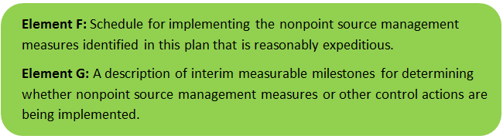

Table FG-1 provides a preliminary schedule for implementation of recommendations provided by this WBP. It is expected that the WBP will be re-evaluated and updated in 2021, or as needed, based on ongoing monitoring results and other ongoing efforts. Implementation of these watershed management tasks is dependent on obtaining additional funding. The below schedule will be updated once every three years, with this plan, to reflect applicable funding timelines.
Table FG-1: Implementation Schedule and Interim Measurable Milestones
Category | Action | Year(s)
Additional Watershed-Based Plan Development | Develop one watershed-based plans for each pond with a TMDL (the Howe Reservoirs, Brierly Pond, and Dorothy Pond) within the Blackstone watershed every three years | 2022-2028
 | Complete desktop prioritization and/or field reconnaissance for potential BMP installation for one of the ponds with established TMDLs (the Howe Reservoirs, Brierly Pond, and Dorothy Pond) every three years | 2022-2028
Monitoring / Vegetation | Review water quality sampling plan objectives relative to water quality goals of this WBP and make necessary modifications | 2019
 | Establish a water quality monitoring program for the ponds with established TMDLs that meets TMDL recommendations | 2021
 | Perform annual water quality sampling per Element H&I monitoring guidance | Annual
Structural BMPs | Complete Armory Village Green Infrastructure Project BMP installation | 2020
 | Obtain funding and implement 2-3 additional BMPs within the watersheds of the ponds with established TMDLs | 2023
 | Obtain funding and implement 2-3 additional BMPs within the watersheds of the ponds with established TMDLs | 2026
 | Obtain funding and implement 2-3 additional BMPs within the watersheds of the ponds with established TMDLs | 2029
Nonstructural BMPs | Document potential pollutant removals from ongoing non-structural BMP practices (i.e., street sweeping, catch basin cleaning) and document potential pollutant removals | 2020
 | Evaluate ongoing non-structural BMP practices and determine if modifications can be made to optimize pollutant removals (e.g., increase frequency). | 2021
 | Routinely implement optimized non-structural BMP practices | Annual
Public Education and Outreach  (See Element E) | Periodically post project updates to website and social media profiles, including completed WBP and updates of progress | Annual
 | Host public information sessions, publish press releases, post informational signage, conduct a social media campaign, and develop a webpage for the Armory Village Green Infrastructure Project | 2020
 | Install pet waste stations at all municipal parks | 2024
 | Develop an informational kiosk for Town Hall to educate property owners. | 2024
 | Implement a storm drain stenciling program | 2024
Adaptive Management  and Plan Updates | Establish working group comprised of stakeholders and other interested parties to implement recommendations and track progress. Meet at least twice per year. | 2020
 | Coordinate with surrounding communities to establish a wider watershed pollutant loading reduction plan | 2021
 | Re-evaluate Watershed-Based Plan at least once every three (3) years and adjust, as needed, based on ongoing efforts (e.g., based on monitoring results, 319 funding, etc.). – Next update, December 2021 | 2021
 | Reach initial goal to reduce land-based phosphorus by 10 pounds | 2022
 | Reach Phosphorus Load Reduction Goals for ponds with established TMDLs | 2024
 | Reach Long-Term Phosphorus Load Reduction Goal (See Element A, Section 4) | 2049

Note: The schedule outlined by this table is dependent on obtaining funding to implement plan recommendations.

Elements H & I: Progress Evaluation Criteria and Monitoring
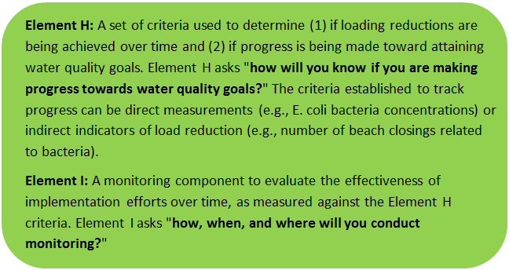 | 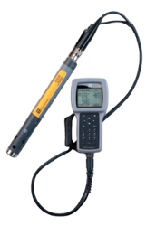

The water quality target concentration(s) is presented under Element A of this plan. To achieve this target concentration, the annual loading must be reduced to the amount described in Element B. Element C of this plan describes the various management measures that will be implemented to achieve this targeted load reduction. The evaluation criteria and monitoring program described below is based on existing monitoring activities and will be used to measure the effectiveness of the proposed management measures (described in Element C) in improving the water quality of the Blackstone River.

Indirect Indicators of Load Reduction
Non-Structural BMPS
Potential load reductions from non-structural BMPs (i.e., street sweeping and catch basin cleaning) can be estimated from indirect indicators, such as the number of miles of streets swept or the number of catch basins cleaned. The Town of Millbury already tracks information related to nonstructural BMPs. Appendix F of the 2016 Massachusetts Small MS4 General Permit provides specific guidance for calculating phosphorus removal from these practices. As indicated by Element C, it is recommended that potential phosphorus removal from these ongoing actives be estimated. Next, it is recommended that ongoing activities be evaluated to see if potential improvements can be implemented to achieve higher pollutant load reductions such as increased frequency or improved technology. Phosphorus load reductions can be estimated in accordance with Appendix F of the 2016 Massachusetts Small MS4 General Permit as summarized by Figure HI-1 and HI-2.
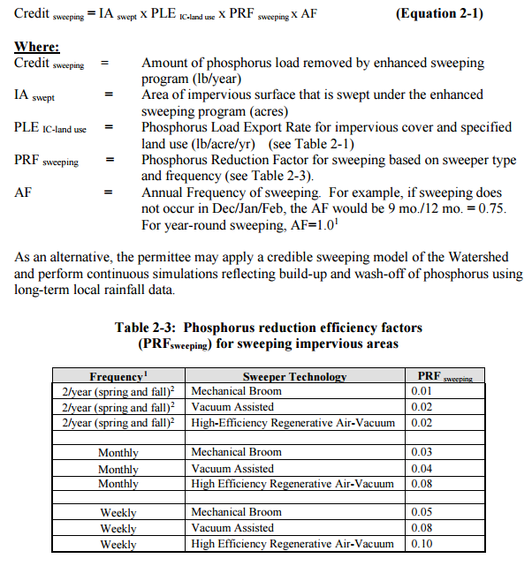
Figure HI-1. Street Sweeping Calculation Methodology
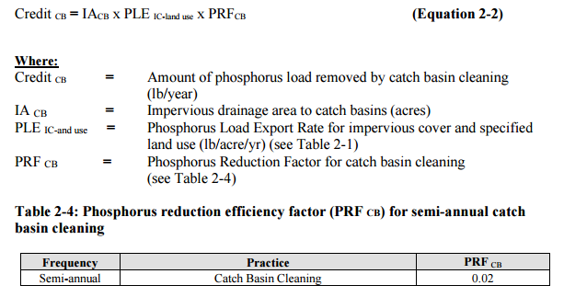
Figure HI-2. Catch Basin Cleaning Calculation Methodology

Project-Specific Indicators

Number of BMPs Installed
Element C of this WBP details the proposed installation of multiple BMPs. The anticipated pollutant load reduction has been documented for the proposed BMPs. The number of BMPs that are installed will be tracked and quantified as part of this monitoring program. For example, if all proposed BMPs are installed, the anticipated phosphorus load reduction is estimated to be 3.9 pounds per year. Load reductions associated with additional future BMPs will also be tracked and quantified as part of this monitoring program.

TMDL Criteria
TMDL requirements encourage additional monitoring by volunteer groups of the northern Blackstone lakes (Brierly Pond, Dorothy Pond, and the Howe Reservoirs). Monitoring by MassDEP staff will also be continued on a regular basis. Recommended baseline survey on the waterbodies includes Secchi disk transparency, nutrient analysis, temperature oxygen profiles, and aquatic vegetation maps of distribution and density.

Direct Measurements
Direct measurements are generally expected to be performed in accordance with existing monitoring activities by UPWPAD, as summarized below, along with additional recommendations to supplement sampling conducted by UPWPAD.

River Sampling
Continue monthly sampling for nutrients (nitrogen and phosphorus) and chlorophyll-a and seasonal summer sampling for periphyton within the Blackstone River. To better quantify the impact of upstream ponds with established TMDLs, sampling locations could be added on the Blackstone River immediately downstream of the confluences with Singletary Brook (receiving water for Brierly Pond) and Dorothy Brook (receiving water for Dorothy Pond and the Howe Reservoirs).

In-Lake Phosphorus and Water Quality Monitoring
Sampling programs specific for the contributing ponds with TMDLs (Brierly Pond, Dorothy Pond, and the Howe Reservoirs) could be established to more closely track the progress of water quality improvements towards TMDL requirements. Based on a literature review summarized in Element A of this plan, the ponds within the watershed of the Blackstone River do not have monitoring plans. It is recommended that sampling programs meeting the recommendations of the TMDL be established, including analysis of Secchi disk transparency, nutrients, temperature oxygen profiles, and aquatic vegetation. In-lake phosphorus and chlorophyll-a measurements will provide the most direct means of evaluating the effects of measures in the plan which have been proposed specifically to reduce phosphorus loading to meet TMDL requirements. These parameters will also enable tracking relative to Carlson’s state trophic index.

Adaptive Management
As discussed by Section 3 of Element B, the baseline monitoring program will be used to establish a long-term i.e., 30 year) phosphorus load reduction goal (or other parameter(s) depending on results). Long-term goals will be re-evaluated at least once every three years and adaptively adjusted based on additional monitoring results and other indirect indicators. If monitoring results and indirect indicators do not show improvement to the total phosphorus concentrations measured within the Blackstone River, the management measures and loading reduction analysis (Elements A through D) will be revisited and modified accordingly. Further, the recommendations from this WBP shall be implemented and overall progress shall be tracked. Updates on progress of the project shall be posted to the Millbury’s website and shared on social media.

References
314 CMR 4.00 (2013). "Division of Water Pollution Control, Massachusetts Surface Water Quality Standards"
Cohen, A. J.; Randall, A.D. (1998). "Mean annual runoff, precipitation, and evapotranspiration in the glaciated northeastern United States, 1951-80." Prepared for United States Geological Survey, Reston VA.
Geosyntec Consultants, Inc. (2014). "Least Cost Mix of BMPs Analysis, Evaluation of Stormwater Standards Contract No. EP-C-08-002, Task Order 2010-12." Prepared for Jesse W. Pritts, Task Order Manager, U.S. Environmental Protection Agency
Geosyntec Consultants, Inc. (2015). "Appendix B: Pollutant Load Modeling Report, Water Integration for the Squamscott-Exeter (WISE) River Watershed."
King, D. and Hagan, P. (2011). "Costs of Stormwater Management Practices in Maryland Counties." University of Maryland Center for Environmental Science Chesapeake Biological Laboratory. October 11, 2011.
Leisenring, M., Clary, J., and Hobson, P. (2014). "International Stormwater Best Management Practices (BMP) Database Pollutant Category Statistical Summary Report: Solids, Bacteria, Nutrients and Metals." Geosyntec Consultants, Inc. and Wright Water Engineers, Inc. December 2014.
Mass Audubon (2016). “Millbury Downtown Improvement through Low Impact Development and Green Infrastructure: Summary Findings Report of Community-Led Workshops”
MassDEP. "Draft Pathogen TMDL for the Blackstone River Watershed "
MassDEP (2002). "Total Maximum Daily Loads of Phosphorus for Selected Northern Blackstone Lakes
MassDEP (2010). "Blackstone River Watershed 2003-2007 Water Quality Assessment Report"
MassDEP (2012). "Massachusetts Year 2012 Integrated List of Waters Final Listing of Massachusetts' Waters Pursuant to Sections 305(b), 314 and 303(d) of the Clean Water Act"
MassDEP (2016a). "Massachusetts Clean Water Toolkit"
MassDEP (2016b). "Massachusetts Stormwater Handbook, Vol. 2, Ch. 2, Stormwater Best Management Practices"
MassGIS (1999). "Networked Hydro Centerlines" Shapefile
MassGIS (2001). "USGS Topographic Quadrangle Images" Image
MassGIS (2007). "Drainage Sub-basins" Shapefile
MassGIS (2009a). "Impervious Surface" Image
MassGIS (2009b). "Land Use (2005)" Shapefile
MassGIS (2013). "MassDEP 2012 Integrated List of Waters (305(b)/303(d))" Shapefile
Schueler, T.R., Fraley-McNeal, L, and K. Cappiella (2009). "Is impervious cover still important? Review of recent research" Journal of Hydrologic Engineering 14 (4): 309-315.
Town of Millbury (2017). “Armory Village Green Infrastructure Project: A Revitalizing Effort Using Low Impact Development & Green Infrastructure in the Blackstone River Watershed” Response to RFR: BRP-RFR-2017-06-319 Section 319 Nonpoint Source Pollution Grant Program. June 2, 2017.
United States Bureau of Labor Statistics (2016). "Consumer Price Index"
United States Geological Survey (2016). "National Hydrography Dataset, High Resolution Shapefile"
University of Massachusetts, Amherst (2004). "Stormwater Technologies Clearinghouse"
UBWPAD (2012). “Blackstone River Water Quality Study: 2012”
UBWPAD (2013). “Blackstone River Water Quality Study: 2013”
UBWPAD (2017). “2017 UBWPAD Blackstone River Monitoring Program Board Presentation”
UBWPAD (2018). “2018 UBWPAD Blackstone River Monitoring Program Board Presentation”
USDA NRCS and MassGIS (2012). "NRCS SSURGO-Certified Soils" Shapefile
USEPA (1986). "Quality Criteria for Water (Gold Book)" EPA 440/5-86-001. Office of Water, Regulations and Standards. Washington, D.C.
USEPA. (2010). "EPA's Methodology to Calculate Baseline Estimates of Impervious Area (IA) and Directly Connected Impervious Area (DCIA) for Massachusetts Communities."
USEPA. (2017). "General Permit for Stormwater Discharges from Small Municipal Separate Storm Sewer Systems in Massachusetts."
USEPA (2018). “Overview of Total Maximum Daily Loads (TMDLs)”
Voorhees, Mark, USEPA. (2015). "FW: Description of additional modelling work for Opti-Tool Project" Message to Chad Yaindl, Geosyntec Consultants. 23 April 2015. E-mail.
Voorhees, Mark, USEPA. (2016a). "FW: EPA Region 1 SW BMP performance equations" Message to Chad Yaindl, Geosyntec Consultants. 25 January 2016. E-mail.
Voorhees, Mark, USEPA. (2016b). "FW: Description of additional modelling work for Opti-Tool Project" Message to Chad Yaindl, Geosyntec Consultants. 23 April 2015. E-mail.

Appendices

Appendix A – Additional Water Quality Information
Blackstone River Watershed 2003-2007 Water Quality Assessment Report (MA51070 - Howe Reservoirs, MA51010 - Brierly Pond, MA51186 - Woolshop Pond, MA51137 - Riverlin Street Pond, MA51039 - Dorothy Pond)
Aquatic Life Use
Biology
A non-native aquatic macrophyte species, Myriophyllum heterophyllum, was observed in Howe Reservoirs [East Basin] during the 1994 Blackstone River Watershed synoptic lake surveys (MassDEP 1994) and in Brierly Pond in July 1994 (MassDEP 1994). The Aquatic Life Use is assessed as impaired for Howe Reservoirs [East Basin] and Brierly Pond because of the infestation with M. heterophyllum, a non-native aquatic macrophyte.

A non-native aquatic macrophyte species, Potamogeton crispus was observed in Woolshop Pond during the 1994 Blackstone River Watershed synoptic lake surveys (MassDEP 1994). The Aquatic Life Use is assessed as impaired for Woolshop Pond because of the infestation with P. crispus, a non-native aquatic macrophyte.

Two non-native aquatic macrophyte species, Myriophyllum heterophyllum and Potamogeton crispus, were observed in Riverlin Street Pond during the 1994 Blackstone River Watershed synoptic lake surveys (MassDEP 1994). The Aquatic Life Use is assessed as impaired for Riverlin Street Pond because of the infestation with M. heterophyllum and P. crispus, non-native aquatic macrophytes.

Non-native aquatic macrophyte species, Myriophyllum spicatum and Potamogeton crispus were observed in Dorothy Pond during the 1994 Blackstone River Watershed synoptic lake surveys (MassDEP 1994). A potential non-native macrophyte species (Myriophyllum sp., possibly M. heterophyllum) has also been reported (MassDEP 2008b). Najas minor was observed during a 1999 field investigation by MassDEP (Beaudoin 1999). The Aquatic Life Use is assessed as impaired for Dorothy Pond because of the infestation with M. spicatum, P. crispus and N.minor, non-native aquatic macrophytes. Infestation with a fourth potential non-native macrophyte species (Myriophyllum sp., possibly M. heterophyllum) is noted as a concern.

Report Recommendations:
Continue to monitor for the presence of invasive non-native aquatic vegetation and determine the extent of the infestation. Prevent spreading of invasive aquatic plants. Once the extent of the problem is determined and control practices are exercised, vigilant monitoring needs to be practiced to guard against infestations in unaffected areas, including downstream from the site, and to ensure that managed areas stay in check. A key portion of the prevention program should be posting of boat access points with signs to educate and alert lake-users to the problem and their responsibility to prevent spreading these species. The watershed/canoe/kayak groups should consider seeking volunteers to provide outreach on preventing the spread of exotic invasive plants at popular access points during the busiest weekends of the summer. The Final GEIR for Eutrophication and Aquatic Plant Management in Massachusetts (Mattson et al. 2004) should also be consulted prior to the development of any lake management plan to control non-native aquatic plant species. Plant control options can be selected from several techniques (e.g., bottom barriers, drawdown, herbicides, etc.) each of which has advantages and disadvantages that need to be addressed for the specific site. However, methods that result in fragmentation (such as cutting or raking) should not be used for many species because of the propensity for these invasive species to reproduce and spread vegetatively (from cuttings).

Blackstone River Watershed 2003-2007 Water Quality Assessment Report (MA51039 - Dorothy Pond)
Fish Consumption Use
Fish were collected by DWM biologists from Dorothy Pond in 1987 and were analyzed for metals, PCBs, and an organic scan (Maietta 2007). MA DPH did not issue a site specific fish consumption advisory based on the results of the analyses (MassDEP 2009).

The Fish Consumption Use is not assessed for Dorothy Pond since no site-specific fish consumption advisory was issued by MA DPH. All applicable statewide fish consumption advisories issued by MA DPH due to mercury contamination apply to this waterbody.

In 2003, the Town of Millbury received 319 grant funding to install numerous structural stormwater treatment units to capture sediments and improve water quality in Dorothy Pond. Observations recorded after rainfall events provided evidence of sediment capture, along with anecdotal observations of reduced coloration in Dorothy Pond (Chase and SEA 2006).

Report Recommendations:
Evaluate sedimentation issues from upstream activities.

Draft Pathogen TMDL for the Blackstone River Watershed (MA51-03 - Blackstone River)
Watershed Description
The Blackstone River watershed drains approximately 640 square miles, 382 of which are in Massachusetts (EOEA 2003). The remaining 258 square miles are located in Rhode Island. The watershed includes portions of 29 cities and towns within central Massachusetts. The Blackstone River begins in the Town of Worcester at approximately 1,400 feet above mean sea level and drains southeast to Narragansett Bay in Rhode Island.
Land use within the watershed is primarily forest and residential areas. Most of the residential developed areas lie within the upper portion of the watershed whereas forested areas are located in the lower portion.
The Blackstone River hydrology is impacted by 19 dams along the length of the river and substantial natural storage in the upper and middle watershed. It has been estimated that it takes three to four days for peak flows in the upper portion to reach the Lower Blackstone (Wright et al. 2001). These areas also allow for the release of stored water during periods of low flow.
The Blackstone River is characterized by numerous impoundments formed by the remains of old mill-dams historically used for water power. Only two of these dams are still used to generate power: Riverdale and Synergics (Tupperware). Water levels in the river fluctuate rapidly over short periods of time due to a combination of storm impacts and water flow regulations. The storm flows are compounded by a predominance of impervious surfaces in the Worcester area (MADEP 2001).
As the river flows through Worcester, combined sewer overflows (CSOs) and illicit sewer connections add waters to the urban river. In recent years, the Worcester Department of Public Works (DPW) has been actively investigating and repairing these connections (City of Worcester, DPW 2000).
In the past, the Blackstone River was known as the “world’s busiest river” as waste discharges from the area’s burgeoning textile industries were discharged into the river (Tennant et al. 1975). During wet weather, resuspension of contaminated sediments in the river has been shown to be a source of water quality criteria violations (Wright et al. 2001). During dry weather, the Blackstone River is characterized by the effluent from many treatment plants. Today, the Blackstone River and its tributaries are commonly used for primary and secondary contact recreation (swimming and boating), fishing, wildlife viewing, habitat for aquatic life, and potable water. The river is also major source of freshwater to Rhode Island's Narraganset Bay, a productive and diverse estuary used for fishing, tourism and recreation.
Problem Assessment
Pathogen impairment has been documented at numerous locations throughout the Blackstone River watershed. Excessive concentrations of indicator bacteria (e.g., fecal coliform, enterococci, E. coli etc.) can indicate the presence of sewage contamination and possible presence of pathogenic organisms. The amount of indicator bacteria and potential pathogens entering waterbodies is dependent on several factors including watershed characteristics and meteorological conditions. Indicator bacteria levels generally increase with increasing development activities, including increased impervious cover, illicit sewer connections, and failed septic systems. Indicator bacteria levels also tend to increase with wet weather conditions as storm sewer systems overflow and/or storm water runoff carries fecal matter that has accumulated to the river via overland flow and storm water conduits. In some cases, dry weather bacteria concentrations can be higher when there is a constant source that becomes diluted during periods of precipitation, such as with illicit connections. The magnitude of these relationships is variable, however, and can be substantially different temporally and spatially throughout the United States or within each watershed.
The following tables (originally Tables 4-1 and 4-2 of “Draft Pathogen TMDL for the Blackstone River Watershed” report) in provide ranges of fecal coliform concentrations in storm water associated with various land use types. Pristine areas are observed to have low indicator bacteria levels and residential areas are observed to have elevated indicator bacteria levels. Development activity generally leads to decreased water quality (e.g., pathogen impairment) in a watershed.
Development-related watershed modification includes increased impervious surface area, which can
(USEPA 1997):
-Increase flow volume,
- Increase peak flow,
- Increase peak flow duration,
- Increase stream temperature,
- Decrease base flow, and
- Change sediment loading rates.
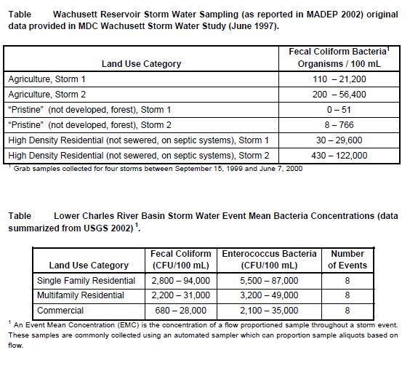
Many of the impacts associated with increased impervious surface area also result in changes in pathogen loading (e.g., increased sediment loading can result in increased pathogen loading). In addition to increased impervious surface impacts, increased human and pet densities in developed areas increase potential fecal contamination. Furthermore, storm water drainage systems and associated storm water culverts and outfall pipes often result in the channelization of streams which leads to less attenuation of pathogen pollution.
Pathogen impaired river segments represent 56.6% of the total river miles assessed (64.4 miles of 113.8 assessed). One hundred thirty-two segments are classified as lakes, none of which are pathogen impaired. In total, eleven segments, each in need of a TMDL, contain indicator bacteria concentrations in excess of the Massachusetts WQS for Class A or B waterbodies (314 CMR 4.05) and/or the MADPH standard for bathing beaches. The basis for impairment listings is provided in the 2002 List (MADEP 2003). Data presented in the WQA and other data collected by the MADEP were used to generate the 2002 List. For more information regarding the basis for listing particular segments for pathogen impairment, please see the Assessment Methodology section of the MADEP WQA for this watershed.
This TMDL was based on the current WQS using fecal coliform as an indicator organism for fresh and marine waters and enterococci for marine beaches. The MADEP is in the process of developing new WQS incorporating E. coli and enterococci as indicator organisms for all waters other than shellfishing and potable water intake areas.
An overview of the Blackstone River watershed pathogen impairment is provided in this section to illustrate the nature and extent of the impairment. Since pathogen impairment has been previously established and documented on the 2002 List, it is not necessary to provide detailed documentation of pathogen impairment herein.
Data from the MADEP, the Blackstone River Initiative (BRI), the Blackstone River Coalition (BRC), and the EPA Region 1 were reviewed and are summarized by segment below for illustrative purposes. Not all data presented herein were used to determine impairment listing due to a variety of reasons (including data quality assurance and quality control). The MADEP used only a subset of the available data to generate the 2002 List. Other data presented in this section are for illustrative purposes only.
Data are broken down into two weather conditions: wet and dry. When data were not categorized as such in individual reports, data collected on days when there was measurable precipitation were considered wet weather conditions and data collected on days when no or “trace” amounts of precipitation were reported were considered dry weather conditions. It should be noted that some reporting entities require a minimum amount of precipitation (i.e. 0.1 or 0.2 inches) before it is considered wet weather. Therefore data between reporting entities may not be directly comparable, but overall conclusions for each segment are consistent.
Data from the Blackstone River Initiative and Blackstone River Coalition are presented in tables at the end of this section. These tables contain the following information:
- “Segment” - column identifies the segment where the samples were collected.
- “Dry Weather Station ID” and “Wet Weather Station ID” - columns display the sampling location identifier issued by the sampling organization during dry and wet weather respectively
-“Location” - column identifies the waterbody from which the sample was taken.
- “Town” - column provides the town name in which samples were collected.
- The other columns provide statistics relating to sampling conducted during wet weather. The wet weather data may be a single value from a single sampling event, the average of a sample and duplicate, or the Event Mean Concentration (EMC) values may be given. Columns with an “EMC” label provide the event mean concentration for samples collected at that station. A label of the type of indicator bacteria measured is provided above each column. The next columns contain dry weather data. Dry weather data may be a single value from a single sampling event or the average of a sample and duplicate. The dry weather data may also be presented under “Min” and “Max” columns where the minimum and maximum dry weather values are given, respectively.
The purpose of this section of the report is to briefly describe the impaired waterbody segments in the Blackstone River watershed. For more information on any of these segments, see the “Blackstone River Basin 1998 Water Quality
Assessment Report” on the MADEP website http://www.mass.gov/dep/brp/wm/wqassess.htm.
Kettle Brook Segment MA51-01
This segment is an 8.0 mile long Class B warm water fishery extending from Leicester to the inlet to Curtis Pond in Worcester. There are two groundwater withdrawals and one surface water withdrawal in this area:
1. The Auburn Water Department has eight groundwater wells, and is permitted to withdraw 1.75 MGD,
2. The Leicester Water Supply district operates four wells and is permitted to withdraw 0.19 MGD.
3. The Worcester DPW has a surface water permit that extends to seven surface water bodies in the Blackstone River Valley. The Lynde Brook Reservoir withdrawal is located within this segment. The total withdrawal limit for the Blackstone River Valley for the Worcester DPW is 14.22 million gallons per day (MGD).
There are no wastewater National Pollutant Discharge Elimination System (NPDES) permits in this segment according to the WQA. There are seven storm water NPDES permits within this subwatershed, including the City of Worcester. This City of Worcester permit, issued to the DPW in September 1998, gives authorization to discharge storm water from the municipal separate storm sewer system (MS4) into Leesville Pond and Kettle Brook. A listing of all the NPDES permittees can be found in the WQA, available for download at http://www.mass.gov/dep/brp/wm/wqassess.htm.
MADEP WQA water quality sampling for bacteria in this segment is limited to grab samples for fecal coliform collected during dry periods in the summer of 1998. Five samples were collected at three locations (3 samples at KB02 and 1 sample at KB09 and at KB10) which ranged from <20 to 880 cfu (colony forming units) per 100ml. For a complete listing of these data please see Appendix B of the WQA (MADEP 2001).
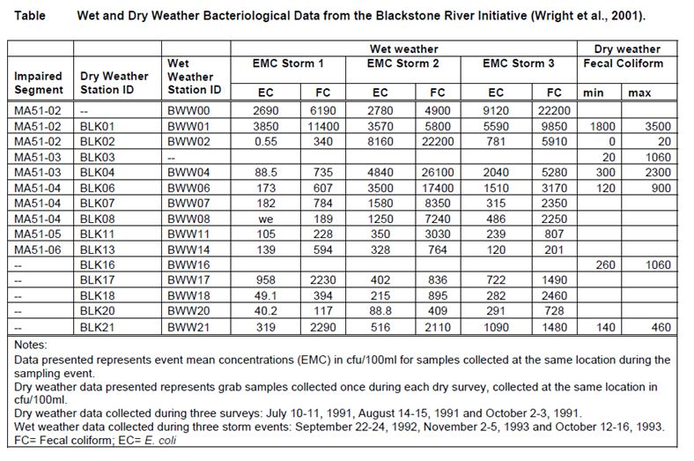
Additional Data
Additional data on seven of the segments described above have been provided by BRC. These data represents the most recent data collected at the time of the writing of this report, collected in fall 2004.
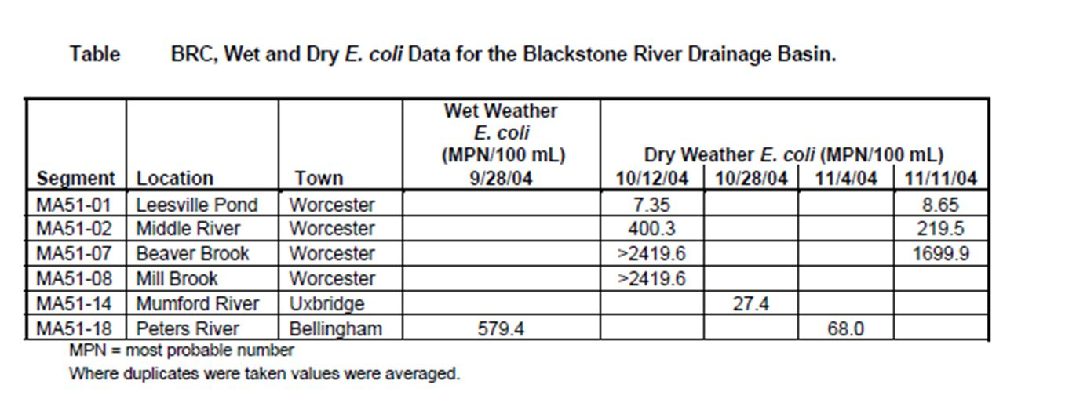
Potential Sources
The Blackstone River watershed has eleven segments, located throughout the watershed, that are listed as pathogen impaired requiring a TMDL. These segments represent 56.6% of the river miles assessed. Sources of indicator bacteria in the Blackstone River watershed are many and varied. A significant amount of work has been done in the last decade to improve the water quality in the Blackstone River watershed.
Largely through the efforts of the EPA, MADEP field staff and the Worcester Department of Public Works (DPW), numerous point and non-point sources of pathogens have been identified. The following table (originally Table 5-1 of “Draft Pathogen TMDL for the Blackstone River Watershed” report) summarizes the river segments impaired due to measured indicator bacteria densities and identifies some of the suspected and known sources described in past literature.
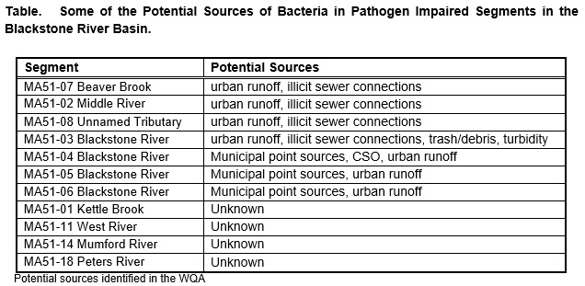
Some dry weather sources include:
1. leaking sewer pipes,
2. storm water drainage systems (illicit connections of sanitary sewers to storm drains),
3. failing septic systems,
4. recreational activities, and
5. wildlife, including birds.
Some wet weather sources include:
1. wildlife and domesticated animals (including pets),
2. storm water runoff including municipal separate storm sewer systems (MS4),
3. combined sewer overflows (CSOs), and
4. sanitary sewer overflows (SSOs).
It is difficult to provide accurate quantitative estimates of indicator bacteria contributions from the various sources in the Blackstone River watershed because many of the sources are diffuse and intermittent, and extremely difficult to monitor or accurately model. Therefore, a general level of quantification according to source category is provided (e.g., see the following tables; originally Tables 5-2 and 5-3 of “Draft Pathogen TMDL for the Blackstone River Watershed” report). This approach is suitable for the TMDL analysis because it indicates the magnitude of the sources and illustrates the need for controlling them. Additionally, many of the sources (failing septic systems, leaking sewer pipes, sanitary sewer overflows, and illicit sanitary sewer connections) are prohibited because they indicate a potential health risk and, therefore, must be eliminated. However, estimating the magnitude of overall indicator bacteria loading (the sum of all contributing sources) is achieved for wet and dry conditions using the extensive ambient data available that define baseline conditions (see segment summary tables and WQA).
Sanitary Waste
Leaking sewer pipes, illicit sewer connections, sanitary sewer overflows (SSOs), combined sewer overflows (CSOs) and failing septic systems represent a direct threat to public health since they result in discharge of partially treated or untreated human wastes to the surrounding environment. Quantifying these sources is extremely speculative without direct monitoring of the source because the magnitude is directly proportional to the volume of the source and its proximity to the surface water. Typical values of fecal coliform in untreated domestic wastewater range from 104 to 106 MPN/100mL.
Illicit sewer connections into storm drains result in direct discharges of sewage via the storm drainage system outfalls. The existence of illicit sewer connections to storm drains is well documented in many urban drainage systems, particularly older systems that may have once been combined. The Worcester DPW and MADEP and many towns in the Blackstone River watershed have been active in the identification and mitigation of these sources. Additionally, reductions of CSO discharges have decreased due to the $54 million dollar CSO abatement work in the Unnamed Tributary segment known as “Mill brook” (MA51-08). It is probable that numerous other illicit sewer connections exist in storm drainage systems serving the older developed portions of the basin.
Monitoring of storm drain outfalls during dry weather is needed to document the presence or absence of sewage in the drainage systems. Much of the Blackstone River watershed (47.47%) is classified as Urban Areas by the United States Census Bureau and is therefore subject to the Stormwater Phase II Final Rule that requires the development and implementation of an illicit discharge detection and elimination plan.
Septic systems designed, installed, operated and maintained in accordance with 310 CMR 15.000: Title 5, are not significant sources of fecal coliform bacteria. Studies demonstrate that wastewater located four feet below properly functioning septic systems contain on average less than one fecal coliform bacteria organism per 100 mL. Failed or non-conforming septic systems, however, can be a major contributor of fecal coliform to the Blackstone River and tributaries. Wastes from failing septic systems enter surface waters either as direct overland flow or via groundwater. Wet weather events typically increase the rate of transport of pollutant loadings from failing septic systems to surface waters because of the wash-off effect from runoff and the increased rate of groundwater recharge.
Recreational use of waterbodies is a source of pathogen contamination. Swimmers themselves may contribute to pathogen impairment at swimming areas. When swimmers enter the water, residual fecal matter may be washed from the body and contaminate the water with pathogens. In addition, small children in diapers may contribute to contamination of the recreational waters. These sources are likely to be particularly important when the number of swimmers is high and the flushing action of waves is low.
Wildlife and Pet Waste
Animals that are not pets can be a potential source of pathogens. Geese, gulls, and ducks are speculated to be a major pathogen source, particularly at lakes and storm water ponds where large resident populations have become established.
Household pets such as cats and dogs can be a substantial source of bacteria – as much as 23,000,000 colonies/gram. A rule of thumb estimate for the number of dogs is ~1 dog per 10 people producing an estimated 0.5 pound of feces per dog per day. Uncollected pet waste is then flushed from the parks, beaches and yards where pets are walked and transported into nearby waterways during wet-weather.
Storm Water
Storm water runoff is another significant contributor of pathogen pollution. As discussed above, during rain events fecal matter from domestic animals and wildlife are readily transported to surface waters via the storm water drainage systems and/or overland flow. The natural filtering capacity provided by vegetative cover and soils is dramatically reduced as urbanization occurs because of the increase in impervious areas (i.e., streets, parking lots, etc.) and stream channelization in the watershed.
Extensive storm water data have been collected and compiled both locally and nationally in an attempt to characterize the quality of storm water. Bacteria are easily the most variable of storm water pollutants, with concentrations often varying by factors of 10 to 100 during a single storm. Considering this variability, storm water bacteria concentrations are difficult to accurately predict. Caution must be exercised when using values from single wet weather grab samples to estimate the magnitude of bacteria loading because it is often unknown whether the sample is representative of the “true” mean.
To gain an understanding of the magnitude of bacterial loading from storm water and avoid overestimating or underestimating bacteria loading, event mean concentrations (EMC) are often used. An EMC is the concentration of a flow proportioned sample throughout a storm event. These samples are commonly collected using an automated sampler which can proportion sample aliquots based on flow. Typical storm water event mean densities for various indicator bacteria in a Massachusetts watershed and nationwide are provided in the tables above (“Lower Charles River Basin Storm Water Event Mean Bacteria Concentrations and Necessary Reductions to Meet Class B WQS” and “Storm Water Event Mean Fecal Coliform Concentrations and Necessary Reductions to Meet Class B WQS”). These EMCs illustrate that storm water indicator bacteria concentrations from certain land uses (i.e., residential) are typically at levels sufficient to cause water quality problems.

Ayres Associates 1993. Onsite Sewage Disposal Systems Research in Florida. The Capacity of Fine Sandy Soil for Septic Tank Effluent Treatment: A Field Investigation at an In-Situ Lysimeter Facility in Florida.
Center for Watershed Protection, 1999. Watershed Protection Techniques. Vol. 3, No. 1.
City of Worcester, DPW. 2000. Stormwater Management Plan Annual Report April 200. Department of Public Works, Worcester, MA.
EOEA 2003. Executive Office of Environmental Affairs (EOEA). Information from website. Last updated 2003, downloaded January 2005.
MADEP 2001. Blackstone River Basin 1998 Water Quality Assessment Report. Massachusetts Department of Environmental Protection, Division of Watershed Management. Worcester, Massachusetts. Available for download at http://www.mass.gov/dep/brp/wm/wqassess.htm
Metcalf and Eddy 1991. Wastewater Engineering: Treatment, Disposal, Reuse. Third Edition.
Tennant, P.A., P.R. Anderson and A.J. Screpetis 1975. Blackstone River 1973 Water Quality Analysis. Massachusetts Division of Pollution Control, Westborough, MA.
USEPA 1997. Urbanization of Streams: Studies of Hydrologic Impacts. EPA 841-R-97-009
Wright R.M., P.M. Nolan, D. Pincumbe, E. Hartman and O.J. Viator, 2001. Blackstone River Initiative: Water Quality Analysis of the Blackstone River Under Wet and Dry Weather Conditions. USEPA New England, Boston, MA.

Total Maximum Daily Loads of Phosphorus for Selected Northern Blackstone Lakes (MA51010 - Brierly Pond, MA51039 - Dorothy Pond, MA51071 - Howe Reservoir)
Waterbody Descriptions and Problem Assessment
Landuse information for each watershed is based on MassGIS digital maps derived from aerial photography taken in 1985. To account for changes in landuse, population growth rates are reported for towns closest to the lake. Population (census) data and estimated growth rates are from projections provided on the internet (www.umass.edu/miser/) by the Massachusetts Institute for Social and Economic Research (MISER) at the University of Massachusetts, Amherst.
Lake Descriptions
Brierly Pond, Millbury is approximately 18 acres in size and about 7 feet in depth. The watershed is 50 percent forested and most of the rest of the watershed is rural agriculture and water. Populations in Millbury ranged between 11,808 and 12,228 from 1980 to the 1990 census. Miser predictions on growth are 12,796 for the year 2000 and 12,962 for the year 2010 with an estimated 20 year growth rate of about 6 percent. The pond was assessed by DEP in the summer of 1994 and the assessment comments reported: "A 14 July 1994 synoptic survey indicates that there is 75% to 100% coverage of all types over approximately 25% of the pond (coves near access and the upper end). Otherwise uncertain of submerged vegetation below open water. The non-native Myriophyllum heterophyllum was present and threatens the aquatic life in approximately 13 acres of the pond. No other data was available to make additional assessments." An early DEP survey in 1979 reported a Secchi disk depth of 6 feet and a total phosphorus concentration of 0.08mg/l (note this is about the detection limit of the analysis at the time).
Dorothy Pond, Millbury is approximately 148 acres in size. The dominant landuses in the watershed are 44 percent urban, followed by 39 percent forest, with little agriculture or rural areas (about 10 percent). The remaining 7 percent of the watershed consists of water and wetlands. Much of the shoreline is lined with homes. The Massachusetts Turnpike (I-90) crosses the watershed. Population in the town has been described above. The pond was assessed by DEP in the summer of 1994 and the assessment comments reported: "Historically algal "blooms" reduce transparency to below the safety criteria (4 ft. Secchi disk). Synoptic survey on 19 July 1994 noted very turbid (green/grey) conditions (< 4 ft. Secchi disk depth) likely caused by a blue-green bloom. In addition, the nonnative macrophyte Myriophyllum spicatum was observed in the pond. Otherwise, no current data available to make additional assessments."
Howe Reservoir, Millbury is approximately 13 acres in size. The watershed is 58 percent forested with 21 percent open land and about 15 percent is in the urban landuse category. Much of the open land includes the Clear View Country Club golf course located upstream. The remaining 6 percent of the watershed is water and wetlands. Population in the town has been described above. The pond was assessed by DEP in the summer of 1994 and the assessment comments reported: "A 14 July 1994 synoptic survey indicates that there were encroaching emergent over approximately one quarter of the pond. There was 75% to 100% density in patches of floating leaves over about one half of the open water. The density of the submergents was uncertain. No other data was available to make assessments."
Pollutant Sources and Background:
Unfortunately, no detailed study of the nutrient sources within the watersheds has been conducted to date. Thus, nutrient sources were estimated based on land use modeling within the DEP’s NPSLAKE model as discussed below. The NPSLAKE model was designed to estimate watershed loading rates of phosphorus to lakes. A brief description of the NPSLAKE model and data inputs is given here. MassGIS digital maps of land use within the watershed were used to calculate areas of landuse within three major types: Forest, rural and urban landuse. This model takes the area in hectares of land use within each of three categories and applies an export coefficient to each to predict the annual external loading of phosphorus to the lake from the watershed. Because much of the landuse data is based on old (1985) aerial photographs, the current landuses within the watershed may be different today. This can be important in the development of the TMDL because different landuses can result in different phosphorus loadings to the waterbody in question. For many rural areas, landuse changes often result in conversion of open or agricultural lands to low density housing, in which case, the export coefficients of the NPSLAKE model are the same and no change in loading is predicted to occur. However, in cases where development changes forests to residential areas or rural landuses to urban landuses, phosphorus loadings are predicted to increase. In some cases, loadings are predicted to decrease if additional agricultural land is abandoned and forest regrowth occurs. To account for this uncertainty in landuse changes, a conservative target is chosen (see below). In addition, the MassGIS landuse maps are scheduled to be updated with current aerial photos and the TMDL can be modified as additional information is obtained.
Other phosphorus sources, such as septic system inputs of phosphorus, are estimated from an export coefficient multiplied by the number of homes within 100 meters of the lake. Point sources are estimated manually based on discharge information and site specific information for uptake and storage. Other sources such as atmospheric deposition to lakes was determined to be small and not significant in the NPSLAKE model, perhaps because lakes tend to be sinks rather than sources of phosphorus (Mattson and Isaac, 1999). For similar reasons wetlands were also not considered to be significant sources of phosphorus following (see discussion and references in Mattson and Isaac, 1999). Other, non-landuse sources of phosphorus such as inputs from waterfowl were not included, but can be added as additional information becomes available. If large numbers of waterfowl are using the lake the total phosphorus budget may be an underestimate, and control measures should be considered. Internal sources (recycling) of phosphorus is not included because it is not considered as a net external load to the lake, but rather a seasonal recycling of phosphorus already present in the lake. In cases where this internal source is large it may result in surface concentrations higher than predicted from landuse loading models and may contribute to water quality violations during the critical summer period. As additional monitoring data become available, these lakes will be assessed for internal contributions and possibly control of these sources by alum or other means. The major sources according to the land use analysis are shown for the lake of interest in the following table (originally part of Table 2 of “Total Maximum Daily Loads of Phosphorus for Selected Northern Blackstone Lakes” report, 2002).

The NPSLAKE model assumes land uses are accurately represented by the MassGIS digital maps and that land use has not changed appreciably since the maps were compiled in 1985. The predicted loading is based on the equation:
P Loading (kg/yr)= 0.5* septics + 0.13* forest ha + 0.3* rural ha + 14* (urban ha)^0.5
The coefficients of the model are based on a combination of values estimated with the aid of multiple regression on a Massachusetts data set and of typical values reported in previous diagnostic/feasibility studies in Massachusetts.
All coefficients fall within the range of values reported in other studies. The overall standard error of the model is approximately 172 kg/yr. If not data is available for internal loading a rough estimate of the magnitude of this sources can be estimated by substitution of the in-lake concentration for TP. The difference in predicted loadings from this approach and the landuse approach is the best estimate of internal loading.
The NPSLAKE model also generates predictions of estimated yearly average water runoff to the lake based on total watershed area and runoff maps of Massachusetts.
Because of the general nature of the landuse loading approach, natural background is included in land use-based export coefficients. Natural background can be estimated based on the forest export coefficient of 0.13 kg/ha/yr multiplied by the hectares of the watershed assuming the watershed to be entirely forested. Without site specific information regarding soil phosphorus and natural erosion rates the accuracy of this estimate would be uncertain and would add little value to the analysis.
There were three NPDES point sources listed in the watersheds of some of the lakes, but further investigation revealed they are no longer official point sources, or in one case will no longer be a point source within two months. The one major industrial discharger (Worcester Spinning and Finishing) has since closed after the factory burned down and it is not expected to reopen. A small wastewater point source for Nazzareth Home for Boys is currently being tied into the sewer system of the Leicester Water District with work expected to be completed within two months. The remaining NPDES site was a general permit for Browning Ferris Industries Inc (BFI) which is now covered under an EPA Muti-Sector Permit and is not considered as a point source in this analysis but is included as industrial (urban) landuse in the model.
Reckhow, K.H. 1979. Uncertainty Analysis Applied to Vollenweider's Phosphorus Loading Criteria. J. Water Poll. Control Fed. 51(8):2123-2128
Mattson, M.D. and R.A. Isaac. 1999. Calibration of Phosphorus Export coefficients for Total Maximum Daily Loads of Massachusetts Lakes. Lake and Reservoir Man. 15(3):209-219.
Reckhow, K.H., M.N. Beaulac, J.T. Simpson. 1980. Modeling Phosphorus Loading and Lake Response Under Uncertainty: A Manual and Compilation of Export Coefficients. U.S.E.P.A. Washington DC. EPA 440/5-80-011.

Total Maximum Daily Loads of Phosphorus for Selected Northern Blackstone Lakes (MA51010 - Brierly Pond, MA51039 - Dorothy Pond, MA51071 - Howe Reservoir)
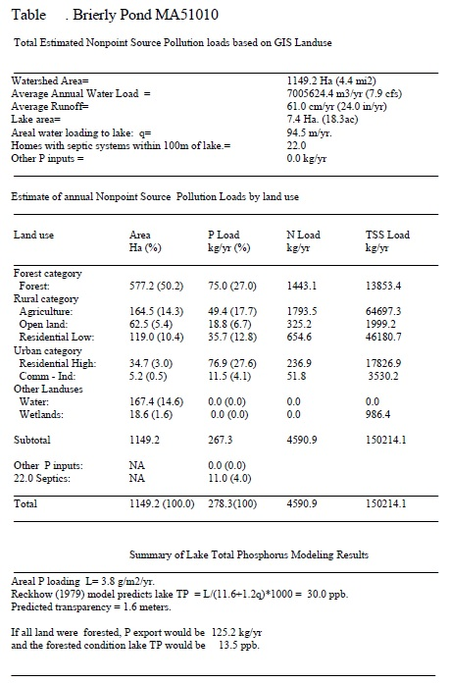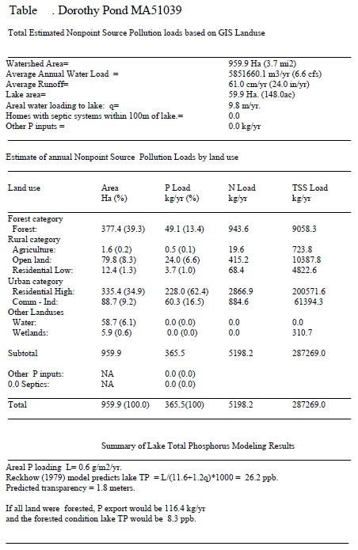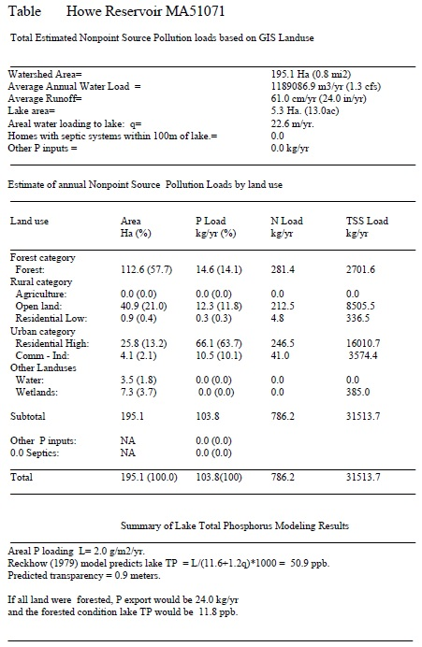

Appendix B – Water Quality Impairments
2012 MA Integrated List of Waters Categories
Integrated List Category | Description
1 | Unimpaired and not threatened for all designated uses.
2 | Unimpaired for some uses and not assessed for others.
3 | Insufficient information to make assessments for any uses.
4 | Impaired or threatened for one or more uses, but not requiring calculation of a Total Maximum Daily Load (TMDL), including:  4a: TMDL is completed  4b: Impairment controlled by alternative pollution control requirements  4c: Impairment not caused by a pollutant - TMDL not required
5 | Impaired or threatened for one or more uses and requiring preparation of a TMDL.

Water Quality Impairments
MS4 Subwatershed #: MILLBURY_01
Assessment  Unit ID | Waterbody | Integrated  List  Category | Designated Use | Impairment Cause | Impairment Source
MA51-03 | Blackstone River | 5 | Aesthetic | Debris/Floatables/Trash | Unspecified Urban Stormwater
MA51-03 | Blackstone River | 5 | Aesthetic | Excess Algal Growth | Unspecified Urban Stormwater
MA51-03 | Blackstone River | 5 | Aesthetic | Foam/Flocs/Scum/Oil Slicks
MA51-03 | Blackstone River | 5 | Aesthetic | Taste and Odor
MA51-03 | Blackstone River | 5 | Aesthetic | Turbidity | Municipal Point Source Discharges
MA51-03 | Blackstone River | 5 | Aesthetic | Turbidity | Unspecified Urban Stormwater
MA51-03 | Blackstone River | 5 | Aesthetic | Turbidity | Wet Weather Discharges (Point Source and Combination of Stormwater, SSO or CSO)
MA51-03 | Blackstone River | 5 | Fish, other Aquatic Life and Wildlife | Ambient Bioassays -- Chronic Aquatic Toxicity | Municipal Point Source Discharges
MA51-03 | Blackstone River | 5 | Fish, other Aquatic Life and Wildlife | Ambient Bioassays -- Chronic Aquatic Toxicity | Source Unknown
MA51-03 | Blackstone River | 5 | Fish, other Aquatic Life and Wildlife | Ambient Bioassays -- Chronic Aquatic Toxicity | Unspecified Urban Stormwater
MA51-03 | Blackstone River | 5 | Fish, other Aquatic Life and Wildlife | Ambient Bioassays -- Chronic Aquatic Toxicity | Wet Weather Discharges (Point Source and Combination of Stormwater, SSO or CSO)
MA51-03 | Blackstone River | 5 | Fish, other Aquatic Life and Wildlife | Aquatic Macroinvertebrate Bioassessments | Channelization
MA51-03 | Blackstone River | 5 | Fish, other Aquatic Life and Wildlife | Aquatic Macroinvertebrate Bioassessments | Combined Sewer Overflows
MA51-03 | Blackstone River | 5 | Fish, other Aquatic Life and Wildlife | Aquatic Macroinvertebrate Bioassessments | Highways, Roads, Bridges, Infrastructure (New Construction)
MA51-03 | Blackstone River | 5 | Fish, other Aquatic Life and Wildlife | Aquatic Macroinvertebrate Bioassessments | Municipal Point Source Discharges
MA51-03 | Blackstone River | 5 | Fish, other Aquatic Life and Wildlife | Aquatic Macroinvertebrate Bioassessments | Unspecified Urban Stormwater
MA51-03 | Blackstone River | 5 | Fish, other Aquatic Life and Wildlife | Fishes Bioassessments | Channelization
MA51-03 | Blackstone River | 5 | Fish, other Aquatic Life and Wildlife | Fishes Bioassessments | Combined Sewer Overflows
MA51-03 | Blackstone River | 5 | Fish, other Aquatic Life and Wildlife | Fishes Bioassessments | Habitat Modification - other than Hydromodification
MA51-03 | Blackstone River | 5 | Fish, other Aquatic Life and Wildlife | Fishes Bioassessments | Highways, Roads, Bridges, Infrastructure (New Construction)
MA51-03 | Blackstone River | 5 | Fish, other Aquatic Life and Wildlife | Fishes Bioassessments | Municipal Point Source Discharges
MA51-03 | Blackstone River | 5 | Fish, other Aquatic Life and Wildlife | Fishes Bioassessments | Wet Weather Discharges (Point Source and Combination of Stormwater, SSO or CSO)
MA51-03 | Blackstone River | 5 | Fish, other Aquatic Life and Wildlife | Lead | Municipal Point Source Discharges
MA51-03 | Blackstone River | 5 | Fish, other Aquatic Life and Wildlife | Lead | Source Unknown
MA51-03 | Blackstone River | 5 | Fish, other Aquatic Life and Wildlife | Lead | Unspecified Urban Stormwater
MA51-03 | Blackstone River | 5 | Fish, other Aquatic Life and Wildlife | Lead | Wet Weather Discharges (Point Source and Combination of Stormwater, SSO or CSO)
MA51-03 | Blackstone River | 5 | Fish, other Aquatic Life and Wildlife | Nutrient/Eutrophication Biological Indicators | Municipal Point Source Discharges
MA51-03 | Blackstone River | 5 | Fish, other Aquatic Life and Wildlife | Nutrient/Eutrophication Biological Indicators | Source Unknown
MA51-03 | Blackstone River | 5 | Fish, other Aquatic Life and Wildlife | Nutrient/Eutrophication Biological Indicators | Unspecified Urban Stormwater
MA51-03 | Blackstone River | 5 | Fish, other Aquatic Life and Wildlife | Nutrient/Eutrophication Biological Indicators | Wet Weather Discharges (Point Source and Combination of Stormwater, SSO or CSO)
MA51-03 | Blackstone River | 5 | Fish, other Aquatic Life and Wildlife | Other | Combined Sewer Overflows
MA51-03 | Blackstone River | 5 | Fish, other Aquatic Life and Wildlife | Other | Municipal Point Source Discharges
MA51-03 | Blackstone River | 5 | Fish, other Aquatic Life and Wildlife | Other | Source Unknown
MA51-03 | Blackstone River | 5 | Fish, other Aquatic Life and Wildlife | Other | Unspecified Urban Stormwater
MA51-03 | Blackstone River | 5 | Fish, other Aquatic Life and Wildlife | Other flow regime alterations | Habitat Modification - other than Hydromodification
MA51-03 | Blackstone River | 5 | Fish, other Aquatic Life and Wildlife | Other flow regime alterations | Highways, Roads, Bridges, Infrastructure (New Construction)
MA51-03 | Blackstone River | 5 | Fish, other Aquatic Life and Wildlife | Other flow regime alterations | Unspecified Urban Stormwater
MA51-03 | Blackstone River | 5 | Fish, other Aquatic Life and Wildlife | Oxygen, Dissolved | Municipal Point Source Discharges
MA51-03 | Blackstone River | 5 | Fish, other Aquatic Life and Wildlife | Oxygen, Dissolved | Source Unknown
MA51-03 | Blackstone River | 5 | Fish, other Aquatic Life and Wildlife | Oxygen, Dissolved | Unspecified Urban Stormwater
MA51-03 | Blackstone River | 5 | Fish, other Aquatic Life and Wildlife | Oxygen, Dissolved | Wet Weather Discharges (Point Source and Combination of Stormwater, SSO or CSO)
MA51-03 | Blackstone River | 5 | Fish, other Aquatic Life and Wildlife | Phosphorus (Total) | Municipal Point Source Discharges
MA51-03 | Blackstone River | 5 | Fish, other Aquatic Life and Wildlife | Phosphorus (Total) | Source Unknown
MA51-03 | Blackstone River | 5 | Fish, other Aquatic Life and Wildlife | Phosphorus (Total) | Unspecified Urban Stormwater
MA51-03 | Blackstone River | 5 | Fish, other Aquatic Life and Wildlife | Phosphorus (Total) | Wet Weather Discharges (Point Source and Combination of Stormwater, SSO or CSO)
MA51-03 | Blackstone River | 5 | Fish, other Aquatic Life and Wildlife | Physical substrate habitat alterations | Habitat Modification - other than Hydromodification
MA51-03 | Blackstone River | 5 | Fish, other Aquatic Life and Wildlife | Physical substrate habitat alterations | Highways, Roads, Bridges, Infrastructure (New Construction)
MA51-03 | Blackstone River | 5 | Fish, other Aquatic Life and Wildlife | Physical substrate habitat alterations | Unspecified Urban Stormwater
MA51-03 | Blackstone River | 5 | Fish, other Aquatic Life and Wildlife | Sedimentation/Siltation | Habitat Modification - other than Hydromodification
MA51-03 | Blackstone River | 5 | Fish, other Aquatic Life and Wildlife | Sedimentation/Siltation | Highways, Roads, Bridges, Infrastructure (New Construction)
MA51-03 | Blackstone River | 5 | Fish, other Aquatic Life and Wildlife | Sedimentation/Siltation | Unspecified Urban Stormwater
MA51-03 | Blackstone River | 5 | Primary Contact Recreation | Debris/Floatables/Trash | Unspecified Urban Stormwater
MA51-03 | Blackstone River | 5 | Primary Contact Recreation | Escherichia coli | Illicit Connections/Hook-ups to Storm Sewers
MA51-03 | Blackstone River | 5 | Primary Contact Recreation | Escherichia coli | Municipal Point Source Discharges
MA51-03 | Blackstone River | 5 | Primary Contact Recreation | Escherichia coli | Unspecified Urban Stormwater
MA51-03 | Blackstone River | 5 | Primary Contact Recreation | Escherichia coli | Wet Weather Discharges (Point Source and Combination of Stormwater, SSO or CSO)
MA51-03 | Blackstone River | 5 | Primary Contact Recreation | Excess Algal Growth | Unspecified Urban Stormwater
MA51-03 | Blackstone River | 5 | Primary Contact Recreation | Foam/Flocs/Scum/Oil Slicks | Unspecified Urban Stormwater
MA51-03 | Blackstone River | 5 | Primary Contact Recreation | Turbidity | Unspecified Urban Stormwater
MA51-03 | Blackstone River | 5 | Secondary Contact Recreation | Debris/Floatables/Trash | Unspecified Urban Stormwater
MA51-03 | Blackstone River | 5 | Secondary Contact Recreation | Escherichia coli | Illicit Connections/Hook-ups to Storm Sewers
MA51-03 | Blackstone River | 5 | Secondary Contact Recreation | Escherichia coli | Municipal Point Source Discharges
MA51039 | Dorothy Pond | 4A | Aesthetic | Turbidity | Source Unknown
MA51039 | Dorothy Pond | 4A | Fish, other Aquatic Life and Wildlife | Eurasian Water Milfoil, Myriophyllum spicatum | Introduction of Non-native Organisms (Accidental or Intentional)
MA51039 | Dorothy Pond | 4A | Fish, other Aquatic Life and Wildlife | Non-Native Aquatic Plants | Introduction of Non-native Organisms (Accidental or Intentional)
MA51039 | Dorothy Pond | 4A | Primary Contact Recreation | Turbidity | Source Unknown
MA51039 | Dorothy Pond | 4A | Secondary Contact Recreation | Turbidity | Source Unknown
MA51070 | Howe Reservoirs | 4C | Aesthetic | Low flow alterations | Source Unknown
MA51070 | Howe Reservoirs | 4C | Fish, other Aquatic Life and Wildlife | Low flow alterations | Source Unknown
MA51070 | Howe Reservoirs | 4C | Fish, other Aquatic Life and Wildlife | Non-Native Aquatic Plants | Introduction of Non-native Organisms (Accidental or Intentional)
MA51070 | Howe Reservoirs | 4C | Primary Contact Recreation | Low flow alterations | Source Unknown
MA51070 | Howe Reservoirs | 4C | Secondary Contact Recreation | Low flow alterations | Source Unknown
MA51071 | Howe Reservoirs | 4A | Aesthetic | Aquatic Plants (Macrophytes) | Source Unknown
MA51071 | Howe Reservoirs | 4A | Primary Contact Recreation | Aquatic Plants (Macrophytes) | Source Unknown
MA51071 | Howe Reservoirs | 4A | Secondary Contact Recreation | Aquatic Plants (Macrophytes) | Source Unknown
MA51-03 | Blackstone River | 5 | Secondary Contact Recreation | Escherichia coli | Unspecified Urban Stormwater
MA51-03 | Blackstone River | 5 | Secondary Contact Recreation | Escherichia coli | Wet Weather Discharges (Point Source and Combination of Stormwater, SSO or CSO)
MA51-03 | Blackstone River | 5 | Secondary Contact Recreation | Excess Algal Growth | Unspecified Urban Stormwater
MA51-03 | Blackstone River | 5 | Secondary Contact Recreation | Foam/Flocs/Scum/Oil Slicks
MA51-03 | Blackstone River | 5 | Secondary Contact Recreation | Taste and Odor | Unspecified Urban Stormwater
MA51-03 | Blackstone River | 5 | Secondary Contact Recreation | Turbidity | Unspecified Urban Stormwater
MA51137 | Riverlin Street Pond | 4C | Aesthetic | Non-Native Aquatic Plants | Introduction of Non-native Organisms (Accidental or Intentional)
MA51137 | Riverlin Street Pond | 4C | Fish, other Aquatic Life and Wildlife | Non-Native Aquatic Plants | Introduction of Non-native Organisms (Accidental or Intentional)
MA51137 | Riverlin Street Pond | 4C | Primary Contact Recreation | Non-Native Aquatic Plants | Introduction of Non-native Organisms (Accidental or Intentional)
MA51137 | Riverlin Street Pond | 4C | Secondary Contact Recreation | Non-Native Aquatic Plants | Introduction of Non-native Organisms (Accidental or Intentional)
MA51186 | Woolshop Pond | 5 | Aesthetic | Aquatic Plants (Macrophytes) | Source Unknown
MA51186 | Woolshop Pond | 5 | Aesthetic | Non-Native Aquatic Plants | Introduction of Non-native Organisms (Accidental or Intentional)
MA51186 | Woolshop Pond | 5 | Aesthetic | Turbidity | Source Unknown
MA51186 | Woolshop Pond | 5 | Fish, other Aquatic Life and Wildlife | Non-Native Aquatic Plants | Introduction of Non-native Organisms (Accidental or Intentional)
MA51186 | Woolshop Pond | 5 | Primary Contact Recreation | Aquatic Plants (Macrophytes) | Source Unknown
MA51186 | Woolshop Pond | 5 | Primary Contact Recreation | Non-Native Aquatic Plants | Introduction of Non-native Organisms (Accidental or Intentional)
MA51186 | Woolshop Pond | 5 | Primary Contact Recreation | Turbidity | Source Unknown
MA51186 | Woolshop Pond | 5 | Secondary Contact Recreation | Aquatic Plants (Macrophytes) | Source Unknown
MA51186 | Woolshop Pond | 5 | Secondary Contact Recreation | Non-Native Aquatic Plants | Introduction of Non-native Organisms (Accidental or Intentional)
MA51186 | Woolshop Pond | 5 | Secondary Contact Recreation | Turbidity | Source Unknown

MS4 Subwatershed #: MILLBURY_05
Assessment  Unit ID | Waterbody | Integrated  List  Category | Designated Use | Impairment Cause | Impairment Source
MA51152 | Singletary Pond | 4C | Fish, other Aquatic Life and Wildlife | Eurasian Water Milfoil, Myriophyllum spicatum | Introduction of Non-native Organisms (Accidental or Intentional)
MA51-31 | Singletary Brook | 5 | Aesthetic | Aquatic Plants (Macrophytes) | Source Unknown
MA51152 | Singletary Pond | 4C | Fish, other Aquatic Life and Wildlife | Non-Native Aquatic Plants | Introduction of Non-native Organisms (Accidental or Intentional)
MA51-31 | Singletary Brook | 5 | Fish, other Aquatic Life and Wildlife | Non-Native Aquatic Plants | Introduction of Non-native Organisms (Accidental or Intentional)
MA51-31 | Singletary Brook | 5 | Primary Contact Recreation | Aquatic Plants (Macrophytes) | Source Unknown
MA51-31 | Singletary Brook | 5 | Secondary Contact Recreation | Aquatic Plants (Macrophytes) | Source Unknown

MS4 Subwatershed #: MILLBURY_06
Assessment  Unit ID | Waterbody | Integrated  List  Category | Designated Use | Impairment Cause | Impairment Source
MA51-03 | Blackstone River | 5 | Secondary Contact Recreation | Turbidity | Unspecified Urban Stormwater
MA51-03 | Blackstone River | 5 | Secondary Contact Recreation | Taste and Odor | Unspecified Urban Stormwater
MA51-03 | Blackstone River | 5 | Secondary Contact Recreation | Foam/Flocs/Scum/Oil Slicks
MA51-03 | Blackstone River | 5 | Secondary Contact Recreation | Excess Algal Growth | Unspecified Urban Stormwater
MA51-03 | Blackstone River | 5 | Secondary Contact Recreation | Escherichia coli | Wet Weather Discharges (Point Source and Combination of Stormwater, SSO or CSO)
MA51-03 | Blackstone River | 5 | Secondary Contact Recreation | Escherichia coli | Unspecified Urban Stormwater
MA51-03 | Blackstone River | 5 | Secondary Contact Recreation | Escherichia coli | Municipal Point Source Discharges
MA51-03 | Blackstone River | 5 | Secondary Contact Recreation | Escherichia coli | Illicit Connections/Hook-ups to Storm Sewers
MA51-03 | Blackstone River | 5 | Secondary Contact Recreation | Debris/Floatables/Trash | Unspecified Urban Stormwater
MA51-03 | Blackstone River | 5 | Primary Contact Recreation | Turbidity | Unspecified Urban Stormwater
MA51-03 | Blackstone River | 5 | Primary Contact Recreation | Foam/Flocs/Scum/Oil Slicks | Unspecified Urban Stormwater
MA51-03 | Blackstone River | 5 | Primary Contact Recreation | Excess Algal Growth | Unspecified Urban Stormwater
MA51-03 | Blackstone River | 5 | Primary Contact Recreation | Escherichia coli | Wet Weather Discharges (Point Source and Combination of Stormwater, SSO or CSO)
MA51-03 | Blackstone River | 5 | Primary Contact Recreation | Escherichia coli | Unspecified Urban Stormwater
MA51-03 | Blackstone River | 5 | Primary Contact Recreation | Escherichia coli | Municipal Point Source Discharges
MA51-03 | Blackstone River | 5 | Primary Contact Recreation | Escherichia coli | Illicit Connections/Hook-ups to Storm Sewers
MA51-03 | Blackstone River | 5 | Primary Contact Recreation | Debris/Floatables/Trash | Unspecified Urban Stormwater
MA51-03 | Blackstone River | 5 | Fish, other Aquatic Life and Wildlife | Sedimentation/Siltation | Unspecified Urban Stormwater
MA51-03 | Blackstone River | 5 | Fish, other Aquatic Life and Wildlife | Sedimentation/Siltation | Highways, Roads, Bridges, Infrastructure (New Construction)
MA51-03 | Blackstone River | 5 | Fish, other Aquatic Life and Wildlife | Sedimentation/Siltation | Habitat Modification - other than Hydromodification
MA51-03 | Blackstone River | 5 | Fish, other Aquatic Life and Wildlife | Physical substrate habitat alterations | Unspecified Urban Stormwater
MA51-03 | Blackstone River | 5 | Fish, other Aquatic Life and Wildlife | Physical substrate habitat alterations | Highways, Roads, Bridges, Infrastructure (New Construction)
MA51-03 | Blackstone River | 5 | Fish, other Aquatic Life and Wildlife | Physical substrate habitat alterations | Habitat Modification - other than Hydromodification
MA51-03 | Blackstone River | 5 | Fish, other Aquatic Life and Wildlife | Phosphorus (Total) | Wet Weather Discharges (Point Source and Combination of Stormwater, SSO or CSO)
MA51-03 | Blackstone River | 5 | Fish, other Aquatic Life and Wildlife | Phosphorus (Total) | Unspecified Urban Stormwater
MA51-03 | Blackstone River | 5 | Fish, other Aquatic Life and Wildlife | Phosphorus (Total) | Source Unknown
MA51-03 | Blackstone River | 5 | Fish, other Aquatic Life and Wildlife | Phosphorus (Total) | Municipal Point Source Discharges
MA51-03 | Blackstone River | 5 | Fish, other Aquatic Life and Wildlife | Oxygen, Dissolved | Wet Weather Discharges (Point Source and Combination of Stormwater, SSO or CSO)
MA51-03 | Blackstone River | 5 | Fish, other Aquatic Life and Wildlife | Oxygen, Dissolved | Unspecified Urban Stormwater
MA51-03 | Blackstone River | 5 | Fish, other Aquatic Life and Wildlife | Oxygen, Dissolved | Source Unknown
MA51-03 | Blackstone River | 5 | Fish, other Aquatic Life and Wildlife | Oxygen, Dissolved | Municipal Point Source Discharges
MA51-03 | Blackstone River | 5 | Fish, other Aquatic Life and Wildlife | Other flow regime alterations | Unspecified Urban Stormwater
MA51-03 | Blackstone River | 5 | Fish, other Aquatic Life and Wildlife | Other flow regime alterations | Highways, Roads, Bridges, Infrastructure (New Construction)
MA51-03 | Blackstone River | 5 | Fish, other Aquatic Life and Wildlife | Other flow regime alterations | Habitat Modification - other than Hydromodification
MA51-03 | Blackstone River | 5 | Fish, other Aquatic Life and Wildlife | Other | Unspecified Urban Stormwater
MA51-03 | Blackstone River | 5 | Fish, other Aquatic Life and Wildlife | Other | Source Unknown
MA51-03 | Blackstone River | 5 | Fish, other Aquatic Life and Wildlife | Other | Municipal Point Source Discharges
MA51-03 | Blackstone River | 5 | Fish, other Aquatic Life and Wildlife | Other | Combined Sewer Overflows
MA51-03 | Blackstone River | 5 | Fish, other Aquatic Life and Wildlife | Nutrient/Eutrophication Biological Indicators | Wet Weather Discharges (Point Source and Combination of Stormwater, SSO or CSO)
MA51-03 | Blackstone River | 5 | Fish, other Aquatic Life and Wildlife | Nutrient/Eutrophication Biological Indicators | Unspecified Urban Stormwater
MA51-03 | Blackstone River | 5 | Fish, other Aquatic Life and Wildlife | Nutrient/Eutrophication Biological Indicators | Source Unknown
MA51-03 | Blackstone River | 5 | Fish, other Aquatic Life and Wildlife | Nutrient/Eutrophication Biological Indicators | Municipal Point Source Discharges
MA51-03 | Blackstone River | 5 | Fish, other Aquatic Life and Wildlife | Lead | Wet Weather Discharges (Point Source and Combination of Stormwater, SSO or CSO)
MA51-03 | Blackstone River | 5 | Fish, other Aquatic Life and Wildlife | Lead | Unspecified Urban Stormwater
MA51-03 | Blackstone River | 5 | Fish, other Aquatic Life and Wildlife | Lead | Source Unknown
MA51-03 | Blackstone River | 5 | Fish, other Aquatic Life and Wildlife | Lead | Municipal Point Source Discharges
MA51-03 | Blackstone River | 5 | Fish, other Aquatic Life and Wildlife | Fishes Bioassessments | Wet Weather Discharges (Point Source and Combination of Stormwater, SSO or CSO)
MA51-03 | Blackstone River | 5 | Fish, other Aquatic Life and Wildlife | Fishes Bioassessments | Municipal Point Source Discharges
MA51-03 | Blackstone River | 5 | Fish, other Aquatic Life and Wildlife | Fishes Bioassessments | Highways, Roads, Bridges, Infrastructure (New Construction)
MA51-03 | Blackstone River | 5 | Fish, other Aquatic Life and Wildlife | Fishes Bioassessments | Habitat Modification - other than Hydromodification
MA51-03 | Blackstone River | 5 | Fish, other Aquatic Life and Wildlife | Fishes Bioassessments | Combined Sewer Overflows
MA51-03 | Blackstone River | 5 | Fish, other Aquatic Life and Wildlife | Fishes Bioassessments | Channelization
MA51-03 | Blackstone River | 5 | Fish, other Aquatic Life and Wildlife | Aquatic Macroinvertebrate Bioassessments | Unspecified Urban Stormwater
MA51-03 | Blackstone River | 5 | Fish, other Aquatic Life and Wildlife | Aquatic Macroinvertebrate Bioassessments | Municipal Point Source Discharges
MA51-03 | Blackstone River | 5 | Fish, other Aquatic Life and Wildlife | Aquatic Macroinvertebrate Bioassessments | Highways, Roads, Bridges, Infrastructure (New Construction)
MA51-03 | Blackstone River | 5 | Fish, other Aquatic Life and Wildlife | Aquatic Macroinvertebrate Bioassessments | Combined Sewer Overflows
MA51-03 | Blackstone River | 5 | Fish, other Aquatic Life and Wildlife | Aquatic Macroinvertebrate Bioassessments | Channelization
MA51-03 | Blackstone River | 5 | Fish, other Aquatic Life and Wildlife | Ambient Bioassays -- Chronic Aquatic Toxicity | Wet Weather Discharges (Point Source and Combination of Stormwater, SSO or CSO)
MA51-03 | Blackstone River | 5 | Fish, other Aquatic Life and Wildlife | Ambient Bioassays -- Chronic Aquatic Toxicity | Unspecified Urban Stormwater
MA51-03 | Blackstone River | 5 | Fish, other Aquatic Life and Wildlife | Ambient Bioassays -- Chronic Aquatic Toxicity | Source Unknown
MA51-03 | Blackstone River | 5 | Fish, other Aquatic Life and Wildlife | Ambient Bioassays -- Chronic Aquatic Toxicity | Municipal Point Source Discharges
MA51-03 | Blackstone River | 5 | Aesthetic | Turbidity | Wet Weather Discharges (Point Source and Combination of Stormwater, SSO or CSO)
MA51-03 | Blackstone River | 5 | Aesthetic | Turbidity | Unspecified Urban Stormwater
MA51-03 | Blackstone River | 5 | Aesthetic | Turbidity | Municipal Point Source Discharges
MA51-03 | Blackstone River | 5 | Aesthetic | Taste and Odor
MA51-03 | Blackstone River | 5 | Aesthetic | Foam/Flocs/Scum/Oil Slicks
MA51-03 | Blackstone River | 5 | Aesthetic | Excess Algal Growth | Unspecified Urban Stormwater
MA51-03 | Blackstone River | 5 | Aesthetic | Debris/Floatables/Trash | Unspecified Urban Stormwater

MS4 Subwatershed #: MILLBURY_07
Assessment  Unit ID | Waterbody | Integrated  List  Category | Designated Use | Impairment Cause | Impairment Source
MA51010 | Brierly Pond | 4A | Aesthetic | Aquatic Plants (Macrophytes) | Source Unknown
MA51010 | Brierly Pond | 4A | Fish, other Aquatic Life and Wildlife | Non-Native Aquatic Plants | Introduction of Non-native Organisms (Accidental or Intentional)
MA51010 | Brierly Pond | 4A | Primary Contact Recreation | Aquatic Plants (Macrophytes) | Source Unknown
MA51010 | Brierly Pond | 4A | Secondary Contact Recreation | Aquatic Plants (Macrophytes) | Source Unknown
MA51152 | Singletary Pond | 4C | Fish, other Aquatic Life and Wildlife | Eurasian Water Milfoil, Myriophyllum spicatum | Introduction of Non-native Organisms (Accidental or Intentional)
MA51-31 | Singletary Brook | 5 | Secondary Contact Recreation | Aquatic Plants (Macrophytes) | Source Unknown
MA51-31 | Singletary Brook | 5 | Primary Contact Recreation | Aquatic Plants (Macrophytes) | Source Unknown
MA51-31 | Singletary Brook | 5 | Fish, other Aquatic Life and Wildlife | Non-Native Aquatic Plants | Introduction of Non-native Organisms (Accidental or Intentional)
MA51152 | Singletary Pond | 4C | Fish, other Aquatic Life and Wildlife | Non-Native Aquatic Plants | Introduction of Non-native Organisms (Accidental or Intentional)
MA51-31 | Singletary Brook | 5 | Aesthetic | Aquatic Plants (Macrophytes) | Source Unknown

Appendix C – Pollutant Load Export Rates (PLERs)

Land Use & Cover¹ | PLERs (lb/acre/year)
 | (TP) | (TSS) | (TN)
AGRICULTURE, HSG A | 0.45 | 7.14 | 2.59
AGRICULTURE, HSG B | 0.45 | 29.4 | 2.59
AGRICULTURE, HSG C | 0.45 | 59.8 | 2.59
AGRICULTURE, HSG D | 0.45 | 91.0 | 2.59
AGRICULTURE, IMPERVIOUS | 1.52 | 650 | 11.3
COMMERCIAL, HSG A | 0.03 | 7.14 | 0.27
COMMERCIAL, HSG B | 0.12 | 29.4 | 1.16
COMMERCIAL, HSG C | 0.21 | 59.8 | 2.41
COMMERCIAL, HSG D | 0.37 | 91.0 | 3.66
COMMERCIAL, IMPERVIOUS | 1.78 | 377 | 15.1
FOREST, HSG A | 0.12 | 7.14 | 0.54
FOREST, HSG B | 0.12 | 29.4 | 0.54
FOREST, HSG C | 0.12 | 59.8 | 0.54
FOREST, HSG D | 0.12 | 91.0 | 0.54
FOREST, HSG IMPERVIOUS | 1.52 | 650 | 11.3
HIGH DENSITY RESIDENTIAL, HSG A | 0.03 | 7.14 | 0.27
HIGH DENSITY RESIDENTIAL, HSG B | 0.12 | 29.4 | 1.16
HIGH DENSITY RESIDENTIAL, HSG C | 0.21 | 59.8 | 2.41
HIGH DENSITY RESIDENTIAL, HSG D | 0.37 | 91.0 | 3.66
HIGH DENSITY RESIDENTIAL, IMPERVIOUS | 2.32 | 439 | 14.1
HIGHWAY, HSG A | 0.03 | 7.14 | 0.27
HIGHWAY, HSG B | 0.12 | 29.4 | 1.16
HIGHWAY, HSG C | 0.21 | 59.8 | 2.41
HIGHWAY, HSG D | 0.37 | 91.0 | 3.66
HIGHWAY, IMPERVIOUS | 1.34 | 1,480 | 10.2
INDUSTRIAL, HSG A | 0.03 | 7.14 | 0.27
INDUSTRIAL, HSG B | 0.12 | 29.4 | 1.16
INDUSTRIAL, HSG C | 0.21 | 59.8 | 2.41
INDUSTRIAL, HSG D | 0.37 | 91.0 | 3.66
INDUSTRIAL, IMPERVIOUS | 1.78 | 377 | 15.1
LOW DENSITY RESIDENTIAL, HSG A | 0.03 | 7.14 | 0.27
LOW DENSITY RESIDENTIAL, HSG B | 0.12 | 29.4 | 1.16
LOW DENSITY RESIDENTIAL, HSG C | 0.21 | 59.8 | 2.41
LOW DENSITY RESIDENTIAL, HSG D | 0.37 | 91.0 | 3.66
LOW DENSITY RESIDENTIAL, IMPERVIOUS | 1.52 | 439 | 14.1
MEDIUM DENSITY RESIDENTIAL, HSG A | 0.03 | 7.14 | 0.27
MEDIUM DENSITY RESIDENTIAL, HSG B | 0.12 | 29.4 | 1.16
MEDIUM DENSITY RESIDENTIAL, HSG C | 0.21 | 59.8 | 2.41
MEDIUM DENSITY RESIDENTIAL, HSG D | 0.37 | 91.0 | 3.66
MEDIUM DENSITY RESIDENTIAL, IMPERVIOUS | 1.96 | 439 | 14.1
OPEN LAND, HSG A | 0.12 | 7.14 | 0.27
OPEN LAND, HSG B | 0.12 | 29.4 | 1.16
OPEN LAND, HSG C | 0.12 | 59.8 | 2.41
OPEN LAND, HSG D | 0.12 | 91.0 | 3.66
OPEN LAND, IMPERVIOUS | 1.52 | 650 | 11.3
¹HSG = Hydrologic Soil Group

MS4 subwatersheds are defined by the WBP-tool by intersecting MassGIS drainage sub-basins with regulated MS4 areas.
A TMDL is the calculated maximum amount of a pollutant that can enter a waterbody so that the waterbody will continue to meet water quality standards for that particular pollutant (USEPA, 2018).
Guidance on funding sources to address nonpoint source pollution: http://prj.geosyntec.com/prjMADEPWBP_Files/Guide/Element%20D%20%20Funds%20and%20Resources%20Guide.pdf

