Phosphorus Watershed-Based Plan | 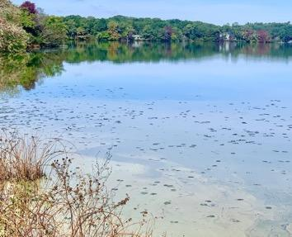
Santuit Pond, Mashpee, MA

December 11, 2022

Prepared By:
Mashpee Wampanoag Tribe
483 Great Neck Road, South
Mashpee, MA 02649

Town of Mashpee
16 Great Neck Road
Mashpee, MA 02649
With technical assistance from the SNEP Network, a project of the New England Environmental Finance funded by the U.S. Environmental Protection Agency’s Southeast New England Program and partners.

Prepared For:

Contents

Table of Contents
Executive Summary 1
Introduction 3
Purpose & Need 3
Watershed-Based Plan Outline 4
Project Partners and Stakeholder Input 5
Summary of Completed and Ongoing Efforts to Reduce Phosphorus Loads to Santuit Pond 5
Data Sources 10
Element A: Identify Causes of Impairment & Pollution Sources 12
General Watershed Information 12
Water Quality Impairments 17
Water Quality Goals 19
Land Use and Impervious Cover Information 20
Element B: Determine Pollutant Load and Load Reductions Needed to Achieve Water Quality Goals 25
Pollutant Loading 25
Estimated Pollutant Load Reductions to Restore Water Quality 27
Element C: Describe management measures that will be implemented to achieve water quality goals 29
Internal Cycling of Phosphorus 30
Watershed Stormwater Runoff 30
Proposed Management Measures 32
Element D: Identify Technical and Financial Assistance Needed to Implement Plan 37
Element E: Public Information and Education 40
Mashpee Wampanoag Tribe (MWT) 40
Town of Mashpee 40
Elements F & G: Implementation Schedule and Measurable Milestones 46
Elements H & I: Progress Evaluation Criteria and Monitoring 50
References 53
Appendices 56

Executive Summary

Santuit Pond is a 170-acre fresh water Great Pond with a maximum depth of approximately 9 ft.
Santuit Pond forms the headwaters of the Santuit River flowing to Popponesset Bay. River herring, alewives, brook trout and American eel run up the stream to the pond via the fish ladder rebuilt with federal wildlife funds in 2013. The pond is listed on “Massachusetts List of Impaired Waterbodies” for fish passage, abnormal fish deformity, chlorophyll-a, nutrient eutrophic biological indicators, pH, total phosphorus, and clarity. Popponesset Bay is impaired for nitrogen and management plans are underway through the Massachusetts Estuary program and the approved Total Maximum Daily Load Report (MassDEP, 2021).

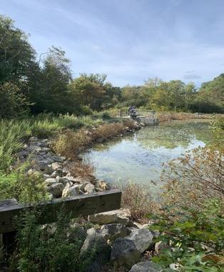
This project is focused on phosphorus reduction in Santuit Pond in the Town of Mashpee, where there are 170 acres of Mashpee Wampanoag Tribe (MWT) Lands taken into trust that are distributed over 11 independent parcels. The Tribe has no control over the Town land use surrounding the Tribe Trust Lands. The land and water resources have been home to the MWT for 12,000 years. The name “Santuit” originates from the Wampanoag word “Sachem” meaning spiritual leader. The Tribal Trust Lands and the associated water resources are sacred and culturally essential to the Tribe, and as such the environmental health of these lands is critical to MWT life and culture. Briant’s Neck (located on Santuit Pond) is the location of the original Old Indian Meetinghouse, the oldest Native American Christian church in the United States. The Old Indian Meetinghouse was moved by oxcart and rolling logs in 1717 to its present location on Meetinghouse Road in Mashpee.

Santuit Pond is home to many non-indigenous Mashpee residents who live in close proximity to Santuit Pond. The Town of Mashpee is distributed over about 27 square miles and is home to approximately 15,000 residents. Both the Town and the Tribe administer programs to manage water resources within their communities. This project seeks to focus on the water quality issues in the Santuit Pond and the associated Santuit Pond Watershed, which is distributed over about 1430 acres in Mashpee, Sandwich and Barnstable, MA.

Previous studies demonstrate that Santuit Pond suffers from poor water quality due to eutrophication (i.e., overabundant nutrient levels, specifically phosphorus in freshwater) and the pond does not fully support the designated water uses including contact recreation and aquatic life support (e.g., the Clean Water Act fishable swimmable goals). The incidence of harmful algal blooms (HABs) in Santuit Pond during both winter and summer has increased dramatically since the late 1990’s early 2000’s. The pond remains under a swimming advisory due to HABs. Sources of phosphorus pollution have been documented in previous studies and include septic inputs, cranberry bogs, stormwater runoff and the historic accumulation of phosphorus in sediment that is now cycling to the water column (AECOM, 2010). While the Santuit Pond Diagnostic Study report concluded that internal cycling of the phosphorus from the sediment is the major source of nutrient pollution, it also stated that “addressing the internal load without reducing external loading will result in re-accumulation of phosphorus in sediments over time and future internal loading.” This plan seeks to build off this prior study and provides recommendations to address internal and external phosphorus loads.

In July of 2021 and 2022 the MWT applied to the Southeast New England Program (SNEP) Network and were awarded technical assistance services to evaluate options to control phosphorus concentration levels in the pond as well as watershed sources contributed through stormwater runoff and sediment cycling. In the same timeframe the Town of Mashpee was awarded two Massachusetts Municipal Vulnerability Preparedness (MVP) program Action Grants. The first MVP grant was awarded $131,691 in 2021 to evaluate stormwater control measures and educate surrounding homeowners in stormwater management, fertilizer use, and maintenance of vegetated buffers. The second grant was awarded in 2022 in the amount of $469,037 to start the construction of the stormwater retrofits during Fall 2022 along the road at the Town Landing. In addition, the Town of Mashpee’s consultant, Fuss and O’Neill, will work with the project team to seek additional funding through MassDEP (604(b) and 319 NPS) to carry out stormwater Retrofit Design Work at the Town Landing as well as other water quality restoration measures described in this plan.

The ongoing public health threat caused by persistent algal blooms is driving the need to evaluate and implement all potential measures to control phosphorus and manage the ongoing public health threat created by harmful blooms. This watershed based plan has been prepared in accordance with the guidelines under Section 319 of the Clean Water Act. The goal of the Watershed Plan is to build off of the activities to date, help guide implementation measures moving forward, and support efforts to identify implementation-funding opportunities for both the Town and the Tribe. The problem statement for Santuit Pond is:

“Santuit Pond located in Mashpee, MA is being degraded by current and historical polluted runoff from surrounding residential development. Phosphorus flowed into the pond for decades from septic systems, stormwater runoff, and agriculture. This has resulted in the accumulation of thick bottom phosphorus- laden sediment in Santuit Pond. Phosphorus is released from the sediment to the surface water in the Pond (aka phosphorus recycling). The release of legacy phosphorus from sediment and polluted runoff have not been addressed to date and are key contributors to Santuit Pond’s persistent HABs. HABs within the pond have led to yearly health advisory postings, including swimming and contact with the water. These blooms, known as blue green algae or cyanobacteria, also negatively affect other forms of recreation, aquatic life, and the Mashpee Wampanoag people’s cultural practices.”

This Santuit Pond Watershed Based Plan is a “living document” developed through a partnership between the MWT and the Town of Mashpee with technical assistance from the SNEP Network and its partners, TRC (formerly ESS Group), and Fuss and O’Neill (FANDO). The Watershed Plan is intended to capture all the phosphorus reduction activities that are completed, planned or being contemplated in the future to restore the water quality in Santuit Pond. The plan will be reviewed annually and updated as appropriate.

Introduction

Purpose & Need
The purpose of a Massachusetts Watershed-Based Plan (WBP) is to organize information about Massachusetts' watersheds and present the information in a format that will enhance the development and implementation of projects that will restore water quality and beneficial uses in the Commonwealth. The Massachusetts WBP follows the United States Environmental Protection Agency’s (EPA's) recommended format for “nine-element” watershed plans, as described below.

All states are required to develop WBPs, but not all states have taken the same approach. Most states develop WBPs only for selected watersheds. Massachusetts Department of Environmental Protection’s (MassDEP's) approach has been to develop a tool to support statewide development of WBPs so that good projects in all areas of the state may be eligible for federal watershed implementation grant funds under Section 319 of the Clean Water Act.

EPA guidelines promote the use of Section 319 funding for developing and implementing WBPs. WBPs are required for all projects implemented with Section 319 funds and are recommended for all watershed projects, whether they are designed to protect unimpaired waters, restore impaired waters, or both.

This project seeks to focus on the water quality issues in Santuit Pond, and its associated watershed in the towns of Mashpee, Sandwich and Barnstable MA. Santuit Pond is a 170-acre fresh water Great Pond with a maximum depth of approximately 9 ft. The pond is listed in Category 5 (requires a TMDL) of “Massachusetts List of Impaired Waterbodies” for fish passage, abnormal fish deformity, chlorophyll-a, nutrient eutrophic biological indicators, pH, total phosphorus, and clarity. The focus of this plan is on the control of phosphorus and no TMDL for Santuit Pond has been developed.

Previous studies demonstrate that Santuit Pond suffers from poor water quality due to eutrophication (i.e., overabundant nutrient levels, e.g., Phosphorus) and the pond does not fully support the designated water uses including contact recreation and aquatic life support (e.g., the Clean Water Act fishable swimmable goals). The incidence of harmful algal blooms (HABs) in Santuit Pond has increased dramatically since the early 2000s and is causing a public health threat. Sources of pollution include septic, agriculture, stormwater runoff and the historic accumulation of phosphorus in sediment that is now releasing to the water column.

On a watershed scale, Santuit Pond drains to the Santuit River (impaired for temperature and fish passage) and ultimately to the Popponesset Bay (MA96-40) which is also impaired for nitrogen. The Final Popponesset Bay Total Maximum Daily Load(s) (TMDL) For Total Nitrogen (Report # 96-TMDL-4 Control #217.0) was published in 2006 and established the nitrogen load reductions necessary to restore water quality in the estuary. The Town of Mashpee is currently in the process of planning, designing and implementing wastewater treatment and sewer collection to address the nitrogen impairments. It is anticipated that the implementation of sewer collection and wastewater treatment will also reduce the phosphorus loading to Santuit Pond that is attributed to septic systems.

On a parallel path, the ongoing public health threat caused by algal blooms in Santuit Pond is driving the need to evaluate and implement all potential measures to control phosphorus, restore water quality and improve public health issues attributed to HABs. This watershed based plan has been prepared in accordance with the guidelines under Section 319 of the Clean Water Act. It is intended to guide implementation efforts as well as to support the Town and Tribe efforts to access funds to implement Santuit Pond phosphorus reduction projects.

In July of 2021 and ongoing through 2023, the MWT and the Town of Mashpee will be receiving technical assistance through the Southeast New England Program (SNEP) Network to develop and implement measures to control phosphorus concentration levels in the pond as well as address watershed sources contributed through stormwater runoff and erosion. In addition, the Town of Mashpee was awarded two MVP Action Grants to evaluate, design and begin construction of stormwater control measures. The grants have funded specialized outreach services to educate the homeowners surrounding the pond in stormwater management, fertilizer use, and maintenance of vegetated buffers. The results of these two projects have helped inform the development of the Santuit Pond Watershed Based Plan. In addition, the SNEP Network funded a baseline water quality monitoring synoptic survey of current water quality conditions along with sediment coring and phosphorus fractionation analysis. The monitoring was performed in accordance with an EPA approved Quality Assurance Project Plan (QAPP) (TRC, 2022). Other activities underway to remediate phosphorus inputs to Santuit Pond will also be described.

This Santuit Pond Watershed Based Plan was developed to address phosphorus impairments through a partnership between the MWT and the Town of Mashpee with technical assistance from the SNEP Network and their partners, TRC (formerly ESS Group)) and Fuss and O’Neill. The Watershed Plan is intended to capture all the phosphorus reduction activities that are completed, planned or being contemplated in the future to restore the water quality in Santuit Pond.

Watershed-Based Plan Outline
This WBP includes nine elements (a through i) in accordance with EPA Guidelines:
- An identification of the causes and sources or groups of similar sources that will need to be controlled to achieve the load reductions estimated in this WBP and to achieve any other watershed goals identified in the WBP, as discussed in item (b) immediately below.
- An estimate of the pollutant loads and load reductions expected for the management measures described under paragraph (c) below, recognizing the natural variability and the difficulty in precisely predicting the performance of management measures over time.
- A description of the nonpoint source (NPS) management measures needed to achieve the load reductions estimated under paragraph (b) above as well as to achieve other watershed goals identified in this WBP and an identification (using a map or a description) of the critical areas in which those measures will be needed to implement this plan.
- An estimate of the amounts of technical and financial assistance needed, associated costs, and/or the sources and authorities that will be relied upon, to implement this plan. As sources of funding, States should consider the use of their Section 319 programs, State Revolving Funds, United States Department of Agriculture’s (USDA's) Environmental Quality Incentives Program and Conservation Reserve Program, and other relevant federal, state, local, and private funds that may be available to assist in implementing this plan.
- An information/education component that will be used to enhance public understanding of the project and encourage their early and continued participation in selecting, designing, and implementing the NPS management measures that will be implemented.
- A schedule for implementing the NPS management measures identified in this plan that is reasonably expeditious.
- A description of interim, measurable milestones for determining whether NPS management measures or other control actions are being implemented.
- A set of criteria to determine if loading reductions are being achieved over time and substantial progress is being made toward attaining water quality standards and, if not, the criteria for determining whether this WBP needs to be revised.
- A monitoring component to evaluate the effectiveness of the implementation efforts over time measured against the criteria established under item (h) immediately above.

Project Partners and Stakeholder Input
With the assistance of SNEP Network, the Mashpee Wampanoag Tribe and the Town of Mashpee are the primary collaborators on the development of the Watershed Based Plan for Santuit Pond along with their consultants. Historically both entities have worked together to protect the quality of Mashpee’s water resources including lakes, ponds, embayments and groundwater.

Pollutants from stormwater runoff are a contributing factor to the impairment of Mashpee’s water bodies, including nutrient enrichment and bacterial contamination. The Town of Mashpee and Mashpee Wampanoag Tribe have worked with neighboring communities, regional agencies, state and federal officials to develop watershed solutions to improve water quality. This document will seek to identify all measures that are underway to reduce phosphorus and nitrogen inputs to Santuit Pond, measures that will be considered for future implementation as well as budget costs are described in Sections C and D. Efforts will be made to quantify specific load reductions in the watershed that may be attributed to town-wide or area-wide mitigation practices. The goal of the Watershed Plan is to build off of the activities to date, help guide implementation measures moving forward and support efforts to identify implementation-funding opportunities for both the Town and the Tribe.

Summary of Completed and Ongoing Efforts to Reduce Phosphorus Loads to Santuit Pond
Numerous activities to address the various sources of phosphorus are either completed or underway. These activities are described briefly below. A summary of the project partners and contact information is included in Appendix A.

Mashpee Wampanoag Tribe (MWT) (ongoing)

The MWT Natural Resources Department manages a wide range of existing programs, described below, that support the Tribes stewardship of natural resources. There is a gap in the Tribes capacity to address local threats to water quality including over-enrichment attributed to phosphorus, because the Tribe does not have jurisdiction over the land use surrounding the pond. The Tribe’s existing projects not related to phosphorus reduction are included in Appendix B and may provide a foundation to leverage funding from other resources to address the water quality issues identified in this plan.

Santuit Pond Dredge Study, Army Corp of Engineers (complete report expected 2023)

The Mashpee Wampanoag Tribe requested that the US Army Corps of Engineers (USACE) conduct a study of the Santuit River basin to investigate alternatives to restore the aquatic ecosystems and address water quality in this 1,430-acre watershed. The study will also focus on improving anadromous fish habitat in the Santuit Pond and river channel. This study is being conducted under the USACE Aquatic Ecosystem Restoration Program, Section 206 of WRDA of 1996, as amended.

The USACE and the Mashpee Wampanoag Tribe executed a feasibility cost sharing agreement (FCSA) on Jan. 30, 2019 to conduct a feasibility study to formulate and assess measures to restore the aquatic ecosystem of the Santuit River basin. The District has conducted testing and discussed preliminary concept plans with the Town and the Tribe. USACE preliminary results verify the aquatic habitat of Santuit Pond is degraded as a result of historic sedimentation build up and ongoing excessive nutrient loads to the pond attributed to stormwater, septic and agriculture operations.

The USACE was originally requested to evaluate the feasibility of dredging the entire pond and restoring the pond to a pristine condition. Sediment sampling revealed an 8 ft. thick layer of bottom sediment. In specific areas of the pond elevated levels of Arsenic were detected in the sediment. As a result the original scope of the study was determined to be infeasible. The USACE objective of the project changed from phosphorus reduction and habitat improvement to a goal of improving pond habitat for the herring fishery near the pond outlet. Three project options have been evaluated to date:
a) No Action – no dredging and no dredge placement,
b) Dredging 35+/- acres in the SE quadrant of the pond, hydraulic dredging 150K+ CY of muck down to and exposing sand substrate, and placing the muck into the proposed coir-log containment area for fringe emergent wetland restoration of 9+ acres as well as placement in several sandpits within the Town-owned “Santuit Reserve” area, and
c) Dredging 25+/- acres in the SE quadrant of the pond – footprint limited to dredging adjacent to Town-owned lands only, hydraulic dredging 100K+/- CY of muck down to and exposing sand substrate, and placing the muck only in the proposed coir-log containment area for fringe emergent wetland restoration of 9+ acres (see attached preliminary draft drawing to be further adjusted).

Options b and c, described above, focus on habitat restoration and will only remedy phosphorus sediment inputs in 25-35 acres of the 170-acre lake bottom, which will not significantly reduce the phosphorus concentration in the Pond to the extent needed to restore water quality. The USACE predicts publishing its results in 2023. If the restoration activity moves forward, implementation would likely take place in 2025 or later and the town and Tribe would need to provide match funding for the project.

Town of Mashpee Stormwater Policy (ongoing)
Mashpee has developed stormwater policy initiatives, provided education to its businesses and citizens, publicly discussed the issues related to stormwater runoff and continually offers many opportunities for residents and businesses to pitch in with cleanup efforts. Most importantly, Mashpee has completed a number of construction projects to remove stormwater discharge to water bodies and strongly promotes the use of innovative technology to remove nutrients and infiltrate stormwater including Low Impact Development (LID) practices.

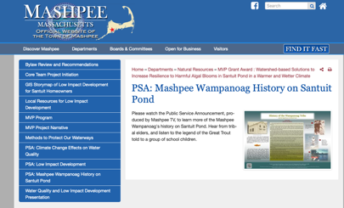
The Town of Mashpee is also undergoing a by-law review of pollution prevention practices. As a result the Town is considering a new by-law that would ban the use of lawn fertilizer around the periphery of all waterbodies. This “no fertilizer” zone will extend 300 feet from the shoreline of all fresh and marine waters. Controlling lawn fertilizer runoff will reduce the flow of nutrients to Santuit Pond and other waterbodies in Mashpee. Other considerations include the elimination of the boat launch at the Santuit Pond Town Landing.

Town of Mashpee Public Outreach, Service Announcements and Webpage
The Town of Mashpee Department of Natural Resources has developed a centralized location on their web page to provide public education resources. HERE. The public education program is focused on improving the public understanding of the measures that need to be taken to restore waters from excessive nutrient pollution. The content of the webpage includes information on by-laws, Low Impact Development, resources to protect waterways as well as public service announcements on the importance of the Pond to the Tribe. A few examples of these resources are listed below:

- Public Service Announcement highlighting phosphorus, cyanobacteria, stormwater management, fertilizer use and the cultural significance of Santuit Pond to the Mashpee Wampanoag Tribe HERE

- Santuit Pond Low Impact Development StoryBoard - HERE

- Town of Mashpee Bylaw Review and Recommendations Nitrogen Control Bylaw– April 2022 - HERE

- Methods to Protect our Waterways - HERE

Mashpee Solarbee Circulation (ongoing)
The Santuit Pond: Diagnostic and Feasibility Study (AECOM, 2010) concluded that Santuit Pond would benefit from promoting circulation. At the time it was anticipated that the introduction of more oxygen into the bottom waters of ponds would limit the amount of phosphorus recycling, thereby controlling algal blooms. In 2012 Solarbee Solar Powered mixers were introduced to the pond. Up to six (6) units were deployed to Santuit Pond and remain active through 2021. Mashpee Department of Natural Resources staff report no noticeable benefit of the units with respect to the pond-wide incidence of HABs and the Town has demonstrated that other measures are needed to remediate phosphorus. In conclusion it is not possible to deploy enough units to reduce the anoxic zone and internal loading from phosphorus with Solarbees alone.

Mashpee Cranberry Bog Conversion to Wetland (ongoing)
There are two inactive cranberry bogs located on Santuit Pond: Baker’s Bog (2.6 acres) on the north shore and Brackett’s Bog on the east shore (6.4 acres). The Brackett’s Bog is now shut down and owned by the town. The Baker’s Bog has not been in operation since 2016 and no longer qualifies for a water use permit.

In 2002 the Town of Mashpee purchased the historic cranberry bogs on the east and south shores of Santuit Pond in a 287-acre acquisition called the “Santuit Pond Preserve”. The property, straddling Mashpee and Barnstable, was purchased with funds from the Mashpee Land Bank, Barnstable Land Bank and the State Environmental Bond. The land provides protected habitat for fish and wildlife conservation and passive public recreation on three miles of walking trails. Habitats include pine-oak forest, beech-holly forest, maple swamps, wet meadows and vernal pools. Rare animals include the Eastern box turtle, spotted turtle, spotted salamander and worm-eating warbler. Most of the wetlands served as cranberry bogs into the 1990s when they were abandoned. The sand pits, access roads, dikes, and flumes are all remnants of that commercial use. AmeriCorps-Cape Cod and volunteer Land Stewards created and currently maintain the trail network.

The Town intends to purchase all agricultural bog lands in the vicinity of Santuit Pond for restoration to wetland. The Town also received state funding in 2021 for a feasibility evaluation and concept development for a cranberry bog restoration project on the 11.7- acre Chop Chaque Bog on the eastern shore of Santuit Pond (Horsley and Witten Group, 2021). The restoration project, if constructed, would potentially help to improve water quality in Santuit Pond and downstream areas by retaining nutrients and floodwaters. See Mashpee GIS Map Lot 23.2 on Mashpee’s GIS page.

Santuit Pond Herring Count Program (Ongoing)
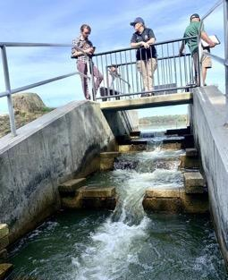
Nutrient pollution and low dissolved oxygen have direct impacts on the ability of herring to grow and reproduce. The Town in conjunction with its partners manages a Herring Count Program at three locations including Santuit Pond to monitor the population. A fish counter was installed in 2021 and data is shared via the Town web page and regionally with the herring counting program on Cape Cod. The program provides useful information relative to herring populations. For more information see the Town web page.

Mashpee Stormwater Management Plan (Mashpee 2019) (ongoing)
In an on-going effort to minimize stormwater impacts within Mashpee, the Town has developed a Stormwater Management Plan (SWMP). The SWMP is required by the U.S. Environmental Protection Agency’s (EPA’s) National Pollutant Discharge Elimination System (NPDES) General Permits for Stormwater Discharges from Small Municipal Separate Storm Sewer Systems (MS4s) in Massachusetts (“Small MS4 General Permit”). The SWMP describes and details the activities and measures that will be implemented by Mashpee to meet the terms and conditions of the permit. The Town of Mashpee’s stormwater management program also includes provisions for addressing specific water quality impairments including excess nutrient loadings that are impacting Santuit Pond. Stormwater annual reports can be accessed at the Town’s web page.

The Town’s SWMP is implemented by the Department of Public Works (DPW) and includes a catch basin cleaning program, street sweeping, winter road maintenance, and stormwater infrastructure maintenance. Town of Mashpee conducts a town wide education program to educate homeowners about eco-friendly property maintenance including use of lawn fertilizer and management of leaf litter that can block catch basins.

Mashpee is in year 5 of their MS4 permit. A private contractor sweeps the “public” roads and cleans catch basins at least once per year. More information on Mashpee’s stormwater management program, including fact sheets and annual reports, is available from their website:
- https://www.mashpeema.gov/public-works/stormwater-management-program
- https://www.mashpeema.gov/sites/g/files/vyhlif3426/f/uploads/2019_mashpee_ma.pdf
- https://www.mashpeema.gov/public-works/stormwater-management-program/pages/reports

Implementation of the SWMP is coordinated between the Department of Public Works and the Town Administrator, Natural Resources, Environmental Oversight Committee, Conservation Commission, Planning Department, and Board of Health. The DPW is supported by Tighe & Bond.

The watershed municipalities of Sandwich, and Barnstable are also regulated under the EPA Massachusetts Small Municipal Separate Storm Sewer System (MS4) General Permit. Each town implements a stormwater management program to comply with the requirements of the MS4 Permit, including public education and participation, illicit discharge detection and elimination programs, land use regulatory controls, good housekeeping and pollution prevention, and stormwater retrofits on municipal properties.

Mashpee Septic System Management Program (ongoing)
Mashpee instituted a program in 2021 through the Town Board of Health (BOH) to enforce septic system inspections within 300 feet of Santuit Pond to make sure they are being pumped. In the fall of 2021 property owners around Santuit Pond were issued a town order requiring an inspection and pumping of their systems.

Of the 118 properties originally identified in the order, 90 are now considered to have fully complied with both the inspection and pumping component. Ten (10) properties have complied with the inspection component only. The following determinations were made on the 100 properties found to be in compliance with the inspection order:
- Pass: 62
- Conditional Pass: 4
- Needs Further Evaluation: 1
- Fail: 21 (includes 7 cesspools)
- Certificate of Compliance: 5
- Innovative/alternative (I/A) System: 4
- Other: 3
Any systems that are shown through testing to be out of compliance with Title 5 will be required to implement remedies within eighteen (18) months of the Town order issued in 2021.

Mashpee Comprehensive Wastewater Management Plan (CWMP) (ongoing implementation)
Mashpee has developed a Comprehensive Wastewater Management Plan (CWMP) to address nitrogen sources from septic systems on a regional scale. The Plan is the result of over 15 years of effort in examining Mashpee’s needs and coordinating with the efforts of the Massachusetts Estuaries Project (MEP) and, most recently, the Cape Cod Commission’s 208 Planning efforts. This has resulted in a 25-plus year implementation schedule allowing mid-course corrections to occur as part of the Adaptive Management process. The Project Planning Area (PPA) includes all of Mashpee and portions of the neighboring communities of Barnstable, Falmouth and Sandwich that fall within the Popponesset Bay watersheds or eastern Waquoit Bay watersheds. Phase I has been approved and is in the process of being implemented at a cost of $54 million. This phase includes the design and construction of centralized wastewater collection and the implementation of sewer collection in portions of the Town. Phase II has been updated to include the installation of sewer collection for all residential housing around Santuit Pond (e.g. Santuit Pond, Beechwood Point Cluster and Cotuit Road) by 2030. During the January 24, 2022 Board of Selectmen meeting it was determined that the goal of the Mashpee Clean Water Plan is the elimination of all Title 5 septic systems in the Town of Mashpee.

2021 Mashpee Massachusetts Municipal Vulnerability Program (MVP) Action Grant
The Town of Mashpee participated in the MVP planning process and identified multiple climate hazards. The plan identified Santuit Pond as a resource that needs to be addressed due to excessive algal blooms. Town of Mashpee is the recipient of a 2021 $131,691 MVP grant entitled Watershed-based Solutions to Increase Resilience to Harmful Algal Blooms in Santuit Pond in a Warmer and Wetter Climate.

Starting in October of 2021 the two-year project will: (1) develop concept design for nutrient pollution reduction at key wet weather input locations around Santuit Pond and carry one design forward to permitting, (2) review and provide recommended changes to municipal bylaws to reduce nutrient impacts to all surface waters in Mashpee, and (3) create a robust public education and outreach program that incorporates the knowledge and perspective of the Wampanoag. The focus of the grant will be to reduce external sources of watershed nutrient inputs, by implementing and encouraging the use of Green Stormwater Infrastructure (GI) and Residential Low Impact Development (LID) Practices.
A technical memorandum (Town of Mashpee, 2022) summarizes current water quality conditions in Santuit Pond, watershed characteristics and pollutant sources, and preliminary recommendations regarding Best Management Practices (BMPs) and Stormwater Control Measures (SCM) to address watershed sources of nutrient and sediment contributions to the pond. The memorandum also reflects the findings and recommendations of field assessments of the Santuit Pond watershed completed in November 2021 to further evaluate known or suspected watershed pollutant sources, the feasibility of potential stormwater retrofits, and areas targeted for non-structural source control measures and residential Low Impact Development (LID) practices. Twenty one (21) locations for stormwater control measure opportunities that may be implemented in close proximity to Santuit Pond have been identified and described. Eight of those projects were flagged as high-priority and the remainder as medium-priority. Nineteen of the 21 project sites are on public lands. The project identified a short list of 5 priority stormwater interventions and one concept design to carry through full-design and permitting. Preliminary designs and expected phosphorus reductions will be described in Element C below.

The Town of Mashpee was awarded a second MVP Acton grant in 2022 grant in the amount of $469,037. The grant award will be used to fund the installation of stormwater control measures along Timberlane Drive in the vicinity of Santuit Pond. A 604(b) grant application was submitted in August of 2022 to fund high-priority site concept designs. The town intends to move forward with the implementation of medium projects as funding becomes available.

SNEP Network Technical Services Award
The MWT and the Town of Mashpee are joint recipients of a Southeast New England Program (SNEP) Network Technical Services Award. The project kicked off in October of 2021 and will run through September of 2023. The SNEP Network Technical Assistance award includes the following elements:

- Training for municipal officials and the Tribe to develop conceptual design(s) for stormwater retrofits and green infrastructure solutions to address identified problems in the Tribe/Town-selected drainage area;
- Santuit Pond water quality monitoring, sediment coring and phosphorus fractionation analysis;
- Assistance with community engagement, communication, partnership building, and implementation of stormwater/watershed management and ecological restoration;
- Assistance in creating a Watershed Based Plan using the MassDEP WBP Tool kit; and
- Contractor assistance to assess measures to address the phosphorus loading from sediment in Santuit Pond using alum treatment.

Stormwater BMPs and polluted runoff reduction measures (e.g., phosphorus, nitrogen, total suspended solids) will be described in Element C.

Other Partners
While not directly involved in the development of the Watershed Based Plan for Santuit Pond there are a number of interested stakeholders and partners listed below:

- Santuit Ponds Estates Association http://www.santuitpondestates.org/
- Santuit Lake Homeowners Association
- Cape Ponds Network https://apcc.org/cape-cod-ponds-network/
- Cape Cod Commission https://www.capecodcommission.org
- Association to Preserve Cape Cod https://apcc.org
- Mashpee Environmental Coalition https://www.mashpeemec.us
- Friends of Santuit Pond friends.santuit@gmail.com
- University of Massachusetts Dartmouth SMAST https://www.umassd.edu/smast/
- US Army Corp of Engineers, New England District https://www.nae.usace.army.mil
- Coastal Ocean Vision (Falmouth MA) – HABstat Raman Unit. This unit is deployed to track species and concentration of cyanobacteria. The unit can also measure bloom toxicity in live feed. https://www.coastaloceanvision.com/.

Data Sources
This WBP was developed using the framework and data sources provided by MassDEP’s WBP Tool. Other data sources include:
- Mashpee Technical Memo (Fuss and O’Neill, June 2022),
- Santuit Pond Interim Feasibility Assessment Presentation (TRC (formerly ESS Group), 2022),
- Army Corp of Engineers Santuit Pond Dredge Study (Personal Communication, Adam Burnett, January 2021)
- The Mashpee Wampanoag Tribe/Town of Mashpee Collaborative Water Quality Monitoring Program,
- Town of Mashpee Diagnostic and Feasibility Assessment Report - AECOM, 2010,
- Town of Mashpee (Chlorophyll, Conductivity, Dissolved Oxygen, pH, TSS, – Water quality monitoring program,
- MassDEP (DO, Temp, pH, Phosphorus, Aquatic Plants) – Water quality assessment reports and Integrated list of Waters,
- Massachusetts Department of Public Health (MDPH),
- NASA (Satellite imaging) - The town is working with NASA to correlate satellite imaging with cyanobacteria in Santuit Pond. The ultimate goal is to be able to use the satellite data alone to track toxin levels,
- Mashpee Environmental Coalition (alkalinity, chlorophyll, transparency, nitrogen, phosphorus) - https://www.mashpeemec.us/ponds-lakes-water-sampling-reports/, and
- Santuit Pond Estates – (visual observation plants, algae, Secchi Disk Reading) http://www.santuitpondestates.org/santuit-pond-water-quality-2021/.

The following sections describe the nine element plan.

Element A: Identify Causes of Impairment & Pollution Sources

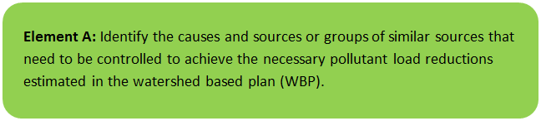

General Watershed Information
Santuit Pond, a 170-acre shallow kettlehole pond, is located within the northeast portion of the Town of Mashpee (Table A-1). The Santuit Pond Watershed extends to 1,430 acres and is situated between Mashpee and Wakeby Ponds to the west and the town boundary with Sandwich to the north and Barnstable to the east, in Barnstable County, Massachusetts (Figure A-1, A-2). The freshwater pond is classified as a Great Pond, which is a pond that contains more than 10 acres in its natural state. Santuit has a maximum depth of 9 feet, an average depth of 5 feet, and an average flushing rate of 3 times per year. Santuit Pond supports a variety of recreational uses (boating, fishing, swimming) and ecological functions, and also holds cultural significance to the Mashpee Wampanoag Tribe.

There is substantial residential development along the eastern and western sides of the pond, including the Briant’s Neck neighborhood, which is situated on a peninsula that extends into the center of the pond. The Mashpee Town Landing public boat launch, which is used for fishing and boating, is located off of Timberlane Drive on the western shore of Santuit Pond. Former cranberry bogs, several of which are now part of preserved conservation land, are situated around the north, east, and south shores of the pond.

There are no major stream inlets to Santuit Pond. Because of the high permeability of the soils in the watershed most incoming water reaches the pond as groundwater inflow or direct precipitation. Stormwater runoff primarily from impervious surfaces also discharges to the pond in some areas. The pond’s only outlet, located at the southern end of the pond, consists of a dam, which partially maintains water levels in the impoundment, and a fish ladder. The pond discharges to the Santuit River (also known as the Cotuit River), which supports an important herring run and flows south to Popponesset Bay, ultimately joining Nantucket Sound on the southern side of the Lower Cape Cod peninsula. Popponesset Bay is impaired by excessive nutrients (MassDEP, 2008) and has an approved nitrogen Total Maximum Daily Load (TMDL).

Santuit Pond is a very nutrient rich (eutrophic) pond with characteristic high phosphorus concentrations and cyanobacteria blooms. It is considered a Category 5 water body on the “Massachusetts Integrated List of Waters” published by the Massachusetts Department of Environmental Protection (MassDEP)(MassDEP, 2008). Massachusetts lists each waterbody in one of five categories ranging from 1 (unimpaired and not threatened for all designated uses), to 5 (impaired or threatened for one or more uses and requiring the development of a TMDL. The U.S. Environmental Protection Agency (USEPA) must approve the TMDLs created for Category 5 waterbodies.

For Santuit Pond, the pollutants needing TMDL calculations are nutrients and noxious aquatic plants (MassDEP, 2008). MassDEP considers toxin-producing cyanobacteria blooms to be a “noxious aquatic plant” impairment. The pond has a low Secchi disk transparency (SDT) level that falls well below the State Sanitary Code guidance criterion of 1.2 m (4 ft) for swimming. MassDEP also observed abnormal fish deformities, erosions, lesions, and tumors in fish samples collected between May and June of 2002 (MassDEP 2011). No information was found relative to the source of these impairments and most of the effort to date has been focused on phosphorus because of the immediate public health threat related to HABs.

The surface total phosphorus (TP) concentrations measured in 2009 at the deep spot off Bryant’s Neck ranged from 40-140 µg/L, which is very elevated compared to the Cape Cod Commission (CCC, 2003) regional phosphorus criterion of 10 µg/L and MassDEP target of less than 20 µg/L for similar ponds in Southeastern MA (MassDEP 2021). Results from a recent synoptic survey completed by TRC in June of 2022 revealed total phosphorus concentrations of 67 ug/L. Historically, Santuit Pond was a moderately enriched, clear water pond with abundant aquatic vegetation. Extensive summer and winter algal blooms became more prevalent in the late 1990s and 2000s.

Table A-1: General Watershed Information
Watershed Name (Assessment Unit ID): | Santuit Pond (MA96277)
Major Basin: | Cape Cod
Watershed Area (within MA): | 1430 (ac) See Figure A2 - for additional drainage area
Water Body Size: | 170 (ac)

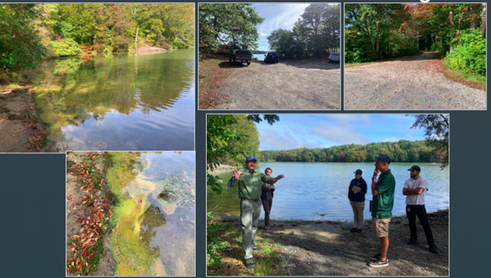
Figure A-1: Algal Bloom at Town Landing During October 12, 2022 SNEP Network Site Visit.
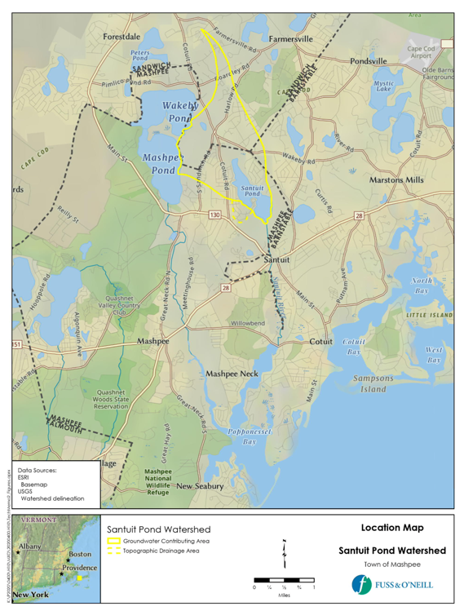

Figure A-2: Watershed Boundary Map (Town of Mashpee, 2022)

The Mashpee Board of Health has posted health advisories almost every year since the Mid-90s with consecutive postings over the last 5 years due to low clarity and the presence of potentially toxic cyanobacteria.

In response to apparent declining pond water quality, residents formed the Friends of Santuit Pond. In 2009, the Town of Mashpee contracted AECOM to conduct a diagnostic study of the pond to identify current phosphorus sources causing the extreme algal blooms and to recommend management strategies that would effectively rehabilitate Santuit Pond to meet desired uses.

Several other organizations also conducted studies on Santuit Pond in 2009, including the Mashpee Environmental Coalition (MEC), Mashpee Wampanoag Tribe and the Town of Mashpee Collaborative Water Quality Monitoring Program (MWT-M-WQMP), MassDEP, and MDPH.

AECOM used historical data as well as the results of the 2009 studies to provide the basis for the evaluation and recommendation. This report summarizes the results of the evaluation and outlines the plan of action to restore Santuit Pond to improve water quality and increase ecological, recreational, and aesthetic functions of this waterbody. Santuit Pond served as a traditional Mashpee Wampanoag fishing and hunting ground (MEC, undated). The native Tribes used the shoreline as a meeting spot and marketplace. English settlers homesteaded in the area in the late 1700s.

Seasonal cottage settlement began in Mashpee in the 1920s and resulted in increased development along Santuit Pond in the 1970s to 2000s (MHC, 1984). Cranberry bog operations began after the 1830s and provided the primary economy of Mashpee in the 1930s. The cranberry bogs on Santuit Pond have been active since the early to mid-1900s. Prior to 2007, the bogs on the southern and eastern shores were also active cranberry operations.

The towns of Mashpee and Barnstable along with the Commonwealth of Massachusetts purchased 200 acres on the eastern and southern shores of Santuit Pond, which includes the cranberry bogs, with funds from the Division of Fisheries Wildlife and Environmental Law Enforcement (MEC, 2009). The outlet to Lovell's Pond on the southeast shore of Santuit Pond was also blocked in 2007.

Santuit Pond Supplemental Watershed Description Developed by Fuss and O’Neill
As part of the MVP grant that was awarded to the Town of Mashpee, Fuss and O’Neill Inc. published a Task 2 Memo entitled Characterization of Watershed Pollutant Sources: Watershed-based Solutions to Increase Resilience to Harmful Algal Blooms in Santuit Pond in a Warmer Wetter Climate (Town of Mashpee, 2022). As part of this grant Fuss and O’Neill carried out a literature review and site visits to characterize the pollutant load sources. They summarized that their findings as follows: “The Santuit Pond Watershed is defined as: 1) the area of land where precipitation recharges groundwater (via Infiltration) that eventually flows to the pond, 2) the pond water surface itself (which receives direct precipitation), and 3) the land area around the pond that contributes surface runoff via storm drainage systems or direct overland flow before it has a chance to infiltrate to the soil.”

Fuss and O’Neill reviewed the Santuit Pond watershed delineation generated by MassDEP Watershed Based Plan Tool and determined that an “additional 51-acre area on the southwest side of the pond” should be included in the watershed footprint. This revised delineation is shown in Figure A-3 below and includes a) the western portion of Shields Road, Tobisset Street, Nobska Road, and Pequot Road. This area encompasses residential lots with impervious surfaces and wetlands directly adjacent to the pond. It was determined that these areas are hydraulically connected and a likely contributor to phosphorus loads. Fuss and O’Neill updated the watershed delineation to include the “topographic” drainage described to include a land area of 1,430 acres ( includes the 170-acre pond). Furthermore, the Memo stated that “Roughly 46% of the watershed (694 acres) lies within the Town of Mashpee and 50% (748 acres) is within the Town of Sandwich to the north. A minimal amount of area is contributed by Barnstable (Approximately 3% or 42 acres) to the east. It should be noted that all stormwater runoff in direct proximity to the pond is located in the Town of Mashpee.

MassDEP Water Quality Assessment Report and TMDL Review
The source of data that was used by MassDEP to assess the condition of Santuit Pond is included in the Cape Cod Coastal Drainage Area 2004-2004 Surface Water Quality Assessment Report (MassDEP 2011). Santuit Pond is listed in Category 5 (TMDL required) of the 2018/2020 Massachusetts Integrated List of Waters (MassDEP 2021). To date there is no phosphorus TMDL that has been published for the pond by MassDEP. However, this watershed plan may potentially serve as a n Alternative TMDL for phosphorus.

The section below summarizes the findings of MassDEPs Water Quality Assessment Report that relay known water quality and water quality impairments. Select excerpts from these documents relating to the water quality in the watershed are included below.

Cape Cod Coastal Drainage Areas 2004 - 2008 Surface Water Quality Assessment Report (MA96277 - Santuit Pond )
Aquatic Life Use
Habitat and Flow
According to Reback et al. (2004) the dam at the outlet Santuit Pond was fitted with a new wooden Denil fishway by DMF in 1997. The ladder functions adequately, however, the dam is leaking badly and, if replaced, should be equipped with a more permanent fish passage structure. The report also mentioned a bog impact unique to the Santuit system is the diversion of thousands of juvenile herring to Lovell's Pond due to withdrawals from Santuit Pond. Lovells Pond is essentially land locked and the loss to the Santuit population may be significant. This situation is also correctable with proper screening (Reback et al. 2004). Since the report was written some bogs in this area were abandoned so concerns regarding herring losses are now likely limited (Chase 2010).
Biology
Several studies by the Installation Restoration Program (IRP) at the MMR in the 1990s identified the presence of tumors on brown bullhead in Ashumet Pond (Baumann et al. 2008). The IRP’s technical advisory group recommended that future evaluations of the problem include a statistically based prevalence study that sampled more fish from the lakes of concern and similar reference lakes. USGS conducted a study of the prevalence of tumors in brown bullhead in Ashumet Pond and two reference lakes, Santuit and Great Herring Ponds in cooperation with USEPA and MassWildlife. As part of this study brown bullhead were collected from Santuit Pond between May and July 2002. The following findings were reported (Baumann et al. 2008) “Brown bullhead from Santuit Pond also had elevated prevalence of raised lesions and liver neoplasms, although the prevalence of large and multiple lesions were significantly lower than that in Ashumet Pond fish. These differences, along with additional differences in internal pathology, may point to differing causes of the raised lesions in the two lakes”.
No non-native macrophytes were noted in Santuit Pond during the 21 September 2004 macrophyte and density mapping survey conducted by DWM biologists (Mass DEP 2004). Moderate to dense algal blooms were observed by DWM personnel in the pond during the three sampling events (one day each in June, July, and August 2004) (Mass DEP 2004).
Water Chemistry
DO and temperature measurements were recorded at the deep hole in the mid pond “narrows” at 15 minute intervals by an unattended multiprobe meter deployed at a depth of 1.2 meters between 1100 hours on 24 August 2004 and 1900 hours on 26 August 2004. DO ranged from 8.4 to 12.1 mg/L and temperature from 22.7 to 25.1°C. A depth profile for DO was also made by DWM personnel on 24 August 2004. There was no evidence of stratification but supersaturation was present (109 to 114%) at all depths (0.5 - 2.0 m) and pH was extremely high (9.1 – 9.2 SU). Water quality sampling at the deep hole of Santuit Pond was also conducted by DWM personnel (one day each in June, July, and August 2004). Chlorophyll measurements were elevated ranging from 13.5 - 70 mg/m3 on the three sampling dates. Reportable total phosphorus concentrations ranged from 0.08 to 0.35 mg/L. The Secchi disk transparency was highest in June (1.6 m) but was below the bathing beach guideline (i.e., was <1.2 m) on both the July and August sampling dates (0.7 and 0.6 m, respectively).
The Aquatic Life Use is assessed as impaired for Santuit Pond based on the biological indicators of nutrient enrichment/eutrophication including excess algal growth (blooms), elevated chlorophyll a, elevated total phosphorus, and high pH, as well as the prevalence of melanistic lesions on Santuit Pond brown bullhead. Internal nutrient recycling in the pond is one identified source of the enriched conditions. The potential impact to the river herring population is noted as a concern.
Primary and Secondary Contact Recreational and Aesthetics Uses
There are several public bathing beaches along the shoreline of Santuit Pond. Currently there is uncertainty associated with the accurate reporting of freshwater beach closure information to the MA DPH which is required as part of the Beaches Bill. Therefore no Primary Contact Recreational Use assessment (either support or impairment) decisions are being made using Beaches Bill data for this waterbody. Moderate to dense algal blooms were observed by DWM personnel in the pond during the three sampling events (one day each in June, July, and August 2004) (Mass DEP 2004). Secchi disk transparency measurements ranged from 0.6 - 1.6 m on the three dates, with two dates below the bathing beach guidelines (<1.2 m). It should also be noted that there was a cyanobacteria bloom that occurred in Santuit Pond in 2009.
The Primary and Secondary Contact Recreational and Aesthetic Uses are assessed as impaired for Santuit Pond based on the presence of moderate to dense algal blooms and the poor Secchi disk transparency. Internal nutrient recycling in the pond is one identified source of the enriched conditions.
Report Recommendations:
Support improvement of freshwater Beaches Bill data quality and reporting.

Historical and current Technical Memoranda (TM) produced by the MassDEP Watershed Planning Program (WPP) are available here: Water Quality Technical Memoranda | Mass.gov and are organized by major watersheds in Massachusetts. Most of these TMs present the water chemistry and biological sampling results of WPP monitoring surveys. The TMs pertaining primarily to biological information (e.g., benthic macroinvertebrates, periphyton, fish populations) contain biological data and metrics that are currently not reported elsewhere. The data contained in the water quality TMs are also provided on the “Data” page (Water Quality Monitoring Program Data | Mass.gov). Many of these TMs have helped inform Clean Water Act 305(b) assessment and 303(d) listing decisions.

Review of data collected by MassDEP, AECOM (2010) and others reported concentrations of total phosphorus ranging between a mean of 40 to 140 µg/L total phosphorus depending on the depth of the sample and locations within the lake. More recent Town collected data from 2019 shows algal blooms are occurring year-round with average chlorophyll-a concentrations exceeding 20 µg/L in January of 2021. From June 2009 through October 2018, MDPH collected 84 water quality samples for algal identification and enumeration. Median, mean, and maximum cyanobacteria cell counts over the period of time were 53,100; 58,129; and 278,800 cells per milliliter of water (cells/ml). Since 2008, MDPH has recommended that access to recreational waters be restricted when a visible scum or mat is present, the total cyanobacteria cell count exceeds 70,000 cells/ml, or the concentration of the algal toxin microsystin exceeds 14 parts per billion (ppb). Approximately 24% of the samples collected by MDPH from 2009-2018 exceeded the criteria based on cyanobacteria cell count. These lines of evidence indicate the waterbody is in a hyper-eutrophic state and remains impaired. Further details can be found in the Santuit Pond Diagnostic Feasibility Study, Mashpee MA, published by AECOM in 2010.

Water Quality Impairments
Known water quality impairments, as documented in the Massachusetts Department of Environmental Protection (MassDEP) 2018/2020 Integrated List of Waters (MassDEP, 2021) are listed below. Impairment categories from the Integrated List are as follows:

Table A-2: 2018/2020 MA Integrated List of Waters Categories
Integrated List Category | Description
1 | Unimpaired and not threatened for all designated uses.
2 | Unimpaired for some uses and not assessed for others.
3 | Insufficient information to make assessments for any uses.
4 | Impaired or threatened for one or more uses, but not requiring calculation of a Total Maximum Daily Load (TMDL), including:  4a: TMDL is completed  4b: Impairment controlled by alternative pollution control requirements  4c: Impairment not caused by a pollutant - TMDL not required
5 | Impaired or threatened for one or more uses and requiring preparation of a TMDL.

Table A-3: Water Quality Impairments (MassDEP 2021)
Assessment  Unit ID | Waterbody | Integrated  List  Category | Designated Use | Impairment Cause | Impairment Source
MA96277 | Santuit Pond | 5 | Aesthetic | Chlorophyll-a, Harmful Algal Blooms, Phosphorus, Total, Transparency / Clarity | Phosphorus release from sediment, septic systems, stormwater runoff, and agriculture
MA96277 | Santuit Pond | 5 | Fish, other Aquatic Life and Wildlife | Abnormal Fish Deformities, Erosions, Lesions, Tumor | Source Unknown
MA96277 | Santuit Pond | 5 | Fish, other Aquatic Life and Wildlife | Chlorophyll-a, Harmful Algal Blooms, Nutrient/Eutrophication Biological Indicators, pH, High, Phosphorus, Total | Phosphorus release from sediment*, septic systems, stormwater runoff, and agriculture
MA96277 | Santuit Pond | 5 | Primary Contact Recreation | Chlorophyll-a, Harmful Algal Blooms, Phosphorus, Total, Transparency / Clarity | Phosphorus release from sediment*, septic systems, stormwater runoff, and agriculture
MA96277 | Santuit Pond | 5 | Secondary Contact Recreation | Chlorophyll-a, Transparency / Clarity, Harmful Algal Blooms, Phosphorus, Total, Transparency / Clarity | Phosphorus release from sediment*, septic systems, stormwater runoff, and agriculture
*Phosphorus release from sediment is also referred to as Phosphorus recycling.

As shown in Table A-3 the causes of nutrient impairment to Santuit Pond are excessive phosphorus and nutrient eutrophication biological indicators (e.g., chlorophyll-a, HAB, Transparency/Clarity, high pH). The sources of phosphorus impairment include septic systems (5%), watershed direct precipitation, surface runoff, water fowl, groundwater, (13%), and agriculture (3%) (AECOM 2010). Phosphorus is present in high concentrations in septic systems can be carried underground to surface water. Watershed sources include stormwater runoff and groundwater infiltration includes phosphorus inputs from fertilized soils and lawns, leaf litter and other vegetative debris. Runoff from impervious surfaces (e.g., roofs, roadway) associated with homes surrounding Santuit Pond is a significant contributor to impairment. Historic use of fertilizer in agricultural operations surrounding the pond also contributed to the discharge of phosphorus to Santuit Pond.

Historic inputs from the above sources over decades led to the accumulation of sediment in the bottom of Santuit Pond. This accumulated sediment has resulted in a phenomenon known as Internal Phosphorus Recycling. It is estimated that phosphorus recycling accounts for 76% of the phosphorus load in the pond. The process of internal phosphorus recycling from lake and pond sediments are complex and influenced by many processes including biological, chemical and physical mixing.

In general, the distribution of organic matter or “muck” is where most of the internal phosphorus recycling occurs. A newly formed lake will not have much organic matter, and rates of internal phosphorus recycling will be low. However, as waterbodies age and organic matter is deposited over time, the rates of internal phosphorus recycling increase. The older the lake, the more internal phosphorus recycling, and the greater risk of cyanobacteria blooms and poor water quality. The Santuit Pond Dredge Study, conducted by the Army Corp of Engineers measured up to eight ft of sediment muck in cores taken from the pond bottom (US ACE 2021). The accumulation of sediment is not attributed to natural pond succession. Together phosphorus cycling and watershed sources account for about 90% of the phosphorus load.

Water Quality Goals
Water quality goals may be established for a variety of purposes, including the following:
a.) For water bodies with known impairments, a Total Maximum Daily Load (TMDL) is established by MassDEP and the United States Environmental Protection Agency (USEPA) as the maximum amount of the target pollutant that the waterbody can receive and still safely meet water quality standards. There is no Santuit Pond TMDL for phosphorus.

b.) For water bodies without a TMDL for total phosphorus (TP), a default water quality goal for TP is based on target concentrations established in the Quality Criteria for Water (USEPA, 1986) (also known as the “Gold Book”). The Gold Book states that TP should not exceed 50 µg/L in any stream at the point where it enters any lake or reservoir, nor 25 µg/L within a lake or reservoir. These values are used as guidelines in cases where site specific standards are missing and may not be stringent enough to restore water quality in some cases.

c.) Massachusetts Surface Water Quality Standards (314 CMR 4.00, 2022) prescribe the minimum water quality criteria required to sustain a waterbody’s designated uses. Santuit Pond is a Class 'B' waterbody. See Table A-5 for a review summary of water quality goals. Massachusetts narrative nutrient criteria applies in the case of Santuit Pond.

“Unless naturally occurring, all surface waters shall be free from nutrients in concentrations that would cause or contribute to impairment of existing designated uses…”

Santuit Pond’s designated uses include aquatic life, primary recreation, secondary recreation and aesthetics.

d.) Other water quality goals set by the community (e.g., protection of high quality waters, in-lake phosphorus concentration goal set by the community to reduce recurrence of cyanobacteria blooms, etc.). To date no water quality goals have been set by the community.

Table A-4: Surface Water Quality Classification by Assessment Unit
Assessment  Unit ID | Waterbody | Class
MA96277 | Santuit Pond | B

Table A-5: Water Quality Goals**
Pollutant | Goal and Targets** | Source
Total Phosphorus (TP) | Total phosphorus should not exceed:  --50 µg/L in any stream (MassDEP WBP)  --25 µg/L within any lake or reservoir (MassDEP WBP)  --10 Cape Cod Commission regional lake Target  --15 µg/L  ---18 µg/L Monponsett Pond | Quality Criteria for Water (USEPA, 1986)  CCC, (2003  AECOM, 2010  MassDEP, 2021
Biological Indicators | See MassDEP Consolidated Assessment and Listing Methodology | https://www.mass.gov/doc/2018-consolidated-assessment-and-listing-methodology-guidance/download
** | MassDEP has not adopted phosphorus criteria for Santuit Pond. Total Phosphorus values are provided to guide management activities.

The derivation of a water quality goal for Santuit Pond will be described in Element B.

Land Use and Impervious Cover Information

Watershed Land Uses
The Town of Mashpee’s consultant Fuss and O’Neill updated the watershed land uses for the Santuit Pond watershed (Figure A-43) (Town of Mashpee, 2022). The land use data is from the statewide dataset containing a combination of land cover mapping from 2016 aerial imagery and land use derived from standardized assessor parcel information for Massachusetts. Table A-6 summarizes the percentage of each land use category within the watershed. Overall, the watershed is approximately 65% undeveloped, with developed land uses comprising approximately 23% of the watershed and open water (primarily Santuit Pond) accounting for approximately 12% of the area.

Undeveloped lands in the watershed consist primarily of forest, wetlands, municipal open space/conservation land, and historic cranberry bogs that are transitioning to wetlands. Residential development (primarily single- family residential) and the associated road network is the major developed land use in the watershed. Higher density residential development is concentrated on the east and west sides of the pond, with lower density residential in the northern portion of the watershed in Sandwich. Vegetated steep slopes buffer most of the residential development along the eastern and western shoreline of Santuit Pond. The residential neighborhoods surrounding the pond are 30-50 years old and are generally wooded with mature trees and moderate to high levels of lot and street tree canopy, which generates large amounts of leaf litter in the fall. Undeveloped forestland and forested wetlands are the predominant land uses adjacent to the north and south ends of the pond.
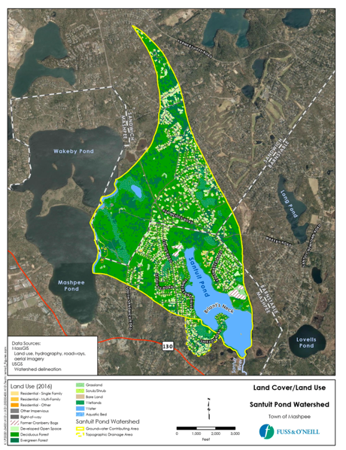
Figure A-3: Watershed Land Use Map (Town of Mashpee (2022), MassGIS 2016).

Most of the roads in the watershed are owned and maintained by the watershed municipalities. There are several privately-owned and maintained roads immediately surrounding the pond, including Shields Court, the Briant’s Neck neighborhood (Shields Road, Shields Lane, Santuit Lane, and South Shields Avenue), Santuit Pond Way in the Beechwood Point neighborhood, and the roads associated with the former Chop Chaque cranberry bog. A short segment of State Route 130 (Main Street) passes through the southwest corner of the watershed, while Cotuit Road, another primary north-south route, traverses the western half of the watershed.

Table A-6: Watershed Land Uses (Town of Mashpee, 2022)
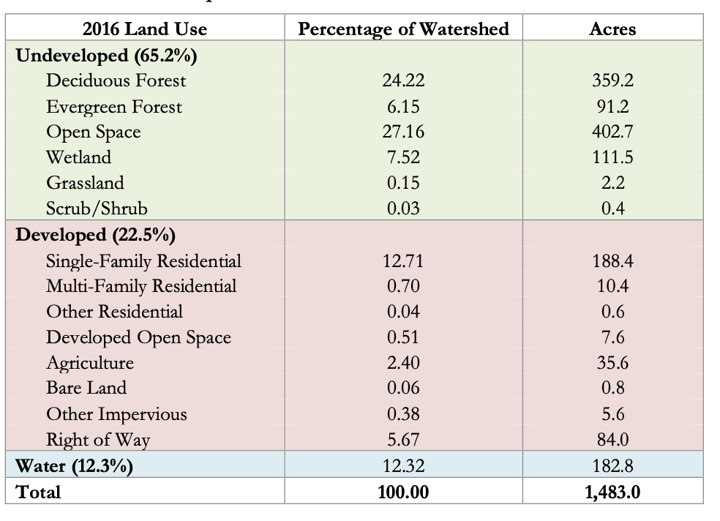

Watershed Impervious Cover
There is a strong link between impervious land cover and surface water quality. Impervious cover includes land surfaces that prevent the infiltration of water into the ground, such as paved roads and parking lots, roofs, basketball courts, etc.

Impervious areas that are directly connected (DCIA) to receiving waters (via storm sewers, gutters, or other impervious drainage pathways) produce higher runoff volumes and transport stormwater pollutants with greater efficiency than disconnected impervious cover areas that are surrounded by vegetated, pervious land. Runoff volumes from disconnected impervious cover areas are reduced as stormwater infiltrates when it flows across adjacent previous surfaces.

An estimate of DCIA for the watershed was calculated based on the Sutherland equations. US EPA provides guidance (USEPA, 2010) on the use of the Sutherland equations to predict relative levels of connection and disconnection based on the type of stormwater infrastructure within the total impervious area (TIA) of a watershed. Within each sub-watershed, the total area of each land use was summed and used to calculate the percent TIA.
Table A-7: TIA and DCIA Values for the Watershed
 | Estimated TIA (%) | Estimated DCIA (%)
Santuit Pond | 11.3 | 11.3

The Analysis in Table A-7 demonstrates that the TIA and DCIA are roughly equivalent. The relationship between TIA and water quality can generally be categorized as shown in Table A-8 (Schuler et al. 2009). Visual examination of Figure A-5 shows the DCIA in close proximity to the pond is significantly greater than 11.3%. Figure A-4 illustrates the distribution of impervious surfaces in the Santuit Pond Watershed.

Table A-8: Relationship between Total Impervious Area (TIA) and water quality (Schueler et al. 2009)
% Watershed  Impervious Cover | Stream Water Quality
0-10% | Typically high quality, and typified by stable channels, excellent habitat structure, good to excellent water quality, and diverse communities of both fish and aquatic insects.
11-25% | These streams show clear signs of degradation. Elevated storm flows begin to alter stream geometry, with evident erosion and channel widening. Streams banks become unstable, and physical stream habitat is degraded. Stream water quality shifts into the fair/good category during both storms and dry weather periods. Stream biodiversity declines to fair levels, with most sensitive fish and aquatic insects disappearing from the stream.
26-60% | These streams typically no longer support a diverse stream community. The stream channel becomes highly unstable, and many stream reaches experience severe widening, down cutting, and stream bank erosion. Pool and riffle structure needed to sustain fish is diminished or eliminated and the substrate can no longer provide habitat for aquatic insects, or spawning areas for fish. Biological quality is typically poor, dominated by pollution tolerant insects and fish. Water quality is consistently rated as fair to poor, and water recreation is often no longer possible due to the presence of high bacteria levels.
>60% | These streams are typical of “urban drainage”, with most ecological functions greatly impaired or absent, and the stream channel primarily functioning as a conveyance for stormwater flows.

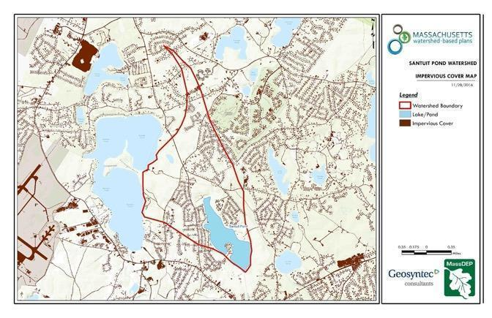
Figure A-4: Watershed Impervious Surface Map (MassGIS, 2009b; MassGIS, 1999; MassGIS, 2001; USGS, 2016)

Element B: Determine Pollutant Load and Load Reductions Needed to Achieve Water Quality Goals

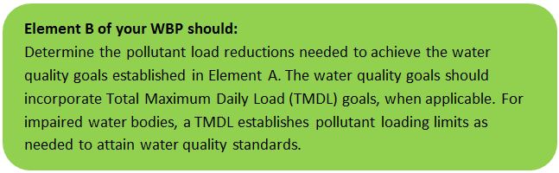

Pollutant Loading
The Massachusetts Watershed Based Plan Tool automates the calculation of pollutant loading using Geographic Information Systems (GIS). The automated process intersects the land use data (MassGIS, 2009b) with impervious cover data (MassGIS, 2009a) and United States Department of Agriculture (USDA) Natural Resources Conservation Service (NRCS) soils data (USDA NRCS and MassGIS, 2012) to create a combined land use/land cover grid. The grid was used to sum the total area of each unique land use/land cover type.

The amount of DCIA was estimated using the Sutherland equations as described above and any reduction in impervious area due to disconnection (i.e., the area difference between TIA and DCIA, which is zero) was assigned to the pervious D soil category for that land use to simulate that some infiltration will likely occur after runoff from disconnected impervious surfaces passes over pervious surfaces.

Pollutant loading for key nonpoint source pollutants in the watershed was estimated by multiplying each land use/cover type area by its pollutant load export rate (PLER). The PLERs are an estimate of the annual total pollutant load exported via stormwater from a given unit area of a particular land cover type. The PLER values for TN, TP and TSS were obtained from USEPA (Voorhees, 2016b) (see documentation provided in Appendix C) as follows:
L_{n} = A_{n} * P_{n}
Where L_{n} = Loading of land use/cover type n (lb/yr);
A_{n} = area of land use/cover type n (acres);
P_{n} = pollutant load export rate of land use/cover type n (lb/acre/yr)

A summary of the estimated pollutant loading to Santuit Pond is provided in Table B-1a. One of the limitations of this analysis is that it does not take into account the loading associated with internal release of phosphorus from sediment or septic systems as documented in the AECOM Santuit Pond Diagnostic Study (2010), and therefore underestimates the total load of phosphorus to be controlled. In addition, the load reduction associated with watershed related sources like stormwater are overestimated.

Table B-1a: Estimated Pollutant Loading for Santuit Pond Key Nonpoint Source Pollutants

Land Use Type | Pollutant Loading¹
 | Total  Phosphorus (TP)  (lbs/yr) | Phosphorus Loading (%)
Agriculture | 6 | 1.6
Commercial | 2 | 0.5
Forest | 122 | 32.6
High Density Residential | 60 | 16.0
Highway | 0 | 0
Industrial | 0 | 0
Low Density Residential | 45 | 12.0
Medium Density Residential | 138 | 37.0
Open Land | 1 | 0
TOTAL | 374 | 100
¹ These estimates do not consider loads from internal release of phosphorus from sediment or septic systems.

To further inform restoration efforts, the AECOM Santuit Pond Loading analysis is included in this watershed-based plan. The loading analysis in Table B1-b shows that nearly 80 percent of the controllable loads are associated with the internal release of phosphorus from sediment (aka internal sediment recycling ) while the remaining 20 percent are associated with agricultural inputs (about 4%), septic systems (5%) and watershed sources like stormwater (13%).

Table B-1b: Estimated Pollutant Loading for Key Nonpoint Source Pollutants (Adapted from AECOM 2010).
Land Use Type | Total  Phosphorus (TP)  (lbs/yr) | Phosphorus  Loading (%) | TN Loading (lbs/yr) | TSS Loading (lbs/yr)
Agriculture (Cranberry Bogs) | 29 | 3.5 | 194 | 3.4
Watershed (direct precipitation, surface runoff, water fowl, groundwater) | 112.0 | 13.4 | 750 | 13.4
Septic | 42 | 5.0 | 281 | 4.9
Internal phosphorus recycling | 653 | 78.1 | 4375 | 76.0
TOTAL Load | 836 | 100 | 5610 | 98.0

Estimated Pollutant Load Reductions to Restore Water Quality
No TMDL has been developed for Santuit Pond. However, the Santuit Pond Diagnostic Study (AECOM 2010) conducted a detailed analysis of the phosphorus loads to the pond and estimated the load reductions necessary to restore the pond designated uses. The Findings in the report are described below.

AECOM evaluated in-lake target total phosphorus (TP) concentrations ranging from 10 µg/L to 56 µg/L and determined that a preliminary target of 15 µg/L was appropriate based on literature, restoration feasibility and best professional judgment. AECOM estimated that in order to attain a target in-lake TP concentration of 15 µg/L, the TP load needs to be reduced to 71 kg/yr (156 lbs/yr). This would require an overall reduction in phosphorus loading of 81%. As some sources are less controllable than others, the actual reduction to be applied to achieve this goal will vary by source. Based on this analysis the annual load of 836 lbs/yr would need to be reduced to a target load of 156 lbs/yr of total phosphorus. AECOM provided an evaluation of alternative loading reduction scenarios as a means to determine the effective phosphorus management strategies for pond restoration.

Based on modeling for removal the largest TP source (e.g., internal recycling of phosphorus) an overall reduction of 78% TP results in an in-lake TP concentration of 17 μg/L, which is higher than the preliminary target of 15 μg/L. The authors concluded that removing only internal phosphorus loading would not be sufficient to restore Santuit Pond to support its designated uses. Also, addressing the internal load without reducing external loading (stormwater runoff, groundwater, waterfowl, septic systems, and agriculture) will result in the re-accumulation of phosphorus in the sediments over time and future internal loading. AECOM further recommended an aggressive phosphorus management strategy that incorporates reductions in both internal (phosphorus recycling) and external loads (watershed, agriculture, septic systems, and waterfowl). The report states “The target may be difficult to attain, but it is a goal to work toward. Reductions in the phosphorus loading below permissible levels (resulting in an in-lake TP concentration of 28 μg/L) will certainly reduce the frequency of algal blooms and improve overall water quality. It is concluded that all possible management strategies to reduce phosphorus loading to the lake should be considered.”

Table B-2 provides a summary of target pollutant loads and the associated percent reduction in annual TP load that is needed to restore water quality in Santuit Pond. This watershed plan will be on reducing the loads associated with internal sediment recycling and addressing external watershed sources that include stormwater runoff, groundwater, and the adoption of green homeowner practices. Agricultural and septic inputs are being addressed through other Town programs described above in the introduction.

Table B-2: Summary Pollutant Load Reductions Needed to Restore Water Quality (AECOM 2010).
Pollutant | Existing Estimated Total Load | Target TP load to Achieve Water Quality Goal | Estimated Phosphorus Load Reduction (%)
Total Phosphorus | 836 lbs/yr | 156 lbs/yr | 81%

Element C: Describe management measures that will be implemented to achieve water quality goals

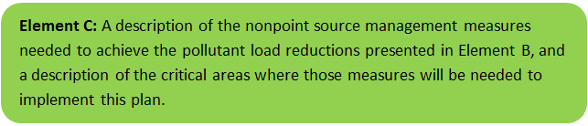

A summary of completed and ongoing management efforts to address excessive phosphorus loads to Santuit Pond are described in the introduction of this plan. The implementation of the Town-wide CWMP is underway and the installation of sewer collection from residential housing in the vicinity of Santuit Pond (Phase II) is on track for implementation in the next 5-7 years. The town has implemented a short-term program to address failing septic systems and cesspools that are within 300 feet of Santuit Pond. Homes are required to be in compliance by the end of 2023. The Town has purchased historic cranberry bogs and is working to convert these areas to wetland.

This section focuses on those sources that are not addressed through other activities as follows:

- Internal recycling of phosphorus from sediment, and
- Watershed stormwater runoff.

Together these sources are estimated to account for 91% of the remaining controllable loads to the pond.

Funding was provided through a 2021 Massachusetts Vulnerability Program Action Grant to the Town of Mashpee that enabled Fuss and O’Neill to conduct a stormwater assessment study. The project included the following components: (1) the development of concept designs for nutrient pollution reduction at key wet water input locations around Santuit Pond and a one location full design and permitting, (2) the review and recommended changes to municipal bylaws to reduce nutrient impacts to all surface waters in Mashpee, and (3) the implementation of a robust public education and outreach program that incorporates the knowledge and perspective of the Wampanoag (Mashpee Public Service Announcement). In 2022 Mashpee received a second MVP grant to implement stormwater retrofits along Timberland Drive.

Through a separate initiative the Mashpee Wampanoag Tribe in partnership with the Town are in receipt of a SNEP Network Technical Assistant Grant that supported the development of this Watershed Based Plan, a facilitated stormwater planning effort for Santuit Pond and the hiring of TRC (formerly ESS Group) to conduct an assessment of options to address internal cycling of phosphorus in Santuit Pond and the implementation of baseline monitoring and sediment fractionation analysis. The results of the baseline monitoring will inform the design of an Alum treatment.

Site visits and surveys were completed during November 2021 and a summary of these efforts, survey findings and recommended actions to address phosphorus loading are provided below. Both grant activities will conclude in 2023.

Internal Cycling of Phosphorus
TRC developed a Focused Feasibility Study Report using observations gathered from site visits as well as existing data and prior studies to evaluate potential water quality improvement measures for implementation at Santuit Pond. The list of water quality improvement options was primarily drawn from the 2004 Massachusetts General Environmental Impact Report (GEIR) for Eutrophication and Aquatic Plant Management. However, it was expanded based on ESS’s understanding of new or emerging technologies and options that have been developed subsequent to the GEIR and may be available for use at Santuit Pond.

The focus of the evaluation was on in-pond management options and included an assessment of advantages, limitations, phosphorus reduction potential, and costs of each. ESS recommended the set of in-pond management options that are likely to provide the most appropriate and cost-effective approach to addressing excessive phosphorus and algal blooms in combination with other phosphorus reduction efforts.

TRC concluded that alum treatment is the most cost-effective short term and long term option to reduce internal nutrient cycling. SNEP Network has provided additional funding to implement baseline monitoring of Santuit Pond and an Alum dosing study that will be used to evaluate the design of alum treatment.

Watershed Stormwater Runoff
The Town of Mashpee was the recipient of a 2021 MVP Action grant to conduct preliminary planning and community outreach to identify opportunities for stormwater BMPs to address polluted runoff to Santuit Pond. The goal of the project is to identify opportunities for Stormwater BMPs in the vicinity of high-density residential housing developments in close proximity to the pond, develop a short list of 5 projects with concept designs with one project carried forward to full design. Figure C-1 shows the anticipated focus areas for BMP identification, concept design and implementation (Town of Mashpee, 2022).

Community outreach and education were a large component of the grant. The Town, in partnership with the MWT and their consultant Fuss and O’Neill, engaged community homeowners in a facilitated planning process to develop a short list of designs to advance toward implementation. Opportunities for stormwater retrofits in the vicinity of Santuit Pond are summarized in Fuss and O’Neill’s Task 2 Report. As of this date, twenty-one (21) locations for stormwater retrofit opportunities have been identified and described. Eight of those projects were flagged as high-priority and the remainder as medium-priority. Nineteen of the 21 project sites are on public lands. The project goal is to develop a short list of 5 priority stormwater interventions concept designs and to carry one forward through full-design and permitting. Preliminary designs and expected phosphorus reductions will be described in Element C below and are included in Appendix D. Stormwater retrofits include bioretention and rain gardens, catch basin and roadway drainage retrofits, water quality swales, leaching catch basins, and possibly subsurface structures.

On a parallel path members of the Tribe and Town have been attending a facilitated stormwater planning workshop hosted by the SNEP Network. The design team includes Ashley Fisher, Director, Department of Natural Resources Town of Mashpee, Jason Steiding, Director Department of Natural Resources, Mashpee Wampanoag Tribe, and Dale Oakley, Assistant Director Department of Natural Resources, Mashpee Wampanoag Tribe. The team attended a site visit with Dr. James Houle, University of New Hampshire Stormwater Center, and Dr. Kimberly Groff, Massachusetts Liaison for the SNEP Network, on October 12, 2021 to evaluate sites and discuss potential retrofit options (see Appendix E).

Through this facilitated planning process (which included a workshop, assignments and one-on-one instruction) the team has decided to focus their design effort on improvement to the Town Landing drainage area. The team sized 2 bioretention basins, improved leaching catch basin function along Timberlane Drive and enhancing polluted runoff capture. The value of the training was that it provided the Town and Tribe with working knowledge of stormwater design and the confidence to manage design engineers and implementation contractors.

In order for the Town and Tribe to move forward with the implementation of stormwater BMPs and Alum treatment, the Town and Tribe will be seeking grant funds through both the MVP Acton Grant and the MassDEP 604(b) and 319 NPS grant program. The following section provides a conceptual summary of the activities that are planned in the next several years.

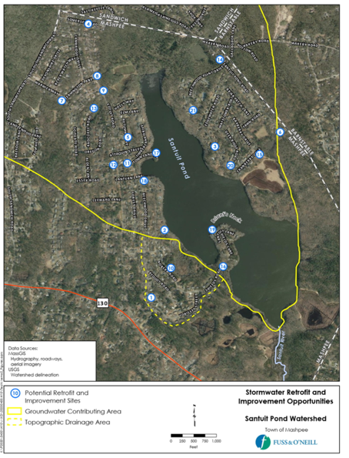

South East
North East
West

Figure C-1: Stormwater Retrofit Locations (Town of Mashpee, 2022) Santuit Pond, Mashpee.

Proposed Management Measures
Table C-1 presents the proposed management measures as well as the estimated pollutant load reductions and costs. The planning level cost estimates and pollutant load reduction estimates and estimates of BMP footprint size were based off information obtained in the following sources and were also adjusted to 2016 values using the Consumer Price Index (CPI) (United States Bureau of Labor Statistics, 2016):

- Town of Mashpee (2022)
- Geosyntec Consultants, Inc. (2014);
- Geosyntec Consultants, Inc. (2015);
- King and Hagen (2011);
- Leisenring, et al. (2014);
- King and Hagen (2011);
- MassDEP (2016a);
- MassDEP (2016b);
- University of Massachusetts, Amherst (2004);
- Voorhees (2015);
- Voorhees (2016a); and
- Voorhees (2016b).

Table C-1: Proposed High Priority Stormwater Management Measures, Estimated Pollutant Load Reductions and Costs. Note this Table was created using MassDEP’s Watershed Plan Tool and the Fuss and O’Neill Task 2 Memo that identified candidate high and medium priority locations for stormwater retrofits around Santuit Pond. This table was created for planning purposes only. Estimated costs are likely underestimated in most locations and are in need of detailed design and cost estimation. There is a high degree of confidence in the locations with site specific planning and cost estimation conducted by Fuss and O’Neill, depicted in bold and Described in Appendix D.
Structural BMPs

BMP TYPE | LEACHING CATCH BASIN (2)
BMP SIZE (storm depth; inches) | 1.0
DRAINAGE AREA (acres) | 0.50
BMP LOCATION | North East Fig C-1 No. 7. Cambridge Drive/ Leamington Lane
LAND USE, COVER TYPE  (in drainage area) | % OF DRAINAGE AREA
HIGH DENSITY RESIDENTIAL, Impervious | 10
HIGH DENSITY RESIDENTIAL, Pervious | 90
ESTIMATED POLLUTANT LOAD REDUCTIONS
TN (lbs/yr) | 0.00
TP (lbs/yr) | 0.00
TSS (lbs/yr) | 31.7 (aggregate 63.4)
ESTIMATED FOOTPRINT (sf)
ESTIMATED COST ($) | $2,500 each $5,000

BMP TYPE | BIORETENTION AND RAIN GARDENS (3)
BMP SIZE (storm depth; inches) | 0.50
DRAINAGE AREA (acres) | 0.5
BMP LOCATION | Fig C-1 No. 8. Leamington Lane/ Cotuit Road
LAND USE, COVER TYPE  (in drainage area) | % OF DRAINAGE AREA
HIGH DENSITY RESIDENTIAL, Impervious | 100
ESTIMATED POLLUTANT LOAD REDUCTIONS
TN (lbs/yr) | 4.3 (12.9 aggregate )
TP (lbs/yr) | 0.7 (aggregate 2.1)
TSS (lbs/yr) | 208 (aggregate 624)
ESTIMATED FOOTPRINT (sf) | 450 each
ESTIMATED COST ($) | $9,317 each ($27,951)

BMP TYPE | BIORETENTION AND RAIN GARDENS, ENHANCED WETLAND, ENHANCED VEGITATIVE BUFFER
BMP SIZE (storm depth; inches) | 1.29
DRAINAGE AREA (acres) | 0.50 (23,138 sf Impervious Cover)
BMP LOCATION | Fig C-1 North East No. 17. Town Landing (See Design Appendix D)
LAND USE, COVER TYPE  (in drainage area) | % OF DRAINAGE AREA
HIGH DENSITY RESIDENTIAL, Impervious | 100
ESTIMATED POLLUTANT LOAD REDUCTIONS
TN (lbs/yr) | 4.35 (aggregate 13.1)
TP (lbs/yr) | 0.7 (aggregate 2.8)
TSS (lbs/yr) | 208 (aggregate 832)
ESTIMATED FOOTPRINT (sf) | 450 each
ESTIMATED COST ($) | $272,000

BMP TYPE | BIORETENTION AND RAIN GARDENS
BMP SIZE (storm depth; inches) | 0.45
DRAINAGE AREA (acres) | 2 (88,237 sf Impervious Cover)
BMP LOCATION | Figure C-1 North East No. 18. Timberlane Drive/ Lantern Lane
LAND USE, COVER TYPE  (in drainage area) | % OF DRAINAGE AREA
HIGH DENSITY RESIDENTIAL, Impervious | 100
ESTIMATED POLLUTANT LOAD REDUCTIONS
TN (lbs/yr) | 4.35 (17.4)
TP (lbs/yr) | 0.7 (aggregate 2.8)
TSS (lbs/yr) | 208 (aggregate 832.0)
ESTIMATED FOOTPRINT (sf) | 1,200
ESTIMATED COST ($) | $256,000

BMP TYPE | BIORETENTION AND RAIN GARDENS
BMP SIZE (storm depth; inches) | 0.5
DRAINAGE AREA (acres) | 0.5
BMP LOCATION | Figure C-1 South East No. 10. Nobska Road
LAND USE, COVER TYPE  (in drainage area) | % OF DRAINAGE AREA
HIGH DENSITY RESIDENTIAL, Impervious | 10
HIGH DENSITY RESIDENTIAL, Pervious | 90
ESTIMATED POLLUTANT LOAD REDUCTIONS
TN (lbs/yr) | 1.5
TP (lbs/yr) | 0.2
TSS (lbs/yr) | 66.6
ESTIMATED FOOTPRINT (sf) | 277.3
ESTIMATED COST ($) | $18,634

BMP TYPE | BIORETENTION AND RAIN GARDENS (2)
BMP SIZE (storm depth; inches) | 0.50
DRAINAGE AREA (acres) | 1.00
BMP LOCATION | Figure C-1 South East No. 16. Shields Road/ Briant’s Neck
LAND USE, COVER TYPE  (in drainage area) | % OF DRAINAGE AREA
HIGH DENSITY RESIDENTIAL, Impervious | 10
LOW DENSITY RESIDENTIAL, Pervious | 90
ESTIMATED POLLUTANT LOAD REDUCTIONS
TN (lbs/yr) | 1.5 (aggregate 3.0)
TP (lbs/yr) | 0.2 (aggregate 0.4)
TSS (lbs/yr) | 66.6 (aggregate 133.2)
ESTIMATED FOOTPRINT (sf) | 277.3 each
ESTIMATED COST ($) | $18,634 each ($37,268)

BMP TYPE | BIORETENTION AND RAIN GARDENS (1)
BMP SIZE (storm depth; inches) | 0.50
DRAINAGE AREA (acres) | 1.00
BMP LOCATION | Figure C-1 South East No. 19. Briant’s Neck
LAND USE, COVER TYPE  (in drainage area) | % OF DRAINAGE AREA
HIGH DENSITY RESIDENTIAL, Impervious | 10
HIGH DENSITY RESIDENTIAL, Pervious | 90
ESTIMATED POLLUTANT LOAD REDUCTIONS
TN (lbs/yr) | 1.5
TP (lbs/yr) | 0.2
TSS (lbs/yr) | 66.6
ESTIMATED FOOTPRINT (sf) | 277.3
ESTIMATED COST ($) | $18,634

BMP TYPE | LEACHING CATCH BASIN (1)
BMP SIZE (storm depth; inches) | 1.0
DRAINAGE AREA (acres) | 1.00
BMP LOCATION | Figure C-1. South East No. 19. Briant’s Neck
LAND USE, COVER TYPE  (in drainage area) | % OF DRAINAGE AREA
HIGH DENSITY RESIDENTIAL, Impervious | 10
HIGH DENSITY RESIDENTIAL, Pervious | 90
ESTIMATED POLLUTANT LOAD REDUCTIONS
TN (lbs/yr) | 0.0
TP (lbs/yr) | 0.0
TSS (lbs/yr) | 63.4
ESTIMATED FOOTPRINT (sf)
ESTIMATED COST ($) | $5,000

BMP TYPE | BIORETENTION AND RAIN GARDENS (1)
BMP SIZE (storm depth; inches) | 0.50
DRAINAGE AREA (acres) | 1.00
BMP LOCATION | Figure C-1 West No. 15. Cranberry Lane/ Bayberry Drive
LAND USE, COVER TYPE  (in drainage area) | % OF DRAINAGE AREA
HIGH DENSITY RESIDENTIAL, Impervious | 10
HIGH DENSITY RESIDENTIAL, Pervious | 90
ESTIMATED POLLUTANT LOAD REDUCTIONS
TN (lbs/yr) | 1.5
TP (lbs/yr) | 0.2
TSS (lbs/yr) | 66.6
ESTIMATED FOOTPRINT (sf) | 277.3
ESTIMATED COST ($) | $18,634

BMP TYPE | GRASSED CHANNEL/ WATER QUALITY SWALE (1)
BMP SIZE (storm depth; inches) | 0.75
DRAINAGE AREA (acres) | 1.00
BMP LOCATION | Figure C-1 West No. 15. Cranberry Lane/ Bayberry Drive
LAND USE, COVER TYPE  (in drainage area) | % OF DRAINAGE AREA
HIGH DENSITY RESIDENTIAL, Impervious | 10
HIGH DENSITY RESIDENTIAL, Pervious | 90
ESTIMATED POLLUTANT LOAD REDUCTIONS
TN (lbs/yr) | 0.2
TP (lbs/yr) | 0.1
TSS (lbs/yr) | 51.9
ESTIMATED FOOTPRINT (sf)
ESTIMATED COST ($) | $16,738

Additional BMPs

BMP TYPE | Improved Street Sweeping and Catch Basin Cleaning
BMP LOCATION | All Housing subdivisions around Pond
DESCRIPTION | Resources will be devoted to increased housekeeping practices in the residential housing areas in the vicinity of Santuit Pond. Resources will be provided to maintain stormwater BMPs.
ESTIMATED POLLUTANT LOAD REDUCTIONS | 20 lbs TP/yr (0.74 lb/curb mile)
ESTIMATED COST ($) | 0 (Integrated into Mashpee DPW practices)

BMP TYPE | Address Sediment cycling alum treatment
BMP TYPE | Apply alum
BMP SIZE (storm depth; inches) | NA
DRAINAGE AREA (acres) | NA
BMP LOCATION | Pond Bottom
ESTIMATED POLLUTANT LOAD REDUCTIONS
TP (lbs/yr) | 630 lb/yr @ 75% efficiency
ESTIMATED FOOTPRINT (sf) | 170 ac
ESTIMATED COST ($) | 600,000

Additional BMPs | Estimated Load Reduction (TP lb/yr) | Implementation | Responsible Entity | Estimated cost
Improved Street Sweeping and Catch Basin Cleaning | 20 lbs TP/yr (0.74 lb/curb mile) | Ongoing | Town of Mashpee | Included in DPW Budget
Stormwater BMP Aggregate | 35 lb/yr | 2022 - 2030 | Town of Mashpee | 685,898
Alum treatment** | 630 lb/yr | 2023 | Town of Mashpee | 600,000
Implement Sewering | 42 lb/yr | 2032 | Town of Mashpee | $57,000,000 plus, phase II sewer collection of Santuit Pond homes cost TBD
Total | 707 lb/yr (≅80% reduction) |  |  | $58,185,898
**Budget cost needs refinement based on dosing, design and actual alum supply costs.

In summary the Town of Mashpee and Mashpee Wampanoag Tribe intend to implement measures to reduce the phosphorus loading to Santuit Pond with the goal of restoring water quality. In addition to the measures described in the introduction the Town intends to implement alum treatment, stormwater control measures and sewer collection from the homes surrounding Santuit Pond within the next 5-7 years. The interventions are expected to reduce phosphorus loads by 80%.

Element D: Identify Technical and Financial Assistance Needed to Implement Plan

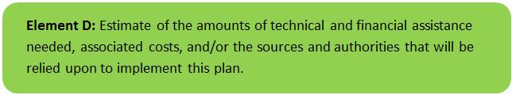

Table D-1 presents the funding needed to implement the management measures presented in this watershed plan. The table includes costs for structural and non-structural BMPs, operation and maintenance activities, information/education measures, and monitoring/evaluation activities.

Town Commitment to Inspecting and Maintaining Stormwater BMPs
The proposed green infrastructure installations will be maintained by the Town of Mashpee Department of Public Works. Mashpee DPW’s commitment to green infrastructure and related stormwater control measures has been shown through the design, construction, and maintenance of stormwater BMPs throughout the Town and, in particular, within targeted areas surrounding the Town’s water resources. The Town has increased funding for this work in the DPW’s annual operating budget. In addition, all road projects funded through Chapter 90, the Complete Streets Program, Cape Cod Transportation Improvement Program, and other infrastructure funds all include stormwater improvements.

The proposed stormwater retrofits will be designed with maintenance in mind, including the maintenance equipment and capabilities of the Mashpee DPW. A project-specific operation and maintenance (O&M) plan will be developed for the Town Landing stormwater BMPs during a future final design phase and will be integrated into the Town’s Municipal Sites and Facilities Operations and Maintenance Plan.
The Town’s FY23 MVP Action Grant project also includes the development of a stormwater BMP O&M guide for DPW staff describing the required regular maintenance of the stormwater retrofits to be installed at Timberlane Drive/Lantern Lane, and a training session for DPW maintenance personnel on those and other stormwater retrofits including the retrofits proposed for Town Landing.
Table D-1: Summary of Estimated Implementation Costs and Additional Funding Needed to Implement the Watershed Plan. Fuss and O’Neill design and cost estimation, depicted in bold italic and Described in Appendix D.
.
Management  Measures | Location | Capital Costs | Operation &  Maintenance Costs | Relevant  Authorities | Technical  Assistance Needed | Funding Needed
Structural and Non-Structural BMPs (from Element C)
High Priority Stormwater Retrofits
LEACHING CATCH BASIN | 7. Cambridge Drive/ Leamington Lane | $ 5,000 | Integrate into Town Maintenance | Town of Mashpee | Fuss and O’Neill | $ 5,000
BIORETENTION AND RAIN GARDENS | 8. Leamington Lane/ Cotuit Road | $27,951 | Integrate into Town Maintenance | Town of Mashpee | Fuss and O’Neill | $27,951
BIORETENTION AND RAIN GARDENS | 17. Town Landing (See Appendix D) | $272,000 | Integrate into Town Maintenance | Town of Mashpee | Fuss and O’Neill | $272,000
BIORETENTION AND RAIN GARDENS | 18. Timberlane Drive/ Lantern Lane (See Appendix D) | $256,000 | Integrate into Town Maintenance | Town of Mashpee | Fuss and O’Neill | $256,000
BIORETENTION AND RAIN GARDENS | 10. South East Nobska Road | $18,634 | Integrate into Town Maintenance | Town of Mashpee | Fuss and O’Neill | $18,634
BIORETENTION AND RAIN GARDENS | 16. South East Shields Road/ Briant’s Neck | $37,268 | Integrate into Town Maintenance | Town of Mashpee | Fuss and O’Neill | $37,268
BIORETENTION AND RAIN GARDENS | 19. South East Briants Neck | $18,634 | Integrate into Town Maintenance | Town of Mashpee | Fuss and O’Neill | $18,634
LEACHING CATCH BASIN | 19. South East Briants Neck | $5,000 | Integrate into Town Maintenance | Town of Mashpee | Fuss and O’Neill | $5,000
BIORETENTION AND RAIN GARDENS | 15. West Cranberry Lane/ Bayberry Drive | $18,634 | Integrate into Town Maintenance | Town of Mashpee | Fuss and O’Neill | $18,634
GRASSED CHANNEL/ WATER QUALITY SWALE | 15. West Cranberry Lane/ Bayberry Drive | $16,738 | Integrate into Town Maintenance | Town of Mashpee | Fuss and O’Neill | $16,738
Subtotal |  |  |  |  |  | $675,859
Medium Priority Stormwater Retrofits
BIORETENTION AND RAIN GARDENS | Aggregate of BMPs at Medium-priority sites | $391,314 | Integrate into Town Maintenance | Town of Mashpee | Fuss and O’Neill | $391,314
GRASSED CHANNEL/ WATER QUALITY SWALE | Aggregate of BMPs at Medium-priority sites | $16,738 | Integrate into Town Maintenance | Town of Mashpee | Fuss and O’Neill | $16,738
LEACHING CATCH BASIN | Aggregate of BMPs at Medium-priority sites | $27,500 | Integrate into Town Maintenance | Town of Mashpee | Fuss and O’Neill | $27,500
Sub-Total |  |  |  |  |  | 435,552
Additional BMPs
Improved Street Sweeping and Catch Basin Cleaning, | All Housing subdivisions around Pond | $0 | Integrate into Town Maintenance | Town of Mashpee | Fuss and O’Neill | $0
Alum Treatment to reduce TP load from sediment. | Pond Sediment | $600,000 | Treatment estimated to last 10 -15 years | Town of Mashpee | Fuss and O’Neill | $600,000
Town WWTP and sewer collection (Phase I & II) | Septic Inputs | $54 million Phase 1, Phase II cost unknown | Integrate into Town Maintenance | Town of Mashpee | Town’s consultant | $0 (funding appropriated through other sources)
Homeowner Septic System Compliance with Title 5 | Septic Inputs | Homeowner responsibility | Homeowner responsibility | Homeowner responsibility | Homeowner responsibility | $0
Sub-Total |  |  |  |  |  | 600,000
Information/Education (see Element E)
General public outreach as described in the introduction plus targeted outreach for Santuit Pond homeowners to participate in the selection of prioritized BMPs.
Monitoring and Evaluation (see Element H/I)
Direct and Indirect measurement of water quality improvement.
Total: |  |  |  |  |  | $1,711,411**
Town Match: |  |  |  |  |  | $450,000
Phase I & II MVP Action Grant, 604 (b) pending |  |  |  |  |  | $600,728
Total Estimated Funding Needed: |  |  |  |  |  | $660,683
Funding Sources: Town of Mashpee General Budget, Town of Mashpee Budget Line Item ($450,000), MassDEP Section 319 NPS grant, MassMVP Action Grant 2022-2023, SNEP Network Technical Support, note $600,728 received in MVP grants.
***Full Project Implementation Contingent on multiple Grant Awards. Overall costs are likely underestimated based on Fuss and O’Neill cost estimates for Town Landing and Timberlane Drive BMPs.

Element E: Public Information and Education

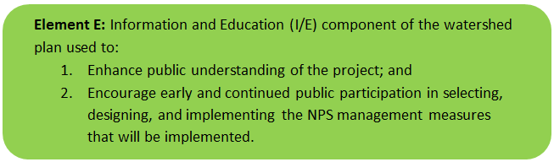

Public Education and Outreach for Santuit Pond is part of a larger comprehensive program administered by the Town of Mashpee and the MWT. Both entities are in close communication and partnership on their individual outreach efforts. A description of each of the outreach elements is provided below.

Mashpee Wampanoag Tribe (MWT)
The Mashpee Wampanoag Tribe (MWT) have been stewards of the land for over 12,000 years and continue to protect the environment including, but not limited to, approximately 170 acres of Tribal lands located in the Town of Mashpee, MA. The Mashpee Wampanoag Tribe, known as “People of the First Light,” strive to work in harmony with their vast local bounty of natural resources, having made their living from the land and the sea for thousands of years. The Tribe’s focus is on general education and outreach through a variety of programs offered to the tribal community and through the Tribe’s webpage. Preserving our Homeland’s (POH) is a specialized summer youth environmental science camp that combines Traditional Ecological Knowledge (TEK) and Western conventional science concepts to teach Mashpee Wampanoag tribal middle school youth about their local environment. The Tribe participates in a regional monitoring program for the New England Cottontail (NEC) that includes animal inventory on tribal lands and in the tribal use area on Cape Cod. MWT collaborates with the federal government to promote appropriate use of pesticides and provides training and resources to its members. The Tribe partners with the Town of Mashpee on public announcement and translates public messaging into native language.

Town of Mashpee
The Town integrates public education into all of its programs through town meetings, town web page, informational leaflets, public announcements and targeted outreach efforts. Annual announcements encourage:

- Proper use and disposal of grass clippings and the proper use of slow-release and phosphorus-free fertilizers (April/May)
- Proper management of pet waste, including noting any existing ordinances where appropriate (June/July)
- Proper disposal of leaf litter (August/September/October) - Why Should I Keep Mashpee Stormwater Drainage Structures Free of Leaves? How Can I Help? Dispose of Leaf Litter by Composting: A

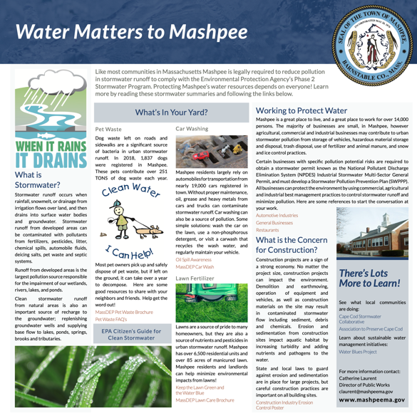

Figure E-1. Example Public Outreach Flier.

MVP Action Grant – the Town of Mashpee was recently awarded an MVP Action Grant to promote community awareness related to homeowner practices in the Santuit Pond Watershed. The grant will specifically focus on Green Infrastructure and Low Impact Development practices. The elements of this project along with public outreach components are shown in Figure E2.

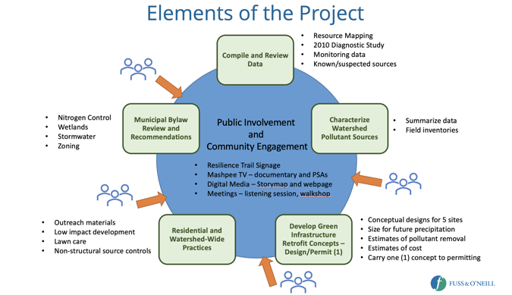
Figure E2 - Elements of MVP Action Grant Santuit Pond.

Step 1: Goals and Objectives
The goals of the outreach program are to provide public education at set frequencies on best practices for mitigating the effects of polluted stormwater runoff.

Targeted outreach to residents on Santuit Pond will take place in 2022 throughout the home makeover initiative and the video documentary.

Public information and education efforts will also support informed stakeholder engagement by watershed homeowners, area business owners, and members of the Mashpee Wampanoag Tribe. Programs will incorporate the knowledge and perspective of the Wampanoag.

Step 2: Target Audience
Goals and objectives for public outreach will vary by audience and management measure.

Homeowners and landowners in the Santuit Pond Watershed: Targeted outreach to the homeowners around Santuit Pond will take place as part of the 2022 MVP Action Grant award. Homeowners within 500’ of the Pond, within highly impervious areas, and in the hotspots highlighted in figure C-1 are top priorities for outreach and engagement. In addition to education related to the health order mandating testing and improved maintenance of septic systems within 500’ of the pond, this group will also receive education and outreach materials focused on yard maintenance, pet waste management, and other stormwater management best practices.

Mashpee Wampanoag Tribe: Tribal representatives will provide guidance on what type of public messaging will be useful to explain the importance of the pond and Tribal perspectives. Opportunities to engage Mashpee Wampanoag Tribal citizens and leaders in public outreach and messaging will be identified as feasible.

Recreational Visitors to the Town Landing Boat Launch: outreach and education related to stormwater management practices in conjunction with planned stormwater retrofit on site. Additional on-site outreach and education focused on nutrient pollution and harmful algal blooms could further expand public outreach and understanding.

Cranberry Farmers: Specific outreach to owners and operators of cranberry bogs in the watershed should focus on best management practices and use of low phosphate fertilizers. This may also include education on the Town’s efforts to acquire bog lands for restoration. It is not clear if inactive bogs are an ongoing source of phosphorus to the pond. Further analysis is needed to determine if additional intervention is needed.

Step 3: Outreach Products and Distribution

Community outreach products and their schedule for distribution are described below.

Table E-1. Summary of Public Outreach.
Focus: Action Item | Responsible Entity | Method & resource | Timing | Audience
Mashpee Web page | Town of Mashpee Department of Natural Resources (Mashpee DNR) | Web | Ongoing | Interested Stakeholders and the general public
Stormwater: Proper use and disposal of grass clippings & encouraging the proper use of slow-release phosphorus-free fertilizers | Town of Mashpee Department of Natural Resources (Mashpee DNR) | Flyer on Town Website and facebook page | Annual - April/May | Homeowners and landowners in the watershed
Stormwater: Proper management of pet waste | Mashpee DNR | Flyer on town Website and Facebook page and available in print. | Annual - June/July | Homeowners and landowners in the watershed; recreational visitors to town landing boat launch
Stormwater: Proper disposal of leaf litter | Mashpee DNR | Flyer on town Website and Facebook page and available in print. | Annual - August/September/October | Homeowners and landowners in the watershed
Resilience Trail Signage | MVP Action Grant – Mashpee DNR | Physical signage | May 2022 | Visitors to the Santuit Pond Resilience Trail
Documentary Video & Public Service Announcements | MVP Action Grant – Mashpee DNR | Videos distributed via town and partner channels including Mashpee TV | April 2022 | General public, Homeowners and landowners in the watershed; recreational visitors to town landing boat launch
StoryMap: “Residential Makeover” (e.g., water conservation, rain gardens, reduced lawn size, reduced fertilizer, riparian buffer benefits) | MVP Action Grant | Online, Physical Signage | Summer 2022 | General public, Homeowners and landowners in the watershed; recreational visitors to town landing boat launch
Septic: Septic maintenance and upgrade informational materials | Town of Mashpee Department of Health | Flyers available on the Town website, Facebook page, and in print. | Ongoing | Homeowners within 500 ft of the Pond
Key public messaging and communications products | SNEP Network Partners | Fact Sheet, Social Media, Website content. | Fall 2022, Winter 2023 | General Public

Public Presentations & Workshops:
- November 2019: MVP Planning Workshops
- March 2020: Community Resilience Building Workshop; Town of Mashpee & Woods Hole Group
- September 2021: Fuss and O’Neill Public Presentation on HAB Resilience: Watershed-based Solutions to Increase Resilience to Harmful Algal Blooms in Santuit Pond in a Warmer and Wetter Climate, MVP Action Grant -- slides available on Mashpee DNR website.
- April 15, 2022: Homeowner workshop to provide education on water conservation, rain gardens, reduced lawn size, reduced fertilizer, riparian buffer benefits
- June 2022: Santuit Pond homeowner workshop
- Fall 2022 and Winter 2023: Stakeholder workshops and development of public messaging strategies

Step 4: Evaluate Information/Education Program
Septic management and maintenance education: We measure the effectiveness of public education focused on septic systems through outcomes of the septic system maintenance program, including full compliance with the Board of Health order mandating testing of septic systems. Metrics include:
- Percent of systems tested (As of March 2022: 84.7%, goal: 100%)
- Percent of systems passing inspection (As of March 2022: 53%; goal: 100%) We anticipate full compliance of the 118 systems by the end of 2023.
- Number of systems upgraded or replaced with innovative/alternative systems (100% of failed system)
Stormwater management education: we will use two sets of metrics to evaluate the effectiveness of our public outreach and education campaigns focus on stormwater: public engagement with the green infrastructure planning and design process and landowner adoption of residential stormwater management practices.
- Participation in the green infrastructure planning and design process (MVP)
  - Number of people who sign up for information about stakeholder meetings, with a breakdown that tracks involvement from priority homeowners (within 500’ of the pond and in hotspots) and members of the Mashpee Wampanoag Tribe.
  - Number of unique participants in stakeholder meetings
- Information shared to homeowners about home-based practices to reduce nutrient flows to Santuit Pond (ex. Rain gardens, impervious cover disconnection, low-phosphorus fertilizer, leaf and grass clipping management, planting of native species, etc.)
  - Number of printed flyers distributed
  - Number of online visits to web-based informational tools
  - Number of homeowners (within and beyond the 500’ Santuit Pond buffer) who adopt pond-friendly practices in their homes and yards.
  - Number of visitors to the “residential makeover” site demonstrating green processes
  - Verbal and anecdotal feedback from homeowners who engage with educational materials
The Town welcomes informal feedback relative to projects and tools and we work to engage the public on our performance at critical stages through our town meetings (televised) and targeted sessions. Our public education emphasizes communication and feedback, both positive and negative, and we work to integrate feedback into processes moving forward. Our best evidence of the effectiveness of our programs is the long-term results-oriented environmental programs that include pollution prevention, water quality restoration, water quality monitoring and multi-year green infrastructure and nature-based climate resilience solutions.

Elements F & G: Implementation Schedule and Measurable Milestones

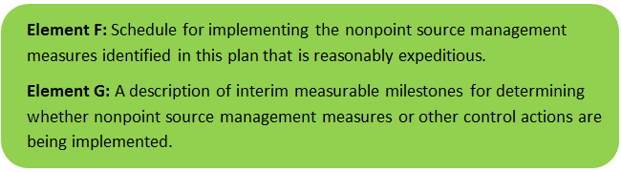

A description of the anticipated task, estimated timeline and interim milestones for the project are outlined below:

Table G-1: Implementation Schedule and Interim Measurable Milestones

Activity | Schedule | Target Interim Milestone
A. Town Water Quality Monitoring of Santuit Pond | Monitoring carried out monthly, data assessed annually | Data evaluated annually to assess water quality improvement relative to targets
B. Public Outreach | Annually | All Public Messages executed in accordance with schedule
Public message -Proper disposal of grass clippings & slow-release phosphorus-free fertilizers | Annually/April May | Public Message Delivered
Public message - Proper management of pet waste | Annually June/July | Public Message Delivered
Public message -Proper disposal of leaf litter | Annually August/September/October | Public Message Delivered
Santuit Pond Residential outreach | March 2022 and ongoing | Community workshop on stormwater homeowner practices is held completed, SNEP Network development of public messaging products
C. Interim Septic System Remediation
Town Board of Health (BOH) to septic system enforce order homes within 300 feet of the pond | July 2021 | 118 properties ordered to test systems
Home septic system owner testing | December 2021 | All properties comply with order
Home septic compliance | December 2022 | All properties are in compliance with Title 5
D. SNEP Network - Planning
1. Stormwater Planning training Curriculum Development | November 2022 | Workshop curriculum completed
2. Facilitated Stormwater Training Series | May 2022 | Town/Tribe completed stormwater retrofit design for Town Landing
3. Santuit Pond Site Visit | October 2021 | Concept designed discussed with Town/ Tribe
4. Draft Santuit Pond Watershed Based Plan | February 2022 | Draft Plan sent to MassDEP for review
5. Final Santuit Pond Watershed Based Plan | October 2022 | Final plan completed
6. TRC (formerly ESS Group) - Assessment of Interim Measures to Address In-lake Phosphorus Report | February 2022 | Final report completed
E. Stormwater Prioritization & Implementation (MVP Action Grant - Fuss and O'Neill )
Required Task 0: Project kickoff | October 2022 | Task completed
1. Compilation and Review of Existing Data | November 2022 | Task completed
2: Characterization of Watershed Pollutant Sources | December 2022 | Task completed
3: Future Precipitation Estimates | January 2022 | Task completed
4: Development of Stormwater Green Infrastructure Retrofit Concepts (19 Town owned sites) Santuit Pond | June 2022 | 19 Town-owned sites identified, 5 concept designs, completed
5: Design and Permitting for One (1) Stormwater Green Infrastructure Retrofit | June 2022 | 1 site full-design & permitting project completed
6: Residential LID Practices and Watershed-wide Non-structural Measures | February 2022 | Task completed
7: Municipal Bylaw Review and Recommendations | February 2022 | Task completed
8: Public Involvement and Community Engagement | March 2022 | Task completed
9: Project Report 2021 MVP Grant | June 2022 | Task completed
10: Project Management and Reporting | June 2022 | Task completed
F. Town Article Match Fund | July 2022 | Allocation approved
G. Submit 2022 MVP Action Grant for Implementation funds | Spring 2022 | Grant request approved
2022 MVP Action Grant Submission | June 2022 | Completed, grant awarded
Timberlane Drive Stormwater Retrofit Construction | Fall 2022 | In progress
H. Submit 604 b grant application | August 2022 | Completed
Submit 319 NPS Grant for Alum treatment | Fall 2022 | Pending
I. Implementation Selected Stormwater Projects Construction
Final Design/permits for High Priority BMPs | 2022-2025 | Final design and permits approved, contingent on funding
Construction Implementation High Priority | 2022-2025 | High Priority Site BMPs are implemented, contingent on funding
J. Implementation of Additional Stormwater BMPs (Medium Priority)
Construction Implementation of remaining High Priority Sites BMPs | 2022-2027 | High Priority Site BMPs are implemented
Final Design/permits for Medium Priority BMPs | 2022-2027 | Final design and permits approved for Medium priority sites
Construction Implementation of Medium Priority Sites BMPs | 2022-2027 | Medium Priority Site BMPs are implemented
K. Alum treatment
Options Assessment | February 2022 | Assessment Report complete
Sediment Core and baseline monitoring, treatment design and permits | Summer, Fall 2022 | In progress
Design, Permits and contracting of Alum Treatment | Winter 2023
Perform Treatment | Estimated 2023, 2024 | Treatment performed in accordance with design plan
L. Implementation of Sewer Collection
Phase I – 54 Million, construction of wastewater treatment plan and installation of Phase I collection systems | 2022-2032 | WWTP operation and sewer collection is in place and functional
Phase II – Installation of collection systems in neighborhoods adjoining Santuit Pond | 2030 | WWTP operations and sewer collection is in place and functional for Santuit Pond homeowners (Beechwood Point and Cotuit Road)
Phase III - V | TBD | TBD
M. ACOE Sediment dredging Report
Evaluation of sediment dredging and habitat restoration options | December 2022 | Report published
Implementation | June 2023 | Go, no go decision

Scheduling and Milestone Timeline:
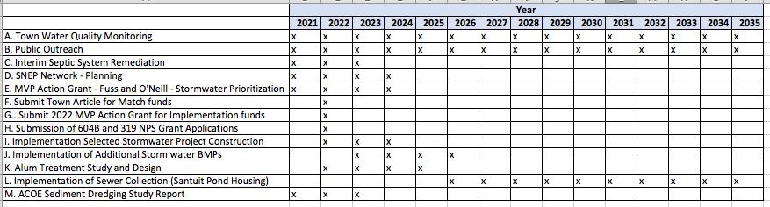

Elements H & I: Progress Evaluation Criteria and Monitoring

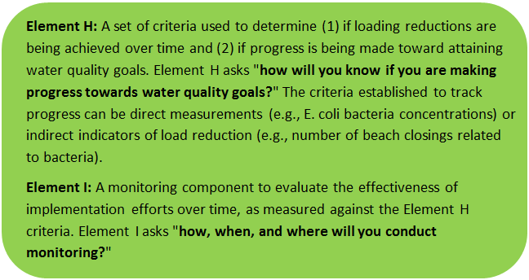 | 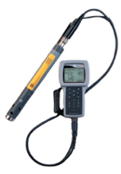

The water quality target concentration is presented under Element A of this plan. To achieve this target concentration, the annual loading must be reduced to the amount described in Element B. Element C of this plan describes the various management measures that will be implemented to achieve this targeted load reduction. The evaluation criteria and monitoring program described below will be used to measure the effectiveness of the proposed management measures (described in Element C) in improving the water quality of Santuit Pond.

Indirect Indicators of Load Reduction
Algae Monitoring: In recent years, an increase in the reported incidence of nuisance blue-green blooms has been one of the most notable and visible symptoms of nutrient enrichment and declining water quality. Continued monitoring (i.e. algae count once per week from June 1st to mid-October) of the abundance and composition of the lake’s algal community will provide a useful metric for understanding water quality trends in response to implementation of the measures recommended under Element C.

Project-Specific Indicators
Planned activities that are implemented over time will be tracked and summarized on an annual basis. As feasible, phosphorus removal credits will be tracked and quantified based on EPA’s Stormwater BMP Pollutant Removal Tools https://www.epa.gov/npdes-permits/stormwater-tools-new-england#swbmp.

MassDEP Monitoring Program
It is anticipated that monitoring by MassDEP staff will be continued as feasible as part of the Departments Water Quality Monitoring Program. Additional monitoring by volunteer groups is encouraged. The development of Quality Assurance Project Plans will be encouraged for third party data collectors. Where feasible third party data with an approved QAPP will be submitted to MassDEP’s water quality assessment program.

Direct Measurements
The Mashpee Water Quality Monitoring Program is an on-going collaborative effort between the Mashpee Wampanoag Tribe, the Town of Mashpee and the Coastal Systems Program (CSP) within the University of Massachusetts – Dartmouth, School of Marine Science and Technology (SMAST). The project has a two-fold goal: 1) to sustain a continuing assessment of the nutrient related water quality of Santuit Pond and 2) monitor improvements in water quality resulting from restoration efforts as undertaken by the Town, Tribe and others. The program goals are achieved through the collection and analysis of water samples and associated field parameters relevant to assessing water quality and these data form the basis for: 1) gauging short and long-term trends in water quality, 2) determining whether phosphorus targets are achieved. The program is supported by the Ponds and Lakes Stewardship program that collects 1 profile nutrient sampling event for each freshwater body on Cape that is sent to SMAST for analysis.

In order to develop a sustainable long-term program, a consortium was created whereby sample collection is completed by volunteers recruited by each consortium partner and by public participants, with equipment and analytical costs distributed between the Mashpee Wampanoag Tribe and the Town of Mashpee. The current program relies on deployed sondes(YSI, EXO2, RBRmastreo (2022)) that collect data at a frequency of 15 minute intervals for Chlorophyll, Cyanobacteria Pigment - Phycocyanin, Dissolved Oxygen, pH, Salinity – Conductivity, Temperature, Turbidity, total Dissolved Solids, and Total Suspended solids. In-lake phosphorus measurements will provide the most direct means of evaluating the effects of BMPs that have been implemented to reduce phosphorus loading (i.e., monthly grab samples from May-October for nutrient analysis). Since this is a shallow lake less than 9 ft in depth the lake is believed to be uniformly mixed.

Adaptive Management
Because of the complexity of the Santuit Pond system and the number of sources to be addressed an adaptive management approach is proposed that allows for a process that is implemented in stages over time. The adaptive management process will allow for continued refinement of pollution management interventions as activities are monitored. A coordinated effort from all responsible and interested parties will be required to achieve the water quality goals that are projected to restore uses.

The Town of Mashpee Department of Natural Resources in conjunction with the MWT, its partners and consultants is responsible for the oversight of the Santuit Pond Watershed Based Plan. The Implementation Schedule and Interim Measurable Milestones is summarized in Table G-1. Progress on the milestones will be reviewed annually and updated as appropriate to ensure implementation activities and monitoring are carried out as conceived.

The ultimate measure of success will be the reduction in phosphorus loads to the pond that result from the implementation of best management practices. The reduction in phosphorus load is anticipated to result in improved water quality and habitat that is measured through the Mashpee Water Quality Monitoring Program. Water quality restoration will be evaluated by comparing direct and indirect measurements to the phosphorus load reduction goals and MassDEP’s Surface Water Quality Standards (314CMR 4.00) and assessed in accordance with the Department’s Comprehensive Assessment and Listing Methodology (MassDEP 2018). The data collected will be evaluated for short and long-term trends in water quality and ultimately whether phosphorus targets are achieved.

Watershed Plan Summary
This Santuit Pond Watershed Based Plan was developed through a partnership between the MWT and the Town of Mashpee with technical assistance from the SNEP Network, TRC and Fuss and O’Neill. The plan was initiated with the MassDEP watershed based plan tool and adapted based on supplemental reports and information collected during its development. The plan includes all nine elements and describes all activities that have been completed, are underway or being planned for the future.

The plan builds on the AECOM Santuit Pond Diagnostic Study that was published in 2010. The report quantified sources of phosphorus and estimated the load reductions that will be required to restore water quality. Updated studies carried out by Fuss and O’Neill as part of the 2022/2023 MVP grant and ESS Group under contract with SNEP provide updated and expanded information to inform management decisions.

It is anticipated that Alum treatment, stormwater control measures and the implementation of sewer collection and treatment will reduce phosphorus load by 80%. Budget estimates for high and medium priority activities suggest that the combined Alum treatment and stormwater retrofit project is approximately $1,700,000 and will be implemented in the next 5 years. The Department of Natural Resources budget request of $450,000 for FY 2023 will serve as a match for both Alum Treatment and the implementation of stormwater BMPs. The Town and Tribe will be seeking additional grant funding for implementation of the activities described in this plan.

The Town of Mashpee Department of Natural Resources in conjunction with the MWT, its partners and consultants is responsible for the oversight of the Santuit Pond Watershed Based Plan. The implementation of the practices described in this plan are anticipated to reduce the phosphorus load to Santuit Pond and improve water quality. The Town and its partners will monitor water quality to evaluate trends and whether water quality targets are achieved. This plan is considered a living document that will be reviewed on an annual basis and updated as appropriate to ensure that implementation activities are carried out using an adaptive management approach.

References
314 CMR 4.00 (2013). "Division of Water Pollution Control, Massachusetts Surface Water Quality Standards"
US ACE (2021). Santuit Pond - Section 206 Aquatic Ecosystem Restoration Project Mashpee, MA, September 2021, UA Army Corps of Engineers, New England District.
AECOM (2010) Santuit Pond Diagnostic Study Mashpee, Massachusetts, prepared for the Town of Mashpee, Mashpee , MA by AECOM, July 19, 2010. https://www.mashpeema.gov/sites/g/files/vyhlif3426/f/uploads/santuitpondreportfinalv2.pdf
ArcGIS (2020a). "USA Soils Hydrologic Group" Imagery Layer
ArcGIS (2020b). "USA Soils Water Table Depth" Imagery Layer
Cape Cod Commission (CCC). 2003. Cape Cod Pond and Lake Atlas. Final Report. CCC Water Resources Office, Massachusetts Executive Office of Environmental Affairs, University of Massachusetts School of Marine Sciences and Technology (SMAST). May 2003.
Cohen, A. J.; Randall, A.D. (1998). "Mean annual runoff, precipitation, and evapotranspiration in the glaciated northeastern United States, 1951-80." Prepared for United States Geological Survey, Reston VA.
Geosyntec Consultants, Inc. (2014). "Least Cost Mix of BMPs Analysis, Evaluation of Stormwater Standards Contract No. EP-C-08-002, Task Order 2010-12." Prepared for Jesse W. Pritts, Task Order Manager, U.S. Environmental Protection Agency
Geosyntec Consultants, Inc. (2015). "Appendix B: Pollutant Load Modeling Report, Water Integration for the Squamscott-Exeter (WISE) River Watershed."
Horsley and Witten Group (2021). Chop Chaque Bogs Restoration Concept Feasibility Assessment, Prepared for Mashpee Conservation Commission, October 2021.
King, D. and Hagan, P. (2011). "Costs of Stormwater Management Practices in Maryland Counties." University of Maryland Center for Environmental Science Chesapeake Biological Laboratory. October 11, 2011.
Leisenring, M., Clary, J., and Hobson, P. (2014). "International Stormwater Best Management Practices (BMP) Database Pollutant Category Statistical Summary Report: Solids, Bacteria, Nutrients and Metals." Geosyntec Consultants, Inc. and Wright Water Engineers, Inc. December 2014.
MA Department of Revenue Division of Local Services (2016). "Property Type Classification Codes, Non-arm’s Length Codes and Sales Report Spreadsheet Specifications" June 2016
MassDEP (2011). “Cape Cod Coastal Drainage Areas 2004-2008 Surface Water Quality Assessment Report, DWM Control Number CN 171.0, May 2011.
MassDEP (2012). "Massachusetts Year 2012 Integrated List of Waters Final Listing of Massachusetts' Waters Pursuant to Sections 305(b), 314 and 303(d) of the Clean Water Act"
MassDEP (2016a). "Massachusetts Clean Water Toolkit"
MassDEP (2016b). "Massachusetts Stormwater Handbook, Vol. 2, Ch. 2, Stormwater Best Management Practices"
MassDEP (2018) Massachusetts Consolidated Assessment and Listing Methodology (CALM) Guidance Manual
for the 2018 Reporting Cycle, CN455, May 2018.
MassDEP (2021). “Final Massachusetts Integrated List of Waters for the Clean Water Act 2018/2020 Reporting Cycle” MassDEP, CN 505.1, November 2021.
MassDEP (2022). Final West and East Monponsett Pond System Total Maximum Daily Loads For Total Phosphorus (CN 446.1), MassDEP, January 2021.
MassGIS (1999). "Networked Hydro Centerlines" Shapefile
MassGIS (2001). "USGS Topographic Quadrangle Images" Image
MassGIS (2005). "Elevation (Topographic) Data (2005)" Digital Elevation Model
MassGIS (2007). "Drainage Sub-basins" Shapefile
MassGIS (2009a). "Impervious Surface" Image
MassGIS (2009b). "Land Use (2005)" Shapefile
MassGIS (2012). "2010 U.S. Census Environmental Justice Populations" Shapefile
MassGIS (2013). "MassDEP 2012 Integrated List of Waters (305(b)/303(d))" Shapefile
MassGIS (2015a). "Fire Stations" Shapefile
MassGIS (2015b). "Police Stations" Shapefile
MassGIS (2017a). "Town and City Halls" Layer
MassGIS (2017b). "Libraries" Layer
MassGIS (2020). "Massachusetts Schools (Pre-K through High School)" Datalayer
MassGIS (2021). "Standardized Assessors’ Parcels" Mapping Data Set
Massachusetts Historical Commission (MHC). 1984. MHC reconnaissance survey town report: Mashpee. Boston, MA.

Mashpee Environmental Coalition. November 2009. Pond Health Project. Interim Report and Appendices.
<http://www.mashpeemec.us/Pond%20Health%2009/2009%20Santuit%20Pd%20Apx.pdf>.

Mashpee Environmental Coalition (MEC). Undated. The Sachem’s Place. Cotuit/Santuit Watershed. <http://www.mashpeemec.us/Santuit%20Book%20Final%20Color.pdf>.
Town of Mashpee and Mashpee Wampanoag Tribe (2022) Quality Assurance Project Plan for Santuit Pond Baseline Monitoring and Sediment Coring Program, prepared by TRC Corp.
Town of Mashpee (2022), Task 2 – Characterization of Watershed Pollutant Sources Watershed-based Solutions to Increase Resilience to Harmful Algal Blooms in Santuit Pond in a Warmer and Wetter Climate, Fuss and O’Neill Inc. (2022).
Town of Mashpee (2020), Community Resilience Building Workshop Summary of Findings, Woods Hole Group, March 2020.

Town of Mashpee (2010) Santuit Pond Diagnostic Study Mashpee, Massachusetts, prepared for the Town of Mashpee, Mashpee , MA by AECOM, July 19, 2010. https://www.mashpeema.gov/sites/g/files/vyhlif3426/f/uploads/santuitpondreportfinalv2.pdf

Town of Mashpee (2019), Mashpee’s Stormwater Management Program, Tighe and Bond, June 2019. https://documentcloud.adobe.com/link/track?uri=urn%3Aaaid%3Ascds%3AUS%3Afdfdca5e-c994-4549-8d54-9d7b6ea90f9a#pageNum=1

Town of Mashpee Stormwater Brief https://www.mashpeema.gov/sites/g/files/vyhlif3426/f/uploads/2019_mashpee_ma.pdf

Schueler, T.R., Fraley-McNeal, L, and K. Cappiella (2009). "Is impervious cover still important? Review of recent research" Journal of Hydrologic Engineering 14 (4): 309-315.

United States Bureau of Labor Statistics (2016). "Consumer Price Index"

United States Geological Survey (2016). "National Hydrography Dataset, High Resolution Shapefile"
University of Massachusetts, Amherst (2004). "Stormwater Technologies Clearinghouse"
USDA NRCS and MassGIS (2012). "NRCS SSURGO-Certified Soils" Shapefile
USEPA (1986). "Quality Criteria for Water (Gold Book)" EPA 440/5-86-001. Office of Water, Regulations and Standards. Washington, D.C.
USEPA. (2010). "EPA's Methodology to Calculate Baseline Estimates of Impervious Area (IA) and Directly Connected Impervious Area (DCIA) for Massachusetts Communities."
Voorhees, Mark, USEPA. (2015). "FW: Description of additional modeling work for Opti-Tool Project" Message to Chad Yaindl, Geosyntec Consultants. 23 April 2015. E-mail.
Voorhees, Mark, USEPA. (2016a). "FW: EPA Region 1 SW BMP performance equations" Message to Chad Yaindl, Geosyntec Consultants. 25 January 2016. E-mail.
Voorhees, Mark, USEPA. (2016b). "FW: Description of additional modeling work for Opti-Tool Project" Message to Chad Yaindl, Geosyntec Consultants. 23 April 2015. E-mail.

Appendices

Appendix A - Project Team Contacts
- Town of Mashpee
  - Ashley Fisher, Director of Natural Resources, afisher@mashpeema.gov, 508-539-1410
- Mashpee Wampanoag Tribe
  - Jason Steiding, Natural Resources Dept. Director, Jason.Steiding@mwtribe-nsn.gov
- Mashpee TV
  - Christopher Ball, chris@mashpeetv.com
- Fuss & O’Neill
  - Diane Mas, Project Manager, dmas@fando.com, 800-286-2469 x4406
- TRC (formerly ESS Group)) - Matt Ladeweig, mladewig@essgroup.com, 401-330-1204
- SNEP Network, Kimberly Groff, kimberlygroffma@gmail.com, 508-932-5528
Appendix B - Wampanoag Mashpee Tribe Activities

Habitat Management - The New England Cottontail (NEC) – the NEC rabbit's ideal habitat has been greatly reduced due to massive development taking place over the last century. Efforts are underway from east of the Hudson River into New England to avoid having the NEC placed on the endangered species list by the U.S. Fish & Wildlife Service by creating new habitats to increase the overall population of NEC rabbits. In an attempt to avoid this classification, the Tribe’s Natural Resources Department has acquired funding from USDA’s Animal and Plant Health Inspection Service through USET to conduct an animal inventory on tribal lands and in the tribal use area on Cape Cod.

Habitat Management – MWT is the recipient of grants from NOAA and the U.S. Fish and Wildlife Grant to collect data and determine the reason(s) for the decline of the River Herring and Brook Trout.

Wetland Planning Grant – MWT is the recipient of a federal grant to identify and map wetlands and develop mitigation measures on tribal reservation lands.

EPA Pesticides Program - MWT collaborates with the federal government to promote appropriate use of pesticides and provides training and resources to its members.

First Light Shellfish farm - Funded by a U.S. Fish and Wildlife Grant, the Mashpee Wampanoag Shellfish Farm began operations in 2009 and our first oysters were sold to our wholesaler in September 2010. Through shellfish cultivation, the Mashpee Wampanoag Tribe improves the water quality of the Popponesset Bay by reducing the nitrogen composites while preserving historic cultural traditions as long-time inhabitants of Southeastern Massachusetts.

Forestry Management and Prescribed Burns – MWT partners with entities in controlled burning to protect people and their homes from wildfires and invigorate shrub growth to enhance habitat for the New England cottontail rabbit and Northern long-eared bats. Burning in a controlled manner under predetermined weather conditions safely reduces litter buildup and ladder fuels that could otherwise fuel a wildfire and make it burn more aggressively and harder to control by firefighters.

Clean-up illegal dumping - The Natural Resources Department (NRD) and the Fish, Wildlife & Natural Resources Commission (FWNRC) participates in the cleanup of illegal dump sites on Tribe and Town land in Mashpee. The NRD and FWNRC has partnered with the Cape Cod Jeep Club and the Mashpee Land Stewards to clean up the Noisy Hole property off of Meetinghouse Rd. and the Johns Pond area on Town land in Mashpee.

Education Native Youth in Science – Preserving our Homelands (POH) held by the Natural Resources Department of the Mashpee Wampanoag Tribe. POH is a summer youth environmental science camp that combines Traditional Ecological Knowledge (TEK) and Western conventional science concepts to teach Mashpee Wampanoag tribal middle school youth about their local environment.

Army Corp of Engineers Dredge Study - update Project Notes January 19, 2022

Barbara Blumeris and Adam Burnett (US Army Corps of Engineers - USACE, New England District, Plan Formulation Branch) virtually met with staff from Mashpee Wampanoag Tribe (Project Sponsor) and Mashpee Town Natural Resources Department (Co-sponsor) on January 19, 2022 to go over USACE’s progress to date in assessing Santuit Pond herring habitat and formulating alternatives, as well as go over the Town’s progress and plans for interim and long-term management of Santuit Pond, including the proposed interim measure of injecting alum treatment into portions of the Santuit Pond substrate for phosphorus release control.

Here is the summary:
1) The Town is proposing to do an interim treatment of alum injection into portions of the Santuit Pond substrate to reduce phosphorus loading into the water column. This year was the worst observed in terms of length and severity of cyanobacteria outbreaks in the pond. The Town is responding by proposing this interim measure in conjunction with our longer-term dredging project to restore herring substrate and create fringe wetland habitat.
2) Adam presented the three alternatives USACE formulated to date:
a) No Action – no dredging and no dredge placement
b) Dredging 35+/- acres in the SE quadrant of the pond, hydraulic dredging 150K+ CY of muck down to and exposing sand substrate, and placing the muck into the proposed coir-log containment area for fringe emergent wetland restoration of 9+ acres as well as placement in several sandpits within the Town-owned “Santuit Reserve” area
c) Dredging 25+/- acres in the SE quadrant of the pond – footprint limited to dredging adjacent to Town-owned lands only, hydraulic dredging 100K+/- CY of muck down to and exposing sand substrate, and placing the muck only in the proposed coir-log containment area for fringe emergent wetland restoration of 9+ acres (see attached preliminary draft drawing to be further adjusted)
3) Adam provided an overview of the sediment analysis that USACE conducted in 2021 in Santuit Pond, including the core locations, core logs, and physical and chemical testing. I explained that a thick layer of silt muck covers the pond with 80% +/- water content, and that areas on the southeast portion of the pond showed sand beds 0’-6’ beneath the muck layer. Adam explained that dredging in these shallow muck areas could expose the sand substrate with reasonable amounts of dredging quantity. These exposed sand substrate areas would be adjacent to an existing narrow nearshore zone of exposed sand substrate – which herring presently use for spawning and nursery habitat. The muck showed elevated levels of arsenic (20-38 PPM), and an area in the extreme north shore of the pond showed very elevated levels of arsenic, mercury, and copper. Our project would completely avoid this one area with higher metal levels.
4) Adam provided an overview of a preliminary analysis of groundwater and surface water flows through the watershed and how the flows may change if we dredge areas removing overlying muck exposing sand substrate and fill areas of the pond with dredged materials in the proposed coir-log containment area. Adam explained that a USGS groundwater model of the area showed that a high rate of groundwater flows through the Santuit watershed generally from north to south through the underlying sand and gravel beds. Adam explained that the thick layer of silt muck in the pond inhibited groundwater flow into the pond since the silt muck has much lower hydraulic conductivity (permeability) than the sand beds. USACE adjusted the model to include the presence and effects of the thick muck layer. Adam explained that dredging down to exposed sand substrate would increase groundwater flow into the pond in the area that was dredged, and that the flows generally from the north would induce groundwater flow into the pond along the perimeter of the dredged area. Adam explained that groundwater flow through the coir-log containment area would be from north to south so water in the containment area would not re-enter the pond and would exit out of the pond to the south – thus not impacting the pond.
5) The Town Herring Warden (Drew McManus) and Natural Resource Director (Ashley Fisher) reiterated that the spawning occurs in very limited sandy substrate in the pond, and survival of eggs and fry are limited/very low in areas of muck, and that expanding the footprint of sandy substrate by removal of the muck would effectively expand productive spawning and nursery habitat.
6) The Tribe and Town participants want to limit the dredging footprint to areas adjacent to the Town property (as we show in Alternative c, above) and that the depth of exposed sand substrate could exceed 10 feet to allow for some buffer in removal of muck away from the restored spawning and nursery areas. Herring could use sandy substrate areas beyond 10 feet for nursery habitat, as long as dissolved oxygen levels were sufficient.
7) The Tribe and Town participants were supportive of the layout in Alternative c, as long as the dredge area and placement area were adjacent to Town-owned property. The footprint for the coir-log placement area was good and does not need adjustment. The footprint of the dredge area of alternative c is also good as long as the area is adjacent to Town-owned property. The Tribe and Town do not want to dredge or fill adjacent private lands because they want to be able to completely control the use of the area for O&M and monitoring.
8) The Tribe and Town participants supported the restoration of fringe emergent wetland by placement of dredged material in the coir-log containment area. Prior to impoundment, the pond had fringe emergent wetlands, which were permanently drowned by the impounded water increasing the water elevation by several feet. Thus, restoration of the fringe emergent wetlands as proposed in Alternative c would provide that needed restoration (we can count this 25 acres of emergent wetland restoration as increased beneficial habitat). The Town liked the idea of creating waterfowl habitat with the restored emergent wetlands. We discussed the positive results of the Milford Pond restoration of wetland areas in the 30-acre coir-log containment area – how it helped and attracted waterfowl. We also discussed placement of nest boxes – as were placed in the Milford project – on the coir-log containment wooden posts.
9) The Town participants discourage the filling of the sand pits because in working with the MA Department of Fish and Game ((F&W, NHESP), areas of critical concern – habitats for various state-protected species - were identified over the entire Town-owned “Santuit Preserve” area, so the Town recommends we drop that alternative from further consideration. Plus, the placement of dredged material in the pits could be considered “off site disposal”, and the elevated levels of arsenic could cause permit restrictions.
10) Placement of the dredged material in the coir-log containment area would be considered on-site placement and more easily permitted.
11) The Town will propose to perform alum injection treatment in the area of the pond that we do not propose to dredge or fill, as an interim measure of phosphorus reduction in the water column from phosphorus release out to the muck. The Town will not propose to place alum treatment in the footprint areas we propose to dredge and fill. The Town will analyze and document the effects of the alum treatment. We will not be further addressing the alum treatment since the areas we dredge and fill will not be treated with alum, and we will reference the Town’s analysis for alum treatment of the rest of the pond. This interim measure of alum treatment would occur within a year and thus prior to our dredging and filling proposal (to be implemented in 2023 or 2024). The alum treatment would likely reduce phosphorus loading in the rest of the pond, further reducing the risk of movement of phosphorus-laden water into the proposed dredge area.
12) The Town has a comprehensive plan for upgrading all septic systems for the housing in the Santuit Pond watershed, and will transition all areas to sewer over the next ten years (approximate). The Town has already implemented strict regulations limiting fertilizer use and constructing and maintaining catch basins to limit negative effects of surface runoff and groundwater impacts. The Town will also propose limiting motorboat use on the pond to reduce substrate disturbance and turbulence.
13) The Town agreed that the restored areas would be monitored and maintained to control non-native invasive vegetation.

The conclusion is that the Tribe and Town are very supportive of Alternative c with only slight adjustments, including the dredging and placement for restoring herring spawning and nursery habitat by exposing sand substrate in areas adjacent to Town property and by restoring fringe emergent and shrub-scrub wetlands by construction of the coir-log containment area. Alternative C substantially increases the quantity and quality of herring spawning and nursery habitat (increases from only a couple of acres to 25 acres) and restores 9 acres of fringe emergent wetland habitat from the minimal remaining fringe wetlands. The Tribe and Town are not supportive of Alternative b. Adam recommended that the study consider the revised Alternative c design, and eliminate Alternative b from further consideration. Adam recommends that the USACE study team should make this adjustment to focus on Alternative c now for on-going analysis, write-ups, and presentations. The Town will propose interim alum treatment in the areas of the northern area of the pond and completely avoid alum treatment in the areas that the Corps proposes to dredge or fill. The alum treatment would be implemented prior to the dredging project.

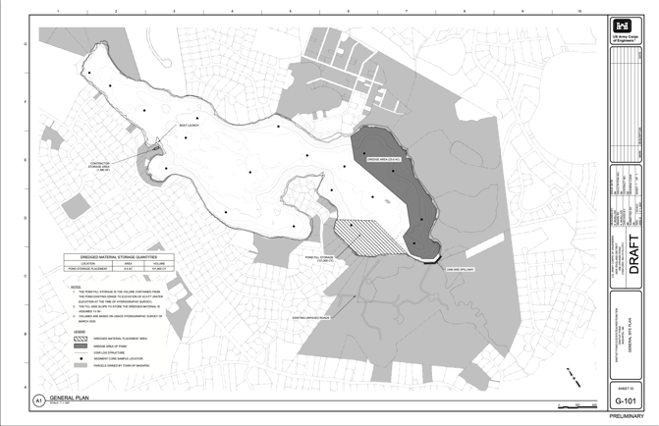

Appendix C – Pollutant Load Export Rates (PLERs)
Land Use & Cover¹ | PLERs (lb/acre/year)
 | (TP) | (TSS) | (TN)
AGRICULTURE, HSG A | 0.45 | 7.14 | 2.59
AGRICULTURE, HSG B | 0.45 | 29.4 | 2.59
AGRICULTURE, HSG C | 0.45 | 59.8 | 2.59
AGRICULTURE, HSG D | 0.45 | 91.0 | 2.59
AGRICULTURE, IMPERVIOUS | 1.52 | 650 | 11.3
COMMERCIAL, HSG A | 0.03 | 7.14 | 0.27
COMMERCIAL, HSG B | 0.12 | 29.4 | 1.16
COMMERCIAL, HSG C | 0.21 | 59.8 | 2.41
COMMERCIAL, HSG D | 0.37 | 91.0 | 3.66
COMMERCIAL, IMPERVIOUS | 1.78 | 377 | 15.1
FOREST, HSG A | 0.12 | 7.14 | 0.54
FOREST, HSG B | 0.12 | 29.4 | 0.54
FOREST, HSG C | 0.12 | 59.8 | 0.54
FOREST, HSG D | 0.12 | 91.0 | 0.54
FOREST, HSG IMPERVIOUS | 1.52 | 650 | 11.3
HIGH DENSITY RESIDENTIAL, HSG A | 0.03 | 7.14 | 0.27
HIGH DENSITY RESIDENTIAL, HSG B | 0.12 | 29.4 | 1.16
HIGH DENSITY RESIDENTIAL, HSG C | 0.21 | 59.8 | 2.41
HIGH DENSITY RESIDENTIAL, HSG D | 0.37 | 91.0 | 3.66
HIGH DENSITY RESIDENTIAL, IMPERVIOUS | 2.32 | 439 | 14.1
HIGHWAY, HSG A | 0.03 | 7.14 | 0.27
HIGHWAY, HSG B | 0.12 | 29.4 | 1.16
HIGHWAY, HSG C | 0.21 | 59.8 | 2.41
HIGHWAY, HSG D | 0.37 | 91.0 | 3.66
HIGHWAY, IMPERVIOUS | 1.34 | 1,480 | 10.2
INDUSTRIAL, HSG A | 0.03 | 7.14 | 0.27
INDUSTRIAL, HSG B | 0.12 | 29.4 | 1.16
INDUSTRIAL, HSG C | 0.21 | 59.8 | 2.41
INDUSTRIAL, HSG D | 0.37 | 91.0 | 3.66
INDUSTRIAL, IMPERVIOUS | 1.78 | 377 | 15.1
LOW DENSITY RESIDENTIAL, HSG A | 0.03 | 7.14 | 0.27
LOW DENSITY RESIDENTIAL, HSG B | 0.12 | 29.4 | 1.16
LOW DENSITY RESIDENTIAL, HSG C | 0.21 | 59.8 | 2.41
LOW DENSITY RESIDENTIAL, HSG D | 0.37 | 91.0 | 3.66
LOW DENSITY RESIDENTIAL, IMPERVIOUS | 1.52 | 439 | 14.1
MEDIUM DENSITY RESIDENTIAL, HSG A | 0.03 | 7.14 | 0.27
MEDIUM DENSITY RESIDENTIAL, HSG B | 0.12 | 29.4 | 1.16
MEDIUM DENSITY RESIDENTIAL, HSG C | 0.21 | 59.8 | 2.41
MEDIUM DENSITY RESIDENTIAL, HSG D | 0.37 | 91.0 | 3.66
MEDIUM DENSITY RESIDENTIAL, IMPERVIOUS | 1.96 | 439 | 14.1
OPEN LAND, HSG A | 0.12 | 7.14 | 0.27
OPEN LAND, HSG B | 0.12 | 29.4 | 1.16
OPEN LAND, HSG C | 0.12 | 59.8 | 2.41
OPEN LAND, HSG D | 0.12 | 91.0 | 3.66
OPEN LAND, IMPERVIOUS | 1.52 | 650 | 11.3
¹HSG = Hydrologic Soil Group

Appendix D. Fuss and O’Neill Concept Design (Town Landing and Timberlane Drive)

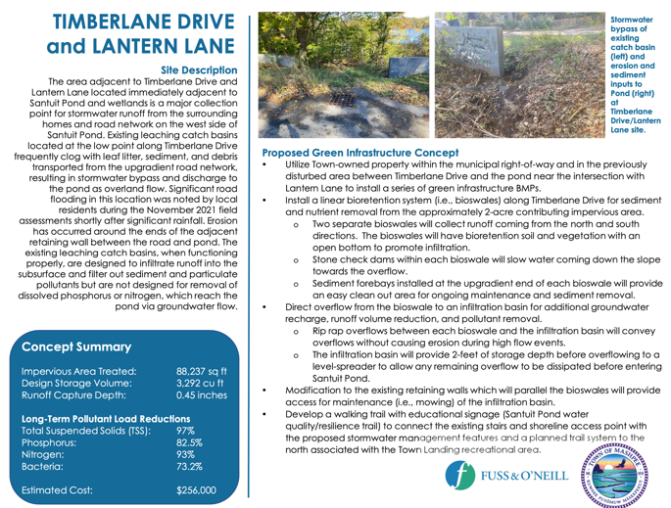

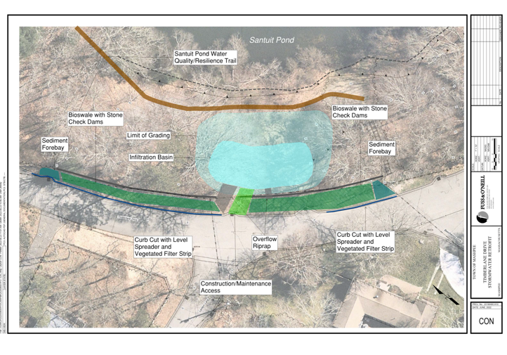

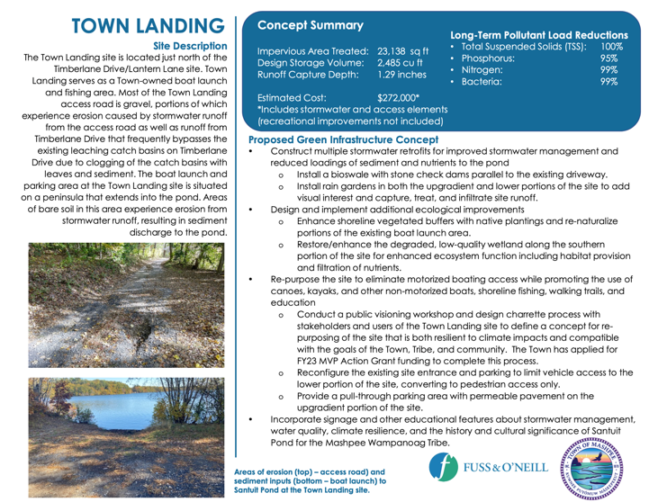

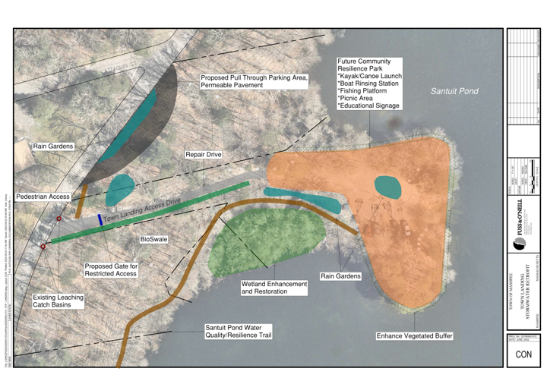

Appendix E SNEP Network Stormwater Series: Highlights from Site Visits to Santuit Pond Mashpee, MA

The objectives of the site visits are that participants and SNEP Network team members:
- become familiar with the selected drainage area for which the community seeks solutions
- understand identified stormwater problem areas and issues (e.g., water quality and/or flooding concerns)
- identify municipally owned properties or other locations where stormwater treatment may be feasible

Santuit Pond Site Visit October 12, 2021

Participants: Jason Steiding (Director Natural Resources, Mashpee Wampanoag Tribe), Ashley Fisher (Director Natural Resources, Town of Mashpee), James Houle (University of New Hampshire), Kimberly Groff (Ma Liaison, SNEP Network).

Background: The Mashpee Wampanoag Tribe/Town of Mashpee are interested in improving water quality in Santuit Pond. Previous studies demonstrated that Santuit Pond suffers from poor water quality due to eutrophication (i.e., overabundant nutrient levels, specifically phosphorus in freshwater) and the pond does not fully support the desired water uses including contact recreation and aquatic life support. The incidence of harmful algal blooms (winter and summer) in Santuit Pond has increased dramatically since the late 1990’s early 2000’s and remains closed to public swimming due to harmful algal blooms (HABs). Sources of phosphorus pollution include septic inputs, cranberry bogs, stormwater runoff and the historic accumulation of phosphorus in sediment that is now cycling to the water column. The focus of the site visit was to evaluate stormwater inputs to the pond and look for opportunities to improve water quality through implementation of stormwater pollution control Best Management Practices (BMPs).

Site Visit Summary: The project team visited the site on October 12, 2021. Prior to the visit the team evaluated land use and found that land use surrounding the pond is largely high, medium, and low density residential (Figure 1). During the site visit the team toured the neighborhoods on the eastern side of Santuit Pond (Timberline Drive), Mashpee Town landing and boat ramp and the dam on the south side of the pond. Land slopes upward from the surface water elevation of the pond in most of the housing neighborhoods surrounding the pond. Neighborhoods abutting the pond are heavily vegetated with tree canopy. Neighborhood streets contain numerous leaching catch basins for collection and infiltration of stormwater. During large storm events in the fall these catch basins become clogged with leaf litter and debris and leaf particulates are conveyed over paved (road surfaces) and unpaved land surface directly to surface water (see photos taken on 11/10/21 site visit following 10/27 storm event) and likely contribute to the phosphorus load in the pond. Ashley Fisher relayed that no regulated stormwater outfalls were identified in the vicinity of the pond during surveys conducted by the town.

The team concluded that there were limited opportunities for stormwater retrofits in the facility of the dam spillway and embankment. Many opportunities for retrofits and improvements exist along Timberline drive and the neighborhoods that immediately surround the pond. It was concluded that the most impactful opportunities for implementation of stormwater pollution control BMPs were in the vicinity of the Town Landing (See Figure 2 and 3) due to the high visibility location and opportunity for public education.

Preliminary Stormwater Pollution Control Options Santuit Pond:
•Town landing provides educational opportunity
•Pave driveway and parking lot
•Contour paving to direct stormwater runoff away from pond
•Install bioswale to capture and treat runoff
•Add educational kiosk

The team learned after the site visit that the Town of Mashpee was awarded a Massachusetts Vulnerability Preparedness (MVP) Program Action grant. The town has hired Fuss and O’Neill (FANDO) to conduct a detailed survey to identify opportunities to improve stormwater management and pollution runoff around the pond. FANDO identified about 25 opportunities for stormwater improvement around the pond and will narrow this down to a top five list, with one of the options being developed through permitting. FANDO will also review and provide recommended changes to municipal bylaws to reduce nutrient impacts to all surface waters in Mashpee, and create a robust public education and outreach program that incorporates the knowledge and perspective of the Wampanoag.

During a follow-up call FANDO signaled that they had also identified the Town Landing Site as one of the better opportunities to address stormwater pollution runoff to the pond. The team agreed to coordinate with FANDO on both the output of the stormwater planning series and the engineering work being conducted under the MVP grant.

The vision is that the perspectives and insight gained by the Town and Tribe attendees of the Stormwater Planning series will be combined with the FANDO engineering to provide a robust and meaningful stormwater pollution improvement design that can be incorporated into the public education component.

Figure 1. Land use surrounding Santuit Pond.

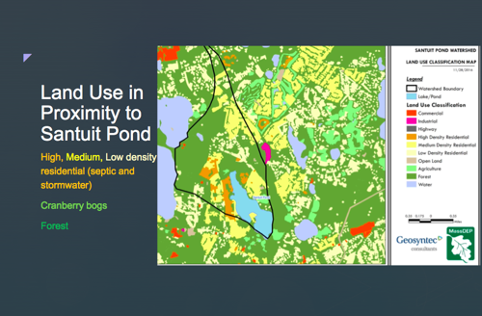

Figure 2. Mashpee Town Landing Location and Site Overview.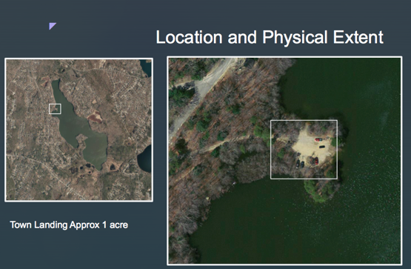

Figure 3. Photos of Santuit Pond Site Visit, Mashpee Town Landing.
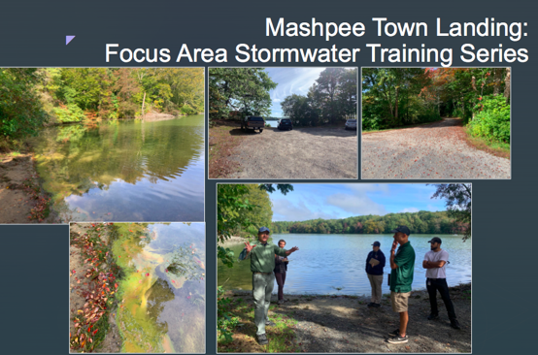

Photos Taken of Leaching Catch Basins on Nov 11, 2021 after October 27th storm event.

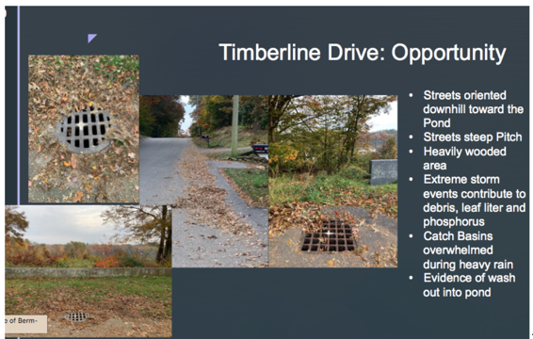

Santuit Pond Diagnostic Study Mashpee, Massachusetts, prepared for the Town of Mashpee, Mashpee , MA by AECOM, July 19, 2010. https://www.mashpeema.gov/sites/g/files/vyhlif3426/f/uploads/santuitpondreportfinalv2.pdf
Note that septic systems inputs to Santuit Pond are being addressed through the Town of Mashpee Board of Health. The Town is in the process of implementing its CWMP to address nitrogen sources from septic systems on a regional scale. Phase I has been approved and is in the process of being implemented at a cost of $54 million. This phase includes the design and construction of centralized wastewater collection and the implementation of sewer collection in portions of the Town. Implementation of the CWMP will also address phosphorus loads from the homes surrounding Santuit Pond. All cranberry bogs in direct proximity to the pond are inactive.
Note Town Landing design and implementation funded through MVP Phase I & II Grant in the amount of $600,728.

