WATERSHED-BASED PLAN
Abbey Brook and Lower Chicopee River Watershed within the
City of Chicopee, MA
October 18, 2019

Prepared By:
City of Chicopee
Geosyntec Consultants

Prepared For:
Contents

Executive Summary iv
Introduction 1
Purpose & Need 1
Watershed-Based Plan Outline 1
Project Partners and Stakeholder Input 2
Data Sources 3
Summary of Past and Ongoing Work 3
Element A: Identify Causes of Impairment & Pollution Sources 4
General Watershed Information 4
MassDEP Water Quality Assessment Report and TMDL Review 6
Additional Water Quality Data 8
Water Quality Impairments 8
Water Quality Goals 9
Land Use Information 11
Pollutant Loading 17
Element B: Determine Pollutant Load Reductions Needed to Achieve Water Quality Goals 19
Estimated Pollutant Loads 19
Water Quality Goals 19
Element C: Describe management measures that will be implemented to achieve water quality goals 21
Field Watershed Investigation 21
Future Management Measures 23
Element D: Identify Technical and Financial Assistance Needed to Implement Plan 24
Current and Ongoing Management Measures 24
Future Management Measures 24
Element E: Public Information and Education 27
Elements F & G: Implementation Schedule and Measurable Milestones 29
Elements H & I: Progress Evaluation Criteria and Monitoring 31
Indirect Indicators of Load Reduction 31
Project-Specific Indicators 31
Direct Measurements 32
Adaptive Management 32
References 33
Appendices 35
Appendix A – Additional Water Quality Information 35
Appendix B – Pollutant Load Export Rates (PLERs) 39
Appendix C – BMP Conceptual Designs 41
Appendix D – Chicopee River Watershed 2003 Water Quality Assessment Report 51

Acronyms
BMPs Best Management Practices
DCIA Directly-Connected Impervious Area
DPW Department of Public Works
IDDE Illicit Discharge Detection & Elimination
MassDEP Massachusetts Department of Environmental Protection
MS4 Municipal Separate Storm Sewer System
MVP Municipal Vulnerability Preparedness
NOI Notice of Intent
NPS Non-Point Source
NRCS Natural Resources Conservation Service
O&M Operations & Maintenance
PLER Pollutant Load Export Rate
PVPC Pioneer Valley Planning Commission
QAPP Quality Assurance Project Plan
SOPs Standard Operating Procedures
TIA Total Impervious Area
TMDL Total Maximum Daily Load
TN Total Nitrogen
TP Total Phosphorus
TSS Total Suspended Solids
USDA United States Department of Agriculture
USEPA United States Environmental Protection Agency
WBP Watershed-Based Plan
WPA Wetlands Protection Act

Executive Summary
Introduction: The purpose of a Massachusetts Watershed-Based Plan (WBP) is to organize information about Massachusetts' watersheds, and present it in a format that will enhance the development and implementation of projects that will restore water quality and beneficial uses in the Commonwealth. The Massachusetts WBP follows the United States Environmental Protection Agency’s (USEPA) recommended format for “nine-element” watershed plans. This WBP was developed by Geosyntec Consultants (Geosyntec) under the direction of the Chicopee Department of Public Works with funding, input, and collaboration with the Massachusetts Department of Environmental Protection (MassDEP).
The Chicopee River watershed includes approximately 45,000 acres of land in southeastern Massachusetts. Abbey Brook is the most downstream tributary to the Chicopee River prior to its confluence with the Connecticut River. This WBP focuses specifically on the Abbey Brook watershed within the City of Chicopee.
Impairments and Pollution Sources: Abbey Brook is a category 5 water body on the 2014 Massachusetts List of Integrated Waters due to total suspended solids (TSS). In addition, the MassDEP 2016 Massachusetts Integrated List of Waters lists Abbey Brook as impaired for Escherichia coli (E. coli), as well as TSS. The sources of these impairments are unknown; however, previous study of the watershed by PVPC identified fecal matter from geese as a significant bacteria source in the watershed.
Goals, Management Measures, and Funding: Water quality goals for this WBP are focused on reducing TSS loading to Abbey Brook. It is expected that reductions in solid loading will result in improvements to bacteria loading as well. This WBP includes an adaptive sequence to establish and track specific water quality goals. First, an interim goal has been established to reduce land use-based solids by 10 tons in the next five years. From there, focus will be shifted to the long-term goal of delisting Abbey Brook based on adaptively adjusting goals based on ongoing monitoring results.
It is expected that goals will be accomplished primarily through installation of structural BMPs to capture runoff and reduce loading, as well as implementation of non-structural BMPs (e.g., street sweeping, catch basin cleaning), and watershed education and outreach. Structural BMPs will first be implemented at Szot Park per a Fiscal Year 2019 Section 319 grant. From there, additional planning and implementation is expected to be performed, focusing on sites identified in this WBP.
It is expected that funding for management measures will be obtained from a variety of sources including grant funding, City capital funds, volunteer efforts, and other sources.
Public Education and Outreach: Goals of public education and outreach are to provide information about proposed stormwater improvements and their anticipated benefits and to promote watershed stewardship. The City of Chicopee and Pioneer Valley Planning Commission aim to engage watershed residents, businesses, and other community stakeholders through informational signage, school learning modules, online resources, local events, and a variety of other means. It is expected that these programs will be evaluated by tracking attendance at educational events, number of pet waste stations installed, activity on online resources, and other tools applicable to the type of outreach performed.
Implementation Schedule and Evaluation Criteria: Project activities will be implemented based on information outlined in the following elements for monitoring, implementation of structural BMPs, and public education and outreach activities. It is expected that water quality monitoring will enable direct evaluation of improvements over time. Other indirect evaluation metrics are also recommended, including quantification of potential pollutant load reductions from non-structural BMPs (e.g., street sweeping). The interim goal of this WBP is to reduce land use-based TSS loading by 10 tons by 2024. The long-term goal of this WBP is to de-list Abbey Brook from the 303(d) list. The WBP will be re-evaluated and adjusted, as needed, once every three years.

Introduction
What is a Watershed-Based Plan?

Purpose & Need
The purpose of a WBP is to organize information about Massachusetts' watersheds, and present it in a format that will enhance the development and implementation of projects that will restore water quality and beneficial uses in the Commonwealth. The Massachusetts WBP follows the USEPA’s recommended format for “nine-element” watershed plans, as described below.
All states are required to develop WBPs, but not all states have taken the same approach. Most states develop watershed-based plans only for selected watersheds. MassDEP’s approach has been to develop a tool to support statewide development of WBPs, so that good projects in all areas of the state may be eligible for federal watershed implementation grant funds under Section 319 of the Clean Water Act.
USEPA guidelines promote the use of Section 319 funding for developing and implementing WBPs. WBPs are required for all projects implemented with Section 319 funds, and are recommended for all watershed projects, whether they are designed to protect unimpaired waters, restore impaired waters, or both.

Watershed-Based Plan Outline
This WBP for Abbey Brook and the Lower Chicopee River watershed within the City of Chicopee includes nine (9) elements (a through i) in accordance with USEPA Guidelines:
- An identification of the causes and sources or groups of similar sources that will need to be controlled to achieve the load reductions estimated in this WBP (and to achieve any other watershed goals identified in the WBP), as discussed in item (b) immediately below.
- An estimate of the load reductions expected for the management measures described under paragraph (c) below (recognizing the natural variability and the difficulty in precisely predicting the performance of management measures over time).
- A description of the nonpoint source (NPS) management measures needed to achieve the load reductions estimated under paragraph (b) above (as well as to achieve other watershed goals identified in this WBP), and an identification (using a map or a description) of the critical areas in which those measures will be needed to implement this plan.
- An estimate of the amounts of technical and financial assistance needed, associated costs, and/or the sources and authorities that will be relied upon to implement this plan. As sources of funding, States should consider the use of their Section 319 programs, State Revolving Funds, United States Department of Agriculture’s (USDA) Environmental Quality Incentives Program and Conservation Reserve Program, and other relevant Federal, State, local and private funds that may be available to assist in implementing this plan.
- An information/education component that will be used to enhance public understanding of the project and encourage their early and continued participation in selecting, designing, and implementing the NPS management measures that will be implemented.
- A schedule for implementing the NPS management measures identified in this plan that is reasonably expeditious.
- A description of interim, measurable milestones for determining whether NPS management measures or other control actions are being implemented.
- A set of criteria to determine if loading reductions are being achieved over time and substantial progress is being made towards attaining water quality standards and, if not, the criteria for determining whether this WBP needs to be revised or, if a NPS Total Maximum Daily Load (TMDL) has been established, whether the TMDL needs to be revised.
- A monitoring component to evaluate the effectiveness of the implementation efforts over time, measured against the criteria established under item (h) immediately above.
Although this WBP includes information for the Lower Chicopee River within the City of Chicopee, the plan focuses specifically on building a plan for the Abbey Brook watershed, which will benefit both Abbey Brook and the Lower Chicopee River.

Project Partners and Stakeholder Input
This WBP was developed by Geosyntec Consultants (Geosyntec) under the direction of the City of Chicopee with funding, input, and collaboration from the MassDEP. This WBP was developed using funds from the Section 319 program to assist grantees in developing technically robust WBPs using MassDEP’s Watershed-Based Planning Tool. The City of Chicopee was a recipient of Section 319 funding in Fiscal Year 2019 to implement best management practices (BMPs) in the Abbey Brook watershed.
Core project stakeholders include:
- Lee M. Pouliot, AICP, ASLA, Director – City of Chicopee Department of Planning and Development
- Michelle Santerre, GIS Coordinator – City of Chicopee Department of Planning and Development
- Ben Strepka, Superintendent of Parks, Recreation, and Cemeteries – City of Chicopee Department of Parks and Recreation
- Patty Gamborini, Principal Environmental Planner/Section Leader – Pioneer Valley Planning Commission
- Matt Reardon and Jane Peirce – MassDEP
This WBP was developed as part of an iterative process. The Geosyntec project team collected and reviewed existing data from the City of Chicopee and conducted a field investigation of the Abbey Brook watershed. This information was then used to develop a preliminary WBP for review by core project stakeholders. A stakeholder conference call was then held to solicit input and gain consensus on elements included in the plan (e.g., water quality goals, public outreach activities, etc.). The WBP was finalized once stakeholder consensus was obtained for all elements.

Data Sources
This WBP was developed using the framework and data sources provided by MassDEP’s Watershed-Based Plan Tool and supplemented by information provided in the Stormwater Management and Stream Restoration for Water Quality in Lower Abbey Brook, Chicopee Section 319 Nonpoint Source Pollution Grant Program application (City of Chicopee, 2018). Additional data sources were reviewed and are summarized in subsequent sections of this WBP, if relevant, as listed by Table 1.
Table 1: Supplemental Data Sources
Title / Description | Source | Date
Lower Chicopee River Watershed Stormwater Assessment Project Final Report | Pioneer Valley Planning Commission (PVPC) / Chicopee 4Rivers Watershed Council | 2017
Lower Bemis Pond Dam 6-Month Follow-Up Inspection/Evaluation Report | GZA GeoEnvironmental, Inc. | 2018
Phase II Engineering Evaluation and Alternatives Analysis | GZA GeoEnvironmental, Inc. | 2018

Summary of Past and Ongoing Work

Lower Chicopee River Watershed Stormwater Assessment Project (PVPC, 2017)
In fiscal year 2016, the PVPC and the Chicopee 4Rivers Watershed Council were awarded funding through the Section 604b grant program administered by MassDEP to investigate causes of water quality impairments in the Lower Chicopee River watershed. Project efforts included water quality sampling and source tracking to identify potential non-human sources of bacteria, development of preliminary stormwater BMP designs and cost estimates, and public outreach to promote better practices with local stakeholders.
Results of the study suggested that fecal matter from geese in Szot Park was potentially a significant source of bacteria in the Abbey Brook watershed. Recommendations of the study were to transform the landscape to be less attractive to waterfowl and install structural BMPs to provide water quality benefits to Abbey Brook. The BMP designs developed for Szot Park in this study served as the basis for the Section 319 grant application submitted by the City of Chicopee in fiscal year 2019.

Phase II Engineering Evaluation and Alternatives Analysis (GZA GeoEnvironmental, Inc., 2018)
A Phase I dam safety inspection of Lower Bemis Pond Dam conducted in 2016 found the dam to be in poor condition; therefore, a Phase II Engineering Evaluation and Alternatives Analysis was completed between 2017 and 2018 to assess alternatives for addressing the safety concerns. As a “no action” approach was not feasible due to Massachusetts Dam Safety Regulations, options to remove the dam or repair the dam were considered. Both options were found to be feasible; however, the removal option presented the potential for the resource area to be restored to a more natural condition. Staff from the City of Chicopee Department of Public Works (DPW) informed the Geosyntec project team during a field visit to Szot Park on 3 July 2019 that the City had decided to move forward with planning and design to remove the Lower Bemis Pond Dam.

Element A: Identify Causes of Impairment & Pollution Sources
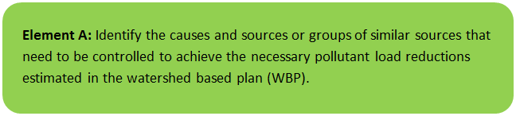

General Watershed Information
The City of Chicopee is located at the confluence of the Chicopee River with the Connecticut River and has parts of the City draining to each of the rivers. The Chicopee River is an 18-mile tributary of the Connecticut River with an approximate 45,000-acre watershed that includes the Quabbin Reservoir. Abbey Brook is the most downstream tributary to the Chicopee River and discharges to the river approximately 1.5 miles prior to its confluence with the Connecticut River. Abbey Brook has origins in a forested wetland in Springfield and it flows into Chicopee, through Upper and Lower Bemis Pond and two (2) associated dams in Szot Park, prior to its discharge to the Chicopee River.
The MS4 module of the watershed-based planning tool was used to enable computations of watershed statistics within the City of Chicopee (identified as CHICOPEE_07; herein referred to as “the watershed”). Table A-1 presents the general watershed information for the applicable MS4 subwatershed and Figure A-1 includes a map of the watershed boundary. The watershed includes areas within the Abbey Brook watershed (MA36-40) and the lower portion of the Chicopee River watershed (MA36-24 and MA36-25). This WBP is primarily focused on addressing water quality in the Abbey Brook watershed; however, the watershed for Abbey Brook is not delineated in the MassDEP WBP tool. Therefore, the MS4 module of the tool was utilized to capture the watershed for Abbey Brook and a portion of the lower Chicopee River watershed.
Table A-1: General Watershed Information
MS4 Subwatershed # | Waterbody Names (Assessment Unit ID) | Watershed Area (ac) | Major Basin
CHICOPEE_07 | Abbey Brook (MA36-40); Chicopee River (MA36-24); Chicopee River (MA36-25) | 4567.7 (ac) | CHICOPEE

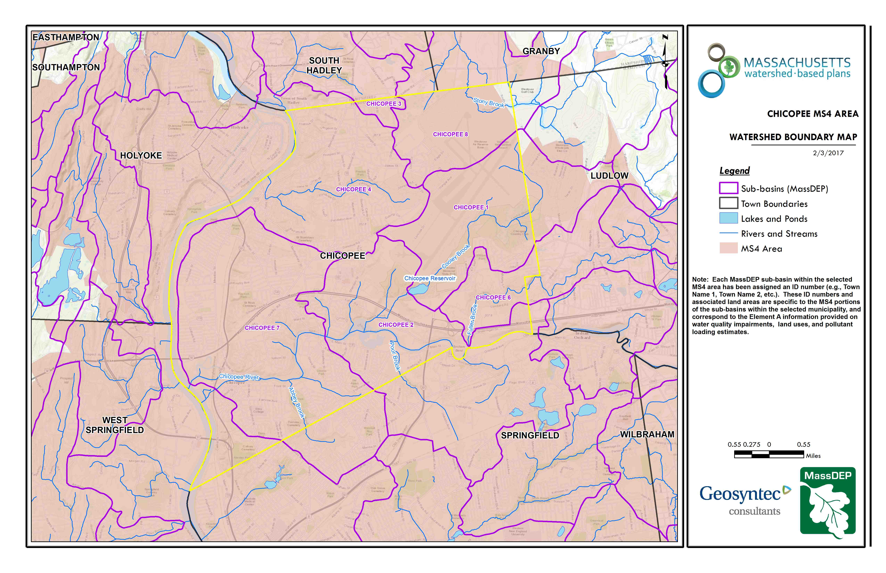Figure A-1: Watershed Boundary Map
City Boundary
Abbey Brook
Approximate Watershed Boundary (Chicopee_07)
Chicopee River
Connecticut River
(MassGIS, 2007; MassGIS, 1999; MassGIS, 2001; USGS, 2016)
Connecticut River

MassDEP Water Quality Assessment Report and TMDL Review
The following reports are available:
- Chicopee River Watershed 2003 Water Quality Assessment Report
- Chicopee River Watershed 2008 DWM Water Quality Monitoring Data
Select excerpts from these documents relating to water quality in the Abbey Brook watershed are included below (note: relevant information is included directly from these documents for informational purposes and has not been modified). Excerpts from the water quality assessment report for the lower Chicopee River (MA36-24 and MA36-25) are included in Appendix A for reference.
Chicopee River Watershed 2003 Water Quality Assessment Report (MA36-40 - Abbey Brook)
USE ASSESSMENT - AQUATIC LIFE
Habitat and Flow
Geosyntec Consultants (Geosyntec undated) as part of the Chicopee River Watershed Degraded Stream Survey, made field observations of Abbey Brook downstream from the Front Street bridge on 19 May 2003. They found bank erosion and substrate fouling. DWM field crews made observations throughout the 2003 field season at Station AB01 (Front Street Bridge, upstream side, Chicopee). They noted minimal erosion, especially on the right bank, on three occasions. Riprap was found along the banks.
Biology
DWM conducted water quality monitoring at one station (AB01, Front Street Bridge, Chicopee) in Abbey Brook between April and October 2003 (Appendix B). DWM crews made notes on conditions at this site throughout the sampling season. No aquatic plants or phytoplankton were found or recorded. Periphyton was noted on five occasions and described as dense on May 14, 2003. In April thin film algae and filamentous algae were noted, while in May a filamentous periphyton was noted. On the rest of the observable occasions a brown periphyton was noted. Water clarity was noted to be slightly turbid on five occasions and clear on three other occasions.
Water Chemistry
DWM conducted water quality monitoring at one station (AB01, Front Street Bridge, Chicopee) in Abbey Brook between April and October 2003 (Appendix B). In-situ parameters were measured on seven occasions, including two pre-dawn occasions. Grab samples were also collected and analyzed for TSS, turbidity, ammonia-nitrogen, and total phosphorus (Appendix B).
Temperature, pH and dissolved oxygen measurements at the DWM station all met criteria on DWM sampling dates (Appendix B). Conductivity was slightly elevated at this station. Ammonia-nitrogen concentrations were low. Total phosphorus concentrations ranged from 0.035 to 0.079 mg/L with the two highest concentrations found on the sampling dates in July and August 2003 (Appendix B).
The Aquatic Life Use is assessed as support based primarily on the limited water quality data, which indicates generally good water quality conditions. This use is identified with an “Alert Status” due to erosion and sedimentation (Geosyntec undated) particularly in the lower reach near the confluence with the Chicopee River.
USE ASSESSMENT - PRIMARY AND SECONDARY CONTACT RECREATION AND AESTHETICS
DWM conducted fecal coliform and E. coli monitoring at one station (AB01, Front Street Bridge, Chicopee) between April and October 2003 (Appendix B). E. coli counts were generally low with the exception of 15 October 2003, a wet weather sampling date, when the E. coli count was 10,000 cfu/100 mL. The geometric mean of E. coli counts was 90 cfu/100 mL.
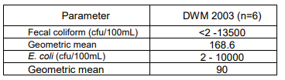
Objectionable deposits consisting of trash were noted on April 14th, July 30th and August 20th by DWM field crews. It is believed that the garbage and trash were localized. In addition to the trash noted on April 14th sand and silt were noted at this station. No scums were noted and, with the exception of one occasion on which a musty water odor was recorded, no odors were noted.
The Primary and Secondary Recreation Contact Uses area assessed as support based on the geometric mean of E. coli counts. Due to the one very high E. coli count both Primary and Secondary Contact Recreation Uses are identified with an “Alert Status.” Given the general lack of extensive objectionable conditions the Aesthetics Use is assessed as support.
In 2000 MA DEM (MA DEM 2002a) awarded the City of Chicopee a $10,000 grant for Bemis Pond to repair the auxiliary spillway wall at the Bemis Pond dam, which stabilized the shoreline and prevent further erosion in the area. In 2002 DEM (DEM 2002b) awarded
Report Recommendations:
Conduct bacteria sampling to evaluate to assess the status of the Primary and Secondary Contact Recreational uses.
Conduct field reconnaissance and a habitat walk along this segment to determine current conditions and assess the extent of habitat degradation. Where appropriate develop and implement best management practices to reduce erosion and sedimentation.
Conduct water quality sampling in Bemis Pond to address a TMDL for TSS.

Chicopee River Watershed 2008 DWM Water Quality Monitoring Data (MA36-25 – Chicopee River)
For the Draft 2016 Integrated List, the Primary and/or Secondary Contact Uses were assessed (using E. coli) for segment MA36-25, consisting of the following sites (data years): W0475 (2008); W2055 (2008); W2056 (2008). The geometric mean of the samples collected at the sites violated the geometric mean criterion for primary contact recreational use.

MassDEP Watershed Planning Program Bacteria Data (2005-2011)
UniqueID | Year | Date First Sample | Date Last Sample | Sample Count | Geometric Mean | Bacteria Type
W0475 | 2008 | 05/20/08 | 09/23/08 | 6 | 169 | E. coli
W2055 | 2008 | 05/20/08 | 09/23/08 | 5 | 210 | E. coli
W2056 | 2008 | 05/20/08 | 09/23/08 | 6 | 187 | E. coli

Abbey Brook (MA36-40) and Chicopee River (MA36-24, MA36-25) will be included in the upcoming “Massachusetts Statewide TMDL for Pathogen-Impaired Inland Freshwater Rivers” which is currently being drafted.

Additional Water Quality Data
Water quality sampling conducted by PVPC in 2016 as part of the Lower Chicopee River Watershed Stormwater Assessment Project, funded by a Section 604b grant, included one sampling location at the outlet of Abbey Brook and one sampling location in the Lower Chicopee River (near Davitt Bridge). Results of dry weather sampling included elevated concentrations of E. coli and ammonia in Abbey Brook for one sampling event (of three sampling events) but did not include elevated (i.e., exceeding recreational thresholds) pollutant concentrations in the Chicopee River. Results of wet weather sampling indicated consistently elevated concentrations of E. coli, ammonia, and surfactants in Abbey Brook (in all four sampling events). Similar to dry weather sampling, wet weather sampling at the Lower Chicopee River sampling location did not indicate elevated concentrations of pollutants (PVPC, 2017).
Source tracking was conducted in the Abbey Brook watershed to further evaluate the sources of the elevated pollutant concentrations. Results included elevated E. coli concentrations at multiple locations in the watershed, across three source tracking events in 2016 (PVPC, 2017). The study concluded that fecal matter from geese in the area around the ponds in Szot Park was contributing to elevated bacterial loading to Abbey Brook.

Water Quality Impairments
Abbey Brook is listed under category 5 of the Massachusetts List of Integrated Water for TSS. The source of the TSS impairment is listed as unknown. In addition, bacteria is a known pollutant in the Abbey Brook watershed. In the MassDEP 2016 Massachusetts Integrated List of Waters, Abbey Brook is listed as impaired for E. coli, in addition to TSS. Previous study of the watershed by PVPC identified fecal matter from geese as a source of significant bacteria concentrations in the watershed. The lower Chicopee River including segments MA36-24 and MA36-25 are listed under category 5 of the Massachusetts List of Integrated Waters due to fecal coliform and E. coli, respectively. The sources of these impairments include combined sewer overflows and unspecified urban stormwater.
Impairment categories from the MassDEP 2014 Massachusetts Integrated List of Waters are included in Table A-2. Known water quality impairments in the watershed, as documented in the Integrated List of Waters, are listed below in Table A-3.

Table A-2: 2014 MA Integrated List of Waters Categories
Integrated List Category | Description
1 | Unimpaired and not threatened for all designated uses.
2 | Unimpaired for some uses and not assessed for others.
3 | Insufficient information to make assessments for any uses.
4 | Impaired or threatened for one or more uses, but not requiring calculation of a Total Maximum Daily Load (TMDL), including:  4a: TMDL is completed  4b: Impairment controlled by alternative pollution control requirements  4c: Impairment not caused by a pollutant - TMDL not required
5 | Impaired or threatened for one or more uses and requiring preparation of a TMDL.

Table A-3: Water Quality Impairments
Assessment  Unit ID | Waterbody | Integrated  List  Category | Designated Use | Impairment Cause | Impairment Source
MA36-40 | Abbey Brook | 5 | Aesthetic | Total Suspended Solids (TSS) | Source Unknown
MA36-40 | Abbey Brook | 5 | Primary Contact Recreation | Total Suspended Solids (TSS) | Source Unknown
MA36-40 | Abbey Brook | 5 | Secondary Contact Recreation | Total Suspended Solids (TSS) | Source Unknown
MA36-24 | Chicopee River | 5 | Primary Contact Recreation | Fecal Coliform | Unspecified Urban Stormwater
MA36-24 | Chicopee River | 5 | Primary Contact Recreation | Fecal Coliform | Combined Sewer Overflows
MA36-25 | Chicopee River | 5 | Secondary Contact Recreation | Escherichia coli | Combined Sewer Overflows
MA36-25 | Chicopee River | 5 | Primary Contact Recreation | Escherichia coli | Combined Sewer Overflows

Water Quality Goals
Water quality goals may be established for a variety of purposes, including the following:
a.) For water bodies with known impairments, a Total Maximum Daily Load (TMDL) is established by MassDEP and the USEPA as the maximum amount of the target pollutant that the waterbody can receive and still safely meet water quality standards. If the waterbody has a TMDL for total phosphorus (TP) or total nitrogen (TN), or total suspended solids (TSS), that information is provided below and included as a water quality goal.

b.) For water bodies without a TMDL for total phosphorus (TP), a default water quality goal for TP is based on target concentrations established in the Quality Criteria for Water (USEPA, 1986) (also known as the “Gold Book”). The Gold Book states that TP should not exceed 50 ug/L in any stream at the point where it enters any lake or reservoir, nor 25 ug/L within a lake or reservoir. For the purposes of developing WBPs, MassDEP has adopted 50 ug/L as the TP target for all streams at their downstream discharge point, regardless of which type of water body the stream discharges to.

c.) Massachusetts Surface Water Quality Standards (314 CMR 4.00, 2013) prescribe the minimum water quality criteria required to sustain a waterbody’s designated uses. Table A-4 lists the Class for each Assessment Unit ID within the watershed. The water quality goal(s) for bacteria are based on the Massachusetts Surface Water Quality Standards. A Class B water is “designated as a habitat for fish, other aquatic life, and wildlife, including for their reproduction, migration, growth and other critical functions, and for primary and secondary contact recreation” [MassDEP, 2019]. Furthermore, a designation of WWF indicates the water is a warm water fishery which includes “waters in which the maximum mean monthly temperature generally exceeds 68°F (20°C) during the summer months and are not capable of sustaining a year-round population of cold water stenothermal aquatic life” [MassDEP, 2013].
Table A-4: Surface Water Quality Classification
Assessment  Unit ID | Waterbody | Class
MA36-40 | Abbey Brook | B
MA36-24 | Chicopee River | B\WWF
MA36-25 | Chicopee River | B\WWF

d.) Other water quality goals set by the community (e.g., protection of high-quality waters, in-lake phosphorus concentration goal to reduce recurrence of cyanobacteria blooms, etc.).
Refer to Table A-5 for a list of water quality goals. The water quality goals are focused on reducing TSS and bacteria loading due to existing impairments in the watershed. It is expected that efforts to reduce TSS pollutant loads to Abbey Brook will also result in reduced bacteria loading from Abbey Brook to the Lower Chicopee River. Element C of this WBP includes proposed BMPs to address impairments, including BMPs that provide increases in infiltration. Infiltration is a commonly used method to reduce bacteria loads in stormwater runoff and it can also capture particulates that contribute to turbidity and TSS. Infiltration can be very effective at removing pollutants in stormwater runoff (USEPA, 1999).

Table A-5: Water Quality Goals
Pollutant | Goal | Source
Total Suspended Solids | Class B Standard  These waters shall be free from floating, suspended and settleable solids in concentrations and combinations that would impair any use assigned to this Class, that would cause aesthetically objectionable conditions, or that would impair the benthic biota or degrade the chemical composition of the bottom. | Massachusetts Surface Water Quality Standards (314 CMR 4.00, 2013)
Bacteria | Class B Standards  • Public Bathing Beaches: For E. coli, geometric mean of 5 most recent samples shall not exceed 126 colonies/ 100 ml and no single sample during the bathing season shall exceed 235 colonies/100 ml. For enterococci, geometric mean of 5 most recent samples shall not exceed 33 colonies/100 ml and no single sample during bathing season shall exceed 61 colonies/100 ml;  • Other Waters and Non-bathing Season at Bathing Beaches: For E. coli, geometric mean of samples from most recent 6 months shall not exceed 126 colonies/100 ml (typically based on min. 5 samples) and no single sample shall exceed 235 colonies/100 ml. For enterococci, geometric mean of samples from most recent 6 months shall not exceed 33 colonies/100 ml, and no single sample shall exceed 61 colonies/100 ml. | Massachusetts Surface Water Quality Standards (314 CMR 4.00, 2013)
Note: There may be more than one water quality goal for bacteria due to different Massachusetts Surface Water Quality Standards Classes for different Assessment Units within the watershed.

Land Use Information
Land use information and impervious cover is presented by the below tables and figures. Land use source data is from 2005 and was obtained from MassGIS (2009b). The watershed is entirely within a MS4 area.

Land Uses in the Lower Chicopee/Abbey Brook Watershed
As summarized by Table A-6, land use in the watershed is mostly residential (approximately 53 percent); approximately 18 percent of the watershed is forested; approximately 15 percent of the watershed is commercial or industrial; approximately 9 percent of the watershed is open land or water; approximately 4 percent is devoted to highways; and approximately 1 percent is agricultural.
Table A-6: Watershed Land Uses
Land Use | Area (acres) | % of Watershed
High Density Residential | 1971.6 | 43.2
Forest | 840.48 | 18.4
Medium Density Residential | 409.95 | 9.0
Commercial | 390.17 | 8.5
Open Land | 316.8 | 6.9
Industrial | 285.04 | 6.2
Highway | 175.97 | 3.9
Water | 103.5 | 2.3
Agriculture | 61.05 | 1.3
Low Density Residential | 13.17 | 0.3
TOTAL | 4,567.73 | 100

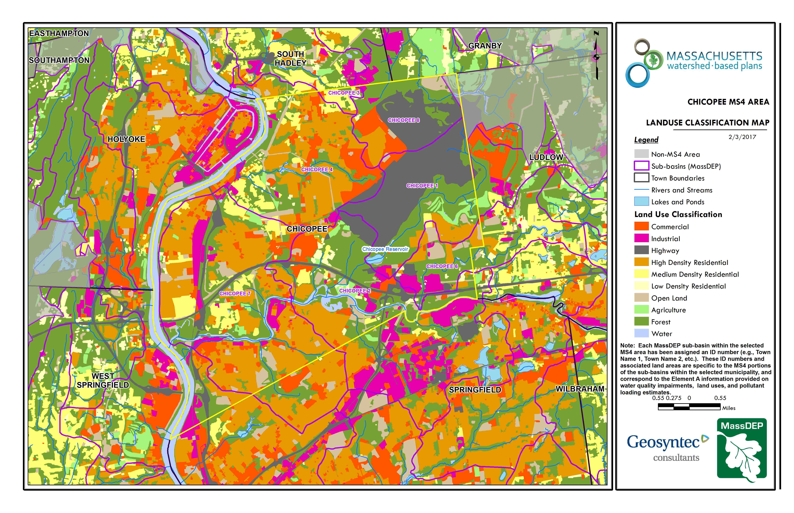
Figure A-2: Watershed Land Use Map
City Boundary
Approximate Watershed Boundary (Chicopee_07)
(MassGIS, 2007; MassGIS, 2009b; MassGIS, 1999; MassGIS, 2001; USGS, 2016)

Watershed Impervious Cover
There is a strong link between impervious land cover and stream water quality. Impervious cover includes land surfaces that prevent the infiltration of water into the ground, such as paved roads and parking lots, roofs, basketball courts, etc. Impervious area within the watershed to Abbey Brook and the Lower Chicopee River is distributed throughout the watershed.
Impervious areas that are directly connected (DCIA) to receiving waters (via storm sewers, gutters, or other impervious drainage pathways) produce higher runoff volumes and transport stormwater pollutants with greater efficiency than disconnected impervious cover areas which are surrounded by vegetated, pervious land. Runoff volumes from disconnected impervious cover areas are reduced as stormwater infiltrates when it flows across adjacent pervious surfaces.
An estimate of DCIA for the watershed was calculated based on the Sutherland equations. USEPA provides guidance (USEPA, 2010) on the use of the Sutherland equations to predict relative levels of connection and disconnection based on the type of stormwater infrastructure within the total impervious area (TIA) of a watershed. The total impervious area of each land use was summed and used to calculate the percent TIA (Table A-7).

Table A-7: TIA and DCIA values for the Watershed
 | Estimated TIA (%) | Estimated DCIA (%)
Abbey Brook/Lower Chicopee River Watershed | 37.2 | 31.1

The relationship between TIA and water quality can generally be categorized as listed by Table A-8 (Schueler et al. 2009). The TIA value for the watershed is 37.2%; therefore, the Abbey Brook and Lower Chicopee River can be expected to have poor to fair water quality.

Table A-8: Relationship between Total Impervious Area (TIA) and water quality (Schueler et al. 2009)
% Watershed  Impervious Cover | Stream Water Quality
0-10% | Typically high quality, and typified by stable channels, excellent habitat structure, good to excellent water quality, and diverse communities of both fish and aquatic insects.
11-25% | These streams show clear signs of degradation. Elevated storm flows begin to alter stream geometry, with evident erosion and channel widening. Streams banks become unstable, and physical stream habitat is degraded. Stream water quality shifts into the fair/good category during both storms and dry weather periods. Stream biodiversity declines to fair levels, with most sensitive fish and aquatic insects disappearing from the stream.
26-60% | These streams typically no longer support a diverse stream community. The stream channel becomes highly unstable, and many stream reaches experience severe widening, downcutting, and streambank erosion. Pool and riffle structure needed to sustain fish is diminished or eliminated and the substrate can no longer provide habitat for aquatic insects, or spawning areas for fish. Biological quality is typically poor, dominated by pollution tolerant insects and fish. Water quality is consistently rated as fair to poor, and water recreation is often no longer possible due to the presence of high bacteria levels.
>60% | These streams are typical of “urban drainage”, with most ecological functions greatly impaired or absent, and the stream channel primarily functioning as a conveyance for stormwater flows.

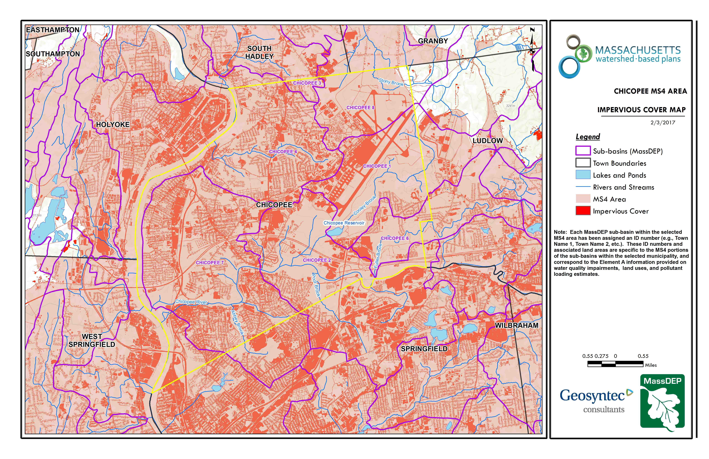
Figure A-3: Watershed Impervious Surface Map
Approximate Watershed Boundary (Chicopee_07)
City Boundary
(MassGIS, 2007; MassGIS 2009a; MassGIS, 1999; MassGIS, 2001; USGS, 2016)

Pollutant Loading
The land use data (MassGIS, 2009b) was intersected with impervious cover data (MassGIS, 2009a) and United States Department of Agriculture (USDA) Natural Resources Conservation Service (NRCS) soils data (USDA NRCS and MassGIS, 2012) to create a combined land use/land cover grid. The grid was used to sum the total area of each unique land use/land cover type.
The amount of DCIA was estimated using the Sutherland equations as described above and any reduction in impervious area due to disconnection (i.e., the area difference between TIA and DCIA) was assigned to the pervious D soil category for that land use to simulate that some infiltration will likely occur after runoff from disconnected impervious surfaces passes over pervious surfaces.
Pollutant loading for key nonpoint source pollutants in the watershed was estimated by multiplying each land use/cover type area by its pollutant load export rate (PLER). The PLERs are an estimate of the annual total pollutant load exported via stormwater from a given unit area of a particular land cover type. The PLER values for TN, TP and TSS were obtained from USEPA (Voorhees, 2016b) (see documentation provided in Appendix B) as follows:
L_{n} = A_{n} * P_{n}
Where L_{n} = Loading of land use/cover type n (lb/yr); A_{n} = area of land use/cover type n (acres); P_{n} = pollutant load export rate of land use/cover type n (lb/acre/yr)
Table A-9: Estimated Pollutant Loading for Key Nonpoint Source Pollutants
Land Use Type | Pollutant Loading¹
 | Total  Phosphorus (TP)  (lbs/yr) | Total  Nitrogen (TN)  (lbs/yr) | Total  Suspended Solids (TSS)  (tons/yr)
High Density Residential | 2,140 | 14,709 | 215.40
Highway | 130 | 1,063 | 59.12
Commercial | 530 | 4,542 | 56.81
Industrial | 354 | 3,049 | 38.13
Forest | 134 | 731 | 31.14
Open Land | 118 | 1,402 | 28.07
Medium Density Residential | 231 | 1,996 | 27.36
Agriculture | 49 | 338 | 8.08
Low Density Residential | 4 | 44 | 0.60
TOTAL | 3,690 | 27,873 | 464.70
¹These estimates do not consider loads from point sources or septic systems.

The pollutant loadings listed in Table A-9 do not consider loads from point sources or septic systems; however, it should be noted that combined sewer overflows can be a contributor to TSS and bacteria impairments in surface water bodies. Infrastructure information available for the Abbey Brook watershed suggests that there are not Chicopee Water Pollution Control outfalls that are active in the watershed.

Element B: Determine Pollutant Load Reductions Needed to Achieve Water Quality Goals

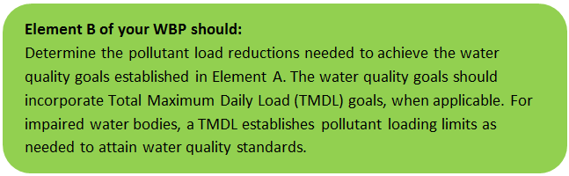

Estimated Pollutant Loads
Estimated pollutant loads for total phosphorus (TP) (3,690 lbs/yr), total nitrogen (TN) (27,873 lb/yr), and total suspended solids (TSS) (465 tons/yr) in the lower Chicopee River and Abbey Brook watershed were previously presented in Element A of this WBP.

Water Quality Goals
There are many methodologies that can be used to set pollutant load reduction goals for a WBP. Goals can be based on water quality criteria, surface water standards, existing monitoring data, existing TMDL criteria, or other data. Water quality goals for this WBP are focused on reducing TSS loading to Abbey Brook, which is expected to contribute to reduced bacteria loading to the Lower Chicopee River, as described in Element A. A description of criteria for each water quality goal is described by Table B-1.
The following adaptive sequence is recommended to establish and track water quality goals specific to Abbey Brook.
- Establish an interim goal to reduce land use-based solids to Abbey Brook by 10 tons over the next 5 years (by 2024).
- Implement a water quality monitoring program in accordance with recommendations from Elements H&I. Use monitoring results to perform trend analysis to identify if proposed Element C management measures are resulting in improvements.
- Establish long-term goals to meet all applicable water quality standards over the next 15 years, leading to the delisting of Abbey Brook from the 303(d) list and water quality improvement in the Lower Chicopee River.

Table B-1: Pollutant Load Reductions Needed
Pollutant | Existing Estimated Total Load | Water Quality Goal | Required Load Reduction
Total Phosphorus | 3,690 lbs/yr | Total phosphorus should not exceed:  --50 ug/L in any stream  --25 ug/L within any pond, lake, or reservoir | --
Total Nitrogen | 27,873 lbs/yr | -- | --
Total Suspended Solids | 465 ton/yr | Class B Standard  These waters shall be free from floating, suspended and settleable solids in concentrations and combinations that would impair any use assigned to this Class, that would cause aesthetically objectionable conditions, or that would impair the benthic biota or degrade the chemical composition of the bottom. | 2 tons/yr (interim goal)
Bacteria | N/A – Concentration Based | Class B Standards  • Public Bathing Beaches: For E. coli, geometric mean of 5 most recent samples shall not exceed 126 colonies/ 100 ml and no single sample during the bathing season shall exceed 235 colonies/100 ml. For enterococci, geometric mean of 5 most recent samples shall not exceed 33 colonies/100 ml and no single sample during bathing season shall exceed 61 colonies/100 ml;  • Other Waters and Non-bathing Season at Bathing Beaches: For E. coli, geometric mean of samples from most recent 6 months shall not exceed 126 colonies/100 ml (typically based on min. 5 samples) and no single sample shall exceed 235 colonies/100 ml. For enterococci, geometric mean of samples from most recent 6 months shall not exceed 33 colonies/100 ml, and no single sample shall exceed 61 colonies/100 ml. | Concentration Based
Notes:
- A default target TP concentrations is provided which is based on guidance provided by the USEPA in Quality Criteria for Water (1986), also known as the “Gold Book”.
- For all waterbodies, including impaired waters that have a pathogen TMDL, the water quality goal for bacteria is based on the Massachusetts Surface Water Quality Standards (314 CMR 4.00, 2013) that apply to the Water Class of the selected water body.

Element C: Describe management measures that will be implemented to achieve water quality goals

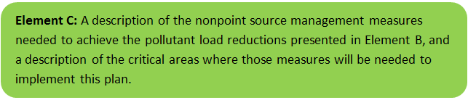

Management measures described in this section focus on the Abbey Brook portion of the watershed because water quality improvements to Abbey Brook are expected to propagate to the Lower Chicopee River.
Management measures in the watershed aim to improve water quality and increase climate resilience of the watershed. The City of Chicopee conducts ongoing efforts to address climate resiliency and plans to complete a climate change study associated with removal of the Lower Bemis Pond Dam.

Field Watershed Investigation
Geosyntec performed a field investigation in the Abbey Brook watershed on July 3, 2019 to identify additional potential structural BMPs that may be implemented to reduce pollutant loads to Abbey Brook with an emphasis on reductions in nutrients and bacteria. All developed portions of the watershed were visited, including the areas listed below (See Figure C-1 for location callouts).
- Szot Park
- 1st Sergeant Kevin A. Dupont Memorial Middle School
- Fairview Cemetery
There are BMPs that are already planned to be implemented in the watershed (in-progress BMPs at Site A), as described in the Stormwater Management and Stream Restoration for Water Quality in Lower Abbey Brook, Chicopee Section 319 Nonpoint Source Pollution Grant Program application. The recommended implementation sites discussed in this section are not intended to be an all-inclusive listing of additional potential stormwater improvements in the watershed. Rather, these recommendations are representative examples of potential opportunistic stormwater improvements and retrofits.
Details of BMP designs that are currently in-progress as well as new BMP opportunity locations identified during the field visit are included in Appendix C and a summary of funding needed to implement these BMPs is included in Table D-1. Each BMP opportunity location includes:
- A site summary that describes current conditions and stormwater drainage patterns;
- A description of proposed improvements, including potential operations and maintenance and permitting requirements;
- Estimated costs that represent installed contractor construction costs (i.e., capital costs); and
- Estimated TP, TN, and TSS pollutant load reduction for the proposed BMP.
Proposed BMPs should be designed to treat the water quality volume to the maximum extent practicable. The water quality volume is currently defined in the Massachusetts Stormwater Handbook (MassDEP is in the process of updating the Handbook) as the volume equal to 0.5 inches of runoff times the total impervious area that drains to the BMP. However, each proposed BMP should be designed to achieve the most treatment that is practical given the size and constraints of the site. Success and effectiveness of these BMPs is tracked by a water quality monitoring program, as discussed in Elements H & I.
Refer to Figure C-1 for a location map of proposed BMPs and to Table D-1 for a summary of BMP characteristics and estimated costs.
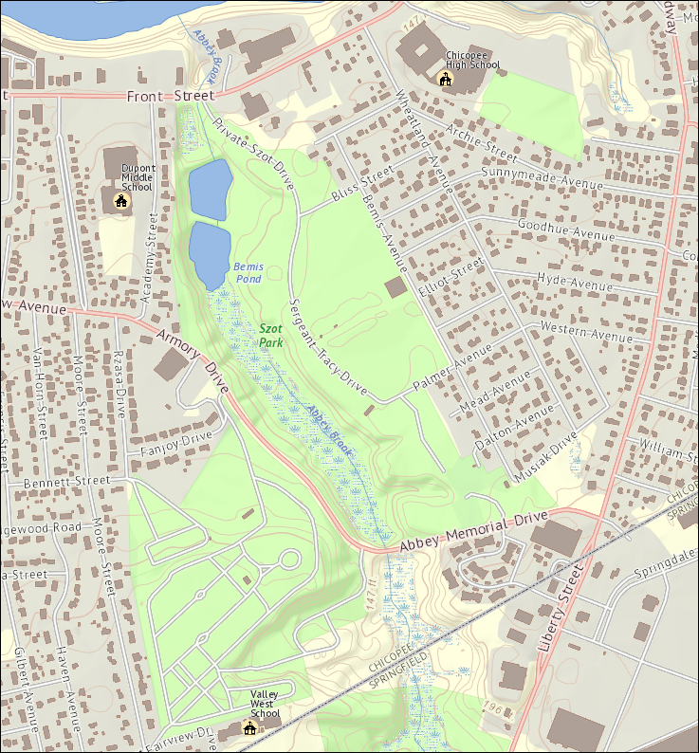
Site 1; Site 2
Site 3
Site 4
Site 5
Site 6
Site 7
Site 9
Site 8
Dupont Middle School
Site A
in-progress BMPs
(shaded area)
Fairview Cemetery
Szot Park
Figure C-1. BMP Opportunity Sites (See Appendix C for site descriptions)
(Map source: MassGIS OLIVER viewer, standard basemap)

Future Management Measures
Once the proposed BMPs have been installed, the City of Chicopee may consider additional investigations with the following recommended general sequence to identify and implement future structural BMPs.

Structural BMPs
- Identify Potential Implementation Locations: Perform a desktop analysis using aerial imagery and GIS data to develop a preliminary list of potentially feasible implementation locations based on soil type (i.e., hydrologic soil groups A and B); available public open space (e.g., lawn area in front of a police station); potential redevelopment sites where additional public-private partnerships may be leveraged; and other factors such as proximity to receiving waters, known problem areas, or publicly owned right of ways or easements. Additional analysis can also be performed to fine-tune locations to maximize pollutant removals such as performing loading analysis on specifically delineated subwatersheds draining to single outfalls and selecting those subwatersheds with the highest loading rates per acre.
- Visit Potential Implementation Locations: Perform field reconnaissance, preferably during a period of active runoff-producing rainfall, to evaluate potential implementation locations, gauge feasibility, and identify potential BMP ideas. During field reconnaissance, assess identified locations for space constraints, potential accessibility issues, presence of mature vegetation that may cause conflicts (e.g., roots), potential utility conflicts, site-specific drainage patterns, and other factors that may cause issues during design, construction, or long-term maintenance.
- Develop BMP Concepts: Once potential BMP locations are conceptualized, use the BMP-selector tool on the watershed-based planning tool to help develop concepts. Concepts can vary widely. One method is to develop 1-page fact sheets for each concept that includes a site description, including definition of the problem, a description of the proposed BMPs, annotated site photographs with conceptual BMP design details, and a discussion of potential conflicts such as property ownership, O&M requirements, and permitting constraints. The fact sheet can also include information obtained from the BMP-selector tool including cost estimates, load reduction estimates, and sizing information (i.e., BMP footprint, drainage area, etc.).
- Rank BMP Concepts: Once BMP concepts are developed, perform a priority ranking based on site-specific factors to identify the implementation order. Ranking can include many factors including cost, expected pollutant load reductions, implementation complexity, potential outreach opportunities and visibility to public, accessibility, expected operation and maintenance effort, and others.
Prioritized BMP concepts should focus on reducing TSS and bacteria loading to Abbey Brook, as summarized by the water quality goals (Element B).

Non-Structural BMPs
Planned BMPs can also be non-structural and can include practices such as street sweeping and catch basin cleaning to reduce TSS, TN, and TP loading; as well as Illicit Discharge Detection and Elimination (IDDE) to reduce bacteria concentrations. For the Abbey Brook watershed, non-structural controls could also focus on geese management to reduce bacterial loading from fecal matter. It is recommended that these municipal programs be evaluated and potentially optimized. First, it is recommended that potential removals from ongoing activities be calculated in accordance with Element H&I. Next, it is recommended that ongoing activities be evaluated to see if potential improvements can be implemented to achieve higher pollutant load reductions such as increased frequency or improved technology.

Element D: Identify Technical and Financial Assistance Needed to Implement Plan

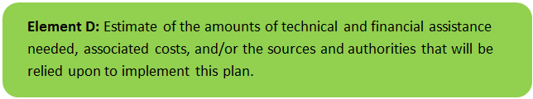

Current and Ongoing Management Measures
Table D-1 presents the anticipated funding needed to implement the management measures in the Abbey Brook watershed presented in this WBP. The table includes planning level costs for structural BMPs, operation and maintenance activities, information/education measures, and monitoring/evaluation activities. The table also includes summary statistics of proposed BMPs including potential pollutant load reductions.
Results from the table indicate that total suspended solids load reductions of over 3,800 pounds per year can be expected through implementation of additional BMPs. Actual load reductions can be calculated when designs are finalized and alternatives are selected. It is expected that implementation of these BMPs will play a significant role in decreasing pollutant loading to Abbey Brook.

Future Management Measures
Funding for future BMP installations to further reduce loads within the watershed may be provided by a variety of sources, such as the Section 319 Nonpoint Source Pollution Grant Program, city capital funds, Municipal Vulnerability Preparedness (MVP) grants, or other grant programs such as hazard mitigation funding. Guidance is available to provide additional information on potential funding sources for nonpoint source pollution reduction efforts.
Table D-1: Summary of Proposed BMPs and Funding Needed to Implement the Watershed Plan
Site | BMP Identification / Location | BMP Description | Drainage Area (ac) | Impervious Area (%) | Est. Load Reduction (lb/yr) |  |  |  | Cost Estimates ($) |  |  |  |  | Site Specific Notes
 |  |  |  |  | TN | TP |  | TSS | Capital¹ | O&M² | Technical Assistance³ | Total | Cost/lb TSS/yr
Structural BMPs (from Element C)
A | Lower Bemis Pond⁴ | Upland sediment forebay, two bioswales, and waterfowl-resistant vegetation | 15.13 | -- | -- | -- |  | 1,178 | $95,600 | $1,200 | $106,600 | $203,400 | $172.67 | Removal of the Lower Bemis Pond dam is also planned as a concurrent project to installation of the BMPs.
1 | Sergeant Tracey Drive | Rain gardens and maintenance of the stormwater conveyance pipe network | 12.80 | 10% | 13.7 | 1.4 |  | 865⁵ | $150,000 | $3,000 | $60,000 | $213,000 | $246.24 | The estimated pollutant load reduction only considers installation of bioretention cells for this planning-level estimate.
2 | Sergeant Tracey Drive Parking Lot | Proposed 450-ft water quality swale with check dams | 3.95 | 52% | -- | 0.4 |  | 901 | $57,000 | $1,140 | $22,800 | $80,940 | $89.83 | There is insufficient data to estimate Nitrogen pollutant removal of a water quality swale.
3 | Szot Park Pavilion | Rain barrel system with public education opportunities | 0.10 | 100% | -- | -- |  | -- | $1,000 | $20 | $400 | $1,420 | -- | The rain barrel system would not be expected to directly reduce pollutant loads but would be expected to reduce erosion and peak runoff volumes.
4 | Bruce Lafreniere Picnic Grove Parking Lot | Bioretention cell with public education opportunities | 1.86 | 31% | 3.9 | 0.4 |  | 304 | $22,000 | $440 | $8,800 | $31,240 | $102.76
5 | Abbey Memorial Drive Outfall | Deep sump catch basin | 0.20 | 100% | 0.0 | 0.0 |  | 33 | $1,000 | $20 | $400 | $1,420 | $43.69
6 | Fairview Cemetery Access Road | Rain garden | 0.70 | 1% | 0.6 | 0.1 |  | 24 | $14,000 | $280 | $5,600 | $19,880 | $828.33
7 | Fanjoy Drive | Curb cut and bioretention cell | 1.80 | 36% | 6.6 | 0.8 |  | 306 | $35,000 | $700 | $14,000 | $49,700 | $162.42
8 | Middle School Playground | Sod Stabilization | 0.85 | 86% | -- | -- |  | -- | $5,000 | $100 | $2,000 | $7,100 | -- | Sod stabilization or permeable pavers would not be expected to directly reduce pollutant loads but would be expected to reduce erosion by stabilizing exposed soil.
9 | Middle School Parking Lot | Rain garden with public education opportunities | 0.50 | 98% | 3.2 | 0.4 |  | 284 | $8,800 | $176 | $3,520 | $12,496 | $44.00
Sub-Total: |  |  |  |  | 28.0 | 3.5 |  | 3,895 | $395,900 | $7,206 | $226,720 | $629,826 | $1,690
Information / Education (Element E)
- | Project Updates | Periodically post project updates to website, including completed WBP | -- | -- | -- | -- |  | -- | -- | -- | -- | $0 | --
- | Signage | Create informational signage for up to 3 BMPs | -- | -- | -- | -- |  | -- | $3,000 | -- | -- | $3,000 | --
- | Education | Develop learning module and display student projects in a public location | -- | -- | -- | -- |  | -- | $1,000 | -- | -- | $1,000 | --
Sub-Total: |  |  |  |  | - | - |  | - | $3,000 | $0 | $0 | $3,000 | --
Monitoring and Evaluation (Element H & I)
- | Sampling QAPP / SOPs | Write sampling QAPP and sampling plan | -- | -- | -- | -- |  | -- | -- | -- | $6,000 | $6,000 | -- | Estimated cost; cost will vary widely depending on level of detail.
- | Annual Water Quality Sampling | TBD | -- | -- | -- | -- |  | -- | -- | -- | $10,000 | $10,000 | -- | Extent of sampling program TBD – annual ballpark cost placeholder.
Sub-Total: |  |  |  |  | -- | -- |  | -- | -- | -- | $16,000 | $16,000 | --
TOTALS: |  |  |  |  |  |  |  |  | $398,900 | $7,206 | $242,720 | $648,826 | $1,690
General Notes
- Planning level capital costs for BMPs obtained from WBP Element C and/or professional judgement from past projects.
- Annual operation and maintenance estimated as 2% of capital costs unless otherwise noted. Actual costs may vary widely based on who performs maintenance.
- Technical assistance (i.e. engineering) estimated based on capital costs - design (30%), survey (2%), permitting (3%), Construction Quality Assurance (5%) unless otherwise noted.
- Drainage area statistics, pollutant load reductions, and cost information for Site A was obtained from the Stormwater Management and Stream Restoration for Water Quality in Lower Abbey Brook, Chicopee Section 319 Nonpoint Source Pollution Grant Program application (City of Chicopee, 2018).
- The drainage areas of the proposed improvements of Site 1 are within the greater watershed of the Site A BMPs. It is recommended that following completion of the BMPs in Site A, the actual removal efficiencies of the improvements be assessed to evaluate if further controls are needed in this portion of the watershed to meet water quality goals. If so, the proposed BMPs at Site 1 provide options for additional upgradient improvements.

Element E: Public Information and Education
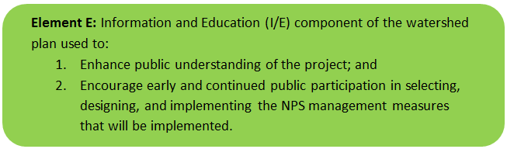

Step 1: Goals and Objectives
The goals and objectives for the watershed information and education program.
- Provide information about proposed stormwater improvements and their anticipated water quality benefits.
- Provide information to promote watershed stewardship.
Step 2: Target Audience
Target audiences that need to be reached to meet the goals and objectives identified above.
- All watershed residents.
- Businesses within the watershed.
- Watershed organizations and other user groups.
- Community stakeholder organizations.
- Schools.
Step 3: Outreach Products and Distribution
The outreach product(s) and distribution form(s) that will be used for each.
- Pet waste stations installed in Szot Park (existing – Figure E-1).
- Develop a fifth grade-level learning module about watershed management and present the module at three Chicopee elementary schools. Students will prepare a project based on the module to be displayed publicly.
- Hold a local event to extend information and learning to the public.
- Post this watershed-based plan and project information on the City of Chicopee website.
- Create additional information signage to highlight BMPs that are installed throughout the watershed on public land.
- Implement community process planned as part of the Lower Bemis Pond Dam removal project.
- Implement S.319 grant education programs.
- Implement programming in Szot Park to introduce visitors to BMPs and their benefits.
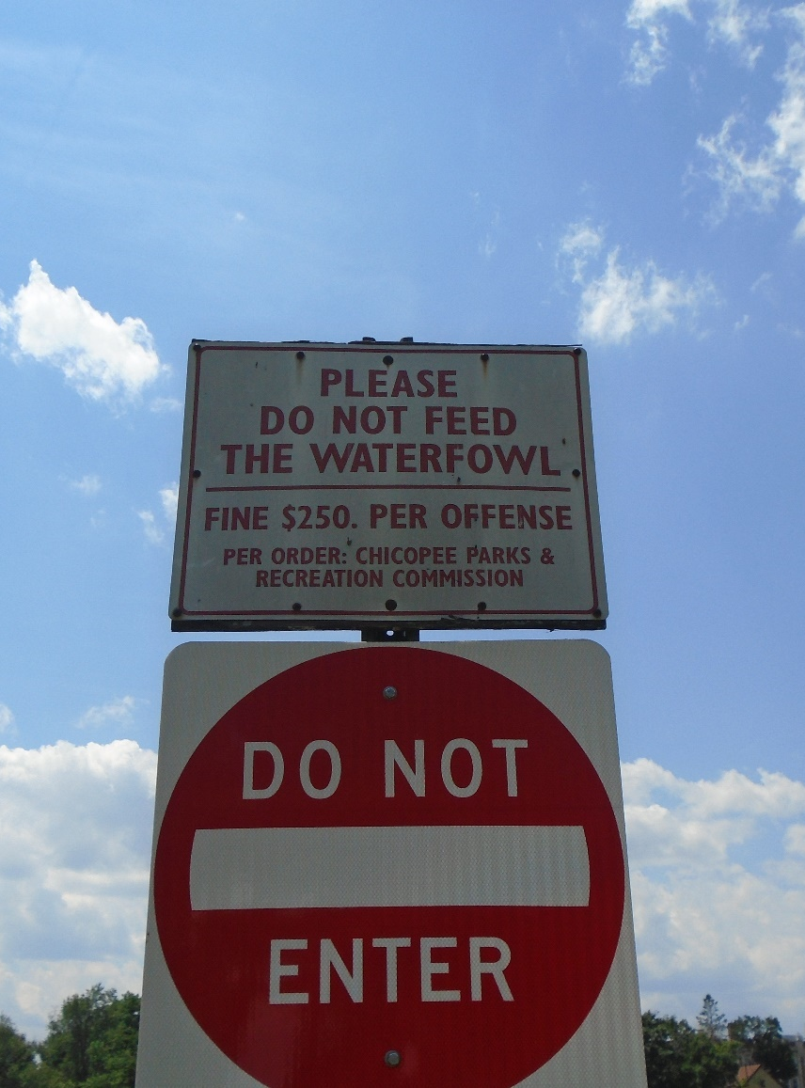
Figure E-1: Existing Examples of Public Education and Outreach in the Abbey Brook Watershed
Step 4: Evaluate Information/Education Program
Information and education efforts and how they will be evaluated.
- Document the number of pet waste stations installed or the number of pet waste bags found in catch basins. Implement education so that proper disposal of pet waste persists in Chicopee.
- Track the number of students participating in the watershed learning module and the number of projects produced by the students.
- Track attendance at local learning events held for the public.
- Track web activity on the City website.
Additional outreach products will be determined if future management measures and activities are planned for implementation in the watershed. This section of the WBP will be updated when the plan is re-evaluated in 2022 in accordance with Element F&G.

Elements F & G: Implementation Schedule and Measurable Milestones
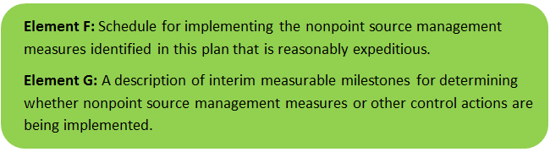

Table FG-1 provides a preliminary schedule for implementation of recommendations provided by this WBP. It is expected that the WBP will be re-evaluated and updated at least once every three (3) years, or as needed, based on ongoing monitoring results and other ongoing efforts.
Table FG-1: Implementation Schedule and Interim Measurable Milestones
Category | Action | Cost Estimate | Year(s)
Monitoring / Vegetation | Write Quality Assurance Project Plan (QAPP) for sampling and establish water quality monitoring program | $6,000 | 2020
 | Perform annual water quality sampling per Element H&I monitoring guidance | $10,000 | Annual
Structural BMPs | Complete installation of BMPs at Szot Park | $203,400 | 2021
 | Obtain funding and implement 2-3 additional BMPs from Appendix C | $142,142 | 2022
 | Obtain funding and implement 2-3 additional BMPs from Appendix C | $142,142 | 2024
 | Obtain funding and implement 2-3 additional BMPs from Appendix C | $142,142 | 2026
Nonstructural BMPs | Document potential pollutant removals from ongoing non-structural BMP practices (i.e., street sweeping, catch basin cleaning) | - | 2020
 | Evaluate ongoing non-structural BMP practices and determine if modifications can be made to optimize pollutant removals (e.g., increase frequency). | - | 2021
 | Routinely implement optimized non-structural BMP practices | - | Annual
Public Education and Outreach  (See Element E) | Distribute project information on the City website | - | 2020
 | Develop and post informational signs at proposed BMP locations and conduct learning events | $3,000 | 2020
 | Develop learning module and display student projects in a public location | $1,000 | 2020
Adaptive Management  and Plan Updates | Establish working group comprised of stakeholders and other interested parties to implement recommendations and track progress. Meet at least twice per year. | - | 2019
 | Re-evaluate Watershed Based Plan at least once every three (3) years and adjust, as needed, based on ongoing efforts (e.g., based on monitoring results, 319 funding, etc.). – Next update, December 2022 | - | 2022
 | Reach interim goal to reduce land-based total suspended solids to Abbey Brook by 10 pounds | - | 2024
 | Establish additional long-term reduction goal(s) from baseline monitoring results, if needed | - | 2024
 | Reach long-term goal to de-list Abbey Brook from the 303(d) list | - | 2034

Elements H & I: Progress Evaluation Criteria and Monitoring
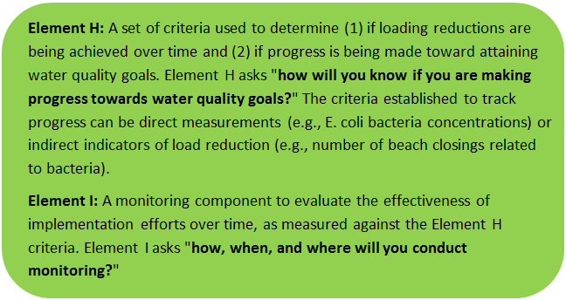 | 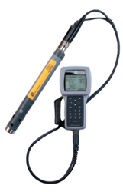

The water quality target concentration(s) is presented under Element A of this plan. To achieve this target concentration, the annual loading must be reduced to the amount described in Element B. Element C of this plan describes the various management measures that will be implemented to achieve this targeted load reduction. The evaluation criteria and monitoring program described will be used to measure the effectiveness of the proposed management measures (described in Element C) in improving the water quality of Abbey Brook and the Lower Chicopee River.

Indirect Indicators of Load Reduction

Non-Structural BMPs
Potential load reductions from non-structural BMPs (i.e., street sweeping and catch basin cleaning) can be estimated from indirect indicators, such as the number of miles of streets swept or the number of catch basins cleaned. As indicated by Element C, it is recommended that potential pollutant removal from these ongoing activities be estimated, particularly for TSS. Next, it is recommended that ongoing activities be evaluated to see if potential improvements can be implemented to achieve higher pollutant load reductions such as increased frequency or improved technology. Additionally, since there is a bacteria impairment for the Lower Chicopee River, it is recommended that illicit discharge detection and elimination (IDDE) efforts required by the MS4 Permit be tracked. However, it should be noted that source tracking previously completed by PVPC suggested that fecal matter from geese in the area was the primary source of bacteria in the Abbey Brook watershed.

Project-Specific Indicators

Number of BMPs Installed and Pollutant Reduction Estimates:
Anticipated pollutant load reductions from existing, ongoing (i.e., under construction), and future BMPs will be tracked as BMPs are installed. For example, once ongoing BMPs are installed, the anticipated TSS load reduction is estimated to be 0.6 tons per year.

Direct Measurements
Direct measurements are generally expected to be performed as described below. Prior to implementing a direct measurement program, an abbreviated quality assurance project plan (QAPP) and/or Standard Operating Procedures (SOPs) will be established to flesh out details of the program and establish best practices for sample collection and analysis. Water quality monitoring may be performed through a volunteer training program to save on costs in accordance with established practices for MassDEP’s environmental monitoring for volunteers; however, it is noted that organization of volunteers would still require funding.

River Sampling
Establish regular sampling of priority pollutants (TSS, fecal coliform and E. coli) and flow rate in Abbey Brook and the Lower Chicopee River; potentially including analysis of other common NPS pollutants, such as total phosphorus, total nitrogen, and turbidity. Additional parameters such as temperature, conductivity, biochemical oxygen demand, salinity, dissolved oxygen, pH, and chlorine could provide additional data for consideration. Monitoring locations will be selected to build upon existing water quality data. It is recommended that, at a minimum, samples be taken in Abbey Brook where it enters Szot Park (under Abbey Memorial Drive) and Abbey Brook near where it enters the Chicopee River. It is recommended that samples be taken during notable storm events with a goal to capture up to four events per year. TSS and discharge measurements can later be converted to estimates of loading to Abbey Brook and will aid in better characterizing base loading to Abbey Brook. Additional monitoring locations may be selected based on accessibility and representativeness and shall be appropriate to quantify water quality improvements in the watershed.

Outfall Screening
Implement an outfall screening program to compare water quality screening criteria before and after implementation of BMPs. Parameters for screening would include temperature, conductivity, fecal coliform, E. coli, biochemical oxygen demand, TSS, salinity, dissolved oxygen, pH, chlorine, nutrients, and flow rate.

Adaptive Management
As discussed by Element B, the baseline monitoring program will be used to establish a long-term (i.e., 10 year) TSS load reduction goal (or other parameter(s) depending on results). Long-term goals will be re-evaluated at least once every three (3) years and adaptively adjusted based on additional monitoring results and other indirect indicators. If monitoring results and indirect indicators do not show improvement to the pollutant concentrations measured within the watershed, the management measures and loading reduction analysis (Elements A through D) will be revisited and modified accordingly.

References

314 CMR 4.00 (2013). "Division of Water Pollution Control, Massachusetts Surface Water Quality Standards"
Cohen, A. J.; Randall, A.D. (1998). "Mean annual runoff, precipitation, and evapotranspiration in the glaciated northeastern United States, 1951-80." Prepared for United States Geological Survey, Reston VA.
Geosyntec Consultants, Inc. (2014). "Least Cost Mix of BMPs Analysis, Evaluation of Stormwater Standards Contract No. EP-C-08-002, Task Order 2010-12." Prepared for Jesse W. Pritts, Task Order Manager, U.S. Environmental Protection Agency
Geosyntec Consultants, Inc. (2015). "Appendix B: Pollutant Load Modeling Report, Water Integration for the Squamscott-Exeter (WISE) River Watershed."
GZA GeoEnvironmental, Inc. (2018). “Phase II Engineering Evaluation and Alternatives Analysis”
King, D. and Hagan, P. (2011). "Costs of Stormwater Management Practices in Maryland Counties." University of Maryland Center for Environmental Science Chesapeake Biological Laboratory. October 11, 2011.
Leisenring, M., Clary, J., and Hobson, P. (2014). "International Stormwater Best Management Practices (BMP) Database Pollutant Category Statistical Summary Report: Solids, Bacteria, Nutrients and Metals." Geosyntec Consultants, Inc. and Wright Water Engineers, Inc. December 2014.
MassDEP (2003). "Chicopee River Watershed 2003 Water Quality Assessment Report"
MassDEP (2012). "Massachusetts Year 2012 Integrated List of Waters Final Listing of Massachusetts' Waters Pursuant to Sections 305(b), 314 and 303(d) of the Clean Water Act"
MassDEP (2014). “Massachusetts Year 2014 Integrated List of Waters Final Listing of Massachusetts’ Waters Pursuant to Sections 305(b), 314 and 303(d) of the Clean Water Act”
MassDEP (2013). “314 CMR 4.00: Massachusetts Surface Water Quality Standards”
MassDEP (2016a). "Massachusetts Clean Water Toolkit"
MassDEP (2016b). "Massachusetts Stormwater Handbook, Vol. 2, Ch. 2, Stormwater Best Management Practices"
MassDEP (2019). “314 CMR 4.00: Massachusetts Surface Water Quality Standards – Narrative Redline Draft”
MassGIS (1999). "Networked Hydro Centerlines" Shapefile
MassGIS (2001). "USGS Topographic Quadrangle Images" Image
MassGIS (2007). "Drainage Sub-basins" Shapefile
MassGIS (2009a). "Impervious Surface" Image
MassGIS (2009b). "Land Use (2005)" Shapefile
MassGIS (2013). "MassDEP 2012 Integrated List of Waters (305(b)/303(d))" Shapefile
PVPC (2014). “Pioneer Valley Green Infrastructure Plan”
PVPC (2017). “Lower Chicopee River Watershed Stormwater Assessment Project Final Report”
Schueler, T.R., Fraley-McNeal, L, and K. Cappiella (2009). "Is impervious cover still important? Review of recent research" Journal of Hydrologic Engineering 14 (4): 309-315.
United States Bureau of Labor Statistics (2016). "Consumer Price Index"
United States Geological Survey (2016). "National Hydrography Dataset, High Resolution Shapefile"
University of Massachusetts, Amherst (2004). "Stormwater Technologies Clearinghouse"
USDA NRCS and MassGIS (2012). "NRCS SSURGO-Certified Soils" Shapefile
USEPA (1986). "Quality Criteria for Water (Gold Book)" EPA 440/5-86-001. Office of Water, Regulations and Standards. Washington, D.C.
USEPA (1999). “Preliminary Data Summary of Urban Storm Water Best Management Practices.”
USEPA. (2010). "EPA's Methodology to Calculate Baseline Estimates of Impervious Area (IA) and Directly Connected Impervious Area (DCIA) for Massachusetts Communities."
Voorhees, Mark, USEPA. (2015). "FW: Description of additional modelling work for Opti-Tool Project" Message to Chad Yaindl, Geosyntec Consultants. 23 April 2015. E-mail.
Voorhees, Mark, USEPA. (2016a). "FW: EPA Region 1 SW BMP performance equations" Message to Chad Yaindl, Geosyntec Consultants. 25 January 2016. E-mail.
Voorhees, Mark, USEPA. (2016b). "FW: Description of additional modelling work for Opti-Tool Project" Message to Chad Yaindl, Geosyntec Consultants. 23 April 2015. E-mail.

Appendices

Appendix A – Additional Water Quality Information
Chicopee River Watershed 2003 Water Quality Assessment Report (MA36-25 - Chicopee River)
USE ASSESSMENT - AQUATIC LIFE
Habitat and Flow
The hydroelectric power plant at the Chicopee Falls Dam is a FERC exempt facility (FERC-exempt #6522). The facility operates a 2,500-Kilowatt hydroelectric power station on this segment of the Chicopee River (FERC 20 December 2000). Under its exempt status, the facility releases 127 cfs in the bypass reach and 230 cfs downstream. The dam has 18-inch flashboards and has all flow releases and power generation are automated. There are no current provisions to allow fish passage (Kleinschmidt Associates and CEEI 1999).
Consolidated Edison Energy Massachusetts Inc. (CEEMI) Dwight Station is a FERC-exempt facility (FERC-exempt #10675) operating a 3,700-Kilowatt hydroelectric power station on the Chicopee River in Chicopee (FERC 20 December 2000). Under its exempt status, the dam is not subject to FERC Part 12 Inspection requirements. The dam had 2.3’ high flashboards that have been removed to assist in the passage of minimum flow. The canal system is currently in disrepair and the hydraulic capacity is limited because of unreliable canal head gates. During the spring the Station is shut down. Since the 1998 Chicopee WQAR report, an eelway has been built at the Dwight Dam through a USFWS grant and cooperation from the Chicopee River Watershed Council Silvio O. Conte Anadromous Fish Research Center and CEEMI (MA EOEA, 2007).
Biology
DWM conducted water quality monitoring at one station (CTO3 – Route 116 Bridge, Chicopee) in this Chicopee River segment between April and October 2003 (Appendix B). DWM crews made notes of conditions at this site throughout the sampling season. Although aquatic plant density was characterized as unobservable on the majority of sampling days, on August 20th aquatic plant density was noted to be moderate and composed of submerged plants, principally moss on rocks and milfoil (Myriophyllum sp.). Sparse periphyton coverage was noted on two occasions (April 16th and July 30th) while moderate coverage was noted on May 15th and August 20th. On the remaining sampling days periphyton coverage was unobservable or not recorded. On June 18th phytoplankton presence was described as sparse while the majority of occasions when observable or recorded no phytoplankton were noted.
Toxicity
Ambient
The Eastern Etching & Manufacturing Company staff collected water from the Chicopee River approximately 100 feet upstream from the Eastern Etching east parking lot, off of Riverview Terrace, for use as dilution water in the facility’s whole effluent toxicity tests. Between May 2000 and May 2002 survival of C. dubia exposed (48 hours) to the Chicopee River water ranged from 90 to 100% (n=5). Between May 2000 and May 2002 survival of P. promelas exposed (48 hours) to the Chicopee River water was all 100% (n=5). Hardness ranged from 19.0 mg/L to 29.0 mg/L (n=5).
Effluent
Acute whole effluent toxicity tests have been conducted on the Eastern Etching & Manufacturing Company treated effluent. Between May 2000 and May 2002 five valid tests were conducted using C. dubia and P. promelas. The LC50 using C. dubia ranged from 56.10% to >100% effluent (n=5). The LC50 tests using P. promelas were all >100% (n=5). All of the tests met the limit of >50%.
Ammonia-nitrogen concentrations reported in the whole effluent toxicity reports between May 2000 and May 2002 ranged from 0.17 mg/L to 3.40 mg/L (n=5). Total residual chlorine (TRC) concentrations reported in the whole effluent toxicity reports between May 2000 and May 2002 ranged from <0.020 to 0.150 mg/L (n=5). Between May 2000 and May 2002 the total aluminum limit was exceeded once on May 10, 2000 when the effluent had an aluminum concentration of 5.3 mg/L (n=5).
Water Chemistry
DWM conducted water quality monitoring at one station (CTO3 – Route 116 Bridge, Chicopee) in this Chicopee River segment between April and October 2003 (Appendix B). In-situ parameters were measured on seven occasions, including two pre-dawn occasions. Grab samples were also collected and analyzed for TSS, turbidity, ammonia-nitrogen, and total phosphorus (Appendix B).
Temperature, pH and dissolved oxygen measurements at the DWM station all met criteria on DWM sampling dates (Appendix B). It should be noted, though, that this station is below the Dwight Dam and this may affect dissolved oxygen concentrations. Ammonia-nitrogen concentrations measured in DWM samples were low while total phosphorus concentrations ranged from 0.024 mg/L to 0.057 mg/L with the highest concentrations found on 18 June 2003, a wet weather sampling date (Appendix B).
Given the good survival of test organism and the generally good water quality conditions, the Aquatic Life Use is assessed as support. The Aquatic Life Use is identified with an “Alert Status” due to potential impacts of hydropower operations and CSOs.
USE ASSESSMENT - PRIMARY AND SECONDARY CONTACT RECREATION AND AESTHETICS
DWM conducted fecal coliform and E. coli bacteria monitoring at one station (CTO3 – Route 116 Bridge, Chicopee) between April and October 2003 (Appendix B). This station is approximately 900 feet below Chicopee CSO #025, which was active during the time of DWM sampling. This station was also below eleven other Chicopee CSOs (during time of sampling). E. coli counts were generally low with the exception of one sample collected on 15 October 2003, which had an E. coli count of 2980 cfu/ 100 mL. This high bacteria sample was collected on a wet weather sampling date.
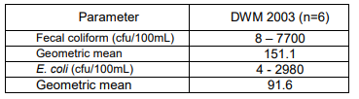
Metcalf and Eddy (2006), as part of CSO work for the Connecticut River Bacteria Monitoring Project, collected bacteria samples at the Route 116 bridge in Chicopee which was downstream from 12 Chicopee CSOs at the time of sampling. Metcalf and Eddy staff sampled three points (equidistant from one another) along a transect going from both banks of the river. They conducted dry weather sampling on 8 August 2001 and wet weather sampling on three occasions: 25 September 2001; 15 September 2002 and 16 October 2002. This project had a MassDEP-approved Quality Assurance Project Plan. Eighteen samples were collected in 2001 by Metcalf and Eddy (1 dry weather event, 1 wet weather event- two days total) and the E. coli geometric mean was 400 cfu/100 mL. Eight of the nine E. coli bacteria counts were greater than 235 cfu/100 mL on 8 August 2001 while none were greater than 1260 cfu/100 mL. Six of the nine E. coli counts collected on 25 September 2001 were greater than 235 cfu/100 mL while three of the nine E. coli counts were greater than 1260 cfu/100 mL. Eighteen samples were collected in 2002 by Metcalf and Eddy (2 wet weather events-2 days total) and the E. coli geometric mean was 412.8 cfu/100 mL. Seven of the E. coli bacteria counts collected on 15 September 2002 were greater than 235 cfu/100 ml and one sample was greater than 1260 cfu/100 mL. Eight of the nine E. coli counts collected on 16 October 2002 were greater than 235 cfu/100 mL and two E. coli counts were greater than 1260 cfu/100 mL.
No objectionable deposits, scums or water odor were recorded by DWM field crews. The water clarity was described as clear or slightly turbid when noted. Minimal erosion was observed on two occasions. Although aquatic plant density was characterized as unobservable on the majority of sampling days, on August 20th aquatic plant density was noted to be moderate and composed of submerged plants, principally moss on rocks and milfoil (Myriophyllum sp.). Sparse periphyton coverage was noted on two occasions (April 16th and July 30th) while moderate coverage was noted on May 15th and August 20th. On the remaining sampling days periphyton coverage was unobservable or not recorded. On June 18th phytoplankton presence was described as sparse while the majority of occasions when observable or recorded no phytoplankton were noted. On April 16th the water level was noted to be extremely high and the storm drains under the bridge were observed to be flowing. On June 18th a storm drain near the bridge on the right bank was flowing.
The Primary and Secondary Contact Recreation Uses are assessed as impaired because of elevated E. coli counts. The highest bacteria counts were collected during wet weather events. Given the lack of objectionable conditions the Aesthetics Use is assessed as support.
This segment begins at the Chicopee Falls Dam at Route 33 in Chicopee Falls. This dam is a 10’ high masonry stone dam that was constructed in the late 1800s. It is currently owned by the City of Chicopee and used as a hydroelectric facility. A second da
Report Recommendations:
Track progress of the City of Chicopee’s CSO abatement activities. Conduct bacteria sampling to evaluate the effectiveness of the CSO abatement and to assess Primary and Secondary Contact Recreation Uses. Wet weather sampling will give the best gage of CSO abatement activities, as E. coli counts in dry weather samples were low at this site.
Additional data are needed to evaluate the impact of hydropower activities on aquatic life conditions. This may include monitoring streamflow conditions and conducting fish population or benthic invertebrate monitoring.
Fish passage at the hydropower dams especially should be considered.

Chicopee River Watershed 2003 Water Quality Assessment Report (MA36-24 - Chicopee River)
USE ASSESSMENT - AQUATIC LIFE

Habitat and Flow
The USGS maintains a gage in Springfield, MA, on the Chicopee River (Gage 01177000) 1000 ft downstream from West Street Bridge at Indian Orchard and 1.1 mi upstream from Fuller Brook.
The drainage area of this gage is 689 mi2 and the period of record is August 1928 to present (pre- Nov. 1938 published as “at Bircham Bend”) (Socolow 2005). The average discharge is 909 cfs (1928-2005) and the maximum discharge occurred on 21 September 1938 (45,200 cfs) while the minimal discharge of 16 cfs occurred several times in 1929-31 (USGS 2007 and Soclolow et al. 2005).
The USGS remarks that flow diversion has occurred since 1941 from 186 mi2 in Swift River basin and at times since 1931 from 97 mi2 in Ware River Basin for Boston Metropolitan District (now MA DCR) (Socolow et al 2005). Diversions have also occurred since 1950 for Chicopee, since 1952 for South Hadley, at times since 1966 for Worcester, and at times since 1955 from 6.5 mi2 in Ware River Basin for Fitchburg. Diversion from Ludlow Reservoir for Springfield and, prior to 1952, for Chicopee has also occurred. Flow is regulated by powerplants upstream, by Quabbin Reservoir 21 mi upstream on the Swift River since 1939, by Barre Falls Reservoir on the Ware River since 1958, by Conant Brook Reservoir since 1966, and by smaller reservoirs (Socolow 2005). Discharge records are considered to be good except for estimated daily discharges, which are poor. (Socolow et al 2005).
There are two dams on this segment of the Chicopee River: Putts Bridge Dam at Route 21 between Ludlow and Indian Orchard (part of Springfield) and the Indian Orchard Dam north of Route 141 adjacent to an old mill on Front Street. The Putts Bridge Dam was constructed in 1918 as a concrete gravity structure. It rises 22’ from the bed of the Chicopee River. The Indian Orchard Dam is a cut stone dam with 28’ of height above the river. Both dams are owned and operated by CEEI as hydroelectric power plants. They generate and release minimum flows depending on the release from the Red Bridge Dam (located further upstream on the Chicopee River) (Kleinschmidt Associates and CEEI 1999). This segment of the Chicopee River ends at the Chicopee Falls Dam, which is a hydroelectric facility owned by the City of Chicopee.
Water Chemistry
DWM conducted water quality monitoring at one station (CH06– River Street/West Street bridge, Springfield/Ludlow) along this segment of the Chicopee River between April and October 2003 (Appendix B). In-situ parameters were measured on seven occasions, including two pre-dawn occasions. Grab samples were also collected and analyzed for TSS, turbidity, ammonia-nitrogen, and total phosphorus (Appendix B).
Dissolved oxygen, pH and temperature met criteria on all sampling dates. It should be noted though that the DWM station was below the Indian Orchard Impoundment. Total phosphorus concentrations during June and August 2003 sampling dates were slightly elevated. Ammonia-nitrogen concentrations were low on all sampling dates.
The Aquatic Life Use is assessed as support for this segment of the Chicopee River based on the good water quality conditions but is given an “Alert Status” due to the presence of CSOs and the potential impacts of hydromodification due to hydropower operations.
USE ASSESSMENT - PRIMARY AND SECONDARY CONTACT RECREATION AND AESTHETICS
Metcalf and Eddy (2006), as part of CSO work for the Connecticut River Bacteria Monitoring Project, collected bacteria samples at the Route 21 bridge on the Springfield/Ludlow border. This station is upstream from the Indian Orchard Impoundment and upstream from the DWM sampling site. Metcalf and Eddy staff collected two samples along a transect. Samples were taken from the river bank east of the bridge on both sides of the river. Dry weather sampling was conducted on 8 August 2001 and wet weather sampling on three occasions: between 25 -27 September 2001; 15-16 September 2002 and 16-18 October 2002. This project had a MassDEP-approved Quality Assurance Project Plan. The sampling conducted between 25-27 September 2001 had quality control issues and the data for this sampling are not used for purposes of this assessment report nor detailed in this report. Six samples were collected during one sampling occasions in 2001 and the E. coli geometric mean was 22.8 cfu/100 mL. In 2002 sixteen samples were collected during two wet weather sampling events and the E. coli geometric mean was 61.8 cfu/100 mL. None of the E. coli counts reported by Metcalf and Eddy (2006) and used in this report were greater than 235 cfu/ 100 mL. High fecal coliform counts were found in numerous samples but the corresponding E. coli counts were not high.
DWM conducted fecal coliform and E. coli bacteria monitoring at one station (CH06– River Street/West Street bridge, Springfield/Ludlow) along this segment of the Chicopee River between April and October 2003 (Appendix B). This site is downstream from 13 CSOs and located just upstream from the USGS gage at Indian Orchard. There is a dam and a mill upstream from this station. The river channel is large and wide. Samples were collected by the bridge drop method at this station.
The E. coli bacteria counts in samples collected by DWM at Station CH06 were generally low. The highest E. coli bacteria count of 126 cfu/100 mL was found in the sample collected on 15 October 2003, a wet weather sampling date. It appears the elevated streamflow was largely due to rain in the upper Chicopee watershed as no significant rainfall was recorded at the NOAA rain gauge in Springfield. This wet weather sampling date may not have captured local CSO discharges. The E. coli geometric mean for Station CH06 was 35.4 cfu/100 mL.
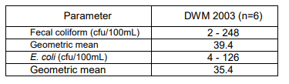
No objectionable deposits, scums or water odor were recorded by DWM field crews although conditions were often unobservable. Water clarity was clear on all days when noted. When observable there were no phytoplankton noted and on the one occasion when periphyton was observable it was characterized as sparse. On three occasions (July 30th, July 31st and August 20th) dense submerged aquatic plants were noted (principally grasses) while on the rest of sampling days aquatic plants were unobservable.
Given the low E. coli bacteria counts the Primary and Secondary Contact Recreation Uses are assessed as support. Due to the presence of CSOs both Primary and Secondary Contact Recreation Uses are listed with an “Alert Status.” Given the lack of objectionable conditions the Aesthetics Use is assessed as support.
FERC
Western Mass Electric Co. (Consolidated Edison Energy, Inc.), Putts Bridge Dam Station, is a FERC-exempt facility (FERC Exempt #10677) operating a 3,200-Kilowatt hydroelectric power station on the Chicopee River in Ludlow/Springfield (FERC 20 Dece
Report Recommendations:
Conduct bacteria sampling at multiple stations along this segment to document the progress of Ludlow, Chicopee, and Springfield’s CSO abatement activities.
Monitor the effects of hydropower activities on the Chicopee River. This may involve fish population sampling or benthic invertebrate sampling.
Fish passage plans should be considered at the hydropower dams along this segment.

Appendix B – Pollutant Load Export Rates (PLERs)

Land Use & Cover¹ | PLERs (lb/acre/year)
 | (TP) | (TSS) | (TN)
AGRICULTURE, HSG A | 0.45 | 7.14 | 2.59
AGRICULTURE, HSG B | 0.45 | 29.4 | 2.59
AGRICULTURE, HSG C | 0.45 | 59.8 | 2.59
AGRICULTURE, HSG D | 0.45 | 91.0 | 2.59
AGRICULTURE, IMPERVIOUS | 1.52 | 650 | 11.3
COMMERCIAL, HSG A | 0.03 | 7.14 | 0.27
COMMERCIAL, HSG B | 0.12 | 29.4 | 1.16
COMMERCIAL, HSG C | 0.21 | 59.8 | 2.41
COMMERCIAL, HSG D | 0.37 | 91.0 | 3.66
COMMERCIAL, IMPERVIOUS | 1.78 | 377 | 15.1
FOREST, HSG A | 0.12 | 7.14 | 0.54
FOREST, HSG B | 0.12 | 29.4 | 0.54
FOREST, HSG C | 0.12 | 59.8 | 0.54
FOREST, HSG D | 0.12 | 91.0 | 0.54
FOREST, HSG IMPERVIOUS | 1.52 | 650 | 11.3
HIGH DENSITY RESIDENTIAL, HSG A | 0.03 | 7.14 | 0.27
HIGH DENSITY RESIDENTIAL, HSG B | 0.12 | 29.4 | 1.16
HIGH DENSITY RESIDENTIAL, HSG C | 0.21 | 59.8 | 2.41
HIGH DENSITY RESIDENTIAL, HSG D | 0.37 | 91.0 | 3.66
HIGH DENSITY RESIDENTIAL, IMPERVIOUS | 2.32 | 439 | 14.1
HIGHWAY, HSG A | 0.03 | 7.14 | 0.27
HIGHWAY, HSG B | 0.12 | 29.4 | 1.16
HIGHWAY, HSG C | 0.21 | 59.8 | 2.41
HIGHWAY, HSG D | 0.37 | 91.0 | 3.66
HIGHWAY, IMPERVIOUS | 1.34 | 1,480 | 10.2
INDUSTRIAL, HSG A | 0.03 | 7.14 | 0.27
INDUSTRIAL, HSG B | 0.12 | 29.4 | 1.16
INDUSTRIAL, HSG C | 0.21 | 59.8 | 2.41
INDUSTRIAL, HSG D | 0.37 | 91.0 | 3.66
INDUSTRIAL, IMPERVIOUS | 1.78 | 377 | 15.1
LOW DENSITY RESIDENTIAL, HSG A | 0.03 | 7.14 | 0.27
LOW DENSITY RESIDENTIAL, HSG B | 0.12 | 29.4 | 1.16
LOW DENSITY RESIDENTIAL, HSG C | 0.21 | 59.8 | 2.41
LOW DENSITY RESIDENTIAL, HSG D | 0.37 | 91.0 | 3.66
LOW DENSITY RESIDENTIAL, IMPERVIOUS | 1.52 | 439 | 14.1
MEDIUM DENSITY RESIDENTIAL, HSG A | 0.03 | 7.14 | 0.27
MEDIUM DENSITY RESIDENTIAL, HSG B | 0.12 | 29.4 | 1.16
MEDIUM DENSITY RESIDENTIAL, HSG C | 0.21 | 59.8 | 2.41
MEDIUM DENSITY RESIDENTIAL, HSG D | 0.37 | 91.0 | 3.66
MEDIUM DENSITY RESIDENTIAL, IMPERVIOUS | 1.96 | 439 | 14.1
OPEN LAND, HSG A | 0.12 | 7.14 | 0.27
OPEN LAND, HSG B | 0.12 | 29.4 | 1.16
OPEN LAND, HSG C | 0.12 | 59.8 | 2.41
OPEN LAND, HSG D | 0.12 | 91.0 | 3.66
OPEN LAND, IMPERVIOUS | 1.52 | 650 | 11.3
¹HSG = Hydrologic Soil Group
Source: Voorhees, 2016b

Appendix C – BMP Conceptual Designs
Site A: Lower Bemis Pond (in-progress BMPs)
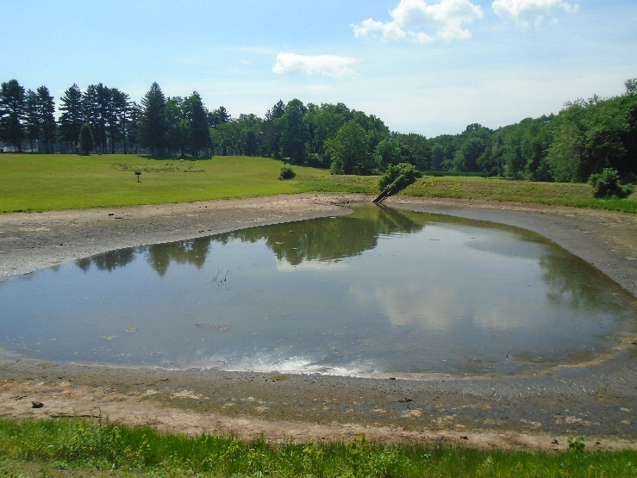
Lower Dam
Upper Bemis Pond
Upper Dam
Geese Habitat
Lower Bemis Pond
Photo A-1
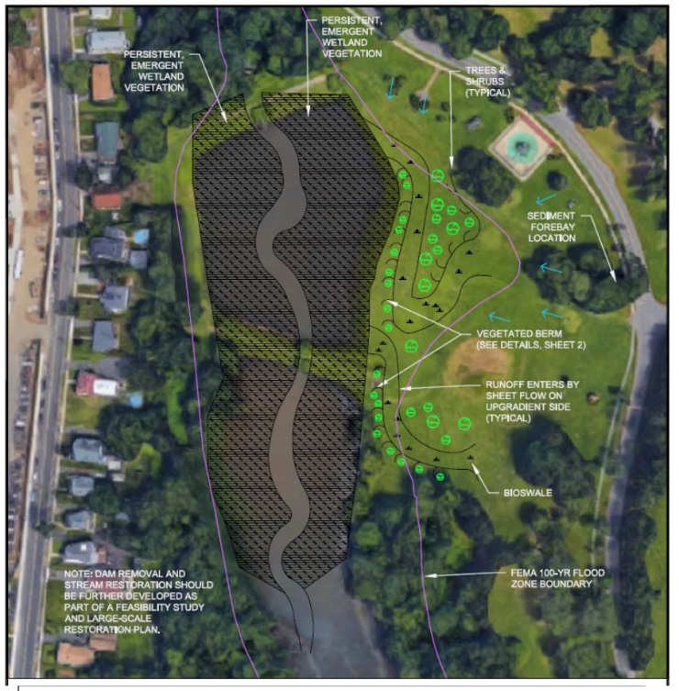
Landscape Restoration
Sediment Forebay
Vegetated Berm
Bioswale
Photo A-2
BMP Type: Sediment Forebay, Bioswales, Vegetation
BMP Location: Szot Park – adjacent to Lower Bemis Pond
Site Summary: Szot Park includes two ponds with dams: Upper Bemis Pond and Lower Bemis Pond. Abbey Brook discharges to these ponds prior to its outlet to the Chicopee River. The grassed slopes adjacent to the ponds are frequently habituated by geese. During field investigation, many geese and evidence of geese fecal matter were observed immediately adjacent to the ponds. Source tracking completed by PVPC in 2016 concluded that fecal matter from geese contributed to elevated concentrations of E. coli in the Abbey Brook, which is listed as impaired for E. coli and TSS in the Massachusetts Year 2016 Integrated List of Waters.
Proposed Improvement: As described in the Stormwater Management and Stream Restoration for Water Quality in Lower Abbey Brook, Chicopee Section 319 Nonpoint Source Pollution Grant Program application (City of Chicopee, 2018), proposed BMPs to address water quality at Lower Bemis Pond include an upland sediment forebay, serpentine bioswales along the stopes of the pond, and a vegetated berm to discourage geese habitation. In addition, the City of Chicopee intends to remove the dam downstream of Lower Bemis Pond and restore the pond to a its natural stream landscape.
Photo A-2 illustrates the proposed conceptual design. Note that the conceptual design also assumes removal of the upper dam and restoration of Upper Bemis Pond. Feasibility of removal of the upper dam will be considered in the future.
Expected O&M: Remove accumulated sediment from sediment forebay and bioswale quarterly and regularly maintain grass. Maintain/replace plants in the bioswale and vegetated berm as needed every two years.
Wetland Permitting: Submittal of a NOI for Wetlands Protection Act (WPA) permitting is expected to be required for removal of the lower dam, restoration of the natural landscape, and minor buffer zone disturbances.
Parcel Ownership: City of Chicopee
Sizing Characteristics¹
BMP Drainage Area (acres) | 15.1
Estimated Pollutant Load Reduction¹
E. coli (billion colonies/yr.) | 11.2
TSS (lbs./yr.) | 1,178
Estimated Cost¹
Planning-level Capital Cost | $203,400
1. The sizing characteristics, estimated pollutant load reductions, and estimated cost were obtained from the Stormwater Management and Stream Restoration for Water Quality in Lower Abbey Brook, Chicopee Section 319 Nonpoint Source Pollution Grant Program application (City of Chicopee, 2018).

Site 1: Sergeant Tracey Drive
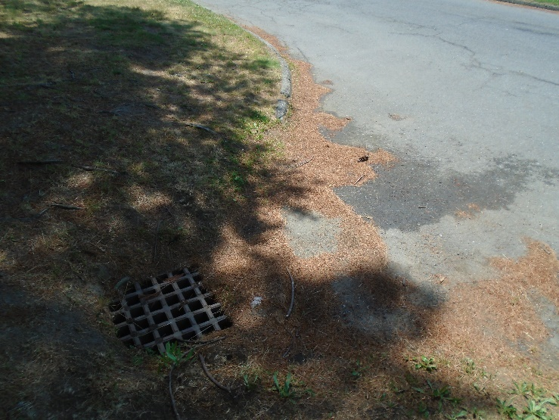
Rain Garden
Runoff
Catch Basin for overflow
Photo 1-1
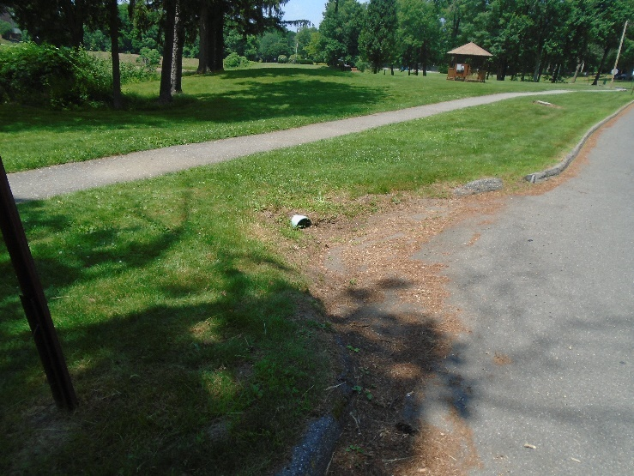
Rain Garden
Runoff
Existing pipe for overflow
Curb Cub
Photo 1-2
Note: The drainage areas of the proposed improvements of this site are within the greater watershed of the Site A BMPs. It is recommended that following completion of the BMPs in Site A, the actual removal efficiencies of the improvements be assessed to evaluate if further controls are needed in this portion of the watershed to meet water quality goals. If so, the proposed BMPs at Site 1 provide options for additional improvements.

BMP Type: Rain Gardens
BMP Location: Szot Park – Sergeant Tracey Drive
Site Summary: Stormwater runoff from the baseball fields in Szot Park generally flows west to Private Szot Drive (paved). Four catch basins are located along the length of the road, along with two curb cuts which discharge via overland flow to Upper and Lower Bemis Pond. According to available mapping information, the catch basins discharge via an outfall to Lower Bemis Pond; however, the outfall was not visible during field investigation. It is assumed that the outfall may be clogged or collapsed. During field investigation, accumulated organic material (e.g., leaves, pine needles, grass cuttings) were observed at the catch basins and curb cuts along Private Szot Drive.
Photo 1-1 depicts an example of a catch basin along Private Szot Drive and Photo 1-2 depicts an example of a curb cut.
Proposed Improvement: Small rain gardens are proposed to be installed at each of the catch basin and curb cut locations (six locations in total) to reduce sediment and pollutant loading to Upper and Lower Bemis Pond. It is also proposed that the catch basin and pipe network be maintained to clear any potential obstructions and expose the outlet of the system. It is expected that this maintenance will allow the system to discharge to the sediment forebay proposed in the Stormwater Management and Stream Restoration for Water Quality in Lower Abbey Brook, Chicopee Section 319 Nonpoint Source Pollution Grant Program application (City of Chicopee, 2018).
Expected O&M: Remove accumulated sediment from rain gardens annually and maintain/replace plants as needed every two years. Re-mulch annually.
Parcel Ownership: City of Chicopee
Sizing Characteristics
BMP Drainage Area (acres) | 12.8
BMP Size (storm depth; inches)² | 0.25
Impervious Area (%) | 10
BMP Estimated Footprint (square feet) | 1,780
Estimated Pollutant Load Reduction¹
TP (lbs./yr.) | 1.4
TN (lbs./yr.) | 13.7
TSS (lbs./yr.) | 865.3
Estimated Cost
Planning-level Capital Cost | $150,000
- The estimated pollutant load reduction only considers installation of bioretention cells for this planning-level estimate.
- The BMP design storm depth was set to 0.25 inches because the BMP Estimated Footprint for the 0.5-inch storm event exceeded available space at the site.

Site 2: Sergeant Tracey Drive Parking Lot
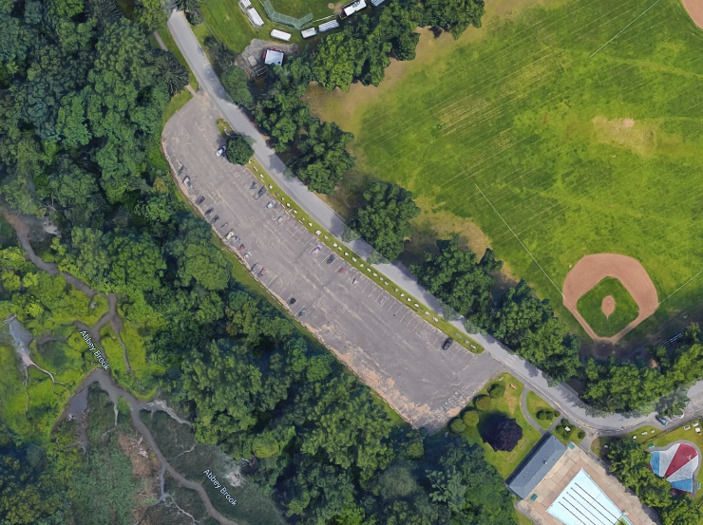
Photo 2-1
(Google Maps, 2019)

(Google Maps, 2019)

Abbey Brook
Accumulated Sediment
Private Szot Drive
Parking Lot
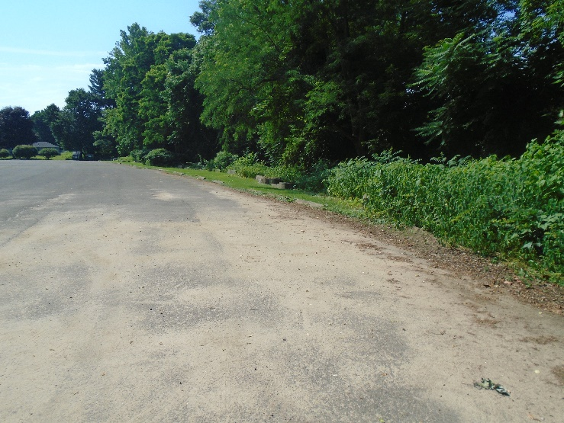

Check Dam
Water Quality Swale
Photo 2-2

(
Runoff
BMP Type: Water Quality Swale
BMP Location: Szot Park – Sergeant Tracey Drive
Site Summary: Stormwater runoff from Private Szot Drive and grassed areas in Szot Park generally flows west to a paved parking lot adjacent to Private Szot Drive. Runoff discharges from the parking lot to steep slopes directly adjacent to Abbey Brook. During field investigation, accumulated sediment was observed in the parking lot and sediment is also visible in aerial photos of the parking (Photo 2-1).
Proposed Improvement: Install an approx. 450-ft water quality swale along the downgradient edge of the parking lot to treat runoff, as illustrated in Photo 2-2. The swale should be installed with check dams to slow flows through the swale and encourage infiltration.
Expected O&M: Remove accumulated sediment from water quality swale and maintain/replace plants as needed every two years.
Wetland Permitting: As a project with minor buffer zone disturbances, WPA permitting is expected to require submittal of a Notice of Intent.
Parcel Ownership: City of Chicopee
Sizing Characteristics
BMP Drainage Area (acres) | 3.95
BMP Size (storm depth; inches) | 0.5
Impervious Area (%) | 52
Estimated Pollutant Load Reduction
TP (lbs./yr.) | 0.4
TN (lbs./yr.)¹ | --
TSS (lbs./yr.) | 900.8
Estimated Cost
Planning-level Capital Cost | $57,000
1. There is insufficient data to estimate Nitrogen pollutant removal of a water quality swale.

Site 3: Szot Park Pavilion
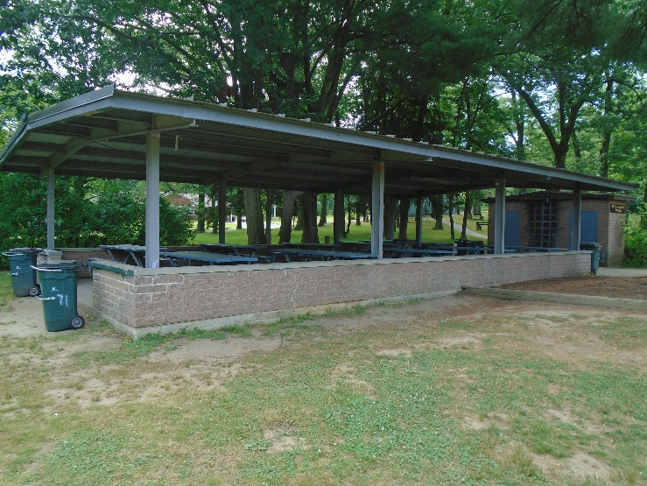
Public Education Sign
Erosion
Rain Barrel
Photo 3-1

BMP Type: Rain Barrels and Public Education
BMP Location: Szot Park
Site Summary: Runoff from the roof of a covered pavilion in Szot Park currently discharges via overland flow to Abbey Brook. The grassed areas surrounding the pavilion were sparsely vegetated at the time of field investigation and showed signs of erosion due to the rooftop runoff, as seen in Photo 3-1.
Proposed Improvement: Install two rain barrels (one for each side of the roof) to capture and store runoff from the roof. The system would be expected to reduce erosion around the pavilion and provide a reduction in peak runoff during small storm events. Water stored in the rain barrels could be used for irrigation or other non-potable uses. In addition, this location offers a great opportunity for public education and outreach, as it is a publicly-available gathering space.
Expected O&M: Remove accumulated debris from gutters and check rain barrel systems for leaks twice per year.
Parcel Ownership: City of Chicopee
Sizing Characteristics
BMP Drainage Area (acres) | 0.1
BMP Size (storm depth; inches) | --
Impervious Area (%) | 100
Estimated Pollutant Load Reduction¹
TP (lbs./yr.) | --
TN (lbs./yr.) | --
TSS (lbs./yr.) | --
Estimated Cost
Planning-level Capital Cost | $1,000
1. The rain barrel system would not be expected to directly reduce pollutant loads but would be expected to reduce erosion and peak runoff volumes.

Site 4: Bruce Lafreniere Picnic Grove Parking Lot
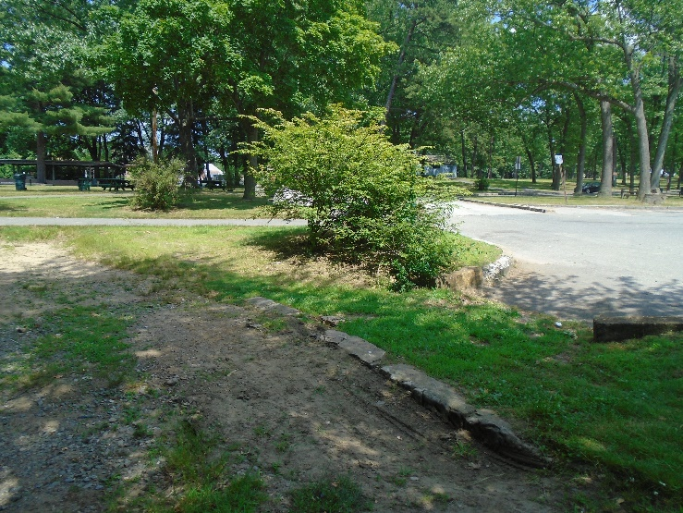
Rip Rap
Runoff
Overflow to Abbey Brook
Bioretention Cell
Picnic Area
Public Education Sign
Photo 4-1
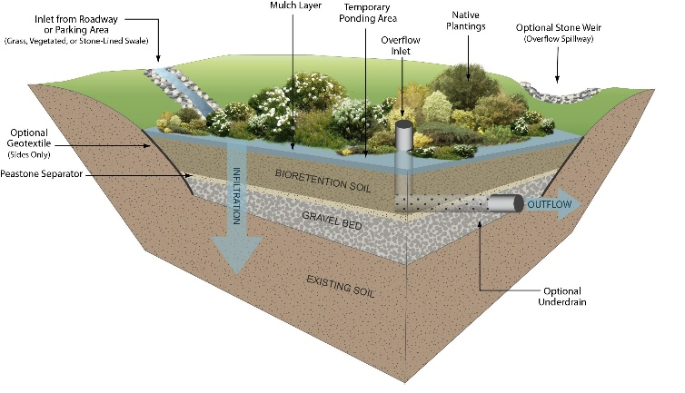
Photo 4-2
BMP Type: Bioretention Cell
BMP Location: Szot Park
Site Summary: Runoff from the paved parking lot for the Bruce Lafreniere Picnic Grove and vegetated areas upgradient discharges via an existing curb cut from the parking lot to a vegetated area that discharges directly to Abbey Brook (Photo 4-1).
Proposed Improvement: Install a bioretention cell with rip rap energy dissipation, a 6-inch gravel bed layer, and a 2.5-4 feet thick bioretention cell soil media layer to increase biological treatment of the stormwater infiltrating through the bioretention cell. Also install 2-3 inches of mulch and include a minimum of 6-inch ponding depth. In addition, native species should be planted within the ponding area of the bioretention cell to improve bioretention resiliency, stormwater treatment, biodiversity and aesthetics (Photo 4-2). With some added informational signage, this BMP could also have significant public education and outreach value.
Expected O&M: Remove accumulated sediment from the bioretention cell and vegetate annually. Replant grass and native plantings as needed to maintain adequate vegetative cover.
Wetland Permitting: As a project with minor buffer zone disturbances, WPA permitting is expected to require submittal of an NOI.
Parcel Ownership: City of Chicopee
Sizing Characteristics
BMP Drainage Area (acres) | 1.86
BMP Size (storm depth; inches)¹ | 0.25
Impervious Area (%) | 31
BMP Estimated Footprint (square feet) | 406
Estimated Pollutant Load Reduction
TP (lbs./yr.) | 0.4
TN (lbs./yr.) | 3.9
TSS (lbs./yr.)¹ | 303.8
Estimated Cost
Planning-level Capital Cost | $22,000
- The BMP design storm depth was set to 0.25 inches because the BMP Estimated Footprint for the 0.5-inch storm event exceeded available space at the site.

Site 5: Abbey Memorial Drive Outfall
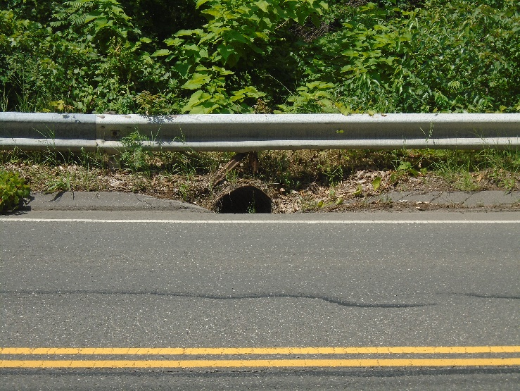
Runoff
Deep Sump Catch Basin
Outfall to Abbey Brook
Photo 5-1
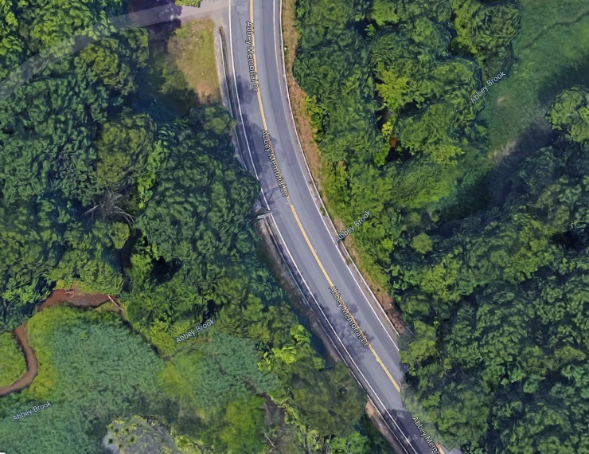
Abbey Memorial Drive
Abbey Brook
Outfall to Abbey Brook
Photo 5-2
BMP Type: Deep Sump Catch Basin
BMP Location: Abbey Memorial Drive
Site Summary: At the low point of the crossing of Abbey Memorial Drive over Abbey Brook, a roadside corrugated metal outfall pipe discharges directly to Abbey Brook. The outfall collects runoff from a portion of the paved Abbey Memorial Drive (Photos 5-1 and 5-2).
Proposed Improvement: Replace the existing outfall with a deep sump catch basin to reduce sediment from Abbey Memorial Drive that discharge directly to Abbey Brook.
Expected O&M: Inspect and clean out the deep sump catch basin quarterly.
Wetland Permitting: As a project with minor buffer zone disturbances, WPA permitting is expected to require submittal of an NOI.
Parcel Ownership: City of Chicopee
Sizing Characteristics
BMP Drainage Area (acres) | 0.2
BMP Size (storm depth; inches) | --
Impervious Area (%) | 100
Estimated Pollutant Load Reduction
TP (lbs./yr.) | 0.0
TN (lbs./yr.) | 0.0
TSS (lbs./yr.) | 32.5
Estimated Cost
Planning-level Capital Cost | $3,500

Site 6: Fairview Cemetery Access Road
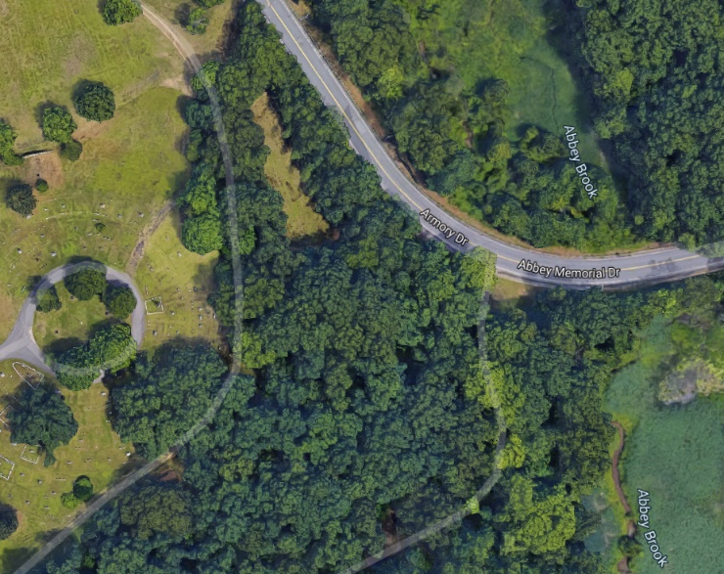
Abbey Brook
Access Road
Fairview Cemetery
Photo 6-1
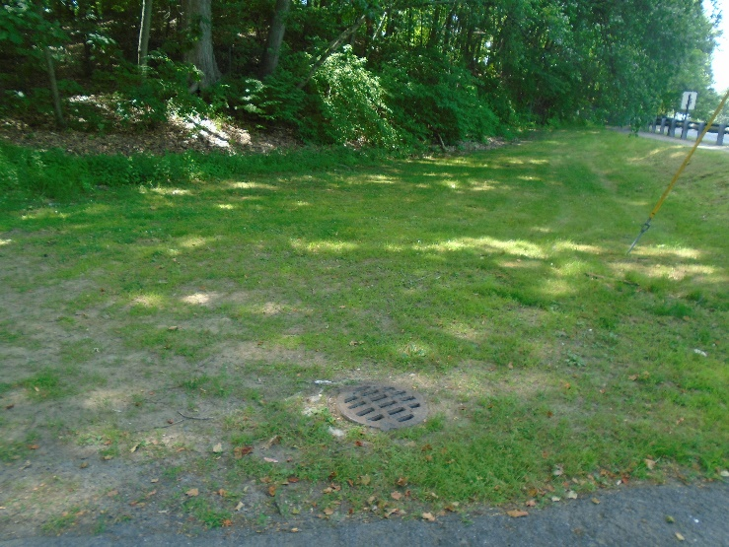
Overflow to Catch Basin
Runoff
Rain Garden
Photo 6-2
BMP Type: Rain Garden
BMP Location: Fairview Cemetery Access Road off Abbey Memorial Drive
Summary: Runoff from vegetated slopes surrounding Fairview Cemetery is collected by a catch basin located next to a paved access road off Abbey Memorial Drive (Photo 6-1). The catch basin discharges directly to Abbey Brook.
Proposed Improvement: Install a raingarden upstream of the catch basin to capture runoff and reduce pollutant loads to Abbey Brook (Photo 6-2).
Expected O&M: Remove accumulated sediment from rain garden annually and maintain/replace plants as needed every two years. Re-mulch annually.
Parcel Ownership: City of Chicopee
Sizing Characteristics
BMP Drainage Area (acres) | 0.7
BMP Size (storm depth; inches) | 0.5
Impervious Area (%) | 1
BMP Footprint (square feet) | 149
Estimated Pollutant Load Reduction
TP (lbs./yr.) | 0.1
TN (lbs./yr.) | 0.6
TSS (lbs./yr.) | 24.0
Estimated Cost
Planning-level Capital Cost | $14,000

Site 7: Fanjoy Drive
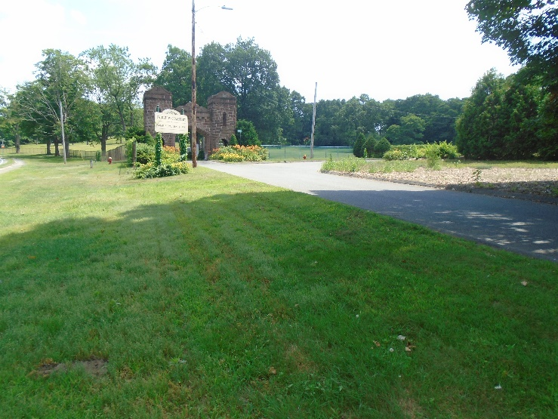
Rip Rap
Curb Cut
Bioretention Cell
Runoff
Photo 7-1
BMP Type: Bioretention Cell
BMP Location: Intersection of Fanjoy Drive and Armory Drive
Site Summary: Fanjoy Drive is a paved residential road adjacent to Fairview Cemetery. Runoff from residential rooftops and paved driveways flows down Fanjoy Drive to catch basins along Armory Drive, which discharge directly to Abbey Brook.
Proposed Improvement: Install a curb cut along Fanjoy Drive and a bioretention cell (Photo 7-1). The bioretention cell would have a 6-inch gravel bed layer and a 2.5-4 feet thick bioretention cell soil media layer to increase biological treatment of the stormwater infiltrating through the bioretention cell. Also install 2-3 inches of mulch and include a minimum of 6-inch ponding depth. In addition, native species should be planted within the ponding area of the bioretention cell to improve bioretention resiliency, stormwater treatment, biodiversity and aesthetics.
Expected O&M: Remove accumulated sediment from the bioretention cell and revegetate annually. Replant grass and native plantings as needed to maintain adequate vegetative cover.
Parcel Ownership: City of Chicopee
Sizing Characteristics
BMP Drainage Area (acres) | 1.8
BMP Size (storm depth; inches) | 0.5
Impervious Area (%) | 36
BMP Estimated Footprint (square feet) | 867
Estimated Pollutant Load Reduction
TP (lbs./yr.) | 0.8
TN (lbs./yr.) | 6.6
TSS (lbs./yr.) | 306.4
Estimated Cost
Planning-level Capital Cost | $35,000

Site 8: Middle School Playground
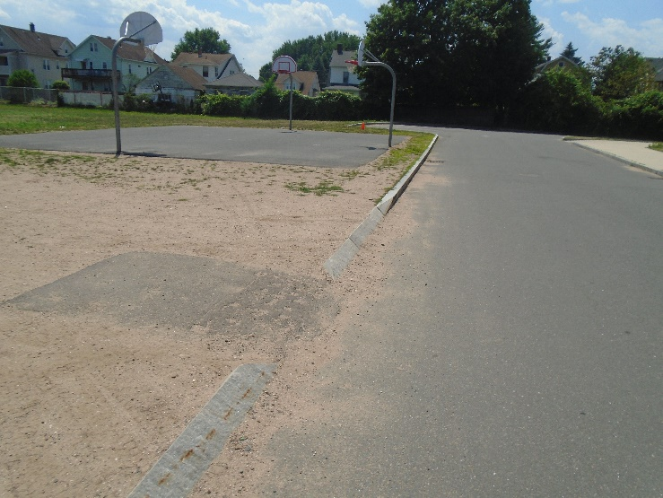
Photo 8-1
Runoff
Catch Basin
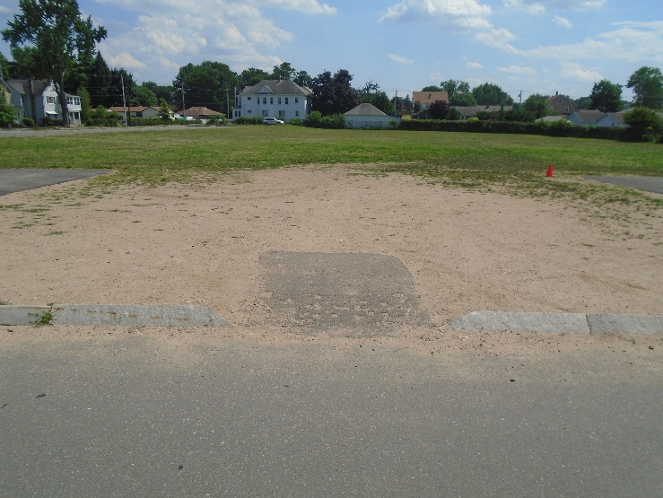
Sod
Photo 8-2
BMP Type: Stabilization
BMP Location: Playground of the 1st Sergeant Kevin A. Dupont Memorial Middle School
Site Summary: The entrance to the playground of the middle school is unpaved and unvegetated. The area receives runoff from the surrounding parking area and from the roof of the school. During field investigation, sediment was observed in the gutters and around catch basins along the playground (Photo 8-1). It is believed that these catch basins discharge to Abbey Brook near its outlet to the Chicopee River.
Proposed Improvement: As it is assumed that the unvegetated area experiences moderate foot traffic, installation of sod stabilization over the entrance to the playground (Photo 8-2) is proposed to reduce erosion and tracking of sediment onto the adjacent pavement. However, if the use of the area is expected to be more significant, the area could alternatively be stabilized with permeable pavers. Permeable pavers will be more resistant to wear from foot traffic than vegetation but will still allow infiltration.
Expected O&M: Remove accumulated sediment semi-annually. Remove accumulated yard waste or leaf debris as needed.
Parcel Ownership: City of Chicopee
Sizing Characteristics
BMP Drainage Area (acres) | 0.85
BMP Size (storm depth; inches) | --
Impervious Area (%) | 86
BMP Estimated Footprint (square feet) | 2,500
Estimated Pollutant Load Reduction¹
TP (lbs./yr.) | --
TN (lbs./yr.) | --
TSS (lbs./yr.) | --
Estimated Cost
Planning-level Capital Cost | $5,000
1. Sod or permeable paver stabilization would not be expected to directly reduce pollutant loads but would be expected to reduce erosion by stabilizing exposed soil.

Site 9: Middle School Parking Lot
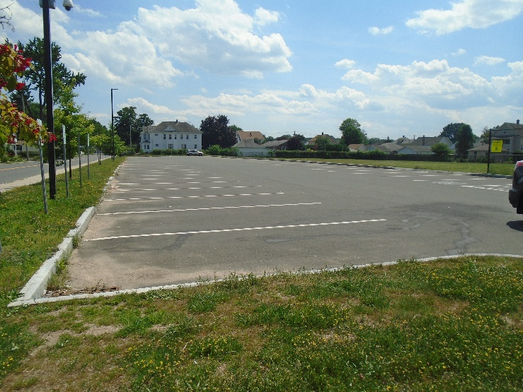
Rain Garden
Public Education Sign
Catch Basin for Overflow
Runoff
Photo 9-1
BMP Type: Rain Garden
BMP Location: Parking lot of the 1st Sergeant Kevin A. Dupont Memorial Middle School
Site Summary: The paved parking lot of the middle school conveys runoff to catch basins that are believed to discharge to Abbey Brook near its outlet to the Chicopee River.
Proposed Improvement: Install a raingarden upgradient of the parking lot catch basin. Due to the heavy foot traffic at the middle school, it is expected that informational signage installed with this BMP could also have significant public education and outreach value.
Expected O&M: Remove accumulated sediment from rain garden annually and maintain/replace plants as needed every two years. Re-mulch annually.
Parcel Ownership: City of Chicopee
Sizing Characteristics
BMP Drainage Area (acres) | 0.5
BMP Size (storm depth; inches) | 0.5
Impervious Area (%) | 98
BMP Estimated Footprint (square feet) | 222
Estimated Pollutant Load Reduction
TP (lbs./yr.) | 0.4
TN (lbs./yr.) | 3.2
TSS (lbs./yr.) | 283.5
Estimated Cost
Planning-level Capital Cost | $8,800

Appendix D – Chicopee River Watershed 2003 Water Quality Assessment Report

MS4 subwatersheds are defined by the WBP-tool by intersecting MassGIS drainage sub-basins with regulated MS4 areas.
The MassDEP WBP Tool is currently configured to use the 2012 Massachusetts List of Integrated Waters; however, impairments for these reaches of Abbey Brook and the Chicopee River are consistent in the 2014 Massachusetts List of Integrated Waters. This reference will likely be updated to the 2016 Massachusetts List of Integrated Waters once the 2016 list has been approved.
This relationship was developed specifically for first-, second-, and third-order streams but is often generalized to apply to larger watersheds [PVPC, 2014].
Guidance on funding sources to address nonpoint source pollution: http://prj.geosyntec.com/prjMADEPWBP_Files/Guide/Element%20D%20-%20Funds%20and%20Resources%20Guide.pdf
Note that goals and milestones of this WBP are intended to be adaptable and flexible. Goals and milestones are not intended to be tied to Municipal Separate Storm Sewer (MS4) permit requirements. Stakeholders will perform tasks contingent on available resources and funding.
Additional guidance is provided at: https://www.epa.gov/sites/production/files/2015-06/documents/stream.pdf and https://www.mass.gov/guides/water-quality-monitoring-for-volunteers#2

