WATERSHED-BASED PLAN
FRANKLIN
Mill River Watershed within
the Town of Franklin
February 28, 2019

Prepared By:
Town of Franklin Department of Public Works
Geosyntec Consultants, Inc.

Prepared For:

Contents
Executive Summary i
Introduction 1
Purpose & Need 1
Watershed-Based Plan Outline 1
Project Partners and Stakeholder Input 2
Data Sources 2
Summary of Past and Ongoing Work 2
Element A: Identify Causes of Impairment & Pollution Sources 5
General Watershed Information 5
MassDEP Water Quality Assessment Report and TMDL Review 7
Water Quality Impairments 10
Water Quality Goals 12
Land Use Information 17
Pollutant Loading 22
Element B: Determine Pollutant Load Reductions Needed to Achieve Water Quality Goals 24
Estimated Pollutant Loads 24
Water Quality Goals 24
Recommended Load Reduction 25
Element C: Describe management measures that will be implemented to achieve water quality goals 26
Existing Management Measures 26
Ongoing Management Measures 27
Future Management Measures 27
Element D: Identify Technical and Financial Assistance Needed to Implement Plan 30
Current and Ongoing Management Measures 30
Future Management Measures 30
Element E: Public Information and Education 31
Elements F & G: Implementation Schedule and Measurable Milestones 32
Elements H & I: Progress Evaluation Criteria and Monitoring 34
Indirect Indicators of Load Reduction 34
Project-Specific Indicators 36
TMDL Criteria 36
Direct Measurements 36
Adaptive Management 36
References 38

Executive Summary
Introduction: The purpose of a Massachusetts Watershed-Based Plan (WBP) is to organize information about Massachusetts' watersheds, and present it in a format that will enhance the development and implementation of projects that will restore water quality and beneficial uses in the Commonwealth. The Massachusetts WBP follows USEPA's recommended format for “nine-element” watershed plans. This WBP was developed by Geosyntec Consultants (Geosyntec) under the direction of the Franklin Department of Public Works with funding, input, and collaboration from the Massachusetts Department of Environmental Protection (MassDEP).
Franklin is located at the headwaters of the Charles River (i.e., upper Charles River) which flows approximately 80 miles to its outlet in the Boston Harbor. The Mill River is a tributary to the Charles River and includes several tributaries and ponds located in the Town of Franklin. This WBP was prepared for waterbodies located within the Mill River Watershed (MA72-15) within the Town of Franklin. These waterbodies include the Franklin Reservoir Northeast, the Franklin Reservoir Southwest, Miller Brook, Uncas Brook, and Uncas Pond.
Impairments and Pollution Sources: The upper Charles River is a category 5 water body on the Massachusetts List of Integrated Waters due to a variety of impairments from multiple sources, including impairments related to turbidity and nutrients (phosphorus). Mill River is also listed on the Massachusetts List of Integrated Waters for various impairments relating to thermal modifications and other habitat alterations. Because of these impairments, TMDLs for pathogens and nutrients were issued for the upper Charles River watershed. These TMDLs include the Mill River watershed.
There are many potential pollutant sources that are causing these impairments; stormwater runoff from existing development and impervious areas is one potential source listed in the TMDLs. The Town of Franklin has identified stormwater runoff from existing development and impervious areas as the largest contributor to water quality impacts of downstream receiving waters within the town and has developed strategies to reduce pollutant loading from runoff that ultimately discharges to the Charles River.
Goals, Management Measures, and Funding: The primary goal of this WBP is to reduce total phosphorus loading to Mill River to address TMDL requirements in the Upper Charles River watershed, eventually leading to delisting of impaired waterbodies in the study area from the 303(d) list. It is expected that these pollutant load reductions will result in improvements to listed impairments throughout the study area. An interim goal is proposed to reduce phosphorus loading by 50% in the next five years. After the first five years, focus will be shifted to the long-term goal of delisting all assessment units within the study area.
It is expected that goals will be accomplished primarily through installation of structural BMPs to capture runoff and reduce loading as well as implementation of non-structural BMPs (e.g., street sweeping, catch basin cleaning), and watershed education and outreach. Structural BMPs will first be implemented at Wyllie Road and Miller Street per a Fiscal Year 2018 Section 319 grant. Additional planning and implementation is expected to be performed in subsequent years, focusing on each water body in the study area.
It is expected that funding for management measures will be obtained from a variety of sources including Section 319 Grant Funding, Town capital funds, volunteer efforts, and other sources.
Public Education and Outreach: Goals of public education and outreach are to provide information about proposed stormwater improvements and their anticipated benefits and to promote watershed stewardship. The Town of Franklin aims to engage watershed residents, businesses, and watershed organizations through informational signage, fact sheets, the “Soak It Up Franklin” website, and a rain barrel purchasing program. It is expected that these programs will be evaluated by tracking neighborhood meeting attendance, number of fact sheets distributed, activity on the “Soak It Up Franklin” webpage, and the number of rain barrels distributed.
Implementation Schedule and Evaluation Criteria: Project activities will be implemented based on the information outlined in the following elements for monitoring, implementation of structural BMPs, public education and outreach activities, and periodic updates to the WBP. It is expected that a water quality monitoring program will enable direct evaluation of improvements over time. Other indirect evaluation metrics are also recommended, included quantification of potential pollutant load reductions from non-structural BMPs (e.g., street sweeping). The interim goal of this WBP is to reduce land use-based phosphorus loading by 50% by 2024. The long-term goal of this WBP is to de-list the all waterbodies within the study area from the 303(d) list by 2034. The WBP will be re-evaluated and adjusted, as needed, once every three years.

Introduction
What is a Watershed-Based Plan?

Purpose & Need
The purpose of a Massachusetts Watershed-Based Plan (WBP) is to organize information about Massachusetts' watersheds, and present it in a format that will enhance the development and implementation of projects that will restore water quality and beneficial uses in the Commonwealth. The Massachusetts WBP follows USEPA's recommended format for “nine-element” watershed plans, as described below.
All states are required to develop WBPs, but not all states have taken the same approach. Most states develop watershed-based plans only for selected watersheds. MassDEP's approach has been to develop a tool to support statewide development of WBPs, so that good projects in all areas of the state may be eligible for federal watershed implementation grant funds under Section 319 of the Clean Water Act.
USEPA guidelines promote the use of Section 319 funding for developing and implementing WBPs. WBPs are required for all projects implemented with Section 319 funds, and are recommended for all watershed projects, whether they are designed to protect unimpaired waters, restore impaired waters, or both.

Watershed-Based Plan Outline
This WBP for Mill River Watershed within the Town of Franklin includes nine elements (a through i) in accordance with USEPA Guidelines:
- An identification of the causes and sources or groups of similar sources that will need to be controlled to achieve the load reductions estimated in this watershed-based plan (and to achieve any other watershed goals identified in the watershed-based plan), as discussed in item (b) immediately below.
- An estimate of the load reductions expected for the management measures described under paragraph (c) below (recognizing the natural variability and the difficulty in precisely predicting the performance of management measures over time).
- A description of the nonpoint source (NPS) management measures needed to achieve the load reductions estimated under paragraph (b) above (as well as to achieve other watershed goals identified in this watershed-based plan), and an identification (using a map or a description) of the critical areas in which those measures will be needed to implement this plan.
- An estimate of the amounts of technical and financial assistance needed, associated costs, and/or the sources and authorities that will be relied upon, to implement this plan. As sources of funding, States should consider the use of their Section 319 programs, State Revolving Funds, USDA's Environmental Quality Incentives Program and Conservation Reserve Program, and other relevant Federal, State, local and private funds that may be available to assist in implementing this plan.
- An information/education component that will be used to enhance public understanding of the project and encourage their early and continued participation in selecting, designing, and implementing the NPS management measures that will be implemented.
- A schedule for implementing the NPS management measures identified in this plan that is reasonably expeditious.
- A description of interim, measurable milestones for determining whether NPS management measures or other control actions are being implemented.
- A set of criteria to determine if loading reductions are being achieved over time and substantial progress is being made towards attaining water quality standards and, if not, the criteria for determining whether this watershed-based plan needs to be revised or, if a NPS Total Maximum Daily Load (TMDL) has been established, whether the TMDL needs to be revised.
- A monitoring component to evaluate the effectiveness of the implementation efforts over time, measured against the criteria established under item (h) immediately above.

Project Partners and Stakeholder Input
This WBP was developed by Geosyntec Consultants (Geosyntec) under the direction of the Franklin Department of Public Works with funding, input, and collaboration from the Massachusetts Department of Environmental Protection (MassDEP). This WBP was developed using funds from the Section 319 program to assist grantees in developing technically robust WBPs using MassDEP’s Watershed-Based Planning Tool. Franklin was a recipient of Section 319 funding in Fiscal Year 2018 to implement BMPs in the Mill River Watershed.
Core project stakeholders included:
- Robert Cantoreggi, Director – Town of Franklin Department of Public Works
- Kate Sjoberg, GIS Manager – Town of Franklin Department of Public Works
- Jane Peirce – MassDEP
This WBP was developed as part of an iterative process. The Geosyntec project team collected and reviewed existing data from the Town of Franklin. This information was then used to develop a preliminary WBP for review by core project stakeholders. A stakeholder conference call was then held to solicit input and gain consensus on elements included in the plan (e.g., water quality goals, public outreach activities, etc.). The WBP was finalized once stakeholder consensus was obtained for all elements.

Data Sources
This WBP was developed using the framework and data sources provided by MassDEP’s Watershed-Based Plan Tool and supplemented by information provided in the Public-Private Partnership for Stormwater Green Infrastructure, the Fairfield at Dean Avenue Section 319 Nonpoint Source Pollution Grant Program application (Town of Franklin, 2017).

Summary of Past and Ongoing Work
The Town of Franklin has a history of successfully planning for watershed improvements as summarized by the below project descriptions (Town of Franklin, 2017).

Island Road Neighborhood Retrofits
Tree wells and an infiltration gallery were installed in 2013 to provide stormwater attenuation and infiltration. Public meetings were also held to educate community members about the installation and its purpose.

DelCarte Conservation Area
A stormwater system consisting of an asphalt berm, deep sump catch basin, sediment forebay, and a bioretention area was installed at the DelCarte Conservation Area playground in 2014. The sediment forebay and the bioretention area were sized for a 100-year storm receiving runoff from a 0.7-acre area consisting primarily of impervious asphalt and forested areas. The system was designed to maintain as many mature trees as possible.

Bright Hill Estates
In 2010, the Bright Hill Estates development was repaved and updated to meet modern ordinances on water quantity and quality management; the road width was narrowed, and sidewalks were restricted to one side of the road. The project resulted in a reduction of 70,000 square feet of impervious surface.

Lockewood Drive, High Ridge Circle & Panther Way Detention Basin Retrofits
Using funds awarded through the s319 grant program, existing detention basins at Lockewood Drive and High Ridge Circle were retrofitted in 2011 to provide extended detention and elongated flow paths to enhance treatment and increase infiltration. A new sediment forebay and infiltration basin was also installed along Panther Way to treat the first flush from a condominium complex that previously discharged directly to a stream without treatment. The installation was designed to recharge approximately 22,000 cubic feet of runoff and provide removal efficiencies of 80% for total suspended solids and 77% for phosphorus.
The Town of Franklin also developed a comprehensive inventory of public and private BMPs installed throughout the town to form a BMP retrofit database.

Depot Street Commuter Rail Parking Lot (Train Station)
The Depot Street commuter rail parking lot was retrofitted in 2011 with rain gardens and tree pit filters to receive and treat stormwater runoff through infiltration.

Parmenter School Rain Garden Project
In collaboration with the Charles River Watershed Association (CRWA), the Town of Franklin installed bioretention areas in a school parking lot to treat stormwater runoff before discharging into existing catch basins. The BMPs were installed in an area with high visibility to increase public awareness of the importance of stormwater management.

Fletcher Field Rain Garden Project
Rain gardens were installed at the Fletcher Field Recreation Area to capture and treat stormwater runoff from the parking lot. Informational signs were also installed around the BMP to educate park users on the importance of stormwater management.

Anchorage Road, Pyne Circle and Fisher Street
The Anchorage Road, Pyne Circle, and Fisher Street cul-de-sacs were updated to narrow the roadways to 28 feet (reducing the impervious cover by nearly 10%) and rain gardens were installed in the interiors of the cul-de-sacs.

Greensfield Road Rain Garden Project
Excessive pavement was removed from the Greensfield Road cul-de-sac and replaced with grass and a rain garden to treat stormwater runoff from the roadway.

Wyllie-Miller Infiltration Chambers and Rain Garden Project
In 2012, the storm drain system on Wyllie Road was retrofitted to discharge to underground infiltration chambers beneath the cul-de-sac. In 2013, the pavement at the intersection of Miller Street and Green Street was replaced with grass cover, a rain garden was installed, and underground infiltration chambers were installed.

Residential Rain Garden Program
In 2014, the Town of Franklin kicked off the Residential Rain Garden Program as part of the CRWA Water Quality and Flow Monitoring Quality Assurance Project Plan. The program sought to improve stormwater management by educating homeowners on the importance of treating stormwater runoff on-site. 20 residential rain gardens were constructed in Franklin as a result of the project. The program continues to provide trainings, preassembled rain garden packages, a website with helpful information, and factsheets.

Element A: Identify Causes of Impairment & Pollution Sources
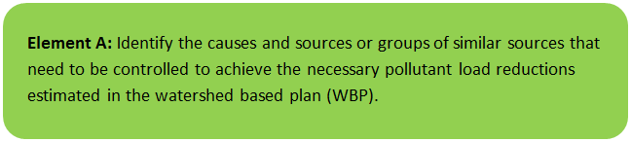

General Watershed Information
Franklin is located at the headwaters of the Charles River which flows approximately 80 miles to its outlet in the Boston Harbor. The Mill River is a tributary to the Charles River and includes several tributaries and ponds located in the Town of Franklin. This WBP was prepared for waterbodies located within the Mill River Watershed (MA72-15) within the Town of Franklin. These waterbodies include the Franklin Reservoir Northeast, the Franklin Reservoir Southwest, Miller Brook, Uncas Brook, and Uncas Pond.
Table A-1 presents the general watershed information for the applicable MS4 subwatershed and Figure A-1 includes a map of the subwatershed boundary. The MS4 module of the watershed-based planning tool was used to enable computation of Mill River watershed statistics within the Town of Franklin (identified as FRANKLIN_01).
Table A-1: General Subwatershed Information
MS4 Subwatershed # | Waterbody Names (Assessment Unit ID) | Subwatershed Area (ac) | Major Basin
FRANKLIN_01 | Franklin Reservoir Northeast (MA72095); Franklin Reservoir Southwest (MA72032); Miller Brook; Uncas Brook; Uncas Pond (MA72122) | 3011.5 (ac) | CHARLES

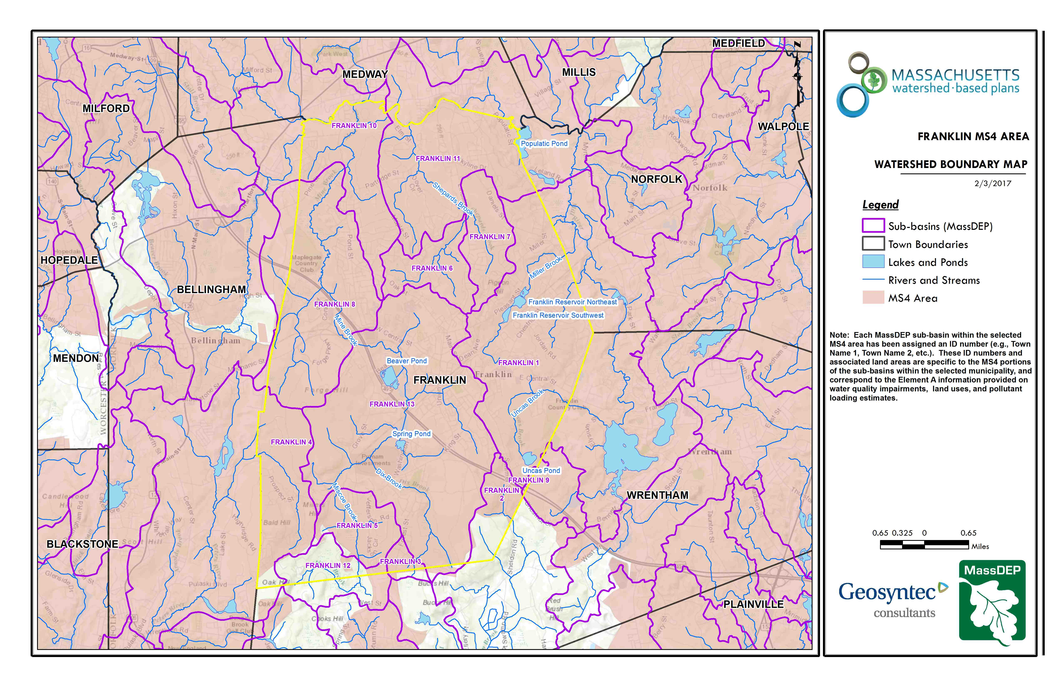Figure A-1: Subwatershed Boundary Map
Franklin_01
Approximate Watershed Boundary
Mill River
(MassGIS, 2007; MassGIS, 1999; MassGIS, 2001; USGS, 2016)

MassDEP Water Quality Assessment Report and TMDL Review
The following reports are available:
- Charles River Watershed 2002-2006 Water Quality Assessment Report
- Final Pathogen TMDL for the Charles River Watershed January 2007
- Total Maximum Daily Load for Nutrients in the Upper/Middle Charles River, Massachusetts
Select excerpts from these documents relating to the water quality in the FRANKLIN_01 subwatershed are included below (note: relevant information is included directly from these documents for informational purposes and has not been modified). Additional summary information for the Mill River, the receiving water for the tributaries and waterbodies in the subwatershed, is included in Appendix A.
Charles River Watershed 2002-2006 Water Quality Assessment Report (MA72122 - Uncas Pond)
Aquatic Life Use
Biology
Uncas Pond is infested with the non-native aquatic plant variable milfoil (M. heterophyllum) (MA DCR 2005).
Water Chemistry
Sampling was conducted by DWM staff at the deep hole (W0969) in Uncas Pond as part of the 2002 Baseline Lake TMDL Project and in 2003 as part of the Nutrient Criteria Development Project (Appendix D, Tables D1, D2, D3 and D4). Chlorophyll a concentrations ranged from 7.2 to 18 mg/m3 while Secchi disk transparency measurements were all > 3.0 m. Oxygen depletion occurred at depths below 4.0 m, which affects approximately 40% of the lake area. Supersaturation (up to 117%) was measured in around the top of the thermocline in July 2003. Total phosphorus concentrations near the bottom ranged from 0.027 to 0.19 mg/L. There is some evidence of internal loading of phosphorus during anoxic conditions even though levels of total phosphorus in the pond seem to be fairly low. All of these factors are indicative of a fairly productive system.
The Aquatic Life Use is assessed as impaired for Uncas Pond based on low dissolved oxygen in the hypolimnion, which affects about 40% of the lake area. Additionally total phosphorus release from the sediments during anoxic conditions also occurs. While chlorophyll a concentrations are generally low, one marginally high value was documented. The infestation of the non-native aquatic macrophyte M. heterophyllum is also problematic.
Primary and Secondary Contact Recreation and Aesthetics Uses
Sampling was conducted by DWM staff at the deep hole (W0969) in Uncas Pond as part of the 2002 Baseline Lake TMDL Project and in 2003 as part of the Nutrient Criteria Development Project (Appendix D, Tables D1 and D2). Secchi disk transparency measurements were all good (Appendix D, Table D1) and no objectionable conditions were noted.
Although no objectionable conditions were recorded (MassDEP 2002a), because of the lack of bacteria data, the Primary Contact Recreational Use is not assessed. The Secondary Contact Recreational and Aesthetics Uses are assessed as support.
Report Recommendations:
Continue to monitor for the presence of invasive non-native aquatic vegetation and determine the extent of the infestation. Prevent spreading of invasive aquatic plants. Once the extent of the problem is determined and control practices are exercised, vigilant monitoring needs to be practiced to guard against infestations in unaffected areas, including downstream from the site, and to ensure that managed areas stay in check. A key portion of the prevention program should be posting of boat access points with signs to educate and alert lake-users to the problem and their responsibility to prevent spreading these species. The Final GEIR for Eutrophication and Aquatic Plant Management in Massachusetts (Mattson et al. 2004) should also be consulted prior to the development of any lake management plan to control non-native aquatic plant species. Plant control options can be selected from several techniques (e.g., bottom barriers, drawdown, herbicides, etc.) each of which has advantages and disadvantages that need to be addressed for the specific site. However, methods that result in fragmentation (such as cutting or raking) should not be used for many species because of the propensity for these invasive species to reproduce and spread vegetatively (from cuttings).
Conduct additional water quality monitoring (chlorophyll a, DO profiles, nutrient sampling at depth) in the pond and the watershed particularly during the summer months in order to develop a TMDL.

Charles River Watershed 2002-2006 Water Quality Assessment Report (MA72095 - Franklin Reservoir Northeast, MA72032 - Franklin Reservoir Southwest)
No quality-assured data are available for Franklin Reservoir Northeast and Franklin Reservoir Southwest. No designated uses are assessed.
Report Recommendations:
Conduct monitoring to evaluate designated uses.

Total Maximum Daily Load for Nutrients in the Upper/Middle Charles River, Massachusetts
(MA72032 - Franklin Reservoir SE, Miller Bk, MA72-04 - Charles River, MA72095 - Franklin Reservoir NE, Miller Bk, MA72096 - Uncas Pond, Uncas Bk)
Although phosphorus is ubiquitous in the natural environment, additional inputs to a watershed come from combined sewer overflows (CSOs), wastewater discharges, stormwater runoff, accumulated organic sediments on the river bottom, and some groundwater sources. There are no known CSOs in the Upper/Middle Charles study area and groundwater sources of phosphorus, including septic tank return flows from functioning systems, are normally very small because phosphorus is highly adsorbed to soil.
The primary human sources of phosphorus in the Upper/Middle Charles are wastewater, stormwater, and benthic sediments. Treated municipal wastewater is discharged from wastewater treatment facilities (WWTFs) that are regulated by the MassDEP and US-EPA National Pollutant Discharge Elimination System (NPDES) permits. Stormwater runoff occurs during rainfall or snowmelt events and conveys phosphorus from land surfaces to the river system. In the fall, dead plant material and algae settle to the river bottom and the following growing season these benthic sediments release nutrients through organic decay.
The three largest WWTFs (flows reported here for 1998-2002) are on the mainstem of the Charles and include the Milford WWTF (3.5 mgd), the Charles River Pollution Control District or CRPCD in Medway serving four communities (4.4 mgd), and the Medfield WWTF (1.0 mgd). Part of the Milford discharge (0.34 mgd) is used consumptively for cooling by the Milford American National Power Plant. The three smaller WWTFs are on the Stop River and include the Caritas Hospital which ceased discharging in 2003 (0.02 mgd), the Massachusetts Correctional Institution at Norfolk (0.4 mgd), and the Wrentham Development Center (0.1 mgd).
Phosphorus from wastewater discharges are mainly in the form of orthophosphate (50-80%) which is highly available for aquatic growth. Discharge is continuous so the impact is augmented in the summertime when river flows are low (less dilution) and water temperatures are high (high aquatic plant growth rates). Permitted summer limits for phosphorus discharge were lowered to 0.2 mg/L in late 2000 and winter limits of 1.0 mg/L were imposed for all but one treatment plant in 2005.
Stormwater runoff occurs from rainfall or snowmelt events when the infiltration capacity of the surface is exceeded. Much of the stormwater runoff originates from impervious surfaces like rooftops, driveways, and roadways but stormwater runoff may also come from vegetated areas, especially if the soil is compacted or saturated. The stormwater runoff carries phosphorus that is adsorbed to sediment and dissolved in the water, and might also come from wastewater sources. Wastewater enters the stormwater system illicitly via wastewater pipes that incorrectly connected to the stormwater drainage system.
Many human activities exacerbate the level of phosphorus in stormwater─ lawn fertilizers; car wash products; vegetative debris such as lawn clippings; some detergents; car exhaust and other oil byproducts, and pet waste. Urbanized zones have large extents of impervious area that produce considerable volumes of stormwater runoff that are directly connected to surface waters. Intensity of development increases phosphorus loads from stormwater both through the increase in impervious area and also the intensity of the land use. High density residential and commercial or industrial activities have higher phosphorus loads than low or medium density residential land uses.
Organic benthic sediment accumulates at the end of the growing season when aquatic plants senesce and settle to the bottom of the river creating a potential source of nutrients that are re-released the following growing season when the organic matter begins to decay with the increase in water temperature. Years of accumulation of organic matter on the river bottom, especially if the historic period had high phosphorus discharges from WWTFs, can create a significant source of nutrients that can be released to the water column long after the water column has been cleaned up.
Losses of phosphorus throughout the system include diversions and internal transient losses like uptake and settling. Streamflow is diverted from the Charles River at Mother Brook into the Neponset River for flood control purposes. The diversions averages about 38 mgd and can result in significant reductions in phosphorus load at the Watertown Dam outlet, especially during the high-flow periods when releases are highest. Internal growth processes result in phosphorus loss via uptake by phytoplankton and benthic algae during the growing season and a phosphorus gain at the end of the growing season from respiration and settling.
An analysis of Upper/Middle Charles total loads and losses was performed for the period 1998-2002 using the calibrated HSPF model. The predicted phosphorus loads were summed over the summer months (Apr-Oct, lb/period) and the full year (Jan-Dec, lb/yr). This five-year period was chosen to match the period used for the load calculations in the Lower Charles TMDL. All flows mentioned in this section are also for that period.
The total wastewater phosphorus load to the Upper/Middle watershed was estimated by summing the daily loads from the six WWTFs. The daily load time series were created from actual daily flows and daily concentrations estimated between measurements using step interpolation. The product of flow and concentration gave the daily load for each WWTF. Daily loads (lbs/d) were then summed to get summer, winter, and annual loads. The final wastewater loads were then converted to metric units (kg/time period).
The total stormwater phosphorus load to the Upper/Middle watershed was estimated from the hydrologic response units (HRUs) by using the calibrated HSPF model to generate the monthly phosphorus loads for groundwater and surface runoff components then accumulating across months and HRUs. Since sediments were not simulated explicitly in the HSPF, the dissolved nutrient components were used to predict the combined dissolved and particulate loads for runoff. The model generated monthly HRU loads (lb/ac/month) for orthophosphate (PO4-P) and degradable organic matter represented by biochemical oxygen demand (BOD) for the 21 pervious HRUs (3 soils x 7 land uses) and the two impervious HRUs (residential and commercial). Monthly total phosphorus (TP) loads for each HRU were calculated as the sum of the PO4-P, labile organic P (BOD/165.8), and refractory organic P (0.5*BOD/165.8) loads. Stormwater TP loads for the summer, winter, and annual (lb/period) periods were calculated using the HRU loads (lb/ac/month) and HRU areas (ac) and summing across the months and HRUs. The final stormwater loads were then converted to metric units (kg/period).
The predicted loads of total phosphorus from the Watertown Dam and Mother Brook were estimated from the hourly flow (cfs) and hourly loads (lb/hr) of PO4-P and TORP (total organic phosphorus) and converted to kg/period or kg/yr. Other total phosphorus loads and losses were also estimated from the HSPF model by turning on/off certain model components. Sources are comprised of atmospheric deposition, benthic sediment release, stormwater, and wastewater while losses are from algae uptake and settling, and diversions. The final loads and losses for the summer (Apr-Oct), winter (Nov-Mar), and whole year are summarized in the following table (originally Table 13 of “Total Maximum Daily Load for Nutrients in the Upper/Middle Charles River, Massachusetts” report, 2011). The simulated annual outlet phosphorus load from the Watertown Dam was 28,262 kg/yr which is close to the measured load of 28,925 kg/yr.
The following figure (originally Figure 6 of “Total Maximum Daily Load for Nutrients in the Upper/Middle Charles River, Massachusetts” report, 2011) shows an annual breakdown of the sources. Stormwater load is the largest source (74%) and includes both developed (48%) and background (forested) stormwater load (26%). Wastewater is 19% and benthic sediment is 6% while atmospheric deposition contributes only 1% of the total source load. Winter wastewater loads were a higher percentage of the total load than summer (22% vs. 16%) because of the higher winter discharge limits for phosphorus. Correspondingly, stormwater loads were a slightly higher percentage in the summer (78%) than the winter (70%).
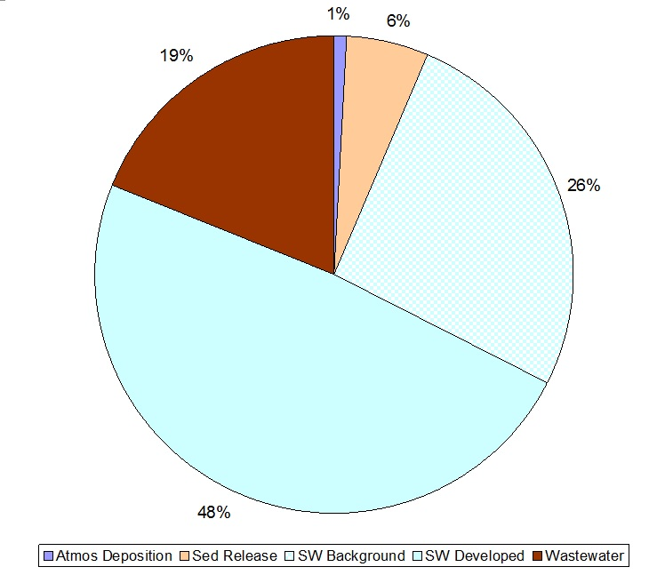
The stormwater nutrient loads are highest in the spring and early summer when the soils are wettest, and runoff occurs readily with any rainfall event. Although significant runoff events can occur during any wet period in the summer, they are much more likely to occur in the spring. The phosphorus nutrient load from WWTFs is usually highest in the winter and lowest in the summer. This pattern occurs because both the waste flows and permitted effluent concentrations are low in the summer. Waste flow variation is governed mostly by groundwater infiltration into the pipes and the groundwater levels follow the same seasonal pattern as streamflow, highest in the winter/spring and lowest in the summer/fall. Permitted phosphorus effluent concentrations are highest in the winter and lowest in the summer.

Total Maximum Daily Load for Nutrients in the Upper/Middle Charles River, Massachusetts
(MA72032 - Franklin Reservoir SE, Miller Bk, MA72-04 - Charles River, MA72095 - Franklin Reservoir NE, Miller Bk, MA72096 - Uncas Pond, Uncas Bk)
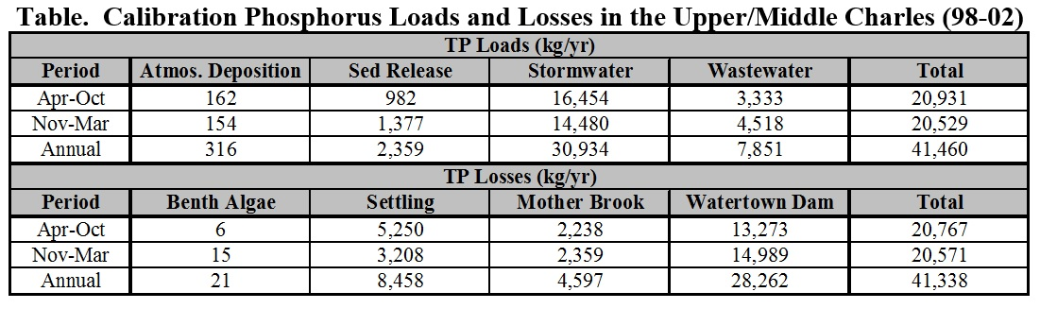

Water Quality Impairments
The upper Charles River is listed under category 5 of the Massachusetts List of Integrated Waters due to over 60 impairments including flow alteration, mercury, noxious aquatic plants, nutrients, organic enrichment/low DO, and turbidity, among others. TMDLs have been established for the Upper/Middle Charles River watershed for nutrients and pathogens. In addition, Mill River is listed under category 5 of the Massachusetts List of Integrated Waters due to impairments relating to thermal modifications and other habitat alterations. Tributaries of Mill River in the Town of Franklin are also listed on the Massachusetts List of Integrated Waters under the categories summarized by Table A-3.
The sources of the impairments listed in Table A-3 are mostly unknown; however, the TMDL established for the Upper/Middle Charles River watershed identifies stormwater runoff from existing development and impervious areas within the watershed (including Franklin) as a potential source of the nutrient impairment for the Charles River (CRWA, 2011). The Town of Franklin has identified stormwater runoff from existing development and impervious areas as the largest contributor to water quality impacts of downstream receiving waters within the town. The Town has therefore developed watershed strategies to reduce pollutant loading from stormwater runoff that ultimately discharges to the Charles River.
Known water quality impairments, as documented in the MassDEP 2012 Massachusetts Integrated List of Waters, are listed below in Table A-3 for waterbodies in the delineated subwatershed area. Impairment categories from the Integrated List are included in Table A-2.
Table A-2: 2012 MA Integrated List of Waters Categories
Integrated List Category | Description
1 | Unimpaired and not threatened for all designated uses.
2 | Unimpaired for some uses and not assessed for others.
3 | Insufficient information to make assessments for any uses.
4 | Impaired or threatened for one or more uses, but not requiring calculation of a Total Maximum Daily Load (TMDL), including:  4a: TMDL is completed  4b: Impairment controlled by alternative pollution control requirements  4c: Impairment not caused by a pollutant - TMDL not required
5 | Impaired or threatened for one or more uses and requiring preparation of a TMDL.

Table A-3: Water Quality Impairments
MS4 Subwatershed #: FRANKLIN_01
Assessment  Unit ID | Waterbody | Integrated List  Category | Designated Use | Impairment Cause | Impairment Source
MA72032 | Franklin Reservoir Southwest | 4A | Aesthetic | Aquatic Plants (Macrophytes) | Source Unknown
MA72032 | Franklin Reservoir Southwest | 4A | Aesthetic | Turbidity | Source Unknown
MA72032 | Franklin Reservoir Southwest | 4A | Primary Contact Recreation | Aquatic Plants (Macrophytes) | Source Unknown
MA72032 | Franklin Reservoir Southwest | 4A | Primary Contact Recreation | Turbidity | Source Unknown
MA72032 | Franklin Reservoir Southwest | 4A | Secondary Contact Recreation | Aquatic Plants (Macrophytes) | Source Unknown
MA72032 | Franklin Reservoir Southwest | 4A | Secondary Contact Recreation | Turbidity | Source Unknown
MA72095 | Franklin Reservoir Northeast | 4A | Aesthetic | Aquatic Plants (Macrophytes) | Source Unknown
MA72095 | Franklin Reservoir Northeast | 4A | Aesthetic | Turbidity | Source Unknown
MA72095 | Franklin Reservoir Northeast | 4A | Primary Contact Recreation | Aquatic Plants (Macrophytes) | Source Unknown
MA72095 | Franklin Reservoir Northeast | 4A | Primary Contact Recreation | Turbidity | Source Unknown
MA72095 | Franklin Reservoir Northeast | 4A | Secondary Contact Recreation | Aquatic Plants (Macrophytes) | Source Unknown
MA72095 | Franklin Reservoir Northeast | 4A | Secondary Contact Recreation | Turbidity | Source Unknown
MA72122 | Uncas Pond | 4A | Fish, other Aquatic Life and Wildlife | Non-Native Aquatic Plants | Introduction of Non-native Organisms (Accidental or Intentional)
MA72122 | Uncas Pond | 4A | Fish, other Aquatic Life and Wildlife | Oxygen, Dissolved | Source Unknown

Water Quality Goals
Water quality goals may be established for a variety of purposes, including the following:
a.) For waterbodies with known impairments, a Total Maximum Daily Load (TMDL) is established by MassDEP and the United States Environmental Protection Agency (USEPA) as the maximum amount of the target pollutant that the waterbody can receive and still safely meet water quality standards. If the waterbody has a TMDL for total phosphorus (TP) or total nitrogen (TN), or total suspended solids (TSS), that information is provided below and included as a water quality goal.
b.) For waterbodies without a TMDL for total phosphorus (TP), a default water quality goal for TP is based on target concentrations established in the Quality Criteria for Water (USEPA, 1986) (also known as the “Gold Book”). The Gold Book states that TP should not exceed 50 ug/L in any stream at the point where it enters any lake or reservoir, nor 25 ug/L within a lake or reservoir. For the purposes of developing WBPs, MassDEP has adopted 50 ug/L as the TP target for all streams at their downstream discharge point, regardless of which type of water body the stream discharges to.
c.) Massachusetts Surface Water Quality Standards (314 CMR 4.00, 2013) prescribe the minimum water quality criteria required to sustain a waterbody’s designated uses. Table A-4 lists the Class for each Assessment Unit ID within the FRANKLIN_01 subwatershed. The water quality goal(s) for bacteria are based on the Massachusetts Surface Water Quality Standards.
Table A-4: Surface Water Quality Classification by Assessment Unit ID
MS4 Subwatershed #: FRANKLIN_01
Assessment  Unit ID | Waterbody | Class
MA72032 | Franklin Reservoir Southwest | B
MA72095 | Franklin Reservoir Northeast | B
MA72122 | Uncas Pond | B

d.) Other water quality goals set by the community (e.g., protection of high-quality waters, in-lake phosphorus concentration goal to reduce recurrence of cyanobacteria blooms, etc.).
Refer to Table A-5 for a list of water quality goals. There are multiple impairments for Mill River tributaries and upstream waterbodies within the Town of Franklin; however, because there are existing TMDLs for nutrients and pathogens for the Upper/Middle Charles River watershed, water quality goals are focused on reducing these common nonpoint source pollutants. Since the Massachusetts Water Quality Standards do not contain specific numeric criteria for phosphorus, TMDL criteria listed by Table A-5 includes specific numeric criteria for chlorophyll-a and dissolved oxygen to be used as direct indicators.
It is expected that efforts to reduce loads of these pollutants will also result in improvements to other listed impairments for waterbodies within the Franklin subwatershed (e.g., turbidity) and the Mill River (e.g., thermal modifications). Element C of this WBP includes proposed BMPs to address these impairments, including BMPs that provided increases in infiltration. Infiltration is a commonly used method to reduce phosphorus and bacteria loads in stormwater runoff and it can also help with peak runoff rate attenuation, reduced thermal impacts to receiving waters, and enhanced base flow to receiving waters (USEPA, 2014).

Table A-5: Water Quality Goals
MS4 Subwatershed #: FRANKLIN_01
Pollutant | Waterbody Name  (Assessment Unit ID(s)) | Goal | Source
Total Phosphorus (TP) | All Assessment Units within the watershed | Total phosphorus should not exceed:  --50 ug/L in any stream  --25 ug/L within any lake or reservoir  (based on below TMDL criteria, see highlighted text) | Quality Criteria for Water (USEPA, 1986)
Additional TMDL Criteria | All Assessment Units within the watershed | The pollutant of concern for this TMDL is phosphorus as this nutrient is directly contributing to the excessive algal biomass in the Upper/Middle and Lower portions of the Charles River. Although phosphorus is ubiquitous in natural soils and vegetation, additional human inputs in the watershed are added from five active municipal wastewater treatment facilities (WWTFs) and stormwater runoff from developed land uses. Even though wastewater discharges are currently treated, they still contribute significant phosphorus loads to receiving waters. Stormwater runoff includes inputs from fertilized soils and lawns; leaf litter and other vegetative debris; car wash products and some detergents; auto exhaust, fuel, and lubricants; and pet waste. Developed land uses including high-density residential, commercial, and industrial have higher loadings of phosphorus per unit area.  The target phosphorus load for the Upper/Middle Charles River was established based on a two-tiered approach. Load scenarios were first screened to ensure the annual phosphorus load at Watertown Dam outlet met the inlet load specified by the Lower Charles TMDL. The Lower Charles TMDL specified that the average annual phosphorus load contribution from the Upper/Middle Charles River cannot exceed 15,109 kg/yr at the Watertown Dam. Second, load scenarios were screened to ensure the phosphorus loads in the Upper/Middle Charles River achieved instream water quality targets and moderate response variables linked to excess nutrients and algal biomass in the river system during extreme low flow conditions when all point sources are discharging at their current design flows. The model was also set up to evaluate instream water quality under extreme high flow conditions.  Since the Massachusetts Water Quality Standards do not contain specific numeric criteria for phosphorus, it was necessary to calculate a numerical endpoint to address the excessive algal biomass resulting from anthropogenic nutrient inputs to the Upper/Middle and Lower Charles River. To do this, targets were established for low and variable dissolved oxygen and chlorophyll-a. Chlorophyll-a served as a surrogate water quality target to define the assimilative capacity of the Upper/Middle Charles River, since chlorophyll-a is the photosynthetic pigment found in algae and is, therefore, a direct indicator of algal biomass. Since the eutrophication-related impairments in the Charles River are the result of excessive amounts of algae, a chlorophyll-a target can be used as a surrogate to reasonably define acceptable amounts of algae that will support the designated uses. The dissolved oxygen saturation targets were consistent with the numeric water quality standards and Best Professional Judgment (BPJ) applied in the Assabet River TMDL.  The chosen chlorophyll-a target, of 10 µg/L for the Upper/Middle Charles TMDL, is consistent with the Lower Charles TMDL and is a site-specific target for this river. The seasonal average is defined as the mean chlorophyll-a concentration in the Charles between April and October of each year. This period represents critical conditions when algal blooms are typically most severe in the Charles River and have the greatest impact on designated uses. The chlorophyll-a target was set at a level that will result in reductions in eutrophication sufficient to enable the Upper/Middle Charles River to attain all applicable Class B narrative (nutrients, aesthetics, and clarity) and numeric (dissolved oxygen and pH) standards. Achieving the seasonal average chlorophyll-a target will reduce algal biomass to levels that are consistent with a mesotrophic status, will address aesthetic impacts, and attain clarity standards. A maximum chlorophyll-a target of 18.9 µg/L was established to ensure good aesthetic quality and water clarity at times when extreme periodic algal blooms could occur during the growing season.  Additional goals are to ensure the minimum dissolved oxygen criterion is met and to reduce the duration of dissolved oxygen supersaturation. A level of 125% dissolved oxygen saturation was used as a reasonable target for control of excessive fluctuations in dissolved oxygen. This metric is consistent with the approach used in other nutrient TMDLs.  Finally, a comparison was made of in-stream total phosphorus concentrations (although not a target) to US-EPA guidance to further validate the model and weight-of-evidence approach. The “Gold Book” (US-EPA, 1986) states that “to prevent the development of biological nuisances and to control accelerated or cultural eutrophication, total phosphates as phosphorus (P) should not exceed 50 µg/L in any stream at the point where it enters any lake or reservoir, nor 25 µg/L within the lake or reservoir. A desired goal for the prevention of plant nuisances in streams or other flowing waters not discharging directly to lakes or impoundments is 100 µg/L total P”. Thus, this guidance provides a range of acceptable criteria for phosphorus based upon specified conditions. The identified targets were used in a “weight of evidence” approach and are consistent with the TMDL evaluation for the Lower Charles TMDL. | Total Maximum Daily Load for Nutrients in the Upper/Middle Charles River, Massachusetts
Bacteria | Franklin Reservoir Southwest (MA72032), Franklin Reservoir Northeast (MA72095), Uncas Pond (MA72122) | Class B Standards  • Public Bathing Beaches: For E. coli, geometric mean of 5 most recent samples shall not exceed 126 colonies/ 100 ml and no single sample during the bathing season shall exceed 235 colonies/100 ml. For enterococci, geometric mean of 5 most recent samples shall not exceed 33 colonies/100 ml and no single sample during bathing season shall exceed 61 colonies/100 ml;  • Other Waters and Non-bathing Season at Bathing Beaches: For E. coli, geometric mean of samples from most recent 6 months shall not exceed 126 colonies/100 ml (typically based on min. 5 samples) and no single sample shall exceed 235 colonies/100 ml. For enterococci, geometric mean of samples from most recent 6 months shall not exceed 33 colonies/100 ml, and no single sample shall exceed 61 colonies/100 ml. | Massachusetts Surface Water Quality Standards (314 CMR 4.00, 2013)
Chlorophyll-A | All Assessment Units within the watershed | Chlorophyll-A should not exceed 18.9 µg/L; Target is 10 µg/L (see above highlighted text) | See above TMDL criteria
Dissolved Oxygen | All Assessment Units within the watershed | Dissolved oxygen saturation should not exceed 125% (see above highlighted text) | See above TMDL criteria
Note: There may be more than one water quality goal for bacteria due to different Massachusetts Surface Water Quality Standards Classes for different Assessment Units within the watershed.

Land Use Information
Land use information and impervious cover is presented by the below tables and figures. Land use source data is from 2005 and was obtained from MassGIS (2009b).

Watershed Land Uses
As summarized by Table A-6, land use in the Mill River watershed (within Franklin) is mostly forested (approximately 51 percent); approximately 36 percent of the watershed is residential; approximately 5 percent of the watershed is open land or water; approximately 5 percent of the watershed is commercial or industrial; approximately 3 percent is agricultural; and approximately 1 percent is devoted to highways.
Table A-6: Subwatershed Land Uses
MS4 Subwatershed #: FRANKLIN_01
Land Use | Area (acres) | % of Watershed
Agriculture | 79.63 | 2.6
Commercial | 116.15 | 3.9
Forest | 1546.84 | 51.4
High Density Residential | 111.28 | 3.7
Highway | 19.21 | 0.6
Industrial | 27.9 | 0.9
Low Density Residential | 714.84 | 23.7
Medium Density Residential | 251.44 | 8.3
Open Land | 82.19 | 2.7
Water | 62 | 2.1
TOTAL: | 3011.89 | 100

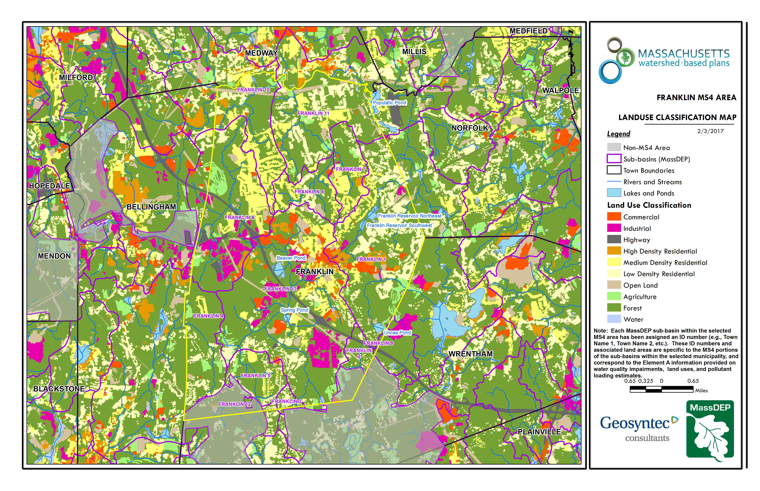Figure A-2: Subwatershed Land Use Map
Mill River
Approximate Watershed Boundary
Franklin_01
(MassGIS, 2007; MassGIS, 2009b; MassGIS, 1999; MassGIS, 2001; USGS, 2016)

Watershed Impervious Cover
There is a strong link between impervious land cover and stream water quality. Impervious cover includes land surfaces that prevent the infiltration of water into the ground, such as paved roads and parking lots, roofs, basketball courts, etc. Impervious area within the watershed of the Mill River within the Town of Franklin is concentrated in central portion of the watershed, along the banks of Uncas Brook and the headwaters of the Franklin Reservoirs, as illustrated in Figure A-8 below.
Impervious areas that are directly connected (DCIA) to receiving waters (via storm sewers, gutters, or other impervious drainage pathways) produce higher runoff volumes and transport stormwater pollutants with greater efficiency than disconnected impervious cover areas which are surrounded by vegetated, pervious land. Runoff volumes from disconnected impervious cover areas are reduced as stormwater infiltrates when it flows across adjacent pervious surfaces.
An estimate of DCIA for the subwatershed area was calculated based on the Sutherland equations. USEPA provides guidance (USEPA, 2010) on the use of the Sutherland equations to predict relative levels of connection and disconnection based on the type of stormwater infrastructure within the total impervious area (TIA) of a watershed. Within the subwatershed, the total area of each land use was summed and used to calculate the percent TIA (Table A-7).
Table A-7: TIA and DCIA values for the subwatershed
MS4 Subwatershed # | Estimated TIA (%) | Estimated DCIA (%)
FRANKLIN_01 | 14.3 | 9

The relationship between TIA and water quality can generally be categorized as listed by Table A-8 (Schueler et al. 2009). The TIA value for the subwatershed range is 14.3%; therefore, the river and surrounding tributaries can be expected to show fair to good water quality.
Table A-8: Relationship between Total Impervious Area (TIA) and water quality (Schueler et al. 2009)
% Watershed  Impervious Cover | Stream Water Quality
0-10% | Typically high quality, and typified by stable channels, excellent habitat structure, good to excellent water quality, and diverse communities of both fish and aquatic insects.
11-25% | These streams show clear signs of degradation. Elevated storm flows begin to alter stream geometry, with evident erosion and channel widening. Streams banks become unstable, and physical stream habitat is degraded. Stream water quality shifts into the fair/good category during both storms and dry weather periods. Stream biodiversity declines to fair levels, with most sensitive fish and aquatic insects disappearing from the stream.
26-60% | These streams typically no longer support a diverse stream community. The stream channel becomes highly unstable, and many stream reaches experience severe widening, downcutting, and streambank erosion. Pool and riffle structure needed to sustain fish is diminished or eliminated and the substrate can no longer provide habitat for aquatic insects, or spawning areas for fish. Biological quality is typically poor, dominated by pollution tolerant insects and fish. Water quality is consistently rated as fair to poor, and water recreation is often no longer possible due to the presence of high bacteria levels.
>60% | These streams are typical of “urban drainage”, with most ecological functions greatly impaired or absent, and the stream channel primarily functioning as a conveyance for stormwater flows.

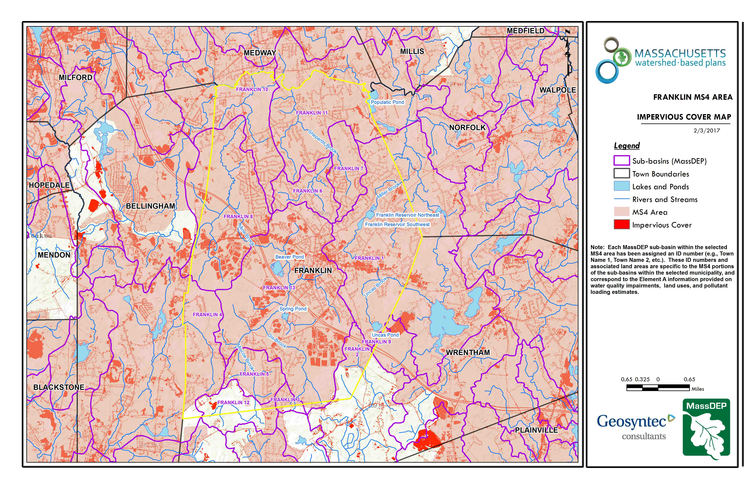Figure A-3: Subwatershed Impervious Surface Map
Approximate Watershed Boundary
Franklin_01
(MassGIS, 2007; MassGIS 2009a; MassGIS, 1999; MassGIS, 2001; USGS, 2016)

Pollutant Loading
The land use data (MassGIS, 2009b) was intersected with impervious cover data (MassGIS, 2009a) and United States Department of Agriculture (USDA) Natural Resources Conservation Service (NRCS) soils data (USDA NRCS and MassGIS, 2012) to create a combined land use/land cover grid. The grid was used to sum the total area of each unique land use/land cover type.
The amount of DCIA was estimated using the Sutherland equations as described above and any reduction in impervious area due to disconnection (i.e., the area difference between TIA and DCIA) was assigned to the pervious D soil category for that land use to simulate that some infiltration will likely occur after runoff from disconnected impervious surfaces passes over pervious surfaces.
Pollutant loading for key nonpoint source pollutants in the subwatershed area was estimated by multiplying each land use/cover type area by its pollutant load export rate (PLER). The PLERs are an estimate of the annual total pollutant load exported via stormwater from a given unit area of a particular land cover type. The PLER values for TN, TP and TSS were obtained from USEPA (Voorhees, 2016b) (see documentation provided in Appendix C) as follows:
L_{n} = A_{n} * P_{n}
Where L_{n} = Loading of land use/cover type n (lb/yr); A_{n} = area of land use/cover type n (acres); P_{n} = pollutant load export rate of land use/cover type n (lb/acre/yr)

The estimated land use-based phosphorus to receiving waters within the subwatershed areas is 850 pounds per year, as presented by Table A-9. The largest contributor of the land use-based phosphorus load originates from areas designated as forested (27% of the total phosphorus load). Phosphorus generated from forested areas is a result of natural process such as decomposition of leaf litter and other organic material and generally represent a “best case scenario” with regards to phosphorus loading, meaning that those portions of the watershed are unlikely to provide opportunities for nutrient load reductions through best management practices.
Table A-9: Estimated Pollutant Loading for Key Nonpoint Source Pollutants
MS4 Subwatershed #: FRANKLIN_01
Land Use Type | Pollutant Loading¹
 | Total  Phosphorus (TP)  (lbs/yr) | Total  Nitrogen (TN)  (lbs/yr) | Total  Suspended Solids (TSS)  (tons/yr)
Agriculture | 40 | 242 | 2.10
Commercial | 139 | 1,193 | 14.92
Forest | 226 | 1,184 | 42.04
High Density Residential | 98 | 654 | 9.71
Highway | 14 | 111 | 6.57
Industrial | 30 | 261 | 3.26
Low Density Residential | 167 | 1,617 | 22.55
Medium Density Residential | 93 | 795 | 11.05
Open Land | 44 | 354 | 8.96
TOTAL | 850 | 6,411 | 121.15
¹These estimates do not consider loads from point sources or septic systems.

Element B: Determine Pollutant Load Reductions Needed to Achieve Water Quality Goals
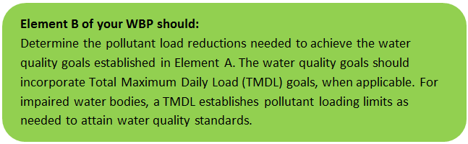

Estimated Pollutant Loads
Estimated pollutant loads for total phosphorus (TP) (850 lbs/yr), total nitrogen (TN) (6,411 lb/yr), and total suspended solids (TSS) (121 tons/yr) were previously presented in Section A.7 of this WBP.

Water Quality Goals
There are many methodologies that can be used to set pollutant load reduction goals for a WBP. Goals can be based on water quality criteria, surface water standards, existing monitoring data, existing TMDL criteria, or other data. Water quality goals from this WBP are based on criteria for the Upper/Middle Charles River total phosphorus TMDL. The TMDL establishes an overall load reduction goal of 50% for the Upper/Middle Charles River watershed and provides Waste Load Allocations (WLA) for total phosphorus based on specific land use areas (see Appendix A for TMDL criteria).
Based these criteria, the Town performed an analysis to identify baseline phosphorus loading and required reductions within subwatershed based on TMDL criteria (Town of Franklin, 2017). Results indicate that an annual reduction of 52.7 kilograms per year (116 pounds per year) is required (Table B-2). This reduction would represent a decrease of 14 percent in the subwatershed.
Note: Calculated land use areas and associated existing pollutant loads from Table B-2 differ from those presented by Section A.6 and A.7 of this WBP. Differences may be attributed to different land use cover data, impervious surface data, DCIA estimates, or other factors such as assumptions relative to soil type.
Table B-1: Estimated TMDL Load Reduction Requirements for Total Phosphorus for the Mill River Subwatershed in Franklin (Town of Franklin, 2017)
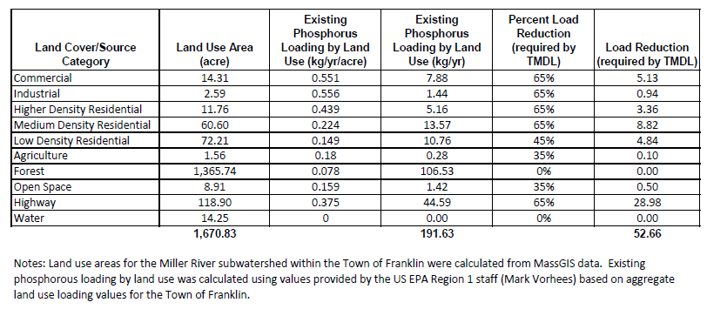

Recommended Load Reduction
The following adaptive sequence is recommended to sequentially track and meet this load reduction goal:
- Given current water quality conditions, establish an interim goal to reduce land use-based phosphorus by 50% (26.4 kg) (58.2 pounds) of the TMDL goal over the next 5 years (by 2024). Considering known pollutant loads for existing and proposed BMPs (please refer to the Introduction or Element C for more details on existing and proposed BMPs), it is anticipated that land use-based phosphorus loading will be reduced by approximately 37% (43.1 pounds) at completion of Franklin’s proposed BMPs (by 2020). It is expected that additional existing BMPs within the watershed with unknown pollutant load reductions also contribute to load reductions.
- Develop specific watershed-based plans or redefine goals and proposed management measures to be specific to the Franklin Reservoirs and Uncas Pond to enable more fine-tuned evaluation and planning.
- Establish a baseline water quality monitoring program in accordance with Element I. Results from the monitoring program should advise if Element C management measures have been effective at addressing listed water quality impairments or water quality goals for other indicator parameters established by Element A.5 of this WBP (e.g., dissolved oxygen, chlorophyll-a). Results can further be used to periodically inform or adjust load reduction goals.
- Establish a long-term reduction goal to reduce land use-based phosphorus by 52.7 kg (116 lbs) over the next 15 years to meet TMDL requirements. Based on monitoring data, establish additional long-term reduction goal(s), if needed, to lead to delisting of all assessment units within the study watershed from the 303(d) list.

Element C: Describe management measures that will be implemented to achieve water quality goals

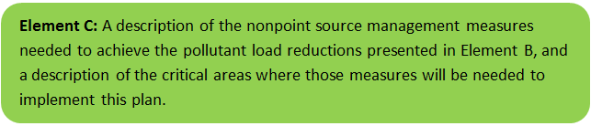
Existing Management Measures
As indicated in the introduction of this WBP, the Town has implemented 3 BMPs over the last 7 years in the Mill River subwatershed, as summarized by Figure C-1. A combined total phosphorus load reduction of 15.98 pounds per year is estimated due to the bioretention and infiltration chambers installed at Wyllie Road and Miller Street (Town of Franklin, 2014). Estimated pollutant load reductions from the other BMPs in the study area are unknown but will be tabulated as summarized by Element HI of this WBP.
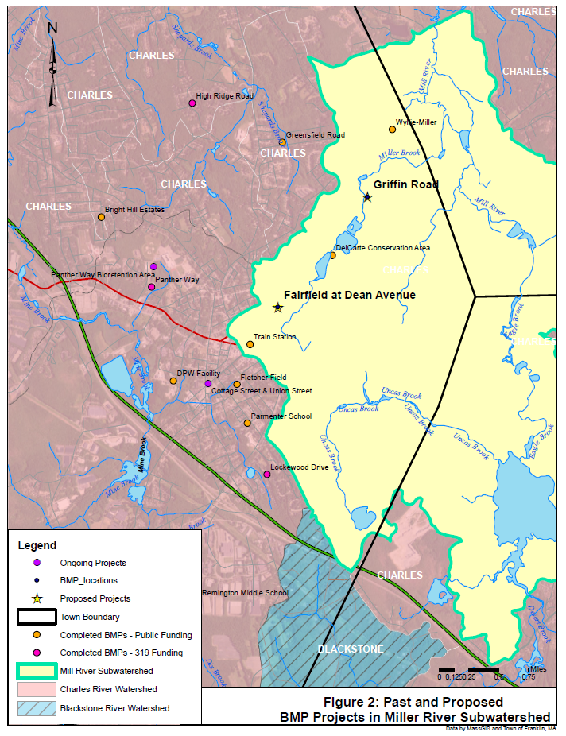
Figure C-1: Existing Management Measures (Town of Franklin, 2017)

Ongoing Management Measures
The Town was awarded funding through the Fiscal Year 2018 Section 319 Nonpoint Source Pollution Grant Program to install the proposed structural BMPs listed in Table C-1 within the Mill River Watershed. The planning level cost estimates and pollutant load reduction estimates were based off information obtained from the Public-Private Partnership for Stormwater Green Infrastructure, the Fairfield at Dean Avenue Section 319 Nonpoint Source Pollution Grant Program application (Town of Franklin, 2017). It is anticipated that these BMPs will result in a combined load reduction of 12.3 kilograms (27.1 pounds) of total phosphorus. Details of BMP design are included in Appendix B.
Table C-1: Proposed Management Measures, Estimated Pollutant Load Reductions and Costs
BMP Description | Location
Four bioretention areas to treat public roadway runoff within the right-of-way. The location has high visibility for public education opportunities. | The Fairfield at Dean Avenue
One rain garden to treat upgradient areas and remove unnecessary pavement. The location has high visibility for public education opportunities. | Griffin Road

Future Management Measures
In 2007, the Town of Franklin performed a town-wide BMP inventory that identified multiple opportunities for BMP installation (Figure C-2). Future management measures will first focus on implementing BMPs from the inventory in the subwatershed to the Mill River. Franklin has identified redevelopment and new development projects within the watershed as the greatest opportunities to manage stormwater runoff. Franklin is focused on public-private partnerships to treat public roadway stormwater runoff by utilizing easements on private land.
Once the options identified on the BMP inventory have been exhausted, Franklin may consider additional investigation with the following recommended general sequence to identify and implement future structural BMPs.
- Identify Potential Implementation Locations: Perform a desktop analysis using aerial imagery and GIS data to develop a preliminary list of potentially feasible implementation locations based on soil type (i.e., hydrologic soil groups A and B); available public open space (e.g., lawn area in front of a police station); potential redevelopment sites where additional public-private partnerships may be leveraged; and other factors such as proximity to receiving waters, known problem areas, or publicly owned right of ways or easements. Additional analysis can also be performed to fine-tune locations to maximize pollutant removals such as performing loading analysis on specifically delineated subwatersheds draining to single outfalls and selecting those subwatersheds with the highest loading rates per acre.
- Visit Potential Implementation Locations: Perform field reconnaissance, preferably during a period of active runoff-producing rainfall, to evaluate potential implementation locations, gauge feasibility, and identify potential BMP ideas. During field reconnaissance, assess identified locations for space constraints, potential accessibility issues, presence of mature vegetation that may cause conflicts (e.g., roots), potential utility conflicts, site-specific drainage patterns, and other factors that may cause issues during design, construction, or long-term maintenance.
- Develop BMP Concepts: Once potential BMP locations are conceptualized, use the BMP-selector tool on the watershed-based planning tool to help develop concepts. Concepts can vary widely. One method is to develop 1-page fact sheets for each concept that includes a site description, including definition of the problem, a description of the proposed BMPs, annotated site photographs with conceptual BMP design details, and a discussion of potential conflicts such as property ownership, O&M requirements, and permitting constraints. The fact sheet can also include information obtained from the BMP-selector tool including cost estimates, load reduction estimates, and sizing information (i.e., BMP footprint, drainage area, etc.).
- Rank BMP Concepts: Once BMP concepts are developed, perform a priority ranking based on site-specific factors to identify the implementation order. Ranking can include many factors including cost, expected pollutant load reductions, implementation complexity, potential outreach opportunities and visibility to public, accessibility, expected operation and maintenance effort, and others.
Prioritized BMP concepts should focus on reducing total phosphorus loading to the Mill River as summarized by the TMDL criteria (Element B, Section 3).
Note that planned BMPs can also be non-structural (e.g., street sweeping, catch basin cleaning). It is recommended that these municipal programs be evaluated and potentially optimized. First, it is recommended that potential pollutant load removals from ongoing activities be calculated in accordance with Element HI. Next, it is recommended that ongoing activities be evaluated to see if potential improvements can be implemented to achieve higher pollutant load reductions such as increased frequency or improved technology.

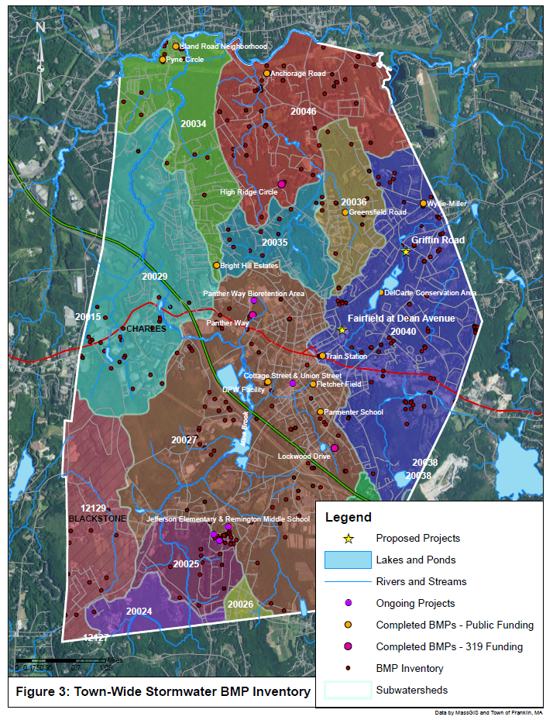
Figure C-2: Stormwater BMP Inventory (Town of Franklin, 2017)

Element D: Identify Technical and Financial Assistance Needed to Implement Plan
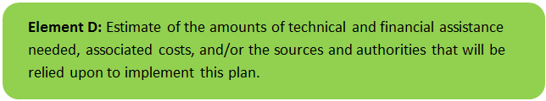

Current and Ongoing Management Measures
The funding needed to implement the proposed management measures presented in this watershed plan is based on estimates from the Public-Private Partnership for Stormwater Green Infrastructure, the Fairfield at Dean Avenue Section 319 Nonpoint Source Pollution Grant Program application (Town of Franklin, 2017). The total costs for structural and non-structural BMPs, operation and maintenance activities, information/education measures, and monitoring/evaluation activities is estimated at approximately $210,220, as detailed by Table D-1.
Table D-1: Summary of Proposed BMPs Costs
Task/Objective | Cost
Town Employee Labor | $55,720
Survey, Engineering, and Permitting | $45,000
Legal Services | $10,000
DPW Equipment/Materials | $29,500
Construction Materials | $68,000
Educational Signs and Mailings | $2,000
Total | $210,220

Future Management Measures
Funding for future BMP installations to further reduce loads within the watershed may be provided by a variety of sources, such as the Section 319 Nonpoint Source Pollution Grant Program, town capital funds, or other grant programs such as hazard mitigation funding. The Town of Franklin has previously been successful with and will continue to pursue securing grant funding through the USEPA Green Infrastructure Program and the MassDEP Sustainable Water Management Initiative (SWMI). Guidance is available to provide additional information on potential funding sources for nonpoint source pollution reduction efforts.

Element E: Public Information and Education
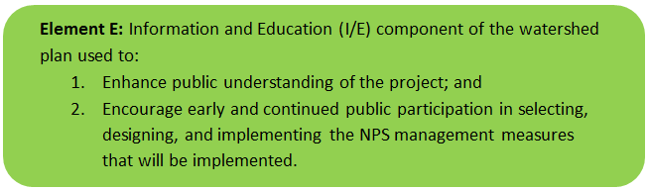

Step 1: Goals and Objectives
The goals and objectives for the watershed information and education program.
- Provide information about proposed stormwater improvements and their anticipated water quality benefits.
- Provide information to promote watershed stewardship.
Step 2: Target Audience
Target audiences that need to be reached to meet the goals and objectives identified above.
- All watershed residents.
- Businesses within the watershed.
- Watershed organizations and other user groups.
Step 3: Outreach Products and Distribution
The outreach product(s) and distribution form(s) that will be used for each.
- Develop and post informational signs at proposed BMP locations and conduct two neighborhood meetings at each site.
- Develop a fact sheet on public-private partnerships for stormwater management and distribute to properties within Franklin with significant impervious surfaces.
- Continue to update the Soak It Up Franklin website.
- Continue to offer the rain barrel purchasing program.
Step 4: Evaluate Information/Education Program
Information and education efforts and how they will be evaluated.
- Track neighborhood meeting attendance.
- Track number of fact sheets distributed.
- Measure and record activity on the Soak It Up Franklin webpages.
- Record the number of rain barrels distributed through the rain barrel purchasing program.

Elements F & G: Implementation Schedule and Measurable Milestones
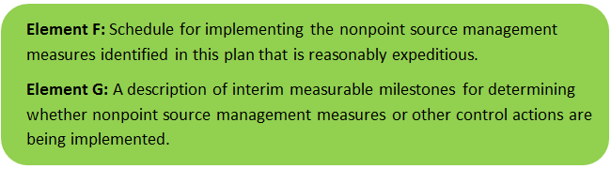

Table FG-1 provides a preliminary schedule for implementation of recommendations provided by this WBP. It is expected that the WBP will be re-evaluated and updated in 2021, or as needed, based on ongoing monitoring results and other ongoing efforts.
Table FG-1: Implementation Schedule and Interim Measurable Milestones
Category | Action | Year(s)
Additional Watershed Based Plan Development | Develop watershed-based plans for the Franklin Reservoirs and Uncas Pond | 2021
Monitoring / Vegetation | Write Quality Assurance Project Plan (QAPP) for sampling and establish water quality monitoring program | 2019
 | Perform annual water quality sampling per Element H&I monitoring guidance | Annual
Structural BMPs | Document estimated pollutant removals from existing BMPs in the watershed | 2019
 | Complete installation of BMPs at the Fairfield at Dean Avenue and the end of Griffin Road | 2020
 | Obtain funding and implement 2-3 additional BMPs within the Mill River subwatershed | 2022
 | Obtain funding and implement 2-3 additional BMPs within the Mill River subwatershed | 2024
 | Obtain funding and implement 2-3 additional BMPs within the Mill River subwatershed | 2026
Nonstructural BMPs | Document potential pollutant removals from ongoing non-structural BMP practices (i.e., street sweeping, catch basin cleaning) | 2020
 | Evaluate ongoing non-structural BMP practices and determine if modifications can be made to optimize pollutant removals (e.g., increase frequency). | 2021
 | Routinely implement optimized non-structural BMP practices | Annual
Public Education and Outreach  (See Element E) | Periodically post project updates to website and social media profiles, including completed WBP and updates of progress | Annual
 | Develop and post informational signs at proposed BMP locations and conduct neighborhood meetings | 2020
 | Develop a fact sheet on stormwater management and distribute | 2020
 | Periodically update the Soak It Up Franklin website and offer the rain barrel purchasing program | Annual
Adaptive Management  and Plan Updates | Establish working group comprised of stakeholders and other interested parties to implement recommendations and track progress. Meet at least twice per year. | 2019
 | Re-evaluate Watershed Based Plan at least once every three (3) years and adjust, as needed, based on ongoing efforts (e.g., based on monitoring results, 319 funding, etc.). – Next update, December 2021 | 2021
 | Reach interim goal to reduce land-based phosphorus by 50% (26.4 kg) | 2024
 | Establish additional long-term reduction goal(s) from baseline monitoring results, if needed | 2024
 | Reach long-term phosphorus load reduction goal to reduce land use-based phosphorus by 52.7 k | 2034

Elements H & I: Progress Evaluation Criteria and Monitoring
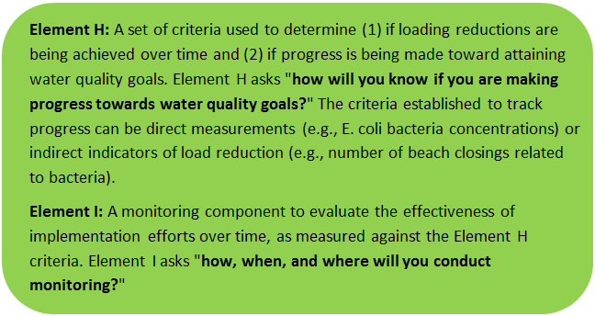 | 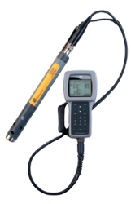

The water quality target concentration(s) is presented under Element A of this plan. To achieve this target concentration, the annual loading must be reduced to the amount described in Element B. Element C of this plan describes the various management measures that will be implemented to achieve this targeted load reduction. The evaluation criteria and monitoring program described will be used to measure the effectiveness of the proposed management measures (described in Element C) in improving the water quality of the Charles River.

Indirect Indicators of Load Reduction

Non-Structural BMPs
Potential load reductions from non-structural BMPs (i.e., street sweeping and catch basin cleaning) can be estimated from indirect indicators, such as the number of miles of streets swept or the number of catch basins cleaned. Appendix F of the 2016 Massachusetts Small MS4 General Permit provides specific guidance for calculating phosphorus removal from these practices. As indicated by Element C, it is recommended that potential phosphorus removal from these ongoing actives be estimated. Next, it is recommended that ongoing activities be evaluated to see if potential improvements can be implemented to achieve higher pollutant load reductions such as increased frequency or improved technology.
Phosphorus load reductions can be estimated in accordance with Appendix F of the 2016 Massachusetts Small MS4 General Permit as summarized by Figure HI-1 and HI-2.
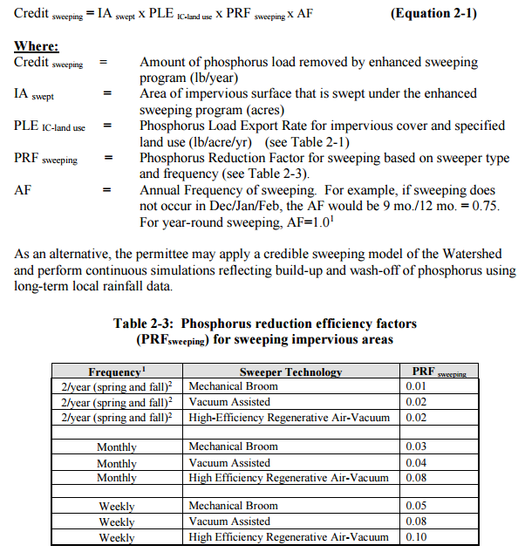
Figure HI-1. Street Sweeping Calculation Methodology
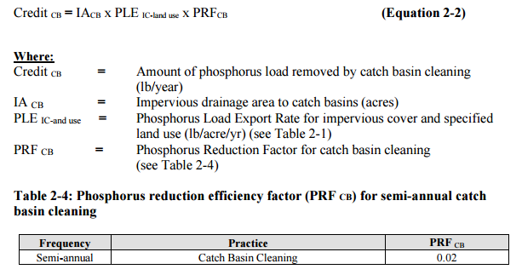
Figure HI-2. Catch Basin Cleaning Calculation Methodology

Project-Specific Indicators

Number of BMPs Installed and Pollutant Reduction Estimates:
Anticipated pollutant load reductions from existing, ongoing (i.e., under construction), and future BMPs will be tracked as BMPs are installed. For example, once ongoing BMPs are installed, the anticipated phosphorus load reduction is estimated to be 12.3 kilograms (27.1 pounds) per year.

TMDL Criteria
TMDL requirements encourage ongoing monitoring to assess progress towards the TMDL’s water quality goals. The TMDL indicates that pilot projects should include monitoring to assess their effectiveness at removing phosphorus.

Direct Measurements
Direct measurements are generally expected to be performed as described below. Prior to implementing a direct measurement program, an abbreviated QAPP and/or Standard Operating Procedures (SOPs) will be established to flesh out details of the program and establish best practices for sample collection and analysis. Water quality monitoring may be performed through a volunteer training program to save on costs in accordance with established practices for MassDEP’s environmental monitoring for volunteers.

River Sampling
Establish regular sampling to meet TMDL recommendations including analysis of phosphorus, chlorophyll-a, dissolved oxygen, turbidity, and temperature in Miller Brook, Uncas Brook, and the unnamed tributary to the Mill River (south of Miller Brook) within the subwatershed. Additional parameters such as conductivity, pH, and flow rate could provide additional data for consideration. Monitoring locations will be selected based on accessibility and representativeness and shall be appropriate to quantify water quality improvements in the subwatershed.

In-Lake Phosphorus and Water Quality Monitoring
Sampling programs specific for the contributing ponds (Uncas Pond and the Franklin Reservoirs) within the watershed could be established to more closely track the progress of water quality improvements towards TMDL requirements. Monitoring locations should at minimum include the outlet of the pond, tributaries, and the deepest “in-lake” location. It is recommended that sampling programs meeting the recommendations of the TMDL be established, including analysis of secchi disk transparency, phosphorus, chlorophyll-a, turbidity, temperature/oxygen profiles, and aquatic vegetation. These parameters will also enable tracking relative to Carlson’s state trophic index to evaluate improvements over time.

Adaptive Management
As discussed by Section 3 of Element B, the baseline monitoring program will be used to establish a long-term i.e., 10 year) phosphorus load reduction goal (or other parameter(s) depending on results). Long-term goals will be re-evaluated at least once every three years and adaptively adjusted based on additional monitoring results and other indirect indicators. If monitoring results and indirect indicators do not show improvement to the total phosphorus concentrations and other indicators (e.g., chlorophyll-a) measured within the subwatershed, the management measures and loading reduction analysis (Elements A through D) will be revisited and modified accordingly.

References
314 CMR 4.00 (2013). "Division of Water Pollution Control, Massachusetts Surface Water Quality Standards"
Cohen, A. J.; Randall, A.D. (1998). "Mean annual runoff, precipitation, and evapotranspiration in the glaciated northeastern United States, 1951-80." Prepared for United States Geological Survey, Reston VA.
Charles River Watershed Association (2011). "Total Maximum Daily Load for Nutrients in the Upper/Middle Charles River, Massachusetts "
Geosyntec Consultants, Inc. (2014). "Least Cost Mix of BMPs Analysis, Evaluation of Stormwater Standards Contract No. EP-C-08-002, Task Order 2010-12." Prepared for Jesse W. Pritts, Task Order Manager, U.S. Environmental Protection Agency
Geosyntec Consultants, Inc. (2015). "Appendix B: Pollutant Load Modeling Report, Water Integration for the Squamscott-Exeter (WISE) River Watershed."
King, D. and Hagan, P. (2011). "Costs of Stormwater Management Practices in Maryland Counties." University of Maryland Center for Environmental Science Chesapeake Biological Laboratory. October 11, 2011.
Leisenring, M., Clary, J., and Hobson, P. (2014). "International Stormwater Best Management Practices (BMP) Database Pollutant Category Statistical Summary Report: Solids, Bacteria, Nutrients and Metals." Geosyntec Consultants, Inc. and Wright Water Engineers, Inc. December 2014.
MassDEP (2008). "Charles River Watershed 2002-2006 Water Quality Assessment Report"
MassDEP (2012). "Massachusetts Year 2012 Integrated List of Waters Final Listing of Massachusetts' Waters Pursuant to Sections 305(b), 314 and 303(d) of the Clean Water Act"
MassDEP (2016a). "Massachusetts Clean Water Toolkit"
MassDEP (2016b). "Massachusetts Stormwater Handbook, Vol. 2, Ch. 2, Stormwater Best Management Practices"
MassGIS (1999). "Networked Hydro Centerlines" Shapefile
MassGIS (2001). "USGS Topographic Quadrangle Images" Image
MassGIS (2007). "Drainage Sub-basins" Shapefile
MassGIS (2009a). "Impervious Surface" Image
MassGIS (2009b). "Land Use (2005)" Shapefile
MassGIS (2013). "MassDEP 2012 Integrated List of Waters (305(b)/303(d))" Shapefile
Schueler, T.R., Fraley-McNeal, L, and K. Cappiella (2009). "Is impervious cover still important? Review of recent research" Journal of Hydrologic Engineering 14 (4): 309-315.
Town of Franklin (2014). “Green Infrastructure Implementation Strategy for the Town of Franklin, Massachusetts”
Town of Franklin (2017). “Public-Private Partnership for Stormwater Green Infrastructure, the Fairfield at Dean Avenue”
United States Bureau of Labor Statistics (2016). "Consumer Price Index"
United States Geological Survey (2016). "National Hydrography Dataset, High Resolution Shapefile"
University of Massachusetts, Amherst (2004). "Stormwater Technologies Clearinghouse"
USDA NRCS and MassGIS (2012). "NRCS SSURGO-Certified Soils" Shapefile
USEPA (1986). "Quality Criteria for Water (Gold Book)" EPA 440/5-86-001. Office of Water, Regulations and Standards. Washington, D.C.
USEPA. (2010). "EPA's Methodology to Calculate Baseline Estimates of Impervious Area (IA) and Directly Connected Impervious Area (DCIA) for Massachusetts Communities."
USEPA (2014). “Attachment 1 – Fact Sheet Massachusetts Small MS4: Charles River Basin Nutrient (Phosphorus) TMDLs, Phosphorus Load Export Rates and BMP Performance.”
Voorhees, Mark, USEPA. (2015). "FW: Description of additional modelling work for Opti-Tool Project" Message to Chad Yaindl, Geosyntec Consultants. 23 April 2015. E-mail.
Voorhees, Mark, USEPA. (2016a). "FW: EPA Region 1 SW BMP performance equations" Message to Chad Yaindl, Geosyntec Consultants. 25 January 2016. E-mail.
Voorhees, Mark, USEPA. (2016b). "FW: Description of additional modelling work for Opti-Tool Project" Message to Chad Yaindl, Geosyntec Consultants. 23 April 2015. E-mail.

Appendices
Appendix A – Additional Water Quality Information
Charles River Watershed 2002-2006 Water Quality Assessment Report (MA72-15 - Mill River)
Aquatic Life Use
Habitat and Flow
There are three dams along Mill River: Bush Pond #2 Dam, Rabbit Hill Pond Dam, and City Mills Pond Dam. On 18 July 2002 MassDEP DWM biologists conducted a habitat assessment at one location on the Mill River 500 m downstream from Main Street, Norfolk (Station MR01A). DWM biologists found this reach to be comprised primarily of shallow riffles with small cobble and pebble benthic substrate (Appendix C). Station MR01A received a total habitat assessment score of 146 out of a possible 200 (Appendix C). Epifaunal and fish habitat was limited by most by the extremely shallow conditions, which resulted in limited velocity/depth combinations and cover for fish, as well as evidence of in-stream sedimentation (Appendix C).
Streamflow estimates of Mill River at River Road in Norfolk (Station 213T1) from July 2002 through December 2005 were reported by CRWA (CRWA 2004a and CRWA 2006). Average daily flow estimates ranged from 0.7 to 221 cfs. The average flow for the period of record was 26.6 cfs. The lowest average monthly flows were documented between July and August 2002 (2.33 to 4.15 cfs) and August and September 2005 (2.04 to 4.7 cfs).
Biology
DWM biologists found limited algae and aquatic vegetation in the Mill River 500 m downstream from Main Street, Norfolk MA (Station MR01A), although a few small patches of green algae and water starwart (Callitriche sp.) were noted (Appendix C). They collected two periphyton samples from the Mill River (Station MR01A) on July 18, 2002 (Appendix C). Canopy cover at this site was reported as 75%, algal cover was <1%, and the dominant algal genera was Chlorophyceae-Microspora sp. (Appendix F).
RBP III analysis indicated that Mill River was slightly impacted compared to the reference station ST01 (Appendix C). DWM biologists found reduced taxa richness and reduced EPT index relative to the reference station and two dominant filter-feeding taxa. The filter-feeding taxa indicate an abundance of FPOM as a food source, but numerous scraping taxa were also found, evidence of a periphyton feeding guild (Appendix C).
A total of 163 fish were collected by the MA Department of Fish and Game using a barge mounted elecroshocker near the mouth of the Mill River (Station 822) in August 2003. Thirteen species were identified with the most common species being redbreast sunfish (n=56), redfin pickerel (31), largemouth bass (19), golden shiner (18), and bluegill (10). These were all macrohabitat generalists. Four brown trout (fluvial specialists – all probably stocked) and eight white sucker (fluvial dependents) were also collected (Richards 2006). Given the habitat at the fish sampling site, and the site’s proximity to the main stem Charles River the dominance of macrohabitat generalists at this particular sampling location is expected.
Water Chemistry
One water quality monitoring station on Mill River at River Road in Norfolk (Station 213T1) was sampled as part of the CRWA Upper Charles River Watershed Total Maximum Daily Load Project (CRWA 2004a and CRWA 2006). Sampling was conducted on 13 August 2002 and 24 August 2005 representing dry weather conditions as well as during two wet weather surveys 16 (two sampling events) October 2002 and 19 and 20 October 2004 (CRWA 2004a and CRWA 2006). Continuous in-situ temperature measurements of Mill Brook at this site were also taken from July 2002 through December 2005 at 15-minute intervals as part of these projects.
The CRWA collected several types of water quality data at this site including in-situ measurements of DO, water temperature, and pH as well as water quality samples collected and analyzed for ammonia-nitrogen, total phosphorus, and chlorophyll a. Of the six surveys conducted, one DO concentration was below 5.0 mg/L (4.2 mg/L measured during dry weather in August 2005). Results of the other water quality samples indicated elevated total phosphorus during the August 2002 dry weather survey (0.1 mg/L phosphorus).
The maximum temperature recorded during CRWA continuous in-situ monitoring was 31.9°C (n=121,456 measurements). The highest measurements (>28.3°C) occurred in both July and August 2002. The warm water fishery temperature criterion (28.3°C) was exceeded on 21 days for a total of 158 hours of exceedance. The average amount of time above 28.3°C was 7.5 hours per day for those days where an exceedance occurred (CRWA 2004a).
The Aquatic Life Use for the Mill River is assessed as impaired because of the frequency, duration, and magnitude of elevated temperatures documented in the summer of 2002 that exceeded the warm water fishery criterion of 28.3°C. While the benthic community analysis indicated only slight impairment, taxa richness was low and dominated by two filter feeding taxa. In-stream habitat at the benthic monitoring stations was limited most by extremely shallow conditions, which resulted in marginal velocity/depth combinations and cover for fish, as well as evidence of in-stream sedimentation. All fish species collected are classified as being tolerant or moderately tolerant to pollution. Low DO is also a concern.
Primary and Secondary Contact Recreation and Aesthetics Uses
DWM biologists noted isolated trash (bottle, pipes) in the Mill River 500 m downstream from Winthrop Street, Medway MA (Station MR01A) on 18 July 2002. Water clarity was clear, and no other objectionable conditions were noted (e.g., oils, odors, other deposits).
One water quality monitoring station on Mill River at River Road in Norfolk (Station 213T1) was sampled as part of the CRWA Upper Charles River Watershed Total Maximum Daily Load Project (CRWA 2004a and CRWA 2006). Sampling was conducted on 13 August 2002 and 24 August 2005 representing dry weather conditions as well as during two wet weather surveys 16 (two sampling events) October 2002 and 19 and 20 October 2004 (CRWA 2004a and CRWA 2006). E. coli counts ranged from <10 to 300 cfu/100 ml (only one count exceeded 235 cfu/100 ml) and the highest counts were representative of wet weather sampling conditions.
Too few bacteria data are available to effectively assess Primary and Secondary Contact Recreational uses (i.e., six samples over four years) so these uses are not assessed. The Aesthetics Use is assessed as support due to the lack of objectionable deposits.
Land use estimates (top 3, excluding water) for the 15.9 mi2 subwatershed.
Forest 47%
Residential 30%
Open land 7%
The estimated percent impervious area for this subwatershed area is 10.5%.
Report Recommendations:
DWM biologists recommend the following (Appendix C)
Implement BMPs to address sediment deposition from road runoff at Main Street, and stream clean-up to address accumulated trash.
Conduct long-term monitoring (increasing spatial coverage for both DO and temperature) and additional nutrient monitoring to assess the Aquatic Life Use.
Additional monitoring and evaluation of flow conditions should be conducted in the Mill River. Note that the USGS estimated base flow (the portion of streamflow originating from ground-water recharge to streams) at the mouth of the Mill River (Station MR1) under dry and average weather conditions and for three water-use scenarios (no withdrawals, average withdrawals, and maximum permitted pumping) (Eggleston 2004). This information may be helpful to better understand flow regimes in this system.
Additional bacterial sampling (minimum of five samples in a sampling season) should be conducted to assess the Primary and Secondary Contact Recreation uses.

TMDL Pollutant Load Criteria
Total Phosphorus (MA72032 - Franklin Reservoir SE, Miller Bk, MA72-04 - Charles River, MA72095 - Franklin Reservoir NE, Miller Bk, MA72096 - Populatic Pond, MA72122 - Uncas Pond, Uncas Bk)
Final TMDL Loads
The Upper/Middle Charles TMDL assessed the phosphorus loads from wastewater treatment facilities (WWTFs), stormwater, and accumulated benthic sediments. An HSPF (Hydrologic Simulation Program – Fortran) water quality model was developed and calibrated to existing water flow and quality data. The calibrated HSPF model was used to evaluate numerous remediation scenarios by comparing simulated total phosphorus load and instream concentrations of phosphorus, dissolved oxygen, and chlorophyll-a (algae).
Average phosphorus loads (kg/yr) for all sources were predicted for the period 1998-2002 using the HSPF model. This period was chosen to match the load calculations for the Lower Charles TMDL. This analysis was repeated for the Current and Final TMDL Scenario to compute the percent change under permitted conditions. The Current Scenario represents the current permitted condition. The Final TMDL Scenario approximates the Lower TMDL phosphorus load requirement at the Watertown Dam with a watershed load of 14,968 kg/yr and also meets the desired water quality targets in all reaches of interest.
Stormwater loads include discharges from piped infrastructure as well as non-point source discharges from overland flow. All land use types contribute phosphorus loads through stormwater runoff including forests and wetlands. Stormwater loads also include any sanitary flows that enter the river through storm drains via illicit cross connections. The HSPF model was developed and calibrated for flow and water quality at many monitoring locations with differing upstream land uses. The HSPF model was designed specifically to include land use as a part of the hydrological response units (HRUs). Stream reaches receive flows and loads from upland areas based on HRUs and weather inputs. Stormwater loads by land use type were then adjusted to match the measured phosphorus load at the Watertown Dam and measured instream water quality responses. The HSPF model thus provides a sound basis on which to estimate and allocate stormwater loads based on land use type.
The HSPF model was used to evaluate 18 management scenarios and assist in selecting the scenario that best meets the TMDL targets. The Upper/Middle Charles TMDL must produce an outlet phosphorus load that is less than Lower Charles TMDL inlet load of 15,109 kg/yr. The TMDL must also meet specific water quality targets (chlorophyll-a, dissolved oxygen, dissolved oxygen saturation, and phosphorus concentrations especially in the critical reaches and below wastewater treatment discharges.
The following table (originally Table 20 of “Total Maximum Daily Load for Nutrients in the Upper/Middle Charles River, Massachusetts” report, 2011) provides the annual phosphorus source loads for the Current and TMDL conditions. Under the Current Scenario, total annual phosphorus load to the Upper/Middle Charles River is 29,872 kg/year while the TMDL load is 14,968 kg/yr. Thus, a 50% reduction in annual phosphorus load is required in order to meet water quality standards in the Upper/Middle Charles River. New development will need to minimize or offset phosphorus loads.
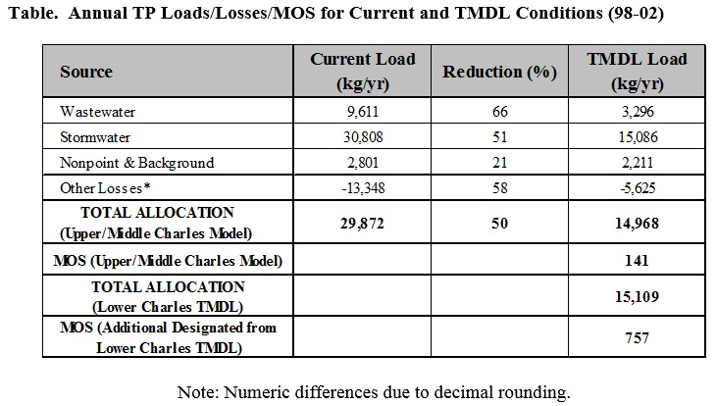
Waste Load and Load Allocations
A TMDL for a given pollutant and water body is composed of the sum of land-area load allocations for nonpoint sources, individual waste load allocations for point sources, and natural background levels. In addition, the TMDL must include an implicit or explicit margin of safety to account for the uncertainty in the relationship between pollutant loads and the quality of the receiving water body. The TMDL components for this watershed are illustrated using the following equation:
TMDL = [(LA+ WLA)-System Losses] + MOS
where LA is the load allocation for nonpoint sources including background, WLA is the waste load allocation, and MOS is the margin of safety. System losses include diversions and internal transient losses like uptake and settling.
US-EPA regulations require that point sources of pollution (discharges from discrete pipes or conveyances) subject to National Pollutant Discharge Elimination System (NPDES) permits receive WLAs specifying the amount of a pollutant they can release to the water body. Non-point sources of pollution and point sources not subject to NPDES permits receive LAs specifying the amount of a pollutant that they can release to the water body.
In the case of stormwater, it is often difficult to identify and distinguish between point source discharges that are subject to NPDES regulation, and those that are not. Therefore, US-EPA has stated that where it is not possible to distinguish between point source discharges that are subject to NPDES regulation and those that are not, it is permissible to include all point source storm water discharges in the WLA portion of the TMDL.
Load Allocation
Both nonpoint sources of phosphorus and unregulated stormwater drainage systems exist throughout the Upper/Middle Charles River watershed. The major nonpoint source categories that contribute phosphorus to the river are diffuse overland runoff, including runoff from forest, open space and wetlands and water, and groundwater recharge to the river and tributaries. Also, there are many stormwater drainage systems in the watershed that are currently not regulated by the NPDES permit program. These systems include privately owned drainage systems serving commercial areas, small construction sites less than an acre in size, certain industrial uses, and municipal drainages systems in more rural portions of the watershed.
The level of information available for this TMDL through the specific HRU setup in the HSPF model makes it suitable for quantifying total phosphorus loadings from watershed areas by land use. Stormwater from these land uses include regulated stormwater and non-stormwater point sources, nonpoint sources, and unregulated stormwater point sources. Currently, there is insufficient information available to confidently apportion the total phosphorus loading from the various land use types to the regulated and non-regulated stormwater source categories within the watershed areas. As a result, this TMDL has assigned LAs to benthic flux, water/wetland areas and atmospheric deposition.
Waste Load Allocation
NPDES regulated point sources in the Upper/Middle Charles River Watershed that contribute phosphorus loads include both WWTF and stormwater sources. The majority of the watershed is comprised of communities that are subject to the Phase II NPDES stormwater regulations governing municipally owned separate stormwater sewer systems (MS4s). NPDES permits are also required for stormwater associated with construction activities disturbing greater than one acre of land and stormwater associated with certain industrial activities.
Currently, there is insufficient information available to confidently apportion the total watershed phosphorus loading from the various land use types to the regulated and non-regulated stormwater source categories within the watershed areas. For this reason, the WLAs for this TMDL include regulated NPDES point sources, and stormwater point sources that are not currently regulated under the NPDES program. The WLA values are estimates that can be refined in the future as more information becomes available.
The top of the following table (Table 21 of “Total Maximum Daily Load for Nutrients in the Upper/Middle Charles River, Massachusetts” report, 2011) contains the total phosphorus WLAs for the six WWTFs that discharge to the Upper/Middle Charles as calculated from the Current and Final TMDL scenarios. Current NPDES permits set the total phosphorus discharge limits at Milford WWTF, Medfield WWTF, and Wrentham Development Center to 0.2 mg/L in the summer (Apr-Oct) and 1.0 mg/L for the winter (Nov-Mar). Charles River Pollution Control District (CRPCD) in Medway and the Massachusetts Correctional Institute (MCI) at Norfolk only have a summer season limit of 0.2 mg/L but do not yet include the winter season limits. This TMDL sets phosphorus WWTF discharge goals for summer/winter for both majors and minors at 0.1/0.3 mg/L. These wastewater reductions are needed for two specific reasons 1) additional summer time reductions were necessary over current permitted loads in order to address water quality problems in critical reaches of the Upper/Middle Charles River Watershed, and 2) winter time reductions are necessary to meet the Lower Charles TMDL load requirement at the Watertown Dam. The Lower Charles TMDL sets an annual cap on loads from the treatment facilities upstream, which must be met at the Watertown Dam. Since the treatment facilities can discharge up to their currently permitted flows the increase in load from existing to permitted flows has to be accounted for in this TMDL. Achieving lower winter permit limits may require additional technology, chemical addition and/or a series of trials before NPDES permit limits can be permanently met. The WWTF’s should be allowed a reasonable schedule, if necessary, and upon request, to test operational methods and various technologies to achieve long-term TMDL goals.
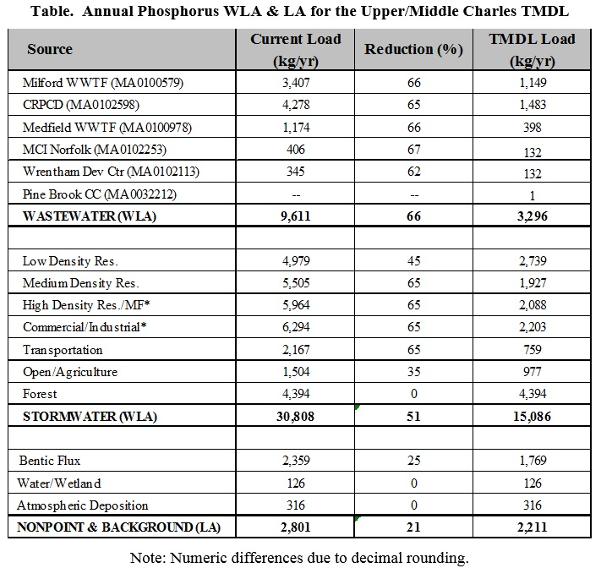
The middle portion of the table above contains the stormwater WLAs for total phosphorus by land use type as calculated from the Current and Final TMDL Scenarios. All intense land uses like Medium Density Residential, High Density Residential, Multi-Family Residential, Commercial/Industrial, and Transportation have a 65% reduction requirement.
In the table above, the modeled Commercial/Industrial/Transportation land use was split into Commercial/Industrial and Transportation categories. The Transportation category applies to transportation land uses defined by MassGIS (airports, docks, divided highway, freight, storage, railroads). Other infrastructure receives the same WLA as the land use type they are within.
The lower portion of the table contains the nonpoint source and background LAs for total phosphorus assigned to atmospheric deposition, water/wetland area, and benthic flux.
The subtotals of the loads for wastewater (3,296 kg/yr), stormwater (15,086), and nonpoint/background (2,211) from the table of “Annual Phosphorus WLA and LA for the Upper/Middle Charles TMDL” appear in the top three rows of “Annual TP Loads/Losses/MOS for Current and TMDL Conditions”, which summarizes the annual total phosphorus loads for current conditions and TMDL conditions (98-02) for all sources and losses. As shown, sources also include system losses from algae uptake and settling, and diversions (-5,625 kg/yr). Most importantly, the table “Annual TP Loads/Losses/MOS for Current and TMDL Conditions“ also shows that the total annual phosphorus load (WLA + LA- system losses), is 14,968 kg/yr, a loading which meets the allocation requirement at the Watertown Dam (15,109 kg/yr). The TMDL allows for a total MOS of approximately 6%. The 6% includes the additional MOS of 757 kg/yr which was apportioned from the Lower Charles TMDL.
Margin of Safety
Both section 303(d) of the Clean Water Act and the regulations at 40 CFR 130.7 require that TMDLs include a margin of safety (MOS). The MOS is the portion of the pollutant loading reserved to account for any uncertainty in the data. There are two ways to incorporate the MOS (1) explicitly specify a portion of the TMDL as the MOS and use the remainder for allocations or (2) implicitly incorporate the MOS by using conservative model assumptions to develop allocations. For this TMDL analysis, the MOS is consistent with the Lower Charles TMDL. The TMDL maintains the 5% explicit margin of safety, and achieves an additional MOS of 1% through conservative model assumptions.
The Upper/Middle Charles TMDL is constrained by the Lower Charles TMDL load at the Watertown Dam and the Lower Charles TMDL included an explicit 5% margin of safety. A portion of that margin of safety for the Lower Charles also applies to the Upper/Middle Charles TMDL. The Lower Charles TMDL margin of safety was explicitly set at 979 kg/yr for a total load of 19,544 kg/yr for the Lower Charles. The margin of safety for the Lower Charles needs to be applied proportionally to account for the Upper/Middle Charles watershed load to the Watertown Dam of 15,109 kg/yr. The Upper/Middle Charles TMDL therefore inherits an explicit margin of safety from the Lower Charles TMDL of 757 kg/yr. Additionally, the Final TMDL for the Upper/Middle Charles is 14,968 kg/yr which is below the Lower Charles TMDL load allocation limit (15,109 kg/yr). This provides for a total explicit MOS of 898 kg/yr or 6% (141 kg/yr from the Upper/Middle Charles TMDL and 757 kg/yr from the Lower to the Upper/Middle TMDL).
The Final TMDL Scenario also includes several conservative assumptions that provide an additional safety factor. First, the model assumes a reduction of the sediment efflux rate for phosphorus of only 25%. Since the total reduction of total phosphorus load for the TMDL is 50%, the long-term efflux rate is expected to eventually be higher than this number. The difference in the assumed reduction and the expected long-term reduction in sediment efflux rates for phosphorus is considered an additional implicit safety factor.
Second, because each reach was analyzed individually for the mean, 90th percentile, and 7-day extreme value for the target water quality parameters, the analysis methodology provided for an additional implicit margin of safety as compared to a TMDL that looks at averages over multiple reaches. The Final TMDL Scenario was selected to provide the best possible protection for all reaches since it consistently meets the defined water quality targets.
Third, the methods of analysis for determining annual average phosphorus load and achieving water quality targets in all reaches was based on a worst case condition. The target annual phosphorus load was based on an average of 1998-2002 and this period is considered representative of a much longer flow period with low flows slightly lower than average. The analysis period used for the reaches was 2002 which is considered to be representative of low flow and should capture the worst case conditions associated with WWTF discharges.
In summary, this TMDL provides for both an explicit (6%) and an implicit margin of safety.
Seasonal Variation
The federal regulations at 40 CFR 130.7 require that TMDLs include seasonal variations and take into account critical conditions for stream flow, loading, and water quality parameters. For this TMDL, nutrient loadings were determined on an hourly basis, and then accumulated to an annual figure, thus accounting for seasonality. Phosphorus sources to Upper/Middle Charles River waters arise from a mixture of dry- and wet-weather sources. The biologic response to nutrient inputs from multiple sources throughout the length of the river is complex and dependent on the loads as well as the physical and hydraulic characteristics of the receiving stream.
The Upper/Lower Charles TMDL model is a dynamic water quality model that simulates hourly water flow and quality data in response to time-varying inputs of land-derived stormwater and wastewater. The model was run for the period 1994-2005 and focused on the period 1998 to 2002 for phosphorus loads and April to October, 2002 for reach responses. The 1998-2002 period was carefully selected to represent the variability in flow conditions while the summer of 2002 was chosen to represent the worst-case water quality response. These two approaches cover the widest possible range of seasonal variability that could be encountered in the Upper/Middle Charles River watershed.
The Upper/Middle Charles TMDL model was used to simulate a frequency distribution of allowable daily phosphorus loadings as estimations of allowable maximum daily loads to the Lower Charles. Combining the frequency distribution of allowable daily loads with the allowable annual load requires that phosphorus controls should be in place throughout the year in order to meet both the allowable annual load and the water quality targets.
Total Maximum Daily Load for Nutrients in the Upper/Middle Charles River, Massachusetts

Appendix B – Proposed BMP Design Details (Town of Franklin, 2017)
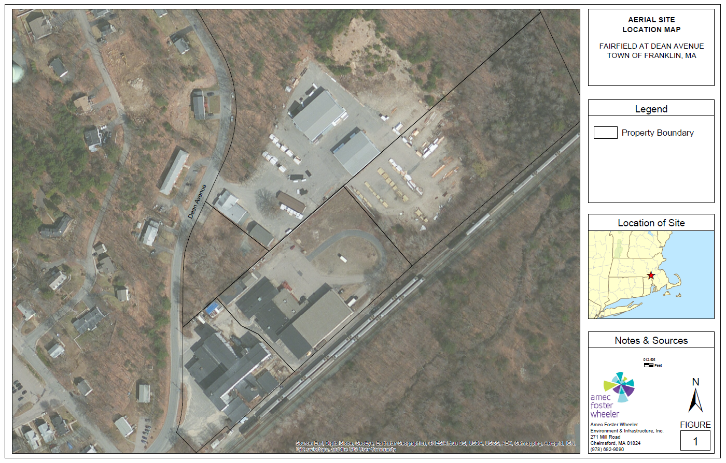

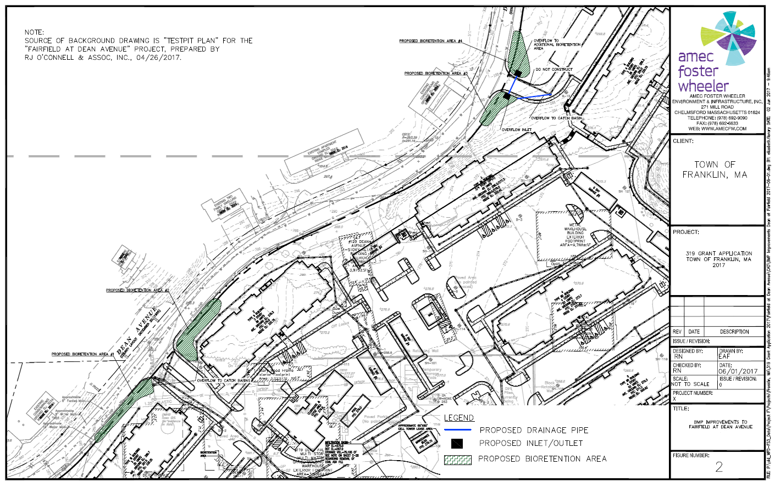
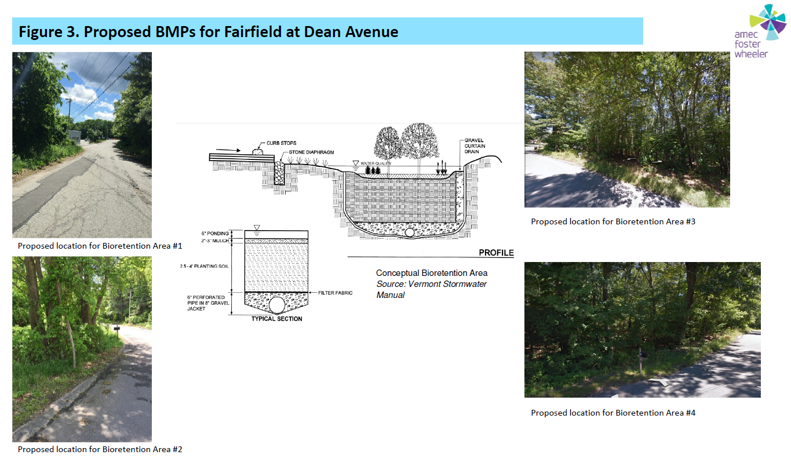
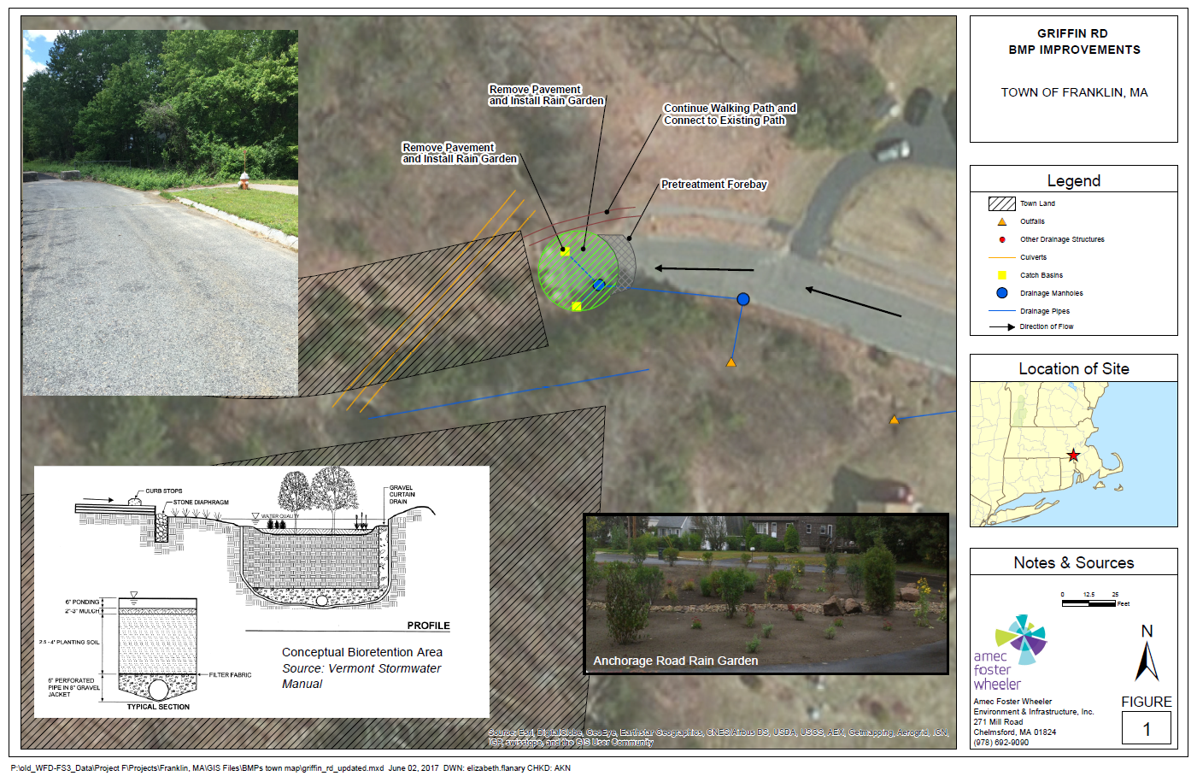

Appendix C – Pollutant Load Export Rates (PLERs)
Land Use & Cover¹ | PLERs (lb/acre/year)
 | (TP) | (TSS) | (TN)
AGRICULTURE, HSG A | 0.45 | 7.14 | 2.59
AGRICULTURE, HSG B | 0.45 | 29.4 | 2.59
AGRICULTURE, HSG C | 0.45 | 59.8 | 2.59
AGRICULTURE, HSG D | 0.45 | 91.0 | 2.59
AGRICULTURE, IMPERVIOUS | 1.52 | 650 | 11.3
COMMERCIAL, HSG A | 0.03 | 7.14 | 0.27
COMMERCIAL, HSG B | 0.12 | 29.4 | 1.16
COMMERCIAL, HSG C | 0.21 | 59.8 | 2.41
COMMERCIAL, HSG D | 0.37 | 91.0 | 3.66
COMMERCIAL, IMPERVIOUS | 1.78 | 377 | 15.1
FOREST, HSG A | 0.12 | 7.14 | 0.54
FOREST, HSG B | 0.12 | 29.4 | 0.54
FOREST, HSG C | 0.12 | 59.8 | 0.54
FOREST, HSG D | 0.12 | 91.0 | 0.54
FOREST, HSG IMPERVIOUS | 1.52 | 650 | 11.3
HIGH DENSITY RESIDENTIAL, HSG A | 0.03 | 7.14 | 0.27
HIGH DENSITY RESIDENTIAL, HSG B | 0.12 | 29.4 | 1.16
HIGH DENSITY RESIDENTIAL, HSG C | 0.21 | 59.8 | 2.41
HIGH DENSITY RESIDENTIAL, HSG D | 0.37 | 91.0 | 3.66
HIGH DENSITY RESIDENTIAL, IMPERVIOUS | 2.32 | 439 | 14.1
HIGHWAY, HSG A | 0.03 | 7.14 | 0.27
HIGHWAY, HSG B | 0.12 | 29.4 | 1.16
HIGHWAY, HSG C | 0.21 | 59.8 | 2.41
HIGHWAY, HSG D | 0.37 | 91.0 | 3.66
HIGHWAY, IMPERVIOUS | 1.34 | 1,480 | 10.2
INDUSTRIAL, HSG A | 0.03 | 7.14 | 0.27
INDUSTRIAL, HSG B | 0.12 | 29.4 | 1.16
INDUSTRIAL, HSG C | 0.21 | 59.8 | 2.41
INDUSTRIAL, HSG D | 0.37 | 91.0 | 3.66
INDUSTRIAL, IMPERVIOUS | 1.78 | 377 | 15.1
LOW DENSITY RESIDENTIAL, HSG A | 0.03 | 7.14 | 0.27
LOW DENSITY RESIDENTIAL, HSG B | 0.12 | 29.4 | 1.16
LOW DENSITY RESIDENTIAL, HSG C | 0.21 | 59.8 | 2.41
LOW DENSITY RESIDENTIAL, HSG D | 0.37 | 91.0 | 3.66
LOW DENSITY RESIDENTIAL, IMPERVIOUS | 1.52 | 439 | 14.1
MEDIUM DENSITY RESIDENTIAL, HSG A | 0.03 | 7.14 | 0.27
MEDIUM DENSITY RESIDENTIAL, HSG B | 0.12 | 29.4 | 1.16
MEDIUM DENSITY RESIDENTIAL, HSG C | 0.21 | 59.8 | 2.41
MEDIUM DENSITY RESIDENTIAL, HSG D | 0.37 | 91.0 | 3.66
MEDIUM DENSITY RESIDENTIAL, IMPERVIOUS | 1.96 | 439 | 14.1
OPEN LAND, HSG A | 0.12 | 7.14 | 0.27
OPEN LAND, HSG B | 0.12 | 29.4 | 1.16
OPEN LAND, HSG C | 0.12 | 59.8 | 2.41
OPEN LAND, HSG D | 0.12 | 91.0 | 3.66
OPEN LAND, IMPERVIOUS | 1.52 | 650 | 11.3
¹HSG = Hydrologic Soil Group

MS4 subwatersheds are defined by the WBP-tool by intersecting MassGIS drainage sub-basins with regulated MS4 areas.
Guidance on funding sources to address nonpoint source pollution: http://prj.geosyntec.com/prjMADEPWBP_Files/Guide/Element%20D%20-%20Funds%20and%20Resources%20Guide.pdf
Additional guidance is provided at: https://www.epa.gov/sites/production/files/2015-06/documents/stream.pdf and https://www.mass.gov/guides/water-quality-monitoring-for-volunteers#2
Additional guidance is provided at: https://www.epa.gov/sites/production/files/2015-06/documents/lakevolman.pdf

