WATERSHED-BASED PLAN
Namskaket / Little Namskaket Creek Watershed
March 22, 2019

Prepared By:
Town of Brewster, Department of Public Works
Association to Preserve Cape Cod
Geosyntec Consultants

Prepared For:

Contents
Executive Summary ii
Introduction 1
Purpose & Need 1
Watershed-Based Plan Outline 1
Project Partners and Stakeholder Input 2
Data Sources 3
Summary of Past and Ongoing Studies 3
Element A: Identify Causes of Impairment & Pollution Sources 6
General Watershed Information 6
MassDEP Water Quality Assessment Report and TMDL Review 10
Water Quality Impairments 11
Water Quality Goals 12
Land Use Information 14
Pollutant Loading 18
Element B: Determine Pollutant Load Reductions Needed to Achieve Water Quality Goals 19
Estimated Pollutant Loads 19
Water Quality Goals 19
Element C: Describe management measures that will be implemented to achieve water quality goals 21
Current and Ongoing Management Measures 21
Future Management Measures 21
Element D: Identify Technical and Financial Assistance Needed to Implement Plan 23
Current and Ongoing Management Measures 23
Future Management Measures 23
Element E: Public Information and Education 24
Elements F & G: Implementation Schedule and Measurable Milestones 25
Elements H & I: Progress Evaluation Criteria and Monitoring 26
References 29
Appendices 31

Appendices
Appendix A – Pollutant Load Export Rates (PLERs)
Appendix B – Proposed BMPs (Town of Brewster, 2017)

Executive Summary
Introduction: The purpose of a Massachusetts Watershed-Based Plan (WBP) is to organize information about Massachusetts' watersheds, and present it in a format that will enhance the development and implementation of projects that will restore water quality and beneficial uses in the Commonwealth. The Massachusetts WBP follows USEPA's recommended format for “nine-element” watershed plans. This WBP was developed by Geosyntec Consultants (Geosyntec) under the direction of the Brewster Department of Public Works with funding, input, and collaboration from the Massachusetts Department of Environmental Protection (MassDEP).
This WBP focuses specifically on the Namskaket Creek Estuary and surrounding watershed located in the Town of Brewster. This portion of the watershed contains six freshwater ponds, including Flax Pond, Higgins Pond, and Cliff Pond. Most of these ponds are in Nickerson State Park which is owned and operated by Massachusetts Department of Conservation and Recreation. The Namskaket Creek Estuary contains high-quality coastal waters, habitat, and resources. These include an Outstanding Resource Water (ORW) that protects the Inner Cape Cod Bay Area of Critical Environmental Concern (ACEC); brackish marsh and salt marsh; BioMap core habitat; priority habitat of rare species; and a state-designated barrier beach and coastal dune.
Impairments and Pollution Sources: Namskaket Creek is listed under Category 4A on the Massachusetts List of Integrated Waters for pathogens (fecal coliform). The potential sources of the impairment, as assessed by MassDEP, include MS4 discharges, waterfowl, and other unknown sources. The Final Pathogen TMDL for the Cape Cod Watershed, including Namskaket Creek, was completed in 2009 (MassDEP, 2009). According to the Cape Cod Commission (2017), all lines of evidence indicate that the estuary has not exceeded its threshold nitrogen level for assimilating additional nitrogen without impairment.
Although not listed on the MA Integrated List of Waters, past studies indicate that all ponds in the study watershed (Cliff Pond, Little Cliff Pond, Flax Pond, Owl Pond) except for Little Cliff Pond have some level of impairment. Impairments based on past water quality data area attributed to bacteria exceedances, elevated phosphorus levels, and low dissolved oxygen levels (Eichner, 2008; MA DOH, 2017). According to Horsley Witten (2013), current threats to the ponds are associated with phosphorus. Potential sources include septic systems near pond shorelines, lawn fertilizers applied adjacent to the ponds, and runoff from roads, driveways and parking lots.
Goals, Management Measures, and Funding:
Water quality goals of this WBP are primarily focused on protecting existing good water quality in the estuary (i.e., nitrogen), improving water quality in the freshwater ponds (i.e., phosphorus), and working to address requirements of the pathogen TMDL for bacteria. An interim goal is proposed to reduce phosphorus loading to freshwater ponds by 10 pounds and nitrogen loading to the estuary by 70 pounds over the next 5 years (by 2024) to protect and improve existing water quality. After the first five years, focus will be shifted to establishing realistic long-term goals based on a to-be-established baseline water quality monitoring program with the ultimate goal of improving water quality in the watershed while delisting the Namskaket Creek watershed from the 303(d) list for bacteria.
It is expected that goals will be accomplished primarily through installation of structural BMPs to capture runoff and reduce loading as well as implementation of non-structural BMPs (e.g., street sweeping, catch basin cleaning), and watershed education and outreach. Structural BMPs will first be implemented at Crosby Lane Landing per a Fiscal Year 2018 Section 319 grant. Additional planning and implementation is expected to be performed in subsequent years, focusing on each water body in the study area.
It is expected that funding for management measures will be obtained from a variety of sources including Section 319 Grant Funding, Town capital funds, volunteer efforts, and other sources.
Public Education and Outreach: Goals of public education and outreach are to provide information about proposed stormwater improvements and their anticipated benefits and to promote watershed stewardship. The Town of Brewster initially aims to engage watershed residents, businesses, and watershed organizations through public meetings and implementation of BMP signage. Public meeting attendance will be tracked to evaluate the level of engagement. Additional outreach products will be determined when future management measures and activities are planned for implementation in the watershed.
Implementation Schedule and Evaluation Criteria: Project activities will be implemented categorically based on the information outlined in the following sections of this WBP (i.e., elements) for monitoring, implementation of structural BMPs, public education and outreach activities, and periodic updates to the WBP. It is expected that a water quality monitoring program will enable direct evaluation of improvements over time. Other indirect evaluation metrics are also recommended, including quantification of potential pollutant load reductions from non-structural BMPs (e.g., street sweeping). The interim goal of this WBP is to reduce land use-based phosphorus loading by 50% by 2024. The long-term goal of this WBP is to de-list all waterbodies within the study area from the 303(d) list. This WBP, including interim and long-term goals, will be re-evaluated at least once every three years and adaptively adjusted based on additional monitoring results and other indirect indicators.

Introduction
What is a Watershed-Based Plan?

Purpose & Need
The purpose of a Massachusetts Watershed-Based Plan (WBP) is to organize information about Massachusetts' watersheds, and present it in a format that will enhance the development and implementation of projects that will restore water quality and beneficial uses in the Commonwealth. The Massachusetts WBP follows USEPA's recommended format for “nine-element” watershed plans, as described below.
All states are required to develop WBPs, but not all states have taken the same approach. Most states develop watershed-based plans only for selected watersheds. MassDEP's approach has been to develop a tool to support statewide development of WBPs, so that good projects in all areas of the state may be eligible for federal watershed implementation grant funds under Section 319 of the Clean Water Act.
USEPA guidelines promote the use of Section 319 funding for developing and implementing WBPs. WBPs are required for all projects implemented with Section 319 funds, and are recommended for all watershed projects, whether they are designed to protect unimpaired waters, restore impaired waters, or both.

Watershed-Based Plan Outline
This WBP for the Namskaket and Little Namskaket Creek Watershed includes nine elements (a through i) in accordance with USEPA Guidelines:
- An identification of the causes and sources or groups of similar sources that will need to be controlled to achieve the load reductions estimated in this watershed-based plan (and to achieve any other watershed goals identified in the watershed-based plan), as discussed in item (b) immediately below.
- An estimate of the load reductions expected for the management measures described under paragraph (c) below (recognizing the natural variability and the difficulty in precisely predicting the performance of management measures over time).
- A description of the nonpoint source (NPS) management measures needed to achieve the load reductions estimated under paragraph (b) above (as well as to achieve other watershed goals identified in this watershed-based plan), and an identification (using a map or a description) of the critical areas in which those measures will be needed to implement this plan.
- An estimate of the amounts of technical and financial assistance needed, associated costs, and/or the sources and authorities that will be relied upon, to implement this plan. As sources of funding, States should consider the use of their Section 319 programs, State Revolving Funds, USDA's Environmental Quality Incentives Program and Conservation Reserve Program, and other relevant Federal, State, local and private funds that may be available to assist in implementing this plan.
- An information/education component that will be used to enhance public understanding of the project and encourage their early and continued participation in selecting, designing, and implementing the NPS management measures that will be implemented.
- A schedule for implementing the NPS management measures identified in this plan that is reasonably expeditious.
- A description of interim, measurable milestones for determining whether NPS management measures or other control actions are being implemented.
- A set of criteria to determine if loading reductions are being achieved over time and substantial progress is being made towards attaining water quality standards and, if not, the criteria for determining whether this watershed-based plan needs to be revised or, if a NPS Total Maximum Daily Load (TMDL) has been established, whether the TMDL needs to be revised.
- A monitoring component to evaluate the effectiveness of the implementation efforts over time, measured against the criteria established under item (h) immediately above.

Project Partners and Stakeholder Input
This WBP was developed by Geosyntec Consultants (Geosyntec) under the direction of the Town of Brewster Department of Public Works with funding, input, and collaboration with the Massachusetts Department of Environmental Protection (MassDEP). This WBP was developed using funds from the Section 319 program to assist grantees in developing technically robust WBPs using MassDEP’s Watershed-Based Planning Tool. Brewster was a recipient of Section 319 funding in Fiscal Year 2018.
Core project stakeholders included:
- Patrick Ellis, Superintendent – Brewster Department of Public Works
- Dr. Jo Ann Muramoto, MassBays Regional Coordinator and Association to Preserve Cape Cod
- April Wobst, Restoration Ecologist – Association to Preserve Cape Cod
- Jane Peirce – MassDEP

This WBP was developed as part of an iterative process. The Geosyntec project team collected and reviewed existing data from the Town of Brewster. This information was then used to develop a preliminary WBP for review by core project stakeholders. A stakeholder conference call was then held to solicit input and gain consensus on elements included in the plan (e.g., water quality goals, public outreach activities, etc.). The WBP was finalized once stakeholder consensus was obtained for all elements. Note that there are additional stakeholders and potential project partners in the watershed that were not involved in development of this baseline WBP. They will be included in future iterations of the plan, including implementation of recommendations.
Additional project stakeholders include:
- Ryan Bennett – Brewster Planning Department
- Chris Miller – Brewster Natural Resources Department
- Noelle Bramer – Brewster Conservation Commission
- Hal Minis – Brewster Conservation Trust
- Massachusetts Department of Conservation and Recreation (Nickerson State Park)
- Massachusetts Department of Transportation (State owned roads in watershed, include Route 6, Route 6A, and the interchange at Exit 12).

Data Sources
This WBP was developed using the framework and data sources provided by MassDEP’s Watershed-Based Planning Tool and supplemented by data from additional studies. Supplemental data sources were reviewed and are summarized in subsequent sections of this WBP, if relevant, as listed by Table 1.
Table 1: Supplemental Data Sources
Title / Description | Source | Date
Watershed Report of Namskaket Creek (Brewster & Orleans) | Cape Cod Commission | 2017
Freshwater Beach Water Quality (Bacteria) Sampling Data | MA Department of Health | 2017
Brewster Freshwater Pond: Water Quality Status | Coastal Systems Group | 2008
Brewster Integrated Water Resource Management Plan | Horsley & Witten | 2013

Summary of Past and Ongoing Studies

Coastal Resilience Grant for Stormwater Treatment and Tidal Culvert Replacement Permitting
The Town of Brewster was awarded a coastal resilience grant to develop permit level engineering plans for stormwater treatment and tidal culvert replacement at the Crosby Lane Culvert and Crosby Landing Beach Parking Lot (Town of Brewster, 2017). Refer to Element C of this WBP for more details.

Tidal Level Monitoring Upstream and Downstream of Crosby Lane Culvert
The Association to Preserve Cape Cod (APCC) performed tidal level monitoring upstream and downstream of the Crosby Lane Culvert. Results found a nearly 1-foot difference in water depth between the restricted and unrestricted sides of the culvert which is indicative of a tidal restriction (Figure 1). Restricted tidal flow limits upstream marsh inundation and can lead to an array of water quality impacts. The Town is in the process of upsizing this culvert as part of an ongoing FFY2018 s.319 grant application (Town of Brewster, 2017). APCC will provide additional monitoring of this area including a comparison of pre- and post-restoration monitoring of water level, salinity, dissolved oxygen, and pH.

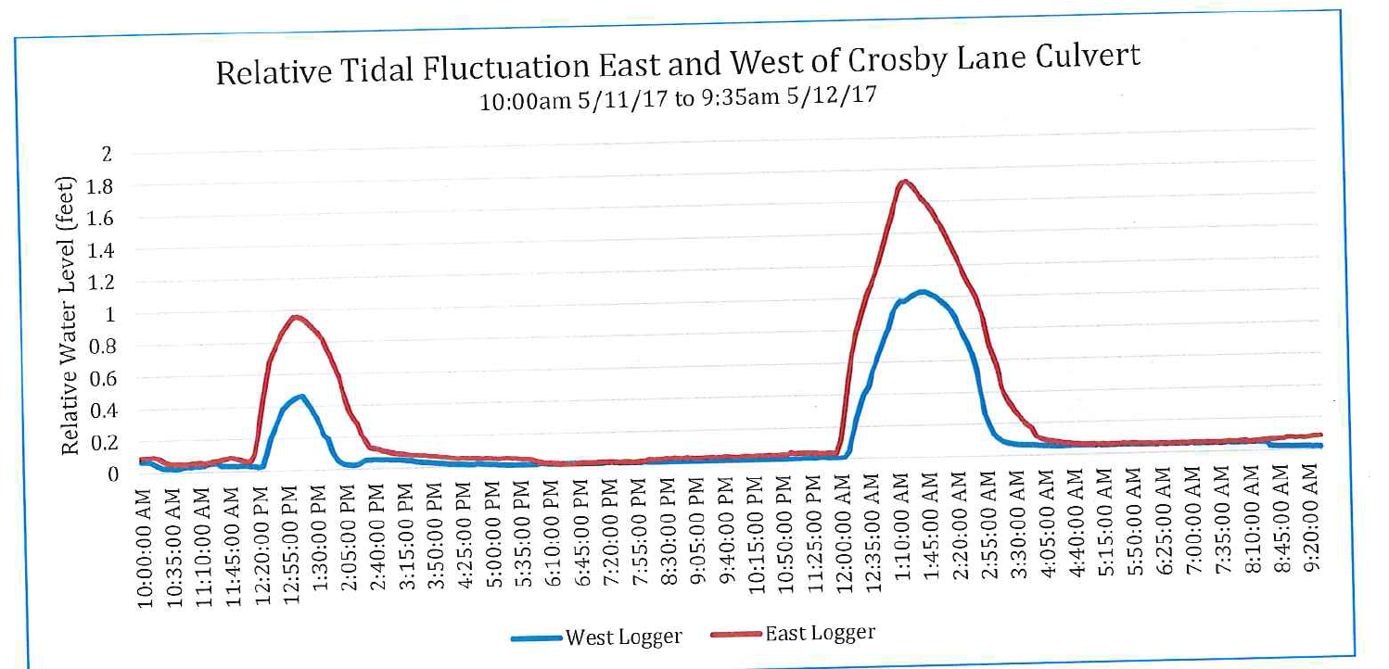
Figure 1. Tidal changes in water depth, east and west of undersized culvert under Crosby Lane
(Town of Brewster, 2017)

Summary of Massachusetts Freshwater Beaches Bacteria Data (2017)
Bacteria (enterococci) were sampled in Cliff Pond and Flax Pond in the Little Namskaket / Namskaket Creek Watersheds in Brewster, Massachusetts in 2017 on a weekly basis. Summary data provided by MA DOH (2017) indicate that both beaches experienced two single sample exceedances resulting in 3 days of beach closures. The minimum and maximum exceedance for Cliff Pond was reported as 72 cfu / 100 mL and 236 cfu / 100 mL, respectively. The minimum and maximum exceedance for Flax Pond was reported as 82 cfu / 100 mL and 114 cfu / 100 mL, respectively.

Summary of Brewster Pond and Lake Stewards Water Quality Data (2001-2007)
The Brewster Ponds and Lake Stewards (PALs) program collected water quality data on 29 ponds between 2001 and 2007. Data were subsequently analyzed and summarized by Eichner (2008). Of those 29 ponds, four are in the Little Namskaket / Namskaket Creek Watersheds (i.e., study area) in Brewster: Cliff Pond, Little Cliff Pond, Flax Pond, and Owl Pond. The follow general findings were noted relative to summary data for key water quality parameters:
- Dissolved Oxygen (DO): DO data were presented for each pond at approximate 0.5-meter depth increments relative to State DO thresholds for warm-water ponds of 5 mg/L (314 CMR 4). Findings indicate that all four ponds in the study area except for Little Cliff Pond exceeded the 5 mg/L threshold for at least one measurement. Exceedances were generally from deeper measurements and not near the surface.
- Total Phosphorus (TP): Average TP concentrations collected between June and September for each pond at approximate 0.5-meter increments were presented relative to the Cape Cod TP threshold for “healthy pond” ecosystems (10 µg/L per Eichner and others, 2003). Findings indicate that all four ponds in the study area except for Little Cliff and Flax exceeded the 10 µg/L threshold for at least one measurement; however, it should be noted that TP concentrations were relatively low relative to the 25 µg/L Goldbook Standard (EPA, 1986). All four ponds had average TP measurements of less than 25 µg/L at all depths except for their deepest depth.
- Trophic Status Index (TSI): TSI values were calculated for each pond base on surface chlorophyll a concentration from data collected between June and September. Findings indicate that Cliff Pond and Owl Pond are classified as Mesotrophic while Little Cliff Pond and Flax Pond are classified as Oligotrophic.

Summary of Integrated Water Resources Management Plan (2013)
In 2009, the Town of Brewster, through its Comprehensive Water Planning Committee (CWPC), embarked on a project to develop an Integrated Water Resource Management Plan (IWRMP). In 2011, the Town completed Phase I of the project that documents existing water quality conditions for the Town’s public supply wells, fresh water ponds and coastal waters. The Horsley Witten Group (HW, 2013) was hired to perform the Phase II work in December 2011. The goals of Phase II were to:
- Analyze the extent of nitrogen reduction needed to protect and restore Pleasant Bay, with a focus on septic system management as the largest source of nitrogen to the Bay;
- Evaluate current and future water quality conditions for the Town’s public supply wells and also determine if there is sufficient water available for potable uses based on future growth in town;
- Conduct a preliminary retrofit analysis to identify stormwater improvements that will provide water quality treatment and reduce impacts on receiving waters, and identify improvements to the Town’s regulations to better manage stormwater across the Town; and
- Further evaluate fresh water pond impacts in town, and make recommendations for how the Town and pond shore residents can minimize phosphorus inputs to the ponds that have a direct impact on water quality.
Results and tasks of this study are wide ranging. For example, a pond health assessment was performed. Findings indicate that all ponds in the Little Namskaket / Namskaket Creek Watersheds (i.e., study area – Cliff Pond, Flax Pond, Owl Pond, Little Cliff Pond) have some level of impairment except for Little Cliff Pond. Current threats to the ponds are associated with phosphorus, the nutrient that feeds excess algae and plant growth in freshwater ponds. Sources include septic systems near pond shorelines, lawn fertilizers applied adjacent to the ponds (especially if applied right before it rains), and runoff from roads, driveways and parking lots. Refer to HW (2013) for more details from this study.

Element A: Identify Causes of Impairment & Pollution Sources
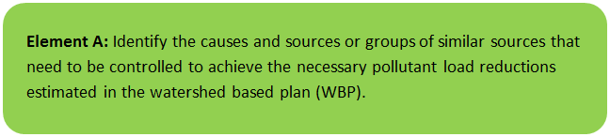

General Watershed Information
The Namskaket Creek / Little Namskaket Creek Estuary and surrounding watershed is located in the Towns of Brewster and Orleans and comprises an area of approximately 2,518 acres (See Table A-1 and Figure A-1). The watershed contains six freshwater ponds, including Flax Pond, Higgins Pond, and Cliff Pond (MA96039). The shoreline of the Namskaket Creek/Little Namskaket Creek estuary is characterized by extensive tidal flats, eelgrass beds, and shorebird/shellfish habitat. Salt marsh surrounds the streams and estuarine waterbodies near the shore (Figure A-2). Wastewater discharge to groundwater is a predominant stressor in the region, with several permitted facilities located in the assessment area (Figure A-3). The area is sparsely developed except for the vicinity of the Rt. 6/Rt. 6A intersection (MACZM, 2017).
Table A-1: General Watershed Information
Watershed Name (Assessment Unit ID): | Namskaket Creek/Little Namskaket Creek (MA96039, MA96-27, MA96-26)
Major Basin: | Cape Cod
Watershed Area: | 2518 (ac)

This WBP focuses specifically on the Namskaket Creek portion of the watershed located in Brewster. This area of Brewster contains high-quality coastal waters, habitat, and resources. These include an Outstanding Resource Water (ORW) that protects the Inner Cape Cod Bay Area of Critical Environmental Concern (ACEC); brackish marsh and salt marsh; BioMap core habitat; priority habitat of rare species; and a state-designated barrier beach and coastal dune. Nearby tidal flats on Cape Cod Bay provide highly productive shellfish growing area and are regularly open for recreational shellfishing. The salt marsh provides important habitat for fish and wildlife, absorbs pollutants, reduces storm damage due to storm surges and flooding, and increases coastal resilience. Namskaket salt marsh is a nitrogen sink that helps to reduce nitrogen loading to coastal waters (Town of Brewster, 2017). Given these factors, the watershed is classified with a “low” water threat level (Cape Cod Commission, 2017); however, it should be noted that there are still water quality impairments and stressors of concern as discussed in Section A.3 and depicted by Figure A-3.
Note that a large proportion of the watershed is located within Nickerson State Park which is owned and operated by MA DCR. Nickerson State Park encompasses Cliff Pond, Flax Pond, Little Cliff Pond, and Higgins Pond. Additional areas of the watershed are operated by MA DOT, including Route 6 and Route 6A. For this reason, MA DCR and MA DOT have been included as stakeholders for this WBP (see Introduction).

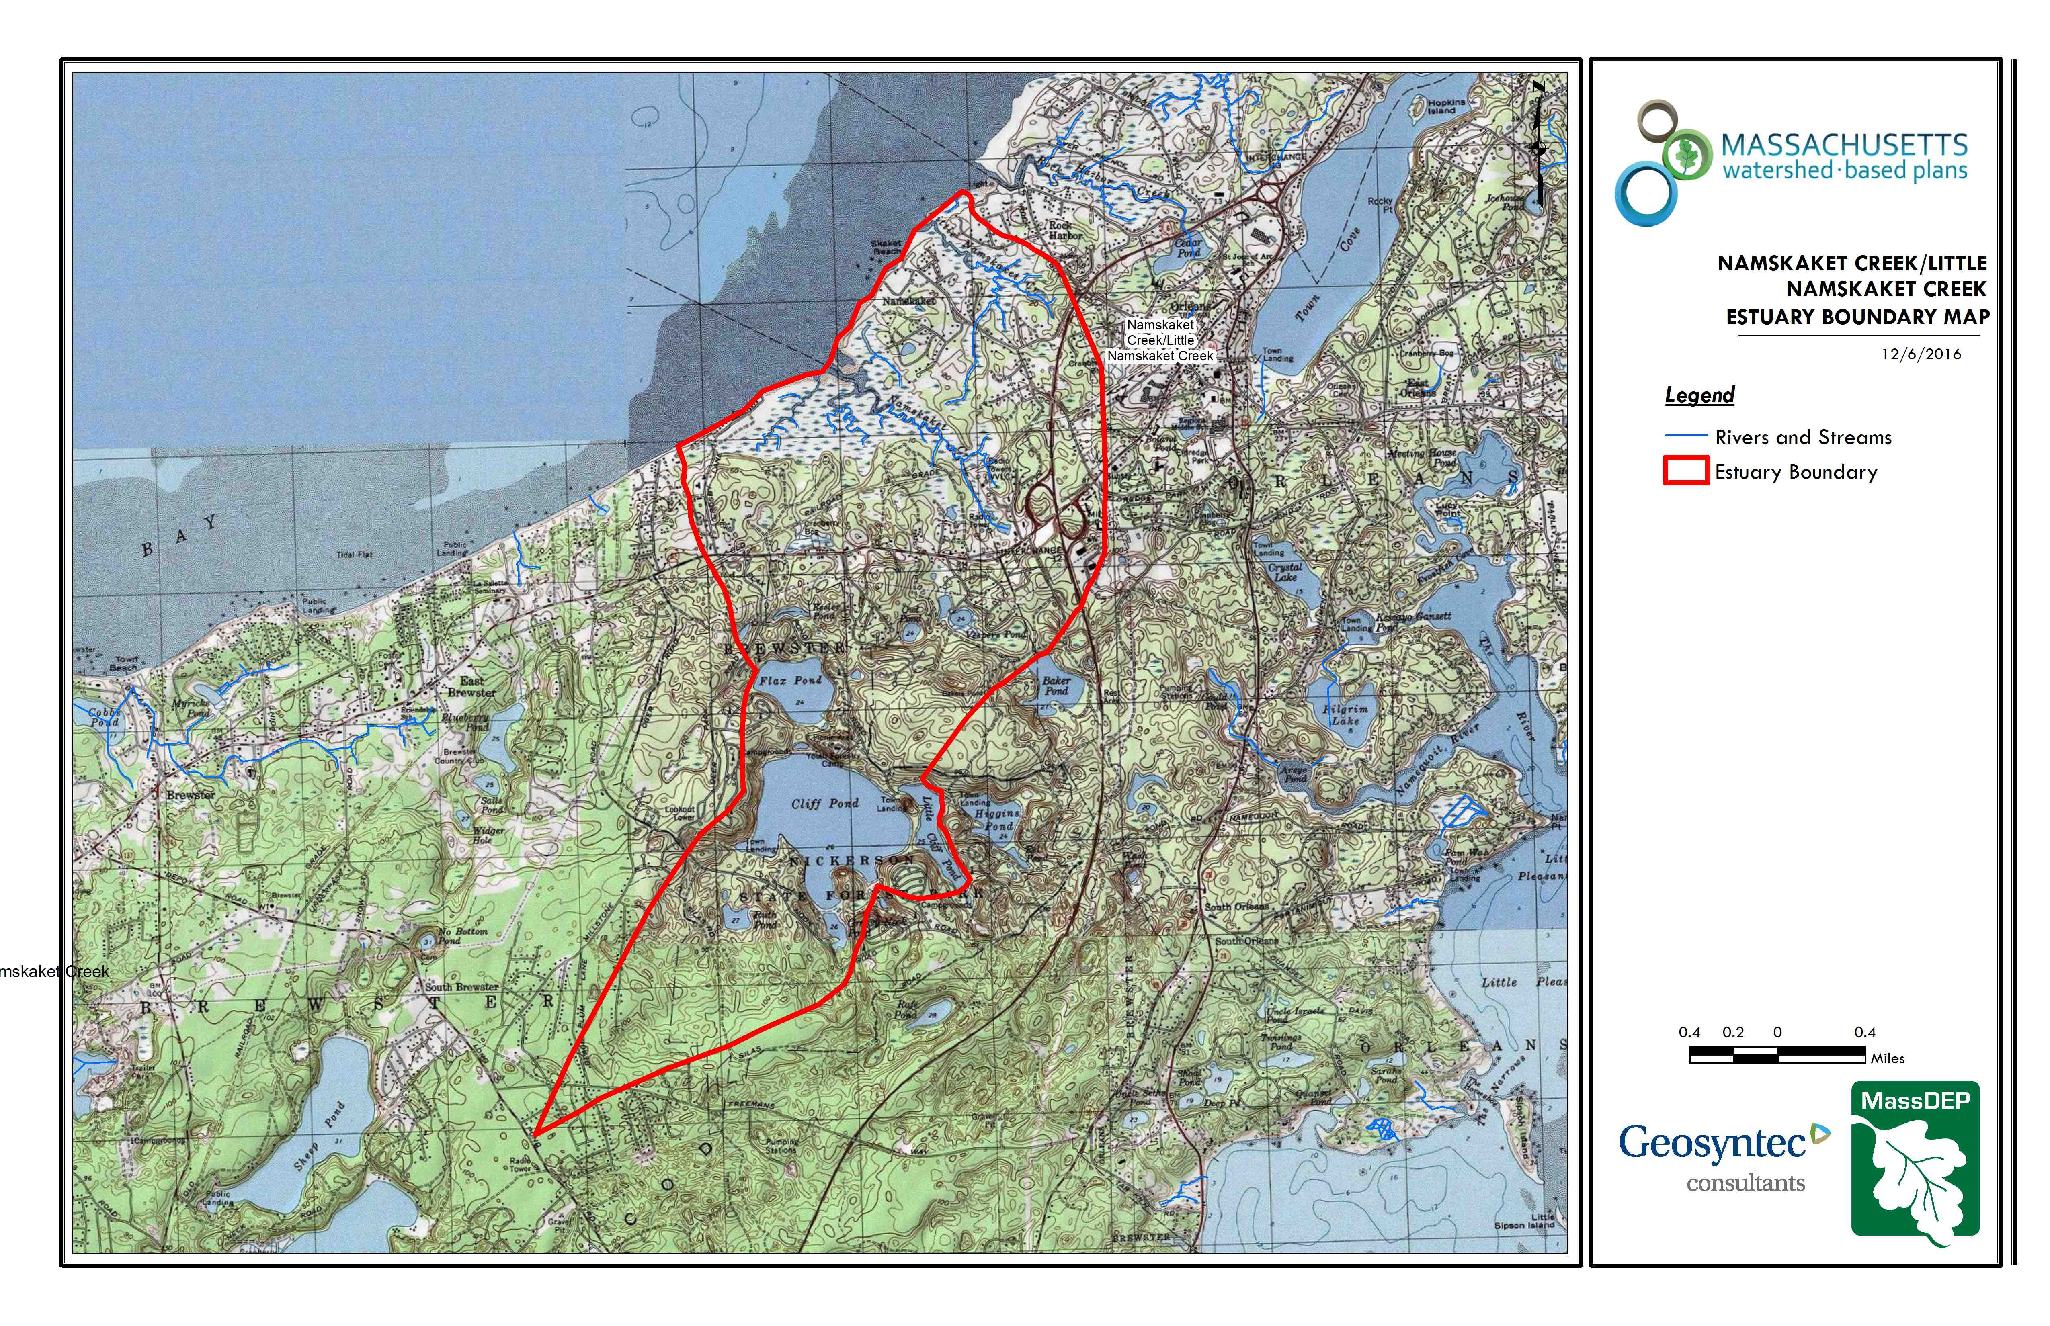
Namskaket Creek
Little Namskaket Creek
Figure A-1: Watershed Boundary Map
(MassGIS, 2007; MassGIS, 1999; MassGIS, 2001; USGS, 2016)
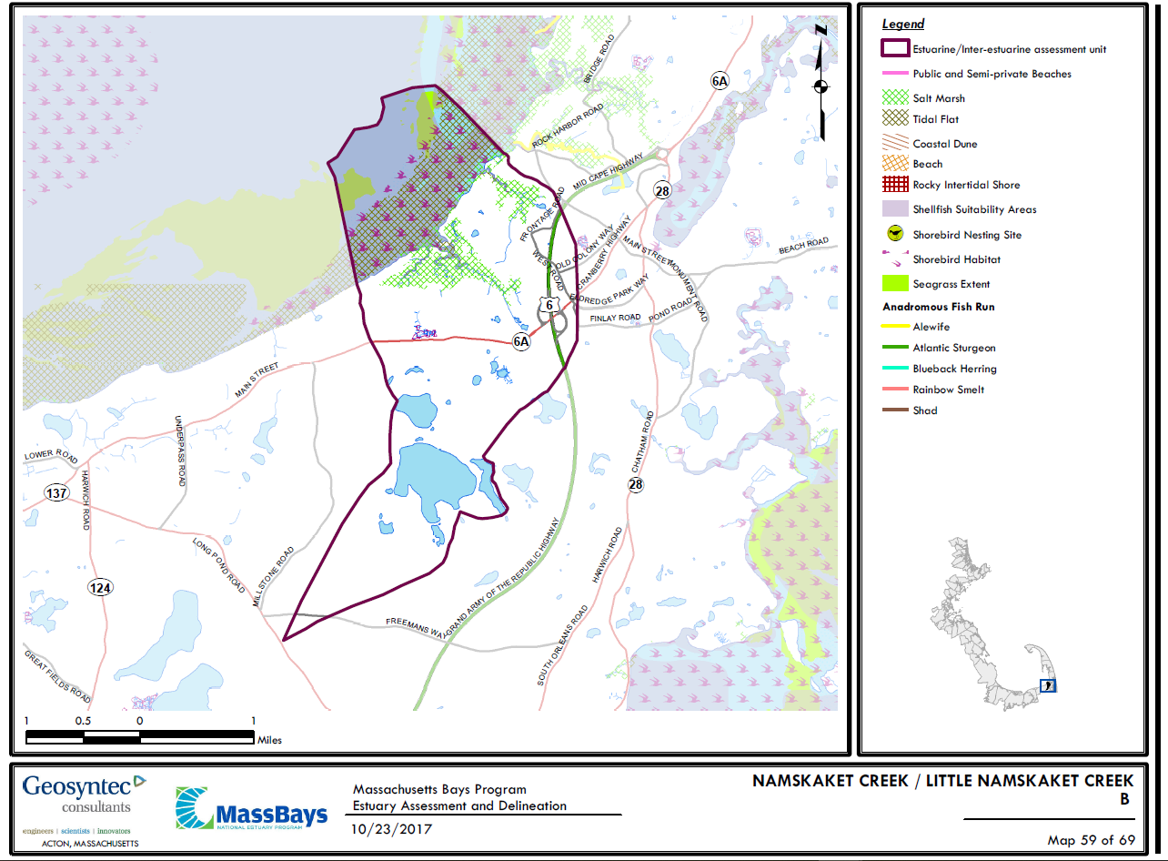

Figure A-2. Resources within Watershed Boundary
(MACZM, 2017)
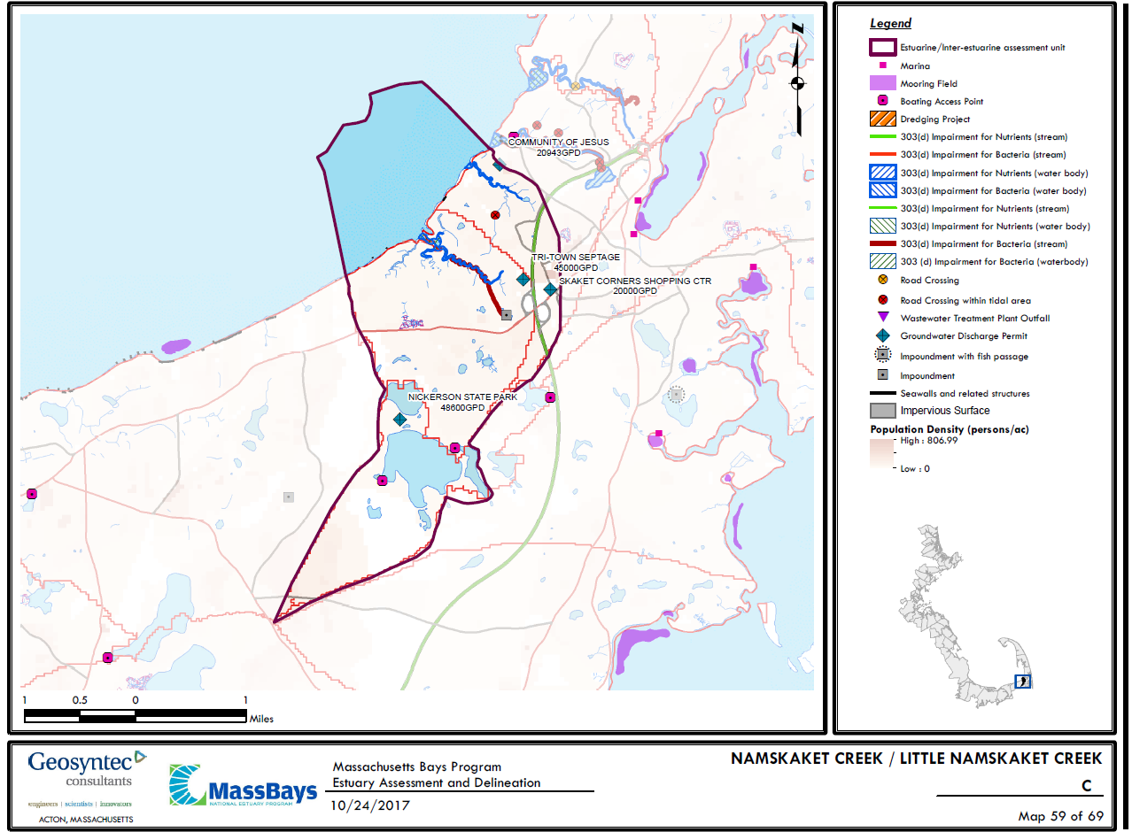
Figure A-3. Stressors within Watershed Boundary
(MACZM, 2017)

MassDEP Water Quality Assessment Report and TMDL Review
The following reports are available:
- Cape Cod Coastal Drainage Areas 2004 - 2008 Surface Water Quality Assessment Report
- Final Pathogen TMDL for the Cape Cod Watershed August 2009

Cape Cod Coastal Drainage Areas 2004 - 2008 Surface Water Quality Assessment Report (MA96-27 - Namskaket Creek / MA96-26 - Little Namskaket Creek )
NOTE: RELEVANT INFORMATION IS INCLUDED DIRECTLY FROM 2004-2008 REPORT FOR INFORMATIONAL PURPOSES AND HAS NOT BEEN MODIFIED.
Habitat: According to the Massachusetts Estuaries Project final report for the Little Namskaket Marsh Estuarine System (UMass Dartmouth SMAST and MassDEP 2008a), “The Little Namskaket Estuary is showing high habitat quality throughout its salt marsh reach. The upper reach appears to be a fully functional tidal salt marsh with deeply incised narrow creeks surrounded by extensive emergent marsh. This reach is typical of New England "pocket" marshes, with smaller tidal creeks and a marsh plain dominated by low marsh and high marsh plant communities with patches of fringing brackish marsh vegetation. The lower reach of the central tidal creek supports bordering marsh plain that is similar to, but less expansive than, the upper tidal reach. The lower tidal reach is influenced by sand transport via nearshore coastal processes associated with adjacent Cape Cod Bay. Plant communities in the lower reach are similar to the upper reach except that there is less fringing brackish water species and the marsh grades to barrier beach/dune vegetation near the tidal inlet. All of the key habitat indicators support the assessment that Little Namskaket Marsh, and particularly its tidal creeks, are supporting high quality habitat relative to the system’s salt marsh structure and function.”

Biology: The infauna surveys were conducted at three sites along Little Namskaket Creek (UMass Dartmouth SMAST and MassDEP 2008a). According to the final report “The communities within the upper reach had moderate to high numbers of individuals, and low species numbers, with lower numbers of individuals and species within the transitional environment of the lower reach…The communities generally contained some organic enrichment tolerant species. However, species like Capitella and Streblospio, typically observed in impaired embayment habitats…did not dominate. The communities were composed of polychaetes, crustaceans and mollusks, with polychaetes being the predominant taxa…The absence of macroalgal accumulations and algal mats within the creek bottoms were also indicative of healthy conditions “(UMass Dartmouth SMAST and MassDEP 2008a).

It is best professional judgement that the Aquatic Life Use be assessed as support for Little Namskaket Creek based on the indicators of healthy habitat and biological conditions described in the Massachusetts Estuary Project final report (UMass Dartmouth SMAST and MassDEP 2008a).

Shellfish Harvesting Use: The MA Division of Marine Fisheries Shellfish Status Report of October 2009 indicates that this segment area (CCB19.0) is Prohibited for shellfish harvesting (MA DFG 2009).

The Shellfish Harvesting Use is assessed as impaired because the segment is Prohibited for shellfish harvesting. Based on the pathogen TMDL (MassDEP, USEPA Region 1, and ENSR 2009) these restrictions are likely due to elevated fecal coliform bacteria counts associated with waterfowl and/or stormwater discharges from the municipal stormwater systems.

Primary and Secondary Contact Recreational and Aesthetics Uses: Frequent testing for Enterococci bacteria during the swimming seasons was conducted at Skaket Beach in Orleans located along a shoreline at the mouth of Little Namskaket Creek from 2002 – 2007 (MA DPH 2009a). The beach was only posted once in 2003 and twice in 2004.

The Primary and Secondary Contact Recreational uses are assessed as support for Little Namskaket Creek since posting of Skaket Beach in Orleans has been neither frequent nor prolonged. The Aesthetics Use in not assessed due to the absence of data.

Report Recommendations: N/A

Cape Cod Coastal Drainage Areas 2004 - 2008 Surface Water Quality Assessment Report (MA96039 - Cliff Pond)
NOTE: RELEVANT INFORMATION IS INCLUDED DIRECTLY FROM 2004-2008 REPORT FOR INFORMATIONAL PURPOSES AND HAS NOT BEEN MODIFIED.
Fish Consumption Use: Fish from Cliff Pond were collected and analyzed in 2001 as part of the Cape Cod Commission study (Michaud 2008). Species collected included largemouth bass, smallmouth bass, and yellow perch. Although mercury was highly elevated in the individual largemouth bass sample, MA DPH does not typically issue advisories based on individual fish samples. Fish from Cliff Pond were also collected by MassDEP biologists in May 2009 (Maietta et al. 2010). Mercury concentrations in composite samples of smallmouth bass, brown bullhead, yellow perch, and white sucker were all below the MA DPH trigger level of 0.5 mg/kg (Appendix B, Table B10).

Since no site-specific fish consumption advisory was issued by the MA DPH, the Fish Consumption Use is not assessed for Cliff Pond.

Primary and Secondary Contact Recreational and Aesthetics Uses: There are several public bathing beaches along the shoreline of Cliff Pond. Currently there is uncertainty associated with the accurate reporting of freshwater beach closure information to the MA DPH which is required as part of the Beaches Bill. Therefore no Primary Contact Recreational Use assessment (either support or impairment) decisions are being made using Beaches Bill data for this waterbody. It should be noted, however, that there was a cyanobacteria bloom that occurred in Cliff Pond in 2009 which is of concern.

Too limited data are available so the Primary and Secondary Contact Recreational and Aesthetics Uses are not assessed. These uses are identified with an Alert Status however because of the cyanobacteria bloom which occurred in the pond in 2009.

Report Recommendations: Support improvement of freshwater Beaches Bill data quality and reporting. Continue to obtain information regarding any cyanobacteria bloom(s) (extent, frequency, duration) in Cliff Pond to better evaluate the status of the Recreational and Aesthetics uses.

Water Quality Impairments
Namskaket Creek and Little Namskaket Creek are both listed under Category 4A on the Massachusetts List of Integrated Waters for pathogens (fecal coliform). The potential sources of the impairment, as assessed by MassDEP, include MS4 discharges, waterfowl, and other unknown sources. The Final Pathogen TMDL for the Cape Cod Watershed, including Namskaket and Little Namskaket Creek, was completed in 2009 (MassDEP, 2009). According to the Cape Cod Commission (2017), all lines of evidence indicate that the estuary has not exceeded its threshold nitrogen level for assimilating additional nitrogen without impairment. Impairment categories from the Massachusetts DEP (2012) Integrated List of Waters are listed in Table A-2. Known impairments are provided in Table A-3.
Although not listed on the MA Integrated List of Waters, past studies summarized in the “Introduction” section of this WBP indicate that all freshwater ponds in the study watershed (Cliff Pond, Little Cliff Pond, Flax Pond, Owl Pond) except for Little Cliff Pond have some level of impairment. Impairments based on past water quality data are attributed to bacteria exceedances, elevated phosphorus levels, and low dissolved oxygen levels (Eichner, 2008; MA DOH, 2017). According to Horsley Witten (2013), current threats to the ponds are associated with phosphorus, the nutrient that feeds excess algae and plant growth in fresh water ponds. Sources include septic systems near pond shorelines, lawn fertilizers applied adjacent to the ponds (especially if applied right before it rains), and runoff from roads, driveways and parking lots.
Table A-2: 2012 MA Integrated List of Waters Categories
Integrated List Category | Description
1 | Unimpaired and not threatened for all designated uses.
2 | Unimpaired for some uses and not assessed for others.
3 | Insufficient information to make assessments for any uses.
4 | Impaired or threatened for one or more uses, but not requiring calculation of a Total Maximum Daily Load (TMDL), including:  4a: TMDL is completed  4b: Impairment controlled by alternative pollution control requirements  4c: Impairment not caused by a pollutant - TMDL not required
5 | Impaired or threatened for one or more uses and requiring preparation of a TMDL.

Table A-3: Water Quality Impairments
Assessment  Unit ID | Waterbody | Integrated  List  Category | Designated Use | Impairment Cause | Impairment Source
MA96-26 | Little Namskaket Creek | 4A | Shellfish Harvesting | Fecal Coliform | Discharges from Municipal Separate Storm Sewer Systems (MS4)
MA96-26 | Little Namskaket Creek | 4A | Shellfish Harvesting | Fecal Coliform | Waterfowl
MA96-27 | Namskaket Creek | 4A | Shellfish Harvesting | Fecal Coliform | Source Unknown

Water Quality Goals
Water quality goals may be established for a variety of purposes, including the following:
a.) For water bodies with known impairments, a Total Maximum Daily Load (TMDL) is established by MassDEP and the United States Environmental Protection Agency (USEPA) as the maximum amount of the target pollutant that the waterbody can receive and still safely meet water quality standards. If the waterbody has a TMDL for total phosphorus (TP) or total nitrogen (TN), or total suspended solids (TSS), that information is provided below and included as a water quality goal.
b.) For water bodies without a TMDL for total phosphorus (TP), a default water quality goal for TP is based on target concentrations established in the Quality Criteria for Water (USEPA, 1986) (also known as the “Gold Book”). The Gold Book states that TP should not exceed 50 ug/L in any stream at the point where it enters any lake or reservoir, nor 25 ug/L within a lake or reservoir. For the purposes of developing WBPs, MassDEP has adopted 50 ug/L as the TP target for all streams at their downstream discharge point, regardless of which type of water body the stream discharges to.
c.) Massachusetts Surface Water Quality Standards (314 CMR 4.00, 2013) prescribe the minimum water quality criteria required to sustain a waterbody’s designated uses. Namskaket Creek/Little Namskaket Creek is a Class 'SA' waterbody. The water quality goal for bacteria is based on the Massachusetts Surface Water Quality Standards (Table A-4).
Table A-4: Surface Water Quality Classification by Assessment Unit ID
Assessment  Unit ID | Waterbody | Class
MA96039 | Cliff Pond | B
MA96-26 | Little Namskaket Creek | SA
MA96-27 | Namskaket Creek | SA

d.) Other water quality goals set by the community (e.g., protection of high quality waters, in-lake phosphorus concentration goal to reduce recurrence of cyanobacteria blooms, etc.).
Refer to Table A-5 for a list of water quality goals. Water quality goals are primarily focused on protecting existing good water quality in the estuary (i.e., nitrogen), improving water quality in the freshwater ponds (i.e., phosphorus), and working to address requirements of the pathogen TMDL for bacteria. Phosphorus goals are based on previously described criteria (USEPA, 1986). Nitrogen goals are based on site-specific criteria from the nearby Stage Harbor System in Chatham as required by MA surface water quality standards. Bacteria goals are based on MA surface water quality standards and the existing pathogen TMDL.
Table A-5: Water Quality Goals
Pollutant | Goal | Source
Total Nitrogen (TN) | Total nitrogen within the estuary should not exceed 38 µg/L. | Massachusetts Surface Water Quality Standards (314 CMR 4.00, 2013) – Site Specific Criteria (Table 28)
Total Phosphorus (TP) | Total phosphorus within freshwater systems should not exceed:  --50 ug/L in any stream  --25 ug/L within any lake or reservoir | Quality Criteria for Water (USEPA, 1986)
Bacteria | Class B Standards  • Public Bathing Beaches: For E. coli, geometric mean of 5 most recent samples shall not exceed 126 colonies/ 100 ml and no single sample during the bathing season shall exceed 235 colonies/100 ml. For enterococci, geometric mean of 5 most recent samples shall not exceed 33 colonies/100 ml and no single sample during bathing season shall exceed 61 colonies/100 ml;  • Other Waters and Non-bathing Season at Bathing Beaches: For E. coli, geometric mean of samples from most recent 6 months shall not exceed 126 colonies/100 ml (typically based on min. 5 samples) and no single sample shall exceed 235 colonies/100 ml. For enterococci, geometric mean of samples from most recent 6 months shall not exceed 33 colonies/100 ml, and no single sample shall exceed 61 colonies/100 ml. | Massachusetts Surface Water Quality Standards (314 CMR 4.00, 2013)
Bacteria | Class SA Standards  • Waters Designated for Shellfishing: Fecal coliform shall not exceed a geometric mean Most Probable Number (MPN) of 14 organisms/100 ml, nor shall more than 10% of the samples exceed a MPN of 28/100 ml (or other values of equivalent protection used by MA Division of Marine Fisheries).  • Public Bathing Beaches: No single enterococci sample during the bathing season shall exceed 104 colonies/100 ml, and the geometric mean of the 5 most recent samples during the same bathing season shall not exceed a geometric mean of 35 colonies/100 ml.  • Other Waters and Non-bathing Season at Bathing Beaches: No single enterococci sample shall exceed 104 colonies/100 ml and the geometric mean of all samples from most recent 6 months (typically based on a min. of 5 samples) shall not exceed 35 colonies/100 ml. | Massachusetts Surface Water Quality Standards (314 CMR 4.00, 2013)
Note: There may be more than one water quality goal for bacteria due to different Massachusetts Surface Water Quality Standards Classes for different Assessment Units within the watershed.

Land Use Information
Land use information and impervious cover is presented by the below tables and figures. Land use source data is from 2005 and was obtained from MassGIS (2009b).
Watershed Land Uses
As summarized by Table A-6, land use in the watershed is mostly forested (approximately 66 percent); approximately 18 percent of the watershed is residential; and approximately 22 percent of the watershed is open water. Most development in the watershed is limited to the northwestern corner, adjacent to the Namskaket Creek Estuary (See Figure A-4).
Table A-6: Watershed Land Uses
Land Use | Area (acres) | % of Watershed
Agriculture | 24.86 | 1
Commercial | 65.38 | 2.6
Forest | 1668.92 | 66.3
High Density Residential | 24.27 | 1
Highway | 0 | 0
Industrial | 47.62 | 1.9
Low Density Residential | 442.24 | 17.6
Medium Density Residential | 52.51 | 2.1
Open Land | 192.2 | 7.6
Water | 548.75 | 21.8

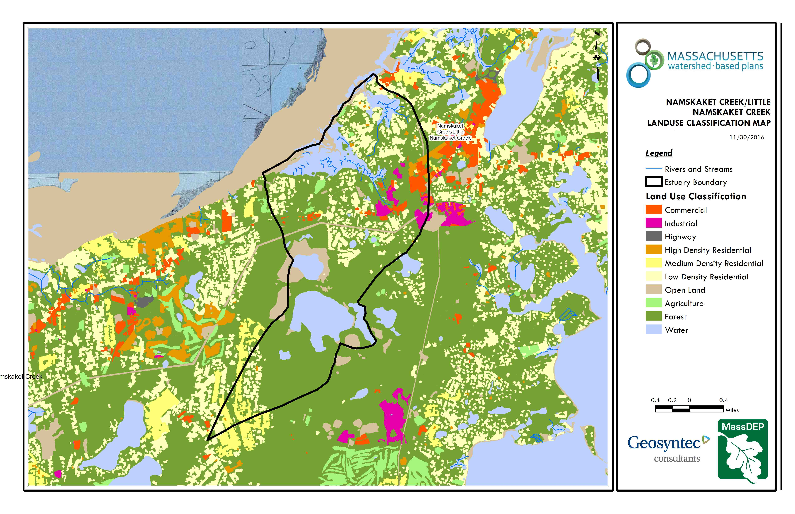
Little Namskaket Creek
Namskaket Creek
Figure A-4: Watershed Land Use Map
(MassGIS, 2007; MassGIS, 2009b; MassGIS, 1999; MassGIS, 2001; USGS, 2016)

Watershed Impervious Cover
Most the watershed’s Total Impervious Area (TIA) is located to the north (Figure A-5). Impervious cover includes land surfaces that prevent the infiltration of water into the ground, such as paved roads and parking lots, roofs, basketball courts, etc. There is a strong link between impervious land cover and stream water quality. Impervious areas that are directly connected (DCIA) to receiving waters (via storm sewers, gutters, etc.) produce higher runoff volumes and transport stormwater pollutants with greater efficiency than disconnected impervious cover areas which are surrounded by vegetated, pervious land. Runoff volumes from disconnected impervious cover areas are reduced as stormwater infiltrates when it flows across adjacent pervious surfaces.
DCIA for the watershed was calculated based on the Sutherland equations. USEPA provides guidance (USEPA, 2010) on the use of the Sutherland equations to predict relative levels of connection and disconnection based on the type of stormwater infrastructure within the TIA of a watershed. Any reduction in impervious area due to disconnection (i.e., the area difference between TIA and DCIA) was assigned to the pervious D soil category for that land use to simulate that some infiltration will likely occur after runoff from disconnected impervious surfaces passes over pervious surfaces. The estimated TIA and DCIA in the watershed is summarized below.
Estimated TIA in the watershed: 13.3%
Estimated DCIA in the watershed: 9.6 %

The relationship between TIA and water quality can generally be categorized as listed by Table A-7 (Schueler et al. 2009). The TIA in the watershed is approximately 13.3%; therefore, surrounding streams (i.e., the outlet) can be expected to show fair to good water quality.
Table A-7: Relationship between Total Impervious Area (TIA) and water quality (Schueler et al. 2009)
% Watershed  Impervious Cover | Stream Water Quality
0-10% | Typically high quality, and typified by stable channels, excellent habitat structure, good to excellent water quality, and diverse communities of both fish and aquatic insects.
11-25% | These streams show clear signs of degradation. Elevated storm flows begin to alter stream geometry, with evident erosion and channel widening. Streams banks become unstable, and physical stream habitat is degraded. Stream water quality shifts into the fair/good category during both storms and dry weather periods. Stream biodiversity declines to fair levels, with most sensitive fish and aquatic insects disappearing from the stream.
26-60% | These streams typically no longer support a diverse stream community. The stream channel becomes highly unstable, and many stream reaches experience severe widening, downcutting, and streambank erosion. Pool and riffle structure needed to sustain fish is diminished or eliminated and the substrate can no longer provide habitat for aquatic insects, or spawning areas for fish. Biological quality is typically poor, dominated by pollution tolerant insects and fish. Water quality is consistently rated as fair to poor, and water recreation is often no longer possible due to the presence of high bacteria levels.
>60% | These streams are typical of “urban drainage”, with most ecological functions greatly impaired or absent, and the stream channel primarily functioning as a conveyance for stormwater flows.

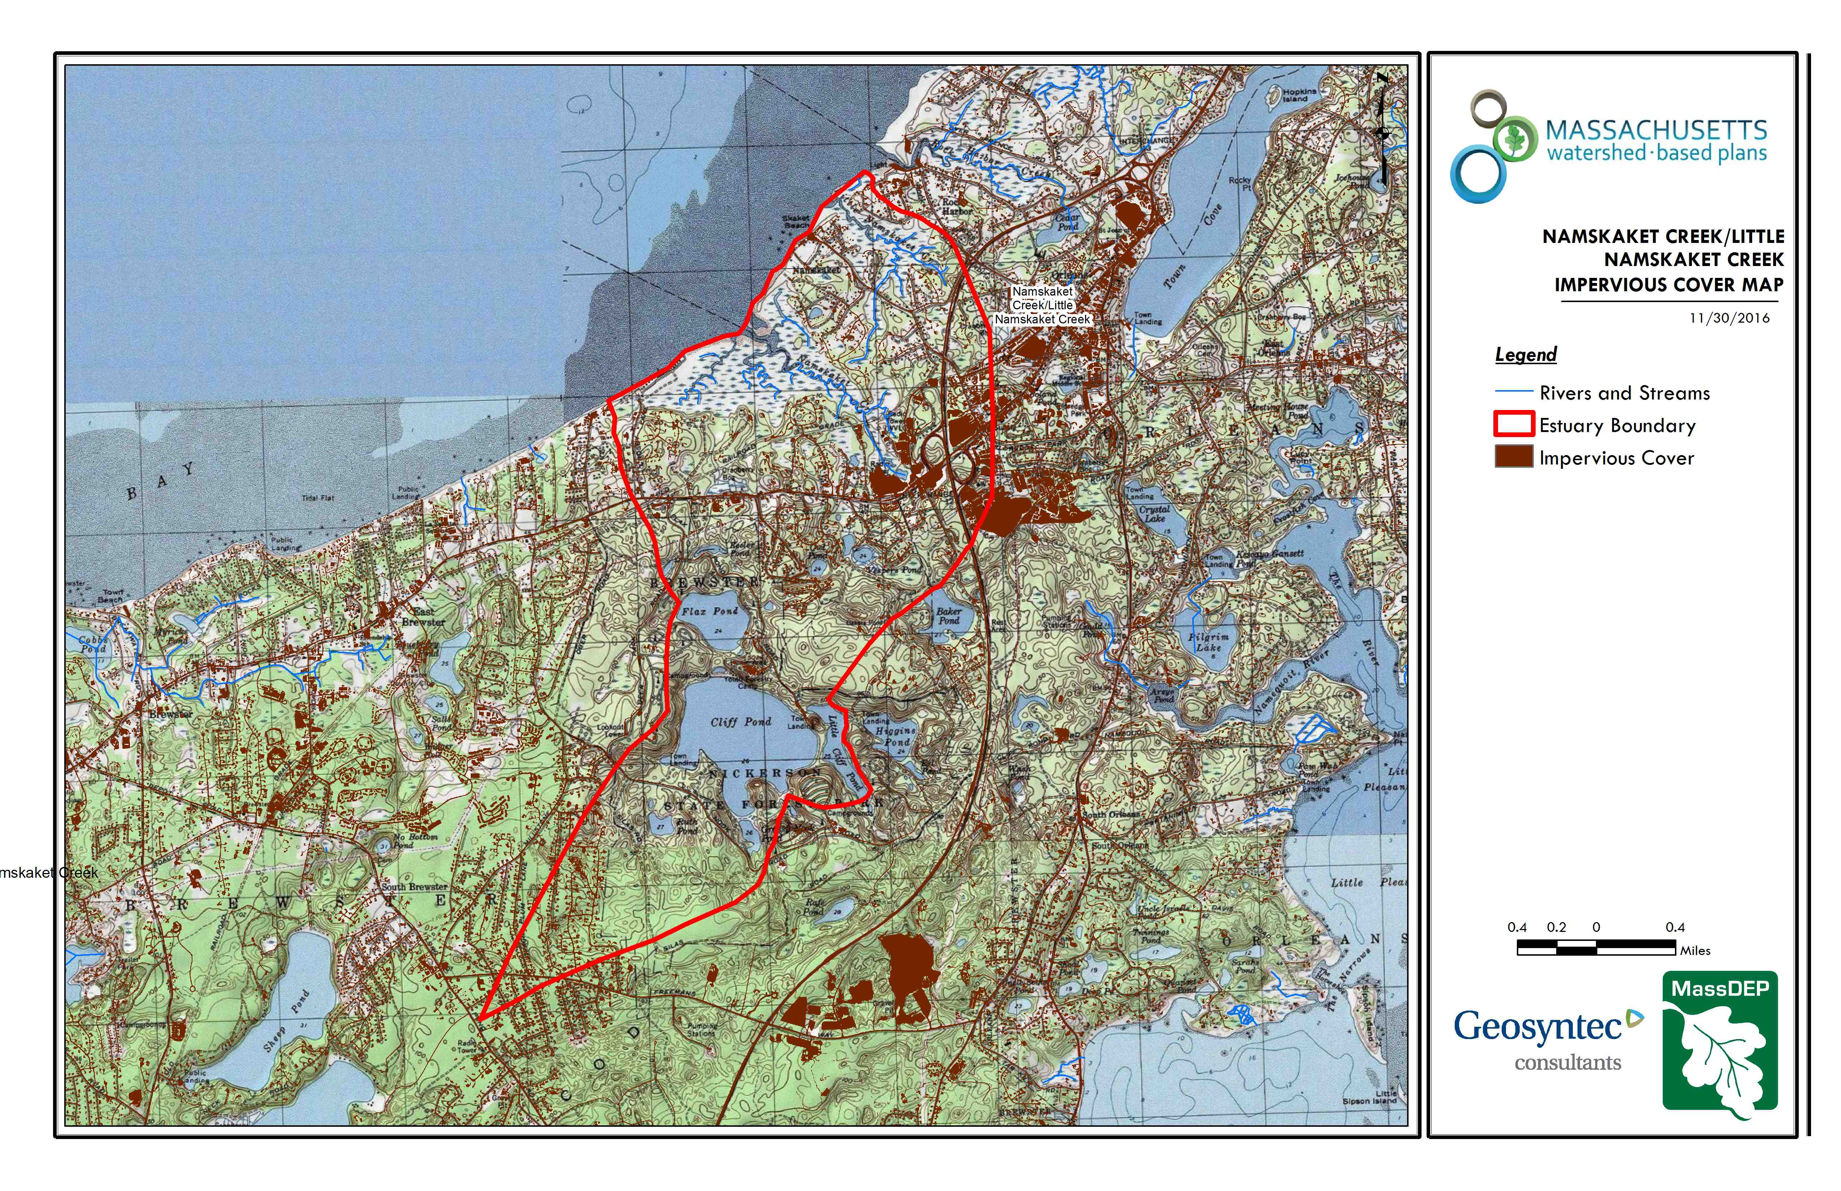
Little Namskaket Creek
Namskaket Creek
Figure A-5: Watershed Impervious Surface Map
(MassGIS, 2007; MassGIS, 2009b; MassGIS, 1999; MassGIS, 2001; USGS, 2016)

Pollutant Loading
The land use data (MassGIS, 2009b) was intersected with impervious cover data (MassGIS, 2009a) and United States Department of Agriculture (USDA) Natural Resources Conservation Service (NRCS) soils data (USDA NRCS and MassGIS, 2012) to create a combined land use/land cover grid. The grid was used to sum the total area of each unique land use/land cover type.
The amount of DCIA was estimated using the Sutherland equations as described above and any reduction in impervious area due to disconnection (i.e., the area difference between TIA and DCIA) was assigned to the pervious D soil category for that land use to simulate that some infiltration will likely occur after runoff from disconnected impervious surfaces passes over pervious surfaces.
Pollutant loading for key nonpoint source pollutants in the watershed was estimated by multiplying each land use/cover type area by its pollutant load export rate (PLER). The PLERs are an estimate of the annual total pollutant load exported via stormwater from a given unit area of a particular land cover type. The PLER values for TN, TP and TSS were obtained from USEPA (Voorhees, 2016b) (see documentation provided in Appendix A) as follows:
L_{n} = A_{n} * P_{n}
Where L_{n} = Loading of land use/cover type n (lb/yr); A_{n} = area of land use/cover type n (acres); P_{n} = pollutant load export rate of land use/cover type n (lb/acre/yr)

Table A-8: Estimated Pollutant Loading for Key Nonpoint Source Pollutants
Land Use Type | Pollutant Loading¹
 | Total  Phosphorus (TP)  (lbs/yr) | Total  Nitrogen (TN)  (lbs/yr) | Total  Suspended Solids (TSS)  (tons/yr)
Agriculture | 14 | 91 | 1.66
Commercial | 82 | 703 | 8.80
Forest | 293 | 1,660 | 44.58
High Density Residential | 21 | 144 | 2.13
Highway | 0 | 0 | 0.00
Industrial | 62 | 531 | 6.64
Low Density Residential | 154 | 1,523 | 21.42
Medium Density Residential | 24 | 189 | 2.80
Open Land | 48 | 371 | 8.04
TOTAL | 699 | 5,212 | 96.07
¹These estimates do not consider loads from point sources or septic systems.

Element B: Determine Pollutant Load Reductions Needed to Achieve Water Quality Goals
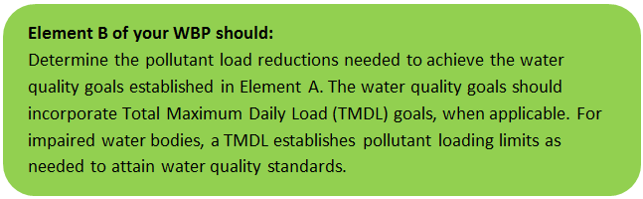

Estimated Pollutant Loads
Estimated pollutant loads for total phosphorus (TP) (699 lbs/yr), total nitrogen (TN) (5,212 lbs/yr), and total suspended solids (TSS) (96.07 tons/yr) were previously presented in Section A.6 of this WBP.

Water Quality Goals
There are many methodologies that can be used to set pollutant load reduction goals for a WBP. Goals can be based on water quality criteria, surface water standards, existing monitoring data, existing TMDL criteria, or other data. As discussed by Section A.4, water quality goals for this WBP are focused on protecting existing good water quality in the estuary (i.e., TN), improving water quality in freshwater ponds (i.e., TP), and working to address requirements of the existing pathogen TMDL.

The following adaptive sequence is recommended to establish and track water quality goals:
- Establish an interim goal to reduce phosphorus loading to freshwater ponds by 10 pounds and nitrogen loading to the estuary by 70 pounds over the next 5 years (by 2024) to protect and improve existing water quality.
- Establish a baseline water quality monitoring program in accordance with Element I. Results from the monitoring program should advise if Element C management measures are effective at improving water quality over time.
- Establish long-term goals to further reduce phosphorus and/or nitrogen loading if necessary, based on monitoring results.
- Ultimate goal is to improve existing water quality in the watershed while delisting Namskaket Creek and Little Namskaket Creek from the 303(d) list for bacteria.

Table B-1: Pollutant Load Reductions Needed
Pollutant | Existing Estimated Total Load | Water Quality Goal | Planned Load Reduction
Total Phosphorus | 699 lbs/yr | 689 | 10
Total Nitrogen | 5212 lbs/yr | 5142 | 70
Bacteria | N/A – Concentration Based | Class SA. Class SA Standards  • Waters Designated for Shellfishing: Fecal coliform shall not exceed a geometric mean Most Probable Number (MPN) of 14 organisms/100 ml, nor shall more than 10% of the samples exceed a MPN of 28/100 ml (or other values of equivalent protection used by MA Division of Marine Fisheries).  • Public Bathing Beaches: No single enterococci sample during the bathing season shall exceed 104 colonies/100 ml, and the geometric mean of the 5 most recent samples during the same bathing season shall not exceed a geometric mean of 35 colonies/100 ml.  • Other Waters and Non-bathing Season at Bathing Beaches: No single enterococci sample shall exceed 104 colonies/100 ml and the geometric mean of all samples from most recent 6 months (typically based on a min. of 5 samples) shall not exceed 35 colonies/100 ml. | Concentration Based (Final Pathogen TMDL for the Cape Cod Watershed August 2009)

Element C: Describe management measures that will be implemented to achieve water quality goals
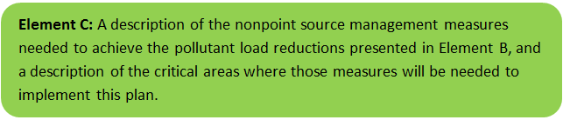

Current and Ongoing Management Measures
The Town of Brewster was awarded funding through the Fiscal Year 2018 Section 319 Nonpoint Source Pollution Grant Program to treat stormwater runoff from Crosby Lane and Crosby Landing Beach parking lot through installation of a bioretention cell with a sediment forebay and vegetated swales. An additional goal of the project is to restore tidal flow and salt marsh by replacing an undersized 12-inch culvert under Crosby Lane with a 5-foot by 5-foot box culvert. It is anticipated that the bioretention cell will result in an annual load reduction of 601 pounds of TSS, 6 pounds of TN, 1 pound of TP, and a 70% bacteria removal efficiency (Town of Brewster, 2017). BMPs were planned during a previous grant and are now in the process of final design and construction. Refer to Appendix B for selected sheets of the 75% design plans from the previous grant.

The Town of Brewster is also in the process of designing a new underground infiltration BMP on Upper Crosby Road. Sizing characteristics and anticipated pollutant load removals will be incorporated into a future version of the WBP once design is complete.

Future Management Measures
As discussed by Section B.2, it is recommended that future planning and implementation of management measures in the watershed primarily focus on protecting existing good water quality in the estuary (i.e., TN) and freshwater ponds (i.e., TP) while working to address requirements of the existing pathogen TMDL. It is recommended that management measures be initially planned to protect existing water quality by reducing TP loading by 10 pounds and TN loading by 70 pounds by 2024, while working to reduce bacteria concentrations throughout the watershed in accordance with TMDL criteria. To achieve these goals, a combination of structural and non-structural BMPs are recommended.

Structural BMPs
Bacteria removal efficiency amongst structural BMPS is currently not well understood and can vary widely based on BMP type and location-specific factors. Research indicates that certain BMP types, such as bioretention cells and sand filters, are effective at reducing bacteria concentrations; presumably due to their lack of exposed standing water, filtration of sediment-bound pathogens, and other factors (Hathaway and Hunt, 2008). Other research indicates that while some BMPs, such as retention basins and grass swales, are typically not effective at reducing bacteria concentrations, they may help reduce runoff volumes and frequency (thereby indirectly reducing bacteria loading) (Clary et al, 2007).
The following general sequence is recommended to identify and implement structure BMPs throughout the watershed.
- Identify Potential Implementation Locations: Perform a desktop analysis using aerial imagery and GIS data to develop a preliminary list of potentially feasible implementation locations based on soil type (i.e. hydrologic soil groups A and B); available public open space (e.g., lawn area in front of a police station); and other factors such as proximity to receiving waters, known problem areas, or publicly owned right of ways or easements. Additional analysis can also be performed to fine-tune locations to maximize pollutant removals such as performing loading analysis on specifically delineated subwatersheds draining to single outfalls and selecting those subwatersheds with the highest loading rates per acre.
- Visit Potential Implementation Locations: Perform field reconnaissance, preferably during a period of active runoff-producing rainfall, to evaluate potential implementation locations, gauge feasibility, and identify potential BMP ideas. During field reconnaissance, assess identified locations for space constraints, potential accessibility issues, presence of mature vegetation that may cause conflicts (e.g., roots), potential utility conflicts, site-specific drainage patterns, and other factors that may cause issues during design, construction, or long-term maintenance.
- Develop BMP Concepts: Once potential BMP locations are conceptualized, use the BMP-selector tool of the watershed based planning tool to help develop concepts. Concepts can vary widely. One method is to develop 1-page fact sheets for each concept that includes a site description, definition of the problem, a description of the proposed BMPs, annotated site photographs with conceptual BMP design details, and a discussion of potential conflicts such as property ownership, O&M requirements, and permitting constraints. The fact sheet can also include information obtained from the BMP-selector tool, such as cost estimates, load reduction estimates, and sizing information (i.e., BMP footprint, drainage area, etc.).
- Rank BMP Concepts: Once BMP concepts are developed, perform a priority ranking based on site-specific factors to identify the implementation order. Ranking can include many factors including cost, expected pollutant load reductions, implementation complexity, potential outreach opportunities and visibility to public, accessibility, expected operation and maintenance effort, and others.

Non-Structural BMPs
Planned BMPs can also be non-structural and can include practices such as street sweeping and catch basin cleaning to reduce TSS, TN, and TP loading; as well as Illicit Discharge Detection and Elimination (IDDE) to reduce bacteria concentrations. The 2016 Massachusetts Small MS4 General Permit includes requirements for implementation of street sweeping, catch basin cleaning, and IDDE programs. It is recommended that these municipal programs be evaluated and potentially optimized. First, it is recommended that potential removals from ongoing activities be calculated in accordance with Element HI. Next, it is recommended that ongoing activities be evaluated to see if potential improvements can be implemented to achieve higher pollutant load reductions such as increased frequency or improved technology. For example, by implementing microbial source tracking protocols to track and eliminate bacteria sources at key outfalls to the estuary.

Element D: Identify Technical and Financial Assistance Needed to Implement Plan
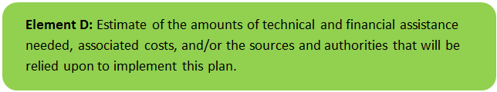

Current and Ongoing Management Measures
The funding needed to implement the proposed management measures presented in this watershed plan is based on estimates from the Crosby Lane Stormwater Treatment and Salt Marsh Restoration Section 319 Nonpoint Source Pollution Grant Program application (Town of Brewster, 2017) as summarized by Table D-1.

Table D-1: Summary of Proposed BMP Costs
Task/Objective | Cost
Engineering and Permitting | $36,600
Construction | $340,000
Outreach and Monitoring | $12,985
Project Management and Reporting | $4,700
Total | $394,285

Future Management Measures
Funding for future BMP installations to further reduce loads within the watershed may be provided by a variety of sources, such as the Section 319 Nonpoint Source Pollution Grant Program, town capital funds, or other grant programs such as hazard mitigation funding. Guidance is available to provide additional information on potential funding sources for nonpoint source pollution reduction efforts.

Element E: Public Information and Education
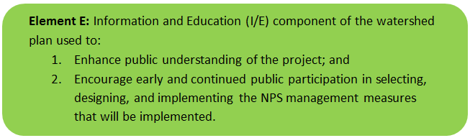

Step 1: Goals and Objectives
The goals and objectives for the watershed information and education program.
- Provide information about proposed improvements and their anticipated water quality benefits.
- Provide information to promote watershed stewardship.
Step 2: Target Audience
Target audiences that need to be reached to meet the goals and objectives identified above.
- All watershed residents.
- Businesses within the watershed.
- Watershed organizations and other user groups.
Step 3: Outreach Products and Distribution
The outreach product(s) and distribution form(s) that will be used for each.
- Hold public meeting to present proposed BMPs.
- Post public meeting presentation and Element H&I monitoring results to Town website.
- Install permanent signage at parking lot to describe stormwater BMP and tidal culvert improvements
Step 4: Evaluate Information/Education Program
Information and education efforts and how they will be evaluated.
- Track attendance at public meeting.
- Track webpage activity (i.e. number of unique visitors).

Additional outreach products will be determined when future management measures and activities are planned for implementation in the watershed. This section of the WBP will be updated when the plan is re-evaluated in 2022 in accordance with Element F&G.

Elements F & G: Implementation Schedule and Measurable Milestones
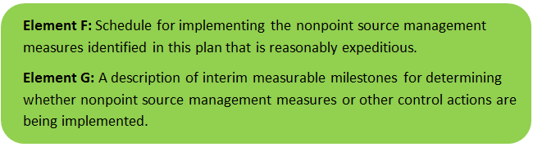

Table FG-1 provides a preliminary schedule for implementation of recommendations provided by this WBP. It is expected that the WBP will be re-evaluated and updated in 2022, or as needed, based on ongoing monitoring results and other ongoing efforts.
Table FG-1: Implementation Schedule and Interim Measurable Milestones
Category | Action | Year(s)
Monitoring | Establish written sampling procedures and water quality monitoring program in accordance with Element H&I. | 2020
 | Perform annual water quality sampling per QAPP. | Annual
Structural BMPs | Complete installation of BMPs at Crosby Lane. | 2020
 | Obtain funding and implement 2-3 additional BMPs within the subwatershed. | 2022
 | Obtain funding and implement 2-3 additional BMPs within the MS4 subwatershed. | 2024
 | Obtain funding and implement 2-3 additional BMPs within the MS4 subwatershed. | 2026
Nonstructural BMPs | Document potential pollutant removals and bacteria concentration reductions from ongoing non-structural BMP practices (i.e., street sweeping, catch basin cleaning, IDDE). | 2020
 | Evaluate ongoing non-structural BMP practices and determine if modifications can be made to optimize pollutant removals (e.g., increase frequency). | 2021
 | Routinely implement optimized non-structural BMP practices and track progress. | Annual
Public Education and Outreach | Hold public meeting to present proposed BMPs. | 2020
 | Post public meeting presentation and Element H&I monitoring results to Town website. | 2020
 | Install permanent signage at parking lot to describe stormwater BMP and tidal culvert improvements. | 2020
 | Plan for additional outreach measures. | 2022
Adaptive Management  and Plan Updates | Establish working group comprised of stakeholders and other interested parties to implement recommendations and track progress. Meet at least twice per year. | 2020
 | Re-evaluate Watershed Based Plan at least once every three (3) years and adjust, as needed, based on ongoing efforts (e.g., based on monitoring results, 319 funding, etc.). | 2022
 | Reach interim goal to reduce TP and TN by 10 pounds and 70 pounds per year, respectively. | 2024
 | Reach long-term goal to de-list watershed from the 303(d) list for bacteria. | 2029
 | Maintain healthy watershed and water quality

Elements H & I: Progress Evaluation Criteria and Monitoring
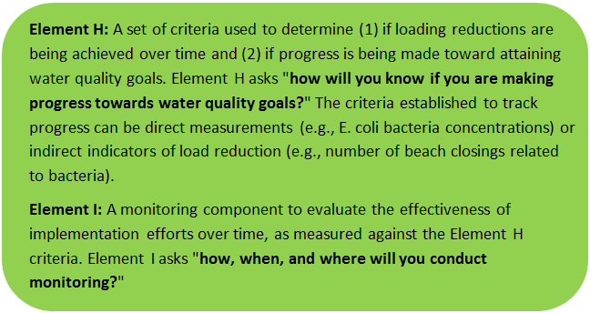 | 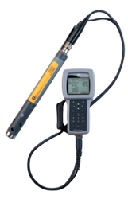

The water quality target concentrations are presented by Element A of this plan. To achieve these target concentrations, the annual loading must be reduced to the amount described in Element B. Element C of this plan describes the various management measures that will be implemented to achieve targeted load reductions. The evaluation criteria and monitoring program described below will be used to measure the effectiveness of the proposed management measures in improving the water quality of Namskaket and Little Namskaket Creek.

Indirect Indicators of Load Reduction
Non-structural BMPs: Potential load reductions from non-structural BMPs (i.e., street sweeping, catch basin cleaning, IDDE) can be estimated from indirect indicators, such as the number of miles of streets swept or the number of catch basins cleaned. Appendix F of the 2016 Massachusetts Small MS4 General Permit provides specific guidance for calculating phosphorus removal from these practices. As indicated by Element C, it is recommended that potential phosphorus removal from these ongoing actives be estimated. Next, it is recommended that ongoing activities be evaluated to see if potential improvements can be implemented to achieve higher pollutant load reductions such as increased frequency or improved technology.
Phosphorus load reductions can be estimated in accordance with Appendix F of the 2016 Massachusetts Small MS4 General Permit as summarized by Figure HI-1 and HI-2. Additionally, since there is a bacteria TMDL in the study area, it is recommended that IDDE efforts required by the NPDES Small MS4 Permit be tracked.

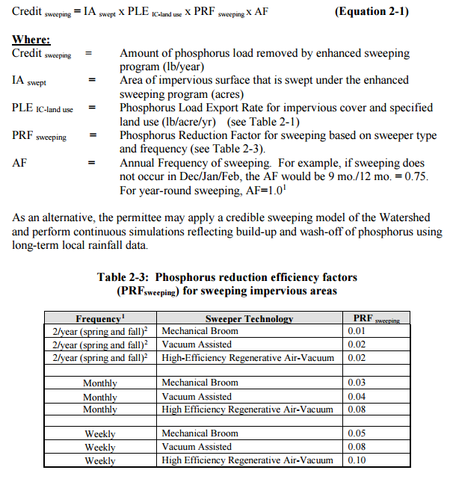
Figure HI-1. Street Sweeping Calculation Methodology
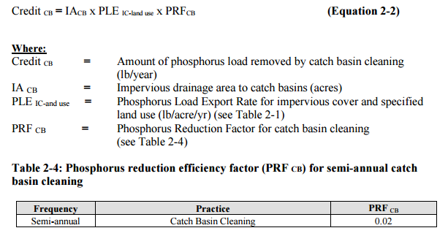
Figure HI-2. Catch Basin Cleaning Calculation Methodology

Project-Specific Indicators
Number of BMPs Installed and Pollutant Reduction Estimates: Anticipated pollutant load reductions from existing, ongoing (i.e. under construction), and future BMPs will be tracked as BMPs are installed. Once ongoing BMPs are installed, the anticipated phosphorus and nitrogen load reduction is estimated to be 2 and 14 pounds per year, respectively.
Direct Measurements
Direct measurements are generally expected to be performed as described below. Prior to implementing a direct measurement program, written Standard Operating Procedures (SOPs) will be established to flesh out details of the monitoring program(s) and establish best practices for sample collection and analysis. Water quality monitoring may be performed through a volunteer training program to save on costs in accordance with established practices for MassDEP’s environmental monitoring for volunteers. Water quality monitoring procedures may also build on past efforts such as the PALS program (see Introduction for summary).
Estuary Monitoring: Continue regular sampling as performed by APCC (Town of Brewster, 2017). Consider expanding estuary sampling program to additional strategic locations in accordance with MassDEP guidance, including channels within the estuary and stormwater outfall discharge points. Sampling parameters may include, but are not limited to, water level, salinity, dissolved oxygen, pH, nutrients, and bacteria.
Pond Monitoring: Consider developing a sampling program for primary contributing ponds within the watershed (i.e., Cliff Pond, Flax Pond, Higgins Pond) to enable tracking of improvements over time. Monitoring locations may include the pond outlets, primary tributaries (inflows), and the deepest “in-lake” location. Perform sampling at least three times per year: once in the spring (late April/early May, once in mid-summer (early to mid-July), and once in late-summer (early- to mid- September). Sampling parameters can include nutrients (nitrogen and phosphorus), dissolved oxygen, temperature, chlorophyll-a, and bacteria (i.e., e. coli and enterococcus). These parameters will enable tracking relative to Carlson’s Trophic State Index to evaluate improvements over time.
Adaptive Management
This WBP, including interim and long-term goals, will be re-evaluated at least once every three years and adaptively adjusted based on additional monitoring results and other indirect indicators. Management measures will be re-evaluated if monitoring results and indirect indicators do not show improvement.

References
314 CMR 4.00 (2013). "Division of Water Pollution Control, Massachusetts Surface Water Quality Standards".
Cape Cod Commission (2017). “Watershed Repot for Namskaket Creek (Brewster & Orleans)”.
Clary, J.C., Jones J.E., Quigley, M.Q., and Strecker, E.S. (2007). “Can Stormwater BMPs Remove Bacteria? New Findings from the International Stormwater BMP Database.”
Cohen, A. J.; Randall, A.D. (1998). "Mean annual runoff, precipitation, and evapotranspiration in the glaciated northeastern United States, 1951-80." Prepared for United States Geological Survey, Reston VA.
Eichner, E. (2008). “Brewster Freshwater Ponds: Water Quality Status and Recommendations for Future Activities.” Coastal Systems Program, School for Marine Science and Technology, University of Massachusetts Dartmouth and Cape Cod Commission. New Bedford and Barnstable, MA. 98 pp.
Hathaway, J.M. and Hunt, B.H. (2008) “Removal of Pathogens in Stormwater”.
Horsley Witten Group (2013). Town of Brewster Phase II Integrated Water Resource Management Plan.
Geosyntec Consultants, Inc. (2014). "Least Cost Mix of BMPs Analysis, Evaluation of Stormwater Standards Contract No. EP-C-08-002, Task Order 2010-12." Prepared for Jesse W. Pritts, Task Order Manager, U.S. Environmental Protection Agency.
Geosyntec Consultants, Inc. (2015). "Appendix B: Pollutant Load Modeling Report, Water Integration for the Squamscott-Exeter (WISE) River Watershed."
King, D. and Hagan, P. (2011). "Costs of Stormwater Management Practices in Maryland Counties." University of Maryland Center for Environmental Science Chesapeake Biological Laboratory. October 11, 2011.
Leisenring, M., Clary, J., and Hobson, P. (2014). "International Stormwater Best Management Practices (BMP) Database Pollutant Category Statistical Summary Report: Solids, Bacteria, Nutrients and Metals." Geosyntec Consultants, Inc. and Wright Water Engineers, Inc. December 2014.
MADOH (2017). “Massachusetts Beach Testing Results: Annual Report Data.”
MACZM (2017). “Massachusetts Bay National Estuary Program Estuary Delineation and Assessment 2.0”
MassDEP (2009). “Final Pathogen TMDL for the Cape Cod Watershed August 2009”.
MassDEP (2012). "Massachusetts Year 2012 Integrated List of Waters Final Listing of Massachusetts' Waters Pursuant to Sections 305(b), 314 and 303(d) of the Clean Water Act".
MassDEP (2016a). "Massachusetts Clean Water Toolkit".
MassDEP (2016b). "Massachusetts Stormwater Handbook, Vol. 2, Ch. 2, Stormwater Best Management Practices".
MassGIS (1999). "Networked Hydro Centerlines" Shapefile.
MassGIS (2001). "USGS Topographic Quadrangle Images" Image.
MassGIS (2007). "Drainage Sub-basins" Shapefile.
MassGIS (2009a). "Impervious Surface" Image.
MassGIS (2009b). "Land Use (2005)" Shapefile.
MassGIS (2013). "MassDEP 2012 Integrated List of Waters (305(b)/303(d))" Shapefile.
Schueler, T.R., Fraley-McNeal, L, and K. Cappiella (2009). "Is impervious cover still important? Review of recent research" Journal of Hydrologic Engineering 14 (4): 309-315.
Town of Brewster, Department of Public Works (2017). “Proposal for Crosby Lane Stormwater Treatment and Salt Marsh Restoration Project, Inner Cape Cod Bay ACEC.” Application for FFY 2018 s.319 Grant Funding, BRP-RFR-2017-06-319.
United States Bureau of Labor Statistics (2016). "Consumer Price Index".
United States Geological Survey (2016). "National Hydrography Dataset, High Resolution Shapefile".
University of Massachusetts, Amherst (2004). "Stormwater Technologies Clearinghouse".
USDA NRCS and MassGIS (2012). "NRCS SSURGO-Certified Soils" Shapefile.
USEPA (1986). "Quality Criteria for Water (Gold Book)" EPA 440/5-86-001. Office of Water, Regulations and Standards. Washington, D.C.
USEPA. (2010). "EPA's Methodology to Calculate Baseline Estimates of Impervious Area (IA) and Directly Connected Impervious Area (DCIA) for Massachusetts Communities."
Voorhees, Mark, USEPA. (2015). "FW: Description of additional modelling work for Opti-Tool Project" Message to Chad Yaindl, Geosyntec Consultants. 23 April 2015. E-mail.
Voorhees, Mark, USEPA. (2016a). "FW: EPA Region 1 SW BMP performance equations" Message to Chad Yaindl, Geosyntec Consultants. 25 January 2016. E-mail.
Voorhees, Mark, USEPA. (2016b). "FW: Description of additional modelling work for Opti-Tool Project" Message to Chad Yaindl, Geosyntec Consultants. 23 April 2015. E-mail.

Water Quality Assessment Reports
"Cape Cod Coastal Drainage Areas 2004 - 2008 Surface Water Quality Assessment Report".

Appendices
Appendix A – Pollutant Load Export Rates (PLERs)
Land Use & Cover¹ | PLERs (lb/acre/year)
 | (TP) | (TSS) | (TN)
AGRICULTURE, HSG A | 0.45 | 7.14 | 2.59
AGRICULTURE, HSG B | 0.45 | 29.4 | 2.59
AGRICULTURE, HSG C | 0.45 | 59.8 | 2.59
AGRICULTURE, HSG D | 0.45 | 91.0 | 2.59
AGRICULTURE, IMPERVIOUS | 1.52 | 650 | 11.3
COMMERCIAL, HSG A | 0.03 | 7.14 | 0.27
COMMERCIAL, HSG B | 0.12 | 29.4 | 1.16
COMMERCIAL, HSG C | 0.21 | 59.8 | 2.41
COMMERCIAL, HSG D | 0.37 | 91.0 | 3.66
COMMERCIAL, IMPERVIOUS | 1.78 | 377 | 15.1
FOREST, HSG A | 0.12 | 7.14 | 0.54
FOREST, HSG B | 0.12 | 29.4 | 0.54
FOREST, HSG C | 0.12 | 59.8 | 0.54
FOREST, HSG D | 0.12 | 91.0 | 0.54
FOREST, HSG IMPERVIOUS | 1.52 | 650 | 11.3
HIGH DENSITY RESIDENTIAL, HSG A | 0.03 | 7.14 | 0.27
HIGH DENSITY RESIDENTIAL, HSG B | 0.12 | 29.4 | 1.16
HIGH DENSITY RESIDENTIAL, HSG C | 0.21 | 59.8 | 2.41
HIGH DENSITY RESIDENTIAL, HSG D | 0.37 | 91.0 | 3.66
HIGH DENSITY RESIDENTIAL, IMPERVIOUS | 2.32 | 439 | 14.1
HIGHWAY, HSG A | 0.03 | 7.14 | 0.27
HIGHWAY, HSG B | 0.12 | 29.4 | 1.16
HIGHWAY, HSG C | 0.21 | 59.8 | 2.41
HIGHWAY, HSG D | 0.37 | 91.0 | 3.66
HIGHWAY, IMPERVIOUS | 1.34 | 1,480 | 10.2
INDUSTRIAL, HSG A | 0.03 | 7.14 | 0.27
INDUSTRIAL, HSG B | 0.12 | 29.4 | 1.16
INDUSTRIAL, HSG C | 0.21 | 59.8 | 2.41
INDUSTRIAL, HSG D | 0.37 | 91.0 | 3.66
INDUSTRIAL, IMPERVIOUS | 1.78 | 377 | 15.1
LOW DENSITY RESIDENTIAL, HSG A | 0.03 | 7.14 | 0.27
LOW DENSITY RESIDENTIAL, HSG B | 0.12 | 29.4 | 1.16
LOW DENSITY RESIDENTIAL, HSG C | 0.21 | 59.8 | 2.41
LOW DENSITY RESIDENTIAL, HSG D | 0.37 | 91.0 | 3.66
LOW DENSITY RESIDENTIAL, IMPERVIOUS | 1.52 | 439 | 14.1
MEDIUM DENSITY RESIDENTIAL, HSG A | 0.03 | 7.14 | 0.27
MEDIUM DENSITY RESIDENTIAL, HSG B | 0.12 | 29.4 | 1.16
MEDIUM DENSITY RESIDENTIAL, HSG C | 0.21 | 59.8 | 2.41
MEDIUM DENSITY RESIDENTIAL, HSG D | 0.37 | 91.0 | 3.66
MEDIUM DENSITY RESIDENTIAL, IMPERVIOUS | 1.96 | 439 | 14.1
OPEN LAND, HSG A | 0.12 | 7.14 | 0.27
OPEN LAND, HSG B | 0.12 | 29.4 | 1.16
OPEN LAND, HSG C | 0.12 | 59.8 | 2.41
OPEN LAND, HSG D | 0.12 | 91.0 | 3.66
OPEN LAND, IMPERVIOUS | 1.52 | 650 | 11.3
¹HSG = Hydrologic Soil Group

Appendix B – Proposed BMPs (Town of Brewster, 2017)
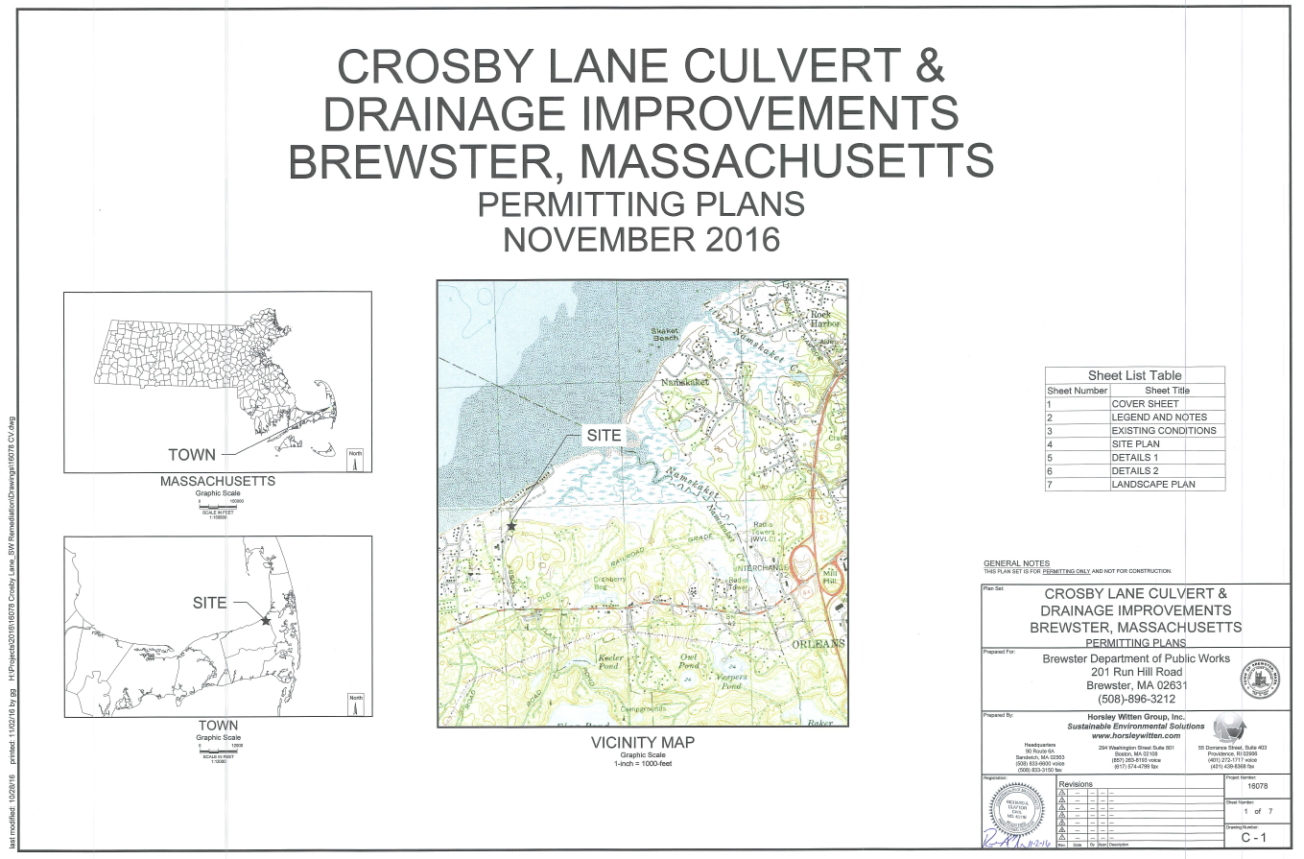
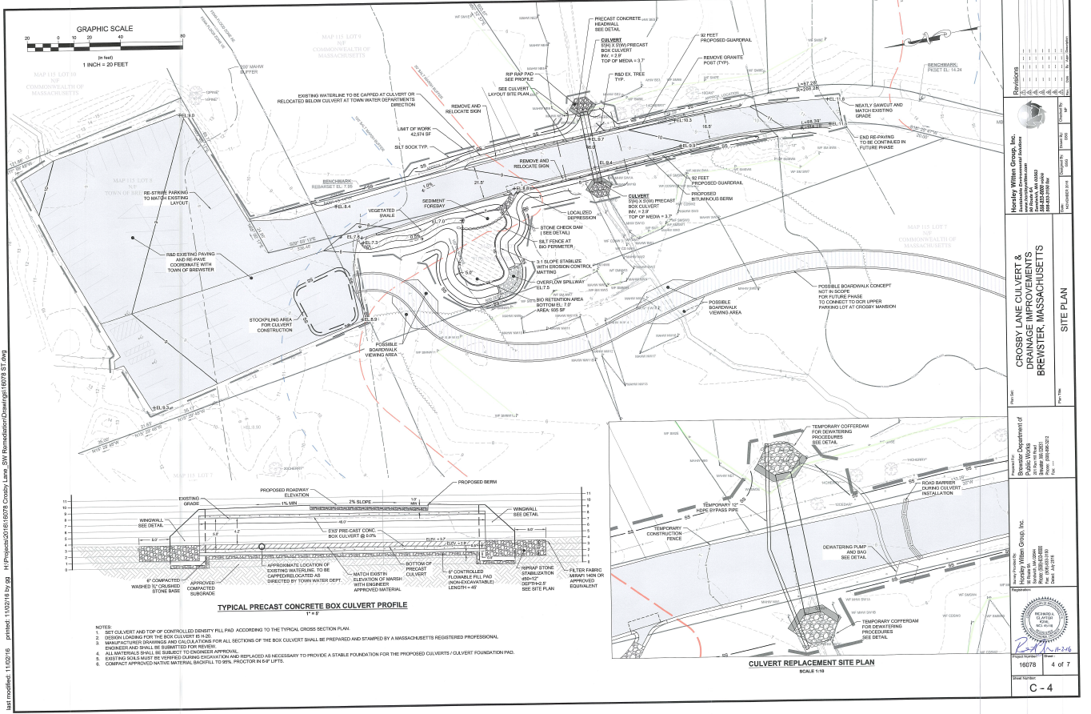

Interim goal has been established as a starting point and is intended to be representative of realistic potential load reductions that can be achieved through ongoing BMP implementation to continue improving water quality. Interim goal is not based on water quality data or calculations of potential concentration-based improvements.
Guidance on funding sources to address nonpoint source pollution: http://prj.geosyntec.com/prjMADEPWBP_Files/Guide/Element%20D%20-%20Funds%20and%20Resources%20Guide.pdf
Note that goals and milestones of this WBP are intended to be adaptable and flexible. Goals and milestones are not intended to be tied to Municipal Separate Storm Sewer (MS4) permit requirements. Stakeholders will perform tasks contingent on available resources and funding.
Example MassDEP Estuary Data Collection Sheet: https://www.mass.gov/doc/example-field-data-sheets-estuaries-pdf
Additional guidance is provided at: https://www.epa.gov/sites/production/files/2015-06/documents/lakevolman.pdf

